SUPPLEMENTARY DATA
Wiebe, S.T., et al: Validation of a drug transporter probe cocktail using the prototypical inhibitors rifampin, probenecid, verapamil and cimetidine
Supplementary Figures S1-S4

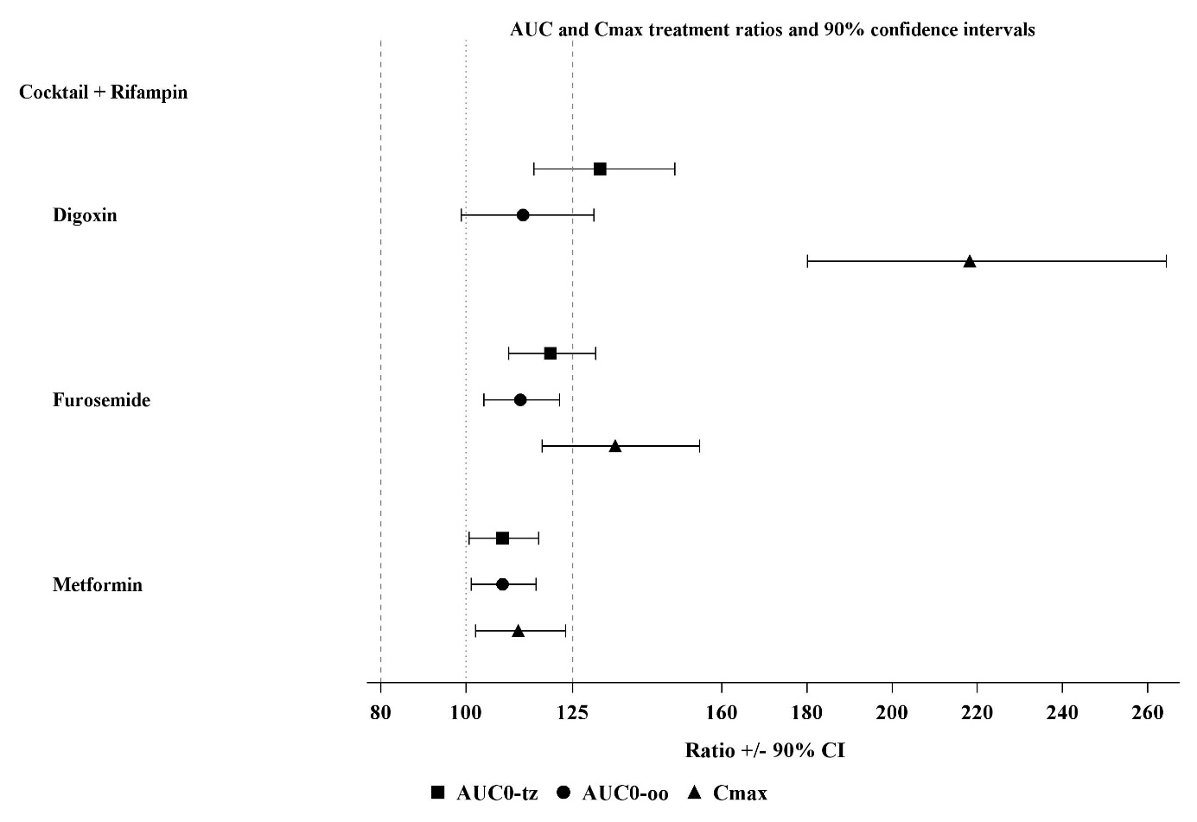

Figure S1 – Forest Plots Trial part 1 – rifampin as inhibitor, plasma pharmacokinetic parameters
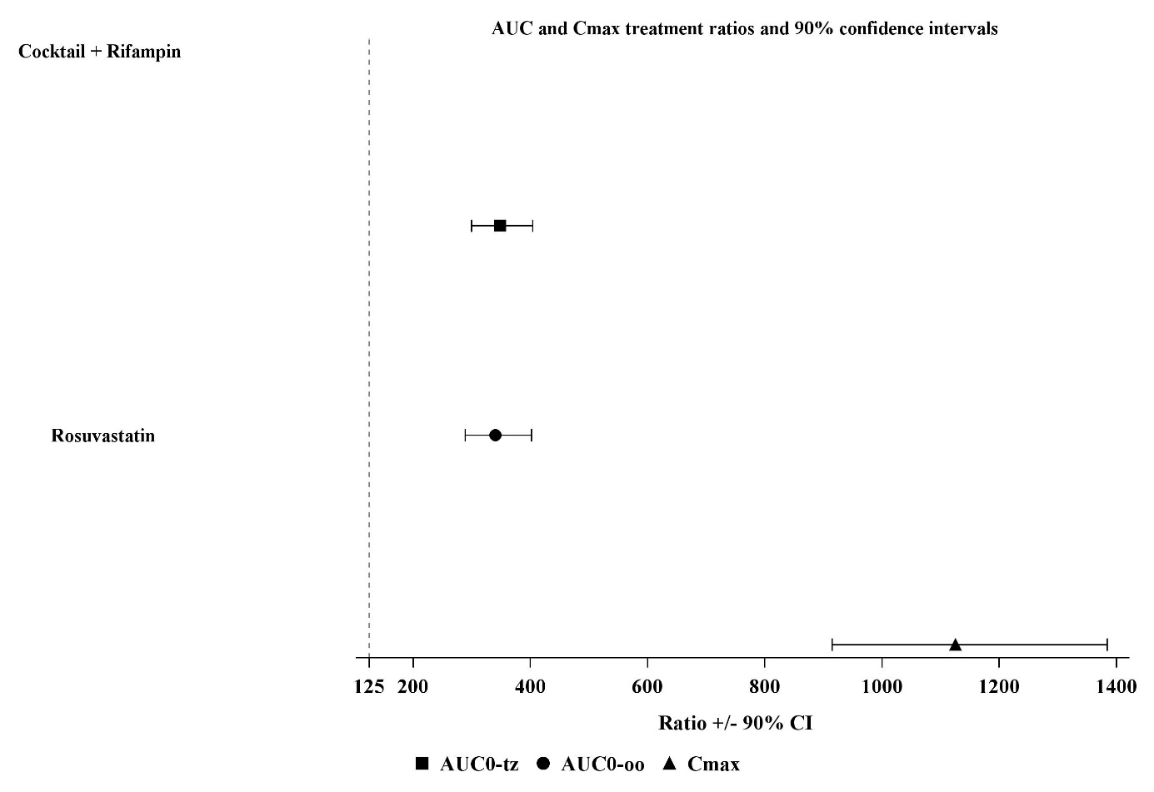

Figure S1 (cont'd) – Forest Plots Trial part 1 – rifampin as inhibitor, plasma pharmacokinetic parameters

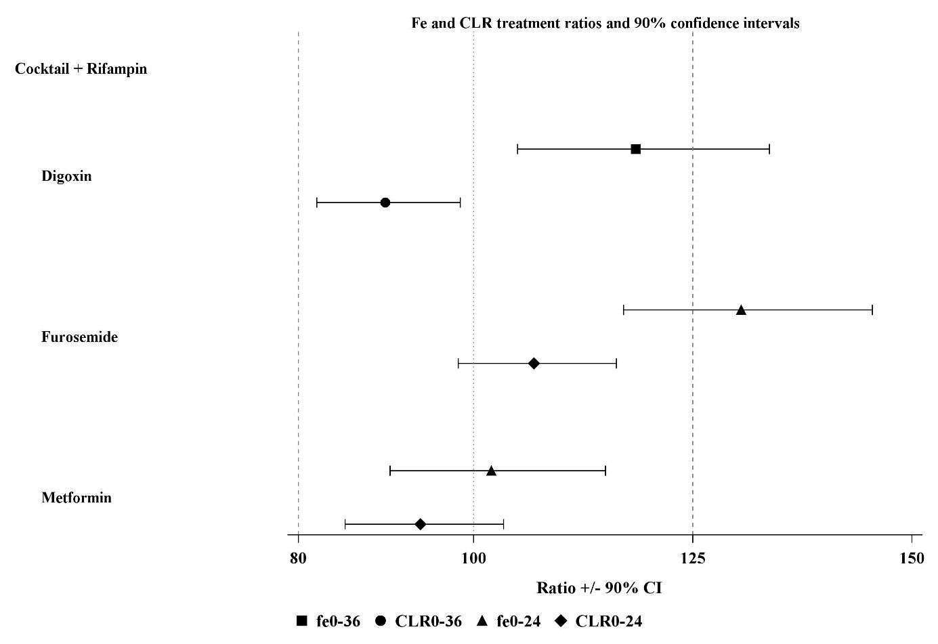

Figure S1 (cont'd) – Forest Plots Trial part 1 – rifampin as inhibitor, urinary pharmacokinetic parameters

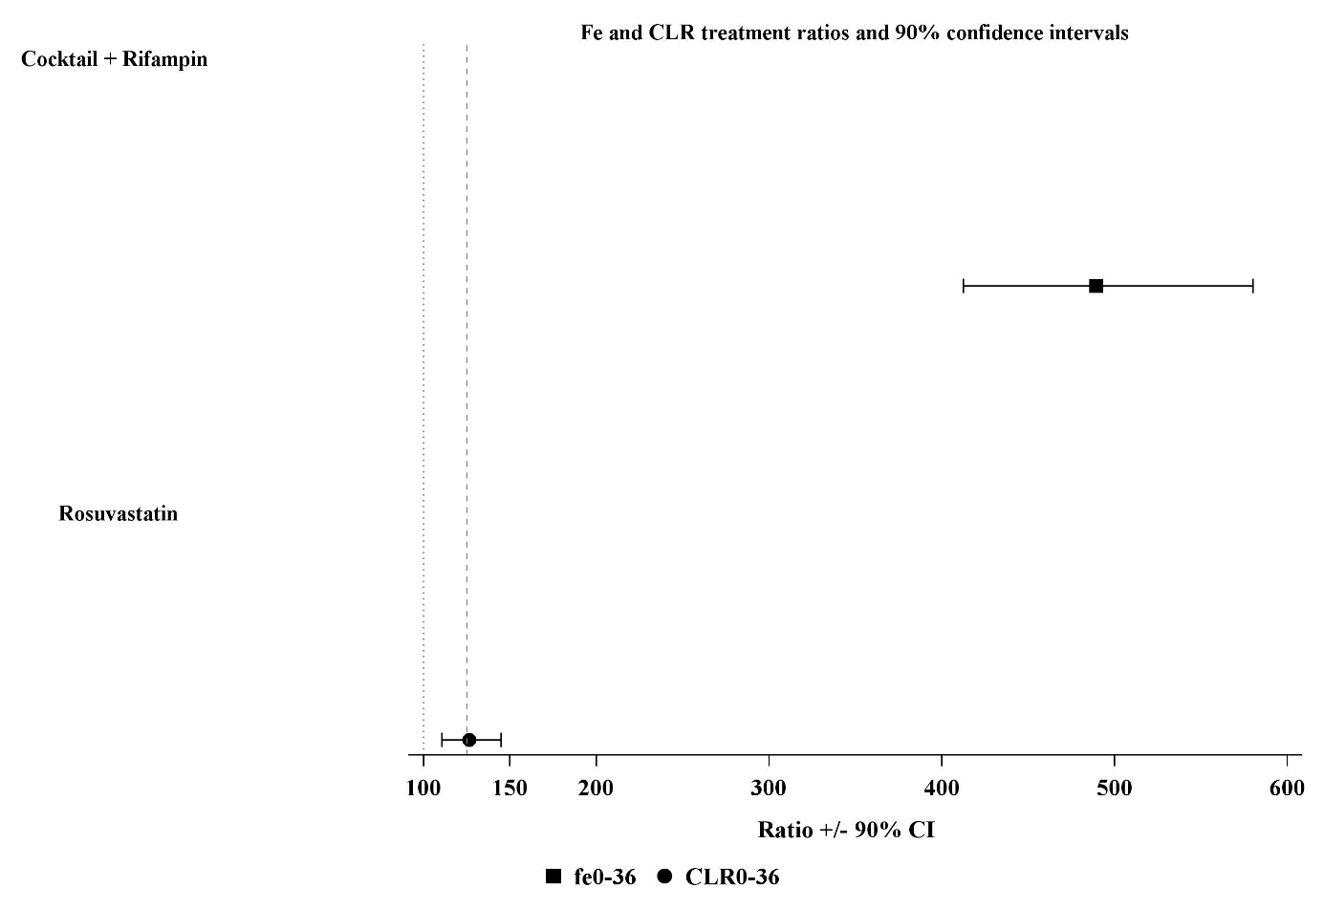

Figure S1 (cont'd) – Forest Plots Trial part 1 – rifampin as inhibitor, urinary pharmacokinetic parameters
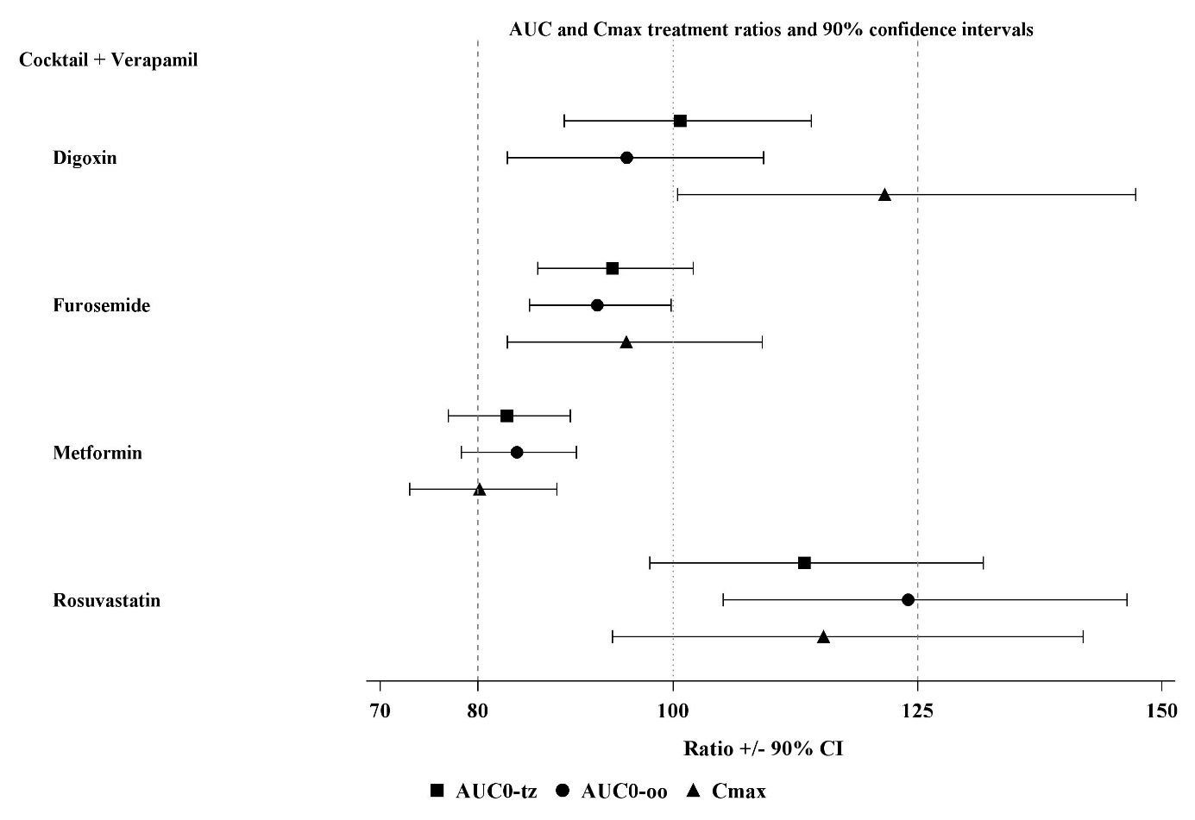

Figure S2 – Forest Plots Trial part 1 – verapamil as inhibitor, plasma pharmacokinetic parameters
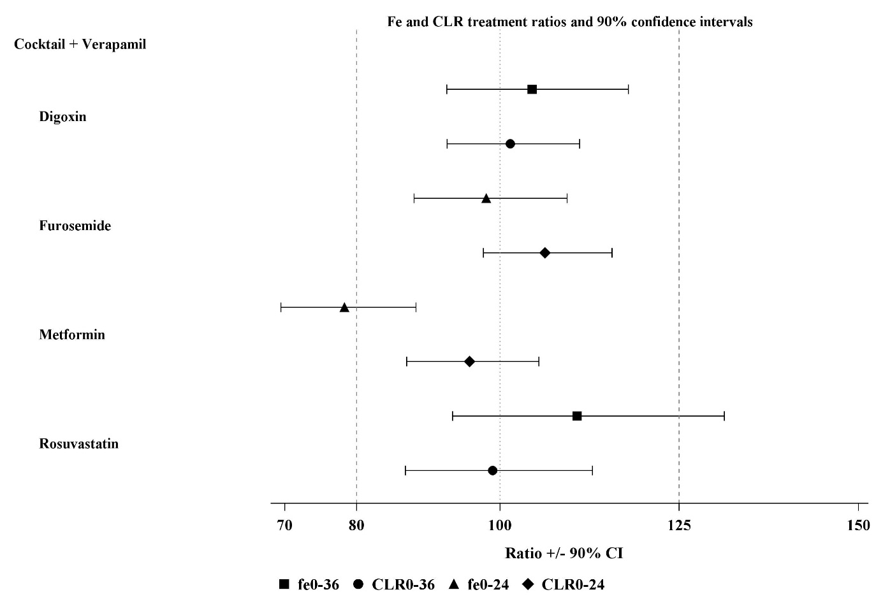

Figure S2 (cont'd) – Forest Plots Trial part 1 – verapamil as inhibitor, urinary pharmacokinetic parameters
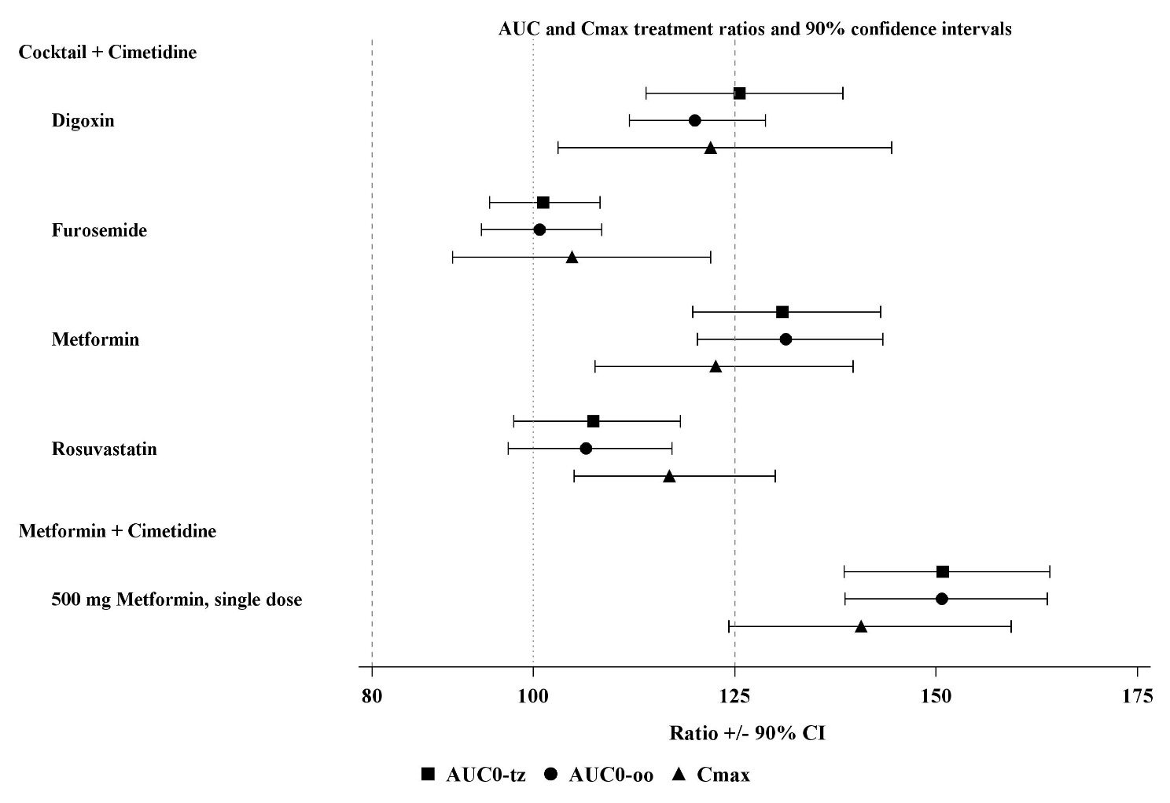

Figure S3 – Forest Plots Trial part 2 – cimetidine as inhibitor, plasma pharmacokinetic parameters
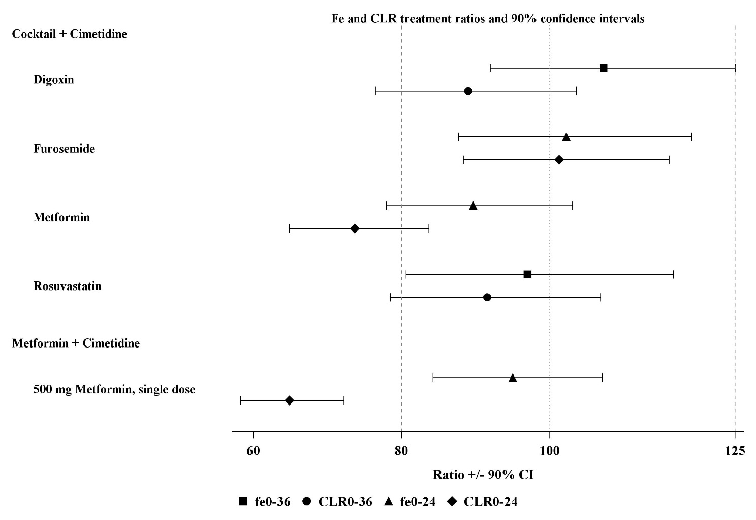

Figure S3 (cont'd) – Forest Plots Trial part 2 – cimetidine as inhibitor, urinary pharmacokinetic parameters
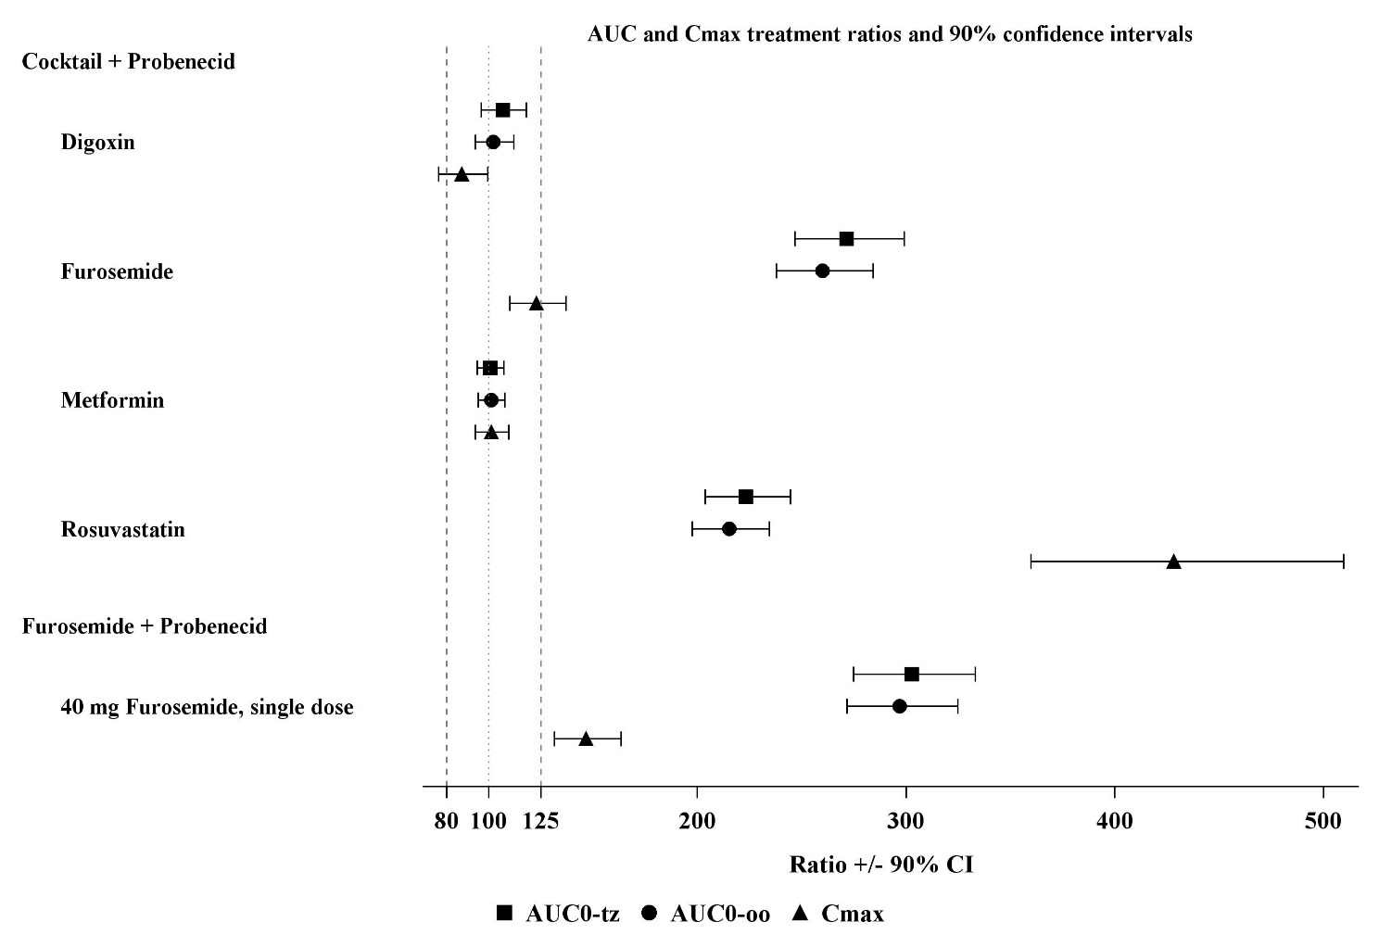

Figure S4 – Forest Plots Trial part 3 – probenecid as inhibitor, plasma pharmacokinetic parameters
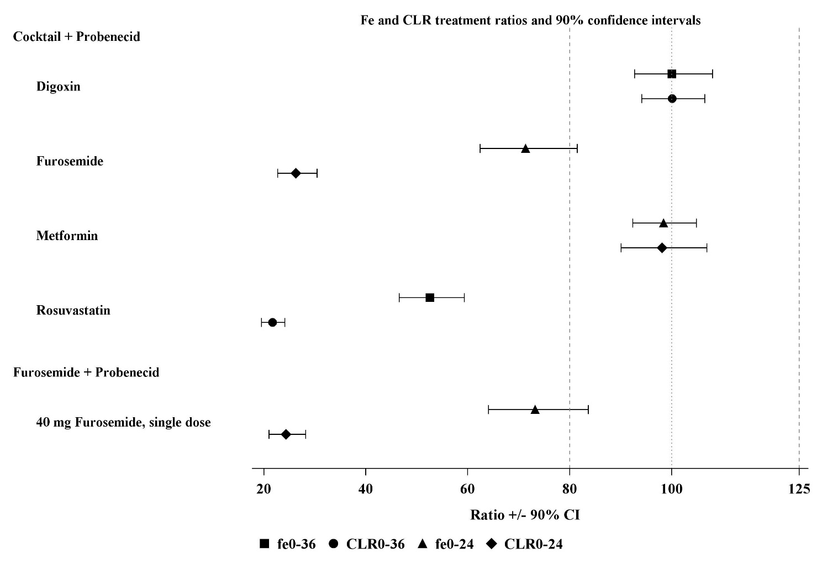

Figure S4 (cont'd) – Forest Plots Trial part 3 – probenecid as inhibitor, urinary pharmacokinetic parameters

