Supplementary Materials
Table 1 Pharmacokinetic and Pharmacodynamic Assessment Time Points in Part A, B and C
 | Pharmacokinetic Assessment |  |  | Pharmacodynamic Assessment | ADA assessment
Part | Blood PK | Urine PK | Pooled Urine | Plasma C5
SAD (Part A) | 0 (pre-dose) and 0.5, 1, 2, 4, 6, 8, 12, 24 and 48 hrs post-dose | 0 (pre-dose) and 6, 12, 24 and 48 hrs post-dose | 0 to 6, 6 to 12 and 12 to 24 hrs | Screening, days -1 and 0 before dosing and on Days 2, 7, 14, 21, 28, 42, 56 and 70 post-dose | Days 0 (pre-dose) and on Days 1, 14 and 70 post-dose
MAD (Part B): weekly dosing cohorts | Days 0 and 28: 0 (pre-dose), 0.5, 1, 2, 4, 6, 8, 12 24 and 48 hrs post dose | Days 0 and 28: 0 (pre-dose) and 6, 12, 24 and 48 hrs post dose | Days 0 and 28:  0 to 6, 6 to 12 and 12 to 24 hrs | Screening, days -1 and day 0 before dosing and on Days 2, 7, 14, 21, 28 during treatment period and on Days 30, 35, 42, 56, 70, 84, 112 and 140 in the post-dose follow-up | Day 0 (pre-dose) and on Day 140 in the post-dose follow-up period
MAD (Part B): biweekly, weekly/monthly and biweekly/monthly | Days 0 and 84:  0 (pre-dose) and 0.5, 1, 2, 4, 6, 8, 12, 24 and 48 hrs post-dose | Days 0 and 84: 0 (pre-dose) and 6, 12, 24 and 48 hrs post dose | Days 0 and 84:  0 to 6, 6 to 12 and 12 to 24 hrs
MD (Part C) | Days 0 and 84:  0 (pre-dose) and 0.5, 1, 2, 4, 6, 8, 12 and 24 hrs post-dose | Days 0 and 84: 0 (pre-dose) and 6, 12 and 24 hrs post dose | Days 0 and 84:  0 to 6, 6 to 12 and 12 to 24 hrs | Screening, days -1 and day 0 before dosing and on Days 7, 14, 21, 28, 35, 42, 49, 56, 63, 70, 77 and 84 during treatment period and on Days 98, 112, 126 and 140 in the post-dose follow-up | Day 0 (pre-dose), Day 28 during treatment period and Day 98 in the post-dose follow-up period

Table 2 Mean (SD) Plasma Pharmacokinetic Parameters of AS(N-2)3’-cemdisiran after Multiple Subcutaneous Doses of Cemdisiran in Healthy Subjects

Parameter | 100mg weekly  (n= 3) |  | 200 mg weekly  (n=3) |  | 400 mg weekly  (n=3) |  | 600 mg biweekly  (n=3) |  | 200 mg weekly/biweekly (n=3) |  | 200 mg weekly/monthly  (n=3)
Day | 0^{b} | 28^{b} | 0 | 28 | 0 | 28 | 0 | 84^{b} | 0 | 84 | 0 | 84
C_{max}, ng/mL | 46.6, 106 | 65.1, 94.9 | 143  (13.0) | 163  (66.2) | 260  (88.2) | 178  (17.9) | 566  (116) | 907, 1250 | 132  (34.1) | 167  (41.0) | 122  (14.9) | 103  (8.48)
t_{max}, hª | 8.00  (8.00, 8.00) | 6.00  (6.00, 6.00) | 8.00  (8.00, 12.00) | 8.00  (6.17, 12.00) | 8.00  (8.00, 12.00) | 12.0  (8.03, 12.08) | 8.00  (8.00, 8.07) | 7.00  (6.00, 8.00) | 4.00  (4.00, 12.00) | 4.94  (3.91, 5.97) | 8.07  (8.00, 12.00) | 8.00  (8.00, 8.00)
AUC_{0-t}, h•ng/mL | 723, 999 | 575, 987 | 2063  (156) | 2007  (196) | 4160  (831) | 3783  (497) | 7678  (918) | 12045, 14217 | 2010  (603) | 2207  (568) | 1564  (70.8) | 1628  (256)
t_{1/2}, h | ND | ND | ND | ND | ND | ND | ND | ND | 6.92, 5.73^{b} | 3.91, 5.97^{b} | ND | ND
AUC_{0-t} area under the curve up to the last measurable concentration, C_{max} maximum plasma drug concentration, ND not determined due to lack of concentrations in the terminal phase of the curve, SD standard deviation, t½ apparent terminal elimination half-life, t_{max} time to maximum plasma concentration.

ª median (minimum, maximum)
^{b} N= 2, Individual Cmax, AUC and t_{1/2} reported

Table 3 Mean (SD) Urine Pharmacokinetic Parameters of AS(N-2)3’-cemdisiran after Multiple Subcutaneous Doses of Cemdisiran in Healthy Subjects
Parameter | 100mg weekly (n= 3) |  | 200 mg weekly (n=3) |  | 400 mg weekly (n=3) |  | 600 mg biweekly (n=3) |  | 200 mg weekly/biweekly (n=3) |  | 200 mg weekly/monthly  (n=3)
Day | 0 | 84 | 0 | 84 | 0 | 84 | 0 | 84ª | 0 | 84 | 0 | 84
fe,% | 5.17  (0.14) | NC | 6.96  (0.18) | NC | 7.73  (2.60) | NC | 9.96  (0.39) | 11.6, 16.6 | 6.30  (2.47) | 9.61  (3.39) | 7.57  (1.85) | 8.95  (2.27)
Ae amount excreted in urine, fe fraction of dose excreted in urine, NC not calculated
ªN=2, Individual %fe reported

Table 4 Mean (SD) Plasma Pharmacokinetic Parameters of AS(N-2)3’-cemdisiran after Multiple Subcutaneous Doses of Cemdisiran in patients with PNH

Parameter | 200 mg weekly (n= 3) |  | 400 mg weekly (n= 3)
Plasma Pharmacokinetics
Day | 0 | 84 | 0 | 84^{c}
C_{max}, ng/ml | 91.8  (22.3) | 89.6, 58.5 ^{b} | 88.7  (9.16) | NA
t_{max}, hª | 0.5  (6.00, 11.58) | 0.5, 0.5^{b} | 2.53  (2.38, 2.68) | NA
AUC_{0-t}, h•ng/mL | 193  (83.8) | 237, 132^{b} | 185  (5.47) | NA
Urine Pharmacokinetics
fe (%) | 10.1  (3.42) | 9.11  (3.16) | 3.72  (1.88) | NA
AUC_{0-t} area under the curve up to the last measurable concentration, C_{max} maximum plasma drug concentration, NA not available, SD standard deviation, t_{max} time to maximum plasma concentration, fe fraction of dose excreted in urine.

ª median (minimum, maximum)
^{b} N= 2, Individual PK parameters reported
^{c} Plasma and urine PK samples were not collected

Fig. 1 Mean Cemdisiran Plasma Concentration Profiles following single subcutaneous doses. Error bars represent standard deviations
Supplement
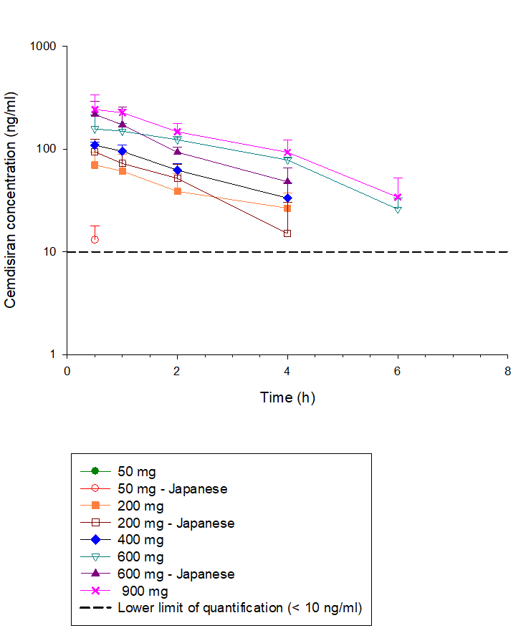
Note: Plasma concentrations below limit of quantification are not shown in the above plot.
Fig. 2 Mean Cemdisiran Plasma Concentration Profiles on Day 0 and 84 Following Multiple Subcutaneous Doses of Cemdisiran
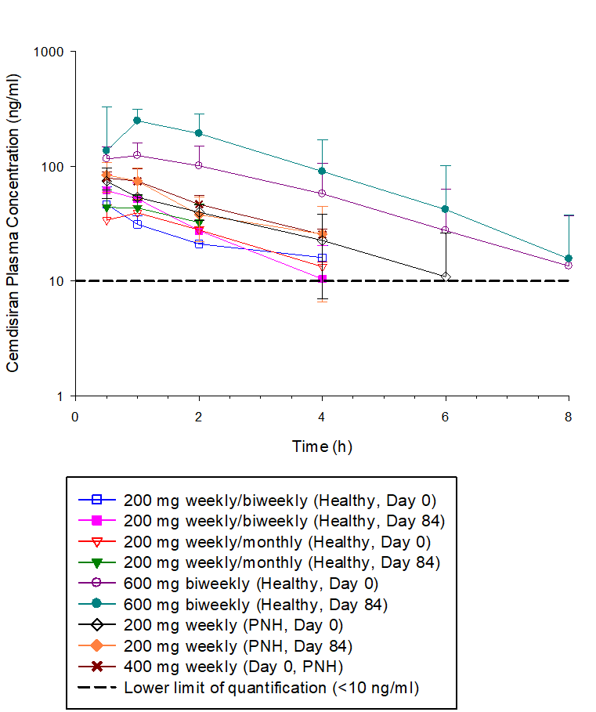

Note: Plasma concentrations below limit of quantification are not shown in the above plot.

