Electronic Supplementary Table S1 Summary of plasma lorlatinib pharmacokinetic parameters following single oral doses of lorlatinib
Parameter (units) | Parameter summary statisticsª by dose
Day −7 lead-in: QD doses^{b} | 10 mg QD | 50 mg QD | 75 mg QD | 100 mg QD | 200 mg QD
N, n | 3, 1 | 2, 2 | 12, 11 | 16, 15 | 3, 3
AUC∞ (ng·h/mL) | 698.0 | (7210, 7240) | 7663 (79) | 8236 (25) | 18340 (61)
AUC∞(dn) (ng·h/mL/mg) | 69.80 | (144, 145) | 102.2 (79) | 82.36 (25) | 91.68 (61)
AUC_{τ} (ng·h/mL) | 488.2 (21) | (3310, 3880) | 3990 (55) | 5110 (28) | 11410 (43)
AUC_{τ} (dn) (ng·h/mL/mg) | 48.82 (21) | (66.1, 77.7) | 53.14 (54) | 51.10 (28) | 57.13 (43)
CL/F (L/h) | 14.30 | (6.91, 6.94) | 9.788 (79) | 12.14 (25) | 10.90 (61)
C_{max} (ng/mL) | 50.80 (17) | (390, 423) | 489.1 (45) | 595.5 (37) | 1201 (19)
C_{max}(dn) (ng/mL/mg) | 5.080 (17) | (7.80, 8.46) | 6.523 (45) | 5.955 (37) | 6.003 (19)
MRT (h) | 23.7 | (27.7, 43.1) | 36.0 ± 11.7 | 27.0 ± 7.04 | 25.8 ± 6.36
T_{max} (h) | 1.98  (1.00–2.97) | 1.25  (0.500–2.00) | 1.09  (0.500–4.03) | 1.96  (0.517–4.33) | 2.00  (1.18–3.00)
V_{z}/F (L) | 373.0 | (166, 307) | 367.9 (54) | 356.3 (39) | 307.8 (41)
t_{½} (h) | 18.0 | (16.6, 30.8) | 27.2 ± 8.30 | 20.9 ± 5.03 | 19.8 ± 3.30
Day −7 lead-in: BID doses | 35 mg BID | 75 mg BID | 100 mg BID
N, n | 3, 2 | 3, 1 | 4, 4
AUC∞ (ng·h/mL) | (2630, 3690) | 6860 | 6318 (56)
AUC∞(dn) (ng·h/mL/mg) | (75.1, 105) | 91.40 | 63.18 (56)
AUC_{τ} (ng·h/mL) | 982.4 (9) | 2996 (20) | 2925 (47)
AUC_{τ} (dn) (ng·h/mL/mg) | 28.03 (9) | 40.00 (20) | 29.25 (47)
CL/F (L/h) | (9.48, 13.3) | 10.9 | 15.83 (56)
C_{max} (ng/mL) | 202.2 (57) | 594.9 (27) | 507.2 (51)
C_{max}(dn) (ng/mL/mg) | 5.776 (57) | 7.933 (27) | 5.072 (51)
MRT (h) | (30.8, 37.7) | 33.0 | 22.1 ± 6.76
T_{max} (h) | 1.20  (0.500–1.97) | 1.23  (1.00–2.00) | 2.00  (1.10–3.07)
V_{z}/F (L) | (362, 472) | 410.0 | 378.3 (54)
t_{½} (h) | (24.6, 26.5) | 26.00 | 17.18 ± 5.19
Cycle 1 Day 1: QD doses | 25 mg QD | 150 mg QD
N, n | 3, 3 | 3, 3
AUC_{τ} (ng·h/mL) | 1387 (35) | 7474 (73)
AUC_{τ} (dn) (ng·h/mL/mg) | 55.49 (35) | 49.80 (73)
C_{max} (ng/mL) | 149.2 (71) | 760.0 (58)
T_{max} (h) | 2.00  (0.500–2.05) | 1.05  (1.00–3.00)
ª Data are expressed as geometric mean (geometric %CV) for all parameters except median (range) for T_{max} and arithmetic mean ± SD for t_{½} and MRT. The single observation was reported when n = 1 and the range was reported when n = 2
^{b} Because midazolam was administered on Day -7, pharmacokinetic data were not available at the Day −7 timepoint for patients who were in the lorlatinib 25 mg QD and 150 mg QD dose groups.

N = Number of patients in the treatment group; n = number of patients where t_{½}, MRT, AUC∞, CL/F and Vz/F were determined.

AUC_{τ} area under the concentration-time profile from time zero to time τ, the dosing interval, where τ = 12 or 24 h for BID or QD dosing, respectively; AUC∞ area under the plasma concentration-time profile from time zero extrapolated to infinite time; BID twice daily, CL/F apparent oral clearance at steady-state, C_{max} maximum observed plasma concentration, dn dose normalized, MRT mean residence time, PK pharmacokinetic, QD once daily, SD standard deviation, t_{½} terminal plasma half-life, T_{max} time to C_{max}, V_{z}/F apparent volume of distribution single dose

Electronic Supplementary Table S2 Summary of trough concentration (ng/mL) of lorlatinib in patients with advanced NSCLC following administration of lorlatinib multiple oral doses (100 mg QD; phase II)
Subpopulation | Visit
Subpopulation | C1D8ª | C1D15ª | C2D1 | C3D1 | C4D1 | C5D1 | C6D1 | C8D1 | C10D1 | C12D1 | C14D1 | C16D1 | C18D1 | C20D1
Phase II and Japan LIC (N = 277)
EXP-1 | 67.0  234  n = 2 | 70.0, 174  n = 2 | 96.32 (57)  n = 29 | 85.88 (51)  n = 26 | 79.68 (55)  n = 28 | 86.25 (43)  n = 28 | 85.61 (51)  n = 22 | 81.88 (45)  n = 21 | 76.26 (52)  n = 12 | 46.43 (62)  n = 7 | 71.94 (45)  n = 7 | 82.87 (37)  n = 6 | 81.2  n = 1 | 57.8  n = 1
EXP-2 | 143  n = 1 | 281.0  n = 1 | 125.8 (60)  n = 25 | 99.06 (51)  n = 25 | 94.95 (55)  n = 24 | 105.4 (46)  n = 21 | 99.87 (51)  n = 18 | 62.48 (50)  n = 13 | 97.59 (92)  n = 8 | 91.2, 169  n = 2 | 75.0, 88.3  n = 2 | 60.9, 163  n = 2 | 2.84, 171  n = 2 | NC
EXP-3 | 103  n = 1 | 16.5, 150  n = 2 | 100.1 (51)  n = 52 | 98.02 (54)  n = 51 | 103.2 (44)  n = 46 | 90.37 (65)  n = 38 | 85.49 (60)  n = 34 | 74.45 (46)  n = 24 | 88.19 (46)  n = 19 | 100.6 (36)  n = 11 | 113.1 (34)  n = 10 | 111.8 (44)  n = 6 | 123.4 (43)  n = 4 | 42.9, 163  n = 2
EXP-4 | 110.8 (22)  n = 5 | 102.6 (40)  n = 6 | 115.5 (57)  n = 56 | 111.2 (51)  n = 50 | 112.8 (41)  n = 50 | 107.0 (40)  n = 43 | 109.8 (68)  n = 33 | 80.52 (83)  n = 29 | 78.73 (95)  n = 28 | 109.0 (63)  n = 20 | 113.5 (62)  n = 13 | 92.80 (33)  n = 6 | 69.55 (53)  n = 6 | NC
EXP-5 | 116.2 (28)  n = 6 | 115.6 (25)  n = 6 | 120.2 (83)  n = 42 | 95.28 (45)  n = 36 | 101.8 (37)  n = 35 | 103.8 (47)  n = 32 | 75.44 (59)  n = 28 | 85.08 (55)  n = 22 | 86.96 (63)  n = 8 | 87.38 (46)  n = 6 | 97.31 (61)  n = 5 | (67.5, 116)  n = 2 | 138.5 (42)  n = 3 | (85.8, 105)  n = 2
EXP-6 | 87.80 (45)  n = 6 | 177.2 (95)  n = 5 | 117.4 (48)  n = 41 | 92.64 (55)  n = 40 | 81.25 (52)  n = 35 | 91.01 (73)  n = 34 | 105.9 (54)  n = 23 | 81.97 (68)  n = 22 | 106.0 (42)  n = 13 | 119.1 (87)  n = 11 | 99.35 (41)  n = 9 | 105.2 (30)  n = 8 | 93.47 (40)  n = 4 | 85.12 (50)  n = 3
Japan LIC | 135.5 (54)  n = 3 | 137.5 (55)  n = 3 | 126.7 (42)  n = 3 | 123.8 (31)  n = 3 | 105.3 (53)  n = 3 | 90.49 (50)  n = 3 | 85.67 (60)  n = 3 | 38.0, 78.7  n = 2 | 41.70  n = 1 | 36.70  n = 1 | 56.00  n = 1 | 53.80  n = 1 | NC | NC
Individual values are presented where n ≤ 2. Geometric means (%CV) are presented where n > 2
ª C1D8 and C1D15 pharmacokinetics were only collected in a subset of patients

N number of patients who had at least one concentration of lorlatinib, n number of observations, C Cycle, CV coefficient of variation,
D Day, EXP expansion cohort, Japan LIC Japanese patient only lead-in cohort, NA not applicable, NC not collected, QD once daily

Electronic Supplementary Table S3 Descriptive summary of plasma midazolam pharmacokinetic parameters following a single oral 2-mg dose alone and in the presence of lorlatinib (25 mg QD or 150 mg QD)
Parameter (units) | Parameter summary statisticsª by treatment
Parameter (units) | Day −7 Lead-in (alone) |  | Cycle 1 Day 15 (with lorlatinib)
Parameter (units) | 25 mg QD | 150 mg QD | 25 mg QD | 150 mg QD
N, n | 3, 3 | 3, 2 | 3, 3 | 3, 3
AUC∞ (ng·h/mL) | 54.53 (43) | (42.2, 46.8) | 21.32 (18) | 16.09 (29)
AUC_{last} (ng·h/mL) | 51.30 (47) | 36.49 (20) | 20.43 (18) | 14.44 (25)
C_{max} (ng/mL) | 16.06 (42) | 11.56 (48) | 9.697 (40) | 5.734 (43)
T_{max} (h) | 0.500 (0.500-1.00) | 0.500 (0.500-0.500) | 0.500 (0.500-1.00) | 0.500 (0.500-0.533)
t_{½} (h) | 4.620 ± 1.933 | (2.35, 7.89) | 3.343 ± 2.036 | 5.257 ± 5.064
CL/F (L/h) | 36.68 (43) | (42.7, 47.4) | 93.86 (18) | 124.2 (29)
Vz/F (L) | 229.0 (7) | (161, 486) | 404.4 (51) | 702.2 (100)
ª Data are expressed as geometric mean (geometric %CV) for all parameters except median (range) for T_{max} and arithmetic mean ± SD for t_{½}. Individual values were reported when n = 2
On Lead-in Day −7, the treatment was a 2-mg dose of midazolam and the exposure parameters were reported for midazolam alone before any doses of lorlatinib were administered. On Cycle 1 Day 15, the exposures reported were for 2-mg dose of midazolam after 15 days of continuous lorlatinib dosing at the respective dose levels

AUC∞ area under the plasma concentration-time profile from time zero extrapolated to infinite time, AUC_{last} area under the plasma concentration-time profile from time zero to the time of the last quantifiable concentration, CL/F apparent oral clearance of a single dose, C_{max} maximum observed plasma concentration, N number of subjects contributing to the summary statistic, n number of subjects where t_{½}, AUC∞, CL/F, and Vz/F could be determined, SD standard deviation, t_{½} terminal plasma half-life, T_{max} time to C_{max}, Vz/F apparent volume of distribution

Electronic Supplementary Table S4 Listing of lorlatinib concentration in CSF, plasma, CSF/plasma ratio, and CSF/free plasma ratio for participants in phase I and II
Study phase | Lorlatinib treatment group | CSF concentration (ng/mL) | Plasma concentration (ng/mL) | Ratio
 |  |  |  | CSF/plasma | CSF/free plasma
Iª | 150 mg QD | 2.64 | 12.7 | 0.2079 | 0.6114
I | 100 mg QD | 125 | 384 | 0.3255 | 0.9574
I | 100 mg QD | 101 | 457 | 0.221 | 0.65
I | 100 mg QD | 81.8 | 311 | 0.263 | 0.7736
II | EXP-1 | 38.1 | 165 | 0.2309 | 0.6791

ª This patient had been off study drug for 8 days at the time of the CSF and plasma sample draws

The lower limit of quantification for plasma concentration was 2.50 ng/mL

The lower limit of quantification for CSF concentration was 1.00 ng/mL
CSF/free plasma ratio = CSF/(plasma • 0.34)
CSF cerebral spinal fluid, EXP expansion cohort, QD once daily

Electronic Supplementary Fig. S1 Plots of lorlatinib dose-normalized pharmacokinetic parameters vs. dose following single oral doses (QD dosing cohorts only). (a) AUC∞ (b) AUC_{τ} (c) C_{max}
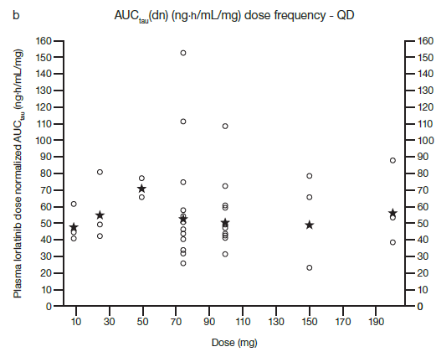
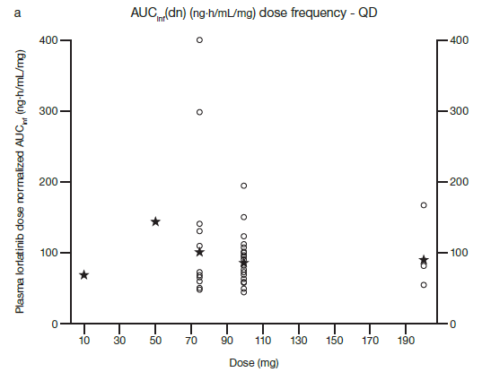

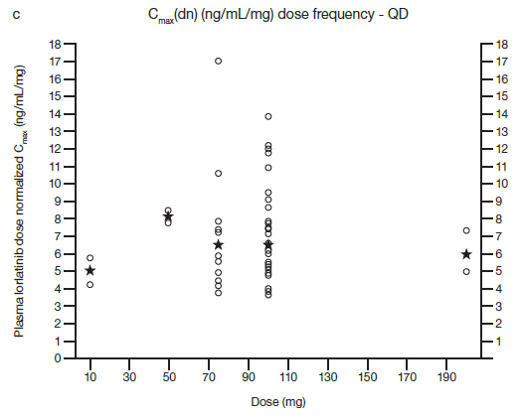
Circles represent individual values and stars represent geometric mean
For 25 mg QD and 150 mg QD dose levels, the AUC_{τ} was derived from Cycle 1 Day 1 data while for the remaining dose levels the AUC_{τ} was obtained from Lead-in Day 7 data
AUC_{τ} area under the concentration-time profile from time zero to time τ, the dosing interval, where τ = 24 h, C_{max} maximum observed plasma concentration, QD, once daily

Electronic Supplementary Fig. S2 Box and whisker plot of changes from baseline in (a) plasma 4ß-hydroxycholesterol/cholesterol and (b) urine 6ß-hydroxycortisol/cortisol ratios against visit following multiple doses of lorlatinib 100 mg QD (phase I)
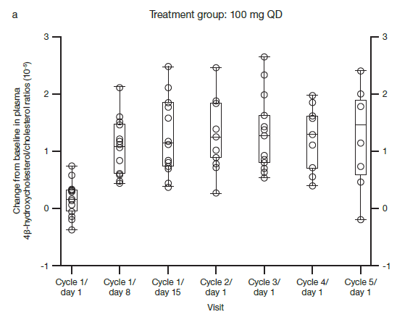
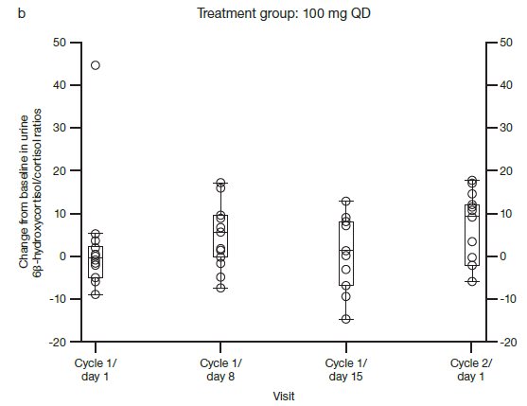

Open circles represent individual values. Box plot shows median and 25%/75% quartiles with whiskers to the last point within 1.5 times the interquartile range
QD once daily

