Supplementary information
Clinical Pharmacokinetics of Oral Semaglutide: Analyses of Data from Clinical Pharmacology Trials

Journal: Clinical Pharmacokinetics

Rune V. Overgaard,¹ Andrea Navarria,² Steen H. Ingwersen,¹ Tine A. Bækdal,¹ Rasmus Juul Kildemoes¹
¹Novo Nordisk A/S, Søborg, Denmark; ²Novo Nordisk A/S, Bagsvaerd, Denmark

Corresponding author: Rune V. Overgaard
Address: Vandtårnsvej 108–110, 2860 Søborg, Denmark
Email: ruvo@novonordisk.com
Telephone: +45 3079 0059
Table of Contents
Section 1 Equations for modelling the effects of T2D and upper GI disease 3
Online resource, Table 1 Parameter estimates from the final PK model 4
Online resource, Fig. 1 Diagnostic plots for the final population PK model 6
Online resource, Fig. 2 Distributions of individual estimated and predicted PK parameters for clearance (a), central volume (b), inter-compartmental clearance (c), and peripheral volume (d) 7
Online resource, Fig. 3 Distribution histogram of bioavailability estimates across all dose administrations and individuals 8
Online resource, Fig. 4 Visual predictive check of the population PK model for data from each trial contributing data 9
Online resource, Fig. 5 Observed and predicted individual PK profiles (a) and associated bioavailabilities (b) vs. time after first dose for 12 individuals 10
Online resource, Fig. 6 Observed individual and mean PK profiles from the dosing conditions trial. Dosing interval for the 1st dose (a) and for the 10th dose (b) of repetitive once-daily oral dosing of semaglutide 12
Online resource, Fig. 7 PK profiles during once-daily oral administration of semaglutide in subjects with T2D with or without upper GI disease 13
References 14

Section 1 Equations for modelling the effects of T2D and upper GI disease
The effects of type 2 diabetes (T2D) and upper gastrointestinal (GI) disease on the oral bioavailability (F) were described as:
$${F=\left(θ_{T2D,F}\right)}^{T2D}∙F_{ref}$$
$${F=\left(θ_{GI disease,F}\right)}^{GI disease}∙F_{ref}$$
where θ_{T2D,F} is the estimated effect of T2D on bioavailability and the exponents (T2D and GI disease) are indicator variables assigned the value 1 for subjects with T2D and upper GI disease, and else 0. F_{ref} represents the oral bioavailability in subjects without T2D and upper GI disease. This model also included an effect of off-site dosing, parametrised as follows:
$$F={\left(θ_{Off-site}\right)}^{Off-site}∙F_{ref}$$
where θ_{Off-site} is the estimated effect of off-site dosing and the exponent (Off-site) is an indicator variable assigned the value 1 for off-site administration and else 0. F_{ref} represents the oral bioavailability for on-site dosing.

Online resource, Table 1 Parameter estimates from the final PK model
Description | Units | Estimate [95% CI] | IIV (CV%) | Shrinkage (%)  [IIV or residual] | IOV (CV%)
Absorption rate constant (k_{a}) | 1/h | 2.09 [1.89, 2.32] | 57.4 | 17 | N/A
Clearance (CL) | L/h | 0.0348 fixed | 15.2 | 60.7 | N/A
Central volume (V_{c}) | L | 3.59 fixed | 15.4 | 61.7 | N/A
Inter-compartmental clearance (Q) | L/h | 0.304 fixed | 15.2 fixedª | 60.7 fixedª | N/A
Peripheral volume (V_{p}) | L | 4.1 fixed | 15.4 fixed^{b} | 61.7 fixed^{b} | N/A
Weight exponent on clearance | - | 1.01 fixed | N/A | N/A | N/A
Weight exponent on volume | - | 0.923 fixed | N/A | N/A | N/A
Diabetes status factor on clearance | - | 1.09 fixed | N/A | N/A | N/A
Bioavailability (F) | % | 0.795 [0.736, 0.864] | 53.5 | 18.3 | 137.44
Weight exponent on bioavailability | - | 0.741 [0.199, 1.19] | N/A | N/A | N/A
Water volume factor on bioavailability  (240 mL) | - | 0.637 [0.467, 0.897] | N/A | N/A | N/A
Fasting time exponent on bioavailability | - | 0.0266 [0.0167, 0.0402] | N/A | N/A | N/A
Fasting time exponent for k_{a} | - | 0.112 [0.068, 0.179] | N/A | N/A | N/A
Absorption rate at long-term fasting | - | 1.35 [1.21, 1.51] | N/A | N/A | N/A
Exponential error (SD) | - | 0.124 [0.0136, 0.0174] | N/A | 10.4 | N/A
ªValues fixed to the values for CL; ^{b}values fixed to the values for V_{c}
CI confidence interval, CV coefficient of variation, IIV inter-individual variability, IOV inter-occasion (within-individual) variability, PK pharmacokinetic, SD standard deviation

Online resource, Fig. 1 Diagnostic plots for the final population PK model
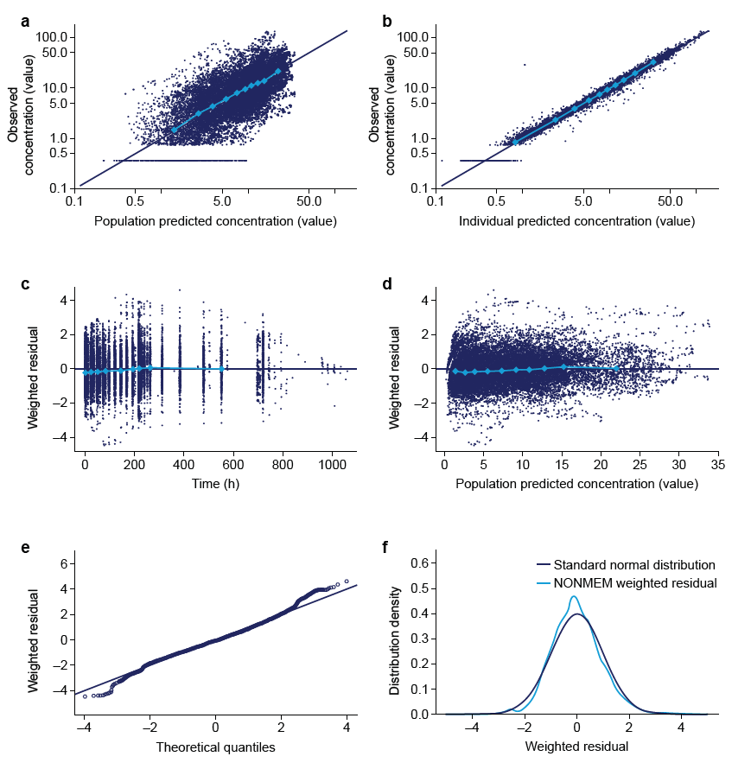
Data are observed concentrations (y axis) vs. population predicted (x axis) (a) and individual predicted (x axis) (b) concentrations, conditional weighted residuals (y axis) vs. time (x axis) (c), vs. population predicted concentrations (x axis) (d), and vs. theoretical quantiles from a normal distribution (x axis) (e),and distribution densities of weighted residuals (x axis) compared to the standard normal density distribution (y axis) (f). Light blue data points with connecting lines represent data trends in terms of mean values for quantiles of concentration or time
Data are from the following trials: dosing conditions (NCT01572753) [2], scintigraphy (NCT01619345) [3], renal (NCT02014259) [4], hepatic (NCT02016911) [5], DDI omeprazole (NCT02249871) [6] and food effect (NCT02172313) [7]
DDI drug-drug interaction, NONMEM Nonlinear mixed effects modelling software, PK pharmacokinetic

Online resource, Fig. 2 Distributions of individual estimated and predicted PK parameters for clearance (a), central volume (b), inter-compartmental clearance (c), and peripheral volume (d)
Lines are simulated parameter distributions based on the covariates and the population parameters in the final model. Bars represent the distribution of the individual parameter estimates for the final model based on oral semaglutide data

Data are from the following trials: dosing conditions (NCT01572753) [15], scintigraphy (NCT01619345) [16], renal (NCT02014259) [17], hepatic (NCT02016911) [18], DDI omeprazole (NCT02249871) [19] and food effect (NCT02172313) [20]
DDI drug-drug interaction, PK pharmacokinetic

Online resource, Fig. 3 Distribution histogram of bioavailability estimates across all dose administrations and individuals

Data are from the following trials: dosing conditions (NCT01572753) [2], scintigraphy (NCT01619345) [3], renal (NCT02014259) [4], hepatic (NCT02016911) [5], DDI omeprazole (NCT02249871) [6] and food effect (NCT02172313) [7]
DDI drug-drug interaction

Online resource, Fig. 4 Visual predictive check of the population PK model for data from each trial contributing data
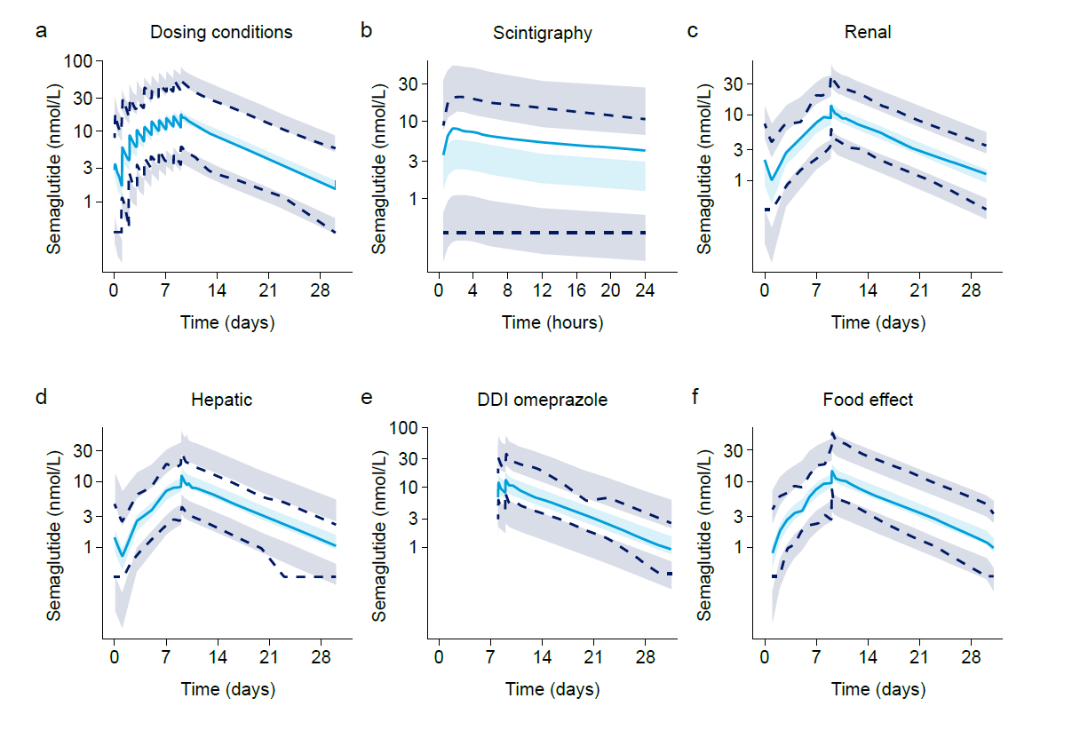
Data are observed (lines) and 95% CIs (shaded areas, n=2000) of simulated medians and 5th and 95th concentration percentiles vs. time since first dose
Data are from the following trials: a: dosing conditions (NCT01572753) [2]; b: scintigraphy (NCT01619345) [3]; c: renal (NCT02014259) [4]; d: hepatic (NCT02016911) [5]; e: DDI omeprazole (NCT02249871) [6]; f: food effect (NCT02172313) [7]
CI confidence interval, DDI drug-drug interaction, PK pharmacokinetic

Online resource, Fig. 5 Observed and predicted individual PK profiles (a) and associated bioavailabilities (b) vs. time after first dose for 12 individuals
a
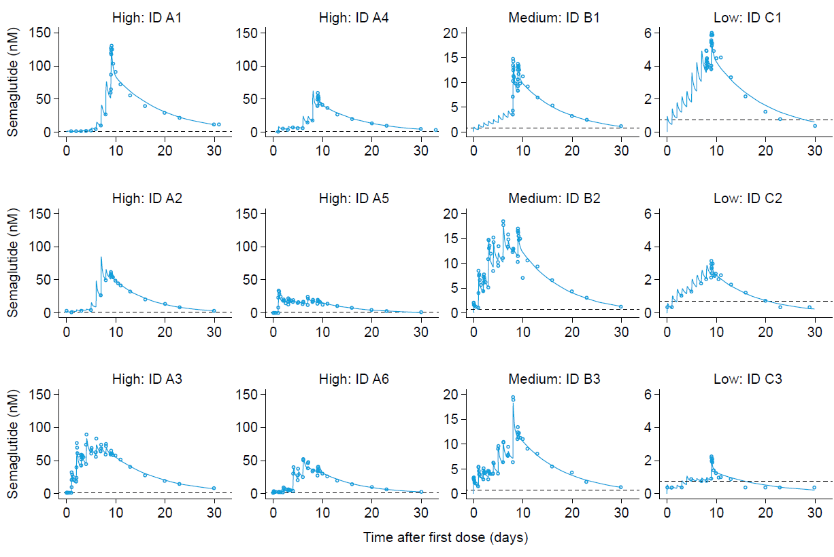
b
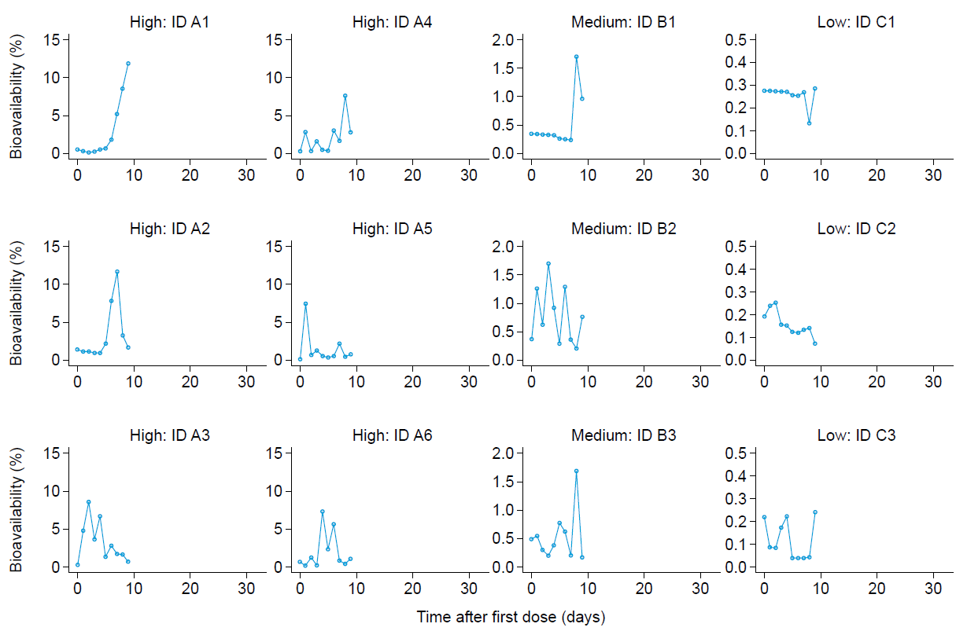
a: Data points and lines are observed and predicted concentrations for individual subjects. The dotted horizontal line represents the lower limit of quantification of the assay
b: Shows model-derived bioavailability for the same subjects. All predictions were from the final PK model. High bioavailability: A1–A6; medium bioavailability: B1–B3; low bioavailability: C1–C3. Subjects were selected to illustrate profiles with high/medium/low bioavailability
Data are from the following trials: dosing conditions (NCT01572753) [2], scintigraphy (NCT01619345) [3], renal (NCT02014259) [4], hepatic (NCT02016911) [5], DDI omeprazole (NCT02249871) [6] and food effect (NCT02172313) [7]
DDI drug-drug interaction, PK pharmacokinetic

Online resource, Fig. 6 Observed individual and mean PK profiles from the dosing conditions trial. Dosing interval for the 1st dose (a) and for the 10th dose (b) of repetitive once-daily oral dosing of semaglutide
a 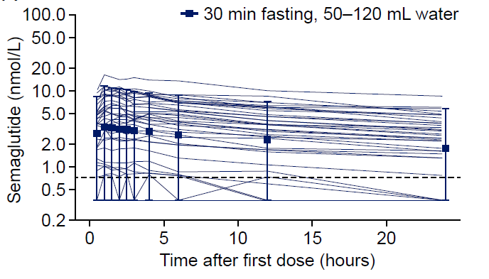 | b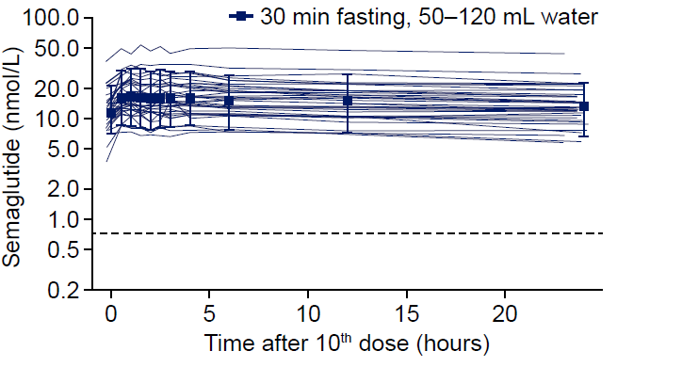
Dosing conditions: co-ingestion of 50 or 120 mL of water and with 30 min of fasting. Full lines are individual profiles, data points with error bars are geometric means with 90% ranges. The dotted horizontal line represents the lower limit of quantification of the assay
Data are from the following trial: dosing conditions (NCT01572753) [2]
PK pharmacokinetic

Online resource, Fig. 7 PK profiles during once-daily oral administration of semaglutide in subjects with T2D with or without upper GI disease
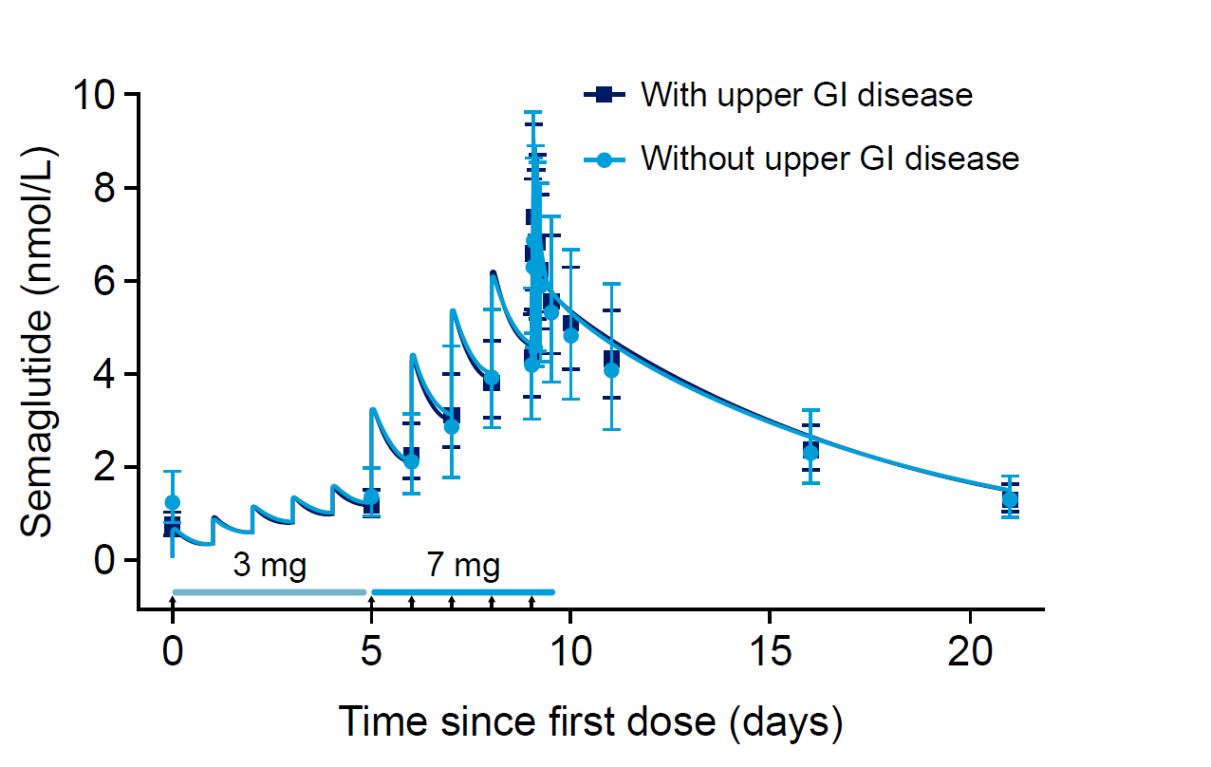
Data points with error bars are geometric mean observed concentrations with 95% CIs. Lines through data are population predictions. Lines along the x axis indicate dose levels and vertical arrows indicate occasions with on-site dosing
Data are from the trial on effects of upper GI disease in T2D [1]
CI confidence interval, GI gastrointestinal, PK pharmacokinetic, T2D type 2 diabetes

References
- Meier J, Granhall C, Hoevelmann U, Navarria A, Plum-Moerschel L, Ramesh C, et al. Effect of upper gastrointestinal disease on the pharmacokinetics of oral semaglutide in subjects with type 2 diabetes. Diabetes 2019;68(Suppl 1):1013-P and poster presented at: 79th Scientific Sessions of the American Diabetes Association Congress, San Francisco, CA, USA, June 7–11, 2019.
- Donsmark M, Borregaard J, Breitschaft A, Bækdal TA, Søndergaard FL. Evaluation of the effects of water volume with dosing and post-dose fasting period on pharmacokinetics of oral semaglutide. Diabetologia 2017;60(Suppl 1):S363–S364.
- Connor A, Donsmark M, Hartoft-Nielsen M-L, Søndergaard FL, Bækdal TA. A pharmacoscintigraphic study of the relationship between tablet erosion and pharmacokinetics of oral semaglutide. Diabetologia 2017;60(Suppl 1):S361.
- Granhall C, Sondergaard FL, Thomsen M, Anderson TW. Pharmacokinetics, safety and tolerability of oral semaglutide in subjects with renal impairment. Clin Pharmacokinet. 2018;57(12):1571–80.
- Baekdal TA, Thomsen M, Kupčová V, Hansen CW, Anderson TW. Pharmacokinetics, safety, and tolerability of oral semaglutide in subjects with hepatic impairment. J Clin Pharmacol. 2018;58:1314–23.
- Baekdal TA, Breitschaft A, Navarria A, Hansen CW. A randomized study investigating the effect of omeprazole on the pharmacokinetics of oral semaglutide. Expert Opin Drug Metab Toxicol. 2018;14(8):869–77.
- Maarbjerg SJ, Borregaard J, Breitschaft A, Donsmark M, Søndergaard FL. Evaluation of the effect of food on the pharmacokinetics of oral semaglutide. Diabetologia 2017;60(Suppl 1):S69.

