SUPPLEMENTAL MATERIAL
Population Pharmacokinetics of Abrocitinib in Healthy Individuals and Patients with Psoriasis or Atopic Dermatitis
Jessica Wojciechowski,¹ Bimal K Malhotra,² Xiaoxing Wang,¹ Luke Fostvedt,³ Hernan Valdez,² Timothy Nicholas¹

¹Department of Global Product Development, Pfizer Inc., Groton, CT, USA; ²Department of Global Product Development, Pfizer Inc., New York, NY, USA; ³Department of Global Product Development, Pfizer Inc., Cambridge, MA, USA
Corresponding author:
Email: Jessica.Wojciechowski@pfizer.com

Online Resource 1 Summary of studies included in the population pharmacokinetics modeling analysis
Protocol | Phase | Protocol design | Population | n | Dose administration | Plasma samplingª
NCT01835197 (B7451001) | I | A phase I, within-cohort, randomized, double-blind, third-party open, placebo-controlled, single and multiple dose–escalation, parallel-group study to evaluate the safety, tolerability, PK, and pharmacodynamics of abrocitinib in healthy Western and Japanese participants | Healthy persons | 79 | Single ascending dose: Western participants received single doses of abrocitinib 3, 10, 30, 100, 200, 400, or 800 mg^{b} or placebo. Japanese participants received a single dose of abrocitinib 800 mg or placebo  Multiple ascending doses: Western participants received abrocitinib 30, 100, 200, or 400 mg QD or abrocitinib 100 or 200 mg or placebo BID for 10 days. Japanese participants received abrocitinib 200 mg BID for 10 days.  Participants were in the fasted state | 0 (before dosing), 0.5, 1, 2, 4, 6, 8, 12, 16, 24, 36, and 48 h on day 1 and day 10 after dosing
NCT02163161 (B7451004) | I | A phase I, open-label, single-dose, 3-way crossover study to evaluate the bioavailability of a solid-dose formulation of abrocitinib relative to a suspension formulation under fasting conditions and the effect of food on the bioavailability of the solid-dose formulation of abrocitinib in healthy participants | Healthy persons | 12 | Abrocitinib 4 × 100-mg tablet^{c} under fasted conditions, abrocitinib 400-mg oral suspension^{b} under fasted conditions, and abrocitinib 4 × 100-mg abrocitinib tablet^{c} under fed conditions, each as a single dose | 0 (before dosing), 0.5, 1, 2, 4, 5, 8, 12, 16, 24, 36, and 48 h after dosing
NCT02201524 (B7451005) | II | A phase II, randomized, double-blind, placebo-controlled study to evaluate safety and efficacy of abrocitinib in participants with moderate to severe psoriasis | Psoriasis | 59 | Abrocitinib 200 mg BID, 400 mg QD, or 200 mg QD^{c} or matching placebo for 4 weeks. Fasted state | 0 (before dosing) on days 1, 7, and 21  −2 (before dosing), 0 (before dosing), and 0.5 h after dosing on day 14  −2 (before dosing), 0 (before dosing), 1, 2, and 4 h after dosing on day 28
NCT02780167 (B7451006) | IIb | A phase IIb, randomized, double-blind, placebo-controlled, parallel-group, multicenter, dose-ranging study to evaluate the efficacy and safety profile of abrocitinib in participants with moderate to severe AD | AD | 267 | Abrocitinib 10, 30, 100, or 200 mg QD^{d} or matching placebo for 12 weeks. Fasted state | Before dosing on day 15 (week 2), day 29 (week 4), and day 57 (week 8)  −2 (before dosing), 0 (before dosing), and 0.5 h after dosing on day 43 (week 6)  −2 h (before dosing), 0 (before dosing), 1, 2, and 4 h after dosing on day 85 (week 12)
NCT03349060 (B7451012) | III | A phase III, randomized, double-blind, placebo-controlled, parallel-group, multicenter study to evaluate the efficacy and safety of abrocitinib monotherapy in participants aged 12 years and older with moderate-to-severe AD | AD | 387 | Abrocitinib 100 or 200 mg QDe or matching placebo for 12 weeks. Fasted state | 0 (before dosing) and 0.5 h after dosing on day 29 (week 4)  0.5 and 4 h after dosing on day 85 (week 12)
NCT03575871 (B7451013) | III | A phase III, randomized, double-blind, placebo-controlled, parallel-group, multicenter study to evaluate the efficacy and safety of abrocitinib monotherapy in participants aged 12 years and older with moderate-to-severe AD | AD | 391 | Abrocitinib 100 or 200 mg QDe or matching placebo for 12 weeks. Fasted state | −2 h (before dosing) on day 57 (week 8)  1 and 2 h after dosing on day 85 (week 12)
NCT03634345 (B7451017) | I | A phase I, open-label, randomized, fixed-sequence, parallel-cohort study to estimate the effect of fluvoxamine or fluconazole on the PK, safety, and tolerability of a single-dose of abrocitinib in healthy participants | Healthy persons | 24 | Fluvoxamine: single-dose of abrocitinib 100 mg^{e} (Period 1) and then 9 d of continuous fluvoxamine 50 mg QD dosing with a single-dose of abrocitinib 100 mg^{e} on day 8 (Period 2)  Fluconazole: single-dose of abrocitinib 100 mg^{e} (Period 1) and then 7 d of continuous fluconazole dosing (400 mg on day 1 and then 200 mg QD on days 2–7) with a single dose of 100 mg^{e} abrocitinib on day 5 (Period 2). Fasted state | 0 (pre-dose), 0.5, 1, 2, 3, 4, 6, 8, 12, 24, 36, and 48 hours (and 72 hours for the fluconazole cohort) post-abrocitinib dose in Period 1 and Period 2
NCT03637790 (B7451019) | I | A phase I, open-label, fixed-sequence study to estimate the effect of repeat-dose rifampin on the PK of abrocitinib in healthy participants | Healthy persons | 12 | Single-dose abrocitinib 200 mg^{e} abrocitinib (Period 1) and then 8 days of continuous rifampin 600 mg QD with a single dose of abrocitinib 200 mg^{e} on day 8 (Period 2). Fasted state | 0 (before dosing), 0.5, 1, 2, 3, 4, 6, 8, 10, 12, 16, 24, and 48 h after abrocitinib dosing in Period 1 and Period 2
NCT03626415 (B7451020) | I | A phase I, non-randomized, open-label, single-dose study to compare the PK, safety, and tolerability of abrocitinib in adult participants with mild and moderate hepatic impairment relative to participants with normal hepatic function | Healthy persons, mild hepatic impairment, moderate hepatic impairment | 24 | Single dose of abrocitinib 200 mg.^{e} Fasted state | 0 (before dosing), 0.5, 1, 2, 3, 4, 6, 8, 10, 14, 24, 36, and 72 h after dosing
NCT03386279 (B7451027) | I | A phase I, randomized, placebo- and positive-controlled crossover study to determine the effect of single-dose abrocitinib on QTc interval in healthy people | Healthy persons | 36 | Abrocitinib 600 mg,^{e} placebo, and moxifloxacin 400 mg, each as a single dose. Fasted state | 0 (before dosing), 0.25, 0.5, 1, 2, 3, 6, 12, and 24 h after abrocitinib dosing
NCT03937258 (B7451043) | I | A phase I, open-label, fixed-sequence study to assess single-dose and multiple-dose PK of abrocitinib and its metabolites, and the effect of repeat-dose probenecid on the single-dose PK of abrocitinib and its metabolites in healthy people | Healthy persons | 12 | Single-dose of abrocitinib 200 mg^{e} (Period 1), then abrocitinib 200 mg QDe for 4 d (Period 2), and then a single-dose of abrocitinib 200 mg^{e} on day 2 in combination with probenecid (Period 3) | 0 (before dosing), 0.5, 1, 2, 3, 4, 6, 8, 10, 12, 24, 36, and 48 h after abrocitinib dosing on Period 1 day 1, Period 2 day 4, and Period 3 day 2
AD atopic dermatitis; BID twice daily, PK pharmacokinetics; QD once daily.
ªOnly for plasma sampling times for abrocitinib concentrations.
^{b}Oral suspension of abrocitinib (000007640) × mg in 100 mL 0.5% weight/volume percentage methylcellulose vehicle (suspension).
^{c}Abrocitinib 100-mg oval white to off-white tablet (D1400040) (phase II tablet).
^{d}Abrocitinib 10-mg round white film-coated tablet (D1500091) or abrocitinib 50-mg round white film coated tablet (D1500093) (phase II tablets).
^{e}Abrocitinib 100-mg round white film-coated tablet (DC) (D1700147) (phase III tablet).
Online Resource 2 Variable descriptions and NONMEM control stream
NONMEM Input Variable | Variable Description
C | Comment column (C or .)
PROT | Protocol number
ID | ID number
AMT | NONMEM dose amount (mg)
EVID | NONMEM event identifier
CMT | NONMEM compartment identifier (for first- and zero-order absorption, 1 = administration into depot compartment, 2 = administration into central compartment)
RATE | NONMEM rate variable (0 = when CMT = 1 and administration directly into depot compartment, −1 = when CMT = 2 and administration into central compartment at rate determined in NONMEM model code)
DV | NONMEM dependent variable (ng/mL)
MDV | NONMEM missing dependent variable
BLQ | Below limit of quantification (0 = no, 1 = yes)
DOSE | Dose amount associated with record (mg)
DOSR | Randomized total daily dose (mg)
FORM | Formulation (2 = tablet, 3 = suspension)
FOOD | Co-administration with food (0 = fasted, 1 = high-fat meal, 2 = not controlled for food)
TAFD | Time after first dose (hours)
TAFO | Time after first dose in the occasion (resets for new treatment periods where there is an appropriate washout between treatments)
SEX | Sex (1 = male, 2 = female)
RACE | Race (0 = Unknown, 1 = White, 2 = Black, 3 = Asian, 4 = Other)
BWT | Baseline weight (kg)
PTST | Patient type (0 = healthy volunteer, 1 = psoriasis, 2 = atopic dermatitis, 3 = mild hepatic impairment, 4 = moderate hepatic impairment)
FORMS | Formulation (1 = suspension, 2 = phase 2 100-mg tablet, 3 = phase 2 10- and 50-mg tablets, 4 = phase 3 100-mg tablet)
FLUDDI | Co-administration with fluvoxamine (0 = no, 1 = yes)
FLZDDI | Co-administration with fluconazole (0 = no, 1 = yes)
RIFDDI | Co-administration with rifampicin (0 = no, 1 = yes)
MULTI | Single or multiple dosing (0 = single dose, 1 = repeated dose)
AGEGRP | Age group (1 = adolescents, 2 = adult)

NONMEM Control Stream

; Abrocitinib Population PK model
; PK concentrations (ng/mL)
; AMT in mg
; Time = Time after first dose (TAFD)
$SIZES PD = -100
$PROBLEM abrocitinib_pk.mod
; 2-compartment model with linear elimination
; Parallel zero- and first-order absorption
; Allometric scaling
$INPUT C PROT ID AMT EVID CMT RATE DV MDV BLQ DOSE DOSR FORM
FOOD TAFD=TIME TAFO SEX RACE BWT PTST FORMS FLUDDI FLZDDI RIFDDI MULTI AGEGRP

$DATA abrocitinib_pk.csv IGNORE = C

$SUBROUTINE ADVAN4 TRANS1

$PK
; Covariates
; Effect of study on RUVPRO
PROTRUVMOD = THETA(10)
PROTRUVHI = THETA(11)
; Reference studies are 1001, 1004, 1013, 1017, 1019, 1020 and 1027
COVPROTRUV = 1
IF (PROT.EQ.1005) COVPROTRUV = 1+PROTRUVMOD
IF (PROT.EQ.1006) COVPROTRUV = 1+PROTRUVHI
IF (PROT.EQ.1012) COVPROTRUV = 1+PROTRUVMOD
IF (PROT.EQ.1043) COVPROTRUV = 1+PROTRUVMOD

; Effect of formulation on first-order absorption lag
FORMALAG12 = THETA(12) ; Tablet formulations
; Reference formulation is suspension
COVFORMALAG1 = 0
IF (FORM.EQ.2) COVFORMALAG1 = FORMALAG12

; Effect of presence of rifampin on CL and F
RIFCL1 = THETA(13) ; Presence of rifampin
RIFF1 = THETA(14) ; Presence of rifampin
; Reference condition is no rifampin
COVRIFCL = 1
COVRIFF = 0
IF (RIFDDI.EQ.1) THEN
COVRIFCL = 1+RIFCL1
COVRIFF = RIFF1
ENDIF

; Effect of presence of fluconazole on CL
FLZCL1 = THETA(15) ; Presence of fluconazole
; Reference condition is no fluconazole
COVFLZCL = 1
IF (FLZDDI.EQ.1) THEN
COVFLZCL = 1+FLZCL1
ENDIF

; Effect of presence of fluvoxamine on CL
FLUCL1 = THETA(16) ; Presence of fluvoxamine
; Reference condition is no fluvoxamine
COVFLUCL = 1
IF (FLUDDI.EQ.1) THEN
COVFLUCL = 1+FLUCL1
ENDIF

; Effect of presence of strong CYP inhibitors on F
CYPINHF1 = THETA(17) ; Presence of fluconazole or fluvoxamine
; Reference condition is no strong CYP inhibitor
COVCYPINHF = 0
IF (FLZDDI.EQ.1.OR.FLUDDI.EQ.1) THEN
COVCYPINHF = CYPINHF1
ENDIF

; Effect of food on AK1
FOODAK11 = THETA(18) ; Fed
; Reference condition is fasted/not controlled for food
COVFOODAK1 = 1
IF (FOOD.EQ.1) COVFOODAK1 = 1+FOODAK11

; Effect of formulations on F
FORMSF3 = THETA(19) ; Phase 2 10 and 50 mg tablets
FORMSF4 = THETA(20) ; Phase 3 100 mg tablet
; Reference formulation is suspension and Phase 2 100 mg tablet
COVFORMSF = 0
IF (FORMS.EQ.3) COVFORMSF = FORMSF3
IF (FORMS.EQ.4) COVFORMSF = FORMSF4

; Effect of formulations on AK1
FORMSAK11 = THETA(21) ; Suspension
FORMSAK13 = THETA(22) ; Phase 2 10 and 50 mg tablets
; Reference formulation is Phase 3 100 mg tablet and Phase 2 100 mg tablet
COVFORMSAK1 = 1
IF (FORMS.EQ.1) COVFORMSAK1 = 1+FORMSAK11
IF (FORMS.EQ.3) COVFORMSAK1 = 1+FORMSAK13

; Effect of multiple dosing on F
MULTIF1 = THETA(23) ; Multiple dosing
; Reference condition is single dose
COVMULTIF = 0
IF (MULTI.EQ.1) COVMULTIF = MULTIF1

; Effect of time (time after dose in the occasion) on CL
TAFOCLDELTA = THETA(24) ; Magnitude of change in CL with time
TAFOCLHL = THETA(25) ; Rate of change in CL with respect to time, half-life, hours
COVTAFOCL = 1+TAFOCLDELTA*(1-EXP(-1*(LOG(2)/TAFOCLHL)*TAFO))

; Effect of effective daily dose on CL
EFFDOSRCL = THETA(26) ; Power model

; Effect of race on F
RACEF34 = THETA(27) ; Asian and Other
; Reference subjects are White, Black, Unknown
COVRACEF = 0
IF (RACE.EQ.3) COVRACEF = RACEF34
IF (RACE.EQ.4) COVRACEF = RACEF34

; Effect of patients on F
PTSTF12 = THETA(28) ; Psoriasis and atopic dermatitis patients
PTSTF34 = THETA(29) ; Mild and moderate hepatic impairment patients
; Reference subjects are healthy volunteers
COVPTSTF = 0
IF (PTST.EQ.1) COVPTSTF = PTSTF12
IF (PTST.EQ.2) COVPTSTF = PTSTF12
IF (PTST.EQ.3) COVPTSTF = PTSTF34
IF (PTST.EQ.4) COVPTSTF = PTSTF34

; Effect of weight on PK parameters
ALLOCLQ = THETA(30) ; CL and Q
ALLOV2V3 = THETA(31) ; V2 and V3

; Effect of age on F
AGEGRPF1 = THETA(32) ; Adolescent patients
; Reference subjects are adults
COVAGEGRPF = 0
IF (AGEGRP.EQ.1) COVAGEGRPF = AGEGRPF1

; Effect of dose on F
DOSEF800 = THETA(33) ; 800 mg dose
; Reference dose is anything less than 800 mg
COVDOSEF = 0
IF (DOSE.EQ.800) COVDOSEF = DOSEF800

; Effect of sex on F
SEXF2 = THETA(34) ; Females
; Reference sex are males
COVSEXF = 0
IF (SEX.EQ.2) COVSEXF = SEXF2

; Population PK parameters
POPF = 0.5977 ; Absolute bioavailability for oral suspension, 1008 ADME study
POPFT = LOG(POPF/(1-POPF)) ; Absolute bioavailability in the logit domain
POPCL = LOG(THETA(1)) ; Linear clearance, L/hr
MU_1 = POPCL ; Mu referencing
POPV2 = LOG(THETA(2)) ; Volume of central compartment, L
MU_2 = POPV2 ; Mu referencing
POPQ = LOG(THETA(3)) ; Inter-compartmental clearance, L/hr
POPV3 = LOG(THETA(4)) ; Volume of peripheral compartment, L
; Absorption parameters
POPK0 = THETA(5) ; Rate of input by the zero-order process, mg/hr
POPAK1 = THETA(6)*COVFOODAK1*COVFORMSAK1 ; Amount absorbed during the first-order process, mg
POPFK1 = POPAK1/DOSE ; Fraction absorbed during the first-order process
IF (POPAK1.GT.DOSE) POPFK1 = 1 ; For when the amount absorbed by first-order is greater than the dose
POPKA = LOG(THETA(7)) ; First-order absorption rate constant, hr^-1
POPALAG1 = 0 ; First-order process absorption lag, hr
POPALAG2 = 0 ; Zero-order process absorption lag, hr

; Individual PK parameters
FT = POPFT+COVRIFF+COVCYPINHF+COVFORMSF+COVMULTIF+COVRACEF+COVPTSTF+COVAGEGRPF+COVDOSEF+COVSEXF ; Individual value for absolute bioavailability in the logit domain, ranges from -Inf to Inf
FI = EXP(FT)/(1+EXP(FT)) ; Individual value for absolute bioavailability, constrained between 0 and 1
; Calculate effective daily dose
EFFDOSR = FI*DOSR ; Account for differences in bioavailability
; Effect of effective daily dose on CL
COVEFFDOSRCL = (EFFDOSR/200)**EFFDOSRCL ; Power model referenced to 200 mg QD
CL = EXP(MU_1+ETA(1))*((BWT/70)**ALLOCLQ)*COVRIFCL*COVFLZCL*COVFLUCL*COVTAFOCL*COVEFFDOSRCL ; Individual value for clearance, log-normally dist
V2 = EXP(MU_2+ETA(2))*((BWT/70)**ALLOV2V3) ; Individual value for central volume, log-normally dist
Q = EXP(POPQ)*((BWT/70)**ALLOCLQ) ; Individual value for inter-compartmental clearance, no random effect
V3 = EXP(POPV3)*((BWT/70)**ALLOV2V3) ; Individual value for peripheral volume, no random effect
; Individual absorption parameters
F1 = FI*POPFK1 ; Fraction into the depot compartment
F2 = FI*(1-POPFK1) ; Fraction directly into the central compartment
KA = EXP(POPKA) ; Individual value for absorption rate constant, no random effect
R2 = POPK0 ; Rate of zero-order process into CMT2 (central)
ALAG1 = POPALAG1+COVFORMALAG1 ; Individual value for absorption lag into depot compartment, no random effect
ALAG2 = ALAG1+POPALAG2 ; Individual value for absorption lag into central compartment, no random effect

; Micro-rate constants
K = CL/V2
K23 = Q/V2
K32 = Q/V3

; Scaling - AMT in mg, concentrations in ng/mL
S2 = V2/1000

$ERROR
; Individual prediction
IPRE = F
; Random unexplained variability
RUVPRO = THETA(8)*COVPROTRUV ; Standard deviation of proportional residual error
RUVADD = THETA(9) ; Standard deviation of additive residual error
W = SQRT(IPRE*IPRE*RUVPRO*RUVPRO+RUVADD*RUVADD) ; Ensure that W is positive
; Lower limit of quantification
LLOQ = 1 ; ng/mL
; Objective function value
IF (BLQ.EQ.0) THEN
F_FLAG = 0
Y = IPRE+W*EPS(1)
IRES = DV-IPRE
IWRE = IRES/W
ENDIF
IF (BLQ.EQ.1) THEN
F_FLAG = 1
Y = PHI((LLOQ-IPRE)/W)
IRES = 0
IWRE = 0
MDVRES = 1
ENDIF

$THETA
(0.01,20) ; TVCL
(0.01,50) ; TVV2
(0.01,1) ; TVQ
(0.01,10) ; TVV3
(0.01,100) ; TVK0
(0.01,200) ; TVAK1
(0.01,2) ; TVKA
(0.01,1) ; TVRUVPRO
(0.01,1) ; TVRUVADD
(-0.999,0.1) ; TVPROTRUVMOD
(-0.999,0.1) ; TVPROTRUVHI
(0.0001,0.25) ; TVFORMALAG12
(-0.999,0.1) ; TVRIFCL1
-0.1 ; TVRIFF1
(-0.999,-0.1) ; TVFLZCL1
(-0.999,-0.1) ; TVFLUCL1
0.1 ; TVCYPINHF1
-1 FIX ; TVFOODAK11
-0.1 ; TVFORMSF3
-0.1 ; TVFORMSF4
(-0.999,0.1) ; TVFORMSAK11
(-0.999,-0.1) ; TVFORMSAK13
0.1 ; TVMULTIF1
(-0.999,-0.1) ; TVTAFOCLDELTA
(0.0001,12) ; TVTAFOCLHL
-0.1 ; TVEFFDOSRCL
0.1 ; TVRACEF34
0.1 ; TVPTSTF12
0.1 ; TVPTSTF34
0.75 ; TVALLOCLQ
1 ; TVALLOV2V3
-0.1 ; TVAGEGRPF1
-0.1 ; TVDOSEF800
0.1 ; TVSEXF2

$OMEGA BLOCK(2)
0.5 ; PPVCL
0.1 0.5 ; PPVV2

$SIGMA
1 FIX ; ERRRES

$ESTIMATION METHOD = SAEM LAPLACIAN NUMERICAL SLOW AUTO = 1 CTYPE = 3 CALPHA = 0.01 SIGL = 8 NOPRIOR = 1 NOABORT

$ESTIMATION METHOD = IMP EONLY = 1 AUTO = 1 NITER = 40 CTYPE = 3 PRINT = 5 SIGL = 8 NOPRIOR = 1 FILE= abrocitinib_pk.ext MSFO = pksimparams

$COVARIANCE PRINT = E UNCONDITIONAL MATRIX = S

Online Resource 3 Key steps in structural model building
Run No. | Description Comments | Condition Number | OFV | AIC | DOF | ∆AICa
1 | 2-compartment model, first-order Initial model | 15.6 | 66702.9 | 66748.9 | 0 | 0
 | absorption, random effects on CL, V_{c},
 | and k_{a}, M3 method, full
 | variance-covariance matrix, combined
 | residual error model, allometric
 | scaling, study effects on RUVPRO,
 | population typical F fixed to 0.5977
 | and logit transformed
7 | Change to parallel zero- and first-order Lowest OFV compared to zero-order | 12.1 | 66637.3 | 66687.3 | 2 | -61.6
 | absorption absorption (OFV: 66695) and
 | first-order absorption (Run 1) models
15 | Remove random effect from k_{a} High inter-individual variability (203%CV), η-shrinkage | 9.2 | 66878.3 | 66922.3 | -3 | +235
 | (30%) on k_{a}, high correlation with V_{c}
 | (0.77; Run 7)
33 | Add first-order absorption lag for Significantly improved fit compared to | 8.48 | 66716.3 | 66762.3 | 1 | -160
 | tablet formulations adding first-order absorption lag for all
 | formulations including suspension
 | (Run 29; ∆OFV = -80.3)
41 | Add effect of rifampin on CL B7451019 demonstrated significant | 9.12 | 66375.2 | 66423.2 | 1 | -339
 | impact on exposure with presence of
 | rifampin
43 | Add effect of fluconazole on CL B7451017 demonstrated significant | 9.72 | 65988.3 | 66038.3 | 1 | -385
 | impact on exposure with presence of
 | fluconazole
45 | Add effect of fluvoxamine on CL B7451017 demonstrated significant | 9.63 | 65799.5 | 65851.5 | 1 | -187
 | impact on exposure with presence of
 | fluvoxamine
47 | Add effect of rifampin on F Bias in CL and V_{c} for rifampin present | 8.73 | 65642.3 | 65696.3 | 1 | -155
 | versus not present still not accounted
 | for with effect on CL alone

Run No. | Description | Comments | Condition Number | OFV | AIC | DOF | ∆AICa
77 | Add effect of high-fat meal on Ak₁ | Also tested on k_{a} (Run 83), ALAG1 | 9.32 | 65567.1 | 65623.1 | 1 | -73.2
 |  | (Run 93), ALAG2 (Run 99), F (Run
 |  | 91) and k₀ (Run 85) in separate
 |  | models. Effect on Ak₁ was most
 |  | significant
133 | Fix food effect to zero-order | Estimate was −0.913, predominantly | 8.92 | 65568.5 | 65622.5 | -1 | -0.575
 | absorption process | zero-order processes. Fixed for model
 |  | stability with parameter approaching
 |  | boundary
137 | Add effect of formulations on F | Individual fixed effects estimated for | 9.95 | 65550.4 | 65610.4 | 3 | -12.2
 |  | each formulation. Also tested on F
 |  | (Run 129), Ak₁ (Run 119), k_{a} (Run
 |  | 121) and ALAG1 (Run 127) in separate
 |  | models with respect to Run 77
141 | Remove effect of Phase 2 100 mg | Poor precision of estimate (60% RSE; | 9.82 | 65557.0 | 65615.0 | -1 | +4.6
 | tablet on F | Run 129, 43% RSE; Run 137)
149 | Add effect of suspension and Phase 2 | Formulations with most significant | 9.42 | 65484.7 | 65546.7 | 2 | -68.3
 | 10 and 50 mg tablets on Ak₁ | effects on Ak₁ when individual fixed
 |  | effects for each formulation on Ak₁
 |  | were tested in Run 147
151 | Add time-dependent F (single vs | Account for differences in absorption | 9.54 | 65251.6 | 65315.6 | 1 | -231
 | multiple dosing) | prior to testing time-dependent CL
253 | Add time-dependent CL (exponential | Non-stationary CL observed in | 10.1 | 65223.2 | 65291.2 | 2 | -24.4
 | model, TAFO) | B7451001 and B7451043 studies
293 | Add effective daily dose on CL | Assume differences in CL are | 10.8 | 65168.5 | 65238.5 | 1 | -52.7
 | (accounting for differences in F) | attributed to the effective amount that
 |  | reaches the systemic circulation in a
 |  | 24-hour period. Not the total amount
 |  | administered.

Run No. | Description | Comments | Condition Number | OFV | AIC | DOF | ∆AICa
295 | Add effect of fluconazole on F | Bias in CL and V_{c} for fluconazole | 19.6 | 65126.7 | 65198.7 | 1 | -39.8
 |  | present versus not present still not
 |  | accounted for with effect on CL alone
297 | Add effect of fluvoxamine on F | Bias in CL and V_{c} for fluvoxamine | 20.3 | 65083.8 | 65157.8 | 1 | -40.9
 |  | present versus not present still not
 |  | accounted for with effect on CL alone
301 | Consolidate effects: combine low | Combine studies with less than 80% | 21.6 | 65234.8 | 65296.8 | -6 | +139
 | variability studies on RUVPRO | increase in RUVPRO with respect to
 |  | FIH study
303 | Consolidate effects: combine | Combine studies with increases in | 21.5 | 65237.0 | 65295.0 | -2 | -1.85
 | moderate variability studies on | RUVPRO between 80 and 200% with
 | RUVPRO | respect to FIH study
305 | Consolidate effects: combine | Similar magnitudes of effect on F, | 9.8 | 65237.1 | 65293.1 | -1 | -1.87
 | fluconazole and fluvoxamine effects | 1.38 versus 1.7 in Run 303
 | on F
Repository artifact ID RA16876568. Line 1 substituted.
ªΔAIC and DOF are determined based on the current run referenced to the previous run.

Online Resource 4 Final model diagnostic plots stratified by dose. (a) Observed versus individual-predicted concentrations, (b) observed versus population-predicted concentrations, (c) conditional weighted residuals versus time after first dose, and (d) conditional weighted residuals versus population-predicted concentrations. Black lines are the lines of identity, colored lines are the linear regression stratified by dose, and black dashed lines represent conditional weighted residuals ±2 (fine) and ±6 (bold) standard deviations from the mean.

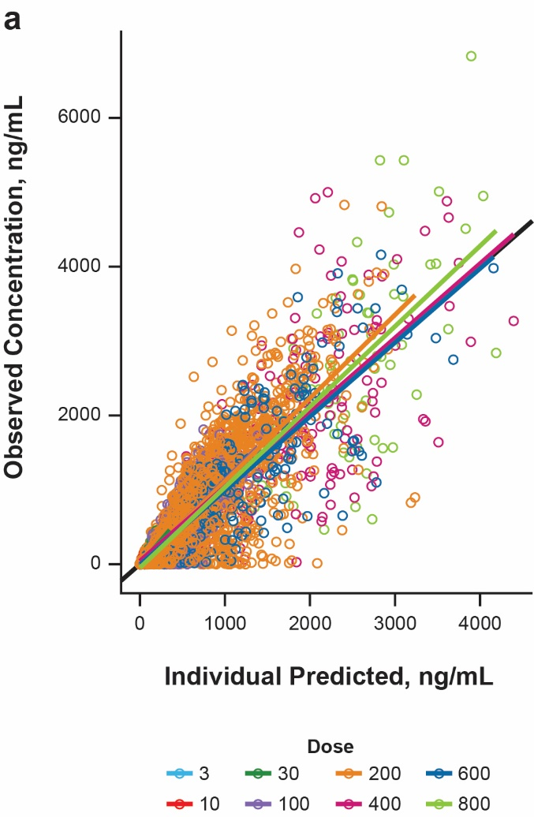 | 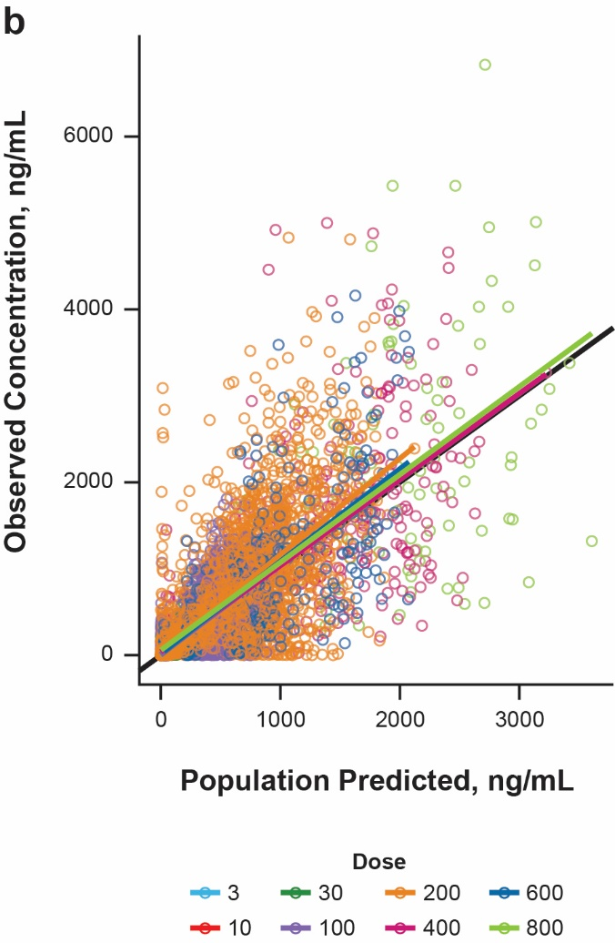
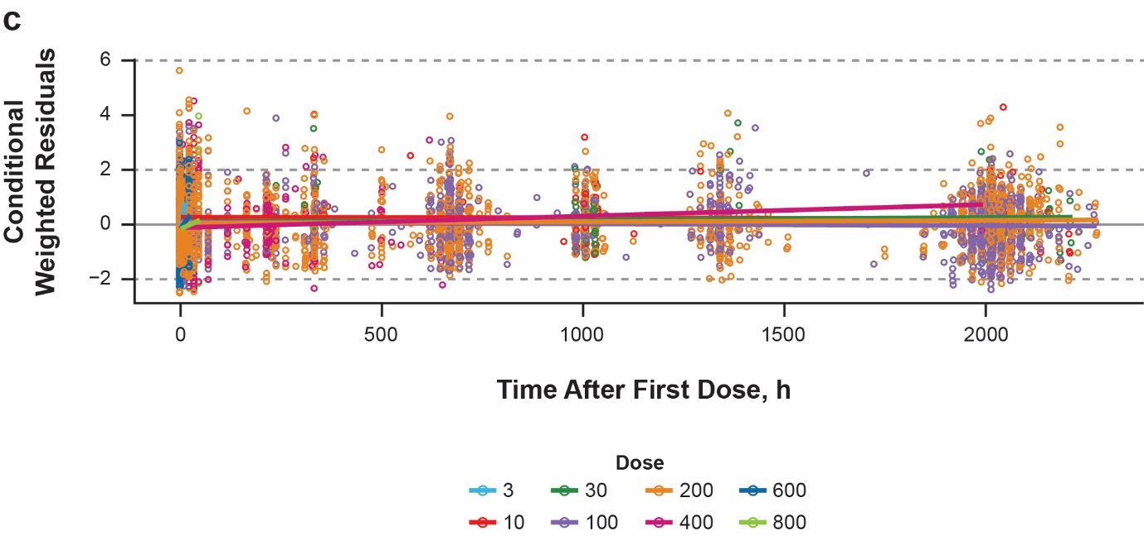
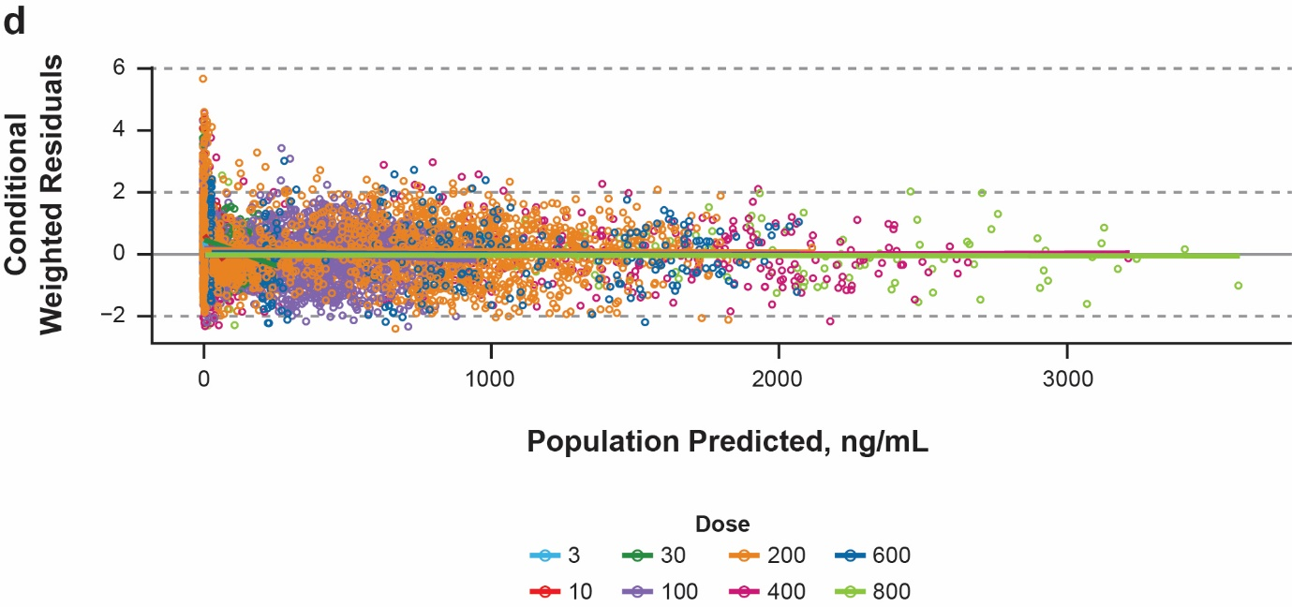

1. Vazquez ML, Kaila N, Strohbach JW, Trzupek JD, Brown MF, Flanagan ME, et al. Identification of N-{cis-3-[Methyl(7H-pyrrolo[2,3-d]pyrimidin-4-yl)amino]cyclobutyl}propane-1-sulfo namide (PF-04965842): A Selective JAK1 Clinical Candidate for the Treatment of Autoimmune Diseases. J Med Chem. 2018;61(3):1130-52.
2. Gooderham MJ, Forman SB, Bissonnette R, Beebe JS, Zhang W, Banfield C, et al. Efficacy and Safety of Oral Janus Kinase 1 Inhibitor Abrocitinib for Patients With Atopic Dermatitis: A Phase 2 Randomized Clinical Trial. JAMA Dermatology. 2019;155(12):1371-9.
3. Silverberg JI, Simpson EL, Thyssen JP, Gooderham M, Chan G, Feeney C, et al. Efficacy and Safety of Abrocitinib in Patients With Moderate-to-Severe Atopic Dermatitis: A Randomized Clinical Trial. JAMA Dermatol. 2020;156(8):863-73.
4. Simpson EL, Sinclair R, Forman S, Wollenberg A, Aschoff R, Cork M, et al. Efficacy and safety of abrocitinib in adults and adolescents with moderate-to-severe atopic dermatitis (JADE MONO-1): a multicentre, double-blind, randomised, placebo-controlled, phase 3 trial. Lancet (London, England). 2020;396(10246):255-66.
5. Collaborators USBoD, Mokdad AH, Ballestros K, Echko M, Glenn S, Olsen HE, et al. The State of US Health, 1990-2016: Burden of Diseases, Injuries, and Risk Factors Among US States. Jama. 2018;319(14):1444-72.
6. Pharmaceuticals and Medical Device Agency (PMDA) H.P. List of Approved Products in Reiwa 3rd-year October 27, 2021. Accessed 05 November 2021. https://www.pmda.go.jp/files/000240478.pdf.
7. Schmieder GJ, Draelos ZD, Pariser DM, Banfield C, Cox L, Hodge M, et al. Efficacy and safety of the Janus kinase 1 inhibitor PF-04965842 in patients with moderate-to-severe psoriasis: phase II, randomized, double-blind, placebo-controlled study. Br J Dermatol. 2018;179(1):54-62.
8. Peeva E, Hodge MR, Kieras E, Vazquez ML, Goteti K, Tarabar SG, et al. Evaluation of a Janus kinase 1 inhibitor, PF-04965842, in healthy subjects: A phase 1, randomized, placebo-controlled, dose-escalation study. British journal of clinical pharmacology. 2018;84(8):1776-88.
9. Dowty M, Yang X, Lin J, Bauman J, Doran A, Goosen T, et al. P190 - The effect of CYP2C9 and CYP2C19 genotype on the pharmacokinetics of PF 04965842, A JAK1 inhibitor in clinical development. Drug Metab Pharmacokinet. 2020;35(1, Supplement):S80.
10. Mould DR, Upton RN. Basic concepts in population modeling, simulation, and model-based drug development-part 2: introduction to pharmacokinetic modeling methods. CPT Pharmacometrics Syst Pharmacol. 2013;2:e38.
11. Mould DR, Upton RN. Basic concepts in population modeling, simulation, and model-based drug development. CPT Pharmacometrics Syst Pharmacol. 2012;1(9):e6.
12. S. B, Sheiner LB, Boeckmann A, Bauer RJ. (1989-2017)NONMEM User’s Guides Gaithersburg, MD, USA: ICON Development Solutions; 2017 [updated 2009. Corpus ID: 65385267:[Available from: https://www.semanticscholar.org/paper/NONMEM-User%E2%80%99s-Guides.-(1989%E2%80%932009)-Beal-Boeckmann/1964357daa9975ac959840262a810b2e0b39c8f4.
13. R Core Team. R: A Language and Environment for Statistical Computing Vienna, Austria: R Foundation for Statistical Computing; 2019 [Available from: https://www.R-project.org/.
14. Beal SL. Ways to fit a PK model with some data below the quantification limit. J Pharmacokinet Pharmacodyn. 2001;28(5):481-504.
15. Kim K, Johnson JA, Derendorf H. Differences in drug pharmacokinetics between East Asians and Caucasians and the role of genetic polymorphisms. Journal of clinical pharmacology. 2004;44(10):1083-105.
16. Krekels EHJ, Rower JE, Constance JE, Knibbe CAJ, Sherwin CMT. Chapter 8 - Hepatic Drug Metabolism in Pediatric Patients. In: Xie W, editor. Drug Metabolism in Diseases. Boston: Academic Press; 2017. p. 181-206.
17. de Wildt SN, Tibboel D, Leeder JS. Drug metabolism for the paediatrician. Archives of disease in childhood. 2014;99(12):1137-42.
18. Kaye JL. Review of paediatric gastrointestinal physiology data relevant to oral drug delivery. International journal of clinical pharmacy. 2011;33(1):20-4.
19. Morgan ET. Impact of infectious and inflammatory disease on cytochrome P450-mediated drug metabolism and pharmacokinetics. Clinical pharmacology and therapeutics. 2009;85(4):434-8.
20. Tanino T, Komada A, Ueda K, Bando T, Nojiri Y, Ueda Y, et al. Pharmacokinetics and Differential Regulation of Cytochrome P450 Enzymes in Type 1 Allergic Mice. Drug metabolism and disposition: the biological fate of chemicals. 2016;44(12):1950-7.
21. Ma G, Xie R, Strober B, Langley R, Ito K, Krishnaswami S, et al. Pharmacokinetic Characteristics of Tofacitinib in Adult Patients With Moderate to Severe Chronic Plaque Psoriasis. Clin Pharmacol Drug Dev. 2018;7(6):587-96.
22. Nader A, Stodtmann S, Friedel A, Mohamed MF, Othman AA. Pharmacokinetics of Upadacitinib in Healthy Subjects and Subjects With Rheumatoid Arthritis, Crohn's Disease, Ulcerative Colitis, or Atopic Dermatitis: Population Analyses of Phase 1 and 2 Clinical Trials. Journal of clinical pharmacology. 2020;60(4):528-39.
23. Klunder B, Mohamed MF, Othman AA. Population Pharmacokinetics of Upadacitinib in Healthy Subjects and Subjects with Rheumatoid Arthritis: Analyses of Phase I and II Clinical Trials. Clin Pharmacokinet. 2018;57(8):977-88.
24. Holford NH. A size standard for pharmacokinetics. Clin Pharmacokinet. 1996;30(5):329-32.

