SUPPLEMENTAL MATERIAL
Pharmacokinetic-Pharmacodynamic Evaluation of the Dipeptidyl Peptidase 1 Inhibitor Brensocatib for Non–Cystic Fibrosis Bronchiectasis
James D. Chalmers, MB, ChB, PhD; Helen Usansky, MD, PhD; Christopher M. Rubino, PharmD; Ariel Teper, MD; Carlos Fernandez, MD, MPH; Jun Zou, PhD; Kevin C. Mange, MD, MSCE

Journal: Clinical Pharmacokinetics

Corresponding author affiliation and email address:
Professor James D. Chalmers
Division of Molecular and Clinical Medicine, Ninewells Hospital and Medical School, Dundee, UK
email: jchalmers@dundee.ac.uk

Table of Contents

Supplementary Fig. 1 Final brensocatib PPK model 2
Supplementary Fig. 2 Standard goodness-of-fit plots for the final model (steady-state phase 1 and phase 2 data) 3
Supplementary Fig. 3 Normalized prediction distribution errors (NPDE) for the final model (steady-state phase 1 and phase 2 data) 4
Supplementary Fig. 4 Brensocatib exposure estimates by age in patients with NCFBE 5
Supplementary Fig. 5 Brensocatib exposure estimates by CLcr in patients with NCFBE 6
Supplementary Fig. 6 Brensocatib exposure estimates by body weight in patients with NCFBE 7
Supplementary Fig. 7 Distribution of steady-state brensocatib by dose group. 8
supplementary Fig. 8 Correlations among steady-state brensocatib exposure estimates. 9
Supplementary Fig. 9 Time to pulmonary exacerbation in patients with non–cystic fibrosis bronchiectasis by AUC_{t} quartile. 10
Supplementary Table 1 Incidence of AESI by steady-state AUC_{τ} quartile 11

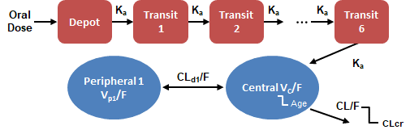
Supplementary Fig. 1 Final brensocatib population pharmacokinetics model. Brensocatib pharmacokinetic profiles were best described with 2 disposition compartments and a chain of 6 transit compartments for the absorption kinetics. CLcr creatinine clearance, CLd/F distributional clearance, CL/F apparent oral clearance, k_{a} absorption rate constant, Vc/F volume of distribution of the central compartment, Vp/F volume of distribution of the peripheral compartment

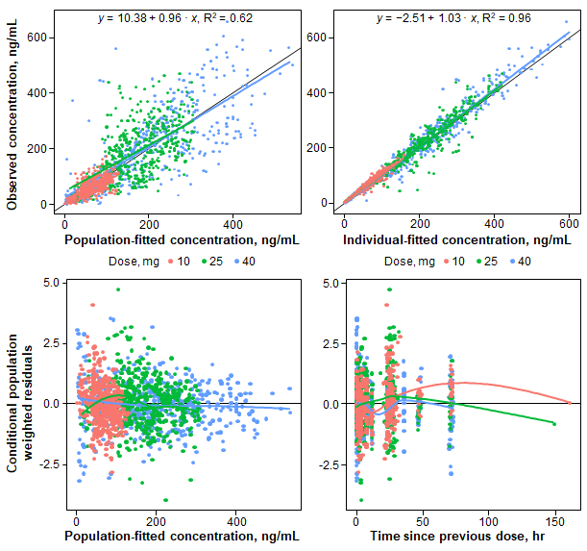

Supplementary Fig. 2 Standard goodness-of-fit plots for the final model (pooled steady-state phase 1 and phase 2 data). Plots indicate a robust and unbiased fit to the observed data with good precision (population predictions vs observations: r²=0.62; individual predictions vs observations: r²=0.96)

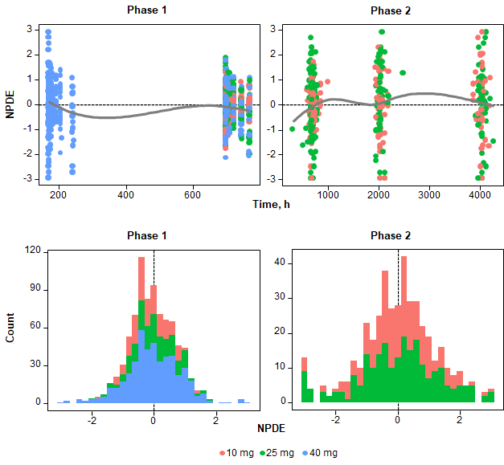
Supplementary Fig. 3 NPDEs for the final model (pooled steady-state phase 1 and phase 2 data). No systematic deviation from the presumed standard normal distribution was observed. Solid lines represent LOESS smoothers through the data. Dashed lines indicate NPDE=0. NPDE normalized prediction distribution error

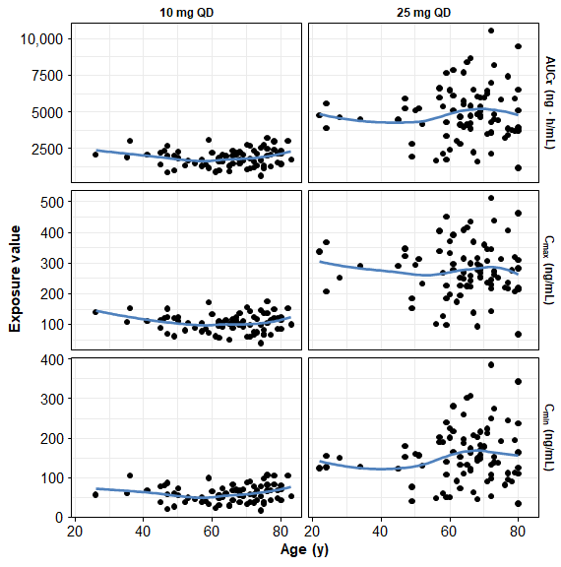
Supplementary Fig. 4 Brensocatib exposure estimates by age in patients with non–cystic fibrosis bronchiectasis. Brensocatib exposure was consistent across a broad range of patient ages. Blue lines indicate LOESS smoothers. AUC_{τ} area under the plasma concentration-time curve from time 0 to 24 h, C_{max} maximum plasma concentration, C_{min} minimum plasma concentration, LOESS locally weighted scatterplot smoothing, QD once daily

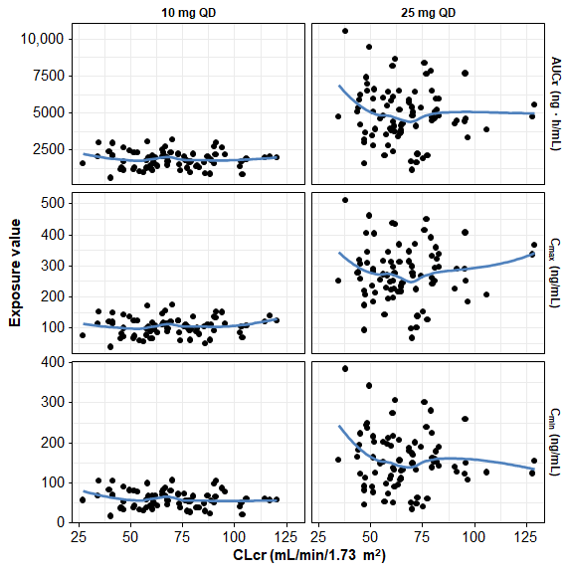
Supplementary Fig. 5 Brensocatib exposure estimates by CLcr in patients with non–cystic fibrosis bronchiectasis. Brensocatib exposure was consistent regardless of individual patient renal status. Blue lines indicate LOESS smoothers. AUC_{τ} area under the plasma concentration-time curve from time 0 to 24 h, CLcr creatinine clearance, C_{max} maximum plasma concentration, C_{min} minimum plasma concentration, LOESS locally weighted scatterplot smoothing, QD once daily

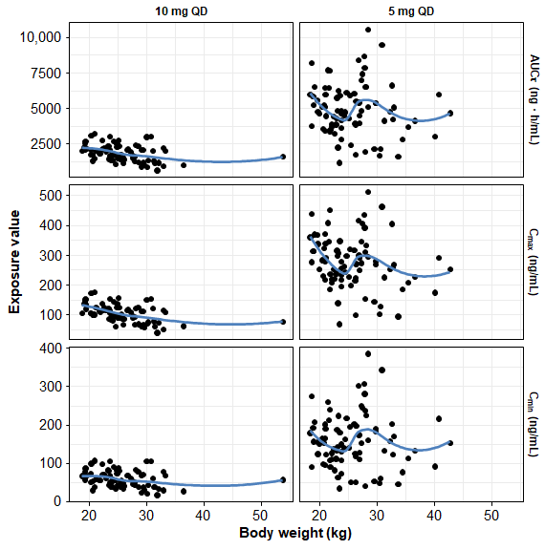
Supplementary Fig. 6 Brensocatib exposure estimates by body weight in patients with non–cystic fibrosis bronchiectasis. Brensocatib exposure was consistent across a wide range of body weights. Blue lines indicate LOESS smoothers. AUC_{τ} area under the plasma concentration-time curve from time 0 to 24 h, CLcr creatinine clearance, C_{max} maximum plasma concentration, C_{min} minimum plasma concentration, LOESS locally weighted scatterplot smoothing, QD once daily

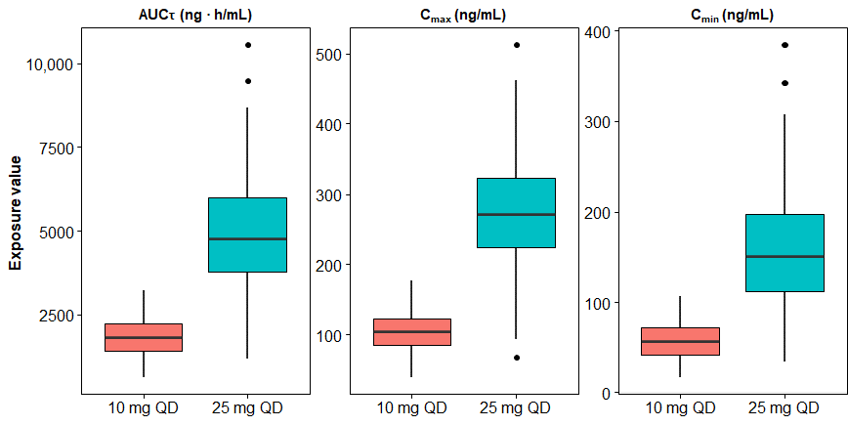
Supplementary Fig. 7 Distribution of steady-state brensocatib by dose group. The 3 measures of drug exposure were consistent between brensocatib 10 and 25 mg. AUC_{τ} area under the plasma concentration-time curve from time 0 to 24 h, C_{max} maximum plasma concentration, C_{min} minimum plasma concentration, QD once daily

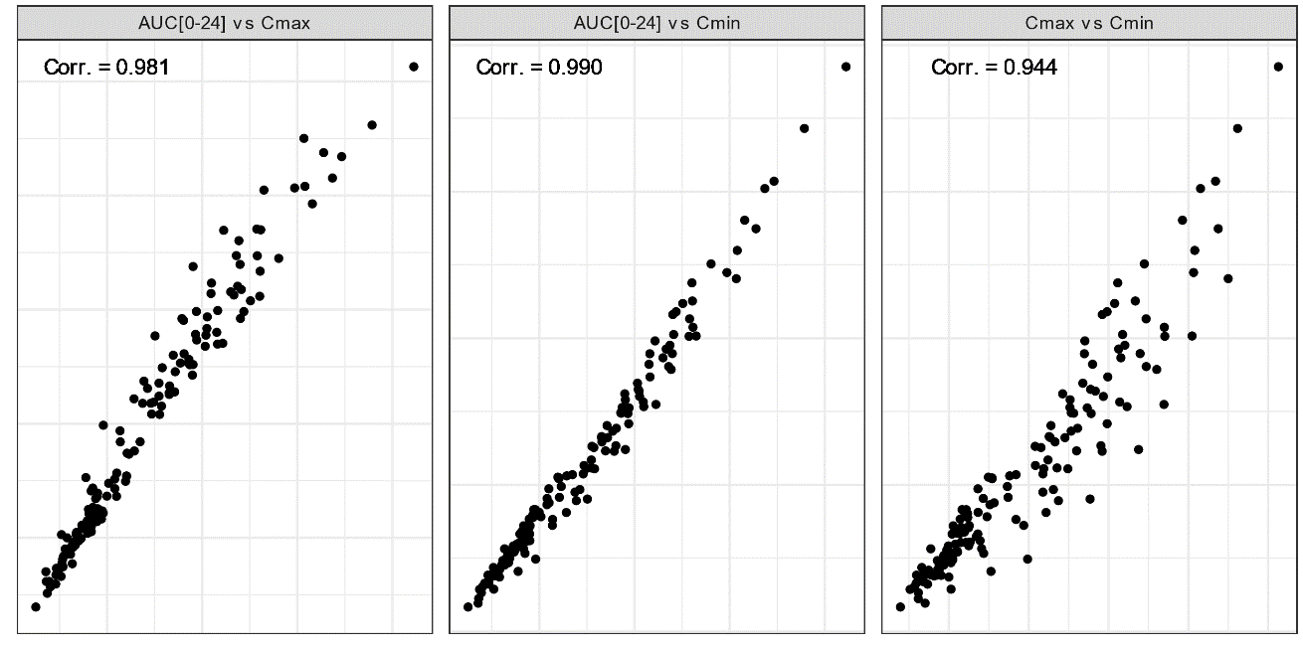
Supplementary Fig. 8 Correlations among steady-state brensocatib exposure estimates. The 3 measures of brensocatib exposure were highly correlated. AUC_{τ} area under the plasma concentration-time curve from time 0 to 24 h, C_{max} maximum plasma concentration, C_{min} minimum plasma concentration
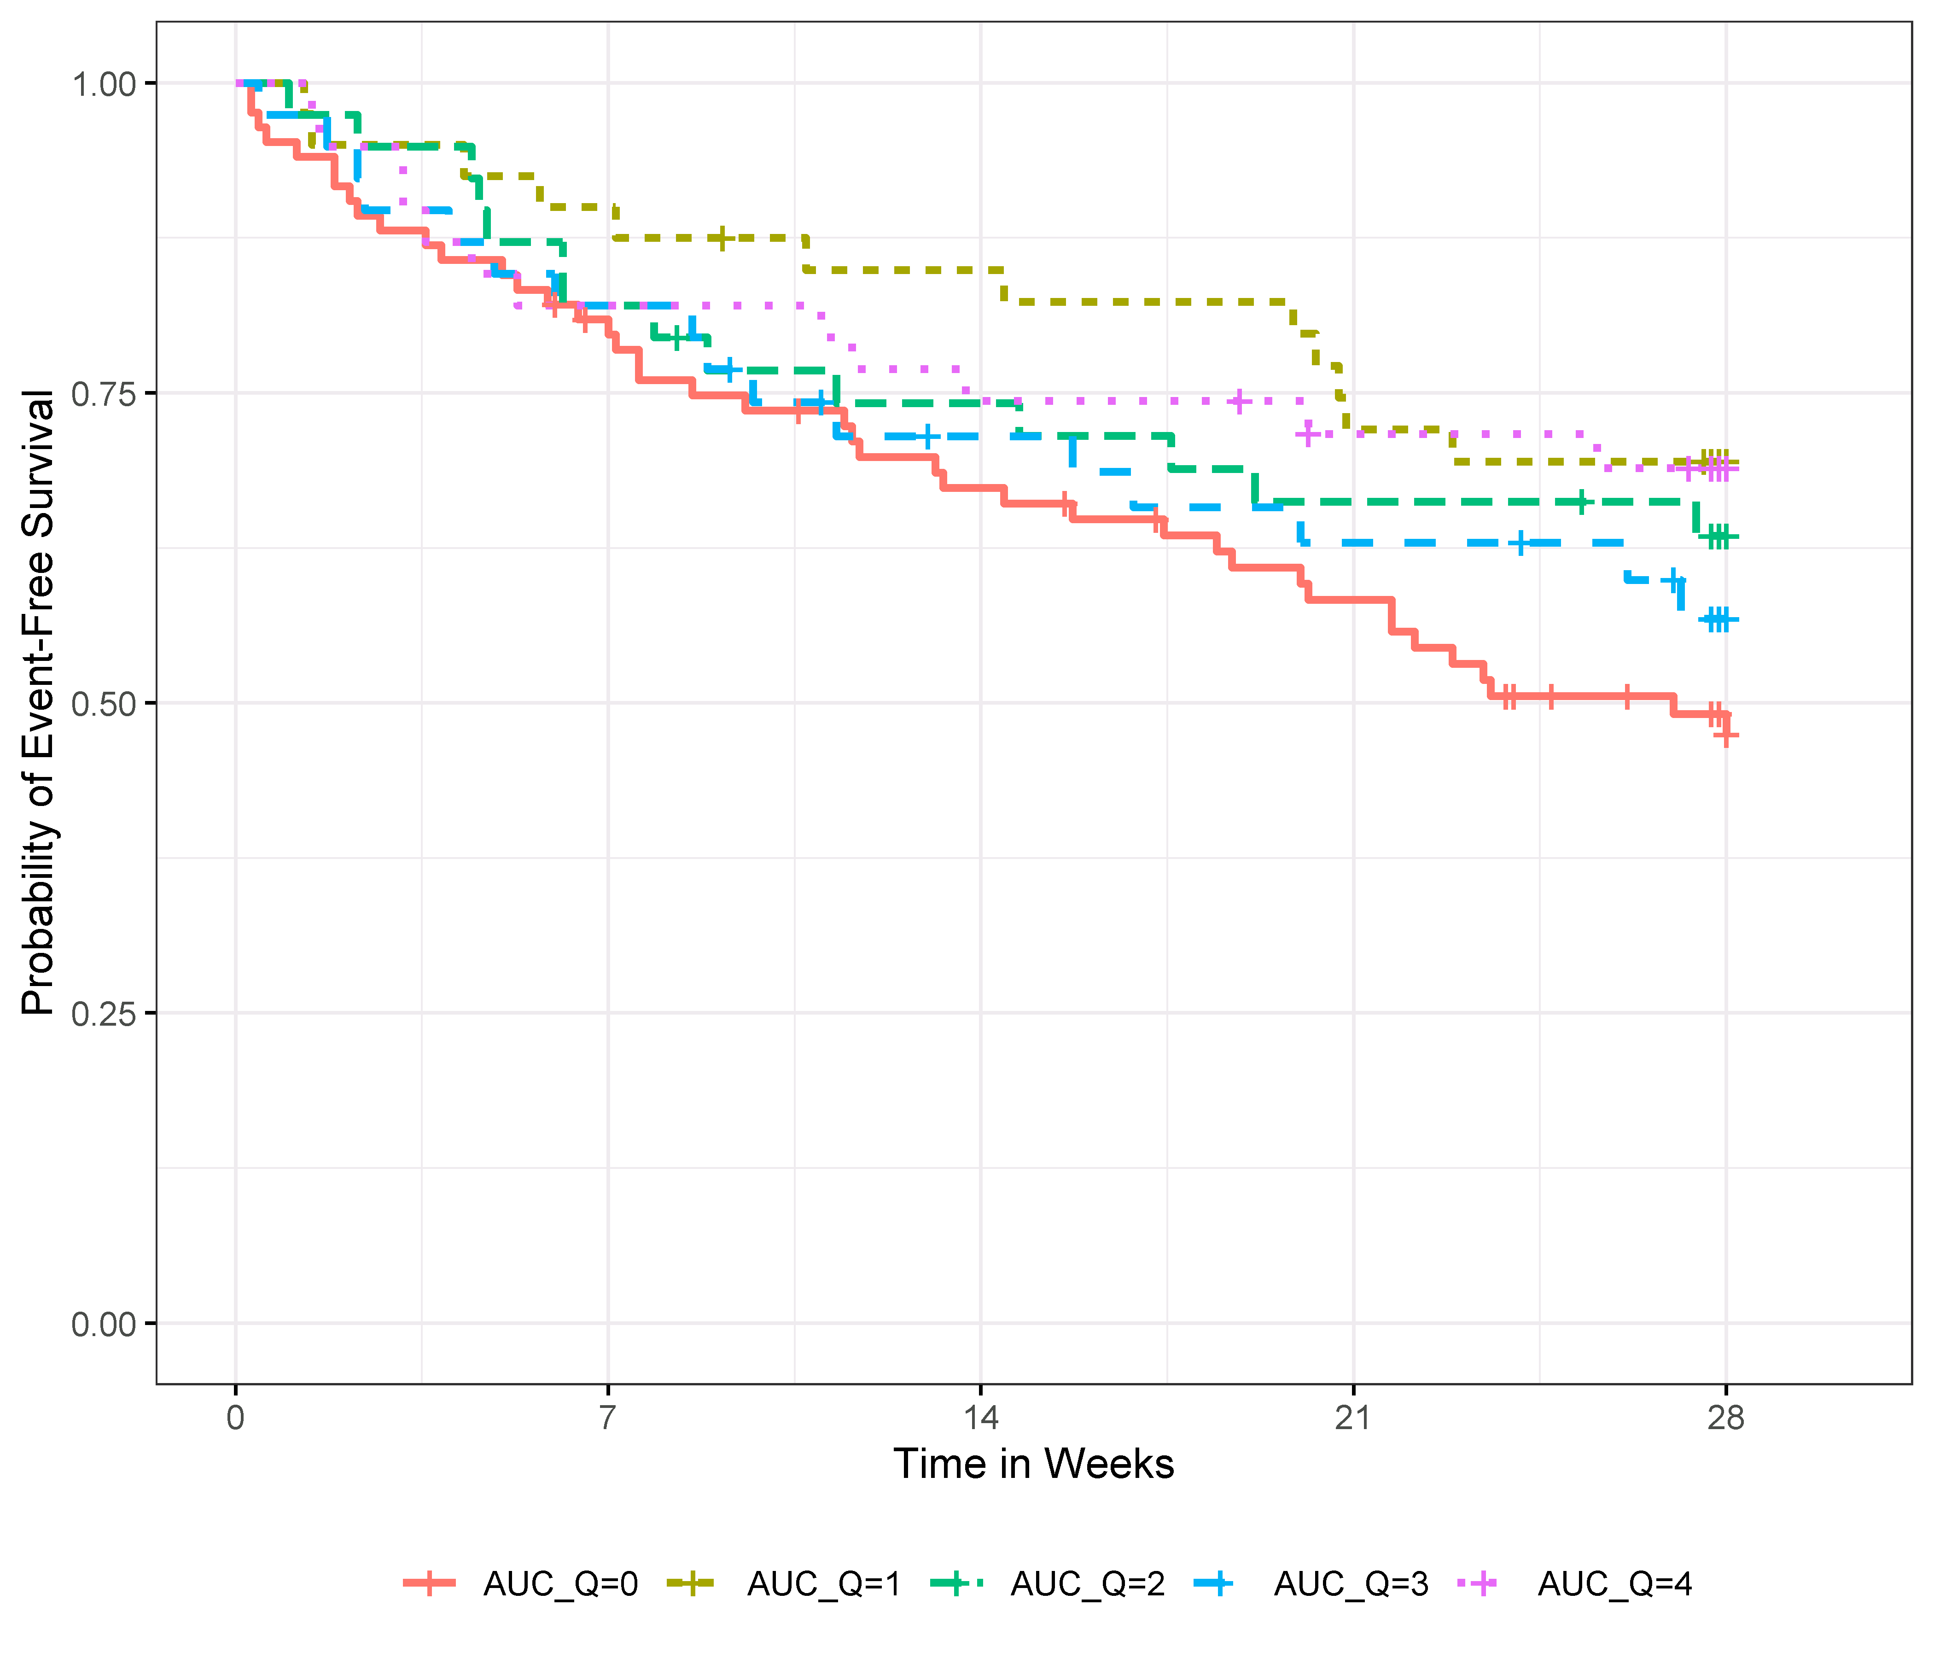
Supplementary Fig. 9 Time to pulmonary exacerbation in patients with non–cystic fibrosis bronchiectasis by AUC_{τ} quartile. While the incidence of pulmonary exacerbations appears to be lower in brensocatib-treated patients (AUC_{τ} Q1-Q4) than in those treated with placebo (AUC_{τ} Q0), a clear relationship between brensocatib exposure and pulmonary exacerbations was not evident. AUC_{τ} area under the concentration-time curve from time 0 to 24 h, Q quartile

Supplementary Table 1 Incidence of AESI by steady-state AUC_{τ} quartile
AESI, n (%) | AUC_{τ} quartile range |  |  |  | Placebo  n=85
AESI, n (%) | Q1  (624–1758  ng • h/mL)  n=40 | Q2  (1813–2753 ng • h/mL)  n=39 | Q3  (2840–4824 ng • h/mL)  n=39 | Q4  (4845–10562 ng • h/mL)  n=39 | Placebo  n=85
Periodontal disease (week 8) | 5 (12.5) | 5 (12.8) | 2 (5.1) | 8 (20.5) | 9 (10.6)
Periodontal disease (week 24) | 5 (12.5) | 7 (17.9) | 7 (17.9) | 6 (15.4) | 9 (10.6)
Hyperkeratosis | 2 (5.0) | 1 (2. 6) | 0 | 1 (2.6) | 0
Infection other than pulmonary | 4 (10.0) | 10 (25.6) | 4 (10.3) | 9 (23.1) | 16 (18.8)
AESI adverse event of special interest, AUC_{τ} area under the concentration-time curve from time 0 to 24 h, Q quartile

