Semi-mechanistic modeling of hypoxanthine, xanthine and uric acid metabolism in asphyxiated neonates
Wan-Yu Chu¹, Karel Allegaert^{2,3}, Thomas P.C. Dorlo¹, Alwin D.R. Huitema^{1,4,5}, on behalf of the ALBINO Study Group*
¹ Department of Pharmacy & Pharmacology, Netherlands Cancer Institute, Amsterdam, the Netherlands
² Department of Development and Regeneration, and Pharmaceutical and Pharmacological Sciences, Leuven, Belgium
³ Department of Clinical Pharmacy, Erasmus MC, Rotterdam, the Netherlands
⁴ Department of Pharmacology, Princess Máxima Center for Pediatric Oncology, Utrecht, the Netherlands
⁵ Department of Clinical Pharmacy, University Medical Center Utrecht, Utrecht University, Utrecht, the Netherlands

* The ALBINO study group involved in this project consist of the coordinating investigators, the PK study group and the beneficiaries and national coordinators. Coordinating investigators are Axel R Franz (University Hospital Tuebingen, Germany) and Mario Rüdiger (University Hospital CG Carus, Medizinische Fakultät der TU Dresden, Germany). The contributors to the PK study group are Laura Nijstad and Kim Annink (Utrecht, the Netherlands), Christian Maiwald (Tuebingen, Germany), Michael Schroth and Anja Hagen (Nuremberg, Germany) and Loubna el Bakkali and Mirjam M van Weisenbruch (Amsterdam, the Netherlands). The beneficiaries and national coordinators are Axel R Franz and Christian F Poets (Tuebingen, Germany), Mario Rüdiger (Dresden, Germany), Manon Benders and Frank van Bel (Utrecht, the Netherlands), Karel Allegaert and Gunnar Naulaers (Leuven, Belgium), Dirk Bassler (Zurich, Switzerland), Katrin Klebermass-Schrehof (Vienna, Austria), Maximo Vento (Valencia, Spain), Hercilia Guimaraes (Porto, Portugal), Tom Stiris (Oslo, Norway), Isabella Mauro (Udine, Italy), Marjo Metsäranta (Helsinki, Finland), Sampsa Vanhatalo (Helsinki, Finland), Jan Mazela (Poznan, Poland), Tuuli Metsvaht (Tartu, Estonia), and Roselinda van der Vlugt-Meijer (ACE Pharmaceuticals, Zeewolde, the Netherlands).

Supplementary files

Supp Figure 1. Disease-related initial estimates vs Thompson-Score (T-Score)
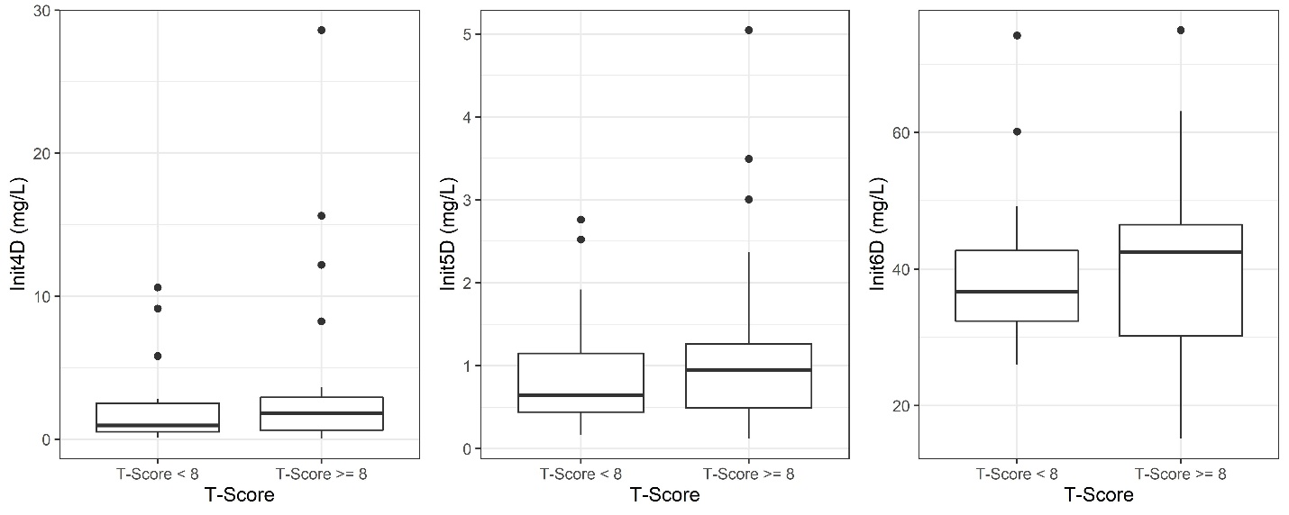
Init4D, disease-related hypoxanthine initial value; Init5D, disease-related xanthine initial value; Init6D, disease-related uric acid initial value.

Supp Figure 2. Disease-related initial estimates vs lactate dehydrogenase (LDH, U/L) and alanine aminotransferase (ALT, U/L)
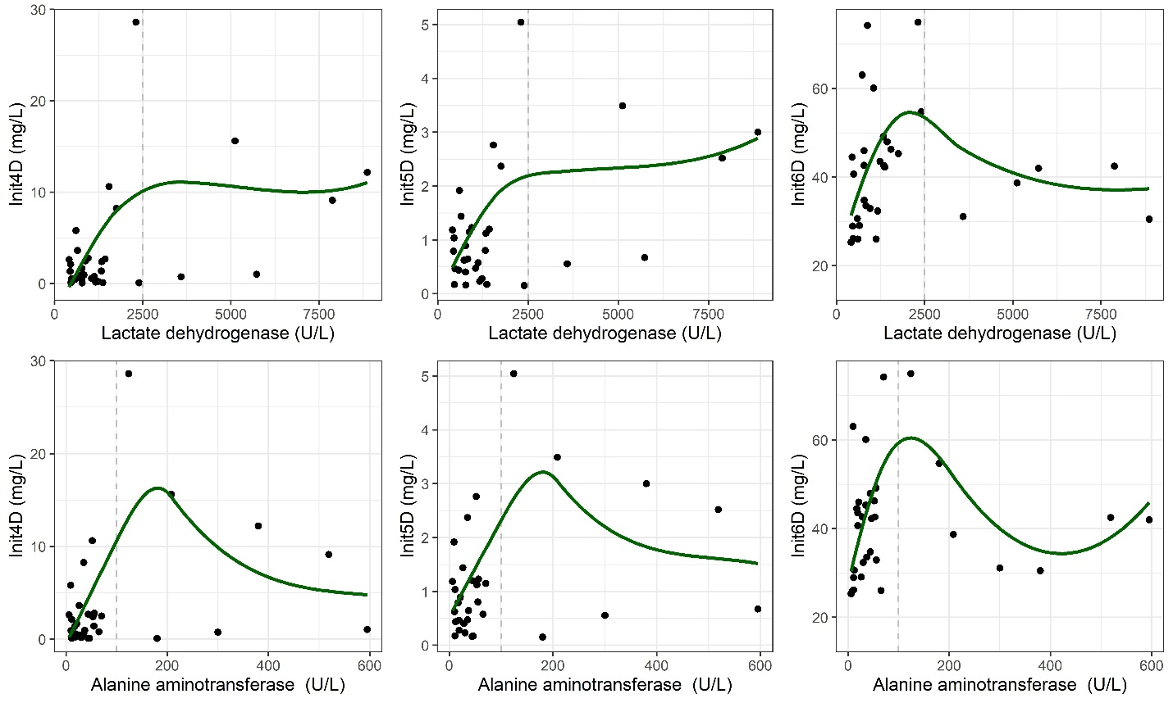
Init4D, disease-related hypoxanthine initial value; Init5D, disease-related xanthine initial value; Init6D, disease-related uric acid initial value.

