Appendix

Supplemental Table 1. Overview of covariate effects that were evaluated on each model parameter
Structural model parameter | Covariate evaluated
F | Dose (also nested per formulation), intake conditions [fasting or non-fasting state] (also nested per formulation), formulation, hematocrit, proton pump inhibitors, time after transplantation (also nested per formulation),
CL | Age, ALP, ALT, AST, bilirubin, body size (body weight and fat-free mass), body mass index, body surface area, calcium channel blocker, ethnicity, eGFR, hematocrit, predniso(lo)n, sex, sulfonylurea derivatives, transplant type
V | Albumin, body size (body weight and fat-free mass), body surface area, body mass index, ethnicity, haptoglobin, hematocrit, predniso(lo)n, sex, total plasma protein
Bmax | eGFR, ethnicity, haptoglobin, hematocrit, low-density lipoprotein cholesterol, mycophenolic acid, predniso(lo)n, sex, transplant type, total cholesterol, total plasma protein, vitamin D use, vitamin B12,
Kd | Hematocrit

Structural Model Parameters |  |  |  | Parameter Estimate | RSE (%)
Apparent plasma clearance (CL, L/hour) |  |  |  | 221.0 | 5.8
Apparent plasma volume of distribution (Vd, L) |  |  |  | 5227.4 | 9.0
Maximum plasma concentration bound to erythrocytes (B_{max}, ng/mL) |  |  |  | 44.5 | 5.4
Plasma concentration resulting in half of maximum binding (C₅₀, ng/mL) |  |  |  | 0.27 | 8.6
Stochastic Model Parameters |  |  | Structure | Estimate (CV%) | RSE (%) | Shrinkage (%)
Between-subject variability on F |  |  | Exponential | 0.32 (61.2) | 6.2 | 9.1%
Between-subject variability on Bmax |  |  | Exponential | 0.03 (17.1) | 12.3 | 30.0%
Residual variability for plasma tacrolimus observations |  |  | Proportional | 0.15 (37.1) | 5.0 | 15.4%
Residual variability for whole blood tacrolimus observations |  |  | Proportional | 0.06 (25.3) | 7.8 | 15.0%
Covariance between residual variability for plasma and whole blood tacrolimus observations |  |  |  | 0.07 (r = 0.61)
Supplemental Table 2. Parameter estimates of base non-linear population pharmacokinetic model
Structural Model Parameters |  |  |  | Parameter Estimate | RSE (%)
Apparent plasma clearance (CL, L/hour) |  |  |  | 227.8 | 2.5
Apparent plasma volume of distribution (Vd, L) |  |  |  | 6302.9 | 8.5
fraction_bound (%) |  |  |  | 99.0 | 1.0
Stochastic Model Parameters |  |  | Structure | Estimate (CV%) | RSE (%) | Shrinkage (%)
Between-subject variability on F |  |  | Exponential | 0.29 (58.4) | 5.9 | 8.4%
Between-subject variability on fraction_bound |  |  | Exponential | 0.05 (22.4) | 12.8 | 29.5%
Residual variability for plasma tacrolimus observations |  |  | Proportional | 0.16 (39.9) | 5.0 | 15.9%
Residual variability for whole blood tacrolimus observations |  |  | Proportional | 0.06 (25.8) | 8.2 | 15.7%
Covariance between residual variability for plasma and whole blood tacrolimus observations |  |  |  | 0.07 (r = 0.60)
Supplemental Table 3. Parameter estimates of base linear population pharmacokinetic model

Supplemental Figure 1. Impact of covariates in the population pharmacokinetic model on the predicted plasma and whole blood trough concentration at month 6. The reference subject is defined as a kidney transplant recipient that uses a dose of 3 mg Prograft, under fasting conditions, hematocrit of 39%, estimated glomerular filtration ratio (eGFR) of 50 mL/min/1.73m², haptoglobin of 1.5 g/L, total cholesterol of 4.8 mmol/L, vitamin B₁₂ of 400 pmol/L, concomitant use of mycophenolic acid and no concomitant use of Vitamin D₃. Points and error bars represent the median and 95% prediction intervals. Shaded areas represent the whole blood reference range (right panel) for kidney (blue) and lung (red) transplant recipients and the 95% prediction intervals for the plasma concentrations (left panel) that correlate with the whole blood reference ranges according to our model.
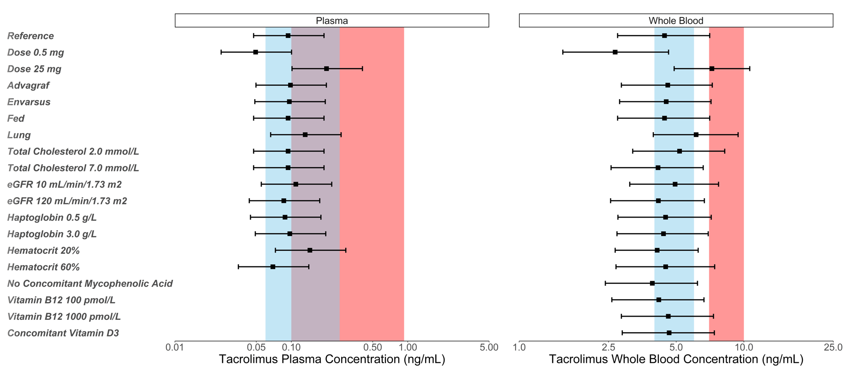

Supplemental Figure 2. Impact of covariates in the population pharmacokinetic model on the predicted plasma and whole blood trough concentration at month 3. Reference subject is defined as a kidney transplant recipient that uses a dose of 3 mg Prograft, under fasting conditions, hematocrit of 39%, estimated glomerular filtration ratio (eGFR) of 50 mL/min/1.73m², haptoglobin of 1.5 g/L, total cholesterol of 4.8 mmol/L, vitamin B₁₂ of 400 pmol/L, concomitant use of mycophenolic acid and no concomitant use of Vitamin D₃. Points and error bars represent the median and 95% prediction intervals. Shaded areas represent the proposed reference range for plasma and reference range for kidney (blue) and lung (red) transplant recipients.
