Journal Name: Clinical Pharmacokinetics

Supplementary information File of

Population Target-Mediated Pharmacokinetics/Pharmacodynamics Modeling to Evaluate SPI-62 Exposure and Hepatic 11β-Hydroxysteroid Dehydrogenase Type 1 (HSD-1) Inhibition In Healthy Adults

Nan Wu, MS¹, David A. Katz, PhD², Guohua An, MD, PhD ^{1,*}

¹ Division of Pharmaceutics and Translational Therapeutics, College of Pharmacy, University of Iowa, Iowa City, Iowa
² Sparrow Pharmaceuticals, Inc., Portland, Oregon

*Correspondence:

Guohua An, MD, Ph.D.
Department of Pharmaceutical Sciences and Experimental Therapeutics,
College of Pharmacy, University of Iowa,
115 S Grand Ave, Iowa City, IA, 52242, USA.
E-mail: guohua-an@uiowa.edu

Supplementary information file, Table 1. Model development history for PK/PD model.
No. | PD link | IIV | Minimization | Covariance step | RSE | Model fitting | OFV | ΔOFV
1 | Activity=(100-E₀)×($1-\frac{I_{max}×C^{r}}{IC_{50}+C^{r}}$)+ E₀  IC₅₀= θ+exp(η);  ɤ= θ; | I_{max}=θ;  E₀=θ+η; | Yes | No | - | Good | 151.128 | -
2 |  | I_{max}=θ;  E₀=θ; | Terminated | - | - | - | -
3 |  | I_{max}=θ+η; (θ was fixed to 1)  E₀=θ+η; | Yes | Yes | High | Good | 151.042 | -0.086
4 |  | I_{max}=θ+η; (θ was fixed to 1)  E₀=θ+exp(η); | Yes | Yes | High | Good | 150.806 | -0.236
5 |  | I_{max}=θ+η; (θ was fixed to 1)  E₀=θ; | Terminated | - | - | - | -
6 |  | I_{max}=θ+η;  E₀=θ+η; | Yes | No | - | Good | 151.743 | 0.937
7 |  | I_{max}=θ+η;  E₀=θ; | Terminated | - | - | - | -
8 |  | I_{max} was fixed to 1;  E₀=θ+η; | Terminated | - | - | - | -
9 |  | I_{max} was fixed to 1;  E₀=θ+exp(η); | Yes | No | - | Good | 149.817 | -1.926
10 |  | I_{max} was fixed to 1;  E₀=θ; | Terminated | - | - | - | -
11 | Activity=100×($1-\frac{I_{max}×C^{r}}{IC_{50}+C^{r}}$);  ɤ= θ; | I_{max}=θ+η;  IC₅₀= θ+exp(η); | Yes | No | - | Good | 152.860 | 3.043
12 |  | I_{max}=θ+exp(η);  IC₅₀= θ+exp(η); | Yes | Yes | High | Good | 150.620 | -2.240
13-final |  | I_{max}=θ;  IC₅₀= θ+exp(η); | Yes | Yes | Good | Good | 153.312 | 2.692
14 |  | I_{max}=θ;  IC₅₀= θ+exp(η);  Additive residual error | Yes | Yes | Good | Good | 234.094 | 80.782
15 |  | I_{max}=θ;  IC₅₀= θ; | Terminated | - | - | - | -
16 |  | I_{max}= θ+exp(η);  IC₅₀= θ; | Terminated | - | - | - | -
17 |  | I_{max}=θ+η;  IC₅₀= θ; | Terminated | - | - | - | -
18 | Activity=100×($1-\frac{{A_{SPI62-HSD1}×I}_{max}}{R_{max}}$) | I_{max}=θ+η; | Yes | Yes | Good | Over-prediction of the higher end and underprediction of the lower end of HSD-1 activity. | 492.364 | 258.27
19 | Activity=100×($1-\frac{{A_{SPI62-HSD1}×I}_{max}}{R_{max}}$) | I_{max}=θ; | Yes | Yes | Good |  | 517.467 | 25.103
# OFV, objective function value; RSE, relative standard errors. ΔOFV were calculated comparing the model with the previous one.
Supplementary information file, Figure S1. Age (left panel) and body weight (right panel) distribution plots. The number of subjects included in our PK-PD analysis with different age and body weight are represented by the red bars.

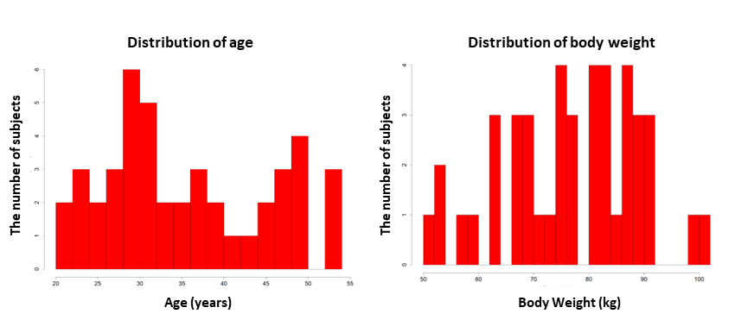

Supplementary information file, Figure S2. Representative exploratory plots to evaluate the impact of potential covariates including age, bodyweight, gender, and race on the individual specific random effect (ηi) for three representative parameters (V_{central}, CL, and IC₅₀). For the continuous covariates age and body weight, the solid black lines represent the linear regression lines the gray diamonds represent the individual observed data, the black dashed lines are the zero lines, and P values, R-Squared (R² or the coefficient of determination) and the equation of linear regression are provided in each plot. For the categorical covariates gender and race, the solid horizontal black lines in boxes represent the median values, the black diamonds represent the mean values. The lower and upper hinges correspond to 25th and 75th percentiles, a black plus indicates an outlier, the upper and lower notches extend to the largest and smallest values excluding any outliers, and the black dashed lines are the zero lines.

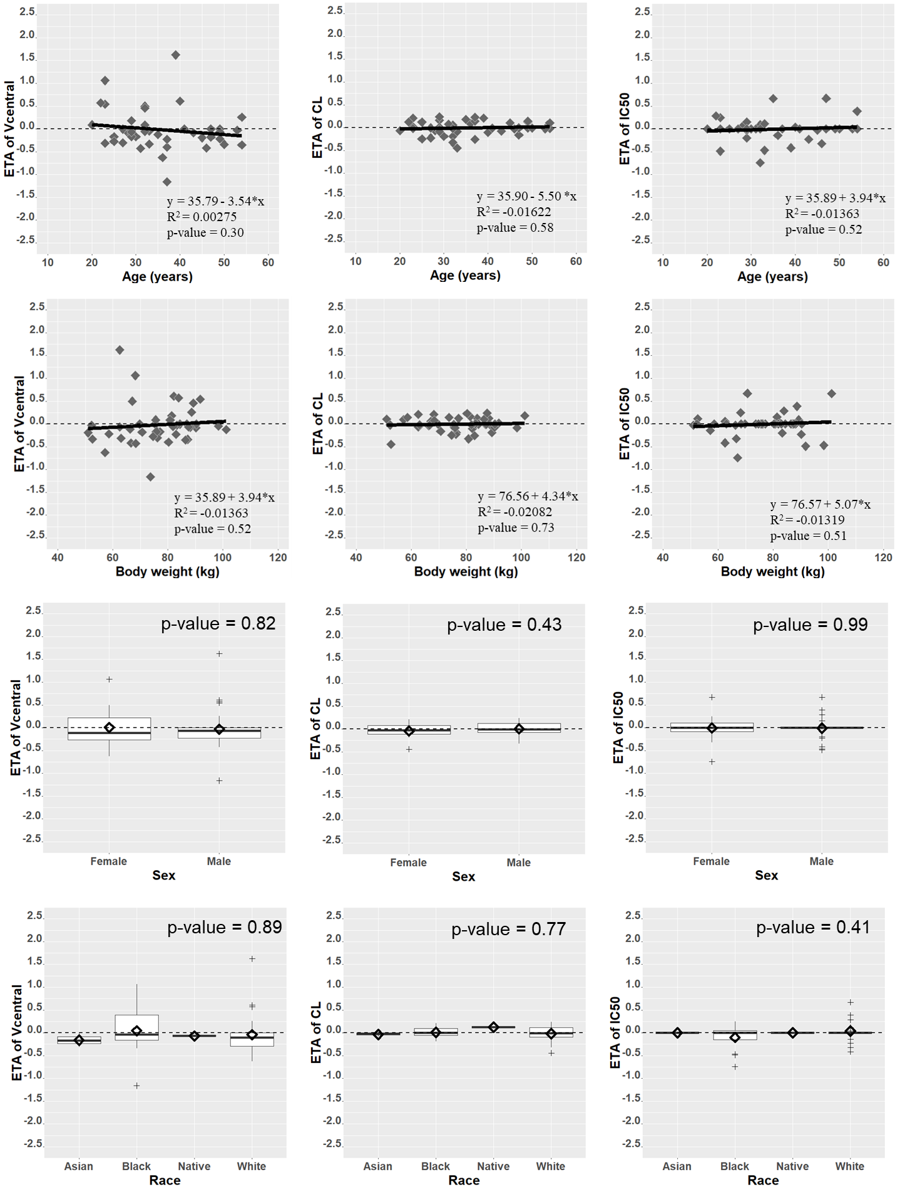

Supplementary information file, Figure S3. Goodness-of-fit plots for the final model of SPI-62. (A) Observed versus population-predicted SPI-62 plasma concentrations, (B) observed versus individual-predicted SPI-62 plasma concentrations, (C) weighted conditional residuals versus time, (D) weighted conditional residuals versus population-predicted SPI-62 plasma concentrations, (E) observed versus population-predicted hepatic HSD-1 activity, (F) observed versus individual-predicted hepatic HSD-1 activity, (G) weighted conditional residuals versus time, (H) weighted conditional residuals versus population-predicted hepatic HSD-1 activity. Solid black lines represent lines of identity in (A), (B), (E), (F) and zero residuals in (C), (D), (G), (H). LOWESS lines are provided in (A), (B), (C), (D) using in blue solid lines and in (E), (F), (G), (H) using red solid lines.
