SUPPLEMENTARY MATERIAL

Population Pharmacokinetic Analysis Supports Initiation Treatment and Bridging from Sublingual Buprenorphine to Subcutaneous Administration of a Buprenorphine Depot (CAM2038) in the Treatment of Opioid Use Disorder
Marcus Björnsson,¹ Chayan Acharya,¹ Kerstin Strandgården,² Fredrik Tiberg²

¹Pharmetheus AB, Uppsala, Sweden; ²Camurus AB, Lund, Sweden

Journal: Clinical Pharmacokinetics

Correspondence to: Fredrik Tiberg, Camurus AB, Ideongatan 1A, 223 62 Lund, Sweden;
Tel: +46 462 865 730; Email: fredrik.tiberg@camurus.com

Short title: CAM2038 Population PK Analysis

Trial registrations: ISRCTN41550730, ISRCTN24987553, NCT02611752, NCT02710526

Funding: Camurus AB

Appendix A: Study Designs of Trials 1–4
Trial 1 (HS-11-426, ISRCTN41550730)[40] was a phase 1, randomized, open-label study performed in healthy volunteers to assess the PK of single doses of SC CAM2038 versus IV BPN (Temgesic®, Indivior UK Ltd, previously RB Pharmaceuticals, UK) and SL BPN (Subutex®, Indivior UK Ltd, previously RB Pharmaceuticals, UK). Participants (N=60) under naltrexone blockade received 0.6 mg IV BPN on day 1, followed by a 7-day washout. On days 8–14, participants were categorized into three groups where they received seven repeated daily doses of either 8, 16, or 24 mg SL BPN, followed by another 7-day washout. On day 21, participants were injected in the buttock with a single dose of either 8, 16, or 32 mg SC CAM2038 Q1W.

Trial 2 (HS-13-487; ISRCTN24987553)[13] was a phase 1, randomized, open-label study in healthy volunteers under naltrexone blockade. In this study, participants (N=87) were randomized into five groups (A–E). All participants received 0.6 mg of IV BPN (Temgesic®) on day 1, followed by a 7-day washout. On days 8–14, participants in groups A, B, and C received seven repeated daily doses of 8, 24, or 16 mg SL BPN (Subutex®), respectively, followed by another 7-day washout. On day 21, groups A and B received a single dose of 64 mg or 128 mg SC CAM2038 Q4W, respectively. Group C received four repeated SC doses of 16 mg CAM2038 Q1W. Groups D and E received a single dose of 96 mg or 192 mg CAM2038 Q4W, respectively, on day 8.[13]

Trial 3 (HS-13-478; NCT02611752)[9] was a phase 2, randomized, double-blind, repeat-dose study in 47 patients with OUD who received two repeated weekly doses of 24 mg or 32 mg of SC CAM2038 Q1W.[9]

Trial 4 (HS-15-549; NCT02710526; unpublished data) was a phase 2, randomized, open-label study in 58 patients with OUD with a history of chronic non-cancer pain. Group 1 patients received three SC doses of 32 mg CAM2038 Q1W administered in the buttock, followed by four SC doses of 32 mg CAM2038 Q1W administered in the buttock, abdomen, thigh, and back of the upper arm. Group 2 received four monthly SC doses of 128 mg CAM2038 Q4W, administered in the buttock. Group 3 received three daily doses of 24 mg SL BPN (Subutex®) for seven days, then four monthly 160 mg SC doses of CAM2038 in the buttock. Group 3 was not included in the initial population PK model analysis but was added in an update of the PK model. All BPN plasma concentrations after administration of 24 mg SL BPN/naloxone for 7 days to patients in Group 3 were excluded due to uncertain dosing history; this exclusion was consistent with the analysis plan.

Where available, further information regarding study design, administration, inclusion/exclusion criteria, withdrawals, or participants lost to follow-up is available in the primary publications or within the appropriate records on the ISRCTN.com or ClinicalTrials.gov registries for these four clinical trials.

Table S1. Plasma sample time points for the analysis data set
Treatment | Time points (post-dose)
Trial 1 (HS-11-426)
IV BPN | Pre-dose (within 45 minutes), 5, 10, 15, 20, 30, and 40 minutes, and 1, 1.5, 2, 4, 6, 10, and 24 hours
SL BPN | Pre-dose (within 45 minutes), 10, 20, 30, and 40 minutes, and 1, 1.5, 2, 3, 4, 6, 10, and 24 hours for the 1st and 7th doses. Additional samples taken at 48 and 72 hours after the 7th dose
SC CAM2038 Q1W | Pre-dose (within 45 minutes), 30 minutes, 1, 2, 4, 6, 10, 24, 36, and 48 hours, and 3, 4, 5, 7 ,14, 21, and 28 days
Trial 2 (HS-13-487)
IV BPN | Pre-dose (within 45 minutes), 5, 10, 15, 20, 30, and 40 minutes, and 1, 1.5, 2, 4, 6, 10, and 24 hours. For groups D and E, additional samples taken at 32 and 48 hours
SL BPN | Pre-dose (within 45 minutes), 10, 20, 30, and 40 minutes, and 1, 1.5, 2, 3, 4, 6, 10, and 24 hours for the 1st and 7th dose. Additional samples taken at 48 and 72 hours after the 7th dose
SC CAM2038 Q1W | Pre-dose (within 45 minutes) on Days 21, 28, 35, and 42. Also taken on Day 21 at 30 minutes, 1, 2, 4, 6, 10, 24, and 48 hours; Day 28 at 24 hours, Day 35 at 24 hours; and Day 42 at 30 minutes, 1, 2, 4, 6, 10, 24, and 48 hours. Additionally, on visits to clinical unit on Days 24, 25, 26, 45, 46, 47, 49, 56, 63, 70, and 77
SC CAM2038 Q4W | Groups A and B: Pre-dose (within 45 minutes) on Day 21, and 30 minutes, 1, 2, 4, 6, 10, 24, and 48 hours. Also, Days 24, 25, 26, 28, 31, 35, 42, 49, 56, 63, 70, and 77  Groups D and E: Pre-dose (within 45 minutes) on Day 8, and 30 minutes, 1, 2, 4, 6, 10, 24, and 48 hours. Also, Days 11, 12, 13, 15, 18, 22, 29, 36, 43, 50, 57, and 64
Trial 3 (HS-13-478)
SC CAM2038 Q1W | Days 0 and 7: Pre-dose and 1, 4, 6, and 8 hours  Days 1–6 and 8–13: ~1 hour before hydromorphone challenge  Day 14: 168 hours
Trial 4 (HS-15-549)
SC CAM2038 Q1W | Doses 1–3: Pre-dose  Doses 4–7: Pre-dose and 30 minutes, 1, 2, 4, 6, 10, 24, 30, 48, 72, 96, 120, and 168 hours post-dose
SC CAM2038 Q4W | Dose 1: Pre-dose and 7, 14, and 21 days post-dose  Doses 2 and 3: Pre-dose, once between 4 and 8 hours, and 2, 7, 14, and 21 days post-dose  Dose 4: Pre-dose, 0.5, 1, 2, 4, 6, 10, 24, 48, 72, 96, and 120 hours, and 7, 10, 14, 21, and  28 days
SL BPN followed by SC CAM2038 Q4W | SLBPN dose 7 (Day 7): Pre-dose (within 45 minutes), 10, 20, 30 and 40 minutes, and  1, 1.5, 2, 3, 4, 6, 10, and 24 hours  CAM2038 Q4W dose 1 (Day 8): Pre-dose, and 7, 14, and 21 days post-dose  CAM2038 Q4W doses 2 and 3 (Days 36/64): Pre-dose, once between 4 and 8 hours  post-dose, and 2, 7, 14, and 21 days post-dose  CAM2038 Q4W dose 4 (Day 92): Pre-dose, 30 minutes, 1, 2, 4, 6, 10, 24, 48, 72, 96, and 120 hours, and 7, 10, 14, 21, and 28 days post-dose
BPN: buprenorphine; IV: intravenous; Q1W: once weekly; Q4W: once monthly; SC: subcutaneous; SL: sublingual.

Table S2. Number of participants and BPN observations, stratified by dose
Trial and Doseª | Initial PK model |  | Updated PK model
Trial and Doseª | Number of participants | Number of BPN observations | Number of participants |  | Number of BPN observations
Trial 1 (HS-11-426)
0.6 mg IV BPN | 60 | 779 | - |  | -
8 mg SL BPN | 19 | 520 | - |  | -
16 mg SL BPN | 19 | 511 | - |  | -
24 mg SL BPN | 19 | 527 | - |  | -
8 mg SC CAM2038 Q1W | 19 | 263 | - |  | -
16 mg SC CAM2038 Q1W | 18 | 271 | - |  | -
32 mg SC CAM2038 Q1W | 19 | 292 | - |  | -
All | 60 | 3163 | - |  | -
Trial 2 (HS-13-487)
0.6 mg IV BPN | 87 | 1180 | 62 |  | 853
8 mg SL BPN | 17 | 471 | 17 |  | 471
16 mg SL BPN | 19 | 523 | - |  | -
24 mg SL BPN | 17 | 469 | 16 |  | 442
16 mg SC CAM2038 Q1W | 17 | 492 | - |  | -
64 mg SC CAM2038 Q4W | 17 | 340 | 17 |  | 340
96 mg SC CAM2038 Q4W | 14 | 278 | 14 |  | 278
128 mg SC CAM2038 Q4W | 16 | 320 | 16 |  | 320
192 mg SC CAM2038 Q4W | 15 | 293 | 15 |  | 293
All | 87 | 4366 | 62 |  | 2997
Trial 3 (HS-13-478)
24 mg SC CAM2038 Q1W | 16 | 350 | - |  | -
32 mg SC CAM2038 Q1W | 31 | 662 | - |  | -
All | 47 | 1012 | - |  | -
Trial 4 (HS-15-549)
32 mg SC CAM2038 Q1W | 24 | 1244 | - |  | -
128 mg SC CAM2038 Q4W | 18 | 475 | 18 |  | 475
160 mg SC CAM2038 Q4W^{b} | - | - | 16 |  | 398
All | 42 | 1719 | 34 |  | 873
All | 236 | 10260 | 96 |  | 3870
ªEach participant could receive more than one formulation in Trial 1 and 2; ^{b}These data were added upon the update of the PK model. BPN: buprenorphine; IV: intravenous; PK: pharmacokinetic; Q1W: once weekly; Q4W: once monthly; SC: subcutaneous; SL: sublingual.

Table S3. Evaluated covariate-parameter relationships for the initial base BPN model
Parameter | Categorical covariates | Continuous covariates
$$CL$$ | Sex, Racea, Populationb | Age, WT, Creatinine clearance
$$V_{c}$$ | Sex, Racea, Populationb | Age, WT
$$F_{SL}$$ | Sex, Racea | Age, WT
$$F_{SL1}$$ | Sex, Racea | Age, WT
$$F_{q1w1}$$ | Sex, Racea, Populationb | Age, WT
$$F_{q4w1}$$ | Sex, Racea, Populationb | Age, WT
ªBlack versus non-Black; ^{b}Healthy volunteers versus patients with opioid use disorder. BPN: buprenorphine; $CL$: plasma clearance; $F_{SL}$: bioavailability after SL BPN dosing; $F_{SL1}$: fraction of bioavailable dose going into compartment SL1; $F_{q1w1}$: fraction of dose going into compartment q1w1; $F_{q4w1}$: fraction of dose going into compartment q4w1; $V_{c}$: central volume of distribution; WT: body weight.

Table S4. Covariate-parameter relationships identified in the SCM on the initial base model for CAM2038
Step | Covariate on Parameter | Base OFV | OFV | ΔOFV | Significanta
Forward 1 | WT-$V_{c}$ | –8426.13 | –8435.80 | 9.67 | Yes
Forward 2 | WT-$CL$ | –8435.80 | –8443.11 | 7.31 | Yes
Forward 3 | Sex-$F_{q1w1}$ | –8443.11 | –8577.35 | 134.24 | Yes
Forward 4 | Population-$V_{c}$ | –8577.35 | –8628.86 | 51.51 | Yes
Forward 5 | Sex-$F_{q4w1}$ | –8628.86 | –8677.45 | 48.59 | Yes
Forward 6 | Population-$F_{q4w1}$ | –8677.45 | –8712.77 | 35.32 | Yes
Forward 7 | Population-$F_{q4w1}$ | –8712.77 | –8741.77 | 28.99 | Yes
Forward 8 | WT-$F_{SL}$ | –8741.77 | –8762.74 | 20.97 | Yes
Forward 9 | Age- $CL$ | –8762.74 | –8783.26 | 20.52 | Yes
Forward 10 | Sex-$F_{SL1}$ | –8783.26 | –8790.16 | 6.90 | Yes
Forward 11 | None | - | - | - | -
Backwards 1 | Sex-$F_{SL1}$ | –8790.16 | –8785.29 | –4.86 | No
Backwards 2 | None | - | - | - | -
ªSignificant: Yes if p<0.01 in the forward search, and No if p≥0.001 in the backward search. $CL$: plasma clearance; $V_{c}$: central volume of distribution; $F_{q1w1}$: fraction of dose going into compartment q1w1; $F_{q4w1}$: fraction of dose going into compartment q4w1; $F_{SL}$: bioavailability after SL buprenorphine dosing; SCM: stepwise covariate modelling; SL: sublingual; WT: body weight.
Study / Doseª |  |  |  | Excluded
 |  | Total | Included | Below LLOQ^{b} | Pre-specified^{c} | Imputed time | Above LLOQ^{d} | Total
HS-11-426
 | 0.6 mg IV BPN | 896 | 779 | 117 | 0 | 0 | 0 | 117
 | 8 mg SL BPN | 531 | 520 | 11 | 0 | 0 | 0 | 11
 | 16 mg SL BPN | 516 | 511 | 5 | 0 | 0 | 0 | 5
 | 24 mg SL BPN | 530 | 527 | 3 | 0 | 0 | 0 | 3
 | 8 mg SC CAM2038 Q1W | 302 | 263 | 39 | 0 | 0 | 0 | 39
 | 16 mg SC CAM2038 Q1W | 288 | 271 | 17 | 0 | 0 | 0 | 17
 | 32 mg SC CAM2038 Q1W | 299 | 292 | 7 | 0 | 0 | 0 | 7
 | All | 3362 | 3163 | 199 | 0 | 0 | 0 | 199
HS-13-487
 | 0.6 mg IV BPN | 1361 | 1180 | 181 | 0 | 0 | 0 | 181
 | 8 mg SL BPN | 475 | 471 | 4 | 0 | 0 | 0 | 4
 | 16 mg SL BPN | 529 | 523 | 6 | 0 | 0 | 0 | 6
 | 24 mg SL BPN | 475 | 469 | 6 | 0 | 0 | 0 | 6
 | 16 mg SC CAM2038 Q1W | 505 | 492 | 13 | 0 | 0 | 0 | 13
 | 64 mg SC CAM2038 Q4W | 340 | 340 | 0 | 0 | 0 | 0 | 0
 | 96 mg SC CAM2038 Q4W | 278 | 278 | 0 | 0 | 0 | 0 | 0
 | 128 mg SC CAM2038 Q4W | 320 | 320 | 0 | 0 | 0 | 0 | 0
 | 192 mg SC CAM2038 Q4W | 293 | 293 | 0 | 0 | 0 | 0 | 0
 | All | 4576 | 4366 | 210 | 0 | 0 | 0 | 210
HS-13-478
 | 24 mg SC CAM2038 Q1W | 367 | 350 | 16 | 0 | 1 | 0 | 17
 | 32 mg SC CAM2038 Q1W | 693 | 662 | 29 | 0 | 0 | 2 | 31
 | All | 1060 | 1012 | 45 | 0 | 1 | 2 | 48
HS-15-549
 | 32 mg SC CAM2038 Q1W | 1412 | 1244 | 0 | 168 | 0 | 0 | 168
 | 128 mg SC CAM2038 Q4W | 532 | 475 | 1 | 56 | 0 | 0 | 57
 | All | 1944 | 1719 | 1 | 224 | 0 | 0 | 225
All
 | All | 10942 | 10260 | 455 | 224 | 1 | 2 | 682

Table S5. Number of observations in the analysis data set for the original model and observations excluded from the derived data file ordered by reason for exclusion from left to right
ªEach subject can have more than one formulation; ^{b}LLOQ was 0.025 µg/mL in all studies; ^{c}Run-in or open-label safety extension phase. Only samples above LLOQ counted here; ^{d} Pre-dose concentration above LLOQ. BPN: buprenorphine; IV: intravenous; LLOQ: lower limit of quantification; Q1W: once weekly; Q4W: once monthly; SC: subcutaneous; SL: sublingual.

Table S6. Number of observations in the analysis data set for the final model and observations excluded from the derived data file ordered by reason for exclusion from left to right
Trial / Doseª |  |  |  | Excluded^{b}
 |  | Total | Included | Trial | Group | ID^{c} | Pre-specified^{d} | Below LLOQ^{e} | Total
HS-11-426
 | 0.6 mg IV BPN | 896 | 0 | 896 | 0 | 0 | 0 | 0 | 896
 | 8 mg SL BPN | 531 | 0 | 531 | 0 | 0 | 0 | 0 | 531
 | 16 mg SL BPN | 516 | 0 | 516 | 0 | 0 | 0 | 0 | 516
 | 24 mg SL BPN | 530 | 0 | 530 | 0 | 0 | 0 | 0 | 530
 | 8 mg SC CAM2038 Q1W | 302 | 0 | 302 | 0 | 0 | 0 | 0 | 302
 | 16 mg SC CAM2038 Q1W | 288 | 0 | 288 | 0 | 0 | 0 | 0 | 288
 | 32 mg SC CAM2038 Q1W | 299 | 0 | 299 | 0 | 0 | 0 | 0 | 299
 | All | 3362 | 0 | 3362 | 0 | 0 | 0 | 0 | 3362
HS-13-487
 | 0.6 mg IV BPN | 1361 | 853 | 0 | 285 | 90 | 0 | 133 | 508
 | 8 mg SL BPN | 475 | 471 | 0 | 0 | 0 | 0 | 4 | 4
 | 16 mg SL BPN | 529 | 0 | 0 | 529 | 0 | 0 | 0 | 529
 | 24 mg SL BPN | 475 | 442 | 0 | 0 | 28 | 0 | 5 | 33
 | 16 mg SC CAM2038 Q1W | 505 | 0 | 0 | 505 | 0 | 0 | 0 | 505
 | 64 mg SC CAM2038 Q4W | 340 | 340 | 0 | 0 | 0 | 0 | 0 | 0
 | 96 mg SC CAM2038 Q4W | 278 | 278 | 0 | 0 | 0 | 0 | 0 | 0
 | 128 mg SC CAM2038 Q4W | 320 | 320 | 0 | 0 | 0 | 0 | 0 | 0
 | 192 mg SC CAM2038 Q4W | 293 | 293 | 0 | 0 | 0 | 0 | 0 | 0
 | All | 4576 | 2997 | 0 | 1319 | 118 | 0 | 142 | 1579
HS-13-478
 | 24 mg SC CAM2038 Q1W | 367 | 0 | 367 | 0 | 0 | 0 | 0 | 367
 | 32 mg SC CAM2038 Q1W | 693 | 0 | 693 | 0 | 0 | 0 | 0 | 693
 | All | 1060 | 0 | 1060 | 0 | 0 | 0 | 0 | 1060
HS-15-549
 | 8 mg SL BPN | 221 | 0 | 0 | 0 | 14 | 207 | 0 | 221
 | 12 mg SL BPN | 14 | 0 | 0 | 0 | 0 | 14 | 0 | 14
 | 32 mg SC CAM2038 Q1W | 1412 | 0 | 0 | 1401 | 0 | 11 | 0 | 1412
 | 128 mg SC CAM2038 Q4W | 532 | 475 | 0 | 0 | 0 | 57 | 0 | 57
 | 160 mg SC CAM2038 Q4W | 493 | 398 | 0 | 0 | 18 | 77 | 0 | 95
 | All | 2672 | 873 | 0 | 1401 | 32 | 366 | 0 | 1799
All
 | All | 11670 | 3870 | 4422 | 2720 | 150 | 366 | 142 | 7800
ªEach subject can have more than one formulation; ^{b}The reason for exclusion was ordered as follows: Trial, Group, ID, Pre-specified and finally Below LLOQ; ^{c}USUBJIDN 549103008 in trial HS-15-549 and six subjects in trial HS-13-487 (USUBJIDN 487212, 487213, 487233, 487234, 487237 and 487271); ^{d}Only for trial HS-15-549. All PK observations if most recent dose is SL BPN. PK observations measured after first SC dose on nominal time points 0, 168 and 336 hours post dose. Post period 1 pre-dose samples; ^{e} LLOQ was 0.025 ng/mL in all trials. BPN: buprenorphine; IV: intravenous; LLOQ: lower limit of quantification; Q1W: once weekly; Q4W: once monthly; SC: subcutaneous; SL: sublingual.
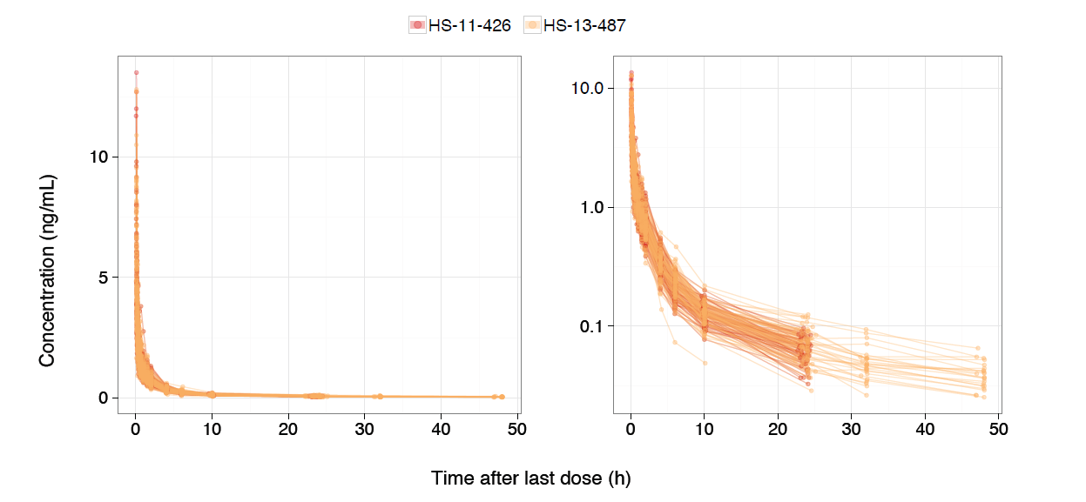

Fig. S1 Observed BPN plasma concentrations over time after IV BPN administration in the analysis data set.
Each line represents the data for one subject and is colored by the study. The left panel represents the data on a linear scale and the right panel represents the data on a semi-logarithmic scale. BPN: buprenorphine; IV: intravenous
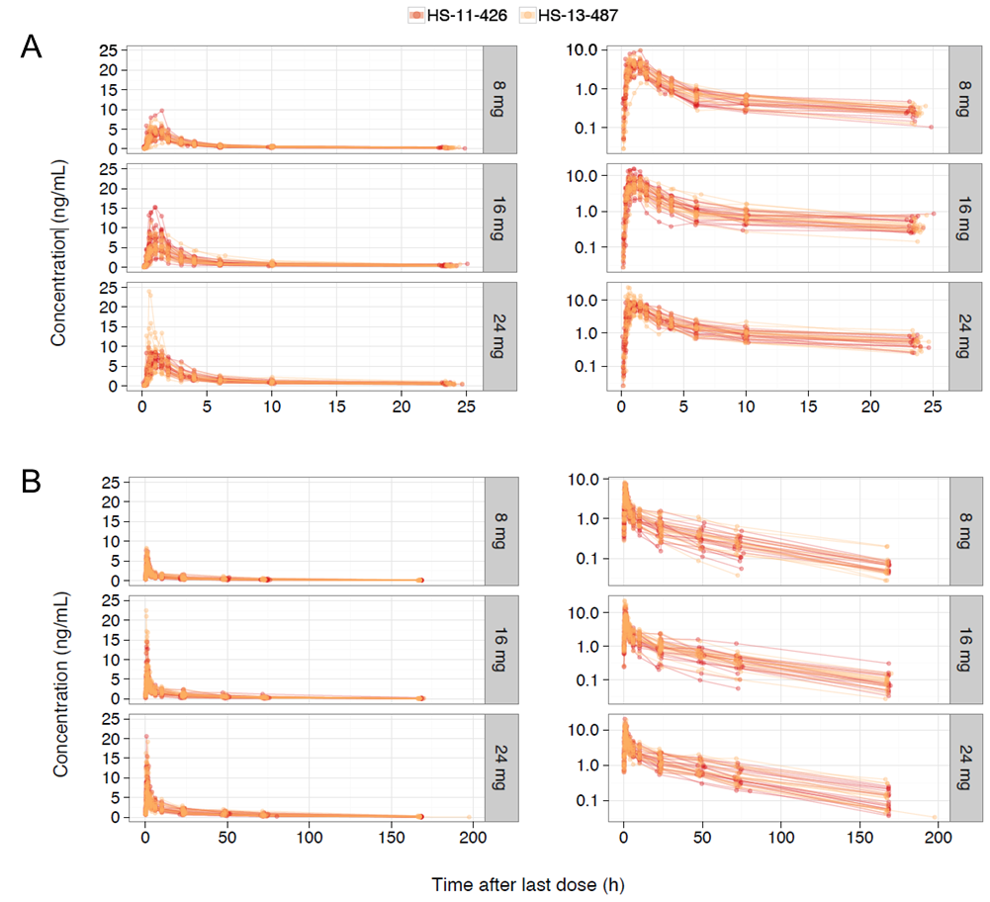

Fig. S2 Observed BPN plasma concentrations over time after (A) the first SL BPN administration and (B) repeated SL BPN administration, stratified by dose, in the analysis data set.
Each line represents the data for one subject and is colored by the study. The left panels represent the data on a linear scale and the right panels represent the data on a semi-logarithmic scale. BPN: buprenorphine; SL: sublingual
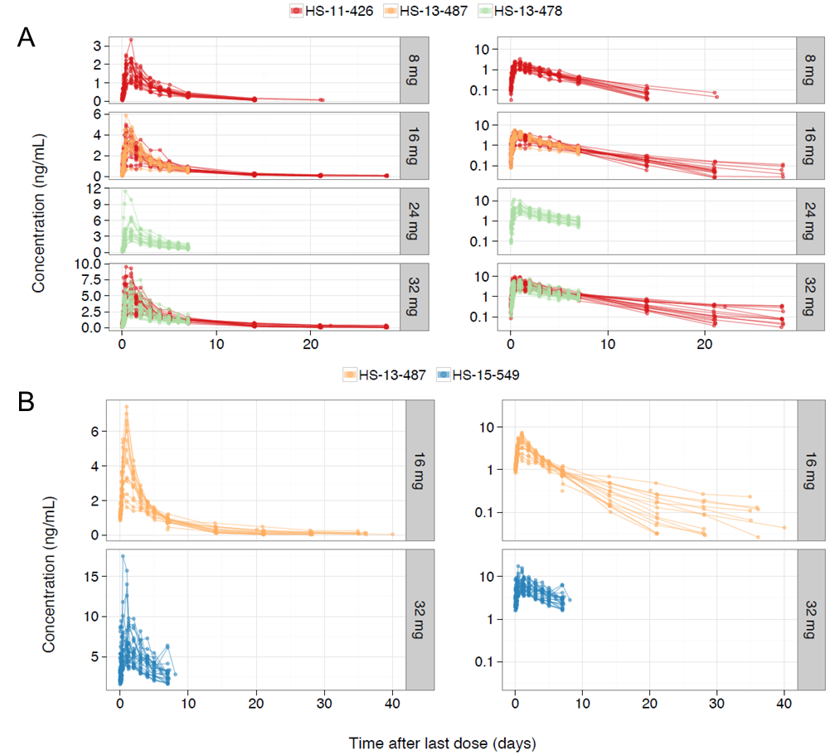

Fig. S3 Observed BPN plasma concentrations over time after (A) the first CAM2038 Q1W administration and (B) repeated CAM2038 Q1W administration, stratified by dose, in the analysis data set.
Each line represents the data for one subject and is colored by the study. The left panels represent the data on a linear scale and the right panels represent the data on a semi-logarithmic scale. BPN: buprenorphine; Q1W: once weekly
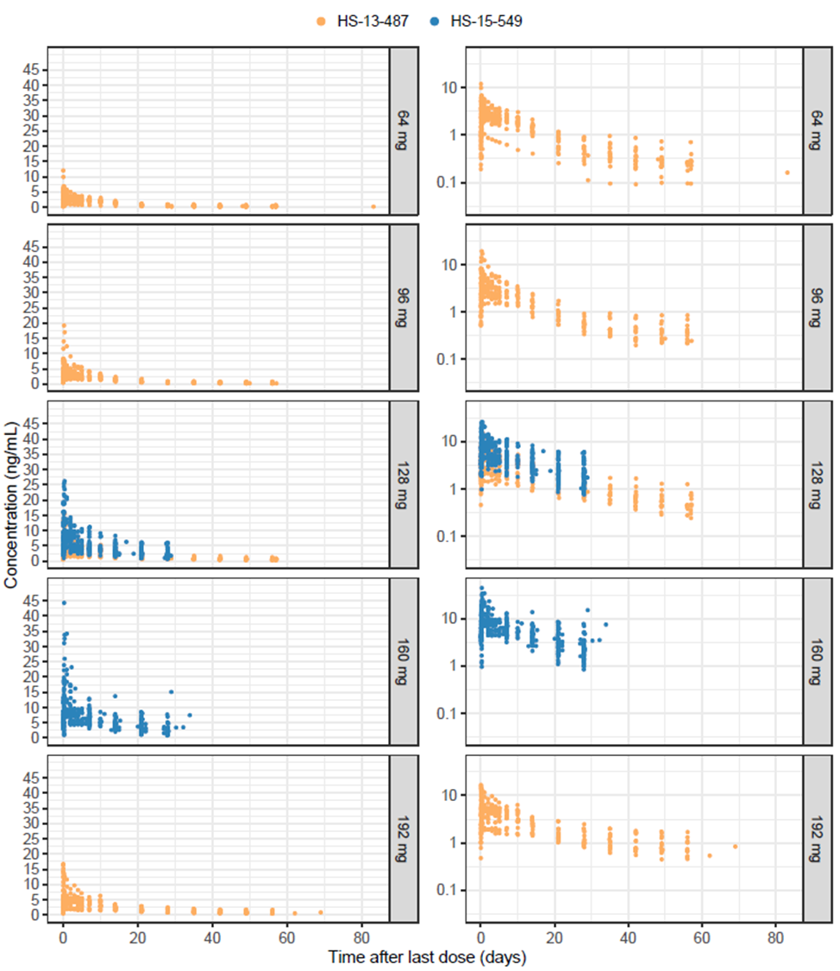

Fig. S4 Observed BPN plasma concentrations over time after first (HS-13-487) and repeated (HS-15-549) CAM2038 Q4W administration, stratified by dose, in the analysis data set.
Data points are colored by the study. The left panels represent the data on a linear scale and the right panels represent the data on a semi-logarithmic scale. BPN: buprenorphine; Q4W: once monthly

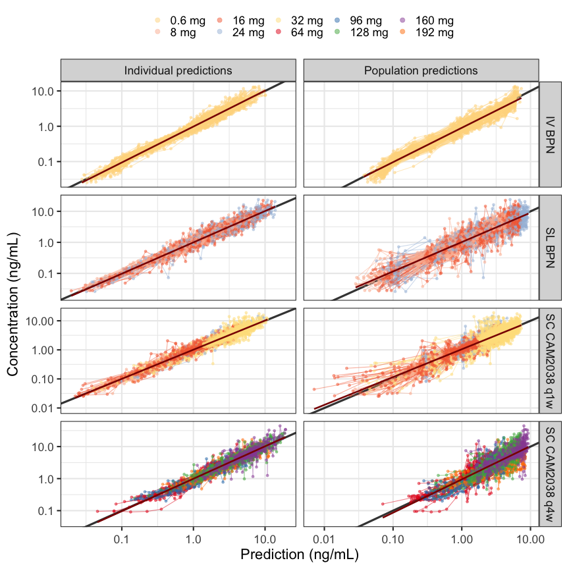
Fig. S5 Observed BPN concentrations versus PRED and IPRED for the final model.
Individual data points are indicated by dots and the points for each individual and visit are connected by a line. The points and lines are colored according to the dose. The diagonal black line is the line of identity, and the red line is a smooth. BPN: buprenorphine; IPRED: individual predications;
IV: intravenous; PRED: population predictions; q1w: once weekly; q4w: once monthly;
SC: subcutaneous; SL: sublingual

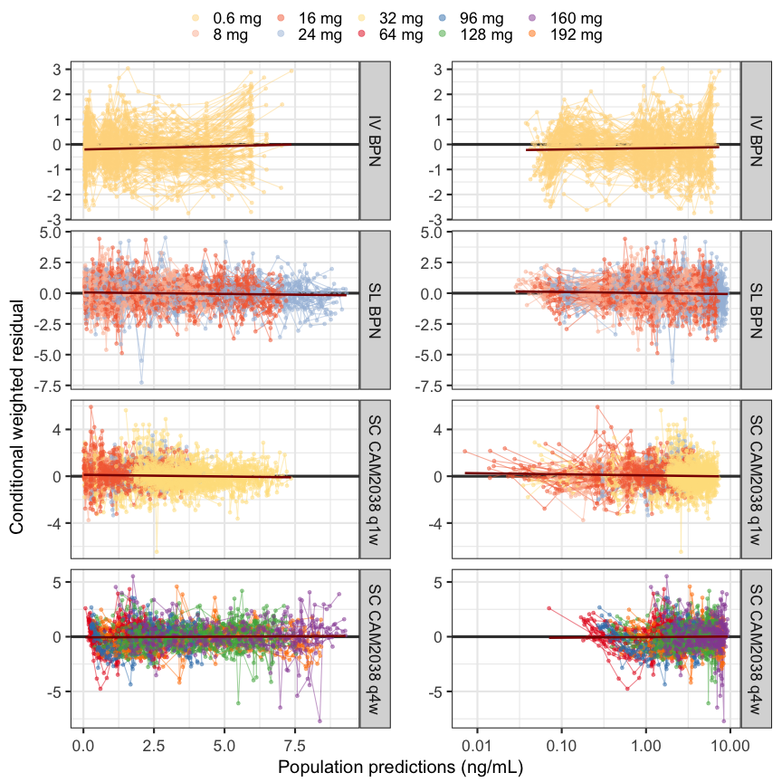
Fig. S6 CWRES versus PRED of BPN concentrations for the final model.
The left panels show the data with the time since first dose on a linear scale and the right panels show the same plot with the time since first dose on a logarithmic scale. Individual data points are indicated by dots and the points for each individual are connected with a line. The horizontal black line is the zero line, and the red line is a smooth. BPN: buprenorphine; CWRES: conditional weighted residuals; IV: intravenous; PRED: population predictions; q1w: once weekly; q4w: once monthly;
SC: subcutaneous; SL: sublingual

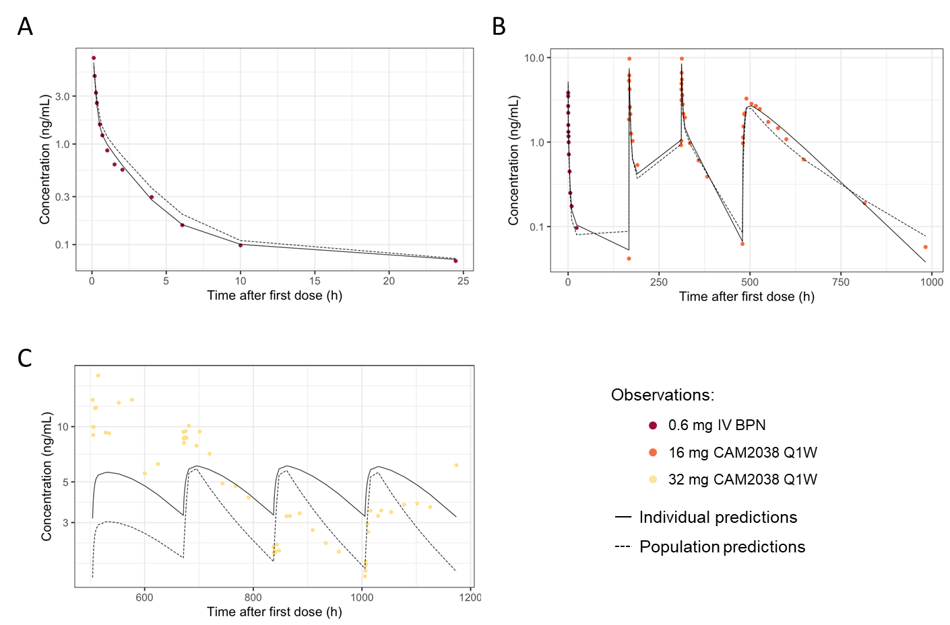

Fig. S7 BPN plasma concentrations (on a logarithmic scale) versus time for the participant with the best (A), middle (B) and worst (C) individual fit based on the RMSE CWRES using the final model. Data where time after dose (TAD) = 0 were excluded prior to ranking of individual fits. The circles represent the PK observations colored by BPN dose. The solid lines represent the IPRED and the dashed lines represent PRED. BPN: buprenorphine; CWRES: conditional weighted residuals; IPRED: individual predictions; PK: pharmacokinetic; PRED: population predictions; RMSE: root mean square error; TAD: time after dose

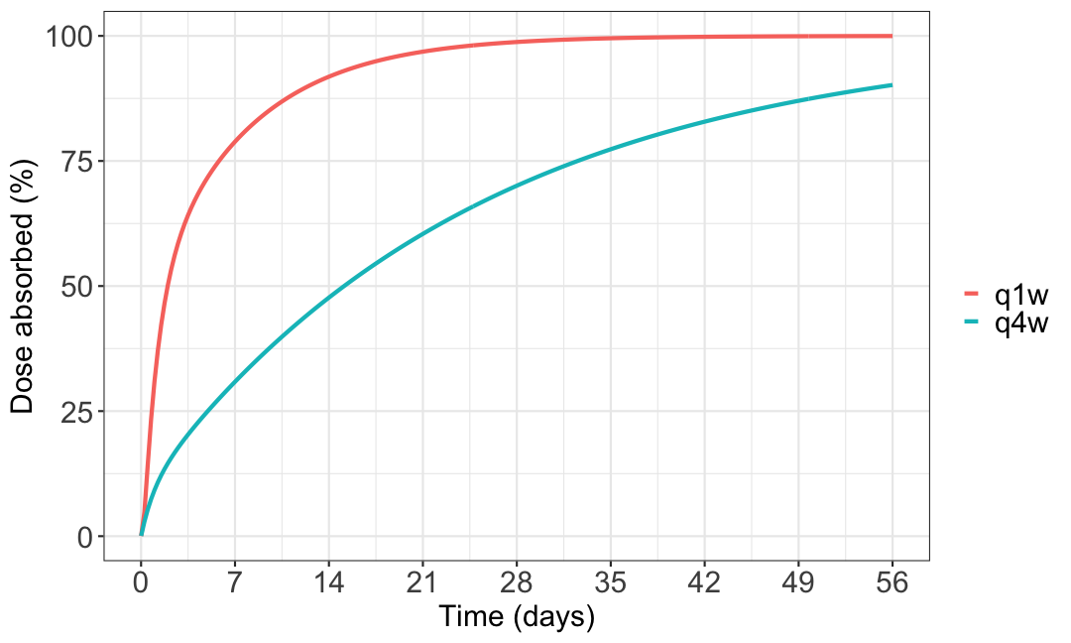

Fig. S8 Percentage of BPN absorbed over time after subcutaneous administration of CAM2038 Q1W or CAM2038 Q4W.
BPN: buprenorphine; q1w: once weekly; q4w: once monthly

