SUPPLEMENTARY DATA FILE FOR:

POPULATION PHARMACOKINETICS OF TOTAL AND UNBOUND ISAVUCONAZOLE IN CRITICALLY ILL PATIENTS: IMPLICATIONS FOR ADAPTIVE DOSING STRATEGIES
ANOUK M.E. JANSEN^{1,2*}, BEATRIJS MERTENS^{3,4}, ISABEL SPRIET^{3,4}, PAUL E. VERWEIJ^{2,5}, JEROEN SCHOUTEN⁶, JOOST WAUTERS⁷, YVES DEBAVEYE⁷, ROB TER HEINE¹, ROGER J.M. BRÜGGEMANN^{1,2}

¹ Department of Pharmacy, Radboud university medical center, Radboud Institute for Medical Innovations, Nijmegen, the Netherlands;
² Radboud university medical center-Canisius Wilhelmina Ziekenhuis Center of Expertise for Mycology, Nijmegen, The Netherlands;
³ Department of Pharmacy, University Hospitals Leuven, Leuven, Belgium;
⁴ Department of Pharmaceutical and Pharmacological Sciences, KU Leuven, Leuven, Belgium;
⁵ Department of Medical Microbiology, Radboud university medical center, Radboud Institute for Medical Innovations, Nijmegen, the Netherlands;
⁶ Department of Intensive Care, Radboud university medical center, Radboud Institute for Medical Innovations, Nijmegen, the Netherlands;
⁷ Department of Intensive Care, University Hospitals Leuven, Leuven, Belgium.
* Corresponding author at: Department of Pharmacy, Radboud university medical center, 864, PO BOX 9101, 6500 HB Nijmegen, The Netherlands. Phone: +316 15 50 57 50. E-mail: anouk.me.jansen@radboudumc.nl.
Figure S1 Goodness-of-fit plots of the final model. The dotted line represents the linear regression line for the observed data with a 95% confidence interval shown as grey shaded area. (a) observed versus population-predicted unbound isavuconazole concentrations. (b) observed versus individual-predicted unbound isavuconazole concentrations. (c) conditional weighted residuals versus time after dose for unbound isavuconazole. (d) conditional weighted residuals versus population-predicted unbound isavuconazole concentrations. (e) observed versus population-predicted total isavuconazole concentration. (f) observed versus individual-predicted total isavuconazole concentration. (g) conditional weighted residuals versus time after dose for total isavuconazole concentrations. (h) conditional weighted residuals versus population-predicted total isavuconazole concentration.
Figure S2 Measured unbound isavuconazole concentrations versus model derived unbound isavuconazole concentrations (a) and measured unbound isavuconazole concentrations versus unbound isavuconazole concentrations calculated using a fixed unbound fraction of 1% (b).
Figure S3 Box-and-whisker plots of simulated unbound (a) and total (b) isavuconazole trough concentrations (C_{min}) at day 3, 7, and 14 days of therapy. Boxes represent the median and 25th and 75th percentile, whiskers represent the range of maximum and minimum values within 1.5x the interquartile range. The dashed horizontal line represents the threshold total isavuconazole C_{min} of 2 mg/L currently recommended by international guidelines [1].
Figure S4 Box-and-whisker plots of simulated unbound (a) and total (b) isavuconazole area under the concentration-time curve (AUC) at day 3, 7, and 14 days of therapy. Boxes represent the median and 25th and 75th percentile, whiskers represent the range of maximum and minimum values within 1.5x the interquartile range. The dashed horizontal line represents the total isavuconazole AUC of 60 mg∙h/L.
Figure S1
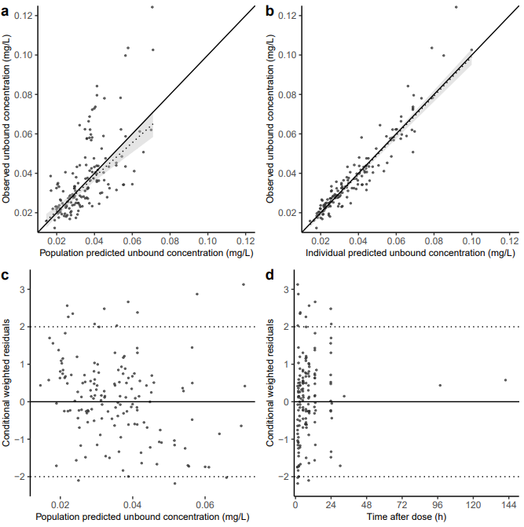
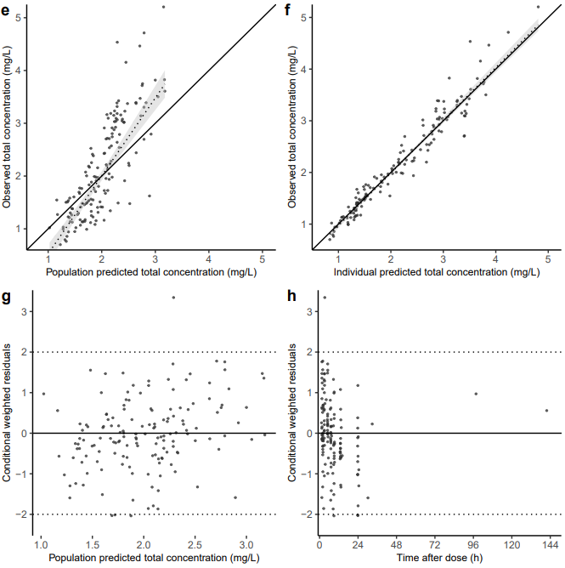
Figure S2
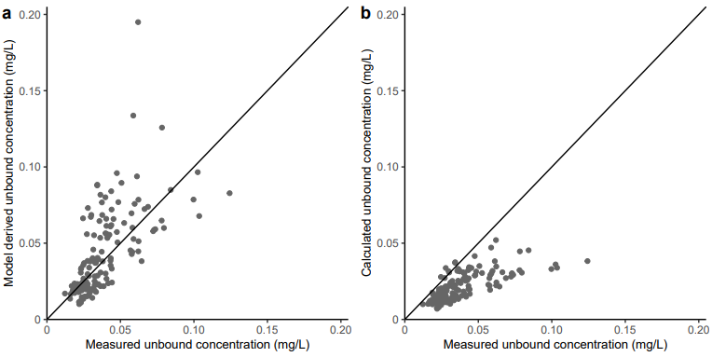

Figure S3
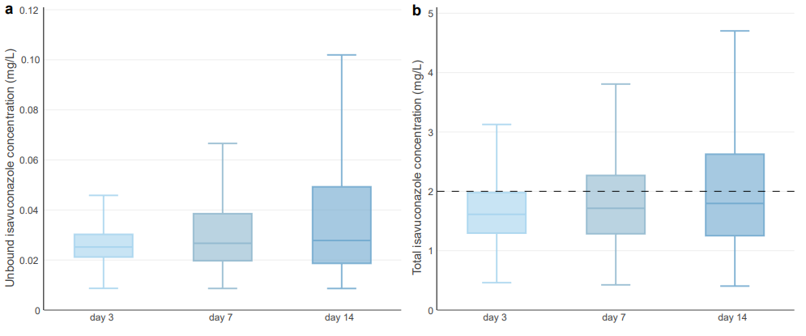

Figure S4
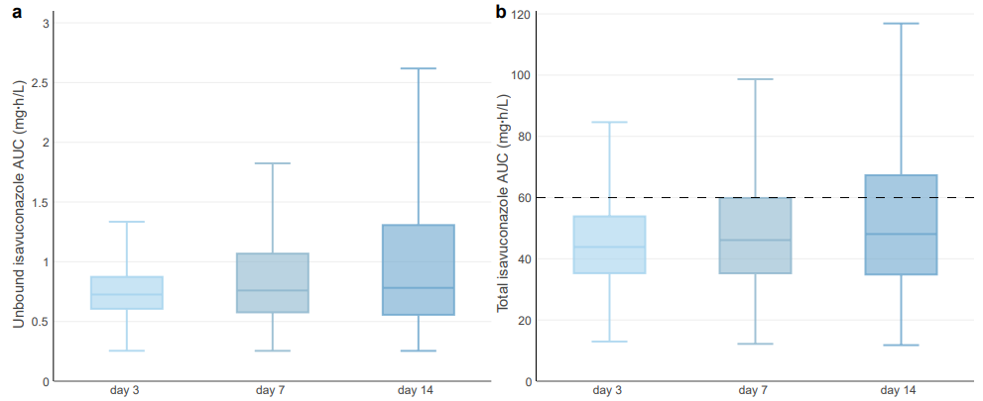

S1. DETAILS PROTEIN BINDING ANALYSIS
As described, three different protein binding models to describe the relationship between total and unbound concentrations were tested: a specific (saturable), non-specific (linear) and combined specific and non-specific protein binding model [2, 3]. The specific protein binding model is described by equations 1 and 2, where C_{bound} = C_{bound,specific}. The non-specific binding model is described by equations 1 and 3, where C_{bound} = C_{bound,non-specific}. The combined specific and non-specific binding model is described by equations 1-3, where C_{bound} = C_{bound,specific} + C_{bound,non-specific}.
- C_{total} = C_{unbound} + C_{bound}
- C_{bound,specific} = (C_{unbound} ∙ B_{max}) / (k_{d} + C_{unbound})
- C_{bound,non-specific} = k_{ns} ∙ C_{unbound}
Here, C_{total} is the total isavuconazole concentration, C_{unbound} the protein unbound isavuconazole concentration, C_{bound} the protein bound isavuconazole concentration, C_{bound,specific} the protein bound isavuconazole concentration by means of specific binding, C_{bound,non-specific} the protein bound isavuconazole concentration by means of non-specific binding, B_{max} the maximum binding capacity, k_{d} the equilibrium dissociation constant, and k_{ns} the rate constant of the non-specific protein binding.
S2. FINAL MODEL CONTROL STREAM
; --- ANOUK M.E. JANSEN, 2023
$PROBLEM ISAVUCONAZOLE TOTAL AND UNBOUND PK
$INPUT …
$DATA data.csv IGNORE=@
; --- UNITS: MILLIGRAMS, LITERS, HOURS

$SUBROUTINES ADVAN5

$MODEL
COMP=(CENTRAL)
COMP=(PERIPHERAL)
COMP=(ORAL)

$PK
; --- CALCULATION TIME AFTER DOSE
IF (NEWIND.LE.1) THEN
DOSE=0
TDOS=0
ENDIF
IF (AMT.GT.0) THEN
DOSE=AMT
TDOS=TIME
ENDIF
TAD=TIME-TDOS

; --- ALLOMETRIC SCALING FACTORS
ALLOCL = ((WT/70)**0.75)
ALLOV = ((WT/70)**1.00)

; --- TYPICAL VALUES FIXED EFFECTS
TVCL = THETA(1)
TVV = THETA(2)
TVQ = THETA(3)
TVV2 = THETA(4)

; --- TYPICAL VALUES RANDOM EFFECTS
BSVCL = ETA(1)
BSVV = ETA(2)
BSVQ = ETA(3)
BSVV2 = ETA(4)

BSVKA = ETA(5)
BSVF3 = ETA(6)
BSVD1 = ETA(7)

; --- BOX-COX TRANSFORMATION OF BSVCL
PHICL = EXP(BSVCL)
BXCL = THETA(7)
ETACL = (PHICL**BXCL-1)/BXCL

; --- PK PARAMETERS
CL = TVCL * ALLOCL * EXP(ETACL)
V = TVV * ALLOV * EXP(BSVV)
Q = TVQ * ALLOCL * EXP(BSVQ)
V2 = TVV2 * ALLOV * EXP(BSVV2)

; --- DESCRIPTION OF ABSORPTION FOR PRE-STUDY ORAL DOSING BASED ON KOVANDA ET AL. [4]
KA = 6.5 * EXP(BSVKA)
F3 = 0.974 * EXP(BSVF3)
D1 = 1 * EXP(BSVD1)

; --- SCALING
S1 = V

; --- DISTRIBUTION
K12 = Q/V
K21 = Q/V2
K10 = CL/V
K31 = KA

$ERROR
CU=F

; --- PROTEIN BINDING MODEL
TVBMAX = THETA(5)
BSVBMAX = ETA(8)
BMAX = TVBMAX * EXP(BSVBMAX)
KD = THETA(6)

CB = (BMAX*CU)/(KD+CU)
CTOT = CU+CB

; --- RESIDUAL ERROR MODEL
IF(UNB.EQ.0) IPRED = CTOT
IF(UNB.EQ.1) IPRED = CU

IF(UNB.EQ.0) Y=IPRED+IPRED*ERR(1)
IF(UNB.EQ.1) Y=IPRED+IPRED*ERR(2)

$THETA
; --- UNBOUND ISAVUCONAZOLE PK
(0, 215) ; 1. CL
(0, 2330) ; 2. V
(0, 2590) ; 3. Q
(0, 28200) ; 4. V2

; --- ISAVUCONAZOLE PROTEIN BINDING
(0, 6.64) ; 5. BMAX
0.0806 FIX ; 6. KD

; ---- BOX-COX TRANSFORMATION OF BSVCL
(-1.28) ; 7. SHAPE FACTOR BOX-COX

$OMEGA
0.771 ; 1. IIV CL
0 FIX ; 2. IIV V
0 FIX ; 3. IIV Q
0 FIX ; 4. IIV V2
0.2116 FIX ; 5. IIV KA (KOVANDA ET AL.)
0.0049 FIX ; 6. IIV F3 (KOVANDA ET AL.)
1.74 FIX ; 7. IIV D1
0.0654 ; 8. IIV BMAX

$SIGMA
0.0103 ; 1. PROP RES TOT
0.0202 ; 2. PROP RES UNB
REFERENCES
1. Ullmann AJ, Aguado JM, Arikan-Akdagli S, Denning DW, Groll AH, Lagrou K, et al. Diagnosis and management of Aspergillus diseases: executive summary of the 2017 ESCMID-ECMM-ERS guideline. Clin Microbiol Infect. 2018 May;24 Suppl 1:e1-e38.
2. Toutain PL, Bousquet-Melou A. Free drug fraction vs free drug concentration: a matter of frequent confusion. J Vet Pharmacol Ther. 2002 Dec;25(6):460-3.
3. Taira Z, Terada H. Specific and non-specific ligand binding to serum albumin. Biochem Pharmacol. 1985 Jun 1;34(11):1999-2005.
4. Kovanda LL, Marty FM, Maertens J, Desai AV, Lademacher C, Engelhardt M, et al. Impact of Mucositis on Absorption and Systemic Drug Exposure of Isavuconazole. Antimicrob Agents Chemother. 2017 Jun;61(6).

