Supplemental Information (SI)

Figure SI -1: Forecasted (x-axis) versus observed (y-axis) infliximab concentrations. The blue line indicates the trend for the data obtained using locally weighted smoothing regression (LOESS).

Figure SI -2: Log-log representation of forecasted (x-axis) versus observed (y-axis) infliximab concentrations. The blue line indicates the trend for the data obtained using locally weighted smoothing regression (LOESS).

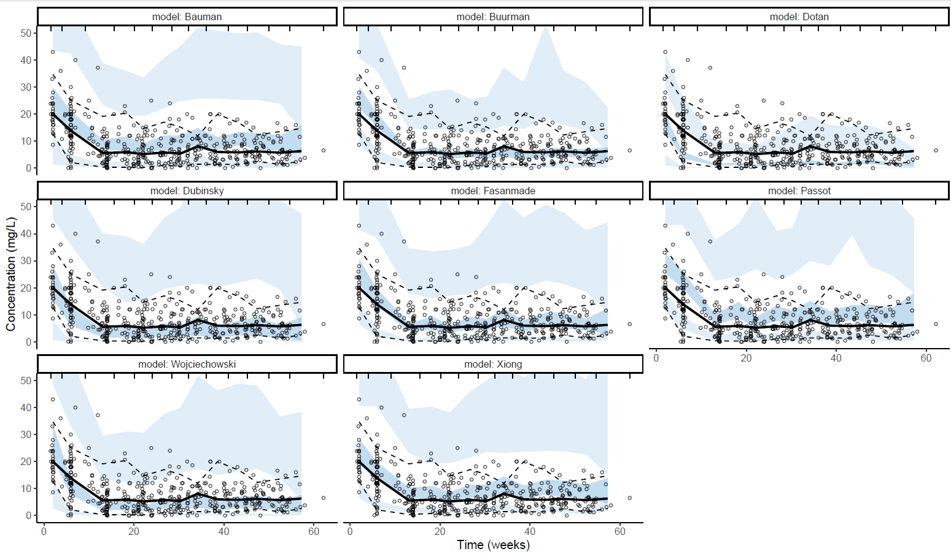
Figure SI- 3a

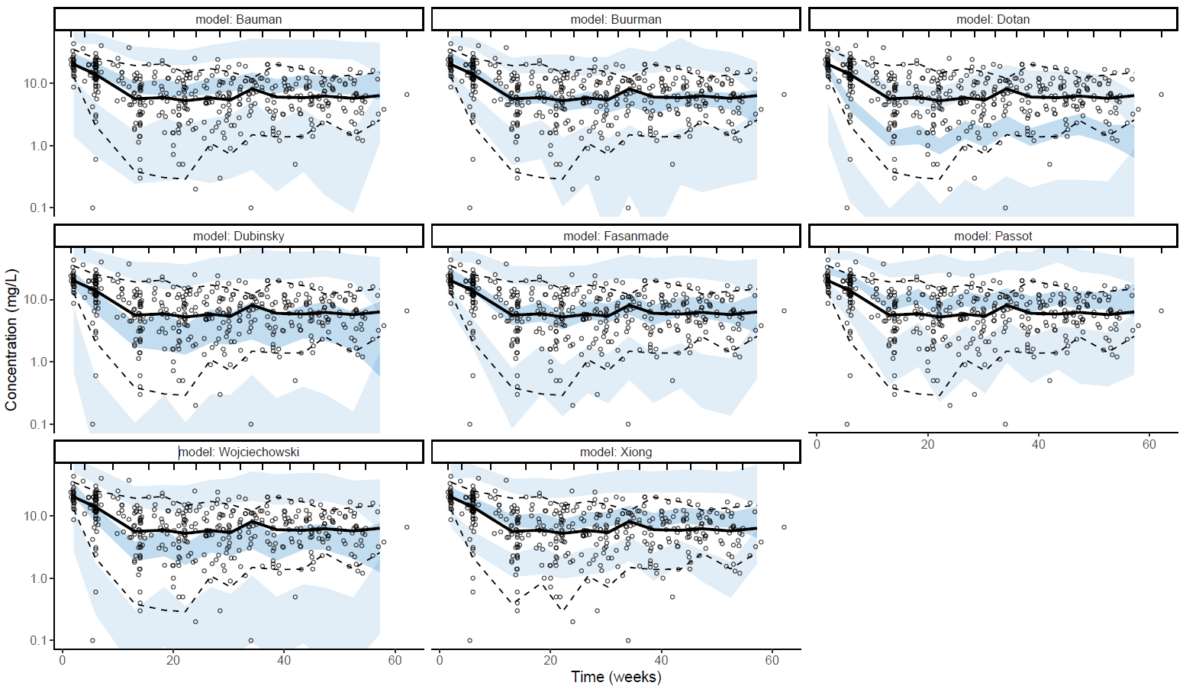
Figure SI- 3b
Comparison of visual predictive checks of population pharmacokinetics using the prior distributions of all parameters. Each VPC is presented in linear scale (a) and logarithmic scale (b). The VPCs were performed as described in the text. Solid and dashed lines indicate the median and 5th/95th percentiles for the observed data respectively. Dark and Light blue areas represent the confidence areas for the median and 5th/95th percentiles for the simulated data.

Table SI-4: Prior and posterior accuracy and precision metrics for 8 PK models in pediatric IBD patients receiving infliximab induction- and maintenance therapy
Model |  | Bias  (mg/L) | rBias  (%) | RMSE  (mg/L) | rRMSE  (%)
Bauman | Prior | -4.98 | -55.5 | 9.54 | 106.3
Bauman | Using: All previous TDM | -1.60 | -20.5 | 5.83 | 74.9
Bauman | Using: T-1 | -3.42 | -43.9 | 7.46 | 95.8
Bauman | Using: T-2 | -2.32 | -29.8 | 6.36 | 81.7
Bauman | Using: T-3 | -1.79 | -23.0 | 5.90 | 75.8
Buurman | Prior | -1.01 | -11.3 | 7.40 | 82.8
Buurman | Using: All previous TDM | 0.79 | 10.2 | 4.96 | 63.7
Buurman | Using: T-1 | 0.87 | 11.2 | 4.18 | 53.7
Buurman | Using: T-2 | 0.91 | 11.7 | 4.37 | 56.1
Buurman | Using: T-3 | 0.88 | 11.3 | 4.49 | 57.7
Dotan | Prior | 5.00 | 55.7 | 7.65 | 85.3
Dotan | Using: All previous TDM | 1.40 | 18.0 | 4.87 | 62.5
Dotan | Using: T-1 | 2.34 | 30.1 | 4.74 | 61.0
Dotan | Using: T-2 | 1.96 | 25.2 | 4.81 | 61.9
Dotan | Using: T-3 | 1.72 | 22.1 | 4.93 | 63.3
Dubinsky | Prior | -0.08 | -0.9 | 8.66 | 97.4
Dubinsky | Using: All previous TDM | 1.01 | 13.0 | 4.68 | 60.2
Dubinsky | Using: T-1 | 1.52 | 19.6 | 4.54 | 58.3
Dubinsky | Using: T-2 | 1.41 | 18.1 | 4.70 | 60.4
Dubinsky | Using: T-3 | 1.24 | 15.9 | 4.85 | 62.4
Fasanmade | Prior | -1.86 | -20.7 | 7.55 | 84.1
Fasanmade | Using: All previous TDM | 0.87 | 11.2 | 4.01 | 51.6
Fasanmade | Using: T-1 | 0.59 | 7.6 | 4.02 | 51.6
Fasanmade | Using: T-2 | 0.73 | 9.4 | 4.04 | 52.0
Fasanmade | Using: T-3 | 0.78 | 10.1 | 4.03 | 51.9
Passot | Prior | -6.77 | -75.7 | 13.63 | 152.4
Passot | Using: All previous TDM | -1.03 | -13.3 | 5.97 | 76.7
Passot | Using: T-1 | -0.53 | -6.8 | 5.61 | 72.1
Passot | Using: T-2 | -0.63 | -8.1 | 5.92 | 76.0
Passot | Using: T-3 | -0.81 | -10.5 | 6.06 | 77.9
Wojciechowski | Prior | 0.61 | 6.8 | 7.01 | 78.1
Wojciechowski | Using: All previous TDM | 1.17 | 15.1 | 4.62 | 59.4
Wojciechowski | Using: T-1 | 1.70 | 21.9 | 4.35 | 55.9
Wojciechowski | Using: T-2 | 1.56 | 20.0 | 4.57 | 58.8
Wojciechowski | Using: T-3 | 1.39 | 17.9 | 4.74 | 61.0
Xiong | Prior | 6.70 | 74.6 | 9.48 | 105.6
Xiong | Using: All previous TDM | -0.30 | -3.9 | 4.56 | 58.6
Xiong | Using: T-1 | -0.95 | -12.2 | 4.62 | 59.3
Xiong | Using: T-2 | -0.54 | -6.9 | 4.58 | 58.8
Xiong | Using: T-3 | -0.39 | -5.0 | 4.64 | 59.6
Abbreviations rBias, relative bias; RMSE, root mean square error; rRMSE, relative root mean square error; TDM, therapeutic drug monitoring
Using: All previous TDM means all available drug-levels have been used, Using:T-1 means using only the last level, or the last two levels(T-2), or the last 3 levels (T-3).

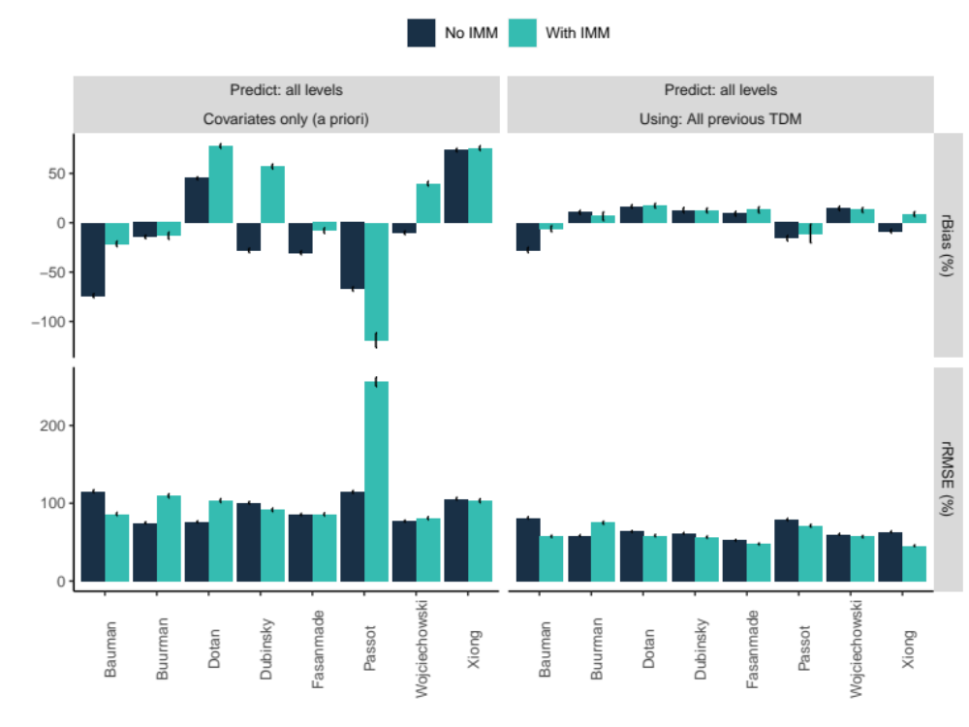
Figure SI-5: Subgroup analysis. Predictive performance of the Fasanmade model for patients who did not and for patients who did use concomitant immune modulation.

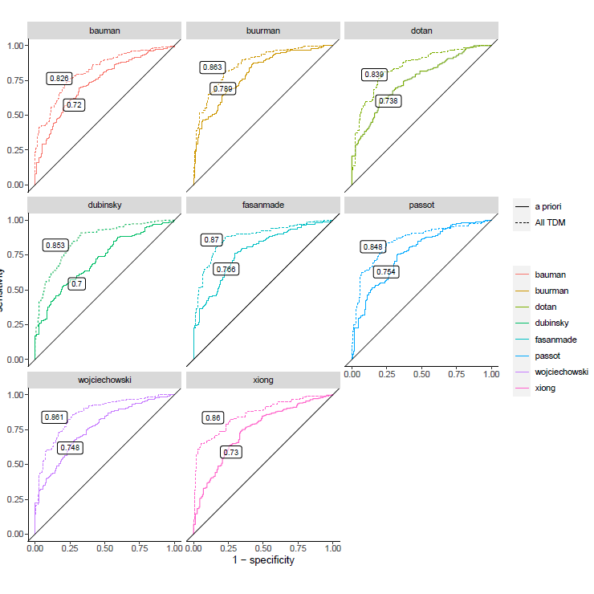
Figure SI-6: ROC curve for next IFX level ≥ 5 mg/L, for one prior and one posterior method using different models

Table SI-7: Comparison of the original populations of the 8 candidate infliximab PopPK models and the study population

Model | N | Population | IBD type | Treatment phase | Sampling time | Age | Female Sex (%) | Weight  (kg) | ALB  (g/L) | ESR  (mm/h) | IM  (%)
Study population | 77 | Children | CD,UC | Induction and maintenance | Trough | 15,2 | 50 | 50,8 | 39 | 22 | 47
Bauman (15) | 135 | Children | CD,UC | Maintenance | Trough | 14,5 | 40 | 56,3 | 37,7 | 9 | 100
Buurman (22) | 42 | Adults | CD,UC | Induction and maintenance | Trough | 44 | 53 | 75 | 41 | (CRP 5 mg/L) | 62,5
Dotan (16) | 54 | Adults | CD,UC | Induction and maintenance | Trough | 36 | 43 | 68,5 | 40 | NS | 59,3
Dubinsky (23) | 50 | Children | CD,UC | Induction and maintenance | Trough | 12,5 | 44 | (17,6 kg/m²) | 39 | (CRP 2,1 mg/L) | 22
Fasanmade _2011 children and adults (24) | 692 | Children and adults | CD | Induction, maintenance | Peak, inter-  mediate, trough | 33,6 | 55,6 | 66,7 | 40 | (WBC count [x 10 9 cells/L] 8,5 | 100
Passot (19) | 218  (79 IBD) | Children and adults | CD, UC | Induction, maintenance | Trough | NS | 65 | 67 | NS | NS | NS
Wojciechowski (18) | 788 | Children and adults | CD,UC | NS | NS | - 483 adults  - 277 children 6- 17  - 28 children ≤5 y | NS | 70 | 40 | NS | NS
Xiong (17) | 78 | Children and young adults <22 years | CD | Induction, maintenance | Peak, intermediate | 13 | 35,9 | 41 | 33 | 15 | NS
Abbreviations: ALB, serum albumin; ATI, antibodies towards infliximab; CD, Crohn’s disease; CHILD, age ≤ 15 years as binary covariate; ESR, erythrocyte sedimentation rate; IMM, immunomodulatory drugs; MAINT, maintenance phase; N, number of patients; nCD64, neutrophil cluster of differentiation 64; NS, not specified; PopPK, Population Pharmacokinetics; UC, ulcerative colitis; WT, body weight

