SUPPLEMENTARY INFORMATION

Clinical Pharmacology of the Antibody–Drug Conjugate Enfortumab Vedotin in Advanced Urothelial Carcinoma and Other Malignant Solid Tumors
Clinical Pharmacokinetics
Tang et al

Additional detail regarding adverse event frequencies by renal/hepatic function and by use of P-gp/CYP3A inhibitors, pharmacokinetic comparisons for Asian versus non-Asian patients and Japanese versus non-Japanese Asian patients, predicted effects of enfortumab vedotin on dQTcF interval, and recommended enfortumab vedotin dose reduction guidelines for adverse events are provided in the following tables and figures.

Online Resource 1 Summary of AEs by Renal Functionª
AE | EV-301, enfortumab vedotin group (N=296) |  |  |  | Enfortumab vedotin 1.25 mg/kg (N=680)
AE | Severe insufficiency  (n=4) | Moderate insufficiency (n=133) | Mild insufficiency  (n=105) | Normal  (n=48) | Severe insufficiency  (n=21) | Moderate insufficiency (n=295) | Mild insufficiency  (n=245) | Normal  (n=112)
TEAE | 4 (100) | 130 (97.7) | 104 (99.0) | 48 (100) | 21 (100) | 292 (99.0) | 244 (99.6) | 111 (99.1)
Treatment-related TEAE | 4 (100) | 123 (92.5) | 102 (97.1) | 45 (93.8) | 21 (100) | 275 (93.2) | 232 (94.7) | 106 (94.6)
Serious TEAE | 1 (25.0) | 61 (45.9) | 54 (51.4) | 18 (37.5) | 9 (42.9) | 134 (45.4) | 112 (45.7) | 46 (41.1)
Treatment-related serious TEAE | 1 (25.0) | 27 (20.3) | 29 (27.6) | 8 (16.7) | 4 (19.0) | 54 (18.3) | 52 (21.2) | 20 (17.9)
TEAE with CTCAE grade ≥3 | 4 (100) | 97 (72.9) | 72 (68.6) | 34 (70.8) | 19 (90.5) | 208 (70.5) | 164 (66.9) | 73 (65.2)
Treatment-related TEAE with CTCAE grade ≥3 | 4 (100) | 73 (54.9) | 50 (47.6) | 22 (45.8) | 13 (61.9) | 155 (52.5) | 108 (44.1) | 52 (46.4)
Values are n (%). Data (ie, renal function) for some patients were missing.
AE, adverse event; CTCAE, Common Terminology Criteria for Adverse Event.
ªCreatinine clearance: severe, 15 to <30 mL/min; moderate, 30 to <60 mL/min; mild, 60 to <90 mL/min; normal, ≥90 mL/min.

Online Resource 2 Summary of AEs by Hepatic Functionª
AE | EV-301, enfortumab vedotin (N=296) |  | Enfortumab vedotin 1.25 mg/kg (N=680)^{b}
AE | Mild hepatic impairment  (n=28) | Normal  (n=256) | Mild hepatic impairment  (n=63) | Normal  (n=603)
TEAE | 26 (92.9) | 254 (99.2) | 61 (96.8) | 600 (99.5)
Treatment-related TEAE^{c} | 24 (85.7) | 244 (95.3) | 56 (88.9) | 571 (94.7)
SAE^{d} | 15 (53.6) | 116 (45.3) | 30 (47.6) | 268 (44.4)
Treatment-related^{c} SAE^{d} | 9 (32.1) | 54 (21.1) | 12 (19.0) | 115 (19.1)
TEAE with CTCAE grade ≥3 | 19 (67.9) | 183 (71.5) | 45 (71.4) | 414 (68.7)
Treatment-related^{c} TEAE with CTCAE grade ≥3 | 14 (50.0) | 132 (51.6) | 29 (46.0) | 296 (49.1)
Values are n (%). Data (ie, hepatic function) for some patients were missing.
AE, adverse event; AST, aspartate aminotransferase; CTCAE, Common Terminology Criteria for Adverse Events; SAE, serious AE; TEAE, treatment-emergent AE; ULN, upper limit of normal.
ªMild impairment, (any AST and total bilirubin >1 to ≤1.5× ULN) or (AST >ULN and total bilirubin ≤ULN); normal, total bilirubin and AST ≤ULN.
^{b}Comprised of clinical trials (EV-101, EV-102, EV-201, and EV-301) of enfortumab vedotin monotherapy and includes 680 unique patients who received enfortumab vedotin 1.25 mg/kg.
^{c}A reasonable possibility that the event could have been caused by the study drug as assessed by the investigator. If relationship was missing, then it was considered to be treatment related.
^{d}Included SAEs upgraded by the sponsor based on review of the sponsor’s list of Always Serious Terms if any upgrade was done. This upgrade was not applicable for the EV-201 study.

Online Resource 3 Summary of AEs by Use of Concomitant P-Glycoprotein Inhibitor
 | Study EV-301 enfortumab vedotin  (N=296) |  | Enfortumab vedotin 1.25 mg/kg  (N=680)
AE | Yes  (n=184) | No  (n=112) | Yes  (n=449) | No  (n=231)
TEAE | 182 (98.4) | 108 (96.4) | 447 (99.6) | 226 (97.8)
Treatment-relatedª TEAE | 174 (94.6) | 104 (92.9) | 424 (94.4) | 215 (93.1)
SAE^{b} | 97 (52.7) | 41 (36.6) | 229 (51.0) | 77 (33.3)
Treatment-relatedª SAE^{b} | 52 (28.3) | 15 (13.4) | 109 (24.3) | 23 (10.0)
TEAE with CTCAE grade ≥3 | 140 (76.1) | 70 (62.5) | 339 (75.5) | 129 (55.8)
Treatment-relatedª TEAE with CTCAE grade ≥3 | 105 (57.1) | 47 (42.0) | 255 (56.8) | 77 (33.3)
Values are n (%).
AE, adverse event; CTCAE, Common Terminology Criteria for Adverse Events; SAE, serious AE; TEAE, treatment-emergent AE.
ªA reasonable possibility that the event could have been caused by the study drug as assessed by the investigator. If relationship was missing, then it was considered to be drug related.
^{b}Included SAEs upgraded by sponsor based on review of sponsor’s list of Always Serious Terms if any upgrade was performed. This upgrade was not applicable to the EV-201 study.

Online Resource 4 Summary of AEs by Use of CYP3A Inhibitor
AE | Study EV-301 enfortumab vedotin  (N=296) |  |  |  | Enfortumab vedotin 1.25 mg/kg  (N=680)
AE | Strong CYP3A inhibitor  (n=1) | Moderate CYP3A inhibitor (n=55) | Mild CYP3A inhibitor (n=67) | No CYP3A inhibitor  (n=173) | Strong CYP3A inhibitor  (n=9) | Moderate CYP3A inhibitor (n=136) | Mild CYP3A inhibitor (n=188) | No CYP3A inhibitor  (n=347)
TEAE | 1 (100) | 55 (100) | 65 (97.0) | 169 (97.7) | 9 (100) | 136 (100) | 186 (98.9) | 342 (98.6)
Treatment-relatedª TEAE | 1 (100) | 55 (100) | 62 (92.5) | 160 (92.5) | 9 (100) | 132 (97.1) | 174 (92.6) | 324 (93.4)
SAE^{b} | 1 (100) | 38 (69.1) | 32 (47.8) | 67 (38.7) | 6 (66.7) | 86 (63.2) | 90 (47.9) | 124 (35.7)
Treatment-relatedª SAE^{b} | 1 (100) | 19 (34.5) | 16 (23.9) | 31 (17.9) | 4 (44.4) | 39 (28.7) | 39 (20.7) | 50 (14.4)
TEAE with CTCAE grade ≥3 | 1 (100) | 51 (92.7) | 43 (64.2) | 115 (66.5) | 8 (88.9) | 115 (84.6) | 128 (68.1) | 217 (62.5)
Treatment-relatedª TEAE with CTCAE grade ≥3 | 1 (100) | 38 (69.1) | 34 (50.7) | 79 (45.7) | 9 (88.9) | 84 (61.8) | 96 (51.1) | 144 (41.5)
Values are n (%).
AE, adverse event; CTCAE, Common Terminology Criteria for Adverse Events; CYP3A, cytochrome P450 3A; SAE, serious AE; TEAE, treatment-emergent AE.
ªA reasonable possibility that the event could have been caused by the study drug as assessed by the investigator. If relationship was missing, then it was considered to be drug related.
^{b}Included SAEs upgraded by sponsor based on review of sponsor’s list of Always Serious Terms if any upgrade was performed. This upgrade was not applicable to the EV-201 study.

Online Resource 5 Statistical Comparisons of Enfortumab Vedotin and Free MMAE Exposures by Asian vs Non-Asian Patients
Analyte | Racial comparison (test/ref) | Parameter | Ref |  | Test |  | Test/Ref, %
Analyte | Racial comparison (test/ref) | Parameter | N | Geometric LS mean | N | Geometric LS mean | Geometric LS mean ratio | 90% CI of ratio
Enfortumab vedotin | Asian/Non-Asianª | AUC_{0–28d}, d•μg/mL | 537 | 99.5 | 158 | 88.8 | 89.2 | 84.2–94.5
Enfortumab vedotin | Asian/Non-Asianª | C_{max}, μg/mL | 537 | 27 | 158 | 25.2 | 93.1 | 90.2–96.1
Enfortumab vedotin | Asian/Non-Asianª | C_{trough}, μg/mL | 537 | 0.19 | 158 | 0.194 | 102.0 | 88.5–118.0
Free MMAE | Asian/Non-Asianª | AUC_{0–28d}, d•ng/mL | 537 | 64.3 | 158 | 58.2 | 90.5 | 83.3–98.3
Free MMAE | Asian/Non-Asianª | C_{max}, ng/mL | 537 | 4.61 | 158 | 4.21 | 91.3 | 85.0–98.2
Free MMAE | Asian/Non-Asianª | C_{trough}, ng/mL | 537 | 0.398 | 158 | 0.382 | 95.9 | 82.0–112.0
Geometric mean ratio (90% CI) calculated from individual model-predicted cycle 1 exposures after enfortumab vedotin 1.25 mg/kg administered on days 1, 8, and 15 of a 28-d cycle (capped at 125 mg for body weights >100 kg).
AUC_{0-28d}, area under the concentration-time curve from time 0 to 28 d; C_{max}, maximum concentration; C_{trough}, trough concentration; LS, least squares; MMAE, monomethyl auristatin E.
ªAnalysis excluded 53 participants with unknown race information when compared by race, resulting in 695 participants when exposures were evaluated by race.

Online Resource 6 Concentration profiles after enfortumab vedotin 1.0 mg/kg and 1.25 mg/kg dosing at cycle 1 in Japanese and non-Japanese patients: (A) mean (SD) concentration profiles of enfortumab vedotin and (B) mean (SD) concentration profiles of MMAE.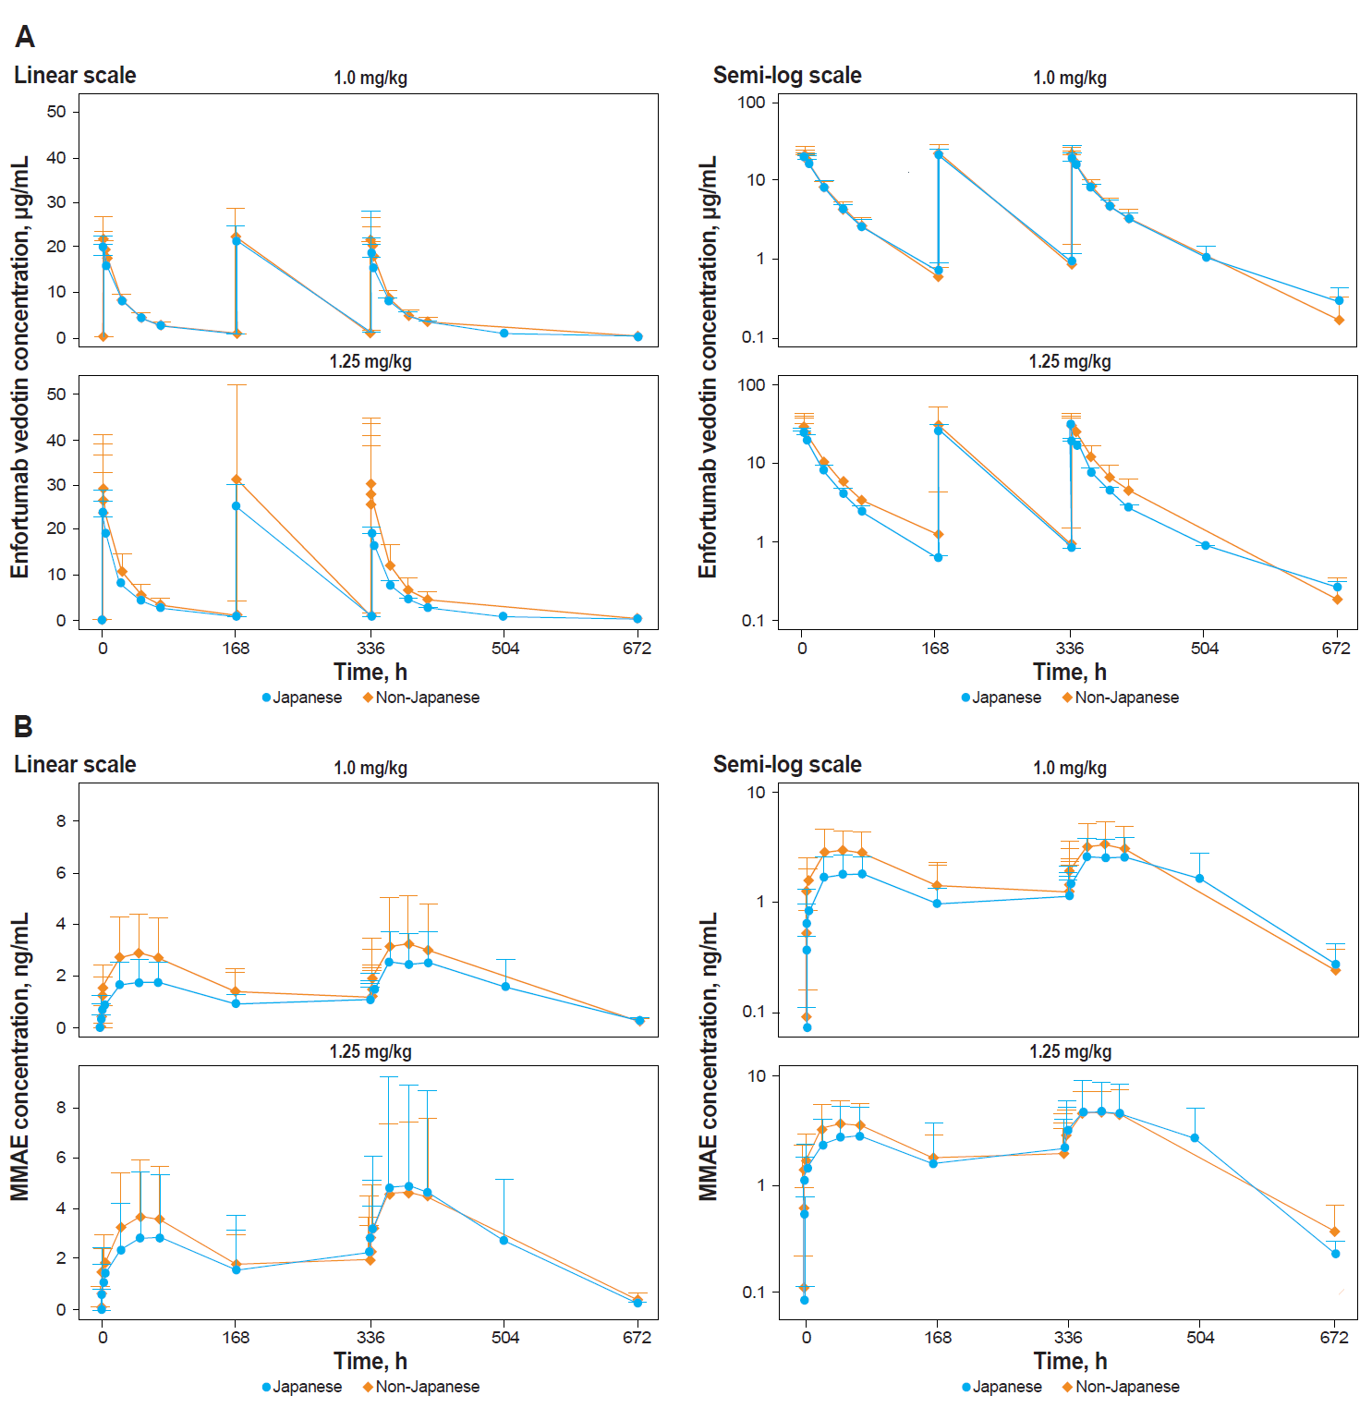
MMAE, monomethyl auristatin E.

Online Resource 7 Box plots of dose-normalized pharmacokinetic parameters of enfortumab vedotin: (A) AUC_{7d} and (B) C_{max,} Japanese versus non-Japanese Asian patients.

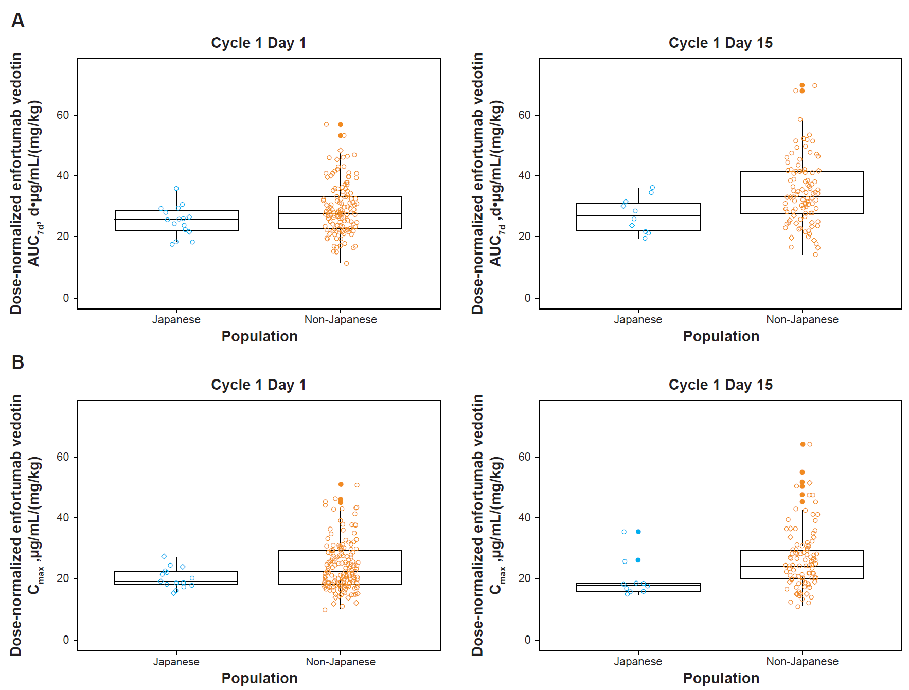
AUC_{7d}, area under the concentration-time curve from time of dosing to 168 h after dosing; C_{max}, maximum concentration.

Online Resource 8 Box plots of dose-normalized pharmacokinetic parameters of MMAE: (A) AUC_{7d} and (B) C_{max}, Japanese versus non-Japanese Asian patients.

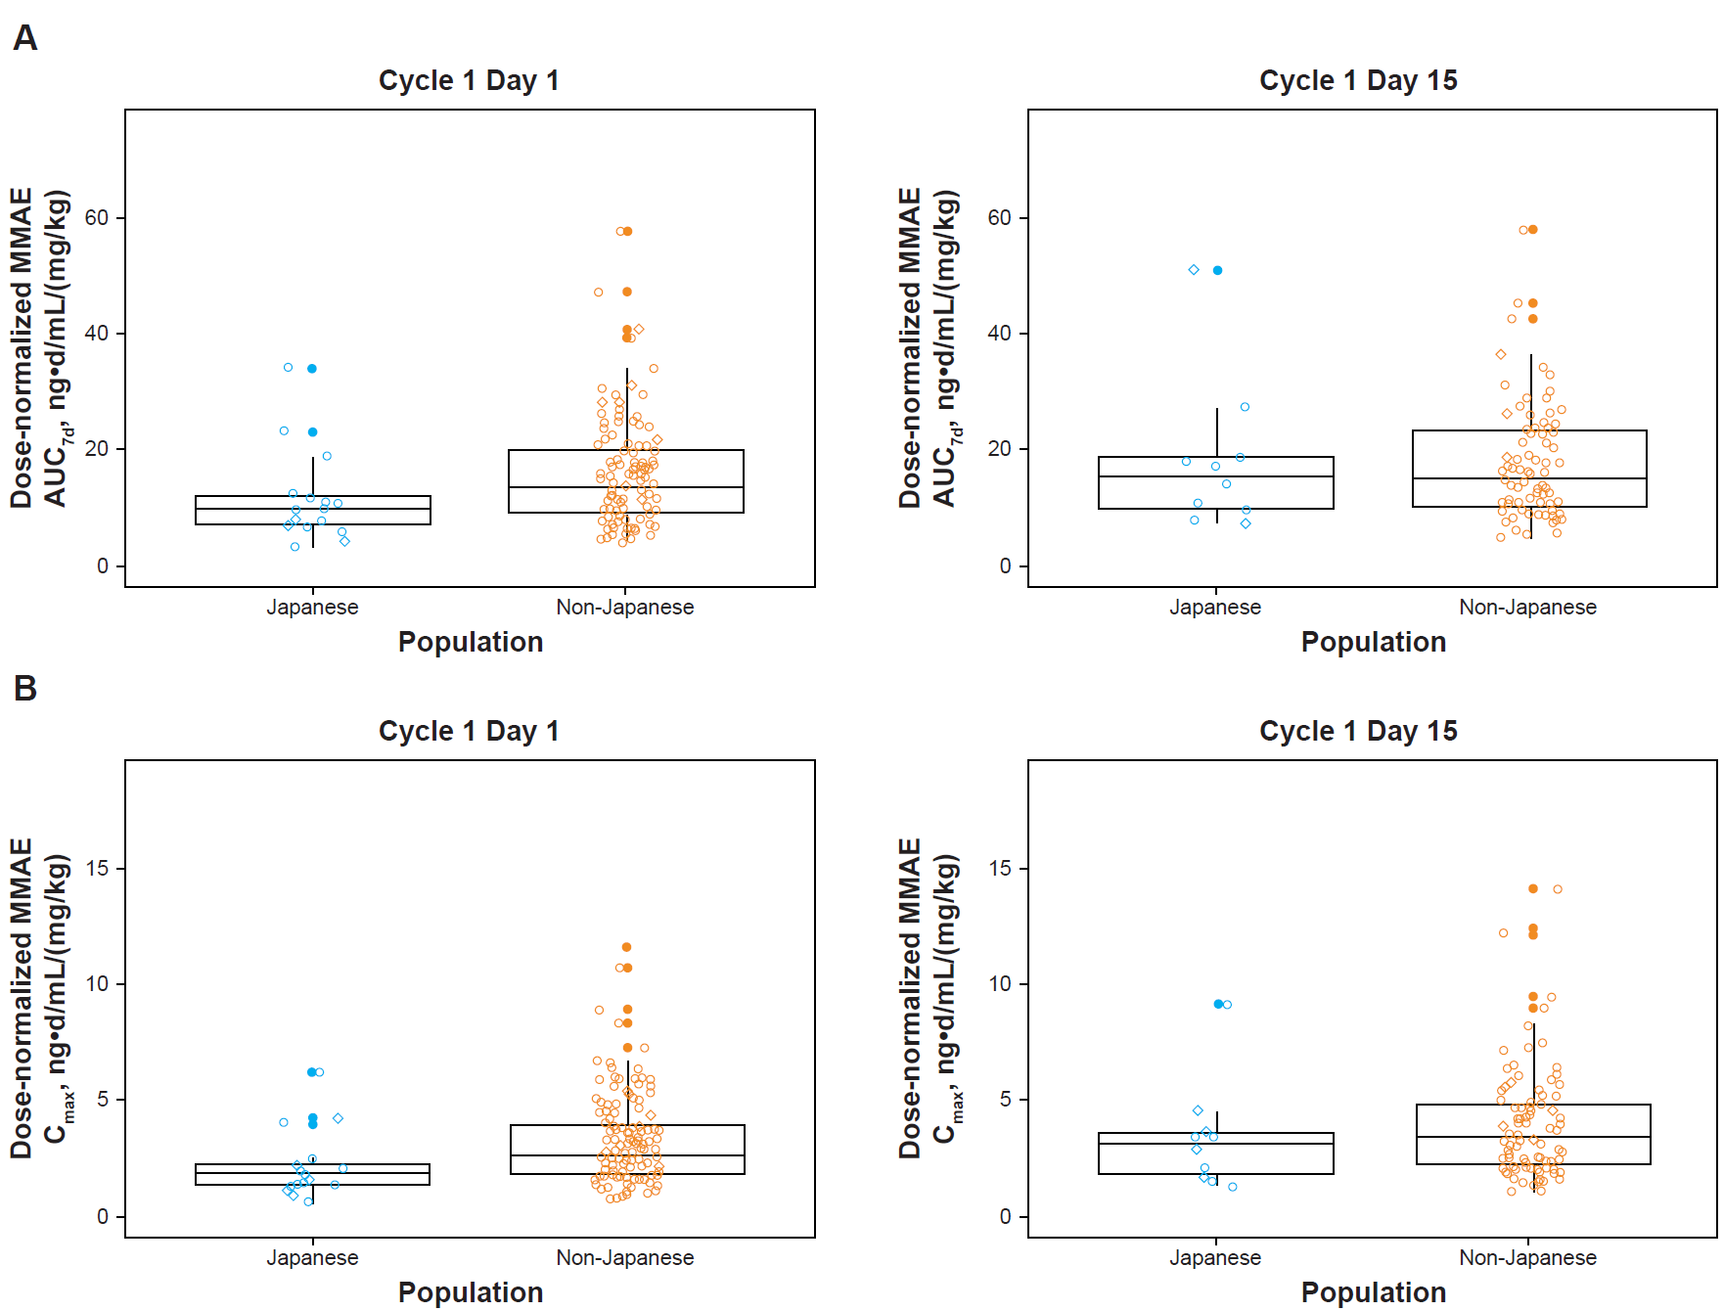
AUC_{7d}, area under the concentration-time curve from time of dosing to 168 h after dosing; C_{max}, maximum concentration; MMAE, monomethyl auristatin E.

Online Resource 9 Geometric Mean Ratios of Pharmacokinetic Parameters for Enfortumab Vedotin and MMAE Between Japanese and Non-Japanese Patients (Linear Mixed-Effects Model)
Parameter | Comparisonª | Geometric mean ratio (90% CI)
Enfortumab vedotin
AUC_{7d} | Japanese (n=16) vs non-Japanese (n=139) | 0.909 (0.802–1.029)
C_{max} | Japanese (n=17) vs non-Japanese (n=140) | 0.925 (0.802–1.068)
MMAE
AUC_{7d} | Japanese (n=16) vs non-Japanese (n=133) | 0.832 (0.667–1.037)
C_{max} | Japanese (n=16) vs non-Japanese (n=143) | 0.730 (0.583–0.914)
AUC_{7d}, area under the concentration-time curve from time of dosing to 168 h after dosing; C_{max}, maximum concentration; MMAE, monomethyl auristatin E.
ªNon-Japanese patients represent the ref population.

Online Resource 10 Predicted Effects of Enfortumab Vedotin and MMAE on dQTcF Intervals at Geometric Mean C_{max} at 1.25 mg/kg
Analyte | C_{max} geometric meanª | Predicted dQTcF interval, ms
Analyte | C_{max} geometric meanª | Mean (SE) | Mean 90% CI
Enfortumab vedotin | 20.1 μg/mL | 6.17 (2.53) | 1.83 to 10.5
MMAE | 3.94 ng/mL | −3.14 (7.22) | −15.8 to 9.52
C_{max}, maximum concentration; dQTcF, change from baseline in QTcF; MMAE, monomethyl auristatin E; QTcF, corrected QT interval by Fridericia formula.
ªAfter the third dose during cycle 1 day 15.

Online Resource 11 Recommended Enfortumab Vedotin Dose Reduction Schedule for Adverse Events
Parameter | Dose level
Starting dose | 1.25 mg/kg, ≤125 mg
First dose reduction | 1.0 mg/kg, ≤100 mg
Second dose reduction | 0.75 mg/kg, ≤75 mg
Third dose reduction | 0.5 mg/kg, ≤50 mg

