Supplementary Information
Clinical Pharmacokinetics
Population Pharmacokinetics of Inotuzumab Ozogamicin in Pediatric Relapsed/Refractory B-Cell Precursor Acute Lymphoblastic Leukemia: results of study ITCC-059

Author: Jen-Hao Wu (1,2)*, Edoardo Pennesi (1,2)*, Francisco Bautista (2), May Garrett (3), Kei Fukuhara (4), Erica Brivio (1,2), Anneke C J Ammerlaan (1,2), Franco Locatelli (5), Inge M van der Sluis (1,2), Claudia Rossig (6), Christiane Chen-Santel (7), Bella Bielorai (8), Arnaud Petit (9), Jan Starý (10), Cristina Díaz-de-Heredia (11), Susana Rives (12,13), Aengus O'Marcaigh (14), Carmelo Rizzari (15), Gernot Engstler (16), Karsten Nysom (17), Alba Rubio-San-Simón (18), Benedicte Bruno (19), Yves Bertrand (20), Benoît Brethon (21), Fanny Rialland (22), Geneviève Plat (23), Uta Dirksen (24), Lucie Sramkova (25), C. Michel Zwaan (1,2)†, Alwin D.R. Huitema (2,26,27)†
*Shared first authorship; †Shared last authorship
Institution: (1) Department of Pediatric Oncology, Erasmus MC-Sophia Children’s Hospital, Rotterdam, the Netherlands; (2) Princess Máxima Center for Pediatric Oncology, Utrecht, the Netherlands; (3) Pfizer Global Pharmacometrics, San Diego, CA, USA; (4) Pfizer R&D Japan, Tokyo, Japan; (5) Department of Hematology, Oncology and of Cell and Gene Therapy, IRCCS Ospedale Pediatrico Bambino Gesú, Catholic University of the Sacred Heart, Rome, Italy; (6) Pediatric Hematology and Oncology, University Children's Hospital Muenster, Muenster, Germany; (7) Department of Pediatrics, Division of Oncology and Hematology, Charité – Universitätsmedizin Berlin, German Cancer Consortium (DKTK) site Berlin, National Center for Tumordiseases (NCT) site Berlin, Berlin, Germany; (8) Division of Pediatric Hematology and Oncology, Sheba Medical Center, Ramat-Gan, Israel; (9) Department of pediatric Hematology and Oncology, Hopital Armand Trousseau, APHP, Sorbonne Université, Paris, France; (10) Department of Pediatric Hematology and Oncology, University Hospital Motol, Prague, Czech Republic; (11) Division of Pediatric Hematology and Oncology. Hospital Universitari Vall d'Hebron, Barcelona, Spain; Institut de Recerca Vall d’Hebron (VHIR), Barcelona, Spain; (12) Pediatric Oncology and Hematology Department, Hospital Sant Joan de Déu de Barcelona, Barcelona, Spain; (13) Institut de Recerca Sant Joan de Déu, Barcelona, Spain; (14) Children’s Health Ireland at Crumlin, Dublin, Ireland; (15) Pediatric Hematology-Oncology Unit, Department of Pediatrics, IRCCS Foundation San Gerardo dei Tintori, Monza and University of Milano-Bicocca, Monza, Italy; (16) St Anna Children's Hospital, Medical University of Vienna, Vienna, Austria; (17) Department of Paediatrics and Adolescent Medicine, Copenhagen University Hospital–Rigshospitalet, Copenhagen, Denmark; (18) Department of Pediatric Oncology and Hematology, Hospital Niño Jesús, Madrid, Spain; (19) Pediatric Hematology, Hôpital Jeanne de Flandre, CHRU de Lille, Lille, France; (20) Institute of Pediatric Hematology and Oncology, Civil Hospital of Lyon, Claude Bernard University, Lyon, France; (21) Department of Pediatric Hematology, Hôpital Robert-Debré, Assistance Publique-Hôpitaux de Paris, Paris, France; (22) Service Onco-Hématologie Pédiatrique, Hôpital Mère-Enfant, Nantes University Hospital, Nantes, France; (23) Service d’Hématologie-Immunologie-Oncologie, Hôpital des Enfants, CHU Toulouse, Toulouse, France; (24) Pediatrics III, University Hospital Essen, German Cancer Consortium (DKTK) site Essen, National Center for Tumordiseases (NCT) site Essen, Essen, Germany; (25) Department of Paediatric Haematology and Oncology, 2nd Faculty of Medicine, Charles University in Prague and Motol University Hospital, Prague, Czech Republic; (26) Department of Pharmacy & Pharmacology, Netherlands Cancer Institute, Amsterdam, the Netherlands; (27) Department of Clinical Pharmacy, University Medical Center Utrecht, Utrecht, The Netherlands

Corresponding author: Prof. C. Michel Zwaan
Email: c.m.zwaan-2@prinsesmaximacentrum.nl
ORCHID: 0000 – 0001 – 6892 – 8268

Supplementary Table 1: Inclusion/exclusion criteria
Inclusion criteria
Age | - Patients must be ≥ 1 and < 18 years of age at the time of enrollment
Diagnosis | Patients must have either  - First relapse of BCP-ALL post allogeneic HSCT  - Second or greater relapsed or refractory BCP-ALL  - Refractory disease, defined as newly diagnosed patients who are induction failures after at least 2 previous regimens without attainment of remission, or patients with refractory first relapse after 1 previous reinduction regimen without attainment of remission  AND must meet the following criteria:  - M2 or M3 marrow status (≥ 5% blasts by morphology)  - The malignant clone needs to be CD22 surface antigen positive (in either the bone marrow or peripheral blood) by institutional standards as determined by the local immunophenotyping laboratory  - The first 6 patients must have M3 marrow status (≥ 25% blasts by morphology)
Performance level and life expectancy | - Karnofsky > 60% (>16 years of age) and Lansky > 60% (≤ 16 years of age)  - A life expectancy of at least 6 weeks
Prior Therapy | Patients must have fully recovered from the acute toxic effects of all prior chemotherapy, immunotherapy, or radiotherapy defined as resolution of all such non-hematologic toxicities to ≤ Grade 2 per the CTCAE 4.03 prior to entering this study  - Chemotherapy: At least 7 days since the completion of cytotoxic therapy, with the exception of hydroxyurea, 6-mercaptopurine and steroids which are permitted up until 48 hours prior to initiating protocol therapy  - Radiotherapy: At least 28 days since any prior radiation therapy  - Hematopoietic Stem Cell Transplant: At least 90 days since previous allo-HSCT. Patient must have no evidence of active graft vs. host disease. Patient must not be receiving GVHD prophylaxis or treatment.  - Hematopoietic growth factors: At least 7 days since the completion of therapy with GCSF or other growth factors. At least 14 days since the completion of therapy with pegfilgrastim (Neulasta®).  - Immunotherapy: At least 42 days since the completion of any type of immunotherapy, e.g. CART therapy. Patients may not have received prior CD22- targeted therapy (immunotoxin or CART therapy).  - Monoclonal antibodies: At least 3 half-lives of the antibody since the last dose of a monoclonal antibody (e.g. Rituximab = 66 days, Epratuzumab = 69 days), with the exclusion of blinatumomab. Patients must have been off blinatumomab infusion for at least 14 days and all drug-related toxicity must have resolved to grade 2 or lower  - Investigational drugs: At least 7 days or 5 drug half-lives (whichever is longer) since prior treatment with any experimental drug (with the exception of monoclonal antibodies) under investigation. No residual toxicities should be observed following previous treatment.  - Prior calicheamicin exposure: Patient has not received prior treatment with a calicheamicin-conjugated antibody (e.g. gemtuzumab ozogamicin).
Renal and hepatic function | - Serum creatinine ≤ 1.5 x institutional ULN according to age. If the serum creatinine > 1.5 x institutional ULN, the patient must have a GFR ≥ 70 mL/min/1.73 m² estimated based on serum creatinine and/or cystatin C levels (e.g. Bedside Schwartz formula)  - AST and ALT ≤ 2.5 x institutional ULN  - Total bilirubin ≤ 1.5 x institutional ULN unless the patient has documented Gilbert syndrome
Cardiac function | - A shortening fraction ≥ 30% by echocardiogram or an ejection fraction > 50% by MUGA
Reproductive function | - Female patients of childbearing potential: must have a negative urine or serum pregnancy test prior to enrollment  - Female patients with infants must agree not to breastfeed on study  - Male and female patients of child-bearing potential must agree to use a highly effective method of contraception (at least 8 months for females and at least 5 months for males after the last dose of InO)

Exclusion criteria
Isolated extramedullary relapse | - Patients with isolated extramedullary disease will be excluded
VOD/SOS | - Any history of prior or ongoing VOD/SOS as per the modified Seattle criteria will be excluded, or prior liver-failure [defined as severe acute liver injury with encephalopathy and impaired synthetic function (INR of ≥1.5)]
Infection | - Patients with a systemic fungal, bacterial, viral or other infection that is exhibiting ongoing signs/symptoms will be excluded  - The patient may not have:  - A requirement for vasopressors  - Positive blood culture within 48 hours of study enrollment  - Fever above 38.2 degrees Celsius within 48 hours of study enrollment with clinical signs of infection. Fever that is determined to be due to tumor burden is allowed if patients have documented negative blood cultures for at least 48 hours prior to enrollment and no concurrent signs or symptoms of active infection or hemodynamic instability  - A positive fungal culture within 30 days of study enrollment  - Active fungal, viral, bacterial, or protozoal infection requiring IV or oral treatment. Chronic prophylaxis therapy to prevent infections is allowed
Other anti-cancer therapy | - Patients will be excluded if there is a plan to administer non-protocol anti-cancer therapy during the study period.  - Patients will be excluded if they have received prior treatment with anti-tumor vaccines
Allergic reaction | - Patients with prior Grade 3/4 allergic reaction to a monoclonal antibody will be excluded
Concurrent disease | - Patients with significant concurrent disease, illness, psychiatric disorder or social issue that would compromise patient safety or compliance with protocol therapy, interfere with consent, study participation, follow up, or interpretation of study results will be excluded  - Children with Down syndrome will be excluded from the dose finding parts of the study

Supplementary Table 2: Detail of Inotuzumab ozogamicin pharmacokinetics sampling schedule for pediatric acute lymphoblastic leukemia patients
Serum concentration | Day 1 |  | Day 8 | Day 15 |  | Day 22 | Day 28
Hour (post-dose) | Pre-dose | 1 hr | Pre-dose | Pre-dose | 1 hr | Trough sample | Trough sample
Cycle1 | X | X | X | X | X | X
Cycle2 |  | X | X | X | X |  | X
Cycle3 |  | X | X | X |  |  | X

Supplementary Table 3 Summary of patient baseline covariates
Covariates,  Median [Range] |  | Adult NHL patients | Adult ALL patients | Pediatric ALL patients
Number of patients |  | 531 | 234 | 53
Sex (%)
 | Male | 317 (59.7) | 141 (60.3) | 36 (67.9)
 | Female | 214 (40.3) | 93 (39.7) | 17 (32.1)
Creatinine clearanceª, mL/min |  | 81.8 [18.2, 264] | 122 [29.4, 368] | 223 [78.7, 636]
Total bilirubin, mg/dL |  | 0.499 [0.100, 3.90] | 0.500 [0.100, 2.16] | 0.430 [0.117, 1.37]
Aspartate aminotransferase, U/L |  | 24.0 [7.00, 163] | 26.0 [5.00, 187] | 40.0 [11.0, 160]
Baseline bone marrow blast, % |  | NA | 65.0 [0.00, 100] | 64.0 [0.50, 99.0]
Prior radiotherapy (%)
 | No | 397 (74.8) | 177 (75.6) | 45 (84.9)
 | Yes | 134 (25.2) | 57 (24.4) | 8 (15.1)
Granulocyte colony-stimulating treatment (%)
 | No | 434 (81.7) | 148 (63.2) | 48 (90.6)
 | Yes | 97 (18.3) | 86 (36.8) | 5 (9.40)
Concomitant hydroxyurea (%)
 | No | 531 (100) | 221 (94.4) | 53 (100)
 | Yes | 0 | 13 (5.60) | 0
P-glycoprotein inhibitors (%)
 | No | 439 (82.7) | 187 (79.9) | 47 (88.7)
 | Yes | 92 (17.3) | 47 (20.1) | 6 (11.3)
Combination therapy with rituximab (%)
 | No | 147 (27.7) | 234 (100) | 53 (100)
 | Yes | 384 (50.2) | 0 | 0
NHL: Non-Hodgkin lymphoma; ALL: Acute lymphoblastic leukemia; NA: Non-applicable
ªCreatinine clearance: estimated by Cockroft & Gault formula for adults; estimated by Bedside Schwartz formula for pediatric patients

Supplementary Table 4 Model development examined in population pharmacokinetic analysis of Inotuzumab Ozogamicin
Adult InO population PK model, after re-estimation (Model 1; model development basis)  Two-compartment model with linear and time-dependent clearance  Covariates:  CL₁: BBSA, ALL effect^{b}, RITUX^{c}; CL₂: BBSA; V₁: BBSA; k_{des}: ALL effect^{b}, BLSTPB  Estimated interindividual variability (IIV) on CL₁, CL₂, V₁, k_{des} | OFV; dOFVª (Reference)  1449.72; 0 (Ref.)
Examined changes | OFV; dOFV (Ref.)
Estimated IIV on Q and V₂ (Model 1a)^{d} | 1316.14; -133.58 (Model 1)
Estimated separate residual error on pediatric population (Model 1b) | 1398.04; -51.68 (Model 1)
Replaced BLSTPB by BLSTABL on k_{des} (Model 1c) | 1392.24; -57.48 (Model 1)
Replaced BBSA by BWT, BWT on V₁ tested by power function (Model 2) | 1425.25; +33.01 (Model 1c)
Replaced BBSA by LBM, LBM on V₁ tested by power function (Model 3) | 1390.32; -1.92 (Model 1c)
Age on k_{des} (Model 4) | 1371.55; -18.77 (Model 3)
Age on CL₁ (Model 5) | 1385.64; -4.68 (Model 3)
Age on CL₂ (Model 6) | 1392.42; +2.10 (Model 3)
BLSTABL on CL₂ (Model 7) | 1389.74; -0.58 (Model 3)
CD22BLST on CL₂ (Model 8) | 1390.74; +0.42 (Model 3)
ALL effect^{b} on CL₂ (Model 9) | 1375.81; -14.51 (Model 3)
CD22BLST on k_{des} (Model 10) | 1391.09; +0.77 (Model 3)
BHGRADE on CL₁ (Model 11) | 1390.20; -0.12 (Model 3)
BALB on CL₁ (Model 12) | 1388.70; -1.62 (Model 3)
BALT on CL₁ (Model 13) | 1393.64; +3.32 (Model 3)
Age on k_{des} and ALL effect on CL₂ (Model 14) | 1356.67; -14.88 (Model 4)
Results of model development: Separate residual error on pediatric population; Replacing BLSTPB by BLSTABL on k_{des}; Replacing BBSA by LBM; Introducing Age on k_{des} and ALL effect on CL2 as an additional significant covariate
InO: Inotuzumab Ozogamicin; PK: Pharmacokinetics; OFV: Objective function value; CL₁: Linear clearance; V₁: Volume of distribution in the central compartment; CL₂: Initial value of time-dependent clearance; k_{des}: Decay coefficient of time-dependent clearance; NHL: Non-Hodgkin lymphoma; ALL: Acute lymphoblastic leukemia; BBSA: Baseline body surface area; LBM: Baseline lean body mass; RITUX: Rituximab combination therapy; BHGRADE: Baseline hepatic impairment grades; BALB: Baseline albumin; BAST: Baseline aspartate aminotransferase; BALT: Baseline alanine aminotransferase; BLSTABL: Baseline absolute blast counts in peripheral blood; CD22BLST: Baseline absolute CD22+ blast counts in peripheral blood
ªDifference in objective function value between the indicated model and the reference model.
^{b}ALL effect accounts for disease type (NHL/ALL) and/or different bioanalytical analysis methods.
^{c}Reference group of concomitant rituximab treatment in this study was “without rituximab”; whereas it was “with rituximab” in the adult study.
^{d}Insufficient information to estimate IIV on peripheral PK parameters indicated by convergence issue and greatly deviated estimates on Q and V₂ observed at the end of the iterative SIR procedure.

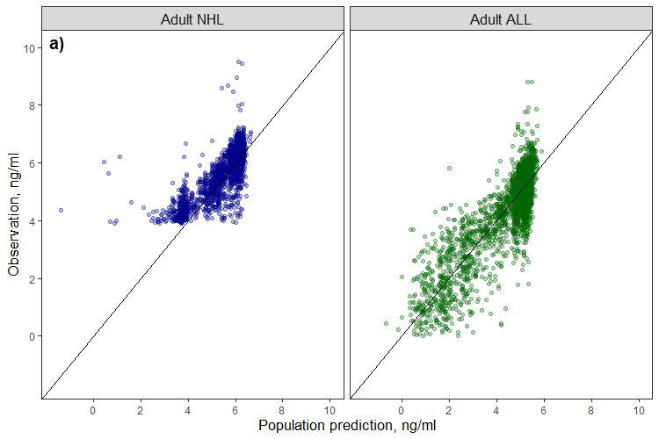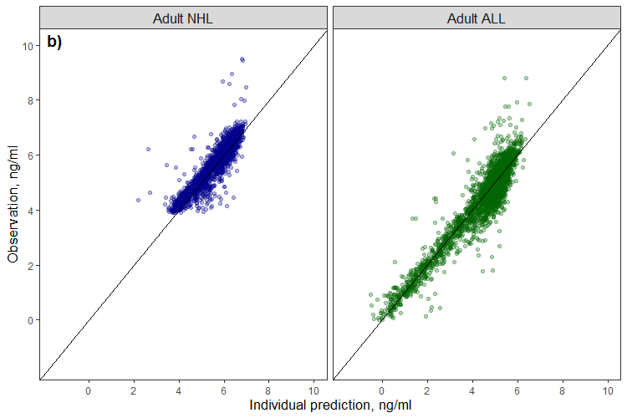
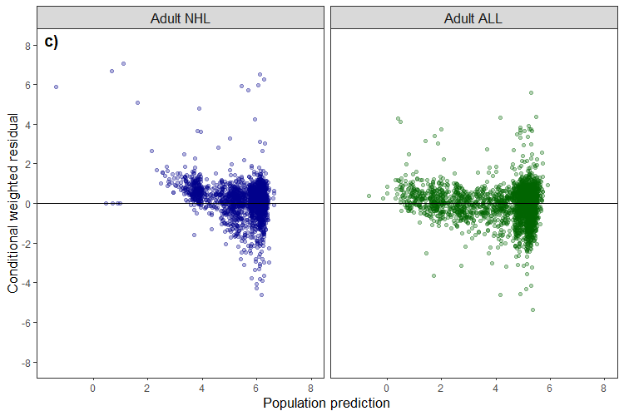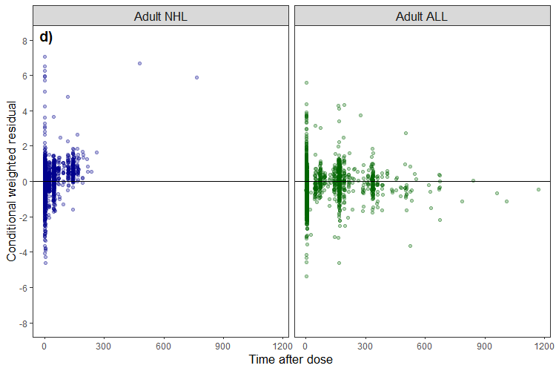
Supplementary Figure 1 Goodness-of-fit diagnostic plots of the final model for adult non-Hodgkin lymphoma (NHL) and adult acute lymphoblastic leukemia (ALL) patients. Log observed Inotuzumab ozogamicin concentration versus a) population prediction and b) individual prediction. The solid lines show the reference line (y = x). c) Scatter plots of conditional weighted residuals against population prediction and d) time after each dose.

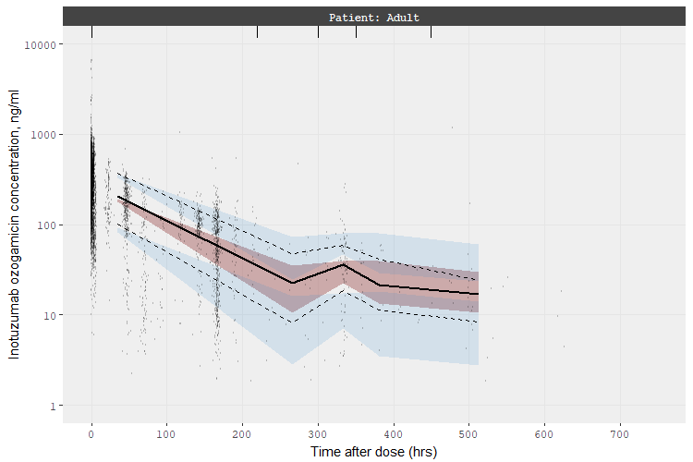
Supplementary Figure 2 Prediction- and variability-corrected visual predictive check in adult non-Hodgkin lymphoma (NHL) and adult acute lymphoblastic leukemia (ALL) patients. Black circles represent the observed data. The black lines show median (solid) and the 25th and 75th percentiles (dash) of the observed data. The shaded regions show the 95% CI of the median (red) and the 25th and 75th percentiles (blue) of the simulated concentration (N = 1000).
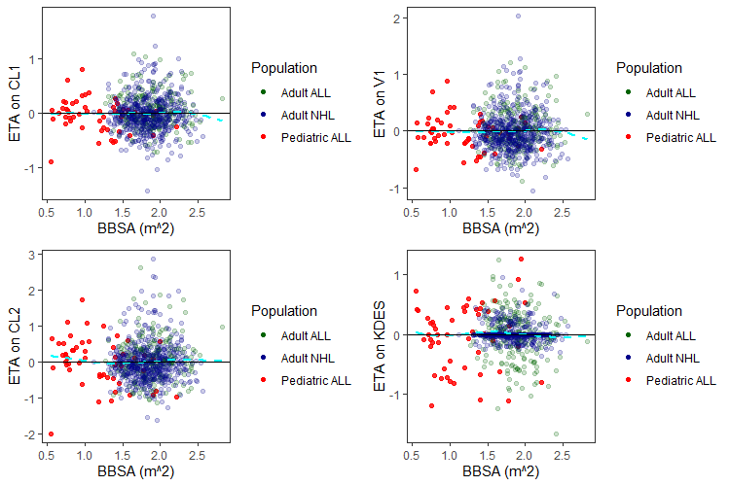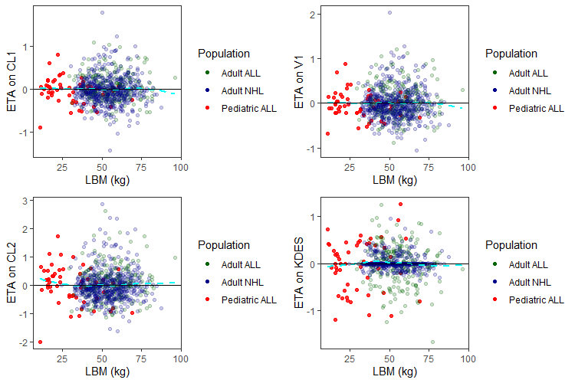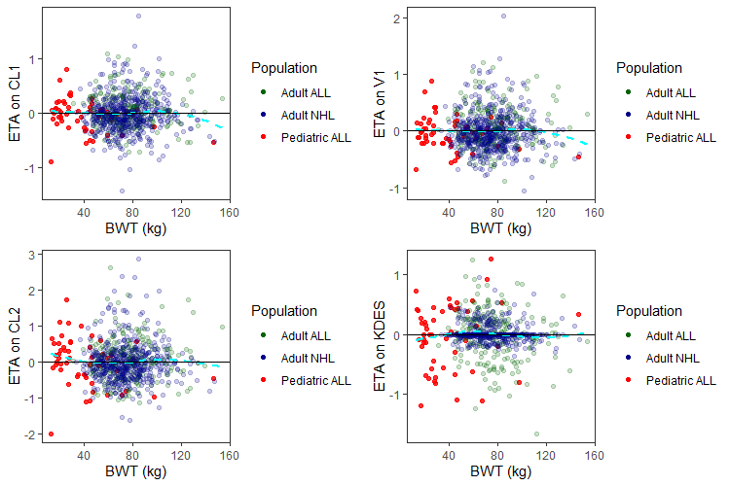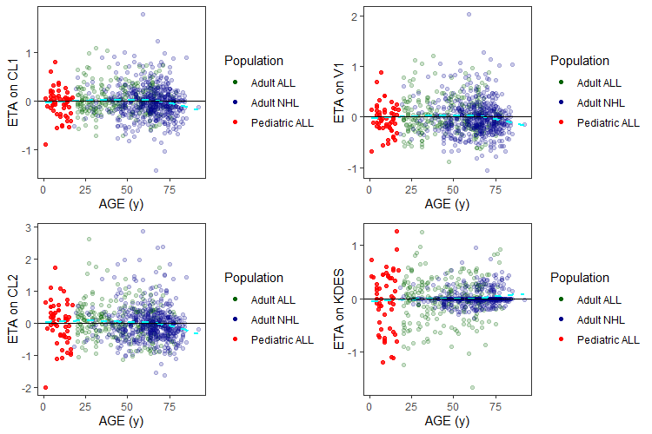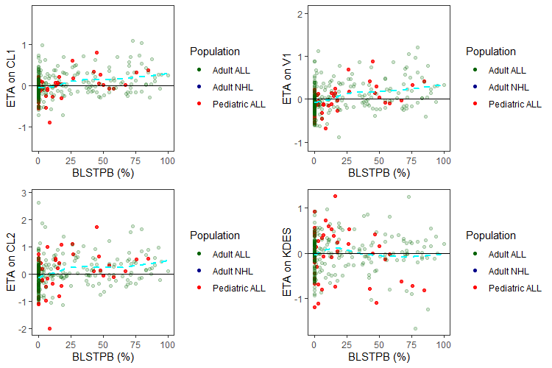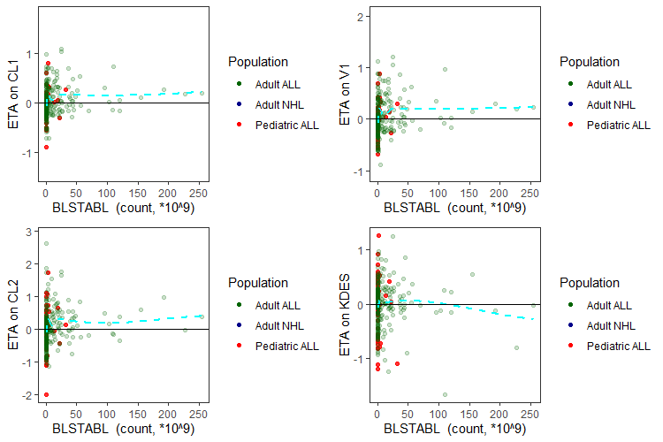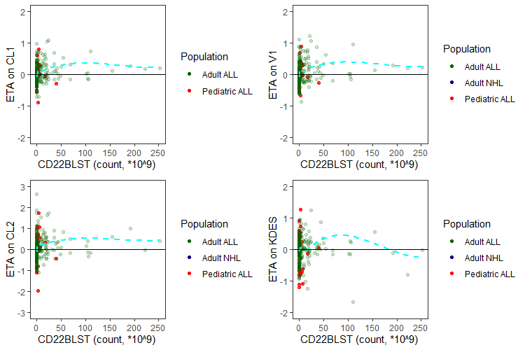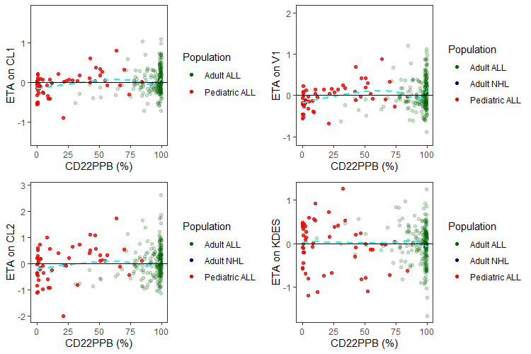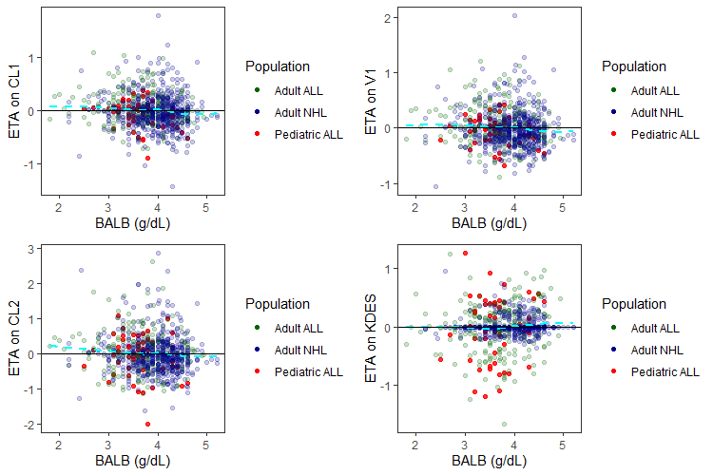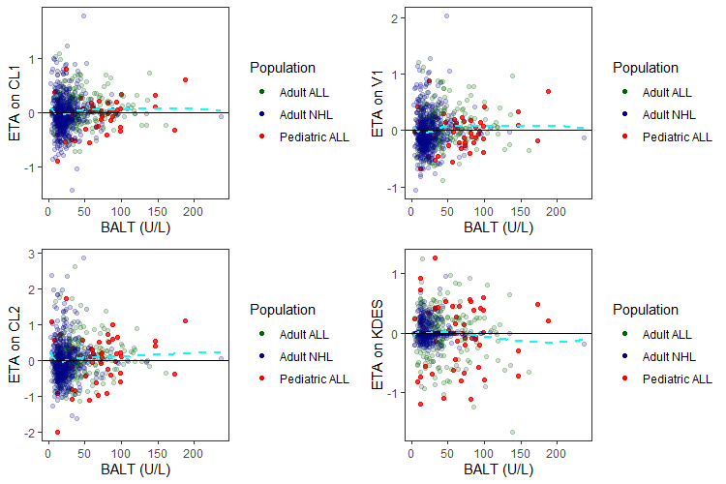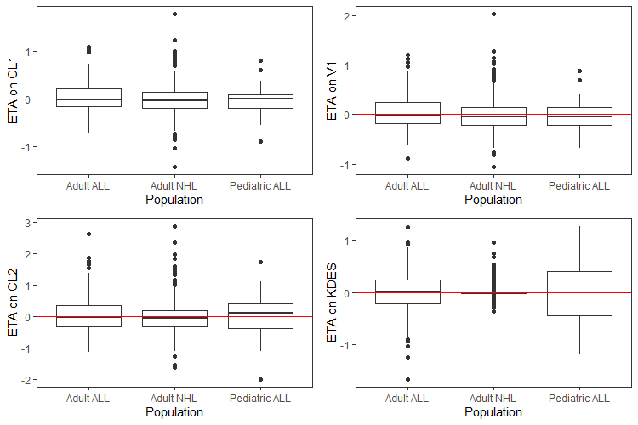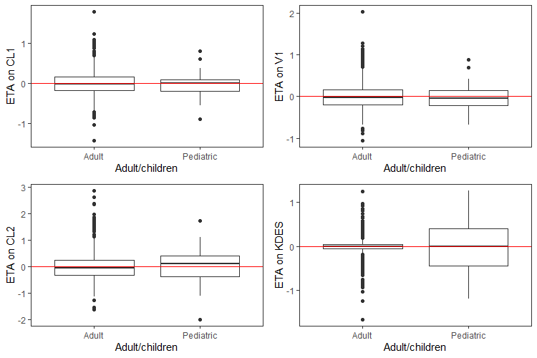
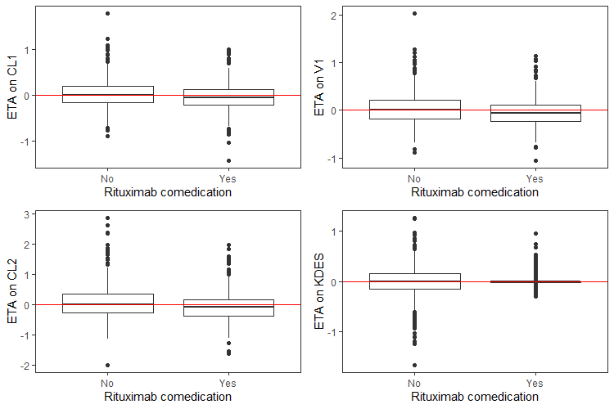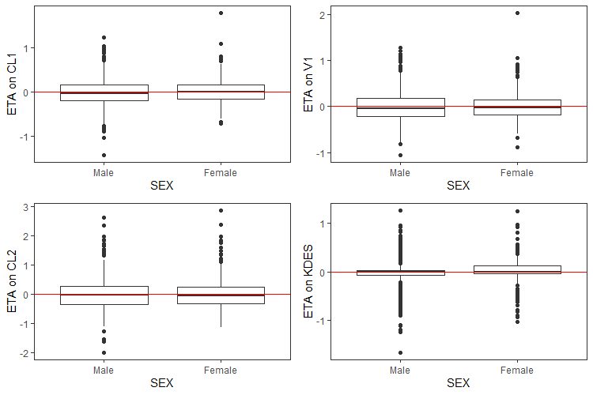
Supplementary Figure 3 Final model ETAs on pharmacokinetics parameters versus baseline covariates
ETA: Empirical Bayes estimate of the interindividual random effect in a pharmacokinetic parameter; NHL: Non-Hodgkin lymphoma; ALL: Acute lymphoblastic leukemia; BBSA: Baseline body surface area; BWT: Baseline body weight; LBM: Baseline lean body mass; BHGRADE: Baseline hepatic impairment grades; BALB: Baseline albumin; BALT: Baseline alanine aminotransferase; BLSTPB: Baseline percentage of blasts in the peripheral blood; CD22PPB: Baseline percent of blasts that are CD22+ in peripheral blood; The cyan dotted lines are the LOESS and the red solid line is the reference line (y = 0).

Supplementary Table 5 Final model-based Inotuzumab ozogamicin exposure simulation in ALL patients
Simulation, cumulative AUC (median [IQR], *10³ ng*h/mL); [Difference (%)]
 |  | End of Cycle1 | End of Cycle2 |  | End of Cycle3
Age >= 31 |  | 19.5 [11.8 - 30.1]; [-4.14] | 78.1 [49.1 - 113]; [-4.16] |  | 154 [107 - 215]; [-2.60]
18 <= Age <= 30 |  | 20.3 [12.8 - 30.9]; [ref.] | 81.5 [53.7 - 117]; [ref.] |  | 158 [112 - 218]; [ref.]
13 <= Age <= 17 |  | 24.7 [15.9 - 35.4]; [+21.4] | 98.6 [67.8 - 130]; [+20.9] |  | 182 [134 - 240]; [+15.1]
7 <= Age <= 12 |  | 27.0 [18.0 - 37.9]; [+32.6] | 110 [80.0 - 143]; [+35.2] |  | 210 [157 - 269]; [+32.7]
1 <= Age <= 6 |  | 27.8 [19.9 - 37.3]; [+37.0] | 113 [89.2 - 141]; [+38.8] |  | 219 [176 - 272]; [+38.4]
Simulation, cumulative AUC (median [IQR], *10³ ng*h/mL; without loading dose (LD) on Day1 Cycle1)
 |  | End of Cycle1 |  | Cumulative AUC difference (%; each corresponding age category with LD as reference)
Age >= 31 |  | 17.7 [10.7 - 27.2] |  | -9.29%
18 <= Age <= 30 |  | 18.5 [11.6 - 28.0] |  | -9.02%
13 <= Age <= 17 |  | 22.7 [14.7 - 32.3] |  | -8.07%
7 <= Age <= 12 |  | 24.9 [16.7 - 34.2] |  | -7.59%
1 <= Age <= 6 |  | 25.4 [18.4 - 33.1] |  | -8.90%
ALL: Acute lymphoblastic leukemia; AUC: area under concentration-time curve

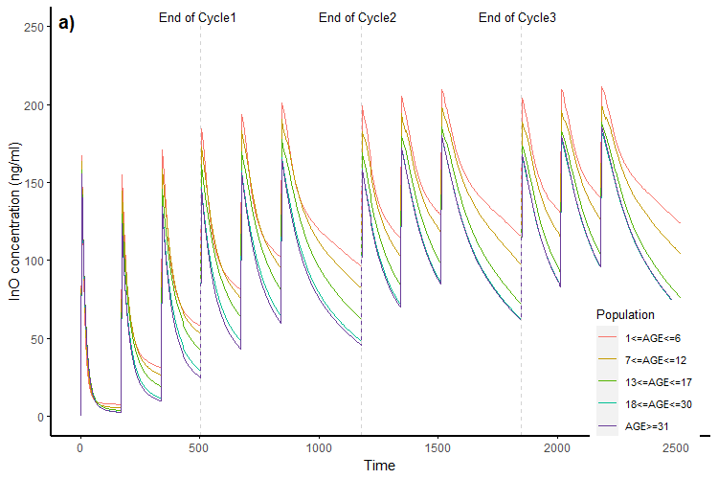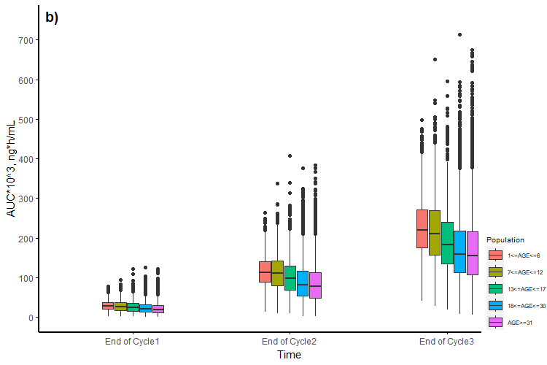Supplementary Figure 4 Simulation of Inotuzumab ozogamicin (InO) stratified by age strata. a) Simulated median concentration-time profile for 4 cycles; b) Cumulative area under concentration-time curve (AUC) at the end of each cycle.

