Can we predict drug excretion into saliva? A systematic review and analysis of physicochemical properties
Supplementary Material
Clinical Pharmacokinetics Journal
Thi A. Nguyen^{1,2,3}*, Ricky H. Chen^{1,4}, Bryson A. Hawkins^{1,5}, David E. Hibbs¹, Hannah Yejin Kim^{1,3,6}, Nial J. Wheate⁷, Paul W. Groundwater¹, Sophie L. Stocker^{1,3,6,8,9#}, Jan-Willem C. Alffenaar^{1,3,6#}
¹Sydney Pharmacy School, Faculty of Medicine and Health, The University of Sydney, Sydney, NSW, Australia
²Westmead Hospital, Sydney, NSW, Australia
³Sydney Institute for Infectious Diseases, The University of Sydney, Sydney, NSW, Australia
⁴Department of Pharmacy, Royal Prince Alfred Hospital, Sydney, NSW, Australia
⁵Antimicrobial Discovery Center, Department of Biology, Northeastern University, Boston, MA, USA
⁶Department of Pharmacy, Westmead Hospital, Sydney, NSW, Australia
⁷School of Natural Sciences, Faculty of Science and Engineering, Macquarie University, Sydney, NSW, Australia
⁸Department of Clinical Pharmacology and Toxicology, St Vincent's Hospital, Sydney, NSW, Australia
⁹Sydney Musculoskeletal Health, The University of Sydney, Sydney, NSW, Australia
# authors contributed equally

*Corresponding author: Thi A. Nguyen
The University of Sydney, Faculty of Medicine and Health, School of Pharmacy, Pharmacy Building (A15), NSW, 2006, Sydney, Australia
Phone: +61 4 0571 4484
Email: thi.a.nguyen@sydney.edu.au
Supplementary Text
The search strategy for Medline, Embase and Web of Science, databases is presented as follows:
1. Medline (R) database including Daily update <1974-January 2023> (using Ovid Citation Analyser Tool, Ovid Technologies, Inc, New York, USA)
# | Query
1 | saliva.mp.
2 | oral fluid.mp.
3 | plasma.mp.
4 | serum.mp.
5 | blood.mp.
6 | saliva-plasma ratio.mp.
7 | saliva-serum ratio.mp.
8 | medication.mp.
9 | drug.mp.
10 | pharmacokinetic*.mp.
11 | therapeutic drug monitoring.mp. or *drug monitoring/
12 | penetration.mp.
13 | distribution.mp.
14 | concentration*.mp.
15 | 1 or 2
16 | 3 or 4 or 5 or 6 or 7
17 | 8 or 9
18 | 10 or 11 or 12 or 13 or 14
19 | 15 and 16 and 17 and 18
20 | limit 19 to humans

2. Embase database including Daily update <1974-January 2023> (using Ovid Citation Analyser Tool, Ovid Technologies, Inc, New York, USA)
# | Query
1 | saliva.mp.
2 | oral fluid.mp.
3 | plasma.mp.
4 | serum.mp.
5 | blood.mp.
6 | saliva-plasma ratio.mp.
7 | saliva-serum ratio.mp.
8 | medication.mp.
9 | drug.mp.
10 | pharmacokinetic*.mp.
11 | therapeutic drug monitoring.mp. or *drug monitoring/
12 | penetration.mp.
13 | distribution.mp.
14 | concentration*.mp.
15 | 1 or 2
16 | 3 or 4 or 5 or 6 or 7
17 | 8 or 9
18 | 10 or 11 or 12 or 13 or 14
19 | 15 and 16 and 17 and 18
20 | limit 19 to humans and "remove medline records"

3. Web of Science database

TI = (saliva OR oral fluid)
AND
(blood OR serum OR plasma)
AND
(human OR man OR patients OR volunteers)
OR

AB = (" (saliva OR oral fluid) AND (blood OR serum OR plasma)
AND
(human OR man OR patients OR volunteers))]
AND

TS = (plasma OR serum OR saliva–plasma ratio OR saliva–serum ratio)
AND
(pharmacokinetic* OR therapeutic drug monitoring OR TDM OR penetration OR distribution OR concentration*)

Supplementary tables
Table S1 PRISMA 2020 Checklist [1]
Section and Topic | Item # | Checklist item | Location where item is reported
TITLE
Title | 1 | Identify the report as a systematic review.
ABSTRACT
Abstract | 2 | See the PRISMA 2020 for Abstracts checklist.
INTRODUCTION
Rationale | 3 | Describe the rationale for the review in the context of existing knowledge.
Objectives | 4 | Provide an explicit statement of the objective(s) or question(s) the review addresses.
METHODS
Eligibility criteria | 5 | Specify the inclusion and exclusion criteria for the review and how studies were grouped for the syntheses.
Information sources | 6 | Specify all databases, registers, websites, organisations, reference lists and other sources searched or consulted to identify studies. Specify the date when each source was last searched or consulted.
Search strategy | 7 | Present the full search strategies for all databases, registers and websites, including any filters and limits used.
Selection process | 8 | Specify the methods used to decide whether a study met the inclusion criteria of the review, including how many reviewers screened each record and each report retrieved, whether they worked independently, and if applicable, details of automation tools used in the process.
Data collection process | 9 | Specify the methods used to collect data from reports, including how many reviewers collected data from each report, whether they worked independently, any processes for obtaining or confirming data from study investigators, and if applicable, details of automation tools used in the process.
Data items | 10a | List and define all outcomes for which data were sought. Specify whether all results that were compatible with each outcome domain in each study were sought (e.g. for all measures, time points, analyses), and if not, the methods used to decide which results to collect.
Data items | 10b | List and define all other variables for which data were sought (e.g. participant and intervention characteristics, funding sources). Describe any assumptions made about any missing or unclear information.
Study risk of bias assessment | 11 | Specify the methods used to assess risk of bias in the included studies, including details of the tool(s) used, how many reviewers assessed each study and whether they worked independently, and if applicable, details of automation tools used in the process.
Effect measures | 12 | Specify for each outcome the effect measure(s) (e.g. risk ratio, mean difference) used in the synthesis or presentation of results.
Synthesis methods | 13a | Describe the processes used to decide which studies were eligible for each synthesis (e.g. tabulating the study intervention characteristics and comparing against the planned groups for each synthesis (item #5)).
Synthesis methods | 13b | Describe any methods required to prepare the data for presentation or synthesis, such as handling of missing summary statistics, or data conversions.
Synthesis methods | 13c | Describe any methods used to tabulate or visually display results of individual studies and syntheses.
Synthesis methods | 13d | Describe any methods used to synthesise results and provide a rationale for the choice(s). If meta-analysis was performed, describe the model(s), method(s) to identify the presence and extent of statistical heterogeneity, and software package(s) used.
Synthesis methods | 13e | Describe any methods used to explore possible causes of heterogeneity among study results (e.g. subgroup analysis, meta-regression).
Synthesis methods | 13f | Describe any sensitivity analyses conducted to assess robustness of the synthesised results.
Reporting bias assessment | 14 | Describe any methods used to assess risk of bias due to missing results in a synthesis (arising from reporting biases).
Certainty assessment | 15 | Describe any methods used to assess certainty (or confidence) in the body of evidence for an outcome.
RESULTS
Study selection | 16a | Describe the results of the search and selection process, from the number of records identified in the search to the number of studies included in the review, ideally using a flow diagram.
Study selection | 16b | Cite studies that might appear to meet the inclusion criteria, but which were excluded, and explain why they were excluded.
Study characteristics | 17 | Cite each included study and present its characteristics.
Risk of bias in studies | 18 | Present assessments of risk of bias for each included study.
Results of individual studies | 19 | For all outcomes, present, for each study: (a) summary statistics for each group (where appropriate) and (b) an effect estimate and its precision (e.g. confidence/credible interval), ideally using structured tables or plots.
Results of syntheses | 20a | For each synthesis, briefly summarise the characteristics and risk of bias among contributing studies.
Results of syntheses | 20b | Present results of all statistical syntheses conducted. If meta-analysis was done, present for each the summary estimate and its precision (e.g. confidence/credible interval) and measures of statistical heterogeneity. If comparing groups, describe the direction of the effect.
Results of syntheses | 20c | Present results of all investigations of possible causes of heterogeneity among study results.
Results of syntheses | 20d | Present results of all sensitivity analyses conducted to assess the robustness of the synthesised results.
Reporting biases | 21 | Present assessments of risk of bias due to missing results (arising from reporting biases) for each synthesis assessed.
Certainty of evidence | 22 | Present assessments of certainty (or confidence) in the body of evidence for each outcome assessed.
DISCUSSION
Discussion | 23a | Provide a general interpretation of the results in the context of other evidence.
Discussion | 23b | Discuss any limitations of the evidence included in the review.
Discussion | 23c | Discuss any limitations of the review processes used.
Discussion | 23d | Discuss implications of the results for practice, policy, and future research.
OTHER INFORMATION
Registration and protocol | 24a | Provide registration information for the review, including register name and registration number, or state that the review was not registered.
Registration and protocol | 24b | Indicate where the review protocol can be accessed, or state that a protocol was not prepared.
Registration and protocol | 24c | Describe and explain any amendments to information provided at registration or in the protocol.
Support | 25 | Describe sources of financial or non-financial support for the review, and the role of the funders or sponsors in the review.
Competing interests | 26 | Declare any competing interests of review authors.
Availability of data, code and other materials | 27 | Report which of the following are publicly available and where they can be found: template data collection forms; data extracted from included studies; data used for all analyses; analytic code; any other materials used in the review.

Table S2 Risk of bias assessment
No. | Sources of bias | Answer | Point given
1 | Confounding  Examples:  Oral diseases  Medical conditions causing dry mouth such as HIV or hepatitis C  Co-medications/drug of interest (risperidone) causing dry mouth such as anticholinergics, antidepressants and opioids
1 | No confounding is expected | Yes | 2
1 | Maybe confounding (citation of prior studies of a similar drug) is expected | Yes | 1
1 | Known important confounding (citation of prior studies of the tested drug) is expected | Yes | 0
2 | Measurement of outcomes
2 | Analytical method development and validation are well-described as per EMA or FDA guidelines; or cited with prior studies | Yes/No/NA | 2/0/0
2 | Analytical method development and validation are scarcely described without the citation of prior studies | Yes/No/NA | 1/0/0
2 | Examples:  Chromatography type.  Assay conditions: chromatographic column, mobile phase composition, gradient and flow rate.  Operating temperature and runtime.  Detection method and parameters.  Validation criteria: linearity, recovery, specificity, sensitivity, reproducibility and stability. | Yes/No/NA | 1/0/0
2 | Comparable analytical methods to measure drug concentrations in plasma/serum and saliva were performed (comparable accuracy and precision defined as CV% within 15% for different methods between saliva and plasma) | Yes/No/NR | 2/0/0
3 | Study design and experimental methods
3 | Sampling at steady-state was performed  Measuring saliva pH for drugs with ionisation sensitive to physiological pH changes (basic drugs with pKa over 6 and acidic drugs with pKa under 8) | Yes/No/NA  Yes/No/NA | 2/0/0  2/0/0
4 | Saliva sampling procedure
4 | Saliva collection is well-described/controlled and compare between different collection methods | Yes/No/NA | 2/0/0
4 | Saliva collection is scarcely described/controlled | Yes/No/NA | 1/0/0
4 | No important confounding in saliva sampling  Examples of confounders:  No mouth rinse described after administration of liquid formulation  Saliva stimulation with citric acid for pH-sensitive drugs  Sampling shortly after tooth brushing | Yes/No/NA | 2/0/0
5 | Sample storage conditions
5 | Sample storage is well-described particularly for unstable drugs in room temperature | Yes/No/NA | 2/0/0
5 | Saliva storage is scarcely described for unstable drugs in room temperature | Yes/No/NA | 0/0/0
5 | Examples: temperature, use of anticoagulants, stabilisers, centrifugation, filtration, etc | Yes/No/NA | 0/0/0
EMA European Medicines Agency, FDA U.S. Food and Drug Administration, NR not reported

Table S3. Chemical structures of the included drugs
Group | No | Drug | Structure
Acidic | 1 | 5-fluorouracile | 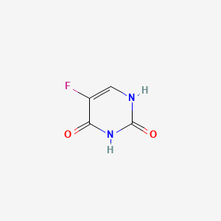
 | 2 | Acetaminophen | 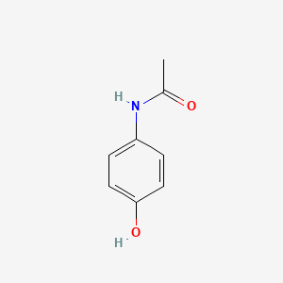
 | 3 | Amoxicillin | 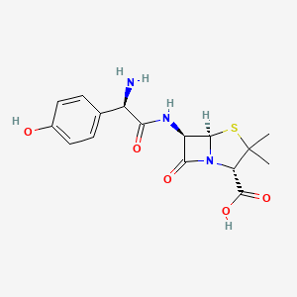
 | 4 | Mycophenolic acid | 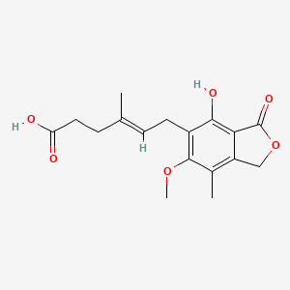
 | 5 | Phenytoin | 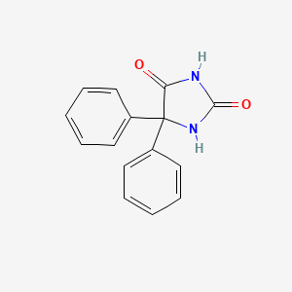
Basic | 1 | Amikacin | 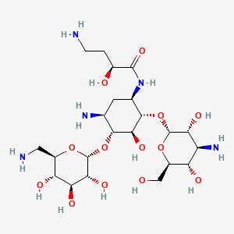
 | 2 | Caffeine | 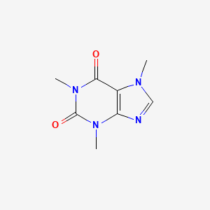
 | 3 | Chloroquine | 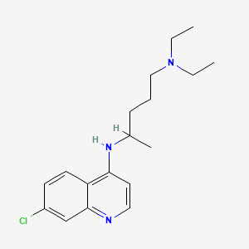
 | 4 | Clarithromycin | 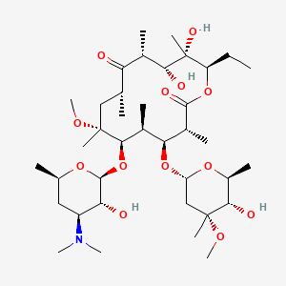
 | 5 | Clonazepam | 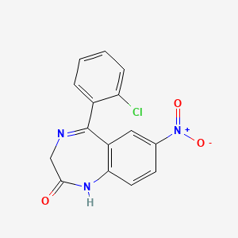
 | 6 | Codeine | 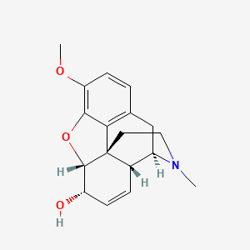
 | 7 | Disopyramide | 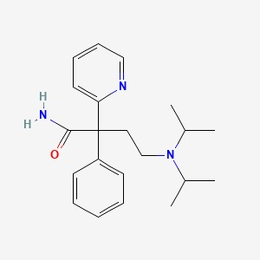
 | 8 | Eletriptan | 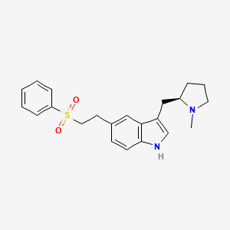
 | 9 | Emtricitabine | 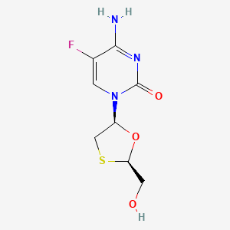
 | 10 | Gepotidacin | 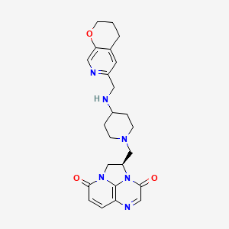
 | 11 | Indinavir | 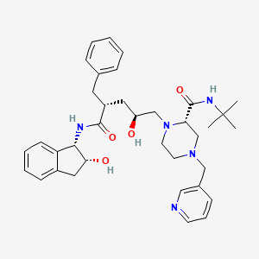
 | 12 | Isoniazid | 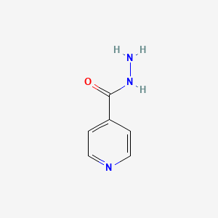
 | 13 | Irinotecan | 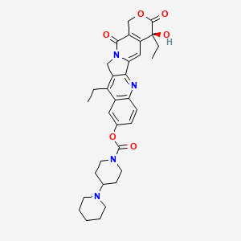
 | 14 | Lamotrigine | 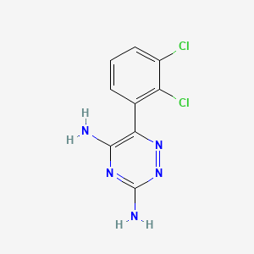
 | 15 | Maraviroc | 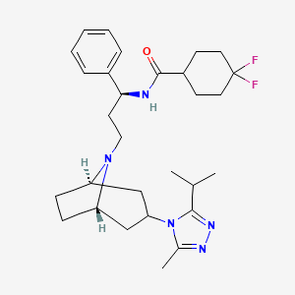
 | 16 | Metformin | 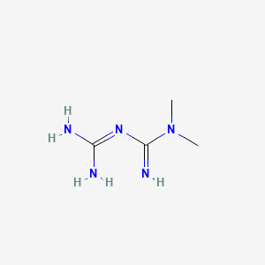
 | 17 | Metronidazole | 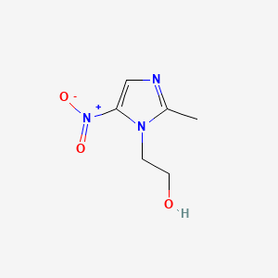
 | 18 | Oxazepam | 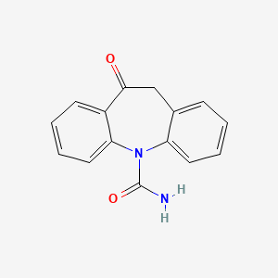
 | 19 | Piroxicam | 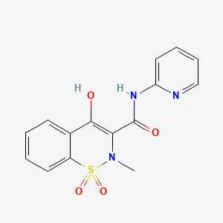
 | 20 | Risperidone | 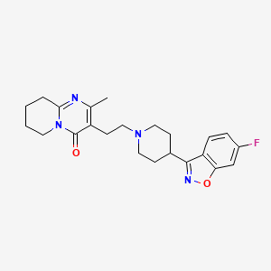
 | 21 | Spiramycin | 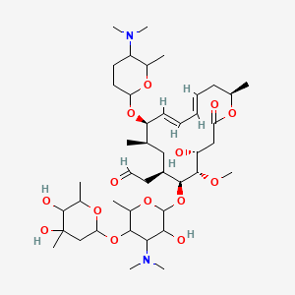
Amphoteric | 1 | Doxycycline | 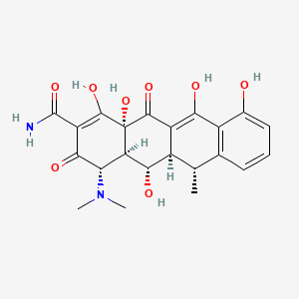
 | 2 | Fluconazole | 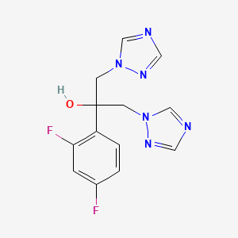
 | 3 | Gatifloxacin | 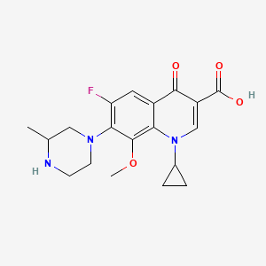
 | 4 | Hydrochlorothiazide | 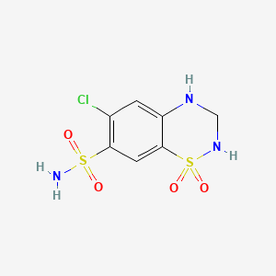
 | 5 | Moxifloxacin | 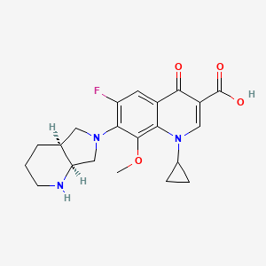
 | 6 | Ofloxacin | 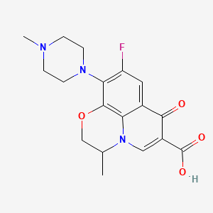
 | 7 | Rifampicin | 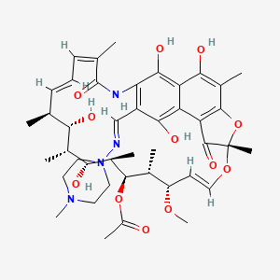
 | 8 | Tenofovir | 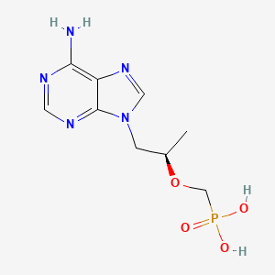
 | 9 | Tolterodine | 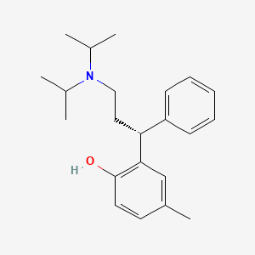
 | 10 | Voriconazole | 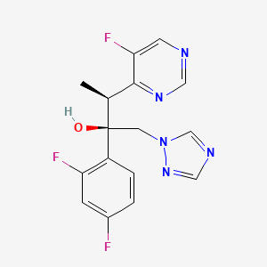
Neutral | 1 | Tacrolimus | 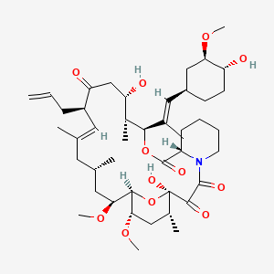
 | 2 | Hydrocortisone | 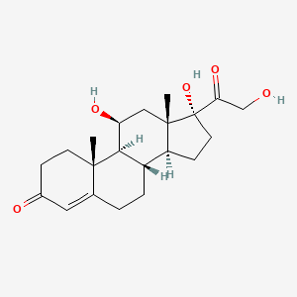
Very weak base to neutral | 1 | Oxcarbazepine
 | 2 | Carbamazepine | 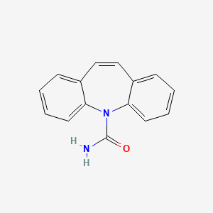
 | 3 | Oxazepam
 | 4 | Caffeine
 | 5 | Clonazepam
Very weak base/acid to neutral | 1 | Hydrochlorothiazide
 | 2 | Fluconazole
 | 3 | Voriconazole

Table S4 Risk of bias assessment for human studies (Derived from ROBINS-I)
First Author | Confounding Bias | Outcome Measurement Bias | Study Design and Experimental Methods Appraisal | Saliva Sampling Procedure | Sample Storage Conditions | Overall Bias
Aman (Risperidone) [2] | 1 | 4 | 1 | 2 | 1 | 9
Baglie (Amoxicillin) [3] | 2 | 4 | 1 | 2 | 1 | 10
Brown (Maraviroc) [4] | 1 | 4 | 1 | 2 | 0 | 8
Burkhardt (Clarithromycin & Moxifloxacin) [5] | 2 | 4 | 1 | 2 | 1 | 10
Calvo (Piroxicam) [6] | 2 | 4 | 1 | 2 | 1 | 10
Cardot (Oxcarbazepine) [7] | 2 | 4 | 2 | 2 | 1 | 11
Cordonnier (Disopyramide) [8] | 1 | 2 | 1 | 1 | 1 | 6
Eeg-Olofsson (Carbemazepine) [9] | 2 | 3 | 1 | 2 | 1 | 9
Ferreira (Mycophenolic) [10] | 2 | 4 | 1 | 2 | 1 | 10
Fonsart (Emtricitabine, Tenofovir) [11] | 2 | 4 | 1 | 2 | 1 | 10
Gandia (Acetaminophen) [12] | 2 | 3 | 1 | 2 | 1 | 9
Ghareeb (Tacrolimus) [13] | 2 | 4 | 2 | 3 | 1 | 12
Gurumurthy (INH, Rifampicin) [14] | 2 | 1 | 1 | 2 | 1 | 7
Hossain (Gepotidacin) [15] | 2 | 4 | 1 | 2 | 1 | 10
Hugen (Indinavir) [16] | 1 | 4 | 2 | 2 | 1 | 10
Idkaidek (Hydrochlorothiazide) [17] | 2 | 3 | 1 | 2 | 1 | 9
Idkaidek (Metformin) [18] | 2 | 3 | 1 | 2 | 1 | 9
Idkaidek (Tolterodin) [19] | 2 | 3 | 1 | 2 | 1 | 9
Incecayir (Lamotrigine) [20] | 2 | 3 | 1 | 2 | 1 | 9
Joulia (5-FU) [20] | 2 | 4 | 0 | 2 | 1 | 9
Koizumi (Ofloxacin) [21] | 2 | 4 | 1 | 2 | 1 | 10
Koks (Fluconazole) [22] | 2 | 4 | 1 | 2 | 1 | 10
Kruizinga (Clonazepam) [23] | 2 | 3 | 0 | 2 | 1 | 8
Liftshitz (Phenytoin) [24] | 2 | 3 | 1 | 1 | 0 | 7
Onyeji (Chloroquin) [25] | 2 | 3 | 1 | 2 | 1 | 9
Poujol (Irinotecan) [26] | 2 | 4 | 0 | 2 | 1 | 9
Shah (Eletriptan) [27] | 2 | 4 | 0 | 2 | 1 | 9
Smink (Oxazepam) [28] | 2 | 4 | 1 | 2 | 1 | 10
Stoller (Doxycycline) [29] | 2 | 3 | 1 | 2 | 1 | 9
van den Elsen (Amikacin) [30] | 2 | 4 | 1 | 2 | 1 | 10
Zylber-Katz (Caffeine) [31] | 1 | 3 | 0 | 2 | 1 | 7
Bergamaschi (Metronidazole) [32] | 1 | 4 | 1 | 2 | 1 | 9
Rotzetter (Metronidazole) [33] | 1 | 4 | 1 | 2 | 1 | 9
Sagawa (Disopyramide) [34] | 1 | 4 | 1 | 3 | 1 | 10
Kim (Codeine) [35] | 2 | 4 | 0 | 2 | 1 | 9
O'Neal (Codeine) [36] | 0 | 4 | 1 | 2 | 1 | 8
Kondratenko (Moxifloxacin) [37] | 2 | 4 | 1 | 2 | 1 | 10
Muller (Moxifloxacin) [38] | 2 | 4 | 1 | 2 | 1 | 10
Nakashima (Gatifloxacin) [39] | 2 | 4 | 1 | 1 | 1 | 9
Mignot (Gatifloxacin) [40] | 2 | 3 | 1 | 2 | 1 | 9
Moolchan (Cocaine) [41] | 2 | 4 | 1 | 2 | 1 | 10
Scheidweiler (Cocaine) [42] | 2 | 4 | 0 | 1 | 1 | 11
Thomson (Hydrocortisone) [43] | 2 | 4 | 0 | 2 | 1 | 9
Purkins (Voriconazole) [44] | 2 | 4 | 2 | 2 | 1 | 11
Vanstraelen (Voriconazole) [45] | 2 | 4 | 2 | 2 | 1 | 11

Table S5 Physico-chemical and pharmacokinetic properties of studied drugs
Group | No | Drug | pKa | logP | Molecular weight | Physiological charge | H-bond donor | H-bond acceptor | Polar surface area | Rotatable bond | fu | Half-life | Stability in solution*
Acidic | 1 | 5-fluorouracile | 8.07 | -1.4 | 262.1918 | 0 | 4 | 6 | 119.33 | 2 | 90 | 10-20 minutes | 48h-72h (25ºC)
Acidic | 2 | Acetaminophen | 9.46 | 0.51 | 151.16 | 0 | 2 | 2 | 49.33 | 1 | 82.5 | 2.5 hours (range 4-8 hours) | 48h-84h (25ºC)
Acidic | 3 | Amoxicillin | 3.23 | 0.75 | 365.404 | 0 | 6 | 4 | 132.96 | 4 | 83 | 61.3 m | 4-8h (25ºC)
Acidic | 4 | Mycophenolic acid | 3.57 | 2.36 | 320.34 | -1 | 2 | 5 | 93.06 | 6 | 2 | 8-16 hours | 5d (25ºC)-90d (-20ºC)
Acidic | 5 | Phenytoin | 8.49 | 2.26 | 252.268 | 0 | 2 | 2 | 58.2 | 2 | 10 | Oral administration: 22 hours (7-42 hours) | 2h (25ºC) (decrease with decreased pH)
Basic | 1 | Amikacin | 9.79 | -3.2 | 585.6 | 4 | 13 | 17 | 331.94 | 10 | 96 | 2-3 hours | 30d (-20ºC)
Basic | 2 | Caffeine | -1.2 (very weak base to neutral) | -0.24 | 194.19 | 0 | 0 | 3 | 58.44 | 0 | 62.2 | 5 hours | 90d (25ºC)
Basic | 3 | Chloroquine | 10.32 | 5.28 | 319.87 | 2 | 1 | 3 | 28.16 | 8 | 40 | 20-60 days | 60d (25ºC)
Basic | 4 | Clarithromycin | 9 | 3.18 | 747.95 | 1 | 4 | 13 | 182.91 | 8 | 46 | 3-4 hours | 24h (5-25ºC)-270d (-20ºC)
Basic | 5 | Clonazepam | 1.89 (very weak base to neutral) | 2.76 | 315.71 | 0 | 1 | 4 | 84.6 | 2 | 16 | 30-40 hours | 60d (25ºC)
Basic | 6 | Codeine | 9.19 | 1.2 | 299.36 | 1 | 1 | 4 | 41.93 | 1 | 84 | 3 hours | 98d (25ºC)
Basic | 7 | Disopyramide | 10.42 | 3.21 | 339.47 | 1 | 1 | 3 | 59.22 | 8 | 42.5 | 6.7 hours (range 4-10 hours) | ND
Basic | 8 | Eletriptan | 8.37 | 3.84 | 382.52 | 1 | 1 | 3 | 53.17 | 6 | 15 | 4 hours | 24h (25ºC)- 30d (4ºC)
Basic | 9 | Emtricitabine | 4.9 | -0.3 | 247.25 | 0 | 3 | 6 | 89.14 | 2 | 96 | 10 hours | 72h (25ºC)- 14d (4ºC)
Basic | 10 | Gepotidacin | 8.62 | 0.97 | 448.53 | 1 | 1 | 7 | 90.37 | 5 | 67 | 8.2-9.1 hours | ND
Basic | 11 | Indinavir | 6.76 | 3.26 | 613.79 | 0 | 4 | 7 | 118.03 | 12 | 40 | 1.8 (± 0.4) hours | 6h (25ºC)- 60d (-78ºC)
Basic | 12 | Isoniazid | 1.8,3.5 and 10.2 | -0.71 | 137.14 | 0 | 2 | 3 | 68.01 | 1 | 95 | Fast acetylators: 0.5 to 1.6 hours. Slow acetylators: 2 to 5 hours. | 24h (2-8ºC)
Basic | 13 | Irinotecan | 9.47 | 3.94 | 586.68 | 1 | 1 | 6 | 112.51 | 5 | 63 | 6-12 hours | 1-24h (25ºC)-28d (2-8ºC without light)
Basic | 14 | Lamotrigine | 5.89 | 1.87 | 256.09 | 0 | 2 | 5 | 90.71 | 1 | 45 | 14-59 hours | 90d-91d (2-25ºC without light)
Basic | 15 | Maraviroc | 9.65 | 4.3 | 513.67 | 1 | 1 | 4 | 63.05 | 8 | 24 | 14-18 hours | 7h (25ºC)-34d (1-8ºC)
Basic | 16 | Metformin | 12.33 | -1.8 | 129.16 | 2 | 4 | 5 | 88.99 | 0 | 100 | 6.2 hours | 6h (25ºC)-30d (4ºC)
Basic | 17 | Metronidazole | 3.03 | -0.15 | 171.15 | 0 | 1 | 4 | 81.19 | 3 | 90 | 6 to 10 hours | 3d (8ºC without light)
Basic | 18 | Oxazepam | -1.5 (very weak base to neutral) | 2.01 | 286.713 | N/A | 2 | 3 | 61.69 | 1 | 11 | 8.2 hours | 30d (25ºC)
Basic | 19 | Piroxicam | 3.79 | 2.2 | 331.35 | 1 | 2 | 5 | 99.6 | 2 | 0.87 | 30-86 hours | 180d (25ºC without light)
Basic | 20 | Risperidone | 8.76 | 3.27 | 410.48 | 1 | 0 | 4 | 61.94 | 4 | 12 | 3-20 hours | 48h (25ºC)
Basic | 21 | Spiramycin | 9.33 | 2.99 | 843.07 | 2 | 4 | 15 | 195.38 | 11 | 82.5 | 4.5 to 13.5 hours | 12h
Amphoteric | 1 | Doxycycline | 8.33 (Strongest Basic), 3.27 (Strongest Acidic) | -0.72 | 444.43 | 0 | 6 | 9 | 181.62 | 2 | 10 | 18 hours | 96h-14d (25ºC)
Amphoteric | 2 | Fluconazole | 2.3 (Strongest Basic), 12.68 (Strongest Acidic) | 0.58 | 306.2708 | 0 | 1 | 5 | 81.65 | 5 | 88.5 | 30 hours (range: 20-50 hours) | 24h-15d (up to 182d at 2-8ºC and without light)
Amphoteric | 3 | Gatifloxacin | 8.82 (Strongest Basic), 5.49 (Strongest Acidic) | -0.23 | 375.3941 | 0 | 2 | 7 | 82.11 | 4 | 80 | 7-14 hours | 7d (40ºC)
Amphoteric | 4 | Hydrochlorothiazide | -2.7 (Strongest Basic), 9.09 (Strongest Acidic) | -0.16 | 297.74 | 0 | 3 | 5 | 118.36 | 1 | 46 | 5.6-14.8 hours | 21-60d (25ºC without light)
Amphoteric | 5 | Moxifloxacin | 9.51 (Strongest Basic), 5.49 (Strongest Acidic) | 0.01 | 401.43 | 0 | 2 | 7 | 82.11 | 4 | 50 | 11.5-15.6 hours (single dose, oral) | 3-14d (25ºC without light)
Amphoteric | 6 | Ofloxacin | 6.72 (Strongest Basic), 5.35 (Strongest Acidic) | -0.02 | 361.37 | -1/+1 | 1 | 7 | 73.32 | 2 | 68 | 9 hours | 48h (4ºC)-182d (-20ºC)
Amphoteric | 7 | Rifampicin | 7.9 (Strongest Basic), 1.7 (Strongest Acidic) | 3.85 | 822.94 | 0 | 6 | 14 | 220.15 | 5 | 11 | 3.35 (+/- 0.66) hours | 8h (24ºC) -72h (4ºC without light)
Amphoteric | 8 | Tenofovir | 3.74 (Strongest Basic), 1.35 (Strongest Acidic) | -1.5 | 287.21 | -1/+1 | 3 | 8 | 136.38 | 5 | 92.8 | 32 hours | 24h (25ºC)
Amphoteric | 9 | Tolterodine | 11.01 (Strongest Basic), 10.28 (Strongest Acidic) | 5.39 | 325.49 | -1/+1 | 1 | 2 | 23.47 | 7 | 3.7 | 1.9-3.7 hours | 6h (25ºC)-24h (4ºC)
Amphoteric | 10 | Voriconazole | 2.01 (Strongest Basic), 12.7 (Strongest Acidic) | 1.65 | 349.3105 | 0 | 1 | 5 | 76.72 | 5 | 42 | 6 hours | 4h (25ºC)-15d (4ºC)
Neutral (or very weak base/acid) | 1 | Tacrolimus | N/A | 3.19 | 804.02 | N/A | 3 | 11 | 178.36 | 7 | 1 | 10.2-35 hours | 24h-9d (25ºC)
Neutral (or very weak base/acid) | 2 | Hydrocortisone | N/A | 1.79 | 362.46 | N/A | 3 | 5 | 94.83 | 2 | 8.9 | 1.39-2.15 hours | 24h (23ºC)-48h (4ºC without light)
Neutral (or very weak base/acid) | 3 | Oxcarbazepine | N/A | 1.76 | 252.27 | N/A | 1 | 2 | 63.4 | 0 | 60 | 2 hours | 24h (10ºC)  181d (-20ºC)  194d (-70ºC)
Neutral (or very weak base/acid) | 4 | Carbamazepine | N/A | 2.1 | 236.27 | N/A | 1 | 1 | 46.33 | 0 | 22.5 | 12-40 hours | 90d (25ºC)
Neutral (or very weak base/acid) | 5 | Oxazepam | N/A (very weak base to neutral) | 2.01 | 286.713 | N/A | 2 | 3 | 61.69 | 1 | 11 | 8.2 hours | 30d (25ºC)
Neutral (or very weak base/acid) | 6 | Hydrochlorothiazide | N/A (very weak base/acid to neutral) | -0.16 | 297.74 | 0 | 3 | 5 | 118.36 | 1 | 46 | 5.6-14.8 hours | 21-60d (25ºC without light)
Neutral (or very weak base/acid) | 7 | Fluconazole | N/A (very weak base/acid to neutral) | 0.58 | 306.2708 | 0 | 1 | 5 | 81.65 | 5 | 88.5 | 30 hours (range: 20-50 hours) | 24h-15d (up to 182d at 2-8ºC and without light)
Neutral (or very weak base/acid) | 8 | Voriconazole | N/A (very weak base/acid to neutral) | 1.65 | 349.3105 | 0 | 1 | 5 | 76.72 | 5 | 42 | 6 hours | 4h (25ºC)-15d (4ºC)
Neutral (or very weak base/acid) | 9 | Caffeine | N/A (very weak base to neutral) | -0.24 | 194.19 | 0 | 0 | 3 | 58.44 | 0 | 62.2 | 5 hours | 90d (25ºC)
Neutral (or very weak base/acid) | 10 | Clonazepam | N/A (very weak base to neutral) | 2.76 | 315.71 | 0 | 1 | 4 | 84.6 | 2 | 16 | 30-40 hours | 60d (25ºC)
h hour, d day, N/A not applicable, ND no data
*Stability in solution of drugs was obtained from the database Stabilis (https://www.stabilis.org/Monographie.php?IdMolecule=818) at concentration ranges corresponding to that in the original studies if available. Chemical stability defined as the concentration above 90-95% of the initial concentration and physical examination studied. If unavailable, stability in solution of drugs was obtained from literature searches.
Table S6 Quantitative classification system to assess the likelihood of drug excretion into saliva. Data are expressed as median (IQR).
Drug properties  Drug group | pKa | Fraction unbound to plasma protein (%) | Octanol-water partition coefficient logP | Hydrogen-bond donor groups (e.g. OHs and NHs) | Polar surface area (Å)
Acidic (S/P≥0.1) | 8.1 (5.6-8.8) | 82.3 (83-86.5)
Acidic (S/P<0.1) | 6.0 (4.8-7.3) | 6 (4-8)
Basic (S/P≥0.1) | 8.8 (6.3-9.6) | 60.0 (40.0-83.3)
Basic (S/P<0.1) | 3.4 (1.8-5.3) | 6.5 (1.7-32.3)
Amphoteric (S/P≥0.1) |  |  |  | 1.5 (1.0-2.0) | 81.7 (75.0-82.1)
Amphoteric (S/P<0.1) |  |  |  | 4.5 (3.8-5.3) | 159.0 (147.7-170.3)
Neutral (S/P≥0.1) |  | 53 (43-61) | 1.1 (0-1.7) | 1 (1-1)
Neutral (S/P<0.1) |  | 10.0 (6.9-12.2) | 2.4 (2.0-2.9) | 2.5 (1.7-3.0)

Table S7 Theoretical ratios of saliva-to-plasma (unbound) concentrations for drugs of different pKa values in physiological saliva pH (Equations 1&2).
pKa | Acidic drugs |  |  | Basic drugs
pKa | Saliva pH |  |  | Saliva pH
pKa | 6 | 7 | 8 | 6 | 7 | 8
3 | 0.04 | 0.40 | 3.98 | 1.00 | 1.00 | 1.00
4 | 0.04 | 0.40 | 3.98 | 1.01 | 1.00 | 1.00
5 | 0.04 | 0.40 | 3.97 | 1.10 | 1.01 | 1.00
6 | 0.08 | 0.42 | 3.87 | 1.96 | 1.06 | 0.97
7 | 0.31 | 0.57 | 3.13 | 8.15 | 1.43 | 0.79
8 | 0.81 | 0.88 | 1.60 | 21.08 | 2.21 | 0.40
9 | 0.98 | 0.99 | 1.07 | 25.50 | 2.47 | 0.27
10 | 1.00 | 1.00 | 1.01 | 26.06 | 2.51 | 0.25
11 | 1.00 | 1.00 | 1.00 | 26.11 | 2.51 | 0.25
12 | 1.00 | 1.00 | 1.00 | 26.12 | 2.51 | 0.25

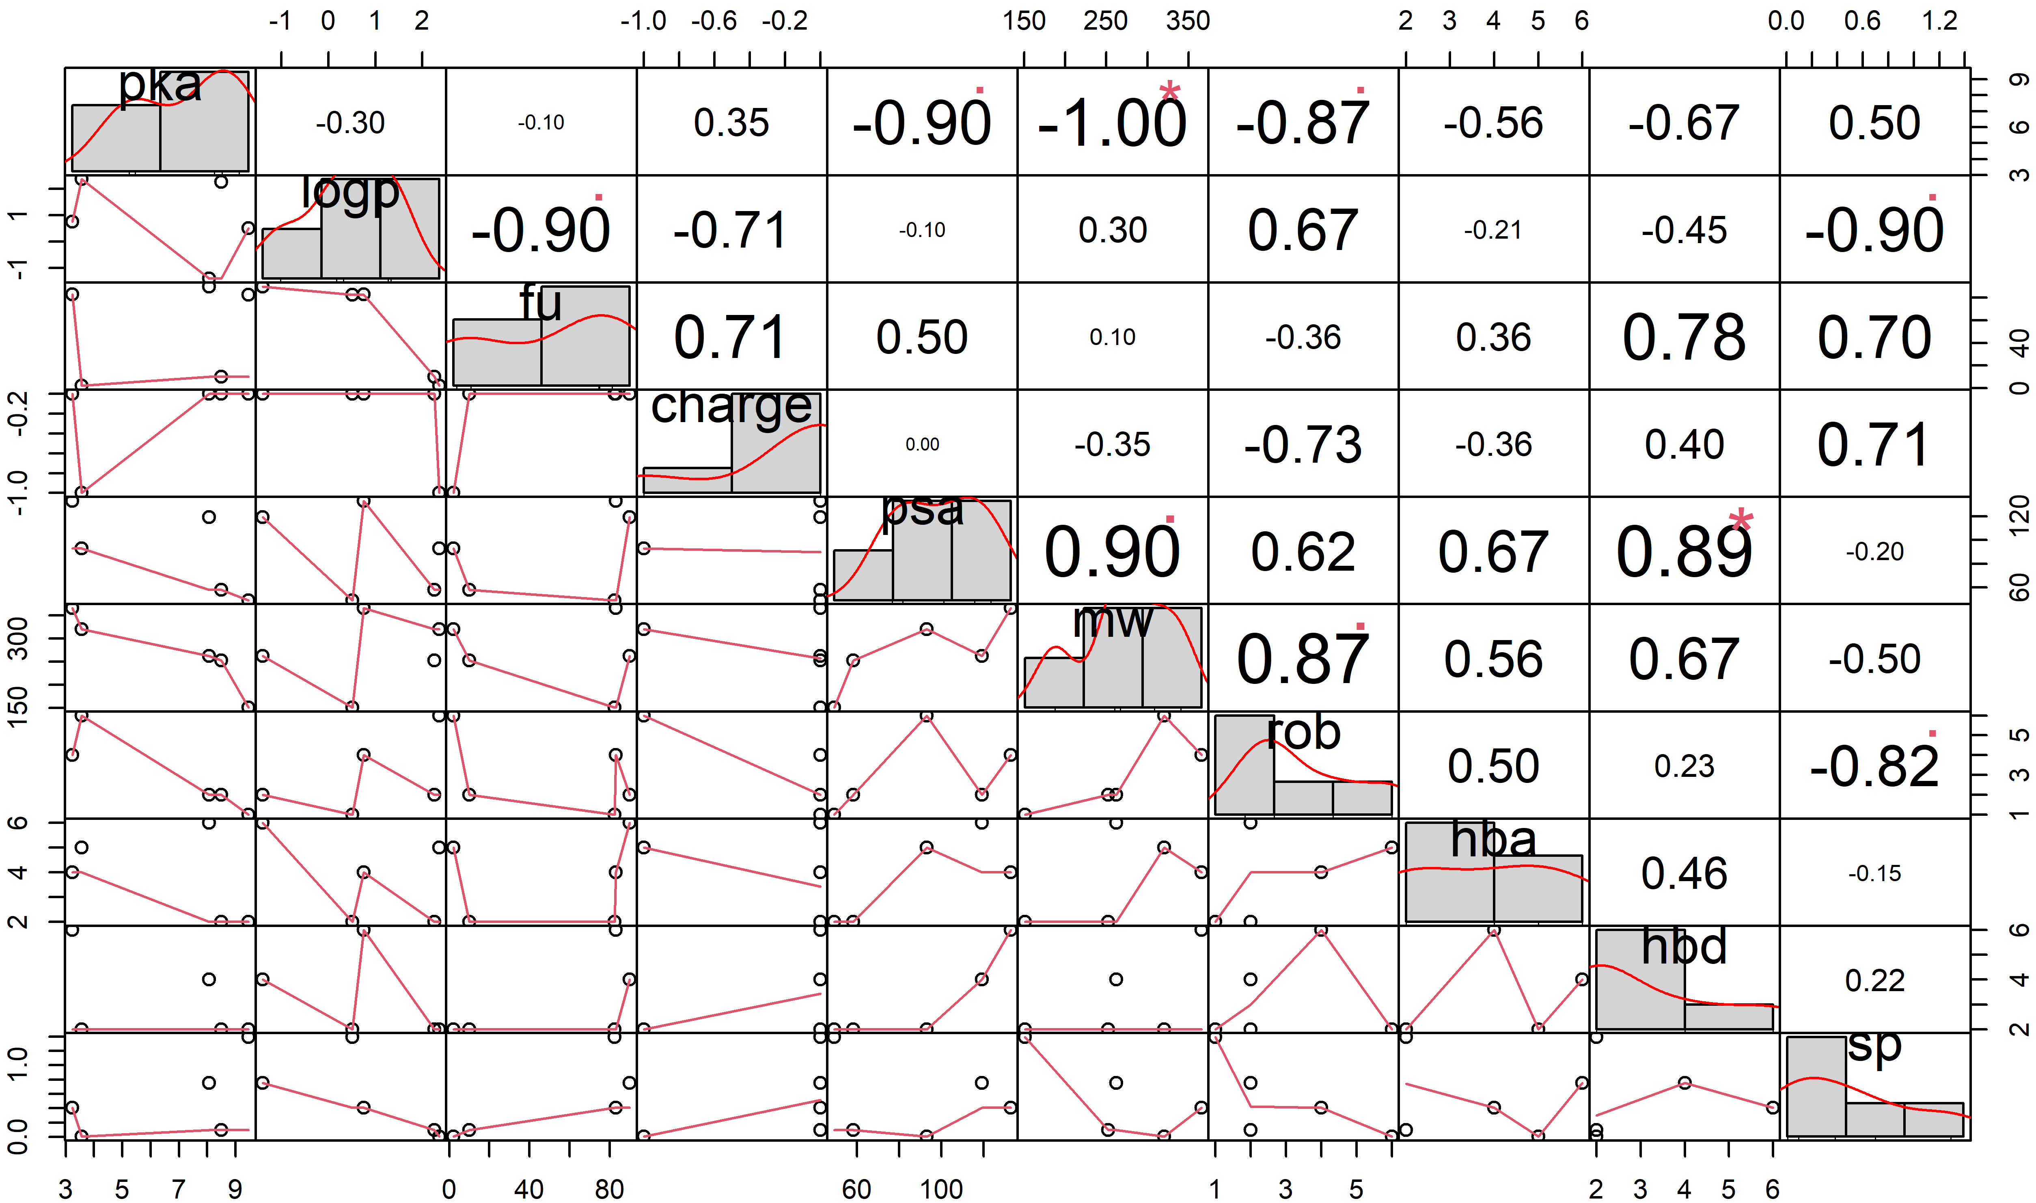
Supplementary figures
Fig. S1 Correlations between physicochemical properties and saliva penetration for acidic drugs (n = 5). Distributions of each physicochemical properties are presented as histograms on the diagonal line. Spearman correlation scatter plots are presented in the last row. Spearman correlation coefficient and p-value are presented in the last column in which p-values of 0, 0.001, 0.01, 0.05, 0.1, and 1 correspond with symbols “***”, “**”, “*”, “.”, and “ ”.
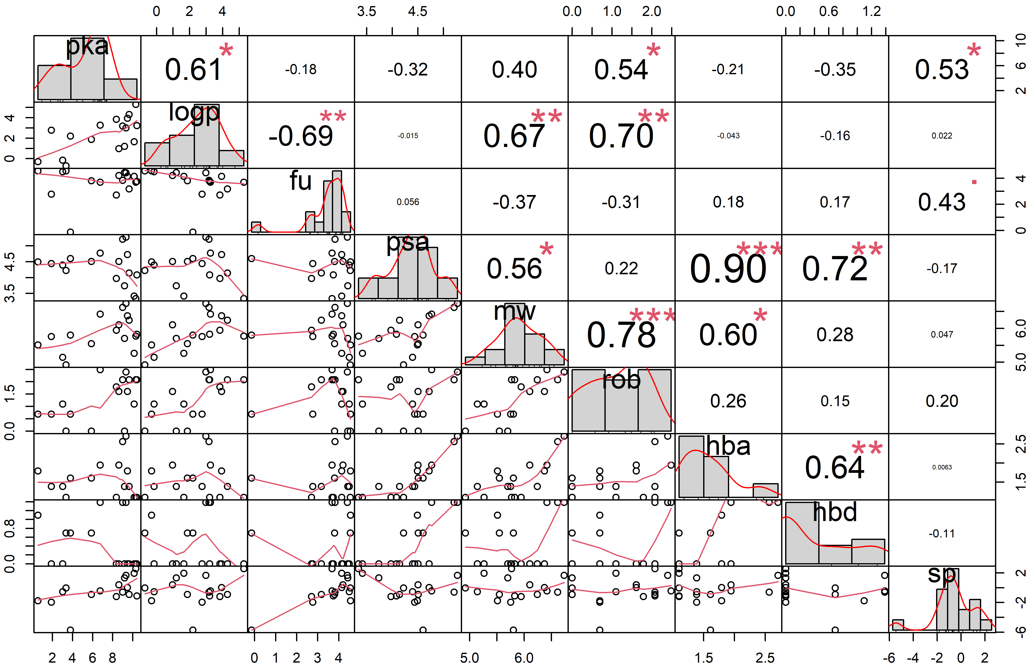
Fig. S2 Correlations between physicochemical properties and saliva penetration for basic drugs after logarithmic transformation (n = 17). Distributions of each physicochemical properties are presented as histograms on the diagonal line. Spearman correlation scatter plots are presented in the last row. Spearman correlation coefficient and p-value are presented in the last column in which p-values of 0, 0.001, 0.01, 0.05, 0.1, and 1 correspond with symbols “***”, “**”, “*”, “.”, and “ ”.
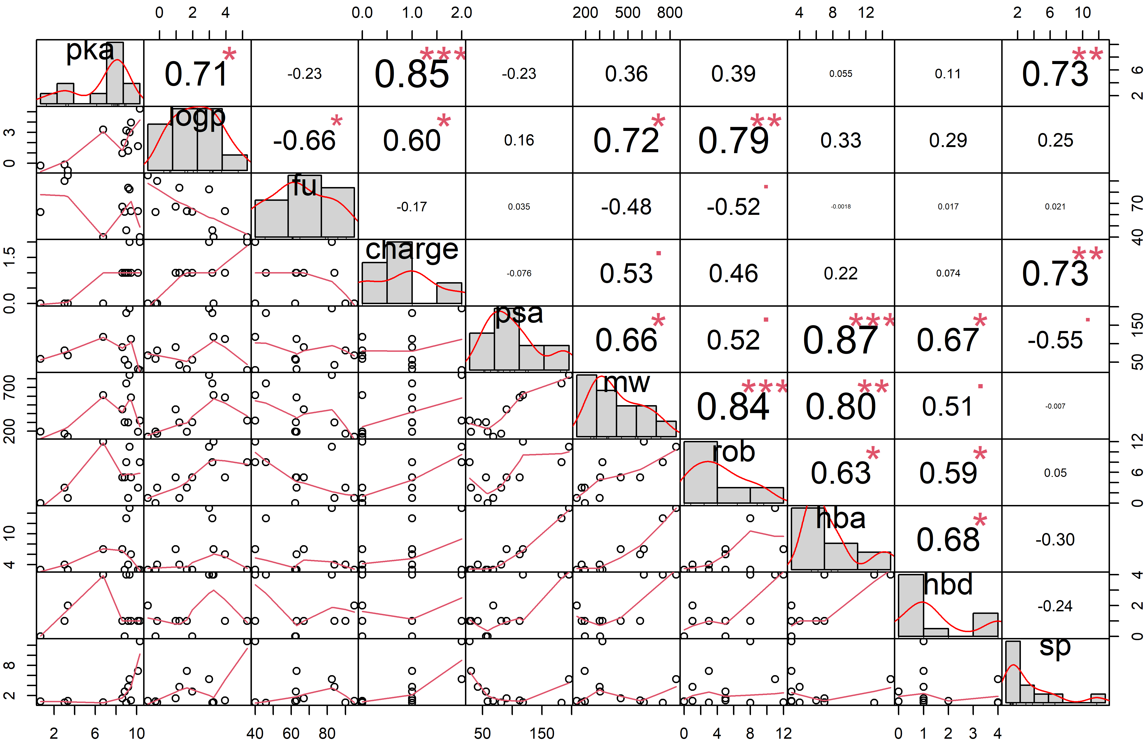
Fig. S3 Correlations between physicochemical properties and saliva penetration for basic drugs with saliva-to-plasma ratio higher than 0.5 (n = 12). Distributions of each physicochemical properties are presented as histograms on the diagonal line. Spearman correlation scatter plots are presented in the last row. Spearman correlation coefficient and p-value are presented in the last column in which p-values of 0, 0.001, 0.01, 0.05, 0.1, and 1 correspond with symbols “***”, “**”, “*”, “.”, and “ ”.
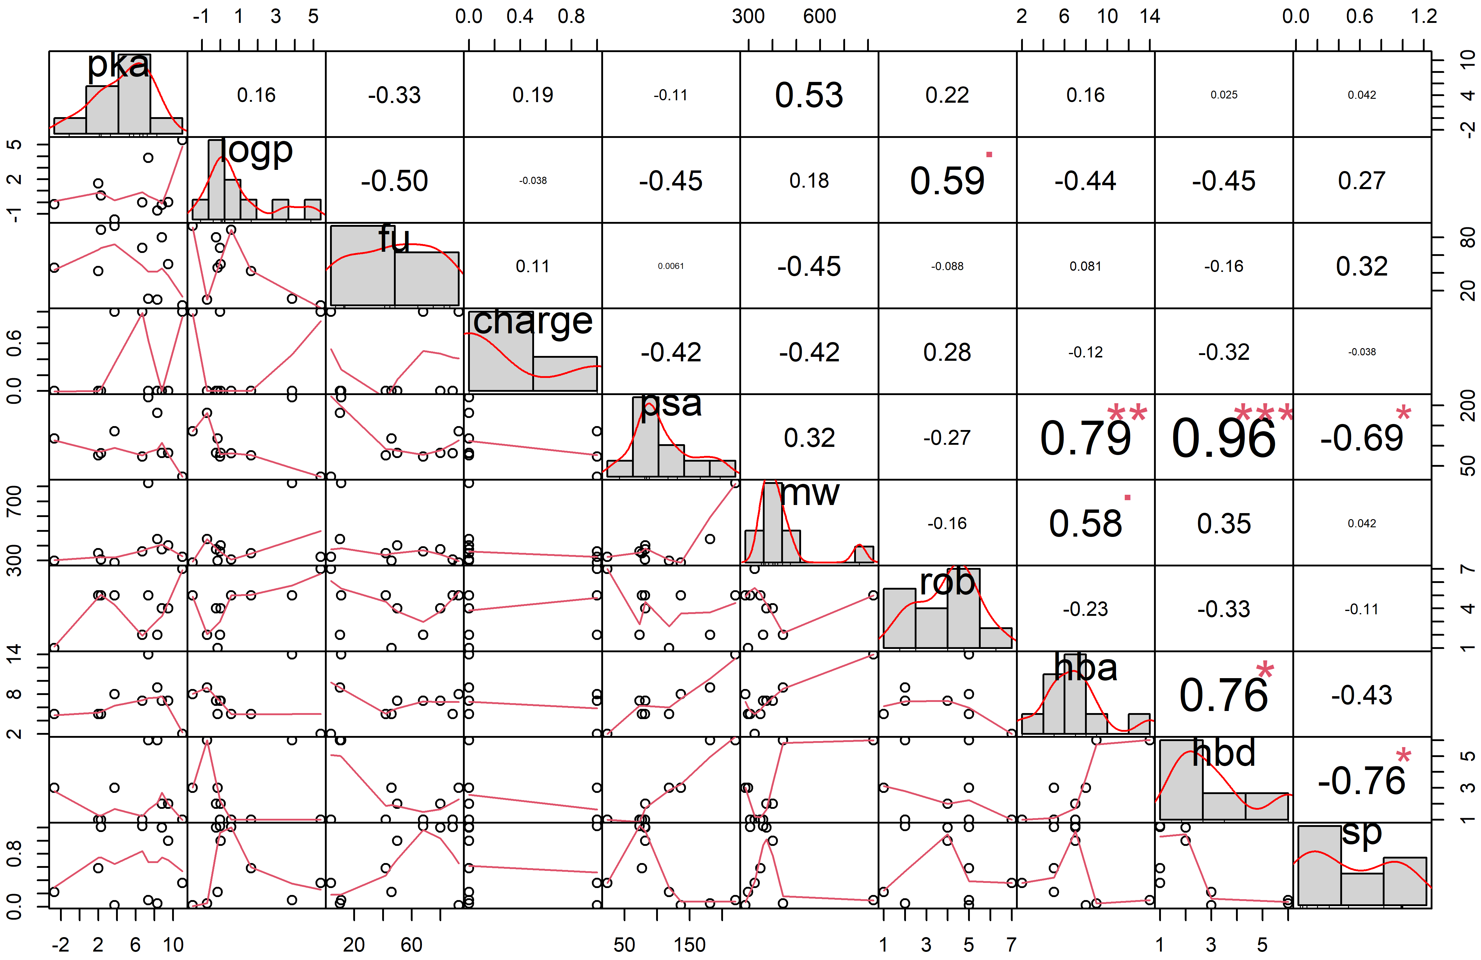
Fig. S4 Correlations between physicochemical properties and saliva penetration for amphoteric drugs (n = 10). Distributions of each physicochemical properties are presented as histograms on the diagonal line. Spearman correlation scatter plots are presented in the last row. Spearman correlation coefficient and p-value are presented in the last column in which p-values of 0, 0.001, 0.01, 0.05, 0.1, and 1 correspond with symbols “***”, “**”, “*”, “.”, and “ ”.
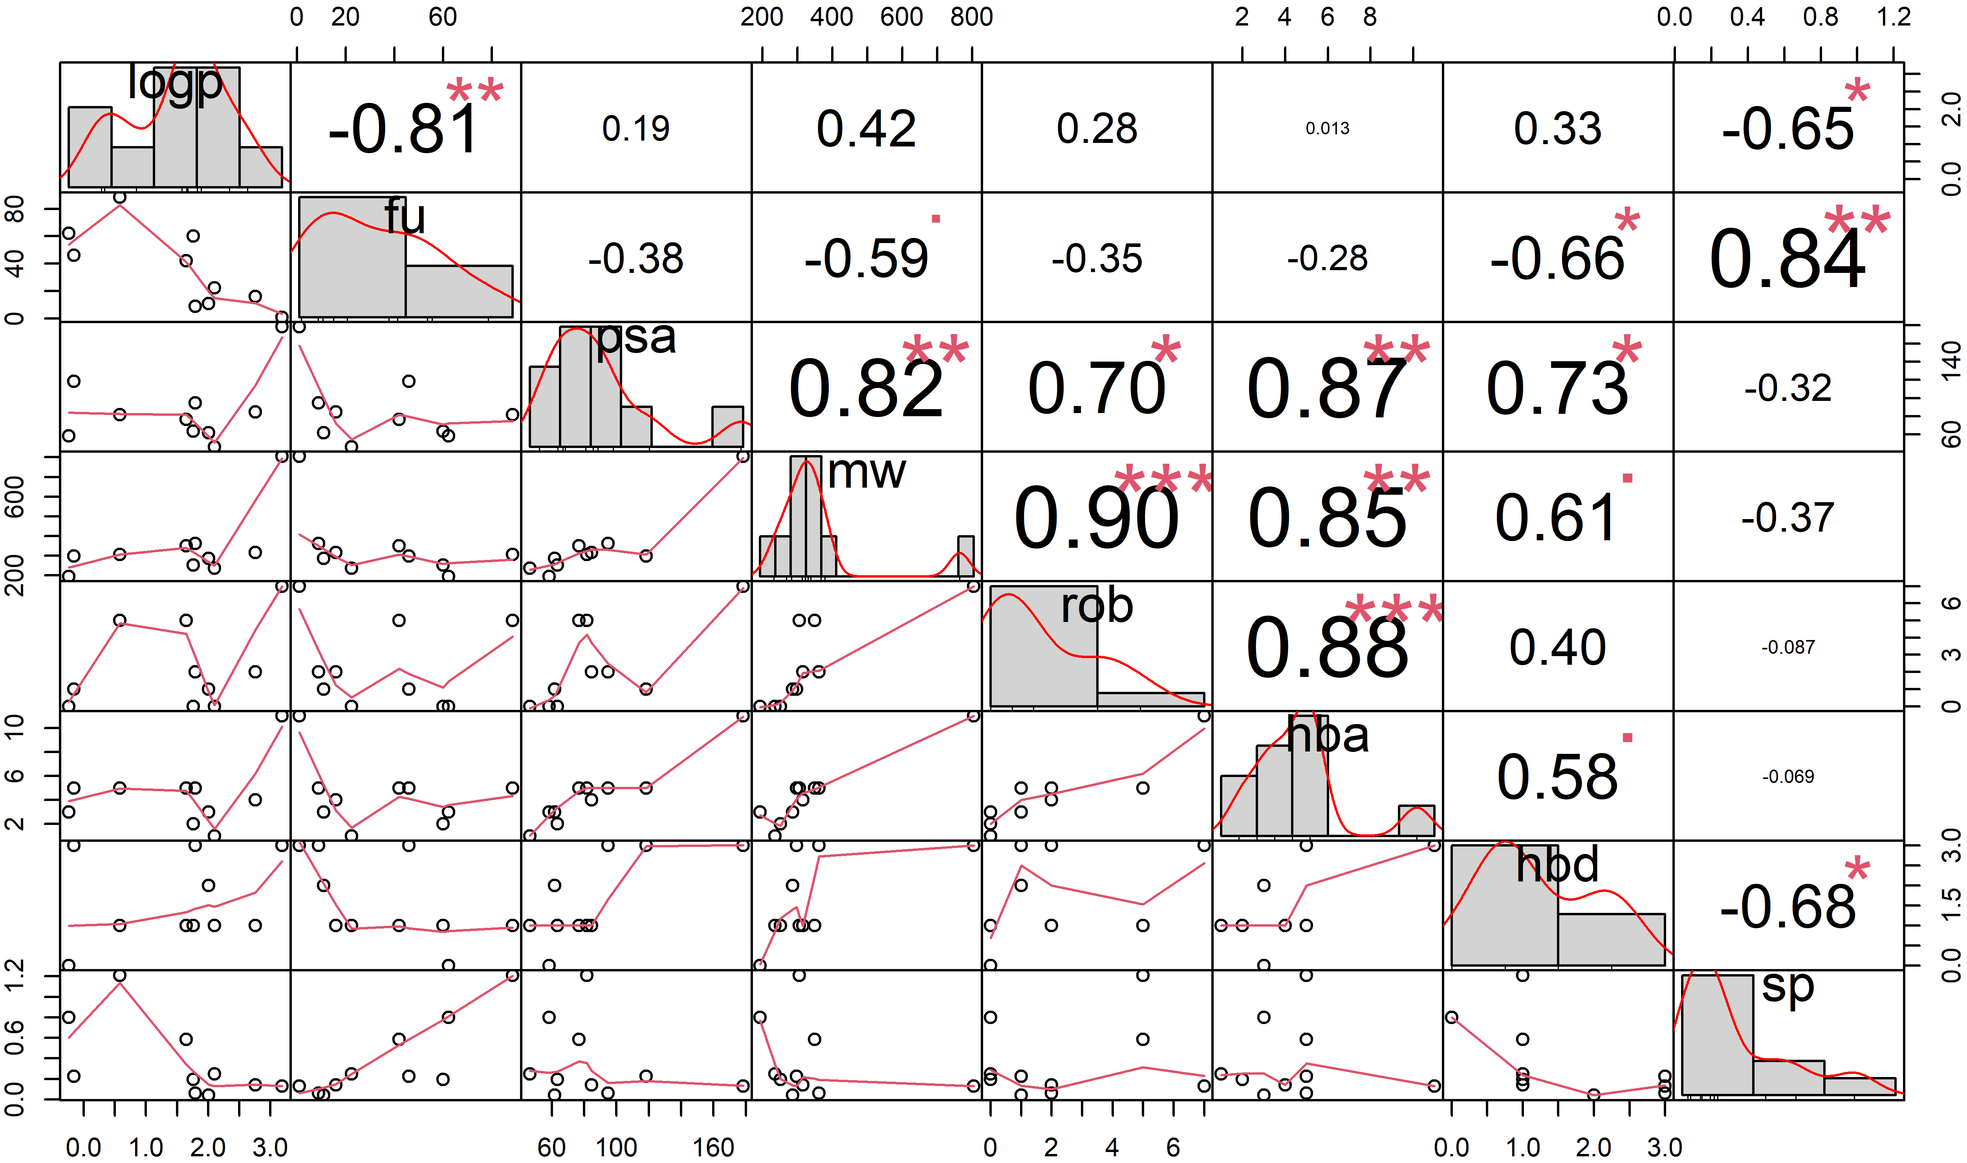
Fig. S5 Correlations between physicochemical properties and saliva penetration for neutral drugs (n = 10). Distributions of each physicochemical properties are presented as histograms on the diagonal line. Spearman correlation scatter plots are presented in the last row. Spearman correlation coefficient and p-value are presented in the last column in which p-values of 0, 0.001, 0.01, 0.05, 0.1, and 1 correspond with symbols “***”, “**”, “*”, “.”, and “ ”.

References
1. Page MJ, McKenzie JE, Bossuyt PM, Boutron I, Hoffmann TC, Mulrow CD, et al. The PRISMA 2020 statement: an updated guideline for reporting systematic reviews. BMJ. 2021 Mar 29;372:n71.
2. Aman MG, Vinks AA, Remmerie B, Mannaert E, Ramadan Y, Masty J, et al. Plasma pharmacokinetic characteristics of risperidone and their relationship to saliva concentrations in children with psychiatric or neurodevelopmental disorders. Clin Ther. 2007;29(7):1476-86.
3. Baglie S, Del Ruenis AP, Motta RH, Baglie RC, Franco GC, Franco LM, et al. Plasma and salivary amoxicillin concentrations and effect against oral microorganisms. Int J Clin Pharmacol Ther. 2007;45(10):556-62.
4. Brown K, Patterson K, Malone S, Shaheen N, Prince H, Dumond J, et al. Antiretrovirals for prevention: maraviroc exposure in the semen and rectal tissue of healthy male volunteers after single and multiple dosing. 17th Conference on Retroviruses and Opportunistic Infections; 2010; 2010. p. 16-9.
5. Burkhardt O, Borner K, Staß H, Beyer G, Allewelt M, Nord CE, et al. Single-and multiple-dose pharmacokinetics of oral moxifloxacin and clarithromycin, and concentrations in serum, saliva and faeces. Scandinavian journal of infectious diseases. 2002;34(12):898-903.
6. Calvo AM, Santos GM, Dionisio TJ, Marques MP, Brozoski DT, Lanchote VL, et al. Quantification of piroxicam and 5 '-hydroxypiroxicam in human plasma and saliva using liquid chromatography-tandem mass spectrometry following oral administration. JOURNAL OF PHARMACEUTICAL AND BIOMEDICAL ANALYSIS. 2016;120:212-20.
7. Cardot JM, Degen P, Flesch G, Menge P, Dieterle W. Comparison of plasma and saliva concentrations of the active monohydroxy metabolite of oxcarbazepine in patients at steady state. Biopharmaceutics & drug disposition. 1995;16(7):603-14.
8. Cordonnier J, Van den Heede M, Heyndrickx A. Saliva concentrations of disopyramide cannot substitute the drug's plasma concentrations. J Anal Toxicol. 1987 Jul-Aug;11(4):179-81.
9. Eeg-Olofsson O, Nilsson HL, Tonnby B, Arvidsson J, Grahn PA, Gylje H, et al. Diurnal variation of carbamazepine and carbamazepine-10,11-epoxide in plasma and saliva in children with epilepsy: a comparison between conventional and slow-release formulations. J Child Neurol. 1990;5(2):159-65.
10. Ferreira PCL, Thiesen FV, de Araujo TT, D'Ávila D O, Gadonski G, de Oliveira CSA, et al. Comparison of plasma and oral fluid concentrations of mycophenolic acid and its glucuronide metabolite by LC-MS in kidney transplant patients. Eur J Clin Pharmacol. 2019;75(4):553-9.
11. Fonsart J, Saragosti S, Taouk M, Peytavin G, Bushman L, Charreau I, et al. Single-dose pharmacokinetics and pharmacodynamics of oral tenofovir and emtricitabine in blood, saliva and rectal tissue: a sub-study of the ANRS IPERGAY trial. J Antimicrob Chemother. 2017;72(2):478-85.
12. Gandia P, Bareille MP, Saivin S, Le-Traon AP, Lavit M, Guell A, et al. Influence of simulated weightlessness on the oral pharmacokinetics of acetaminophen as a gastric emptying probe in man: A plasma and a saliva study. JOURNAL OF CLINICAL PHARMACOLOGY. 2003;43(11):1235-43.
13. Ghareeb M, Gohh RY, Akhlaghi F. Tacrolimus Concentration in Saliva of Kidney Transplant Recipients: Factors Influencing the Relationship with Whole Blood Concentrations. Clin Pharmacokinet. 2018;57(9):1199-210.
14. Gurumurthy P, Rahman F, Narayana A, Sarma GR. Salivary levels of isoniazid and rifampicin in tuberculous patients. Tubercle. 1990;71(1):29-33.
15. Hossain M, Tiffany C, Raychaudhuri A, Nguyen D, Tai G, Alcorn H, Jr., et al. Pharmacokinetics of Gepotidacin in Renal Impairment. Clin Pharmacol Drug Dev. 2020;9(5):560-72.
16. Hugen PWH, Burger DM, de Graaff M, ter Hofstede HJM, Hoetelmans RMW, Brinkman K, et al. Saliva as a specimen for monitoring compliance but not for predicting plasma concentrations in patients with HIV treated with indinavir. Ther Drug Monit. 2000;22(4):437-45.
17. Idkaidek N, Agha H, Arafat T. Saliva versus Plasma Bioequivalence of Valsartan/Hydrochlorothiazide in Humans: Validation of Classes II and IV Drugs of the Salivary Excretion Classification System. Drug Res (Stuttg). 2018;68(1):54-9.
18. Idkaidek N, Arafat T. Saliva vs. plasma bioequivalence of metformin in humans: validation of class II drugs of the salivary excretion classification system. Drug Res (Stuttg). 2014;64(11):599-602.
19. Idkaidek N, Najib N, Salem, II, Najib O. Saliva versus Plasma Relative Bioavailability of Tolterodine in Humans: Validation of Class III Drugs of the Salivary Excretion Classification System. Drug Res (Stuttg). 2016;66(6):312-5.
20. Incecayir T, Agabeyoglu I, Gucuyener K. Comparison of plasma and saliva concentrations of lamotrigine in healthy volunteers. Arzneimittelforschung. 2007;57(8):517-21.
21. Koizumi F, Ohnishi A, Takemura H, Okubo S, Kagami T, Tanaka T. Effective monitoring of concentrations of ofloxacin in saliva of patients with chronic respiratory tract infections. Antimicrobial agents and chemotherapy. 1994;38(5):1140-3.
22. Koks CH, Meenhorst PL, Hillebrand MJ, Bult A, Beijnen JH. Pharmacokinetics of fluconazole in saliva and plasma after administration of an oral suspension and capsules. Antimicrob Agents Chemother. 1996;40(8):1935-7.
23. Kruizinga MD, Zuiker R, Bergmann KR, Egas AC, Cohen AF, Santen GWE, et al. Population pharmacokinetics of clonazepam in saliva and plasma: Steps towards noninvasive pharmacokinetic studies in vulnerable populations. Br J Clin Pharmacol. 2022;88(5):2236-45.
24. Liftshitz M, Ben-Zvi Z, Gorodischer R. Monitoring phenytoin therapy using citric acid-stimulated saliva. Ther Drug Monit. 1990;12:334-8.
25. Onyeji CO, Ogunbona FA. Time-dependent variability of chloroquine secretion into human saliva. Pharm World Sci. 1996;18(6):211-6.
26. Poujol S, Pinguet F, Malosse F, Astre C, Ychou M, Culine S, et al. Sensitive HPLC-fluorescence method for irinotecan and four major metabolites in human plasma and saliva: Application to pharmacokinetic studies. CLINICAL CHEMISTRY. 2003;49(11):1900-8.
27. Shah AK, Harris SC, Greenhalgh C, Morganroth J. The pharmacokinetics and safety of single escalating oral doses of eletriptan. J Clin Pharmacol. 2002;42(5):520-7.
28. Smink BE, Hofman BJ, Dijkhuizen A, Lusthof KJ, de Gier JJ, Egberts AC, et al. The concentration of oxazepam and oxazepam glucuronide in oral fluid, blood and serum after controlled administration of 15 and 30 mg oxazepam. Br J Clin Pharmacol. 2008;66(4):556-60.
29. Stoller NH, Johnson LR, Trapnell S, Harrold CQ, Garrett S. The pharmacokinetic profile of a biodegradable controlled-release delivery system containing doxycycline compared to systemically delivered doxycycline in gingival crevicular fluid, saliva, and serum. J Periodontol. 1998;69(10):1085-91.
30. van den Elsen SH, Akkerman OW, Huisman JR, Touw DJ, van der Werf TS, Bolhuis MS, et al. Lack of penetration of amikacin into saliva of tuberculosis patients. European Respiratory Journal. 2018;51(1).
31. Zylber-Katz E, Granit L, Levy M. Relationship between caffeine concentrations in plasma and saliva. Clin Pharmacol Ther. 1984;36(1):133-7.
32. Bergamaschi CD, Berto LA, Venancio PC, Cogo K, Franz-Montan M, Motta RHL, et al. Concentrations of metronidazole in human plasma and saliva after tablet or gel administration. JOURNAL OF PHARMACY AND PHARMACOLOGY. 2014;66(1):40-7.
33. Rotzetter PA, Le Liboux A, Pichard E, Cimasoni G. Kinetics of spiramycin/metronidazole (Rodogyl) in human gingival crevicular fluid, saliva and blood. J Clin Periodontol. 1994;21(9):595-600.
34. Sagawa K, Mohri K, Shimada S, Shimizu M, Muramatsu J. Disopyramide concentrations in human plasma and saliva: comparison of disopyramide concentrations in saliva and plasma unbound concentrations. Eur J Clin Pharmacol. 1997;52(1):65-9.
35. Kim I, Barnes AJ, Oyler JM, Schepers R, Joseph RE, Jr., Cone EJ, et al. Plasma and oral fluid pharmacokinetics and pharmacodynamics after oral codeine administration. Clin Chem. 2002;48(9):1486-96.
36. O'Neal CL, Crouch DJ, Rollins DE, Fatah A, Cheever ML. Correlation of saliva codeine concentrations with plasma concentrations after oral codeine administration. J Anal Toxicol. 1999;23(6):452-9.
37. Kondratenko SN, Zolkina IV, Shikh EV. A study of the pharmacokinetics of moxifloxacin by the dynamics of its distribution in the blood plasma and saliva of healthy volunteers: a comparative analysis and possible extrapolation methods. Drug Metab Pers Ther. 2020;35(4).
38. Müller M, Stass H, Brunner M, Möller JG, Lackner E, Eichler HG. Penetration of moxifloxacin into peripheral compartments in humans. Antimicrob Agents Chemother. 1999;43(10):2345-9.
39. Nakashima M, Uematsu T, Kosuge K, Kusajima H, Ooie T, Masuda Y, et al. Single-and multiple-dose pharmacokinetics of AM-1155, a new 6-fluoro-8-methoxy quinolone, in humans. Antimicrobial agents and chemotherapy. 1995;39(12):2635-40.
40. Mignot A, Guillaume M, Brault M, Gualano V, Millérioux L, Göhler K, et al. Multiple-dose pharmacokinetics and excretion balance of gatifloxacin, a new fluoroquinolone antibiotic, following oral administration to healthy Caucasian volunteers. Chemotherapy. 2002;48(3):116-21.
41. Moolchan ET, Cone EJ, Wstadik A, Huestis MA, Preston KL. Cocaine and metabolite elimination patterns in chronic cocaine users during cessation: plasma and saliva analysis. J Anal Toxicol. 2000;24(7):458-66.
42. Scheidweiler KB, Spargo EA, Kelly TL, Cone EJ, Barnes AJ, Huestis MA. Pharmacokinetics of cocaine and metabolites in human oral fluid and correlation with plasma concentrations after controlled administration. Ther Drug Monit. 2010;32(5):628-37.
43. Thomson AH, Devers MC, Wallace AM, Grant D, Campbell K, Freel M, et al. Variability in hydrocortisone plasma and saliva pharmacokinetics following intravenous and oral administration to patients with adrenal insufficiency. Clin Endocrinol (Oxf). 2007;66(6):789-96.
44. Purkins L, Wood N, Ghahramani P, Greenhalgh K, Allen M, Kleinermans D. Pharmacokinetics and safety of voriconazole following intravenous-to oral-dose escalation regimens. Antimicrobial agents and chemotherapy. 2002;46(8):2546-53.
45. Vanstraelen K, Maertens J, Augustijns P, Lagrou K, de Loor H, Mols R, et al. Investigation of Saliva as an Alternative to Plasma Monitoring of Voriconazole. Clin Pharmacokinet. 2015;54(11):1151-60.

