Exposure to rifampicin and its metabolite 25-deacetylrifampicin rapidly decreases during tuberculosis therapy
Supplemental material

Sylvain Goutelle^{1,2,3}, Olivier Bahuaud^{3,4}, Charlotte Genestet^{5,6}, Aurélien Millet⁷, François Parant⁷, Oana Dumitrescu^{3,5,6}, Florence Ader^{3,4,6}, on behalf of the Lyon TB Study Group

¹ Hospices Civils de Lyon, GH Nord, Service de Pharmacie, Lyon, France.
² Univ Lyon, Université Claude Bernard Lyon 1, UMR CNRS 5558, Laboratoire de Biométrie et Biologie Evolutive, Villeurbanne, France.
³ Univ Lyon, Université Claude Bernard Lyon 1, Facultés de Médecine et de Pharmacie de Lyon, Lyon, France.
⁴ Hospices Civils de Lyon, Groupement Hospitalier Nord, Hôpital de la Croix-Rousse, Service des Maladies Infectieuses et Tropicales, Lyon, France
⁵ Hospices Civils de Lyon, Hôpital de la Croix Rousse, Institut des Agents Infectieux, Laboratoire des Mycobactéries, Lyon, France
⁶ CIRI – Centre International de Recherche en Infectiologie, Inserm, U1111, Université́ Claude Bernard Lyon 1, CNRS, UMR5308, École Normale Supérieure de Lyon, Univ Lyon, F-69007, Lyon, France.
⁷ Hospices Civils de Lyon, Groupement Hospitalier Sud, Service de Biochimie et Biologie Moléculaire, UM Pharmacologie -Toxicologie, Lyon, France.

Supplementary methods
Drug assay
Concentrations of RIF and 25-dRIF were measured in serum by liquid-chromatography (AcquityTM, Waters, MA, USA) coupled with a tandem mass spectrometer (XEVO TQ S micro, Waters). Chromatographic separation was realized in gradient mode, using a BEH C₁₈ column (1.7 µm, 2.1 x 50 mm, Waters) maintained at 40°C. Mobile phases consisted of solvent (A), 10 mM ammonium formiate in ultra-pure water and solvent (B) 0.1% (v/v) formic acid in acetonitrile. The gradient program of mobile phases was as follows: linear gradient from 75% of aqueous phase (A) to 40% for 1.5 min, followed by 0.7 min of cleaning (95% of organic phase) and 0.8 min of reconditioning (75% A), with a flow rate of 0.600 mL/min. In these conditions, retention times of RIF and 25-dRIF were 1.45 min and 1.23 min respectively. This validated method was linear from 0 to 20 mg/L for RIF and from 0 to 8 mg/L for 25-dRIF, with lower limit of quantification (LOQ) of RIF and 25-dRIF determined at 0.05 mg/L. Calibration curves were constructed using six calibrators including blank (0, 0.1, 1, 5, 10 and 20 mg/L for RIF and 0, 0.05, 0.2, 1, 4 and 8 mg/L for 25-dRIF). Sample preparation was realized using OSTRO® precipitation and dephospholipidation plate (Waters) as follows: to 30 µL of serum were added 100 µL of 0.1 % formic acid in acetonitrile containing internal standards (RIF-d8 and 25-dRIF-d8). After mxing and filtration with a positive pressure processor, the extract is diluted in 300 µL of ultrapure water. Then 1 µL of extract was injected on the chromatographic system. Quantification transitions (m/z) were set as follows: RIF 823.6 > 791.5, RIF-d8 831.6 > 799.6, 25-dRIF 749.5 > 95.1 and 25-dRIF-d8 757.5 > 95. Illustrations of LC-MS/MS chromatograms are shown in Figure S1 below.

Figure S1. LC-MS/MS chromatogram of a blank sera (A), a low QC sample (B) and a sample from a patient treated with RIF (C, RIF determined at 7.73 mg/L and 25-dRIF at 1.02 mg/L).

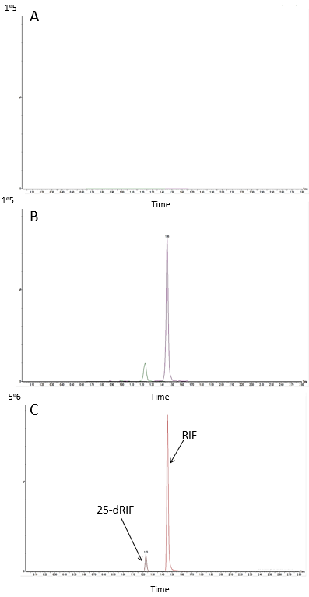

Three levels of quality controls (QCs) were used to evaluate analytical performances. Concentrations of QCs were fixed at 0.5 and 0.11 mg/L for RIF and 25-dRIF respectively (low QC), 8 and 1 mg/L (medium QC) and 16 and 4.5 mg/L (high QC). This method presented acceptable performances according to FDA guidelines (https://www.fda.gov/files/drugs/published/Bioanalytical-Method-Validation-Guidance-for-Industry.pdf), with accuracies (bias %) and precision (CV %) below 10%, as described in Table S1 below.

Table S1. Accuracy and precision of the LC-MS/MS method of quantification of RIF and 25-dRIF
 | Accuracy |  | Precision
 | Within day  RIF / 25-dRIF | Between day  RIF / 25-dRIF | Within day  RIF / 25-dRIF | Between day  RIF / 25-dRIF
Low QC | -0.3 % / 4.8 % | 6.0 % / -9.1 % | 8.2 % / 8.3 % | 9.2 % / 8.8 %
Medium QC | 1.2 % / 3.3 % | 1.0 %/ -4.8 % | 5.8 % / 4.1 % | 7.3 % / 9.4 %
High QC | 1.4 % / -1.1 % | 1.9 % / -2.9 % | 4.5 % / 6.6 % | 7.1 % / 5.5 %

Supplementary results

Figure S2. Structure of RIF and 25-dRIF PK model

Abbreviations : CL_{RIF}, apparent total body clearance of rifampicin; CL_{25-dRIF}, apparent total body clearance of rifampicin metabolite; DAY₅₀, time to half-maximum increase in clearance; Fm, fraction of RIF dose metabolized into 25-dRIF; Ka, absorption rate constant; MAX_{RIF}, maximal increase in RIF clearance from baseline; MAX_{25-dRIF}, maximal increase in 25-dRIF clearance from baseline; V, apparent volume of distribution of RIF and 25-dRIF.

Figure S3. Correlation between RIF concentration or AUC₂₄ and other exposure metrics

