Pharmacokinetics and Lung Deposition After Administration of Inhaled Mosliciguat (BAY 1237592): Results from Randomized Phase I Studies in Healthy Men

Soundos Saleh¹ · Tobias Mundry¹ · Johannes Nagelschmitz¹ · Ulf Buetehorn¹ · Stephan Holzschuh¹ · Sylvia Nikkho¹
- Bayer AG, Pharmaceuticals R&D, Pharma Research Center, Wuppertal, Germany

Corresponding author: Soundos Saleh, Bayer AG, Pharmaceuticals R&D, Pharma Research Center, Wuppertal, Germany
soundos.saleh@bayer.com
Journal: Clinical Pharmacokinetics

Supplementary material
1 Study 1: Mosliciguat Dosing in Part 1
Subjects received a single dose of mosliciguat as an oral solution (500 or 1000 μg) or intravenous (IV) formulation (25, 50, or 100 μg as a 2-hour infusion). The higher doses were given to new subjects only if the previous dose was shown to be safe and tolerable on planned safety assessments after the safety follow-up visit, conducted 7–10 days after administration of study drug. Two subjects were planned to receive each regimen.
2 Additional Information on Inclusion Criteria (All Studies Unless Specified)
Study subjects of reproductive potential were required to agree to use two reliable and acceptable methods of contraception simultaneously when sexually active during the period between signing of the informed consent form and 12 weeks after the last administration of the study intervention. The following contraceptive methods were regarded as adequate:
- condoms (male or female) with or without a spermicidal agent
- diaphragm or cervical cap with spermicide
- intra-uterine device
- hormone-based contraception
(In Study 3: female partner sterilized by tubal ligation, bilateral tubal occlusion, or hysterectomy.)
Note: The combination of condom and diaphragm was not allowed (Pearl Index > 1).
Subjects were required not to act as sperm donors during the study and for 12 weeks
after the last administration of study intervention.
Subjects were required to be capable of giving signed informed consent, which included compliance with the requirements and restrictions listed in the informed consent form (ICF) and in the study protocols. The ICF had to be signed before any study-specific tests or procedures were done. Subjects had to be able to understand and follow study-related instructions/procedures.
In Study 2, confirmation of the subject’s health insurance coverage was required before the first screening/examination visit.
3 Exclusion Criteria (All Studies Unless Specified)
- Medical conditions
  - Incompletely cured pre-existing diseases (e.g., vomiting, diarrhea, major gastrointestinal surgery) for which it could be assumed that the absorption, distribution, metabolism, elimination, and effects of the study drugs were not normal.
  - A history of relevant diseases of vital organs, of the central nervous system or other organs, specifically the lung.
  - Known hypersensitivity to the study drugs (active substances or excipients of the preparations).
  - Known severe allergies (e.g., allergies affecting the lower respiratory tract—allergic asthma, allergies requiring therapy with corticosteroids).
  - Known severe allergies, non-allergic drug reactions, or multiple drug allergies.
  - Febrile illness within 1 week before study drug administration.
  - Hypersensitive bronchopulmonary system (e.g., as shown by methacholine challenge test) or confirmed abnormal lung function test or any relevant anamnestic lung disease or dysfunction.
  - Relevant diseases (e.g., infection of the upper respiratory tract) within the 4 weeks before study drug administration.
  - Medical disorder, condition, or history of such that would impair subjects’ ability to participate in or complete this study in the opinion of the investigator.
  - Lactose intolerance.
- Prior/concomitant therapy
  - Regular use of medicines.
  - Regular use of therapeutic or recreational drugs (e.g., carnitine products, anabolics, and high-dose vitamins).
  - Use of systemic or topical medicines or substances (prescription or over the counter), or herbal products that oppose the study objective or that might have influenced it within 1 week before study drug administration (e.g., no inhibitors or inducers of the cytochrome P450 [CYP] system—such as grapefruit, St. John’s wort, itraconazole, or clarithromycin—within 1 week before study drug administration).
  - Use of systemic strong CYP3A4 inducers within 4 weeks (or at least five half-lives of the active substance, whichever is longer) before administration of study drug (Study 1 only).
  - Smoking (former smokers should have stopped smoking for ≥ 12 months before first drug administration).
  - Regular daily consumption of more than 500 mL of beer or the equivalent quantity of approximately 20 g of alcohol in another form.
  - Regular daily consumption of more than 1 L of methylxanthine-containing beverages.
  - Intake of foods or beverages containing pomelo (Studies 1 and 3 only), grapefruit, Seville orange, or tangelo within 1 week before the first study drug administration.
  - Special diets preventing subjects from eating the standard meals during the study.
  - Suspicion of drug or alcohol abuse.
  - Blood donation of more than 100 mL within 4 weeks and of 500 mL within 3 months before study drug administration.
  - Plasmapheresis within 3 months before study drug administration.
  - Exaggerated physical activity from 1 week before dosing until the end of follow-up.
- Prior/concurrent clinical study experience
  - Prior (within 3 months) or concomitant participation in another clinical study with an investigational medicinal product.
  - Exclusion periods from other studies or simultaneous participation in other clinical studies (Studies 2 and 3 only).
- Diagnostic assessments
  - Clinically relevant electrocardiogram (ECG) findings, such as a first-, second-, or third-degree atrioventricular block, prolongation of the QRS complex
> 120 ms or of the Fridericia-corrected QT-interval > 450 ms at screening.
  - Systolic blood pressure < 100 or > 140 mmHg at screening.
  - Diastolic blood pressure < 60 or > 90 mmHg at screening.
  - Heart rate over 1 minute (taken from ECG) < 50 or > 90 beats/min at screening.
  - Clinically relevant findings in the physical examination that, in the opinion of the investigator, preclude participation for safety reasons.
  - Clinically relevant deviations of the screened laboratory parameters from reference ranges at screening.
  - Positive results for hepatitis B virus surface antigen, hepatitis C virus antibodies, or human immune deficiency virus antibodies (anti-HIV 1+2).
  - Positive urine drug screening.
  - Positive alcohol breath test.
  - Positive cotinine test in urine.
  - Thyroid disorders as demonstrated by assessment of thyroid-stimulating hormone, free triiodothyronine, and free thyroxine levels outside the normal reference range at screening.
- Other exclusions
  - Assignment to a previous treatment step during the study (Studies 2 and 3).
  - Close affiliation with the investigational site (e.g., a close relative of the investigator or a dependent person; employee or student of the investigational site).
  - Criteria that, in the opinion of the investigator, preclude participation for scientific, compliance, or safety reasons.
  - Excluded therapies (physiotherapy, acupuncture) within 1 week before first study drug administration.
  - Subject is in custody by order of an authority or a court of law.
  - Subject is an employee of the study sponsor.
- COVID-19-related criteria (Study 3 only)
  - History of COVID-19 within 6 months before screening.
  - Contact with a patient who is SARS-CoV-2-positive or has COVID-19 within the 4 weeks before admission to the clinical unit.
  - Positive SARS-CoV-2 viral RNA test (approved molecular test: polymerase chain reaction or validated immunologic test for a viral antigen).
  - Suspected or confirmed active or prior SARS-CoV-2 infection according to local guidelines/practice.
  - Long COVID-19 syndrome or other clinically relevant COVID-19-related symptoms or sequelae.
  - Incomplete SARS-CoV-2 vaccination at planned first administration of study intervention or SARS-CoV-2 vaccination planned before completion of the last study visit.
    - Vaccines with a prime-boost scheme: administration of study intervention not permitted between receipt of prime vaccination and 15 days after receipt of boost vaccination.
    - Vaccines with a single-dose scheme: administration of study intervention not permitted within 28 days after receipt of vaccination.
4 Calculation of PK Parameters
Area under the concentration–time curve (AUC) from zero to infinity after single (first) dose:
$$AUC={AUC}_{(0-tlast)}+ \frac{C_{last,calc}}{λ_{Z}}$$
C_{last.calc} calculated concentration value at t_{last} by regression of terminal phase, LLOQ lower limit of quantification, t_{last} time of last concentration above LLOQ, λ_{Z} apparent terminal rate constant, calculated from the last slope of a log-linear regression of the unweighted data considering the last concentration-time points >LLOQ
AUC from time 0 to the last data point >LLOQ (AUC(0-t_{last})), calculated up by linear trapezoidal rule, down by logarithmic trapezoidal rule:
$${AUC(t}_{i}-t_{i+1})= \frac{1}{2}(C_{i}+ C_{i+1})∙(t_{i+1}- t_{i})$$
$$AUC\left(t_{i}-t_{i+1}\right)= \frac{(C_{i}-C_{i+1})∙(t_{i+1}- t_{i})}{lnC_{i}-lnC_{i+1}}$$
AUCt area under the concentration–time curve, C concentration, t time
Half-life associated with the terminal slope (t_{1/2}):
$$t_{1/2}= \frac{ln2}{λ_{Z}}$$
LLOQ lower limit of quantification, λ_{Z} apparent terminal rate constant, calculated from the last slope of a log-linear regression of the unweighted data considering the last concentration-time points >LLOQ
Accumulation ratio calculated from AUCt (R_{A}AUC) after multiple dosing (md) and single dosing (sd) during planned dosing interval t:
$$R_{A}AUC= \frac{{AUC}_{τ,md}}{{AUC}_{τ.sd}}$$
AUCt area under the concentration–time curve for the planned dose interval after the single (first) dose, md multiple dose, sd single dose and also first dose in a multiple-dose study
Accumulation ratio calculated from maximum plasma concentration (C_{max}) after multiple dosing and C_{max} during planned t after single dose:
$$R_{A}C_{max}= \frac{C_{max,md}}{C_{max,sd}}$$
C_{max} maximum drug concentration, md multiple dose, sd single dose and also first dose in a multiple-dose study
Accumulation ratio calculated from trough plasma concentration (C_{trough}) after multiple dosing and C_{trough} during planned τ after single dose:
$$R_{A}C_{trough}= \frac{C_{trough,md}}{C_{trough,sd}}$$
C_{trough} drug concentration at the end of a dosing interval, md multiple dose, sd single dose and also first dose in a multiple-dose study
Linearity factor (R_{LIN}) of pharmacokinetics after repeated administration of identical doses calculated as ratio of AUCτ after multiple dosing and AUC after single dosing:
$$R_{LIN}= \frac{AUC_{τ,md}}{{AUC}_{sd}}$$
AUC area under the concentration–time curve for the planned dose interval after the single (first) dose, md multiple dose, sd single dose and also first dose in a multiple-dose study
5 Bioanalytical Methods
Quantitative analysis of mosliciguat in plasma (and in mouth rinse in Study 1) was performed using a fully validated high-performance liquid chromatography and tandem mass spectrometric detection (LC-MS/MS). For the mouth rinse analysis in inhalation groups using a charcoal block, participants gargled 200 mL of non-sparkling water immediately following inhalation and prior to ingesting 240 mL of water. The water used for the mouth rinse was collected and analyzed. The analyses were performed in compliance with the pertinent guidelines on Bioanalytical Method Validation .
Concentrations of mosliciguat in plasma were determined after protein precipitation with acetonitrile (Study 1) or acetonitrile/formic acid (2%) 90/10 volume in volume (v/v) (Study 2) containing a stable isotope-labeled internal standard ([¹³C₆,²H₃]mosliciguat).
In Study 1, the calibration range of the procedure for mosliciguat in plasma was from 50.0 ng/L (lower limit of quantification [LLOQ]) to 50,000 ng/L (upper limit of quantification [ULOQ]). Mean inter-assay accuracy of back-calculated concentrations (except LLOQ) in calibrators ranged between 99.2% and 101.0% and precision was ≤ 3.6%. Accuracy and precision at the lowest calibrator (LLOQ) were equal to 99.8% and 6.1%, respectively. Quality control (QC) samples in the concentration range 150–37,500 ng/L were determined with an accuracy of 98.0–105.0% and a precision of 2.2–4.2%. All samples were stored at
–85 (±10)°C and analyzed within 160 days after sampling.
The calibration range of the procedure for mosliciguat in mouth rinse was from 10.0 (LLOQ) to 10,000 µg/L (ULOQ). Mean inter-assay accuracy of back-calculated concentrations (except LLOQ) in calibrators ranged between 89.9% and 104.8% and precision was ≤ 5.4%. Accuracy and precision at the lowest calibrator (LLOQ) were equal to 97.9% and 5.8%, respectively. QC samples in the concentration range 30–7500 µg/L were determined with an accuracy of 97.1–106.3% and a precision of 2.2–3.1%. All samples were stored at 85 (±10)°C and analyzed within 107 days after sampling.
In Study 2, the calibration range of the procedure for sequences 2018-BS-00053 and 2018-BS-00060 for mosliciguat in plasma was from 0.2 (LLOQ) to 1000 µg/L (ULOQ). For all other sequences, the linear range was 0.2–500 μg/L. QC samples in the concentration range 0.6–800 µg/L were determined with an accuracy of 86–102% and a precision of 3.1–8.8%. All samples were stored at or below –15°C and analyzed within 82 days after sampling.
In Study 3, mosliciguat was determined in plasma by high-performance liquid chromatography/mass spectrometry (HPLC/MS) with a calibration range of 0.05 (LLOQ) to 50 µg/L (ULOQ). All samples were stored at –85 (±10)°C throughout the study. QC samples in concentrations of 0.15, 2.0, and 37.5 µg/L were determined with a cumulative accuracy of 93.1–108.5% and a cumulative precision of ≤ 8.6%. Cumulative accuracy of back-calculated calibration samples was 92.8–105.2% with cumulative precision ≤ 8.8%.

References
- European Medicines Agency. Guideline on bioanalytical method validation (EMEA/CHMP/EWP/192217/2009), 2011. Available at: https://www.ema.europa.eu/en/documents/scientific-guideline/guideline-bioanalytical-method-validation_en.pdf. Last accessed October 2024.
- US Food and Drug Administration Center for Drug Evaluation and Research (CDER) Center for Veterinary Medicine. Guidance for industry: bioanalytical method validation, 2018. Available at: https://www.fda.gov/files/drugs/published/Bioanalytical-Method-Validation-Guidance-for-Industry.pdf. Last accessed October 2024.

Table S1 In vitro data for dry powder inhaler formulations used in Studies 1–3
Parameter | 1000 µg capsule | 480 µg  capsule | 1000 µg  capsule | 1000 µg  capsule
Study | 1 | 2 | 2 | 3
Mosliciguat content, µgª (%) | 962 (96) | 449 (94) | 982 (98) | 987 (99)
Delivered dose, µg | 624 | 316 | 671 | 705
Fine particle dose, µg | 194 | 126 | 242 | 258
Fine particle fraction, < 4.5 µm^{b} | 19% | 26% | 24% | 26%
Capsule residual, µg | 160 | 84 | 207 | 157
Device residual, µg | 119 | 43 | 107 | 107
ªAssayed by high-performance liquid chromatography
^{b}Related to nominal capsule content

Table S2 Baseline characteristics for Part 1 of Study 1
 | 25 mg IV  (n = 2) | 50 mg IV  (n = 2) | 100 mg IV  (n = 2) | 500 mg oral  (n = 2) | 1000 mg oral  (n = 2)
Male sex, n (%) | 2 (100) | 2 (100) | 2 (100) | 2 (100) | 2 (100)
Race, n (%)  White  Black | 2 (100)  0 | 2 (100)  0 | 2 (100)  0 | 2 (100)  0 | 2 (100)  0
Age, years, mean (SD) | 31.0 (9.9) | 29.5 (12.0) | 32.0 (2.8) | 34.0 (7.1) | 32.0 (2.8)
BMI, kg/m², mean (SD) | 19.7 (1.0) | 22.8 (4.7) | 24.5 (5.7) | 23.5 (0.4) | 26.5 (1.8)
Smoking history, n (%)  Never  Former | 2 (100)  0 | 1 (50.0)  1 (50.0) | 2 (100)  0 | 2 (100)  0 | 1 (50.0)  1 (50.0)
Alcohol consumption, g/day, mean (SD) | 1.0 (1.4) | 3.0 (4.2) | 7.0 (5.7) | 9.5 (13.4) | 6.0 (4.2)
BMI body mass index, IV intravenous, SD standard deviation

Fig. S1 Geometric mean plasma mosliciguat trough concentrations over time (Study 2)

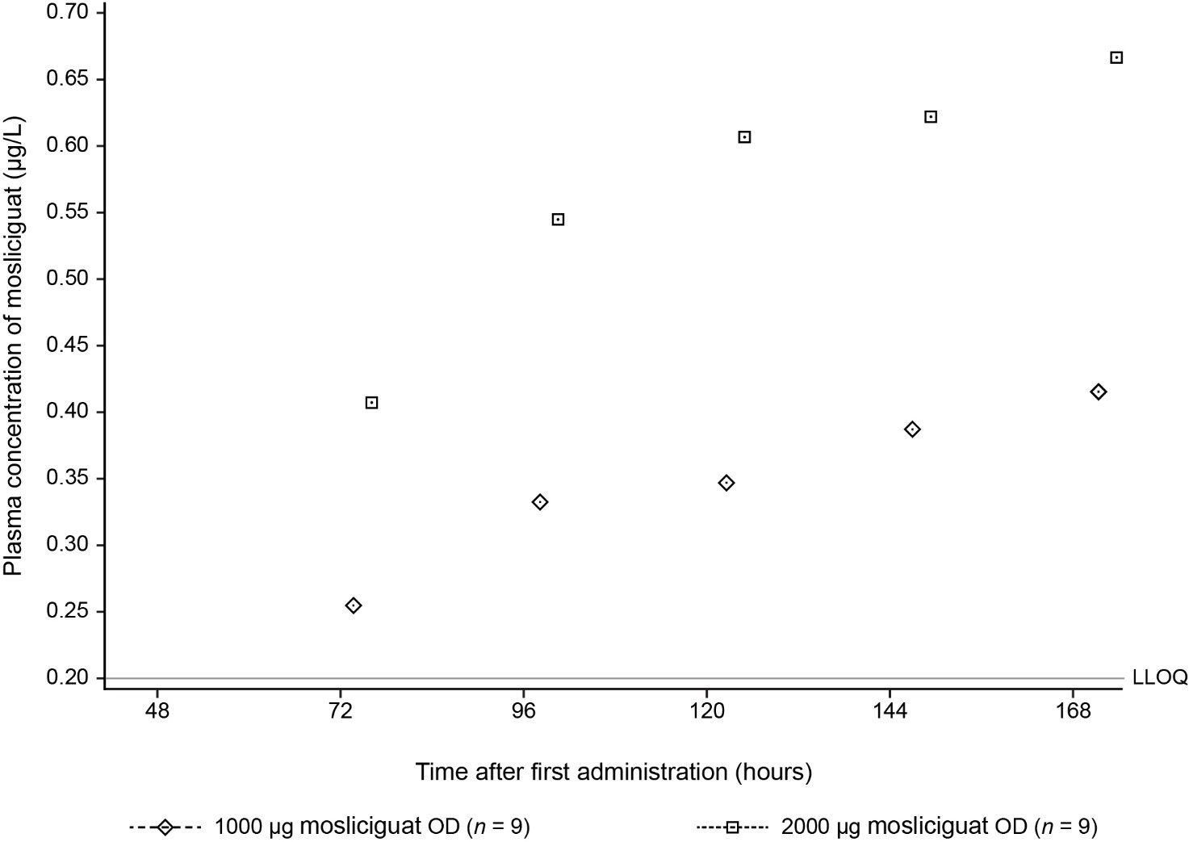LLOQ lower limit of quantification, OD once daily

