Supplemental Information for “Population Cellular Kinetics of Idecabtagene Vicleucel in Patients with Triple-Class–Exposed Relapsed/Refractory Multiple Myeloma”

Fan Wu¹, Jian Zhou¹, Xirong Zheng¹, Madhan Masilamani¹, Yiming Cheng¹, Andrea Caia², Mark Cook³, Julia Piasecki⁴, Manisha Lamba¹

1 Translational Medical & Clinical Pharmacology, Bristol Myers Squibb, Princeton, NJ, USA
2 Clinical Science, Bristol Myers Squibb, Boudry, Neuchatel, Switzerland
3 Clinical Development, Bristol Myers Squibb, Boudry, Neuchatel, Switzerland
4 Cancer Immunology & Cell Therapy, Seattle, WA, USA

Corresponding author: Fan Wu
Bristol Myers Squibb
Princeton, NJ, USA
Tel: (862) 273-2025
Email: fanwunj@icloud.com

Running Title: Population cellular kinetics of idecabtagene vicleucel

CONFLICTS OF INTEREST
F.W., J. Z., X.Z., M.M., Y.C., A.C., M.C., J.P., and M.L. were employees and stockholders of Bristol Myers Squibb during preparation of the manuscript. F.W. is currently affiliated with Deerfield Management, and M.L. is currently affiliated with Pfizer.

FUNDING INFORMATION
This study was funded by Bristol Myers Squibb.

Keywords: Population pharmacokinetics, cellular kinetics, multiple myeloma, CAR T

Supplemental Information

Text S1: Mathematical Descriptions of the Population Cellular Kinetics Model
In addition to the structural model described in Figure 1, mathematical descriptions of the random effect model and error model are provided below.
The inter-individual variabilities (IIV) on cellular kinetic parameters of the base model were specified by a lognormal model with nonzero covariance between the IIV on r and Tmax as:
$$\left(\log\left(r\right),\log\left(Tmax\right)\right)∼N\left(0,Ω\right)$$
$$Ω=\left(ω_{r}^{2}, corr_{r,Tmax}∙ω_{r}∙ω_{Tmax}; corr_{r,Tmax}∙ω_{r}∙ω_{Tmax}, ω_{Tmax}^{2} \right)$$
$$\log\left(r\right)∼N\left(0,ω_{r}^{2}\right)$$
$$\log\left(Tmax\right)∼N\left(0,ω_{Tmax}^{2}\right)$$
where N, Ω, ω², corr refer to the normal distribution function, covariance matrix, variance, and correlation coefficient, respectively.
To implement a log error model of ide-cel CK, the residual error model was selected to be an additive error model of log-transformed CAR+ T-cell concentrations based on diagnostic plots and the information criteria as:
$$y=log⁡(C)+ε∙a$$
where y is the modeled value for the observed variable, C is the model predicted value of CAR+ T-cell concentrations, ε is the residual error, and a is the error model parameter.

Table S1: Summary of Covariates
Characteristics |  | Total (N = 225)
Actual doses (×10⁶ cells) | Median [range] | 445 [175–529]
LVV Type | aLVV | 167 [74.2%]
 | sLVV | 58 [25.8%]
Age (years) | Median [range]) | 63 [30–81]
Sex (n [%]) | Female | 84 [37.3%]
 | Male | 141 [62.7 %]
Weight (kg) | Median [range] | 82.7 [41.1–144]
Body surface area (m²) | Median [range] | 1.97 [1.32–2.52]
 | Missing N [%] | 5 [2.22%]
Race (n [%]) | Asian | 6 [2.67%]
 | Black or African American | 17 [7.56]
 | White | 155 [68.9%]
 | Other | 2 [0.89%]
 | Unknown | 45 [20.0%]
Ethnicity (n [%]) | Hispanic or Latino | 10 [4.44%]
 | Not Hispanic or Latino | 169 [75.1%]
 | Unknown | 46 [20.4%]
Creatinine clearance at baseline (mL/min) | Median [range] | 87.0 [10.4–205]
LDH at baseline (U/L) | Median [range] | 187 [89–1620]
AST at baseline (U/L) | Median [range] | 20 [9–163]
ALT at baseline (U/L) | Median [range] | 16 [5–348]
ADA status at baseline (n [%]) | Negative | 214 [95.1%]
 | Positive | 5 [2.22%]
 | Unknown | 6 [2.67%]
Number of prior regimens (n [%]) | 2 | 71 [31.6%]
 | 3 | 85 [37.8%]
 | 4 | 69 [30.7%]
Triple refractory (n [%]) | No | 86 [38.2%]
 | Yes | 139 [61.8%]
Bridging therapy (n [%]) | No | 33 [14.7%]
 | Yes | 192 [85.3%]
Prior hematopoietic stem cell transplant (n [%]) | No | 36 [16.0%]
 | Yes | 189 [84.0%]
ECOG performance status at baseline (n [%]) | 0 | 112 [49.8%]
 | 1 | 113 [50.2%]
International staging system (n [%]) | I | 138 [61.3%]
 | II | 60 [26.7%]
 | III | 27 [12.0%]
Extramedullary plasmacytoma (EMP) at baseline (n [%]) | No | 171 [76.0%]
 | Yes | 53 [23.6%]
 | Unknown | 1 [0.44%]
Cytogenetic high risk (n [%]) | No | 141 [62.7%]
 | Yes | 84 [37.3%]
Pre-infusion soluble BCMA level (ng/mL) | Median [range] | 145 [1.8–789]
 | Missing N [%] | 5 [2.22%]
Pre-infusion IL-6 level (pg/mL) | Median [range] | 13 [3–295]
 | Missing N [%] | 8 [3.56%]
Pre-infusion IL-15 level (pg/mL) | Median [range] | 43 [8.80–158]
 | Missing N [%] | 6 [2.67%]
Pre-infusion TNF-α level (pg/mL) | Median [range] | 27 [8.8–160]
 | Missing N [%] | 6 [2.67%]
Pre-infusion soluble CD137 level (pg/mL) | Median [range] | 105 [27–624]
 | Missing N [%] | 5 [2.22%]
ADA, anti-drug antibody; LDH, lactate dehydrogenase; ALT, alanine aminotransferase; AST, aspartate aminotransferase; ECOG, eastern cooperative oncology group; EMP, extramedullary plasmacytoma; BCMA, B-cell maturation antigen; Cytogenetic high risk, defined as presence of t[4;14], t[14;16], or del[17p]

Table S2: List of Candidate models during Model Development
Candidate model | Model description | OFV (-2LL) | BICc | Adopted
CK01 | Piecewise cellular kinetic model with a linear cell growth rate, random effects on all structural parameters, constant error model | 8563 | 8652 | -
CK02 | Piecewise cellular kinetic model with a linear cell growth rate and a lag time, random effects on all structural parameters, constant error model | 8525 | 8629 | Yes
CK03 | Piecewise cellular kinetic model with a saturable cell growth rate, random effects on all structural parameters, constant error model | 8436 | 8539 | Yes
CK04 | Piecewise cellular kinetic model with a saturable cell growth rate and a lag time, random effects on all structural parameters, constant error model | 8266 | 8383 | Yes
CK05 | CK04 + PRSB on δ_{M} | 8247 | 8369 | Yes
CK06 | CK05 + PRSB on Tmax | 8236 | 8364 | Yes
CK07 | CK06 + FORMU on Vmax | 8226 | 8359 | Yes
CK08 | CK07 + CRCLBL on E0 | 8213 | 8352 | Yes
CK09 | CK08 + DOSEA on Vmax | 8206 | 8350 | Yes
CK10 | CK09 + BEMP on Vmax | 8204 | 8353 | No
CK11 | CK09 + BADA on δ_{E} | 8191 | 8340 | Yes
CK11-1 | CK11 + ADA on Vmax, Km, r, δ_{E} and δ_{M} | 8137 | 8354 | Yes
CK11-2 | CK11 + ADA on r, δ_{E} and δ_{M} | 8132 | 8323 | Yes
CK11-3 | CK11 + ADA on r and δ_{M} | 8119 | 8298 | Yes
CK11-4 | CK11 + ADA on δ_{E} and δ_{M} | 8182 | 8344 | No
CK11-5 | CK11 + ADA on δ_{M} | 8134 | 8296 | Yes
CK12 | CK11 + PHSCT on A0 | 8185 | 8340 | No
CK13 | CK11-5 + BRDTH on A0 | 8198 | 8352 | No
CK14 | CK11-5 + PRIL15 on Tmax | 8185 | 8340 | No
CK15 | CK11-5 + FORMU on A0 | 8120 | 8288 | Yes
CK16 | CK15 + RACE on Vmax | 8115 | 8299 | No
CK17 | CK15 + PRIL6 on Tlag | 8125 | 8299 | No
CK18 | CK15 + PHSCT on A0 | 8114 | 8288 | No
CK19 | CK15 + correlation between r and Tmax | 8085 | 8259 | Yes
CK20 | CK19 + PRIL15 on δ_{E} | 8080 | 8259 | No
The final model is highlighted by the bold fonts. BICc, corrected Bayesian Information Criterion;

Model description | OFV (-2LL) | BICc | Remove
CK19 (Full model) | 8085 | 8259 | -
Remove PRSB on δ_{M} | 8112 | 8280 | No
Remove PRSB on Tmax | 8099 | 8267 | No
Remove FORMU on Vmax | 8096 | 8264 | No
Remove CRCLBL on E0 | 8099 | 8268 | No
Remove DOSEA on Vmax | 8104 | 8272 | No
Remove BADA on δ_{E} | 8101 | 8270 | No
Remove FORMU on E0 | 8101 | 8269 | No

Table S3: Results of Backward Elimination during model development

BICc, corrected Bayesian Information Criterion;

Table S4: Summary of Median Progression Free Survival (PFS) Stratified by Quartiles of Individual Cellular Kinetic ParametersParameter | Quartiles | Median (Range) PFS (months)
E0 | Q1: [36.2, 211) | 20.3 (13.6, 25.3)
E0 | Q2: [210.6, 325) | 18.3 (13.8, 29)
E0 | Q3: [324.9, 510) | 13.8 (12, 19)
E0 | Q4: [509.8,2029] | 11.9 (9, 19.7)
Tlag | Q1: [1.83,1.92) | 16 (11.2, 22.9)
Tlag | Q2: [1.92,1.94) | 12.7 (11, 19)
Tlag | Q3: [1.94,1.96) | 16.6 (12.2, 22.6)
Tlag | Q4: [1.96,2.06] | 20.3 (13.6, 26.4)
Tmax | Q1: [5.17, 7.40) | 10.6 (7.6, 17.7)
Tmax | Q2: [7.40, 8.60) | 15.5 (11.9, 22.9)
Tmax | Q3: [8.60, 9.64) | 17.4 (14.7, 26.4)
Tmax | Q4: [9.64,27.44] | 16 (11.3, 25.3)
Vmax | Q1: [30041, 72895) | 9 (5.9, 15.3)
Vmax | Q2: [72895, 81555) | 14.7 (12, 20.3)
Vmax | Q3: [81555, 97922) | 18.9 (12.7, 26.6)
Vmax | Q4: [97922,165232] | 21.2 (18.3, 25.3)
Km | Q1: [40545, 60420) | 22.9 (19.8, 29.7)
Km | Q2: [60420, 68313) | 17.7 (13.8, 26.6)
Km | Q3: [68313, 79886) | 13.3 (10.8, 16.2)
Km | Q4: [79886,147581] | 11.3 (6.4, 16.6)
r | Q1: [0.00000586,0.000134) | 20.4 (13.8, 25.3)
r | Q2: [0.00013426,0.000347) | 20.7 (12.4, 24.5)
r | Q3: [0.00034720,0.000750) | 15.4 (11.8, 18.9)
r | Q4: [0.00074955,0.006916] | 11.8 (7.8, 15.8)
δ_{E} | Q1: [0.0273,0.0844) | 20.9 (14.7, 26.7)
δ_{E} | Q2: [0.0844,0.1133) | 17.2 (14.4, 25.8)
δ_{E} | Q3: [0.1133,0.1648) | 16 (11.8, 24.2)
δ_{E} | Q4: [0.1648,0.6048] | 8.3 (7.1, 12.2)
δ_{M} | Q1: [0.00138,0.00419) | 22.4 (18.3, 29)
δ_{M} | Q2: [0.00419,0.00562) | 16.6 (12.4, 24.5)
δ_{M} | Q3: [0.00562,0.00711) | 12.1 (6.4, 18.9)
δ_{M} | Q4: [0.00711,0.01265] | 11 (8, 13.8)

Figure S1: Model-Predicted Relationships between Ide-cel Concentration and Growth Rate Constant (= Vmax/(Km+E)).

The vertical dashed lines indicate approximate ide-cel transgene levels at the day of infusion and the time of peak expansion in a representative individual given a dose of 445×10⁶ CAR+ cells.
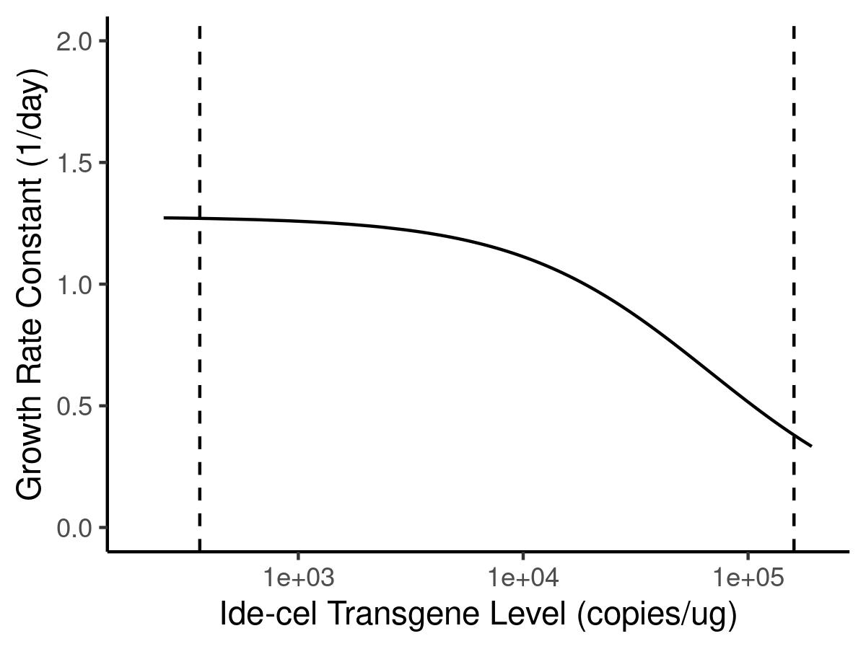

Figure S2: VPCs using the Population CK with the Linear Growth Rate versus the Saturable Growth Rate.

Blue solid dots represent observed ide-cel CK data and red solid dots represent censored data. Blue solid lines represent median, 10th, 50th, and 90th percentiles of observations. Black dashed lines represent 10th, 50th, and 90th percentiles of model simulated CK profiles. The orange-shaded regions represent the 90% prediction intervals for the 50th percentile of model-simulated CK profiles, while the blue-shaded regions represent the 90% prediction intervals for the 10th and 90th percentiles of model-simulated CK profiles. The red area indicates empirical percentiles that are outside prediction intervals.

Model with the first-order growth rate | Model with the saturable growth rate
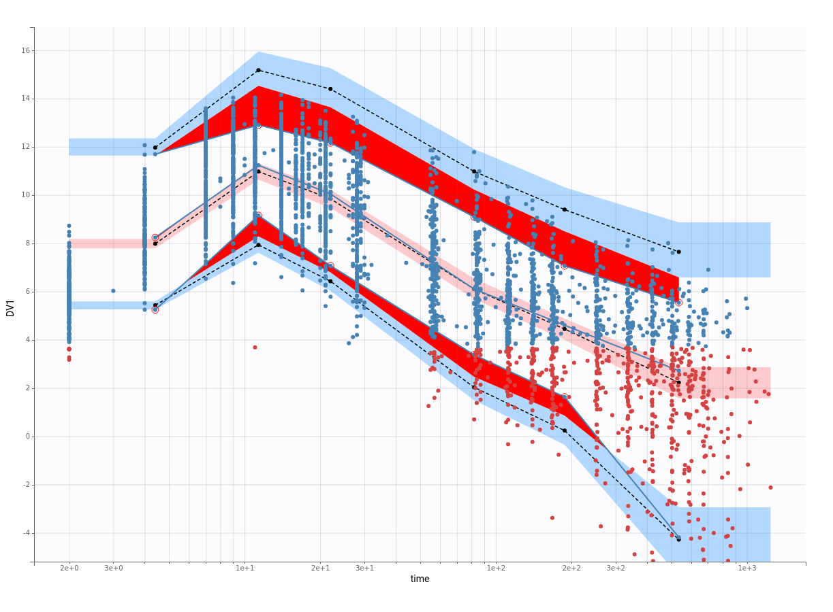 | 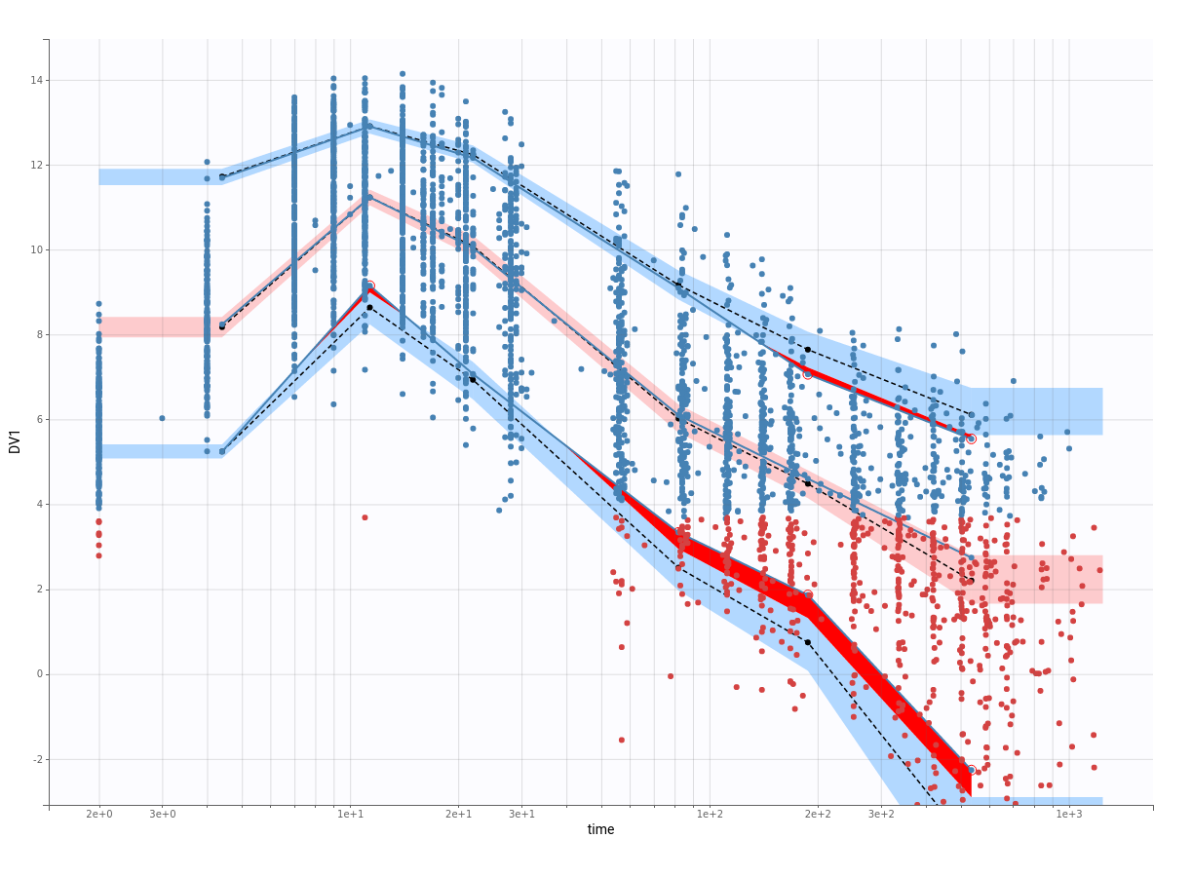

Figure S3: Model-simulated Ide-cel Cellular Kinetics with Treatment-Emergent Anti-drug Antibody in a Representative Patient
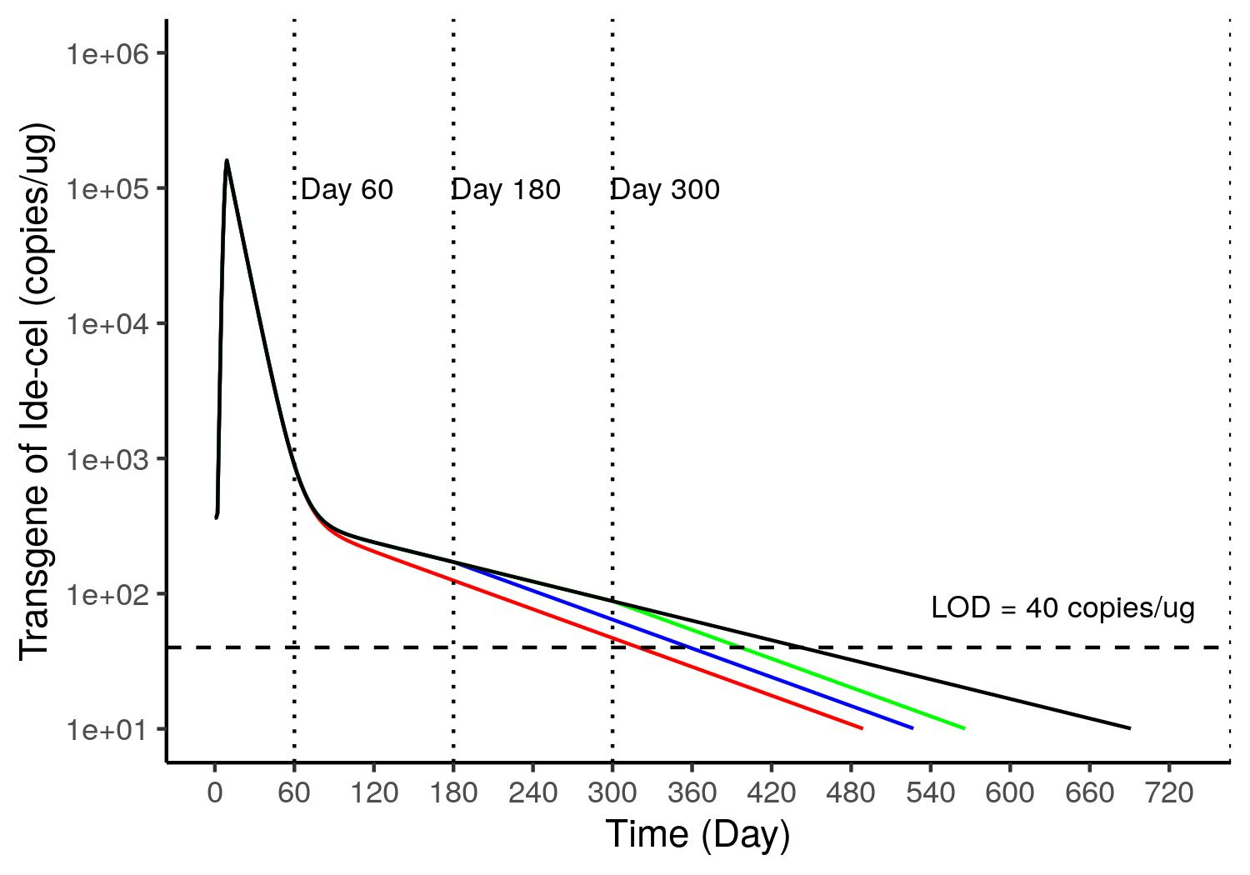
Note: The ide-cel transgene levels are predicted to decrease below limit of detection (LOD) of 40 copies/ug with the last measurable values observed (i.e., Tlast) at 396 days (green curve), 358 days (blue curve), and 319 days (red curve), when the treatment-emergent anti-drug antibody (ADA) starts to form at Day 300, Day 180, and Day 60 post-infusion, respectively. In absence of any treatment-emergent ADA, the Tlast is predicted to be 442 days (black curve) in a representative patient.

Figure S4: Association between Individual Ide-cel Cellular Kinetic Parameters and Status of Objective Response (OR) and Cytokine Release Syndrome Requiring Corticosteroids (sCRS)
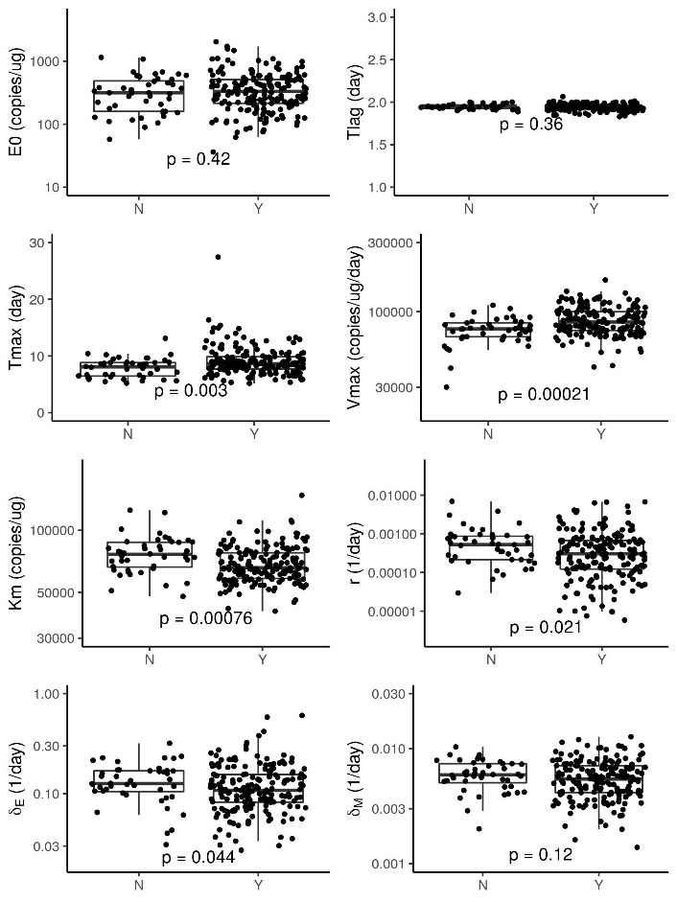 | 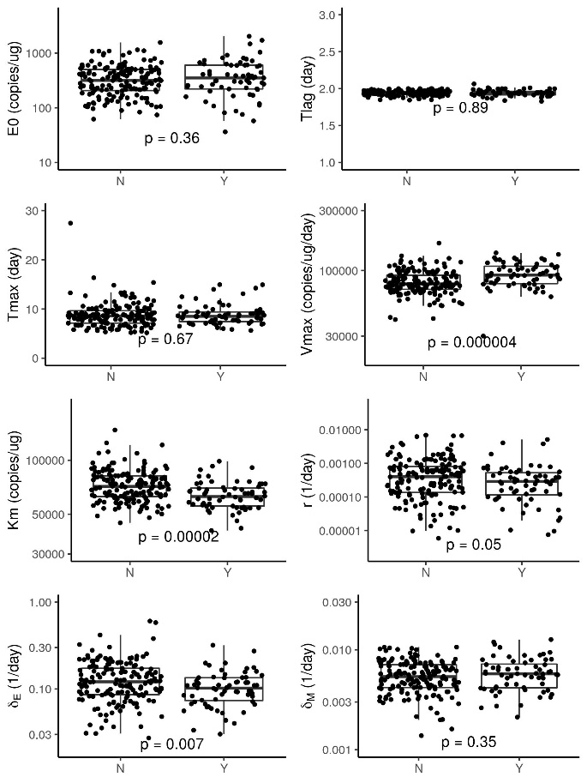

Figure S5: Visual Predictive Check (normal scale) with Data from Study KarMMa-3 (Ide-cel Arm).
Black open circles represent observed ide-cel CK data and red open circles represent censored data. Blue dashed lines represent median, 10th, 50th, and 90th percentiles of observations. Black solid lines represent 10th, 50th, and 90th percentiles of model simulated CK profiles. The orange-shaded regions represent the 90% prediction intervals for the 50th percentile of model-simulated CK profiles, while the blue-shaded regions represent the 90% prediction intervals for the 10th and 90th percentiles of model-simulated CK profiles. The red area indicates empirical percentiles that are outside prediction intervals. The BLQ data was sampled from the conditional distribution of estimated population and individual parameters with residual errors included, shown as values distributed between LLOQ and 0.
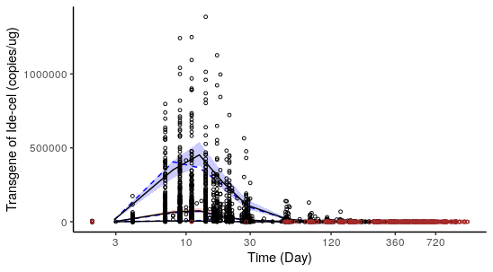

Figure S6: Correlations Between Individual Exposure Parameters.
AUC0-28D – Area under curves of transgene levels from 0 to 28 days postdose, Cmax – peak expansion, Tmax – time when Cmax is achieved, expansion rate - Cmax/Tmax

Figure S7: Correlations Between Individual Parameters Values of E0 and Dose
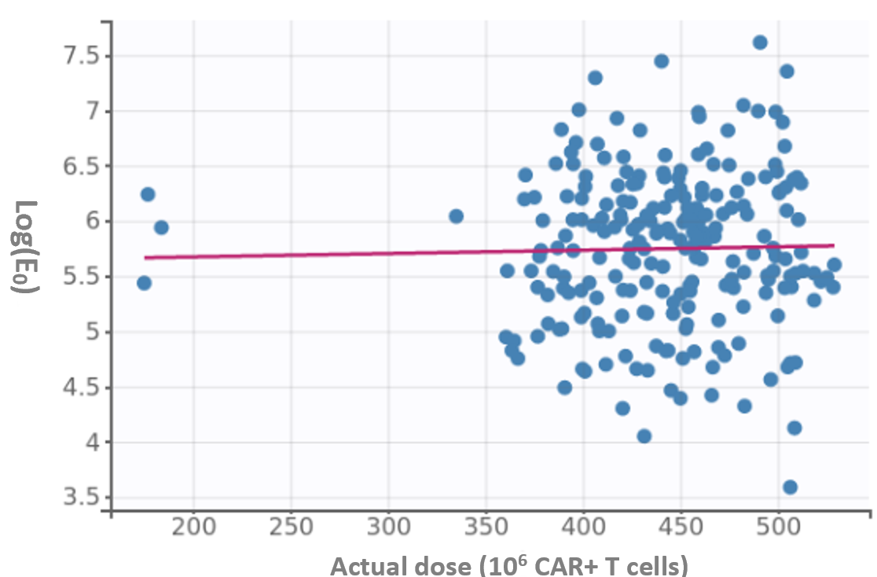

Figure S8: Goodness of Fit with Data from Study KarMMa-3 (Ide-cel Arm, without data truncation).
Dashed lines represent the 90% predicted percentiles and solid blue splines represent visual cues. Red and black solid dots represent BLQ and non-BLQ data, respectively. BLQ, below the limit of quantification; h, hour; IWRES, individual weighted residuals.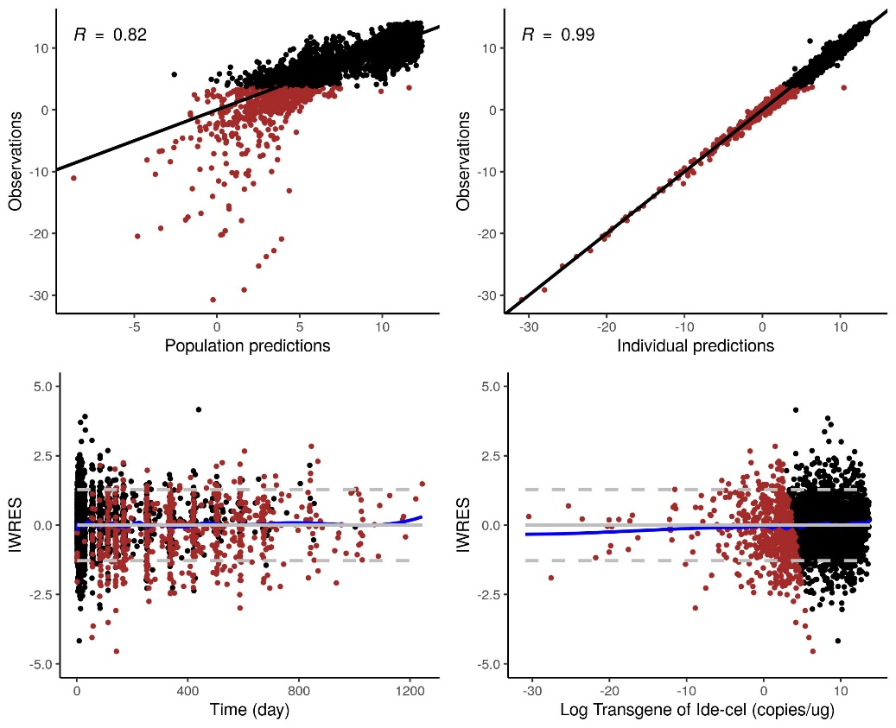

Figure S9: Covariate Effects on Exposure Parameters Estimated from the Posthoc Individual CK Parameters (N=225)

