Supplemental material
Pharmacokinetic-pharmacokinetic model
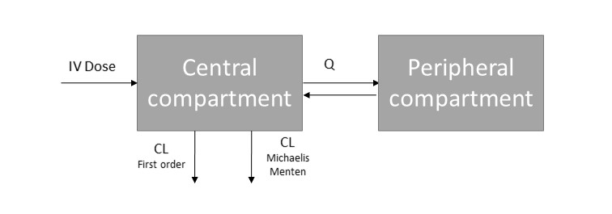
Figure S1 Schematic representation of the pharmacokinetic model

Goodness-of-fit plots and a prediction corrected visual predictive check for the pharmacokinetic model for eculizumab in patients with atypical hemolytic uremic syndrome (aHUS) and paroxysmal nocturnal hemoglobinuria (PNH) are shown in supplementary Figure S1 and S2.

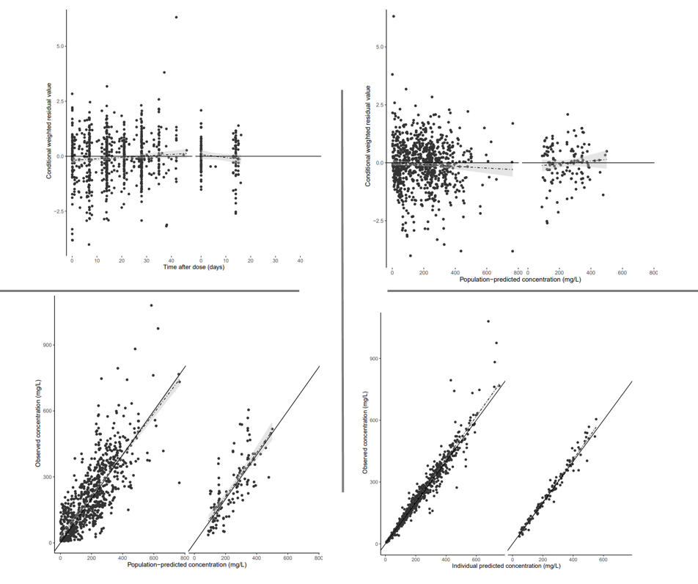

Figure S2 Standard goodness-of-fit plots for the final covariate pharmacokinetic model of Eculizumab. All plots are stratified on disease. The left graph in each plot represents the data for aHUS and the right graph in each plot represents the data for PNH. Upper Left figure: Time after dose (TAD) versus conditional weighted residuals (CWRES). Upper right figure: Population predicted concentration (PRED) versus CWRES. These plots visualize that the CWRES do not indicate model misspecification, as the data is homogenous distributed with the trendline approximating zero and most of the data lying within a -2.5 to +2.5 interval. Lower left plot: PRED vs observed concentration. Lower right plot: Individual predicted concentration versus observed concentration. The lower figures visualized the good correlation for the population predicted and individual predicted eculizumab concentrations versus the observed concentrations.

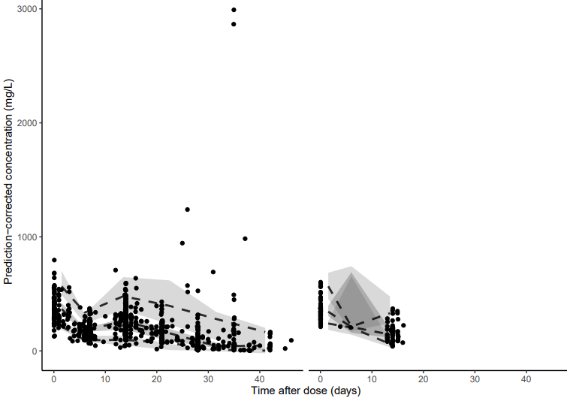
Figure S3. Prediction-Corrected visual predictive checks of the final pharmacokinetic model of eculizumab, stratified on disease (left: aHUS and right PNH). The black dots represent the observed concentrations. The dashed lines represent the 5th, median, 95th percentile of the predictions. The shaded grey areas represent the corresponding 95% confidence intervals. For the aHUS patients, a very rich dataset was used and patients were receiving eculizumab with different dosing intervals (up to 42 days). In the left plot for aHUS, It was shown that the majority of the predicted concentrations are in line with the observed concentrations, indicating appropriate validity of the model. For PNH (right plot), only peak concentrations were measured and a trough concentration on day 14 of treatment (all patients were receiving eculizumab with a dosing interval of fourteen days). For one patient, eculizumab was also measured two times in the first week after eculizumab administration. The limited sampling times in PNH explains the observed VPC.

Nonmem code
$SIZES LVR=95 LNP4=7000
$PROBLEM PK
$INPUT ID TIME AMT RATE DV MDV EVID CMT WT SEX AGE II SS
CH50 OCC METH1 METH2 DISEASE
$DATA PNHAHUS_okt22.csv
$SUBROUTINE ADVAN13 TOL=6
$ABBREVIATED DERIV2=NOCOMMON
$MODEL
COMP=(CENTRAL)
COMP=(PERIPHERAL)

$PK

"FIRST
" COMMON /PRCOMG/ IDUM1,IDUM2,IMAX,IDUM4,IDUM5
" INTEGER IDUM1,IDUM2,IMAX,IDUM4,IDUM5
" IMAX=1000000

; --- TIME AFTER DOSE CALCULATION
IF (NEWIND.LE.1) THEN
DOSE=0
TDOS=0
ENDIF
;Remember dose and time of dose
IF (AMT.GT.0) THEN
DOSE=AMT
TDOS=TIME
ENDIF
;Time after dose for every record
TAD=TIME-TDOS

; IOV
IF(OCC.EQ.1) IOV = ETA(1)
IF(OCC.EQ.2) IOV = ETA(2)
IF(OCC.EQ.3) IOV = ETA(3)
IF(OCC.EQ.4) IOV = ETA(4)
IF(OCC.EQ.5) IOV = ETA(5)
IF(OCC.EQ.6) IOV = ETA(6)
IF(OCC.EQ.7) IOV = ETA(7)
IF(OCC.EQ.8) IOV = ETA(8)
IF(OCC.EQ.9) IOV = ETA(9)
IF(OCC.EQ.10) IOV = ETA(10)
IF(OCC.EQ.11) IOV = ETA(11)
IF(OCC.EQ.12) IOV = ETA(12)
IF(OCC.EQ.13) IOV = ETA(13)
IF(OCC.EQ.14) IOV = ETA(14)
IF(OCC.EQ.15) IOV = ETA(15)
IF(OCC.EQ.16) IOV = ETA(16)
IF(OCC.EQ.17) IOV = ETA(17)
IF(OCC.EQ.18) IOV = ETA(18)
IF(OCC.EQ.19) IOV = ETA(19)
IF(OCC.EQ.20) IOV = ETA(20)
IF(OCC.EQ.21) IOV = ETA(21)
IF(OCC.EQ.22) IOV = ETA(22)
IF(OCC.EQ.23) IOV = ETA(23)
IF(OCC.EQ.24) IOV = ETA(24)
IF(OCC.EQ.25) IOV = ETA(25)
IF(OCC.EQ.26) IOV = ETA(26)
IF(OCC.EQ.27) IOV = ETA(27)
IF(OCC.EQ.28) IOV = ETA(28)
IF(OCC.EQ.29) IOV = ETA(29)
IF(OCC.EQ.30) IOV = ETA(30)
IF(OCC.EQ.31) IOV = ETA(31)
IF(OCC.EQ.32) IOV = ETA(32)
IF(OCC.EQ.33) IOV = ETA(33)
IF(OCC.EQ.34) IOV = ETA(34)
IF(OCC.EQ.35) IOV = ETA(35)
IF(OCC.EQ.36) IOV = ETA(36)
IF(OCC.EQ.37) IOV = ETA(37)
IF(OCC.EQ.38) IOV = ETA(38)
IF(OCC.EQ.39) IOV = ETA(39)
IF(OCC.EQ.40) IOV = ETA(40)
IF(OCC.EQ.41) IOV = ETA(41)
IF(OCC.EQ.42) IOV = ETA(42)
IF(OCC.EQ.43) IOV = ETA(43)
IF(OCC.EQ.44) IOV = ETA(44)
IF(OCC.EQ.45) IOV = ETA(45)
IF(OCC.EQ.46) IOV = ETA(46)
IF(OCC.EQ.47) IOV = ETA(47)
IF(OCC.EQ.48) IOV = ETA(48)
IF(OCC.EQ.49) IOV = ETA(49)
IF(OCC.EQ.50) IOV = ETA(50)
IF(OCC.EQ.51) IOV = ETA(51)
IF(OCC.EQ.52) IOV = ETA(52)
IF(OCC.EQ.53) IOV = ETA(53)
IF(OCC.EQ.54) IOV = ETA(54)
IF(OCC.EQ.55) IOV = ETA(55)
IF(OCC.EQ.56) IOV = ETA(56)
IF(OCC.EQ.57) IOV = ETA(57)
IF(OCC.EQ.58) IOV = ETA(58)
IF(OCC.EQ.59) IOV = ETA(59)
IF(OCC.EQ.60) IOV = ETA(60)
IF(OCC.EQ.61) IOV = ETA(61)
IF(OCC.EQ.62) IOV = ETA(62)
IF(OCC.EQ.63) IOV = ETA(63)
IF(OCC.EQ.64) IOV = ETA(64)
IF(OCC.EQ.65) IOV = ETA(65)
IF(OCC.EQ.66) IOV = ETA(66)
IF(OCC.EQ.67) IOV = ETA(67)
IF(OCC.EQ.68) IOV = ETA(68)
IF(OCC.EQ.69) IOV = ETA(69)
IF(OCC.EQ.70) IOV = ETA(70)
IF(OCC.EQ.71) IOV = ETA(71)
IF(OCC.EQ.72) IOV = ETA(72)
IF(OCC.EQ.73) IOV = ETA(73)
IF(OCC.EQ.74) IOV = ETA(74)
IF(OCC.EQ.75) IOV = ETA(75)
IF(OCC.EQ.76) IOV = ETA(76)
IF(OCC.EQ.77) IOV = ETA(77)
IF(OCC.EQ.78) IOV = ETA(78)
IF(OCC.EQ.79) IOV = ETA(79)
IF(OCC.EQ.80) IOV = ETA(80)
IF(OCC.EQ.81) IOV = ETA(81)
IF(OCC.EQ.82) IOV = ETA(82)
IF(OCC.EQ.83) IOV = ETA(83)
IF(OCC.EQ.84) IOV = ETA(84)
IF(OCC.EQ.85) IOV = ETA(85)
IF(OCC.EQ.86) IOV = ETA(86)

PNH = 0
IF (DISEASE.EQ.2) PNH=1

IF (PNH.EQ.0) CL = THETA(1) * ((WT/70)**0.75) * EXP(ETA(87)) * EXP(IOV)
IF (PNH.EQ.1) CL = THETA(1) * ((WT/70)**0.75) * EXP(ETA(87))

V1 = THETA(2) * (WT/70) * EXP(ETA(88))
V2 = THETA(5) * (WT/70)
Q = THETA(6) * (WT/70)**0.75
VM = THETA(3) * (WT/70)**0.75
KM = THETA(4)

V=V1
S1=V

ICL=CL
IV1=V1
IV2=V2
IQ=Q

KEL=CL/V1 ;Elimination rate constant
K12=Q/V1
K21=Q/V2

$ERROR
IPRED=F
IF (METH1.LT.2) Y=IPRED+ERR(1)+(IPRED*ERR(2))
IF (METH1.EQ.2) Y=IPRED+ERR(1)+(IPRED*ERR(3))

$THETA
(0, 0.1626) ; 1 CL
(0, 4.299) ; 2 V1
(0, 25.64) ; 3 VM
(0, 13.54) ; 4 KM
(0, 2.63) ; 5 V2
(0, 0.6243) ; Q

$DES
C1=A(1)/S1
DADT(1)= -KEL*A(1) - ((VM*C1)/(KM+C1)) -K12*A(1) + K21*A(2)
DADT(2) = -K21*A(2) + K12*A(1)

$OMEGA BLOCK(1)
0.112 ; 1 IOV
$OMEGA BLOCK(1) SAME
$OMEGA BLOCK(1) SAME
$OMEGA BLOCK(1) SAME
$OMEGA BLOCK(1) SAME
$OMEGA BLOCK(1) SAME
$OMEGA BLOCK(1) SAME
$OMEGA BLOCK(1) SAME
$OMEGA BLOCK(1) SAME
$OMEGA BLOCK(1) SAME
$OMEGA BLOCK(1) SAME
$OMEGA BLOCK(1) SAME
$OMEGA BLOCK(1) SAME
$OMEGA BLOCK(1) SAME
$OMEGA BLOCK(1) SAME
$OMEGA BLOCK(1) SAME
$OMEGA BLOCK(1) SAME
$OMEGA BLOCK(1) SAME
$OMEGA BLOCK(1) SAME
$OMEGA BLOCK(1) SAME
$OMEGA BLOCK(1) SAME
$OMEGA BLOCK(1) SAME
$OMEGA BLOCK(1) SAME
$OMEGA BLOCK(1) SAME
$OMEGA BLOCK(1) SAME
$OMEGA BLOCK(1) SAME
$OMEGA BLOCK(1) SAME
$OMEGA BLOCK(1) SAME
$OMEGA BLOCK(1) SAME
$OMEGA BLOCK(1) SAME
$OMEGA BLOCK(1) SAME
$OMEGA BLOCK(1) SAME
$OMEGA BLOCK(1) SAME
$OMEGA BLOCK(1) SAME
$OMEGA BLOCK(1) SAME
$OMEGA BLOCK(1) SAME
$OMEGA BLOCK(1) SAME
$OMEGA BLOCK(1) SAME
$OMEGA BLOCK(1) SAME
$OMEGA BLOCK(1) SAME
$OMEGA BLOCK(1) SAME
$OMEGA BLOCK(1) SAME
$OMEGA BLOCK(1) SAME
$OMEGA BLOCK(1) SAME
$OMEGA BLOCK(1) SAME
$OMEGA BLOCK(1) SAME
$OMEGA BLOCK(1) SAME
$OMEGA BLOCK(1) SAME
$OMEGA BLOCK(1) SAME
$OMEGA BLOCK(1) SAME
$OMEGA BLOCK(1) SAME
$OMEGA BLOCK(1) SAME
$OMEGA BLOCK(1) SAME
$OMEGA BLOCK(1) SAME
$OMEGA BLOCK(1) SAME
$OMEGA BLOCK(1) SAME
$OMEGA BLOCK(1) SAME
$OMEGA BLOCK(1) SAME
$OMEGA BLOCK(1) SAME
$OMEGA BLOCK(1) SAME
$OMEGA BLOCK(1) SAME
$OMEGA BLOCK(1) SAME
$OMEGA BLOCK(1) SAME
$OMEGA BLOCK(1) SAME
$OMEGA BLOCK(1) SAME
$OMEGA BLOCK(1) SAME
$OMEGA BLOCK(1) SAME
$OMEGA BLOCK(1) SAME
$OMEGA BLOCK(1) SAME
$OMEGA BLOCK(1) SAME
$OMEGA BLOCK(1) SAME
$OMEGA BLOCK(1) SAME
$OMEGA BLOCK(1) SAME
$OMEGA BLOCK(1) SAME
$OMEGA BLOCK(1) SAME
$OMEGA BLOCK(1) SAME
$OMEGA BLOCK(1) SAME
$OMEGA BLOCK(1) SAME
$OMEGA BLOCK(1) SAME
$OMEGA BLOCK(1) SAME
$OMEGA BLOCK(1) SAME
$OMEGA BLOCK(1) SAME
$OMEGA BLOCK(1) SAME
$OMEGA BLOCK(1) SAME
$OMEGA BLOCK(1) SAME
$OMEGA BLOCK(1) SAME
$OMEGA
0.1546 ; IIV CL
0.0812 ; IIV V1

$SIGMA
19.1; ADD
0.0185 ; PROP
0.187 ; PROP2
$ESTIMATION METHOD=1 INTERACTION NOABORT MAXEVAL=5000 NSIG=2 SIGL=6
PRINT=5
$COVARIANCE PRINT=E MATRIX=S UNCONDITIONAL

