Rifampicin exposure in Tuberculosis Patients with Comorbidities in sub-Saharan Africa: Prioritizing Populations for Treatment - A Systematic Review and Meta-Analysis
Bibie Said^{1,2*}, Yuan Pétermann³, Patrick Howlett⁴, Monia Guidi^{3,5,6}, Yann Thoma⁷, Violet Dismas Kajogoo⁸, Margaretha Sariko⁹, Scott K. Heysell¹⁰, Jan-Willem Alffenaar^{11,12,13}, Emmanuel Mpolya¹, Stellah Mpagama²
¹ Department of Health and Biomedical Sciences, School of Life Sciences, Nelson Mandela African Institution of Science and Technology (NM-AIST), Arusha, Tanzania
² Kibong'oto Infectious Diseases Hospital - Sanya Juu Siha Kilimanjaro Tanzania, Mae
³ Center for Research and Innovation in Clinical Pharmaceutical Sciences, Lausanne University Hospital and University of Lausanne, Lausanne, Switzerland.
⁴ National Heart &amp; Lung Institute, Imperial College London, Guy Scadding Building, Cale Street, London, SW3 6LY
⁵ Service of Clinical Pharmacology, Lausanne University Hospital and University of Lausanne, Lausanne, Switzerland.
⁶ Institute of Pharmaceutical Sciences of Western Switzerland, University of Geneva, University of Lausanne, Geneva & Lausanne, Switzerland
⁷ School of Engineering and Management Vaud, HES-SO University of Applied Sciences and Arts Western Switzerland, 1401 Yverdon-les-Bains, Switzerland
⁸ Department of clinical trials, Tanzania Diabetes Association, P.O. Box 65201, Dar-es-salaam, Tanzania
⁹ Kilimanjaro Clinical Research Institute
¹⁰ Division of Infectious Diseases and International Health, University of Virginia, Charlottesville, Virginia
¹¹ School of Pharmacy, Faculty of Medicine and Health, University of Sydney, Sydney, NSW, Australia
¹² The University of Sydney Infectious Diseases Institute, University of Sydney, Sydney, NSW, Australia
¹³ Westmead Hospital, Department of Pharmacy, Sydney, NSW, Australia

* Correspondence: Bibie N. Said, MD., MSc. Clinical trials bibiesd90@gmail.com, (https://orcid.org/0000-0002-3687-6827), Kibong'oto Infectious Diseases Hospital - Sanya Juu, P.O. Box 12, Siha/Kilimanjaro, Tanzania

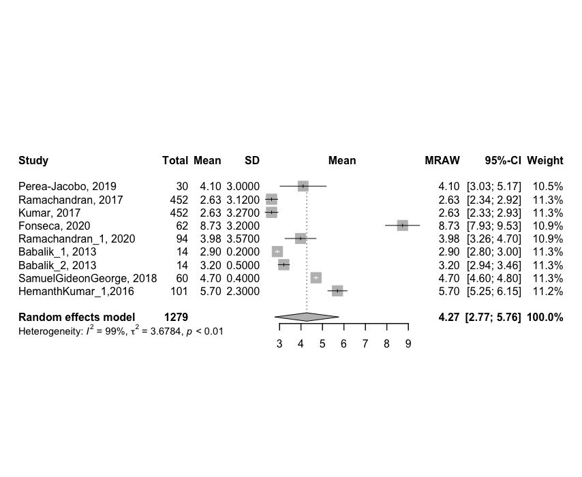
Fig. 5: Forest plot for the pooled peak plasma concentration C_{max} (mg. L⁻¹) among TB-Diabetes population in non-sub-Saharan Africa population

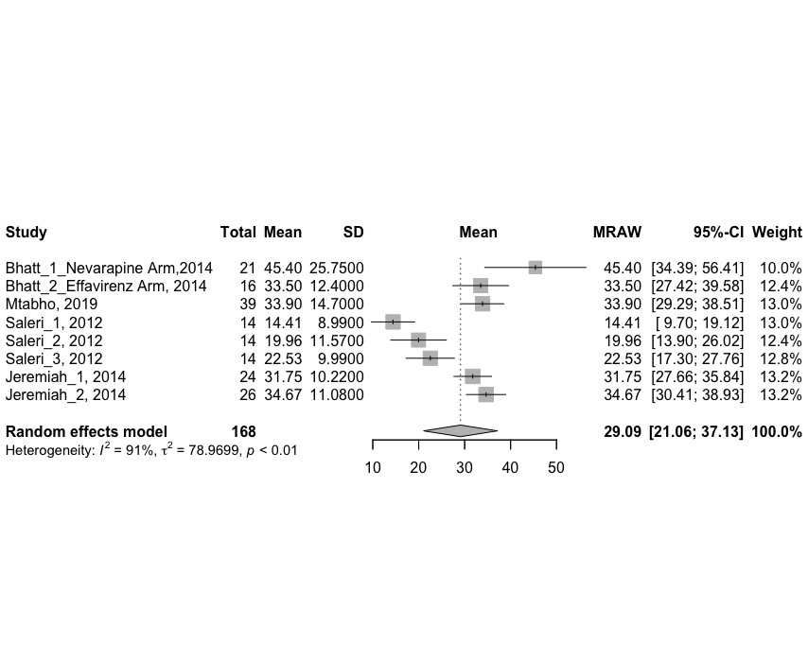
Fig. 6: Forest Plot for pooled AUC (mg.h. L⁻¹) in TB-HIVs Patients in Sub-Saharan Africa population

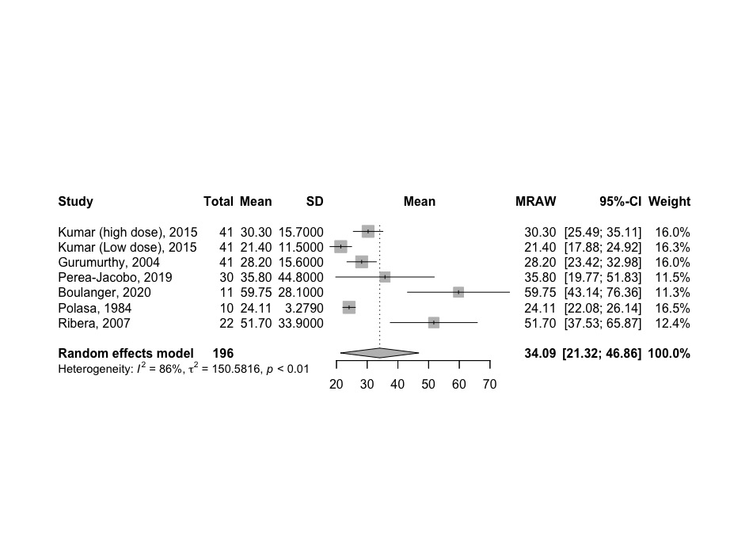
Fig. 7: Forest Plot for pooled AUC (mg.h. L⁻¹) in TB-HIVs Patients in non- sub-Saharan Africa studies population.

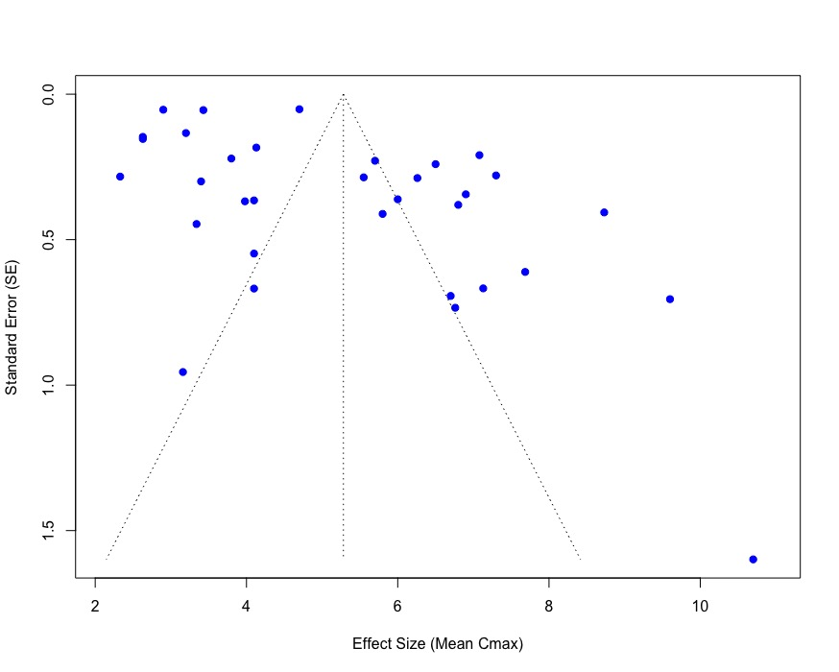
Fig. 8a: Funnel plot for mean C_{max} (mg. L⁻¹) Meta-Analysis for included population in mg/L

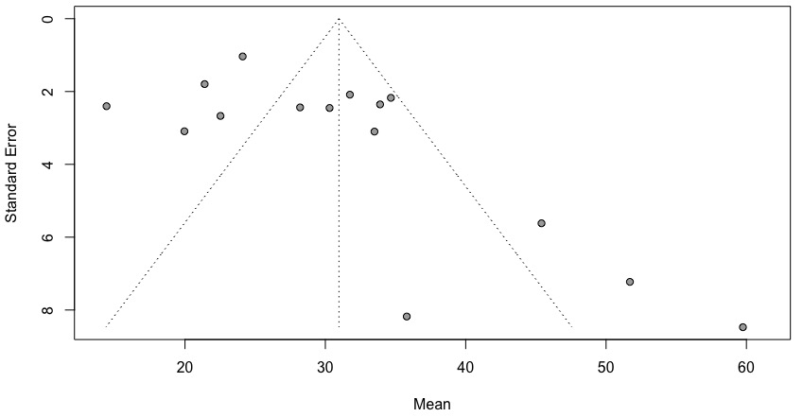
Fig. 8b: Funnel plot for mean AUC (mg.h. L⁻¹) Meta-Analysis for whole HIV included populations.

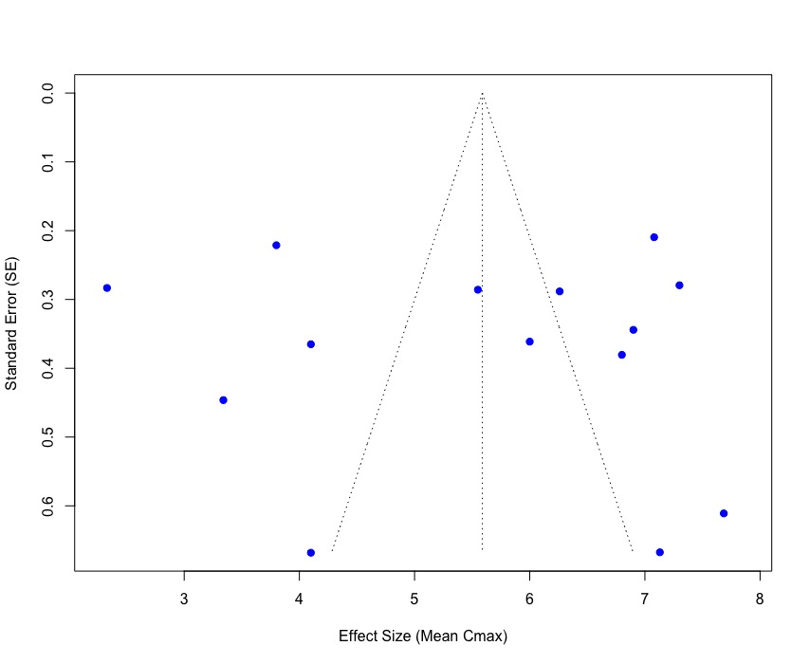
Fig. 8c: Funnel plot for mean C_{max} (mg. L⁻¹) Meta-Analysis in TB-HIV for sub-Saharan Africa population in mg/L

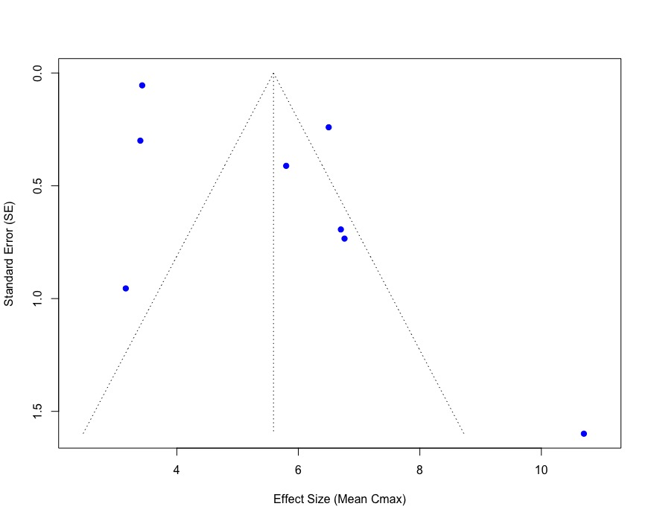
Fig. 8d: Funnel plot for pooled mean C_{max} (mg. L⁻¹) Meta-Analysis in TB-HIV for other population

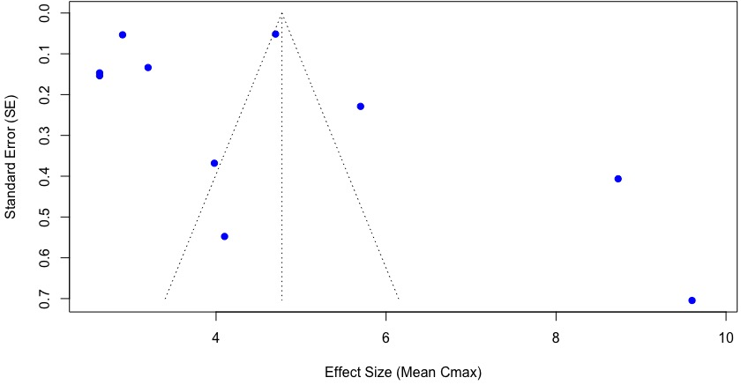
Fig. 8e: Funnel plot for mean C_{max} (mg. L⁻¹) Meta-Analysis in TB-Diabetes population (P< 0.0001)

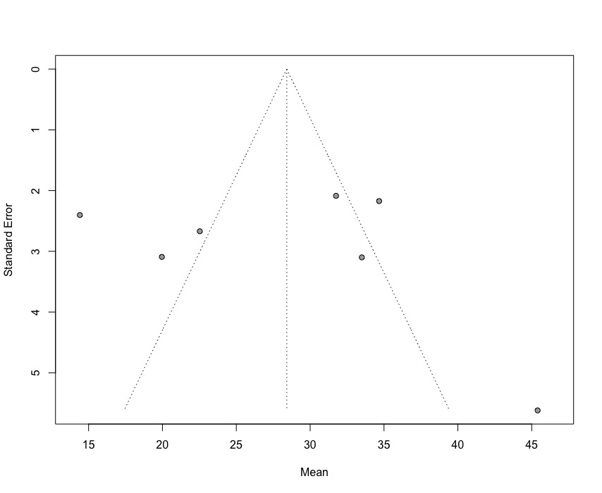
Fig. 8f: Funnel plot for mean AUC(mg.h. L⁻¹) Meta-Analysis in TB-HIV for sub-Saharan Africa population (P< 0.0001)

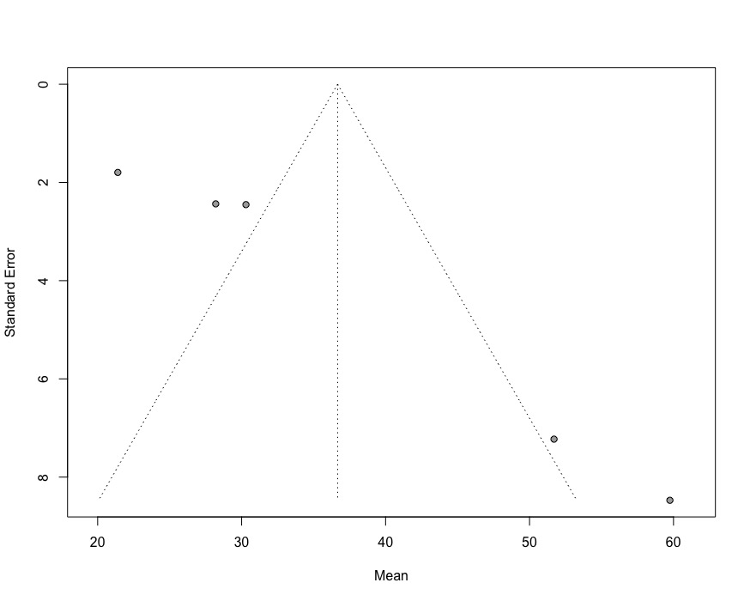
Fig. 8g: Funnel plot for mean AUC (mg.h. L⁻¹) Meta-Analysis in TB-HIV for other population (P< 0.0001)

Search strategy :

Advanced search Word on PubMed
((((("drug monitoring"[MeSH Terms] OR ("drug"[All Fields] AND "monitoring"[All Fields]) OR "drug monitoring"[All Fields] OR ("therapeutic"[All Fields] AND "drug"[All Fields] AND "monitoring"[All Fields]) OR "therapeutic drug monitoring"[All Fields] OR ("hiv"[MeSH Terms] OR "hiv"[All Fields] OR ("human"[All Fields] AND "immunodeficiency"[All Fields] AND "virus"[All Fields]) OR "human immunodeficiency virus"[All Fields])) AND ("hiv"[MeSH Terms] OR "hiv"[All Fields])) OR ("diabete"[All Fields] OR "diabetes mellitus"[MeSH Terms] OR ("diabetes"[All Fields] AND "mellitus"[All Fields]) OR "diabetes mellitus"[All Fields] OR "diabetes"[All Fields] OR "diabetes insipidus"[MeSH Terms] OR ("diabetes"[All Fields] AND "insipidus"[All Fields]) OR "diabetes insipidus"[All Fields] OR "diabetic"[All Fields] OR "diabetics"[All Fields] OR "diabets"[All Fields])) AND (("diabete"[All Fields] OR "diabetes mellitus"[MeSH Terms] OR ("diabetes"[All Fields] AND "mellitus"[All Fields]) OR "diabetes mellitus"[All Fields] OR "diabetes"[All Fields] OR "diabetes insipidus"[MeSH Terms] OR ("diabetes"[All Fields] AND "insipidus"[All Fields]) OR "diabetes insipidus"[All Fields] OR "diabetic"[All Fields] OR "diabetics"[All Fields] OR "diabets"[All Fields]) AND "mellitus"[All Fields])) OR ("malnutrition"[MeSH Terms] OR "malnutrition"[All Fields] OR "malnutrition s"[All Fields] OR "malnutritional"[All Fields] OR "malnutritions"[All Fields]) OR ("pharmacokinetic"[All Fields] OR "pharmacokinetical"[All Fields] OR "pharmacokinetically"[All Fields] OR "pharmacokinetics"[MeSH Subheading] OR "pharmacokinetics"[All Fields] OR "pharmacokinetics"[MeSH Terms]) OR ("tuberculosi"[All Fields] OR "tuberculosis"[MeSH Terms] OR "tuberculosis"[All Fields] OR "tuberculoses"[All Fields] OR "tuberculosis s"[All Fields])) AND ("drug"[All Fields] AND ("concentrate"[All Fields] OR "concentrated"[All Fields] OR "concentrates"[All Fields] OR "concentrating"[All Fields] OR "concentration"[All Fields] OR "concentrations"[All Fields]))

Embase.com
('tuberculosis'/exp AND ('comorbidity'/de OR 'coinfection'/exp OR 'Human immunodeficiency virus'/exp OR 'diabetes mellitus'/exp OR 'malnutrition'/exp OR (((concurrent OR simultaneous) NEXT/3 (problem* OR disease* OR disorder* OR infect*)) OR comorbid* OR "co morbid*" OR "co infect*" OR Coinfect* OR "dual disease*"):ab,ti,kw) OR ((Tuberculosis OR Tuberculous OR Tubercular OR TB) NEAR/6 (HIV OR AIDS OR "human immunodeficiency virus" OR "human immuno deficiency virus" OR "immunodeficiency associated virus" OR "immuno deficiency associated virus" OR "lymphadenopathy associated retrovirus" OR "Lymphadenopathy associated virus" OR Diabet* OR Malnutri* OR Undernutri* OR Underfeed* OR Underfed OR Malnourish* OR Undernourish* OR Cachexi*)):ab,ti,kw) AND ('tuberculostatic agent'/de OR 'rifampicin'/exp OR 'rifampicin derivative'/exp OR 'rifampicin plus trimethoprim'/exp OR (Rifampicin OR RIF OR "aptecin" OR "ba 41 166" OR "ba 41166" OR "ba 41166e" OR "ba41166" OR "ba41166e" OR "benemicin" OR "doloresum" OR "eremfat" OR "finamicina" OR "kalrifam" OR "l 5103" OR "lositril" OR "manorifcin" OR "medifam" OR "nsc 113916" OR "nsc 113926" OR "orifam" OR "prolung" OR "ramfin" OR "ramicin" OR "rhymactan" OR "rifa" OR "rifacilin" OR "rifadin" OR "rifadine" OR "rifagen" OR "rifaldin" OR "rifamax" OR "rifamed" OR "rifampicine" OR "rifampin" OR "rifampycin" OR "rifamsolin" OR "rifapiam" OR "rifarad" OR "rifaren" OR "rifasynt" OR "rifcap" OR "rifcin" OR "rifodex" OR "rifoldin" OR "rimactan" OR "rimactane" OR "rimapen" OR "rimpacin" OR "rimpin" OR "rimycin" OR "ripin" OR "ripolin" OR "rofact" OR "sinerdol" OR "syntoren" OR "tubocin" OR "tuborin" OR RHEZ OR rifamethoprim OR rifap OR rimstar):ab,ti,kw,tn OR ((TB NEAR/3 (treat* OR drug*)) OR (anti NEXT/1 (Tuberculosis OR Tuberculous OR Tubercular)) OR Tuberculostatic OR Antituberculosis OR Antituberculostatic OR Antituberculous OR Antitubercular):ab,ti,kw) AND ('pharmacokinetics'/exp OR 'pharmacokinetic parameters'/exp OR 'pharmacodynamics'/de OR 'pharmacodynamic parameters'/exp OR 'drug toxicity and intoxication'/exp OR 'drug monitoring'/exp OR ("drug monitor*" OR "medication monitor*" OR TDM OR pharmacokinetic* OR PK OR pharmacodynamic* OR "maximum concentration*" OR Cmax* OR "c max*" OR "peak concentration*" OR "time to max*" OR Tmax* OR "t max*" OR "time to peak*" OR "area under the curv*" OR "area under curv*" OR AUC OR MIC OR "minimum inhibitory concentration*" OR "Serum drug concentr*" OR "serum concentr*" OR "plasma concentration*" OR "blood concentration*" OR Absor* OR Malabsor* OR "Drug exposure" OR ((treatment* OR dose* OR dosing) NEAR/3 optimi*) OR "dosing strateg*"):ab,ti,kw) NOT ([animals]/lim NOT [humans]/lim) NOT ('juvenile'/exp NOT 'adult'/exp) NOT 'conference abstract'/it

Web of Science
(TS=("Tuberculosis") AND TS=("Human Immunodeficiency Virus") AND (TS=("Diabetes") OR TS=("Diabetic Mellitus"))
AND TS=("Malnutrition") AND TS=("Rifampicin") AND TS=("Therapeutic Drug Monitoring")
AND TS=("Drug Concentration") AND TS=("Pharmacokinetics") AND TS=("Pharmacodynamics"))

