Title: Pharmacometric Targets During Anti-TNF Induction and Their Association with Deep Remission in Pediatric Crohn’s Disease
Journal: Clinical Pharmacokinetics
Authors: Alexander Nasr^{1,2}, Tomoyuki Mizuno^{2,3}, Kei Irie³, Jonathan R Dillman^{2,4}, Kimberly Jackson¹, Kimberly Lynch¹, Alexa Horrell², Thomas Aviles¹, Kelly Chun⁵, Jane Yang⁵, Brendan Boyle⁶, Jeffrey S. Hyams⁷, Joshua Noe⁸, Lee. A. Denson^{1,2}, Phillip Minar^{1,2}
Affiliations: ¹Division of Pediatric Gastroenterology, Hepatology and Nutrition, Cincinnati Children’s Hospital Medical Center; Cincinnati, Ohio, USA. ²University of Cincinnati College of Medicine; Cincinnati, Ohio, USA. ³Division of Clinical Pharmacology, Cincinnati Children’s Hospital Medical Center; Cincinnati, Ohio, USA. ⁴Department of Radiology, Cincinnati Children’s Hospital Medical Center, Cincinnati, Ohio, USA. ⁵Esoterix, LabCorp Specialty Lab, Calabasas, California, USA. ⁶Division of Pediatric Gastroenterology, Hepatology and Nutrition, Nationwide Children’s Hospital; Columbus, Ohio, USA. ⁷Division of Digestive Diseases and Nutrition, Connecticut Children’s Medical Center; Hartford, Connecticut, USA. ⁸Division of Pediatric Gastroenterology, Medical College of Wisconsin; Milwaukee, Wisconsin, USA.
Corresponding author email: phillip.minar@cchmc.org

Supplemental Methods
The MRI protocol at each center included routine clinical coronal and axial single-shot fast spin-echo (SSFSE) sequences, coronal and axial fat-saturated SSFSE sequences, and axial diffusion-weighted imaging. Major acquisition parameters (e.g., slice thickness, flip angle, echo time, repetition time, number of signal averages, and diffusion b-values) were standardized across sites. Examinations were performed at both 1.5T and 3T. Oral contrast material was ingested by participants prior to MR imaging using a weight-based protocol.

Supplemental Figures
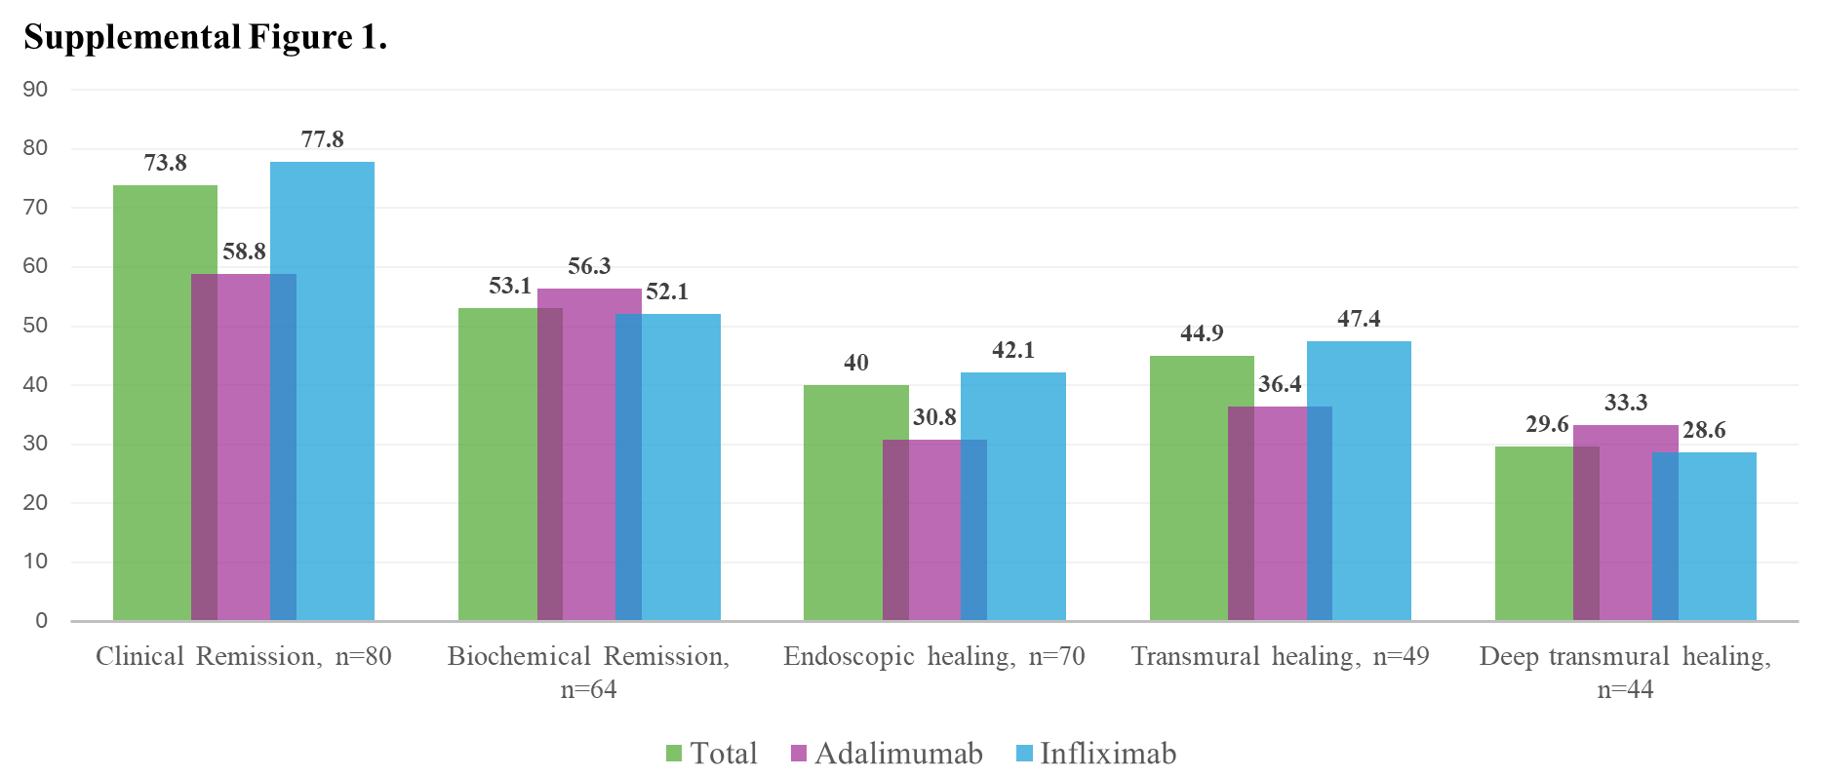

Supplemental Figure 1. Secondary outcomes at Month12. There was no statistical difference between adalimumab and infliximab for all outcomes shown. Clinical remission, weighted pediatric Crohn’s disease (CD) activity index <12.5 and off corticosteroids for >8 weeks. Biochemical remission, fecal calprotectin <250 µg/g. Endoscopic healing, simple endoscopic score-CD (SES-CD) =0. Transmural healing, simplified MARIA (sMARIA) <1 for both ileum and colon segments. Deep transmural healing, SES-CD<3 and a sMARIA<1 for ileal and colonic segments. For both transmural healing and deep transmural healing, patients that stopped the biologic or had surgery were included as failures.

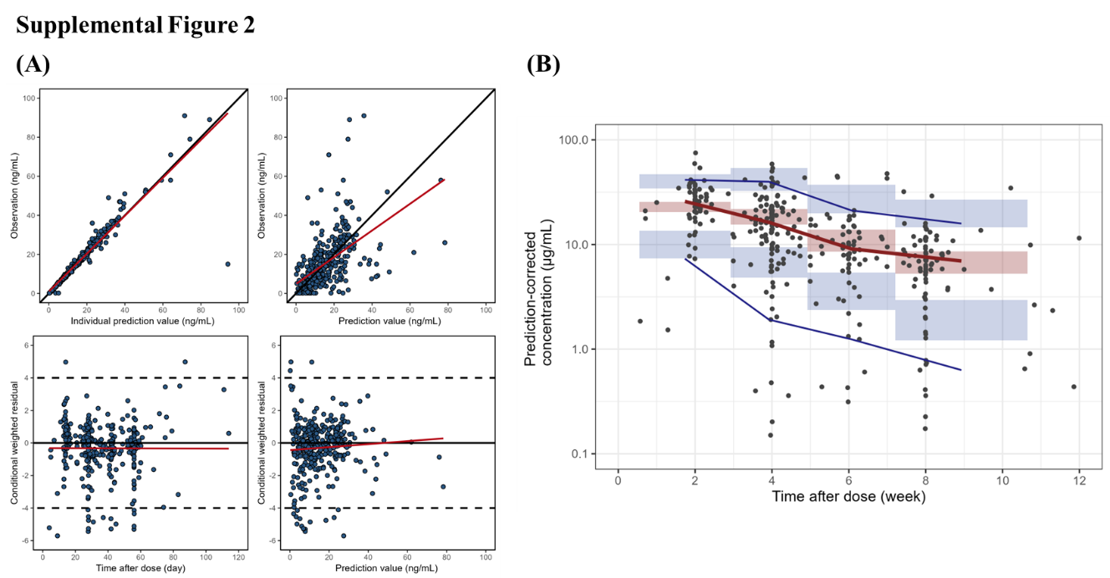

Supplemental Figure 2. Evaluation of published infliximab population pharmacokinetic model performance in the ENvISION cohort. (A) Goodness-of-fit diagnostics. Upper panels show observed concentrations versus individual predictions (left) and population predictions (right). Lower panels show conditional weighted residuals versus time after dose (left) and versus population predictions (right). The red lines represent locally weighted smoothing trends. (B) Prediction-corrected visual predictive check of the population pharmacokinetic models. Observed prediction-corrected concentrations are shown as black circles. The red line represents the observed median concentration, and the blue lines represent the observed 5th and 95th percentiles. Shaded areas indicate the corresponding 95% confidence intervals from model simulations.

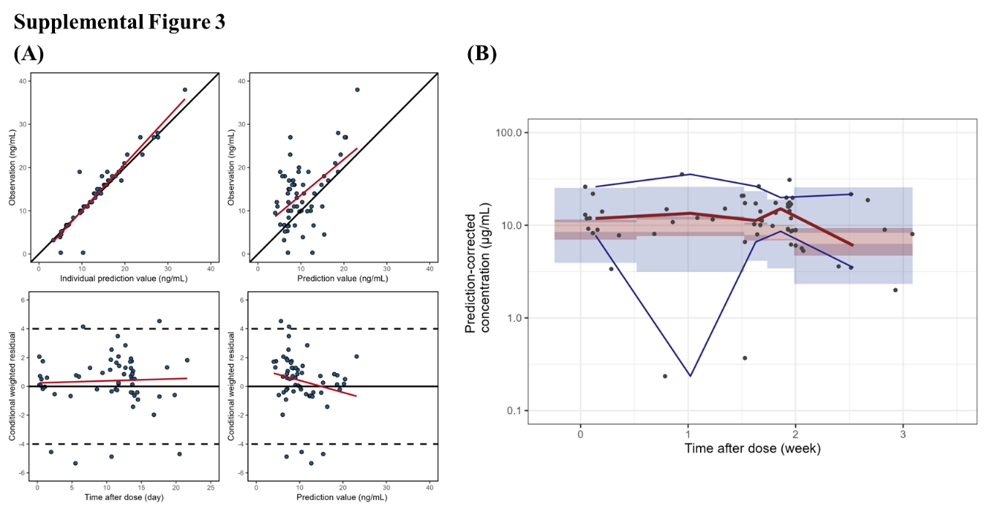

Supplemental Figure 3. Evaluation of published adalimumab population pharmacokinetic model performance in the ENvISION cohort. (A) Goodness-of-fit diagnostics. Upper panels show observed concentrations versus individual predictions (left) and population predictions (right). Lower panels show conditional weighted residuals versus time after dose (left) and versus population predictions (right). The red lines represent locally weighted smoothing trends. (B) Prediction-corrected visual predictive check of the population pharmacokinetic models. Observed prediction-corrected concentrations are shown as black circles. The red line represents the observed median concentration, and the blue lines represent the observed 5th and 95th percentiles. Shaded areas indicate the corresponding 95% confidence intervals from model simulations.

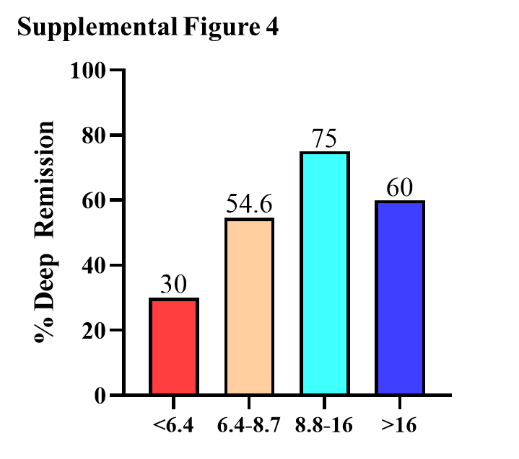

Supplemental Figure 4. Infliximab trough concentrations and deep remission. Infliximab trough concentrations at month12 (µg/mL) and are presented as quartiles with the proportion of patients achieving deep remission noted above each quartile.

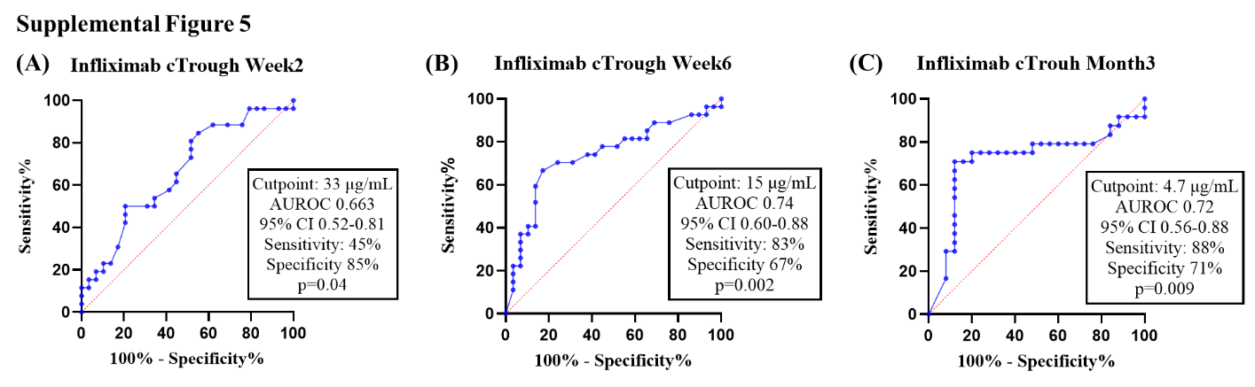
Supplemental Figure 5. Infliximab trough concentration cut-points associated with deep remission. The Youden index was used to determine the trough concentrations targets at (a) week2, (b) week6, and (c) month3. AUROC, area under the receiver operating characteristic, CI; confidence interval.

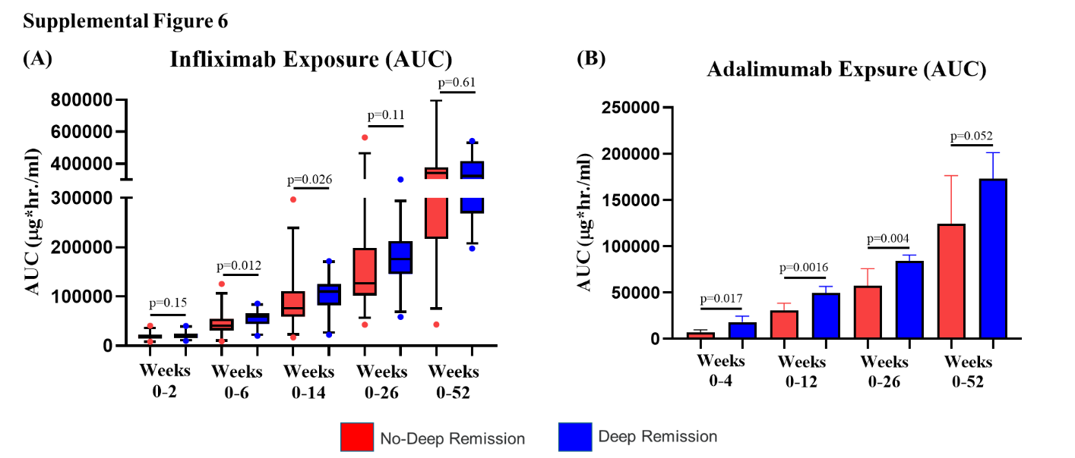
Supplemental Figure 6. Anti-TNF exposure throughout the first year of treatment. Area under the concentration curve (AUC) was assessed for (A) infliximab and (B) adalimumab in deep remitters and those without deep remission.

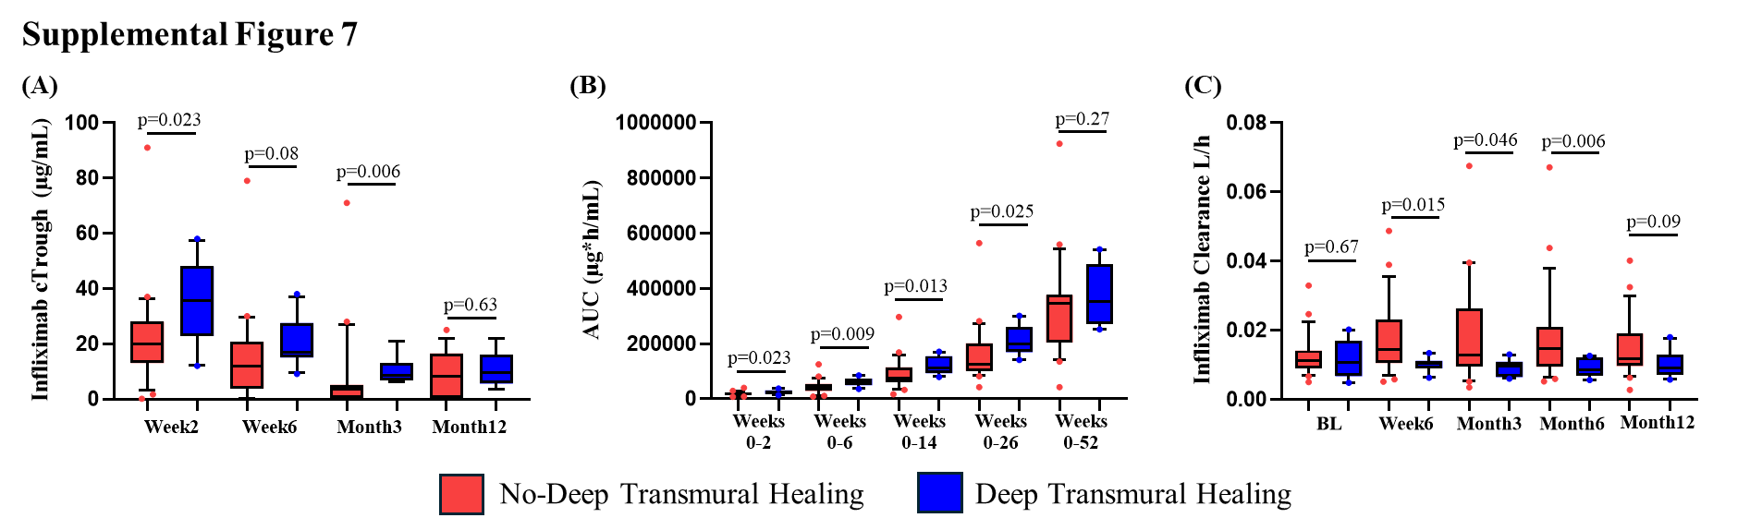
Supplemental Figure 7. Relationship between pharmacokinetic metrics and deep transmural healing. Various infliximab pharmacometrics were assessed, including (A) trough concentrations, (B) AUC and (C) clearance in patients with and without deep transmural healing. Deep transmural healing, simple endoscopic score-Crohn’s disease <3 and sMARIA <1 for both colon and ileum.

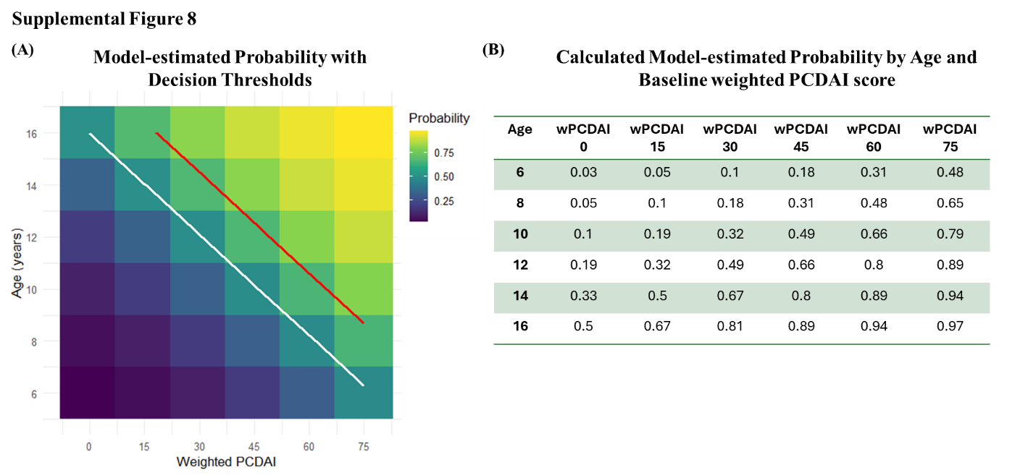

Supplemental Figure 8. Model-estimated probability of rapid infliximab clearance prior to starting therapy. (A) Heatmap shows predicted probability of rapid infliximab clearance across patient age (years) and the weighted pediatric Crohn’s disease activity index (wPCDAI) score, with increasing color intensity indicating a lower probability. Contour lines denote clinically relevant decision thresholds at 50% (white line) and 70% (red line). (B) Calculated probabilities by increasing age and baseline wPCDAI.

Supplemental Table 1. Baseline demographics and disease characteristics along with baseline and Month12 laboratory results and outcomes by anti-TNF therapy.
Characteristic | All patients  (n=80) | Infliximab  (n=63) | Adalimumab (n=17) | p-value
Age at enrollment, years (mean, SD) | 13.7 (3.5) | 13.2 (3.4) | 15.4 (3.1) | 0.016
Age at diagnosis (mean, SD) | 13.4 (3.6) | 13 (3.5) | 14.9 (3.4) | 0.051
Gender, female | 34 (42.5%) | 25 (39.7%) | 9 (52.9%) | 0.41
Race, white | 72 (90%) | 59 (93.7%) | 13 (76.5%) | 0.058
Ethnicity, non-Hispanic | 78 (97.5%) | 61 (96.8%) | 17 (100%) | 0.99
Body mass index, kg/m² | 17 (15-21) | 16.9 (15.3-21.2) | 20.4 (18.5-21.8) | 0.005
Methotrexate combination from start | 8 (10%) | 7 (11.1%) | 1 (5.9%) | 0.99
Baseline corticosteroid exposure | 37 (46.3%) | 30 (47.6%) | 7 (41.2%) | 0.79
Prednisone : Budesonide | 19 : 18 | 18 : 12 | 1 : 6 | -
Time to anti-TNF, days | 31 (16-48) | 31 (16-43) | 30 (16-58) | 0.99
Less than 90 days form diagnosis | 72 (90%) | 57 (90.5%) | 15 (88.2%) | 0.68
Crohn’s Location
L1 : L2 : L3 | 26 : 10 : 44 | 19 : 8 : 36 | 7 : 2 : 8 | -
Perianal phenotype | 17 (21.3%) | 16 (%) | 1 (5.9%) | 0.10
Crohn’s behavioral
B1 : B2 : B3 : B4 | 66 : 11 : 3 : 0 | 53 : 8 : 2 : 0 | 13 : 3 : 1 : 0 | -
Baseline Assessment
Weighted Pediatric CD activity index | 33 (18-50) | 34 (18-51) | 26 (10-44) | 0.34
Albumin, g/dL | 3.6 (3.3-4) | 3.5 (3.3-3.9) | 3.9 (3.4-4.3) | 0.07
Erythrocyte sedimentation rate, mm/h | 28 (12-40) | 26.5 (11-37) | 33 (18-41) | 0.23
Neutrophil CD64 ratio | 6 (4-9.4) | 6 (4.1-9.8) | 4.5 (3.7-6.9) | 0.18
Soluble CD64, ng/mL (mean, SD) | 27.1 (8.7) | 27.8 (8.7) | 24.3 (8.7) | 0.21
Fecal calprotectin, µg/g | 2102 (878-3694) | 1987 (878-3457) | 2466 (733-3802) | 0.62
Month12 Assessment & Outcomes
Weighted Pediatric CD activity index | 5 (0-10) | 5 (0-10) | 8 (0-13) | 0.31
Albumin, g/dL (mean, SD) | 4.2 (0.41) | 4.2 (0.42) | 4.2 (0.33) | 0.63
Erythrocyte sedimentation rate, mm/h | 8 (2-11) | 8 (2-11) | 9 (3-32) | 0.51
Neutrophil CD64 ratio | 3.2 (2.5-3.9) | 3.3 (2.6-3.8) | 2.7 (2.3-3.8) | 0.18
Soluble CD64, ng/mL (mean, SD) | 17.9 (7.2) | 18 (6.9) | 17.1 (8.6) | 0.73
Fecal calprotectin, µg/g | 138 (50-410) | 155 (50-410) | 75 (44-787) | 0.63
Trough concentration, µg/mL (mean, SD) | 13.7 (17.4) | 13.9 (19.5) | 13.1 (7.3) | 0.41
Simple Endoscopic Score-CD | 1 (0-6) | 1 (0-6) | 1 (0-11) | 0.95
Deep Remission | 34 | 29 (50.9%) | 5 (35.7%) | 0.28
Data shown as number (%) or median (25-75 interquartile range) unless otherwise specified as mean (SD, standard deviation). P-value represents the comparison between infliximab and adalimumab.

Model Code 1. NONMEM code for Bayesian post hoc estimation of infliximab pharmacokinetics with interoccasion variability .
$PROB IFX
$INPUT ID MDV TIME RATE=DROP DUR AMT DV ATI WT ESR ALB nCD64 EVID CMT OC
$DATA ENVISION_IFX.csv
IGNORE=@
$SUBROUTINES ADVAN3 TRANS4
$PK

; Covariate effects

IF(nCD64.EQ.-99) THEN
CLNCAR_n=1
ELSE
CLNCAR_n=((nCD64/4.6)**THETA(7))
ENDIF

IF(WT.EQ.-99) THEN
V1WT=1
ELSE
V1WT=((WT/65)**THETA(10))
ENDIF

V1COV=V1WT

IF(WT.EQ.-99) THEN
CLWT=1
ELSE
CLWT=((WT/65)**THETA(9))
ENDIF

IF(ESR.EQ.-99) THEN
CLESR=1
ELSE
CLESR=((ESR/9)**THETA(8))
ENDIF

IF(ATI.LE.22) THEN
CLATI=1
ELSE
CLATI=((ATI/22)**THETA(6))
ENDIF

IF(ALB.EQ.-99) THEN
CLALB=1
ELSE
CLALB=((ALB/3.5)**THETA(5))
ENDIF

CLCOV=CLALB*CLATI*CLESR*CLWT*CLNCAR_n

; Inter-occasion variability

IOV = 0
IF (OC.EQ.1) IOV = ETA(5)
IF (OC.EQ.2) IOV = ETA(6)
IF (OC.EQ.3) IOV = ETA(7)
IF (OC.EQ.4) IOV = ETA(8)
IF (OC.EQ.5) IOV = ETA(9)
IF (OC.EQ.6) IOV = ETA(10)
IF (OC.EQ.7) IOV = ETA(11)
IF (OC.EQ.8) IOV = ETA(12)
IF (OC.EQ.9) IOV = ETA(13)
IF (OC.EQ.10) IOV = ETA(14)
IF (OC.EQ.11) IOV = ETA(15)
IF (OC.EQ.12) IOV = ETA(16)
IF (OC.EQ.13) IOV = ETA(17)
IF (OC.EQ.14) IOV = ETA(18)
IF (OC.EQ.15) IOV = ETA(19)

TVCL=THETA(1)
TVCL=CLCOV*TVCL
CL=TVCL*EXP(ETA(1)+IOV)

TVV1=THETA(2)
TVV1=V1COV*TVV1
V1=TVV1*EXP(ETA(2))

TVQ=THETA(3)
Q=TVQ*EXP(ETA(3))*(WT/65)

TVV2=THETA(4)
V2=TVV2*EXP(ETA(4))*(WT/65)**0.586

S1=V1

$ERROR

IPRED=F
Y=IPRED*(1+ERR(1))

$THETA
0.0138 FIX ; CL
2.97 FIX ; V1
0.00953 FIX ; Q
2.84 FIX ; V2
-1.07 FIX ; ALB on CL
0.134 FIX ; ATI on CL
0.168 FIX ; nCD64 on CL
0.101 FIX ; ESR on CL
0.594 FIX ; WT on CL
0.55 FIX ; WT on V1

$OMEGA 0.0629 FIX ; IIV CL
0 FIX
0 FIX
0 FIX

$OMEGA BLOCK(1) 0.04 FIX ; IOV CL
$OMEGA BLOCK(1) SAME
$OMEGA BLOCK(1) SAME
$OMEGA BLOCK(1) SAME
$OMEGA BLOCK(1) SAME
$OMEGA BLOCK(1) SAME
$OMEGA BLOCK(1) SAME
$OMEGA BLOCK(1) SAME
$OMEGA BLOCK(1) SAME
$OMEGA BLOCK(1) SAME
$OMEGA BLOCK(1) SAME
$OMEGA BLOCK(1) SAME
$OMEGA BLOCK(1) SAME
$OMEGA BLOCK(1) SAME
$OMEGA BLOCK(1) SAME

$SIGMA 0.0225 FIX ; proportional error

$ESTIMATION METHOD=1 INTERACTION PRINT=5 MAX=0 SIG=3 MSFO=IFX_posthoc.MSF

$COVARIANCE MATRIX=S PRINT=E

$TABLE ID MDV TIME AMT DV ATI WT ESR ALB nCD64 EVID CMT OC IPRED PRED CWRES
NOAPPEND NOPRINT FILE=IFX

Model Code 2. NONMEM code for Bayesian post hoc estimation of adalimumab pharmacokinetics with interoccasion variability.
$PROB ADA
$INPUT ID TIME EVID MDV CMT AMT DV WT AAA OC
$DATA ENVISION_ADA.csv
IGNORE=@;
$SUBROUTINES ADVAN2 TRANS2
$PK

; Inter-occasion variability
IOV = 0
IF (OC.EQ.1) IOV = ETA(2)
IF (OC.EQ.2) IOV = ETA(3)
IF (OC.EQ.3) IOV = ETA(4)
IF (OC.EQ.4) IOV = ETA(5)
IF (OC.EQ.5) IOV = ETA(6)
IF (OC.EQ.6) IOV = ETA(7)
IF (OC.EQ.7) IOV = ETA(8)
IF (OC.EQ.8) IOV = ETA(9)
IF (OC.EQ.9) IOV = ETA(10)
IF (OC.EQ.10) IOV = ETA(11)
IF (OC.EQ.11) IOV = ETA(12)
IF (OC.EQ.12) IOV = ETA(13)
IF (OC.EQ.13) IOV = ETA(14)
IF (OC.EQ.14) IOV = ETA(15)
IF (OC.EQ.15) IOV = ETA(16)
IF (OC.EQ.16) IOV = ETA(17)
IF (OC.EQ.17) IOV = ETA(18)
IF (OC.EQ.18) IOV = ETA(19)
IF (OC.EQ.19) IOV = ETA(20)
IF (OC.EQ.20) IOV = ETA(21)
IF (OC.EQ.21) IOV = ETA(22)
IF (OC.EQ.22) IOV = ETA(23)
IF (OC.EQ.23) IOV = ETA(24)
IF (OC.EQ.24) IOV = ETA(25)
IF (OC.EQ.25) IOV = ETA(26)
IF (OC.EQ.26) IOV = ETA(27)
IF (OC.GE.27) IOV = ETA(28)

; Covariate effects
AAA_E=0
IF(AAA.GE.25) AAA_E=1

CL = (THETA(1)/24)*((WT/45.2)**THETA(5))*(1+THETA(4)*AAA_E)*EXP(ETA(1)+IOV)
V = THETA(2)*((WT/45.2)**THETA(6))
KA = THETA(3)/24

S2 = V

$ERROR
IPRED = F
Y = F*(1+EPS(1))+EPS(2)
IRES = DV-IPRED

$THETA
0.281 FIX ; CL
4.750 FIX ; V
0.200 FIX ; KA
1.080 FIX ; AAA on CL
0.480 FIX ; WT on CL
0.904 FIX ; WT on V

$OMEGA
0.0445 FIX ; IIV CL
$OMEGA BLOCK(1) 0.04 FIX ; IOV CL
$OMEGA BLOCK(1) SAME
$OMEGA BLOCK(1) SAME
$OMEGA BLOCK(1) SAME
$OMEGA BLOCK(1) SAME
$OMEGA BLOCK(1) SAME
$OMEGA BLOCK(1) SAME
$OMEGA BLOCK(1) SAME
$OMEGA BLOCK(1) SAME
$OMEGA BLOCK(1) SAME
$OMEGA BLOCK(1) SAME
$OMEGA BLOCK(1) SAME
$OMEGA BLOCK(1) SAME
$OMEGA BLOCK(1) SAME
$OMEGA BLOCK(1) SAME
$OMEGA BLOCK(1) SAME
$OMEGA BLOCK(1) SAME
$OMEGA BLOCK(1) SAME
$OMEGA BLOCK(1) SAME
$OMEGA BLOCK(1) SAME
$OMEGA BLOCK(1) SAME
$OMEGA BLOCK(1) SAME
$OMEGA BLOCK(1) SAME
$OMEGA BLOCK(1) SAME
$OMEGA BLOCK(1) SAME
$OMEGA BLOCK(1) SAME
$OMEGA BLOCK(1) SAME

$SIGMA
0.01 FIX ; proportional error
0 FIX ; additive error

$ESTIMATION METHOD=1 INTERACTION PRINT=5 MAX=0 SIG=3 MSFO=posthoc.MSF

$COVARIANCE MATRIX=S PRINT=E

$TABLE ID TIME EVID MDV CMT AMT DV WT AAA OC PRED IPRED CWRES
UNCONDITIONAL NOPRINT NOAPPEND ONEHEADER FILE=PK.txt

