Supplementary Materials
Understanding Pharmacokinetic Variability of Pomalidomide: A Physiologically Based Pharmacokinetic Analysis of Disease-Related Physiology, Ethnicity, Hepatic Impairment, Food Effects, Drug Interactions, and Smoking
Jeffry Adiwidjaja^{1,2}, Alan V. Boddy³, Andrew J. McLachlan¹
¹ Sydney Pharmacy School, The University of Sydney, Sydney, New South Wales, Australia
² Simulations Plus, Inc., Research Triangle Park, North Carolina, USA
³ School of Pharmacy and Biomedical Sciences, Adelaide University, Adelaide, South Australia, Australia

Corresponding author
Dr. Jeffry Adiwidjaja
Email: jeffry.adiwidjaja@sydney.edu.au; jeffry.adiwidjaja@simulations-plus.com

Table S1 Summary of clinical studies used for development and verification of the PBPK model of pomalidomide and comparison of simulated and clinically-reported pharmacokinetic parameters
Pomali-domide dose | Study participants | PK metric | C_{max} (ng/mL) |  |  | AUC_{0-t} (ng.h/mL) |  |  | t_{max} (h) |  |  | CL/F (L/h) |  |  | Study by
Pomali-domide dose | Study participants | PK metric | Pred | Reported | P/R | Pred | Reported | P/R | Pred | Reported | P/R | Pred | Reported | P/R | Study by
4 mg (caps) ^{a)} | Healthy individuals [n=28; 75% male; mean age = 42.3 years (range: 18–63); mean BW = 81.4 kg (range: 54.5–113.4); mean HT = 170.2 cm (range: 144.3–191.8); mean BMI = 27.9 kg/m² (range: 21.9–31.6)] | Single dose | 54.05 | 57.3  (CV: 30.1%) | 0.94 | 535.3 | 581  (CV: 31.1%) | 0.92 | 1.77 | 2.0  (1.0–6.0) | 0.89 | 7.39 | 6.78  (CV: 31.6%) | 1.09 | Li et al, 2018a [1]
4 mg (caps) ^{a)} | Healthy adult males [n=16; mean age = 32.8 years (range: 20–54); BW: 60-100 kg; BMI: 19.3–30.3 kg/m²]; fed state (standard moderate-fat, moderate-calorie meal) | Single dose | 50.75 | 48.8 | 1.04 | 532.6 ^{b)} | 529.2 ^{b)} | 1.01 | 2.70 | 3.3  (CV: 32%) | 0.82 | 7.51 | 7.6  (CV: 24.9%) | 0.99 | Kasserra et al, 2015 [2]
0.5 mg/d  (caps) | Healthy adult males [n=8 per dose level; ~79% of European ancestry; mean age = 32 years (range: 20–51); mean BW = 77.4 kg (range: 63.1–94.7); mean HT = 174.4 cm (range: 161.9–184.0); mean BMI = 25.5 kg/m² (range: 20.6–29.9)] | Day 1 | 6.78 | 6.73  (CV: 17.8%) | 1.01 | 61.5 | 58.6  (CV: 24.5%) | 1.05 | 1.58 | 1.8  (1.0–3.0) | 0.88 | 7.88 | N.R. | N.A. | Li et al, 2018b [3]
0.5 mg/d  (caps) |  | Day 5 | 7.21 | 7.7  (CV: 20.8%) | 0.94 | 63.5 | 66.5  (CV: 24.0%) | 0.95 | 1.52 | 2.0  (1.0–4.0) | 0.76 | 7.88 | 6.78  (CV: 27.6%) | 1.16 | Li et al, 2018b [3]
1 mg/d (caps) |  | Day 1 | 13.54 | 13.1  (CV: 18.0%) | 1.03 | 123.0 | 95.0  (CV: 35.4%) | 1.29 | 1.63 | 1.8  (1.0–3.0) | 0.91 | 7.62 | N.R. | N.A. | Li et al, 2018b [3]
1 mg/d (caps) |  | Day 5 | 14.41 | 13.6  (CV: 18.2%) | 1.06 | 131.2 | 103  (CV: 39.4%) | 1.27 | 1.57 | 1.6  (1.6–3.1) | 1.01 | 7.62 | 9.12  (CV: 45.3%) | 0.84 | Li et al, 2018b [3]
2 mg/d (caps) |  | Day 1 | 26.89 | 28.5  (CV: 18.6%) | 0.94 | 245.87 | 232  (CV: 24.5%) | 1.06 | 1.62 | 2.3  (1.6–4.0) | 0.70 | 7.61 | N.R. | N.A. | Li et al, 2018b [3]
2 mg/d (caps) |  | Day 5 | 28.62 | 30.6  (CV: 26.2%) | 0.94 | 262.67 | 242  (CV: 25.0%) | 1.09 | 1.58 | 2.3  (1.6–4.0) | 0.68 | 7.61 | 7.74  (CV: 26.8%) | 0.98 | Li et al, 2018b [3]
0.5 mg (caps) | Japanese patients with RRMM [n=6 per dose level; 50% male; median age = 67.5 years (range: 65–69)] | Single dose | 8.30 | 9.1  (CV: 18.8%) | 0.91 | 96.5 | 84.9  (CV: 14.9%) | 1.14 | 2.76 | N.R. | N.A. | 5.18 | 5.4  (CV: 14.6%) | 0.96 | Matsue et al, 2015 [4]
2 mg/d (caps) |  | Day 1 | 33.23 | 35.6  (CV: 15.9%) | 0.93 | 385.8 | 364.4  (CV: 20.3%) | 1.06 | 2.78 | N.R. | N.A. | 5.18 | 4.9  (CV: 26.4%) | 1.06 | Matsue et al, 2015 [4]
2 mg/d (caps) |  | Day 10 | 38.98 | 37.6  (CV: 20.9%) | 1.04 | 386.7 | 411.5  (CV: 17.7%) | 0.94 | 2.79 | N.R. | N.A. | 5.17 | 4.9  (CV: 17.7%) | 1.06 | Matsue et al, 2015 [4]
4 mg/d (caps) | Japanese patients with RRMM [n=6; 66.7% male; median age = 69 years (range: 52–76)] | Day 1 | 66.34 | 70.2  (CV: 49.7%) | 0.95 | 772.8 | 685.7  (CV: 43.1%) | 1.13 | 2.73 | N.R. | N.A. | 5.18 | 5.3  (CV: 44.8%) | 0.98 | Matsue et al, 2015 [4]
4 mg/d (caps) |  | Day 10 | 76.08 | 71.2  (CV: 40.6%) | 1.07 | 774.6 | 713.8  (CV: 40.1%) | 1.09 | 2.58 | N.R. | N.A. | 5.16 | 5.6  (CV: 40.1%) | 0.92 | Matsue et al, 2015 [4]
4 mg/d (caps) | Patients with RRMM [n=144; 74.3% male; median age = 53 years (range: 19-83); median BW = 78.1 kg (range: 44.4–127.0); median HT = 171.5 cm (range: 142.0–191.3); median BMI = 26.5 kg/m² (range: 16.4–48.3)] | Steady state | 54.76 | N.R. | N.A. | 504.7 | N.R. | N.A. | 1.70 | N.R. | N.A. | 7.93 | 8.52  (CV: 66%) ^{c)} | 0.93 | Li et al,  2015 [5]
2 mg/d (caps) | Patients with RRMM [n=12; 83.3% male; median age = 68 years (range: 52-77); median BW = 76.4 kg (range: 67.0–98.0); median BSA = 1.92 m² (range: 1.73–2.24)] | Peak (day 15) | 32.0 | Median = 36.5 (range: 25.6–53.2) | 0.88 | 266.9 | N.R. | N.A. | 1.53 | N.R. | N.A. | 7.49 | N.R. | N.A. | Seefat et al, 2026
2 mg/d (caps) |  | Trough (day 15) | 3.0 | Median = 3.9 (range: 1.3–24.6) | 0.77
4 mg/d (caps) |  | Peak (day 15) | 62.5 | Median = 74.5 (range: 53.7–92.7) | 0.84 | 533.5 | N.R. | N.A. | 1.68 | N.R. | N.A. | 7.50 | N.R. | N.A. | Seefat et al, 2026
4 mg/d (caps) |  | Trough (day 15) | 6.1 | Median = 7.7 (range: 4.2–21.6) | 0.79
4 mg EOD (caps) |  | Peak (day 15) | 57.9 | Median = 67.8 (range: 42.1–133.5) | 0.85 | 533.7 | N.R. | N.A. | 1.67 | N.R. | N.A. | 7.50 | N.R. | N.A. | Seefat et al, 2026
4 mg EOD (caps) |  | Trough (day 15) | 0.9 | Median = 1.1 (range: BLQ–2.0) | 0.85
4 mg (caps) | Healthy adult males [n=8; 87.5% of European ancestry (Caucasian); mean age = 55.8 years (range: 50-66); mean BW = 86.3 kg (range: 70.0–101.2); mean HT = 175.2 cm (range: 167.0–182.3); mean BMI = 28.1 kg/m² (range: 24.3–31.9)] | Single dose | 51.22 | 60.7 ± 14.1 | 0.84 | 498.4 | 493.3 ± 122.4 | 1.01 | 1.80 | 1.5  (1.0–2.5) | 1.20 | 8.00 | 8.4 ± 1.9 | 0.95 | Li et al,  2019 [6]
4 mg (caps) | Adult males with mild HI [n=8; 75% Caucasian; mean age = 56.4 years (range: 51-68); mean BW = 86.9 kg (range: 71.7–103.0); mean HT = 174.5 cm (range: 165.0–187.0); mean BMI = 28.7 kg/m² (range: 23.1–34.4)] | Single dose | 49.91 | 56.2 ± 7.3 | 0.89 | 718 | 728.4 ± 243.8 | 0.99 | 2.13 | 2.0  (2.0–4.0) | 1.07 | 5.43 | 5.8 ± 2.2 | 0.94 | Li et al,  2019 [6]
4 mg (caps) |  | Ratio vs healthy cohort | 0.97 | 0.93 | 1.05 | 1.44 | 1.48 | 0.97 | 1.18 | 1.33 | 0.89 | 0.68 | 0.69 | 0.99 | Li et al,  2019 [6]
4 mg (caps) | Adult males with moderate HI [n=8; 100% Caucasian; mean age = 59.3 years (range: 54–69); mean BW = 87.5 kg (range: 71.5–100.3); mean HT = 171.1 cm (range: 160.0–181.0); mean BMI = 29.9 kg/m² (range: 24.9–35.2)] | Single dose | 51.12 | 58.0 ± 15.1 | 0.88 | 987.5 | 764.5 ± 239.6 | 1.29 | 2.23 | 2.25  (1.0–4.0) | 0.99 | 3.73 | 5.6 ± 2.6 | 0.67 | Li et al,  2019 [6]
4 mg (caps) |  | Ratio vs healthy cohort | 1.00 | 0.96 | 1.04 | 1.98 | 1.55 | 1.28 | 1.24 | 1.50 | 0.83 | 0.47 | 0.67 | 0.70 | Li et al,  2019 [6]
4 mg (caps) | Adult males with severe HI [n=8; 87.5% Caucasian; mean age = 53.1 years (range: 42–62); mean BW = 90.5 kg (range: 69.0-114.0); mean HT = 171.5 cm (range: 152.0–182.0); mean BMI = 30.8 kg/m² (range: 23.9–36.6)] | Single dose | 50.54 | 49.1 ± 18.5 | 1.03 | 1,271 | 821.9 ± 289.2 | 1.55 | 2.47 | 2.5  (1.0–6.0) | 0.99 | 3.15 | 5.4 ± 3.3 | 0.58 | Li et al,  2019 [6]
4 mg (caps) |  | Ratio vs healthy cohort | 0.99 | 0.81 | 1.22 | 2.55 | 1.67 | 1.53 | 1.37 | 1.67 | 0.82 | 0.39 | 0.64 | 0.61 | Li et al,  2019 [6]
^{a)} Assigned as the training dataset during PBPK model development
^{b)} Reported as AUC_{0-inf} (area under the plasma concentration-time curve from time zero extrapolated to infinity)
^{c)} Reported from a population pharmacokinetic analysis as the typical population value, with interindividual variability expressed as CV (%) = $\sqrt{\left(e^{variance}-1\right)} x 100$
Abbreviations: AUC_{0-t}, area under the plasma concentration-time curve from time zero to the last sampling time; BLQ, below limit of quantitation; BMI, body mass index; BSA, body surface area; BW, body weight; CL/F, oral clearance; caps, capsule; C_{max}, peak plasma concentration; CV, coefficient of variation; EOD, every other day; HI, hepatic impairment; HT, height; N.A., not applicable; N.R., not reported; pred, PBPK model prediction; PBPK, physiologically based pharmacokinetic; PK, pharmacokinetic; P/R, ratio of PBPK model prediction to clinically-reported value; RRMM, relapsed and/or refractory multiple myeloma; t_{max}, time to reach C_{max}

Table S2 PBPK model predictions and clinically-reported pharmacokinetic parameters of pomalidomide under fasted and fed conditions (high-fat, high-calorie meal), and in the presence of drug interactions with fluvoxamine (CYP1A2 inhibition), ketoconazole (CYP3A4 inhibition) and tobacco cigarette smoking (CYP1A2 induction)
Pomalido-mide dose | Precipitant | Study participants | Parame-ter | Pomalidomide alone (control) |  |  | With interaction |  |  | Ratio to control |  |  | Study by
 |  |  |  | Pred | Reported | P/R | Pred | Reported | P/R | Pred | Reported | P/R | Study by
4 mg (suspension) | High-fat, high-calorie meal | Healthy individuals [n=28; 75% male; mean age = 42.3 years (range: 18–63); mean BW = 81.4 kg (range: 54.5–113.4); mean HT = 170.2 cm (range: 144.3–191.8); mean BMI = 27.9 kg/m² (range: 21.9–31.6)] | C_{max} (ng/mL) | 56.41 | 63.9  (CV: 31.8%) | 0.88 | 43.58 | 41.8  (CV: 28.2%) | 1.04 | 0.77 | 0.65 | 1.18 | Li et al, 2018a [1]
4 mg (suspension) | High-fat, high-calorie meal |  | AUC_{0-inf} (ng.h/mL) | 522.2 | 587  (CV: 32.2%) | 0.89 | 512.7 | 569.0  (CV: 31.9%) | 0.90 | 0.98 | 0.97 | 1.01 | Li et al, 2018a [1]
4 mg (suspension) | High-fat, high-calorie meal |  | t_{max} (h) | 1.55 | 1.5  (1.0–3.0) | 1.03 | 4.00 | 4.5  (2.5–8.0) | 0.89 | 2.58 | 3.00 | 0.86 | Li et al, 2018a [1]
4 mg (suspension) | High-fat, high-calorie meal |  | CL/F (L/h) | 7.66 | 6.81  (CV: 32.2%) | 1.12 | 7.80 | 7.02  (CV: 31.9%) | 1.11 | 1.02 | 1.03 | 0.99 | Li et al, 2018a [1]
1 mg (capsule) | High-fat, high-calorie meal | Healthy Chinese males [n=24; mean age = 41 years (range: 20–62); mean BW = 67.7 kg (range: 50.0–86.6); mean BMI = 23.6 kg/m² (range: 18.9–28.0)] | C_{max} (ng/mL) | 16.54 | 21.9 ± 5.9 | 0.76 | 13.89 | 15.0 ± 2.6 | 0.93 | 0.84 | 0.68 | 1.23 | Liu et al, 2023 [7]
1 mg (capsule) | High-fat, high-calorie meal |  | AUC_{0-inf} (ng.h/mL) | 180.8 | 154.94 ± 45.59 | 1.17 | 177.6 | 153.06 ± 37.87 | 1.16 | 0.98 | 0.99 | 0.99 | Liu et al, 2023 [7]
1 mg (capsule) | High-fat, high-calorie meal |  | t_{max} (h) | 1.63 | 1.25  (0.5–3.0) | 1.30 | 3.90 | 4.00  (2.5–6.0) | 0.98 | 2.39 | 3.20 | 0.75 | Liu et al, 2023 [7]
4 mg (capsule) | High-fat, high-calorie meal | Healthy Chinese males [n=28; age = 28.5 ± 7.5 years (range: 18–65); BW = 62.7 ± 7.7 kg; HT = 166.8 ± 6.3 cm; BMI = 22.5 ± 2.2 kg/m² (range: 18.0–28.0)] | C_{max} (ng/mL) | 67.71 | 70.8 ± 12.5 | 0.96 | 57.85 | 60.3 ± 15.7 | 0.96 | 0.85 | 0.85 | 1.00 | Wang et al, 2022 [8]
4 mg (capsule) | High-fat, high-calorie meal |  | AUC_{0-inf} (ng.h/mL) | 754.7 | 712.8 ± 155.0 | 1.06 | 740.6 | 652.9 ± 154.1 | 1.13 | 0.98 | 0.92 | 1.07 | Wang et al, 2022 [8]
4 mg (capsule) | High-fat, high-calorie meal |  | t_{max} (h) | 1.83 | 2.0  (0.5–5.0) | 0.92 | 3.78 | 4.5  (3.0–12.0) | 0.84 | 2.07 | 2.25 | 0.92 | Wang et al, 2022 [8]
4 mg (capsule) | Fluvoxamine 50 mg twice daily for 7 days | Healthy adult males [n=15; mean age = 34.2 years (range: 23–50); mean BW = 84.3 kg (range: 64.8–98.6); mean HT = 176.6 cm (range: 164.0–188.1); mean BMI = 27.0 kg/m² (range: 20.8–31.3)], fed state (standard moderate-fat, moderate-calorie meal) | C_{max} (ng/mL) | 48.04 | 49.2  (CV: 26.2%) | 0.98 | 56.93 | 59.5  (CV: 21.9%) | 0.96 | 1.19 | 1.21 | 0.98 | Li et al, 2018c [9]
4 mg (capsule) | Fluvoxamine 50 mg twice daily for 7 days |  | AUC_{0-inf} (ng.h/mL) | 508.1 | 526.5  (CV: 33.2%) | 0.97 | 1,048.0 | 1,179.4  (CV: 23.4%) | 0.89 | 2.06 | 2.24 | 0.92 | Li et al, 2018c [9]
4 mg (capsule) | Fluvoxamine 50 mg twice daily for 7 days |  | t_{max} (h) | 2.61 | 3.0  (2.5–6.0) | 0.87 | 3.12 | 4.5  (3.0–6.0) | 0.69 | 1.20 | 1.50 | 0.80 | Li et al, 2018c [9]
4 mg (capsule) | Fluvoxamine 50 mg twice daily for 7 days |  | CL/F (L/h) | 7.87 | 7.6  (CV: 33.2%) | 1.04 | 3.82 | 3.4  (CV: 23.4%) | 1.12 | 0.49 | 0.45 | 1.08 | Li et al, 2018c [9]
4 mg (capsule) | Ketoconazole 200 mg twice daily for 7 days | Healthy adult males [n=16; 53% Caucasian; mean age = 32.8 years (range: 20–54); BW range: 60–100 kg; BMI range = 19.3–30.3 kg/m²], fed state (standard moderate-fat, moderate-calorie meal) | C_{max} (ng/mL) | 51.59 | 48.8 | 1.06 | 53.99 | 52.3 | 1.03 | 1.05 | 1.07 | 0.98 | Kasserra et al, 2015 [2]
4 mg (capsule) | Ketoconazole 200 mg twice daily for 7 days |  | AUC_{0-inf} (ng.h/mL) | 528.1 | 483.8 | 1.09 | 587.2 | 575 | 1.02 | 1.11 | 1.19 | 0.94 | Kasserra et al, 2015 [2]
4 mg (capsule) | Ketoconazole 200 mg twice daily for 7 days |  | t_{max} (h) | 2.72 | 3.1  (CV: 18.4%) | 0.88 | 2.80 | 3.1  (CV: 19.1%) | 0.90 | 1.03 | 1.00 | 1.03 | Kasserra et al, 2015 [2]
4 mg (capsule) | Ketoconazole 200 mg twice daily for 7 days |  | CL/F (L/h) | 7.57 | 8.3  (CV: 32.7%) | 0.91 | 6.81 | 7.0  (CV: 27.8%) | 0.97 | 0.90 | 0.84 | 1.07 | Kasserra et al, 2015 [2]
4 mg (capsule) | Fluvoxamine 50 mg twice daily and ketoconazole 200 mg twice daily for 7 days | Healthy adult males [n=16; 53% Caucasian; mean age = 32.8 years (range: 20–54); BW range: 60–100 kg; BMI range = 19.3–30.3 kg/m²], fed state (standard moderate-fat, moderate-calorie meal) | C_{max} (ng/mL) | 51.55 | 48.8 | 1.06 | 63.68 | 59.2 | 1.08 | 1.24 | 1.21 | 1.02 | Kasserra et al, 2015 [2]
4 mg (capsule) |  |  | AUC_{0-inf} (ng.h/mL) | 528.1 | 483.8 | 1.09 | 1,280 | 1,188.6 | 1.08 | 2.42 | 2.46 | 0.99 | Kasserra et al, 2015 [2]
4 mg (capsule) |  |  | t_{max} (h) | 2.78 | 3.1  (CV: 18.4%) | 0.90 | 3.15 | 4.7  (CV: 49.5%) | 0.67 | 1.13 | 1.52 | 0.75 | Kasserra et al, 2015 [2]
4 mg (capsule) |  |  | CL/F (L/h) | 7.57 | 8.3  (CV: 32.7%) | 0.91 | 3.13 | 3.6  (CV: 19.6%) | 0.87 | 0.41 | 0.43 | 0.95 | Kasserra et al, 2015 [2]
4 mg (capsule) | Cigarette smoking (~25 cigarettes per day for 10 days) | Healthy nonsmoking males [n=14; mean age = 50.4 years (range: 40–66); mean BW = 91.2 kg (range: 73.0–110.4); mean HT = 177.1 cm (range: 162.0–191.7); mean BMI = 29.1 kg/m² (range: 24.6–36.9)], fed state (standard moderate-fat, moderate-calorie meal)  Heavy smokers [n=14 males; mean age = 51.9 years (range: 40–67); mean BW = 80.4 kg (range: 50.0–116.0); mean HT = 173.9 cm (range: 168.2–184.0); mean BMI = 26.6 kg/m² (range: 17.7–36.1)] | C_{max} (ng/mL) | 49.29 | 56.3  (CV: 16.6%) | 0.88 | 50.59 | 64.4  (CV: 18.7%) | 0.79 | 1.03 | 1.14 | 0.90 | Li et al, 2018c [9]
4 mg (capsule) | Cigarette smoking (~25 cigarettes per day for 10 days) |  | AUC_{0-inf} (ng.h/mL) | 613.2 | 684.4  (CV: 19.6%) | 0.90 | 436 | 463.1  (CV: 32.5%) | 0.94 | 0.71 | 0.68 | 1.04 | Li et al, 2018c [9]
4 mg (capsule) | Cigarette smoking (~25 cigarettes per day for 10 days) |  | t_{max} (h) | 2.81 | 3.0  (1.5–6.0) | 0.94 | 1.77 | 1.8  (1.0–3.0) | 0.98 | 0.63 | 0.60 | 1.05 | Li et al, 2018c [9]
4 mg (capsule) | Cigarette smoking (~25 cigarettes per day for 10 days) |  | CL/F (L/h) | 6.52 | 5.8  (CV: 19.6%) | 1.12 | 9.18 | 8.6  (CV: 32.5%) | 1.07 | 1.41 | 1.48 | 0.95 | Li et al, 2018c [9]
Abbreviations: AUC_{0-inf}, area under the plasma concentration-time curve from time zero extrapolated to infinity; BMI, body mass index; BW, body weight; CL/F, oral clearance; C_{max}, peak plasma concentration; pred, PBPK model prediction; P/R, ratio of PBPK model prediction to clinically-reported value; t_{max}, time to reach C_{max}
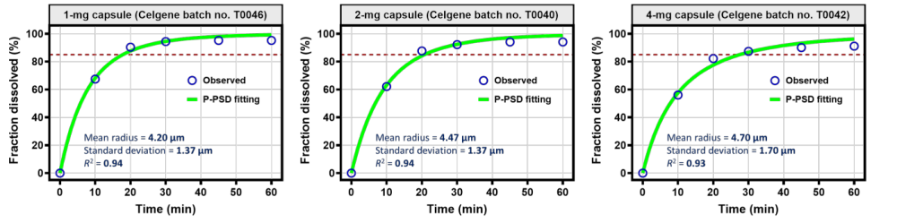
Fig. S1 Fitted product-particle size distribution (P-PSD) parameters describing the observed dissolution profiles of 1-, 2-, and 4-mg Imnovid® capsules (surrogate batches) in HCl solution (pH 1.2; 37°C; 900 mL; USP 2 apparatus; 50 rpm) [10]
Abbreviation: r², coefficient of determination

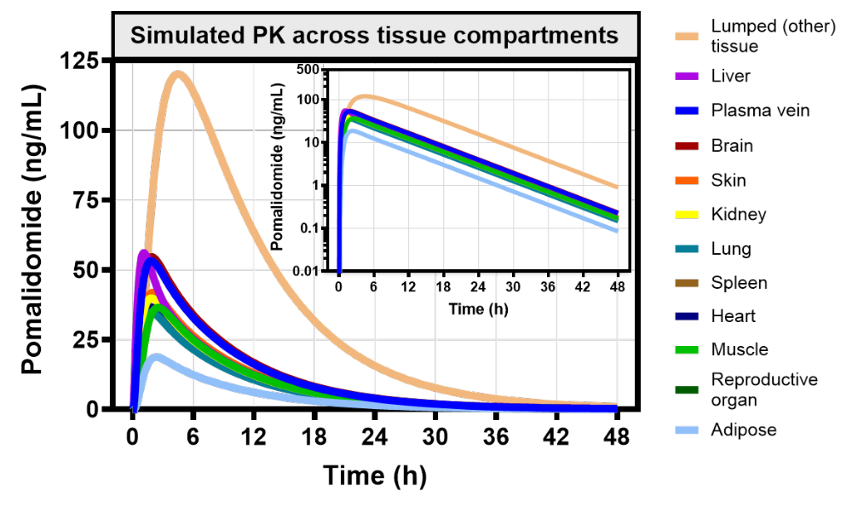
Fig. S2 Predicted pomalidomide concentrations across tissue compartments represented within the PBPK model following a single 4-mg oral dose administered under fasted state
The PBPK simulation was performed using a representative virtual individual matched to the mean demographic and physiological characteristics of participants reported by Li et al [1]
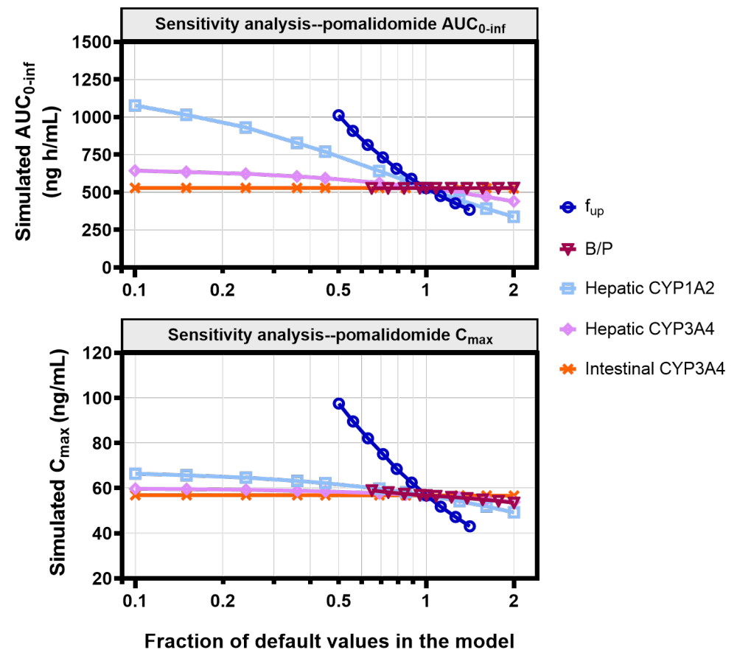
Fig. S3 Sensitivity analysis illustrating the impact of variations in plasma protein binding (f_{up}), blood partitioning (B/P), and hepatic CYP1A2, hepatic CYP3A4, and intestinal CYP3A4 abundance on pomalidomide AUC_{0-inf} (upper panel) and C_{max} (lower panel)
Abbreviation: B/P, blood-to-plasma ratio; f_{up}, unbound fraction in plasma

References
1. Li Y, Liu L, Huang L, Wang X, Hoffmann M, Reyes J, et al. A phase I, open-label, randomized, crossover study in healthy subjects to evaluate the bioavailability of, and the food effect on, a pomalidomide oral liquid suspension. Clin Pharmacol. 2018;10:89-99. https://doi.org/10.2147/CPAA.S171735
2. Kasserra C, Assaf M, Hoffmann M, Li Y, Liu L, Wang X, et al. Pomalidomide: evaluation of cytochrome P450 and transporter-mediated drug-drug interaction potential in vitro and in healthy subjects. J Clin Pharmacol. 2015;55(2):168-78. https://doi.org/10.1002/jcph.384
3. Li Y, Wang X, Liu L, Reyes J, Palmisano M, Zhou S. Distribution of pomalidomide into semen of healthy male subjects after multiple doses. Clin Pharmacol. 2018;10:53-62. https://doi.org/10.2147/CPAA.S167017
4. Matsue K, Iwasaki H, Chou T, Tobinai K, Sunami K, Ogawa Y, et al. Pomalidomide alone or in combination with dexamethasone in Japanese patients with refractory or relapsed and refractory multiple myeloma. Cancer Sci. 2015;106(11):1561-7. https://doi.org/10.1111/cas.12772
5. Li Y, Xu Y, Liu L, Wang X, Palmisano M, Zhou S. Population pharmacokinetics of pomalidomide. J Clin Pharmacol. 2015;55(5):563-72. https://doi.org/10.1002/jcph.455
6. Li Y, Wang X, Liu L, Zhang C, Gomez D, Reyes J, et al. An open-label, phase 1 study to assess the effects of hepatic impairment on pomalidomide pharmacokinetics. Clin Pharmacol Drug Dev. 2019;8(3):346-54. https://doi.org/10.1002/cpdd.470
7. Liu Z, Xu Z, Gao Z, Ren Q, Chang T, Xue J, et al. Pharmacokinetics and bioequivalence of two pomalidomide capsules in healthy Chinese subjects under fasting and fed conditions. Invest New Drugs. 2023;41(1):60-9. https://doi.org/10.1007/s10637-022-01320-9
8. Wang Y, Lin S, Wang Y, Wang Z. Bioequivalence of pomalidomide capsules in fasting and fed states in healthy male volunteers: a randomized, open, single-dose, biperiodic, double-crossover study. Clin Pharmacol Drug Dev. 2022;11(11):1246-52. https://doi.org/10.1002/cpdd.1173
9. Li Y, Liu L, Wang X, Zhang C, Reyes J, Hoffmann M, et al. In vivo assessment of the effect of CYP1A2 inhibition and induction on pomalidomide pharmacokinetics in healthy subjects. J Clin Pharmacol. 2018;58(10):1295-304. https://doi.org/10.1002/jcph.1145
10. United States Food and Drug Administration. Pomalyst® clinical pharmacology and biopharmaceutics review. 2012. https://doi.org/https://www.accessdata.fda.gov/drugsatfda_docs/nda/2013/204026Orig1s000ClinPharmR.pdf

