Comparing the predictive performance of machine learning models with a newly developed population pharmacokinetic model for busulfan in paediatric patients

Clinical Pharmacokinetics
Supplementary Material 3

Tianwu Yang¹ (ORCID: 0009-0005-0856-4497), Maria Thastrup² (ORCID: 0000-0001-9950-5911), Tania Nicole Masmas² (ORCID: 0000-0003-1604-422X), Hilde Hylland Uhlving² (ORCID: 0000-0003-0389-3767), Jacob Nersting² (ORCID: 0000-0001-9144-7972), Malene Johanne Petersen² (ORCID: 0000-0002-0531-8531), Anna Sofie Buhl Rasmussen² (ORCID: 0000-0002-4997-2914), Kjeld Schmiegelow*^{2, 3} (ORCID: 0000-0002-0829-4993), Trine Meldgaard Lund*¹ (ORCID: 0000-0001-8598-2880)
¹ Department of Drug Design and Pharmacology, University of Copenhagen, Denmark
² Department of Paediatrics and Adolescent Medicine, Copenhagen University Hospital, Rigshospitalet, Denmark
³ Institute of Clinical Medicine, Faculty of Medicine, University of Copenhagen, Copenhagen, Denmark
* Shared last authorship

Corresponding author:
Trine Meldgaard Lund
Address: Department of Drug Design and Pharmacology, Faculty of Health and Medical Sciences, University of Copenhagen, Universitetsparken 2, 2100 Copenhagen, Denmark
E-mail: trine.lund@sund.ku.dk
Tel.: + 45 35 33 63 40

The shiny app can be found at:
https://github.com/tian666-cpu/Busulfan-Shiny-popPK

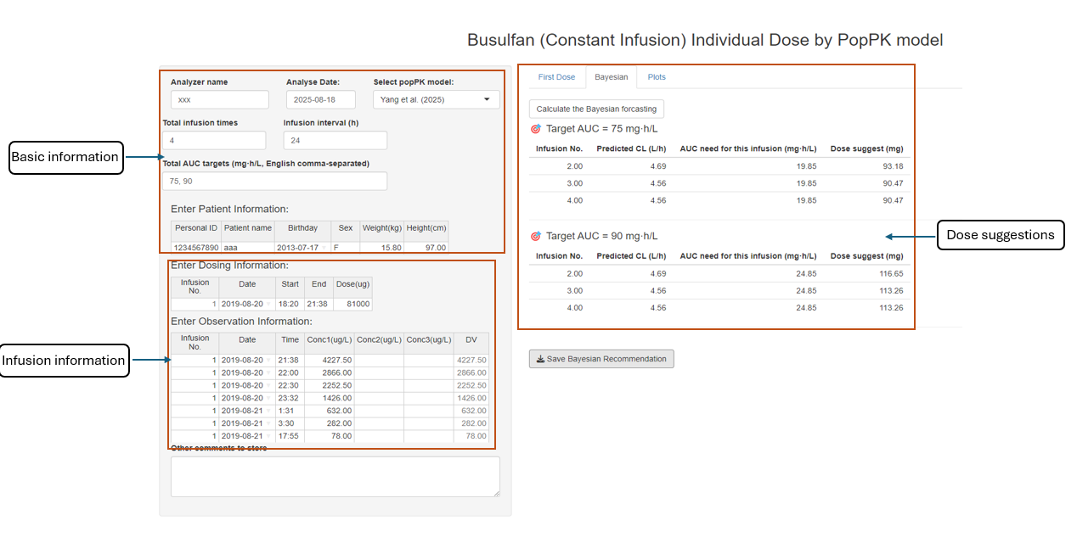
Figure S3.1 The design of the Shiny app (“Bayesian” tab)

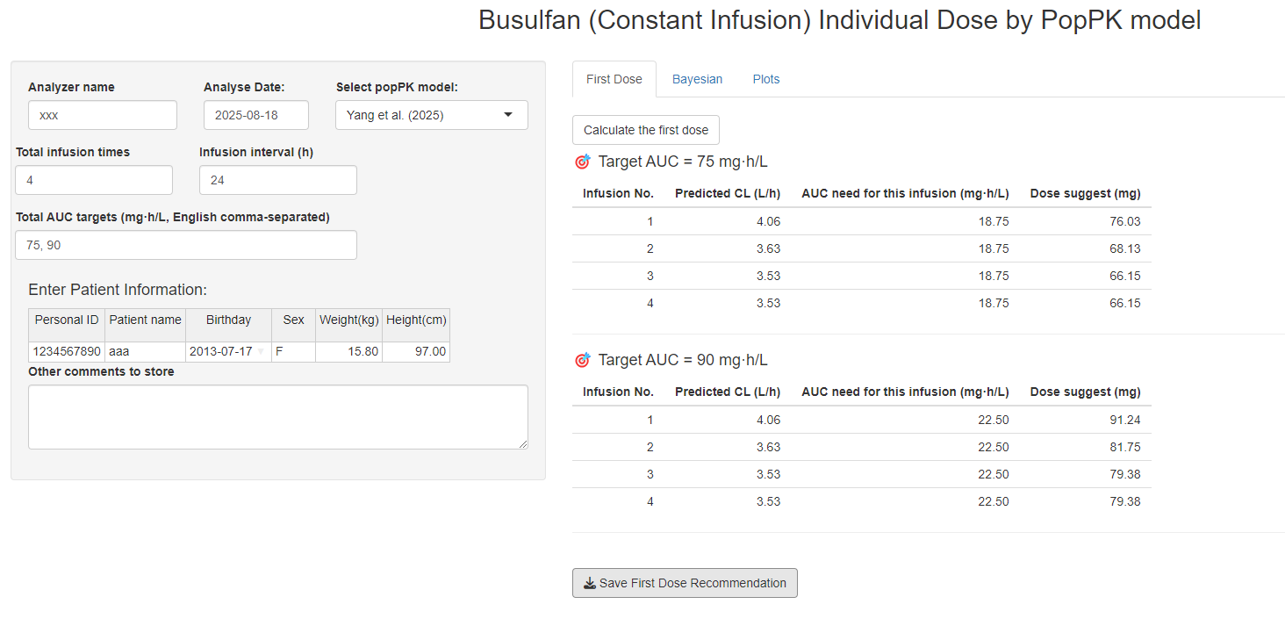
Figure S3.2 The design of the Shiny app (“First Dose” tab)

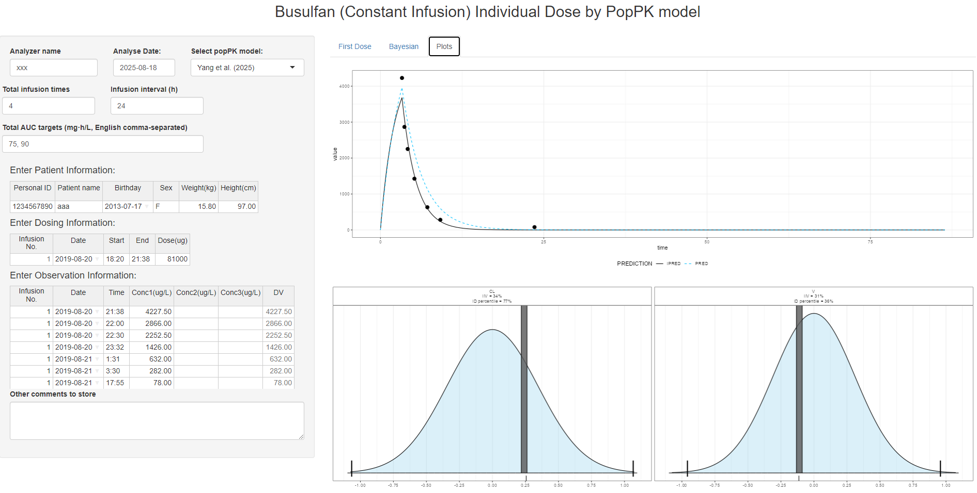
Figure S3.3 The design of the Shiny app (“Plots” tab)

The open-sourced Shiny app was developed with R software (version 4.5.0). The MAP calculation was carried out by the package mapbayr, and the popPK model was coded in mrgsolve.

The Shiny app was developed for easy implementation of our popPK model in clinical settings (Figure S3.1). The upper left side of the user interface is the module for registering basic information, including the current infusion schedule and target, as well as patient demographics and covariates. For our model (“Yang et al. (2025)”), the patient's total body weight is compulsory. The lower left side is where the user inputs the infusion information, including the dosage regimen and TDM sample observations. On the right side, there were subtabs: “First Dose”, “Bayesian”, and “Plots”. Figure S3.1 shows an example result of the “Bayesian” tab. After the user enters all the required information on the left side (including Basic information and Infusion information) and clicks the button “Calculate the Bayesian forecasting”, the result of predicted CL and suggested dose for the upcoming infusion will be shown. The “Plots” tab shows summary plots of the corresponding Bayesian forecasting in the “Bayesian” tab (Figures S3.2 and S3.3). The “First Dose” tab is like the “Post Hoc” tab, where the user only needs to register the basic information (covariates), and the suggested dose, based on a priori estimates for the first infusion, will be shown on the right side. A report for clinicians can be downloaded by clicking the "Save Report" button.

