Drug Safety

Interest in a mobile app for two-way risk communication – A survey study among European healthcare professionals and patients

Sieta T. de Vries, Petra Denig, Carmen Lasheras Ruiz, François Houÿez, Lisa Wong, Alastair Sutcliffe,
Peter G.M. Mol, on behalf of IMI Web-RADR work package 3b Consortium
p.g.m.mol@umcg.nl

Supplemental Digital Content

This Supplemental Digital Content contains the appendix referred to in the full version of this article, which can be found at http://adisonline.com/drugsafety

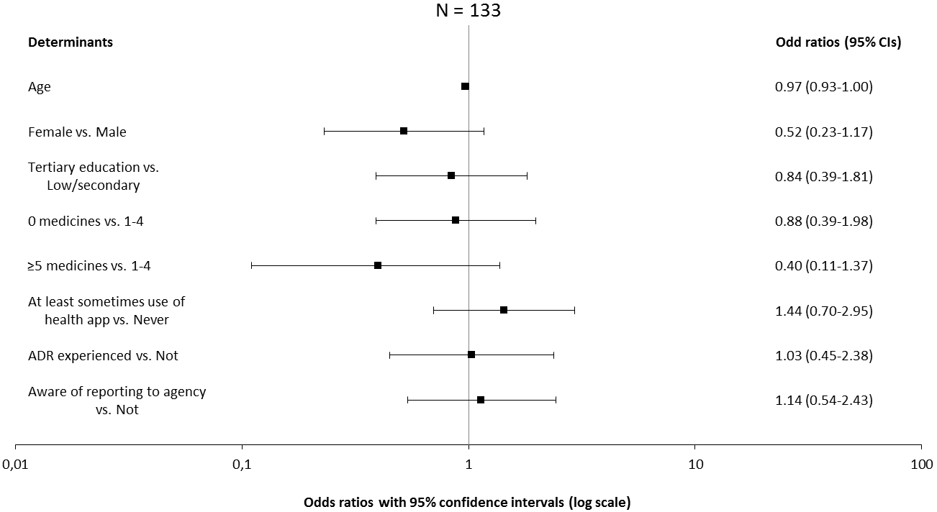
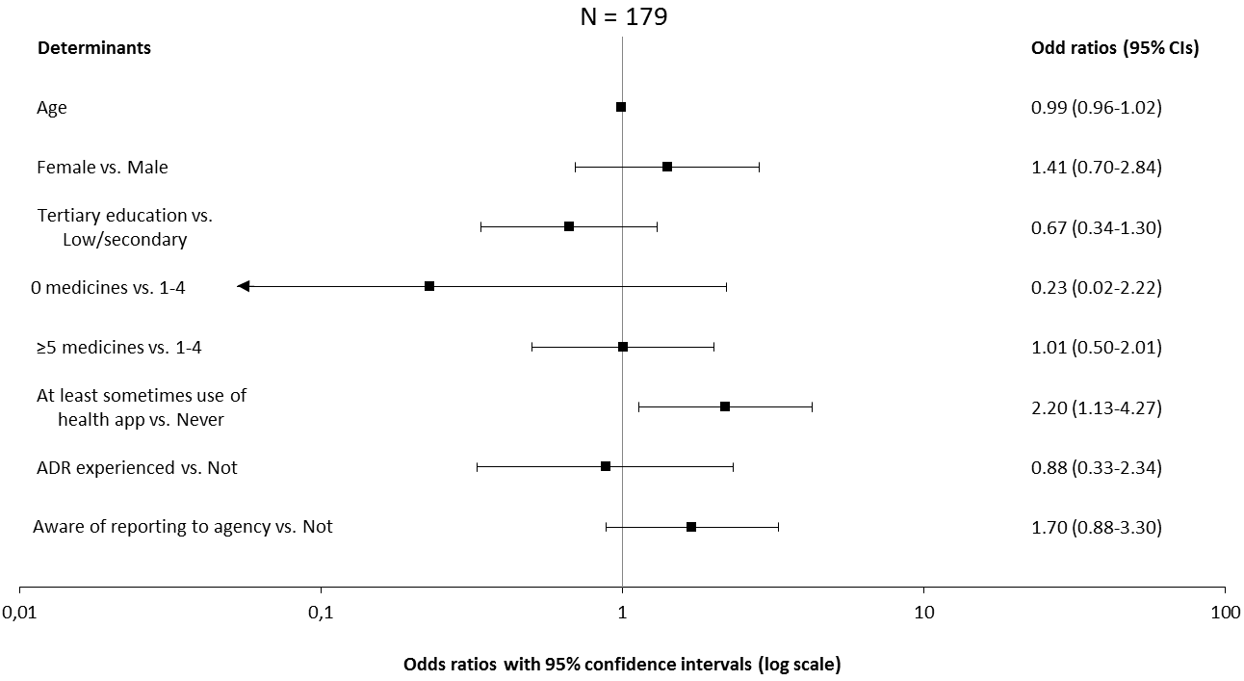

(a)
(b)
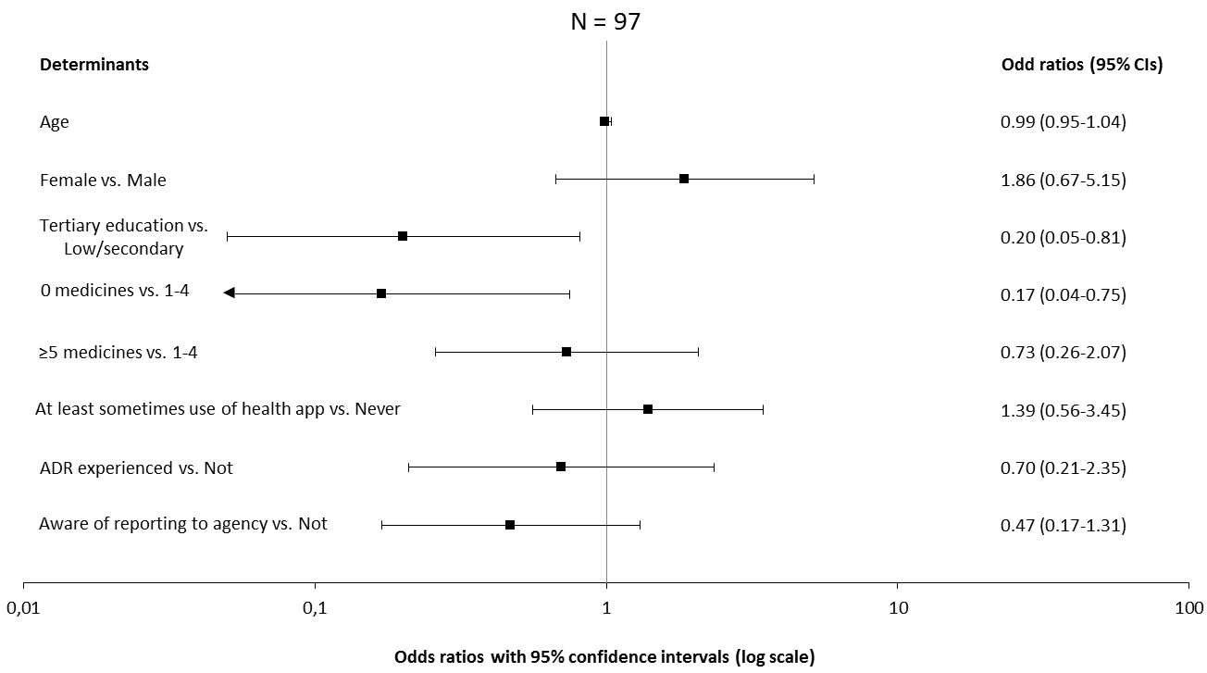

Electronic Supplementary Material 7. Results of the logistic regression analysis with the patient data per country: a. Croatia, b. the Netherlands, c. the UK
(c)

