Supplementary Electronic Materials
Article title: Anticoagulant Use and Bleeding Risk in Central European Patients with Idiopathic Pulmonary Fibrosis (IPF) Treated with Antifibrotic Therapy: Real-World Data from EMPIRE
Journal name: Drug Safety
Author names: Abigél M. Kolonics-Farkas, Martina Šterclová, Nesrin Mogulkoc, Jan Kus,
Marta Hájková, Veronika Müller, Dragana Jovanovic, Jasna Tekavec-Trkanjec, Simona Littnerová, Karel Hejduk, Martina Vašáková
Affiliation and e-mail address of the corresponding author: Department of Pulmonology, Semmelweis University, Budapest, Hungary; email: kolonics-farkas.abigel@med.semmelweis-univ.hu

Supplementary Fig. 1 Participant flow
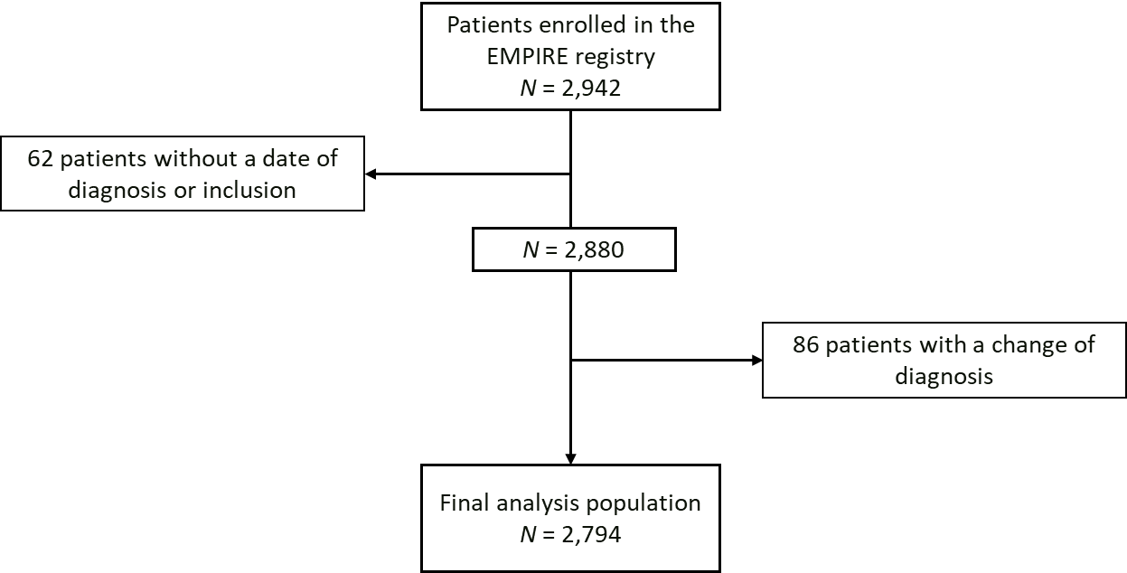
The final number of patients included in the analysis had (1) a known date of diagnosis and inclusion; (2) an unchanged IPF diagnosis.
EMPIRE European MultiPartner IPF Registry, IPF Idiopathic pulmonary fibrosis
Supplementary Table 1 Additional patient characteristics
 | Group A  (N = 1,828) | Group B  (N = 227) | Group C  (N = 659) | Group D  (N = 80)
Country, n (%)
CZ | 534 (29.2) | 111 (48.9) | 254 (38.5) | 34 (42.5)
TR | 438 (24.0) | 15 (6.6) | 60 (9.1) | 5 (6.3)
PL | 312 (17.1) | 32 (14.1) | 138 (20.9) | 14 (17.5)
HU | 163 (8.9) | 16 (7.0) | 57 (8.6) | 9 (11.3)
SK | 141 (7.7) | 17 (7.5) | 33 (5.0) | 0 (0.0)
IL | 82 (4.5) | 6 (2.6) | 52 (7.9) | 10 (12.5)
RS | 72 (3.9) | 11 (4.8) | 22 (3.3) | 2 (2.5)
HR | 49 (2.7) | 8 (3.5) | 23 (3.5) | 1 (1.3)
AT | 27 (1.5) | 10 (4.4) | 19 (2.9) | 3 (3.8)
BG | 10 (0.5) | 1 (0.4) | 1 (0.2) | 2 (2.5)
BMI, kg/m² (range) | 27.8  (21.5–35.8) | 28.7  (21.0–36.6) | 28.4  (22.3–35.8) | 28.4  (23.9–35.8)
Symptoms, n (%)
Dyspnea – NYHA
I | 160 (10.9) | 9 (4.8) | 39 (7.3) | 2 (3.0)
II | 733 (50.1) | 83 (44.4) | 275 (51.2) | 32 (47.8)
III | 537 (36.7) | 90 (48.1) | 202 (37.6) | 33 (49.3)
IV | 33 (2.3) | 5 (2.7) | 21 (3.9) | 0 (0.0)
Cough
Yes | 976 (66.5) | 138 (74.2) | 360 (67.5) | 51 (76.1)
Dry | 616 (64.4) | 83 (61.9) | 219 (62.2) | 29 (58.0)
Productive | 340 (35.6) | 51 (38.1) | 133 (37.8) | 21 (42.0)
Crackles | 1,646 (90.2) | 212 (93.4) | 628 (95.6) | 78 (97.5)
Finger clubbing | 669 (36.7) | 93 (41.0) | 240 (36.6) | 21 (26.3)
HRCT pattern, n (%)
UIP | 1,243 (68.2) | 176 (77.9) | 491 (74.5) | 59 (73.8)
Possible UIP | 515 (28.3) | 46 (20.4) | 151 (22.9) | 18 (22.5)
Inconsistent with UIP | 64 (3.5) | 4 (1.8) | 17 (2.6) | 3 (3.8)
Data are n (%) or median (5th–95th percentile).
AT Austria, BG Bulgaria, BMI body mass index, CZ Czech Republic, HR Croatia, HRCT high-resolution computed tomography, HU Hungary, IL Israel, NYHA New York Heart Association, PL Poland, RS Serbia, SK Slovakia, TR Turkey, UIP usual interstitial pneumonia
Supplementary Table 2 Additional lung function values according to treatment groups
 | Group A | Group B | Group C | Group D
FEV₁ (L) | 2.05  (1.07–3.32) | 2.07  (1.07–3.20) | 2.10  (1.17–3.24) | 2.17  (1.18–2.95)
FEV₁ (% predicted) | 85  (63–122) | 83  (63–111) | 86  (64–121) | 84  (65–117)
TLC (L) | 4.20  (2.07–6.57) | 4.27  (2.24–6.36) | 4.26  (2.29–6.49) | 4.37  (1.88–6.32)
TLC (% predicted) | 70  (38–105) | 68  (35–93) | 69  (42–99) | 68  (42–92)
KL_{CO}% | 79^{c}  (39–123) | 74  (37–115) | 75ª  (36–115) | 73  (43–120)
Data are mean (5th–95th percentile).
FEV₁ forced expiratory volume in 1 second, KL_{CO} diffusing capacity of the lungs for carbon monoxide corrected on lung volume, TLC total lung capacity

Participating investigators
Beata Zolnowska: 1st Department of Pulmonary Diseases, Institute of Tuberculosis and Lung Diseases, Warsaw, Poland; Vladimír Bartoš: Pulmonary Department, University Hospital and Medical Faculty of Charles University in Hradec Králové, Hradec Králové, Czech Republic; Martina Plačková: Department of Pneumology, Faculty Hospital Ostrava, Ostrava, Czech Republic; Ladislav Lacina: Clinic of Pneumology and Thoracic Surgery, Hospital Na Bulovce, Prague, Czech Republic; Robert Slivka: National Institute of Tuberculosis, Lung Disorders and Thoracic Surgery Vyšné Hágy, Vyšné Hágy, Slovakia; Martina Doubková: Department of Pneumology, Faculty of Medicine and University Hospital, Brno, Czech Republic; Radka Bittenglová: Department of Respiratory Diseases, Charles University in Pilsen, Pilsen, Czech Republic; Marina Roksandić Milenkovic: University Hospital of Pulmonology, Clinical Center of Serbia, Belgrade, Serbia; Magdalena Martusewicz-Boros: 3rd Department of Pulmonary Diseases, Institute of Tuberculosis and Lung Diseases, Warsaw, Poland; Imrich Jonner: National Institute of Tuberculosis, Lung Disorders and Thoracic Surgery, Vyšné Hágy, Slovakia; Monika Žurková: Department of Respiratory Medicine, Faculty of Medicine and Dentistry, Palacky University and University Hospital, Olomouc, Czech Republic; Małgorzata Sobiecka: 1st Department of Pulmonary Diseases, Institute of Tuberculosis and Lung Diseases, Warsaw, Poland; Ilona Binková: Department of Pneumology, Faculty of Medicine and University Hospital, Brno, Czech Republic; Marzena Trzaska-Sobczak: Department of Pneumology, Medical University of Silesia in Katowice, Katowice, Poland; Richard Tyl: Department of Respiratory Diseases, Hospital in Nový Jičín, Nový Jičín, Czech Republic; Amelia Szymanowska-Narloch: Department of Allergology and Pneumology, Medical University of Gdansk, Gdansk, Poland; Vladimíra Lošťáková: Department of Respiratory Medicine, Faculty of Medicine and Dentistry, Palacky University and University Hospital, Olomouc, Czech Republic; Pawel Sliwinski: 2nd Department of Pulmonary Diseases, Institute of Tuberculosis and Lung Diseases, Warsaw, Poland; Miklós Zsiray: Department of Pulmonology, National Korányi Tuberculosis and Pulmonology Institute, Budapest, Hungary; Hana Šuldová: Pulmonary Department, Hospital České Budějovice, České Budějovice, Czech Republic; Sebastian Majewski: Department of Pneumology and Allergy, Medical University of Lodz, Lodz, Poland; Pavlína Lisá: Department of Pneumology, 2nd Faculty of Medicine, Charles University in Prague and Motol University Hospital, Prague, Czech Republic; Katarzyna Lewandowska: 1st Department of Pulmonary Diseases, Institute of Tuberculosis and Lung Diseases, Warsaw, Poland; Ján Plutinský: Pneumology and Phthisiology Outpatient Centre, ZAPA JJ Ltd., Levice, Slovakia; Ana Jakić: Institute for Pulmonary Diseases of Vojvodina, Clinic for Tuberculosis and Granulomatous Diseases, Sremska Kamenica, Serbia; Bohumil Matula: Pneumology and Phthisiology, Specialized Hospital of St. Zoerardus Zobor, Nitra, Slovakia; Anikó Bohács: Department of Pulmonology, Semmelweis University, Budapest, Hungary; Štefan Tóth: Clinic of Pneumology and Phthisiology, L. Pasteur University Hospital Košice, Košice, Slovakia; František Petřík: Department of Pneumology, 2nd Faculty of Medicine, Charles University in Prague and Motol University Hospital, Prague, Czech Republic; Lenka Šišková: Department of Respiratory Diseases, Thomas Bata Regional Hospital Zlín, Zlín, Czech Republic; Jana Pšíkalová: Pneumology and Allergology Department, Kroměříž Hospital, Kroměříž, Czech Republic; Zoltán Balikó: Department of Pulmonology, Faculty of Medicine, University of Pecs, Pecs, Hungary; Zsuzsanna Szalai: Department of Pulmonology, Petz Aladár County Teaching Hospital, Gyor, Hungary; Jan Anton: Department of Respiratory Diseases of the First Faculty of Medicine Charles University, Thomayer Hospital, Prague, Czech Republic; Margita Bučeková: National Institute of Tuberculosis, Lung Disorders and Thoracic Surgery, Vyšné Hágy, Slovakia; Štefan Laššán: Clinic of Pneumology and Phthisiology, University Hospital Bratislava, Bratislava, Slovakia; Imre Lajkó: Department of Pulmonology, University of Szeged, Szeged, Hungary; Pavlína Musilová: Department of Respiratory Diseases, Hospital Jihlava, Jihlava, Czech Republic; Tomáš Snížek: Department of Respiratory Diseases, Hospital Jihlava, Jihlava, Czech Republic; Renata Králová: Department of Pulmonology, Regional Hospital Pardubice, Pardubice, Czech Republic; Peter Palúch: Department of Respiratory Diseases of the First Faculty of Medicine Charles University, Thomayer Hospital, Prague, Czech Republic; Daniel Doležal: Department of Pulmonary Diseases and Tuberculosis, Masaryk Hospital, Ústí nad Labem, Czech Republic; Vladimír Řihák: Department of Respiratory Diseases, Thomas Bata Regional Hospital Zlín, Zlín, Czech Republic; Aleksander Kania: Jagiellonian University, School of Medicine, Department of Pulmonology, Kraków, Poland; Violeta Vučinić-Mihailović: University Hospital of Pulmonology, Clinical Center of Serbia, Belgrade, Serbia; Pavel Reiterer: Department of Pulmonary Diseases and Tuberculosis, Masaryk Hospital, Ústí nad Labem, Czech Republic; Róbert Vyšehradský: Clinic of Pneumology and Phthisiology, University Hospital Martin, Martin, Slovakia; Peter Fabián: National Institute of Tuberculosis, Lung Disorders and Thoracic Surgery Vyšné Hágy, Vyšné Hágy, Slovakia; Elzbieta Wiatr: 3rd Department of Pulmonary Diseases, Institute of Tuberculosis and Lung Diseases, Warsaw, Poland.

