Title: Incidence rates of autoimmune diseases in European healthcare databases: a contribution of the ADVANCE project
Journal name: Drug Safety
Authors: Corinne Willame,ª Caitlin Dodd,ª Lieke van der Aa,^{b} Gino Picelli,^{c} Hanne- Dorthe Emborg,^{d} Johnny Kahlert,^{e} Rosa Gini,^{f} Consuelo Huerta,^{g} Elisa Martín-Merino,^{g} Chris McGee,^{h,i} Simon de Lusignan,^{h,i} Giuseppe Roberto,^{f} Marco Villa,^{j} Daniel Weibel,^{k,l} Lina Titievsky^{m}, Miriam CJM Sturkenboom ^{a,k,n}
Affiliations:
ª Julius Global Health, University Medical Center Utrecht, Heidelberglaan 100, The Netherlands
^{b} Sciensano, Rue Juliette Wytsmanstraat 14, 1050 Brussels, Belgium
^{c} Epidemiological Information for Clinical Research from an Italian Network of Family Paediatricians (PEDIANET), Padova, Italy
^{d} Department of Infectious Disease Epidemiology and Prevention, Statens Serum Institut, Artillerivej 5, DK-2300, Denmark
^{e} Aarhus University Hospital, Olof Palmes Alle 43-45, DK-8200 Aarhus, Denmark
^{f} Agenzia regionale di sanità della Toscana, Osservatorio di epidemiologia, Florence, Italy
^{g} Spanish Agency of Medicines and Medical Devices, Madrid, Spain
^{h} University of Surrey, Guildford, Surrey GU2 7XH, UK
^{i} Royal College of General Practitioners, Research and Surveillance Centre, 30 Euston Square, London NW1 2FB, UK
^{j} Ospedale Val Padana, Cremona, Italy
^{k} VACCINE.GRID, Basel, Switzerland VACCINE.GRID, Spitalstrasse 33, Basel, Switzerland
^{l} Erasmus University Medical Center, PO box 2014, 3000 CA Rotterdam, The Netherlands
^{m} Pfizer, 219 East 42nd St, NY, NY 10017, USA
^{n} P-95, Leuven, Belgium Koning Leopold III laan 1 3001 Heverlee Belgium

Corresponding author:

Corinne Willame, University Medical Center Utrecht, Heidelberglaan 100, The Netherlands (c.willame@umcutrecht.nl) ORCID number: orcid.org/0000-0002-6310-6019
Detailed descriptions of the characterisation of the seven European electronic healthcare databases analysed
Denmark
Aarhus University Hospital (AUH) holds a record linkage database that links clinical and prescription data for the 1.8 million inhabitants of the Central Denmark and North Denmark Regions (formerly North-Jutland, Aarhus, Ringkjoebing and Viborg counties). These data are linked to the national registry of information on admissions to Danish somatic hospitals, emergency rooms and outpatient clinics, diagnosis codes and procedures, as well as national vaccination, hospital treatments, prescription and reimbursement registries. This data source has been used for numerous pharmaco-epidemiological studies, but not many vaccine-related studies. AUH has vaccination data available from 2003.
The Staten Serum Institute (SSI) has a direct access to the Danish Civil and Health Registration System database via an ad hoc linkage between the Danish Civil Registration system, the Danish Vaccination registry, the Danish National Patient registry plus other relevant databases (e.g., disease surveillance, medications, microbiology). The national data have been used for many vaccine studies, including recently safety studies for measles, mumps, rubella (MMR), human papillomavirus (HPV) and childhood vaccination [1-3]. Various studies on the Danish national patient registry reported that the positive predictive values i.e., the proportion of patients registered with a disease who truly had the disease, varied between specialities from 66% to 83% [4]. A study on tetanus, diphtheria, pertussis and polio (Tdap-IPV) booster vaccination in the 2000 to 2003 birth cohort identified substantial underreporting of the Tdap-IPV booster in the childhood vaccination database, mainly due to GPs failing to register vaccinations given [5]. This led to several interventions to improve registration of vaccinations, including the compulsory registration of vaccinations since 2015.
The AUH population is included in the population accessible to SSI and uses the same national patient registry. Danish registries are listed and described in the ENCePP data catalogue: http://www.encepp.eu/encepp/viewResource.htm?id=25067.
Spain
The BIFAP (Base de Datos para la Investigación Farmacoepidemiológica en Atencion Primaria) database is a computerised database of primary care medical records operated by the Spanish Medicines Agency (AEMPS) covering data from nine regions in Spain, which are sent annually [6]. Vaccines administered by the paediatrician or GP are recorded using local codes. The database has been recently been used for HPV vaccine-related studies [7, 8].
Italy
The ATS (Local Health Agency in Val Padana) is responsible for the health of the citizens living in the Cremona and Mantova provinces and for the governance and control of all health-related services (prevention, treatment, residential care, etc.). ATSVP is a record linkage database that contains data for mortality (with cause of death), hospitalisations (with diagnosis), drug prescriptions and legally notifiable infectious diseases for this population. It also contains vaccination data, including information on brand and dose for routine childhood vaccines, notified to the ATS. The database was used for 2009 H1N1 pandemic safety studies [9].
PEDIANET is a paediatric primary care medical record database based on transmission of specific data (determined by individual studies) from the patient computerised clinical files of the paediatricians in the network [10]. PEDIANET can link to other databases such as the Veneto Regional vaccine register using unique patient identifiers. In this vaccine register information on routine childhood vaccination are captured including brand and dose. Informed consent has to be obtained from the parents before data can be used in studies. For ADVANCE PEDIANET contributed data on children born in 2006 and 2007 that had been linked to the Veneto vaccine register for a previous vaccine-related study [11].
The Agenzia regionale di sanità (ARS) database is a record linkage database that contains a copy of the healthcare administrative databases of the Tuscany Regional Healthcare System, linked to other healthcare registries [12]. It contains mortality and hospitalisation data for the Tuscany region population since 2003 and on emergency healthcare use since 2009. Information on vaccines administered by the personnel of the Regional Healthcare System, including brand, batch number and dose, are available since 2013 and information on vaccinations administered by family paediatricians are available since 2018. Although several pharmaco-epidemiological studies have been conducted with the ARS database, prior to ADVANCE there had been no vaccine-related studies [13, 14]. ARS did not participate in the earlier activities of ADVANCE as they joined as a full partner in June 2017. There is no overlap between the populations in the ATSVP, ARS and PEDIANET databases.
United Kingdom
The Health Improvement Network (THIN) database is a collaboration between In Practice Systems, who developed Vision software used by GPs to manage patient data in the UK and IMS Health, who provide access to these data for use in medical research [15]. The GPs data are collected during routine practice and regularly transferred to the THIN database. The ADVANCE project had access to the THIN database via a license held by a partner, Erasmus Medical Centre. Many pharmaco-epidemiological studies, including vaccine-related studies, have been conducted using the THIN database [16, 17].
The Royal College of General Practitioners Research and Surveillance Centre (RCGP RSC) is a primary care sentinel network, was set up to monitor influenza and respiratory disease surveillance in 1967 [18]. Computer recording of diagnostic data in the 1990’s facilitated expansion of the database’s analytical possibilities to include trend analysis of secular change in the incidence of common diseases and chronic conditions. In 2015 the database was extended to collect all Read-coded data on an individual patient basis ion from 107 GP practices throughout the UK. The RCGP RSC database has been used for several vaccine effectiveness studies [19-22].

Table S1 Code lists for the 9 autoimmune diseases
Autoimmune diseases | Concept Unique Identifier | Concept name | ICD-9 | ICD-10 | ICPC | READ
ADEM | C0011302 | Demyelinating disease of central nervous system | 341.9 | G35-G37.9  G37.9 | - | Fyu4.  X005b
ADEM | C0014038 | Encephalitis | - | - | - | XE15D  F03z.
ADEM | C0014058 | Encephalitis, myelitis and encephalomyelitis | 323 | G04  G04.9 | - | XE15B  F03..
ADEM | C0014070 | Encephalomyelitis | - | - | - | X001X  Xa3f9  XaEI5  F03..  F03y.
ADEM | C0270626 | Acute ascending myelitis | - | G04 | - | -
ADEM | C0477368 | Acute disseminated demyelination, unspecified | - | G36.9 | - | Fyu42
ADEM | C1719353 | Encephalitis and encephalomyelitis following immunization procedures | 323.51 | - | - | -
ADEM | C1719359 | Acute necrotizing hemorrhagic encephalopathy | - | G04.3 | - | -
ADEM | C1719360 | Other postinfectious encephalitis and encephalomyelitis | 323.62 | - | - | -
ADEM | C1719364 | Toxic encephalitis, myelitis, and encephalomyelitis | 323.7 | - | - | -
ADEM | C1719365 | Other causes of encephalitis and encephalomyelitis | 323.81 | - | - | -
ADEM | C1719367 | Other causes of myelitis | 323.82 | - | - | -
ADEM | C1719369 | Unspecified cause of encephalitis, myelitis, and encephalomyelitis | 323.9 | - | - | -
ADEM | C1719722 | Infectious acute disseminated encephalomyelitis (ADEM) | 323.61 | - | - | -
ADEM | C2316057 | Inflammation of spinal cord due to toxin | 323.72 | - | - | -
Bell's palsy | C0376175 | Bell Palsy | 351.0 | G51.0 | N91  N91001 | F310.
GBS | C0018378 | Guillain-Barre Syndrome | 357.0 | G61.0 | N94005 | F3701  F370z  F3700  F370.
ITP narrow | C0272282 | Thrombocytopenia, cyclic | - | D69.3 | - | -
ITP narrow | C0398650 | Immune thrombocytopenic purpura | 287.31 | D69.3 | B83006 | D3130
ITP broad | C0040034 | Thrombocytopenia | 287.5 | D69.6 | B83012 | 42P2.  D315.
ITP broad | C0154301 | Acquired thrombocytopenia | 287.4 | D69.5 | - | D314z  D314.
ITP broad | C0272282 | Thrombocytopenia, cyclic | - | D69.3 | - | -
ITP broad | C0398648 | Posttransfusion purpura | 287.41 | D69.51 | - | -
ITP broad | C0398650 | Immune thrombocytopenic purpura | 287.31 | D69.3 | B83006 | D3130
ITP broad | C0477317 | Other primary thrombocytopenia | 287.39 | D69.4 | - | Dyu32
ITP broad | C0701157 | Primary thrombocytopenia | 287.3 | D69.49 | - | D313.  D313z
ITP broad | C2873806 | Hemorrhagic (thrombocytopenic) purpura | - | D69.3 | - | -
ITP broad | C2921024 | Posttransfusion purpura from whole blood (fresh) or blood products | - | D69.51 | - | -
ITP broad | C2921026 | Other secondary thrombocytopenia | 287.49 | D69.59 | - | -
Kawasaki disease | C0026691 | Mucocutaneous Lymph Node Syndrome | 446.1 | M30.3 | B99022 | G7510  G751z
Narcolepsy | C0007384 | Cataplexy | - | - | - | F270.
Narcolepsy | C0027404 | Narcolepsy | 347.0 | G47.41  G47.419 | N99013 | F271.
Narcolepsy | C0751362 | Narcolepsy-Cataplexy Syndrome | 347  347.01 | G47.4  G47.411 | - | F27z.  F27..
Optic neuritis | C0029134 | Optic Neuritis | 377.3  377.30 | H46  H46.9 | F99011 | F4H3z  F4H3.  F4H30
SLE | C0024138 | Lupus Erythematosus, Discoid | - | L93.0 | L99034  S99034 | M1541
SLE | C0024141 | Lupus Erythematosus, Systemic | 710.0 | M32  M32.9 | L99065 | N000.  N000z
SLE | C0155180 | Discoid lupus erythematosus of eyelid | 373.34 | H01.12 | - | F4D33
SLE | C0409974 | Lupus Erythematosus | 695.4 | L93  L93.0 | L99056 | M154.  M154z
Transverse myelitis | C1719356 | Myelitis following immunization procedures | 323.52 | - | - | -
Transverse myelitis | C0270627 | Myelitis, Acute Transverse | 341.2  341.20 | G37.3 | - | -
Transverse myelitis | C0494470 | Acute transverse myelitis in demyelinating disease of central nervous system | - | G37.3 | - | -
Transverse myelitis | C0026975 | Myelitis | - | - | N99012 | F03..
Transverse myelitis | C0026976 | Myelitis, Transverse | - | - | - | F037.
ADEM: Acute disseminated encephalomyelitis, GBS: Guillain Barré syndrome, ITP: Immune Thrombocytopenia Purpura, SLE: Systemic Lupus Erythematosus

Table S2 Age and sex specific incidence rates (/100,000 PY) for each autoimmune disease per databases over the period 2003-2014
 |  | Italy |  |  |  |  |  | Denmark
 |  | ARS |  | Val Padana |  | Pedianet |  | AUH
 |  | IR (95%CI) |  | IR (95%CI) |  | IR (95%CI) |  | IR (95%CI)
Health Outcome | Age  Groups | Female | Male | Female | Male | Female | Male | Female | Male
Acute disseminated  encephalomyelitis | Overall | 16.3 (15.77-16.86) | 10.4 (9.91-10.81) | 16.0 (14.35-17.85) | 10.7 (9.35-12.31) | 1.6 (0.51-4.95) | 1.5 (0.48-4.57) | 5.8 (5.55-6.04) | 5.0 (4.73-5.19)
Acute disseminated  encephalomyelitis | 0-1y | 6.7 (4.48-10.14) | 6.9 (4.67-10.23) | 3.0 (0.42-21.36) | 0.0 | 2.6 (0.36-18.19) | 0.0 | 4.3 (3.06-5.99) | 4.7 (3.41-6.38)
Acute disseminated  encephalomyelitis | 2-4y | 6.2 (4.38-8.85) | 5.5 (3.82-7.91) | 2.0 (0.28-14.27) | 7.4 (2.78-19.72) | 0.0 | 1.9 (0.26-13.18) | 3.0 (2.20-4.20) | 4.5 (3.44-5.78)
Acute disseminated  encephalomyelitis | 5-14y | 3.7 (2.91-4.79) | 4.7 (3.75-5.78) | 0.6 (0.08-4.07) | 4.9 (2.54-9.39) | 2.0 (0.50-8.05) | 1.9 (0.47-7.44) | 1.9 (1.55-2.36) | 2.2 (1.78-2.63)
Acute disseminated  encephalomyelitis | 15-24y | 16.3 (14.46-18.30) | 8.1 (6.91-9.56) | 12.3 (7.92-19.04) | 8.1 (4.79-13.67) | - | - | 3.0 (2.54-3.48) | 2.1 (1.72-2.50)
Acute disseminated  encephalomyelitis | 25-44y | 26.3 (24.99-27.62) | 14.0 (13.10-15.04) | 29.4 (25.10-34.46) | 16.6 (13.47-20.41) | - | - | 8.1 (7.59-8.75) | 5.2 (4.81-5.71)
Acute disseminated  encephalomyelitis | 45-64y | 18.6 (17.53-19.74) | 11.1 (10.24-12.00) | 18.0 (14.74-21.90) | 10.9 (8.46-14.03) | - | - | 7.7 (7.10-8.25) | 6.5 (5.98-7.03)
Acute disseminated  encephalomyelitis | 65y+ | 8.7 (7.96-9.52) | 8.4 (7.58-9.40) | 9.2 (6.96-12.19) | 7.7 (5.29-11.09) | - | - | 5.4 (4.86-6.03) | 7.5 (6.79-8.35)
Acute disseminated  encephalomyelitis | Overall | 16.3 (15.77-16.86) | 10.4 (9.91-10.81) | 16.0 (14.35-17.85) | 10.7 (9.35-12.31) | 1.6 (0.51-4.95) | 1.5 (0.48-4.57) | 5.8 (5.55-6.04) | 5.0 (4.73-5.19)
Bells palsy | 0-1y | 5.6 (3.55-8.72) | 3.9 (2.29-6.53) | 6.0 (1.51-24.06) | 5.5 (1.37-21.88) | 2.6 (0.36-18.19) | 4.8 (1.19-19.03) | 7.9 (6.19-10.15) | 8.3 (6.52-10.45)
Bells palsy | 2-4y | 5.4 (3.72-7.90) | 5.5 (3.82-7.91) | 8.0 (3.02-21.43) | 0.0 | 2.0 (0.28-14.29) | 5.6 (1.80-17.28) | 7.3 (5.94-9.00) | 8.9 (7.42-10.72)
Bells palsy | 5-14y | 6.7 (5.61-8.12) | 6.2 (5.13-7.47) | 7.5 (4.33-12.85) | 5.4 (2.92-10.09) | 9.1 (4.71-17.41) | 7.4 (3.72-14.88) | 11.1 (10.15-12.09) | 9.8 (8.97-10.77)
Bells palsy | 15-24y | 3.4 (2.59-4.35) | 3.1 (2.37-4.02) | 1.2 (0.31-4.91) | 1.7 (0.56-5.38) | - | - | 11.8 (10.89-12.77) | 12.6 (11.70-13.62)
Bells palsy | 25-44y | 4.2 (3.74-4.79) | 5.5 (4.93-6.15) | 2.0 (1.11-3.63) | 3.6 (2.34-5.62) | - | - | 21.6 (20.65-22.53) | 21.6 (20.74-22.58)
Bells palsy | 45-64y | 5.7 (5.07-6.30) | 8.2 (7.45-8.96) | 2.0 (1.11-3.63) | 3.6 (2.34-5.62) | - | - | 22.3 (21.39-23.35) | 26.2 (25.21-27.32)
Bells palsy | 65y+ | 9.6 (8.79-10.42) | 11.7 (10.68-12.83) | 3.8 (2.43-5.83) | 5.7 (3.74-8.81) | - | - | 25.8 (24.55-27.11) | 29.6 (28.05-31.13)
Bells palsy | Overall | 6.2 (5.85-6.52) | 7.3 (6.93-7.69) | 3.0 (2.35-3.88) | 3.6 (2.87-4.59) | 5.8 (3.24-10.56) | 6.4 (3.71-11.01) | 19.0 (18.53-19.43) | 20.2 (19.77-20.70)
Guillain-Barré  syndrome | 0-1y | 0.9 (0.28-2.72) | 1.1 (0.41-2.95) | 0.0 | 0.0 | 0.0 | 0.0 | 0.3 (0.06-1.01) | 0.5 (0.18-1.27)
Guillain-Barré  syndrome | 2-4y | 1.8 (0.94-3.47) | 1.5 (0.76-3.03) | 0.0 | 0.0 | 4.0 (1.01-16.10) | 0.0 | 0.7 (0.38-1.42) | 1.3 (0.77-2.04)
Guillain-Barré  syndrome | 5-14y | 0.8 (0.50-1.42) | 1.0 (0.60-1.55) | 2.3 (0.86-6.11) | 0.0 | 0.0 | 0.0 | 0.6 (0.41-0.87) | 0.7 (0.52-1.02)
Guillain-Barré  syndrome | 15-24y | 1.6 (1.09-2.32) | 1.4 (0.95-2.07) | 0.0 | 2.3 (0.87-6.16) | - | - | 1.1 (0.82-1.39) | 1.3 (1.02-1.64)
Guillain-Barré  syndrome | 25-44y | 1.4 (1.13-1.74) | 2.0 (1.64-2.36) | 1.0 (0.40-2.31) | 2.6 (1.54-4.40) | - | - | 1.8 (1.55-2.09) | 2.2 (1.96-2.55)
Guillain-Barré  syndrome | 45-64y | 2.3 (1.91-2.68) | 4.0 (3.48-4.54) | 2.4 (1.38-4.10) | 3.3 (2.06-5.18) | - | - | 2.8 (2.47-3.16) | 4.0 (3.57-4.39)
Guillain-Barré  syndrome | 65y+ | 3.7 (3.22-4.23) | 5.8 (5.06-6.56) | 2.8 (1.70-4.68) | 9.8 (7.10-13.65) | - | - | 3.5 (3.06-4.01) | 5.9 (5.26-6.64)
Guillain-Barré  syndrome | Overall | 2.2 (2.01-2.41) | 3.1 (2.88-3.37) | 1.8 (1.33-2.53) | 3.8 (3.00-4.77) | 1.1 (0.27-4.25) | 0.0 | 2.0 (1.86-2.16) | 2.8 (2.59-2.93)
ITP (broad) | 0-1y | 25.8 (20.92-31.77) | 27.1 (22.23-33.03) | 15.0 (6.26-36.15) | 30.1 (16.67-54.37) | 2.6 (0.36-18.19) | 2.4 (0.34-16.89) | 17.1 (14.47-20.25) | 27.2 (23.84-30.92)
ITP (broad) | 2-4y | 25.9 (21.80-30.79) | 26.4 (22.32-31.12) | 34.2 (21.26-55.01) | 22.2 (12.62-39.13) | 2.0 (0.28-14.29) | 1.9 (0.26-13.18) | 13.6 (11.64-15.80) | 16.2 (14.14-18.57)
ITP (broad) | 5-14y | 10.4 (8.99-12.11) | 10.7 (9.31-12.39) | 6.9 (3.91-12.13) | 6.5 (3.70-11.47) | 4.0 (1.51-10.72) | 2.8 (0.90-8.65) | 5.0 (4.40-5.71) | 5.6 (4.95-6.31)
ITP (broad) | 15-24y | 9.2 (7.86-10.76) | 8.1 (6.91-9.57) | 3.7 (1.65-8.20) | 2.9 (1.20-6.95) | - | - | 6.0 (5.33-6.67) | 4.0 (3.54-4.63)
ITP (broad) | 25-44y | 11.2 (10.34-12.06) | 7.8 (7.12-8.56) | 8.6 (6.45-11.57) | 4.5 (2.99-6.66) | - | - | 10.4 (9.77-11.07) | 5.5 (5.02-5.94)
ITP (broad) | 45-64y | 16.6 (15.61-17.71) | 23.4 (22.14-24.69) | 12.6 (9.97-15.99) | 10.7 (8.29-13.82) | - | - | 14.6 (13.84-15.43) | 17.3 (16.42-18.13)
ITP (broad) | 65y+ | 38.0 (36.41-39.66) | 61.0 (58.56-63.45) | 18.4 (15.12-22.46) | 27.1 (22.24-32.98) | - | - | 28.6 (27.29-29.98) | 44.7 (42.87-46.65)
ITP (broad) | Overall | 20.0 (19.38-20.58) | 23.9 (23.24-24.60) | 12.5 (11.03-14.12) | 11.7 (10.24-13.32) | 3.2 (1.43-7.10) | 2.5 (1.02-5.91) | 13.4 (13.07-13.83) | 14.4 (14.03-14.82)
ITP (narrow) | 0-1y | 6.2 (4.01-9.43) | 5.5 (3.57-8.57) | 3.0 (0.42-21.36) | 5.5 (1.37-21.89) | 0.0 | 2.4 (0.34-16.89) | 10.1 (8.09-12.53) | 17.0 (14.41-20.02)
ITP (narrow) | 2-4y | 9.6 (7.26-12.79) | 6.6 (4.76-9.24) | 12.1 (5.42-26.85) | 3.7 (0.93-14.80) | 0.0 | 1.9 (0.26-13.18) | 11.1 (9.37-13.13) | 12.1 (10.29-14.11)
ITP (narrow) | 5-14y | 3.3 (2.54-4.32) | 3.1 (2.35-4.00) | 0.6 (0.08-4.07) | 2.7 (1.13-6.52) | 3.0 (0.97-9.36) | 1.9 (0.47-7.44) | 3.7 (3.15-4.27) | 3.6 (3.05-4.14)
ITP (narrow) | 15-24y | 1.3 (0.85-1.97) | 1.3 (0.90-2.01) | 0.0 | 1.2 (0.29-4.62) | - | - | 3.4 (2.89-3.90) | 1.8 (1.48-2.21)
ITP (narrow) | 25-44y | 1.1 (0.87-1.42) | 0.9 (0.65-1.14) | 0.6 (0.19-1.78) | 0.4 (0.09-1.49) | - | - | 4.4 (3.98-4.83) | 2.3 (1.98-2.57)
ITP (narrow) | 45-64y | 1.7 (1.41-2.08) | 1.4 (1.12-1.75) | 0.9 (0.38-2.20) | 1.3 (0.61-2.66) | - | - | 4.9 (4.46-5.39) | 4.6 (4.16-5.04)
ITP (narrow) | 65y+ | 2.8 (2.38-3.27) | 3.7 (3.16-4.37) | 3.2 (1.99-5.14) | 2.7 (1.47-5.08) | - | - | 9.4 (8.62-10.17) | 12.6 (11.59-13.60)
ITP (narrow) | Overall | 2.2 (1.99-2.38) | 2.1 (1.87-2.28) | 1.6 (1.16-2.30) | 1.6 (1.10-2.26) | 1.6 (0.51-4.95) | 2.0 (0.74-5.24) | 5.5 (5.23-5.71) | 5.0 (4.80-5.26)
Kawasaki | 0-1y | 23.4 (18.82-29.17) | 32.9 (27.49-39.38) | 0.0 | 16.4 (7.38-36.55) | 15.4 (6.91-34.21) | 28.6 (16.22-50.29) | 4.9 (3.59-6.72) | 9.6 (7.68-11.91)
Kawasaki | 2-4y | 12.5 (9.71-15.97) | 15.0 (12.01-18.67) | 4.0 (1.01-16.08) | 1.9 (0.26-13.14) | 14. (6.72-29.58) | 5.6 (1.80-17.28) | 5.1 (3.97-6.53) | 6.7 (5.45-8.31)
Kawasaki | 5-14y | 1.4 (0.92-2.09) | 2.6 (1.96-3.49) | 0.0 | 1.6 (0.52-5.05) | 1.0 (0.14-7.15) | 0.9 (0.13-6.60) | 0.9 (0.68-1.25) | 1.4 (1.13-1.82)
Kawasaki | 15-24y | 0.1 (0.01-0.42) | 0.2 (0.08-0.60) | 0.0 | 0.0 | - | - | 0.1 (0.03-0.21) | 0.1 (0.03-0.20)
Kawasaki | 25-44y | 0.0 | 0.1 (0.02-0.16) | 0.0 | 0.0 | - | - | 0.0 (0.00-0.07) | 0.1 (0.04+0.16)
Kawasaki | 45-64y | 0.0 | 0.0 | 0.0 | 0.0 | - | - | 0.1 (0.04-0.16) | 0.1 (0.04-0.16)
Kawasaki | 65y+ | 0.0 | 0.0 | 0.0 | 0.0 | - | - | 0.0 (0.01-0.13) | 0.1 (0.02-0.19)
Kawasaki | Overall | 0.8 (0.67-0.91) | 1.3 (1.13-1.45) | 0.1 (0.02-0.40) | 0.5 (0.28-0.98) | 7.4 (4.41-12.57) | 7.9 (4.82-12.84) | 0.4 (0.37-0.51) | 0.7 (0.63-0.80)
Narcolepsy | 0-1y | 0.0 | 0.0 | 0.0 | 0.0 | 0.0 | 0.0 | 0.0 | 0.0
Narcolepsy | 2-4y | 0.2 (0.03-1.42) | 0.2 (0.03-1.34) | 0.0 | 0.0 | 0.0 | 1.9 (0.26-13.18) | 0.2 (0.08-0.76) | 0.7 (0.37-1.35)
Narcolepsy | 5-14y | 0.4 (0.20-0.88) | 0.3 (0.15-0.76) | 0.6 (0.08-4.07) | 1.1 (0.27-4.34) | 0.0 | 0.9 (0.13-6.60) | 0.7 (0.53-1.05) | 0.8 (0.61-1.14)
Narcolepsy | 15-24y | 0.4 (0.16-0.79) | 0.5 (0.26-0.97) | 0.6 (0.09-4.36) | 0.0 | - | - | 3.7 (3.18-4.23) | 2.5 (2.15-3.01)
Narcolepsy | 25-44y | 0.2 (0.13-0.38) | 0.3 (0.21-0.51) | 0.0 | 0.0 | - | - | 2.9 (2.60-3.29) | 2.1 (1.83-2.40)
Narcolepsy | 45-64y | 0.3 (0.21-0.51) | 0.3 (0.21-0.52) | 0.2 (0.03-1.30) | 0.2 (0.03-1.29) | - | - | 1.5 (1.25-1.76) | 1.6 (1.38-1.91)
Narcolepsy | 65y+ | 0.3 (0.18-0.47) | 0.7 (0.51-1.06) | 0.0 | 0.3 (0.04-1.94) | - | - | 1.7 (1.40-2.05) | 1.2 (0.95-1.58)
Narcolepsy | Overall | 0.3 (0.23-0.37) | 0.4 (0.34-0.52) | 0.1 (0.05-0.46) | 0.2 (0.08-0.56) | 0.0 | 1.0 (0.25-3.93) | 2.0 (1.90-2.19) | 1.7 (1.53-1.80)
Optic neuritis | 0-1y | 0.3 (0.04-2.08) | 0.0 | 0.0 | 0.0 | 0.0 | 0.0 | 0.0 | 0.0
Optic neuritis | 2-4y | 0.2 (0.03-1.42) | 0.2 (0.03-1.34) | 0.0 | 0.0 | 0.0 | 0.0 | 0.2 (0.04-0.66) | 0.2 (0.08-0.73)
Optic neuritis | 5-14y | 1.8 (1.26-2.58) | 1.5 (1.00-2.17) | 1.1 (0.29-4.59) | 0.0 | 0.0 | 0.0 | 0.9 (0.70-1.27) | 0.6 (0.45-0.92)
Optic neuritis | 15-24y | 4.8 (3.84-5.93) | 1.6 (1.13-2.34) | 3.1 (1.28-7.37) | 0.0 | - | - | 5.6 (4.96-6.26) | 2.1 (1.77-2.56)
Optic neuritis | 25-44y | 4.6 (4.08-5.18) | 2.7 (2.30-3.15) | 5.0 (3.40-7.33) | 2.2 (1.27-3.93) | - | - | 10.7 (10.02-11.34) | 4.6 (4.22-5.06)
Optic neuritis | 45-64y | 2.7 (2.28-3.31) | 2.4 (2.00-2.82) | 1.1 (0.49-2.44) | 1.1 (0.49-2.42) | - | - | 5.7 (5.18-6.17) | 3.6 (3.20-3.98)
Optic neuritis | 65y+ | 1.8 (1.45-2.15) | 1.8 (1.41-2.26) | 1.7 (5.19-5.67) | 1.6 (0.74-3.65) | - | - | 1.9 (1.62-2.32) | 2.0 (1.61-2.41)
Optic neuritis | Overall | 3.0 (2.74-3.20) | 2.1 (1.91-2.31) | 2.4 (1.79-3.15) | 1.3 (0.85-1.88) | 0.0 | 0.0 | 5.4 (5.19-5.67) | 2.8 (2.68-3.03)
Systemic lupus  erythematosus | 0-1y | 0.9 (0.28-2.72) | 1.1 (0.41-2.95) | 0.0 | 0.0 | 0.0 | 2.4 (0.34-16.89) | 0.8 (0.34-1.68) | 1.1 (0.56-2.07)
Systemic lupus  erythematosus | 2-4y | 0.4 (0.10-1.60) | 0.4 (0.09-1.51) | 2.0 (0.28-14.27) | 0.0 | 0.0 | 0.0 | 0.0 | 0.2 (0.04-0.63)
Systemic lupus  erythematosus | 5-14y | 1.3 (0.82-1.94) | 0.5 (0.27-0.98) | 1.7 (0.55-5.34) | 0.5 (0.08-3.85) | 0.0 | 0.9 (0.13-6.60) | 1.1 (0.83-1.45) | 0.5 (0.34-0.77)
Systemic lupus  erythematosus | 15-24y | 4.4 (3.52-5.54) | 0.7 (0.38-1.18) | 2.5 (0.92-6.54) | 0.0 | - | - | 4.6 (4.03-5.21) | 0.5 (0.35-0.75)
Systemic lupus  erythematosus | 25-44y | 7.0 (6.37-7.73) | 1.4 (1.14-1.76) | 8.8 (6.62-11.79) | 1.1 (0.50-2.49) | - | - | 10.1 (9.52-10.80) | 1.6 (1.35-1.84)
Systemic lupus  erythematosus | 45-64y | 6.1 (5.53-6.81) | 2.2 (1.80-2.58) | 7.5 (5.52-10.19) | 1.6 (0.85-3.14) | - | - | 11.6 (10.95-12.37) | 3.0 (2.68-3.40)
Systemic lupus  erythematosus | 65y+ | 4.6 (4.05-5.17) | 2.2 (1.82-2.76) | 6.4 (4.57-8.95) | 1.6 (0.74-3.65) | - | - | 9.4 (8.66-10.21) | 3.7 (3.17-4.25)
Systemic lupus  erythematosus | Overall | 5.2 (4.94-5.56) | 1.6 (1.44-1.79) | 6.4 (5.38-7.59) | 1.2 (0.76-1.76) | 0.0 | 1.0 (0.25-3.93) | 7.9 (7.62-8.20) | 1.9 (1.73-2.01)
Transverse myelitis | 0-1y | 0.0 | 0.0 | 0.0 | 0.0 | 0.0 | 0.0 | 0.0 | 0.1 (0.02-0.85)
Transverse myelitis | 2-4y | 0.0 | 0.0 | 2.0 (0.28-14.27) | 1.9 (0.26-13.14) | 0.0 | 0.0 | 0.0 | 0.5 (0.21-1.04)
Transverse myelitis | 5-14y | 0.1 (0.01-0.43) | 0.1 (0.01-0.40) | 0.0 | 0.0 | 0.0 | 0.0 | 0.2 (0.07-0.32) | 0.3 (0.18-0.51)
Transverse myelitis | 15-24y | 0.4 (0.20-0.86) | 0.1 (0.03-0.45) | 0.6 (0.09-4.36) | 0.0 | - | - | 0.8 (0.62-1.13) | 0.3 (0.17-0.47)
Transverse myelitis | 25-44y | 0.4 (0.26-0.59) | 0.3 (0.21-0.51) | 0.0 | 0.0 | - | - | 1.5 (1.30-1.80) | 1.1 (0.88-1.29)
Transverse myelitis | 45-64y | 0.5 (0.39-0.77) | 0.4 (0.25-0.58) | 0.5 (0.18-1.70) | 0.4 (0.09-1.45) | - | - | 1.4 (1.19-1.68) | 1.3 (1.09-1.56)
Transverse myelitis | 65y+ | 0.3 (0.19-0.49) | 0.5 (0.35-0.82) | 0.4 (0.09-1.50) | 0.5 (0.14-2.19) | - | - | 0.8 (0.62-1.08) | 1.0 (0.75-1.32)
Transverse myelitis | Overall | 0.4 (0.30-0.46) | 0.3 (0.25-0.42) | 0.3 (0.17-0.73) | 0.3 (0.11-0.63) | 0.0 | 0.0 | 1.0 (0.93-1.14) | 0.9 (0.77-0.96)

(Continued)
 |  | Spain |  | UK
 |  | BIFAP |  | RCGP RSC |  | THIN
 |  | IR (95%CI) |  | IR (95%CI) |  | IR (95%CI)
Health Outcome | Age  Groups | Female | Male | Female | Male | Female | Male
Acute disseminated  encephalomyelitis | Overall | 2.3 (2.10-2.58) | 1.8 (1.61-2.06) | 3.0 (2.63-3,42) | 1.9 (1.56-2.20) | 1.3 (1.14-1.40) | 0.8 (0.72-0.93)
Acute disseminated  encephalomyelitis | 0-1y | 1.2 (0.44-3.16) | 1.4 (0.58-3.35) | 0.5 (0.08-3.84) | 1.0 (0.26-4.11) | 0.4 (0.14-1.33) | 0.7 (0.28-1.63)
Acute disseminated  encephalomyelitis | 2-4y | 0.5 (0.12-1.85) | 0.0 | 1.3 (0.40-3.89) | 1.2 (0.39-3.71) | 1.1 (0.57-1.97) | 1.3 (0.76-2.26)
Acute disseminated  encephalomyelitis | 5-14y | 0.6 (0.30-1.21) | 0.9 (0.49-1.52) | 1.0 (0.50-2.01) | 1.5 (0.89-2.63) | 0.8 (0.57-1.22) | 0.6 (0.36-0.88)
Acute disseminated  encephalomyelitis | 15-24y | 0.9 (0.61-1.38) | 0.6 (0.37-1.02) | 2.4 (1.51-3.70) | 0.8 (0.38-1.69) | 1.4 (1.02-1.88) | 0.6 (0.39-0.93)
Acute disseminated  encephalomyelitis | 25-44y | 1.6 (1.25-1.96) | 0.8 (0.60-1.14) | 4.3 (3.45-5.27) | 1.9 (1.35-2.57) | 1.5 (1.29-1.84) | 0.7 (0.53-0.90)
Acute disseminated  encephalomyelitis | 45-64y | 2.3 (1.86-2.87) | 2.1 (1.63-2.62) | 3.7 (2.97-4.72) | 2.1 (1.52-2.83) | 1.5 (1.29-1.84) | 0.9 (0.75-1.19)
Acute disseminated  encephalomyelitis | 65y+ | 6.6 (5.64-7.64) | 7.1 (5.91-8.45) | 2.3 (1.62-3.24) | 2.8 (1.98-4.01) | 0.8 (0.62-1.10) | 1.1 (0.82-1.45)
Acute disseminated  encephalomyelitis | Overall | 2.3 (2.10-2.58) | 1.8 (1.61-2.06) | 3.0 (2.63-3,42) | 1.9 (1.56-2.20) | 1.3 (1.14-1.40) | 0.8 (0.72-0.93)
Bells palsy | 0-1y | 14.8 (11.22-19.53) | 14.8 (11.30-19.37) | 3.8 (1.80-7.93) | 2.6 (1.07-6.17) | 3.7 (2.52-5.44) | 3.4 (2.29-5.02)
Bells palsy | 2-4y | 9.5 (6.99-12.89) | 8.3 (6.06-11.45) | 7.9 (5.07-12.45) | 7.2 (4.53-11.41) | 6.1 (4.75-7.94) | 5.6 (4.27-7.25)
Bells palsy | 5-14y | 22.0 (19.63-24.69) | 16.6 (14.63-18.93) | 13.4 (11.12-16.25) | 11.3 (9.23-13.76) | 16.7 (15.28-18.15) | 11.2 (10.11-12.38)
Bells palsy | 15-24y | 36.3 (34.05-38.78) | 33.9 (31.69-36.33) | 24.8 (21.54-28.45) | 21.1 (18.27-24.41) | 29.0 (27.15-31.04) | 24.2 (22.61-25.97)
Bells palsy | 25-44y | 40.3 (38.52-42.09) | 44.4 (42.52-46.42) | 30.0 (27.71-32.53) | 29.3 (27.01-31.78) | 34.5 (33.22-35.82) | 33.0 (31.75-34.27)
Bells palsy | 45-64y | 50.8 (48.50-53.17) | 52.0 (49.53-54.40) | 36.6 (34.02-39.44) | 36.9 (34.25-39.69) | 39.1 (37.77-40.57) | 41.1 (39.73-42.58)
Bells palsy | 65y+ | 65.1 (62.04-68.32) | 59.5 (55.95-63.30) | 39.4 (36.19-42.79) | 38.5 (34.96-42.31) | 40.3 (38.69-42.04) | 43.8 (41.85-45.79)
Bells palsy | Overall | 43.1 (42.12-44.19) | 41.5 (40.43-42.56) | 29.8 (28.54-31.04) | 28.1 (26.90-29.35) | 32.7 (32.02-33.34) | 31.5 (30.90-32.20)
Guillain-Barré  syndrome | 0-1y | 0.3 (0.04-2.10) | 0.6 (0.14-2.23) | 1.1 (0.27-4.32) | 0.5 (0.07-3.65) | 0.6 (0.21-1.52) | 0.3 (0.07-1.09)
Guillain-Barré  syndrome | 2-4y | 0.2 (0.03-1.64) | 0.7 (0.21-2.04) | 0.4 (0.06-2.97) | 2.0 (0.83-4.80) | 1.1 (0.57-1.97) | 1.0 (0.54-1.88)
Guillain-Barré  syndrome | 5-14y | 0.5 (0.20-1.01) | 0.5 (0.24-1.05) | 0.6 (0.26-1.51) | 0.4 (0.11-1.09) | 0.7 (0.49-1.11) | 0.6 (0.36-0.88)
Guillain-Barré  syndrome | 15-24y | 0.3 (0.16-0.64) | 0.7 (0.40-1.07) | 1.5 (0.85-2.63) | 0.5 (0.17-1.23) | 1.0 (0.68-1.41) | 1.0 (0.68-1.36)
Guillain-Barré  syndrome | 25-44y | 0.8 (0.55-1.05) | 1.2 (0.88-1.52) | 1.2 (0.77-1.73) | 1.7 (1.18-2.34) | 1.5 (1.22-1.76) | 1.2 (0.95-1.43)
Guillain-Barré  syndrome | 45-64y | 0.9 (0.68-1.33) | 2.4 (1.93-3.00) | 1.8 (1.26-2.47) | 2.5 (1.92-3.37) | 2.0 (1.67-2.29) | 2.7 (2.39-3.12)
Guillain-Barré  syndrome | 65y+ | 1.3 (0.92-1.82) | 2.5 (1.88-3.41) | 3.2 (2.41-4.32-) | 3.6 (2.67-4.96) | 2.3 (1.95-2.75) | 4.3 (3.74-4.97)
Guillain-Barré  syndrome | Overall | 0.8 (0.64-0.92) | 1.4 (1.24-1.64) | 1.7 (1.39-1.98) | 1.9 (1.59-2.23) | 1.6 (1.46-1.75) | 2.0 (1.80-2.12)
ITP (broad) | 0-1y | 27.8 (22.74-34.07) | 30.7 (25.48-37.02) | 15.7 (10.89-22.55) | 15.4 (10.78-22.06) | 11.7 (9.41-14.51) | 17.1 (14.37-20.38)
ITP (broad) | 2-4y | 20.8 (16.96-25.63) | 20.4 (16.65-25.00) | 13.4 (9.46-18.92) | 16.4 (12.06-22.25) | 8.8 (7.09-10.90) | 13.3 (11.17-15.73)
ITP (broad) | 5-14y | 16.8 (14.75-19.17) | 14.9 (12.96-17.02) | 5.4 (4.01-7.28) | 3.9 (2.75-5.45) | 4.8 (4.09-5.64) | 5.4 (4.67-6.25)
ITP (broad) | 15-24y | 26.4 (24.46-28.49) | 19.4 (17.69-21.19) | 11.6 (9.43-14.16) | 8.2 (6.49-10.33) | 8.9 (7.85-10.00) | 4.0 (3.41-4.78)
ITP (broad) | 25-44y | 33.4 (31.79-35.04) | 26.8 (25.31-28.34) | 17.1 (15.34-18.97) | 10.8 (9.42-12.32) | 11.8 (11.07-12.59) | 7.3 (6.77-7.95)
ITP (broad) | 45-64y | 56.1 (53.72-58.63) | 77.8 (74.82-80.90) | 19.5 (17.64-21.60) | 28.8 (26.52-31.33) | 15.1 (14.24-15.98) | 20.2 (19.22-21.21)
ITP (broad) | 65y+ | 104.5 (100.64-108.60) | 169.0 (162.88-175.28) | 46.7 (43.22-50.40) | 86.0 (80.66-91.65) | 33.3 (31.82-34.86) | 61.0 (581.69-63.33)
ITP (broad) | Overall | 47.2 (46.14-48.30) | 53.0 (51.84-54.25) | 21.3 (20.27-22.39) | 26.3 (25.14-27.51) | 15.7 (15.21-16.13) | 18.9 (18.37-19.37)
ITP (narrow) | 0-1y | 3.6 (2.02-6.26) | 5.6 (3.60-8.65) | 9.2 (5.71-14.77) | 6.7 (3.88-11.51) | 6.3 (4.67-8.42) | 10.5 (8.36-13.07)
ITP (narrow) | 2-4y | 4.2 (2.63-6.61) | 3.5 (2.15-5.73) | 10.0 (6.72-14.97) | 10.8 (7.39-15.72) | 7.5 (5.96-9.49) | 11.6 (9.69-13.97)
ITP (narrow) | 5-14y | 1.7 (1.09-2.52) | 1.2 (0.76-1.96) | 3.4 (2.33-4.95) | 2.6 (1.70-3.92) | 3.4 (2.78-4.07) | 4.1 (3.44-4.81)
ITP (narrow) | 15-24y | 1.0 (0.67-1.48) | 1.0 (0.69-1.52) | 3.0 (2.00-4.45) | 2.5 (1.67-3.85) | 3.2 (2.66-3.96) | 1.5 (1.11-1.95)
ITP (narrow) | 25-44y | 1.5 (1.18-1.87) | 0.8 (0.56-1.08) | 4.2 (3.36-5.16) | 1.9 (1.39-2.63) | 3.3 (2.92-3.73) | 1.9 (1.59-2.18)
ITP (narrow) | 45-64y | 1.3 (0.98-1.74) | 1.4 (1.06-1.89) | 4.1 (3.25-5.06) | 3.3 (2.56-4.19) | 3.9 (3.53-4.42) | 3.4 (3.03-3.85)
ITP (narrow) | 65y+ | 3.1 (2.52-3.91) | 2.9 (2.18-3.82) | 6.7 (5.50-8.25) | 9.7 (8.05-11.76) | 7.7 (7.04-8.51) | 9.8 (8.90-10.76)
ITP (narrow) | Overall | 1.8 (1.57-1.99) | 1.5 (1.29-1.69) | 4.7 (4.26-5.25) | 4.1 (3.63-4.56) | 4.5 (4.30-4.79) | 4.3 (4.04-4.51)
Kawasaki | 0-1y | 1.8 (0.80-3.95) | 2.5 (1.31-4.83) | 9.7 (6.13-15.44) | 11.8 (7.85-17.79) | 7.3 (5.52-9.56) | 8.8 (6.92-11.25)
Kawasaki | 2-4y | 0.9 (0.35-2.47) | 3.1 (1.82-5.18) | 6.7 (4.10-10.92) | 8.4 (5.47-12.86) | 7.7 (6.15-9.72) | 11.4 (9.51-13.75)
Kawasaki | 5-14y | 0.2 (0.07-0.70) | 0.6 (0.29-1.15) | 2.1 (1.33-3.43) | 2.2 (1.42-3.50) | 1.2 (0.83-1.60) | 1.5 (1.10-1.92)
Kawasaki | 15-24y | 0.0 | 0.0 (0.01-0.29) | 0.4 (0.12-1.16) | 0.6 (0.24-1.38) | 0.0 (0.00-0.24) | 0.2 (0.10-0.44)
Kawasaki | 25-44y | 0.0 | 0.0 (0.00-0.16) | 0.0 | 0.1 (0.01-0.36) | 0.0 (0.01-0.10) | 0.0 (0.01-0.12)
Kawasaki | 45-64y | 0.0 | 0.0 (0.00-0.22) | 0.0 | 0.0 | 0.0 (0.01-0.10) | 0.0 (0.00-0.09)
Kawasaki | 65y+ | 0.0 | 0.0 | 0.0 | 0.0 | 0.0 (0.01-0.14) | 0.0 (0.01-0.18)
Kawasaki | Overall | 0.1 (0.05-0.14) | 0.2 (0.17-0.34) | 0.7 (0.56-0.96) | 1.0 (0.76-1.22) | 0.6 (0.50-0.67) | 0.8 (0.74-0.95)
Narcolepsy | 0-1y | 0.0 | 0.0 | 0.0 | 0.0 | 0.0 | 0.0
Narcolepsy | 2-4y | 0.0 | 0.0 | 0.0 | 0.0 | 0.0 | 0.1 (0.01-0.72)
Narcolepsy | 5-14y | 0.4 (0.16-0.90) | 0.1 (0.01-0.51) | 0.4 (0.12-1.17) | 0.4 (0.11-1.09) | 0.3 (0.17-0.59) | 0.5 (0.29-0.77)
Narcolepsy | 15-24y | 1.0 (0.71-1.53) | 0.3 (0.16-0.66) | 1.6 (0.94-2.78) | 1.3 (0.70-2.29) | 1.6 (1.16-2.07) | 1.1 (0.78-1.50)
Narcolepsy | 25-44y | 1.0 (0.73-1.29) | 1.0 (0.79-1.39) | 1.6 (1.09-2.21) | 1.1 (0.73-1.68) | 1.2 (1.00-1.49) | 1.2 (0.99-1.47)
Narcolepsy | 45-64y | 0.5 (0.34-0.83) | 0.9 (0.62-1.29) | 0.8 (0.47-1.29) | 0.9 (0.55-1.42) | 1.0 (0.77-1.22) | 1.0 (0.79-1.23)
Narcolepsy | 65y+ | 0.4 (0.21-0.73) | 0.5 (0.28-1.02) | 0.6 (0.29-1.15) | 0.8 (0.43-1.57) | 0.8 (0.62-1.10) | 1.1 (0.84-1.48)
Narcolepsy | Overall | 0.7 (0.57-0.83) | 0.7 (0.55-0.82) | 1.0 (0.75-1.21) | 0.9 (0.67-1.11) | 0.9 (0.84-1.06) | 1.0 (0.85-1.08)
Optic neuritis | 0-1y | 0.0 | 0.3 (0.04-1.98) | 0.0 | 0.0 | 0.0 | 0.0
Optic neuritis | 2-4y | 0.0 | 0.0 | 0.4 (0.06-2.97) | 0.0 | 0.2 (0.05-0.85) | 0.2 (0.05-0.81)
Optic neuritis | 5-14y | 0.8 (0.46-1.50) | 0.4 (0.19-0.96) | 1.5 (0.86-2.65) | 0.4 (0.11-1.09) | 1.0 (0.70-1.41) | 0.5 (0.34-0.85)
Optic neuritis | 15-24y | 3.1 (2.46-3.85) | 1.1 (0.76-1.62) | 3.5 (2.40-5.04) | 1.4 (0.79-2.44) | 5.1 (4.32-5.95) | 1.9 (1.45-2.39)
Optic neuritis | 25-44y | 2.8 (2.39-3.34) | 1.8 (1.45-2.24) | 9.1 (7.89-10.56) | 3.4 (2.65-4.28) | 10.8 (10.10-11.56) | 3.6 (3.24-4.08)
Optic neuritis | 45-64y | 2.9 (2.42-3.54) | 3.1 (2.53-3.75) | 6.3 (5.27-7.52) | 2.9 (2.19-3.72) | 4.8 (4.33-5.31) | 2.7 (2.35-3.08)
Optic neuritis | 65y+ | 3.5 (2.81-4.26) | 3.6 (2.79-4.62) | 1.8 (1.21-2.65) | 2.5 (1.68-3.58) | 1.7 (1.40-2.09) | 1.9 (1.51-2.32)
Optic neuritis | Overall | 2.7 (2.44-2.95) | 2.0 (1.74-2.21) | 5.0 (4.54-5.57) | 2.3 (1.96-2.66) | 5.2 (4.93-5.45) | 2.3 (2.16-2.51)
Systemic lupus  erythematosus | 0-1y | 0.3 (0.04-2.10) | 0.6 (0.14-2.23) | 1.1 (0.27-4.32) | 0.5 (0.07-3.65) | 0.7 (0.30-1.71) | 0.5 (0.20-1.45)
Systemic lupus  erythematosus | 2-4y | 0.2 (0.03-1.64) | 0.2 (0.03-1.56) | 0.0 | 0.0 | 0.3 (0.10-0.98) | 0.1 (0.01-0.72)
Systemic lupus  erythematosus | 5-14y | 1.9 (1.27-2.79) | 0.4 (0.15-0.86) | 0.3 (0.06-1.00) | 0.1 (0.02-0.83) | 0.9 (0.64-1.34) | 0.3 (0.16-0.55)
Systemic lupus  erythematosus | 15-24y | 7.4 (6.44-8.58) | 1.1 (0.76-1.62) | 5.3 (3.96-7.20) | 0.5 (0.17-1.23) | 5.5 (4.75-6.446) | 1.0 (0.68-1.36)
Systemic lupus  erythematosus | 25-44y | 14.4 (13.34-15.48) | 3.7 (3.13-4.25) | 15.3 (13.68-17.12) | 2.2 (1.61-2.92) | 12.5 (11.77-13.34) | 1.8 (1.56-2.16)
Systemic lupus  erythematosus | 45-64y | 13.3 (12.15-14.54) | 4.5 (3.83-5.30) | 19.6 (17.75-21.72) | 3.5 (2.74-4.42) | 14.1 (13.31-14.99) | 3.6 (3.19-4.03)
Systemic lupus  erythematosus | 65y+ | 7.7 (6.70-8.86) | 3.4 (2.59-4.35) | 13.4 (11.62-15.48) | 4.2 (3.13-5.58) | 10.2 (9.43-11.12) | 3.7 (3.13-4.26)
Systemic lupus  erythematosus | Overall | 10.2 (9.67-10.67) | 2.9 (2.59-3.15) | 12.5 (11.71-13.33) | 2.3 (1.94-2.63) | 9.9 (9.50-10.22) | 2.2 (2.05-2.39)
Transverse myelitis | 0-1y | - | - | 0.0 | 0.5 (0.07-3.65) | 0.7 (0.30-1.71) | 0.4 (0.13-1.26)
Transverse myelitis | 2-4y | - | - | 0.4 (0.06-2.97) | 1.2 (0.39-3.71) | 0.7 (0.35-1.55) | 1.0 (0.54-1.88)
Transverse myelitis | 5-14y | - | - | 0.4 (0.12-1.17) | 0.9 (0.47-1.88) | 0.6 (0.41-0.99) | 0.6 (0.36-0.88)
Transverse myelitis | 15-24y | - | - | 1.6 (0.94-2.78) | 0.6 (0.24-1.38) | 1.2 (0.85-1.65) | 0.7 (0.44-1.00)
Transverse myelitis | 25-44y | - | - | 3.3 (2.56-4.16) | 1.2 (0.81-1.80) | 2.6 (2.29-3.01) | 1.5 (1.22-1.75)
Transverse myelitis | 45-64y | - | - | 2.0 (1.44-2.72) | 1.1 (0.75-1.74) | 1.9 (1.57-2.18) | 1.4 (1.16-1.69)
Transverse myelitis | 65y+ | - | - | 1.1 (0.70-1.87) | 1.3 (0.75-2.15) | 0.8 (0.60-1.08) | 0.9 (0.67-1.24)
Transverse myelitis | Overall | - | - | 1.9 (1.57-2.19) | 1.1 (0.86-1.34) | 1.6 (1.46-1.75) | 1.1 (1.01-1.25)

Figure S1 Yearly Incidence rates according to the type of data source (General practitioners versus hospitalization record linkage)
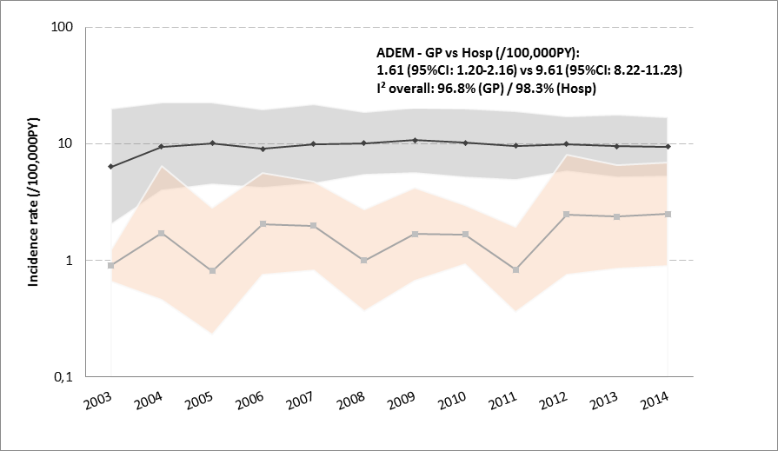 | 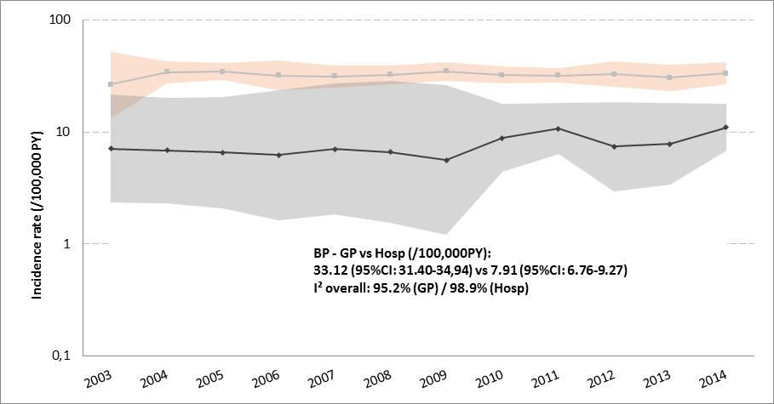
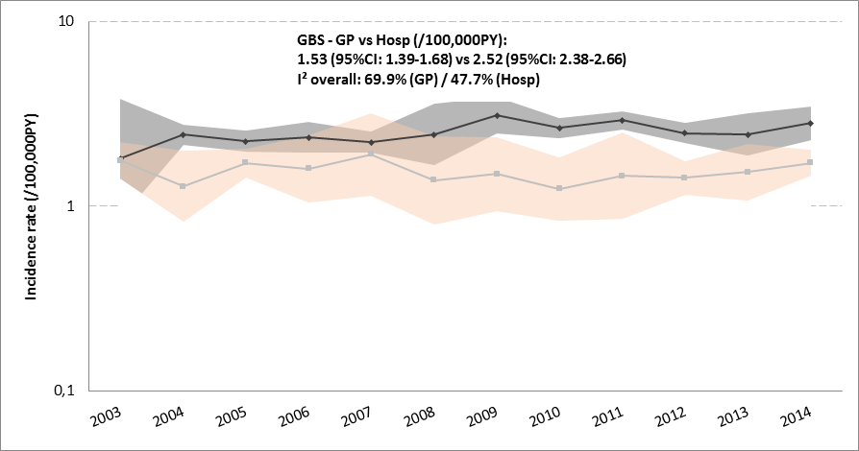 | 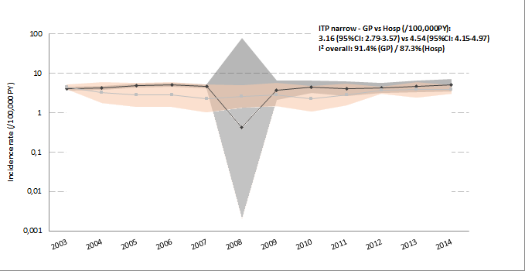
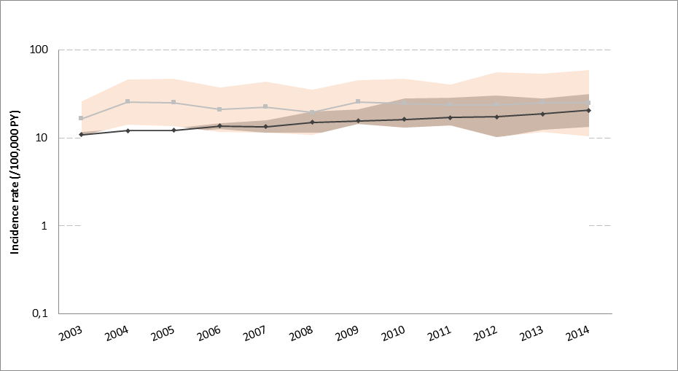  ITP broad - GP vs Hosp (/100,000PY):  23.62 (95%CI: 19.72-28.29) vs 15.23 (95%CI: 13.54-17.12)  I² overall: 99.5% (GP) / 98.5% (Hosp) | 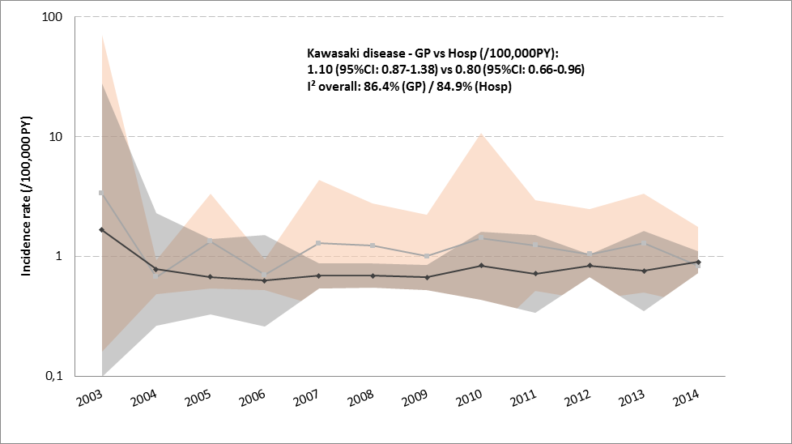
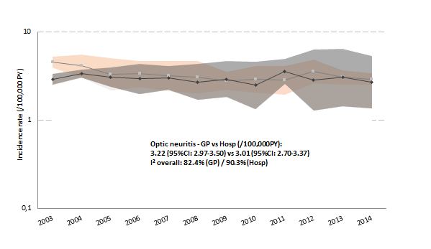 | 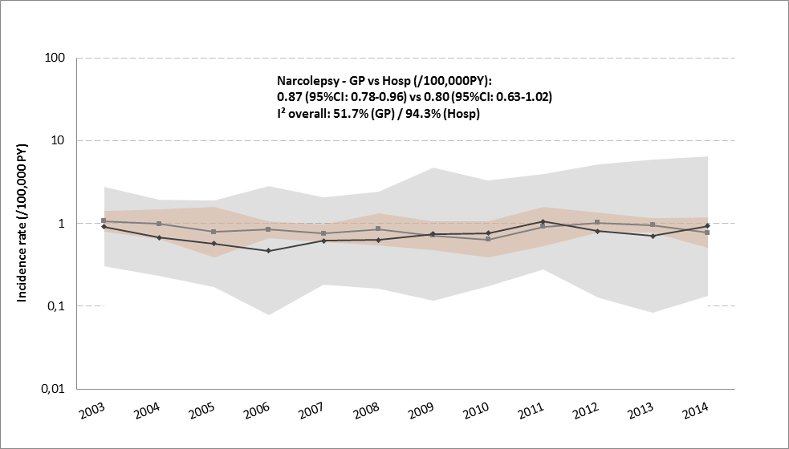
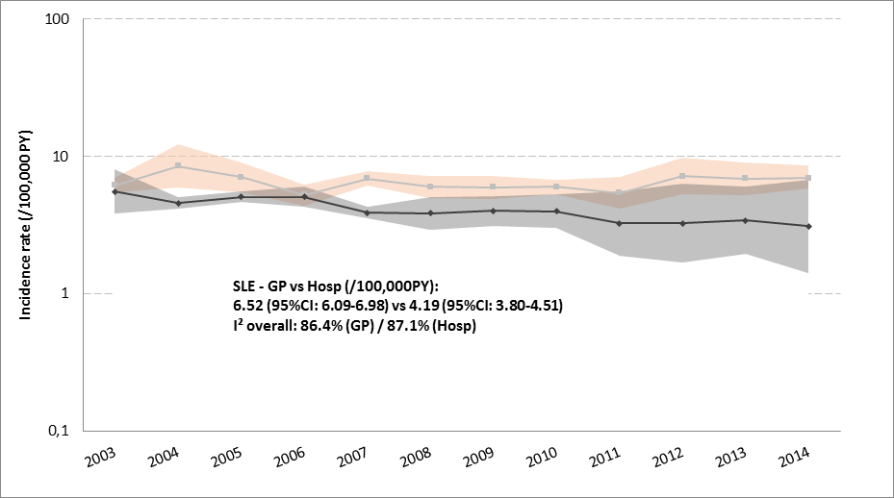 | 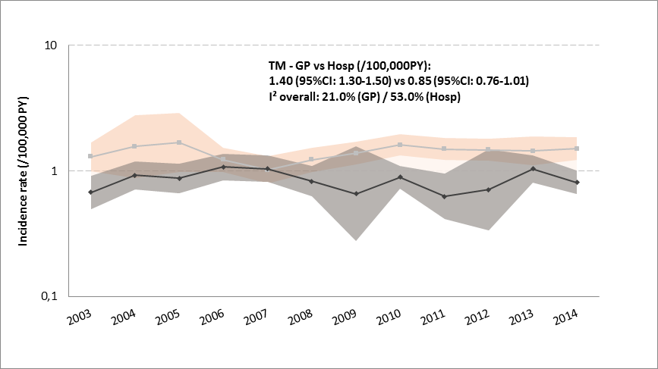
Black line corresponds to hospital record linkage databases, Grey line corresponds to General practitioners’ databases. Log scale was used on the Y-axis. ADEM: Acute disseminated encephalomyelitis, BP: Bell’s palsy, GBS: Guillain Barré syndrome, GP: General practitioners, Hosp: Hospitalization record linkage, ITP: Immune Thrombocytopenia Purpura, SLE: Systemic Lupus Erythematosus, TM: Transverse Myelitis

References
[1] Hviid A, Hansen JV, Frisch M, Melbye M. Measles, mumps, rubella vaccination and autism: a nationwide cohort study. Ann Intern Med. 2019.
[2] Hviid A, Svanstrom H, Scheller NM, Gronlund O, Pasternak B, Arnheim-Dahlstrom L. Human papillomavirus vaccination of adult women and risk of autoimmune and neurological diseases. J Intern Med. 2018;283:154-65.
[3] Soegaard SH, Rostgaard K, Schmiegelow K, Kamper-Jorgensen M, Hargreave M, Hjalgrim H, et al. Childhood vaccinations and risk of acute lymphoblastic leukaemia in children. Int J Epidemiol. 2017;46:905-13.
[4] Schmidt M, Schmidt SA, Sandegaard JL, Ehrenstein V, Pedersen L, Sorensen HT. The Danish National Patient Registry: a review of content, data quality, and research potential. Clinical epidemiology. 2015;7:449-90.
[5] Wojcik OP, Simonsen J, Molbak K, Valentiner-Branth P. Validation of the 5-year tetanus, diphtheria, pertussis and polio booster vaccination in the Danish childhood vaccination database. Vaccine. 2013;31:955-9.
[6] ENCePP. BIFAP database 2019 [Last accessed 27 March 2019]. Available from: http://www.encepp.eu/encepp/viewResource.htm?id=21501.
[7] Martín-Merino E, Llorente-García A, Montero Corominas D, Huerta C. The longitudinal incidence of human papillomavirus vaccination in Spanish primary care in the first 6 years after approval2019.
[8] Martin-Merino E, Llorente-Garcia A, Montero-Corominas D, Huerta C. The recording of human papillomavirus (HPV) vaccination in BIFAP primary care database: A validation study. Pharmacoepidemiol Drug Saf. 2019;28:201-8.
[9] Villa M, Black S, Groth N, Rothman KJ, Apolone G, Weiss NS, et al. Safety of MF59-adjuvanted influenza vaccination in the elderly: results of a comparative study of MF59-adjuvanted vaccine versus nonadjuvanted influenza vaccine in northern Italy. Am J Epidemiol. 2013;178:1139-45.
[10] ENCePP. 2019 [Last accessed 27 March 2019]. Available from: http://www.encepp.eu/encepp/viewResource.htm?id=20131.
[11] Giaquinto C, Gabutti G, Baldo V, Villa M, Tramontan L, Raccanello N, et al. Impact of a vaccination programme in children vaccinated with ProQuad, and ProQuad-specific effectiveness against varicella in the Veneto region of Italy. BMC Infect Dis. 2018;18:103.
[12] ENCePP. ARS database 2019 [Last accessed 27 March 2019]. Available from: http://www.encepp.eu/encepp/viewResource.htm?id=24417.
[13] Charlton RA, Klungsøyr K, Neville AJ, Jordan S, Pierini A, de Jong-van den Berg LTW, et al. Prescribing of Antidiabetic Medicines before, during and after Pregnancy: A Study in Seven European Regions. PloS One. 2016;11:e0155737.
[14] Roberto G, Bartolini C, Rea F, Onder G, Vitale C, Trifirò G, et al. NSAIDs utilization for musculoskeletal indications in elderly patients with cerebro/cardiovascular disease. Eur J Clin Pharmacol. 2018;74:637-43.
[15] ENCePP. THIN database 2019 [Last accessed 27 March 2019]. Available from: http://www.encepp.eu/encepp/viewResource.htm?id=10237.
[16] Hall GC, Davies PTG, Karim MY, Haag MDM, O'Leary C. Observational safety study of specific outcomes after trivalent cell culture seasonal influenza vaccination (Optaflu((R)) ) among adults in THIN database of electronic UK primary healthcare records. Pharmacoepidemiol Drug Saf. 2018;27:52-8.
[17] Wijnans L, Dodd CN, Weibel D, Sturkenboom M. Bell's palsy and influenza(H1N1)pdm09 containing vaccines: A self-controlled case series. PloS One. 2017;12:e0175539.
[18] RCGP Research and Surveillance Centre. 2019 [Last accessed 27 March 2019]. Available from: https://www.rcgp.org.uk/clinical-and-research/our-programmes/research-and-surveillance-centre.aspx.
[19] Correa A, Hinton W, McGovern A, van Vlymen J, Yonova I, Jones S, et al. Royal College of General Practitioners Research and Surveillance Centre (RCGP RSC) sentinel network: a cohort profile. BMJ Open. 2016;6:e011092.
[20] Amirthalingam G, Andrews N, Keel P, Mullett D, Correa A, de Lusignan S, et al. Evaluation of the effect of the herpes zoster vaccination programme 3 years after its introduction in England: a population-based study. The Lancet Public health. 2018;3:e82-e90.
[21] Pathirannehelage S, Kumarapeli P, Byford R, Yonova I, Ferreira F, de Lusignan S. Uptake of a dashboard designed to give realtime feedback to a sentinel network about key data required for influenza vaccine effectiveness studies. Stud Health Technol Inform. 2018;247:161-5.
[22] Pebody RG, Sinnathamby MA, Warburton F, Andrews N, Boddington NL, Zhao H, et al. Uptake and impact of vaccinating primary school-age children against influenza: experiences of a live attenuated influenza vaccine programme, England, 2015/16. Euro Surveillance: Bulletin Europeen Sur Les Maladies Transmissibles = European Communicable Disease Bulletin. 2018;23.

