Title: Safety of apremilast in patients with psoriasis and psoriatic arthritis: findings from the UK Clinical Practice Research Datalink
Journal: Drug Safety
Rebecca Persson,¹ Myriam Missoup Cordey,² Maria Paris,² Susan Jick ^{1,3}
¹Boston Collaborative Drug Surveillance Program, Lexington, MA, USA
²Amgen Inc., Thousand Oaks, CA, USA
³Boston University School of Public Health, Boston, MA, USA
Address for correspondence: sjick@bu.edu

Supplement 1: Methods and results for CPRD Aurum study
Methods
The CPRD Aurum study followed the same methods as the CPRD GOLD study (as described in the main manuscript) except where described below.
Data sources
The CPRD Aurum database, available to researchers since 2019, includes over 30 years of electronic healthcare data for over 13 million currently registered patients from 1373 practices and is currently undergoing validation assessments [1-5]. CPRD Aurum data includes demographics, diagnoses, prescriptions, symptoms and lifestyle factors recorded by a GP as well as clinical information sent to GPs from hospitalizations and specialist encounters. Although sourced from the same health system as the CPRD GOLD, CPRD Aurum is based on a different patient management system—EMIS—and data are captured with different coding systems. Differences between CPRD GOLD and CPRD Aurum are described in Table S1.
Hospital Episode Statistics (HES) Admitted Patient Care data, which include information on inpatient hospitalizations in England since 1997 for the purpose of hospital payment, were used as the external reference standard for validation of hospitalized adverse events of special interest (AESIs) recorded in CPRD Aurum [6]. All CPRD Aurum practices in England are linked to HES data. HES data contain details of each National Health Service (NHS) hospital stay, including dates of admission and discharge, and primary and secondary diagnoses made during the hospital stay.
Cohort definitions
No differences from the CPRD GOLD study.
Outcomes
AESIs expected to require hospitalization (i.e., hospitalized infections, major adverse cardiac events [MACE], tachyarrhythmias, and solid and hematological malignancies) were validated using HES inpatient data.
Analysis
Upon receipt of CPRD Aurum data, we discovered that apremilast prescriptions subsequent to the treatment initiation pack were not captured for most patients (see Results and Comment sections below). Thus, patients in all cohorts in CPRD Aurum analyses were censored after the approximate length of 1 apremilast prescription (30 days) plus the outcome-specific lag time. Thus, patients were censored at the first of the following: 1) study outcome occurred (separately for each outcome), 2) 30 days + outcome-specific lag time, 3) end of patient record, 4) death, or 5) end of data collection. All outcomes except for malignancies were limited to those recorded before the censor date. Malignancies were identified through the end of patient record.

Results
Overall, 441 apremilast-exposed patients were matched by age, sex, and length of record before cohort entry to 10,473 patients exposed to non-apremilast treatments. Apremilast-exposed patients were generally similar to patients in comparison cohorts. However, apremilast-exposed patients were less likely to have PsA than patients using oral + injectable treatments and more likely to have PsA than patients using oral only or injectable only treatments. Apremilast-exposed patients were also more likely to have a history of malignancy before cohort entry than patients in the corresponding non-apremilast cohorts (Table S2).
As described above, 91% of patients in the apremilast-exposed cohort had only 1 prescription for apremilast recorded in their GP record in CPRD Aurum (Table S3). This pattern of use is inconsistent with apremilast use in CPRD GOLD and other data sources [7], and indicates that CPRD Aurum does not capture all prescriptions for this drug. Attempts to validate the length of apremilast use in CPRD Aurum through GP questionnaires were delayed due to COVID-19.
No incident apremilast-exposed cases of MACE, tachyarrhythmias, vasculitis, treated depression, suicidal behaviors, or death were recorded in CPRD Aurum within 30 days + lag time after first apremilast use. There were also no cases of hematological malignancy at any time after exposure to apremilast. Incidence rates (IRs) of opportunistic and serious infections, hypersensitivity reactions, and solid and skin malignancies were generally similar across all cohorts except in the injectable non-apremilast cohort where the rates were lower. However, confidence intervals were wide for all estimates. (Table S4, Figs. S1 and S2). The IRs of treated anxiety were lower in all non-apremilast cohorts than in the apremilast-exposed cohort; however the, IR in the apremilast-exposed cohort was based on less than 5 apremilast-exposed cases.

Comment
CPRD Aurum’s usefulness for assessing the safety of apremilast is limited to AESIs that occur soon after the first exposure. AESIs occurring after longer duration or larger cumulative dose cannot be assessed in this data source. Within the first 30 days of apremilast use (+ appropriate lag periods), there were no concerning excess cases of any AESI. The rate of treated anxiety was higher among apremilast-exposed patients than among patients in the non-apremilast cohorts; however, this rate as based on a very small number of cases. In addition to the limited information on apremilast exposure, the CPRD Aurum study is subject to the same limitations described in the CPRD GOLD study.

References
- Wolf A, Dedman D, Campbell J, Booth H, Lunn D, Chapman J, et al. Data resource profile: Clinical Practice Research Datalink (CPRD) Aurum. Int J Epidemiol. 2019;48:1740-40g.
- Jick SS, Hagberg KW, Persson R, Vasilakis‐Scaramozza C, Williams T, Crellin E, et al. Quality and completeness of diagnoses recorded in the new CPRD Aurum Database: evaluation of pulmonary embolism. Pharmacoepidemiol Drug Saf. 2020;29:1134-40.
- Persson R, Sponholtz T, Vasilakis-Scaramozza C, Hagberg KW, Williams T, Kotecha D, et al. Quality and completeness of myocardial infarction recording in Clinical Practice Research Datalink Aurum. Clin Epidemiol. 2021;13:745-53.
- Persson R, Vasilakis-Scaramozza C, Hagberg KW, Sponholtz T, Williams T, Myles P, et al. CPRD Aurum database: assessment of data quality and completeness of three important comorbidities. Pharmacoepidemiol Drug Saf. 2020;29:1456-64.
- Clinical Practice Research Datalink. (2021). CPRD Aurum June 2021 (Version 2021.06.001) [Data set]. Clinical Practice Research Datalink. https://doi.org/10.48329/pyc2-we97.
- Herbert A, Wijlaars L, Zylbersztejn A, Cromwell D, Hardelid P. Data resource profile: Hospital Episode Statistics Admitted Patient Care (HES APC). Int J Epidemiol. 2017;46:1093-1093i.
- Vasilakis-Scaramozza C, Persson R, Hagberg KW, Jick S. The risk of treated anxiety and treated depression among patients with psoriasis and psoriatic arthritis treated with apremilast compared to biologics, DMARDs and corticosteroids: a cohort study in the United States MarketScan database. J Eur Acad Dermatol Venereol. 2020;34:1755-63.
- Herrett E, Gallagher AM, Bhaskaran K, Forbes H, Mathur R, Van Staa T, et al. Data resource profile: Clinical Practice Research Datalink (CPRD). Int J Epidemiol. 2015;44:827-36.
- Clinical Practice Research Datalink. (2021). CPRD GOLD February 2021 (Version 2021.02.001) [Data set]. Clinical Practice Research Datalink. https://doi.org/10.48329/S0M3-8M14.
Table S1: CPRD data sources and their characteristics
Database feature | CPRD GOLD [8, 9] | CPRD Aurum [1, 5]
Country | England, Scotland, Northern Ireland, Wales | Englandª and Northern Ireland
Coverage | National | National
Period of coverage | 1990–2020 | 1990–2020
Currently registered patients | Over 3 million | Over13 million
Inpatient visits | Yes, though may not be complete. English practices can be linked to HES data⁸ | Yes, though may not be complete. English practices can be linked to HES data^{b 1}
Outpatient visits | Yes | Yes
Medications | Prescriptions at GP outpatient visits | Prescriptions at GP outpatient visits
Height, weight, and BMI | Yes | Yes
Diagnosis codes | Read codes | Read/SNOMED CT
Medication codes | Gemscript | ProdCode
Mortality | Yes | Yes
Data validation | Extensive validation for many outcomes | Currently being validated
ª99% of practices currently contributing to CPRD Aurum are in England.
^{b}Virtually all patients in the CPRD Aurum are eligible for linkage to HES data. HES data contain details of hospital stays, including dates of admission and discharge, the primary diagnosis, and additional diagnoses, and procedures. We obtained HES data, where available, for all patients to ensure that we did not miss any AESI-related hospitalization and to validate any identified AESI-related hospitalization found in the CPRD Aurum records.
AESI=adverse event of special interest, BMI=body mass index, CPRD=Clinical Practice Research Datalink, GP=general practitioner, HES, Hospital Episode Statistics, SNOMED CT= Systemized Nomenclature of Medicine – Clinical Terms.
Table S2: Description of patients in the apremilast and matched non-apremilast treatment cohorts: CPRD Aurum + HESª (2015–2020)
 | Apremilast  N = 441 | Oral only  N = 3865 | Injectable only  N = 3509 | Oral + injectable  N = 3099
Sex
Female | 232 (53) | 1957 (51) | 1772 (51) | 1673 (54)
Male | 209 (47) | 1908 (49) | 1737 (49) | 1426 (46)
Age at cohort entry (years)
Mean ± SD | 53 ± 15 | 54 ± 15 | 55 ± 14 | 55 ± 13
18–44 | 131 (30) | 1062 (27) | 847 (24) | 677 (22)
45–59 | 157 (36) | 1382 (36) | 1303 (37) | 1251 (40)
≥ 60 | 153 (35) | 1421 (37) | 1359 (39) | 1171 (38)
Diagnosis
PsA with or without psoriasis | 201 (46) | 1077 (28) | 1051 (30) | 1764 (57)
Psoriasis only | 221 (50) | 2788 (72) | 2458 (70) | 1335 (43)
Neither diagnosis code in record ^{b} | 19 (4) | 0 (0) | 0 (0) | 0 (0)
Smoking status at cohort entry
Current | 107 (25) | 1120 (29) | 796 (23) | 700 (23)
Former smoker | 156 (35) | 1326 (35) | 1265 (36) | 1124 (36)
Non-smoker | 177 (40) | 1409 (36) | 1434 (41) | 1263 (41)
Unknown smoking status | < 5 (< 1) | 10 (0) | 14 (0) | 12 (0)
BMI before cohort entry
< 18.5 | 13 (3) | 60 (2) | 36 (1) | 32 (1)
18.5 to < 25.0 | 84 (19) | 916 (24) | 703 (20) | 619 (20)
25.0 to < 30.0 | 122 (28) | 1212 (31) | 1147 (33) | 947 (31)
≥ 30.0 | 190 (43) | 1495 (39) | 1432 (41) | 1368 (44)
Unknown | 32 (7) | 182 (5) | 191 (5) | 133 (4)
Time between registration with GP and cohort entry (years)
Mean ± SD | 14 ± 10 | 15 ± 9 | 16 ± 9 | 17 ± 9
< 1^{c} | 58 (13)^{c} | 0 (0) | 0 (0) | 0 (0)
1–9 | 123 (28) | 1267 (33) | 1021 (29) | 852 (27)
≥ 10 | 260 (59) | 2598 (67) | 2488 (71) | 2247 (73)
Prevalence of comorbidities at cohort entry
MACEª | 38 (9) | 260 (7) | 212 (6) | 213 (7)
Tachyarrhythmiasª | 44 (10) | 293 (8) | 211 (6) | 230 (7)
Vasculitis | < 5 (< 1) | 31 (1) | 23 (1) | 38 (1)
Malignancyª | 79 (18) | 390 (10) | 363 (10) | 317 (10)
Solid ª | 44 (10) | 263 (7) | 201 (6) | 207 (7)
Hematologicalª | 16 (4) | 65 (2) | 32 (1) | 47 (2)
Non-melanoma skin | 29 (7) | 115 (3) | 152 (4) | 105 (3)
Treated depression^{d} | 122 (27) | 1130 (29) | 1004 (29) | 996 (32)
Treated anxiety^{e} | 63 (14) | 709 (18) | 620 (18) | 560 (18)
Suicidal behaviors | 37 (8) | 355 (9) | 266 (8) | 281 (9)
Acute comorbidities in the year before cohort entry
Opportunistic infections^{f} | 16 (4) | 144 (4) | 108 (3) | 128 (4)
Hypersensitivity reactions | 52 (12) | 427 (11) | 303 (9) | 314 (10)
All results are presented as n (%), unless specified.
ªIncludes diagnoses recorded in HES for MACE, tachyarrhythmias, and solid and hematological malignancies.
^{b}Psoriasis and psoriatic arthritis were the only approved indications for apremilast during the study period.
^{c}The study population included patients with at least 1 year of recorded data. Given the small number of apremilast-exposed patients present in the data, we also included all apremilast-exposed patients regardless of record length before the first apremilast prescription.
^{d}Record contains at least 1 prescription for an antidepressant recorded within 60 days of a depression diagnosis, with both treatment and diagnosis codes recorded before the cohort entry date.
^{e}Record contains at least 1 prescription for an anti-anxiety treatment recorded within 60 days of an anxiety diagnosis, with both treatment and diagnosis codes recorded before the cohort entry date.
^{f}Serious (i.e., hospitalized) infections before cohort entry are not captured here.
BMI=body mass index, CPRD=Clinical Practice Research Datalink, GP=general practitioner, HES=Hospital Episode Statistics, MACE= major adverse cardiac event, PsA=psoriatic arthritis, SD=standard deviation.
Note: Cell sizes less than 5 are not reportable per license agreement.

Table S3: Characteristics of patients in the apremilast and matched non-apremilast treatment cohorts during study follow-up: CPRD Aurum (2015–2020)
 | Apremilast  N = 441 | Oral only  N = 3865 | Injectable only  N = 3509 | Oral + injectable  N = 3099
Length of medical record follow-up after cohort entry (months)ª
Mean ± SD | 20 ± 14 | 20 ± 13 | 21 ± 14 | 23 ± 13
Median (IQR) | 17 (9–29) | 17 (9–28) | 18 (10–30) | 20 (13–32)
< 6 | 68 (15) | 577 (15) | 465 (13) | 213 (7)
6–11 | 79 (18) | 748 (19) | 638 (18) | 480 (15)
12–23 | 150 (34) | 1306 (34) | 1164 (33) | 1151 (37)
24–35 | 81 (18) | 726 (19) | 718 (20) | 721 (23)
36–47 | 38 (9) | 346 (9) | 339 (10) | 341 (11)
> 48 | 25 (6) | 162 (4) | 185 (5) | 193 (6)
Number of study drug prescriptions on or after cohort entry^{b}
Mean ± SD | 1 ± 1 | 6 ± 10 | 3 ± 5 | 12 ± 13
1 | 402 (91) | 1613 (42) | 2434 (69) | 0 (0)
2 | 25 (6) | 540 (14) | 464 (13) | 501 (16)
3–5 | 8 (2) | 647 (17) | 293 (8) | 710 (23)
6–9 | 5 (1) | 395 (10) | 137 (4) | 529 (17)
≥ 10 | < 5 (< 1) | 670 (17) | 181 (5) | 1359 (44)
Study drugs used by ≥ 5% of patients in any cohort during follow-up
Apremilast | 441 (100) | 0 (0) | 0 (0) | 0 (0)
Adalimumab | < 5 (< 1) | 0 (0) | 327 (9) | 422 (14)
Etanercept | 0 (0) | 0 (0) | 100 (3) | 207 (7)
Leflunomide | < 5 (1) | 103 (3) | 0 (0) | 248 (8)
Methotrexate | 26 (6) | 989 (26) | 739 (21) | 1712 (55)
Methylprednisolone | < 5 (< 1) | < 5 (< 1) | 1297 (37) | 778 (25)
Prednisolone | 34 (8) | 2523 (65) | 0 (0) | 1461 (47)
Sulfasalazine | 14 (3) | 352 (9) | 0 (0) | 660 (21)
Triamcinolone | < 5 (< 1) | 0 (0) | 836 (24) | 414 (13)
All results are presented as n (%), unless specified.
ªLength of available medical record after cohort entry date. Patients may have been censored at an earlier date (see Methods).
^{b}In the apremilast-exposed cohort, only prescriptions for apremilast were assessed for this measure (i.e., concomitant oral or injectable treatments are not included).
CPRD=Clinical Practice Research Datalink, IQR=interquartile range, SD=standard deviation.
Note: Cell sizes less than 5 are not reportable per license agreement.
Table S4: Incidence rates and rate ratios of adverse events of special interest among patients in the apremilast and matched non-apremilast treatment cohorts: CPRD Aurum + HESª (2015 – 2020)
AESI  Treatment cohort | Events | PY | IR per 1000 PY (95% CI) | Crude IRR  (95% CI)^{b}
Opportunistic and serious infectionsª
Apremilast | 7 | 36 | 194 (92–406) | Reference
Oral only | 60 | 312 | 193 (150–248) | 1.0 (0.4–2.1)
Injectable only | 29 | 260 | 112 (78–161) | 0.5 (0.2–1.2)
Oral + injectable | 53 | 237 | 224 (171–293) | 1.1 (0.5–2.4)
Hypersensitivity reactions
Apremilast | 6 | 36 | 166 (75–370) | Reference
Oral only | 79 | 310 | 255 (204–318) | 1.5 (0.7–3.5)
Injectable only | 25 | 259 | 97 (65–143) | 0.5 (0.2–1.3)
Oral + injectable | 37 | 236 | 157 (114–216) | 0.9 (0.4–2.1)
Treated anxiety
Apremilast | < 5 | 25 | 122 (39–379)
Oral only | 9 | 206 | 44 (23–84)
Injectable only | < 5 | 175 | 11 (3–46)
Oral + injectable | < 5 | 147 | 20 (7–63)
Malignancy – solidª
Apremilast | < 5 | 32 | 32 (5–225)
Oral only | 12 | 280 | 43 (24–76)
Injectable only | 5 | 237 | 21 (9–51)
Oral + injectable | 16 | 218 | 73 (45–120)
Malignancy – non-melanoma skin
Apremilast | < 5 | 30 | 33 (5–237)
Oral only | < 5 | 275 | 11 (4–34)
Injectable only | < 5 | 229 | 18 (7–47)
Oral + injectable | 8 | 213 | 38 (19–75)
ªIncludes diagnoses recorded in HES for opportunistic and serious infections and solid malignancies.
^{b}IRRs provided for AESI with 5 or more cases in the apremilast cohort.
AESI=adverse events of special interest, CI= confidence interval, CPRD=Clinical Practice Research Datalink, HES=Hospital Episode Statistics, IR=incidence rate, IRR=incidence rate ratio, PY=person-years.
Note: Cell sizes less than 5 are not reportable per license agreement.

Figure S1: Cumulative incidence of first opportunistic or serious infection: CPRD Aurum + HES (2015–2020)
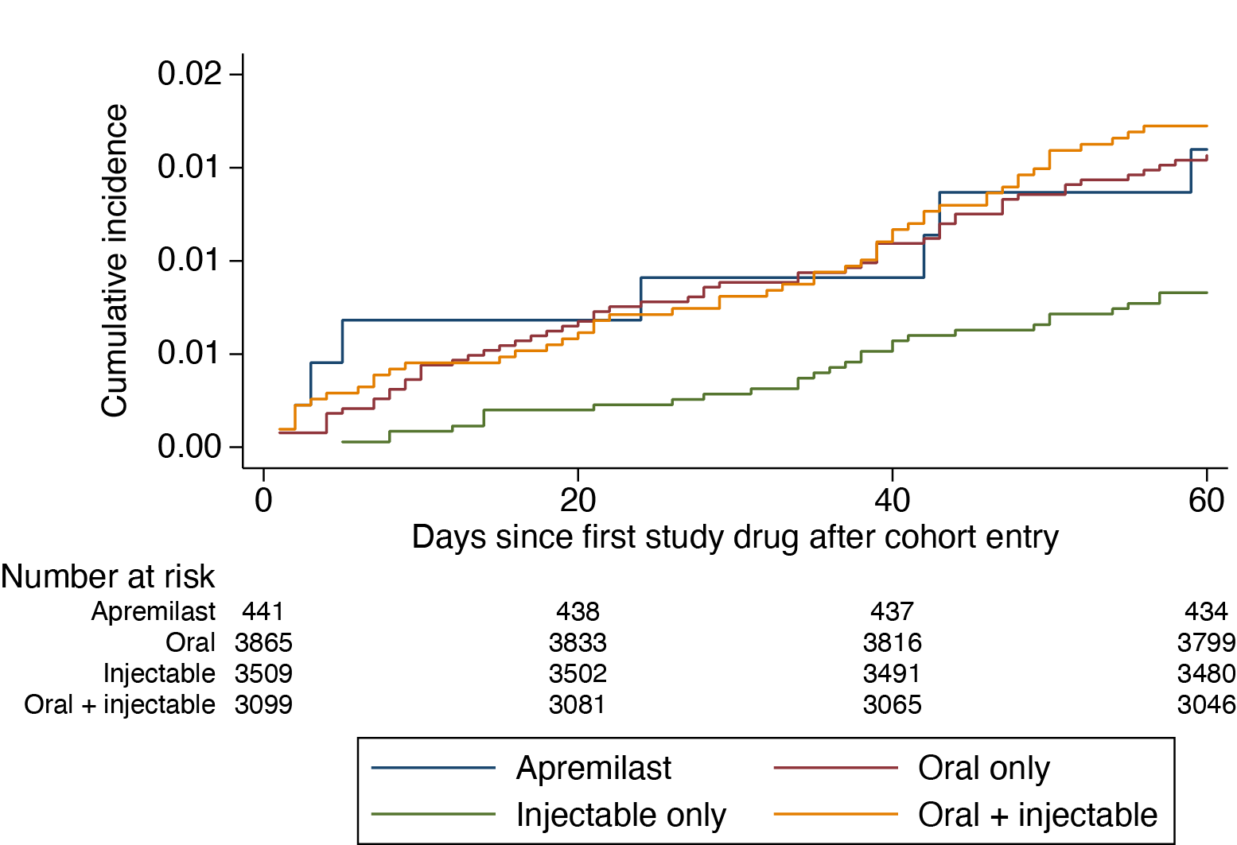

CPRD=Clinical Practice Research Datalink, HES=Hospital Episode Statistics.

Figure S2: Cumulative incidence of first hypersensitivity reaction: CPRD Aurum (2015–2020)
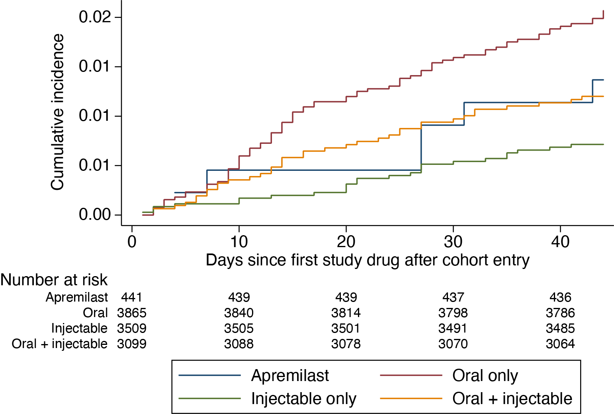

CPRD=Clinical Practice Research Datalink.

