Title
Estimating the Prevalence of Prescribed Medication Use in Pregnancy – A Systematic Review and Meta Analysis

Authors
Clare Sullivan, Aisling Kerr, Marie Cahill, Angela C. Flynn, Fergal O’Shaughnessy, Brian Cleary, Kathleen Bennett

Journal
Drug Safety

Author Affiliations
Ms Clare Sullivan, School of Population Health, RCSI University of Medicine and Health Sciences & Central Statistics Office (CSO) Ireland
Dr Aisling Kerr, School of Pharmacy and Biomolecular Sciences, RCSI University of Medicine and Health Sciences
Ms Marie Cahill, School of Pharmacy and Biomolecular Sciences, RCSI University of Medicine and Health Sciences
Dr Angela Flynn, School of Population Health, RCSI University of Medicine and Health Sciences
Dr Fergal O'Shaughnessy, Pharmacy Department, Rotunda Hospital Dublin & School of Pharmacy and Biomolecular Sciences, RCSI University of Medicine and Health Sciences
Dr Brian Cleary, Pharmacy Department, Rotunda Hospital Dublin & School of Pharmacy and Biomolecular Sciences, RCSI University of Medicine and Health Sciences
Professor Kathleen Bennett, Data Science Centre, School of Population Health, RCSI University of Medicine and Health Sciences

Contact
Clare Sullivan claresullivan23@rcsi.com

Appendices

Appendix A: Search Strategy
PubMed (Medline)
Step | Query | Articles
1 | "Pregnancy"[Mesh] OR "Gestational Age"[Mesh] OR "Pregnancy Trimesters"[Mesh] OR "Prenatal Care/methods"[Mesh] OR Abortion[Mesh] OR "Fetal Development"[Mesh] OR "Fetus"[Mesh] OR "Pregnancy Complications"[Mesh] OR "Pregnancy Outcome"[Mesh] OR "Stillbirth"[Mesh] OR "Abortion, Induced/statistics and numerical data"[Mesh] OR "Abortion, Spontaneous"[Mesh] OR "Abortion, Spontaneous/epidemiology"[Mesh] OR "Fetal Development/drug effects"[Mesh] OR "Fetus/drug effects"[Mesh] OR "Pregnancy Complications/etiology"[Mesh] OR "Pregnancy Complications/therapy"[Mesh] OR "Pregnancy Complications/epidemiology"[Mesh] OR "Pregnancy Complications/drug therapy"[Mesh] OR "Pregnancy Complications/chemically induced"[Mesh] OR "Pregnancy Outcome"[Mesh] OR "Pregnancy Outcome/epidemiology"[Mesh] OR "Stillbirth/epidemiology"[Mesh] OR pregnancy[Title/Abstract] OR maternal[Title/Abstract] OR prenatal[Title/Abstract] OR Expectant[Title/Abstract] OR Gestation[Title/Abstract] OR childbearing[Title/Abstract] | 1,473,672
2 | "Pharmaceutical Preparations"[Mesh] OR "Pharmaceutical Preparations/administration and dosage"[Mesh] OR "Pharmaceutical Preparations/classification"[Mesh] OR "Prescription Drugs"[Mesh] OR "Prescription Drugs/administration and dosage"[Mesh] OR "Prescription Drugs/adverse effects"[Mesh] OR "Prescription Drugs/classification"[Mesh] OR "Prescription Drugs/therapeutic use"[Mesh] OR "Prescription Drugs/therapeutic use"[Mesh] OR "Drug-Related Side Effects and Adverse Reactions"[Mesh] OR "Drug-Related Side Effects and Adverse Reactions/epidemiology"[Mesh] OR prescribing[Title/Abstract] OR prescription*[Title/Abstract] OR medication[Title/Abstract] OR medicine[Title/Abstract] OR drug*[Title/Abstract] OR prescribe[Title/Abstract] | 3,962,368
3 | "Drug Therapy/statistics and numerical data"[Mesh] OR "Drug Utilization Review/statistics and numerical data"[Mesh] OR "Drug Utilization/statistics and numerical data"[Mesh] OR "Drug Prescriptions/statistics and numerical data"[Mesh] OR "Insurance, Pharmaceutical Services/statistics and numerical data"[Mesh] OR "Maternal Health Services/statistics and numerical data"[Mesh] OR "Medical Record Linkage"[Mesh] OR "Medicaid/statistics and numerical data"[Mesh] OR "Pharmacoepidemiology/methods"[Mesh] OR "Population Surveillance/methods"[Mesh] OR "Prenatal Care/statistics and numerical data"[Mesh] OR "Prevalence"[Mesh] OR "Registries/statistics and numerical data"[Mesh] OR prevalence[Title/Abstract] OR occurrence*[Title/Abstract] OR Frequency[Title/Abstract] OR Proportion[Title/Abstract] | 2,963,005
4 | #1 AND #2 AND #3 | 16,260
5 | AND ((english[Filter]) AND (2010:2025[pdat])) Filters: Humans, Female | 7,693

Embase
Step | Query | Articles
1 | ‘pregnancy'/exp OR 'gestational age'/exp OR 'prenatal care'/exp OR 'abortion'/exp OR 'fetus'/exp OR 'induced abortion'/exp OR 'spontaneous abortion'/exp OR 'fetus development'/exp OR 'pregnancy complication'/exp OR 'pregnancy outcome'/exp OR 'stillbirth'/exp OR pregnancy:ti,ab OR maternal:ti,ab OR prenatal:ti,ab OR expectant:ti,ab OR gestation:ti,ab OR childbearing:ti,ab | 1,903,844
2 | ‘prescription drug'/exp OR 'adverse drug reaction'/exp OR prescribing:ti,ab OR prescription*:ti,ab OR medication:ti,ab OR medicine:ti,ab OR drug*:ti,ab OR prescribe:ti,ab | 5,049,472
3 | ‘health insurance'/exp OR 'maternal health service'/exp OR 'medical record'/exp OR 'medicaid'/exp OR 'pharmacoepidemiology'/exp OR 'population surveillance'/exp OR 'prenatal care'/exp OR 'prevalence'/exp OR 'register'/exp OR prevalence:ti,ab OR occurrence*:ti,ab OR frequency:ti,ab OR proportion:ti,ab | 5,116,880
4 | #1 AND #2 AND #3 | 46,492
5 | #4 AND (2010:py OR 2011:py OR 2012:py OR 2013:py OR 2014:py OR 2015:py OR 2016:py OR 2017:py OR 2018:py OR 2019:py OR 2020:py OR 2021:py OR 2022:py OR 2023:py OR 2024:py OR 2025:py) AND ([embase]/lim NOT ([embase]/lim AND [medline]/lim) OR [preprint]/lim OR 'clinical trial':dtype) AND [female]/lim AND 'article'/it AND 'human'/de | 3,062

EBSCO (Cinahl) (excluding Medline)
Step | Query | Articles
1 | ( TI ( "Pregnancy" OR "maternal" OR "prenatal" OR "Expectant" OR "Gestation" OR "childbearing" ) OR AB ( "Pregnancy" OR "maternal" OR "prenatal" OR "Expectant" OR "Gestation" OR "childbearing" ) ) OR (MH "Pregnancy+") OR (MH "Gestational Age") OR (MH "Pregnancy Trimesters+") OR (MH "Prenatal Care") OR (MH "Abortion, Induced+") OR (MH "Fetal Development+") OR ( (MH "Fetus+") OR (MH "Fetal Development+") ) OR (MH "Pregnancy Complications+") OR (MH "Pregnancy Outcomes") OR (MH "Perinatal Death") OR (MH "Abortion, Spontaneous+") | 511,270
2 | ( TI ( "prescribing" OR "prescription*" OR "medication" OR "medicine" OR "drug*" OR "prescribe" ) OR AB ( "prescribing" OR "prescription*" OR "medication" OR "medicine" OR "drug*" OR "prescribe" ) ) OR (MH "Drugs, Prescription+") OR (MH "Drug Therapy+") OR (MH "Drug Utilization+") | 1,179,217
3 | ( TI ( "Prevalence" OR "occurrence*" OR "Frequency" OR "Proportion" ) OR AB ( "Prevalence" OR "occurrence*" OR "Frequency" OR "Proportion" ) ) OR (MH "Maternal Health Services+") OR (MH "Insurance, Pharmaceutical Services") OR (MH "Medical Record Linkage") OR (MH "Medicaid+") OR (MH "Prevalence") OR (MH "Registries, Personnel") | 1,102,282
4 | #1 AND #2 AND #3 | 7,671
5 | Limiters - Publication Date: 20100101-20251231  Narrow by Population: - human  Narrow by SubjectGender: - female  Narrow by Language: - english | 651

Scopus
Step | Query | Articles
1 | TITLE-ABS_KEY ("Pregnancy" OR "Gestational Age" OR "Pregnancy Trimesters" OR "Prenatal Care" OR "abortion, induced" OR "Fetal Development" OR "Fetus" OR "Pregnancy Complications" OR "Pregnancy Outcome" OR "Stillbirth" OR ( abortion W/2 induced ) OR ( abortion W/2 spontaneous ) OR "Fetal Development" OR "Pregnancy Complications*" OR "Pregnancy Outcome*" OR "Stillbirth*" OR "Maternal" OR "Prenatal" OR "Expectant" OR "Gestation" OR "Childbearing") | 1,851,517
2 | TITLE-ABS-KEY ("pharmaceutical preparation*" OR "prescription drug*" OR ("drug related" W/2 ("side effect*" OR "adverse reaction*" ) ) OR "prescribing" OR "prescription*" OR "medication" OR "medicine" OR "drug*" OR "prescribe") | 12,575,217
3 | TITLE-ABS-KEY (( insurance W/2 pharmaceutical ) OR "Medical Record Linkage" OR "medicaid" OR "pharmacoepidemiology" OR "population surveillance*" OR registries OR "Prevalence" OR "occurrence*" OR "Frequency" OR "Proportion") | 7,995,656
4 | #1 AND #2 AND #3 | 54,571
6 | AND NOT INDEX ( medline ) ) AND PUBYEAR > 2009 AND PUBYEAR < 2026 AND ( LIMIT-TO ( DOCTYPE , "ar" ) ) AND ( LIMIT-TO ( LANGUAGE , "English" ) ) AND ( LIMIT-TO ( EXACTKEYWORD , "Female" ) OR LIMIT-TO ( EXACTKEYWORD , "Human" ) OR EXCLUDE ( EXACTKEYWORD , "Mouse" ) OR EXCLUDE ( EXACTKEYWORD , "Animal Model" ) OR EXCLUDE ( EXACTKEYWORD , "Animal Tissue" ) OR EXCLUDE ( EXACTKEYWORD , "Animal Experiment" ) OR EXCLUDE ( EXACTKEYWORD , "Nonhuman" ) OR EXCLUDE ( EXACTKEYWORD , "Male" ) OR EXCLUDE ( EXACTKEYWORD , "Animals" ) OR EXCLUDE ( EXACTKEYWORD , "Nonhuman" ) OR EXCLUDE ( EXACTKEYWORD , "Animal" ) OR EXCLUDE ( EXACTKEYWORD , "Veterinary Medicine" ) OR EXCLUDE ( EXACTKEYWORD , "Cattle" ) OR EXCLUDE ( EXACTKEYWORD , "Bovine" )) AND ( LIMIT-TO ( SRCTYPE , "j" ) ) AND ( LIMIT-TO ( PUBSTAGE , "final" ) ) | 2,408

Web of Science
Step | Query | Articles
1 | TS= ("Pregnancy" OR "maternal" OR "prenatal" OR "Expectant" OR "Gestation" OR "childbearing") | 971,311
2 | TS= (prescribing OR prescription* OR medication OR medicine OR drug* OR prescribe) | 3,916,108
3 | TS= (prevalence OR occurrence* OR frequency OR proportion) | 5,865,291
4 | #3 AND #2 AND #1 | 15,503
5 | Years: 2025 or 2024 or 2023 or 2022 or 2021 or 2020 or 2019 or 2018 or 2017 or 2016 or 2015 or 2014 or 2013 or 2012 or 2011 or 2010.  Document Types: Article.  Languages: English  NOT Research Areas: Veterinary Sciences or Environmental Sciences Ecology or Agriculture or Food Science Technology or Plant Sciences or Engineering.  Web of Science Categories: Obstetrics Gynecology or Pharmacology Pharmacy. | 2,684

Appendix B: Inclusion Criteria
Inclusion Criteria | Exclusion Criteria
- Published between January 2010 and May 2025  - English Language  - Timeframe covers at least part of the gestational period  - Includes prescribed medication use during pregnancy  - Human subjects  - Population wide estimates  - Observational studies, retrospective and prospective cohort studies, surveillance studies, population studies | - Published before 2010  - Non-English Language  - Does not cover any of the gestational period  - Includes only illicit drugs, herbal medicines or over the counter / non-prescribed medications  - Non-Human / Animal subjects  - Specific sub-populations that do not represent the general population / Studies that are not representative of the entire population  - Randomised Control Trials (RCTs), cross-over trials, quasi-experimental studies, time-series studies, case-control studies, case series

Appendix C: Deduplication Code
Article Deduplication Code written in R Code using RStudio
library(revtools)
library(dplyr)

# PubMed
pubmed25f <- read_bibliography("pubmed-PregnancyM-set.nbib")
# Scopus
scopus25f <- read_bibliography("scopus.bib")
# Ebsco
ebsco25f <- read_bibliography("ebsco.ris")
# Embase
embase25f <- read_bibliography("embase.ris")
# Web of Science
wos25f1 <- read_bibliography("wos1.bib")
wos25f2 <- read_bibliography("wos2.bib")
wos25f3 <- read_bibliography("wos3.bib")
wos25f <- bind_rows(wos25f1, wos25f2, wos25f3)

# Required Columns
select_cols <- c("label", "author", "title", "year", "journal", "volume", "doi", "abstract", "issn")

# Restrict to Only Required Columns
pubmed_short_25f <- pubmed25f[,select_cols]
scopus_short_25f <- scopus25f[,select_cols]
ebsco_short_25f <- ebsco25f[,select_cols]
embase_short_25f <- embase25f[,select_cols]
wos_short_25f <- wos25f[,select_cols]

# Combine data from all databases together
all_search <- merge_columns(pubmed_short_25f, scopus_short_25f)
all_search <- merge_columns(all_search, ebsco_short_25f)
all_search <- merge_columns(all_search, embase_short_25f)
all_search <- merge_columns(all_search, wos_short_25f)

# Identify Duplicates based on Title
all_dup <- find_duplicates(all_search, "title", match_function = "exact", to_lower=TRUE)
# Remove Duplicates based on Title
unique_search <- extract_unique_references(all_search, all_dup)
# Identify Articles with no DOI
no_doi <- unique_search %>% filter(is.na(doi) | doi %in% c("10.1515/jpm-2017-3002", "10.1515/jpm-2017-3001"))
# Save those with no DOI to add back in
unique_search1 <- unique_search %>% filter(!is.na(doi) & !(doi %in% c("10.1515/jpm-2017-3002", "10.1515/jpm-2017-3001")))
# Identify Duplicates based on DOI
all_dup2 <- find_duplicates(unique_search1, "doi", match_function = "exact", to_lower = TRUE)
# Remove Duplicates based on DOI
unique_search2 <- extract_unique_references(unique_search1, all_dup2)

# Add back in articles with no DOI
unique_search3 <- rbind(unique_search2, no_doi)

# Save Final Results
write.csv(unique_search3, "database_unique_search.csv")

Appendix D: Data Extraction Table
Item | Description
First Author | The first author name in format Bloggs, J.
Title | The title of the article
Publication Year | The year of publication in format: 2024
Country | The name of the country / countries where the research carried out
Main Focus | The main focus / aims of the study
Data Collection Start | The year data collection started
Data Collection End | The year data collection ended
Study Design | The design of the study e.g. cohort study, cross-sectional study
Method of Data Collection | How data was collected, e.g. survey, database
Data Source | The name(s) of the data sources.
Method of Data Linkage | The method used to link data from multiple sources
Sampling Approach | How the participants were sampled
Response Rate | The response rate for participants
Study Sample | A description of the participants in the study
Unit Measured | The individual measured units e.g. pregnant women or pregnancies
Multiplicity | Details regarding the inclusion of multiple pregnancies e.g. twins, triplets
Parity (Previous Births) | Details regarding the parity of included participants
Gravidity (Previous Pregnancies) | Details regarding the gravidity of included participants
Pregnancy Outcomes Included | Details regarding the pregnancy outcomes included, e.g. live births, stillbirths, planned abortions, spontaneous abortions, ectopic pregnancies, other
Pregnancy Outcomes Excluded | Details regarding the pregnancy outcomes excluded
Birth Health | Details regarding birth health, e.g. birth weight, congenital anomalies
Pregnancy Identified | Details about how the pregnant women or pregnancies were identified
Pregnancy Timeframe | The definition of the pregnancy timeframe used in the study
First Day of Gestation | The definition of the first day of gestation used in the study
End of Pregnancy | The definition of the last day of gestation used in the study
Gestational Age at Pregnancy Outcome | The gestational age at the end of pregnancy
Minimum Gestational Age | The minimum gestational age at pregnancy outcome included
Maternal Age Timing | The time point at which maternal age is measured
Maternal Age | Maternal ages - in groupings
Maternal Age Mean | Mean maternal age
Maternal Age Minimum | Minimum maternal age
Maternal Age Maximum | Maximum maternal age
Drug Classification System Used | The drug classification system used e.g. ATC, FDA, other
Total Sample Included | The total sample size of included pregnancies / pregnant women
Medication Source | The data source for details regarding medication use
Exposure Timeframe | The definition of the medication exposure timeframe
Medications Included | The medications included in the prevalence estimate e.g. prescribed medications alone, prescribed vitamins and minerals, non-prescribed medications
First Trimester Definition | The definition used for the first trimester start and end
Second Trimester Definition | The definition used for the second trimester start and end
Third Trimester Definition | The definition used for the third trimester start and end
Prevalence Denominator | The total sample pregnancies included in the prevalence estimate
Prevalence Numerator | The total number who used medications during pregnancy included in the prevalence estimate
Proportion | The proportion who used medication during pregnancy
First Trimester Denominator | The total number of pregnancies included in the first trimester estimate
First Trimester Numerator | The total number who used medications during the first trimester
First Trimester Proportion | The proportion who used medication during the first trimester
Second Trimester Denominator | The total number of pregnancies included in the second trimester estimate
Second Trimester Numerator | The total number who used medications during the second trimester
Second Trimester Proportion | The proportion who used medication during the second trimester
Third Trimester Denominator | The total number of pregnancies included in the third trimester estimate
Third Trimester Numerator | The total number who used medications during the third trimester
Third Trimester Proportion | The proportion who used medication during the third trimester
Number of medications used (Mean) | The average number of medications used by women during pregnancy
Most frequently used medications | The most commonly used medications during pregnancy

Appendix E: Sample Code for Forest Plots
Meta-analysis and Forest Plot Code written in R Code using RStudio
library(meta)

# Read in table of results
data <- read.csv(“results_table.csv”)

# Create Meta Analysis Summary
summary <- metaprop(numerator, denominator, study, data, sm=”PLOGIT”)

# Create the Forest Plot
forest(summary, sortvar = Proportion, common = FALSE, xlim = c(0,1))

Appendix F: Study Design and Data Sources
Study | Country | Data Collection |  | Design | Data Collection Method | Data Source | Sample Size
Study | Country | Start | End
Admasie, C. 2014 [1] | Ethiopia | 2013 | 2013 | Cross-Sectional | Questionnaire &  Records | (i) Semi-structured questionnaires  (ii) Antenatal follow up cards using a data extraction form | 510
Alema, N. 2020 [2] | Ethiopia | 2018 | 2019 | Cross-Sectional | Administrative - Records | (i) Medical charts & registration logbooks, data extracted using a pre-designed data collection checklist | 277
Alemu, B. 2019 [3] | Ethiopia | 2018 | 2018 | Cross-Sectional | Administrative - Records | (i) Review of medical records using a data abstraction form | 263
Alemu, M. 2024 [4] | Ethiopia | 2022 | 2022 | Cross-Sectional | Administrative - Records | (i) Review of medical records using a data abstraction form | 359
Almuhareb, A. 2024 [5] | Saudi Arabia | 2023 | 2023 | Cross-Sectional | Questionnaire | (i) A questionnaire adapted from those used in other published studies | 562
Al-Riyami, I. 2011 [6] | Oman | 2008 | 2008 | Cohort | Questionnaire & Records | (i) A structured questionnaire developed by the research team  (ii) Supplemented by information from the electronic patient record | 139
Alyami, M. 2023 [7] | Saudi Arabia | 2021 | 2021 | Cohort | Questionnaire | (i) A structured questionnaire developed by Navaro, Vezzosi [58], translated into Arabic and retested for validity | 287
Araujo, M. 2021 [8] | France | 2015 | 2016 | Cohort | Administrative - Insurance Database | (i) Permanent Beneficiaries Sample - EBG included in the French national health database (Systeme National des Donnees de Sante, SNDS) | 18,279
Artama, M. 2011 [9] | Finland | 1996 | 2006 | Cohort | Administrative - Linked Databases  Linkage: UID | Finnish national health registers:  (i) Medical Birth Register (MBR),  (ii) Register on Induced Abortions (AR) and  (iii) Register of Congenital Malformations (RCM)  (iv) databases form the Social Insurance Institution (SII) for maternal drug purchases and medical reimbursements | 739,924
Baraka, M. 2013 [10] | Belgium | 2009 | 2009 | Cross-Sectional | Questionnaire | (i) A questionnaire available in Dutch, French, English and Arabic | 641
Bebitoglu, B. 2022 [11] | Turkey | 2019 | 2020 | Cross-Sectional | Questionnaire | (i) An anonymous self-completed questionnaire with 3 sections and 35 items | 469
Bedewi, N. 2018 [12] | Ethiopia | 2016 | 2017 | Cross-Sectional | Administrative - Records | (i) Medical records | 369
Berard, A. 2022 [13] | Canada | 1995 | 2020 | Cohort | Administrative - Linked Databases  Linkage: UID, DOB, names | (i) Medical service databases  (ii) Prescription drug file  (iii) Hospitalization databases (Discharge Abstract Database and National Ambulatory Care Reporting System)  (iv) Birth and death databases | 157,6269
Berard, A 2014 [14] | Canada | 1997 | 2009 | Cohort | Administrative - Linked Databases  Linkage: UID, DOB, names | (i) Regie de l’Assurance Maladie du Quebec (RAMQ): medical and pharmaceutical data  (ii) Med-Echo: hospitalizations  (iii) Birth and death registries of l’Institut de la Statistique du Quebec (ISQ): births/deaths  (iv) Ministere de l’education, des loisirs et des sports du Quebec (MELS): Ministry of Education data | 289,688
Berard, A. 2019 [15] | France | 2010 | 2013 | Cohort | Administrative - Linked Databases  Linkage: NS | French Pregnancy Cohort (FPC)  (i) Programme de Médicalisation des Systèmes Informatiques (PMSI, national discharge summaries): demographic, health and medical information  (ii) SNIIRAM (reimbursement claims in ambulatory care): information on filled prescriptions | 36,065
Bercaw, J. 2010 [16] | USA | NS | NS | Cross-Sectional | Questionnaire | (i) A questionnaire available in English or Spanish | 485
Bjorn, A. 2011 [17] | Denmark | 1999 | 2009 | Population based study | Administrative - Linked Databases  Linkage: UID | (i) Danish Medical Birth Registry - all births in Denmark  (ii) Aarhus University Prescription Database - prescriptions for reimbursed drugs (covers most drugs) from outpatient pharmacies | 85,710
Bornhauser, C. 2017 [18] | Switzerland | 2007 | 2012 | Cohort | Questionnaire | (i) Swiss health surveys, telephone or face to face interview and written questionnaire | 309
Brian, M. 2025 [19] | Uganda | 2023 | 2024 | Cross-Sectional | Questionnaire | (i) A questionnaire based on a review of the literature and validated by an expert panel | 415
Campos, H. 2023 [20] | Brazil | 2019 | 2019 | Cross-Sectional | Questionnaire & Records | (i) Structured interviews  (ii) Documentary analysis of the patient cards | 337
Ceulemans, M. 2022 [21] | Ireland, Norway, Switzerland, Netherlands,  United Kingdom | 2020 | 2020 | Cross-Sectional | Questionnaire | (i) Online survey promoted on websites, social media accounts and forums in Ireland, Norway, Switzerland, The Netherlands, and the United Kingdom | 3,339
Ceulemans, M. 2019 [22] | Belgium | 2016 | 2017 | Cross-Sectional | Questionnaire | (i) The survey was part of the PREVIM‐study (pregnancy related use of vitamins and medication) | 379
Chang , Y. 2023 [23] | USA | 1999 | 2016 | Cross-Sectional | Questionnaire | (i) National Health and Nutrition Examination Survey (NHANES) database run by the Centers for Disease Control and Prevention at 2-year intervals | 1,591
Cleary, B. 2010 [24] | Ireland | 2000 | 2007 | Cohort | Questionnaire & Records | (i) Maternal self-report, recorded as part of the booking interview usually at the end of the first trimester  (ii) Data on patient demographics, medical, obstetric and social history extracted from the hospital's electronic medical records | 61,203
Crespin, S. 2011 [25] | France | 2007 | 2007 | Cohort | Administrative - Insurance Database | (i) French Health Insurance Service database | 23,898
Daw, J. 2012 [26] | Canada | 2001 | 2006 | Cohort | Administrative - Linked Databases  Linkage: NS | (i) Population Data British Columbia, hospital records and demographic information  (ii) British Columbia PharmaNet, outpatient prescription drug claims database | 163,082
deCastro, C. 2024 [27] | Brazil | 2012 | 2014 | Cohort Study | Questionnaire & Records | (i) A standardized questionnaire with 116 questions grouped into seven axes  (ii) Clinical record details relating to prenatal services | 1,058
deWaard, M. 2019 [28] | Netherlands | 2012 | 2013 | Cross-Sectional | Questionnaire & Records | (i) Author developed questionnaire  (ii) Medical chart | 292
Dillon, P. 2015 [29] | Ireland | 2007 | 2013 | Cohort Study | Administrative - GP Database | (i) General Practice (GP) electronic health record data | 2,361
Donald, S. 2020 [30] | New Zealand | 2005 | 2015 | Cohort Study | Administrative - Linked Databases  Linkage: UID | New Zealand Pregnancy Cohort - a national cohort of pregnancies from four national health databases:  (i) hospital discharges  (ii) maternity care  (iii) laboratory tests  (iv) mortality records | 874,884
Engeland, A. 2018 [31] | Norway | 2005 | 2015 | Registry Study | Administrative - Linked Databases  Linkage: UID | (i) Norwegian Prescription Database (NorPD)  (ii) Medical Birth Registry of Norway (MBRN) | 638,532
Etefa, K. 2015 [32] | Ethiopia | 2012 | 2013 | Cross-Sectional | Administrative - Records | (i) Antenatal follow-up cards | 314
Fortinguerra, F. 2023 [33] | Italy | 2016 | 2018 | Cohort | Administrative - Linked Databases  Linkage: UID | (i) Regional Birth Registry (CeDAP, Certificato di Assistenza al Parto) database  (ii) Regional Health Information Systems, data on prescriptions | 449,012
Gebremedhin, L. 2014 [34] | Ethiopia | 2014 | 2014 | Cross-Sectional | Questionnaire & Records | (i) Semi-structured questionnaire  (ii) Follow up medical cards | 400
Gerbier, E. 2022 [35] | Norway, Belgium, Switzerland, Netherlands,  United Kingdom | 2021 | 2021 | Cross-Sectional | Questionnaire | (i) Anonymous questionnaire distributed in Norway, Belgium, Switzerland, the Netherlands, and the United Kingdom between 10 June and 22 August 2021 | 3,411
Given, J. 2022 [36] | Northern Ireland (NI) | 2011 | 2016 | Cohort | Administrative - Linked Databases  Linkage: UID, postcode | (i) The NI Maternity System (NIMATS) database, all women giving birth in NI  (ii) The NI Enhanced Prescribing Database (EPD), all General Practitioner (GP) prescribed medications dispensed by pharmacists  (ii) Area deprivation data | 139,687
Haas, D. 2018 [37] | USA | 2010 | 2013 | Cohort | Questionnaire & Records | (i) Three questionnaires, one in each trimester  (ii) Chart data extraction at end of pregnancy | 9,546
Houben, E. 2019 [38] | Netherlands | 1999 | 2017 | Cohort | Administrative - Linked Databases  Linkage: DOB, addresses | PHARMO Perinatal Research Network (PPRN), combines records from the  (i) Netherlands Perinatal Registry (Perined), nationwide pregnancy registry, gestational age at least 16 weeks  (ii) PHARMO Database Network (PHARMO), dispensing records from community pharmacies for 25% of the Dutch population | 487,122
Ingstrup, K. 2018 [39] | Denmark | 1997 | 2012 | Descriptive Study | Administrative - Linked Databases  Linkage: UID | (i) Danish Medical Birth Registry  (ii) Danish National Prescription Registry | 981,392
Irvine, L. 2010 [40] | Scotland | 2007 | 2007 | Cohort | Administrative - Linked Databases  Linkage: UID | (i) Medicines Monitoring Unit (MEMO) dispensed prescribing dataset  (ii) Scottish Maternity Record (SMR02) maternity hospital data  (iii) Scottish Index of Multiple Deprivation (SIMD) social disadvantage | 3,937
Jackson, H. 2023 [41] | Australia | 2013 | 2018 | Cohort | Administrative - Linked Databases  Linkage: NS | Maternity 1000 linked dataset  (i) Queensland Perinatal Data Collection linked to  (ii) Pharmaceutical Benefits Scheme claims | 328,868
Judistiani, R. 2023 [42] | Indonesia | 2018 | 2018 | Cross-Sectional | Questionnaire & Records | (i) Interviews and  (ii) Reviews of maternity books | 439
Khoa, J. 2017 [43] | Malaysia | 2013 | 2013 | Cross-Sectional | Questionnaire | (i) Questionnaire | 500
Larcin, L. 2021 [44] | Belgium | 2003 | 2017 | Cohort | Administrative - Insurance Database | (i) The permanent sample (EPS) | 23,912
Larcin, L. 2024 [45] | Belgium | 2010 | 2016 | Cohort | Administrative - Linked Databases  Linkage: UID | Belgian Medication Exposure during Pregnancy (BeMeP):  (i) birth and death certificates (STATBEL)  (ii) hospital database (RHM)  (iii) pharmacy claims database from health insurers (IMA) | 884,260
Leke, A. 2018 [46] | Cameroon | 2015 | 2015 | Cross-Sectional | Questionnaire & Records | (i) Nurse administered author developed questionnaire based on the literature  (ii) Antenatal files and hospital books | 795
Leong, C. 2019 [47] | Canada | 2001 | 2013 | Cohort | Administrative - Linked Databases  Linkage: UID | Validated administrative data for the universal healthcare system:  (i) Manitoba Population Research Data Repository  (ii) Manitoba Health Insurance Registry - demographic information, discharge data  (iii) Drug Program Information Network (DPIN) - drug information  (iv) Hospital records - gravidity, parity and gestational age  (v) Statistics Canada - socioeconomic status | 246,817
Lupattelli, A. 2014 [48] | Europe, North and South America, Australia | 2011 | 2012 | Cross-Sectional | Questionnaire | (i) Anonymous, self-administered web-based electronic questionnaire open to the public through banners posted on highly accessed pregnancy-related websites, fora and social networks across Europe, North and South America and Australia | 9,459
Lutz, B. 2020 [49] | Brazil | 2015 | 2015 | Cohort | Questionnaire | 2015 Pelotas (Brazil) Birth Cohort Study (C2015)  (i) Antenatal questionnaires including questions about medications  (ii) Perinatal interviews including questions about medications | 4,270
Marxer, C. 2024 [50] | Switzerland | 2015 | 2021 | Descriptive Study | Administrative - Insurance Database | (i) Swiss Helsana health insurance claims database | 34,584
McLay, J. 2017 [51] | Scotland | 2012 | 2012 | Cohort | Questionnaire | (i) Anonymous questionnaire in English, tested for face and content validity by a panel of healthcare professionals, pregnant and postpartum women | 889
Mohammed, A. 2013 [52] | Ethiopia | 2012 | 2012 | Cross-Sectional | Questionnaire & Records | (i) Face-to-face interview using a pre-tested questionnaire  (ii) Review of medical charts | 339
Molla, F. 2017 [53] | Ethiopia | 2015 | 2015 | Cross-Sectional | Questionnaire & Records | (i) Semi-structured questionnaire, pre-tested  (ii) Data extraction forms to review antenatal follow up cards | 647
Mosha, D. 2014 [54] | Tanzania | 2012 | 2013 | Observational Study | Questionnaire & Records  Linkage: UID | (i) Structured questionnaire, on a monthly basis to record new drugs and pregnancy outcome  (ii) Medical registry, used for additional information and clarification | 994
Navaro, M. 2018 [55] | Italy | 2016 | 2017 | Cross-Sectional | Questionnaire | (i) Questionnaire consisting of 30 questions, pretested for face and construct validity and question interpretation | 503
Negasa, M. 2014 [56] | Ethiopia | 2012 | 2013 | Cross-Sectional | Administrative - Records | (i) Patient card | 395
Nishigori, H. 2017 [57] | Japan | 2011 | 2014 | Cohort | Birth Cohort (Questionnaires) | (i) Nationwide birth cohort - dataset jecs-ag-20160426, collected through two interviews, one in the 1st/2nd trimester and the second in the 2nd/3rd trimester | 97,464
Noda, A. 2024 [58] | Japan | 2013 | 2017 | Cohort | Birth Cohort (Questionnaires) | (i) Tohoku Medical Megabank Project Birth and  (ii) Three-Generation Cohort Study (TMM Three Cohort Study) | 19,297
Obadeji, S. 2020 [59] | Nigeria | 2016 | 2016 | Cross-Sectional | Questionnaire & Records | (i) A pre-designed structured questionnaire  (ii) Patient case notes | 369
Odalovic, M. 2012 [60] | Serbia | 2009 | 2010 | Cohort | Questionnaire | (i) Author designed questionnaire | 311
Palmsten, K. 2015 [61] | USA | 2000 | 2007 | Cohort | Administrative - Linked Databases  Linkage: NS | Medicaid data from the Medicaid Statistical Information System (MSIS), and Medicaid Analytic eXtract (MAX):  (i) Personal summary file (PS)  (ii) Inpatient file (IP)  (iii) Prescription drug file (RX) | 1,106,757
Rajan, B. 2022 [62] | India | 2017 | 2019 | Cross-Sectional | Administrative - Records | (i) Data was collected from the designed case record form | 442
Roberson, E. 2014 [63] | USA | 2009 | 2011 | Population Based Study | Questionnaire | (i) Hawai'i Pregnancy Risk Assessment Monitoring System (PRAMS) survey data - questionnaire mailed 3-8 months post-partum  (ii) Birth certificates | 4,735
Smolina, K. 2015 [64] | Canada | 2002 | 2011 | Cohort | Administrative - Linked Databases  Linkage: NS | (i) British Columbia (BC) Perinatal Data Registry (PDR)  (ii) BC PharmaNet  (iii) Income quintiles estimated from government records based on neighborhoods of approximately 400–700 residents | 322,219
Stephansson, O. 2011 [65] | Sweden | 2007 | 2007 | Cohort | Administrative - Linked Databases  Linkage: UID | (i) Swedish Medical Birth Register (MBR) - data from the standardized antenatal medical record  (ii) Swedish Prescribed Drug Register (PDR) | 102,995
Thunbo, M. 2024 [66] | Denmark | 1998 | 2018 | Cohort | Administrative - Linked Databases  Linkage: UID | (i) Danish National Patient Registry  (ii) Danish Medical Birth Register  (iii) Danish National Health Services Prescription Database | 1,402,327
Ventura, M. 2018 [67] | Italy | 2008 | 2012 | Cohort | Administrative - Linked Databases  Linkage: UID | The Regional Birth Register (CeDAP):  (i) Regional Health Information Systems (HIS), social, clinical and hospital data  (ii) Regional Drug Claims Register (PHARM), dispensed drug prescriptions | 189,923
Vorstenbosch, S. 2018 [68] | Netherlands | 2014 | 2018 | Cohort | Questionnaire | (i) Web based questionnaire at enrollment, usually weeks 8-10  (ii) Permission for linkage with Perined (the perinatal registry of the Netherland)  Note other questionnaires also completed but results in this paper presented from first questionnaire | 3,401
Zhang, J. 2019 [69] | China | 2015 | 2015 | Cross-Sectional | Administrative - Insurance Database | The China Health Insurance Association (CHIRA) database, a sample which is representative of Basic Medical Insurance (BMI) beneficiaries (covers 97% of Chinese population), enrolled in two of three public health insurance schemes  (i) Urban Employee Basic Medical Insurance (UEBMI)  (ii) Urban Resident Basic Medical Insurance (URBMI) | 2,896
Zhu, X. 2010 [70] | China | 2008 | 2009 | Cohort | Birth Cohort (Questionnaires) | The ABCD cohort study (Anhui Birth Defects and Child Development Cohort Study) - an on-going prospective longitudinal cohort study in Anhui Province of China.  (i) Questionnaire in the first trimester  (ii) Maternal health handbook | 4,290
Notes: NS= Not Specified, UID = Unique Identification Numbers, DOB = Dates of Birth

Appendix G: Quality Assessment - Overview

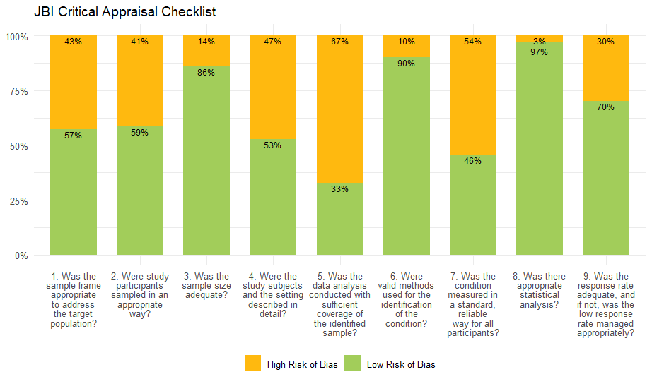

Appendix H: Quality Appraisal – Details
Authors | Q1. Was the sample frame appropriate to address the target population? | Q2. Were study participants sampled in an appropriate way? | Q3. Was the sample size adequate? | Q4. Were the study subjects and the setting described in detail? | Q5. Was the data analysis conducted with sufficient coverage of the identified sample? | Q6. Were valid methods used for the identification of the condition? | Q7. Was the condition measured in a standard, reliable way for all participants? | Q8. Was there appropriate statistical analysis? | Q9. Was the response rate adequate, and if not, was the low response rate managed appropriately? | Total
Admasie, C. 2014 [1] | 1 | 1 | 0 | 1 | 0 | 1 | 0 | 1 | 1 | 6
Admasie, C. 2014 [1] | Pregnant women attending antenatal care at selected government health centres. Health centres stratified as rural and urban, two rural and three urban selected by lottery | Multistage random sampling | Sample size calculation provided indicated 518 and actual sample size was 510 | Demographic details in table 1 (age, occupation, monthly income) and in socio demographic characteristics section (mean age, marital status, educational status, history of chronic disease, gravidity, planned pregnancy, hospitalization during current pregnancy, number of ANC visits). | No details regarding pregnancy outcomes and no details of how the sample relates to the wider population. | Clinic attendance and self-report during an interview | Interviews were not conducted at a consistent time point during pregnancy for all women. | Numerator, denominator and proportion provided. Confidence intervals not specified. | The authors state a response rate of 98.5%. | Medium
Alema, N. 2020 [2] | 0 | 1 | 0 | 1 | 0 | 1 | 0 | 1 | 0 | 4
Alema, N. 2020 [2] | Only covered pregnant women attending one hospital. | Systematic random sampling | Sample size calculation provided indicated 314 and actual sample size was 277. | Demographic detail in table 1 and 2 (age, religion, marital status, education status, occupation, urban/rural, gravida, planned pregnancy, number of visits to health facilities, history of chronic disease, reasons for visit to health facilities, time of first visit for antenatal care. | No details regarding pregnancy outcomes and no details of how the sample relates to the wider population. | Medical charts and registration log-books | Data extraction regarding medication use was not conducted at a consistent gestational stage for all women. | Numerator, denominator and proportion are provided. Confidence intervals not specified. | Sample size was not achieved | Medium
Alemu, B. 2019 [3] | 0 | 1 | 1 | 0 | 0 | 1 | 0 | 1 | 1 | 5
Alemu, B. 2019 [3] | Only covered pregnant women attending one hospital. | Systematic random sampling | Authors provided sample size calculation of 263 and 263 women were included | Demographic details in table 1 (age, gravidity, number of MCH visits). No details regarding maternal health, education or income status, or parity and gestational age. | No details regarding pregnancy outcomes and no details of how the sample relates to the wider population | Medical records | Information was collected up to the time point available in the records, not consistent for all women. | Numerator, denominator and proportion are provided. Confidence intervals not specified. | Not applicable since collected sufficient medical records to meet sample | Medium
Alemu, M. 2024 [4] | 0 | 1 | 0 | 0 | 0 | 1 | 0 | 1 | 0 | 3
Alemu, M. 2024 [4] | Only covered pregnant women attending one hospital. | Simple random sampling and systematic random sampling | The authors provide a sample size calculation of 384 and the sample was 359. | Details regarding maternal age, education, income, parity and chronic health status. No details regarding pregnancy outcome, obstetric health or maternal habits. | No details regarding pregnancy outcomes and no details advising of how the sample relates to the wider population. | Medical records | Information was collected up to the time point available in the records. This was not consistent for all women, some were in their 1st, 2nd and 3rd trimesters. | Numerator, denominator and proportion are provided. Confidence intervals not specified. | Sample size was not achieved | Low
Almuhareb, A. 2024 [5] | 1 | 0 | 1 | 0 | 0 | 0 | 0 | 1 | 0 | 3
Almuhareb, A. 2024 [5] | Pregnant women residing in Riyadh City. | Convenience and snowball sampling | Sample size calculation provided gave 383 and actual sample size was 562. | Demographic details in table 1 (age, nationality, education, occupation, number of pregnancies). No details regarding maternal health, income status, parity or gestational age. | No details regarding pregnancy outcomes and no details advising of how the sample relates to the wider population. | WhatsApp and emails, unclear how contact details were obtained. Medication use was identified through self-report on a survey. | Medication use was identified through self-report during an interview however women were at different gestational stages at the interview. | Numerator, denominator and proportion are provided. Confidence intervals not specified. | Response rate Not specified | Low
Al-Riyami, I. 2011 [6] | 0 | 0 | 1 | 1 | 0 | 1 | 0 | 1 | 0 | 4
Al-Riyami, I. 2011 [6] | Women attending one hospital and one community clinic both in Muscat, Sultanate of Oman. | Convenience sampling | Sample size calculation in study gave 122 and study sample was 139. | Table 1 provides demographic details (mean age, educational status, employment status, planned pregnancy, parity, prior pregnancy method of delivery). | No details regarding pregnancy outcomes. No details how the sample relates to the wider population. | Antenatal care attendance, self-report via a survey validated by electronic patient records. | Women were at different gestational stages when the interview was conducted. | Numerator denominator and proportion provided. Confidence intervals not reported. | No response rate provided. It is not reported how many participants declined participation in the study. | Medium
Alyami, M. 2023 [7] | 0 | 0 | 1 | 1 | 0 | 1 | 0 | 1 | 0 | 4
Alyami, M. 2023 [7] | Women attending one hospital. | Convenience sampling | The authors provide a sample size calculation of 270 and the actual sample size was 287. | Demographic details provided in table 1 (age, gestational age, Saudi nationals, marital status, residence, education, obstetric history). No details regarding maternal health or income. | No details regarding the birth outcomes included. No details how the sample relates to the wider population. | Women attending the obstetrics and gynaecology department. Medication use identified by questionnaire. | Medication use identified through a questionnaire. Tool was assessed for face and content validity by 3 experts. The questionnaire was not conducted at the same gestational time for all women. | Numerator, denominator and proportion are provided. Confidence intervals not specified. | No response rate provided. | Medium
Araujo, M. 2021 [8] | 1 | 1 | 1 | 0 | 1 | 1 | 1 | 1 | 1 | 8
Araujo, M. 2021 [8] | The sample was drawn from women covered by French health insurance, breakdown similar in age and sex to the overall population. | Random sample representative of the population covered by health insurance. | Large national sample so assume to be large enough. | Demographic details provided in the results section (age range, mean age, pregnancy outcome, mean gestational age for live births). No details regarding parity, health, education or income status. | The sample includes pregnancies ending in delivery, the author state that the sample is representative of all French pregnant women | Pregnancy was identified through health care reimbursement data based on ICD codes.  Medication use was based on reimbursed medications. | Records of reimbursed medications dispensed during the course of pregnancy. | Numerator, denominator and proportion are provided. Confidence intervals not specified. | No response rate provided, but large national sample used. | High
Artama, M. 2011 [9] | 1 | 1 | 1 | 0 | 1 | 1 | 1 | 0 | 1 | 7
Artama, M. 2011 [9] | Close to full population of pregnancies in Finland during the specified timeframe. | The data is from a national cohort which covers almost the full population of births and terminations of pregnancy. | The study includes a large national sample so it can be assumed to be large enough. | Table 2 has demographic details (maternal age at delivery, parity, socioeconomic status, smoking status during pregnancy). No summary of gestational age, health status or maternal education. | Covers births (pregnancies at least 22 weeks gestational age or 500g) and termination of pregnancy. Women were not excluded based on demographic details. | Pregnancies were identified from three registers relating to births, abortions and congenital malformations. Medication use identified from database on reimbursed prescriptions from pharmacies, covers 99% of prescribed medications in Finland. | Prescribed reimbursed medicines from almost all pharmacies in Finland. Covers during pregnancy and 1 month prior to pregnancy. | Numerator, denominator and proportions provided. Different groupings of births and terminations used so there is a lack of consistency in reporting throughout the paper. Confidence intervals not specified. | The study included close to full population. | High
Baraka, M. 2013 [10] | 0 | 0 | 1 | 0 | 0 | 1 | 0 | 1 | 0 | 3
Baraka, M. 2013 [10] | Women attending one hospital. | Convenience sampling | No sample size calculation provided and sample was 641.  A sample size calculation would have given n=1.96^2*(0.5)*(1-0.5)/(0.05)^2=384 | Table 1 provides demographic details (age, parity, ethnicity). No details on gestational age, health, income or education status. | No details of pregnancy outcomes included. No details of how the sample relates to the wider population. | Pregnant women were identified through hospital attendance. Medication identified through self-report using interviews. | Interview during clinic attendance, however, interviews were not conducted at a consistent time. | Numerator denominator and proportion provided. Confidence intervals not reported. | No response rate provided. It is not reported how many participants declined participation. | Low
Bebitoglu, B. 2022 [11] | 0 | 0 | 1 | 1 | 0 | 1 | 0 | 1 | 1 | 5
Bebitoglu, B. 2022 [11] | Women were sampled from women attending one hospital. | Convenience sampling | A sample size calculation gave a sample size of 461. The sample size was 469. | There are details regarding maternal age, ability to read, employment, smoking status, alcohol use, gravidity, chronic disease and assisted reproduction. | No details regarding the birth outcomes included. No details as to how the sample relates to the wider population. | Pregnant women were identified through clinic attendance and medication use was identified through self-report. | Data was not collected at the same gestational stage, women were in their 1st, 2nd or 3rd trimesters. | Numerator denominator and proportion provided. Confidence intervals not reported. | Response rate of 93.3% provided | Medium
Bedewi, N. 2018 [12] | 0 | 1 | 1 | 0 | 0 | 1 | 0 | 1 | 1 | 5
Bedewi, N. 2018 [12] | Only covered pregnant women attending one hospital. | Simple random sampling | Sample size calculation provided gave 369 and actual sample size was 369. | Demographic data in table 1 (age, gravidity, area of resident). No details regarding maternal health, education or income status, parity or gestational age. | No details regarding pregnancy outcomes and no details advising of how the sample relates to the wider population. | Pregnant women were identified from their hospital medical records. Medication use was also identified from the medical records. | Medication use was based on records of medication prescribed in the medical records. It is unclear if all women had completed pregnancy at time of data extraction. | Numerator, denominator and proportion provided. Confidence intervals not specified. | Response rate not applicable as data taken from records and they extracted just the number needed to meet their sample size calculation. | Medium
Berard, A. 2022 [13] | 1 | 1 | 1 | 0 | 0 | 1 | 1 | 1 | 1 | 7
Berard, A. 2022 [13] | Close to full population of births in the regions Quebec, Manitoba, Saskatchewan and Alberta. With some bias in the Quebec population toward those of lower sociodemographic status due to data from public insurance coverage. | The data covers almost full population for the regions for which there is full data availability and mother child linkage possible. | The study includes a combination of large regional samples so it can be assumed to be large enough. | No details of participant demographics | For most regions covered, no exclusions are made based on demographic data. For Quebec the women are those covered by public healthcare and while comorbidities are similar to other regions they are of lower socio-economic status. | Pregnancies identified by records of a prenatal visit or a therapeutic procedure related to pregnancy and through linkage with a child. Medication use was identified from records for filled prescribed medications during pregnancy. | Filled prescribed medications during pregnancy. Covered time from first day of last menstrual period to pregnancy outcome. | Proportion provided, denominator can be calculated by adding the totals for each region, numerator calculated based on proportion and denominator. Confidence intervals not specified. | As the sample is from a large regional cohort, this is assumed to be sufficiently large. | High
Berard, A. 2014 [14] | 0 | 1 | 1 | 0 | 0 | 1 | 1 | 1 | 1 | 6
Berard, A. 2014 [14] | Sampled from those with pharmaceutical coverage in the RAMQ (roughly 43% of the region's population) which is typically those who are of lower socioeconomic status but comparable in terms of comorbidity. | Essentially full population who were eligible and present in the database. | Large national sample so assume to be large enough. | Table 1 (maternal age, duration of pregnancy, living in rural area, welfare recipient, comorbidities). Table 3 demographic details cannot be used as only covers a very small group of the sample. No details concerning obstetric health or education. | Pregnancy outcomes included deliveries, planned abortions and miscarriages. While the authors state that the sample is representative in terms of comorbidities, it covers those of a lower socioeconomic status. | Pregnant women identified by a prenatal visit or therapeutic procedure related to pregnancy in the database.  Medication use based on records of dispensed medications. | Medications covered on the drugs list and dispensed or interval overlapping pregnancy. | Denominator and proportion provided. Numerator and confidence intervals not specified. | No response rate provided, but large national sample used. | Medium
Berard, A. 2019 [15] | 1 | 1 | 1 | 0 | 1 | 1 | 1 | 1 | 1 | 8
Berard, A. 2019 [15] | The sample is drawn from women covered by French health insurance, breakdown similar in age and sex to the overall population. | Random sample representative of the population covered by health insurance. | 1/97th representative sample of all women covered by French health insurance ~ 36,000 so assume sufficiently large. | Demographic details in table 1 (calendar year of pregnancy, maternal age, gestational age, multiplicity, maternal comorbidities). No details regarding parity, education or income status. | The sample includes pregnancies ending in delivery, the author state that the sample is representative of all French pregnant women. | Pregnancies were identified through ICD-10 codes in the database. Medication use identified through records of reimbursed prescriptions with the timeframe overlapping the pregnancy period. | From records of reimbursed medications where the issue date of the medication was during the pregnancy timeframe or overlapped the pregnancy interval. | Numerator, denominator and proportion are provided. Confidence intervals not specified. | No response rate provided, but large national sample used. | High
Bercaw, J. 2010 [16] | 0 | 0 | 0 | 1 | 0 | 1 | 1 | 1 | 0 | 4
Bercaw, J. 2010 [16] | Only one hospital was used to obtain sample. | Convenience sampling | Sample size calculation of 490 provided but only 485 included. | Table 1 provides demographic details (age, past pregnancies, marital status, education, place of birth primary language, medical and obstetric history, insurance, prenatal care). | Only women attending one public hospital were included. The sample was also biased towards those who were young with low educational attainment and uninsured. | Women were identified during their post-partum stay in hospital. Medication use was self-reported. | Questionnaire - self reported survey completed during their post-partum stay. | Numerator, denominator and proportion are provided. Confidence intervals not specified. | Article states that 10% of women approached declined participation, and sample size did not achieve that in sample size calculation. | Medium
Bjorn, A. 2011 [17] | 1 | 1 | 1 | 0 | 1 | 1 | 1 | 1 | 1 | 8
Bjorn, A. 2011 [17] | Close to full population of primiparous women who gave birth >= 22 weeks in the central and northern regions of Denmark which comprise 33% of the Danish population. | The data is from a national cohort which covers almost the full population of births >= 22 weeks from primiparous women. | The study includes a large national sample so it can be assumed to be large enough. | Table 1 has demographic details (maternal age, smoking status, multiplicity and birth weight). No details provided on maternal health status, parity, education, income or gestational age. | Includes only primiparous women. Women were only included from two Danish regions but were not excluded based on any other demographic details. | Pregnancies were identified from a birth registry. Medication use was identified from a prescription database which only covers outpatient pharmacies. | Redeemed prescriptions from outpatient pharmacies. Covers 30 days before conception to end of pregnancy. | Numerator, denominator and proportion are provided. Confidence intervals not specified. | The study included close to full population. | High
Bornhauser, C. 2017 [18] | 1 | 1 | 0 | 0 | 0 | 1 | 0 | 1 | 0 | 4
Bornhauser, C. 2017 [18] | Close to full population of women aged 15 and older, excluding those in hospitals or care homes. | Stratified random sampling | No sample size calculation provided and sample was 309.  A sample size calculation would have given n=1.96^2*(0.5)*(1-0.5)/(0.05)^2=384 | Demographic details in table 1 (year of survey, age, language, marital status, housing area, region, nationality, origin, paid work, full-time/part-time, degree of employment, personal net income). Table 2 has health status (self-reported health, presence of medication problems). No details of education status, parity or gestational age. | No birth outcomes detailed and while the wider survey is representative of the general population, there are no details as to whether this holds true when only the pregnant women are extracted. | Pregnancy was identified through self-report on the survey. Medication use was also self-report on the survey. | Medication use was related only to the past 7 days. | Numerator, denominator and proportion provided. Confidence intervals not specified. | No response rate detailed. | Medium
Brian, M. 2025 [19] | 0 | 0 | 1 | 1 | 0 | 1 | 0 | 1 | 0 | 4
Brian, M. 2025 [19] | Only one hospital was used to obtain sample. | Convenience sampling | Sample size calculation given was 404 and sample size was 415. | Details are provided regarding maternal age, education, occupation, health problems, obstetric health. | No details regarding birth outcomes included. Participants were sampled from one hospital, no details how this relates to the wider population. | Pregnant women were identified through clinic attendance and medication use was identified through self-report. | Data was not collected at the same gestational stage, women were in their 1st, 2nd or third trimesters. | Numerator, denominator and proportion provided. Confidence intervals not specified. | No response rate detailed. | Medium
Campos, H. 2023 [20] | 1 | 0 | 0 | 1 | 0 | 1 | 0 | 1 | 0 | 4
Campos, H. 2023 [20] | Women receiving care in the municipality of Barreiras Bahia. | Convenience sampling | No sample size calculation provided and sample was 337.  A sample size calculation would have given n=1.96^2*(0.5)*(1-0.5)/(0.05)^2=384 | Demographic details in table 1 (maternal age, planned pregnancy, schooling, marital status, family income, economic class, skin colour, smoker, alcohol consumption, number of previous pregnancies, history of miscarriage, start of pre-natal care). | There are no details regarding pregnancy outcomes and no details advising of how the sample relates to the wider population. | Women were identified through attendance at a pre-natal appointment. Medication use was identified through self-report on an interview. | Women were not all at the same gestational stage. | Denominator and proportion provided. Numerator and confidence intervals not specified. | No response rate provided | Medium
Ceulemans, M. 2022 [21] | 1 | 0 | 1 | 0 | 0 | 0 | 0 | 0 | 1 | 3
Ceulemans, M. 2022 [21] | Pregnant women older than 18 years in the countries included in the study. | Convenience sampling | No sample size calculation provided and sample was 3339.  A sample size calculation would have given n=1.96^2*(0.5)*(1-0.5)/(0.05)^2=384 | Demographic data provided in table 1 (country, age, relationship status, professional status, education, smoking). No details regarding health, parity or gestational age. | Data covered samples from multiple countries and there are no details regarding how the respective samples related to the populations of the various countries. | Pregnant women and medication use were identified through self-report on an online survey circulated via social media. | Self-reported in a questionnaire but only asks about medication usage over past 3 months so misses some of pregnancy. | Numerator, denominator and proportion are provided. However numbers differ slightly in different tables. | Response rate 87% | Low
Ceulemans, M. 2019 [22] | 0 | 0 | 0 | 1 | 0 | 0 | 0 | 1 | 1 | 3
Ceulemans, M. 2019 [22] | Only one hospital was used to obtain sample. | Convenience sampling | No sample size calculation provided and sample was 379.  A sample size calculation would have given n=1.96^2*(0.5)*(1-0.5)/(0.05)^2=384 | Demographic data in table 1 (age, nationality, country of birth, language, education, occupation, marital status). Table 2 contains obstetric details (gestational trimester, multiplicity, parity, past miscarriage, reproductive assistance, BMI). | There are no details regarding the birth outcomes included. The sample is drawn from one hospital and there are no details regarding how this relates to the wider population. | Pregnant women identified by attendance at outpatient obstetrics clinic for antenatal care.  Medication identified through self-report on a questionnaire, however the questionnaire only asked about the past 30 days. | Self-reported on a questionnaire but timeframe only covers the past 30 days. | Denominator and proportion provided but numerator not specified. | Response rate 87% | Low
Chang, Y. 2023 [23] | 1 | 1 | 1 | 1 | 0 | 0 | 0 | 1 | 1 | 6
Chang, Y. 2023 [23] | A nationally representative sample. | The NHANES sample represents the noninstitutionalized civilian population and consists of a multi-year stratified clustered four stage sample with some subgroups oversampled to increase precision. | No sample size calculation provided and sample was 1591.  A sample size calculation would have given n=1.96^2*(0.5)*(1-0.5)/(0.05)^2=384 | Demographic data in table 1 (race, age, marital status, poverty income ratio, educational level, health status, health insurance). | No details regarding the birth outcomes included in the study. No details regarding how the sample relates to the wider population. | Women who answered yes to question on pregnancy status in the interview. Medication use identified through a national survey but the survey only asked about the past 30 days. | Self-reported medication use in response to a survey for the 30 days prior to the survey however no details provided about the gestational stage of the women. | Denominator and proportion provided. Numerator and confidence intervals not specified. | 1999/2000 - 82%  2001/02 - 84%  2003/04 - 79%  2005/06 - 80.45%  2007/08 - 78.4%  2009/10 - 79.4%  2011/12 - 72.6%  2013/14 - 71.0%  2015/16 - 61.3% | Medium
Cleary. B. 2010 [24] | 0 | 1 | 1 | 1 | 0 | 1 | 0 | 1 | 1 | 6
Cleary. B. 2010 [24] | Only covered one hospital. | Essentially full population of those eligible. | Large sample, so assume large enough 62,063 | Demographic details in table 3 (age at delivery, gestation at delivery, gestation at booking, parity, planned pregnancy, socioeconomic group, nationality, region, marital status, smoking, alcohol use, public / private). | Sample covers only one hospital and no details regarding how this relates to the wider population. Birth outcomes not detailed. | Pregnant women were identified at their booking interview at the hospital. Medication use was identified through self-report during the booking interview. | Exposure timeframe was not consistent for all women as women had their booking interview at different gestational stages from less than 12 weeks to 20 weeks. | Numerator, denominator and proportion provided. Confidence intervals not specified. | Large database study. | Medium
Crespin, S. 2011 [25] | 0 | 1 | 1 | 0 | 0 | 1 | 0 | 1 | 1 | 5
Crespin, S. 2011 [25] | Women who gave birth in the Midi-Pyrenees region registered for National Health Insurance Fund for salaried employees. Unemployed or self-employed not captured. | Essentially full population of those eligible. | Large national sample so assume to be large enough. | The only demographic details provided were mean, median and range of maternal age. | The sample covered includes women who gave birth in the region. The sample only covered salaried employees so does not cover self-employed or unemployed. | Pregnancies and medications identified from a health insurance database. | At least one reimbursed prescribed and dispensed medication, during pregnancy, excluding the 9th month where pregnancy was > 8 months. | Numerator, denominator and proportion are provided. Confidence intervals Not specified. | No response rate provided, but large national sample used. | Medium
Daw, J. 2012 [26] | 0 | 1 | 1 | 0 | 1 | 1 | 1 | 1 | 1 | 7
Daw, J. 2012 [26] | Close to full population of live births in hospitals in British Columbia. Excluded women with hospital stay post birth of > 7 days as assumptions about gestational age would not hold true. Some complicated births would be excluded. | Essentially full population of those eligible. | Large national sample so assume to be large enough. | No demographic details provided | Sample covered all live births in the region during the timeframe. Women were not excluded based on demographic details. | Pregnancy identified using ICD 10 diagnostic code indicating delivery on maternal hospital record. Medications from outpatient prescription drug claims database. | Prescriptions dispensed from community pharmacies during pregnancy. | Denominator and proportion provided. Numerator and confidence intervals not specified. | Database study | High
deCastro, C. 2024 [27] | 1 | 0 | 1 | 1 | 0 | 1 | 0 | 1 | 0 | 5
deCastro, C. 2024 [27] | All women of the region attending prenatal care. | Not specified | No sample size calculation provided and sample was 1058. A sample size calculation would have given n=1.96^2*(0.5)*(1-0.5)/(0.05)^2=384 | Details are provided regarding maternal age, education, income, general health, smoking, obstetric history and gravidity. | There are no details regarding the birth outcomes included in the study. There are no details regarding how the sample relates to the wider population. | Pregnant women were identified through prenatal clinic attendance. Medication use was identified through self-report in an interview. | Women were not interviewed at the same gestational stage. | Proportion and denominator provided, numerator not provided. | No response rate provided. | Medium
deWaard, M. 2019 [28] | 1 | 0 | 1 | 1 | 0 | 1 | 1 | 1 | 0 | 6
deWaard, M. 2019 [28] | In the main good coverage, women receiving hospital or home birth care from a regional medical centre. Excludes some poor outcomes, where new-born had poor life expectancy. | Convenience sampling | Sample size calculation of 196 provided and total sample was 292. | Table 2 contains demographic information (parity, caesarean section, ethnicity, education, risk level of delivery, reason for high-risk delivery), also demographic details under characteristics of sample (mean age, mean gestational age and mean birth weight). | Covers pregnancies ending in a birth. Some high-risk pregnancies excluded as women whose child had a life expectancy of less than 72 hours were excluded. The sample was mainly from one hospital and there are no details of how this relates to the wider population. | Pregnant women were identified by attendance for obstetric care at the hospital. Medication use was identified by self-report on a survey. | Self-reported on a survey excluding medications administered during labour. The survey was conducted within 4 months after discharge home. Potentially some issues with recall. | Numerator, denominator and proportion provided. Confidence intervals not reported. | While there is a flow chart of study participants there is no response rate calculation so it is unclear if the response rate is adequate. | Medium
Dillon, P. 2015 [29] | 0 | 1 | 1 | 0 | 0 | 1 | 1 | 1 | 1 | 6
Dillon, P. 2015 [29] | Only covered 9 General Practitioner practices and these were a convenience sample of practices. | All relevant patients from these practices were included. | No sample size calculation provided and sample was 2361. A sample size calculation would have given n=1.96^2*(0.5)*(1-0.5)/(0.05)^2=384 | Demographic details regarding age, private / public status and reimbursement status are provided. No details regarding gestational age, parity, health, education or income status. | Pregnancies all ended in a birth. Miscarriages were excluded. Abortions not legal in Ireland at the time of the study however, women may have travelled abroad. Most women were private patients. | Pregnant women identified from their attendance for antenatal care. Medication use was identified from records of GP issued prescriptions. | GP issued prescriptions - where issue date fell during the pregnancy timeframe which was defined as the LMP plus 40 weeks. | Numerator, denominator and proportion are provided. Confidence intervals not specified. | All eligible women available in the database. | Medium
Donald, S. 2020 [30] | 1 | 1 | 1 | 1 | 1 | 1 | 1 | 1 | 1 | 9
Donald, S. 2020 [30] | Close to full population of pregnancies in New Zealand for the specified timeframe. | The data is from a national cohort which covers almost the full population of births, miscarriages, terminations and early pregnancy loss. | The study includes a large national sample so it can be assumed to be large enough. | Table 1 has demographic details (maternal age group, ethnicity, deprivation, BMI, smoking status, parity, pregnancy outcome)  No details of maternal education or gestational age. | No women excluded based on demographic details. All pregnancy outcomes (live births, stillbirths, miscarriage, termination, extrauterine pregnancy / non-viable products of conception) are included. | Pregnancies identified from a national health database with details on live / stillbirths and early pregnancy loss. Medication use identified using records from outpatient pharmacies. | Dispensed prescriptions of publicly funded medications from outpatient pharmacies. Covers 14 days after the LMP to pregnancy outcome. | Denominator and proportion provided for all birth outcomes together but no numerator. Denominator and proportion provided for births (live births / stillbirths) but no numerator. No confidence intervals. | The study included close to full population. | High
Engeland, A. 2018 [31] | 1 | 1 | 1 | 0 | 1 | 1 | 1 | 1 | 1 | 8
Engeland, A. 2018 [31] | Close to full population coverage of singleton pregnancies lasting at least 12 weeks with supplementary information on multiples. | Essentially full population of those eligible. | Large national sample so assume to be large enough. | Demographic details provided in table 1 (year of birth, maternal age, parity, maternal country of birth). No details concerning gestational age, health, education or income status. | The sample includes singleton pregnancies lasting at least 12 weeks. Separate analysis was conducted on multiples. Women were not excluded based on any demographic details. | Pregnancies identified from a birth register. Medication use identified from a prescription database covering pharmacies in ambulatory care. | Records of medications dispensed during pregnancy. | Numerator, denominator and proportion are provided. Confidence intervals not specified. | No response rate provided, but large national sample used. | High
Etefa, K. 2015 [32] | 1 | 1 | 1 | 0 | 0 | 1 | 0 | 1 | 1 | 6
Etefa, K. 2015 [32] | Pregnant women residing in Arada subcity and surrounding area attending antenatal care services in one of the seven health centres. | Systematic random sampling. | A sample size calculation given was 314 and the actual sample size was 314. | Table 1 contains demographic details (age, time of first visit, number of visits). No details regarding maternal health, education, income, parity or gestational age. | Birth outcomes are not detailed and there are no details regarding how the sample represents the wider population. | Women attending an antenatal clinic. | Women were not interviewed at the same gestational stage. | Numerator, denominator and proportion provided. Confidence intervals not specified. | All selected records were included. | Medium
Fortinguerra, F. 2023 [33] | 1 | 1 | 1 | 1 | 1 | 1 | 1 | 1 | 1 | 9
Fortinguerra, F. 2023 [33] | Women resident in the covered regions of Italy, aged 15-49 and who gave birth in a Birth Unit. | Essentially full population of those eligible. | Large national sample so assume to be large enough. | Demographic details in table 1 (age, nationality, education, occupational status, previous birth / miscarriage, gestational age at birth, parity, invasive prenatal diagnosis, assisted reproduction, previous caesarean section). | Sample covers the first delivery of a women aged 15-49 during the timeframe. Women were not excluded based on other demographic details. | Pregnancies identified from a birth registry and medications identified from prescriptions database. | Reimbursed prescriptions taken during pregnancies. | Numerator, denominator and proportion are provided. Confidence intervals not specified. | No response rate provided, but large national sample used. | High
Gebremedhin, L. 2014 [34] | 1 | 1 | 0 | 0 | 0 | 1 | 0 | 1 | 0 | 4
Gebremedhin, L. 2014 [34] | Covered women attending both government and private hospitals.  Excluded women who visited the hospitals less than twice. | Systematic random sampling. | The authors provide a sample size calculation of 422 but the sample size was only 400. | Table 1 contains demographic details (age, marital status, educational status, employment status). No details on maternal health, income, parity or gestational age. | Birth outcomes are not detailed and there are no details regarding how the sample represents the wider population. | Women attending the hospitals. | No details of the timing of the survey and data extraction so it is not possible to determine the gestational stage of the women and if this was consistent. | Numerator, denominator and proportion provided. Confidence intervals not specified. | Response rate unknown | Medium
Gerbier, E. 2022 [35] | 0 | 0 | 1 | 1 | 0 | 0 | 0 | 1 | 0 | 3
Gerbier, E. 2022 [35] | The population of pregnant women in a number of countries who visited the websites where the survey was advertised. | Convenience sampling | No sample size calculation provided and sample was 5210.  A sample size calculation would have given n=1.96^2*(0.5)*(1-0.5)/(0.05)^2=384 | Demographic details provided in table 1 (country, age, relationship status, professional status, working in healthcare, level of education, smoking during pregnancy, chronic disease, parity, planned pregnancy, gestational weeks, covid infection). | There are no details regarding the birth outcomes included in the sample. The sample included data from multiple countries and there are no details regarding how these relate to the population of each country. | Self-identified through websites, forums and social media. | Self-reported medication use for the past three months. Women were at different gestational stages 1st, 2nd and 3rd trimester. | Numerator, denominator and proportion are provided. Confidence intervals not specified. | No response rate provided. | Low
Given, J. 2022 [36] | 1 | 1 | 1 | 0 | 1 | 1 | 0 | 1 | 1 | 7
Given, J. 2022 [36] | Close to full population of Northern Ireland where data was available for early pregnancy. A small number of exclusions due to concerns about data accuracy. | The database covers the full population with the exclusion of data with missing relevant data. | Large national sample so assume to be large enough. | Demographic details provided in results section (mean gestational age at delivery, parity, mean maternal age. In table S2 there is information about maternal age and pregnancy planning and table S3 information about deprivation index. No details about parity, health or education status. | The cohort includes deliveries. Women were not excluded based on demographic details. | Pregnancies identified from a maternity system database. Medication use was identified from a database of redeemed prescriptions dispensed from community pharmacies. | This covered early pregnancy so data covers women up to the date of the booking interview which can be up to 20 weeks. As gestational age varies at the booking interview, medication use was not evaluated at a consistent time point as half of women were within the first ten weeks of pregnancy. | Numerator denominator and proportion provided. Confidence intervals not reported. | As the sample is taken from a database, there is no response rate applicable. The sample size is sufficiently large. | High
Haas, D. 2018 [37] | 0 | 0 | 1 | 0 | 0 | 1 | 1 | 1 | 0 | 4
Haas, D. 2018 [37] | Women aged at least 13 years were recruited from eight geographically diverse clinical centres. No details of how these sites were selected. | No details of how participants were sampled. | No sample size calculation provided and sample was 9546.  A sample size calculation would have given n=1.96^2*(0.5)*(1-0.5)/(0.05)^2=384 | Table 1 and 2 contain demographic details (age, race/ethnicity, education, health payment, income). All women were nulliparous. No details regarding maternal health or gestational age. | Birth outcomes are not detailed and no details regarding how the sample represents the wider population. | Women attending clinical centres. | Women were asked about medication usage during multiple study visits up to the time of delivery. | Numerator, denominator, proportion and confidence intervals provided. | Response rate unknown. | Medium
Houben, E. 2019 [38] | 1 | 0 | 1 | 1 | 0 | 1 | 1 | 1 | 1 | 7
Houben, E. 2019 [38] | Sampled from a national registry of pregnancies with a gestational age of at least 16 weeks. | While the outpatient pharmacy database is said to be representative of the population, linkage could only be obtained for about 20% so it is difficult to identify if this was sampled in an appropriate way. | Large national sample so assume to be large enough. | Demographic details presented in table 2 (age at delivery, socioeconomic status, year of delivery, ethnicity, parity, gestational age at birth). | Covers pregnancies of at >= 22 weeks, both live and stillbirths. It is not clear how the sample represents the wider population. | Pregnant women identified from a perinatal registry with a gestational age >= 22 weeks. Medications identified from drug dispensing records from outpatient pharmacies. | Medications prescribed and dispensed from out-patient pharmacies during pregnancy. | Numerator and denominator provided but no confidence interval. | No response rate provided, but large national sample used. | High
Ingstrup, K. 2018 [39] | 1 | 1 | 0 | 1 | 1 | 1 | 1 | 1 | 1 | 8
Ingstrup, K. 2018 [39] | Close to full population of pregnant women between 15 and 55 who delivered and resided in Denmark. | Essentially full population of those eligible. | Large national sample so assume to be large enough. | Demographic details in table 1 (age at conception, parity, smoking, socioeconomic status at conception (quartiles), calendar year of childbirth). | Covers all live-born singletons in Denmark during the study period aged 15-55. Women were not excluded based on other demographic details. | Pregnancies were identified from a birth registry and medications were identified from a prescription registry related to community pharmacies. | Medication use was determined based on prescriptions redeemed from the first day of the last menstrual period to delivery. | Numerator, denominator, proportion and confidence intervals provided. | Database study | High
Irvine, L. 2010 [40] | 1 | 1 | 1 | 1 | 1 | 1 | 1 | 1 | 1 | 9
Irvine, L. 2010 [40] | All women who gave birth in the region of Tayside. | Essentially full population of those eligible. | Large national sample so assume to be large enough. | Details provided in table II (age at conception, parity, deprivation score, current smoker, estimated gestation). | Sample covers all women who gave birth in the region. No exclusions based on demographic details. | Pregnant women identified from maternity records and medications identified from dispensing records from community pharmacies. | Medications dispensed during pregnancy from community pharmacies. | Numerator, denominator and proportion are provided. Confidence intervals not specified. | No response rate provided, but large national sample used. | High
Jackson, H. 2023 [41] | 1 | 1 | 1 | 0 | 1 | 1 | 1 | 1 | 1 | 8
Jackson, H. 2023 [41] | All women who gave birth at >= 20 weeks or >=400g who were entitled to Medicare benefits, this is all citizens of Australia or New Zealand or where a health care agreement is in place. | Essentially full population of those eligible. | Large national sample so assume to be large enough. | Demographic details in table 1 (plurality, maternal age, gravidity, country of birth, indigenous status, funding for antenatal care, smoking, BMI, medical conditions, pregnancy complications, birth outcome). No details on education, income status or gestational age. | Sample contains women who gave birth at >= 20 weeks or 400g. Women were not excluded based on demographic details. | Pregnant women identified from perinatal database. Medication identified from medications claimed. | Medications dispensed approved for public subsidy from after day 30 of pregnancy to the date of delivery. | Denominator, numerator, proportion and confidence intervals provided. | No response rate provided, but large national sample used. | High
Judistiani, R. 2023 [42] | 0 | 0 | 1 | 1 | 0 | 1 | 0 | 1 | 0 | 4
Judistiani, R. 2023 [42] | Women receiving antenatal care at community health posts. No details about how these represent the population. | Convenience sampling | Sample size calculation of 384 provided in the study, actual sample size was 439. | Demographic details provided in table 2 (age, educational status, parity, gestational age, antenatal care provider, health insurance). | No details regarding the birth outcomes included and no details regarding how the sample relates to the wider population. | Women identified through attendance at antenatal care services.  Medication use identified through an interview and review of maternity books. | Interview during clinic attendance, interviews not conducted at a consistent time - some were in their 2nd trimester and some in their 3rd trimester. | Numerator, denominator and proportion are provided. Confidence intervals not specified. | No response rate is provided. | Medium
Khoa, J. 2017 [43] | 0 | 0 | 1 | 0 | 0 | 1 | 0 | 1 | 1 | 4
Khoa, J. 2017 [43] | Women sampled from just one hospital. | Convenience sampling | No sample size calculation provided and sample was 500.  A sample size calculation would have given n=1.96^2*(0.5)*(1-0.5)/(0.05)^2=384 | Table 1 contains demographic details (age, ethnicity, educational level). No details regarding health, income, parity or gestational age. | Birth outcomes are not detailed and there are no details regarding how the sample represents the wider population. | Women attending an antenatal clinic. | Women were not interviewed at the same gestational stage. | Numerator, denominator, proportion and confidence intervals provided. | The response rate was 94.7% | Medium
Larcin, L. 2021 [44] | 1 | 0 | 1 | 0 | 0 | 1 | 1 | 1 | 1 | 6
Larcin, L. 2021 [44] | A 1/40 sample of the Belgian population who gave birth and were covered by compulsory health insurance, representative in terms of sex and age of the national population. Some bias as self-employed people were excluded due to data availability. | Representative in terms of age and sex but no mention of how representative the sample is in terms of sociodemographic characteristics. Self-employed residents were excluded so this group have not been covered. | No sample size calculation was provided and sample was 23912. A sample size calculation would have given n=1.96^2*(0.5)*(1-0.5)/(0.05)^2=384 | Table 1 provides demographic details (maternal age, region of residence). No details regarding gestational age, parity, health, education or income. | Only pregnancies ending in births are included in the sample. The sample does not include women who were self-employed. | Pregnancies identified from a national health insurance database using codes related to the delivery of a baby. Medication use identified from a database of all medications from hospital pharmacies and reimbursed medications from public pharmacies. | Reimbursed medications from public pharmacies and all medications from hospital pharmacies. Covers pregnancy timeframe, which was assumed to be from date of delivery to 270 days previous, excluding the day of delivery. | Numerator, denominator and proportion are provided. Confidence intervals not specified. | As the sample is taken from a database, there is no response rate applicable. The sample size is sufficiently large. | Medium
Larcin, L. 2024 [45] | 1 | 1 | 1 | 1 | 1 | 1 | 1 | 1 | 1 | 9
Larcin, L. 2024 [45] | Close to full population of pregnancies in Belgium for the specified timeframe. | The database covers the full population with the exclusion of data that could not be linked or with missing relevant data. | The study includes a large national sample so it can be assumed to be large enough. | Table 4 has demographic information (maternal age, parity, maternal education, maternal social status, living alone, maternal nationality, multiplicity, region of residence, gestational age at birth, mode of delivery, congenital anomalies, birth weight, Apgar, infant mortality). | No women excluded based on demographic details. Included live births, stillbirths, abortions, ectopic pregnancies. Table 7 shows the sample covers 96.3% of all live births and 83.5% of all stillbirths. Table 8 compares the sample based on age, region of residence and mode of delivery for live births to the national population. | Pregnancies were identified by diagnostic codes associated with admissions. Medication use was identified using pharmacy claims database which covers both community and hospital pharmacies. | Reimbursed medications from community pharmacies and all dispensed medications from hospitalizations. Covers pregnancy, excluding the final week of pregnancy. For ectopic and abortions a fixed period of 8 and 12 weeks were assumed respectively. | Numerator and denominators provided for each birth outcome (live births, stillbirths, abortion, ectopic), these figures can be used directly for subgroups and summed for overall prevalence. Prevalence figure provided also for these groups and overall can be calculated. No confidence intervals. | The study included close to full population. | High
Leke, A. 2018 [46] | 1 | 1 | 1 | 1 | 0 | 1 | 1 | 1 | 0 | 7
Leke, A. 2018 [46] | Covered women delivering at a range of hospitals 20 out of 41, both public and private which were selected randomly. | A two-stage cluster sampling technique was used, eligible hospital were randomly selected and then all eligible women were invited to participate. | The authors provide a sample size calculation of 374 and the actual sample size was 795. | Demographic details in table 2 (health unit, health district, urban / rural, age, marital status, education, living condition, alcohol use, gravidity, parity, previous terminations /miscarriages, gestational age (GA) at interview, GA at booking, pregnancy planning, GA of pregnancy awareness, diseases / conditions). | Birth outcomes are not detailed and no details regarding how the sample represents the wider population. | Pregnant women were identified through hospital attendance at antenatal clinic. Medication use was identified through self-report in an interview. The timing of the interview was between 3 and 7 months gestation but the study relates only to first trimester medication usage and all women had completed the first trimester. | Gestational period for all women was the first trimester. While interviews took place between 3 and 7 months gestation all were asked about first trimester usage. The author acknowledges some impact of recall bias. | Numerator, denominator and proportion provided. Confidence intervals not specified. | Response rate unknown. | High
Leong, C. 2019 [47] | 1 | 1 | 1 | 1 | 1 | 1 | 1 | 1 | 1 | 9
Leong, C. 2019 [47] | Close to full population of pregnancies in the region of Manitoba during the specified timeframe. May have excluded some high-risk pregnancies due to the exclusion of long hospital stays post-delivery. | The data is from a regional cohort which covers almost the full population of births and abortions (spontaneous or planned). | The study includes a large regional sample so it can be assumed to be large enough. | Table 1 has demographic details (maternal age, gestational age, past pregnancies, parity, income quintile). | Molar or ectopic pregnancies were excluded. Women with a hospital stay of greater than 7 days and no birthdate were excluded, this may exclude some high risk / complicated deliveries. In a previous publication which the authors reference this was approximately 2%. | Pregnancies were identified using hospital discharge records and medical claims data. Medication use was identified using a database of medications dispensed from community pharmacies. | Prescribed medications dispensed from community pharmacies. Covers from the date of conception to the pregnancy outcome. | Figures for proportion of pregnancies for medication use for births and abortions separately in the text and denominator figures in table 1. These can be combined for overall prevalence. No confidence intervals.. | The study included close to full population. | High
Lupattelli, A. 2014 [48] | 0 | 0 | 1 | 1 | 0 | 0 | 0 | 1 | 0 | 3
Lupattelli, A. 2014 [48] | No sampling frame used. People with access to the internet and saw the notification about the study and self-selected to participate. Excludes those who did not hear about study. | Convenience sampling | No sample size calculation provided and sample was 9459.  A sample size calculation would have given n=1.96^2*(0.5)*(1-0.5)/(0.05)^2=384 | Demographic details in table 2 (region of residence, maternal age, previous children, marital status, working status, educational level, alcohol use, smoking). | The sample covers multiple countries and it is not detailed how this represents the populations in these countries. No birth outcomes are detailed. | Women were identified through self-report on a web-based questionnaire advertised through social networks. Mediation use was self-report on a survey. | Women were at different gestational stages when they completed the survey and there were also some women who had given birth to a child in the last year. | Numerator, denominator and proportion provided. Confidence intervals not specified. | 9615 women accessed the survey, 9483 women completed the survey. This is not a true response rate as we don't know how many encountered the survey. | Low
Lutz, B. 2020 [49] | 1 | 1 | 1 | 1 | 1 | 1 | 0 | 1 | 1 | 8
Lutz, B. 2020 [49] | All women who gave birth in the five maternity wards in Pelotas during the timeframe. | Essentially full population of those eligible for live or stillbirths. | 98.7% of the sample were included 4270 out of 4333 | Demographic details in table 1 (skin colour, age, schooling, monthly income, parity, prenatal consultation, marital status, smoking, health problems in pregnancy, hospitalization during pregnancy, pregnancy trimester at onset of prenatal care). | Covers all women who gave birth, both live and stillbirth, in the maternity wards during the timeframe. Women were not excluded based on demographic details. | Women were identified during hospital attendance. Medication use was identified through self-report in a survey. | Medication use was measured through a survey at the clinic between 16 and 24 weeks, participants were therefore not all at the same gestational stage. | Numerator, denominator, proportion and confidence intervals provided. | 98.7% of the sample were included 4275 out of 4333 | High
Marxer, C. 2024 [50] | 1 | 1 | 1 | 0 | 1 | 1 | 1 | 1 | 1 | 8
Marxer, C. 2024 [50] | An insurance database, health insurance is mandatory in the country. | All relevant women identified during the timeframe. | Large national sample so assume to be large enough. | Details provided on maternal age and pregnancy outcomes included. No details on maternal or obstetric health, education, income, habits. | All relevant records in the database during the timeframe. | Procedure codes used to identify women. Records of reimbursed medications from outpatient pharmacies used for medication usage. | Estimates were used regarding the exposure period of 270 days or 240 days for full term / preterm birth. Otherwise records were treated the same. | Numerator, denominator and proportion provided. Confidence intervals not specified. | All relevant records included. | High
McLay, J. 2017 [51] | 0 | 0 | 1 | 0 | 0 | 1 | 0 | 1 | 1 | 4
McLay, J. 2017 [51] | Data collection was from just one hospital for women attending for their mid-trimester scan or after giving birth. | Not detailed / convenience sampling | No sample size calculation provided and sample was 889.  A sample size calculation would have given n=1.96^2*(0.5)*(1-0.5)/(0.05)^2=384 | Demographic details provided in table 1 (age, education level). These details only relate to those who took medication not the full sample. No details regarding gestational age, parity, health or income status. | No details regarding birth outcomes included in the sample. The sample is a mix of women mid-pregnancy and immediately post live birth from one hospital, no details how this relates to the wider population. | Women were identified through their attendance for antenatal care or post-delivery. Medication use identified through a questionnaire which was tested for face and content validity. | The questionnaire was not conducted at a consistent time, some women were attending for their mid-trimester scan (18-21 weeks) and other were within the first 24 hours follow a live birth in the postnatal unit. | Numerator, denominator and proportion are provided. Confidence intervals not specified. | Response rates of 66% and 80% are reported in the study for the two different samples they used. | Medium
Mohammed, A. 2013 [52] | 0 | 0 | 1 | 1 | 0 | 1 | 0 | 1 | 0 | 4
Mohammed, A. 2013 [52] | Women were sampled from women attending one hospital. In addition, women were recruited from the antenatal clinic, psychiatry clinic, ambulatory clinic and internal medicine ward. The sample would be biased towards those with a medical condition due to recruitment from other wards than just routine antenatal care. | Consecutive sampling | The authors say that a sample size calculation was conducted based on a previous study done in a similar setting with a prevalence of medication use in pregnancy as 71.3% and with a 5% non-response rate this gave them a sample size of 339. The sample in the study was also 339 as they authors kept sampling until the target sample size was achieved. | Table 1 provides demographic details (age, religion, ethnic background, marital status, educational level, occupation, place of residence and income level). Table 2 has details on obstetric and medical history (pregnancy stage, parity, pregnancy planning, family planning, smoking, alcohol, pregnancy history). | No details regarding the birth outcomes included in the sample. The participants were sampled from one hospital and there are no details as to how this relates to the wider population. | Pregnant women were identified through hospital attendance. Medication use was identified through self-report on a questionnaire and details in the medical chart.  The questionnaire was pre-tested to assess its usability. Content and face validity of the questionnaire were checked. | Medication use was collected through an interview during clinic attendance, interviews were not conducted at a consistent time. Women were in their first trimester 56 (16.5%), second trimester 89 (26.3%) and third trimester 194 (57.2%). | Numerator denominator and proportion provided. Confidence intervals not reported. | No response rate provided. It is not reported how many participants declined participation in the study. | Medium
Molla, F. 2017 [53] | 1 | 1 | 1 | 0 | 0 | 1 | 0 | 1 | 1 | 6
Molla, F. 2017 [53] | Pregnant women receiving obstetrics-gynaecology and antenatal services in the region. | Multistage sampling and simple random sampling. | Sample size calculation provided gave 709 and actual sample size was 647. However as this is still larger than the estimated required sample size this is scored 1. n=1.96^2*(0.5)*(1-0.5)/(0.05)^2=384 | Demographic details in table 1 (age, marital status, education, employment, urban / rural). No details of maternal health, income status, parity or gestational age. | There are no details regarding pregnancy outcomes and no details advising of how the sample relates to the wider population. | Pregnant women were identified through hospital or health centre attendance and data on medication use was retrieved from the ante-natal care chart. | Medication use identified through review of antenatal care charts but data was not retrieved for the entire pregnancy only for the trimesters at the time of data collection. | Numerator, denominator and proportion are provided. Confidence intervals not specified. | The response rate was 91.3%. | Medium
Mosha, D. 2014 [54] | 1 | 0 | 1 | 1 | 0 | 1 | 1 | 1 | 1 | 7
Mosha, D. 2014 [54] | Pregnant women with gestational age below 20 weeks from health clinics and house visits. | Convenience sampling | No sample size calculation provided and sample was 2896  A sample size calculation would have given n=1.96^2*(0.5)*(1-0.5)/(0.05)^2=384 | Demographic details in table 1 (mean age, mean BMI, mean gestational age at enrolment, gravidity, recruited sites, alcohol, smoking, mean haemoglobin, HIV, syphilis). | Covers live births, stillbirths and abortions. Patient were recruited from both a health facility and the community. No details regarding how the sample relates to the general population. | Women identified through clinic attendance and medication use identified through monthly surveys and review of the patient logbook, prescription sheet or hospital registry until delivery. | Monthly surveys until delivery. | Numerator, denominator and proportion provided. Confidence intervals not specified. | 91.3% 1089 pregnant women were enrolled and 994 completed the follow-up. | High
Navaro, M. 2018 [55] | 0 | 1 | 1 | 1 | 0 | 1 | 0 | 1 | 1 | 6
Navaro, M. 2018 [55] | Three public General Hospitals and one Teaching Hospital selected randomly from the 16 hospitals that provides childbirth services in the geographic area. All pregnant women who presented for their routine clinical appointment were eligible. There are no details regarding how these represent the population. | The 4 hospitals were randomly selected from all 16 hospitals. All pregnant women attending their routine clinic appointment were eligible so assume all women were included. | Sample size calculation of 475 provided in the study, actual sample size was 503. | Demographic details in table 1 (age, nationality, marital status, education, employment, parity, pregnancy history, gestational age, pregnancy at risk, self-perceived health, health problems in last year, medication consultation in past year, GP visit in current pregnancy). | There are no details regarding birth outcomes. While the sample is drawn from many hospitals, there are no details as to how this relates to the wider population. | Women who attended for routine care at outpatient Gynaecology and Obstetrics clinics. Medication use identified by a questionnaire pretested for face and construct validity and question interpretation | The questionnaire was not completed at a consistent time, some were in 1st, 2nd or 3rd trimesters. | Numerator, denominator and proportion are provided. Confidence intervals not specified. | A response rate of 98.6% is stated by the authors. | Medium
Negasa, M. 2014 [56] | 0 | 1 | 1 | 0 | 0 | 1 | 0 | 1 | 1 | 5
Negasa, M. 2014 [56] | Only covered pregnant women attending one hospital. | Systematic random sampling | No sample size calculation provided and sample was 395.  A sample size calculation would have given n=1.96^2*(0.5)*(1-0.5)/(0.05)^2=384 | Demographic details in table 1 (inpatient/ outpatient, age of mother). No details regarding maternal health, education, income, parity or gestational age. | There are no details regarding pregnancy outcomes and no details advising of how the sample relates to the wider population. | Pregnant women were identified through hospital attendance and their patient card. Medication use was identified from their patient card. | Medications listed on the patient card up to the point at which data collection took place. This was not a consistent gestational stage for all women. | Numerator, denominator and proportion are provided. Confidence intervals not specified. | The authors report that 395 of the 422 records available were included in the study. | Medium
Nishigori, H. 2017 [57] | 1 | 0 | 1 | 1 | 0 | 1 | 0 | 1 | 1 | 6
Nishigori, H. 2017 [57] | Women residing in the study areas (multiple regions of Japan) at time of recruitment and expected to reside continually in Japan and able to read and write in Japanese. | Not specified, as many participants as possible were contacted in the study areas. | The authors do not detail a sample size calculation. The sample was 97,464 which would be assumed to be sufficiently large. According to the authors this represents approximately 3% of births in the covered years. | Table 1 has demographic details (age, marital status, education, family income, BMI, smoking, alcohol, parity, fertility treatment, abortion history, mental health history, other health history, obstetric health). | No details regarding the birth outcomes included in the sample. While the sample is large there are no details as to how it represents the general population. | Mothers were identified through attendance at their first prenatal examination or through local government offices issuing pregnancy journals. Medication use was identified through self-report on two surveys. | The first survey was conducted in the 1st or 2nd trimester and the second survey was conducted in the 2nd or 3rd trimester. This means that women were not at the same gestational stages when the interviews took place. | Denominator and proportion provided. Confidence intervals and numerator not specified. | The authors report an agreement ratio of 79%. Given the large sample size this would be considered sufficient. | Medium
Noda, A. 2024 [58] | 1 | 0 | 1 | 1 | 0 | 1 | 1 | 1 | 1 | 7
Noda, A. 2024 [58] | Pregnant women contacted at obstetric clinics or hospitals. Approximately 50 obstetric clinics in the Miyagi Prefecture participated in the recruiting process. In the Miyagi Prefecture and the Iwate Prefecture community recruitment occurred through community support centres. | No details on sampling approach. | Large national sample so assume to be large enough. | Demographic details are in table 1 (age, educational attainment, household income, infertility treatment, cigarette smoking, alcohol consumption, presence of chronic disease). | While the sample is large and women were not excluded based on demographic details, the authors do not say how much the sample is representative of the wider population in terms of size or demographics. | Women were identified through attendance at hospital or community clinics. Medication use was identified through two questionnaires. | The questionnaires relating to medication use were conducted at approximately 12 weeks and at approximately 26 weeks. | Numerator, denominator and proportion provided. Confidence intervals not specified. | Response rate not specified but large sample. | High
Obadeji, S. 2020 [59] | 0 | 0 | 0 | 1 | 0 | 1 | 0 | 1 | 0 | 3
Obadeji, S. 2020 [59] | Only covers one antenatal clinic | Convenience sampling | No sample size calculation provided and sample was 369.  A sample size calculation would have given n=1.96^2*(0.5)*(1-0.5)/(0.05)^2=384 | Demographic details in table 1 (age group, marital status, employment status, level of education, parity, planned pregnancy, religion). | There are no details regarding pregnancy outcomes and no details advising of how the sample relates to the wider population. | Women were identified through health facility attendance. Medication use was identified through interview. | Women were not all at the same gestational stage. | Numerator and denominator provided, no confidence intervals. | No response rate provided | Low
Odalovic, M. 2012 [60] | 0 | 0 | 0 | 1 | 0 | 0 | 0 | 1 | 1 | 3
Odalovic, M. 2012 [60] | Women attending a range of hospitals/ clinics/pharmacies but no details regarding how these were selected. | Convenience sampling of women attending clinics or pharmacies. As women attending pharmacies would be more likely to use medication sample would be biased. | No sample size calculation provided and sample was 311.  A sample size calculation would have given n=1.96^2*(0.5)*(1-0.5)/(0.05)^2=384 | Demographic details provided in table 1 (age, resident area, parity, education, household income, smoking before pregnancy, smoking during pregnancy, alcohol consumption, BMI, chronic disease, previous prenatal death). No details of gestational age. | There are no details regarding the birth outcomes included in the sample or details as to how the sample represents the wider population. | Pregnant women attending a maternity care centre or community pharmacy. Women attending a pharmacy more likely to use medication so this would introduce bias. Medication use collected using a questionnaire. | Author designed questionnaire, covers time up to the end of 6 months of pregnancy. Women were at different gestational stages when they were interviewed. | Numerator denominator and proportion provided. Confidence intervals not reported. | Authors report that 750 questionnaires distributed, 49 declined, 218 women not eligible, 172 women failed to answer question on drug use. Excluding those ineligible due to timing gives a response rate of 311/(750-218) = 58% | Low
Palmsten, K. 2015 [61] | 0 | 1 | 1 | 0 | 0 | 1 | 1 | 1 | 1 | 6
Palmsten, K. 2015 [61] | Women enrolled in Medicaid in 45 states and Washington DC so covers low income, racially / ethnically diverse and younger women. | Essentially full population of those eligible. | Large national sample so assume to be large enough. | Demographic details provided in supplementary material (age, race/ethnicity, year of birth). No details regarding parity, maternal health, education or income status or gestational age. | Sample covers women enrolled in Medicaid so covers women of a lower socioeconomic status and younger. | Pregnancy identified using delivery-related healthcare claims and medication use identified from insurance database related to outpatient pharmacies. | Medication use determined as having a record of filled reimbursed outpatient pharmacy prescriptions during pregnancy. | Denominator and proportion provided. Numerator and confidence intervals not specified. | Database study | Medium
Rajan, B. 2022 [62] | 0 | 0 | 1 | 1 | 0 | 1 | 1 | 1 | 1 | 6
Rajan, B. 2022 [62] | Only covered women attending one hospital. | Consecutive sampling | A sample size calculation gave a sample size of 442 and 442 participants were recruited. | Details regarding maternal age, maternal education, employment status, maternal disease, obstetric history and gravidity were provided. | The sample covers deliveries but there are no details how the sample relates to the general population. | Women identified through hospital attendance. Medication use identified through prescriptions recorded in the medical record. | All women were attending the hospital for labour so were at similar time in pregnancy and medication use was identified in the same way for al. | Numerator, denominator and proportion are provided. Confidence intervals not specified. | A response rate of 97.36% was provided. | Medium
Roberson, E. 2014 [63] | 1 | 1 | 1 | 1 | 1 | 1 | 1 | 1 | 1 | 9
Roberson, E. 2014 [63] | Birth certificates were used to identify sample so the sample frame would cover all registered live births in the region. | Stratified sample - drawn from certificates of live births in Hawai'i | No sample size calculation provided and sample was 4735.  A sample size calculation would have given n=1.96^2*(0.5)*(1-0.5)/(0.05)^2=384 | Table 1 has demographic details (age, race/ethnicity, nativity, education, federal poverty level, parity, chronic disease or medical problems). | No coverage of non-live births or other pregnancy outcomes. Women not excluded on demographic details. With the response rate achieved, authors state the sample, when weighted, can be considered representative of the population. | Pregnancies identified from live birth certificates. Medication use identified from self-report on a survey 3 to 4 months post-partum. | Survey question at 3 or 4 months post-partum. | Denominator and proportion (including confidence intervals) provided for weighted estimates but numerator was calculated. | According to the authors a sample which gives a weighted response rate of 65% or greater is considered generalizable to all live births in the state in that year. The authors achieved 71-73% weighted response rates. | High
Smolina, K. 2015 [64] | 1 | 1 | 1 | 1 | 1 | 1 | 1 | 1 | 1 | 9
Smolina, K. 2015 [64] | Close to full population of pregnant women who gave birth in British Columbia during the timeframe. Excluded a small percentage of women not covered by the federal health insurance program. Abortions not included, some births had a gestational age of < 20 weeks which in other studies would be considered abortions. | The data is from a regional cohort which covers almost the full population of births. However, the gestational age at which a pregnancy outcome is defined a birth is unclear. | The study includes a large regional sample so it can be assumed to be large enough. | Table 1 has demographic details (age, pre-pregnancy BMI, smoking status during pregnancy, parity, multiplicity, gestational age, income quintile, chronic disease, reproductive history). | Only pregnancies ending in births are included. Women are not excluded based on other demographic details. | Pregnancies were identified from a perinatal data registry. Medication use was identified using a pharmacy database which covers both hospital and outpatient pharmacies. | Filled and dispensed prescriptions from both hospital and outpatient pharmacies. Covers pregnancy timeframe, estimated date of conception to date of delivery. | Numerator, denominator and proportion are provided. Confidence intervals not specified. | The study included close to full population. | High
Stephansson, O. 2011 [65] | 1 | 1 | 1 | 0 | 1 | 1 | 1 | 1 | 1 | 8
Stephansson, O. 2011 [65] | All singleton births to residents in Sweden. | Essentially full population of those eligible. | Large national sample so assume to be large enough. | No details of participant demographics. | Sample includes all singleton births > 22 weeks. No exclusions based on demographic details. | Pregnant women identified from a birth registry and medications identified from an outpatient drug register. | Medications dispensed from outpatient pharmacies during pregnancy. | Numerator, denominator and proportion are provided. Confidence intervals not specified. | No response rate provided, but large national sample used. | High
Thunbo, M. 2024 [66] | 1 | 1 | 1 | 0 | 1 | 1 | 1 | 1 | 1 | 8
Thunbo, M. 2024 [66] | Close to full population of pregnancies with a gestational age of 10 weeks or more in Denmark during the specified timeframe. | The data is from a national cohort which covers almost the full population of births and abortions >= 10 weeks. | The study includes a large national sample so it can be assumed to be large enough. | Table 1 has demographic details (maternal age at conception, pregnancy outcome, multiplicity). No details of gestational age at pregnancy outcome, parity, health status, education or income. | Molar pregnancies and pregnancies with a gestational age less than 10 weeks were excluded. Pregnancies ending in birth or abortion after 10 weeks included. Women were not excluded based on other demographic details. | Pregnancies were identified using a pregnancy-related diagnosis in the national registry, or a birth registered.  Medication use was identified using the national prescription database, covers outpatient pharmacies. | Redemption of a prescribed medication from outpatient pharmacies. Covers 28 days before conception to the end of pregnancy. | Numerator, denominator and proportion are provided. Confidence intervals not specified. | The study included close to full population. | High
Ventura, M. 2018 [67] | 1 | 1 | 1 | 1 | 1 | 1 | 0 | 1 | 1 | 8
Ventura, M. 2018 [67] | The first pregnancy of all women in the region of Latium aged 18-45 who delivered at a regional birth unit during the timeframe covered. | Essentially full population of those eligible. | Large national sample so assume to be large enough. | Demographic details in table 1 (age at delivery, nationality, level of education, gestational age, parity). | Deliveries to women in the region aged 18-45 were included. Women were not excluded based on other demographic details. | Pregnant women identified from hospital data and medication use identified from register of dispensed drug prescriptions from outpatient pharmacies. | Medications dispensed from outpatient pharmacies during pregnancy, excluding medications prescribed only once during the first two months to avoid medications taken when the mother was unaware of being pregnant. | Numerator, denominator and proportion are provided. Confidence intervals not specified. | No response rate provided, but large national sample used. | High
Vorstenbosch, S. 2018 [68] | 0 | 0 | 1 | 1 | 1 | 1 | 0 | 1 | 1 | 6
Vorstenbosch, S. 2018 [68] | Women were sampled from all Dutch women who were pregnant and heard about the study, spoke Dutch and had access to the internet. Many different approaches to circulating the study were used but it is unclear how much of the population would have known about the study. | The authors used many different ways to contact potential participants but this was largely convenient in approach. | No sample size calculation provided and sample was 3401.  A sample size calculation would have given n=1.96^2*(0.5)*(1-0.5)/(0.05)^2=384 | Table 2 describes the sample (maternal age, maternal country of birth, maternal education, maternal pre-pregnancy BMI, parity, fertility treatment, plurality). Details of birth outcomes and gestational age at time of questionnaire detailed in text. | In table 2 demographics are compared with the general Dutch population of women. The main differences are the lower proportion of women born outside the Netherlands participating and a larger proportion of younger women. | The women were identified through clinic attendance or self-identified. | Women completed the first questionnaire in early pregnancy which was not the same time point for all women. | Denominator and proportion provided, numerator and confidence intervals not specified. | The authors report a response rate of 92.6% based on the number of invitations sent to complete the questionnaire. | Medium
Zhang, J. 2019 [69] | 1 | 1 | 1 | 0 | 1 | 1 | 1 | 1 | 1 | 8
Zhang, J. 2019 [69] | Women aged 12-54 years with a singleton delivery covered by basic medical insurance which covers 97% of the Chinese population. | A two-stage systematic sampling design was used to obtain a national representative sample. Sampling was proportional to the size of the regions | No sample size calculation provided and sample was 2896  A sample size calculation would have given n=1.96^2*(0.5)*(1-0.5)/(0.05)^2=384 | Demographic details in table 1 (age, location, insurance type, delivery type). No details regarding health, education, income status, parity or gestational age. | Sample covers women aged 12-54 with a singleton delivery, considered to be representative of the population. Women were not excluded based on other demographic details. | Women were identified through ICD-10 codes in medical records. Medication use identified through records of dispensed medication. | Medication use was evaluated during pregnancy, which was estimated as date of delivery less 270 days for full term and less 245 days for preterm based on a previously validated algorithm. | Denominator and proportion provided. Numerator and confidence intervals not specified. | Large database study so response rate not applicable. | High
Zhu, X. 2010 [70] | 1 | 0 | 1 | 1 | 0 | 1 | 1 | 1 | 0 | 6
Zhu, X. 2010 [70] | Women who received prenatal care at seven maternal and child health centres. The regions covered had 766,743 women of childbearing age. | The authors do not describe how the participants were recruited but state that it was considered to be representative of the whole of the two regions covered. | No sample size calculation provided and sample was 4290.  A sample size calculation would have given n=1.96^2*(0.5)*(1-0.5)/(0.05)^2=384 | Table 1 describes the sample (maternal age, place of residence, BMI, educational level, family income, timing of first prenatal visit, abortion history, chronic diseases). | The authors state that the sample is representative of the regions covered but do not detail how they determined this. There are no details regarding the birth outcomes. | Attendance at health centres and a questionnaire. | While women were at any gestational stage, they were only asked about first trimester medication use. | Numerator denominator and proportion provided. Confidence intervals not reported. | It is not reported how many participants declined participation in the study. | Medium

Appendix I: Pregnancies and Pregnancy Timeframes
Study | Pregnancy Identified | Study Population | Unit Measured | Multiplicity | Pregnancy Outcomes | First Day of Gestation | End of Pregnancy | 1st Trimester | 2nd Trimester | 3rd Trimester
Admasie, C. 2014 [1] | Hospital / Clinic | Pregnant women at any gestational age attending antenatal care services at selected government health centers in Bahir Dar city, Ethiopia | Pregnant women | NS | NS | NS | NS | NS | NS | NS
Alema, N. 2020 [2] | Medical records | Pregnant women in any trimester attending obstetrics-gynecology and antenatal care services of Adigrat general hospital, Ethiopia | Pregnant women | NS | NS | NS | NS | NS | NS | NS
Alemu, B. 2019 [3] | Medical records | Pregnant women in any trimester attending maternal and child health clinic of Kemisse General Hospital, Ethiopia | Pregnant women | NS | NS | NS | NS | NS | NS | NS
Alemu, M. 2024 [4] | Hospital / Clinic | Pregnant women in any trimester attending antenatal care units at Debre Tabor Comprehensive Specialized Hospital, Ethiopia | Pregnant women | NS | NS | NS | NS | NS | NS | NS
Almuhareb, A. 2024 [5] | Self-identified | Pregnant women residing in Riyadh City, Saudi Arabia | Pregnant women | NS | NS | NS | NS | Months 1-3 | Months 4-6 | Months 7-9
Al-Riyami, I. 2011 [6] | Hospital / Clinic | Women attending the antenatal clinic or the family and community medicine clinic at the Sultan Qaboos University Hospital, Oman | Pregnant women | NS | NS | NS | NS | Weeks 0-13 | Weeks 14-27 | Weeks 28-42
Alyami, M. 2023 [7] | Hospital / Clinic | Pregnant women attending for routine antenatal care at any gestational age at King Saud Medical City (KSMC) public hospital, Saudi Arabia | Pregnant women | NS | NS | NS | NS | NS | NS | NS
Araujo, M. 2021 [8] | Procedure Codes | Pregnant women aged 10-60 years registered in the French national health database with full insurance through their pregnancy and with a pregnancy outcome | Pregnancies | NS | Live births, stillbirths, planned abortions, spontaneous abortions, ectopic pregnancies | Estimated as date of hospital admission less gestational age | Admission date | Weeks 0-15  (from conception) | Weeks 16-27 (from conception) | Weeks 28-delivery  (from conception)
Artama, M. 2011 [9] | Register | All pregnancies ending in births or terminations in Finland during the timeframe | Pregnancies | NS | Live births, stillbirths or infant death, planned abortions | LMP | Pregnancy outcome | NS | NS | NS
Baraka, M. 2013 [10] | Hospital / Clinic | Women attending obstetrics clinics in their second or third trimester at the UZ Brussel university hospital, Belgium | Pregnant women | NS | NS | NS | NS | Weeks 0-14 | Weeks 15-28 | Weeks 29-42
Bebitoglu, B. 2022 [11] | Hospital / Clinic | Women at any gestational age attending the gynecology and obstetrics clinic of a tertiary hospital in Turkey | Pregnant women | NS | NS | NS | NS | NS | NS | NS
Bedewi, N. 2018 [12] | Medical records | Pregnant women attending the maternal and child health clinic of Hiwot Fana Specialized University Hospital, Ethiopia | Pregnant women | NS | NS | NS | NS | NS | NS | NS
Berard, A. 2022 [13] | Procedure Codes | Women who gave birth with continuous medication data coverage during pregnancy in the Mother-Child cohort in Quebec (lower socioeconomic status), Manitoba, Saskatchewan and Alberta (all), Canada | Pregnancies | Included | Live births, stillbirths | LMP | Pregnancy outcome | Weeks 0-14 | Weeks 15-26 | Weeks 26-pregnancy outcome
Berard, A. 2014 [14] | Procedure Codes | Pregnancies covered by the Quebec provincial prescription drug insurance (lower socioeconomic status), Canada | Pregnancies | Included | Live births, stillbirths, planned abortions, spontaneous abortions | LMP | Pregnancy outcome | Weeks 0-14 | Weeks 15-25 | Weeks 26-pregnancy outcome
Berard, A. 2019 [15] | Procedure Codes | Women with at least one procedure related to pregnancy, a birth or abortion and full healthcare coverage in France from the year before to the year after pregnancy | Pregnancies | Included | Live births, stillbirths, planned abortions, spontaneous abortions | LMP | Pregnancy outcome | Weeks 0-14  (0 to 98 days) | Weeks 15-27 (99 days to 182 days) | Weeks 28- end of pregnancy (183 days to end)
Bercaw, J. 2010 [16] | Hospital / Clinic | Hispanic pregnant women during their post-partum inpatient stay at a public hospital in Houston, Texas, USA | Pregnant women | NS | Births | NS | NS | NS | NS | NS
Bjorn, A. 2011 [17] | Register | All primiparous women giving birth (>= 22 weeks) in central and northern Denmark with full prescription records from 30 days before conception to delivery | Pregnant women | Included | Live births, stillbirths | Calculated date of conception as date of pregnancy outcome less gestational age plus 14 days | Pregnancy outcome | Weeks 1-12 | Weeks 13-28 | Weeks 29-delivery
Bornhauser, C. 2017 [18] | Self-identified | Pregnant women aged 15 years an older living in Switzerland, excluding those in hospitals or care homes | Pregnant women | NS | NS | NS | NS | NS | NS | NS
Brian, M. 2025 [19] | Hospital / Clinic | Pregnant women attending the antenatal care unit for routine care at Kyegegwa General Hospital, Uganda | Pregnant women | NS | NS | NS | NS | NS | NS | NS
Campos, H. 2023 [20] | Hospital / Clinic | Women and children receiving care in the municipality of Barreiras Bahia, Brazil | Pregnant women | NS | NS | NS | NS | NS | NS | NS
Ceulemans, M. 2022 [21] | Self-identified | Pregnant women in six European countries identified through an online survey | Pregnant women | NS | NS | NS | NS | Weeks 0-12 | Weeks 13-24 | Weeks 25-40
Ceulemans, M. 2019 [22] | Self-identified | Pregnant women aged 18 years and older at any gestational age attending antenatal care at University Hospital Leuven, Belgium | Pregnant women | Included | NS | NS | NS | Weeks 0-13 | Weeks 14-27 | Weeks 28-40
Chang , Y. 2023 [23] | Self-identified | Non-institutionalized population in the USA of childbearing age (15-44) who were pregnant | Pregnant women | NS | NS | NS | NS | NS | NS | NS
Cleary, B. 2010 [24] | Hospital / Clinic | Women with booking and delivery records (usually >= 24 weeks or 500g) in the Coombe Women and infants University Hospital, Dublin, Ireland | Pregnant women | Included | Deliveries / NS | NS | Pregnancy outcome | Weeks 0-12 | NS | NS
Crespin, S. 2011 [25] | NS | Women who gave birth in Mid-Pyrenees region and registered for the National Health Insurance Fund, France | Pregnancies | NS | Births | NS | Pregnancy outcome | NS | NS | NS
Daw, J. 2012 [26] | Procedure Codes | Pregnancies ending in live births in hospital in British Columbia of women resident in British Columbia, excluding those with a hospital stay of > 7 days, Canada | Pregnancies | Included | Live births | Estimated as date of hospital admission less gestational age | Admission date | Weeks 1-13 | Weeks 14-26 | Weeks 27-delivery
deCastro, C. 2024 [27] | Hospital / Clinic | Pregnant women at any gestational age attending the Family Health Unit for prenatal care at the Brazilian Unified Health System | Pregnant women | NS | NS | NS | NS | NS | NS | NS
deWaard, M. 2019 [28] | Hospital / Clinic | Pregnant women giving birth under the care of VU University Medical  Center, Amsterdam, Netherland, excluding those with a new-born life expectancy of less than 72 hours | Pregnant women | Included | Live births | NS | NS | NS | NS | NS
Dillon, P. 2015 [29] | Hospital / Clinic | Pregnant women attending one of nine Irish Primary Care Research Network affiliated General Practices | Pregnancies | NS | Births | LMP | Estimated as 40 weeks after the LMP | Days 0-90 | Days 91-180 | Days 181-240
Donald, S. 2020 [30] | Medical records | All pregnancies of women aged 15-49 recorded in the national health databases, New Zealand | Pregnancies | NS | Life births, stillbirths, planned abortions, spontaneous abortions, extrauterine pregnancy / non-viable products of conception | Conception LMP + 14 days | Pregnancy outcome | Days 0-70  (12 weeks gestation)  (based on conception) | Days 70-182 (Weeks 12-28)  (based on conception) | Days 182-pregnancy outcome  (28 weeks-pregnancy outcome)  (based on conception)
Engeland, A. 2018 [31] | Register | All births in Norway for singleton pregnancies lasting at least 12 weeks | Pregnancies | Singleton | Live births, stillbirths, planned abortions, spontaneous abortions | NS | Pregnancy outcome | Weeks 0-12 | Weeks 13-26 | Weeks 27 onwards
Etefa, K. 2015 [32] | Hospital / Clinic | Pregnant women residing in Arada subcity, Ethiopia, attending antenatal care at one of the seven health centres | Pregnant women | NS | NS | NS | NS | Weeks 0-12 | Weeks 13-28 | Weeks 29-40
Fortinguerra, F. 2023 [33] | Register | Women aged between 15-49 who gave birth in a maternity unit, covered by the Italian National Healthcare Service, resident in eight Italian regions | Pregnant women | NS | Live births, stillbirths | Calculated date of pregnancy outcome less gestational age | Pregnancy outcome | Days 0-91  (after LMP) | Days 92-189 | Days 190-birth
Gebremedhin, L. 2014 [34] | Hospital / Clinic | Pregnant women attending antenatal care services in four hospitals (two government and two private) in the Mekelle region, Ethiopia | Pregnant women | NS | NS | NS | NS | NS | NS | NS
Gerbier, E. 2022 [35] | Self-identified | Pregnant women 18 years and older at any gestational age or had given birth in the previous 3 months in 5 European countries | Pregnant women | NS | NS | NS | NS | Weeks 0-14 | Weeks 14-28 | Weeks 28-end of pregnancy
Given, J. 2022 [36] | Medical records | Women who are resident and gave birth in Northern Ireland | Pregnancies | Included | Live births, stillbirths | Calculated date of pregnancy outcome less gestational age | Pregnancy outcome | NS | NS | NS
Haas, D. 2018 [37] | Hospital / Clinic | Nulliparous women aged at least 13 years attending one of eight clinical centers in the USA covering both public and private practices | Pregnant women | NS | NS | NS | NS | NS | NS | NS
Houben, E. 2019 [38] | Register | Women who gave birth (>= 22 weeks) in the Netherlands and also registered in the out-patient pharmacy database | Pregnancies | NS | Live births, stillbirths | LMP | Pregnancy outcome | Weeks 0-12 | Weeks 13-28 | Weeks 28-delivery
Ingstrup, K. 2018 [39] | Register | Pregnant women aged 15-55 living in Denmark with a live born singleton registered | Pregnancies | Singleton | Live births | LMP | Pregnancy outcome | NS | NS | NS
Irvine, L. 2010 [40] | Medical records | Women who gave birth in Tayside, Scotland | Pregnant women | Included | Live births, stillbirths | Estimated LMP+14 from date of delivery and estimated gestational age | Pregnancy outcome | Days 14-98  (after LMP) | Days 98-189 (after LMP) | Days 189-delivery  (after LMP)
Jackson, H. 2023 [41] | Register | Pregnant women who gave birth (>= 20 weeks or >=400g), both public and private covered by Medicare benefits (most Australian or New Zealand Citizens and permanent residents) | Pregnancies | Included | Live births, stillbirths | Calculated date of pregnancy outcome less gestational age | Pregnancy outcome | Days 31-13 weeks + 6 days | Weeks 14-27 weeks + 6 days | Weeks 28-delivery
Judistiani, R. 2023 [42] | Hospital / Clinic | Pregnant women at any gestational age attending antenatal care services at community health posts in Soreang, Indonesia | Pregnant women | NS | NS | NS | NS | NS | NS | NS
Khoa, J. 2017 [43] | Hospital / Clinic | Pregnant women at least 21 years old in their second or third trimester attending antenatal care at a major teaching hospital in Malaysia | Pregnant women | NS | NS | NS | NS | NS | NS | NS
Larcin, L. 2021 [44] | Procedure Codes | Women with data for the entire pregnancy in the EPS a 1/40 representative sample of the Belgian population covered by health insurance | Pregnant women | NS | Live births, stillbirths | Estimated as date of pregnancy outcome less 270 days | Pregnancy outcome | Days 1-90 | Days 91-180 | Days 181-delivery
Larcin, L. 2024 [45] | Procedure Codes | Women with health insurance (required by all in Belgium) and delivery or hospitalization for pregnancy related event in Belgium | Pregnancies | Included | Live births, stillbirths, planned abortions, spontaneous abortions, ectopic pregnancies | Estimated as week of birth less gestational age | Pregnancy outcome | NS | NS | NS
Leke, A. 2018 [46] | Hospital / Clinic | Pregnant women between three and seven months gestation attending one of 20 hospitals in Cameroon | Pregnant women | NS | NS | LMP | NS | Months 1-3 | NS | NS
Leong, C. 2019 [47] | Procedure Codes | Women with a pregnancy outcome identified and continuous healthcare coverage before and during pregnancy living in Manitoba, Canada | Pregnancies | Included | Live births, stillbirths, planned abortions, spontaneous abortions | Estimated as date of hospital admission less gestational age | Pregnancy outcome | Days 0-91 days | Days 92-182 | Days 183-pregnancy outcome
Lupattelli, A. 2014 [48] | Self-identified | Pregnant women at any gestational age and mothers of children less than one year living in a member country of the European Network of Teratology Information Services | Pregnant women | NS | Births and NS | NS | Pregnancy outcome | Weeks 0-12 | Weeks 13-24 | Weeks 25-delivery
Lutz, B. 2020 [49] | Hospital / Clinic | Women who gave birth in one of the five maternity wards in Pelotas City, Brazil | Pregnant women | NS | Live births, stillbirths | LMP | Pregnancy outcome | Weeks 0-13 | Weeks 14-27 | Weeks 28-onwards
Marxer, C. 2024 [50] | Procedure Codes | Pregnant women aged 13 - 49 with continuous insurance coverage before and during pregnancy with delivery records in the SwissHelsana claims database (5.6% of successful pregnancies in Switzerland) | Pregnancies | Included | Live births, stillbirths | Estimated as date of pregnancy outcome less 270 days or 245 days | Pregnancy outcome | Days 0-90 | Days 91-180 | Days 181-245/270
McLay, J. 2017 [51] | Hospital / Clinic | Women attending their mid-trimester (18-21 weeks) scan and women within the first 24 hours following a live birth admitted to the postnatal unit at the Royal Aberdeen Maternity Hospital,  Scotland | Pregnant women | NS | NS | NS | NS | NS | NS | NS
Mohammed, A. 2013 [52] | Hospital / Clinic | Pregnant women at any gestational age attending antenatal, psychiatry, ambulator and internal medicine clinics at a tertiary care hospital in Ethiopia | Pregnant women | NS | NS | NS | NS | NS | NS | NS
Molla, F. 2017 [53] | Hospital / Clinic | Pregnant women receiving obstetrics-gynecology and antenatal care in 35 health centers and 4 hospitals in the Regional State of Tigray, Ethiopia | Pregnant women | NS | NS | NS | NS | NS | NS | NS
Mosha, D. 2014 [54] | Hospital / Clinic | Pregnant women at a gestational age less than 20 weeks followed through to delivery attending child health clinics in Eastern Tanzania | Pregnant women | NS | Live births, stillbirths, spontaneous abortions | LMP | Pregnancy outcome | NS | NS | NS
Navaro, M. 2018 [55] | Hospital / Clinic | Pregnant women attending for routine appointment at the gynecology and obstetric clinics in three general hospitals and one teaching hospital in Naples, Italy | Pregnant women | NS | NS | NS | NS | NS | NS | NS
Negasa, M. 2014 [56] | Hospital / Clinic | Pregnant women attending the obstetrics and gynecology department of Hiwot Fana Specialized University Hospital, Ethiopia | Pregnant women | NS | NS | NS | NS | NS | NS | NS
Nishigori, H. 2017 [57] | Hospital / Clinic | Women living in one of the 15 selected regions of Japan for the entire pregnancy | Pregnancies | Included | NS | NS | NS | Weeks 0-12 | NS | NS
Noda, A. 2024 [58] | Hospital / Clinic | Women attending obstetric clinics or hospitals and who agreed to be part of the Tohoku Medical Megabank Project Brith and Three-Generation Cohort Study | Pregnancies | NS | NS | NS | NS | NS | NS | NS
Obadeji, S. 2020 [59] | Hospital / Clinic | Pregnant women attending antenatal clinic at the General Hospital, Abeokuta, Nigeria a secondary health facility | Pregnant women | NS | NS | NS | NS | NS | NS | NS
Odalovic, M. 2012 [60] | Clinic attendance or Pharmacy attendance | Pregnant women aged 15-49 attending one of 6 maternity care units or one of 5 community pharmacies which are part of the public primary health sector in Serbia | Pregnant women | NS | NS | NS | NS | NS | NS | NS
Palmsten, K. 2015 [61] | Healthcare claims | Pregnant women enrolled before and during pregnancy in Medicaid, >40% of all USA deliveries, typically younger and low income | Pregnancies | NS | Live births | LMP estimated as date of pregnancy outcome less 270 days or 245 days | Pregnancy outcome | Days 0-89  (Based on LMP) | Days 90-179 (Based on LMP) | Days 180 before the delivery date (Based on LMP)
Rajan, B. 2022 [62] | Hospital / Clinic | Women booked for labor > 18 years at St. John’s Medical College Hospital, Bangalore, India | Pregnant women | NS | NS | NS | Pregnancy outcome | NS | NS | NS
Roberson, E. 2014 [63] | Birth certificates | Women who gave birth in Hawaii, USA, identified through certificates of live birth | Pregnant women | NS | Live births | NS | NS | NS | NS | NS
Smolina, K. 2015 [64] | Register | Women who gave birth in British Columbia, Canada | Pregnancies | Included | Births | Calculated date of conception as date of pregnancy outcome less gestational age plus 14 days | Pregnancy outcome | Days 0-90 | Days 91-181 | Days 182-delivery
Stephansson, O. 2011 [65] | Register | Women with singleton births residing in Sweden | Pregnant women | Singleton | Births | LMP | Pregnancy outcome | Weeks 0-13 | Weeks 14-28 | Weeks 29-delivery
Thunbo, M. 2024 [66] | Procedure Codes | Clinically recognizable pregnancies in Denmark (>= 10 weeks) with a recorded conclusion | Pregnancies | Included | Births, abortions | Calculated date of conception as date of pregnancy outcome less gestational age plus 14 days | Pregnancy outcome | Days -28 (before conception) to 69 days after,  11 weeks + 6 days or to end of pregnancy if abortion before | Days 70 after conception to 181 days after,  12 weeks to 27 weeks + 6 days | Days 182 days after conception to the end of pregnancy,  28+ weeks until end of pregnancy
Ventura, M. 2018 [67] | Register | Pregnant women 18-45 years delivering in a regional birth unit in Latium, Italy | Pregnant women | NS | Births | Calculated date of pregnancy outcome less gestational age | Pregnancy outcome | NS | NS | NS
Vorstenbosch, S. 2018 [68] | Hospital / Clinic | Pregnant women living in the Netherlands who accessed the online survey | Pregnant women | Included | Live births, stillbirths, abortion (spontaneous and planned) | NS | NS | NS | NS | NS
Zhang, J. 2019 [69] | Procedure Codes | Women aged 12-54 with a singleton delivery live birth with details covering at least one trimester in the China Health Insurance Association Database | Pregnant women | Singleton | Live births | Estimated as date of hospital admission less 270/245 days | Admission date | Days 1-90 | Days 91-180 | Days 181-270
Zhu, X. 2010 [70] | Hospital / Clinic | Women receiving prenatal care at maternal and child health centers in the Anhui Province of China | Pregnant women | NS | NS | LMP | NS | Weeks 0-12 (after LMP) | NS | NS
Note: NS = Not Specified, LMP = Last Menstrual Period

Appendix J: Summary of Prevalence Figures by Study
Author | Year | Country | Pregnancy Outcomes | Medications Identified | Incl. Meds | QA | Adjustments to Exposure Period or Medications | Sample Size | Preg | First Tri. Sample Size | First Tri. | Second Tri. Sample Size | Second Tri. | Third Tri. Sample Size | Third Tri.
Prescribed Medications
Larcin, L. [45] | 2024 | Belgium | B(LS)-A(PS)-E | Reimb. outpatient, all hospital | P | High | Excl. final week of pregnancy, fixed 8 weeks (ectopic) and 12 weeks (abortion) | 884,260 | 0.77 [0.77, 0.78]
Donald, S. [30] | 2020 | New Zealand | B(LS)-A(PS)-E | Disp. and publicly funded outpatient | P | High | Excludes first 14 days after LMP | 874,884 | 0.58 [0.58, 0.58] | 874,884 | 0.35 [0.35, 0.35]
Leong, C. [47] | 2019 | Canada | B(LS)-A(PS) | Disp. outpatient | P | High | Excl. contraceptives, excl. medications prescribed if also available non-prescribed | 246,817 | 0.62 [0.62, 0.62] | 246,817 | 0.44 [0.44, 0.44]
Thunbo, M. [66] | 2024 | Denmark | B-A | Disp. outpatient | P | High | Incl. 28 days before conception | 1,402,327 | 0.58 [0.58, 0.58] | 1,402,327 | 0.34 [0.34, 0.35]
Artama, M. [9] | 2011 | Finland | B(LS)-A(P) | Reimb. outpatient | P | High | Incl.1 month prior to pregnancy | 739,924 | 0.45 [0.45, 0.46]
Marxer, C. [50] | 2024 | Switzerland | B(LS) | Reimb. outpatient | P | High |  | 34,584 | 0.87 [0.87, 0.88] | 34,584 | 0.59 [0.59, 0.60] | 34,584 | 0.59 [0.58, 0.59] | 34,584 | 0.67 [0.66, 0.67]
Larcin, L. [44] | 2021 | Belgium | B(LS) | Reimb. outpatient, all hospital | P | Medium | Excl. day of delivery | 23,912 | 0.83 [0.82, 0.83]
Larcin, L. [45] | 2024 | Belgium | B(LS) | Reimb. outpatient, all hospital | P | High | Excl. final week of pregnancy | 829,953 | 0.79 [0.79, 0.79]
Donald, S. [30] | 2020 | New Zealand | B(LS) | Disp. and publicly funded outpatient | P | High | Excludes first 14 days after LMP | 584,895 | 0.65 [0.65, 0.65] | 584,987 | 0.35 [0.35, 0.35]
Leong, C. [47] | 2019 | Canada | B(LS) | Disp. outpatient | P | High | Excl. contraceptives, excl, medications prescribed if also available non-prescribed | 174,848 | 0.65 [0.65, 0.65] | 174,848 | 0.44 [0.44, 0.44]
Berard, A. [13] | 2022 | Canada | B(LS) | Disp. outpatient | P | High | Incl. high dose folic acid | 1,576,269 | 0.61 [0.61, 0.61]
Bjorn, A. [17] | 2011 | Denmark | B(LS) | Reimb. outpatient | P | High | Incl. 30 days before conception | 85,710 | 0.56 [0.56, 0.56]
Artama, M. [9] | 2011 | Finland | B(LS) | Reimb. outpatient | P | High | Incl. 1 month prior to pregnancy | 622,672 | 0.49 [0.48, 0.49] | 612,851 | 0.22 [0.22, 0.22] | 612,851 | 0.22 [0.22, 0.22] | 612,851 | 0.22 [0.22, 0.22]
Given, J. [36] | 2022 | Northern Ireland | B(LS) | Disp. general practice issued | P | High | Up to week 20 |  |  | 139,687 | 0.49 [0.48, 0.49]
Smolina, K. [64] | 2015 | Canada | B | Disp. outpatient and hospital | P | High |  | 322,219 | 0.62 [0.62, 0.62] | 322,219 | 0.43 [0.43, 0.43] | 322,219 | 0.33 [0.33, 0.33] | 322,219 | 0.31 [0.31, 0.32]
Dillon, P. [29] | 2015 | Ireland | B | Issued prescriptions (general practice), excl. hospital | P | Medium |  | 2,361 | 0.40 [0.38, 0.42]
Bercaw, J. [16] | 2010 | USA | B | Self-report | P | Medium |  | 485 | 0.29 [0.25, 0.33]
Palmsten K. [61] | 2015 | USA | B(L) | Disp. outpatient | P | Medium | Excl. fertility treatments | 1,106,757 | 0.83 [0.82, 0.83] | 1,106,757 | 0.54 [0.54, 0.54] | 1,106,757 | 0.55 [0.55, 0.55] | 1,106,757 | 0.57 [0.57, 0.57]
Larcin, L. [45] | 2024 | Belgium | B(L) | Reimb. outpatient, all hospital | P | High | Excl. final week of pregnancy | 828,016 | 0.79 [0.79, 0.79]
de Waard, M. [28] | 2019 | Netherlands | B(L) | Self-report | P | Medium | Excl. delivery | 279 | 0.71 [0.66, 0.76]
Bjorn, A. [17] | 2011 | Denmark | B(L) | Reimb. outpatient | P | High | Incl. 30 days before conception | 85,348 | 0.56 [0.56, 0.56]
Roberson, E. [63] | 2014 | USA | B(L) | Self-report | P | High |  | 4,735 | 0.18 [0.17, 0.19]
Larcin, L. [45] | 2024 | Belgium | B(S) | Reimb. outpatient, all hospital | P | High | Excl. final week of pregnancy | 1,937 | 0.80 [0.78, 0.81]
Bjorn, A. [17] | 2011 | Denmark | B(S) | Reimb. outpatient | P | High | Incl. 30 days before conception | 362 | 0.61 [0.56, 0.66]
Artama, M. [9] | 2011 | Finland | B(S) or infant death | Reimb. outpatient | P | High | Incl. 1 month prior to pregnancy | 3,938 | 0.50 [0.48, 0.51] | 3,938 | 0.31 [0.30, 0.32] | 3,938 | 0.27 [0.26, 0.28] | 3,938 | 0.16 [0.15, 1.17]
Larcin, L. [45] | 2024 | Belgium | A(PS) | Reimb. outpatient, all hospital | P | High | Fixed 12 weeks | 47,905 | 0.56 [0.56, 0.57]
Artama, M. [9] | 2011 | Finland | A(P) | Reimb. outpatient | P | High | Incl. 1 month prior to pregnancy | 117,252 | 0.29 [0.29, 0.29]
Leong, C. [47] | 2019 | Canada | A | Disp. outpatient | P | High | Excl. contraceptives, excl, medications prescribed if also available non-prescribed | 71,969 | 0.45 [0.44, 0.45] | 71,969 | 0.44 [0.44, 0.44]
Larcin, L. [45] | 2024 | Belgium | E | Reimb. outpatient, all hospital | P | High | Fixed 8 weeks | 6,402 | 0.49 [0.48, 0.50]
Etefa, K. [32] | 2015 | Ethiopia | NS | Issued prescriptions | P | Medium | Truncated | 314 | 0.95 [0.92, 0.97]
Alyami, A. [7] | 2023 | Saudi Arabia | NS | Self-report | P | Medium | Truncated | 287 | 0.66 [0.61, 0.71]
Mohammed, A. [52] | 2013 | Ethiopia | NS | Self-report & medical records | P | Medium | Truncated | 339 | 0.55 [050, 0.60] | 339 | 0.11 [0.08, 0.14] | 339 | 0.15 [0.11, 0.19] | 339 | 0.30 [0.25, 0.35]
McLay, J. [51] | 2017 | Scotland | NS | Self-report | P | Medium | Truncated | 889 | 0.45 [0.42, 0.49]
Navaro, M. [55] | 2018 | Italy | NS | Self-report | P | Medium | Truncated | 503 | 0.41 [0.37, 0.45]
Ceulemans, M. [22] | 2019 | Belgium | NS | Self-report | P | Medium | Past 7 days | 379 | 0.36 [ 0.31, 0.40]
Judistiani, R. [42] | 2023 | Indonesia | NS | Self-report | P | Medium | Truncated | 439 | 0.31 [0.27, 0.36] | 71 | 0.30 [0.20, 0.41] | 191 | 0.30 [0.24, 0.37] | 177 | 0.34 [0.27, 0.41]
Odalovic, M. [60] | 2012 | Serbia | NS | Self-report | P | Low | First 6 months | 311 | 0.27 [ 0.22, 0.32] | 311 | 0.12 [0.08, 0.16] | 311 | 0.20 [0.16, 0.24]
Chang, Y. [23] | 2023 | USA | NS | Self-report | P | Medium | Past 30 days | 1,591 | 0.25 [0.23, 0.27]
Baraka, M. [10] | 2013 | Belgium | NS | Self-report | P | Low | Truncated  Excl. contraceptives | 641 | 0.20 [0.17, 1.19] | 641 | 0.12 [0.10, 0.15] | 641 | 0.14 [0.12, 0.17] | 397 | 0.08 [0.05, 0.11]
Bedewi, N. [12] | 2018 | Ethiopia | NS | Issued prescriptions | P | Medium | Truncated | 369 | 0.11 [0.08, 0.15]
Al-Riyami , I. [6] | 2011 | Oman | NS | Self-report & medical records | P | Medium | Truncated |  |  | 139 | 0.41 [0.33, 0.49] | 129 | 0.43 [0.35, 0.52] | 80 | 0.41 [0.30, 0.52]
Zhu, X. [70] | 2010 | China | NS | Self-report | P | Medium | First trimester |  |  | 4,290 | 0.17 [0.15, 0.18]
Prescribed Medications including Prescribed Vitamins and Minerals
Araujo, M. [8] | 2021 | France | B(LS)-A(PS)-E | Reimb. and disp. excl. hospital | P-PV | High |  | 18,279 | 0.93 [0.93, 0.94] | 18,279 | 0.77 [0.77, 0.78] | 13,633 | 0.83 [0.82, 0.83] | 13,481 | 0.84 [0.83, 0.84]
Donald, S. [30] | 2020 | New Zealand | B(LS)-A(PS)-E* | Disp. and publicly funded outpatient | P-PV | High | Excludes first 14 days after LMP | 874,884 | 0.69 [0.69, 0.69]
Bérard, A. [15] | 2019 | France | B(LS)-A(PS) | Disp. excl. hospital | P-PV | High | Incl. before pregnancy if interval overlapped | 36,065 | 0.90 [0.90, 0.90] | 36,065 | 0.76 [0.76, 0.77] | 27,387 | 0.82 [0.81, 0.82] | 27,014 | 0.89 [0.88, 0.89]
Engeland, A. [31] | 2018 | Norway | B(LS)-A(PS) | Disp. outpatient | P-PV | High |  | 638,532 | 0.60 [0.59, 0.60] | 638,532 | 0.35 [0.35, 0.35]
Bérard, A. [14] | 2014 | Canada | B(LS)-A(PS) | Disp. from a list of 7000 covered medications | P-PV | Medium | Incl. before pregnancy if interval overlapped | 289,688 | 0.59 [0.59, 0.59] | 289,688 | 0.47 [0.47, 0.47]
Marxer, C. [50] | 2024 | Switzerland | B(LS) | Reimb. Outpatient  Incl. vaccinations | P-PV | High |  | 34,584 | 0.98 [0.98, 0.98] | 34,584 | 0.75 [0.75, 0.76] | 34,584 | 0.84 [0.83, 0.84] | 34,584 | 0.88 [0.88, 0.89]
Bérard, A. [15] | 2019 | France | B(LS) | Disp. excl. hospital | P-PV | High | Incl. before pregnancy if interval overlapped | 27,253 | 0.97 [0.97, 0.97] | 27,253 | 0.80 [0.80, 0.81] | 27,248 | 0.82 [0.82, 0.83] | 27,014 | 0.89 [0.88, 0.89]
Irvine, L. [40] | 2010 | Scotland | B(LS) | Disp. outpatient | P-PV | High |  | 3,937 | 0.85 [0.84, 0.86] | 3,937 | 0.54 [0.53, 0.56] | 3,937 | 0.53 [0.51, 0.54] | 3,937 | 0.68 [0.67, 0.70]
Houben, E. [38] | 2019 | Netherlands | B(LS) | Disp. outpatient | P-PV | High | Excl. hormonal drugs | 487,122 | 0.73 [0.73, 0.73] | 487,122 | 0.58 [0.58, 0.58] | 487,122 | 0.55 [0.55, 0.55] | 483,799 | 0.53 [0.53, 0.53]
Fortinguerra, F. [33] | 2023 | Italy | B(LS) | Reimb. excl. hospital | P-PV | High |  | 449,012 | 0.73 [0.73, 0.73]
Jackson, H. [41] | 2023 | Australia | B(LS) | Disp. and publicly funded | P-PV | High | Excl. first 30 days and day of delivery | 328,868 | 0.61 [0.61, 0.61] | 328,868 | 0.37 [0.37, 0.37] | 328,868 | 0.34 [0.34, 0.34] | 328,868 | 0.33 [0.33, 0.33]
Given, J. [36] | 2022 | Northern Ireland | B(LS) | Disp. general practice issued | P-PV | High | Up to week 20 |  |  | 139,687 | 0.63 [0.63, 0.64]
Bérard, A. [15] | 2019 | France | B(L) | Disp. excl. hospital | P-PV | High | Incl. before pregnancy if interval overlapped | 27,052 | 0.97 [0.97, 0.97] | 27,052 | 0.80 [0.80, 0.81] | 27,047 | 0.82 [0.82, 0.83] | 26,919 | 0.89 [0.89, 0.89]
Irvine, L. [40] | 2010 | Scotland | B(L) | Disp. outpatient | P-PV | High |  | 3,914 | 0.85 [0.84, 0.86]
Ingstrup, K. [39] | 2018 | Denmark | B(L) | Disp. outpatient | P-PV | High |  | 981,392 | 0.66 [0.66, 0.66]
Daw, J. [26] | 2012 | Canada | B(L) | Disp. outpatient | P-PV | High |  | 163,082 | 0.64 [0.63, 0.64] | 163,082 | 0.42 [0.42, 0.42] | 163,082 | 0.34 [0.33, 0.34] | 163,082 | 0.34 [0.34, 0.35]
Crespin, S. [25] | 2011 | France | B | Reimb. excl. hospital | P-PV | Medium | Excl. 9th month | 23,898 | 0.96 [0.95, 0.96]
Ventura, M. [67] | 2018 | Italy | B | Reimb. excl. hospital | P-PV | High | Excl. medications prescribed only once during the first two months | 189,923 | 0.81 [0.80, 0.81] | 189,923 | 0.53 [0.53, 0.54] | 189,923 | 0.57 [0.57, 0.58] | 189,923 | 0.49 [0.49, 0.49]
Smolina, K. [64] | 2015 | Canada | B | Disp. outpatient and hospital | P-PV | High |  | 322,219 | 0.64 [0.64, 0.64] | 322,219 | 0.45 [0.45, 0.45] | 322,219 | 0.35 [0.35, 0.35 | 322,219 | 0.33 [0.33, 0.33]
Stephansson, O. [65] | 2011 | Sweden | B | Disp. outpatient | P-PV | High |  | 102,995 | 0.58 [0.57, 0.58] | 102,995 | 0.35 [0.35, 0.35] | 102,995 | 0.31 [0.31, 0.31] | 102,995 | 0.29 [0.28, 0.29]
Berard, A. [15] | 2019 | France | A(PS) | Disp. excl. hospital | P-PV | High | Incl. before pregnancy if interval overlapped | 8,812 | 0.67 [0.66, 0.68] | 8,812 | 0.67 [0.66, 0.68] | 139 | 0.54 [0.46, 0.62]
Berard, A. [15] | 2019 | France | B(S) | Disp. excl. hospital | P-PV | High | Incl. before pregnancy if interval overlapped | 201 | 0.97 [0.93, 0.98] | 201 | 0,84 [0.79, 0.89] | 201 | 0.80 [0.74, 0.86] | 95 | 0.75 [0.66, 0.84]
Irvine, L. [40] | 2010 | Scotland | B(S) | Disp. outpatient | P-PV | High |  | 23 | 0.83 [0.62, 0.93]
Rajan, B. [62] | 2022 | India | NS | Issued prescriptions | P-PV | Medium | Truncated  Incl. vaccinations | 442 | 1.00 [0.98, 1.00]
Alemu, M. [4] | 2024 | Ethiopia | NS | Issued prescriptions | P-PV | Low | Truncated | 359 | 0.97 [0.95, 0.99]
Alemu, B. [3] | 2019 | Ethiopia | NS | Issued prescriptions | P-PV | Medium | Truncated | 263 | 0.89 [0.85, 0.92]
Admasie, C. [1] | 2014 | Ethiopia | NS | Self-report | P-PV | Medium | Truncated | 510 | 0.88 [0.85, 0.91]
Alema, N. [2] | 2020 | Ethiopia | NS | Issued prescriptions | P-PV | Medium | Truncated | 277 | 0.88 [0.83, 0.91]
Molla, F. [53] | 2017 | Ethiopia | NS | Self-report excl. hospital | P-PV | Medium | Truncated | 647 | 0.87 [0.85, 0.90]
Bedewi, N. [12] | 2018 | Ethiopia | NS | Issued prescriptions | P-PV | Medium | Truncated | 369 | 0.85 [0.81, 0.88]
Negasa, M. [56] | 2014 | Ethiopia | NS | Issued prescriptions | P-PV | Medium | Truncated | 395 | 0.81 [0.77, 0.85]
Gebremedhin, L. [34] | 2014 | Ethiopia | NS | Self-report & medical records | P-PV | Medium | Truncated | 400 | 0.62 [0.57, 0.67]
Almuhareb, A. [5] | 2024 | Saudi Arabia | NS | Self-report | P-PV | Low | Truncated | 562 | 0.44 [0.40, 0.48]
Noda, A. [58] | 2024 | Japan | NS | Self-report | P-PV | High | Truncated |  |  | 19,297 | 0.29 [0.28, 0.30]
Prescribed Medications including Non-Prescribed Medications
Vorstenbosch, S. [68] | 2018 | Netherlands | B(LS)-A(PS) | Self-report & pharmacy records | P-NP | Medium | Truncated |  |  | 3,401 | 0.64 [0.62, 0.66]
Lutz, B. [49] | 2020 | Brazil | B(LS) | Self-report | P-NP | High |  | 4,270 | 0.92 [0.91, 0.93]
Lupattelli, A. [48] | 2014 | Multiple | B | Self-report | P-NP | Low |  | 4,370 | 0.84 [0.83, 0.85]
Zhang, J. [69] | 2019 | China | B(L) | Disp. | P-NP | High |  | 2,896 | 0.12 [0.11, 0.13] | 2,896 | 0.06 [0.05, 0.07] | 5,377 | 0.05 [0.04, 0.06] | 7,946 | 0.06 [0.05, 0.07]
Lupattelli, A. [48] | 2014 | Multiple | NS | Self-report | P-NP | Low | Truncated | 5,089 | 0.79 [0.78, 0.80]
Alyami, A. [7] | 2023 | Saudi Arabia | NS | Self-report | P-NP | Medium | Truncated | 287 | 0.77 [0.72, 0.82]
Brian, M. [19] | 2025 | Uganda | NS | Self-report | P-NP | Medium | Truncated | 415 | 0.76 [0.72, 0.80]
Haas, D. [37] | 2018 | USA | NS | Self-report & medical records | P-NP | Medium | Excl. delivery | 9,546 | 0.73 [0.72, 0.74] | 9,546 | 0.55 [0.54, 0.56]
Khoa, J. [43] | 2017 | Malaysia | NS | Self-report | P-NP | Medium | Truncated | 500 | 0.62 [0.58, 0.66] | 500 | 0.31 [0.27, 0.35]
Ceulemans, M. [21] | 2022 | Multiple | NS | Self-report | P-NP | Low | Past 3 months | 3,339 | 0.59 [0.57, 0.61]
Ceulemans, M. [22] | 2019 | Belgium | NS | Self-report | P-NP | Medium | Past 7 days | 379 | 0.52 [0.47, 0.57]
Bebitoglu, B. [11] | 2022 | Turkey | NS | Self-report | P-NP | Medium | Truncated | 469 | 0.45 [0.41, 0.50]
Baraka, M. [10] | 2013 | Belgium | NS | Self-report | P-NP | Low | Truncated  Excl. contraceptives | 641 | 0.37 [0.33, 0.40]
Judistiani, R. [42] | 2023 | Indonesia | NS | Self-report | P-NP | Medium | Truncated | 439 | 0.35 [0.31, 0.40] | 71 | 0.35 [0.24, 0.46] | 191 | 0.32 [0.25, 0.29] | 177 | 0.38 [0.31, 0.45]
Gerbier, E. [35] | 2022 | Multiple | NS | Self-report | P-NP | Low | Past 3 months | 3,411 | 0.29 [0.29, 0.30]
Nishigori, H. [57] | 2017 | Japan | NS | Self-report | P-NP | Medium | Truncated |  |  | 97,464 | 0.36 [0.36, 0.36]
Prescribed Medications including Non-Prescribed Medications, Vitamins and Minerals
Mosha, D. [54] | 2014 | Tanzania | B(LS)-A(S) | Self-report | P-V-NP | High |  | 994 | 0.98 [0.97, 0.99]
Cleary, B. [24] | 2010 | Ireland | B(LS) | Self-report | P-V-NP | Medium | Up to 20 weeks  Excl. folic acid |  |  | 61,203 | 0.39 [0.39, 0.39]
Zhang, J. [69] | 2019 | China | B(L) | Disp. | P-V-NP | High |  | 2,896 | 0.12 [0.11, 0.13] | 2,896 | 0.06 [0.05, 0.07] | 5,377 | 0.05 [0.04, 0.06] | 7,946 | 0.06 [0.05, 0.07]
Obadeji, S. [59] | 2020 | Nigeria | NS | Self-report | P-V-NP | Low | Truncated | 369 | 1.00 [0.99, 1.00]
Haas, D. [37] | 2018 | USA | NS | Self-report & medical records | P-V-NP | Medium | Excl. delivery | 9,546 | 0.97 [0.97, 0.97] | 9,546 | 0.96 [0.96, 0.96]
Baraka, M. [10] | 2013 | Belgium | NS | Self-report | P-V-NP | Low | Truncated  Excl. contraceptives | 641 | 0.84 [0.81, 0.87]
deCastro, C. [27] | 2024 | Brazil | NS | Self-report | P-V-NP | Medium | Truncated | 1,058 | 0.84 [0.82, 0.86]
Campos, H. [20] | 2023 | Brazil | NS | Self-report | P-V-NP | Medium | Truncated | 337 | 0.81 [0.77, 0.85]
Bornhauser, C. [18] | 2017 | Switzerland | NS | Self-report | P-V-NP | Medium | Past 7 days | 309 | 0.39 [0.33, 0.44]
Leke, A. [46] | 2018 | Cameroon | NS | Self-report | P-V-NP | High | First trimester |  |  | 795 | 0.73 [0.70,0.76]
Notes: Reimb. = Reimbursed, Disp. = Dispense, Incl. = Including, Excl. = Excluding, Truncated = gestational period truncated by timing of data collection
B= Births, L= Live, S=Still, A=Abortions, P=Planned, S=Spontaneous, E=Ectopic, NS = Not Specified, Tri. = Trimester

Appendix K: Forest Plots
Figure 2: Prescribed Medications – Full Gestational Period
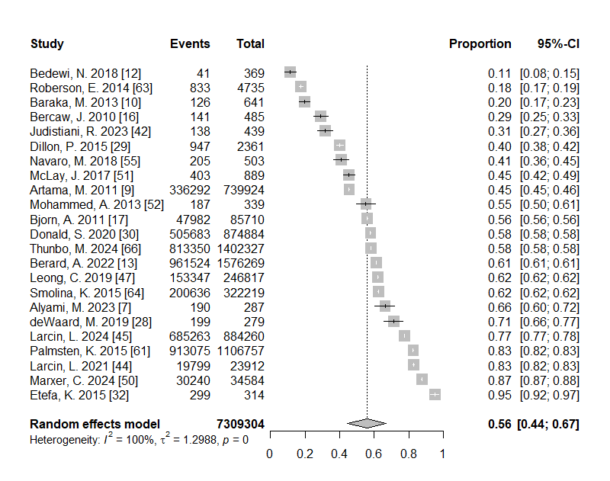

Figure 3: Prescribed Medications – First Trimester
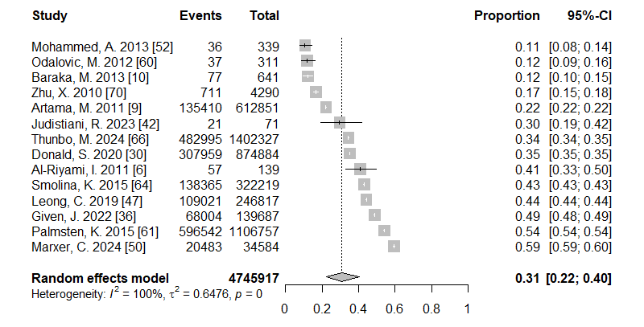
Figure 4: Prescribed Medications – Second Trimester
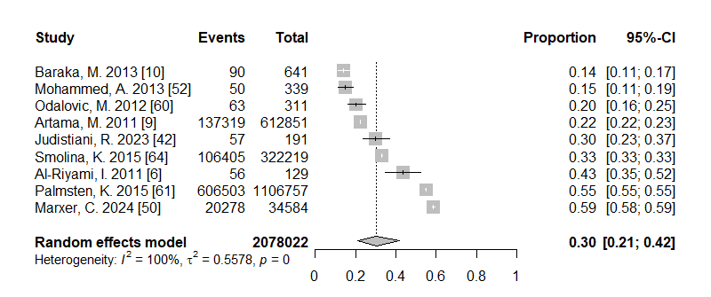

Figure 5: Prescribed Medications – Third Trimester
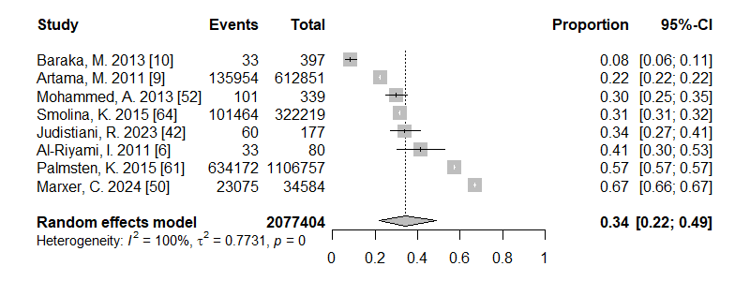

Figure 6: Prescribed Medications including Prescribed Vitamins and Minerals – Full Gestational Period
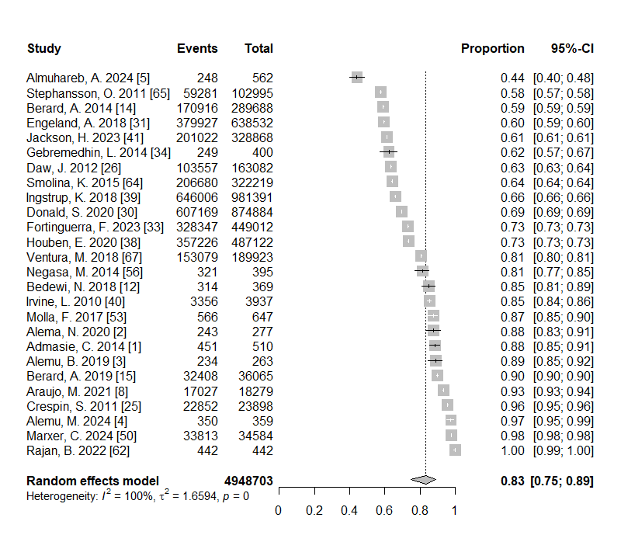

Figure 7: Prescribed Medications including Prescribed Vitamins and Minerals – First Trimester
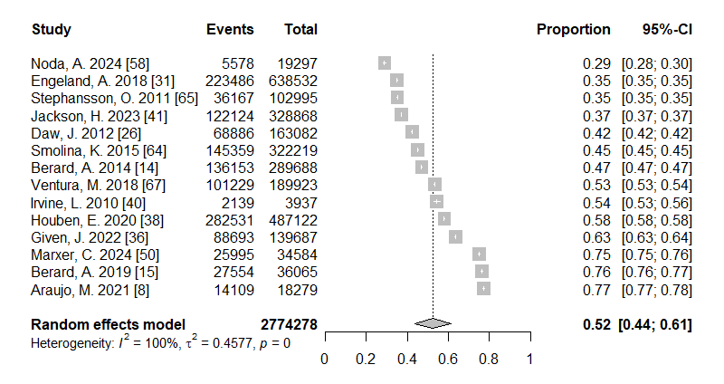

Figure 8: Prescribed Medications including Prescribed Vitamins and Minerals – Second Trimester
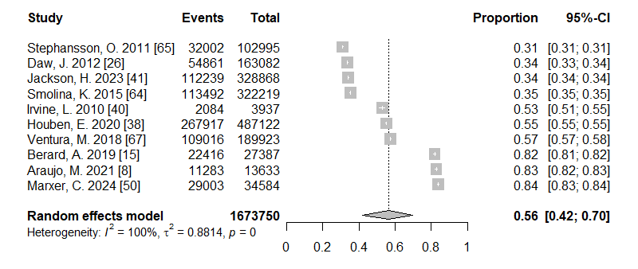

Figure 9: Prescribed Medications including Prescribed Vitamins and Minerals – Third Trimester
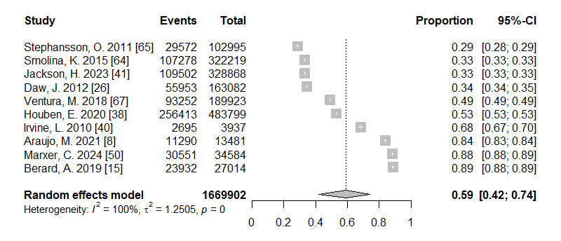

Figure 10: Prescribed Medications - Outcomes Included: Live Births, Stillbirths
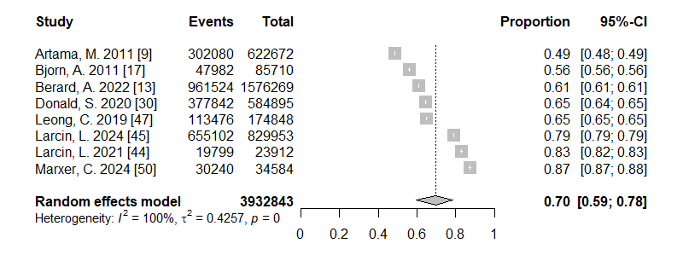

Figure 11: Prescribed Medications - Outcomes Included: Live Births
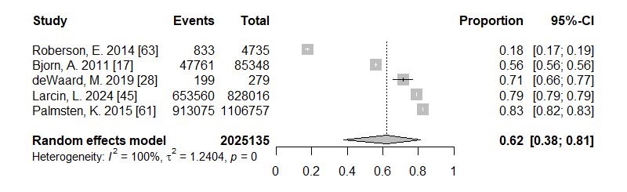

Figure 12: Prescribed Medications including Prescribed Vitamins and Minerals – Pregnancy Outcomes Included: Live Births, Stillbirths
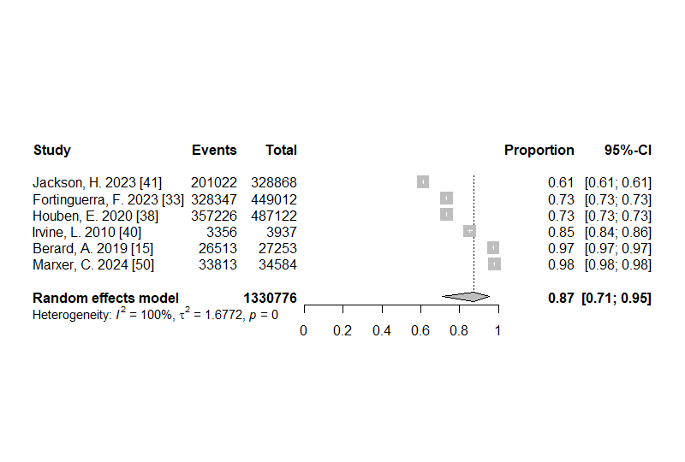

Figure 13: Prescribed Medications – Europe
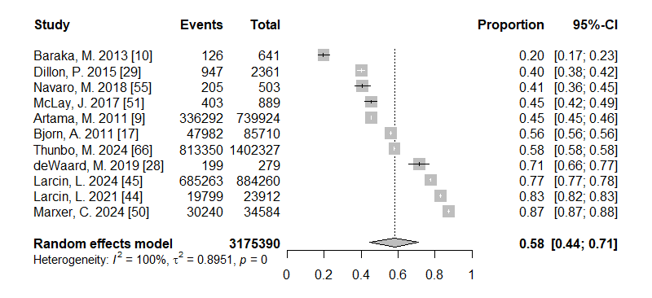

Figure 14: Prescribed Medications – North America
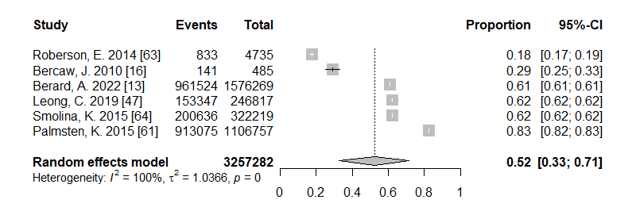

Figure 15: Prescribed Medications including Prescribed Vitamins & Minerals – Europe
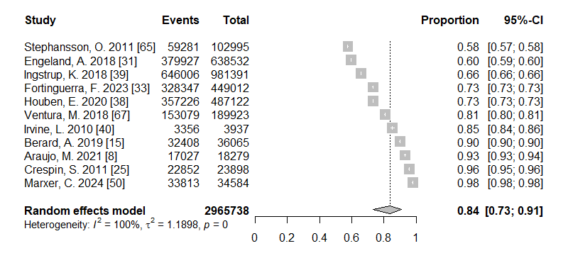

Figure 16: Prescribed Medications including Vitamins and Minerals – Africa
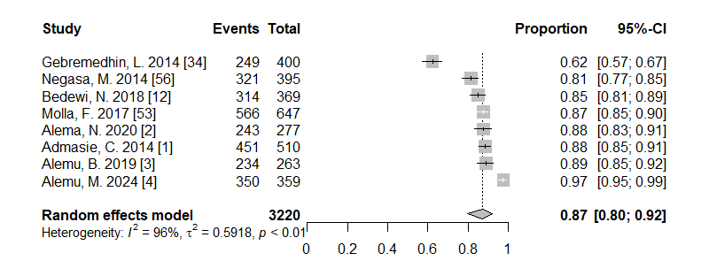

Appendix L: Sensitivity Analysis – Meta-Analysis adjusted for Study Quality
Table 9: Sensitivity Analysis – Full Gestational Period and Trimesters
Exposure Duration | Prescribed Medications |  |  |  |  |  |  | Prescribed Medications Including Prescribed Vitamins and Minerals
Exposure Duration | Forest Plot | Number of Studies | Population Size | Pooled Prevalence (95% Confidence Interval) | I2 | τ2 | p | Forest Plot | Number of Studies | Population Size | Pooled Prevalence (95% Confidence Interval) | I2 | τ2 | p
Overall | Appendix L -Figure 17 | 10 | 6,171,729 | 59% [46%-71%] | 100% | 0.72 | <0.01 | Appendix L -Figure 19 | 14 | 4,630,893 | 78% [68%-85%] | 100% | 0.95 | <0.01
First Trimester | Appendix L -Figure 18 | 6 | 3,020,518 | 44% [37%-52%] | 100% | 0.14 | <0.01 | Appendix L -Figure 20 | 13 | 2,484,590 | 53% [43%-62%] | 100% | 0.49 | <0.01
Second Trimester |  | n<5 | Insufficient studies |  |  |  |  |  | No change
Third Trimester |  | n<5 | Insufficient studies |  |  |  |  |  | No change
Notes: Pregnancy = Entire gestational period as defined by the study authors (see table 2)
First, Second and Third Trimesters = Pregnancy trimesters as defined by the study authors (see table 3)
I2 = Heterogeneity Statistic, τ2 = Between Study Variance, p = p-value for Cochran’s Q test

Table 10: Sensitivity Analysis – Pregnancy Outcomes
Exposure Duration | Prescribed Medications |  |  |  |  |  |  | Prescribed Medications Including Prescribed Vitamins and Minerals
Exposure Duration | Forest Plot | Number of Studies | Population Size | Pooled Prevalence (95% Confidence Interval) | I2 | τ2 | p | Forest Plot | Number of Studies | Population Size | Pooled Prevalence (95% Confidence Interval) | I2 | τ2 | p
Births Live & Still | Appendix L -Figure 21 | 7 | 3,908,931 | 67% [57%-77%] | 100% | 0.40 | <0.01 | Appendix L -Figure 22 | 6 | 1,330,776 | 87% [71%-95%] | 100% | 1.68 | <0.01
Live Births |  | n<5 | Insufficient studies |  |  |  |  |  | n<5 | Insufficient studies
Notes: Pregnancy = Entire gestational period as defined by the study authors (see table 2)
First, Second and Third Trimesters = Pregnancy trimesters as defined by the study authors (see table 3)
I2 = Heterogeneity Statistic, τ2 = Between Study Variance, p = p-value for Cochran’s Q test

Table 11: Sensitivity Analysis – Continents
Exposure Duration | Prescribed Medications |  |  |  |  |  |  | Prescribed Medications Including Prescribed Vitamins and Minerals
Exposure Duration | Forest Plot | Number of Studies | Population Size | Pooled Prevalence (95% Confidence Interval) | I2 | τ2 | p | Forest Plot | Number of Studies | Population Size | Pooled Prevalence (95% Confidence Interval) | I2 | τ2 | p
Europe | Appendix L-Figure 23 | 5 | 3,146,805 | 67% [51%-80%] | 100% | 0.59 | <0.01 | Appendix L-Figure 24 | 10 | 2,941,840 | 82% [70%-90%] | 100% | 1.08 | <0.01
North America |  | n<5 | Insufficient studies |  |  |  |  |  | n<5 | Insufficient studies
Africa |  | n<5 | Insufficient studies |  |  |  |  |  | n<5 | Insufficient studies
Notes: Pregnancy = Entire gestational period as defined by the study authors (see table 2)
First, Second and Third Trimesters = Pregnancy trimesters as defined by the study authors (see table 3)
I2 = Heterogeneity Statistic, τ2 = Between Study Variance, p = p-value for Cochran’s Q test

Figure 17: Prescribed Medications – Full Gestational Period – Quality Rating = “High”
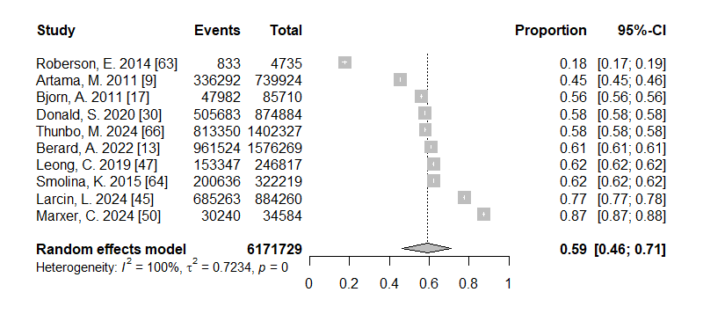
Figure 18: Prescribed Medications – First Trimester – Quality Rating = “High”
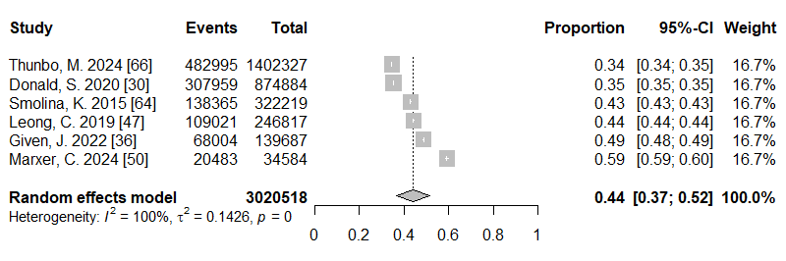

Figure 19: Prescribed Medications including Prescribed Vitamins and Minerals – Full Gestational Period – Quality Rating = “High”
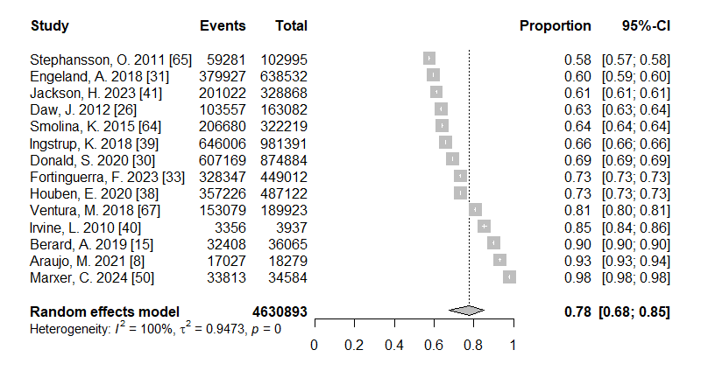

Figure 20: Prescribed Medications including Prescribed Vitamins and Minerals – First Trimester – Quality Rating = “High”
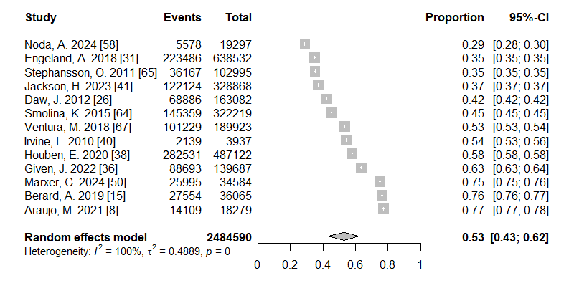

Figure 21: Prescribed Medications Live Births and Stillbirths – Quality Rating = “High”
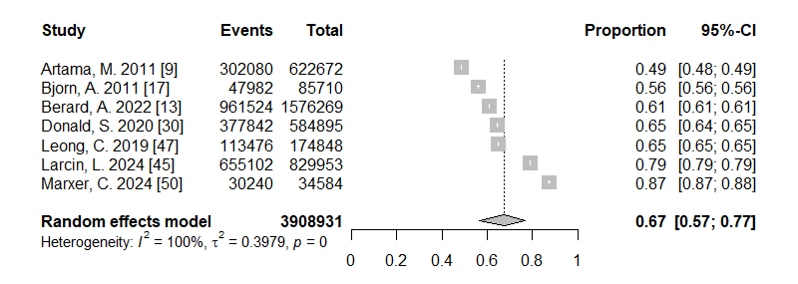
Figure 22: Prescribed Medications including Vitamins and Minerals Live Births and Stillbirths – Quality Rating = “High”

Figure 23: Prescribed Medications Europe – Quality Rating = “High”
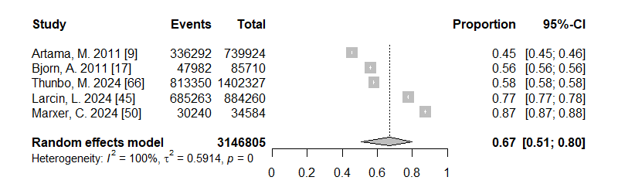

Figure 24: Prescribed Medications including vitamins and minerals Europe – Quality Rating = “High”
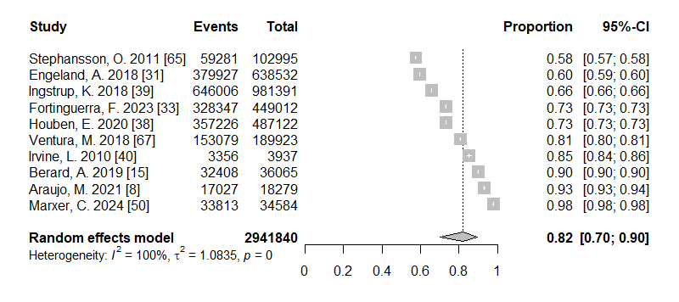

References
1. Admasie C, Wasie B, Abeje G. Determinants of prescribed drug use among pregnant women in Bahir Dar city administration, Northwest Ethiopia: a cross sectional study. BMC Pregnancy Childbirth. 2014;14:325.
2. Alema NM, Semagn G, Melesse S, Araya EM, Gebremedhin H, Demsie DG, et al. Patterns and determinants of prescribed drug use among pregnant women in Adigrat general hospital, northern Ethiopia: a cross-sectional study. BMC Pregnancy Childbirth. 2020;20:624.
3. Alemu BK, Wolle NN. Prescription drug use and potential teratogenicity risk among pregnant women attending maternal and child health clinic of Kemisse General Hospital, Northeast, Ethiopia. BMC Res Notes. 2019;12:592.
4. Alemu MA, Zewdu WS, Ferede YA, Zeleke MM, Ayele TM, Assefa AN, et al. Patterns, Potential Teratogenicity, and Associated Factors of Drugs Prescribed to Pregnant Women Attending Antenatal Care Units in Debre Tabor Comprehensive Specialized Hospital, Debre Tabor, Northwest Ethiopia. Biomed Res Int. 2024;2024:5577862.
5. Almuhareb A, Al Sharif A, Cahusac P. Knowledge, attitude, and practice of medication use among pregnant women in Riyadh City: a cross-sectional study. Front Glob Womens Health. 2024;5:1402608.
6. Al-Riyami IM, Al-Busaidy IQ, Al-Zakwani IS. Medication use during pregnancy in Omani women. Int J Clin Pharm. 2011;33:634-41.
7. Alyami AA, Alem MM, Dorgham SR, Alshamandy SA. Trends of over-the-counter and prescribed medication use during pregnancy: a cross-sectional study. Journal of Multidisciplinary Healthcare. 2023:3847-56.
8. Araujo M, Hurault-Delarue C, Sommet A, Damase-Michel C, Benevent J, Lacroix I. Drug prescriptions in French pregnant women between 2015 and 2016: A study in the EGB database. Therapie. 2021;76:239-47.
9. Artama M, Gissler M, Malm H, Ritvanen A, Drugs, Pregnancy Study G. Nationwide register-based surveillance system on drugs and pregnancy in Finland 1996-2006. Pharmacoepidemiol Drug Saf. 2011;20:729-38.
10. Baraka MA, Steurbaut S, Coomans D, Dupont AG. Ethnic differences in drug utilization pattern during pregnancy: a cross-sectional study. J Matern Fetal Neonatal Med. 2013;26:900-7.
11. Bebitoğlu BT, Hıdıroğlu S, Ayaz R, Sarısaltık A, Koç D. Investigation of medication use patterns among pregnant women attending a tertiary referral hospital. İstanbul Journal of Pharmacy. 2022;52:90-5.
12. Bedewi N, Sisay M, Edessa D. Drug utilization pattern among pregnant women attending maternal and child health clinic of tertiary hospital in eastern Ethiopia: Consideration of toxicological perspectives. BMC Res Notes. 2018;11:858.
13. Berard A, Kaul P, Eltonsy S, Winquist B, Chateau D, Hawken S, et al. The Canadian Mother-Child Cohort Active Surveillance Initiative (CAMCCO): Comparisons between Quebec, Manitoba, Saskatchewan, and Alberta. PLoS One. 2022;17:e0274355.
14. Berard A, Sheehy O. The Quebec Pregnancy Cohort--prevalence of medication use during gestation and pregnancy outcomes. PLoS One. 2014;9:e93870.
15. Berard A, Abbas-Chorfa F, Kassai B, Vial T, Nguyen KA, Sheehy O, et al. The French Pregnancy Cohort: Medication use during pregnancy in the French population. PLoS One. 2019;14:e0219095.
16. Bercaw J, Maheshwari B, Sangi-Haghpeykar H. The use during pregnancy of prescription, over-the-counter, and alternative medications among Hispanic women. Birth. 2010;37:211-8.
17. Bjørn A-MB, Nørgaard M, Hundborg HH, Nohr EA, Ehrenstein V. Use of prescribed drugs among primiparous women: an 11-year population-based study in Denmark. Clinical epidemiology. 2011:149-56.
18. Bornhauser C, Quack Lotscher K, Seifert B, Simoes-Wust AP. Diet, medication use and drug intake during pregnancy: data from the consecutive Swiss Health Surveys of 2007 and 2012. Swiss Med Wkly. 2017;147:w14572.
19. Brian M, Goruntla N, Bommireddy BR, Mopuri B, Vigneshwaran E, Mantargi MJS, et al. Knowledge, Attitude, and Practice of Medication Use During Pregnancy: A Cross-Sectional Study in Western Uganda. Health Sci Rep. 2025;8:e70644.
20. Campos HMN, Mattos MP, Gomes DR. Use of medications by pregnant women in the Family Health Strategy in the Northeast of Brazil. Revista Brasileira de Saúde Materno Infantil. 2023;22:975-86.
21. Ceulemans M, Foulon V, Panchaud A, Winterfeld U, Pomar L, Lambelet V, et al. Self-Reported Medication Use among Pregnant and Breastfeeding Women during the COVID-19 Pandemic: A Cross-Sectional Study in Five European Countries. Int J Environ Res Public Health. 2022;19.
22. Ceulemans M, Van Calsteren K, Allegaert K, Foulon V. Health products' and substance use among pregnant women visiting a tertiary hospital in Belgium: A cross-sectional study. Pharmacoepidemiol Drug Saf. 2019;28:1231-8.
23. Chang YC, Huang HY, Shen TH, Wu CH. Prevalence, trends, and characteristics of polypharmacy among US pregnant women aged 15 to 44 years: NHANES 1999 to 2016. Medicine (Baltimore). 2023;102:e33828.
24. Cleary BJ, Butt H, Strawbridge JD, Gallagher PJ, Fahey T, Murphy DJ. Medication use in early pregnancy-prevalence and determinants of use in a prospective cohort of women. Pharmacoepidemiol Drug Saf. 2010;19:408-17.
25. Crespin S, Bourrel R, Hurault-Delarue C, Lapeyre-Mestre M, Montastruc JL, Damase-Michel C. Drug prescribing before and during pregnancy in south west France: a retrolective study. Drug Saf. 2011;34:595-604.
26. Daw JR, Mintzes B, Law MR, Hanley GE, Morgan SG. Prescription drug use in pregnancy: a retrospective, population-based study in British Columbia, Canada (2001-2006). Clin Ther. 2012;34:239-49 e2.
27. de Castro CT, Leal LF, Ramos DO, Santana JDM, Cordeiro RC, Rivemales M, et al. Racial Disparities in Medication Use During Pregnancy: Results from the NISAMI Cohort. J Multidiscip Healthc. 2024;17:2755-75.
28. de Waard M, Blomjous BS, Hol MLF, Sie SD, Corpeleijn WE, van Goudoever JHB, et al. Medication Use During Pregnancy and Lactation in a Dutch Population. J Hum Lact. 2019;35:154-64.
29. Dillon P, O'Brien KK, McDonnell R, Donnelly-Swift E, Galvin R, Roche A, et al. Prevalence of prescribing in pregnancy using the Irish primary care research network: a pilot study. BMC Pregnancy Childbirth. 2015;15:67.
30. Donald S, Sharples K, Barson D, Horsburgh S, Parkin L. Patterns of prescription medicine dispensing before and during pregnancy in New Zealand, 2005-2015. PLoS One. 2020;15:e0234153.
31. Engeland A, Bjorge T, Klungsoyr K, Hjellvik V, Skurtveit S, Furu K. Trends in prescription drug use during pregnancy and postpartum in Norway, 2005 to 2015. Pharmacoepidemiol Drug Saf. 2018;27:995-1004.
32. Etefa K, Kahissay M. Assessment of drug prescribing pattern among pregnant women attending antenatal care in health centers found in Arada Subcity, Addis Ababa, Ethiopia. J Pharm Sci Bioscientific Res. 2015;5:347-62.
33. Fortinguerra F, Belleudi V, Poggi FR, Perna S, Bortolus R, Donati S, et al. Monitoring medicine prescriptions before, during and after pregnancy in Italy. PLoS One. 2023;18:e0287111.
34. Gebremedhin GL, Gomathi P. Assessment of drug use and effect in pregnant women attending antenatal care in hospitals of Mekelle, Tigray, Ethiopia. J Drug Deliv Ther. 2014;4:75-82.
35. Gerbier E, Favre G, Tauqeer F, Winterfeld U, Stojanov M, Oliver A, et al. Self-Reported Medication Use among Pregnant and Postpartum Women during the Third Wave of the COVID-19 Pandemic: A European Multinational Cross-Sectional Study. Int J Environ Res Public Health. 2022;19.
36. Given J, Casson K, Dolk H, Loane M. Sociodemographic variation in prescriptions dispensed in early pregnancy in Northern Ireland 2010-2016. PLoS One. 2022;17:e0267710.
37. Haas DM, Marsh DJ, Dang DT, Parker CB, Wing DA, Simhan HN, et al. Prescription and Other Medication Use in Pregnancy. Obstet Gynecol. 2018;131:789-98.
38. Houben E, Te Winkel B, Steegers EAP, Herings RMC. Dutch trends in the use of potentially harmful medication during pregnancy. Br J Clin Pharmacol. 2020;86:2377-92.
39. Ingstrup KG, Liu X, Gasse C, Debost JP, Munk-Olsen T. Prescription drug use in pregnancy and variations according to prior psychiatric history. Pharmacoepidemiol Drug Saf. 2018;27:105-13.
40. Irvine L, Flynn RW, Libby G, Crombie IK, Evans JM. Drugs dispensed in primary care during pregnancy: a record-linkage analysis in Tayside, Scotland. Drug Saf. 2010;33:593-604.
41. Jackson H, Grzeskowiak LE, Enticott J, Callander E. Pharmacoepidemiology and costs of medications dispensed during pregnancy: A retrospective population-based study. BJOG. 2023;130:1317-27.
42. Judistiani RTD, Pratiwi AE, Wahyudi K, Gunawan A, Rahmawati A, Ruslami R. Medication Use and Associated Factors Among Indonesian Pregnant Women: A Cross-Sectional Study. J Multidiscip Healthc. 2023;16:4173-9.
43. KHOa JV, CHUAab SS, DALLUMAL RM, OMAR SZ. Medications used by pregnant women: any safety concerns? Malay. 2017;318:63.6.
44. Larcin L, Lona M, Karakaya G, Van Espen A, Damase-Michel C, Kirakoya-Samadoulougou F. Using administrative healthcare database records to study trends in prescribed medication dispensed during pregnancy in Belgium from 2003 to 2017. Pharmacoepidemiol Drug Saf. 2021;30:1224-32.
45. Larcin L, Neven A, Damase-Michel C, Kirakoya-Samadoulougou F. Belgian medication exposure during pregnancy (BeMeP), a new nationwide linked database: Linkage methods and prevalence of medication use. Pharmacoepidemiol Drug Saf. 2024;33:e5705.
46. Leke AZ, Dolk H, Loane M, Casson K, Maboh NM, Maeya SE, et al. First trimester medication use in pregnancy in Cameroon: a multi-hospital survey. BMC Pregnancy Childbirth. 2018;18:450.
47. Leong C, Chateau D, Dahl M, Falk J, Katz A, Bugden S, et al. Prescription medication use during pregnancies that resulted in births and abortions (2001-2013): A retrospective population-based study in a Canadian population. PLoS One. 2019;14:e0211319.
48. Lupattelli A, Spigset O, Twigg MJ, Zagorodnikova K, Mardby AC, Moretti ME, et al. Medication use in pregnancy: a cross-sectional, multinational web-based study. BMJ Open. 2014;4:e004365.
49. Lutz BH, Miranda VIA, Silveira MPT, Dal Pizzol TDS, Mengue SS, da Silveira MF, et al. Medication Use among Pregnant Women from the 2015 Pelotas (Brazil) Birth Cohort Study. Int J Environ Res Public Health. 2020;17.
50. Marxer CA, Graber SM, Surbek D, Panchaud A, Meier CR, Spoendlin J. Dispensed drugs during pregnancy in outpatient care between 2015 and 2021 in Switzerland: a retrospective analysis of Swiss healthcare claims data. Swiss Med Wkly. 2024;154:3616.
51. McLay JS, Izzati N, Pallivalapila AR, Shetty A, Pande B, Rore C, et al. Pregnancy, prescription medicines and the potential risk of herb-drug interactions: a cross-sectional survey. BMC Complement Altern Med. 2017;17:543.
52. Mohammed MA, Ahmed JH, Bushra AW, Aljadhey HS. Medications use among pregnant women in Ethiopia: a cross sectional study. Journal of Applied Pharmaceutical Science. 2013;3:116-23.
53. Molla F, Assen A, Abrha S, Masresha B, Gashaw A, Wondimu A, et al. Prescription drug use during pregnancy in Southern Tigray region, North Ethiopia. BMC Pregnancy Childbirth. 2017;17:170.
54. Mosha D, Mazuguni F, Mrema S, Abdulla S, Genton B. Medication exposure during pregnancy: a pilot pharmacovigilance system using health and demographic surveillance platform. BMC Pregnancy Childbirth. 2014;14:322.
55. Navaro M, Vezzosi L, Santagati G, Angelillo IF, Collaborative Working G. Knowledge, attitudes, and practice regarding medication use in pregnant women in Southern Italy. PLoS One. 2018;13:e0198618.
56. Negasa M, Tigabu BM. Drug prescribing pattern among pregnant mothers attending obstetrics and gynecology department in Hiwot Fana Specialized Teaching Hospital, Ethiopia. Archives of Pharmacy practice. 2014;5:78-83.
57. Nishigori H, Obara T, Nishigori T, Metoki H, Ishikuro M, Mizuno S, et al. Drug Use before and during Pregnancy in Japan: The Japan Environment and Children's Study. Pharmacy (Basel). 2017;5.
58. Noda A, Obara T, Shirota M, Ueno F, Matsuzaki F, Hatanaka R, et al. Medication use before and during pregnancy in Japan: the Tohoku Medical Megabank Project Birth and Three-Generation Cohort Study. Eur J Clin Pharmacol. 2024;80:1171-80.
59. Obadeji ST, Obadeji A, Bamidele JO, Ajayi FT. Medication use among pregnant women at a secondary health institution: utilisation patterns and predictors of quantity. Afr Health Sci. 2020;20:1206-16.
60. Odalovic M, Vezmar Kovacevic S, Ilic K, Sabo A, Tasic L. Drug use before and during pregnancy in Serbia. Int J Clin Pharm. 2012;34:719-27.
61. Palmsten K, Hernandez-Diaz S, Chambers CD, Mogun H, Lai S, Gilmer TP, et al. The Most Commonly Dispensed Prescription Medications Among Pregnant Women Enrolled in the U.S. Medicaid Program. Obstet Gynecol. 2015;126:465-73.
62. Rajan B, Pasangha E, Devi P, George S. Patterns of medication use and their determinants in pregnancy among women admitted to the obstetrics wards of a tertiary care hospital: a cross-sectional study: patterns of medication use and their determinants in pregnancy. Journal of Pharmacology and Pharmacotherapeutics. 2022;13:388-95.
63. Roberson EK, Hurwitz EL. Prescription drug use during and immediately before pregnancy in Hawai'i-findings from the Hawai'i Pregnancy Risk Assessment Monitoring System, 2009-2011. Hawaii J Med Public Health. 2014;73:382-6.
64. Smolina K, Hanley GE, Mintzes B, Oberlander TF, Morgan S. Trends and Determinants of Prescription Drug Use during Pregnancy and Postpartum in British Columbia, 2002-2011: A Population-Based Cohort Study. PLoS One. 2015;10:e0128312.
65. Stephansson O, Granath F, Svensson T, Haglund B, Ekbom A, Kieler H. Drug use during pregnancy in Sweden - assessed by the Prescribed Drug Register and the Medical Birth Register. Clin Epidemiol. 2011;3:43-50.
66. Thunbo MO, Vendelbo JH, Witte DR, Larsen A, Pedersen LH. Use of medication in pregnancy on the rise: Study on 1.4 million Danish pregnancies from 1998 to 2018. Acta Obstet Gynecol Scand. 2024;103:1210-23.
67. Ventura M, Maraschini A, D'Aloja P, Kirchmayer U, Lega I, Davoli M, et al. Drug prescribing during pregnancy in a central region of Italy, 2008-2012. BMC Public Health. 2018;18:623.
68. Vorstenbosch S, Te Winkel B, van Gelder M, Kant A, Roeleveld N, van Puijenbroek E. Aim and Design of pREGnant, the Dutch Pregnancy Drug Register. Drug Saf. 2019;42:1-12.
69. Zhang J, Ung COL, Guan X, Shi L. Safety of medication use during pregnancy in mainland China: based on a national health insurance database in 2015. BMC Pregnancy Childbirth. 2019;19:459.
70. Zhu X, Qi X, Hao J, Huang Z, Zhang Z, Xing X, et al. Pattern of drug use during the first trimester among Chinese women: data from a population-based cohort study. Eur J Clin Pharmacol. 2010;66:511-8.

