Title: When does Follow-Up on Adverse Events Improve the Understanding of Medicine and Vaccine Safety? Insights from Global Expert Perspectives
Authors: Vijay Kara^{1,2}, Florence Van Hunsel^{1,3}, Manal Younus⁴, Manfred Hauben^{5,6}, Andrew Bate^{2,7}, Eugène van Puijenbroek^{1,3}
¹Department of PharmacoTherapy, Epidemiology & Economics, Groningen Research Institute of Pharmacy (GRIP), University of Groningen, The Netherlands.
² GSK, London, UK
³Netherlands Pharmacovigilance Centre Lareb, The Netherlands.
⁴Iraqi Pharmacovigilance Centre, Ministry of Health, Baghdad, Iraq
⁵Merck KGaA, New York City, USA
⁶Department of Family Community Medicine, New York Medical College, Valhalla, NY, USA
⁷London School of Hygiene and Tropical Medicine, London, UK.
Corresponding author: v.kara@rug.nl

Supplemental Material Table 1: Interview Guide

Interview Guide

Introduction
Thank you for agreeing to participate in this interview. This study aims to explore when follow-up on adverse events (AEs) is beneficial to understanding the safety profile of medicines and vaccines and when it offers minimal value. As an expert in pharmacovigilance, your insights are invaluable.
This interview will be recorded for research purposes using Microsoft Teams Recording which will produce transcripts of the conversation. Prior to the commencement of recording you will be asked to provide your consent to the recording of the session.
Following the interview you will be provided a copy of the transcript should there be any corrections or modifications required.
The aim of this interview is to discuss your views on follow-up of Adverse Events reports received by your organisation, not limited to spontaneous reports. The intent is to capture scenarios when it offers value and conversely when it may not offer value. The intent is not to focus on particular case types or data attributes but to describe principles when follow-up would offer value.
Secondary to this we would like to understand how follow-up is conducted in your organisation including current mechanisms for communication, the output for this will be aggregated and anonymised.
Please confirm that you consent to the interview being recorded.

Interview Questions
- Introduction
- Could you briefly introduce yourself and the organization/company you work for?
- What is your professional background?
- How many years of experience do you have with handling reports that may require follow-up?
- Scenario Exploration

- Can you describe a typical scenario in your work where follow-up on an AE has been valuable?
- Conversely, can you recall instances where follow-up did not add significant value?

- Understanding Value (Core Questions)

- Multiple reasons may exist for asking for follow-up. Which criteria do you consider to be important from your point of view?
Note: Initially, question without examples, the below serves as a guide to facilitate discussion if needed.
  - Medical perspective (e.g., seriousness, differential diagnosis, course of the reaction not clear yet, treatment and impact of interventions)
  - Regulatory perspective (e.g., regulations in place requiring follow-up, time after marketing)
  - Product/ Class-specific (e.g., indication of use, experiences with related drugs)
  - ADR-specific (e.g., labelled or not, AESI, DME)
  - Product-ADR -specific
  - Any other reasons for triggering follow-up?
- How do you decide which cases merit follow-up and which do not?
- From a multi-stakeholder (i.e. patient, HCP, PV centre/ MAH) perspective what factors should be considered to determine the need and value of follow-up?

- Effectiveness and Challenges (Problem-Solving Questions)

- What are the main challenges you encounter in follow-up practices?
- From your experience, how does the method of follow-up (e.g., digital, telephone, in-person) influence its effectiveness?
- What logistical or ethical considerations might impact follow-up’s perceived value?
- Can you suggest ways to enhance the efficiency of follow-up procedures in PV?
- Can you suggest ways to enhance the effectiveness of follow-up procedures in PV?
- Risk-Based Approach (Strategy Questions)

A Risk-Based Approach in pharmacovigilance follow-up is a strategy that utilises a prioritisation strategy for the follow-up of adverse event reports
- What does a risk-based approach to AE follow-up look like from your perspective, which criteria or factors define the approach?
- How might this approach vary based on the
  - resource availability,
  - healthcare infrastructure,
  - or regulatory frameworks?

- Potential Improvements (Forward-Looking Questions)

- Are the current rules for requesting follow-up sufficiently clear?
  - If not, what would you like to change? Could any improvements be made?
- What role do you see technology playing in future follow-up practices for pharmacovigilance?

- Organization of Follow-Up (Base Lining Questions)
- Could you describe how follow-up is conducted within your organization/company?
- Are there Standard Operating Procedures (SOPs) in place?
  - What are the criteria for follow-up according to these SOPs?
- Are there differences in follow-up procedures between:
  - Different products?
  - Different types of Adverse Drug Reactions (ADRs)?

- Final Remarks
- Do you have any final thoughts or comments you would like to share regarding follow-up in pharmacovigilance?

Supplemental Material Table 2: Network graph from Atlas.ti
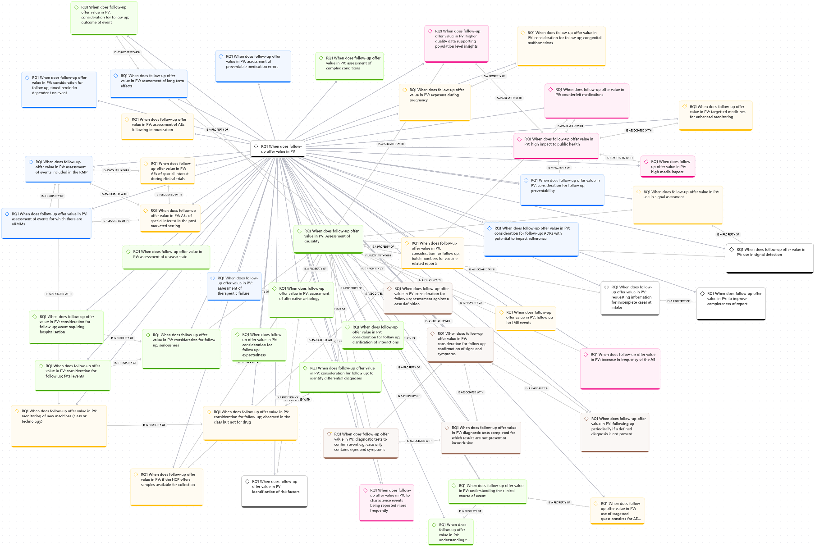
Figure supportive of Figures 3-6 in manuscript

