Scene 1
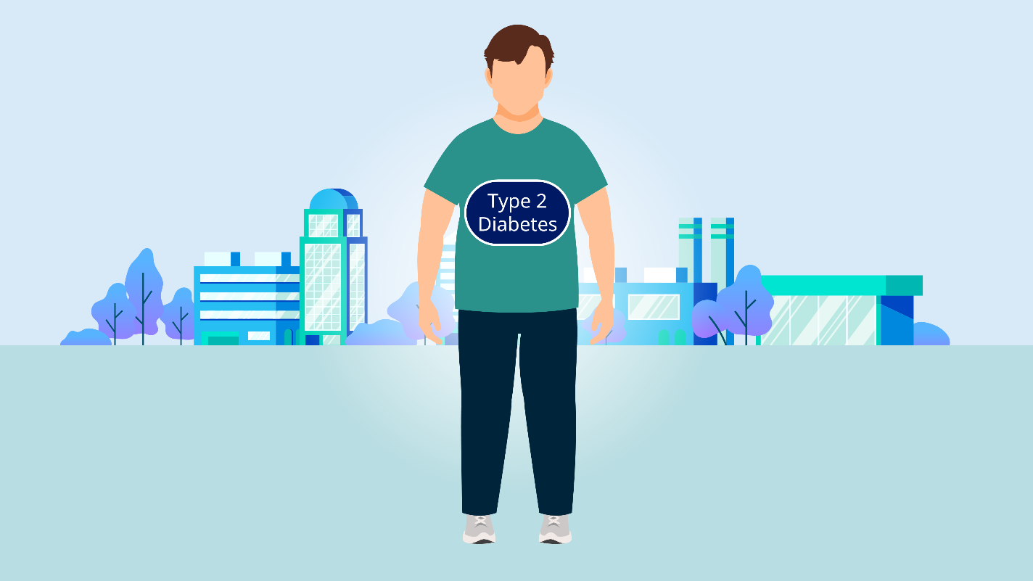

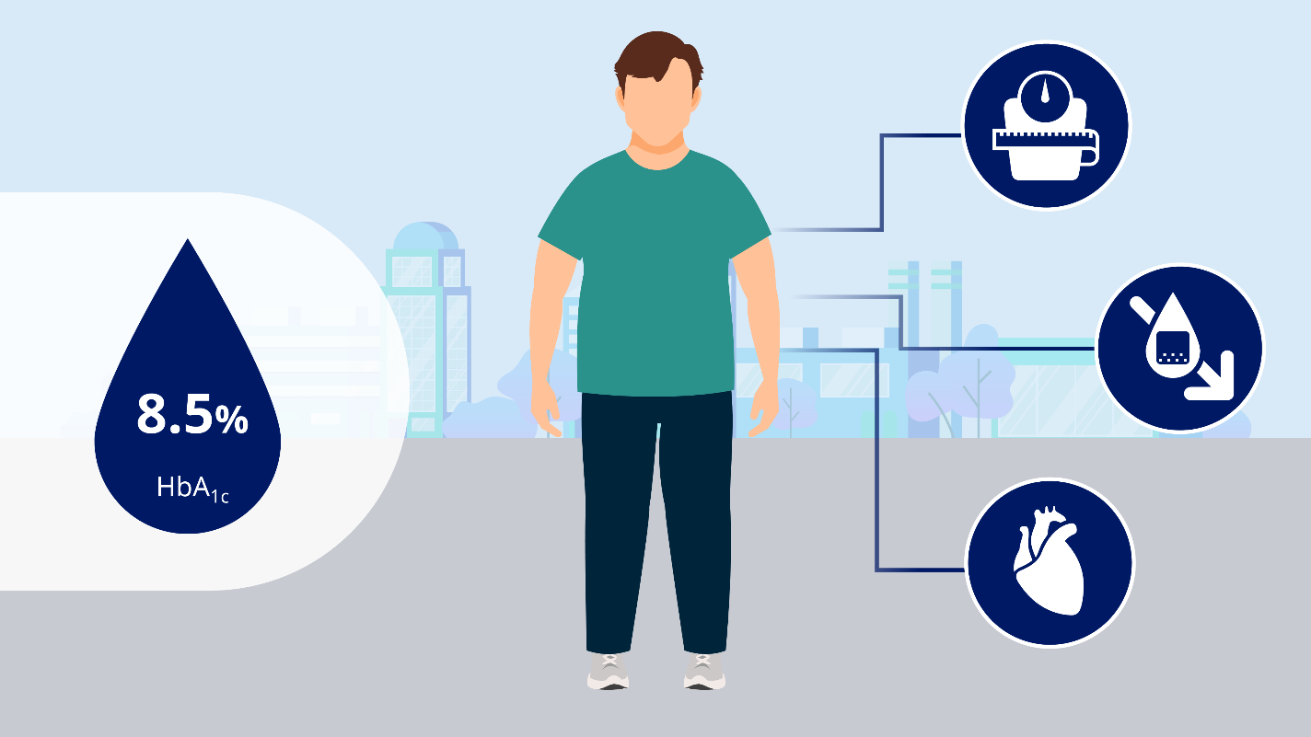

Script: In patients with type 2 diabetes it is important to achieve glycemic control while also minimizing weight gain, and the risk of hypoglycemia and cardiovascular events | Direction: Background fades colour when icons introduced

Scene 2
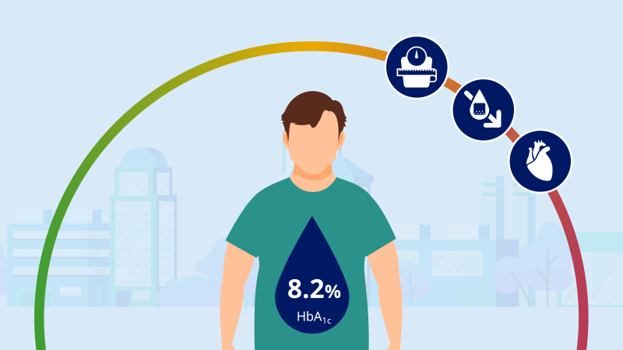

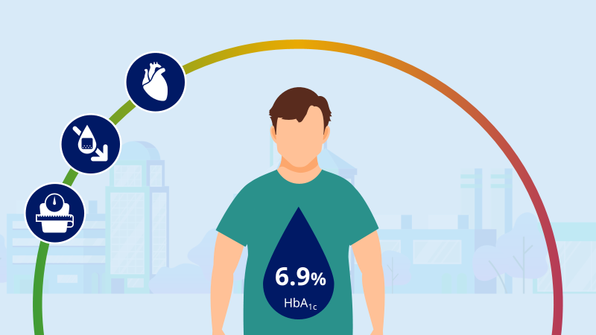

Script: Glucagon-like peptide-1 receptor agonists are effective agents for achieving glycemic control, reducing body weight, reducing the risk of cardiovascular events, with a low risk of hypoglycemia, in patients with type 2 diabetes | Direction: Icons shrink onto scale – numbers change when script mentions reduction

Scene 3
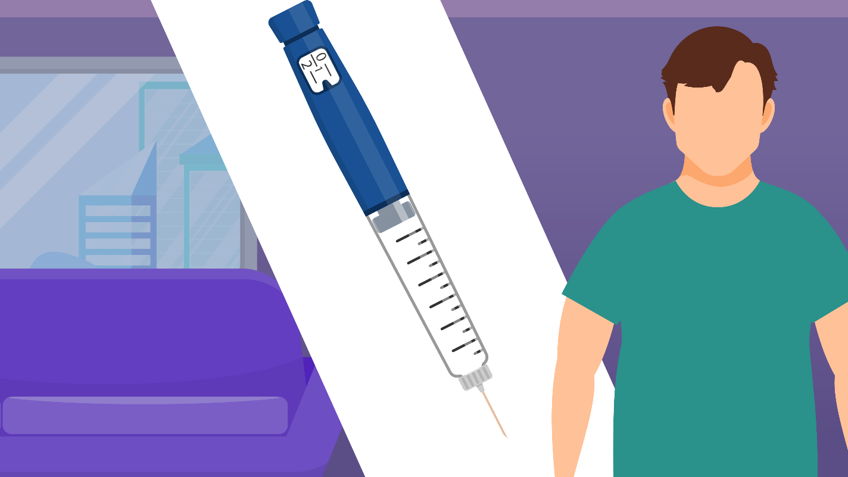

Script: However, GLP-1RAs are peptide-based agents that, until recently were only administered by injection, and this may limit the use of these agents | Direction: Move indoors – diagonal stripe appears and syringe flies in

Scene 4


Script: However, recently the GLP-1RA, semaglutide, was formulated with an absorption enhancer… | Direction: Slide right – scene lightens and pill introduced

Scene 5




Script: …so that it can be administered as a tablet. To be effective, oral semaglutide should be administered with half a glass of water in a fasting state upon waking | Direction: Tablet travels to open mouth in arc. And goes down throat in arrow. Introduces clock and water

Scene 6
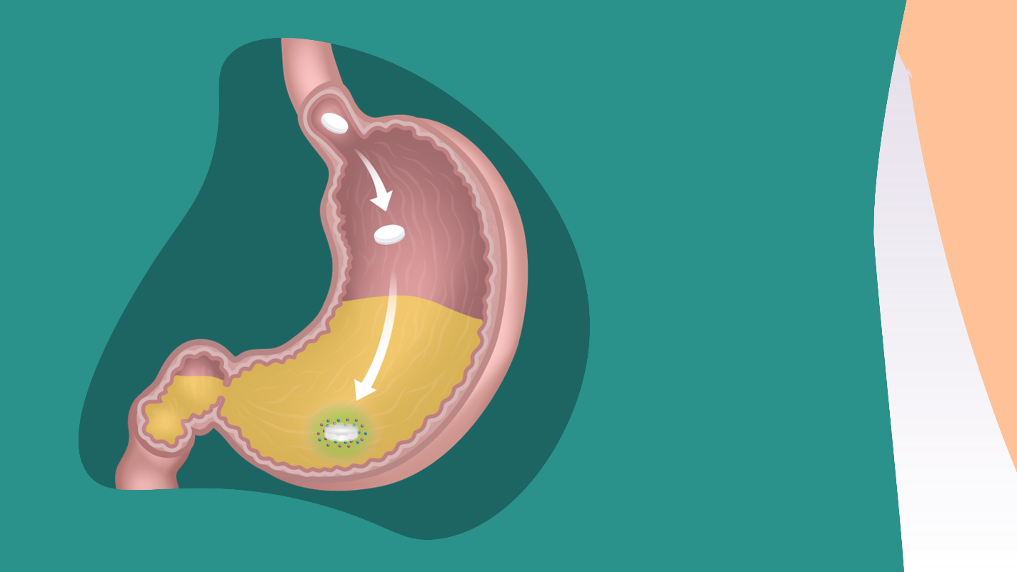

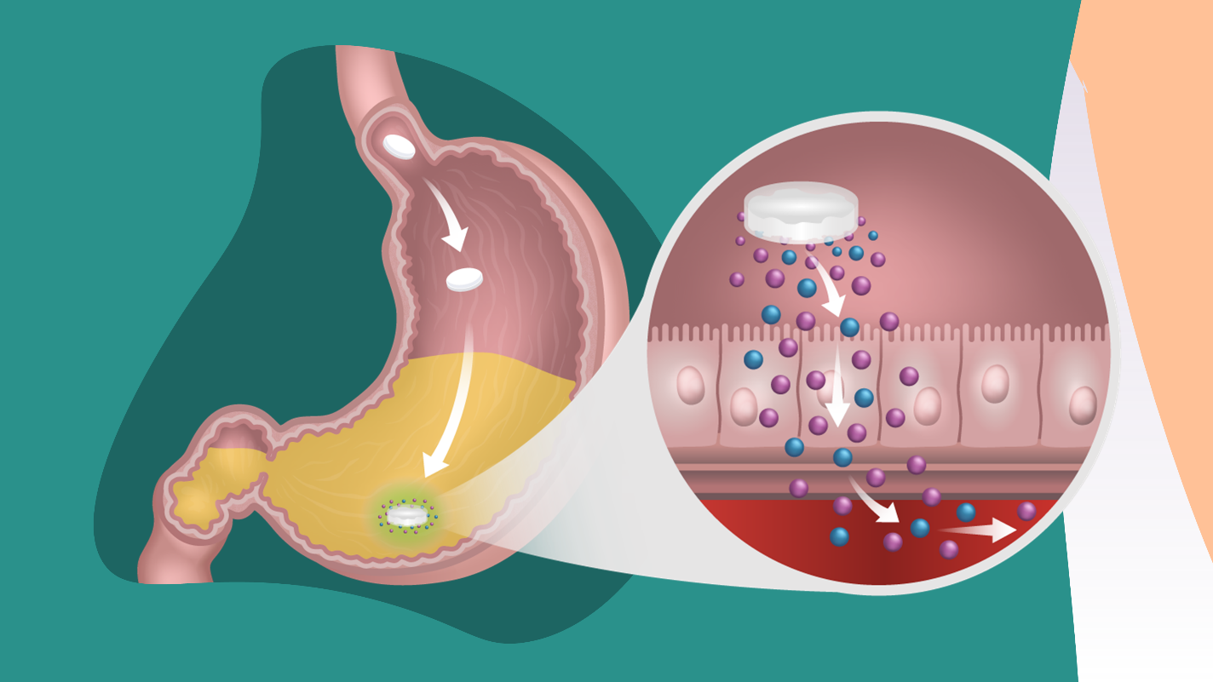

Script: As the tablet erodes, SNAC causes a transient, localized increase in pH, protecting semaglutide from proteolytic degradation  SNAC facilitates a highly localized absorption of semaglutide across the gastric mucosa in a concentration-dependent manner via effects on transcellular pathways | Direction: Zoom into gut – MOA shows when mentioned in script

Scene 7


Script: …The patient must wait at least half an hour before taking food, drink or other oral medications. | Direction: Clock changes by 30 min and glass now empty

Scene 8
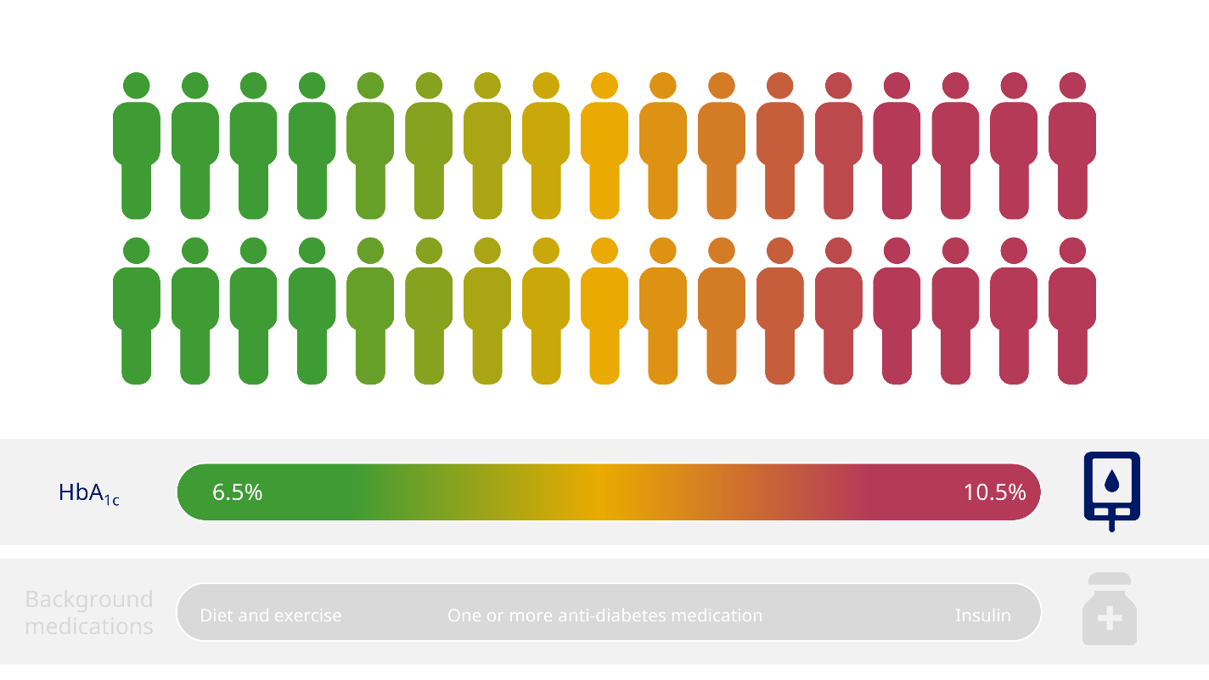

Script: The safety and efficacy of oral semaglutide has been assessed in a large phase 3 trial program that covered a wide range of patients… | Direction: Patient to morph into smaller person and recolour on HbA

Scene 9
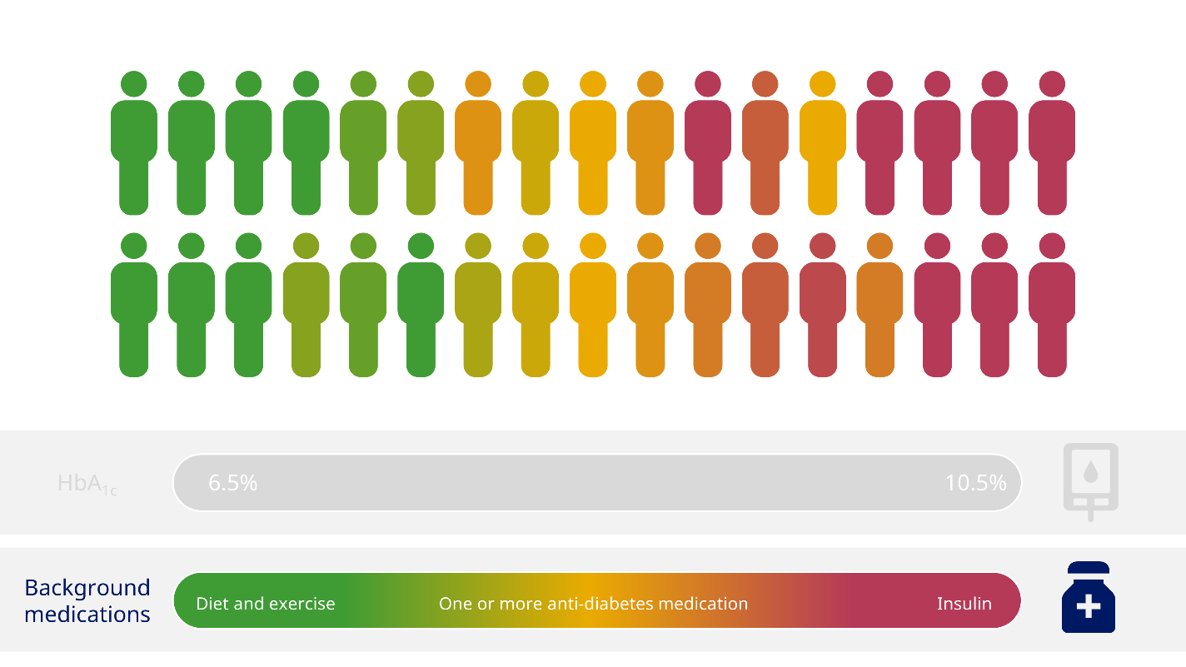

Script: and background medications,… | Direction: Patient colours to change

Scene 10
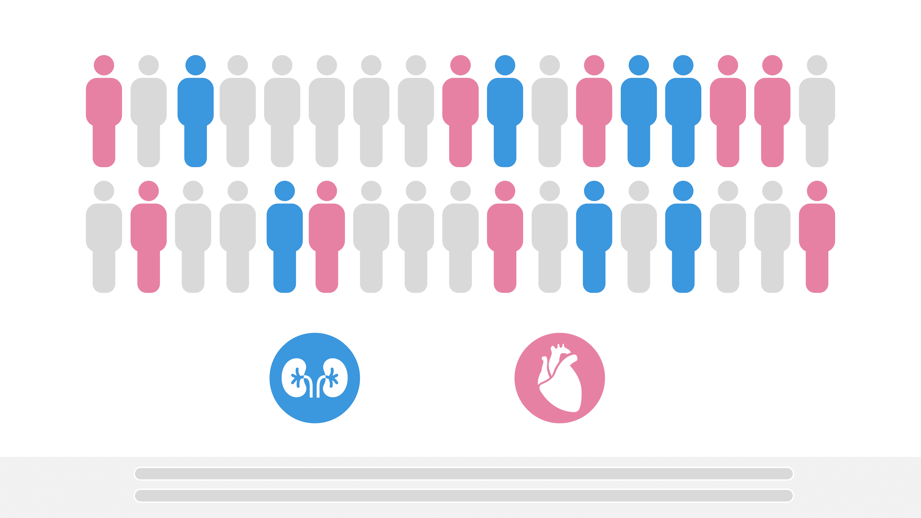

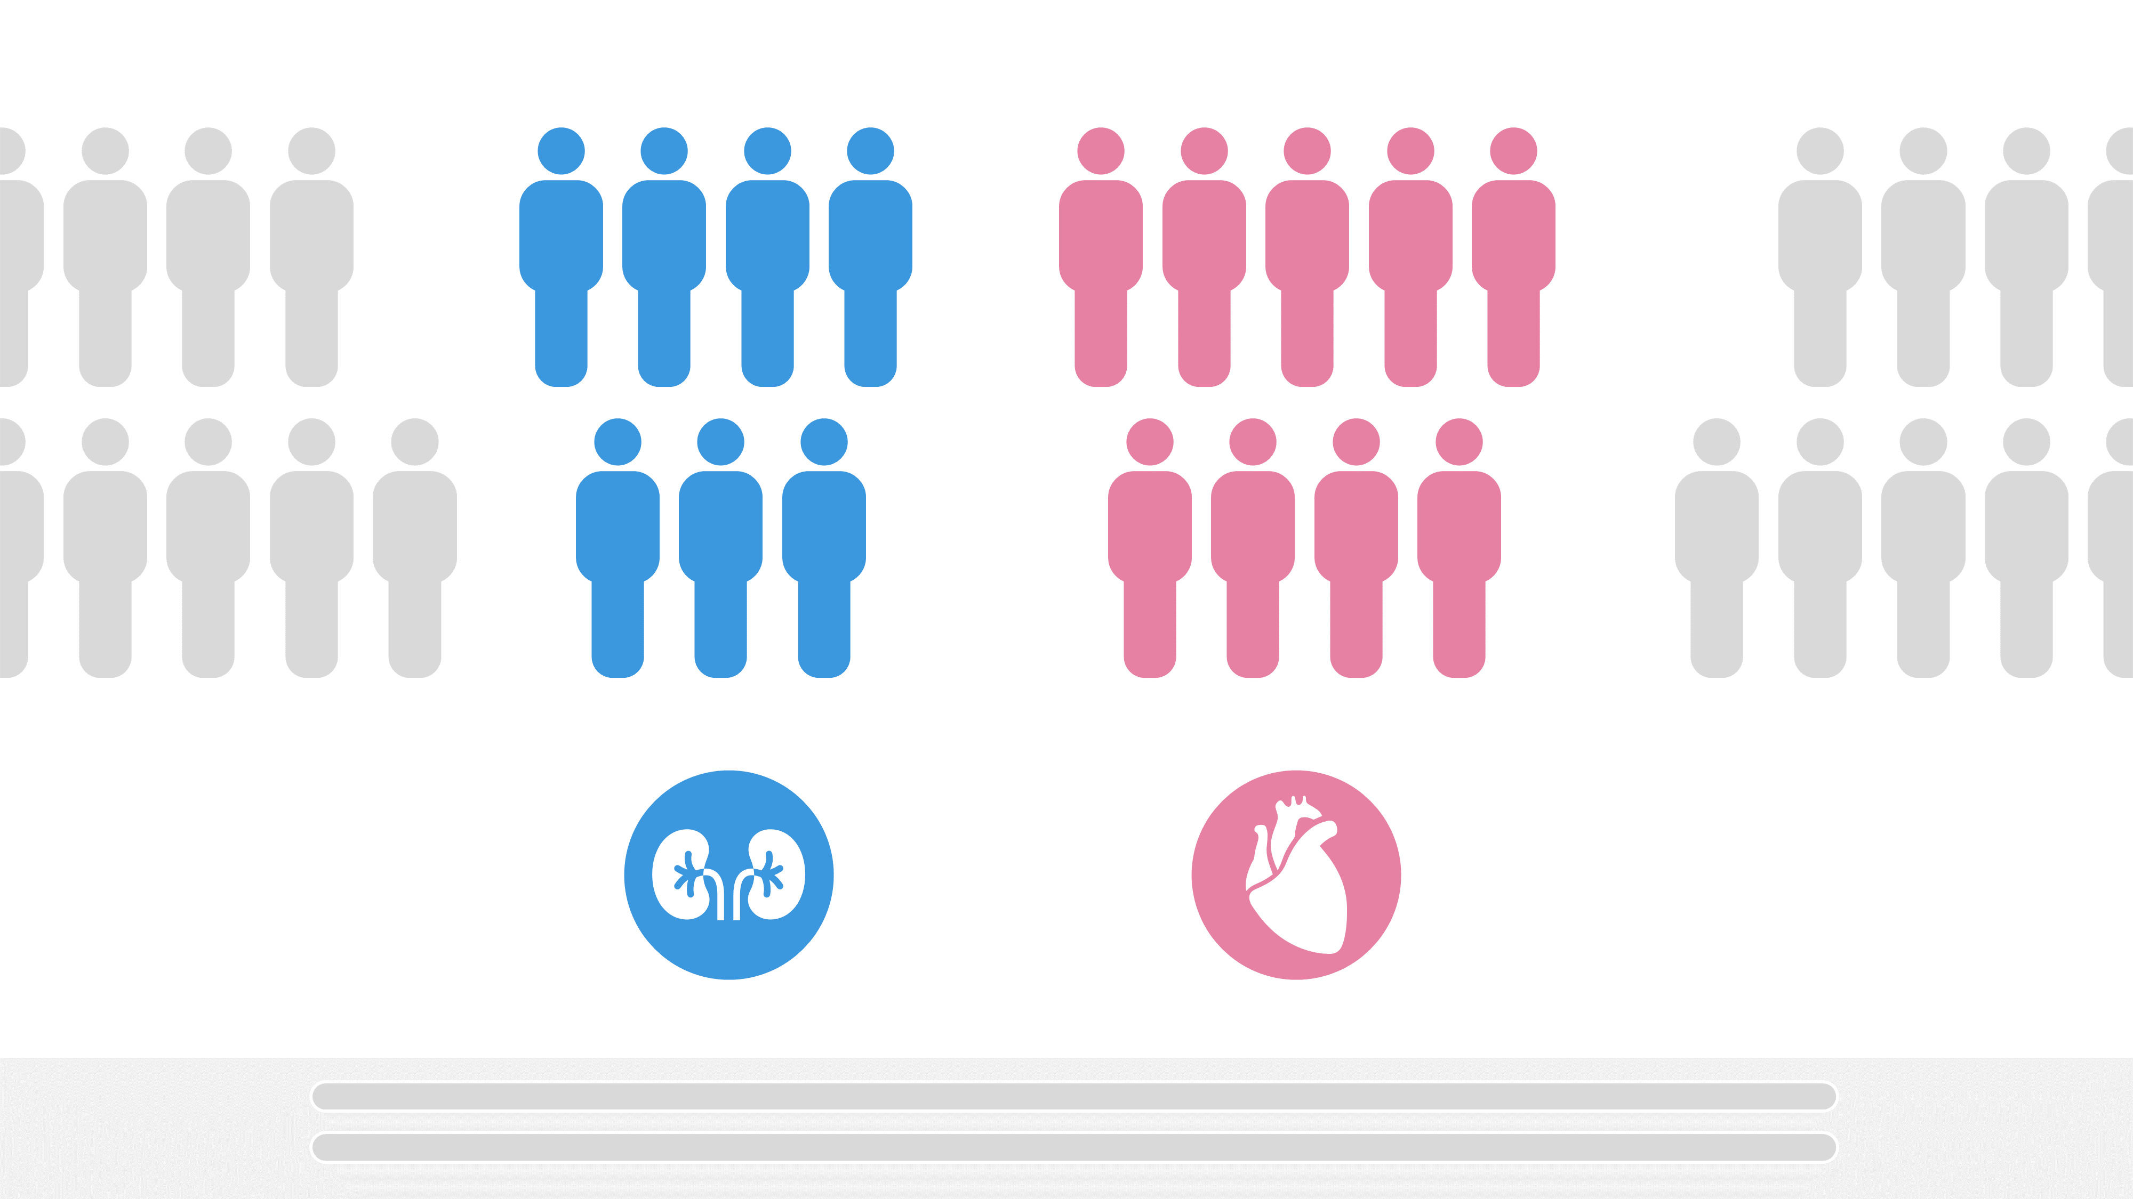

Script: …including patients with renal impairment or high cardiovascular risk. | Direction: Patients to split into relevant sections

Scene 11
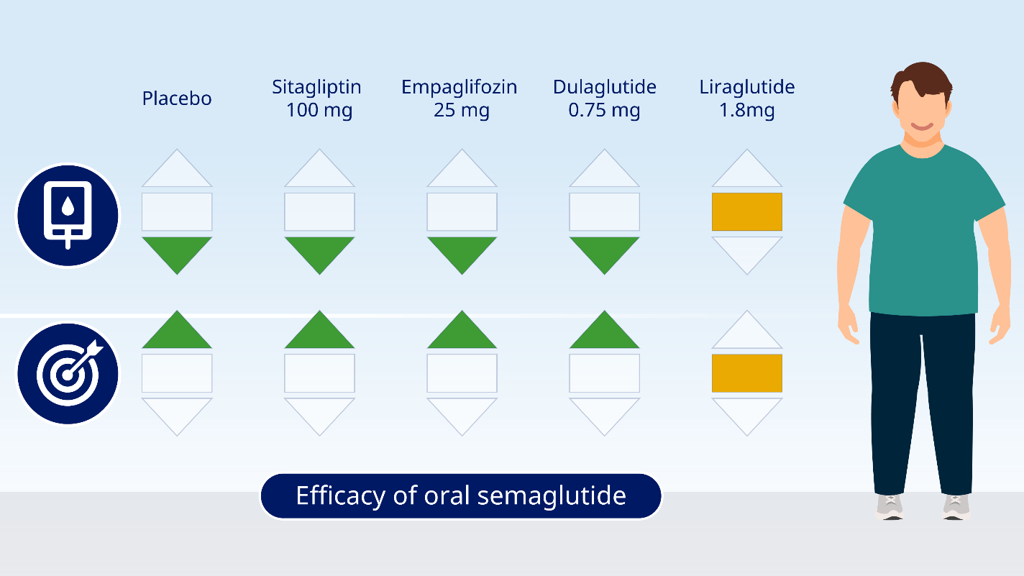

Script: Oral semaglutide was shown to be effective at helping patients achieve glycemic control, reducing glycated hemoglobin and helping patients with type 2 diabetes to achieve their targets compared with a range of comparators including a DPP-4 inhibitor, sitagliptin, an SGLT-2 inhibitor, empagliflozin, and other GLP-1RAs, such as dulaglutide and liraglutide

Scene 12
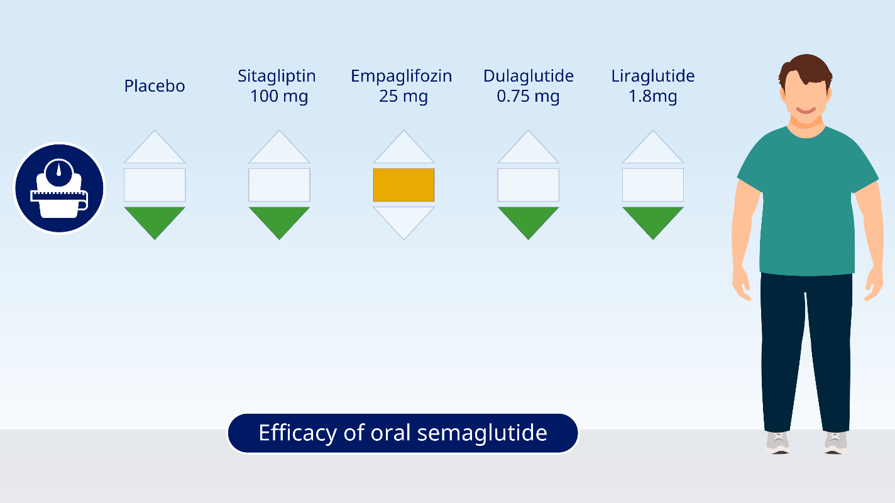

Script: Oral semaglutide also reduced body weight more than many comparators in patients with type 2 diabetes

Scene 13
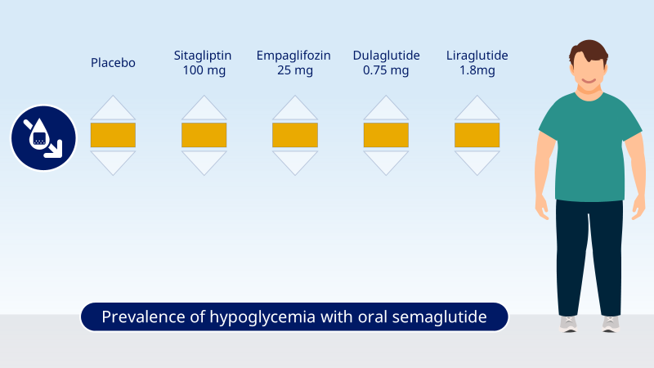

Script: The safety and tolerability of oral semaglutide is as expected for a GLP-1RA. The risk of hypoglycemia was low and similar to that seen with placebo, a DPP-4 inhibitor, an SGLT-2 inhibitor and other GLP-1RAs

Scene 14
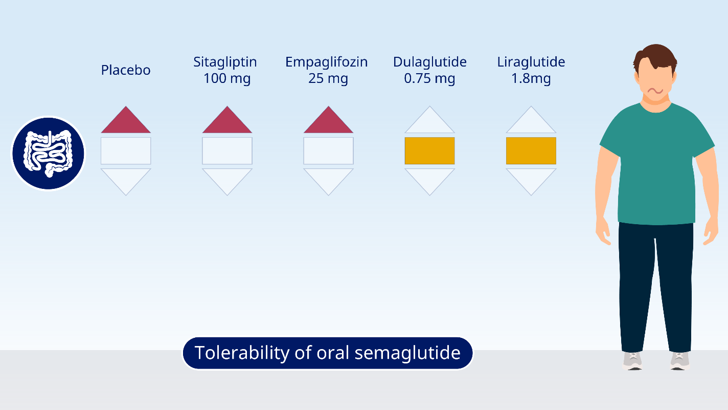

Script: Gastrointestinal adverse events, such as nausea, were the most frequently observed adverse events, generally occurring in more patients than observed with non-GLP-1RA medications. This is what would be expected with a GLP-1RA

Scene 15
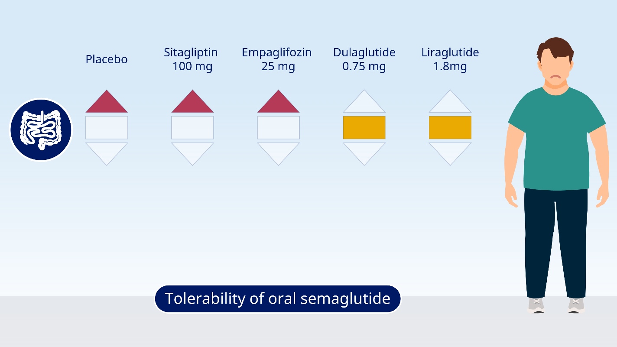

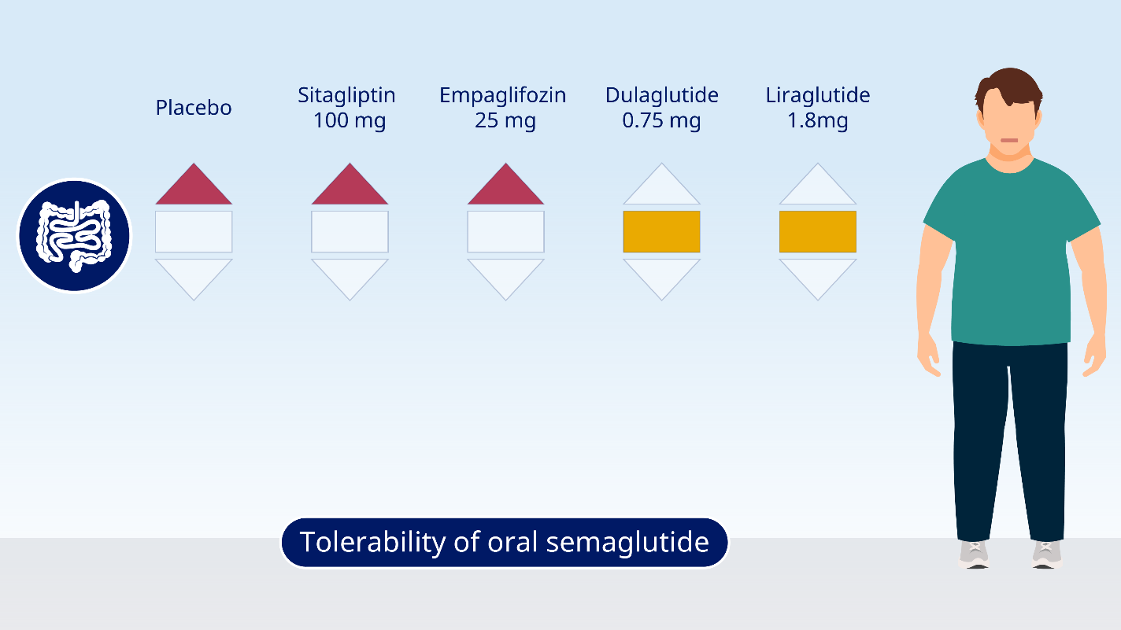

Script: However, these events were typically mild-to-moderate in severity… and transient.

Scene 16
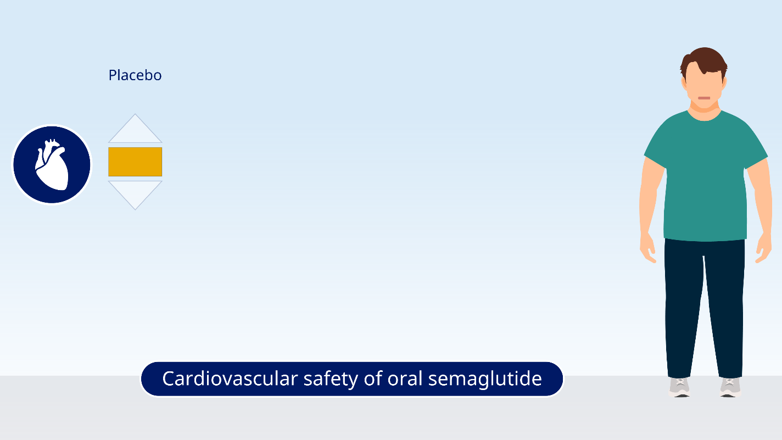

Script: In a cardiovascular outcomes trial, oral semaglutide was not associated with an increased risk of cardiovascular events

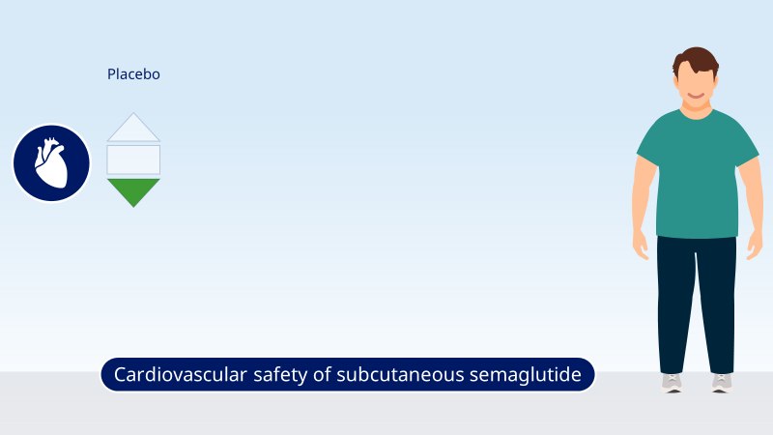
Script: and a larger outcomes trial with the injectable form of semaglutide has shown reductions in cardiovascular risk versus placebo

Scene 17




Script: Treatment intensification may be required to help patients achieve targets. Although GLP-1RAs are effective treatments to help patients achieve glycemic control, until recently they were only available as subcutaneous injections. | Direction: Doctor’s office scene – speech bubbles sync with patient concern and doctor response

Scene 18




Script: However, some patients may have a preference for oral glucose-lowering therapies, Therefore, as the first GLP-1RA available in a tablet form, oral semaglutide could play an important role in facilitating treatment intensification by helping patients with a preference for oral glucose-lowering therapy to achieve better glycemic control. An orally available GLP-1 receptor agonist therefore increases the options for clinicians to conduct patient-centered, individualized management of diabetes as recommended by guidelines.

