Supplementary Material

Title: REal worlD Effectiveness and Safety of mepolizumab in a multicentric Spanish cohort of asthma patients stratified by eosinophils: the REDES Study

Authors: Christian Domingo Ribas^{1,2}, Teresa Carrillo Díaz^{3,4}, Marina Blanco Aparicio⁵, Eva Martínez Moragón⁶, David Banas⁷ M Guadalupe Sánchez Herrero⁷ on behalf of the REDES Study group⁸
¹ Corporació Sanitària Parc Taulí, Sabadell, Spain
² Universitat Autònoma de Barcelona (UAB), Barcelona, Spain
³ H. Universitario de Gran Canaria Doctor Negrín, Las Palmas de Gran Canaria, Spain
⁴ Universidad de Las Palmas Gran Canaria, Las Palmas de Gran Canaria, Spain
⁵ H. Universitario A Coruña, A Coruña, Spain
⁶ H. Universitario Doctor Peset, Valencia, Spain
⁷ Specialty Care Medical Department, GlaxoSmithKline, Madrid, Spain
⁸ Collaborators listed in the Supplementary Material

Index
Contents
Index 2
Table 1. Comparison of the proportion of patients who exacerbate and rate of severe asthma exacerbations during the 12 months pre and during mepolizumab treatment by blood eosinophil count. 3
Table 2. Percentage of patients with exacerbations Pre and post mepolizumab exacerbations by exacerbation type 4
Table 3. Evolution and mean differences of spirometric values pre and post bronchodilator after mepolizumab initiation. 5
Table 4. Summary of OCS dose (prednisone equivalent), blood eosinophil counts, and ACT at baseline, 6 and 12 months following mepolizumab treatment 6
Figure 1. Overall design of the study 7
Figure 2. Distribution of number of total exacerbations during the 12 months pre and post mepolizumab initiation 8

Table 1. Comparison of the proportion of patients who exacerbate and rate of severe asthma exacerbations during the 12 months pre and during mepolizumab treatment by blood eosinophil count.
 |  | N | Pre-Mepolizumab | Mepolizumab | Difference | % Difference | p-value
Presence of exacerbations
 | Overall | 318
 | No |  | 26 (8.2%) | 161 (50.6%) | - |  | <0.001
 | Yes |  | 292 (91.8%) | 157 (49.4%) | 42,4 |  | <0.001
 | Eosinophil subgroups
 | Eosinophils<150 cell/µL | 25 | 23 (92.0%) | 13 (52.0%) | 40 |  | 0.0039
 | 150<=Eosinophils<300 cell/µL | 23 | 20 (87.0%) | 13 (56.5%) | 30,5 |  | 0.0348
 | 300<=Eosinophils<500 cell/µL | 84 | 77 (91.7%) | 49 (58.3%) | 33,4 |  | <.0001
 | 500<=Eosinophils<700 cell/µL | 61 | 60 (98.4%) | 24 (39.3%) | 59,1 |  | <.0001
 | Eosinophils>=700 cell/µL | 124 | 112 (90.3%) | 57 (46.0%) | 44,3 |  | <.0001
 | Eosinophil thresholds
 | Eosinophils>=150 cell/µL | 292 | 269 (92.1%) | 143 (49.0%) |  |  | <.0001
 | Eosinophils>=300 cell/µL | 269 | 249 (92.6%) | 130 (48.3%) |  |  | <.0001
 | Eosinophils>=500 cell/µL | 185 | 172 (93.0%) | 81 (43.8%) |  |  | <.0001
 | Eosinophils>=700 cell/µL | 124 | 112 (90.3%) | 57 (46.0%) |  |  | <.0001
Number of exacerbations
 | Overall | 318
 | Mean number (SD) |  | 4.48 (3.51) | 1.00 (1.44) | -3.47 (3.29) | 77.5% | <.0001
 | Eosinophil subgroups
 | Eosinophils<150 cell/µL | 25 | 4.44 (3.76) | 1.32 (1.68) | -3.12 (3.22) | 70.3% | <.0001
 | 150<=Eosinophils<300 cell/µL | 23 | 4.04 (3.24) | 1.00 (1.24) | -3.04 (3.15) | 75.2% | 0.0001
 | 300<=Eosinophils<500 cell/µL | 84 | 4.11 (2.85) | 1.36 (1.65) | -2.75 (2.53) | 66.9% | <.0001
 | 500<=Eosinophils<700 cell/µL | 61 | 4.66 (3.74) | 0.57 (0.99) | -4.08 (3.76) | 87.6% | <.0001
 | Eosinophils>=700 cell/µL | 124 | 4.77 (3.80) | 0.91 (1.40) | -3.85 (3.47) | 80.7% | <.0001
 | Eosinophil thresholds
 | Eosinophils>=150 cell/µL | 292 | 4.50 (3.49) | 0.98 (1.42) | -3.52 (3.30) | 78.2% | <.0001
 | Eosinophils>=300 cell/µL | 269 | 4.54 (3.52) | 0.97 (1.43) | -3.56 (3.31) | 78.4% | <.0001
 | Eosinophils>=500 cell/µL | 185 | 4.73 (3.77) | 0.80 (1.29) | -3.93 (3.56) | 83.1% | <.0001
 | Eosinophils>=700 cell/µL | 124 | 4.77 (3.80) | 0.91 (1.40) | -3.85 (3.47) | 80.7% | <.0001
Number of exacerbations are presented as mean number of total exacerbations one year before and after mepolizumab initiation, with standard deviation, according to baseline eosinophil counts subgroups.

Table 2. Percentage of patients with exacerbations Pre and post mepolizumab exacerbations by exacerbation type
 |  | Pre-Mepolizumab | Mepolizumab | p-value
Presence of exacerbations |  |  |  | <0.001
 | Overall
 | No | 26 (8.2%) | 161 (50.6%)
 | Yes | 292 (91.8%) | 157 (49.4%)
Exacerbations requiring only SC |  |  |  | <0.001
 | No | 75 (23.6%) | 193 (60.7%)
 | Yes | 243 (76.4%) | 125 (39.3%)
Exacerbations requiring ER visit |  |  |  | <0.001
 | No | 158 (49.7%) | 268 (84.3%)
 | Yes | 160 (50.3%) | 50 (15.7%)
Exacerbations requiring Hospitalization |  |  |  | <0.001
 | No | 252 (79.2%) | 298 (93.7%)
 | Yes | 66 (20.8%) | 20 (6.3%)
Exacerbations  requiring ER/hospitalization |  |  |  | <0.001
 | No | 137 (43.1%) | 256 (80.5%)
 | Yes | 181 (56.9%) | 62 (19.5%)
Percentages are based on the total population (n=318). Type of exacerbation were classified into three categories: Exacerbations requiring only corticosteroid burst (SC), requiring emergency room (ER) visit, and requiring hospitalization. Total exacerbations represent total of patients experiencing exacerbations, while exacerbations requiring ER/hospitalizations represent the sum of each individual category.

Table 3. Evolution and mean differences of spirometric values pre and post bronchodilator after mepolizumab initiation.
Outcome |  |  | Baseline |  | 6 months | p-value |  | 12 months | p-value
Pre-bronchodilator spirometry
 | FVC (%) |  | (n=253) |  | (n=232) |  |  | (n=209)
 | Mean (SD) |  | 88.91 (19.82) |  | 96.44 (20.11) |  |  | 96.77 (20.19)
 | FVC (L) |  | (n=255) |  | (n=234) |  |  | (n=211)
 | Mean (SD) |  | 2.96 (0.98) |  | 3.15 (0.96) |  |  | 3.12 (0.96)
 | FEV1 (%) |  | (n=254) |  | (n=232) |  |  | (n=209)
 | Mean (SD) |  | 70.12 (22.25) |  | 78.63 (22.11) |  |  | 80.55 (21.66)
 | FEV1 (L) |  | (n=256) |  | (n=234) |  |  | (n=211)
 | Mean (SD) |  | 1.88 (0.76) |  | 2.07 (0.79) |  |  | 2.08 (0.76)
 | FEV1/FVC (%) |  | (n=255) |  | (n=234) |  |  | (n=211)
 | Mean (SD) |  | 63.42 (12.75) |  | 65.14 (13.05) |  |  | 66.54 (11.87)
Pre-bronchodilator spirometry differences before-after mepolizumab
 | FVC(L) |  |  |  | (n=221) |  |  | (n=205)
 | Mean difference (SD) |  | NA |  | 0.19 (0.53) | <.0001 |  | 0.2 (0.51) | <.0001
 | FEV1 (L) |  |  |  | (n=221) |  |  | (n=205)
 | Mean difference (SD) |  | NA |  | 0.16 (0.48) | <.0001 |  | 0.21 (0.46) | <.0001
 | FEV1/FVC (%) |  |  |  | (n=221) |  |  | (n=205)
 | Mean difference (SD) |  | NA |  | 1.38 (9.24) | 0.0272 |  | 2.68 (8.43) | <.0001
Post-bronchodilator spirometry
 | FVC (%) |  | (n=207) |  | (n=175) |  |  | (n=159)
 | Mean (SD) |  | 91.05 (23.44) |  | 97.52 (21.78) |  |  | 97.70 (23.02)
 | FVC (L) |  | (n=210) |  | (n=173) |  |  | (n=157)
 | Mean (SD) |  | 3.01 (0.94) |  | 3.11 (0.94) |  |  | 3.13 (0.91)
 | FEV1 (%) |  | (n=209) |  | (n=175) |  |  | (n=162)
 | Mean (SD) |  | 76.33 (23.17) |  | 81.30 (23.22) |  |  | 82.30 (23.49)
 | FEV1 (L) |  | (n=212) |  | (n=172) |  |  | (n=156)
 | Mean (SD) |  | 2.01 (0.73) |  | 2.07 (0.73) |  |  | 2.11 (0.70)
 | FEV1/FVC (%) |  | (n=210) |  | (n=172) |  |  | (n=154)
 | Mean (SD) |  | 66.66 (12.24) |  | 66.39 (12.41) |  |  | 66.78 (12.34)
Post-bronchodilator spirometry differences before-after mepolizumab
 | FVC(L) |  |  |  | (n=151) |  |  | (n=139)
 | Mean difference (SD) |  | NA |  | 0.1 (0.41) | 0.0027 |  | 0.14 (0.4) | <.0001
 | FEV1 (L) |  |  |  | (n=151) |  |  | (n=139)
 | Mean difference (SD) |  | NA |  | 0.08 (0.4) | 0.0144 |  | 0.15 (0.39) | <.0001
 | FEV1/FVC (%) |  |  |  | (n=151) |  |  | (n=139)
 | Mean difference (SD) |  | NA |  | 0.1 (6.93) | 0.8600 |  | 1.49 (6.87) | 0.0118
NA=Not applicable

Table 4. Summary of OCS dose (prednisone equivalent), blood eosinophil counts, and ACT at baseline, 6 and 12 months following mepolizumab treatment
Outcome |  |  | Baseline |  | 6 months |  | 12 months
Patients on OCS maintenance dose |  |  | (n=98) |  | (n=93) |  | (n=90)
 | Mean (SD) dose in mg/day |  | 12.1 (10.0) |  | 6.0 (7.3) |  | 4.9 (6.9)
 | Median (IQR) dose in mg/day |  | 10.0 (5.0; 18.0) |  | 3.3 (0.0; 10.0) |  | 2.3 (0.0; 8.8)
 | 0 mg/day |  | - |  | 32 (34.4%) |  | 43 (47.8%)
 | 0.1 to 5 mg/day |  | 38 (38.8%) |  | 31 (33.3%) |  | 19 (21.1%)
 | 5.1 to 10 mg/day |  | 24 (24.5%) |  | 12 (12.9%) |  | 16 (17.8%)
 | 10.1 to 20 mg/day |  | 22 (22.4%) |  | 15 (16.1%) |  | 10 (11.1%)
 | 20.1 to 30 mg/day |  | 11 (11.2%) |  | 3 (3.2%) |  | 2 (2.2%)
 | >30 mg/day |  | 3 (3.1%) |  | - |  | -
 | Missing, n |  | 0 |  | 5 |  | 8
Patients on high OCS dose
 | ≥7.5 mg/day |  | 56 (57.1%) |  | 30 (32.3%) |  | 26 (28.9%)
Blood eosinophil count |  |  | (n=317) |  | (n=253) |  | (n=226)
 | Mean (SD) |  | 710.2 (836.8) |  | 187.0 (697.4) |  | 124.7 (457.7)
 | Median (IQR) |  | 550.0 (360.0; 860.0) |  | 90.0 (50.0; 110.0) |  | 70.0 (40.0; 100.0)
ACT (categorical) |  |  | (n=279) |  | (n=264) |  | (n=260)
 | Not well-controlled (ACT <20) |  | 237 (84.9%) |  | 82 (31.1%) |  | 71 (27.3%)
 | Well-controlled (ACT>=20) |  | 42 (15.1%) |  | 182 (68.9%) |  | 189 (72.7%)
OCS: oral corticosteroid. ACT: asthma control test. IQR: interquartile range. SD: standard deviation.

Figure 1. Overall design of the study
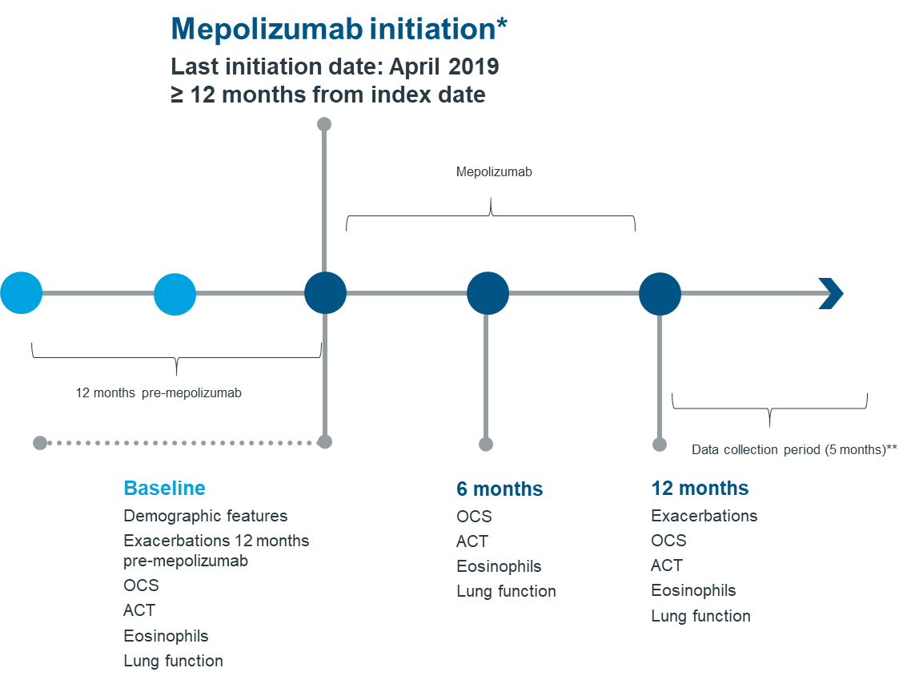

*Mepolizumab initiation was required to have been at least 12 months before the date of inclusion to the study. Therefore, the last date for the start of treatment was set to April 2019. ** Data collection was intended to last 5 months, although extended to 8 months due to COVID-19´s impact.

Figure 2. Distribution of number of total exacerbations during the 12 months pre and post mepolizumab initiation
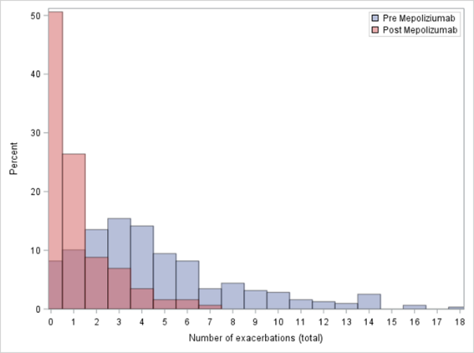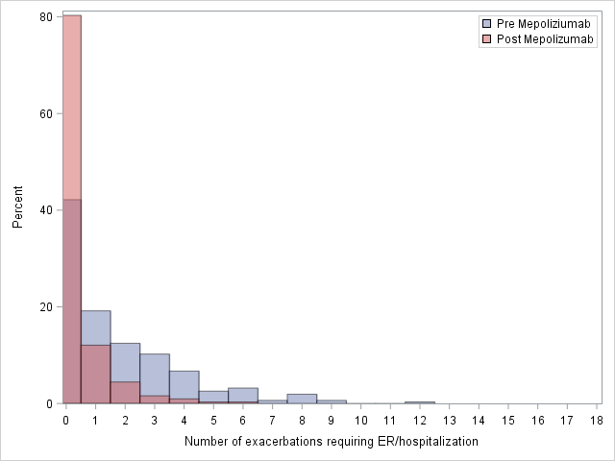
Percentage totals are based on the total number of patients (n=318). Areas with overlapping colours represent shared proportions of patients experiencing each number of exacerbations during both the pre and post mepolizumab period.

