RBX2660 for the Prevention of Recurrent Clostridioides difficile Infection
Drugs
Authors: Sahil Khanna, Maha Assi, Christine Lee, David Yoho, Thomas Louie, Whitfield Knapple, Humberto Aguilar, Julia Garcia-Diaz, Gary P. Wang, Scott M. Berry, Joe Marion, Xin Su, Tricia Braun, Lindy Bancke, Paul Feuerstadt
Corresponding author:
Sahil Khanna, MBBS, MS, FACG, AGAF
Professor of Medicine
Gastroenterology and Hepatology
Mayo Clinic
Email: Khanna.Sahil@mayo.edu
Table of Contents
List of Investigators 4
List of Key Inclusion and Exclusion Criteria 6
Bayesian Hierarchical Model and Success Criteria 8
Selection of the Borrowing Hyper Parameters 11
Defining Treatment Failure and Study Populations 13
CDI-related Serious Adverse Event Vignettes 15
Supplementary Figures 20
Supplementary Fig. 1 Study design. 20
Supplementary Fig. 2 Posterior distribution of the success rate in each treatment arm (A) and difference between arms (B) using the Bayesian hierarchical model. 21
Supplementary Fig. 3 Difference in model-estimated treatment success rates within 8 weeks of blinded treatment across various subgroups using the Bayesian hierarchical model (mITT population). 22
Supplementary Tables 23
Supplementary Table 1. Comparison of key study design features between PUNCH CD2 and PUNCH CD3 23
Supplementary Table 2. PUNCH CD3 participants with sustained clinical response through 6 months after blinded treatment (mITT, ITT, and PP populations without Bayesian analysis) 24
Supplementary Table 3. Incidence of treatment-emergent adverse events reported with placebo and RBX2660 administered blinded or open-label (safety population, N = 267) 25

List of Investigators

Investigator | Organization | Country
Aguilar, Humberto | Louisiana Research Center, LLC | United States
Altomare, John | Digestive Disease Associates | United States
Assi, Maha | IDC Clinical Research, LLC | United States
Barto, Amy | Duke University Medical Center | United States
Behrend, Clint | Grand Teton Research Group | United States
Berhe, Mezgebe | North Texas Infectious Disease Consultants, PA | United States
Birch, Thomas | Holy Name Medical Center | United States
Blanco, Antonio | Vista Health Research, LLC | United States
Challa, Shekhar | Kansas City Medical Clinic | United States
Cohen, Stuart | University of California Davis | United States
Curry, Scott | Medical University of South Carolina - ID | United States
Diaz, Julia | Ochsner Clinical Foundation | United States
DiGiovanna, Michael | DiGiovanna Institute for Medical Education & Research | United States
Dubberke, Erik | Washington University School of Medicine | United States
DuPont, Herbert | University of Texas/Kelsey Research Foundation | United States
English, Gregory | Monument Health Clinical Research | United States
Feuerstadt, Paul | Gastroenterology Center of Connecticut | United States
Galbraith, Mark | Winchester Medical Center | United States
Goldstein, Phillip | Carolina Digestive Diseases & Endoscopy Center | United States
Goldstein, Jonathan | Gastroenterology Group of Rochester | United States
Greenberg, Richard | University of Kentucky | United States
Hall, Matthew | Marshfield Clinic | United States
Handel, Daniel | Minnesota Gastroenterology, PA | United States
Hecht, Gail | Loyola University Chicago | United States
Hemaidan, Ammar | Advanced Medical Research Center | United States
Hendrix, Ernest | North Alabama Research Center, LLC | United States
Jauregui, Luis | Mercy Health St. Vincent Medical Center LLC | United States
Jazwari, Saad | Northwest Gastroenterology | United States
Kamepalli, Ravi | Regional Infectious Disease | United States
Kao, Dina | University of Alberta | Canada
Khalili, Hamed | Massachusetts General Hospital | United States
Khanna, Sahil | Mayo Clinic - Minnesota | United States
Knapple, Whitfield | Arkansas Gastroenterology | United States
Kraft, Colleen | Emory University | United States
Lee, Christine | Vancouver Island Health Authority | Canada
Louie, Thomas | University of Calgary | Canada
Lutz, Jon | Summit Medical Group Oregon BMC | United States
Meyer, Thomas | Indiana University Health Arnett | United States
Nagpal, Avish | Sanford Health | United States
Oneto, Caterina | Manhattan Clinical Research, LLC | United States
Orenstein, Robert | Mayo Clinic - Arizona | United States
Pruthi, Jatinder | OM Research | United States
Ramesh, Mayur | Henry Ford Hospital | United States
Ranga, Vishweshwar | Sierra Clinical Research | United States
Roque, Maria | Mayo Clinic - Jacksonville | United States
Rosenberg, Jonathan | Illinois Gastroenterology Group, LLC | United States
Ruthardt, Frederick | Frontier Clinical Research | United States
Rutland, Travis | Digestive Health Specialists of the Southeast | United States
Safdar, Nasia | University of Wisconsin | United States
Schmitt, Colleen | Galen Medical Group | United States
Schooneveld, Trevor | University of Nebraska Medical Center | United States
Simon, Karen | Diverse Research Solutions | United States
Smith, Kent | Velocity Clinical Research, Salt Lake City/Gut Whisperer | United States
Smyth, Daniel | Moncton Hospital - Horizon Health Network | Canada
Steiner, Ted | University of British Columbia | Canada
Sullivan, Shelby | University of Colorado | United States
Trinh, Trong | Polyclinic | United States
Uslan, Daniel | University of California, LA Health | United States
Wang, Gary | University of Florida | United States
Webster, Duncan | Horizon Health Network | Canada
Webster, Brian | Wilmington Health PLLC | United States
Yoho, David | Mid-Atlantic Permanente Group | United States

List of Key Inclusion and Exclusion Criteria
Inclusion criteria
1. Adults aged 18 years or older.
2. Medical record documentation of recurrent Clostridioides difficile (C. difficile) infection (CDI) per the study definition, including either: a) at least 1 recurrence after a primary episode and had completed at least 1 round of standard-of-care oral antibiotic therapy or b) had at least 2 episodes of severe CDI resulting in hospitalization within the last year.
3. A positive stool test for the presence of toxigenic C. difficile within 30 days before enrollment.
- Although the protocol stated that the C. DIFF QUIK CHEK COMPLETE® Test rapid enzyme immunoassay test was preferred, a C. difficile laboratory testing according to the site’s standard of care was also acceptable for enrollment, and toxin testing was not required.
- Polymerase chain reaction (PCR) was the predominant standard-of-care diagnostic test at the time the study was conducted.
4. Was currently taking or had just been prescribed antibiotics to control CDI-related diarrhea at the time of enrollment.
Note: Participant’s CDI diarrhea had to be controlled (<3 unformed/loose [i.e., Bristol Stool Scale type 6-7] stools/day for 2 consecutive days) while taking antibiotics during screening.
5. Was willing and able to have an enema(s).
6. Was willing and able to complete the stool and serum testing required for the study.
7. Agreed not to take non-dietary probiotics through 8 weeks after receiving the last study enema (including over the counter and prescription).
8. Agreed not to take any oral vancomycin, metronidazole, fidaxomicin, rifaximin, nitazoxanide, and intravenous immunoglobulin through the 8-week follow-up assessment unless newly prescribed by a treating investigator during the course of the study as a result of recurrent CDI diagnosis.
Exclusion criteria
1. A known history of refractory CDI.
2. Had continued CDI diarrhea despite being on a course of antibiotics prescribed for CDI treatment.
3. Required antibiotic therapy for a condition other than CDI.
4. Previous fecal transplant, RBX2660 treatment, receipt of CDI vaccine, or treatment with CDI monoclonal antibodies prior to study enrollment.
5. History of inflammatory bowel disease (e.g., ulcerative colitis, Crohn’s disease, or microscopic colitis).
6. Diagnosis of irritable bowel syndrome as determined by Rome III criteria.
7. History of chronic diarrhea.
8. History of celiac disease.
9. Disease symptoms (diarrhea) caused by a confirmed intestinal pathogen other than C. difficile.
10. Currently had a colostomy.
11. Intraabdominal surgery within the past 60 days.
12. Evidence of active, severe colitis.
13. History of short gut syndrome or motility disorders.
14. Required the regular use of medications to manage bowel hypermotility.
15. Had planned therapy within 3 months that might cause diarrhea (e.g., chemotherapy).
16. Planned surgery requiring perioperative antibiotics within 6 months of study enrollment.
17. Life expectancy of < 6 months.
18. Compromised immune system (e.g., human immunodeficiency virus [HIV] infection with a cluster of differentiation 4 [CD4] count < 200/mm³; inherited/primary immune disorders; immunodeficient or immunosuppressed due to a medical condition or medication).
Note: Eligible HIV patients who had a CD4 count > 200/mm³ who were on stable, highly active anti-retroviral therapy were considered for enrollment.
19. Taking systemic steroids (> 20 mg prednisone a day or prednisone-equivalent) or was expected to be on steroids (> 20 mg prednisone a day or equivalent) after enrollment through 8 weeks after completing the assigned study treatment.
Note: Eligible patients taking a steroid dose equivalent to prednisone 20 mg/day for > 2 weeks, antimetabolites (e.g., azathioprine, 6-mercaptopurine, or low-dose methotrexate for autoimmune disease), calcineurin inhibitors (e.g., tacrolimus and cyclosporine), or mycophenolate mofetil might have been enrolled only after consultation with the Medical Monitor, and only if the doses had been stable (except for drug therapeutic monitoring adjustments for calcineurin inhibitors) for 90 days and had not been associated with diarrhea before the current episode of CDI.
20. An absolute neutrophil count of <1000 cells/µL during screening.

Bayesian Hierarchical Model and Success Criteria
The primary analysis was conducted using the primary analysis population (mITT). The analysis used a Bayesian hierarchical model to include data from the phase 2b trial. This was a joint analysis of the phase 2b and phase 3 studies that provided estimates of the treatment effect in both studies, allowing for differences in study design and population. For the phase 2b trial, data from the primary analysis population (ITT) was used.
Let $N_{k,s}$ be the number of participants assigned to treatment $k$ (k$=T$ for patients who received a single dose of RBX2660 and k$=C$ for patients who received the control) in study $s$ ($s=1$ for the current phase 3 study, $s=2$ for the previous phase 2 study). We modeled the number of responders, $X_{k,s }$, in each arm/study as
$$X_{k,s}∼Binomial(N_{k,s},p_{k,s})$$
where $p_{k,s}$ was the underlying event rate for arm $k$ in study s. The event rates were transformed to the log-odds scale and modeled as:
$$log\left(\frac{p_{C, s}}{1-p_{C,s}}\right)=α_{s}$$
for the control arms and
$$log\left(\frac{p_{T,s}}{1-p_{T, s}}\right)=α_{s}+θ_{s}$$
for the treatment arms. The parameter $θ_{s}$ represents the effect of RBX2660, relative to placebo, on the log-odds scale for trial $s$. Hierarchical models are used to borrow information about the treatment and control effects across studies. The following prior was used for the control rates across the two trials:
$${ α}_{s}∼N\left(α, τ_{α}^{2} \right) for s=1, 2$$
$$α∼N(0, {10}^{2})$$
$$τ_{α}^{2}∼Inverse Gamma(0.001, 0.1)$$
A similar prior was used for the treatment effects across the two trials:
$$θ_{s}∼N\left(θ, τ_{θ}^{2} \right) for s=1, 2$$
$$θ∼N(0, {10}^{2})$$
$$τ_{θ}^{2}∼Inverse Gamma(0.01, 0.01)$$
The priors on $α$ and $θ$ were chosen to be conservative and emphasize a prior assumption of a control response rate near 0.5, with a treatment effect centered around 0. The priors on the hierarchical variance terms $τ_{α}^{2}$ and $τ_{η}^{2}$ were parameterized by their location $μ$ and weight $ω$ (rather than the traditional $shape=ω/2$ and $scale= μ^{2}⋅ω/2$ parameterization). These priors were chosen to encourage dynamic borrowing between the studies. This distribution was defined by the density:
$$f\left(x | μ,ω\right)∝\frac{e^{-μ^{2}ω/2x}}{x^{ω/2+1}}$$
Success criteria for the primary interest lies in the treatment effect (TE) for the current phase 3 study (s$=1$):
$$TE=p_{T, 1}-p_{C,1}$$
The primary goal of the trial was to demonstrate the efficacy of RBX2660 by testing the hypothesis:
$$H_{0}:TE≤0 vs. H_{A}:TE>0$$
We tested this hypothesis by calculating the posterior probability of superiority, Pr($TE> 0$ | Data) , which is equivalent to Pr($θ_{1}>0$ | Data). The thresholds for defining success at each analysis are summarized in the table below.

Analysis | Criteria | Participants complete
Interim 1 | Pr($TE>0$ | Data) > 0.99943 | Minimum 160
Interim 2 | Pr($TE>0$ | Data) > 0.99943 | 220
Final | Pr($TE>0$ | Data) > ${0.99943}^{*}$ | Maximum 270
Final | Pr($TE>0$ | Data) > 0.97706 | Maximum 270
*Indicates that the success criteria may be updated at the final analysis to ensure the correct amount of $α-$spend.
The success criteria of 0.99943 was chosen using a Pocock spending function for analysis performed at 160, 220, and 270 patients complete with a cumulative $α$ spend of 0.00125. Success at this level is considered appropriate for approval based on results from a single trial. The lower, secondary, threshold of 0.97706 at the final analysis allowed for success at the less demanding $α=0.025$ level. The second threshold at the final analysis controlled the overall Type I error rate for the trial at 2.5% (without borrowing), accounting for the $α$ spend at the interims and higher look at the final analysis.
The thresholds at the final analysis were adjusted to ensure that the overall nominal $α-$spend was performed at the pre-specified 0.00125 and 0.025 levels. These thresholds could need adjustment for several reasons. First, the definition of the mITT population allowed for the final analysis to be performed with fewer than 270 completed participants. In addition, the first interim analysis could be performed when more than 160 participants were enrolled. Finally, the second interim analysis could be omitted if the first interim analysis occurred sufficiently close to 220 participants enrolled. Therefore, to account for uncertainty in the information fraction at each analysis, the success criteria at the final analysis were updated to reflect the information spend at each interim analysis. This change was made based on the fraction of information at each interim analysis and did not depend on the outcome data for the trial. When the final analysis was performed, the higher success criteria was updated to 0.99933 and the lower success criteria was updated to 0.97503 so that each threshold preserved a nominal $α-$spend of 0.00125 and 0.025, respectively.

Selection of the Borrowing Hyper Parameters

The hyper-priors on $τ_{α}^{2}$ and $τ_{θ}^{2}$ were chosen to encourage dynamic borrowing from the phase 2b trial. Dynamic borrowing is the idea that when the observed data in the current trial are similar to the previous trial, the strength of our conclusions should increase. On the other hand, if the newly observed data are quite different from the previous data, the prior data should contribute less information to our inference. Consider two extremes: the first is the case of full borrowing, where data from the previous study is added to data from the new trial and inference is performed using the full weight of both studies. Alternatively, there could be no borrowing, ignoring information from the previous trial and conducting our analysis with only the new information. The hyper-priors on $τ_{α}^{2}$ and $τ_{θ}^{2}$ were specified to provide dynamic borrowing, behaving similarly to the full-borrowing approach when the observed data resembles the phase 2b data and mimicking the no-borrowing approach when the results differ between the two trials. The effect of the dynamic borrowing is illustrated in the Figure below.
Figure: Effective sample size (ESS) borrowed in the treatment arm for different observed treatment and response rates at the first interim.
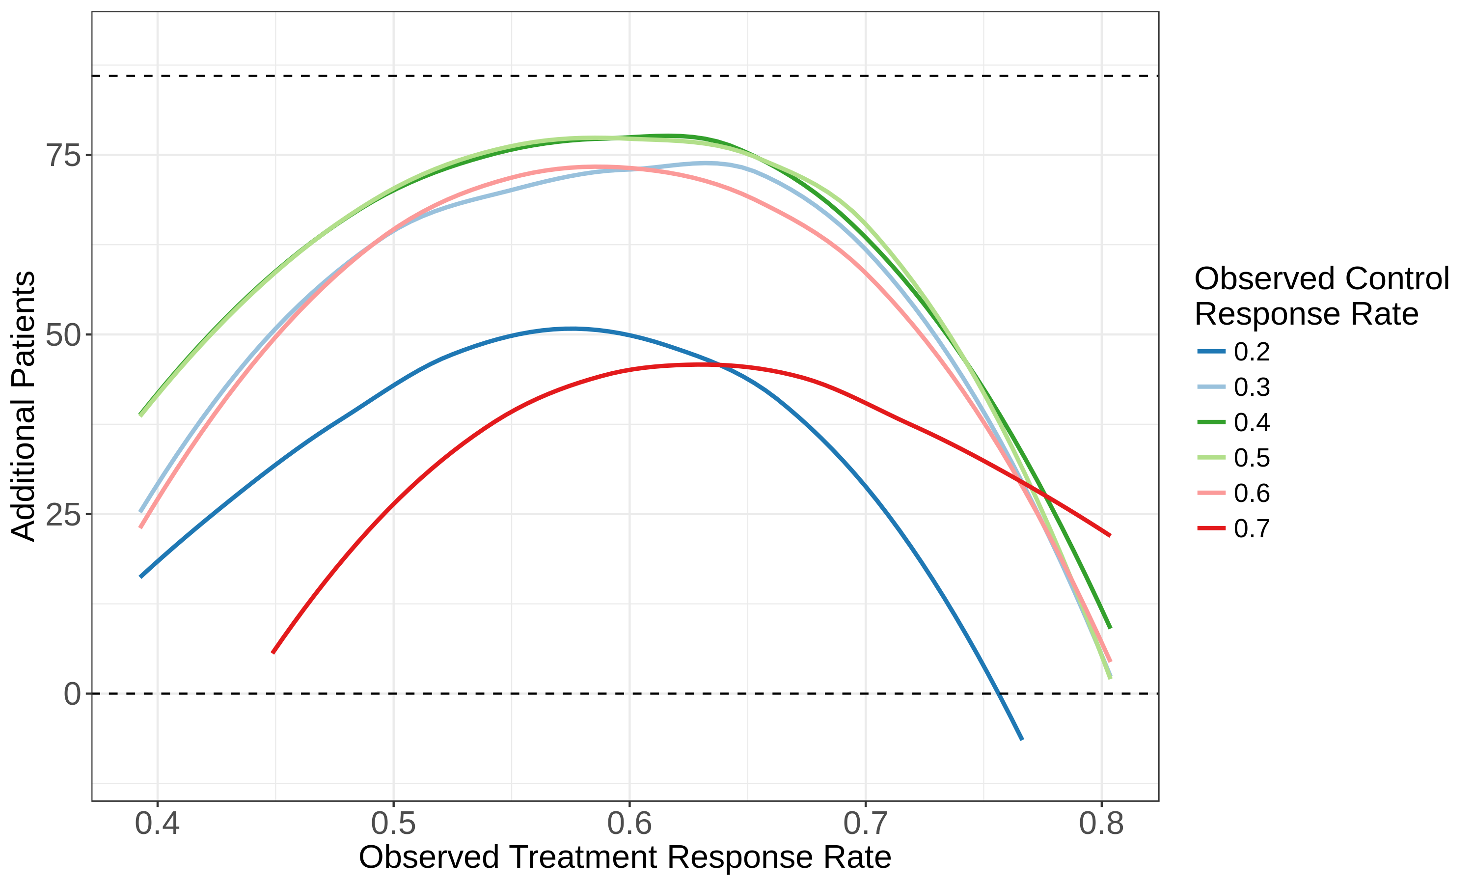
This figure summarizes the amount of borrowing from the hierarchical model for different observed treatment success proportions (${X_{T, 1}}/{N_{T, 1}},$the x-axis) and different observed control proportions (${X_{C, 1}}/{N_{C, 1}}$, differently colored lines). At the first interim analysis, 104 participants were assumed to be enrolled in the treatment arm, with 56 participants enrolled in the control arm. The y axis shows the effective number of additional treatment patients borrowed by the model, given by the equation
$$\text{Additional patients}= \frac{\text{Var}\left(θ_{full}\right)}{\text{Var}\left(θ_{1}\right)}\left(N_{1}+N_{2}\right)-N_{ 2}$$
The quantity $\text{Var}\left(θ_{1}\right)$ is the posterior variance of the treatment effect under the hierarchical model and $\text{Var}\left(θ_{full}\right)$ is the variance of the treatment effect under the full-borrowing model. The ratio of these terms is the relative effective sample size, which measures the uncertainty in the hierarchical model relative to the full model. When this ratio is small, there is substantially more uncertainty in the hierarchical model compared to the full model.
The horizontal dashed lines correspond to 0 (no borrowing from the phase 2b data) and 86 (full borrowing of the phase 2b data in the treatment arm). The hierarchical model borrowed the most patients from the phase 2b trial when the observed treatment response rate was close to the treatment response rate in the previous study (a rate of 0.595). As the observed control rate differed from the historical rate, fewer additional patients from the previous trial were used and the amount of borrowing diminished. When the observed control rate differed from the historical rate, borrowing was strongest when the log-odds of the treatment effect were similar to the phase 2b data. The chosen hyper-priors created appropriate dynamic behavior, decreasing uncertainty when then-observed data were in concordance with the previous trial and increasing uncertainty when the phase 3 trial results differed from the phase 2b trial.

Defining Treatment Failure and Study Populations
Treatment Failure
- Treatment failure was defined as CDI diarrhea within 8 weeks of administration of a study enema.
  - CDI diarrhea was defined as the passage of ≥3 unformed/loose (i.e., Bristol Stool Scale type 6-7) stools in 24 or fewer consecutive hours for at least 2 consecutive days, and a positive stool test for the presence of C. difficile toxin documented at the time of the diarrhea.
- To ensure consistency across clinical sites for the determination of study failures, a central laboratory was used to perform the C. DIFF QUIK CHEK COMPLETE® Test rapid enzyme immunoassay for glutamate dehydrogenase (GDH) and toxins A and B. Additionally, an Endpoint Adjudication Committee provided independent, blinded adjudication of treatment success or failure that was used for study analysis and reporting purposes.
Populations
- Modified intent-to-treat (mITT) population was defined as all randomly assigned participants who successfully received blinded treatment, but excluded participants who withdrew before treatment, participants in whom treatment was attempted but not completed, and participants who discontinued from the study before evaluation of treatment failure/success if the reason for exit was not related to CDI symptoms.
- The intent-to-treat (ITT) population was defined as all randomly assigned participants with patients assigned to their randomized group. The ITT analysis served as the conservative analysis as it considered all participants who exited before the 8-week efficacy assessment as treatment failures regardless of treatment failure documentation.
- The per-protocol (PP) population was defined as participants who successfully received blinded treatment and was analyzed according to the treatment they received, excluding participants who had documented deviations to inclusion or exclusion criteria and/or participants who exited before the 8-week efficacy evaluation if the reason for exit was not related to CDI symptoms.
- The safety population included all participants for whom enema treatment was attempted.

CDI-related Serious Adverse Event Vignettes
Aged 79 years  White, Female | PMH: Hypertension, hyperlipidemia, diabetes mellitus type 2, congestive heart failure, cardiovascular disease, chronic kidney disease, diabetic neuropathy, chronic urinary tract infections  Concomitant medications: Pregabalin, carvedilol, clopidogrel, simvastatin, Levemir, furosemide  SAE 1: Hypotension (severe, onset 30Oct-08Nov2018 resolved). Serious criterion of hospitalization/prolonging existing hospitalization. Assessed as unrelated to investigational product, procedure, or C. difficile disease.  SAE 2: Cardiac failure congestive (severe, 23-27Nov2018 resolved). Serious criterion of hospitalization/prolonging existing hospitalization. Assessed as unrelated to IP, procedure, or C. difficile disease.  SAE 3: Clostridium difficile infection (moderate, 03-12Dec2018 resolved). Serious criterion of hospitalization/prolonging existing hospitalization. Assessed as unrelated to IP and procedure and related to C. difficile disease.  SAE 4: Multimorbidity (potentially life threatening, 22Dec2018, fatal). Assessed as unrelated to IP, procedure, or C. difficile disease.  The participant received the blinded RBX2660 enema on 27 Jun 2018 (Day 1). The participant was considered a blinded treatment failure on 08 Jul 2018 (Day 12) as documented by central laboratory GDH testing and a toxin positive result. On 25 Jul 2018 (Day 29), the participant received open-label RBX2660 enema.  On Days 126 and 150, the participant was hospitalized for hypotension (30 Oct-08 Nov 2018, severe, resolved) and cardiac failure, congestive (23-27 Nov 2018, severe, resolved) respectively. On 03 Dec 2018 (Day 160), the participant presented to the emergency department with reports of confusion and loose stools. Stool sample was positive for C. difficile and the participant was hospitalized. Additionally, the participant was diagnosed with a nonserious event of urinary tract infection. Treatment included IV fluids, IV ceftriaxone, oral vancomycin, and oral fidaxomicin. Additional treatment on Day 162 included IV metronidazole. On 06 Dec 2018 (Day 163), the participant was diagnosed with a nonserious event of moderate decubitus ulcer. Treatment included topical collagenase. On 12 Dec 2018 (Day 169), the serious event of C. difficile infection and the nonserious event of urinary tract infection were considered resolved. Additional treatment included oral vancomycin, topical mupirocin, and oral doxycycline for the ongoing decubitus ulcer events. On 22 Dec 2018 (Day 179), the participant died because multimorbidity. The events of chronic obstructive pulmonary disease and decubitus ulcer (right heel and sacrum) were considered ongoing at the time of death. An autopsy report and death certificate were considered permanently unavailable. No additional information was available.
Aged 80 years  Black, Female | PMH: Congestive heart failure, diabetes mellitus type, hypertension, gastroesophageal reflux disease, chronic kidney disease stage 3  Concomitant medications: Amlodipine, atorvastatin, NovoLog (insulin aspart), Lantus (insulin glargine), quinapril, Zantac (famotidine), spironolactone, potassium bicarb-citric acid, potassium chloride, acetylsalicylic acid  SAE: Clostridium difficile infection (moderate, 09-27 Apr 2018 resolved). Serious criterion of hospitalization/prolonging existing hospitalization. Assessed as unrelated to IP and procedure, and definitely related to C. difficile disease  The participant received the RBX2660 enema on 19 Mar 2018 (Day 1) and an open-label RBX2660 enema on 30 Apr 2018 (Day 43).  On 09 Apr 2018 (Day 22), the participant presented to the 3-week follow-up visit with reports of loose, mucous stool and malaise. On 12 Apr 2018 (Day 25), the participant presented to the emergency department with worsening loose-to-watery stools every hour along with left lower quadrant abdominal pain, lightheadedness, and tenderness and irritation around her intergluteal cleft. She was admitted to the hospital for evaluation, which revealed no abdominal tenderness, guarding, or distention. Laboratory testing revealed a magnesium of 1.4 mg/dL (1.8-2.3), potassium of 2.9 mmol/L (3.5-5.0), creatinine of 0.64 mg/dL (0.6-1.2), and white blood cell count of 9.5 K/µL (3.8-10.6). On 13 Apr 2018 (Day 26), a stool sample taken the previous day tested positive for C. difficile toxin B. Treatment for the event included intravenous fluids, electrolyte replacement, and vancomycin. On 13 Apr 2018 (Day 26), the participant was discharged from the hospital and was instructed to complete a 1-month-long course of vancomycin. On 27 Apr 2018 (Day 40), the event of recurrent C. difficile infection was considered resolved.
Aged 59 years  White, Female | PMH: Multiple sclerosis  Concomitant medications: Gabapentin, Toradol, fampridine, ocrelizumab, Ampyra  SAE: Clostridium difficile infection (severe, 01-05 Apr 2019, resolved). Serious criterion of hospitalization/prolonging existing hospitalization. Assessed as unrelated to IP and procedure, and definitely related to C. difficile disease.  The participant received the RBX2660 enema on 25 Mar 2019 (Day 1).  On 01 Apr 2019 (Day 08), the participant presented to the emergency room (ER) with fever and diarrhea, consistent with episode of C. difficile infection a month prior. She was admitted. White blood cell count (WBC) was 12.2 k/µL (4.0-10.5). A stool sample was positive for C. difficile. A CT scan revealed mild colitis with no bowel obstruction. Blood and urine cultures were negative. Treatment included oral vancomycin, acetaminophen, ketorolac, lactated Ringer’s solution, magnesium, and potassium. On 02 Apr 2019 (Day 9), she had worsening of multiple sclerosis (moderate, ongoing) treated by adding bedtime gabapentin dose. On 05 Apr 2019 (Day 12) the C. difficile infection was considered resolved and she was discharged.
Aged 61 years  White, Female | PMH: Colitis, acute urinary tract infection, tooth abscess, biliary dilatation, hematuria, pancreatic disorder, varicella, tooth fracture, dental operation, swelling face, hypoalbuminemia, hypokalemia, hyponatremia, anemia  Concomitant medications at first SAE: Ondansetron, paracetamol, nitrofurantoin  SAE 1: Bacteremia (moderate, 23 Oct-06 Nov 2018, resolved). Serious criterion of hospitalization/prolonging existing hospitalization.  SAE 2: Clostridium difficile infection (moderate, 13 Nov-05 Dec 2018, resolved). Serious criterion of hospitalization/prolonging existing hospitalization. Assessed as unrelated to IP and procedure, and definitely related to C. difficile disease.  The participant received the RBX2660 enema on 10 Sep 2018 (Day 1) and an open-label RBX2660 enema on 05 Oct 2018 (Day 26).  On 20 Oct 2018 (Day 41), the participant presented to the ER with fever and symptoms of a urinary tract infection (cystitis, moderate, 20 Oct-06 Nov 2018). Treatment included nitrofurantoin and paracetamol. On 23 Oct 2018 (Day 44), she was admitted after one of two blood cultures from 20 Oct 2018 was positive for Providencia rustigianii. Urine culture was positive for Escherichia coli. Treatment included tobramycin, ceftriaxone, acetaminophen, Saccharomyces boulardii, vancomycin, and levofloxacin. On 26 Oct 2018 (Day 47), she was discharged and on 06 Nov 2018 (Day 58), the event of bacteremia was resolved. On 14 Nov 2018 (Day 66), she presented to the ER with fever, nausea, vomiting, and diarrhea. She was admitted for recurrence of C. difficile infection. WBC was 27.0 × 10³/µL (4.4-10.1), C. difficile test was positive, and peak procalcitonin 4.07 ng/mL (≤0.50). Treatment included IV fluids, paracetamol, metronidazole, ondansetron, S. boulardii, and vancomycin. On 18 Nov 2018 (Day 70) she was discharged. 03 Dec 2018 (Day 85) she received bezlotoxumab. On 05 Dec 2018 (Day 87) the event of C. difficile infection was considered resolved.
Aged 85 years  White, Female | PMH: Colitis, hypertension, diabetes mellitus type 2, coronary artery disease, glaucoma, hyperlipidemia, cardiac failure congestive, anemia, myocardial infarction, gastroesophageal reflux disease, asthma, chronic obstructive pulmonary disease, gastrointestinal hemorrhage, urinary tract infection, diabetic neuropathy, rash, cholelithiasis, pancreatic cyst, cyst  Concomitant medications: Glipizide, acetylsalicylic acid, ferrous sulfate, latanoprost, multivitamins, vaccinium macrocarpon, ascorbic acid, cyanocobalamin, pregabalin, sitagliptin, Lekovit ca, metoprolol, atorvastatin  SAE: Clostridium difficile colitis (severe, 18 May-17 Jul 2019, resolved). Serious criterion of hospitalization/prolonging existing hospitalization. Assessed as unrelated to IP and procedure and related to C. difficile disease.  The participant received the RBX2660 enema on 04 Apr 2019 (Day 1) and an open-label RBX2660 enema on 06 May 2019 (Day 33).  The participant had a prior pretreatment SAE of cardiac failure acute from 09 Mar (Day 6)-02 Apr 2019 (severe, resolved) as well as a prior treatment-emergent SAE of C. difficile colitis (severe, 13 Apr [Day 10]-04 May 2019, resolved) along with sepsis (moderate, 14-19 Apr 2019, resolved), acute kidney injury (mild, 15-19 Apr 2019, resolved), hyponatremia (mild, 16 Apr-07 May 2019, resolved). The participant had hematuria (mild, 07-17 May 2019, resolved) and urinary tract infection (moderate, 07-17 May 2019, resolved) treated with cephalexin (07-13 May 2019) and gentamicin (17 May 2019). On 18 May 2019 (Day 45), the participant presented to the ER with fatigue, weakness, abdominal pain, and diarrhea. WBC was 16.72 K/µL (3.90-12.70) and a stool was positive for C. difficile. She was admitted, and treatment included one dose each of ciprofloxacin and metronidazole, electrolytes, and oral vancomycin. On 21 May 2019 (Day 48) she was discharged and on 17 Jul 2019 (Day 105) the event was considered resolved.
Aged 52 years  Black, Female | PMH: Cerebrovascular accident, chronic obstructive pulmonary disease, diabetes mellitus type 2, chronic pain, depression, anemia, gastroesophageal reflux disease, fibromyalgia, hyperlipidemia, vitamin D deficiency, hypertension, tachycardia, recurrent pancreatitis, recurrent respiratory infections  Concomitant medications: Albuterol, atorvastatin, diazepam, duloxetine, ergocalciferol, gabapentin, guanfacine, lisinopril, metformin, metoprolol tartrate, oxycodone acetaminophen, Protonix, Phenergan, clonidine, amitriptyline, ezetimibe, magnesium, dicyclomine, naloxone, methylprednisolone, duloxetine DR  SAE 1: Clostridium difficile infection (severe, 05-17 Jun 2019, resolved) Serious criterion of hospitalization/prolonging existing hospitalization. Assessed as unrelated to IP and procedure and related to C. difficile disease.  SAE 2: Colitis (severe, 19-25 Sep2019, resolved) Serious criterion of hospitalization/prolonging existing hospitalization. Assessed as unrelated to IP and procedure and related to C. difficile disease.  The participant received a placebo enema on 19 June 2019 (Day 1).  The participant experienced a pretreatment SAE of C. difficile infection from 05 Jun 2019 (Day 14) to 17 Jun 2019 (severe, resolved). On 19 Sep 2019 (Day 93), the participant experienced symptoms of nausea, non-bloody diarrhea, and abdominal pain which was reported as colitis. On 24 Sep 2019 (Day 98), the participant reported to the emergency department after experiencing multiple episodes of diarrhea which had continued since receipt of the placebo enema on Day 1. She was admitted to the hospital for further evaluation. The abdominal pain was described as diffuse and cramping. The participant reported a home temperature of 101.3 °F and decreased appetite with poor intake. Vital signs revealed tachycardia and hypertension (heart rate and blood pressure not provided); however, the participant was hemodynamically stable. A CT scan of the abdomen and pelvis revealed no acute process with “some” fluid and stool reported in both small and large bowel. Treatment for the event included dicyclomine, unspecified pain control, and unspecified intravenous fluid. The participant improved with treatment; stool testing was negative for C. difficile. On 25 Sep 2019 (Day 99), the event of colitis was considered resolved and the participant was discharged.
Aged 65 years  White, Male | PMH: Depression, hemiplegia, hemorrhage intracranial, irritable bowel syndrome, inflammatory bowel disease, colitis, proctitis ulcerative, acute kidney injury, dyslipidemia, hypertension  Concomitant medications: Fluoxetine, mirtazapine, quetiapine, gabapentin, dalteparin, atorvastatin, lenoltec with codeine, ramipril, amlodipine, paracetamol melatonin, mineral NOS w/vitamins NOS, vitamin D NOS, ferrous sulfate, budesonide, prednisone, Mezavant, amitriptyline, cholestyramine  SAE 1: Clostridium difficile colitis (severe, 27 May-05 Jun 2019, resolved). Serious criterion of hospitalization/prolonging existing hospitalization. Assessed as unrelated to the investigational product, the enema procedure, and related to C. difficile disease.  SAE 2: Diarrhea (severe, 10-17 Jun 2019, resolved). Serious criterion of hospitalization/prolonging existing hospitalization. Assessed as unrelated to the investigational product, the enema procedure, and related to C. difficile disease.  SAE 3: Failure to thrive (severe, 10-17 Jun 2019, resolved). Serious criterion of hospitalization/prolonging existing hospitalization. Assessed as unrelated to the investigational product, the enema procedure, and related to C. difficile disease.  SAE 4: Failure to thrive (moderate, 18 Jun-23 Jul 2019, resolved). Serious criterion of hospitalization/prolonging existing hospitalization. Assessed as unrelated to the investigational product, the enema procedure, or C. difficile disease.  SAE 5: Diarrhea (severe, 20 Jun-23 Jul 2019, resolved). Serious criterion of hospitalization/prolonging existing hospitalization. Assessed as unrelated to the investigational product, the enema procedure, and related to C. difficile disease.  SAE 6: Failure to thrive (moderate, 28 Jul-01 Aug 2019). Serious criterion of hospitalization/prolonging existing hospitalization. Assessed as unrelated to the investigational product, the enema procedure, or C. difficile disease.  The participant received the RBX2660 enema on 09 May 2019.  On 28 May 2019 (Day 20) the participant presented to the ER with diarrhea, fatigue, and abdominal pain for 1 day. Nucleic acid amplified technology (NAT) was positive for C. difficile toxin B and he was admitted on 29 May 2019 (Day 21). Treatment for the event included oral vancomycin. Cholestyramine and mesalamine were begun based on a colonoscopy 2 months prior, suggesting idiopathic inflammatory bowel disease and ulcerative proctosigmoiditis with mild active chronic colitis on biopsy. On 05 Jun 2019 (Day 28), the event was considered resolved and he was discharged. An AE of acute kidney injury (mild, 27 May-05 Jun 2019, resolved) was also recorded. On 11 Jun 2019 (Day 34), he was readmitted for weakness, diarrhea, dehydration (moderate 10-27 Jun 2019, resolved), lower abdominal pain, and fever. Creatinine was 130 µmol/L (45-110), acute kidney injury (mild, 10-27 Jun 2019, resolved) was treated intravenous fluids. Oral vancomycin was administered for 1 day. No stool testing was performed. Mesalamine and cholestyramine were resumed (not prescribed on prior discharge) resolution of diarrhea. On 17 Jun 2019 (Day 40), the events of diarrhea and failure to thrive were considered resolved and he was discharged. On 18 Jun 2019 (Day 41), he presented to the ER with left-sided abdominal pain and loose, bloody bowel movements. Treatment included hydrocortisone and mesalamine. A stool sample was positive for C. difficile. On 19 Jun 2019 (Day 42) he was discharged from the ER on hydrocortisone and mesalamine. An AE of abdominal pain (mild, 18-19 Jun 2019, resolved) was reported. On 21 Jun 2019 (Day 44), he presented with lower quadrant abdominal pain, bloody diarrhea, weakness, shortness of breath, fever, and emesis. WBC was 20.8 × 10⁹/L (4.0-11.0), hemoglobin was 120 g/L (135-170), C-reactive protein was 78.2 mg/L (<3.1), gamma-glutamyl transferase was 319 U/L (15-80). An abdominal x-ray revealed a non-specific bowel gas pattern. He was admitted, and treatment included intravenous fluids, vancomycin, mesalamine, and prednisone; it was determined he was not taking his inflammatory bowel medications as an outpatient. On 23 Jul 2019 (Day 76), the events of diarrhea and failure to thrive were considered resolved and he was discharged from the hospital. An AE of acute kidney injury (mild, 21-28 Jun 2019, resolved) was also reported. On 28 Jul 2019 (Day 81), he presented to the ER with diarrhea (mild, 23 Jul 2019-ongoing) and was admitted for failure to thrive. An AE of depression (mild, 28 Jul-01 Aug 2019, resolved) was also reported. Treatment during hospitalization included amitriptyline. On 01 Aug 2019 (Day 85), the events of failure to thrive and depression were considered resolved and he was discharged.
Aged 47 years  White, Female | PMH: Gastroesophageal reflux disorder, peptic ulcer disease, constipation, cholecystectomy, hysterectomy, dependence, anxiety, pain, bipolar disorder, borderline personality disorder, hypothyroidism, post-traumatic stress disorder, hyperhidrosis, mammoplasty  Concomitant medications: Diazepam, quetiapine, vortioxetine, lamotrigine, levothyroxine, paracetamol, Temgesic-nx  SAE 1: Ileus (severe, 25 Jun-04 Jul 2018, resolved). Serious criterion of hospitalization/prolonging existing hospitalization. Assessed as unrelated to investigational product, the enema procedure, and related to C. difficile disease.  SAE 2: Abdominal pain (moderate, 05 Jan 2020-ongoing, recovering). Serious criterion of hospitalization/prolonging existing hospitalization. Assessed as unrelated to investigational product, the enema procedure, and related to C. difficile disease.  The participant received the RBX2660 enema on 22 Jun 2018 (Day 1).  On 25 Jun 2018 (day 4), the participant developed worsening abdominal pain, nausea, and vomiting. On 26 Jun 2018 (day 5) she presented to the ER with worsened abdominal pain and vomiting and was admitted on 27 Jun 2018 (day 6). Stool was negative for C. difficile antigens and toxins; vancomycin was initiated. An initial CT scan showed a possible small bowel obstruction which was later ruled out. On 30 Jun 2018 (day 9) ileus was diagnosed; treatment included milk of magnesium, dimenhydrinate, morphine, pantoprazole, hydromorphone, ondansetron, metoclopramide, tramadol/acetaminophen, and potassium chloride. On 02 Jul 2018 (day 11) she was discharged, and on 04 Jul 2018 (day 13) the event was considered resolved.  On 18 Aug 2018 (day 58), she presented to the ER with abdominal pain since 13 Aug 2018 (day 53) and was admitted. CT scan revealed a definite stricture involving the distal ileum with proximal small bowel obstruction and possible stricture of the sigmoid colon with dilation of the colon suspicious for a large bowel obstruction. On 21 Aug 2018 (day 61) a colonoscopy was "essentially normal." Treatment included lactulose, docusate sodium, senna glycoside, polyethylene glycol, and Prepopik. On 22 Aug 2018 (day 62) an MRI revealed decompression of the left colon and improvement of the large bowel dilation. On 22 Aug 2018 (day 62) the event was considered resolved and she was discharged. The participant had an additional SAE: On 25 Aug 2018 (day 65) she had loose stools following colonoscopy bowel preparation. On 27 Aug 2018 (day 67) stool was positive for C. difficile; oral vancomycin was initiated. On 28 Aug 2018 (day 68) she was admitted with C. difficile infection (potentially life-threatening, 28 Aug-14 Sep 2018, resolved). Treatment included intravenous fluid, vancomycin, pantoprazole, fidaxomicin, metronidazole, piperacillin/tazobactam, hydromorphone, dalteparin, ondansetron, furosemide, haloperidol, metoclopramide, acetaminophen, fecal microbial transplant, total colectomy, and end ileostomy. On 14 Sep 2018 (day 85), the event was considered resolved and she was discharged.

Supplementary Figures

Supplementary Fig. 1 Study design.

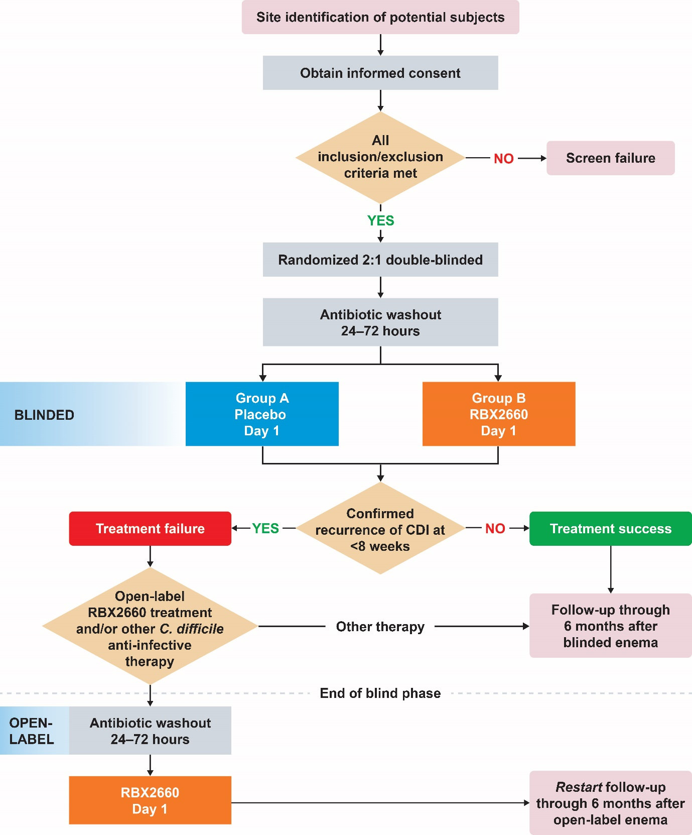
CDI, Clostridioides difficile infection
ªAn antibiotic washout period of 24-72 hours was required if antibiotic treatment was administered.

Supplementary Fig. 2 Posterior distribution of the success rate in each treatment arm (A) and difference between arms (B) using the Bayesian hierarchical model.
mITT modified intent-to-treat

Supplementary Fig. 3 Difference in model-estimated treatment success rates within 8 weeks of blinded treatment across various subgroups using the Bayesian hierarchical model (mITT population).

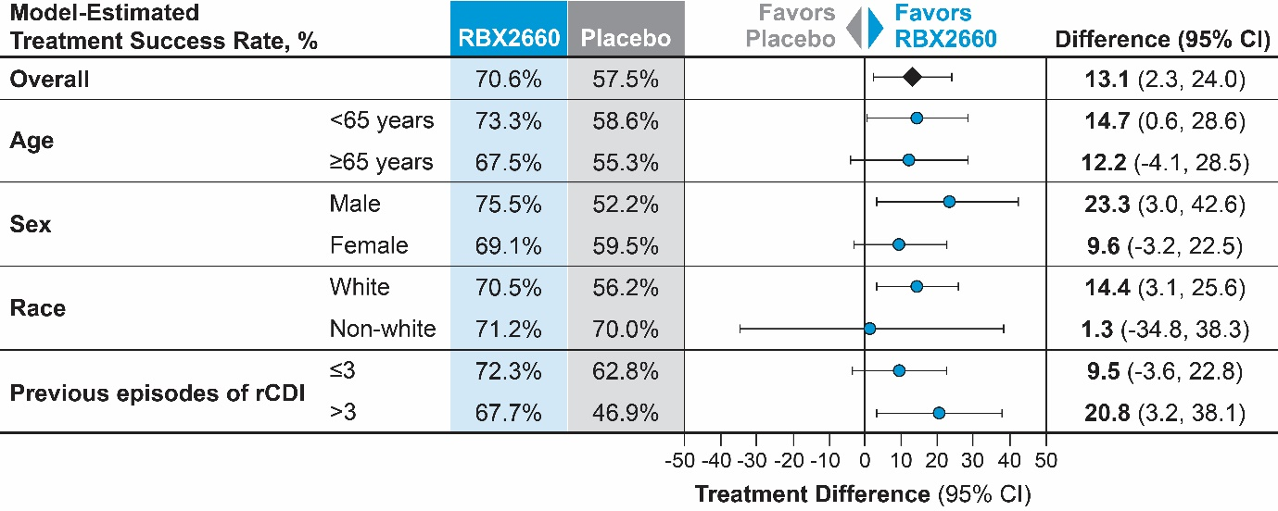
rCDI recurrent Clostridioides difficile infection, CI credible interval.
Data presented as % treatment difference (95% CI).
The difference is the model estimated treatment difference in success rates between the two treatment arms accompanied by the 95% credible interval.

Supplementary Tables

Supplementary Table 1. Comparison of key study design features between PUNCH CD2 and PUNCH CD3

Design Feature | PUNCH CD2 | PUNCH CD3
Population | Participants aged ≥18 years with documented recurrent CDI | Participants aged ≥18 years with documented recurrent CDI
Number of previous CDIs, including qualifying event | ≥2 recurrences and ≥2 rounds of SOC oral antibiotic therapy | >1 recurrence and ≥1 round of SOC oral antibiotic therapy
Comorbidities  excluded | IBD, IBS, microscopic colitis, celiac disease, and immunocompromised conditions | IBD, IBS, microscopic colitis, celiac disease, and immunocompromised conditions
Antibiotic before enrollment | Currently taking or started course of antibiotics to control recurrent CDI symptoms | Currently taking or started course of antibiotics to control recurrent CDI symptoms
Antibiotic washout | 24-48 hours | 24-72 hours
Randomization | 1:1:1 ratio among 3 dose groups, created using randomized blocks based within 3 strata based on antibiotics used at screening | 2:1 ratio of RBX2660: placebo, created using randomized blocks within 4 strata based on antibiotics used at screening
Investigational product | Placebo or RBX2660  50 g/150 mL (in each enema bag) | Placebo or RBX2660  50 g/150 mL (in each enema bag)
Treatment regimen | 2 enemas administered 7 ± 2 days apart  Group A: 2 RBX2660  Group B: 2 placebo  Group C: 1 RBX2660 and 1 placebo | 1 enema  RBX2660  Placebo
Stool test for recurrence | Local laboratory | Central laboratory
Outcome adjudication | DSMB | EAC
Main efficacy end point(s) | Treatment success, defined as the absence of CDI diarrhea within 8 weeks of study treatment | Treatment success, defined as the absence of CDI diarrhea within 8 weeks of study treatment
Demographicsª: Female, %  White, %  ≥65 years of age, % | 61.7  97.7  46.9 | 68.5  92.1  45.7
Participantsª treated with vancomycin alone for enrolling CDI episode, % | 89.8 | 88.0
CDI Clostridioides difficile infection, DSMB Data and Safety Monitoring Board, EAC Endpoint Adjudication Committee, IBD inflammatory bowel disease, IBS irritable bowel syndrome, SOC standard-of-care
ªSafety population.

Supplementary Table 2. PUNCH CD3 participants with sustained clinical response through 6 months after blinded treatment (mITT, ITT, and PP populations without Bayesian analysis)
 | ITT |  | mITT |  | PP
 | RBX2660  n = 180 | Placebo  n = 87 | RBX2660  n = 177 | Placebo  n = 85 | RBX2660  n = 167 | Placebo  n = 78
Treatment response through 8 weeks
Success, n (%) | 126 (70.0) | 53 (60.9) | 126 (71.2) | 53 (62.4) | 120 (71.9) | 48 (61.5)
Failure, n (%) | 54 (30.0) | 34 (39.1) | 51 (28.8) | 32 (37.7) | 47 (28.1) | 30 (38.5)
Differenceª | 9.1 |  | 8.8 |  | 10.3
95% CI^{b} | -3.2 to 21.3 |  | -3.4 to 21.1 |  | -2.5 to 23.1
p-value^{c} | 0.139 |  | 0.150 |  | 0.105
Treatment response through 6 months
Success, n (%) | 116 (64.4) | 48 (55.2) | 116 (65.5) | 48 (56.5) | 110 (65.9) | 43 (55.1)
Failure, n (%) | 64 (35.6) | 39 (44.8) | 61 (34.5) | 37 (43.5) | 57 (34.1) | 35 (44.9)
Differenceª | 9.3 |  | 9.1 |  | 10.7
95% CI^{b} | -3.3 to 21.9 |  | -3.6 to 21.7 |  | -2.4 to 23.9
p-value^{c} | 0.145 |  | 0.156 |  | 0.106
Sustained clinical response from 8 weeks through 6 months^{d}
Yes, n (%) | 116 (92.1) | 48 (90.6) | 116 (92.1) | 48 (90.6) | 110 (91.7) | 43 (89.6)
No, n (%) | 10 (7.9) | 5 (9.4) | 10 (7.9) | 5 (9.4) | 10 (8.3) | 5 (10.4)

CDI C. difficile infection, ITT intent-to-treat, mITT modified intent-to-treat, PP per protocol
ªDifference in percentage of treatment successes between the treatment groups.
^{b}Two-sided 95% confidence interval (CI) using the normal approximation for difference in percentages between
treatments.
^{c}p-value from Pearson’s χ² test for the difference between treatment groups with respect to the
percentage of treatment successes.
^{d}The denominator is the number of participants with treatment success at 8 weeks.

Supplementary Table 3. Incidence of treatment-emergent adverse events reported with placebo and RBX2660 administered blinded or open-label (safety population, N = 267)
 | Blinded placebo,  no open-label RBX2660  n = 63 | Blinded RBX2660,  no open-label RBX2660  n = 139 | Blinded placebo,  received open-label RBX2660  n = 24 | Blinded RBX2660,  received open-label RBX2660  n = 41 | Total  N = 267
AEs occurring in ≥5% of all participants during overall study period, n (%)
Participants with AEs | 36 (57.1) | 94 (67.6) | 16 (66.7) | 32 (78.0) | 178 (66.7)
Diarrhea | 12 (19.0) | 28 (20.1) | 7 (29.2) | 10 (24.4) | 57 (21.3)
Abdominal pain | 5 (7.9) | 26 (18.7) | 6 (25.0) | 5 (12.2) | 42 (15.7)
Nausea | 3 (4.8) | 15 (10.8) | 3 (12.5) | 1 (2.4) | 22 (8.2)
Abdominal distension | 3 (4.8) | 8 (5.8) | 2 (8.3) | 2 (4.9) | 15 (5.6)

AE adverse event

