APPENDICES

Appendix 1- Protocol changes

1. An editing error was made in the published protocol, stating our primary outcome as the mean reduction in daily dose of opioid analgesic medications (in morphine milligram equivalents). However, for this review we intended to investigate the mean daily opioid dose (in morphine milligram equivalents) as the primary outcome.

Appendix 2- Full search strategies
Search strategy for MEDLINE via Ovid
Search Terms
- randomized controlled trial.pt
- controlled clinical trial.pt
- randomized.ti,ab,kw
- placebo.ti,ab,kw
- clinical trials as topic [mesh: noexp]
- randomly.ti,ab,kw
- trial.ti,ab,kw
- #1 OR #2 OR #3 OR #4 OR #5 OR #6 OR #7
- (animals NOT (humans and animals)).sh.
- #8 NOT #9
- deprescrib*
- deprescriptions
- inappropriate.ti,ab
- polypharmacy.ti,ab
- discontinu*.ti,ab
- withdraw*.ti,ab
- drugs.ti,ab
- prescribing.ti,ab
- reduc*.ti,ab
- inappropriate prescribing
- review*.ti,ab
- medication.ti,ab
- dose reduction.ti,ab
- taper*.ti,ab
- #11 OR #12 OR #13 OR #14 OR #16 OR #17 OR #18 OR #20 OR #21 OR #23 OR #24
- exp Analgesics, Opioid/
- exp Morphine Derivatives/
- (opioid* or opiate*).ti,ab,kw
- #26 OR #27 OR #28
- exp Pain, Postoperative/
- ((postoperative adj4 pain*) or (post-operative adj4 pain*) or post-operative-pain* or (postoperative adj4 analgesi*) or (post-operative adj4 analgesi*) or post-operative-analgesi*).mp.
- ((post-surgical adj4 pain*) or ("post surgical" adj4 pain*) or (post-surgery adj4 pain*)).mp.
- ("pain‐relief after surg*" or "pain following surg*" or "pain control after").mp.
- (("post surg*" or post-surg*) and (pain* or discomfort)).mp.
- ((pain* adj4 "after surg*") or (pain* adj4 "after operat*") or (pain* adj4 "follow* operat*") or (pain* adj4 "follow* surg*")).mp.
- ((analgesi* adj4 "after surg*") or (analgesi* adj4 "after operat*") or (analgesi* adj4 "follow* operat*") or (analgesi* adj4 "follow* surg*")).mp.
- #30 OR #31 OR #32 OR #33 OR #34 OR #35 OR #36 OR #37
- #10 AND #25 AND #29 AND #37

Search strategy for EMBASE via Ovid
Search Terms
- randomised controlled trial.mp
- controlled clinical trial.mp
- randomized.ti,ab,kw
- placebo.ti,ab,kw
- clinical trials as topic [mesh: noexp]
- randomly.ti,ab,kw
- trial.ti,ab,kw
- #1 OR #2 OR #3 OR #4 OR #5 OR #6 OR #7
- (animals NOT (humans and animals)).sh.
- #8 NOT #9
- deprescrib*
- deprescriptions
- inappropriate.ti,ab
- polypharmacy.ti,ab
- discontinu*.ti,ab
- withdraw*.ti,ab
- drugs.ti,ab
- prescribing.ti,ab
- reduc*.ti,ab
- inappropriate prescribing
- review*.ti,ab
- medication.ti,ab
- dose reduction.ti,ab
- taper*.ti,ab
- #11 OR #12 OR #13 OR #14 OR #16 OR #17 OR #18 OR #20 OR #21 OR #23 OR #24
- exp Analgesics, Opioid/
- exp Morphine Derivatives/
- (opioid* or opiate*).ti,ab,kw
- #26 OR #27 OR #28
- exp Pain, Postoperative/
- ((postoperative adj4 pain*) or (post-operative adj4 pain*) or post-operative-pain* or (postoperative adj4 analgesi*) or (post-operative adj4 analgesi*) or post-operative-analgesi*).mp.
- ((post-surgical adj4 pain*) or ("post surgical" adj4 pain*) or (post-surgery adj4 pain*)).mp.
- ("pain‐relief after surg*" or "pain following surg*" or "pain control after").mp.
- (("post surg*" or post-surg*) and (pain* or discomfort)).mp.
- ((pain* adj4 "after surg*") or (pain* adj4 "after operat*") or (pain* adj4 "follow* operat*") or (pain* adj4 "follow* surg*")).mp.
- ((analgesi* adj4 "after surg*") or (analgesi* adj4 "after operat*") or (analgesi* adj4 "follow* operat*") or (analgesi* adj4 "follow* surg*")).mp.
- #30 OR #31 OR #32 OR #33 OR #34 OR #35 OR #36
- #10 AND #25 AND #29 AND #37

Search strategy for PsycINFO
- randomized controlled trial.mp
- controlled clinical trial.mp
- randomized.ti,ab.
- placebo.ti,ab.
- clinical trials as topic [mesh: noexp]
- randomly.ti,ab.
- trial.ti,ab.
- 1 OR 2 OR 3 OR 4 OR 5 OR 6 OR 7
- (animals/ NOT (humans/ AND animals/))
- 8 NOT 9
- deprescribe.mp
- deprescriptions.mp
- inappropriate.ti,ab.
- polypharmacy.ti,ab.
- discontinu*.ti,ab.
- withdraw*.ti,ab.
- drugs.ti,ab.
- prescribing.ti,ab.
- reduc*.ti,ab.
- inappropriate prescribing.mp
- review*.ti,ab.
- medication.ti,ab.
- dose reduction.ti,ab.
- taper*.ti,ab.
- 11 OR 12 OR 13 OR 14 OR 16 OR 17 OR 18 OR 20 OR 21 OR 23 OR 24
- Opioid Analgesics.mp
- exp Morphine / or Morphine Derivatives.mp
- (opioid*.ti,ab. OR opiate*.ti,ab.)
- 26 OR 27 OR 28
- exp Pain/ or Postoperative/
- ((postoperative.mp. ADJ4 pain*.mp.) OR (post-operative.mp. ADJ4 pain*.mp.) OR post-operative-pain*.mp. OR (postoperative.mp. ADJ4 analgesi*.mp.) OR (post-operative.mp. ADJ4 analgesi*.mp.) OR post-operative-analgesi*.mp.)
- ((post-surgical.mp. ADJ4 pain*.mp.) OR ("post surgical".mp. ADJ4 pain*.mp.) OR (post-surgery.mp. ADJ4 pain*.mp.))
- ("pain‐relief after surg*".mp. OR "pain following surg*".mp. OR "pain control after".mp.)
- (("post surg*".mp. OR post-surg*.mp.) AND (pain*.mp. OR discomfort.mp.))
- ((pain*.mp. ADJ4 "after surg*".mp.) OR (pain*.mp. ADJ4 "after operat*".mp.) OR (pain*.mp. ADJ4 "follow*operat*".mp.) OR (pain*.mp. ADJ4 "follow* surg*".mp.))
- ((analgesi*.mp. ADJ4 "after surg*".mp.) OR (analgesi*.mp. ADJ4 "after operat*".mp.) OR (analgesi*.mp. ADJ4 "follow*operat*".mp.) OR (analgesi*.mp. ADJ4 "follow* surg*".mp.))
- #30 OR #31 OR #32 OR #33 OR #34 OR #35 OR #36
- #10 AND #25 AND #29 AND #37
Results: 645- 06/09/22
53-22/11/23

Search strategy for Cochrane Central Register of Controlled Trials (CENTRAL)
- randomized controlled trial.mp or randomized controlled trial/
- controlled clinical trial.mp or controlled clinical trial/
- randomized,ti.
- Placebo.ti
- clinical trials as topic [mesh: noexp]
- randomly.ti
- trial.ti
- #1 OR #2 OR #3 OR #4 OR #5 OR #6 OR #7
- (animals/ NOT (humans/ AND animals/))
- #8 NOT #9
- deprescribe*
- deprescriptions
- inappropriate.ti
- polypharmacy.ti
- discontinue.ti
- withdraw.ti
- drugs.ti
- prescribing.ti
- reduce.ti
- inappropriate prescribing
- review.ti
- medication.ti
- dose reduction.ti
- taper.ti
- #11 OR #12 OR #13 OR #14 OR #16 OR #17 OR #18 OR #20 OR #21 OR #23 OR #24
- Opioid analgesics.mp or analgesics, opioid/
- Morphine derivatives.mp or Morphine derivatives/
- (opioid.ti OR opiate.ti)
- #26 OR #27 OR #28
- Pain, Postoperative/
- Postoperative analgesia.mp
- Post surgical pain.ti
- pain‐relief after surgery.ti
- #30 OR #31 OR #32 OR #33
- #10 AND #25 AND #29 AND #34

Search strategy for ClinicalTrials.gov
Condition or disease | postoperative pain OR post-operative pain OR post-operative-pain OR orthopaedic surgery
Other terms | (Opioid OR morphine OR opiate OR narcotic) AND (discharge OR after hospital OR post hospital OR release hospital OR dismiss hospital) AND (deprescribe OR dose reduction OR taper OR withdraw)
Study type/s | Randomised controlled trials
Study results | Studies with results

Search strategy for ICTRP
In the title | Opioid OR morphine OR opiate OR narcotic
In the condition | postoperative pain OR post-operative pain OR post-operative-pain OR orthopaedic surgery
In the Intervention
Study results | With results only
Appendix 3- GRADE criteria.

For each GRADE domain the certainty of evidence will be downgraded one level with each flaw found (when the criterion for the level is not satisfactorily met), using the below criteria: ³⁰

- Risk of bias: downgrade by one level if more than 25% of studies are considered at high risk of bias (i.e. 2 or more out of 6 Cochrane ROB domains were judged as being high-risk).
- Inconsistency: Inconsistency will be downgraded by one level if heterogeneity was large (I² statistic value >50%, representing potentially substantial heterogeneity and/or visual inspection on a forest plot).
- Indirectness: Indirectness will be present if the question of effectiveness of interventions designed to reduce the dose of opioid analgesics, delivered after orthopaedic surgery in this systematic review differs from the available evidence regarding either the population, intervention, comparator, or an outcome in the included randomised trial/s. The quality of evidence will be downgraded by one level if indirectness is present in either area of population, intervention, comparator or outcomes. However, as most studies which display indirectness will be excluded during the screening process, we do not expect indirectness to be present in the included studies.
- Imprecision: we will downgrade the certainty of evidence by one level if any of the below reasons exist:³¹
- The total population size was less than 400 for continuous outcomes or when dichotomous outcomes have less than 300 events.
- If the 95% confidence intervals include the possibility of a small or no effect AND appreciable benefit or harm. For instance; for dichotomous outcomes we will follow the suggested threshold for appreciable benefit and harm (a relative risk of under 0.75 or over 1.25). For continuous outcomes of pain and disability we will consider a between group difference of less than 5 out of 100 points on a 100-point scale to be a small difference, and a between group difference of greater than 10 out of 100 points to be an appreciable benefit.³¹ Therefore, if the 95%CI contains values less than 5 and greater than 10, it will be considered imprecise. If the 95%CL contains values less than 0.2 or greater than 0.5 SMD it will be considered imprecise.
- The threshold to determine a worthwhile effect for mean opioid dose reduction (MME) will be determined after a review of the data and considering clinical factors such as indications.
- Publication bias: The quality of evidence will be downgraded by one level if a funnel plot could be constructed and suggested publication bias was present.

Appendix 4- Description of intervention and control groups

Interventions

Multimodal analgesics- multimodal analgesia consists of the administration of 2 or more analgesic drugs that act by different mechanisms for providing analgesia. For example, acetaminophen plus non-steroidal anti-inflammatories.

Opioid analgesics- commonly referred to as prescription opioids, medications from the opioid class that have been used to treat moderate to severe pain in some patients, for example morphine or oxycodone.

Non-opioid analgesics- any analgesic (medication used to relieve pain) from any class other than the opioid class, e.g. paracetamol, ibuprofen.

Acupuncture/acupressure- the Chinese medicine practice of penetrating the skin with thin, solid, metallic needles which are then activated through gentle and specific movements of the practitioner's hands or with electrical stimulation.

Electrotherapy- the use of medical appliances to generate cutaneous electrical stimulation, for example transcutaneous electrical nerve stimulation (TENS)

Cryotherapy- The application of ice, icing or cold as therapy.

Behavioural interventions- interventions designed to affect the actions that individuals take with regard to their health, including interventions administered to the patient or comparing different ways an intervention is delivered. Interventions included in this category were: acceptance and commitment therapy, physical copy of an opioid prescription versus an automatically filled prescription of opioid analgesics and nurse administered versus patient controlled analgesia.

Other therapies- Includes therapies which do not fall into any of the above classifications, and can be either pharmacological or non-pharmacological; cannabis, essential oils, homeopathy, magnesium, open label placebo and non-pharmacological ‘pain relief kit’

Control groups

Placebo/no intervention/usual care- placebo, which also includes sham treatments, is a treatment that appears real, but is designed to have no therapeutic benefit. This control group also includes patients that only receive usual or standard care which either differs or is the same to that as the intervention group.

Active control- an already known, effective treatment (unlike a placebo) is being compared to the experimental treatment.

Appendix 5- Reasons for exclusion of screened studies
Publication | Reason/s for exclusion
Brown CR et al. Analgesic efficacy and safety of single-dose oral and intramuscular ketorolac tromethamine for postoperative pain. Pharmacotherapy: The Journal of Human Pharmacology & Drug Therapy 1990;10;6:59S-70S. | Does not include an aim or outcome to reduce opioid use and not orthopaedic surgery
Cakan T et al. Intravenous paracetamol improves the quality of postoperative analgesia but does not decrease narcotic requirements. Journal of Neurosurgical Anesthesiology 2008;20:3:169-173. | Intervention was not implemented post-surgery
Campbell KA et al. Opioid education for arthroscopic shoulder surgery had no effect on consumption: an RCT. Arthroscopy - Journal of Arthroscopic and Related Surgery. 2021;37:e1-e2. | Intervention was not implemented post-surgery
Claus CF et al. The effect of ketorolac on posterior thoracolumbar spinal fusions: a prospective double-blinded randomised placebo-controlled trial protocol. BMJ Open. 2019;9:1:e025855. | Intervention was not implemented post-surgery
Crowell MS et al. The effectiveness of battlefield acupuncture in addition to standard physical therapy treatment after shoulder surgery: a protocol for a randomized clinical trial." Trials. 2020;21:1:995. | Not an RCT- Protocol only
Dorr LD et al. Multimodal analgesia without parenteral narcotics for total knee arthroplasty. Journal of Arthroplasty. 2008;23:4:502-508. | Intervention was not implemented post-surgery
Elhakim M et al. Intra-articular tenoxicam relieves post-arthroscopy pain. Acta Anaesthesiologica Scandinavica. 1996;40:10:1223-1226. | Intervention was not implemented post-surgery
Farmery AD et al. The analgesic effect of epidural clonidine after spinal surgery: a randomized placebo-controlled trial. Anesthesia & Analgesia. 2009;108:2:631-634. | Does not include an aim to reduce opioid use
Gebuhr PH et al. A multiple-dose, double-blind comparison of intramuscularly and orally administered ketorolac tromethamine and ketogan in patients with pain following orthopaedic surgery. Journal of International Medical Research. 1994;22:4:202-217. | Does not include an aim to reduce opioid use
Gharibo CG et al. Opioid-sparing effects of solumatrix indomethacin in a phase 3 study in patients with acute postoperative pain. Clinical Journal of Pain. 2018;34:2:138-144. | Unable to report outcome data.
Gurkan Y et al. The effect of ibuprofen on postoperative opioid consumption following total hip replacement surgery. Turk Anestezi Ve Reanimasyon Dergisi. 2019;47:1:31-34. | Intervention was not implemented post-surgery
Hancock KJ et al. Efficacy of multimodal analgesic injections in operatively treated ankle fractures: a randomized controlled trial. Journal of Bone & Joint Surgery. 2019;101:24:2194-2202. | Intervention was not implemented post-surgery
Hernandez-Palazon J et al. Intravenous administration of propacetamol reduces morphine consumption after spinal fusion surgery. Anesthesia & Analgesia. 2001;92:6:1473-1476. | Intervention was not implemented post-surgery
Herrlinger C et al.. Reducing opiate use in postoperative analgesia. Therapiewoche. 1985;35(37):4191-8. | Intervention was not implemented post-surgery. Does not include an aim to reduce opioid use
Hommeril JL et al. Ketoprofen for pain after hip and knee arthroplasty. British Journal of Anaesthesia. 1994;72:4:383-387. | Does not include an aim to reduce opioid use
Jacques YD. Does duloxetine reduce sub-acute pain after knee arthroplasty? A randomized controlled trial. Regional Anesthesia and Pain Medicine Conference: 41st Annual Regional Anesthesiology and Acute Pain Medicine Meeting of the American Society of Regional Anesthesia and Pain Medicine, ASRA 2016;41. | Intervention was not implemented post-surgery.
Karvonen S et al. Efficacy of oral paracetamol and ketoprofen for pain management after major orthopedic surgery. Methods & Findings in Experimental & Clinical Pharmacology. 2008;30:9:703-706. | Intervention was not implemented post-surgery.
Klasen JA et al. Intraarticular, epidural, and intravenous analgesia after total knee arthroplasty. Acta Anaesthesiologica Scandinavica. 1999;43:10:1021-1026. | Does not include an aim to reduce opioid use
Koh IJ et al. Pain management by periarticular multimodal drug injection after anterior cruciate ligament reconstruction: a randomized, controlled study. Arthroscopy. 2012;28:5:649-657. | Intervention was not implemented post-surgery. Does not include an aim to reduce opioid use
Korkmaz Dilmen O et al. Efficacy of intravenous paracetamol, metamizol and lornoxicam on postoperative pain and morphine consumption after lumbar disc surgery. European Journal of Anaesthesiology. 2010;27:5:428-432. | Intervention was not implemented post-surgery.
Laoruengthana A et al. Periarticular injection of ketorolac augmenting intravenous administration of ketorolac for postoperative pain control: a randomized controlled trial in simultaneous bilateral total knee arthroplasty. The Journal of Knee Surgery. 2022;35:8: 868-873. | Intervention was not implemented post-surgery. Does not include an aim to reduce opioid use
Litke J et al. Diclofenac for treatment of postoperative pain after hip arthroplasty in older patients. Chirurgia Narzadow Ruchu i Ortopedia Polska. 1997;62:5:415-419. | Does not include an aim to reduce opioid use
Ma HH et al. An opioid-sparing protocol with intravenous parecoxib can effectively reduce morphine consumption after simultaneous bilateral total knee arthroplasty. Scientific Reports. 2021;11:1:7362. | Intervention was not implemented post-surgery.
Malek J et al. Diclofenac 75mg. and 30 mg. orfenadine (Neodolpasse) versus placebo and piroxicam in postoperative analgesia after arthroscopy. Acta Chirurgiae Orthopaedicae et Traumatologiae Cechoslovaca. 2004;71:2:80-83. | Intervention was not implemented post-surgery.
Manen Berga F et al. Effect of ischemic tourniquet pressure on the intensity of postoperative pain. Revista Espanola de Anestesiologia y Reanimacion. 2002;49:3:131-135. | Intervention was not implemented post-surgery.
Miyama T et al. Evaluation of analgesic effects of drugs on postoperative pain. Masui - Japanese Journal of Anesthesiology. 1972;21:3:259-265. | Not orthopeadic surgery
Moyano JR, Zambrano SC. The influence of information leaflets on morphine consumption in postoperative patients using patient-controlled analgesia. J. pain palliat. Care. pharmacother. 2011;25:335-339. | Mixed populations/not orthopaedic surgeries
Nesioonpour S et al. The effect of low-level laser on postoperative pain after tibial fracture surgery: a double-blind controlled randomized clinical trial. Anesthesiology & Pain Medicine. 2014;4:3:e17350. | Does not include an aim to reduce opioid use
Nikoda VV et al. Study of analgesic efficacy of propacetamol in the postoperative period using a double blind placebo controlled method. Anesteziologiia i Reanimatologiia. 2002;4:26-29. | Not orthopeadic surgery
Petersen T et al. No effect of acupuncture as adjunctive therapy for patients with total knee replacement: a randomized controlled trial. Pain Medicine. 2018;19:6:1280-1289. | Does not include an aim to reduce opioid use
Pollak R et al. Analgesic efficacy of valdecoxib for acute postoperative pain after bunionectomy. Journal of the American Podiatric Medical Association. 2006;96:5:393-407. | Does not include an aim to reduce opioid use
Rakel BA et al. Transcutaneous electrical nerve stimulation for the control of pain during rehabilitation after total knee arthroplasty: A randomized, blinded, placebo-controlled trial. Pain. 2014;155:12:2599-2611. | Intervention was not implemented post-surgery. Does not include an aim to reduce opioid use
Rasmussen GL. Etoricoxib provides analgesic efficacy to patients after knee or hip replacement surgery: a randomized, double-blind, placebo-controlled study. Anesthesia & Analgesia. 2005;101:4:1104-1111. | Does not include an aim to reduce opioid use
Riff DS et al. Diclofenac potassium liquid-filled soft gelatin capsules in the management of patients with postbunionectomy pain: a phase III, multicenter, randomized, double-blind, placebo-controlled study conducted over 5 days. Clinical Therapeutics. 2009;31:10:2072-2085. | Does not include an aim to reduce opioid use
Sharpe KP et al. Safety, Tolerability, and Effect on Opioid Use of Meloxicam IV Following Orthopedic Surgery." Journal of pain research. 2020;13:221-229. | Does not include an aim to reduce opioid use
Sinatra RS et al. Efficacy and safety of single and repeated administration of 1 gram intravenous acetaminophen injection (paracetamol) for pain management after major orthopedic surgery. Anesthesiology. 2005;102:4:822-831. | Does not include an aim to reduce opioid use
Singla N et al. A multi-center, randomized, double-blind placebo-controlled trial of intravenous-ibuprofen (IV-ibuprofen) for treatment of pain in post-operative orthopedic adult patients. Pain Medicine. 2010;11:8:1284-1293. | Intervention was not implemented post-surgery.
Skinner HB et al. Results of a multimodal analgesic trial involving patients with total hip or total knee arthroplasty. American Journal of Orthopedics. 2004;33:2:85-92. | Does not include an aim to reduce opioid use
Sullivan MD et al. Prescription opioid taper support for outpatients with chronic pain: A randomized controlled trial. The Journal of Pain. 2017;18:3:308-318. | Intervention was not implemented post-surgery.
Szatmari A et al. The role of multimodal postoperative analgesia after primary hip arthroplasty. Orvosi Hetilap. 2019;160:52:2054-2060. | Intervention was not implemented post-surgery. Does not include an aim to reduce opioid use
Tammachote N et al. Periarticular multimodal drug injection is better than single anesthetic drug in controlling pain after total knee arthroplasty. European journal of orthopaedic surgery & traumatology. 2018;28:4:667-675. | Intervention was not implemented post-surgery. Does not include an aim to reduce opioid use
Tashjian RZ et al. Zolpidem reduces postoperative pain, fatigue, and narcotic consumption following knee arthroscopy: a prospective randomized placebo-controlled double-blinded study. The Journal of Knee Surgery. 2006;19:2:105-111. | Does not include an aim to reduce opioid use
Thybo KH et al. PANSAID - Paracetamol and NSAID in combination: study protocol for a randomised trial." Trials. 2017;18:1:11. | Intervention was not implemented post-surgery.
Twiston-Davies CW et al. Rectal indomethacin for postoperative pain in orthopaedic surgery. A double-blind study. Journal of Bone & Joint Surgery. 1990;72:3:510-511. | Intervention was not implemented post-surgery.
Wang HL et al. Foot and hand massage as an intervention for postoperative pain. Pain Management Nursing. 2004;5:2:59-65. | Not an RCT
Webb JM. The use of cold compression dressings after total knee replacement: a randomized controlled trial. Orthopedics. 1998;21:1:59-61. | Does not include an aim to reduce opioid use
Wilson SH et al.Impact of ketorolac on opioid consumption after knee arthroscopy. Austin Journal of Anesthesia & Analgesia. 2018;6:2. | Intervention was not implemented post-surgery.
Xu H et al. Synergistic effect of a prolonged combination course of tranexamic acid and dexamethasone involving high initial doses in total knee arthroplasty: a randomized controlled trial. The Journal of Knee Surgery. 2021;18:18. | Intervention was not implemented post-surgery.
Yeh ML et al. Acupoint electrical stimulation reduces acute postoperative pain in surgical patients with patient-controlled analgesia: a randomized controlled study. Alternative Therapies in Health & Medicine. 2010;16:10-8. | Intervention was not implemented post-surgery. Does not include an aim to reduce opioid use
Yrjola H et al. Intravenous indomethacin for postoperative pain. A double-blind study of ankle surgery. Acta Orthopaedica Scandinavica. 1988;59:1: 43-45. | Does not include an aim to reduce opioid use
Ziadni MS et al. My surgical success: feasibility and impact of a single-session digital behavioral pain medicine intervention on pain intensity, pain catastrophizing, and time to opioid cessation after orthopedic trauma surgery-a randomized trial. Anesthesia & Analgesia. 2022;135:394-405. | Intervention was not implemented post-surgery.
Harricharan S et al. Intravenous Acetaminophen for Non-Narcotic Postoperative Pain Management Following Knee Arthroscopy. Canadian Agency for Drugs and Technologies in Health. 2018. | Intervention was not implemented post-surgery.

Appendix 6: Summary of study characteristics (n = 39 studies)
Study | Study and participant characteristics | Groups
Akbas 2021 | Country: Turkey. # Randomised: 75.  # Males: 38. # Females: 37.0.  *Age: 40.0 (7.6). Surgery: spinal surgery. | Group 1: 800mg ibuprofen administered through IV infusion over 30 min, then repeated every 6h for 24h, plus IV morphine, at wound closure.  Group 2: 1g paracetamol administered through IV infusion over 30 min, then repeated every 6h for 24h, plus IV morphine, at wound closure.  Group 3: 250mL of saline administered through IV infusion over 30 min, then repeated every 6h for 24h, plus Intravenous morphine, at wound closure.
Anthony 2020 | Country: USA. # Randomised: 82.  # Males: 41. # Females: 41.  *Age: 47.1 (15.3). Surgery: fracture surgery. | Group 1: twice-daily, text-based mobile messages communicating an Acceptance and Commitment Therapy (ACT) based intervention for the first 2 weeks following surgery. Mobile messages sent twice per day, morning and evening, to help recipients understand and develop better coping skills in relation to their postoperative pain.  Group 2: no mobile message communication.
Blumenkopf 1987 | Country: USA. # Randomised: 50.  # Males: 32. # Females: 18.  *Age: 43.0 (range 15-69). Surgery: spinal surgery. | Group 1: 25mg promethazine hydrochloride, plus 1 mg/kg meperidine hydrochloride plus 5mg diazepam, orally 3 times daily and 5mg baclofen on day 1, 7.5mg on day 2 and 10mg on day 3, orally three times daily.  Group 2: 25mg promethazine hydrochloride, plus 1 mg/kg meperidine hydrochloride as needed.
Bilir 2007 | Country: Turkey. # Randomised: 50.  # Males: 24. # Females: 26.  *Age: 60.4 (range 42-78). Surgery: hip arthroplasty | Group 1: 50mg magnesium sulphate in 5 mL as a bolus dose was given followed by a continuous epidural infusion of 100 mg magnesium sulphate at a total 24 mL volume for 24h. Plus patient-controlled epidural analgesia (initial bolus dose of 5mL fentanyl (5mg/mL) with no background infusion, lockout interval 20 min, and 4 hour limit of 30mL (150mg fentanyl).  Group 2: participants received epidural saline at a rate of 1mL/h for 24h, plus patient-controlled epidural analgesia.
Breit 2004 | Country: Australia.  # Randomised: 69.  # Males: 32. # Females: 37.  *Age: 73.0 (SD NR). Surgery: knee arthroplasty | Group 1: TENS set at maximum output level and participants were told that they could change the settings as desired, but not turn off the machine for 24h, plus, patient-controlled analgesia containing 1mg/mL of morphine with a 5-minute lock out. TENS setting not reported. TENS pads applied either side of surgical wound.  Group 2: TENS sham where the wires were simply placed deep within the dressing to appear connected for 24h. plus patient-controlled analgesia containing 1mg of morphine per millilitre with a 5-minute lock out. TENS setting not reported. TENS pads applied either side of surgical wound.  Group 3: patient-controlled analgesia only containing 1mg/mL of morphine with a 5-minute lock out.
Brouwers 2020 | Country: Netherlands. # Randomised: 106. # Males: 44. # Females: 58.  *Age: 69.4 (8.0). Surgery: knee arthroplasty | Group 1: standard care comprising of paracetamol, naproxen and gabapentin for 7 days (strength, dose not reported), plus additional postoperative cryotherapy on the operated knee post-surgery (6ºC for 6h) for 7 days, applied TID [Day 1: 8ºC for 4h, TID; Day 2-7: Day 1: 8ºC for 2h in the morning, second application option, 10ºC for 2h in the evening).  Group 2: standard care only (as above).
Castenallo 2016 | Country: USA. # Randomised: 40.  # Males: 16. # Females: 24.  *Age: 55.6 (SD NR). Surgery: hip arthroplasty | Group 1: active neuromuscular electrical stimulation device for two 20-minute sessions per day while they were inpatients, and continued post discharge at home, for up to 6 weeks. Device settings were not reported.  Group 2: control device that delivered a sub-clinical level of stimulation for two 20-minute sessions per day while they were inpatients, and continued post discharge at home, for up to 6 weeks. Device settings were not reported.
Chang 2012 | Country: Taiwan. # Randomised: 62.  # Males: 9. # Females: 53.  *Age: 70.9 (7.6). Surgery: knee arthroplasty | Group 1: auricular acupressure involving embedding the magnetic beads within skin-colored adhesive tape, placed on the auricular acupoints and retained in situ for 3 days.  Group 2: skin-colored adhesive tape placed on the acupoints only.
Collingsworth 2019 | Country: USA. # Randomised: 41.  # Males: 31. # Females: 9.  *Age: 20.4 (1.4). Surgery: shoulder surgery. | Group 1: up to 5 acupuncture needles in each ear for 6 weeks post-surgery. The number of treatments was dictated by each subject’s response and desire for further treatments. In addition to standard postsurgical care.  Group 2: standard postsurgical care of therapeutic modalities and prescribed/over-the-counter pain medications plus appropriate home exercise programs per their respective shoulder surgeries.
Crawford 2019 | Country: USA. # Randomised: 233.  # Males: 141. # Females: 92.  *Age: 44.6 (SD NR). Surgery: lower limb surgery. | Group 1: 5 10 acupuncture needles in each ear plus standard care (surgeons could prescribe medicines as per their usual practice), delivered within 30min post-anaesthesia care unit.  Group 2: sham acupuncture plus standard care (as above), within 30min post-anaesthesia care unit.  Group 3: standard care (as above), within 30min post-anaesthesia care unit.
Etches 1995 | Country: Canada. # Randomised: 181.  # Males: 85. # Females: 89.  *Age: 64.5 (0.7). Surgery: knee or hip arthroplasty | Group 1: ketorolac in a 1mL bolus, 30 mg/mL over 15-30s, followed by a continuous IV infusion at a rate of 5 mL/h ketorolac 1 mg/mL for 24 h plus PCA morphine (a bolus of 0.02mg/kg, a lockout interval of 6 min).  Group 2: placebo in a 1mL bolus, 30 mg/mL over 15-30s, followed by a continuous IV infusion at a rate of 5mL/h placebo 1mg/mL for 24 h, plus PCA morphine (a bolus of 0.02mg/kg, a lockout interval of 6min). Placebo ingredients not reported.
Fleischman 2019 | Country: USA. # Randomised: 235.  # Males: 126. # Females: 109.  *Age: 63.3 (8.8). Surgery: hip arthroplasty | Group 1: minimal opiate supply policy of a fixed-schedule dose multimodal analgesic regimen (100mg acetaminophen QID 4 weeks, 200mg gabapentin BID 4 weeks, 15mg meloxicam once a day (am) 2 weeks and 20mg omeprazole once a day (am) 2 weeks) plus 10 tablets each of 5mg oxycodone every 4h and 50mg tramadol ever 6h and for use as emergency pain relief only.  Group 2: fixed-dose multimodal analgesic regimen (as above), plus a conventional 2-week opiate supply (60 tablets each of 5 mg oxycodone every 4h and 50mg tramadol every 4h). Participants were again instructed to take non-opiate medications on a fixed daily schedule.  Group 3: 500mg acetaminophen every 4h for 4 weeks, plus a 2-week supply of opiates to be taken as needed basis, starting with acetaminophen for mild pain and opioid medications for moderate or severe pain.
Flowers 2021 | Country: USA. # Randomised: 51.  # Males: 31. # Females: 20.  *Age: 60.1 (13.1). Surgery: spinal surgery. | Group 1: 500 to 1000mg acetaminophen every 6 to 8h, and 5-10mg oxycodone or 1-2mg hydromorphone, every 4 to 6h as needed, plus 1 placebo tablet, TID.  Group 2: usual care (same pharmacological care as the intervention group, minus the placebo tablets).
Gombotz 2010 | Country: Austria. # Randomised: 120.  # Males: 62. # Females: 58.  *Age: 62.9 (10.1). Surgery: hip arthroplasty | Group 1: a single infusion of 250mL of neodolpasse infusion (combination of 75mg diclofenac and 30mg orphenadrin) solution, administered over 60–90 min. First dose immediately after surgery. Second 12h after the start of the first infusion.  Group 2: a single infusion of 250mL of isotonic saline, administered the same as intervention group.
Haffar 2022 | Country: USA. # Randomised: 89.  # Males: 41. # Females: 39.  *Age: 65.3 (8.1). Surgery: knee arthroplasty | Group 1: topical cannabidiol formulation with a concentration of 120 mg/ounce plus standard multimodal analgesia.  Group 2: essential oil topical formulation contained arnica and wintergreen plus standard multimodal analgesia.  Group 3: a combination of topical cannabidiol and essential oil topical formulation contained arnica and wintergreen plus standard multimodal analgesia.  Group 4: placebo plus standard multimodal analgesia.  Topical applications were TID (8am, 3pm and 8pm) for 14 days.  Standard multimodal analgesia was 1,000 mg acetaminophen QID, 300mg gabapentin TID, and 15mg meloxicam once daily. Overall duration unclear. As need medication permitted (5mg oxycodone 4-6h for moderate pain or 10 mg every 4-6h for severe pain not controlled by acetaminophen and meloxicam. 50mg tramadol TID was used as an alternative to oxycodone if needed.
Hans 1993 | Country: Belgium. # Randomised: 40.  # Males: 27. # Females: 13.  *Age: 38.3 (10.1). Surgery: spinal surgery. | Group 1: IV 2g propacetamol over 20 min every 6h until 24h post-surgery.  Group 2: IV saline over 20 min every 6h until 24h post-surgery.
Hartwell 2020 | Country: USA. # Randomised: 105.  # Males: 51. # Females: 44.  *Age: 44.3 (12.5). Surgery: anterior cruciate ligament surgery. | Group 1: participants were provided with a physical paper copy of 20 tablets of 5mg oxycodone and instructed to fill it only if necessary.  Group 2: participants had all of their prescriptions, including 20 tablets of oxycodone 5mg electronically prescribed to their pharmacy.
Hartwell 2021 | Country: USA. # Randomised: 96.  # Males: 38. # Females: 47.  *Age: 32.2 (9.5). Surgery: spinal surgery. | Group 1: 30 tablets of 10mg hydrocodone/325mg acetaminophen. Duration unclear.  Group 2: 60 tablets of 10mg hydrocodone/325mg acetaminophen. Duration unclear.
Huang 2022 | Country: Taiwan. # Randomised: 82.  # Males: 28. # Females: 51.  *Age: 73.2 (7.8). Surgery: knee arthroplasty | Group 1: laser acupuncture. Six selected acupuncture points were stimulated using a low-level laser from a trans laser phototherapy device at 3 Joules by applying a wavelength of 808 nm and power density of 300mW for 10 s, delivered at 2, 6, 10, 24, 48 and 72h after surgery.  Group 2: sham acupuncture. Another trans laser phototherapy device that had no laser energy output performed at the same time points as group 1.
Ilfeld 2020 | Country: USA. # Randomised: 65.  # Males: 33. # Females: 32.  *Age: 56.0 (16.0). Surgery: various surgical procedures. | Group 1: percutaneous peripheral nerve stimulation electric current. Following surgery, stimulators were attached to the leads and initiated within the recovery room. Stimulation was delivered with a square waveform at 100 Hz, with fixed frequency but the amplitude and pulse duration may be adjusted by the patient within a provider defined range. Intervention continued upon discharge. Health care providers removed the lead on postoperative day 14. Plus participants were discharged with standard care of immediate-release oral opioid tablets (5mg oxycodone; 1–2 tablets every 4–6h).  Group 2: sham peripheral nerve stimulation with a percutaneously inserted lead and wearable sham stimulator. Intervention continued upon discharge. Health care providers removed the lead on postoperative day 14. Plus participants were discharged with standard care of immediate-release oral opioid tablets (5mg oxycodone; 1–2 tablets every 4–6h).
Jildeh 2021 | Country: USA. # Randomised: 61.  # Males: 44. # Females: 17.  *Age: 45 (15.2). Surgery: spinal surgery. | Group 1: multimodal non-opioid protocol. For day 1-5 of 1000mg acetaminophen TID, 10mg ketorolac QID, 300mg gabapentin TID and 5mg diazepam QID. For days 6-10 of 1000mg acetaminophen TID, meloxicam BID and 5mg diazepam TID.  Group 2: opioid regime comprised of 40 pills of 5mg hydrocodone/325 mg acetaminophen, 1 to 2 tablets orally every 4 to 6h as needed.  Over the counter medicines permitted.
Jules-Elysee 2022 | Country: USA. # Randomised: 180.  # Males: 90. # Females: 84.  *Age: 63.6 (7.4). Surgery: hip arthroplasty | Group 1: patient-controlled epidural analgesia plus standard care.  Group 2: patient controlled epidural analgesia plus periarticular injection and standard care. Periarticular injection at the end of surgery consisting of a deep injection made up of 0.5% bupivacaine with epinephrine, 8mg morphine, 40mg methylprednisolone and 500mg cefazolin. A superficial injection of 0.25% bupivacaine was performed prior to wound closure.  Group 3: periarticular injection and standard care. Periarticular injection at the end of surgery as described in Group 2 plus superficial injection at wound closure.  Patient-controlled epidural analgesia of an infusion pump (0.06% bupivacaine) was started at 4 mL/h with a 4 mL bolus with a 10-minute lockout and with a 20 mL hourly maximum setting.  Standard care consisted of acetaminophen every 6h, 1,000 mg; IV ketorolac for a total of 3 postoperative doses, 200mg celecoxib post-operative (total of 2 doses, 60mg duloxetine on day 1 and day 2, 325mg aspirin 325mg every 12h as prophylaxis for deep vein thrombosis; and oxycodone as needed.
Kastanias 2010 | Country: Canada. # Randomised: 90.  # Males: 24. # Females: 49.  *Age: 65.6 (9.4). Surgery: knee arthroplasty | Group 1: nurse administered analgesia. Participants called the nurse to receive their prescribed short-acting opioid. The doctor determined the type and dose of short-acting opioid for each study subject via patient assessment.  Group 2: patient controlled analgesia. Participants received a single dose of their individually prescribed, short-acting opioid and were instructed to take this dose when they felt the need to do so, to a maximum of one dose every 2h. The doctor determined the type and dose of short-acting opioid for each study subject via patient assessment.
Kinsella 1992 | Country: Scotland. # Randomised: 75.  # Males: 31. # Females: 34.  *Age: 48.3 (range 18-69). Surgery: various surgeries. | Group 1: 30mg IM ketorolac trometamol, 6-hourly over the 24-h postoperative period, the first dose being given immediately after surgery. Plus 10mg IM morphine as needed (maximum one dose two hourly).  Group 2: matching placebo injection 6-hourly over the 24-h postoperative period, the first dose being given immediately after surgery. Plus 10mg IM morphine as needed (maximum one dose two hourly).
Leegwater 2012 | Country: Netherlands. # Randomised: 30.  # Males: 12. # Females: 18.  *Age: 67.0 (range 31-83). Surgery: hip arthroplasty | Group 1: tricot compression bandage plus intermittent cryo-compression therapy 15 times for 30 min. Plus standard post-operative analgesia of 1000mg paracetamol 1000 mg QID, 15mg meloxicam once daily, and if needed morphine retard 15mg twice and morphine solution 2mg/mL 10mL 6 times daily.  Group 2: standard post-operative analgesia (as above).
Li 2020 | Country: USA. # Randomised: 216.  # Males: 65. # Females: 78.  *Age: 65.8 (8.2). Surgery: knee arthroplasty | Group 1: multimodal pain management plus opioid and non-opioid medications; 650mg acetaminophen every 6h, 100mg gabapentin am and 300mg pm, 15mg meloxicam QID, 800mg metaxalone TID PLUS opioid regimen.  Group 2: opioid regimen to be taken as needed (50mg tramdol 50mg every 6h, 5-10mg oxycodone or 1.5/325mg hydrocodone 1-2 tablets every 4h).
Madava 2020 | Country: USA. # Randomised: 107.  # Males: 51. # Females: 49.  *Age: 60.1 (SD NR). Surgery: rotator cuff surgery. | Group 1: liposomal bupivacaine (LB) interscalene nerve block containing 10mL of LB, 15mL of 0.5% bupivacaine and 10mg of IV Decadron. Plus post-operative oral pain medication (300mg of gabapentin at night for 5 nights, 600mg of ibuprofen every 8h for 72h, and 100mg of acetaminophen every 8h for 72h and then as needed, as well as 15 oxycodone 5mg tablets to be taken as needed every 4h).  Group 2: standard bupivacaine containing 25mL of 0.5% bupivacaine with 10mg of IV Decadron. Plus post-operative oral pain medication (as above).
O'Hara 2022 | Country: USA. # Randomised: 53.  # Males: 35. # Females: 18.  *Age: 38.0 (19.0). Surgery: various surgeries. | Group 1: standard care plus the pain relief kit, TID (every 6-8h). The kit comprised of BioFreeze Roll-on 4% menthol (BioFreeze Warrenville, IL, USA) for application during the morning hygiene routine or up to 3 times throughout the day in response to pain, and 5 min prior to and following exercise or any other moderate intensity activity. Kinesiology tape was applied to the affected area at 25% elongation and reapplied every 3 days or as needed when tape failed to adhere. TheraPearl (Bausch & Lomb Inc., New York, USA), was applied during the morning hygiene routine and as needed in response to pain. Heat was recommended for 30 min prior to engaging in exercise and the use of a cold pack for 20 min following exercise.  Group 2: standard care but no components of the pain relief kit.
Quinlan 2017 | Country: USA. # Randomised: 148.  # Males: 58. # Females: 90.  *Age: 61.9 (13.3). Surgery: spinal surgeries. | Group 1: standard care (defined as standardized pain medication order set) plus cold packs (1L crushed ice) for 20min.  Group 2: standard care without cold packs.
Raak 2022 | Country: Germany. # Randomised: 100.  # Males: 42. # Females: 46.  *Age: 51.6 (13.7). Surgery: spinal surgery. | Group 1: 3 globules of homeopathic Hypericum perforatum BID for up to 5 days postoperatively, taken 30min after food.  Group 2: placebo BID.
Ramanathan 2017 | Country: USA. # Randomised: 116.  # Males: 36. # Females: 30.  *Age: 62.0 (8.4). Surgery: knee arthroplasty | Group 1: active, intermittent TENS device applied immediately after surgery, applied for 2h sessions followed by 30mins of rest, used as needed, at 0-60 milliamps of output current. 4 pads applied anteriorly and 4 pads posteriorly.  Group 2: sham TENS device delivered non-therapeutic electrical stimulation (using same parameters as active device).
Theinpoint 2014 | Country: Belgium. # Randomised: 116.  # Males: 25. # Females: 75.  *Age: 68.0 (10.3). Surgery: knee arthroplasty | Group 1: advanced cryotherapy, participants received 4h of continuous cooling at 11ºC (range, 6ºC–15ºC) immediately after surgery. The day after surgery the protocol consisted of 2h of treatment followed by their standard physiotherapy followed by 2h of cold treatment. Duration continued throughout the night.  Group 2: first generation cryotherapy, participants received 15min of cold pack treatment (conserved at minus 17ºC), on arrival to the recovery room and again on arrival to the ward. This was repeated 2h and 4h after surgery. The following days participants received the same cold pack cryotherapy 15min after their physiotherapy session and during the evening and night whenever they considered it useful for comfort and pain control. No compression was applied to the cold packs. Duration of 15min.
Thijs 2019 | Country: Netherlands. # Randomised: 60.  #. Males: 32. # Females: 28.  *Age: 65.1 (6.5). Surgery: knee arthroplasty | Group 1: participants received immediately after surgery cryotherapy at 10°C. In the evening and during the first night at home, participants received an additional 4h of cryotherapy. The day after surgery the fixed protocol consisted of 2h of cryotherapy in the morning at 10°C, followed by 2h in the afternoon at 10°C. During the second evening and night participants received one session of 4h at 12°C. From then, participants were allowed to use cryotherapy device at 12°C.  Group 2: participants were following exactly the same cooling protocol but with another temperature setting of 21°C.
Thomas 2021 | Country: USA. # Randomised: 260.  # Males: 97. # Females: 137.  *Age: 66.5 (range 57-74). Surgery: knee and hip arthroplasty | Group 1: buccal sample for genotyping of opioid analgesics dosage and frequency (tramadol, codeine, hydrocodone, or oxycodone) to individuals pain phenotype.  Group 2: usual pain management plus buccal sample taken.
Thompson 2021 | Country: USA. # Randomised: 80.  # Males: 52. # Females: 28.  *Age: 31.3 (10.5). Surgery: shoulder surgery. | Group 1: 30 tablets of ibuprofen (600mg every 6 to 8h as needed) and  10 tablets of 5mg oxycodone/325mg acetaminophen every 6h as needed.  Group 2: 30 tablets of oxycodone/325mg acetaminophen as needed.
Usichenko 2008 | Country: Germany. # Randomised: 80.  # Males: 27. # Females: 53.  *Age: 66.5 (7). Surgery: knee arthroplasty | Group 1: 6 sessions of millimetre wave therapy (MWT) at 50-75GHz, 4.2mW/cm², each session of 30min duration. The first MWT session was performed in the evening of the surgery day. The second MWT session was performed on the first postoperative day and then again on the 3rd, 5th, 7th and 9th postoperative days.  Group 2: sham millimetre wave therapy following the same schedule as group 1. The sham generator looked like the MWT generator but had no MW output.
Wanich 2011 | Country: USA. # Randomised: 23.  # Males: 6. # Females: 17.  *Age: 71 (SD NR). Surgery: knee arthroplasty. | Group 1: percutaneous neuromodulation technology treatment twice daily for 30 min and occurred 30 min before morning and evening continuous passive motion sessions). Sessions continued until discharge.  Group 2: sham percutaneous neuromodulation technology treatments twice daily at 30min duration and occurred 30min before morning and evening continuous passive motion sessions). Device set to 0% intensity. Sessions continued until discharge.
Westrich 2019 | Country: USA. # Randomised: 154.  # Males: 63. # Females: 91.  *Age: 64.0 (10.0). Surgery: hip arthroplasty. | Group 1: 15-minute IV infusion of 1g acetaminophen (100mL of solution), plus 2 oral placebo capsules, every 6h for 3 full days postoperatively, or until discharge.  Group 2: 1g of oral acetaminophen (in 2 capsules) and 15-min IV placebo infusion (100mL of saline), every 6h for 3 full days postoperatively, or until discharge.
Yin 2022 | Country: China. # Randomised: 240.  # Males: 133. # Females: 102.  *Age: 50.0 (12.7). Surgery: various surgeries. | Group 1: 500mg IV paracetamol over 15–30 min, every 6 h for 24h.  Group 2: 50mL IV placebo (saline) over 15–30 min, every 6 h for 24h.
Abbreviations: IM = intra-muscular; IV = intravenous; NR = Not Reported. PCA = Patient Controlled Analgesia; TENS = Transcutaneous Electrical Nerve Stimulation.
BID = twice a day; TID = three times a day; QID = four time a day.
Footnotes: Baseline participant characteristics: # Number of. * Age in years is presented as mean and (SD) unless otherwise specified.

Appendix 7- Results of studies tables
*the green rows represent the data pooled in the forest plots.

Table 7.1. Mean daily dose of opioid analgesic medications (MME), medium-term
Intervention vs control group | Studies | Mean (SD) (intervention) | Mean (SD) (control) | Effect Estimate (MD, 95% CI) | Pooled results and GRADE score or reason for not pooling data
Multimodal analgesics vs placebo/no intervention/usual care
 | Li | 12.9 (1.8) | 19.4 (1.4) | -6.5 (-6.9 to -6.1) | Single study in this group
Multimodal analgesics vs active control
 | Fleischman (1) | 0.8 | 1.5 |  | No measure of variance provided
 | Fleischman (2) | 0.8 | 1.5 |  | No measure of variance provided
Opioid analgesics vs active control
 | Fleischman (3) | 0.8 | 0.8 |  | No measure of variance provided
Acupuncture/acupressure vs placebo/no intervention/usual care
 | Crawford (4) | 8.6 (9.4) | 11.9 (18.5) | -3.3 (-8.4 to 1.8) | -1.36 (-4.4 to 1.6)
 | Crawford (5) | 8.6 (9.4) | 8.9 (10.2) | -0.3 (-4.0 to 3.4) | GRADE score = Low
Electrotherapy vs placebo/no intervention/usual care
 | Ilfeld | 0.001 (0.001) | 0.001 (0.001) | 0.0 (-0.0 to 0.0) | Single study in this group
 | Ramanathan | 30.1 | 33.6 |  | No measure of variance provided
 | Castenallo | 3.1 mean days on opioids | 3.4 mean days on opioids |  | Different measure of effect reported
Cryotherapy vs placebo/no intervention/usual care
 | Leegwater | 2 (1) | 2.4 (1.8) | -0.4 (-1.4 to 0.6) | Single study in this group
Other therapies vs placebo/no intervention/usual care
 | O'Hara | 3.6 (8.4) | 4.4 (5.3) | -0.8 (-3.5 to 1.9) | 0.3 (-1.4 to 2.0)
 | Haffar (6) | 6.1 (3.3) | 6.4 (6.8) | -0.3 (-5.5 to 4.9) | GRADE score = Moderate
 | Haffar (7) | 6.1 (3.3) | 5.9 (5.6) | 0.2 (-4.8 to 5.2)
 | Haffar (8) | 5.9 (5.6) | 4.3 (4.5) | 1.6 (-4.0 to 7.2)
 | Haffar (9) | 6.1 (3.3) | 4.3 (4.5) | 1.8 (-2.2 to 5.8)
 | Haffar (10) | 6.4 (6.8) | 4.3 (4.5) | 2.1 (-3.8 to 8.0)
Other therapies vs active control
 | Haffar (11) | 5.9 (5.6) | 6.4 (6.8) | -0.5 (-6.8 to 5.8) | Single study in this group
Footnotes; (1). Group 1 (minimal opiate supply) vs Group 3 (traditional opiate supply), (2). Group 2 (multimodal with traditional opiate supply policy) vs Group 3 (traditional opiate supply), (3). Group 1 (minimal opiate supply) vs Group 2 (multimodal with traditional opiate supply policy), (4). Group 1 (acupuncture) vs Group 2 (sham acupuncture), (5). Group 1 (acupuncture) vs Group 3 (standard care only) (6). Group 3 (CBD plus essential oils) vs Group 2 (essential oils only), (7). Group 3 (CBD plus essential oils) vs Group 1 (CBD only), (8). Group 1 (CBD alone) vs Group 4 (Placebo), (9). Group 3 (CBD plus essential oils) vs Group 4 (placebo), (10). Group 2 (essential oils only) vs Group 4 (placebo), (11). Group 1 (CBD alone) vs Group 2 (essential oils only).

Table 7.2. Mean daily dose of opioid analgesic medications (MME), short-term
Intervention vs control group | Studies | Mean (SD) (intervention) | Mean (SD) (control) | Effect Estimate (MD, 95% CI) | Pooled results and GRADE score or reason for not pooling data
Multimodal analgesics vs placebo/no intervention/usual care
 | Blumenkopf | 100% of patients consumed Low dose (<2mg/day) | 66% consumed Low dose (<2mg/day) and 33% consumed high dose (>2mg/day) |  | Different measure of effect reported
 | Gombotz | 38.7 (21.3) | 55.9 (31.1) | -17.2 (-26.7 to -7.7) | Single study in this group
 | Jules-Elysee (1) | 13.3 | 15 |  | No measure of variance provided
 | Jules-Elysee (2) | 13.3 | 17.5 |  | No measure of variance provided
Multimodal analgesics vs active control
 | Jildeh | 0.001 (0.001) | 4.5 (8.3) | -4.5 (-7.5 to -1.5) | -4.3 (-6.8 to -1.9)
 | Thompson | 8.5 (7.4) | 12.5 (11.6) | -4.0 (-8.3 to 0.3) | GRADE score = Low
Opioid analgesics vs active control
 | Hartwell 2021 | 4.5 (4.8) | 5.8 (6.8) | -1.3 (-3.7 to 1.1) | Single study in this group
 | Thomas | 200 (Median), Range- 100-280MME | 240 (Median), Range- 130-360MME |  | Different measure of effect reported
Non-opioid analgesics vs placebo/no intervention/usual care
 | Yin | 8.7 (7.7) | 11.2 (9.2) | -2.5 (-4.7 to -0.4) | Overall I² = 99%
 | Akbas (3) | 7.6 (1.8) | 19 (3.8) | -11.4 (-13.6 to -9.2)
 | Akbas (4) | 13.1 (3.7) | 19 (3.8) | -5.9 (-8.5 to -3.3)
 | Etches | 41.1 (4.1) | 68.7 (6.7) | -27.6 (-29.3 to -26.0)
 | Hans | 7.2 (1.5) | 11 (1.8) | -3.8 (-4.8 to -2.8)
 | Kinsella | 0mg in minor surgery group, 10mg in major surgery group. Range 0-10mg in minor surgery group. 10-30mg in major surgery group | 10mg in minor surgery group, 30mg in major surgery group. Range 0-20mg in minor surgery group. 20-40mg in major surgery group |  | Different measure of effect reported
Non-opioid analgesics vs active control
 | Akbas (5) | 13.1 (3.7) | 19.04 (3.8) | -5.96 (-8.9 to -3.0) | High clinical heterogeneity compared to Westrich
 | Madava | 4.7 | 6.5 |  | No measure of variance provided
 | Jules-Elysee (6) | 15 | 17.5 |  | No measure of variance provided
 | Westrich | 40.3 (23.7) | 36 (21) | 4.3 (-2.8 to 11.4) | High clinical heterogeneity compared to Akbas
Acupuncture/acupressure vs placebo/no intervention/usual care
 | Chang | 12.8 (5.2) | 17.7 (6.6) | -4.9 (-7.9 to -1.9) | Overall I² = 97%
 | Collinsworth | 0.001 (0.001) | 0.001 (0.001) | 0.0 (-0.0 to 0.0)
 | Huang | 4.6 (2.1) | 9.6 (3.6) | -5 (-6.3 to -3.7)
Electrotherapy vs placebo/no intervention/usual care
 | Ilfeld | 0.001 (0.001) | 0.001 (0.001) | 0.0 (-0.0 to 0.0) | 0.0 (0.0 to 0.0)
 | Usichenko | 26.5 (11.5) | 26.3 (13.5) | 0.2 (-5.3 to 5.7) | GRADE score = Moderate
 | Wanich | 10 | 18 |  | No measure of variance provided
 | Ramanathan | 30.08 | 33.55 |  | No measure of variance provided
 | Breit (7) | 48.5 | 48.9 |  | No measure of variance provided
 | Breit (8) | 48.5 | 45.4 |  | No measure of variance provided
Cryotherapy vs placebo/no intervention/usual care
 | Brouwers | 84.6 | 176.7 |  | No measure of variance provided
 | Quinlan | 12.6 (31.5) | 23.7 (40) | -11.1 (-25.5 to 3.3) | Single study in this group
Cryotherapy vs active control
 | Theinpoint | 66.2 (51) | 70.2 (67) | -4.0 (-25.7 to 17.7) | Single study in this group
 | Thijs | 58.7 | 103.7 |  | No measure of variance provided
Behavioural interventions vs placebo/no intervention/usual care
 | Anthony | 14.3 (11.7) | 21.9 (11.9) | -7.6 (-12.7 to -2.5) | Single study in this group
Behavioural interventions vs active control
 | Hartwell 2020. | 25.3 (45) | 33.8 (45) | -8.5 (-25.7 to 8.7) | Overall I² = 97%
 | Kastanias | 46.5 (5) | 37.5 (4) | 9.0 (7.1 to 10.9)
Other therapies vs placebo/no intervention/usual care
 | Haffar (9) | 15.9 (14.7) | 11 (10.5) | 4.9 (-8.5 to 18.3) | Overall I² = 78%
 | Haffar (10) | 15.4 (8.4) | 16.4 (14) | -1 (-12.3 to 10.3)
 | Haffar (11) | 15.4 (8.4) | 11 (10.5) | 4.4 (-5.3 to 14.1)
 | Haffar (12) | 15.4 (8.4) | 15.9 (14.7) | -0.5 (-12.9 to 11.9)
 | Haffar (13) | 16.4 (14) | 11 (10.5) | 5.4 (-6.7 to 17.5)
 | O'Hara | 35 | 42 |  | No measure of variance provided
 | Raak | 100 (20) | 125 (25) | -25.0 (-33.9 to -16.1) | Overall I² = 78%
 | Bilir | 42.6 (15.7) | 56.8 (14.3) | -14.2 (-22.5 to -5.9)
 | Flowers | 10 (15) | 25 (25) | -15.0 (-26.4 to -3.6)
Other therapies vs active control
 | Haffar (14) | 15.9 (14.7) | 16.4 (14) | -0.5 (15.1 to 14.1) | Single study in this group
Footnotes; (1). Group 2. (PAI + PCEA group- Periarticular injection + PCEA with 0.06% bupivacaine) vs Group 1. (PCEA group-Patient-controlled epidural analgesia with 0.06% bupivacaine), (2). Group 2. (PAI + PCEA group- Periarticular injection + PCEA with 0.06% bupivacaine) vs Group 3. (PAI only), (3). Group 1 (paracetamol) vs Group 3 (control) saline) (4). Group 2 (ibuprofen) vs Group 3 (control) saline), (5). Group 1 (paracetamol) vs Group 2 (ibuprofen), (6). Group 1. (PCEA group-Patient-controlled epidural analgesia with 0.06% bupivacaine) vs Group 3. (PAI only), (7). (8). (9). Group 3 (CBD plus essential oils) vs Group 2 (essential oils only), (10). Group 3 (CBD plus essential oils) vs Group 1 (CBD only), (11). Group 1 (CBD alone) vs Group 4 (Placebo), (12). Group 3 (CBD plus essential oils) vs Group 4 (placebo), (13). Group 2 (essential oils only) vs Group 4 (placebo), (14). Group 1 (CBD alone) vs Group 2 (essential oils only).

Table 7.3. Number of patients who reduced or ceased opioids
Intervention vs control group | Studies | Number events/total  (intervention) | Number events/total (control) | Effect Estimate (RD, 95% CI) | Pooled results and GRADE score or reason for not pooling data
Multimodal analgesics vs placebo/no intervention/usual care
 | Jules-Elysee (1) | 7/30 | 12/56 | 0.0 (-0.2 to 0.2) | 0.1 (-0.0 to 0.2)
 | Jules-Elysee (2) | 7/29 | 5/59 | 0.2 (-0.0 to 0.3) | GRADE score = Moderate
Multimodal analgesics vs active control
 | Fleischman (3) | 39/39 | 39/39 | 0.0 (-0.1 to 0.1) | Overall I² = 99%
 | Fleischman (4) | 39/40 | 39/40 | 0.0 (-0.1 to 0.1)
 | Jildeh | 31/31 | 13/30 | 0.6 (0.4 to 0.7)
Non-opioid analgesics vs active control
 | Madava | 47/52 | 46/55 | 0.1 (-0.1 to 0.2) | Single study in this group
Acupuncture/acupressure vs placebo/no intervention/usual care
 | Collinsworth | 21/21 | 20/20 | 0.00 (-0.1 to 0.1) | Single study in this group
Electrotherapy vs placebo/no intervention/usual care
 | Castenallo | 12/20 | 11/20 | 0.05 (-0.3 to 0.4) | Single study in this group
Cryotherapy vs placebo/no intervention/usual care
 | Brouwers | 42/53 | 32/53 | 0.19 (0.1 to 0.4) | Single study in this group
Footnotes; (1). Group 2. (PAI + PCEA group- Periarticular injection + PCEA with 0.06% bupivacaine) vs Group 1. (PCEA group-Patient-controlled epidural analgesia with 0.06% bupivacaine), (2). Group 2. (PAI + PCEA group- Periarticular injection + PCEA with 0.06% bupivacaine) vs Group 3. (PAI only), (3). Group 1 (minimal opiate supply) vs Group 3 (traditional opiate supply), (4). Group 2 (multimodal with traditional opiate supply policy) vs Group 3 (traditional opiate supply).

Table 7.4. Pain, medium-term
Intervention vs control group | Studies | Mean (SD) (intervention) | Mean (SD) (control) | Effect Estimate (MD, 95% CI) | Pooled results and GRADE score or reason for not pooling data
Acupuncture/acupressure vs placebo/no intervention/usual care
 | Collinsworth | 10.1 | 8.3 |  | No measure of variance provided
Electrotherapy vs placebo/no intervention/usual care
 | Ilfeld | 3 (9) | 8 (17) | -5 (-11.5 to 1.5) | Single study in this group
 | Ramanathan | 16.9 | 16.5 |  | No measure of variance provided
Cryotherapy vs placebo/no intervention/usual care
 | Brouwers | 20 | 31 |  | No measure of variance provided
Cryotherapy vs active control
 | Theinpoint | 40 (30) | 35 (25) | 5 (-5.8 to 15.8) | 2.9 (-4.6 to 10.5)
 | Thijs | 20 (23) | 19 (18) | 1 (-9.5 to 11.5) | GRADE score = Low
Other therapies vs placebo/no intervention/usual care
 | Haffar (1) | 28.1 (20.0) | 20.2 (12.5) | 7.9 (-10.6 to 26.4) | 2.5 (-4.4 to 9.3)
 | Haffar (2) | 29.6 (20.7) | 27.8 (20.3) | 1.8 (-18.3 to 21.9) | GRADE score = Moderate
 | Haffar (3) | 29.6 (20.7) | 20.2 (12.5) | 9.4 (-7.7 to 26.5)
 | Haffar (4) | 29.6 (20.7) | 28.1 (20) | 1.5 (-20.0 to 23.0)
 | Haffar (5) | 27.8 (20.3) | 20.2 (12.5) | 7.6 (-9.7 to 24.9)
 | O'Hara | 16 (18) | 21 (25) | -5.0 (-16.9 to 6.9)
Other therapies vs active control
 | Haffar (6) | 28.1 (20) | 27.8 (20.3) | 0.30 (-21.7 to 22.3) | Single study in this group
Footnotes; (1) Group 1 (CBD alone) vs Group 4 (Placebo), (2). Group 3 (CBD plus essential oils) vs Group 2 (essential oils only), (3). Group 3 (CBD plus essential oils) vs Group 4 (placebo), (4). Group 3 (CBD plus essential oils) vs Group 1 (CBD only), (5). Group 2 (essential oils only) vs Group 4 (placebo), (6). Group 1 (CBD alone) vs Group 2 (essential oils only).

Table 7.5. Pain, short-term
Intervention vs control group | Studies | Mean (SD) (intervention) | Mean (SD) (control) | Effect Estimate (MD, 95% CI) | Pooled results and GRADE score or reason for not pooling data
Multimodal analgesics vs placebo/no intervention/usual care
 | Blumenkopf | 50% mild, 30% moderate, 10% severe | 60% mild, 10% moderate, 20% severe |  | Different measure of effect reported
 | Gombotz | 10 (2.5) | 17.5 (2.5) | -7.5 (-8.4 to -6.6) | Overall I² = 63%
 | Jules-Elysee (1) | 13 (14) | 12 (15) | 1.0 (-6.3 to 8.3)
 | Jules-Elysee (2) | 13 (14) | 18 (16) | -5.0 (-12.6 to 2.6)
 | Li | 35 | 30 |  | No measure of variance provided
Multimodal analgesics vs active control
 | Thompson | 27 (17) | 27 (19) |  | Single study in this group
 | Jildeh | 13 | 23 |  | No measure of variance provided
Opioids vs active control
 | Hartwell 2021 | 10 (0) | 32 (17) |  | Single study in this group
 | Thomas | Median- 22.5 (Range= 2-3) | Median- 23 (Range= 2-3) |  | Different measure of effect reported
Non-opioid analgesics vs placebo/no intervention/usual care
 | Akbas (3) | 10 (8.6) | 4.8 (12.6) | 5.2 (-2.7 to 13.1) | 2.2 (-2.6 to 7.0)
 | Akbas (4) | 6 (10.8) | 4.8 (12.6) | 1.2 (-6.9 to 9.3) | GRADE score = Moderate
 | Hans | 16 (18) | 16.5 (11) | -0.50 (-9.8 to 8.8)
 | Etches | 17 | 30 |  | No measure of variance provided
 | Kinsella | 7 median VAS in minor surgery group. 27 median VAS in Major surgery group (Range = 3-16.1 in minor surgery group. Range = 7.5-38.3 in major surgery group) | 18 median VAS in minor surgery group. 28.5 median VAS in Major surgery group (Range = 10.1-23 in minor surgery group. Range = 14.9-52.9 in major surgery group) |  | Different measure of effect reported
 | Yin | 21 | 20 |  | No measure of variance provided
Non-opioid analgesics vs active control
 | Akbas (5) | 10 (8.6) | 6 (10.8) |  | High clinical heterogeneity compared to Westrich
 | Jules-Elysee (6) | 12 (15) | 18 (16) | -6 (-13.9 to 1.9) | Single study in this group
 | Madava | 14 | 18 |  | No measure of variance provided
 | Westrich | 39 (24) | 36 (24) |  | High clinical heterogeneity compared to Akbas
Acupuncture/acupressure vs placebo/no intervention/usual care
 | Chang | 27.4 (12.2) | 27.7 (15.7) | -0.30 (-7.3 to 6.7) | Overall I² = 95%
 | Collinsworth | 10.3 | 10.8 |  | No measure of variance provided
 | Crawford (7) | 18 (18) | 20 (18) | -2 (-8.9 to 4.9) | Overall I² = 95%
 | Crawford (8) | 18 (18) | 19 (18) | -1 (-7.8 to 5.8)
 | Huang | 17.4 (7.2) | 38.5 (8.9) | -21.10 (-24.6 to -17.6)
Electrotherapy vs placebo/no intervention/usual care
 | Castenallo | Mean VAS score reduction = 1.73 | Mean VAS score reduction = 2.21 |  | Different measure of effect reported
 | Ilfeld | 9 (6) | 19 (16) | -10 (-15.8 to -4.2) | Single study in this group
 | Ramanathan | 27.2 | 24.8 |  | No measure of variance provided
 | Wanich | 19 | 25 |  | No measure of variance provided
Cryotherapy vs placebo/no intervention/usual care
 | Brouwers | 16 | 27 |  | No measure of variance provided
 | Quinlan | -11 (11) | -12 (9) | 1 (-2.2 to 4.2) | Single study in this group
Cryotherapy vs active control
 | Theinpoint | 40 (30) | 35 (25) | 5 (-5.1 to 15.1) | Single study in this group
Behavioural interventions vs active control
 | Hartwell 2020. | 23 (21) | 20 (10) | 3 (-3.6 to 9.6) | Too different clinically to pool
 | Kastanias | 43 (19) | 43 (17) | 0 (-8.3 to 8.3) | Too different clinically to pool
Other therapies vs placebo/sham/no intervention
 | Flowers | 35 (26) | 40 (18.7) | -5.0 (-17.4 to 7.4) | -1.3 (-8.4 to 5.8)
 | Haffar (9) | 47 (18.8) | 40 (18.7) | 7.0 (-13.4 to 27.5) | GRADE score = Low
 | Haffar (10) | 40.9 (15) | 33.4 (24.4) | 7.5 (-12.3 to 27.4)
 | Haffar (11) | 40.9 (15) | 40 (18.7) | 0.9 (-16.4 to 18.2)
 | Haffar (12) | 40.9 (15) | 47 (18.8) | -6.10 (-24.4 to 12.2)
 | Haffar (13) | 33.4 (24.4) | 40 (18.7) | -6.6 (-28.8 to 15.6)
 | Bilir | 12 | 27 |  | No measure of variance provided
 | O'Hara | 40 | 49 |  | No measure of variance provided
 | Raak | 27 | 25 |  | No measure of variance provided
Other therapies vs active control
 | Haffar (14) | 47 (18.8) | 33.4 (24.4) | 13.6 (-9.2 to 36.4) | Single study in this group
Footnotes; (1). Group 2. (PAI + PCEA group- Periarticular injection + PCEA with 0.06% bupivacaine) vs Group 1. (PCEA group-Patient-controlled epidural analgesia with 0.06% bupivacaine), (2). Group 2. (PAI + PCEA group- Periarticular injection + PCEA with 0.06% bupivacaine) vs Group 3. (PAI only), (3) Group 1 (paracetamol) vs Group 3 (control) saline) (4). Group 2 (ibuprofen) vs Group 3 (control) saline), (5). Group 1 (paracetamol) vs Group 2 (ibuprofen), (6). Group 1. (PCEA group-Patient-controlled epidural analgesia with 0.06% bupivacaine) vs Group 3. (PAI only), (7). Group 1 (acupuncture) vs Group 2 (sham acupuncture), (8). Group 1 (acupuncture) vs Group 3 (standard care only), (9). Group 1 (CBD alone) vs Group 4 (Placebo), (10). Group 3 (CBD plus essential oils) vs Group 2 (essential oils only), (11). Group 3 (CBD plus essential oils) vs Group 4 (placebo), (12). Group 3 (CBD plus essential oils) vs Group 1 (CBD only), (13). Group 2 (essential oils only) vs Group 4 (placebo), (14). Group 1 (CBD alone) vs Group 2 (essential oils only).

Table 7.6. Disability, medium-term
Intervention vs control group | Studies | Mean (SD) (intervention) | Mean (SD) (control) | Effect Estimate (MD, 95% CI) | Pooled results and GRADE score or reason for not pooling data
Cryotherapy vs active control
 | Thijs | 90.2 (9.7) | 85.8 (13.6) | 4.4 (-1.6 to 10.4) | Single study in this group
Other therapies vs placebo/no intervention/usual care
 | Haffar (4) | 66.9 (11.2) | 66.4 (11) | 0.50 (-10.8 to 11.8)
 | Haffar (1) | 61.9 (10) | 66.4 (11) | -4.5 (-15.9 to 6.9) | -1.5 (-6.1 to 3.0)
 | Haffar (2) | 63.8 (7.8) | 66.9 (11.2) | -3.10 (-12.6 to 6.4) | GRADE score = Moderate
 | Haffar (3) | 63.8 (7.8) | 66.4 (11) | -2.60 (-11.9 to 6.7)
 | Haffar (5) | 63.8 (7.8) | 61.9 (10) | 1.9 (-7.8 to 11.6)
Other therapies vs active control
 | Haffar (6) | 61.9 (10) | 66.9 (11.2) | -5 (-15.7 to 5.7) | Single study in this group
Footnotes; (1) Group 2 (essential oils only) vs Group 4 (placebo), (2). Group 1 (CBD alone) vs Group 4 (Placebo), (3). Group 3 (CBD plus essential oils) vs Group 2 (essential oils only), (4). Group 3 (CBD plus essential oils) vs Group 4 (placebo), (5). Group 3 (CBD plus essential oils) vs Group 1 (CBD only), (6). Group 1 (CBD alone) vs Group 2 (essential oils only).
Table 7.7. Disability, short-term
Intervention vs control groups | Studies | Mean (SD) (intervention) | Mean (SD) (control) | Effect Estimate (MD, 95% CI) | Pooled results and GRADE score or reason for not pooling data
Opioids vs active control
 | Thomas | 64 (16) | 65.5 (14) | -1.5 (-5.3 to 2.3) | Single study in this group
Electrotherapy vs placebo/no intervention/usual care
 | Ramanathan | 65.7 | 65.4 |  | Single study in this group and no measure of variance provided
Cryotherapy vs placebo/no intervention/usual care
 | Brouwers | 63.8 (27.2) | 61 (22.7) | 2.8 (-6.7 to 12.3) | Single study in this group

Table 7.8. Quality of life, medium-term
Intervention vs control groups | Studies | Mean (SD) (intervention) | Mean (SD) (control) | Effect Estimate (MD, 95% CI) | Pooled results and GRADE score or reason for not pooling data
Acupuncture/acupressure vs placebo/no intervention/usual care
 | Crawford (1) | 58.1 (8.7) | 59.4 (7.9) | -1.30 (-4.5 to 2.0) | -2.0 (-4.3 to 0.2)
 | Crawford (2) | 58.1 (8.7) | 60.8 (6.8) | -2.7 (-5.8 to 0.4) | GRADE score = Low
Electrotherapy vs placebo/no intervention/usual care
 | Ramanathan | 39.3 | 36.7 |  | Single study in this group and no measure of variance provided
Cryotherapy vs placebo/no intervention/usual care
 | Brouwers | 56.3 (29.7) | 50 (25) | 6.3 (-4.2 to 16.8) | Single study in this group
Cryotherapy vs active control
 | Thijs | 90.4 (8.5) | 87.9 (8.9) | 2.5 (-1.9 to 6.9) | Single study in this group
Other therapies vs placebo/no intervention/usual care physical component scores
 | Haffar (3) | 35.4 (8.3) | 35.7 (8.2) | -0.3 (-9.3 to 8.7) | -3.6 (-7.2 to 0.0)
 | Haffar (4) | 30.6 (6.4) | 39.4 (8.7) | -8.8 (-16.3 to -1.3) | GRADE score = Moderate
 | Haffar (5) | 30.6 (6.4) | 35.7 (8.2) | -5.1 (-12.6 to 2.4)
 | Haffar (6) | 30.6 (6.4) | 35.4 (8.3) | -4.8 (-12.8 to 3.2)
 | Haffar (7) | 39.4 (8.7) | 35.7 (8.2) | 3.7 (-4.9 to 12.3)
Other therapies vs placebo/no intervention/usual care mental component scores
 | Haffar (3) | 53.8 (9) | 53.1 (11.5) | 0.7 (-10.5 to 11.9) | 0.9 (-3.7 to 5.5)
 | Haffar (4) | 54.5 (9.4) | 52.6 (9.8) | 1.9 (-7.5 to 11.3) | GRADE score = Moderate
 | Haffar (5) | 54.5 (9.4) | 53.1 (11.5) | 1.4 (-9.3 to 12.1)
 | Haffar (6) | 54.5 (9.4) | 53.8 (9) | 0.7 (-9.0 to 10.4)
 | Haffar (7) | 52.6 (9.8) | 53.1 (11.5) | -0.5 (-11.3 to 10.3)
Other therapies vs active control physical component scores
 | Haffar (8) | 35.4 (8.3) | 39.4 (8.7) | -4.0 (-13.0 to 5.0) | Single study in this group
Other therapies vs active control mental component scores
 | Haffar (8) | 53.8 (9.0) | 52.6 (9.8) | 1.2 (-8.7 to 11.1) | Single study in this group
Footnotes; (1). Group 1 (acupuncture) vs Group 2 (sham acupuncture), (2). Group 1 (acupuncture) vs Group 3 (standard care only), (3) Group 1 (CBD alone) vs Group 4 (Placebo), (4). Group 3 (CBD plus essential oils) vs Group 2 (essential oils only), (5). Group 3 (CBD plus essential oils) vs Group 4 (placebo), (6). Group 3 (CBD plus essential oils) vs Group 1 (CBD only), (7). Group 2 (essential oils only) vs Group 4 (placebo), (8). Group 1 (CBD alone) vs Group 2 (essential oils only).

Table 7.9. Quality of life, short-term
Intervention vs control groups | Studies | Mean (SD) (intervention) | Mean (SD) (control) | Effect Estimate (MD, 95% CI) | Pooled results and GRADE score or reason for not pooling data
Electrotherapy vs placebo/no intervention/usual care
 | Ramanathan | 33.6 | 31.7 |  | No measure of variance provided
Cryotherapy vs placebo/no intervention/usual care
 | Brouwers | 50 (25.0) | 40.6 (26.6) | 9.4 (-0.4 to 19.2) | Single study in this group

Table 7.10. Adverse events*
Intervention vs control groups | Studies | Number events/total (intervention) | Number events/total (control) | Effect Estimate (RD, 95% CI) | Pooled results and GRADE score or reason for not pooling data
Multimodal analgesics vs placebo/no intervention/usual care
 | Blumenkopf | 2/21 | 1/29 | 0.1 (-0.1 to 0.2) | Overall I² = 76%
 | Gombotz | 43/60 | 51/60 | -0.1 (-0.3 to 0.0)
Opioids vs active control
 | Hartwell 2021. | 24/50 | 25/46 | -0.1 (-0.3 to 0.1) | Single study in this group
Non-opioid analgesics vs placebo/no intervention/usual care
 | Yin | 83/116 | 83/119 | 0.0 (-0.1 to -0.1) | Single study in this group
Non-opioid analgesics vs active control
 | Akbas (3) | 7/13 | 10/13 | -0.2 (-0.6 to 0.1) | Overall I² = 87%
 | Westrich | 0/77 | 0/77 | 0.0 (-0.0 to 0.0)
Acupuncture/acupressure vs placebo/no intervention/usual care
 | Chang | 0/31 | 0/31 | 0.0 (-0.1 to 0.1) | Overall I² = 86%
 | Collinsworth | 0/21 | 0/19 | 0.0 (-0.1 to 0.1)
Electrotherapy vs placebo/no intervention/usual care
 | Ilfeld | 2/31 | 1/34 | 0.0 (-0.1 to 0.1) | Single study in this group
 | Usichenko** | 18/42 | 27/38 | -0.3 (-0.5 to -0.1) | Different unit of measure used
Cryotherapy vs placebo/no intervention/usual care
 | Brouwers | 1/51 | 0/51 | 0.02 (-0.0 to 0.1) | 0.0 (-0.0 to 0.1)
 | Leegwater | 1/12 | 1/14 | 0.00 (-0.2 to 0.2) | GRADE score = Low
Cryotherapy vs active control
 | Thijs | 1/30 | 0/30 | 0.03 (-0.1 to 0.1) | Single study in this group
Behavioural interventions vs active control
 | Hartwell 2020. | 5/47 | 7/48 | -0.03 (-0.2 to 0.1) | Single study in this group
Other therapies vs placebo/no intervention/usual care
 | Haffar (4) | 0/8 | 2/8 | -0.3 (-0.6 to 0.1) | 0.0 (-0.1 to 0.1)
 | Haffar (5) | 0/8 | 0/7 | -0.0 (-0.2 to 0.2) | GRADE score = Moderate
 | Haffar (6) | 0/8 | 1/6 | -0.2 (-0.5 to 0.2)
 | Haffar (7) | 2/8 | 0/7 | 0.3 (-0.1 to 0.6)
 | Haffar (8) | 1/6 | 0/8 | 0.2 (-0.2 to 0.5)
 | Raak | 3/45 | 1/43 | 0.0 (-0.0 to 0.1)
 | Bilir | 2/25 | 2/25 | 0.0 (-0.0 to 0.1)
Other therapies vs active control
 | Haffar (9) | 1/7 | 2/7 | 0.00 (-0.0 to 0.0) | Single study in this group
* The number of events is the number of people who experienced an event/s.
**This study only reported the total number of events, not the number of people.
Footnotes; (1). Group 1 (paracetamol) vs Group 3 (control) saline) (2). Group 2 (ibuprofen) vs Group 3 (control) saline), (3). Group 1 (paracetamol) vs Group 2 (ibuprofen), (4) Group 3 (CBD plus essential oils) vs Group 2 (essential oils only), (5). Group 3 (CBD plus essential oils) vs Group 4 (placebo), (6). Group 3 (CBD plus essential oils) vs Group 1 (CBD only), (7). Group 2 (essential oils only) vs Group 4 (placebo), (8). Group 1 (CBD alone) vs Group 4 (Placebo), (9). Group 1 (CBD alone) vs Group 2 (essential oils only).

Table 7.11. Serious adverse events*
Intervention vs control groups | Studies | Number events/total (intervention) | Number events/total (control) | Effect Estimate (RD, 95% CI) | Pooled results and GRADE score or reason for not pooling data
Multimodal analgesics vs placebo/no intervention/usual care
 | Gombotz | 0/60 | 2/60 | -0.03 (-0.1 to 0.0) | Single study in this group
Multimodal analgesics vs active control
 | Fleischman (1) | 2/38 | 2/39 | 0.00 (-0.1 to 0.1) | -0.0 (-0.1 to 0.0)
 | Fleischman (2) | 0/40 | 2/40 | -0.05 (-0.1 to 0.0) | GRADE score = Low
Opioids vs active control
 | Fleischman (3) | 2/39 | 0/39 | 0.05 (-0.0 to 0.1) | 0.0 (-0.0 to 0.1)
 | Hartwell 2021 | 0/43 | 0/42 | 0.00 (-0.0 to 0.0) | GRADE score = Low
Non-opioid analgesics vs placebo/no intervention/usual care
 | Yin | 3/116 | 1/119 | 0.02 (-0.0 to 0.1) | Single study in this group
Electrotherapy vs placebo/no intervention/usual care
 | Ilfeld | 0/31 | 0/34 | 0.00 (-0.1 to 0.1) | 0.0 (-0.0 to 0.0)
 | Ramanathan | 0/31 | 0/35 | 0.00 (-0.0 to 0.0) | GRADE score = Moderate
Cryotherapy vs placebo/no intervention/usual care
 | Brouwers | 0/53 | 0/53 | 0.00 (-0.0 to 0.0) | Single study in this group
Cryotherapy vs active control
 | Theinpoint | 0/50 | 0/50 | 0.00 (-0.0 to 0.0) | 0.0 (-0.0 to 0.0)
 | Thijs | 0/30 | 0/30 | 0.00 (-0.1 to 0.1) | GRADE score = Low
Other therapies vs placebo/no intervention/usual care
 | Haffar (4) | 0/8 | 0/8 | 0.00 (-0.2 to 0.2) | -0.0 (-0.1 to 0.0)
 | Haffar (5) | 0/8 | 1/7 | -0.1 (-0.5 to 0.2) | GRADE score = Moderate
 | Haffar (6) | 0/8 | 0/6 | 0.00 (-0.2 to 0.2)
 | Haffar (7) | 0/6 | 0/7 | 0.00 (-0.3 to 0.3)
 | Haffar (8) | 0/8 | 1/8 | -0.1 (-0.4 to 0.2)
 | Raak | 1/45 | 2/43 | -0.02 (-0.1 to 0.1)
Other therapies vs active control
 | Haffar (9) | 0/7 | 0/7 | 0.00 (-0.0 to 0.0) | Single study in this group
* The number of events is the number of people who experienced an event/s.
Footnotes; (1). Group 1 (minimal opiate supply) vs Group 3 (traditional opiate supply), (2). Group 2 (multimodal with traditional opiate supply policy) vs Group 3 (traditional opiate supply), (3). Group 1 (minimal opiate supply) vs Group 2 (multimodal with traditional opiate supply policy), (4) Group 3 (CBD plus essential oils) vs Group 2 (essential oils only), (5). Group 3 (CBD plus essential oils) vs Group 4 (placebo), (6). Group 3 (CBD plus essential oils) vs Group 1 (CBD only), (7). Group 2 (essential oils only) vs Group 4 (placebo), (8). Group 1 (CBD alone) vs Group 4 (Placebo), (9). Group 1 (CBD alone) vs Group 2 (essential oils only).

Appendix 8- Forest plots for secondary outcomes
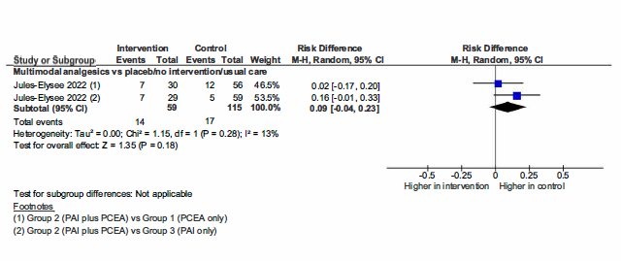
8.1. Number of participants who reduced or ceased opioids.

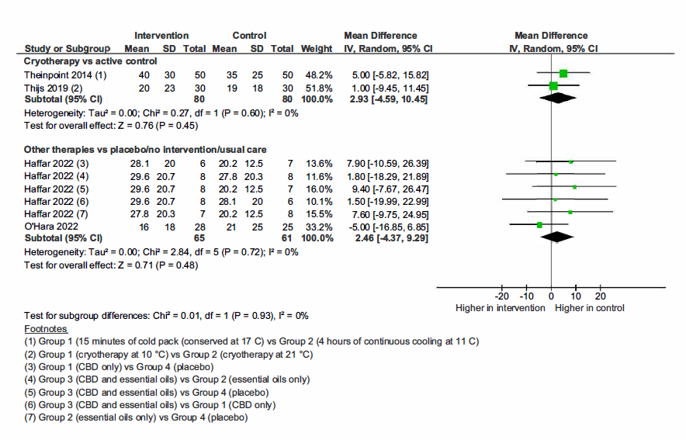

Figure 8.2. Mean pain intensity medium-term forest plot

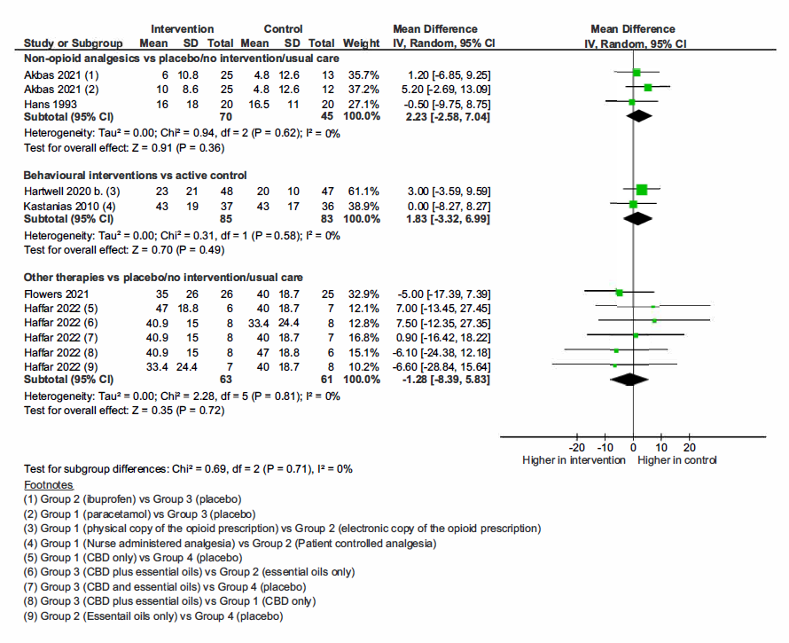

Figure 8.3. Mean pain intensity short-term forest plot

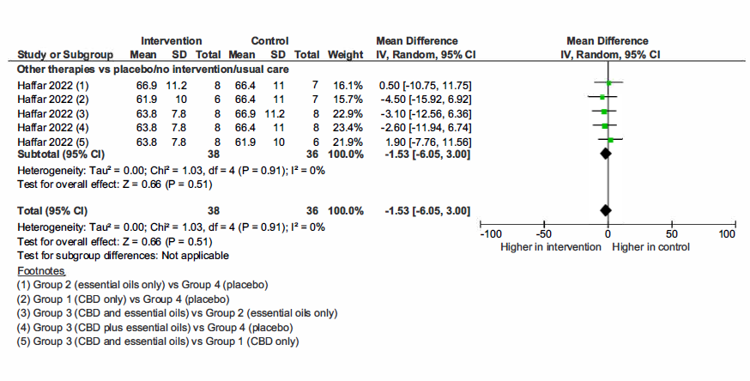
Figure 8.4. Disability medium-term forest plot

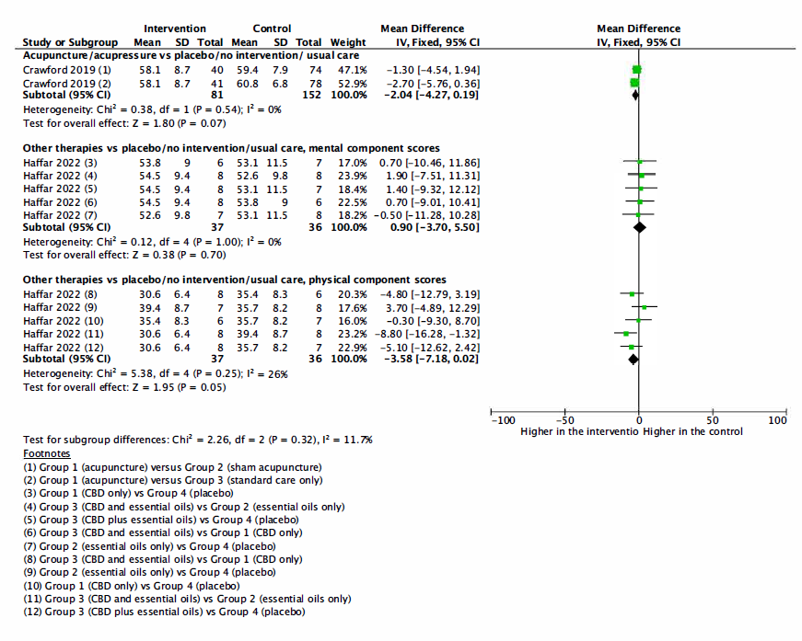
Figure 8.5. QOL medium-term forest plot

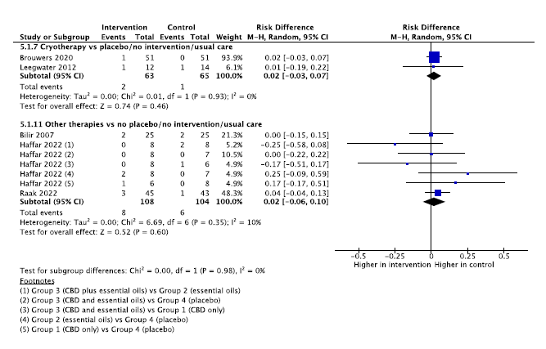
Figure 8.6. Number of participants who experienced adverse events forest plot

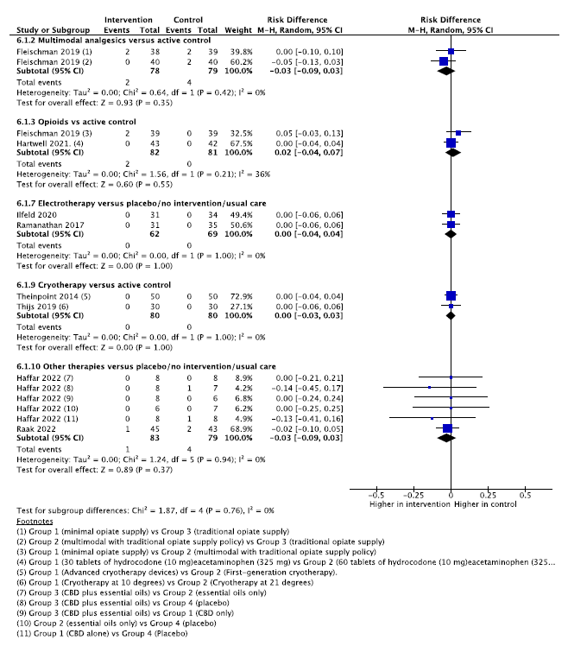

Figure 8.7. Number of participants who experienced serious adverse events forest plot

