Electronic Supplementary Material
Article title: Efficacy of Umeclidinium/Vilanterol in Elderly Patients with COPD: A Pooled Analysis
Journal: Drugs and Aging
Authors: Riju Ray, Lee Tombs, Michael J. Asmus, Isabelle Boucot, Chris Compton, Ian Naya
Corresponding author: Riju Ray, US Medical Affairs, GSK, Research Triangle Park, NC, USA, Email: riju.x.ray@gsk.com
Online Resource 1. Studies included in the pooled analysis
Study | Objectives | Design | Eligibility criteria | Treatments | N
Included in the 12-week and 24-week integration analysis
DB2113360 (NCT01316900)[1] | Evaluate efficacy and safety over 24 weeks | R, B, PG, AC | ≥40 years  History of COPD in accordance with the ATS/ERS definition [2]  Post-bronchodilator FEV₁ ≤70% predicted and FEV₁/FVC <0.70  mMRC ≥2 | UMEC/VI 125/25 µgQD, IH | 214
 |  |  |  | UMEC/VI 62.5/25 µg QD, IH | 212
 |  |  |  | VI 25 µg QD, IH | 209
 |  |  |  | TIO 18 µg QD, IH | 208
DB2113373 (NCT01313650)[3] | Evaluate efficacy and safety over 24 weeks | R, B, PG, AC, PC | ≥40 years  History of COPD in accordance with the ATS/ERS definition [2]  Post-bronchodilator FEV₁ ≤70% predicted and FEV₁/FVC <0.70  mMRC ≥2 | Placebo, IH | 280
 |  |  |  | UMEC 62.5 µg QD, IH | 418
 |  |  |  | VI 25 µg QD, IH | 421
 |  |  |  | UMEC/VI 62.5/25 µg QD, IH | 413
DB2113374 (NCT01316913)[1] | Evaluate efficacy and safety over 24 weeks | R, B, PG, AC | ≥40 years  History of COPD in accordance with the ATS/ERS definition [2]  Post-bronchodilator FEV₁ ≤70% predicted and FEV₁/FVC <0.70  mMRC ≥2 | UMEC/VI 125/25 µg QD, IH | 215
 |  |  |  | UMEC/VI 62.5/25 µg QD, IH | 217
 |  |  |  | UMEC 125 µg QD, IH | 222
 |  |  |  | TIO 18 µg QD, IH | 215
ZEP117115 (NCT01777334)[4] | Evaluate efficacy and safety over 24 weeks | R, B, PG, AC | ≥40 years  History of COPD in accordance with the ATS/ERS definition [2]  Post-bronchodilator FEV₁ ≤70% predicted and FEV₁/FVC <0.70  mMRC ≥2 | UMEC/VI 62.5/25 µg QD, IH | 454
 |  |  |  | TIO 18 µg QD, IH | 451
Included only in the 12-week integration analysis
DB2114930 (NCT01817764)[5] | Evaluate efficacy and safety over 12 weeks | R, B, PG, AC | ≥40 years  History of COPD in accordance with the ATS/ERS definition [2]  Post-bronchodilator FEV₁ ≥30% and ≤70% predicted and FEV₁/FVC <0.70  mMRC ≥2  No exacerbation in prior year | UMEC/VI 62.5/25 µg QD, IH | 353
 |  |  |  | FSC 250/50 µg, BID, IH | 353
DB2114951 (NCT01879410)[5] | Evaluate efficacy and safety over 12 weeks | R, B, PG, AC | ≥40 years  History of COPD in accordance with the ATS/ERS definition [2]  Post-bronchodilator FEV₁ ≥30% and ≤70% predicted and FEV₁/FVC <0.70  mMRC ≥2  No exacerbation in prior year | UMEC/VI 62.5/25 µg QD, IH | 349
 |  |  |  | FSC 250/50 µg, BID, IH | 348
MID201211 (NCT02152605)[6] | Evaluate efficacy and safety over 12 weeks | R, B, PG, PC | ≥40 years  History of COPD in accordance with the ATS/ERS definition [2]  Post-bronchodilator FEV₁ ≤70% predicted and FEV₁/FVC <0.70  mMRC ≥2 | UMEC/VI 62.5/25 µg QD, IH | 248
 |  |  |  | Placebo QD, IH | 248
Included in the 12-week crossover analysis
DB2114417 (NCT01328444)[7] | Evaluate the effects of UMEC/VI on exercise performance, expiratory flow and lung volumes over 12 weeks; safety | R, B, XO, AC, PC | ≥40 years  History of COPD in accordance with the ATS/ERS definition [2]  Post-bronchodilator FEV₁ ≥35% and ≤70% predicted and FEV₁/FVC <0.70  mMRC ≥2  Resting FRC ≥120% of predicted | Placebo | 170
 |  |  |  | UMEC 62.5 µg QD, IH | 49
 |  |  |  | UMEC 125 µg QD, IH | 50
 |  |  |  | VI 25 µg QD, IH | 76
 |  |  |  | UMEC/VI 62.5/25 µg QD, IH | 152
 |  |  |  | UMEC/VI 125/25 µg QD, IH | 144
DB2114418 (NCT01323660)[7] | Evaluate the effects of UMEC/VI on exercise performance, expiratory flow and lung volumes over 12 weeks; safety | R, B, XO, AC, PC | ≥40 years  History of COPD in accordance with the ATS/ERS definition [2]  Post-bronchodilator FEV₁ ≥35% and ≤70% predicted and FEV₁/FVC <0.70  mMRC ≥2  Resting FRC ≥120% of predicted | Placebo | 151
 |  |  |  | UMEC 62.5 µg QD, IH | 40
 |  |  |  | UMEC 125 µg QD, IH | 41
 |  |  |  | VI 25 µg QD, IH | 64
 |  |  |  | UMEC/VI 62.5/25 µg QD, IH | 130
 |  |  |  | UMEC/VI 125/25 µg QD, IH | 128
MID201317 (NCT02275052)[8] | Effect of UMEC/VI on exercise endurance time over 12 weeks; safety | R, B, XO, PC | ≥40 years  History of COPD in accordance with the ATS/ERS definition [2]  Post-bronchodilator FEV₁ ≥30% and ≤70% predicted and FEV₁/FVC <0.70  mMRC ≥2  Resting FRC ≥120% of predicted | Placebo QD, IH | 198
 |  |  |  | UMEC/VI 62.5/25 µg QD, IH | 198
AC, active control; ATS, American Thoracic Society; B, blinded; BID, twice daily; COPD, chronic obstructive pulmonary disease; ERS, European Respiratory Society; FEV₁, forced expiratory volume in 1 second; FRC, functional residual capacity; FSC, fluticasone propionate/salmeterol; FVC, forced vital capacity; IH, inhalation; mMRC, modified Medical Research Council; PC, placebo control; PG, parallel group; QD, once-daily; R, randomized; TIO, tiotropium; UMEC, umeclidinium; VI, vilanterol; XO, crossover group
Online Resource 2. Absolute change from baseline in trough FEV₁ by age group and analysis
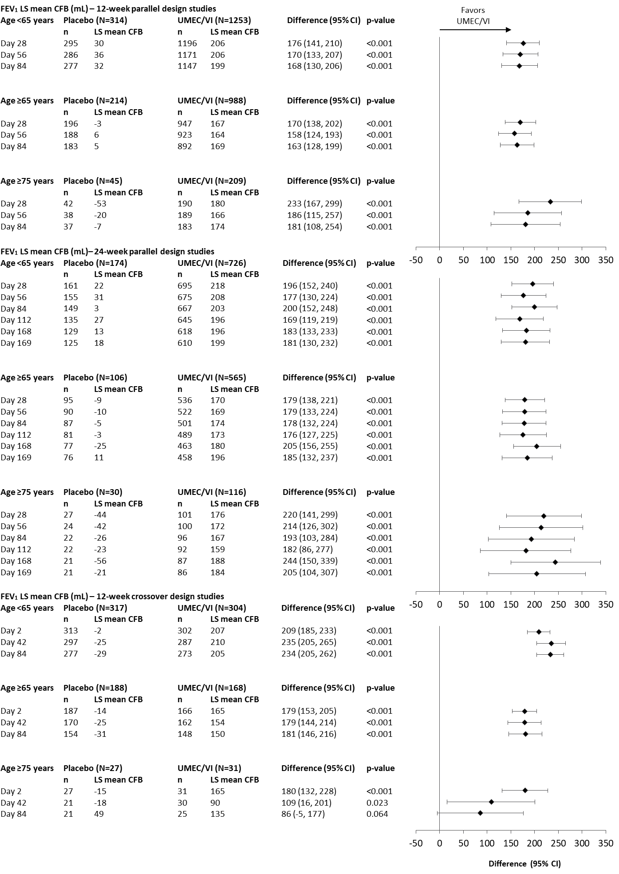
Data for Day 140 in the 24-week parallel design analysis are not presented as data were not available for the placebo group at this timepoint. P-values given for the adjusted difference (UMEC/VI minus placebo) in trough FEV₁ LS mean CFB. CFB, change from baseline; CI, confidence interval; FEV₁, forced expiratory volume in 1 second; LS, least squares; n, number of patients at each timepoint; N, total number of patients in subgroup; UMEC, umeclidinium; VI, vilanterol
Online Resource 3. Trough FEV₁ percent change from baseline by age group and analysis
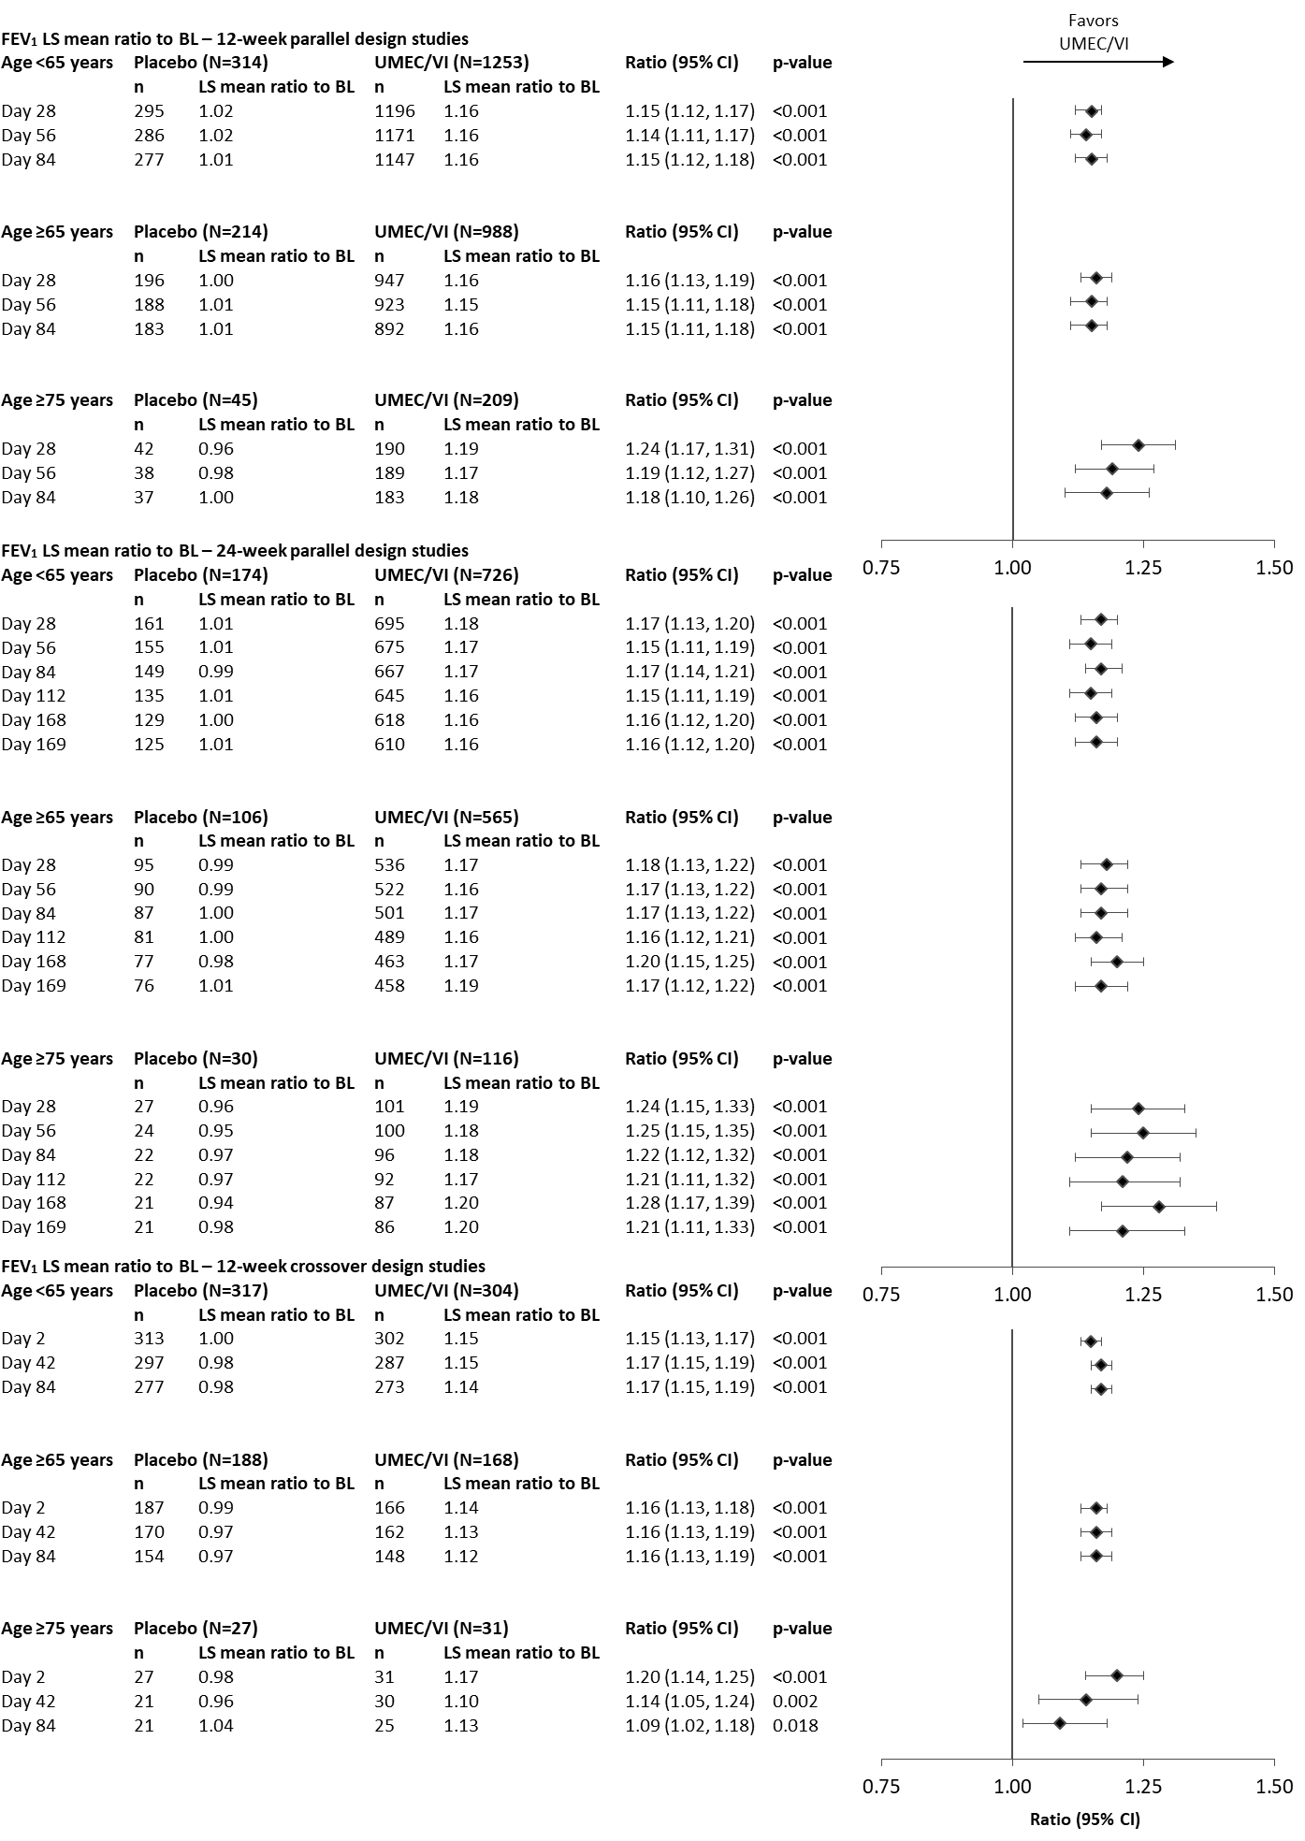
Ratios for Day 140 in the 24-week parallel design analysis are not presented as data were not available for the placebo group at this timepoint. P-values given for the adjusted percent change from baseline (UMEC/VI vs placebo ratio).
CI, confidence interval; FEV₁, forced expiratory volume in 1 second; LS, least squares; n, number of patients at each timepoint; N, total number of patients in subgroup; UMEC, umeclidinium; VI, vilanterol
Online Resource 4. Proportion of trough FEV₁ responders by age group and analysis
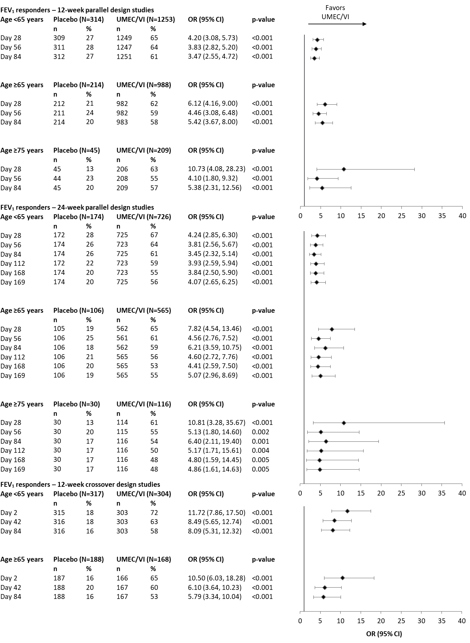
OR for Day 140 in the 24-week parallel design analysis are not presented as data were not available for the placebo group at this timepoint. In the 12-week crossover analysis, the model does not converge in the subgroup of patients ≥75 years of age due to small patient numbers (placebo n=27; UMEC/VI n=31) and hence the OR from this group could not be calculated. FEV₁ responders defined as increase from baseline in trough FEV₁ ≥100 mL at timepoint considered. P-values given for the responder analysis OR (UMEC/VI vs placebo). CI, confidence interval; FEV₁, forced expiratory volume in 1 second; n, number of patients at each timepoint; N, total number of patients in subgroup; OR, odds ratio; UMEC, umeclidinium; VI, vilanterol

Online Resource 5. Adverse events occurring in ≥2 patients across both treatment arms and ≥3% of patients in either treatment arm by age and analysis
 | Parallel design studies |  |  |  | Crossover design studies
 | 12-week analysis |  | 24-week analysis |  | 12-week analysis
 | Placebo (N=528) | UMEC/VI (N=2246) | Placebo (N=280) | UMEC/VI (N=1296) | Placebo (N=505) | UMEC/VI (N=472)
Age subgroup <65 years | N=314 | N=1257 | N=174 | N=730 | N=317 | N=304
Headache | 28 (9) | 109 (9) | 21 (12) | 67 (9) | 9 (3) | 3 (<1)
Viral URTI | 21 (7) | 74 (6) | 11 (6) | 55 (8) | 14 (4) | 5 (2)
Back Pain | - | - | 3 (2) | 21 (3) | - | -
URTI | - | - | 7 (4) | 15 (2) | - | -
Gastroenteritis | - | - | 5 (3) | 4 (<1) | - | -
Age subgroup ≥65 years | N=169 | N=780 | N=106 | N=566 | N=188 | N=168
Headache | 14 (7) | 70 (7) | 5 (5) | 49 (9) | 10 (5) | 8 (5)
Viral URTI | 10 (5) | 62 (6) | 4 (4) | 46 (8) | 9 (5) | 10 (6)
Back pain | 7 (3) | 28 (3) | 4 (4) | 20 (4) | - | -
URTI | 11 (5) | 18 (2) | 9 (8) | 16 (3) | - | -
Cough | - | - | 3 (3) | 15 (3) | - | -
Oropharyngeal pain | 6 (3) | 12 (1) | - | - | - | -
Hypertension | 7 (3) | 11 (1) | - | - | - | -
Rhinitis | - | - | 3 (3) | 5 (<1) | - | -
Sinusitis | - | - | - | - | 5 (3) | 0 (0)
Dyspnea | - | - | 4 (4) | 3 (<1) | 5 (3) | 3 (2)
Arthralgia | - | - | - | - | 2 (1) | 5 (3)
Age subgroup ≥75 years | N=45 | N=209 | N=30 | N=116 | N=27 | N=31
Headache | 3 (7) | 17 (8) | 2 (7) | 11 (9) | - | -
Viral URTI | 3 (7) | 12 (6) | 3 (10) | 9 (8) | - | -
Back pain | 2 (4) | 8 (4) | 0 (0) | 6 (5) | 3 (11) | 1 (3)
URTI | 2 (4) | 2 (<1) | 2 (7) | 2 (2) | 0 (0) | 2 (6)
Oropharyngeal pain | 2 (4) | 3 (1) | - | - | - | -
Dyspnea | 2 (4) | 2 (<1) | 2 (7) | 1 (<1) | - | -
Rhinitis | 3 (7) | 1 (<1) | 2 (7) | 1 (<1) | - | -
Nasopharyngitis | 2 (4) | 1 (<1) | 2 (7) | 1 (<1) | - | -
Cough | - | - | 1 (3) | 2 (2) | - | -
Influenza | - | - | 1 (3) | 1 (<1) | - | -
Diarrhea | - | - | 0 (0) | 4 (3) | - | -
Pain in extremity | - | - | 0 (0) | 3 (3) | - | -
Urinary tract infection | - | - | 1 (3) | 2 (2) | - | -
Edema peripheral | - | - | 1 (3) | 3 (3) | - | -
Muscle spasms | - | - | 1 (3) | 1 (<1) | - | -
Gastritis | - | - | 1 (3) | 2 (2) | - | -
Vomiting | - | - | 0 (0) | 4 (3) | - | -
Chest discomfort | - | - | 1 (3) | 1 (<1) | - | -
Decreased appetite | - | - | 0 (0) | 3 (3) | - | -
Fall | - | - | 0 (0) | 3 (3) | - | -
Data expressed as n (%). - indicates that the AE was not reported, or was reported in <2 patients or <3% or patients across both treatment arms. AE, Adverse events; SAE, serious adverse events; UMEC, umeclidinium; URTI, upper respiratory tract infection; VI, vilanterol

References
1. Decramer M, Anzueto A, Kerwin E, Kaelin T, Richard N, Crater G et al. Efficacy and safety of umeclidinium plus vilanterol versus tiotropium, vilanterol, or umeclidinium monotherapies over 24 weeks in patients with chronic obstructive pulmonary disease: results from two multicentre, blinded, randomised controlled trials. Lancet Respir Med. 2014;2(6):472-86. doi:10.1016/S2213-2600(14)70065-7.
2. Celli BR, MacNee W, Force AET. Standards for the diagnosis and treatment of patients with COPD: a summary of the ATS/ERS position paper. Eur Respir J. 2004;23(6):932-46.
3. Donohue JF, Maleki-Yazdi MR, Kilbride S, Mehta R, Kalberg C, Church A. Efficacy and safety of once-daily umeclidinium/vilanterol 62.5/25 mcg in COPD. Respir Med. 2013;107(10):1538-46. doi:10.1016/j.rmed.2013.06.001.
4. Maleki-Yazdi MR, Kaelin T, Richard N, Zvarich M, Church A. Efficacy and safety of umeclidinium/vilanterol 62.5/25 mcg and tiotropium 18 mcg in chronic obstructive pulmonary disease: results of a 24-week, randomized, controlled trial. Respir Med. 2014;108(12):1752-60. doi:10.1016/j.rmed.2014.10.002.
5. Donohue JF, Worsley S, Zhu CQ, Hardaker L, Church A. Improvements in lung function with umeclidinium/vilanterol versus fluticasone propionate/salmeterol in patients with moderate-to-severe COPD and infrequent exacerbations. Respir Med. 2015;109(7):870-81. doi:10.1016/j.rmed.2015.04.018.
6. Siler TM, Donald AC, O'Dell D, Church A, Fahy WA. A randomized, parallel-group study to evaluate the efficacy of umeclidinium/vilanterol 62.5/25 μg on health-related quality of life in patients with COPD. Int J Chron Obstruct Pulmon Dis. 2016;11:971-9. doi:10.2147/COPD.S102962.
7. Maltais F, Singh S, Donald AC, Crater G, Church A, Goh AH et al. Effects of a combination of umeclidinium/vilanterol on exercise endurance in patients with chronic obstructive pulmonary disease: two randomized, double-blind clinical trials. Ther Adv Respir Dis. 2014;8(6):169-81. doi:10.1177/1753465814559209.
8. Riley JH, Kalberg CJ, Donald A, Lipson DA, Shoaib M, Tombs L. Effects of umeclidinium/vilanterol on exercise endurance in COPD: a randomised study. ERJ Open Res. 2018;4(1). doi:10.1183/23120541.00073-2017.

