Supplement to

Psychiatric Adverse Events of Acetylcholinesterase Inhibitors in Alzheimer’s Disease and Parkinson’s Dementia – Systematic Review and Meta-Analysis

Nadine Bittner^{1*}, Cleo S. M. Funk², Alexander Schmidt³, Felix Bermpohl¹, Eva J. Brandl¹, Engi E. A. Algharably², Reinhold Kreutz², and Thomas G. Riemer^{1,2*}

^{1*}Charité - Universitätsmedizin Berlin, corporate member of
Freie Universität Berlin, Humboldt-Universität zu Berlin, and Berlin Institute of Health, Department of Psychiatry and Psychotherapy, 10117 Berlin, Germany.
²Charité - Universitätsmedizin Berlin, corporate member of Freie Universität Berlin, Humboldt-Universität zu Berlin, and Berlin Institute of Health, Institute of Clinical Pharmacology and Toxicology, 10115 Berlin, Germany.
³Humboldt-Universität zu Berlin, Department of Psychology, 10099 Berlin, Germany.

*Corresponding author(s). E-mail(s): nadine.bittner@charite.de; thomas.riemer@charite.de
Contributing authors: cleo-sarah-maria.funk@charite.de; alexander.schmidt@ipb.medicalschool-berlin.de; felix.bermpohl@charite.de; eva.brandl@charite.de; engi.algharably@charite.de; reinhold.kreutz@charite.de

SUPPLEMENTARY APPENDIX

Table of contents

- Supplemental references for all included studies (see tables S6 and S7 for an overview)
- Table S1. Common psychiatric adverse events registered in Food and Drug Administration (FDA) and the European Medicines Agency (EMA) surveillance systems
- Table S2. Inclusion and exclusion criteria
- Table S3. Symptoms considered to psychiatric adverse events
- Table S4. Rating sheet for assessment of quality of adverse-event measuring and reporting
- Table S5. Rationale for sensitivity analyses
- Table S6. Characteristics of double-blind, randomized controlled parallel-arm studies included in this meta-analysis and review
- Table S7. Characteristics of double-blind, randomized controlled parallel-arm studies reporting numbers of patients affected with adverse events of interest during AChEI use
- Table S8. Absolute risks, risk ratios and risk differences for all PAEs investigated through meta-analyses during AChEIs vs. placebo
- Table S9. Absolute risks, risk ratios and risk differences for all PAEs investigated through meta-analyses for analysis of dose-effects
- Fig. S1. Forest plot for anorexia during AChEIs vs. placebo
- Fig. S2. Forest plot for decreased appetite during AChEIs vs. placebo
- Fig. S3. Forest plot for insomnia during AChEIs vs. placebo
- Fig. S4. Forest plot for depression during AChEIs vs. placebo
- Fig. S5. Forest plot for agitation during AChEIs vs. placebo
- Fig. S6. Forest plot for anxiety during AChEIs vs. placebo
- Fig. S7. Forest plot for confusion during AChEIs vs. placebo
- Fig. S8. Forest plot for hallucination during AChEIs vs. placebo
- Fig. S9. Forest plot for somnolence during AChEIs vs. placebo
- Fig. S10. Forest plot for nausea during AChEIs vs. placebo
- Fig. S11. Forest plot for diarrhea during AChEIs vs. placebo
- Fig. S12. Funnel plot for anorexia during AChEIs vs. placebo
- Fig. S13. Funnel plot for insomnia during AChEIs vs. placebo
- Fig. S14. Funnel plot for depression during AChEIs vs. placebo
- Fig. S15. Funnel plot for agitation during AChEIs vs. placebo
- Fig. S16. Funnel plot for anxiety during AChEIs vs. placebo
- Fig. S17. Funnel plot for confusion during AChEIs vs. placebo
- Table S10. Results of sensitivity analyses (placebo-controlled studies)
- Table S11. Results of subgroup analyses (placebo-controlled studies)
- Fig. S18. Forest plot for anorexia for analysis of dose-effects
- Fig. S19. Forest plot for decreased appetite for analysis of dose-effects
- Fig. S20. Forest plot for agitation for analysis of dose-effects
- Fig. S21. Forest plot for anxiety for analysis of dose-effects
- Fig. S22. Forest plot for confusion for analysis of dose-effects
- Fig. S23. Forest plot for depression for analysis of dose-effects
- Fig. S24. Forest plot for insomnia for analysis of dose-effects
- Fig. S25. Forest plot for somnolence for analysis of dose-effects
- Fig. S26. Forest plot for nausea for analysis of dose-effects
- Fig. S27. Forest plot for diarrhea for analysis of dose-effects
- Fig. S28. Funnel plot for anorexia for dose-effects
- Fig. S29. Funnel plot for insomnia for dose-effects
- Supplemental references for all included studies

- Haig, G.M., Pritchett, Y., Meier, A., Othman, A.A., Hall, C., Gault, L.M., R.A., L.: A randomized study of H3 antagonist ABT-288 in mild-to-moderate Alzheimer’s dementia. J Alzheimers Dis. 42(3) (2014)
- Marek, G.J., Katz, D.A., Meier, A., Greco, N., Zhang, W., Liu, W., Lenz, R.A.: Efficacy and safety evaluation of HSD-1 inhibitor ABT-384 in Alzheimer’s disease. Alzheimers Dement. 5, 364–73 (2014)
- Rogers, S.L., Friedhoff, L.T.: The efficacy and safety of donepezil in patients with Alzheimer’s disease: results of a US Multicentre, Randomized, Double-Blind, Placebo-Controlled Trial. The Donepezil Study Group. Dementia. 7(6), 293–303 (1996)
- Jia, J., Wei, C., Jia, L., Tang, Y., Liang, J., Zhou, A., Li, F., Shi, L., Doody, R.S.: Efficacy and Safety of Donepezil in Chinese Patients with Severe Alzheimer’s Disease: A Randomized Controlled Trial. J Alzheimers Dis. 56(4), 1495–1504 (2017)
- Gault, L.M., Lenz, R.A., Ritchie, C.W., Meier, A., Othman, A.A., Tang, Q., Berry, S., Pritchett, Y., Robieson, W.Z.: ABT-126 monotherapy in mild-to-moderate Alzheimer’s dementia: randomized double-blind, placebo and active controlled adaptive trial and open-label extension. Alzheimers Res Ther. 8(1) (2016)
- Homma, A., Atarashi, H., Kubota, N., Nakai, K., Takase, T.: Efficacy and Safety of Sustained Release Donepezil High Dose versus Immediate Release Donepezil Standard Dose in Japanese Patients with Severe Alzheimer’s Disease: A Randomized, Double-Blind Trial. J Alzheimers Dis. 52(1), 345–57 (2016)
- Han, S.H., Lee, J.H., Kim, S.Y., Park, K.W., Chen, C., Tripathi, M., Dash, A., Kubota, N.: Donepezil 23 mg in Asian patients with moderate to-severe Alzheimer’s disease. Acta Neurol Scand. 135(2), 252–256 (2017)
- Dubois, B., Tolosa, E., Katzenschlager, R., Emre, M., Lees, A.J., Schumann, G., Pourcher, E., Gray, J., Thomas, G., Swartz, J., Hsu, T., Moline, M.L.: Donepezil in Parkinson’s disease dementia: a randomized, double-blind efficacy and safety study. Mov Disord. 27(10), 1230–8 (2012)
- Gold, M., Alderton, C., Zvartau-Hind, M., Egginton, S., Saunders, A.M., Irizarry, M., Craft, S., Landreth, G., Linnamägi, U., Sawchak, S.: Rosiglitazone monotherapy in mild-to-moderate Alzheimer’s disease: results from a randomized, double-blind, placebo-controlled phase III study. Dement Geriatr Cogn Disord. 30(2), 131–46 (2010)
- Farlow, M.R., Salloway, S., Tariot, P.N., Yardley, J., Moline, M.L., Wang, Q., Brand-Schieber, E., Zou, H., Hsu, T., Satlin, A.: Effectiveness and tolerability of high-dose (23 mg/d) versus standard-dose (10 mg/d) donepezil in moderate to severe Alzheimer’s disease: A 24-week, randomized, double-blind study. Clin Ther. 32(7), 1234–51 (2010)
- Homma, A., Imai, Y., Tago, H., Asada, T., Shigeta, M., Iwamoto, T., Takita, M., Arimoto, I., Koma, H., Ohbayashi, T.: Donepezil treatment of patients with severe Alzheimer’s disease in a Japanese population: results from a 24-week, double-blind, placebo-controlled, randomized trial. Dement Geriatr Cogn Disord. 25(5), 399–407 (2008)
- Seltzer, B., Zolnouni, P., Nunez, M., Goldman, R., Kumar, D., Leni, J., Richardson, S.: Donepezil ”402” Study Group. Efficacy of donepezil in early-stage Alzheimer disease: a randomized placebo-controlled trial. 2004 61(12), 1852–6 (Arch Neurol.)
- Tariot, P.N., Cummings, J.L., Katz, I.R., Mintzer, J., Perdomo, C.A., Schwam, E.M., Whalen, E.: A randomized, double-blind, placebocontrolled study of the efficacy and safety of donepezil in patients with Alzheimer’s disease in the nursing home setting. J Am Geriatr Soc. 49(12), 1590–9 (2001)
- Feldman, H., Gauthier, S., Hecker, J., Vellas, B., Subbiah, P., Whalen, E., Donepezil MSAD Study Investigators Group: A 24-week, randomized, double-blind study of donepezil in moderate to severe Alzheimer’s disease. Neurology. 57(4), 613–20 (2001)
- Homma, A., Takeda, M., Imai, Y., Udaka, F., Hasegawa, K., Kameyama, M., Nishimura, T.: Clinical efficacy and safety of donepezil on cognitive and global function in patients with Alzheimer’s disease. A 24-week, multicenter, double-blind, placebo-controlled study in Japan. E2020 Study Group. Dement Geriatr Cogn Disord. 11(6), 299–313 (2000)
- Burns, A., Rossor, M., Hecker, J., Gauthier, S., Petit, H., Möller, H.J., Rogers, S.L., Friedhoff, L.T.: The effects of donepezil in Alzheimer’s disease - results from a multinational trial. Dement Geriatr Cogn Disord. 10(3), 237–44 (1999)
- Rogers, S.L., Farlow, M.R., Doody, R.S., Mohs, R., Friedhoff, L.T.: A 24-week, double-blind, placebo-controlled trial of donepezil in patients with Alzheimer’s disease. Donepezil Study Group. Neurology. 50(1), 136–45 (1998)
- Maher-Edwards, G., Watson, C., Ascher, J., Barnett, C., Boswell, D., Davies, J., Fernandez, M., Kurz, A., Zanetti, O., Safirstein, B., Schronen, J.P., Zvartau-Hind, M., Gold, M.: Two randomized controlled trials of SB742457 in mild-to-moderate Alzheimer’s disease. Alzheimers Dement (N Y). 1(1), 23–36 (2015)
- Winblad, B., Engedal, K., Soininen, H., Verhey, F., Waldemar, G., Wimo, A., Wetterholm, A.L., Zhang, R., Haglund, A., Subbiah, P., Donepezil Nordic Study Group: A 1-year, randomized, placebo-controlled study of donepezil in patients with mild to moderate AD. Neurology. 57(3), 489–95 (2001)
- Mohs, R.C., Doody, R.S., Morris, J.C., Leni, J.R., Rogers, S.L., Perdomo, C.A., Pratt, R.D., ”312” Study Group: A 1-year, placebo-controlled preservation of function survival study of donepezil in AD patients. Neurology. 57(3), 481–8 (2001). Erratum in: Neurology 2001 Nov 27;57(10):1942.
- Winblad, B., Kilander, L., Eriksson, S., Minthon, L., Båtsman, S., Wetterholm, A.L., Jansson-Blixt, C., Haglund, A.: Severe Alzheimer’s Disease Study Group. Donepezil in patients with severe Alzheimer’s disease: double-blind, parallel-group, placebo-controlled study. Lancet. 367(9516), 1057–1065 (2006). Erratum in: Lancet. 2006 Nov 11;368(9548):1650
- Ma, Y., Ji, J., Li, G., Yang, S., Pan, S.: Effects of donepezil on cognitive functions and the expression level of _{β}-amyloid in peripheral blood of patients with Alzheimer’s disease. Exp Ther Med. 15(2), 1875–1878 (2018)
- Zhang, Z., Yu, L., Gaudig, M., Schäuble, B., Richarz, U.: Galantamine versus donepezil in Chinese patients with Alzheimer’s disease: results from a randomized, double-blind study. Neuropsychiatr Dis Treat. 8, 571–7 (2012)
- Hager, K., Baseman, A.S., Nye, J.S., Brashear, H.R., Han, J., Sano, M., Davis, B., Richards, H.M.: Effects of galantamine in a 2-year, randomized, placebo-controlled study in Alzheimer’s disease. Neuropsychiatr Dis Treat. 10(391-401) (2014). Erratum in: Neuropsychiatr Dis Treat. 2014;10:1997.
- Rockwood, K., Mintzer, J., Truyen, L., Wessel, T., Wilkinson, D.: Effects of a flexible galantamine dose in Alzheimer’s disease: a randomised, controlled trial. J Neurol Neurosurg Psychiatry 71(5), 589–95 (2001)
- Wilkinson, D., Murray, J.: Galantamine: a randomized, double-blind, dose comparison in patients with Alzheimer’s disease. Int J Geriatr Psychiatry. 16(9), 852–7 (2001)
- Burns, A., Bernabei, R., Bullock, R., Cruz Jentoft, A.J., Frölich, L., Hock, C., Raivio, M., Triau, E., Vandewoude, M., Wimo, A., Came, E., Van Baelen, B., Hammond, G.L., van Oene, J.C., Schwalen, S.: Safety and efficacy of galantamine (Reminyl) in severe Alzheimer’s disease (the SERAD study): a randomised, placebo-controlled, double-blind trial. Lancet Neurol. 8(1), 39–47 (2009)
- Raskind, M.A., Peskind, E.R., Wessel, T., Yuan, W.: Galantamine in AD: A 6-month randomized, placebo-controlled trial with a 6-month extension.The Galantamine USA-1 Study Group. Neurology. 54(12), 2261–8 (2000)

- Bullock, R., Touchon, J., Bergman, H., Gambina, G., He, Y., Rapatz, G., Nagel, J., Lane, R.: Rivastigmine and donepezil treatment in moderate to moderately-severe Alzheimer’s disease over a 2-year period. Curr Med Res Opin. 21(8), 1317–27 (2005)
- Karaman, Y., Erdoğan, F., Köseoğlu, E., Turan, T., Ersoy, A.O.: A 12month study of the efficacy of rivastigmine in patients with advanced moderate Alzheimer’s disease. Dement Geriatr Cogn Disord. 19(1), 51–6 (2005)
- Forette, F., Anand, R., Gharabawi, G.: A phase II study in patients with Alzheimer’s disease to assess the preliminary efficacy and maximum tolerated dose of rivastigmine (Exelon). Eur J Neurol. 6(4), 423–9 (1999)
- Zhang, Z.X., Hong, Z., Wang, Y.P., He, L., Wang, N., Zhao, Z.X., Zhao, G., Shang, L., Weisskopf, M., Callegari, F., Strohmaier, C.: Rivastigmine Patch in Chinese Patients with Probable Alzheimer’s disease: A 24-week, Randomized, Double-Blind Parallel-Group Study Comparing Rivastigmine Patch (9.5 mg/24 h) with Capsule (6 mg Twice Daily). CNS Neurosci Ther. 22(6), 488–96 (2016)
- Farlow, M.R., Grossberg, G.T., Sadowsky, C.H., Meng, X., Somogyi, M.: A 24-week, randomized, controlled trial of rivastigmine patch 13.3 mg/24h versus 4.6 mg/24 h in severe Alzheimer’s dementia. CNS Neurosci Ther. 19(10), 745–52 (2013)
- Emre, M., Aarsland, D., Albanese, A., Byrne, E.J., Deuschl, G., De Deyn, P.P., Durif, F., Kulisevsky, J., van Laar, T., Lees, A., Poewe, W., Robillard, A., Rosa, M.M., Wolters, E., Quarg, P., Tekin, S., Lane, R.: Rivastigmine for dementia associated with Parkinson’s disease. N Engl J Med. 351(24), 2509–18 (2004)
- Feldman, H.H., Lane, R., Study 304 Group: Rivastigmine: a placebo controlled trial of twice daily and three times daily regimens in patients with Alzheimer’s disease. J Neurol Neurosurg Psychiatry. 78(10), 1056–63 (2007)
- Rösler, M., Anand, R., Cicin-Sain, A., Gauthier, S., Agid, Y., Dal-Bianco, P., Stähelin, H.B., Hartman, R., Gharabawi, M.: Efficacy and safety of rivastigmine in patients with Alzheimer’s disease: international randomised controlled trial. BMJ. 218(7184), 633–8 (1999). Erratum in: BMJ 2001 Jun 16;322(7300):1456.
- Sramek, J.J., Anand, R., Wardle, T.S., Irwin, P., Hartman, R.D., Cutler, N.R.: Safety/tolerability trial of SDZ ENA 713 in patients with probable
Alzheimer’s disease. Life Sci. 58(15), 1201–7 (1996)
- Table S1. Common psychiatric adverse events registered in Food and Drug Administration (FDA) and the European Medicines Agency (EMA) surveillance systems
AChEIs/ No. Reports FDA

PAE | Donepezil | Galantamine | Rivastigmine | Total
Abnormal behavior | 120 | 50 | 303 | 473
Abnormal dreams | 113 | 14 | 40 | 167
Aggression | 188 | 75 | 422 | 685
Agitation | 386 | 123 | 467 | 976
Anger | 35 | 15 | 54 | 104
Anxiety | 134 | 46 | 282 | 462
Apathy | 32 | 13 | 61 | 106
Confusional State | 572 | 160 | 839 | 1,571
Decreased appetite | 392 | 163 | 486 | 1,041
Delirium | 193 | 61 | 198 | 452
Delusion | 125 | 29 | 103 | 257
Depressed level of consciousness | 165 | 331 | 125 | 621
Depressed mood | 34 | 14 | 76 | 124
Depression | 158 | 43 | 281 | 482
Disorientation | 102 | 50 | 296 | 448
Emotional Disorder | 34 | 4 | 17 | 55
Feeling abnormal | 72 | 26 | 319 | 417
Hallucination | 266 | 78 | 541 | 885
Hallucination, auditory | 25 | 5 | 31 | 61
Hallucination, visual | 81 | 27 | 145 | 253
Hostility | 74 | ‒ | ‒ | 74
Insomnia | 302 | 43 | 327 | 672
Irritability | 60 | 12 | 85 | 157
Mania | 78 | 24 | 25 | 127
Memory impairment | 142 | 34 | 557 | 733
Nervousness | 66 | 15 | 119 | 200
Nightmare | 107 | 27 | 73 | 207
Psychotic disorder | 70 | 27 | 84 | 181
Restlessness | 101 | 37 | 154 | 292
Sleep Disorder | 58 | 14 | 90 | 162
Somnolence | 245 | 116 | 405 | 766
Suicidal Ideation | 33 | 13 | 62 | 108
Psychiatric adverse events (PAE) were retrieved from the FDA and EMA adverse drug reaction (ADR) surveillance systems in June 2022.

AChEIs/ No. Reports EMA

PAE | Donepezil | Galantamine | Rivastigmine | Total
Abnormal behavior | 42 | 21 | 143 | 206
Abnormal dreams | 32 | 6 | 16 | 54
Aggression | 211 | 60 | 268 | 539
Agitation | 245 | 79 | 352 | 676
Anger | 18 | 14 | 32 | 64
Anxiety | 73 | 30 | 152 | 255
Apathy | 35 | 8 | 64 | 107
Confusional State | 333 | 128 | 640 | 1,101
Decreased appetite | 241 | 124 | 388 | 753
Delirium | 126 | 57 | 156 | 339
Delusion | 73 | 20 | 76 | 169
Depressed level of consciousness | 70 | 173 | 79 | 322
Depressed mood | 14 | 10 | 40 | 64
Depression | 70 | 35 | 169 | 274
Disorientation | 65 | 23 | 163 | 251
Emotional Disorder | 3 | ‒ | 7 | 10
Feeling abnormal | ‒ | ‒ | ‒ | 0
Hallucination | 219 | 93 | 458 | 770
Hallucination, auditory | 21 | 5 | 33 | 59
Hallucination, visual | 66 | 25 | 107 | 198
Hostility | 2 | ‒ | ‒ | 2
Insomnia | 174 | 33 | 175 | 382
Irritability | 60 | 11 | 54 | 125
Mania | 57 | 6 | 18 | 81
Memory impairment | 57 | 13 | 219 | 289
Nervousness | 10 | 9 | 54 | 73
Nightmare | 112 | 22 | 55 | 189
Psychotic disorder | 36 | 20 | 61 | 117
Restlessness | 55 | 36 | 123 | 214
Sleep Disorder | 57 | 7 | 41 | 105
Somnolence | 187 | 91 | 303 | 581
Suicidal Ideation | 21 | 8 | 49 | 78
Psychiatric adverse events (PAE) were retrieved from the FDA and EMA adverse drug reaction (ADR) surveillance systems August 6th 2022.

- Table S2. Inclusion and exclusion criteria
 | Inclusion criteria | Exclusion criteria
Population | patients with Alzheimer’s dementia (AD) or Parkinson’s dementia (PDD); not preselected for AChEI tolerance or intolerance prior to the study | non-human subjects, healthy volunteers; indications other than AD or PDD; preselection for tolerance or intolerance prior to the study
Intervention | minimum one arm AChEIs monotherapy, applied systemically for at least four weeks | combination therapy, no AChEI therapy or AChEIs only as background regimen; treatment duration < four weeks
Comparator | placebo or active comparator (including AChEIs) | no defined / disclosed pharmacological comparator
Outcome(s) | patients with PAE reported as absolute or relative frequencies (including 0) | no mention of AE, AE reported, but no mention of PAE, AE reported in measures other than frequencies (e.g. study visits, scores)
Study Design | double-blind RCTs with parallel-arm design | all other study types (e.g. non-interventional studies, and interventional studies with open-label, single-blind, or double-blind, cross-over designs)
Other |  | sample size unclear, data implausible, duplicate data, record unavailable

- Table S3. Symptoms considered to psychiatric adverse events
Symptom clusters | Symptoms reported in trials | Final selection of common symptoms / symptom clusters
agitation | agitation, aggression, irritability, restlessness | agitation (includes agitation, mental restlessness, restlessness)  irritability (includes irritability, irritation)  restlessness (includes restlessness)
aggression | aggression, hostility, conduct disorder, anger | aggression (includes aggression, hostility, conduct disorder)  anger (includes anger)
anxiety disorders | anxiety, fearful thoughts | anxiety (includes anxiety, fearful thoughts)
appetite disorders | anorexia, inappetence, poor appetite, appetite suppression, appetite loss, loss of appetite, decreased appetite | anorexia (includes anorexia, inappetence, poor appetite, appetite suppression)  appetite loss (includes appetite loss, loss of appetite)  decreased appetite (decreased appetite)
delirium | confusion, confusional state, confused thoughts, disorientation, delirium | confusion (includes confusion, confusional state, confused thoughts)  disorientation (includes disorientation)  delirium (includes delirium)
depressed mood | depression, depressed mood, low mood, dysthymic disorder | depression (includes depression)  depressed mood (includes depressed mood, low mood, dysthymic disorder)
dreams/sleep disorders | insomnia, sleeplessness, sleeping difficulties, sleep disturbance, sleeping problems, trouble sleeping, poor quality sleep, sleep disorder, nightmares, abnormal dreams, vivid dreams, increased dreaming | insomnia (includes insomnia, sleeplessness, sleeping difficulties)  sleep disturbance (includes sleep disturbance, sleeping problems, trouble sleeping, poor quality sleep)  sleep disorder (includes sleep disorder)  abnormal dreams (includes abnormal dreams, vivid dreams, increased dreaming)  nightmares (includes nightmares)
hallucination | hallucination, hallucination visual, hallucination auditory | hallucination (includes hallucination)  hallucination visual (includes hallucination visual)  hallucination auditory (includes hallucination auditory)
mood disorders | mood swings, affect lability | mood swings (includes mood swings, affect lability)
nervousness | nervousness | nervousness (includes nervousness)
somnolence | somnolence, drowsiness, sleepiness | somnolence (includes somnolence, drowsiness, sleepiness)

- Table S4. Rating sheet for assessment of quality of adverse-event measuring and reporting
 | Item | Response | Next item
Q1 | Does the study report adverse events? | □󠇯 Yes  □󠇯 No | (proceed with Q2)  (proceed with Q9)
Q2 | Does the study specify how adverse events were assessed? | □󠇯 Yes  □󠇯 No | (proceed with Q3)  (proceed with Q4)
Q3 | Were adverse events assessed actively or passively?* | □󠇯 actively  □󠇯 passively | (proceed with R3)
R3 | Record the assessment method(s).
Q4 | Does the study report baseline frequencies for adverse events? | □󠇯 Yes  □󠇯 No | (proceed with Q5)
Q5 | Does the study report symptom severity grades for adverse events? | □󠇯 Yes  □󠇯 No | (proceed with Q6)
Q6 | Does the study report all observed adverse events? | □󠇯 Yes  □󠇯 No | (proceed with Q9)  (proceed with Q7)
Q7 | Are there quantitative limitations to adverse event reporting†? | □󠇯 Yes  □󠇯 No | (proceed with R7)  (proceed with Q8)
R7 | Record the type(s) of quantitative limitation(s) †.
Q8 | Are there qualitative limitations to adverse event reporting‡? | □󠇯 Yes  □󠇯 No | (proceed with R8)  (proceed with Q9)
R8 | Record the type(s) of qualitative limitation(s) ‡.
Q9 | Does the study report the number of patients withdrawn from therapy due to adverse events? | □󠇯 Yes  □󠇯 No | (proceed with Q10)  (end rating)
Q10 | Does the study report individual adverse events leading to withdrawal of therapy? | □󠇯 Yes  □󠇯 No | (end rating)
*Active assessment includes questionnaires, specific questions, structured interviews, and symptom checklists; passive assessment includes general questions and spontaneous complaints. †Quantitative limitations refer to any kind of frequency threshold/criterion applied when selecting the adverse event to be reported (e.g. most common symptoms, symptoms occurring in at least 5% of the participants). They usually affect whether or not a specific adverse event is reported at all. ‡Qualitative limitations refer to preselection processes that affect the number reported for individual adverse events (e.g. drug-related adverse events, serious adverse events, new adverse events) if the study does not report the total number of adverse events as well.

- Table S5. Rationale for sensitivity analyses
Analysis | Reason for the analysis
Restrict the analysis to studies with a duration ≥ 8 weeks | Some symptoms might only reliably emerge after some duration of drug exposure.
Exclude studies rated to have a high risk of bias | Studies with a high risk of bias may be more prone to unblinding or other methodological problems, therefore reducing the credibility of the reported data.
Exclude the study with the greatest weight | The total effect of an analysis might be substantially influenced and distorted by a singular large study.
Restrict the analysis to studies assessing adverse events actively¹ | Passive assessment may lead to an underreporting of adverse events.
Exclude studies with clear evidence of industry sponsorship² | Sponsored studies may be biased in assessing or reporting adverse events, towards a more favorable outcome.
¹For this analysis, studies that did not report their method of adverse event assessment were not considered. ²Aside from studies that explicitly reported industry sponsorship, we also considered those authored by employees of pharmaceutical companies as having clear evidence of industry sponsorship.

- Table S6. Characteristics of double-blind, randomized controlled parallel-arm studies included in this meta-analysis and review

No. | Author/ ClinicalTrials.gov Identifier: | Treatment | Treatment duration | Exposed patients |  | Risk of bias | Detection of PAE
 |  |  |  | AChEI | PLC
1 | Haig et al. (2014), [1] | Donepezil | 12 weeks | 60 | 63 | low risk | Not specified
2 | Marek et al. (2014), [2] | Donepezil | 12 weeks | 66 | 66 | low risk | Not specified
3 | Rogers et al. (1996), [3] | Donepezil | 12 weeks | 121 | 40 | low risk | Scheduled questioning
4 | NCT02064920* | Donepezil | 16 weeks | 28 | 6 | some concerns | Systematic assessment
5 | Jia et al. (2017), [4] | Donepezil | 24 weeks | 157 | 156 | low risk | Not specified
6 | Gault et al. (2016), [5] | Donepezil | 24 weeks | 75 | 104 | low risk | Not specified
7 | Homma et al. (2016), [6] | Donepezil | 24 weeks | 351 | ‒ | low risk | Not specified
8 | Han et al. (2016), [7] | Donepezil | 24 weeks | 223 | ‒ | low risk | Not specified
9 | Dubois et al. (2012), [8] | Donepezil | 24 weeks | 377 | 173 | low risk | Not specified
10 | Gold et al. (2010), [9] | Donepezil | 24 weeks | 83 | 165 | some concerns | Not specified
11 | Farlow et al. (2010), [10] | Donepezil | 24 weeks | 1434 | ‒ | low risk | Spontaneous reporting
12 | Homma et al. (2008), [11] | Donepezil | 24 weeks | 197 | 105 | low risk | Adverse events monitoring
13 | Seltzer et al. (2004), [12] | Donepezil | 24 weeks | 96 | 57 | low risk | Not specified
14 | Tariot et al. (2001), [13] | Donepezil | 24 weeks | 103 | 105 | low risk | Not specified
15 | Feldman et al. (2001), [14] | Donepezil | 24 weeks | 144 | 146 | low risk | Not specified
16 | Homma et al. (2000), [15] | Donepezil | 24 weeks | 136 | 131 | some concerns | Not specified
17 | Burns et al. (1999), [16] | Donepezil | 24 weeks | 544 | 274 | low risk | General questioning
18 | Rogers et al. (1998), [17] | Donepezil | 24 weeks | 311 | 162 | some concerns | Not specified
19 | Maher-Edwards et al. (2015), [18] | Donepezil | 24 weeks | 151 | 145 | low risk | Not specified
20 | NDA 20-690* | Donepezil | 24 weeks | 670 | 355 | low risk | Not specified
21 | Winblad et al. (2001), [19] | Donepezil | 52 weeks | 142 | 144 | low risk | Not specified
22 | NCT00895895* | Donepezil | 52 weeks | 104 | 106 | some concerns | Systematic assessment
23 | Mohs et al. (2001), [20] | Donepezil | 54 weeks | 214 | 217 | low risk | Spontaneous reporting
24 | Winblad et al. (2006), [21] | Donepezil | 6 months | 128 | 120 | low risk | Not specified
25 | Ma et al. (2018), [22] | Donepezil | 6 months | 38 | 38 | some concerns | Not specified
26 | Zhang et al. (2012), [23] | Donepezil/Galantamine | 16 weeks | 117/116 | ‒ | low risk | Not specified
27 | GAL-USA-10* | Galantamine | 24 weeks | 692 | 286 | low risk | Spontaneous reporting and non-leading questions
28 | Hager et al. (2014), [24] * | Galantamine | 24 months | 1024 | 1021 | low risk | Not specified
29 | NCT00814801* | Galantamine | 24 weeks | 376 | 194 | low risk | Non- systematic assessment
30 | GAL-INT-10* | Galantamine | 26 weeks | 645 | 320 | low risk | Spontaneous reporting and non-directed questions
31 | GAL-INT-1* | Galantamine | 26 weeks | 438 | 215 | some concerns | Spontaneous reporting and non-leading questions
32 | Rockwood et al. (2001), [25]* | Galantamine | 3 months | 261 | 125 | low risk | Not specified
33 | Wilkinson et al. (2001), [26] | Galantamine | 3 months | 198 | 87 | high risk | Not specified
34 | Burns et al. (2009), [27] | Galantamine | 6 months | 207 | 200 | low risk | Not specified
35 | Raskind et al. (2000), [28] * | Galantamine | 6 months | 423 | 213 | low risk | Not specified
36 | GAL-ALZ-302* | Galantamine | 6 months | 162 | 149 | low risk | Spontaneous reporting
37 | Bullock et al. (2005), [29] | Rivastigmine/Donepezil | 24 months | 404/453 | ‒ | high risk | General questioning
38 | Karaman et al. (2005), [30] | Rivastigmine | 12 months | 24 | 20 | high risk | Not specified
39 | D2340* | Rivastigmine | 48 weeks | 563 | ‒ | low risk | Not specified
40 | D2320* | Rivastigmine | 24 weeks | 594 | 302 | low risk | Not specified
41 | Forette et al. (1999), [31] | Rivastigmine | 18 weeks | 90 | 24 | high risk | Not specified
42 | Zhang et al. (2016), [32] | Rivastigmine | 24 weeks | 501 | ‒ | low risk | Not specified
43 | Farlow et al. (2013), [33] | Rivastigmine | 24 weeks | 714 | ‒ | low risk | Not specified
44 | Emre et al. (2004), [34] | Rivastigmine | 24 weeks | 362 | 179 | low risk | Not specified
45 | NCT00423085* | Rivastigmine | 24 weeks | 569 | 286 | high risk | Systematic assessment
46 | Feldman et al. (2007), [35] | Rivastigmine | 26 weeks | 455 | 222 | high risk | Not specified
47 | Rösler et al. (1999), [36] | Rivastigmine | 26 weeks | 484 | 239 | high risk | Not specified
48 | Sramek et al. (1996), [37] | Rivastigmine | 9 weeks | 40 | 10 | high risk | Spontaneous reporting/AE diary
*contains unpublished data

- Table S7. Characteristics of double-blind, randomized controlled parallel-arm studies reporting numbers of patients affected with adverse events of interest during AChEI use
 | Psychiatric adverse events |  |  |  |  |  |  |  |  |  |  |  |  | Positive control symptoms
Study | Exposed patients | AGGR | AGIT | ANOR | ANXI | APPT | CONF | DEPR | HALL | INSM | NERV | NIGHT | SOMN | NAUS | DIAR
Bullock et al. (2005), [29] | 857 | 44 | 81 | 40 |  |  |  | 37 |  |  |  |  |  | 76 | 56
Burns et al. (1999), [16] | 544 |  |  | 33 |  |  | 38 |  |  | 44 |  |  |  | 87 | 71
Burns et al. (2009), [27] | 207 |  | 19 | 11 |  |  |  | 12 |  |  |  |  |  | 25 | 27
D2320* | 594 |  | 10 |  | 17 | 36 |  | 23 |  | 16 |  |  |  | 85 | 49
D2340* | 563 |  | 20 |  | 11 | 21 |  | 16 |  | 8 |  |  |  | 37 | 26
Dubois et al. (2012), [8] | 377 |  |  | 16 |  |  | 16 |  | 18 | 23 |  |  |  | 72 | 19
Emre et al. (2004), [35] | 362 |  |  | 22 |  |  | 13 |  | 17 |  |  |  |  | 105 | 26
Farlow et al. (2010), [10] | 1434 | 38 | 56 | 59 |  |  |  |  |  | 44 |  |  | 25 | 130 | 105
Farlow et al. (2013), [33] | 714 |  | 92 |  | 32 | 22 | 25 | 32 |  | 40 |  |  | 21 | 32 | 42
Feldman et al. (2001), [14] | 144 | 14 |  |  |  |  | 9 | 8 |  |  |  |  |  | 10 | 18
Feldman et al. (2007), [36] | 455 |  | 35 | 89 | 21 |  |  |  |  |  |  |  |  | 232 | 78
Forette et al. (1999), [31] | 90 |  |  | 15 |  |  |  |  |  |  |  |  |  | 52
GAL-ALZ-302* | 162 | 14 | 19 | 11 |  |  |  | 12 |  | 7 |  |  |  | 25 | 27
GAL-INT-1* | 438 |  | 20 | 45 | 18 |  | 25 | 26 |  | 17 |  |  |  | 169 | 45
GAL-INT-10* | 645 | 13 | 42 | 41 | 15 |  | 15 | 34 | 7 | 23 | 9 |  | 15 | 99 | 37
GAL-USA-10* | 692 |  | 71 | 50 | 23 |  | 19 | 49 | 16 | 26 | 16 |  | 25 | 90 | 56
Gault et al. (2016), [5] | 75 |  |  |  | 0 |  |  |  |  |  |  |  |  | 6 | 4
Gold et al. (2010), [9] | 83 |  |  |  |  |  |  |  |  | 3 |  |  |  | 4 | 4
Hager et al. (2014), [24] * | 1024 |  | 21 |  | 21 | 31 | 4 | 17 | 5 | 41 | 7 |  | 8 | 86 | 26
Haig et al. (2014), [1] | 60 |  | 0 |  | 2 | 1 |  |  |  | 1 |  |  |  | 4
Han et al. (2016), [7] | 223 |  |  | 17 |  |  |  |  |  |  |  |  |  | 28 | 13
Homma et al. (2000), [15] | 136 |  |  | 2 |  |  |  |  |  |  |  |  |  | 6 | 5
Homma et al. (2008), [11] | 197 |  |  | 8 |  | 9 |  |  |  |  |  |  |  |  | 14
Homma et al. (2016), [6] | 351 |  |  |  |  | 25 |  |  |  | 8 |  |  | 4 | 14 | 19
Jia et al. (2017), [4] | 157 |  |  | 7 |  |  |  |  |  |  |  |  |  |  | 4
Karaman et al. (2005), [30] | 24 |  |  | 2 |  |  |  |  |  |  |  |  |  | 4
Ma et al. (2018), [22] | 38 |  |  | 0 |  |  |  |  |  |  |  |  |  | 1 | 1
Maher-Edwards et al. (2015), [18] * | 151 |  | 0 |  |  |  | 0 |  | 0 | 5 |  | 3 | 0 | 5 | 3
Marek et al. (2014), [2] | 66 |  |  |  | 2 | 2 |  |  |  |  |  |  |  |  | 5
Mohs et al. (2001), [20] | 214 |  | 28 | 12 |  |  |  |  |  | 16 |  |  |  | 19 | 37
NCT00423085* | 569 |  |  |  |  | 5 |  |  |  |  |  |  |  | 23 | 20
NCT00814801* | 386 |  |  | 34 |  | 24 |  |  |  |  |  |  |  | 56 | 40
NCT00895895* | 104 | 0 | 0 |  |  |  | 0 |  |  | 1 |  |  |  |  | 7
NCT02064920* | 28 |  |  |  |  |  |  |  |  | 2 |  |  |  |  | 4
NDA 20-690* | 670 |  |  | 27 |  |  |  |  |  | 60 |  |  |  | 79 | 69
Raskind et al. (2000), [28] * | 423 |  | 42 | 73 |  |  | 17 | 28 |  | 23 |  |  | 29 | 172 | 68
Rockwood et al. (2001), [25]* | 261 |  | 16 | 31 |  |  |  |  |  | 17 |  |  | 20 | 84 | 38
Rogers et al. (1996), [3] | 121 |  | 6 |  |  |  |  |  |  |  |  |  |  | 7 | 5
Rogers et al. (1998), [17] | 311 |  |  | 14 |  |  |  |  |  |  |  |  |  | 32 | 41
Rösler et al. (1999), [37] | 484 |  |  | 42 |  |  |  |  |  |  |  |  |  | 162 | 63
Seltzer et al. (2004), [12] | 96 |  |  |  |  |  |  |  |  | 5 |  |  |  | 10 | 19
Sramek et al. (1996), [38] | 40 |  | 6 |  |  |  |  |  |  |  |  |  |  | 19 | 15
Tariot et al. (2001), [13] | 103 |  | 10 | 9 |  |  | 6 |  |  |  |  |  |  | 9 | 15
Wilkinson et al. (2001), [26] | 198 |  |  |  |  | 11 |  |  |  |  |  |  |  | 45 | 7
Winblad et al. (2001), [19] | 142 | 4 |  |  | 15 |  | 4 | 16 |  | 14 |  |  |  | 16 | 10
Winblad et al. (2006), [21] | 128 |  |  |  | 8 |  |  |  | 8 |  |  |  |  | 8 | 12
Zhang et al. (2012), [23] | 233 |  |  | 10 |  |  |  |  |  |  |  |  |  | 40 | 8
Zhang et al. (2016), [32] | 501 |  |  |  |  | 51 |  |  |  |  |  |  | 15 | 47
AGGR, aggression; AGIT, agitation; ANOR, anorexia; ANXI, anxiety; APPT, decreased appetite; CONF, confusion; DEPR, depression; HALL, hallucinations, INSM, insomnia; NERV, nervousness; NIGHT, nightmares; SOMN, somnolence; NAUS, nausea; DIAR, diarrhea

- Table S8. Absolute risks, risk ratios and risk differences for all PAEs investigated through meta-analyses during AChEIs vs. placebo

Measure of effect |  |  |  |  | Absolute risks | Risk ratios | Risk differences
 | AChEI |  | Placebo
Psychiatric adverse events | Number with positive (bad) outcome | Number with negative (good) outcome: | Number with positive (bad) outcome | Number with negative (good) outcome:
AGGR | 45 | 1,152 | 30 | 835 | 3.75 | 1.28 | 0.00
AGIT | 345 | 5,034 | 205 | 3,220 | 6.41 | 1.00 | 0.01
ANOR | 594 | 6,782 | 101 | 4,001 | 8.05 | 2.74 | 0.05
ANXI | 142 | 4,177 | 79 | 2,784 | 3.28 | 1.16 | 0.01
APPT | 119 | 2,975 | 41 | 2,083 | 3.84 | 1.89 | 0.02
CONF | 166 | 4,728 | 109 | 2,967 | 3.39 | 0.85 | -0.00
DEPR | 225 | 4,199 | 87 | 2,907 | 5.10 | 1.55 | 0.02
HALL | 71 | 3,308 | 50 | 2,194 | 2.10 | 0.75 | -0.00
INSM | 344 | 6,364 | 135 | 4,201 | 5.13 | 1.52 | 0.02
NERV | 32 | 2,329 | 12 | 1,615 | 1.35 | 1.49 | 0.00
SOMN  Positive control symptoms  NAUS  DIAR | 97  1,908  989 | 3,099  8,539  9,836 | 31  370  397 | 2,079  6,161  6,466 | 3.03  18,19  9,13 | 1.50  2.75  1.51 | 0.01  0.10  0.03
Absolute risk, actual or overall probability of a PAE occurring within a group exposed to AChEI ; Risk ratio, probability of a PAE being developed in a group exposed to AChEI to the probability of the same PAE being developed in the control group; Risk difference, estimated difference in the probability of experiencing a certain PAE. AGGR, aggression; AGIT, agitation; ANOR, anorexia; ANXI, anxiety; APPT, decreased appetite; CONF, confusion; DEPR, depression; HALL, hallucinations, INSM, insomnia; NERV, nervousness; SOMN, somnolence; NAUS, nausea; DIAR, diarrhea

- Table S9. Absolute risks, risk ratios and risk differences for all PAEs investigated through meta-analyses for analysis of dose-effects

Measure of effect |  |  |  |  | Absolute risks | Risk ratios | Risk differences
 | High-dose |  | Low-dose
Psychiatric adverse events | Number with positive (bad) outcome | Number with negative (good) outcome: | Number with positive (bad) outcome | Number with negative (good) outcome:
AGIT  ANOR | 150  270 | 2,492  3,002 | 137  130 | 1,881  2,498 | 5,67  8,25 | 0.87  1.82 | -0.00  0.04
ANXI | 43 | 1,386 | 48 | 1,245 | 3,00 | 0.82 | -0.01
APPT | 133 | 1,896 | 52 | 1,982 | 6,55 | 2.43 | 0.04
CONF  DEPR  INSM | 62  86  179 | 1,450  1,554  3,382 | 67  65  118 | 1,330  1,440  2,842 | 4,10  5,24  5,02 | 0.88  1.15  1.28 | -0.01  0.01  0.01
SOMN  Positive control symptoms  NAUS  DIAR | 74  962  499 | 2,166  4,273  4,579 | 38  441  284 | 1,558  4,136  4,146 | 3,30  18,37  9,83 | 1.44  2.23  1.57 | 0.01  0.09  0.03
Absolute risk, actual or overall probability of a PAE occurring within a group exposed to high-dose or low-dose AChEI; Risk ratio, probability of a PAE being developed in a group exposed to high-dose AChEI to the probability of the same PAE being developed in low-dose AChEI; Risk difference, estimated difference in the probability of experiencing a certain PAE. AGIT, agitation; ANOR, anorexia; ANXI, anxiety; APPT, decreased appetite; CONF, confusion; DEPR, depression; INSM, insomnia; SOMN, somnolence; NAUS, nausea; DIAR, diarrhea

- Fig. S1. Forest plot for anorexia during AChEIs vs. placebo
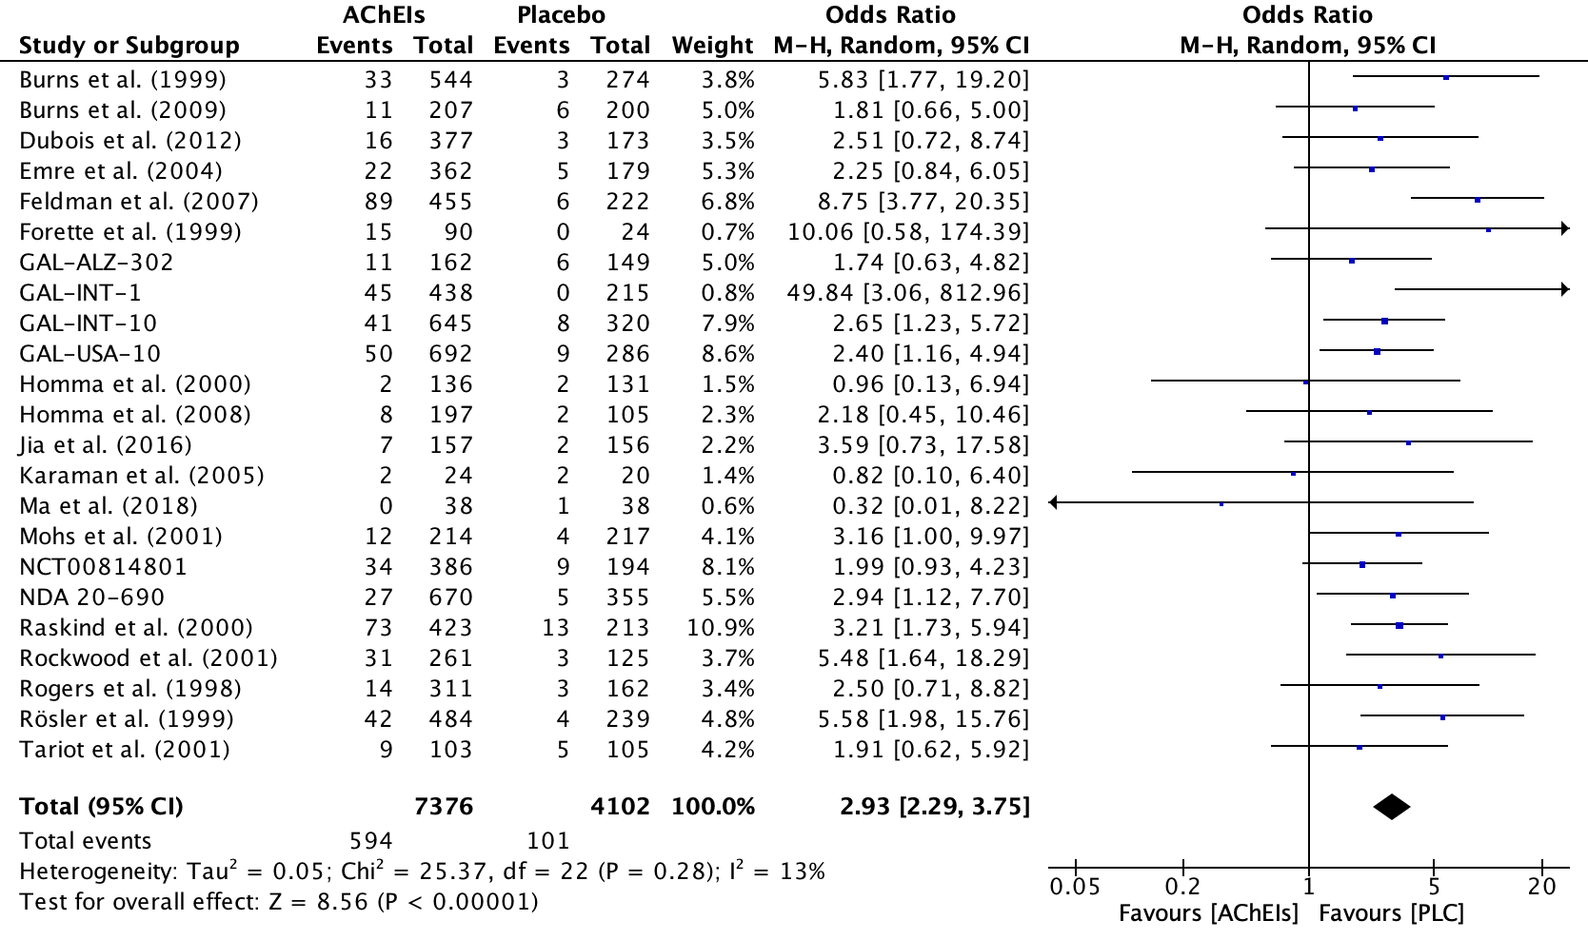

- Fig. S2. Forest plot for decreased appetite during AChEIs vs. placebo
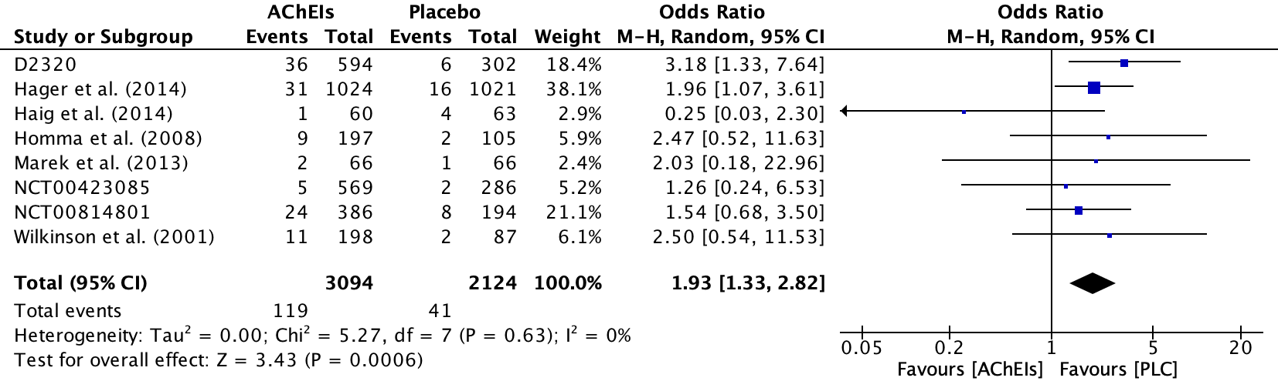

- Fig. S3. Forest plot for insomnia during AChEIs vs. placebo
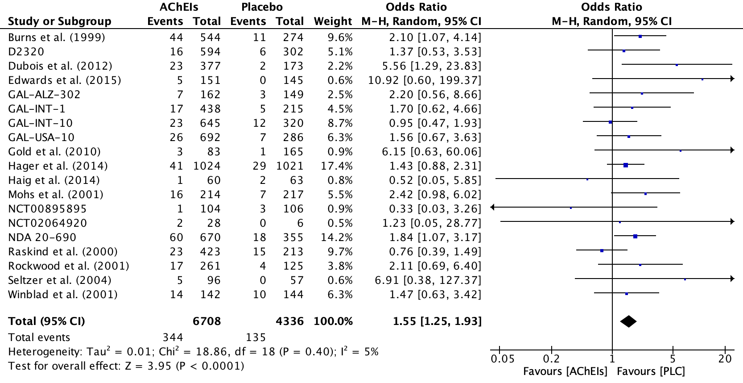

- Fig. S4. Forest plot for depression during AChEIs vs. placebo
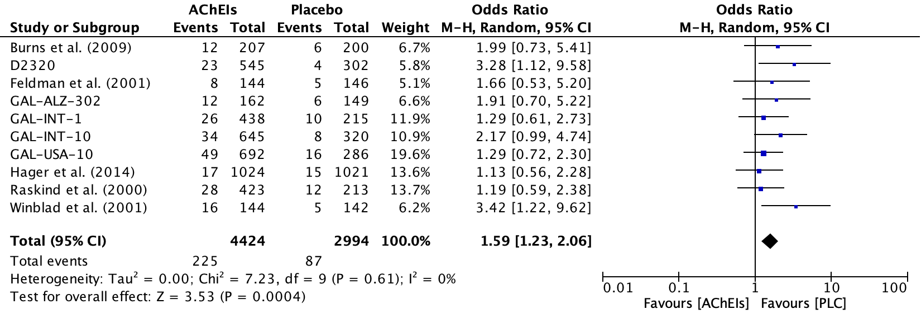

- Fig. S5. Forest plot for agitation during AChEIs vs. placebo
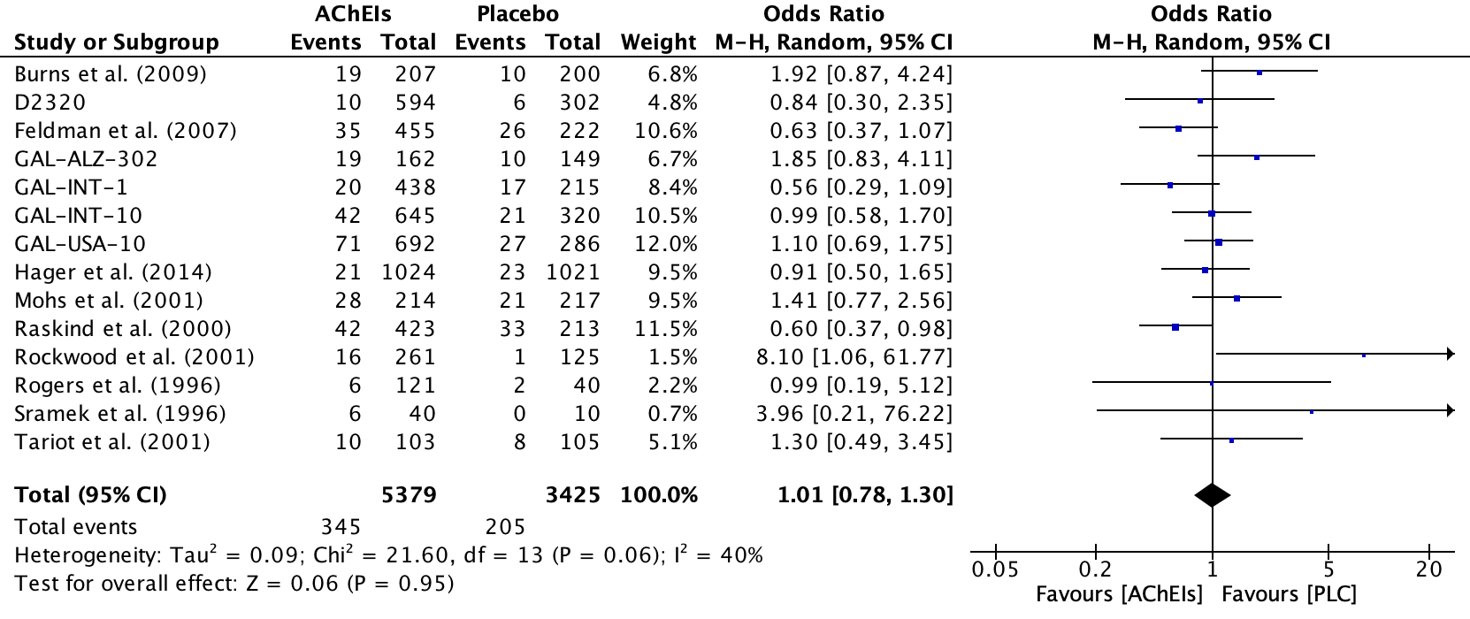

- Fig. S6. Forest plot for anxiety during AChEIs vs. placebo
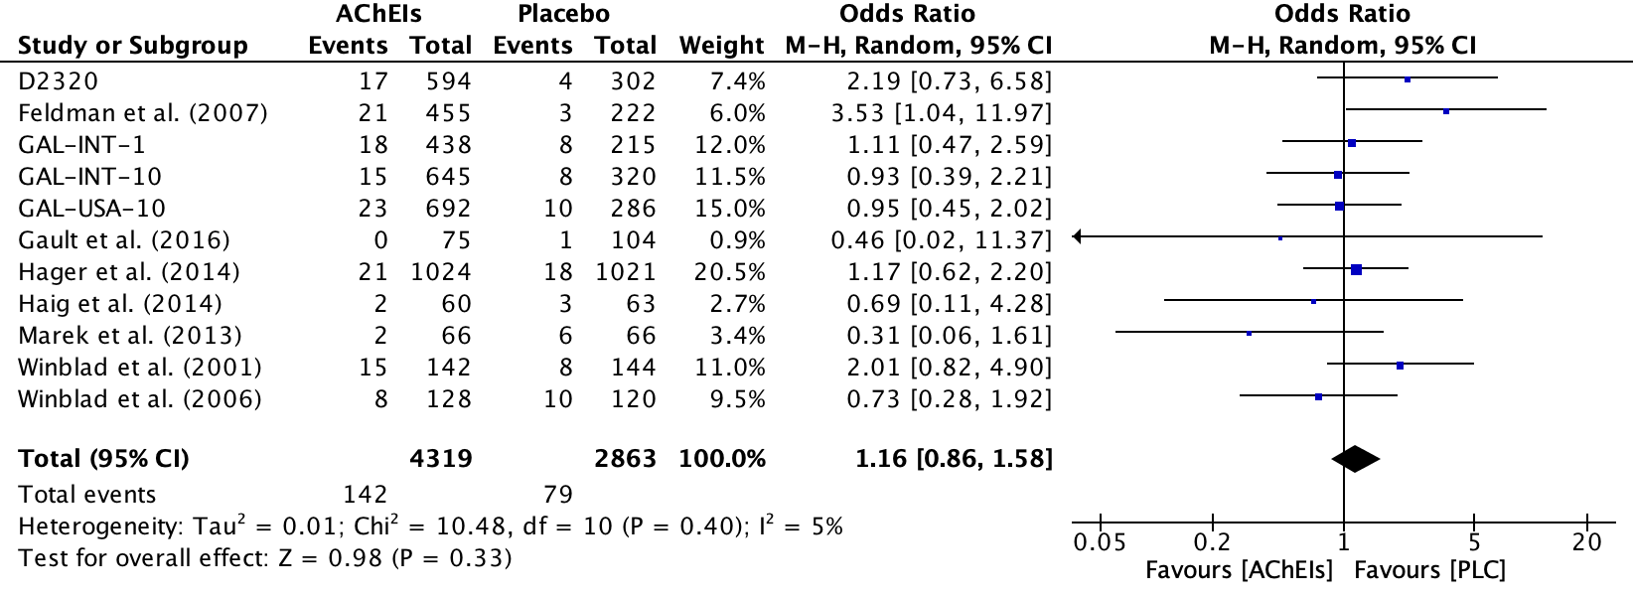

- Fig. S7. Forest plot for confusion during AChEIs vs. placebo
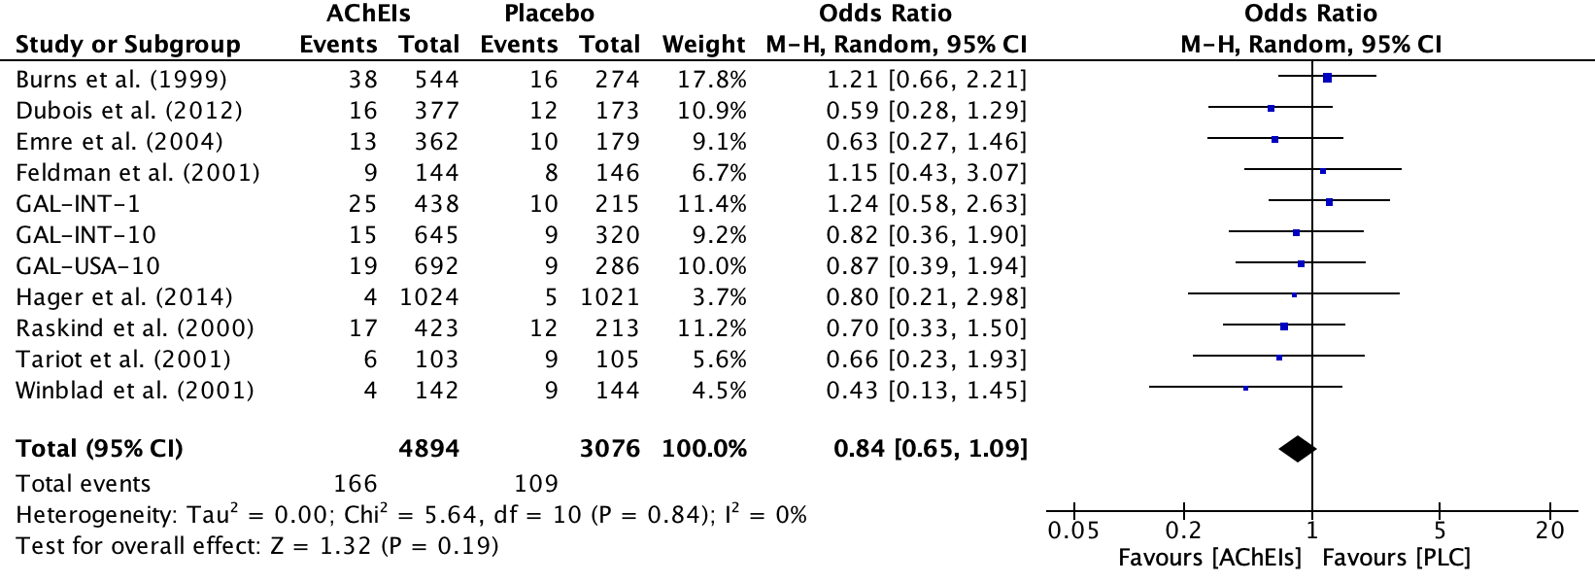

- Fig. S8. Forest plot for hallucination during AChEIs vs. placebo
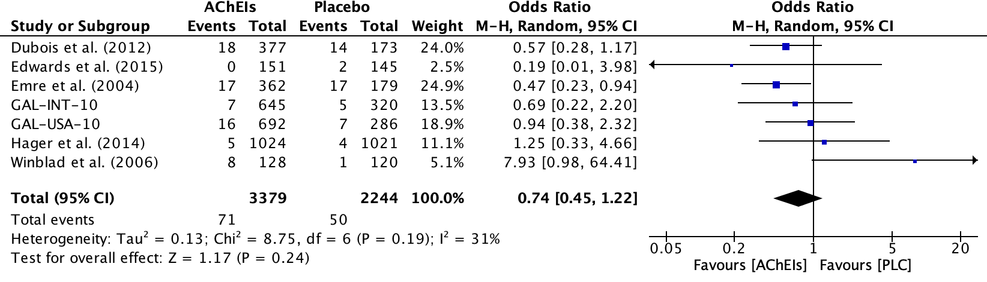

- Fig. S9. Forest plot for somnolence during AChEIs vs. placebo

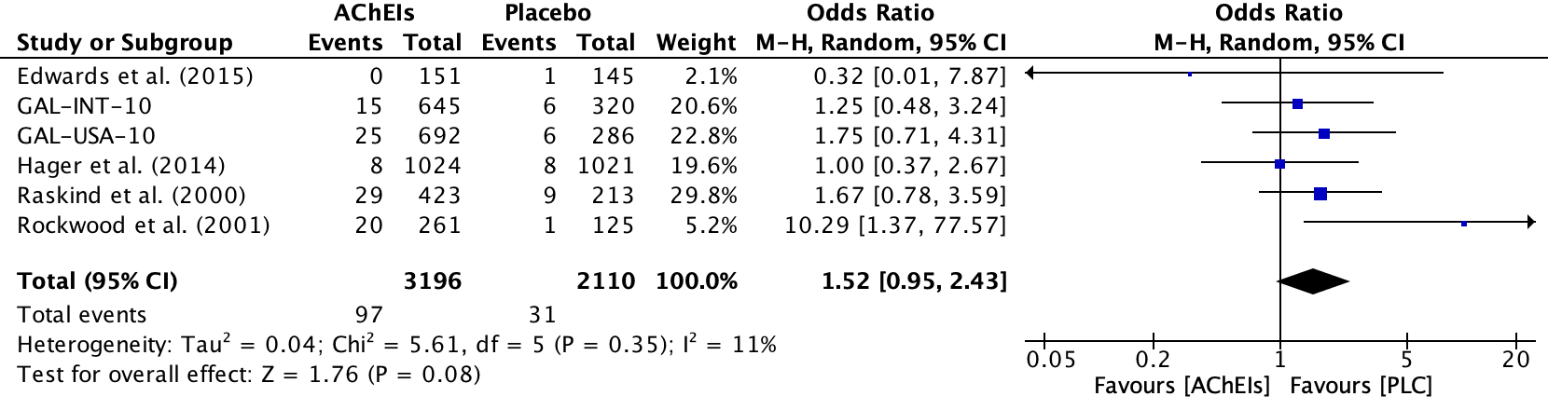

- Fig. S10. Forest plot for nausea during AChEIs vs. placebo
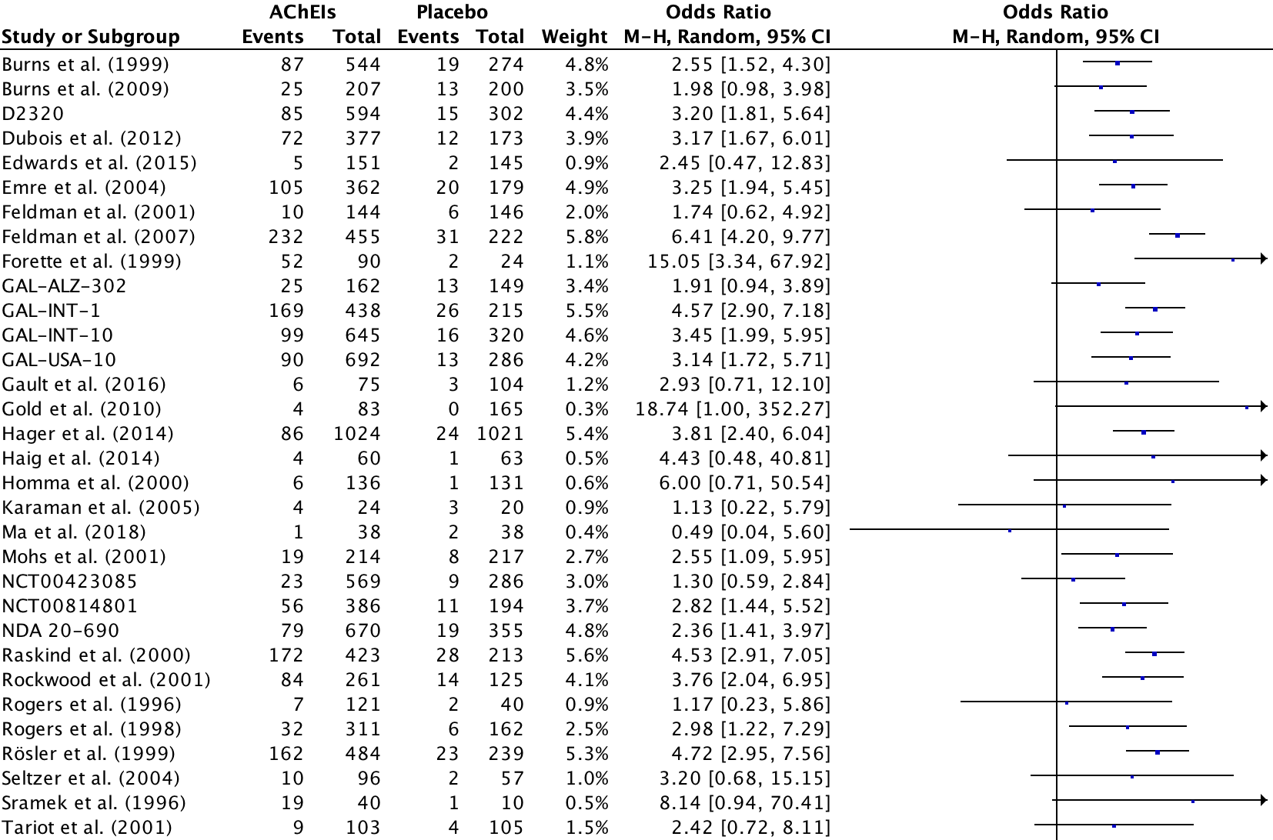
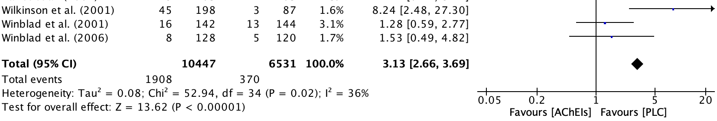

- Fig. S11. Forest plot for diarrhea during AChEIs vs. placebo
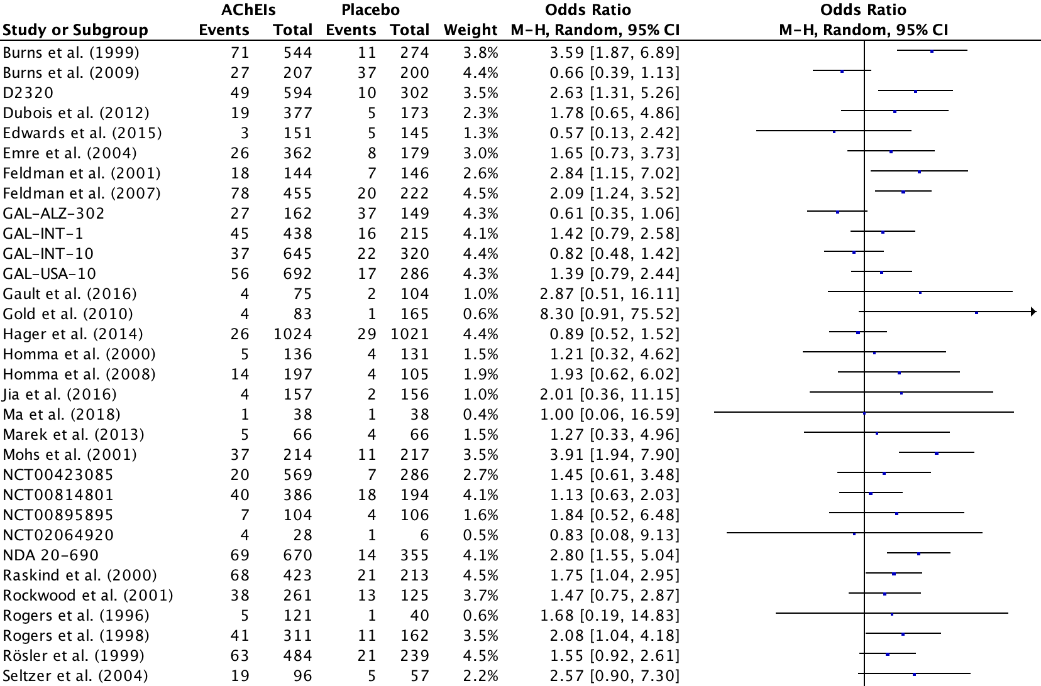
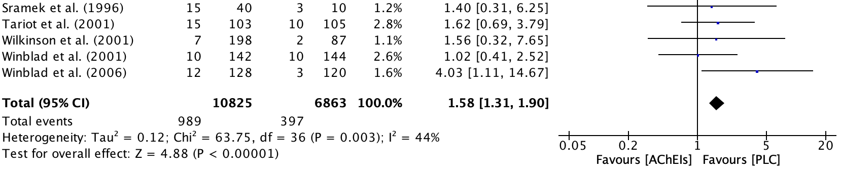
- Fig. S12. Funnel plot for anorexia during AChEIs vs. placebo
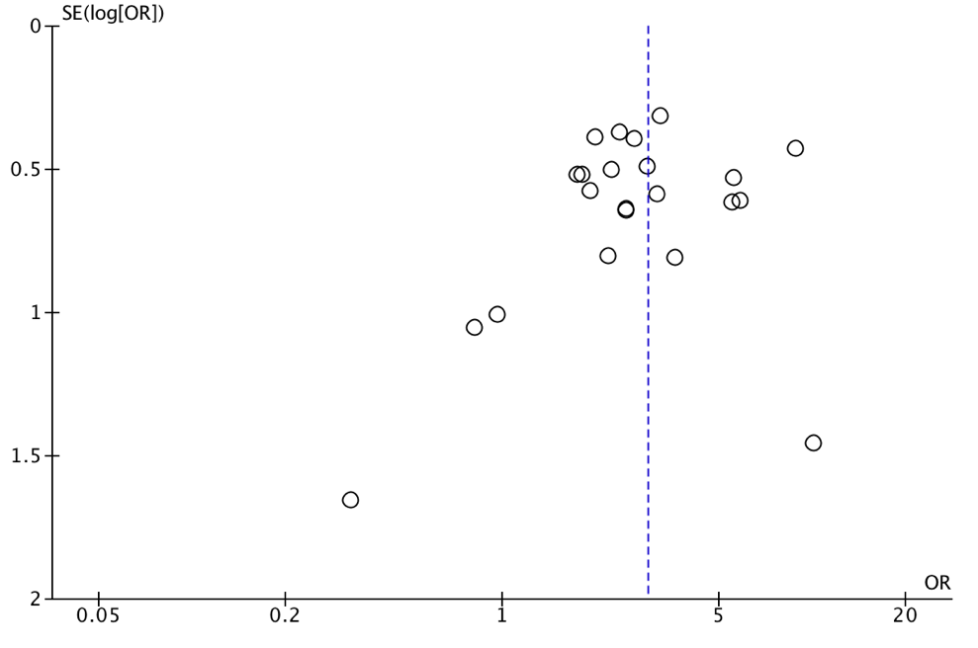

- Fig. S13. Funnel plot for insomnia during AChEIs vs. placebo
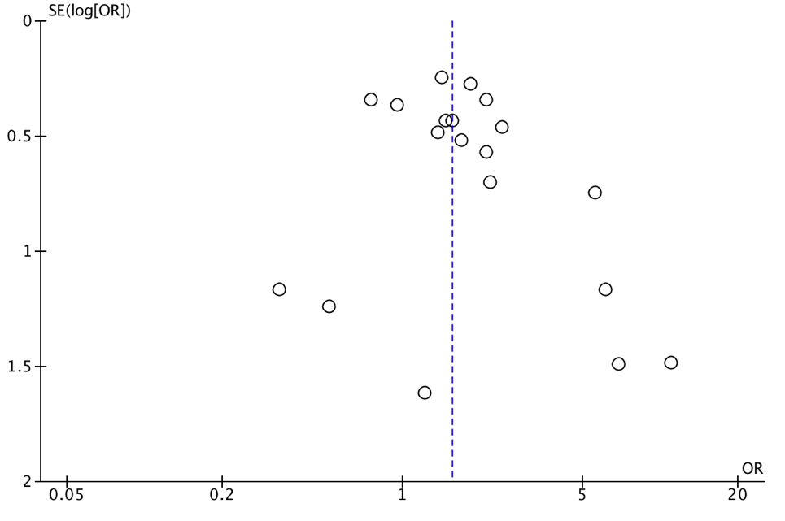

- Fig. S14. Funnel plot for depression during AChEIs vs. placebo
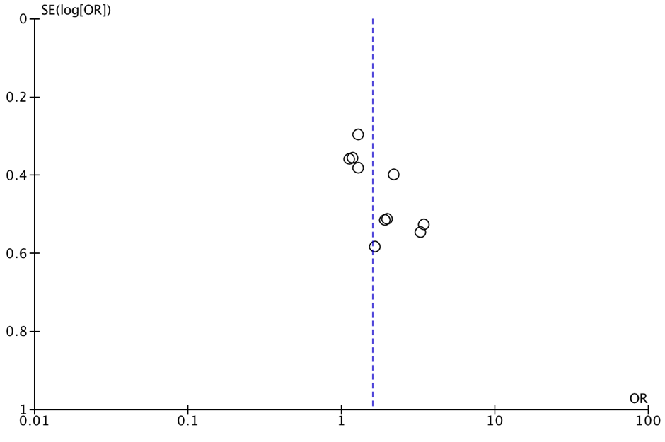
- Fig. S15. Funnel plot for agitation during AChEIs vs. placebo
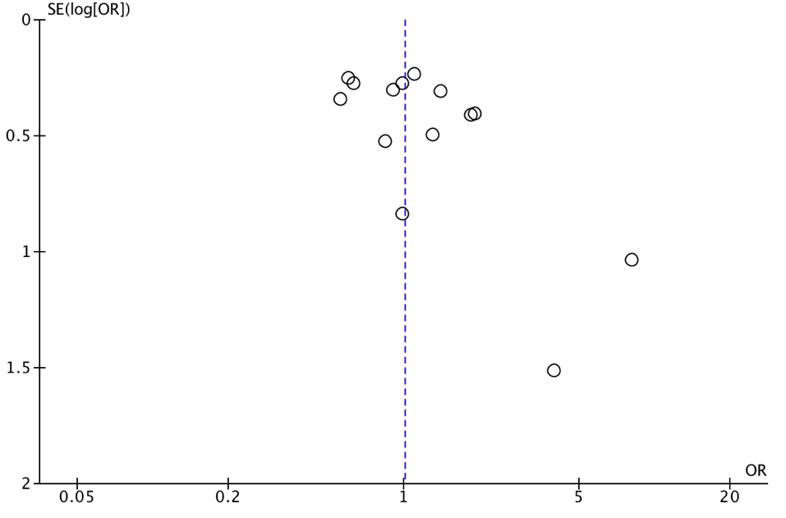

- Fig. S16. Funnel plot for anxiety during AChEIs vs. placebo
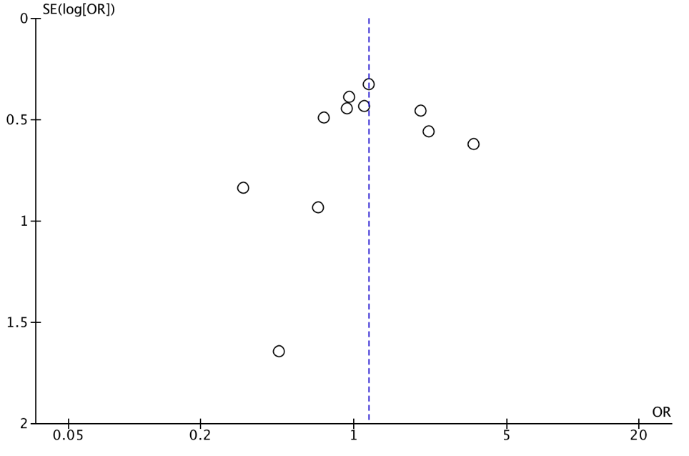
- Fig. S17. Funnel plot for confusion during AChEIs vs. placebo
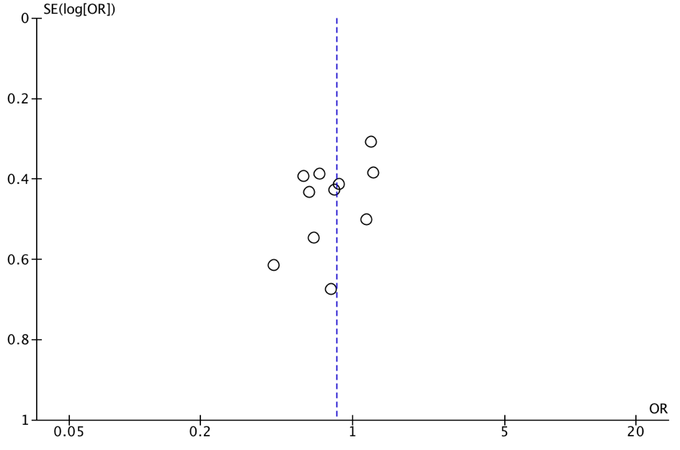
- Table S10. Results of sensitivity analyses (placebo-controlled studies)
Symptom | Unmodified analysis | Exclusion of studies with a duration of fewer than eight weeks | Exclusion of studies with risk of bias | Exclusion of the study with greatest weight | Limited to studies with active adverse event assessment | Limited to unsponsored studies
Agitation | 14 pairs;  OR 1.01, CI 0.78–1.30; p=0.95; I2=40% | see unmodified analysis | 12 pairs;  OR 1.05, CI 0.81–1.38; p=0.70; I2=39% | 13 pairs;  OR 1.01, CI 0.75–1.34; p=0.96; I2=44% | – | –
Anorexia | 23 pairs;  OR 2.93, CI 2.29–3.75; p=<0.00001; I2=13% | see unmodified analysis | 19 pairs;  OR 2.62, CI 2.06–3.33; p=<0.00001; I2=0% | 22 pairs;  OR 2.90, CI 2.21–3.81; p=<0.00001; I2=0% | – | –
Anxiety | 11 pairs;  OR 1.16, CI 0.86–1.58; p=0.33; I2=5% | see unmodified analysis | 10 pairs;  OR 1.09, CI 0.80–1.47; p=0.59; I2=0% | 10 pairs;  OR 1.16, CI 0.81–1.68; p=0.42; I2=14% | – | –
Confusion | 11 pairs;  OR 0.84, CI 0.65–1.09; p=0.19; I2=0% | see unmodified analysis | see unmodified  analysis | 10 pairs;  OR 0.78, CI 0.59–1.03; p=0.08; I2=0% | – | –
Decreased Appetite | 8 pairs;  OR 1.93, CI 1.33–2.82; p=0.0006; I2=0% | see unmodified analysis | 6 pairs;  OR 1.90, CI 1.29–2.80; p=0.001; I2=0% | 7 pairs;  OR 1.92, CI 1.19–3.09; p=0.008; I2=0% | – | –
Depression | 10 pairs;  OR 1.59, CI 1.23–2.06; p=0.0004; I2=0% | see unmodified analysis | see unmodified  analysis | 9 pairs;  OR 1.68, CI 1.26–2.23; p=0.0004; I2=0% | – | –
Hallucination | 7 pairs;  OR 0.74, CI 0.45–1.22; p=0.24; I2=31% | see unmodified analysis | see unmodified  analysis | 6 pairs;  OR 0.87, CI 0.48–1.57; p=0.65; I2=29% | – | –
Insomnia | 19 pairs;  OR 1.55, CI 1.25–1.93; p=<0.0001; I2=5% | see unmodified analysis | see unmodified  analysis | 18 pairs;  OR 1.59, CI 1.24–2.05; p=0.0003; I2=9% | – | –
Somnolence | 6 pairs;  OR 1.52, CI 0.95–2.43; p=0.08; I2=11% | see unmodified analysis | see unmodified  analysis | 5 pairs;  OR 1.50, CI 0.77–2.90; p=0.23; I2=29% | – | –
Positive control symptoms
Nausea | 35 pairs;  OR 3.13, CI 2.66–3.69; p=<0.00001; I2=36% | see unmodified analysis | 28 pairs;  OR 3.03, CI 2.65–3.47; p=<0.00001; I2=0% | 34 pairs;  OR 3.03, CI 2.60–3.53; p=<0.00001; I2=23% | – | –
Diarrhea | 37 pairs;  OR 1.58, CI 1.31–1.90; p=<0.00001; I2=44% | see unmodified analysis | 32 pairs;  OR 1.58, CI 1.27–1.95; p=<0.0001; I2=50% | 36 pairs;  OR 1.57, CI 1.30–1.91; p=<0.00001; I2=45 % | – | –
Sensitivity analyses were only performed if there were at least five studies available. If analyses could not be performed, lines were marked with “–“. Sensitivity analyses for industry sponsorship could not be performed for any of the symptoms. Industry sponsorship was rated “yes” if it was either explicitly reported or if industry representatives were among the authors. Mere provision of study medication was not considered as industry sponsorship.

- Table S11. Results of subgroup analyses (placebo-controlled studies)
Symptom | Subgroup analysis: grouped by type of AChEI
Agitation | DON (3) vs GAL (8) vs RIV (3)  Chi²=4.02, df=2, p=0.13
Anorexia | DON (10) vs GAL (8) vs RIV (5)  Chi²=1.18, df=2, p=0.55
Anxiety | DON (5) vs GAL (4)  Chi²=0.14, df=1, p=0.71
Confusion | DON (5) vs GAL (5)  Chi²=0.02, df=1, p=0.88
Decreased Appetite | DON (3) vs GAL (3)  Chi²=0.32, df=1, p=0.57
Depression | ‒
Hallucination | DON (3) vs GAL (3)  Chi²=0.01, df=1, p=0.92
Insomnia | DON (11) vs GAL (7)  Chi²=4.26, df=1, p=0.04 (DON > GAL)
Somnolence | ‒
Positive control symptoms
Nausea | DON (17) vs GAL (10) vs RIV (8)  Chi²=7.52, df=2, p=0.02 (RIV/GAL > DON)
Diarrhea | DON (21) vs GAL (10) vs RIV (6)  Chi²=14.91, df=2, p=0.0006 (DON/RIV > GAL)
Subgroup analyses were only performed if there were at least three studies per group available. The numbers in parentheses indicate the number of available studies.

- Fig. S18. Forest plot for anorexia for analysis of dose-effects
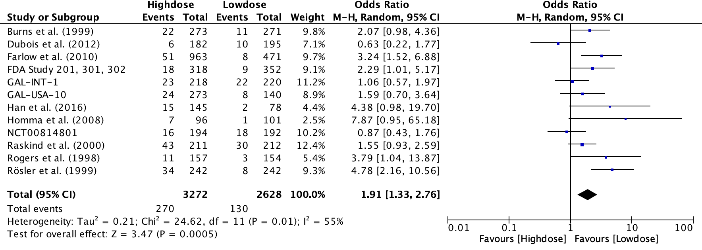

- Fig. S19. Forest plot for decreased appetite for analysis of dose-effects
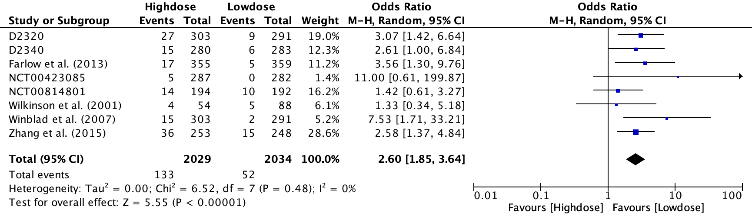
- Fig. S20. Forest plot for agitation for analysis of dose-effects
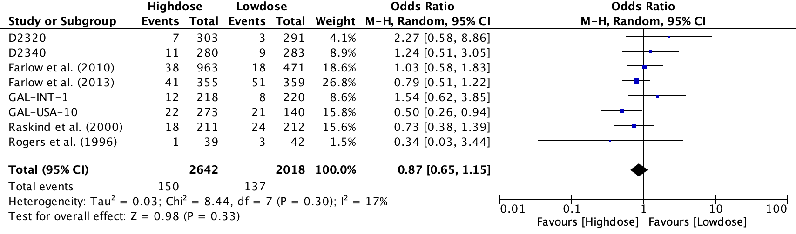
- Fig. S21. Forest plot for anxiety for analysis of dose-effects
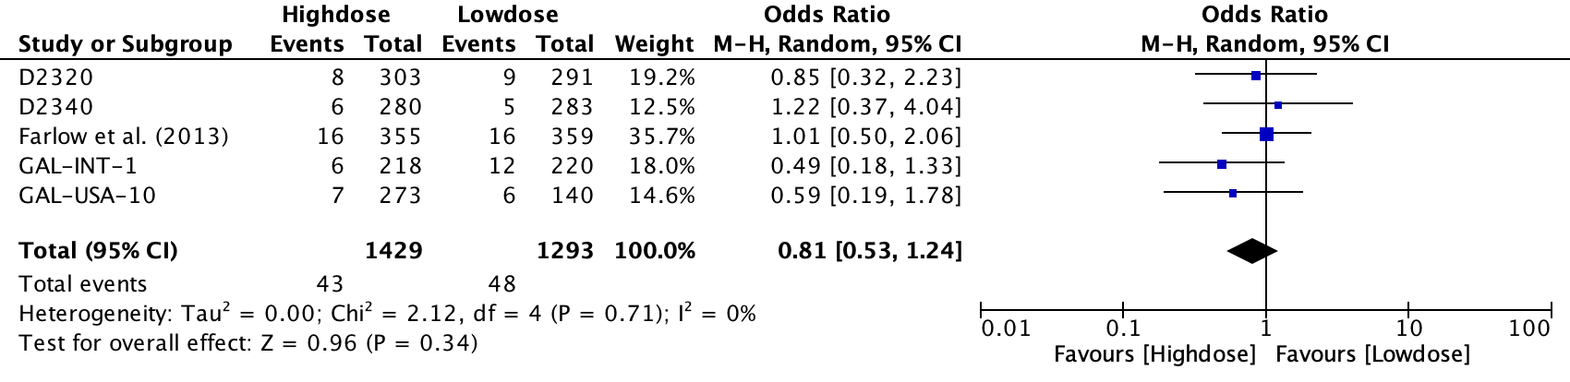

- Fig. S22. Forest plot for confusion for analysis of dose-effects
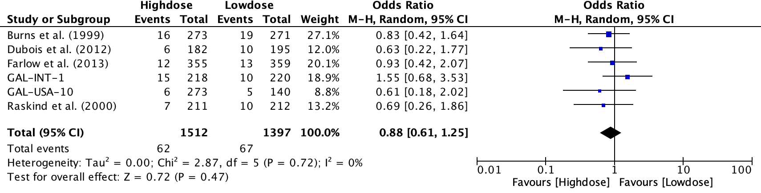

- Fig. S23. Forest plot for depression for analysis of dose-effects

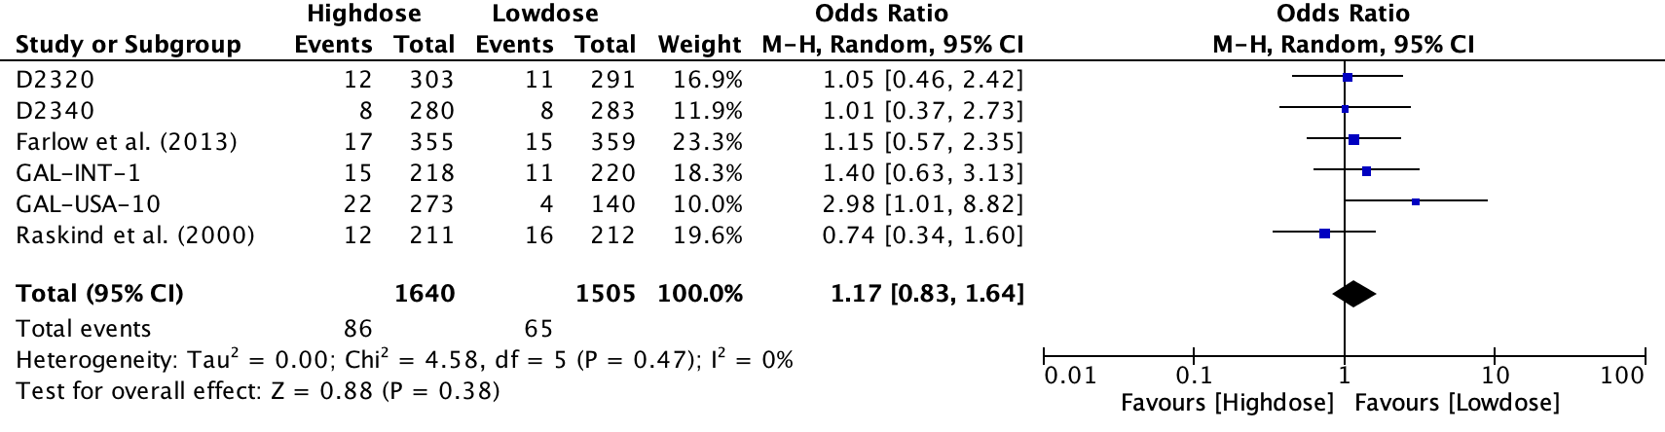

- Fig. S24. Forest plot for insomnia for analysis of dose-effects
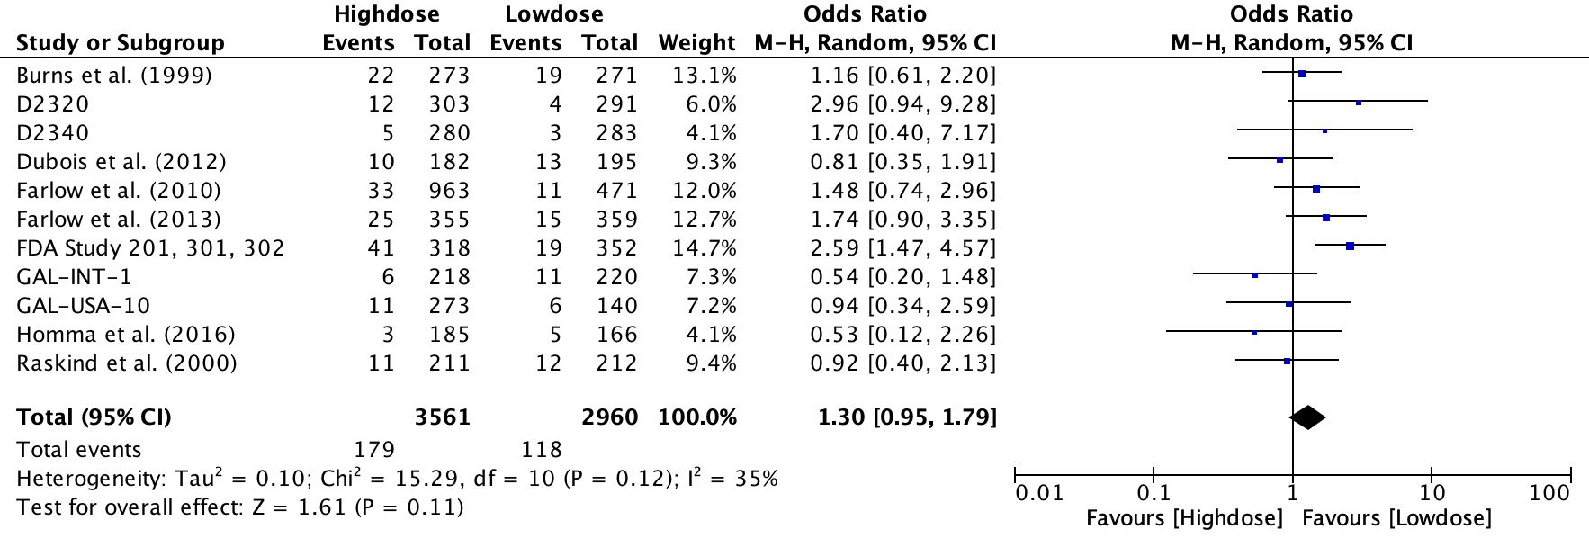

- Fig. S25. Forest plot for somnolence for analysis of dose-effects
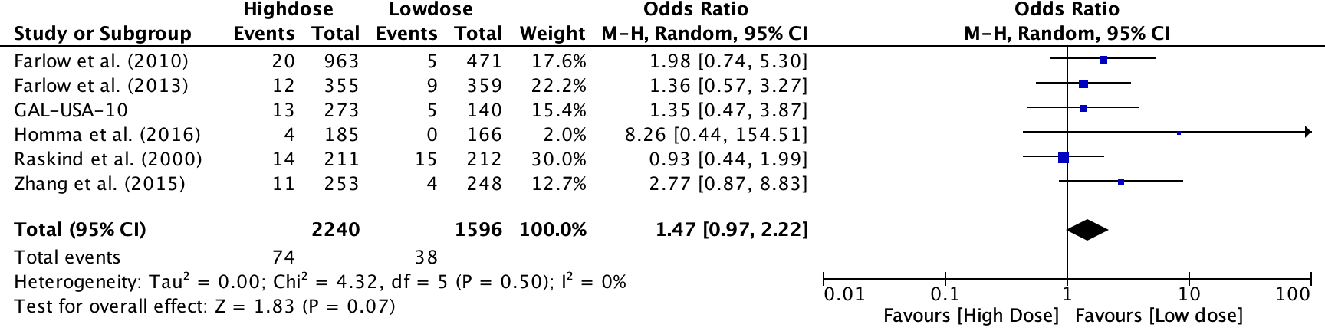

- Fig. S26. Forest plot for nausea for analysis of dose-effects
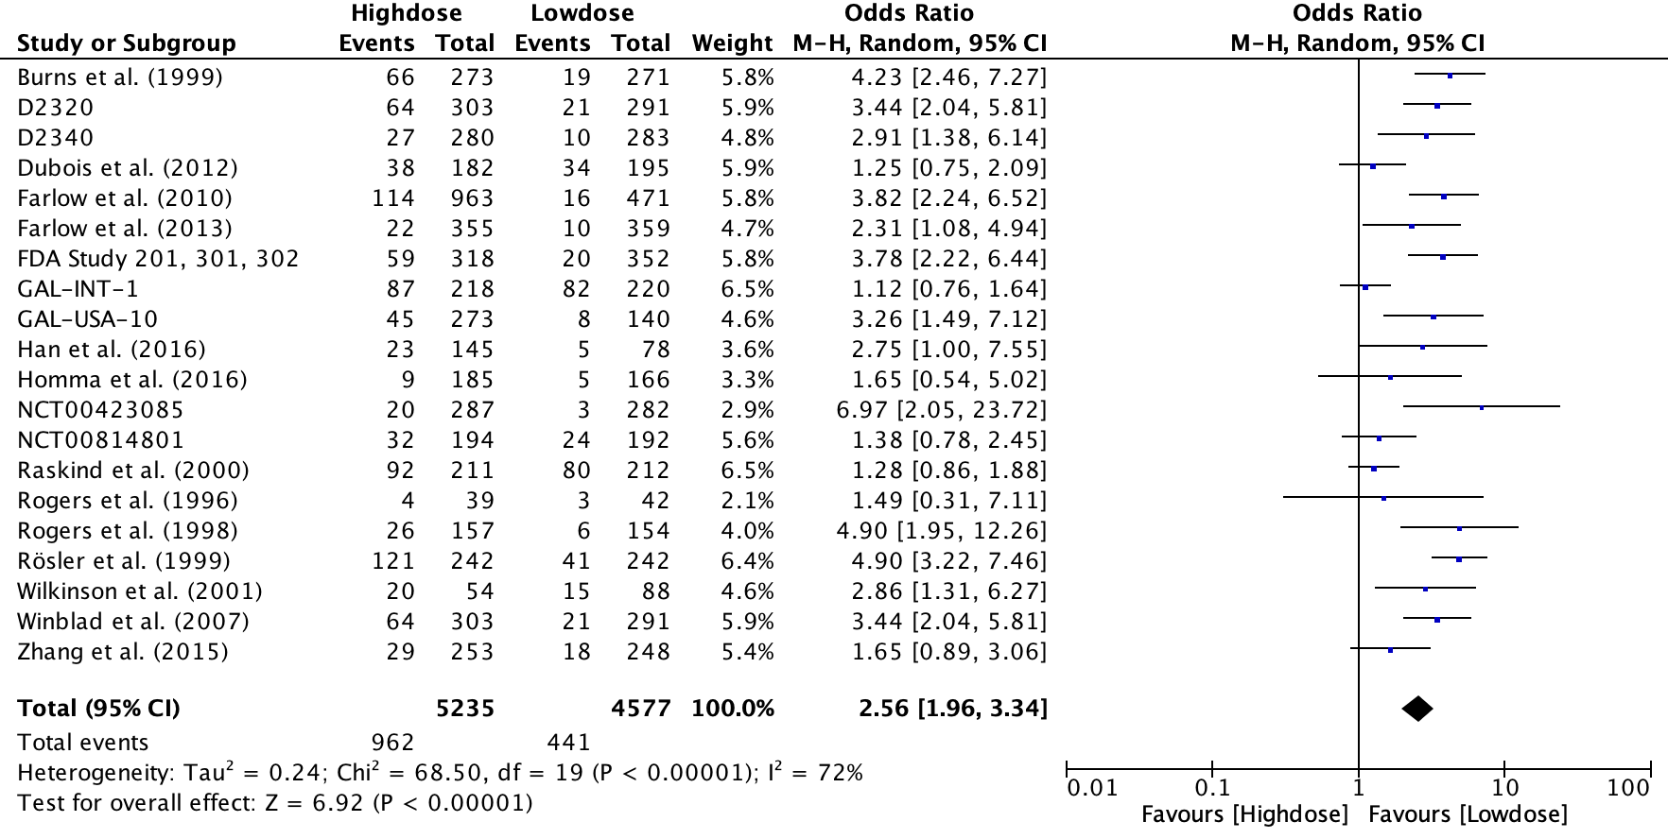
- Fig. S27. Forest plot for diarrhea for analysis of dose-effects
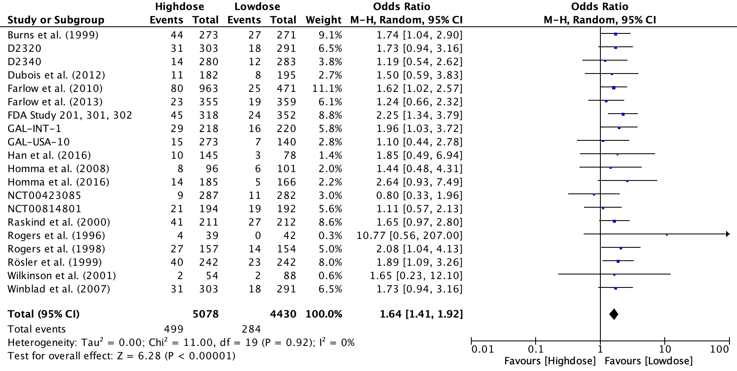
- Fig. S28. Funnel plot for anorexia for dose-effects
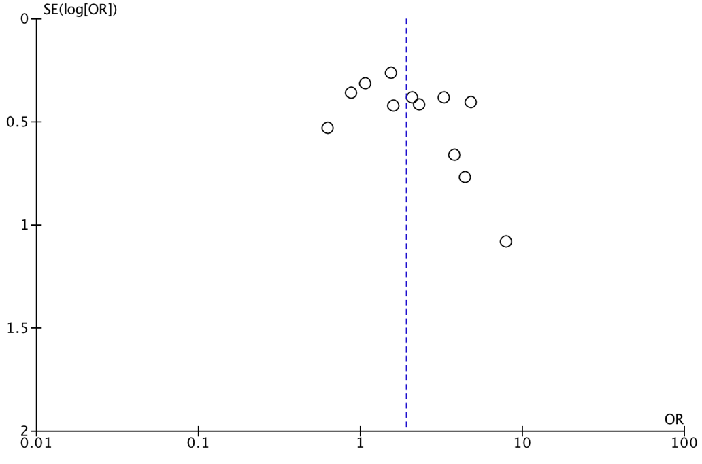

- Fig. S29. Funnel plot for insomnia for dose-effects
