SUPPLEMENTAL MATERIAL
Figure S1. Participant Disposition
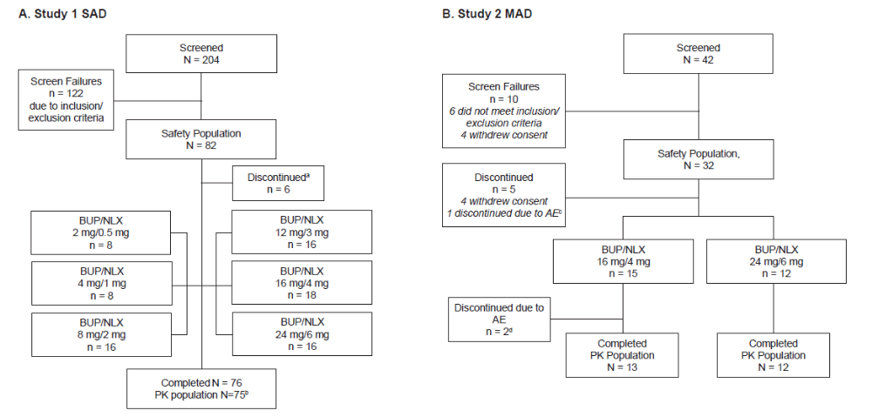

ªSix participants withdrew after 1 dose of naltrexone and prior to taking buprenorphine/naloxone; these participants were included in the safety analysis.
^{b}One participant vomited following BUP/NLX administration and was included in the safety but not pharmacokinetic population.
^{c}One participant withdrew due to adverse events of nausea, vomiting, and epigastric pain following BUP/NLX administration.
^{d}Two participants withdrew due to adverse events on stable dosage stage day 1 or 2.
AE, adverse event; BUP/NLX, buprenorphine/naloxone.

Figure S2. Mean C_{max} and AUC after a single dose of buprenorphine/naloxone sublingual tablets in healthy Chinese and Western participants

A. Buprenorphine

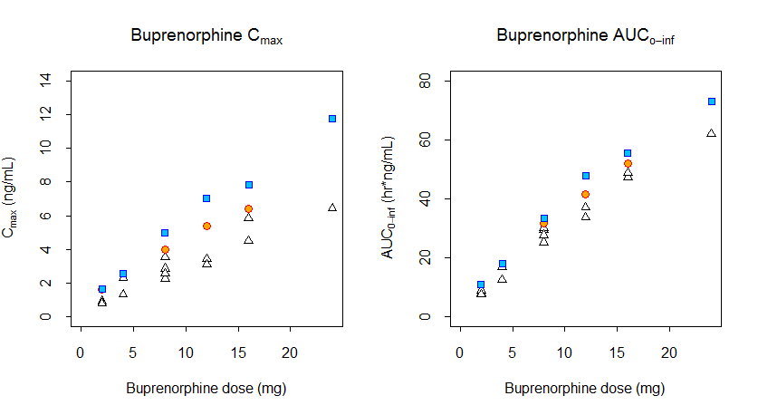

The blue squares represent mean data in Chinese participants in the present study. The white triangles represent mean data in Western participants in a historical study conducted by the sponsor. The orange dots represent mean data in Western participants in the report by McAleer, 2003.

B. Naloxone

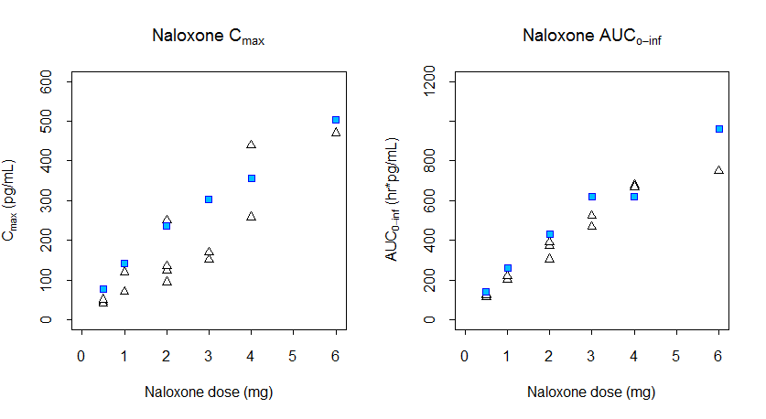
The blue squares represent mean data in Chinese participants in the single dose study. The white triangles represent mean data in Western participants in historical single dose studies conducted by the sponsor. The pink squares represent mean data in Chinese participants in the multiple dose study. The orange dot represents mean data in Western participants in one historical multiple dose study conducted by the sponsor.

C. Buprenorphine/Naloxone Ratio
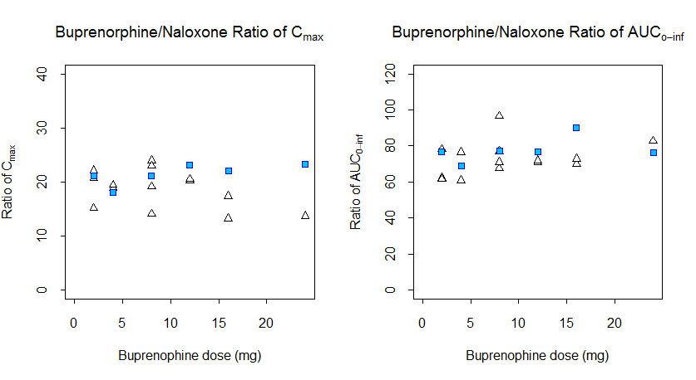
The blue squares represent mean data in Chinese participants in the present study. The white triangles represent mean data in Western participants in historical studies conducted by the sponsor.

Table S1. Evaluation of dose proportionality for buprenorphine, norbuprenorphine, and naloxone (Study 1)
Compound | Beta Point Estimate  ± 90% CI | Adjusted Rangeª | Bioequivalence Range
Buprenorphine  AUC_{0-inf}  AUC_{0-last}  C_{max} | 0.79 (0.71, 0.87)  0.81 (0.73, 0.90)  0.78 (0.68, 0.88) | 0.94, 1.09  0.94, 1.09  0.86, 1.14 | 0.80, 1.25  0.80, 1.25  0.70, 1.43
Norbuprenorphine  AUC_{0-inf}  AUC_{0-last}  C_{max} | 1.04 (0.91, 1.17)  1.19 (1.03, 1.35)  1.26 (1.09, 1.44) | 0.94, 1.09  0.94, 1.09  0.86, 1.14 | 0.80, 1.25  0.80, 1.25  0.70, 1.43
Naloxone  AUC_{0-inf}  AUC_{0-last}  C_{max} | 0.72 (0.59, 0.85)  0.78 (0.68, 0.89)  0.71 (0.58, 0.84) | 0.94, 1.09  0.94, 1.09  0.86, 1.14 | 0.80, 1.25  0.80, 1.25  0.70, 1.43
ªCalculated as [1+ln(0.8)/ln(r), 1+ln (1.25)/ln(r)], where r = high dose / low dose.
AUC_{0-inf}, steady-state area under the curve from 0 to infinity; AUC_{0-last}, area under the plasma concentration-time curve from 0 to last time point observed; C_{max,} maximum observed plasma concentration; CV, coefficient of variation; MAD, multiple ascending dose; NR, not reported; CI, confidence interval.

