Supplementary Material
Stopping criteria for dose escalation
These criteria were meant to facilitate the SRC in decision making on dose escalation but not exhaustive. Stopping of dose escalation was to be considered if any of the following occurred:
Part 1
- Gastrointestinal AEs (eg, nausea, vomiting, abdominal cramps, etc) of moderate severity in ≥2 of 3 subjects (60/140 mg groups) or in ≥3 of 5 subjects (240/360/480 mg groups)
- Any clinically significant effect on sedation: MOAA/S <3 in ≥2 of 3 subjects (60/140 mg groups) or in ≥3 of 5 subjects (240/360/480 mg groups)
- Any significant AE, deemed related to remimazolam with respiratory or cardiovascular focus (delineated below) that occurred in ≥2 of 3 subjects (60/140 mg group) or in ≥ 3 of 5 subjects (240/360/480 mg groups)
- Respiratory depression (<8 breaths per minute) requiring intervention
- Hypoxemia:
- Oxygen desaturation with oxygen saturation (SpO2) <90% for ≥1 min requiring supplemental oxygen for more than 20 min
- Oxygen desaturation with SpO2 <80% for ≥15 sec following stimulation
- Symptomatic bradycardia and/or heart rate <40 beats per min that lasted continuously for at least 30 sec requiring intervention
- Symptomatic hypotension and/or mean arterial pressure <65 mmHg requiring IV fluid administration and/or vasopressors
Part 2
- Gastrointestinal AEs (eg, nausea, vomiting, abdominal cramps, etc) of moderate severity in ≥6 of 12 subjects
- Any clinically significant effect on memory or sedation: MOAA/S <3 in ≥8 of 12 subjects
- Any significant AE, deemed related to the trial drug with a respiratory or cardiovascular focus (delineated below) that occurred in ≥4 of 12 subjects within a dose group
- Respiratory depression (<8 breaths per min) requiring intervention
- Hypoxemia:
- Oxygen desaturation with SpO₂ <90% for ≥1 min requiring supplemental oxygen for more than 20 min
- Oxygen desaturation with SpO2 <80% for ≥15 sec following stimulation
- Symptomatic bradycardia and/or heart rate <40 beats per min that lasted continuously for at least 30 sec requiring intervention
- Symptomatic hypotension and/or mean arterial pressure <65 mmHg, necessitating IV fluid administration and/or vasopressors

Flow chart: Study design of Part 1 and 2 of Trial 2
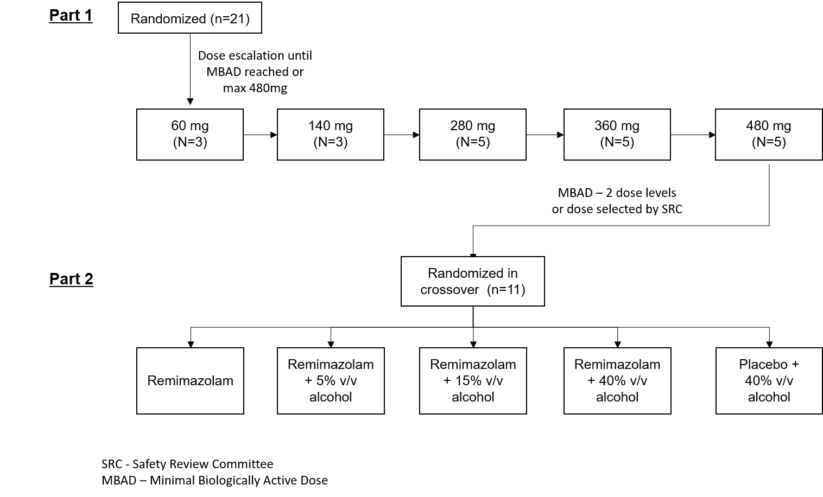

Table S1. Summary of Treatment Emergent Adverse Events of Interest by System Organ Class and Preferred Term (Trial 1; Safety Population)
System organ class  Preferred Term | 1.25‒2.58 mg  (N=14) | 7.00‒14.4 mg  (N =14) | Total  (N=14)
Subjects with at least 1 TEAE | 7 ( 50.0) | 7 ( 50.0) | 9 ( 64.3)
General disorders and administration site conditions  Feeling abnormal  Feeling of relaxation | 1 ( 7.1)  1 ( 7.1)  0 | 3 ( 21.4)  2 ( 14.3)  1 ( 7.1) | 4 ( 28.6)  3 ( 21.4)  1 ( 7.1)
Investigations  Blood pressure diastolic decreased  Heart rate decreased | 5 ( 35.7)  5 ( 35.7)  0 | 3 ( 21.4)  2 ( 14.3)  1 ( 7.1) | 7 ( 50.0)  6 ( 42.9)  1 ( 7.1)
Nervous system disorders  Dizziness  Somnolence | 1 ( 7.1)  0  1 ( 7.1) | 3 ( 21.4)  2 ( 14.3)  2 ( 14.3) | 4 ( 28.6)  2 ( 14.3)  3 ( 21.4)
Vascular disorders  Hypotension | 1 ( 7.1)  1 ( 7.1) | 0  0 | 1 ( 7.1)  1 ( 7.1)

Table S2. Summary of Treatment Emergent Adverse Events Related to Effects Seen with Medications Known to Be Associated with Abuse by System Organ Class and Preferred Term (Trial 2 Part 1; Safety Population)
System organ class  Preferred Term | 60 mg  (N=3) | 140 mg  (N=3) | 240 mg  (N=5) | 360 mg  (N=5) | 480 mg  (N=5) | Total  (N=21)
Subjects with at least 1 TEAE | 1 (33.3) | 3 ( 100) | 3 (60.0) | 4 (80.0) | 4 (80.0) | 15 (71.4)
Gastrointestinal disorders  Nausea | 0  0 | 0  0 | 0  0 | 0  0 | 1 (20.0)  1 (20.0) | 1 ( 4.8)  1 ( 4.8)
General disorders and administration site conditions  Feeling of relaxation  Fatigue  Feeling abnormal | 1 (33.3)  1 (33.3)  0  0 | 2 (66.7)  0  2 (66.7)  0 | 0  0  0  0 | 1 (20.0)  0  0  1 (20.0) | 3 (60.0)  2 (40.0)  0  1 (20.0) | 7 (33.3)  3 (14.3)  2 ( 9.5)  2 ( 9.5)
Nervous system disorders  Somnolence  Cognitive disorder | 0  0  0 | 1 (33.3)  1 (33.3)  0 | 3 (60.0)  3 (60.0)  0 | 4 (80.0)  4 (80.0)  0 | 2 (40.0)  2 (40.0)  1 (20.0) | 10 (47.6)  10 (47.6)  1 ( 4.8)
Psychiatric disorders  Euphoric mood | 0  0 | 0  0 | 1 (20.0)  1 (20.0) | 0  0 | 0  0 | 1 ( 4.8)  1 ( 4.8)

Table S3: Summary of Treatment Emergent Adverse Events Related to Effects Seen with Medications Known to Be Associated with Abuse by System Organ Class and Preferred Term (Trial 1 Part 2; Safety Population)
System organ class  Preferred Term | Remimazolam 360 mg  (N=11) | Remimazolam 360 mg + 5% v/v alcohol  (N=11) | Remimazolam 360 mg + 15% v/v alcohol  (N=11) | Remimazolam 360 mg + 40% v/v alcohol  (N=11) | Placebo + 40% v/v alcohol  (N=11) | Total  (N=11)
Subjects with at least 1 TEAE | 7 (63.6) | 10 (90.9) | 9 (81.8) | 7 (70.0) | 9 (81.8) | 11 ( 100)
Gastrointestinal disorders  Nausea  Vomiting | 0  0  0 | 0  0  0 | 0  0  0 | 1 (10.0)  0  1 (10.0) | 1 ( 9.1)  1 ( 9.1)  0 | 2 (18.2)  1 ( 9.1)  1 ( 9.1)
General disorders and administration site conditions  Feeling drunk  Feeling abnormal  Feeling of relaxation | 1 ( 9.1)  0  0  1 ( 9.1) | 1 ( 9.1)  0  1 ( 9.1)  0 | 0  0  0  0 | 3 (30.0)  3 (30.0)  0  0 | 4 (36.4)  4 (36.4)  0  0 | 7 (63.6)  5 (45.5)  1 ( 9.1)  1 ( 9.1)
Injury, poisoning and procedural  complications  Poisoning | 0  0 | 0  0 | 1 ( 9.1)  1 ( 9.1) | 0  0 | 2 (18.2)  2 (18.2) | 2 (18.2)  2 (18.2)
Investigations  Blood pressure diastolic decreased  Blood pressure systolic decreased | 0  0  0 | 0  0  0 | 0  0  0 | 1 (10.0)  1 (10.0)  1 (10.0) | 0  0  0 | 1 ( 9.1)  1 ( 9.1)  1 ( 9.1)
Nervous system disorders  Somnolence  Dizziness  Headache  Memory impairment | 7 (63.6)  6 (54.5)  1 ( 9.1)  1 ( 9.1)  0 | 9 (81.8)  9 (81.8)  0  0  0 | 9 (81.8)  9 (81.8)  0  0  1 ( 9.1) | 5 (50.0)  4 (40.0)  1 (10.0)  0  0 | 4 (36.4)  3 (27.3)  2 (18.2)  0  0 | 11 ( 100)  11 ( 100)  3 (27.3)  1 ( 9.1)  1 ( 9.1)
Psychiatric disorders  Euphoric mood  Restlessness | 0  0  0 | 0  0  0 | 1 ( 9.1)  1 ( 9.1)  0 | 0  0  0 | 2 (18.2)  2 (18.2)  1 ( 9.1) | 2 (18.2)  2 (18.2)  1 ( 9.1)

Figure S2: Mean plasma concentration of remimazolam over time (results of Trial 1 and Trial 2)
Values below the limit of quantification were not shown.
