SUPPLEMENTARY MATERIALS
Pharmacokinetics, Pharmacodynamics, and Safety of Intravenous Efgartigimod and Subcutaneous Efgartigimod PH20 in Healthy Chinese Participants
Drugs in R&D
Shan Jing¹ • Yu Zhang² • Yang Lin¹ • Xiaowen Gu³ • Jing Liu³ • Antonio Guglietta⁴ • Jan Noukens⁵ • Tonke Van Bragt⁵ • Lina Wang³ • Jiajia Chen³ • Harald Reinhart⁶ • Xia Pu⁶

Corresponding Author:
Xia Pu, PhD
E-mail: xia.pu@zailaboratory.com
Zai Lab (US) LLC, Cambridge, MA, USA

Inclusion and Exclusion Criteria
Inclusion Criteria
- Chinese adults, aged between 18–65 years, inclusive, on the day of signing the informed consent form (ICF).
- Body mass index (BMI) between 18–30 kg/m², inclusive, with a screening weight of no less than 50 kg and no more than 100 kg.
- Willingness and ability to understand the purpose and risks of the study and provide signed and dated informed consent prior to any procedures and be available for all study visits.
- Males and females. Contraceptives used by men and women were consistent with local regulations regarding the methods of contraception for those participating in clinical studies and:
  - Female participants had a negative serum pregnancy test at screening and at baseline before investigational medicinal product (IMP) can be administered.
  - Male participants agreed not to donate sperm from signing the ICF until the end of the study.
The contraceptive requirements for males and females of childbearing potential are described in the protocol (Appendix 16.1.1).
- The participant was in good physical and mental health, per the opinion of the investigator, based on medical history, physical examination, electrocardiogram (ECG), and vital sign findings; and biochemistry, hematology, virology, and urinalysis test results prior to the first IMP administration.
- The participant agreed to discontinue and refrain from all medications (including over-the-counter and/or prescription medications), except for occasional paracetamol use (maximum dose of 2 g/day and maximum of 10 g/2 weeks), antacid use, and ibuprofen use (maximum dose of 400 mg/day and not to be co-administered with antacid) at least 2 weeks before the first IMP administration through to the final follow-up visit on day 78.
- The participant agreed to withhold from strenuous activities from at least 2 weeks before the first IMP administration through to the final follow-up visit on day 78.
- The participant was a non-smoker and did not use any nicotine-containing products. A non-smoker was defined as an individual who has abstained from smoking for at least 1 year prior to screening.
- Negative urine drug screen (such as opiates, amphetamine, ketamine, cannabis, cocaine, cotinine) at screening and on day –1.
- Negative alcohol breath test at screening and on day –1.
- The participant had a body temperature of 35.2°C to 37.6 °C at screening and on day –1.
Exclusion Criteria
- The participant had previously participated in clinical studies with efgartigimod (ARGX-113) or other drugs with the same mechanism of action and was administered an IMP.
- Known hypersensitivity to IMP ingredients or a significant allergic reaction to any drug, as determined by the investigator, such as anaphylaxis requiring hospitalization.
- Participants with clinically significant active or chronic uncontrolled bacterial, viral, or fungal infection at screening.
- The participant tested positive at screening for any of the following conditions:
  - The participant had an active hepatitis B virus (HBV) infection (acute or chronic) at screening as determined by hepatitis B serology. (https://www.cdc.gov/hepatitis/HBV/PDFs/SerologicChartv8.pdf). HBV DNA level could be used at investigator discretion to detect the active form of the disease.
  - The participant had serology positive for hepatitis C virus (HCV) antibody (unless associated with a negative HCV RNA test).
  - The participant had human immunodeficiency virus positive serology associated with an acquired immunodeficiency syndrome–defining condition or a CD4 count < 200 cells/mm3.
- Participants with clinical evidence of other significant serious diseases, participants who underwent a recent major surgery, or any other reason that could confound the results of the trial or put the participant at undue risk.
- The participant had total immunoglobulin G < 6 g/L at screening.
- Known history or any symptom of clinically significant illness in the 6 months before the first IMP administration.
- Presence or having sequelae of liver, kidney, or other conditions known to interfere with the absorption, distribution, metabolism, or excretion of drugs.
- History of malignancy unless deemed cured by adequate treatment with no evidence of recurrence for ≥ 3 years before the first administration of the IMP. Participants with the following cancer could be included at any time:
  - Adequately treated basal cell or squamous cell skin cancer.
  - Carcinoma in situ of the cervix.
  - Carcinoma in situ of the breast.
  - Incidental histological finding of prostate cancer (Tumour, Node, Metastasis (TNM) stage T1a or T1b).
- Clinically relevant abnormalities detected on ECG regarding either rhythm or conduction [e.g. QT interval (the time from the start of the Q wave to the end of the T wave) using Fridericia’s formula (QTcF) > 450 ms for male and QTcF > 470 ms for female participants, or a known long QT syndrome]. A first-degree heart block or sinus arrhythmia was not considered a significant abnormality.
- Clinically relevant abnormalities detected on vital signs prior to first dosing.
- Significant blood loss [including blood donation (> 500 mL)] or had a transfusion of any blood product within 12 weeks prior to the initial IMP administration or planned one within 4 weeks after the end of the study.
- Treatment with any drug known to have a well-defined potential for toxicity to a major organ in the last 3 months preceding the initial IMP administration.
- The participant had a history of consuming more than 21 units of alcoholic beverages per week or has a history of alcoholism or drug/chemical/substance abuse within the 2 years prior to screening (Note: 1 unit = 330 mL of beer, 110 mL of wine, or 28 mL of spirits). Regular consumption of a large quantity of coffee, tea (> 6 cups per day), or equivalent within
3 weeks prior to first dose is also exclusionary.
- Use of other investigational products within 3 months or 5 half-lives (whichever was longer) before the first dose of the IMP.
- Received a live/live-attenuated vaccine less than 28 days before first dosing. The receipt of any inactivated, sub-unit, polysaccharide, or conjugate vaccine at any time before screening was not considered an exclusion criterion.
- Administration of any systemic immunosuppressant agent within 6 months prior to initial IMP administration.
- Administration of any systemic steroid within 2 months prior to initial IMP administration.
- The participant had received any monoclonal antibody within 6 months prior to first IMP administration.
- Investigator or any sub-investigator, research assistant, pharmacist, study coordinator, or other staff or relative thereof who was directly involved in the conduct of the study.
- Any condition or circumstances that, in the opinion of the investigator, could make a participant unlikely or unable to complete the study or comply with study procedures and requirements.
- Unsuitable vein for infusion and/or blood sampling.
- The participant was a pregnant or lactating women or intended to become pregnant during the study or within 90 days after last dosing.
- The participant had a positive nasopharyngeal/oropharynx polymerase chain reaction test for severe acute respiratory syndrome coronavirus 2 (SARS-CoV-2) on day –1 and within 7 days prior to randomization.
- The participant had any contact with SARS-CoV-2 positive or COVID-19 infected individual within the 2 weeks prior to admission to the clinical research center.

Statistical Analysis Sets
The pharmacokinetic (PK) set included all randomized participants who received at least one dose of efgartigimod and had at least one evaluable PK measurement.
The safety set included all randomized participants who received at least one dose of the study drug.
The pharmacodynamic (PD) set included all participants in the safety set who had at least one evaluable PD measurement.
The antidrug antibody (ADA) set included all participants in the safety set who had baseline and at least one postbaseline ADA measurement.
Noncompartmental analysis methods
NCA method: Linear up log down.
Calculation of terminal elimination: The following three rules were applied to determine the accurate λz when calculating by linear regression:
- Three quantifiable concentrations except C_{max} in the elimination log-linear phase should have been included;
- Percentage of the area under the curve that was extrapolated from the last time point to infinity should not be >20% (AUC_%_{Extrap} ≤20%);
- The correction coefficient of determination (Adjusted R²) should not be <0.850 (Adj__{Rsq} ≥0.850).
Handling of BQL:
- Data below the lower limit of quantitation (LLOQ) were reported as BQL (below the LLOQ). For samples with concentrations below LLOQ, concentrations before C_{max} were set as 0 and concentrations after C_{max} were set as not detectable (ND) when performing PK analysis.
- When at least one concentration at a time point is BQL, geometric mean and geometric coefficient of variation will not be reported for descriptive statistical analysis at this time point. When more than half (>50%) of serum concentrations of efgartigimod at a scheduled time point are BQL, mean and median values were reported as 0 (namely BQL), SD and CV% would not need to be reported (NC, not calculated). Observations were reported as minimum and maximum values (including BQL).
- In a linear plot, all BQL data were set to 0 for representation, in a semi-log plot, all BQL data were not represented. For the mean or median concentration-time plots, when more than half (>50%) of serum concentrations at a scheduled time point were BQL, the mean or median serum concentration at this time point was BQL. When the mean or median serum concentration at a time point was BQL, it was set to 0 in the linear plot and was not represented in a semi-log plot.
Supplementary Table S1 Pharmacodynamic parameters after four once-weekly administrations of efgartigimod IV 10 mg/kg and placebo IV, and efgartigimod PH20 SC 1000 mg and placebo PH20 SC (pharmacodynamic set)
 | Efgartigimod IV | Placebo IV | Efgartigimod PH20 SC | Placebo  PH20 SC
PD set  participant numbers | 12 | 4 | 12 | 3
Baseline (µg/mL) | 13000 (824) | 11800 (1850) | 13100 (473) | 12700 (785)
TE_{max} (days) | 24.0 (21.0, 35.0) | 3.0 (0.0, 14.0) | 24.0 (21.0, 28.0) | 3.0 (3.0, 3.0)
E_{max} (%) | –60.7 (2.0) | –18.4 (14.9) | –66.4 (1.4) | –2.4 (0.9)
E_{168h} (%) | –56.2 (2.8) | 18.5 (6.6) | –64.2 (1.5) | 5.6 (2.5)
AUEC_{3–4w} (%.h) | –9640 (375) | 3090 (1050) | –10900 (235) | 758 (182)
AUEC_{0–4w} (%.h) | –25500 (1540) | 6960 (4980) | –29300 (916) | 5700 (1250)
AUEC (%.h) | –58200 (3630) | 24800 (10100) | –66500 (4070) | 21400 (5100)

AUEC area under the effect curve from time zero to the time of the last quantifiable concentration, AUEC_{0–4w} area under the effect curve from time zero to week 4, AUEC_{3–4w} area under the effect curve from week 3 to week 4, E_{168h} percentage change of total immunoglobulin G levels from baseline after 1 week of last dose, E_{max} maximum observed percentage change compared with baseline, IV intravenous, PD pharmacodynamic(s), SC subcutaneous, SE standard error, TE_{max} time to E_{max}

Note: Median (minimum, maximum) for TE_{max} and mean (SE) for other parameters

Supplementary Table S2 Incidence and prevalence of antidrug antibody against efgartigimod after four once-weekly administrations of efgartigimod IV 10 mg/kg and placebo IV, and efgartigimod PH20 SC 1000 mg and placebo PH20 SC (antidrug antibody set)
n (%) | Efgartigimod IV | Placebo IV | Efgartigimod PH20 SC | Placebo PH20 SC
ADA set  participant numbers | 12 | 4 | 12 | 3
ADA positive (baseline) | 2 (16.67) | 0 | 1 (8.33) | 1 (33.33)
ADA positive participant | 4 (33.33) | 0 | 6 (50.00) | 0
Treatment-induced ADAª | 4 (33.33) | 0 | 6 (50.00) | 0
Treatment-boosted ADA^{b} | 0 | 0 | 0 | 0
ADA negative participant | 8 (66.67) | 0 | 6 (50.00) | 3 (100.00)
Negative^{c} | 6 (50.00) | 0 | 5 (41.67) | 2 (66.67)
Treatment-unaffected ADA^{d} | 2 (16.67) | 0 | 1 (8.33) | 1 (33.33)
ADA unevaluable^{e} | 0 | 0 | 0 | 0
Incidence^{f} | 4 (33.33) | 0 | 6 (50.00) | 0
Prevalence^{g} | 6 (50.00) | 0 | 7 (58.33) | 1 (33.33)
ADA antidrug antibody, IV intravenous, n number of participants in the specific category, SC subcutaneous
ªTreatment-induced: A participant having a negative baseline ADA status and at least 1 positive postbaseline ADA
sample
^{b}Treatment-boosted: A participant having a positive baseline ADA status, and the postbaseline ADA titer increased by ≥ 4
times compared with baseline
^{c}Negative: A participant with negative ADA samples both at baseline and at all postbaseline time points
^{d}Treatment-unaffected: A participant having a positive ADA status, and the postbaseline ADA titer increased by < 4 times
compared with baseline
^{e}ADA unevaluable: A participant that could not be classified into one of the previously mentioned classes because the
sample at the time point before or after the administration could not be assessed or the sample was incomplete
^{f}Incidence: Percentage of treatment-induced and treatment-boosted ADA participants
^{g}Prevalence: Percentage of treatment-induced, treatment-boosted, and treatment-unaffected ADA participants
Supplementary Table S3 Incidence and prevalence of antidrug antibody against rHuPH20 after four once-weekly administrations of efgartigimod PH20 SC 1000 mg or placebo PH20 SC (antidrug antibody set)
n (%) | Efgartigimod PH20 SC | Placebo PH20 SC
ADA set participant numbers | 12 | 3
ADA positive (baseline) | 1 (8.33) | 0
ADA positive participant | 1 (8.33) | 0
Treatment-induced ADAª | 1 (8.33) | 1 (33.33)
Treatment-boosted ADA^{b} | 0 | 0
ADA negative participant | 11 (91.67) | 2 (66.67)
Negative^{c} | 10 (83.33) | 2 (66.67)
Treatment-unaffected ADA^{d} | 1 (8.33) | 0
ADA unevaluable^{e} | 0 | 0
Incidence^{f} | 1 (8.33) | 1 (33.33)
Prevalence^{g} | 2 (16.67) | 1 (33.33)
ADA antidrug antibody, n number of participants in the specific category, rHuPH20 recombinant human hyaluronidase PH20, SC subcutaneous
ªTreatment-induced: A participant having a negative baseline ADA status and at least 1 positive postbaseline ADA
sample
^{b}Treatment-boosted: A participant having a positive baseline ADA status, and the postbaseline ADA titer increased by ≥ 4
times compared with baseline
^{c}Negative: A participant with negative ADA samples both at baseline and at all postbaseline time points
^{d}Treatment-unaffected: A participant having a positive ADA status, and the postbaseline ADA titer increased by < 4 times
compared with baseline
^{e}ADA unevaluable: A participant that could not be classified into one of the previously mentioned classes because the
sample at the time point before or after the administration could not be assessed or the sample was incomplete
^{f}Incidence: Percentage of treatment-induced and treatment-boosted ADA participants
^{g}Prevalence: Percentage of treatment-induced, treatment-boosted, and treatment-unaffected ADA participants

Supplementary Fig. S1 Study design

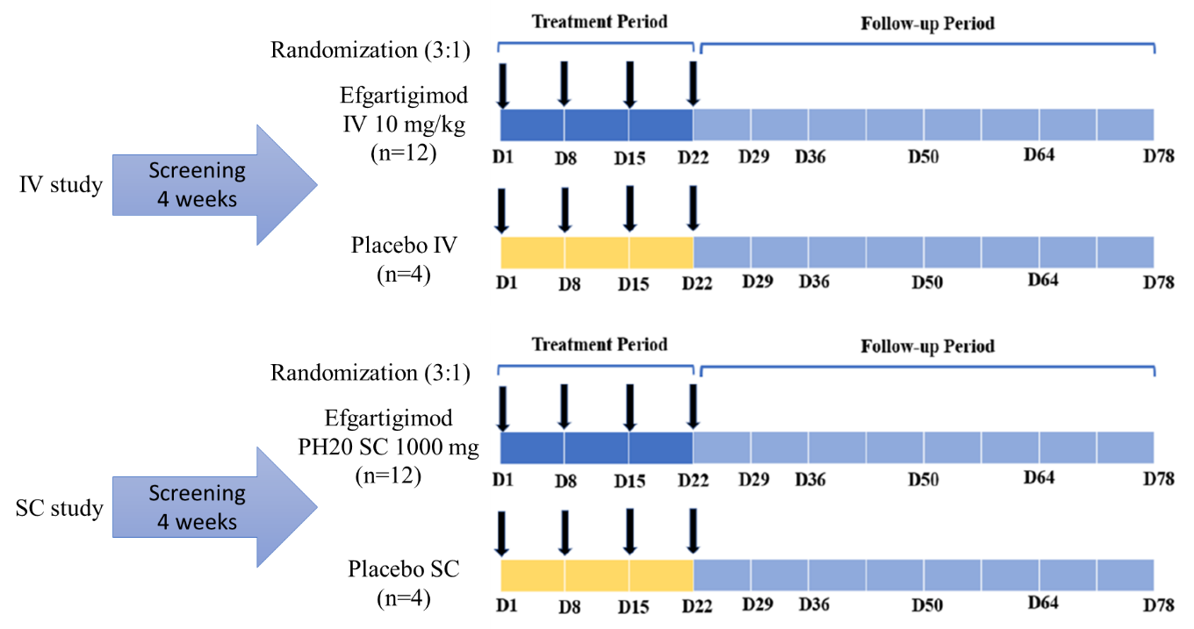

Arrow indicated each time point of study drug administration. D day, IV intravenous, SC subcutaneous

Supplementary Fig. S2 Healthy participant disposition

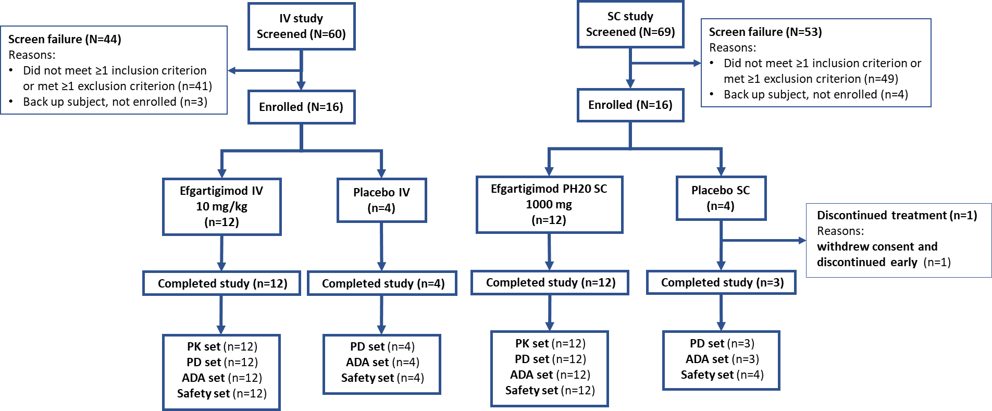

ADA antidrug antibody, IV intravenous, PD pharmacodynamic, PK pharmacokinetic, SC subcutaneous
Supplementary Fig. S3 Mean ± SE percentage change from baseline in serum albumin level after four once-weekly administrations of (a) efgartigimod IV 10 mg/kg and placebo IV, and (b) efgartigimod PH20 SC 1000 mg and placebo PH20 SC (safety set)
a
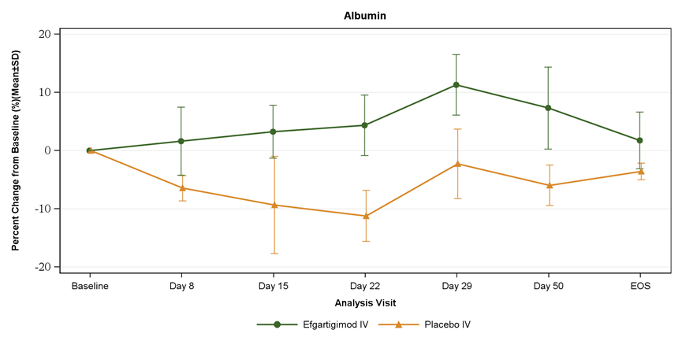
b
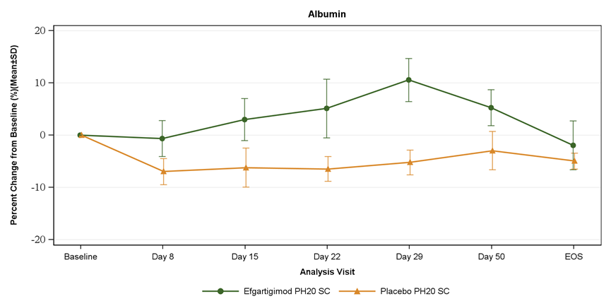
IV intravenous, SC subcutaneous, SE standard error
Supplementary Fig. S4 Mean ± SE percentage change from baseline in total cholesterol level after four once-weekly administrations of (a) efgartigimod IV 10 mg/kg and placebo IV, and (b) efgartigimod PH20 SC 1000 mg and placebo PH20 SC (safety set)
a
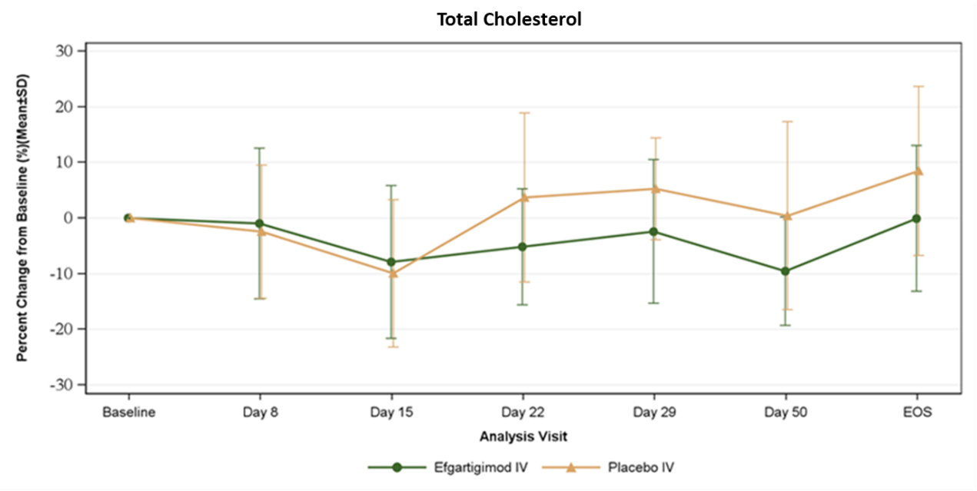
b
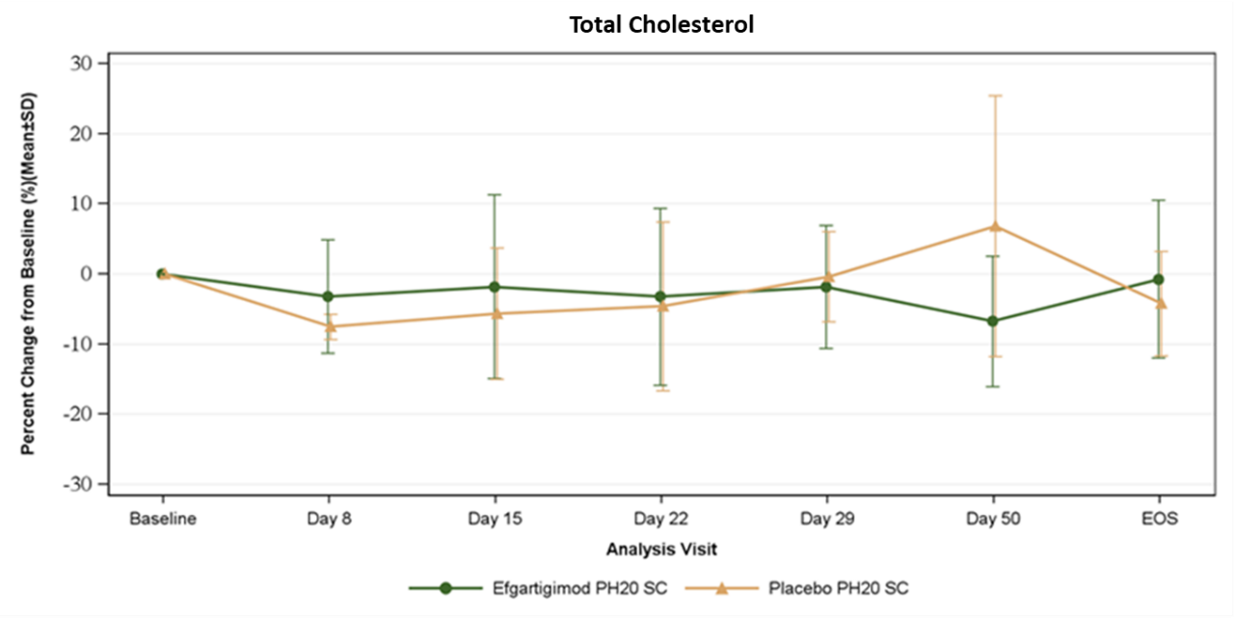
IV intravenous, SC subcutaneous, SE standard error

Supplementary Fig. S5 Mean ± SE percentage change from baseline in LDL cholesterol level after four once-weekly administrations of (a) efgartigimod IV 10 mg/kg and placebo IV, and (b) efgartigimod PH20 SC 1000 mg and placebo PH20 SC (safety set)
a
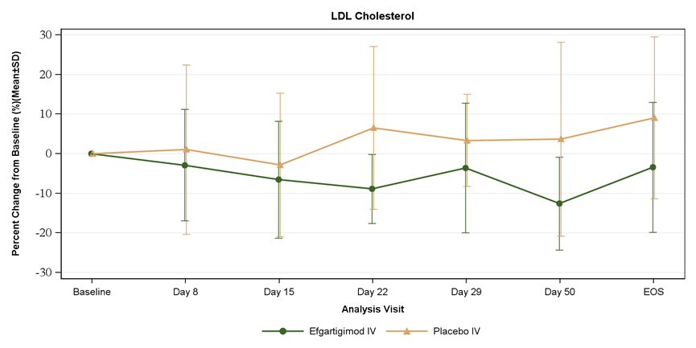
b
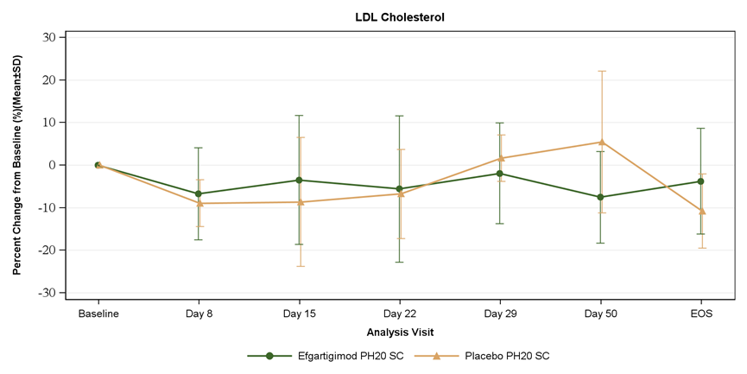
IV intravenous, LDL low-density lipoprotein, SC subcutaneous, SE standard error

