Supplementary Material Overview of the concept elicitation section of the patient interview guide
Section | Questions
Diagnosis and symptoms | Talk me through a typical day living with gout.
Diagnosis and symptoms | Tell me about a good day is like with gout?
Diagnosis and symptoms | Tell me about a bad day is like with gout?
Diagnosis and symptoms | What does a ‘flare up’ mean to you?
Diagnosis and symptoms | How many times have you had a ‘flare’?
Diagnosis and symptoms | Tell me about your worst symptom.
Diagnosis and symptoms | Tell me about the symptoms you experience, if any, most frequently? Least frequently?
Diagnosis and symptoms | Tell me about the symptoms, if any, that bother you the most?
Diagnosis and symptoms | Tell me about what led you to be diagnosed with gout?
Diagnosis and symptoms | What do you dislike the most about having gout?
Diagnosis and symptoms | Tell me about how your symptoms change over time, if at all?
Diagnosis and symptoms | Tell me about anything which triggers or causes a flare or a worsening of your symptoms?
Diagnosis and symptoms | How do you feel between your gout attacks (flare ups)?
Impact | In what ways does having gout impact your daily life, if at all?
Impact | Tell me about how gout makes you feel emotionally?
Impact | Does having gout affect your relationship with any of your family or friends in any way? If yes, please explain.
Impact | Does having gout have any impact on your job or the work that you do each day? If yes, please explain.
Impact | Does your gout impact your sleep at all? If yes, please explain.

Supplementary Material Overview of qualitative real-time collection tasks and administration
Task | Day of administration
Task | 1 | 2 | 3 | 4 | 5 | 6 | 7
1. Introductory task with some general questions about the patient and a broad question asking about the patient’s experience with gout.
2. Ongoing task to allow the patient to capture their experiences related to gout throughout the week.
3. Avoidance task asking about the patient’s behavior in terms of dealing with gout.
4. Flares and tophi task asking about the patient’s experience of flares and tophi, and asking about any factors that trigger flares and tophi.
5. Treatment task asking about the treatment experience of patients.
6. End of week task asking patient’s to discuss their experience of gout that week.

Supplementary Material Overview of relevance for each item in the HAQ-DI (non-tophaceous patients only; n=20)
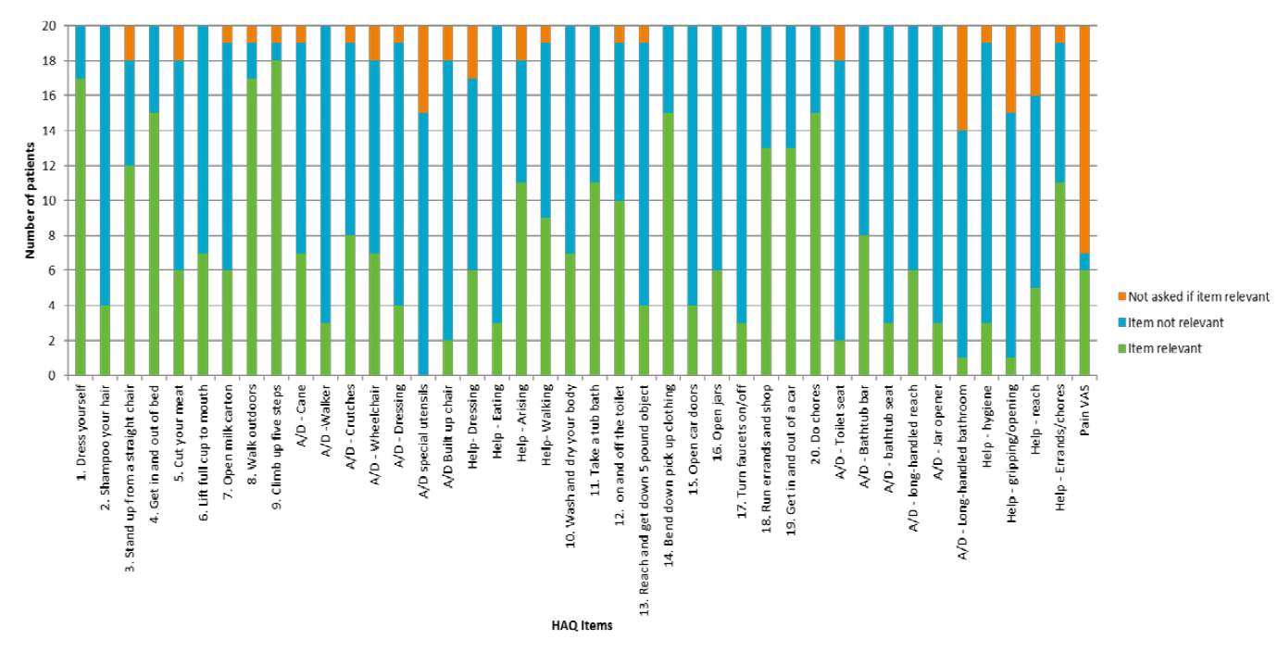
Supplementary Material Overview of relevance for each item in the HAQ-DI (tophaceous patients only; n=10)
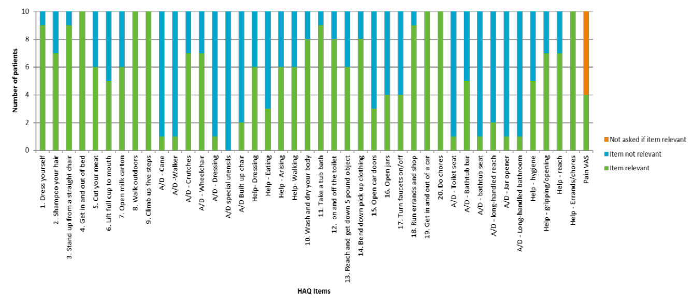
Supplementary Material Overview of relevance for each item in the 'overall concern' GAQ domain (non-tophaceous patients only; n=20)
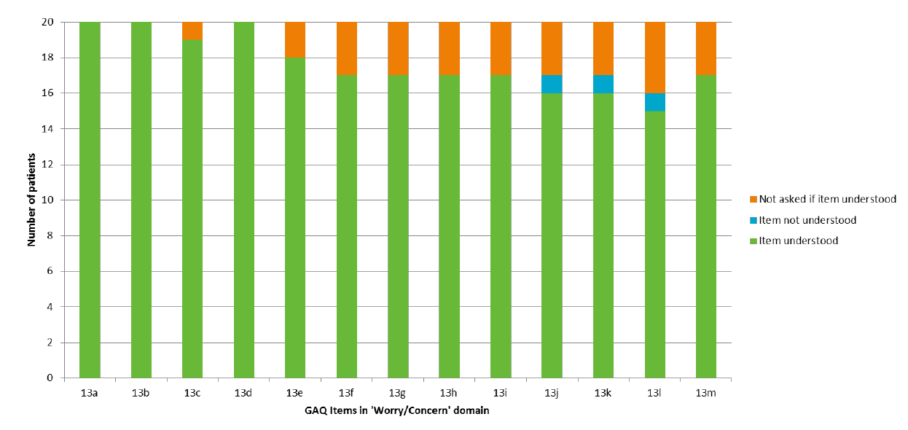
Supplementary Material Overview of relevance for each item in the TIQ-20 (tophaceous patients only; n=10)
