Supplemental material

Supplemental Table Patient descriptions of frequently reported AIP attack symptoms
Symptom | Descriptions | Exemplar quotes | No. (%)
Memory loss | Holes in memory | “When I go into an attack … I have holes in my memory. I maybe remember flashes of a day, but that’s one of the biggest things with porphyria that has always bothered me … I don’t have a lot of memory when I’m in an attack.” (Patient No. 01) | 8 (42)
Constipation | Serious blockage, cannot eat because of constipation, resulting in distension | “My stomach looks three, four months pregnant because of the constipation. It would – you know, I would take stool softeners, but the stool softeners would only, you know, help you go a little bit. You don’t have like a big bowel movement or nothing like that.” (Patient No. 11) | 8 (42)
Weakness | Loss of strength, feeling weighed down | “I was like a skeleton. It was to the point that they were feeding me Jell-O in the hospital because it had a flavor to it. I couldn’t – I was too weak to open up my mouth, to sip through the straw the chicken broth. I was just let the Jell-O dissolve in my mouth and I would just swallow it. Like my dad would put the Jell-O in my mouth – it was just – it’s crazy.” (Patient No. 11) | 8 (42)
Paralysis | Unable to move, loss of strength, loss of feeling, not being able to use hands, unable to walk | “I have permanent paralysis in my thumbs and wrists. Uh, mainly from my extensors, um, from the damage that was done and going so long without a proper diagnosis and proper treatment, so…” (Patient No. 09) | 7 (37)
Numbness | Loss of feeling in body parts, cannot stand or walk for long periods of time, unable to move body parts, feels like bugs crawling over body | “… it makes me feel numb to the point I can’t walk. I wiggle my toes and I can’t feel my toes.” (Patient No. 11)  “… the numbness is really now has become permanent. And it started, um, the top of my – it started on my right side from the, the top and side to my knee. And so my, uh, hematologist sent me to a neurologist who ordered an MRI and a CT after she did a prick test ‘cause I could feel absolutely nothing, no sensation at all, and there’s still no sensation.” (Patient No. 18) | 7 (37)
Tiredness | Need to lie down/rest, lack of energy, inability to complete tasks | “I get so tired. … I got to lay down and rest a little bit and then you know between helping them and trying to keep them on path, trying to keep up on cleaning house and things like that and so it can be a little exhausting. There’s days where I don’t keep caught up as well as I should.” (Patient No. 03) | 7 (37)
Fatigue | Need to sleep/rest, extreme tiredness, loss of stamina, drowsy all day | “Mostly it would be like fatigue and, and backaches. Um, very noticeable in the morning when I first wake up. Um, I’m just really sore. Um, and, you know, just not having the stamina that I used to have. I’m 38 years old and, you know, putting in an eight-hour day is something that’s just not possible for me” (Patient No. 09) | 7 (37)
AIP acute intermittent porphyria, CT computed tomography, MRI magnetic resonance imaging

Supplemental Fig. 1 Heme metabolism pathway with corresponding porphyria. Adapted from Bovenschen HJ, Vissers HPM. Primary hemochromatosis presented by porphyria cutanea tarda: a case report. Cases J. 2009;2:7246
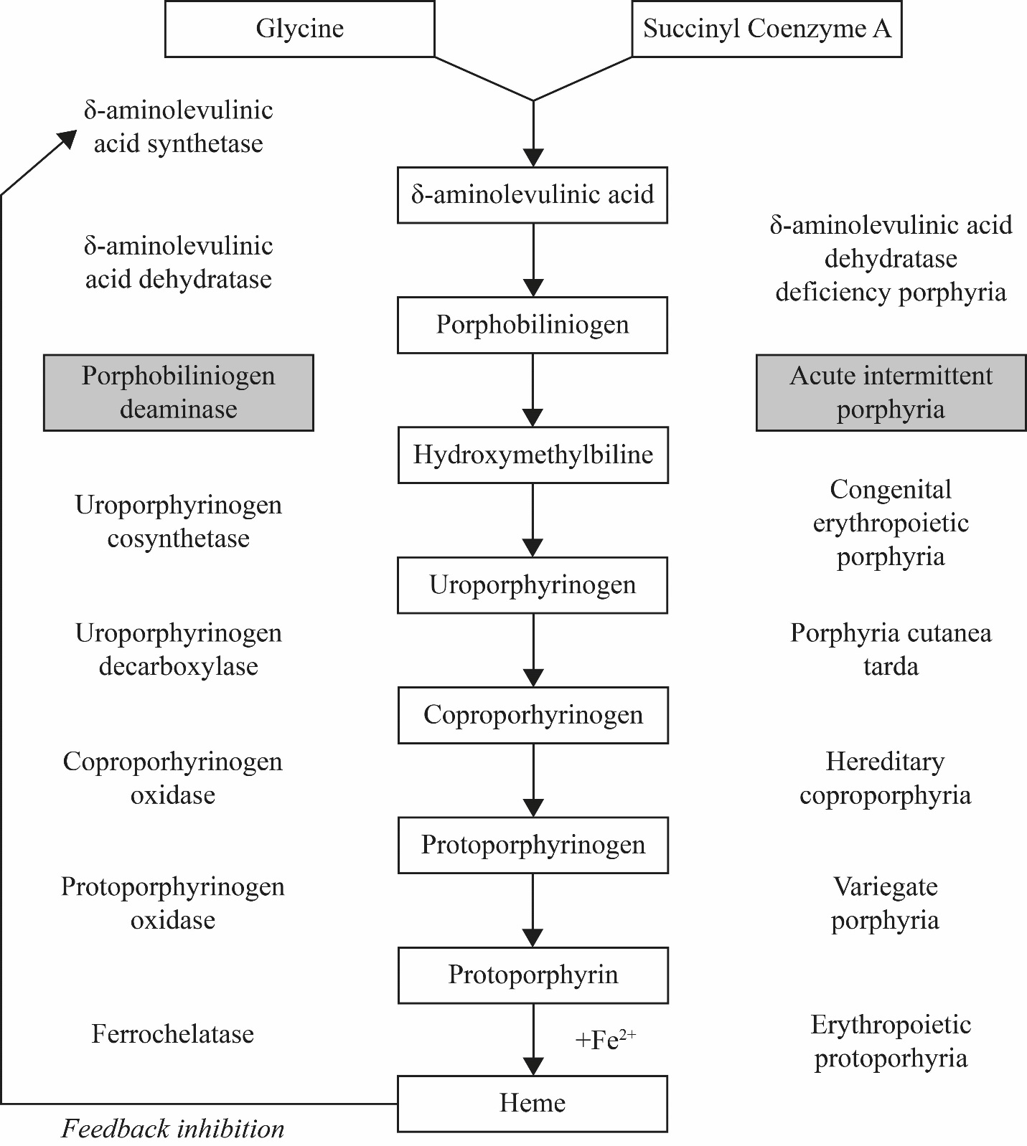

Supplemental Fig. 2 Semi-structured interview guide
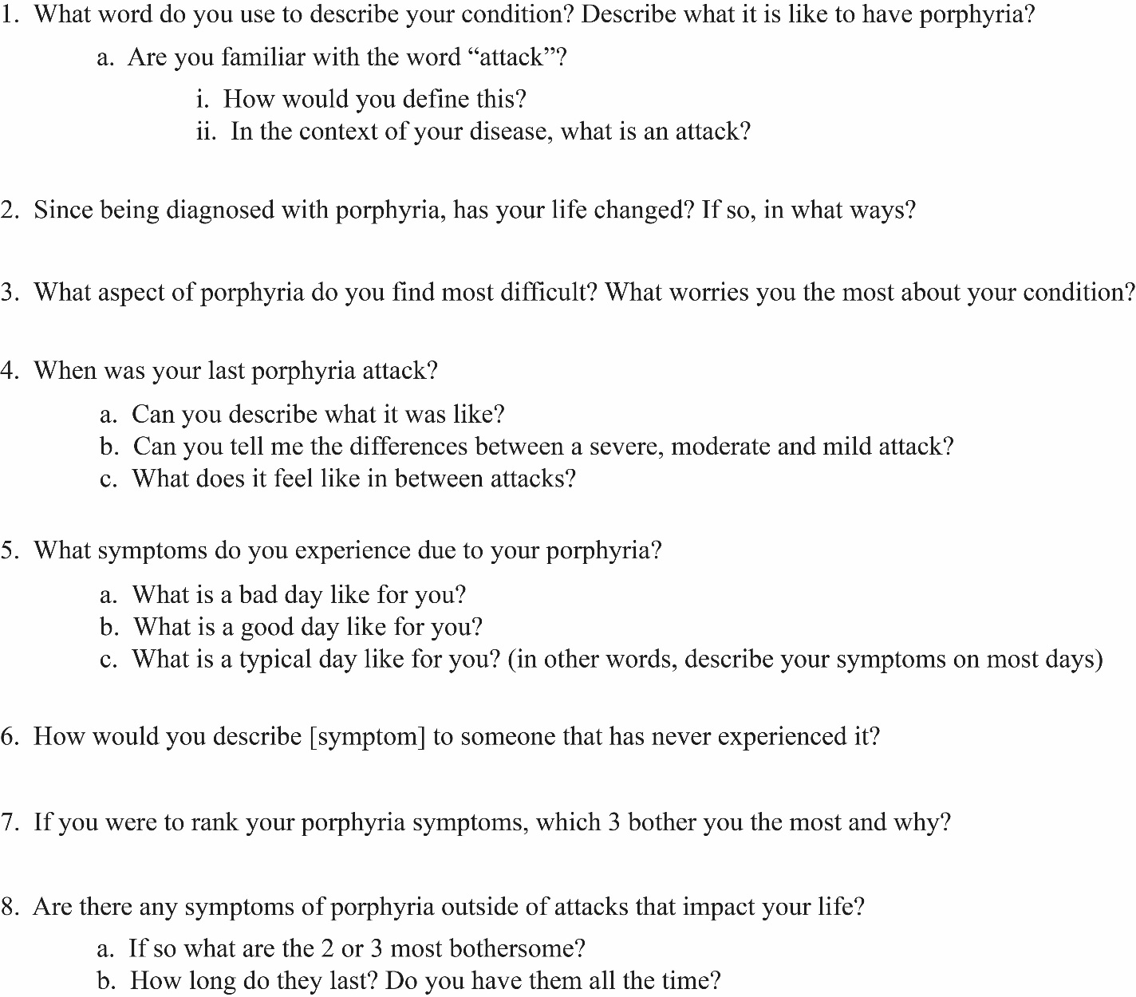

Supplemental Fig. 3 Overview of the study process
