SUPPLEMENTARY MATERIAL

Patient Preferences for Neuromyelitis Optica Spectrum Disorder (NMOSD) Treatments: Results From a Discrete Choice Experiment Study in the United States
Journal: The Patient - Patient-Centered Outcomes Research
Running title: US Patient Preferences for Features of NMOSD Treatments

Justin R. Abbatemarco,¹ Adrian Kielhorn,² Jeffrey C. Yu,² Sami Fam,² Kelley Myers,³ Christine J. Poulos,³ Devon S. Conway¹

¹Cleveland Clinic, Cleveland, OH; ²Alexion, AstraZeneca Rare Disease, Boston, MA; ³RTI Health Solutions, Research Triangle Park, NC

*Correspondence to: Justin R. Abbatemarco, MD; Mellen Center, Cleveland Clinic, 9500 Euclid Ave., Cleveland, OH 44195; abbatej2@ccf.org

Online Resource 1 Quality control measures and DCE survey completion criteria
The survey included questions to assess and reinforce respondent comprehension of the attribute descriptions, comprehension of the risk grids used to present attribute levels, and comprehension of the choice questions. If responses to these items indicated that the respondent did not comprehend the information, graphics, or questions, the survey provided feedback to the respondent and repeated the information that the respondent may not have understood.
The survey was considered complete only if a respondent did not complete the survey too quickly (in 6 minutes or less), answered at least 2 treatment-choice questions in the DCE, and had variation in their responses to the choice-experiment questions (i.e., did not “flat line” or select Treatment A or Treatment B on all choice questions). Respondents who chose not to answer certain demographic or treatment history questions were noted in the summary statistics, but their responses to DCE questions were included in the DCE analysis.

Online Resource 2 Description of random-parameters logit approach
Random-parameters logit (RPL) is similar to the conditional-logit model, except that the estimated vector of parameters, β, is modified to include a respondent-specific stochastic component, η, as follows:
$U_{jt}^{i}=V_{jt}^{i}+ε_{jt}^{i}=\sum_{k=1}^{K}{\left[\left(β_{k}+η_{k}^{i}\right)x_{kjt}\right]}+ε_{jt}^{i}$,
Where U ^{i}_{jt},j = 1,…,J is the individual (i) respondent’s conjoint utility for each of J alternative treatment profiles in each sequence of T questions; and where t = 1,2,…,T, and T is the total number of choice questions the respondent answers. V ^{i}_{jt} is the determinate part of the utility of alternative j; β _{k} is estimated by the RPL and is the relative preference weight for the level in x_{kjt} of attribute k, k = 1,…, K shown in alternative j, question t; and ε denotes the random-error term. Assuming ε is a distributed type-1 extreme value, the probability of observing a particular sequence of choices in T choice questions with J alternatives is:
$Prob\left[C_{j1}^{i},…,C_{jT}^{i}\right]=\prod_{t=1}^{T}{\left[\frac{exp\left(\sum_{k=1}^{K}{\left[\left(β_{k}+η_{k}^{i}\right)x_{kjt}\right]}\right)}{\sum_{j=1}^{J}{exp\left(\sum_{k=1}^{K}{\left[\left(β_{k}+η_{k}^{i}\right)x_{kjt}\right]}\right)}}\right]}$.
For any pair of treatment profiles with attribute levels indexed by vectors A and B, the mean choice probability is logit:
$Prob\left(C_{j}\right)=\frac{1}{1+exp\left(\sum_{k=1}^{K}{β_{k}x_{kB}}-\sum_{k=1}^{K}{β_{k}x_{kA}}\right)}$ or $Prob\left(C_{j}\right)=\frac{exp\left(\sum_{k=1}^{K}{β_{k}x_{kA}}\right)}{exp\left(\sum_{k=1}^{K}{β_{k}x_{kA}}\right)+exp\left(\sum_{k=1}^{K}{β_{k}x_{kB}}\right)}$,
and the mean odds ratio (OR) for any two treatment profiles is $exp\left(\sum_{k=1}^{K}{β_{k}x_{kA}-\sum_{k=1}^{K}{β_{k}x_{kB}}}\right)$.
Effects-coded independent variables will be used for each attribute level (e.g., for a 3-level attribute: 0 1, 1 0, −1 −1, such that the parameter for the omitted category is the negative sum of the included categories) instead of continuous variables or dummy-coded variables (e.g., 0 1, 1 0, 0 0), so that the mean effect for each attribute is normalized to be zero, rather than having a zero value corresponding to a zero level in continuous variables or setting all omitted categories to zero in dummy-coded variables. Thus, the OR for any treatment profile with attribute levels denoted A, relative to a treatment profile with all attributes set to the mean effect is $exp\left(\sum_{k=1}^{K}{\sum_{l=1}^{L}{β_{kl}}I_{klA}}\right)$, where I_{klA} is the effects-coded variable indicating that level l (l = 1,…, L levels) for attribute k is present or absent from treatment profile A. The average marginal OR for the difference between a given attribute k level l, and the mean effect of an attribute is $exp\left(β_{kl}\right)$. Finally, the log odds for a given attribute k is β_{kl} and is referred to as the preference weight. To examine whether preferences for any treatment attributes vary across subgroups, interactions between effects-coded independent variables and respondent characteristics will be included.
The table below summarizes the variables in the RPL model, which include an effects-coded variable for each attribute level. With effects coding, zero indicates the mean effect across all attribute levels rather than the omitted level, as in dummy coding (Hensher DA, et al. Applied Choice Analysis. 2nd ed: Cambridge University Press; 2015). This procedure produces parameter estimates for all levels of an attribute, where the parameter on the omitted level is the negative sum of the parameters on the included levels. The resulting log-odds parameter estimates from the RPL model can be interpreted as preference weights that indicate the relative strength of preferences for each attribute level. The Delta method was used to calculate standard errors for the preference weight for each omitted attribute level (Hensher DA, et al. Applied Choice Analysis. 2nd ed: Cambridge University Press; 2015). The estimated preference weights were used to calculate OR.
Model variables for estimating preference weights
Attributes | Levels | Coefficients
Chance of relapse in the first year of treatment | RLP1 | Effects-coded variables for chance of relapse. RLP1 = 1 if 0%, RLP2 = 1 if 15%, RLP3 = 1 if 25%, RLP4 = 1 if 50%. RLP4 was omitted for model identification.
Chance of relapse in the first year of treatment | RLP2
Chance of relapse in the first year of treatment | RLP3
Chance of relapse in the first year of treatment | RLP4
Pretreatment requirements | PRE1 | Effects-coded variables for pretreatment requirements. PRE1 = 1 if no routine bloodwork, PRE2 = 1 if routine bloodwork. PRE2 was omitted for model identification.
Pretreatment requirements | PRE2
Treatment maintenance requirements | MNT1 | Effects-coded variables for treatment maintenance requirements. MNT1 = 1 if no activities required, MNT2 = 1 if medication before each treatment, MNT3 = 1 if routine bloodwork, MNT4 = 1 if both routine bloodwork and medication before each treatment. MNT4 was omitted for model identification.
Treatment maintenance requirements | MNT2
Treatment maintenance requirements | MNT3
Treatment maintenance requirements | MNT4
Mode of administration | MOA1 | Effects-coded variables for mode of administration. MOA1 = 1 if self-administered injection with a prefilled syringe or pen, MOA2 = 1 if intravenous infusion administered by a healthcare professional. MOA2 was omitted for model identification.
Mode of administration | MOA2
Frequency of administration | FRQ1 | Effects-coded variables for frequency of administration. FRQ1 = 1 if once every 24 weeks (once every 6 months), FRQ2 = 1 if once every 8 weeks (once every 2 months), FRQ3 = 1 if once every 4 weeks (once per month), FRQ4 = 1 if once every 2 weeks (2 times per month). FRQ4 was omitted for model identification.
Frequency of administration | FRQ2
Frequency of administration | FRQ3
Frequency of administration | FRQ4
Risk of meningococcal infection | MEN1 | Effects-coded variables for risk of meningococcal infection. MEN1 = 1 if no, MEN2 = 1 if yes. MEN2 was omitted for model identification.
Risk of meningococcal infection | MEN2
Risk of elevated liver enzymes | LIV1 | Effects-coded variables for risk of elevated liver enzymes. LIV1 = 1 if no, LIV2 = 1 if yes. LIV2 was omitted for model identification.
Risk of elevated liver enzymes | LIV2
Risk of serious opportunistic infection or recurrent infection | INF1 | Effects-coded variables for risk of serious opportunistic infection or recurrent infection. INF1 = 1 if no, INF2 = 1 if yes. INF2 was omitted for model identification.
 | INF2
FRQ frequency of administration, INF risk of serious opportunistic infection or recurrent infection, LIV risk of elevated liver enzymes, MEN risk of meningococcal infection, MNT treatment maintenance requirements, MOA mode of administration, PRE pretreatment requirements, RLP chance of relapse in the first year of treatment
Based on the specification assumed for each attribute, Model 1 was estimated following the specification shown in below, where V is the systematic indirect utility for a profile (specified as a function of the attributes, as in the equation above) and β is a parameter estimate for each attribute level. A Wald χ2 test was used to determine the statistical significance of differences between adjacent attribute levels for each attribute. A P value ≤ 0.05 was considered statistically significant. The mean parameter estimates are reported along with 95% confidence intervals (CIs).
Preference Model Specification
Model description | Model specification
Model 1: Main-effects model | V = β_{RLP1} × RLP1 + β_{RLP2} × RLP2 + β_{RLP3} × RLP3 +  β_{PRE1} × PRE1 +  β_{MNT1} × MNT1 + β_{MNT2} × MNT2 + β_{MNT3} × MNT3 +  β_{MOA1} × MOA1 +  β_{FRQ1} × FRQ1 + β_{FRQ2} × FRQ2 + β_{FRQ3} × FRQ3 +  β_{MEN1} × MEN1 +  β_{LIV1} × LIV1 +  β_{INF1} × INF1
Model 2: Main-effects model with subgroup interaction terms, where SUB is any dummy variable used to identify a subgroup (exploratory analysis) | V = β_{RLP1} × RLP1 + β_{RLP2} × RLP2 + β_{RLP3} × RLP3 +  β_{PRE1} × PRE1 +  β_{MNT1} × MNT1 + β_{MNT2} × MNT2 + β_{MNT3} × MNT3 +  β_{MOA1} × MOA1 +  β_{FRQ1} × FRQ1 + β_{FRQ2} × FRQ2 + β_{FRQ3} × FRQ3 +  β_{MEN1} × MEN1 +  β_{LIV1} × LIV1 +  β_{INF1} × INF1 +  SUB × β_{RLP1} × RLP1 + SUB × β_{RLP2} × RLP2 + SUB × β_{RLP3} × RLP3 +  SUB × β_{PRE1} × PRE1 +  SUB × β_{MNT1} × MNT1 + SUB × β_{MNT2} × MNT2 + SUB × β_{MNT3} × MNT3 +  SUB × β_{MOA1} × MOA1 +  SUB × β_{FRQ1} × FRQ1 + SUB × β_{FRQ2} × FRQ2 + SUB × β_{FRQ3} × FRQ3 +  SUB × β_{MEN1} × MEN1 +  SUB × β_{LIV1} × LIV1 +  SUB × β_{INF1} × INF1
FRQ frequency of administration, INF risk of serious opportunistic infection or recurrent infection, LIV risk of elevated liver enzymes, MEN risk of meningococcal infection, MNT treatment maintenance requirements, MOA mode of administration, PRE pretreatment requirements, RLP chance of relapse in the first year of treatment, SUB subgroup variable, β coefficient

Online Resource 3 Survey recruitment
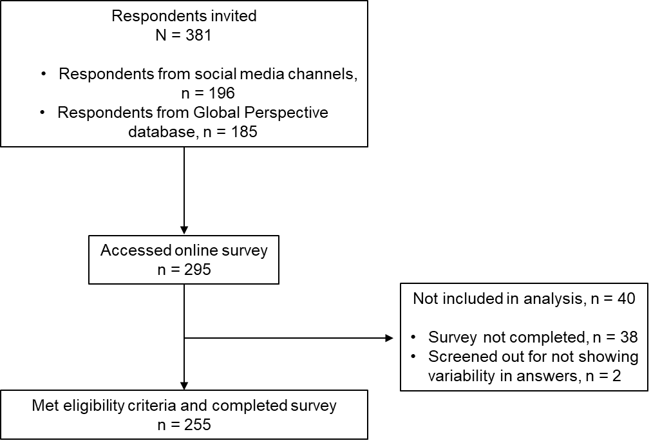

Online Resource 4 Expanded respondent information
Self-reported characteristic, n (%) | Respondents with AQP4-Ab+ NMOSD  (N = 255)
Marital status
Married, living as married, or civil partnership | 152 (59.6)
Single or never married | 79 (31.0)
Divorced or separated | 17 (6.7)
Widowed or surviving partner | 4 (1.6)
Prefer not to say | 3 (1.2)
Racial category | Standard US census-based | Method allowing assigning percentages to racial categoriesª
American Indian or Alaskan Native | 3 (1.2) | 6 (2.3)
Asian | 13 (5.1) | 14 (5.7)
Black or African American | 119 (46.7) | 115 (44.9)
Native Hawaiian or other Pacific Islander | 7 (2.7) | 8 (3.1)
White | 104 (40.8) | 105 (41.1)
Prefer not to answer | 1 (0.4) | NA
Other | NA | 7 (2.8)
Unknown | NA | 0
Chose more than one category | 8 (3.1) | NA
Skin tone
1 (lightest) | 21 (8.2)
2 | 27 (10.6)
3 | 43 (16.9)
4 | 26 (10.2)
5 | 25 (9.8)
6 | 36 (14.1)
7 | 25 (9.8)
8 | 27 (10.6)
9 | 11 (4.3)
10 (darkest) | 14 (5.5)
Education level
High school or equivalent | 27 (10.6)
Some college but no degree | 30 (11.8)
Technical school | 16 (6.3)
Associate’s degree (2-year college degree) | 30 (11.8)
4-year college degree | 102 (40.0)
Some graduate school but no degree | 3 (1.2)
Graduate or professional degree | 42 (16.5)
Prefer not to say | 5 (2.0)
Comorbidities^{b}
Asthma or allergies | 56 (22.0)
Depression | 50 (19.6)
High cholesterol | 45 (17.6)
High blood pressure | 42 (16.5)
Migraines | 37 (14.5)
Stomach or digestive problems | 36 (14.1)
Arthritis | 33 (12.9)
Diabetes | 28 (11.0)
Thyroid problems (low or high thyroid levels) | 28 (11.0)
Atopic dermatitis (eczema) | 21 (8.2)
Multiple sclerosis | 14 (5.5)
Osteoporosis | 13 (5.1)
Psoriasis | 13 (5.1)
Systemic lupus erythematosus (SLE) | 10 (3.9)
Swelling or edema | 8 (3.1)
Heart disease | 6 (2.4)
Kidney disease | 6 (2.4)
Rheumatoid arthritis | 5 (2.0)
Seizures | 5 (2.0)
Emphysema | 3 (1.2)
Epilepsy | 1 (0.4)
Stroke | 1 (0.4)
None of the above | 95 (37.3)
Access to healthcare
Has had difficulty accessing NMOSD treatment-related healthcare | 27 (10.6)
Has ever required financial assistance to cover out-of-pocket NMOSD treatment-related expenses | 86 (33.7)
AQP4-Ab+ anti-aquaporin-4 water channel protein antibody-positive, NA not applicable, NMOSD neuromyelitis optica spectrum disorder
ªRespondents could assign percentages to multiple racial categories, totaling 100%. The percentage for each category was weighted
^{b}Respondents were permitted to select more than one answer, so categories are not mutually exclusive

Online Resource 5 Random-parameters logit model output: full sample (N = 255)
Attributes | Levels | Coefficient estimate | Standard error | P value | 95% Confidence intervals
Mean preference-weight estimates
Chance of relapse in the first year of treatment | 0 out of 100 people (0%) | 2.1* | 0.3 | < 0.001 | 1.5-2.7
Chance of relapse in the first year of treatment | 15 out of 100 people (15%) | 0.9* | 0.2 | < 0.001 | 0.6-1.2
Chance of relapse in the first year of treatment | 25 out of 100 people (25%) | −0.1* | 0.1 | 0.164 | −0.3 to 0.1
Chance of relapse in the first year of treatment | 50 out of 100 people (50%) | −2.9* | 0.4 | < 0.001 | −3.7 to −2.1
Pretreatment requirements | No routine bloodwork | 0.0 | 0.0 | 0.985 | −0.1 to 0.1
Pretreatment requirements | Routine bloodwork | 0.0 | 0.0 | 0.985 | −0.1 to 0.1
Treatment maintenance requirements | No activities required | −0.1* | 0.1 | 0.343 | −0.3 to 0.1
Treatment maintenance requirements | Medication before each treatment | 0.1 | 0.1 | 0.624 | −0.2 to 0.3
Treatment maintenance requirements | Routine bloodwork | 0.0 | 0.1 | 0.724 | −0.2 to 0.3
Treatment maintenance requirements | Both routine bloodwork and medication before each treatment | 0.0 | 0.1 | 0.937 | −0.2 to 0.2
Mode of administration | Self-administered injection with a prefilled syringe or pen | 0.1* | 0.1 | 0.039 | 0-0.3
Mode of administration | Intravenous infusion administered by a healthcare professional | −0.1* | 0.1 | 0.039 | −0.3 to 0
Frequency of administration | Once every 24 weeks (once every 6 months) | 0.1 | 0.1 | 0.318 | −0.1 to 0.3
Frequency of administration | Once every 8 weeks (once every 2 months) | 0.4* | 0.1 | 0.002 | 0.1-0.6
Frequency of administration | Once every 4 weeks (once per month) | −0.1 | 0.1 | 0.415 | −0.3 to 0.1
Frequency of administration | Once every 2 weeks (2 times per month) | −0.4* | 0.1 | 0.002 | −0.6 to −0.1
Risk of meningococcal infection | No | 0.3* | 0.1 | < 0.001 | 0.2-0.5
Risk of meningococcal infection | Yes | −0.3* | 0.1 | < 0.001 | −0.5 to −0.2
Risk of elevated liver enzymes | No | 0.3* | 0.1 | < 0.001 | 0.1-0.4
Risk of elevated liver enzymes | Yes | −0.3* | 0.1 | < 0.001 | −0.4 to −0.1
Risk of serious opportunistic infection or recurrent infection | No | 0.3* | 0.1 | < 0.001 | 0.2-0.5
 | Yes | −0.3* | 0.1 | < 0.001 | −0.5 to −0.2
Standard deviation estimates
Chance of relapse in the first year of treatment | 0 out of 100 people (0%) | 2.1* | 0.3 | < 0.001 | 1.5-2.8
Chance of relapse in the first year of treatment | 15 out of 100 people (15%) | −0.8* | 0.2 | < 0.001 | −1.2 to −0.4
Chance of relapse in the first year of treatment | 25 out of 100 people (25%) | −0.1 | 0.5 | 0.908 | −1.0 to 0.9
Chance of relapse in the first year of treatment | 50 out of 100 people (50%) | Reference
Pretreatment requirements | No routine bloodwork | 0.1 | 0.1 | 0.396 | −0.2 to 0.4
Pretreatment requirements | Routine bloodwork | Reference
Treatment maintenance requirements | No activities required | −0.1 | 0.3 | 0.765 | −0.6 to 0.4
Treatment maintenance requirements | Medication before each treatment | −0.1 | 0.3 | 0.716 | −0.7 to 0.5
Treatment maintenance requirements | Routine bloodwork | 0.3 | 0.3 | 0.204 | −0.2 to 0.9
Treatment maintenance requirements | Both routine bloodwork and medication before each treatment | Reference
Mode of administration | Self-administered injection with a prefilled syringe or pen | 0.6* | 0.1 | < 0.001 | 0.4-0.8
Mode of administration | Intravenous infusion administered by a healthcare professional | Reference
Frequency of administration | Once every 24 weeks (once every 6 months) | −0.5 | 0.2 | 0.057 | −1.0 to 0.0
Frequency of administration | Once every 8 weeks (once every 2 months) | −0.1 | 0.4 | 0.883 | −0.7 to 0.6
Frequency of administration | Once every 4 weeks (once per month) | −0.3 | 0.2 | 0.154 | −0.8 to 0.1
Frequency of administration | Once every 2 weeks (2 times per month) | Reference
Risk of meningococcal infection | No | 0.4* | 0.1 | < 0.001 | 0.2-0.7
Risk of meningococcal infection | Yes | Reference
Risk of elevated liver enzymes | No | 0.4* | 0.1 | 0.001 | 0.2-0.6
Risk of elevated liver enzymes | Yes | Reference
Risk of serious opportunistic infection or recurrent infection | No | 0.5* | 0.1 | < 0.001 | 0.3-0.7
 | Yes | Reference
Goodness of fit measures
AIC | 1986.99
BIC | 2144.37
Pseudo R² | 0.113
Adjusted Pseudo R² | 0.088
AIC Akaike information criterion, BIC Bayesian information criterion
*Significant at the 95% confidence level.

Online Resource 6 Descriptions of the subgroups analyzed and Wald test results (N = 255)
Subgroup pair | Characteristic | Sample size,  n (%) | p value
Age | 40 years or older | 128 (50.2) | 0.167
Age | Younger than 40 years | 127 (49.8) | 0.167
Current treatment | Currently taking an oral IST or oral corticosteroid alone | 67 (26.3) | 0.066
Current treatment | Currently taking an IV or SC injection alone or with an oral treatment | 188 (73.7) | 0.066
Duration of disease | Diagnosed ≥ 5 years ago | 134 (52.5) | 0.827
Duration of disease | Diagnosed < 5 years ago | 121 (47.5) | 0.827
Disease impactª | “Very affected” or “Significantly affected” by mobility/walking or bladder/bowel control or vision | 116 (45.8) | 0.660
Disease impactª | “Somewhat affected,” “Affected,” or “Not affected at all” by mobility/walking, bladder/bowel control, and vision | 137 (54.2) | 0.660
Number of relapses in the past 12 months^{b} | ≥ 2 relapses | 139 (55.8) | 0.261
Number of relapses in the past 12 months^{b} | < 2 relapses | 110 (44.2) | 0.261
IST immunosuppressant therapy, IV intravenous, SC subcutaneous
ªMissing data for two respondents; N = 253
^{b}Missing data for six respondents; N = 249

Online Resource 7 Minimum acceptable reduction in chance of relapseª required to accept changes in other treatment attributes for current treatment subgroups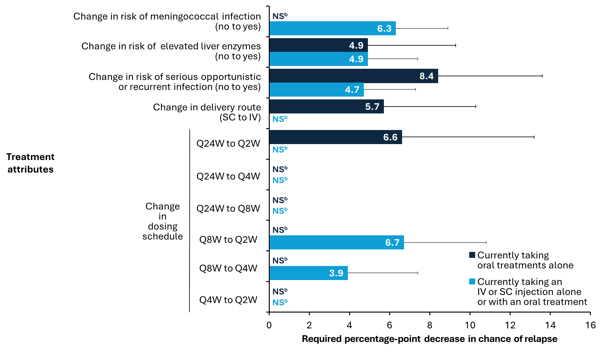
CI confidence interval, IV intravenous, NS not significant, Q2W every 2 weeks, Q4W every 4 weeks, Q8W every 8 weeks, Q24W every 24 weeks, SC subcutaneous
Data are expressed as mean ± 95% CI
ªMinimum acceptable benefit assessed the mean increase in efficacy required by respondents to accept negative changes in other treatment attributes. In this analysis, increased efficacy was defined as a reduction in the chance of relapse in the first year of the new treatment
^{b}Differences between levels were not statistically significant for the indicated comparison and subgroup. Therefore, the minimum acceptable benefit was not reported as the change from one level to the other and does not have a statistically meaningful impact on the average respondent’s preference

Online Resource 8 Predicted probabilities for choosing a ravulizumab-like profile for subgroup analysis of (a) patients currently taking oral treatments alone and (b) patients currently taking an IV or SC injection alone or with an oral treatment
a
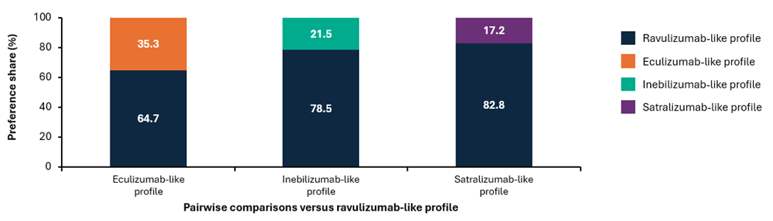
b
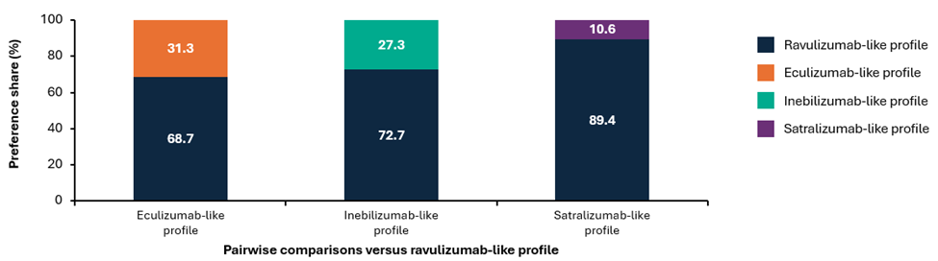
IV intravenous, SC subcutaneous

