Incorporating the Patient Voice into Attribute and Level Selection for a Preference Study: A Qualitative Study in Non-Muscle Invasive Bladder Cancer
The Patient

Brad Mason¹, Anthony Eccleston², Lara Ayala-Nunes¹, Brett Hauber³, Adam Gater¹, Joshua Coulter³, Pam Hallworth⁴, Allison Thompson³, Bethany Bell⁴, Jane Chang³, Julia Brinkmann⁵, Joseph C. Cappelleri⁶, Stephanie Chisolm⁷ and Raj Satkunasivam⁸

¹Adelphi Values Patient-Centered Outcomes, Bollington, UK
²Pfizer Inc, Surrey, UK
³Pfizer Inc, New York, NY, USA
⁴Adelphi Research, Bollington, UK
⁵Pfizer Pharma GmbH, Friedrichstrasse 110, 10117 Berlin, Germany
⁶Pfizer Inc, Groton, CT, USA
⁷Bladder Cancer Advocacy Network (BCAN), Bethesda, MD
⁸Department of Urology, Houston Methodist Hospital, Texas, USA

Corresponding author: Brad Mason, Adelphi Values Patient Centered Outcomes, Bollington, Cheshire, United Kingdom. Email: brad.mason@adelphivalues.com

Electronic Supplementary Material A: Evidence review
An evidence review, including a targeted literature review, was conducted to identify information from the patient perspective on the importance of attributes for currently marketed or investigational PD-(L)1 inhibitor therapies. This review involved several searches:
- Bibliographic database search (via Ovid®): PubMed (Medline), EMBASE, APA PsycINFO.
- Google Scholar: Supplementary key-word search
- Clinical resources and guidelines
Methods: Bibliographic database search
The search string below was used to conduct the literature search on 27 October 2021.
Search string | Area of interest | Search terms | Number of abstracts
1 | Disease-specific terms | ("non muscle invasive bladder cancer" or "non-muscle invasive bladder cancer" or "nonmuscle invasive bladder cancer" or "non-muscle-invasive bladder cancer" or NMIBC).mp. | 10,122
2 | Disease-specific terms | exp Non muscle invasive bladder cancer/ | 4,772
3 | Preference methodology terms | (prefer* or decision* or satisf* or elicit* or choice* or discrete choice* or DCE).mp. | 5,234,811
4 | Preference methodology terms | exp Patient Preference/ or exp Patient Satisfaction/ | 272,142
5 | Social media listening methodology terms | (social media or social media listening).mp. | 76,368
6 | Social media listening methodology terms | exp Social Media/ | 59,731
7 | Qualitative methodology terms | (qualitative or hermeneutic* or interview* or delphi or (focus adj1 group*) or phenomenolog* or ethnograph* or (grounded adj1 theor*) or (themat* adj2 analy*)).mp. | 2,145,609
8 | Qualitative methodology terms | exp qualitative research/ or qualitative analysis/ or interviews/ or interview/ or interviewers/ or interviewing/ or focus groups/ or phenomenology/ or ethnography/ or grounded theory/ or thematic analysis/ | 793,850
9 | HR-NMIBC clinical trial terms | (CREST or PF-06801591 or NCT04165317 or sasanlimab or ALBAN or atezolizumab or MPDL3280A or Tecentriq or NCT03799835 or KEYNOTE-676 or KEYNOTE-057 or pembrolizumab or MK-3475-676 or KEYTRUDA or MK-3475 or NCT03711032 or POTOMAC or NCT03528694 or Durvalumab or MEDI4736).mp. | 106,436
10 | 1 or 2 |  | 10,122
11 | 3 or 4 or 5 or 6 or 7 or 8 |  | 7,175,239
12 | 10 and 11 |  | 1,154
13 | 9 and 10 |  | 278
14 | 12 or 13 |  | 1,393
15 | Remove duplicates from 14 |  | 1,029
16 | Limit 15 to abstracts |  | 975
17 | Limit 16 to English language |  | 939
18 | Limit 17 to yr="2010 -Current" |  | 904
19 | Limit 18 to human |  | 853
Total number of abstracts |  |  | 853
Multi-purpose (MP): ti, ab, hw, tc, id, ot, tm, mh, tn, dm, mf, dv, kf, fx, dq, nm, ox, px, rx, ui, sy

The titles and abstracts of the articles generated by the searches were reviewed to identify relevant publications for full review. To be selected for review, articles had to contain keywords in the title and/or abstract.
Criteria | Description of criteria
Include | Publication type: Journal article (dissertations, books or chapters), conference abstracts and excerpts  Relevant clinical term in the title and/or abstract (e.g., ‘non-muscle invasive bladder cancer’ or ‘NMIBC’)  AND EITHER:  Relevant treatment term (e.g., BCG)  OR  Relevant trial term included in the title and/or abstract:  CREST trial: PF-06801591, NCT04165317, sasanlimab  ALBAN trial: MPDL3280A, Tecentriq, NCT03799835, atezolizumab  KEYNOTE-676 trial: MK-3475-676, KEYTRUDA, MK-3475, NCT03711032, pembrolizumab  POTOMAC trial: NCT03528694, MEDI4736, durvalumab.
Exclude | Abstract does not include a relevant clinical term for NMIBC in the title and/or abstract.  Abstract only includes mention of low-risk and/or intermediate-risk NMIBC.  Abstract only includes mention of muscle-invasive bladder cancer (MIBC).  Abstract does not discuss any specific attributes for the treatments/trials of interest.

Methods: Google Scholar search
A supplementary search was conducted in Google Scholar. The ‘Sort by relevance’ function was applied to the search results and limited to the past 10 years. Results from the first 10 pages of each search string were reviewed.
The following combinations were used:
- ("CREST" OR "PF-06801591" OR "NCT04165317" OR "sasanlimab" OR "ALBAN" OR "atezolizumab" OR "MPDL3280A" OR "Tecentriq" OR "NCT03799835" OR "KEYNOTE-676" OR "KEYNOTE-057" OR "pembrolizumab" OR "MK-3475-676" OR "KEYTRUDA") AND (“NMIBC” OR “non muscle invasive bladder cancer”)
- ("CREST" OR "PF-06801591" OR "NCT04165317" OR "sasanlimab" OR "ALBAN" OR "atezolizumab" OR "MPDL3280A" OR "Tecentriq" OR "NCT03799835" OR "KEYNOTE-676" OR "KEYNOTE-057" OR "pembrolizumab" OR "MK-3475-676" OR "KEYTRUDA") AND (“NMIBC” OR “non muscle invasive bladder cancer”) AND (“side effect” OR “tolerance” OR “adverse reaction” OR “adverse event” OR “adverse effect”)
- ("CREST" OR "PF-06801591" OR "NCT04165317" OR "sasanlimab" OR "ALBAN" OR "atezolizumab" OR "MPDL3280A" OR "Tecentriq" OR "NCT03799835" OR "KEYNOTE-676" OR "KEYNOTE-057" OR "pembrolizumab" OR "MK-3475-676" OR "KEYTRUDA") AND (“NMIBC” OR “non muscle invasive bladder cancer”) AND (“efficacy” OR “effective” OR “treatment outcome” OR “therapy outcome”)
- (“NMIBC” OR “non muscle invasive bladder cancer”) AND (“BCG” OR “Bacillus Calmette–Guérin”) AND (“discrete choice” OR “conjoint analysis” OR “patient preference” OR “patient perspective”)
- (“NMIBC” OR “non muscle invasive bladder cancer”) AND (“BCG” OR “Bacillus Calmette–Guérin”) AND (“side effect” OR “tolerance” OR “adverse reaction” OR “adverse event” OR “adverse effect”)
- (“NMIBC” OR “non muscle invasive bladder cancer”) AND (“BCG” OR “Bacillus Calmette–Guérin”) AND (“efficacy” OR “effective” OR “treatment outcome” OR “therapy outcome”)

Methods: Clinical resources search
- Published EAU guidelines¹ – Published EAU guidelines for NMIBC, TaT1 and carcinoma in situ (CIS) were included in the review. These guidelines provide current practical recommendations on the clinical management of NMIBC with a focus on clinical presentation and recommendations.
- ClinicalTrials.gov database – Clinical trial design information of the IO treatments under investigation in high-risk NMIBC were included in the review. These include the CREST trial (sasanlimab)², ALBAN trial (atezolizumab)³, KEYNOTE-676 trial (pembrolizumab)⁴ and POTOMAC trial (durvalumab).⁵
- BCG TICE® United States Prescribing Information (USPI)⁶ – The published prescribing information for use of BCG for the treatment and prophylaxis of carcinoma in situ (CIS) of the urinary bladder and for the prophylaxis of primary or recurrent state Ta and/or T1 papillary tumors following TURBT was included in the review.
- Drugs@FDA Database – FDA-approved prescribing information for ICI therapies of interest (pembrolizumab, atezolizumab, durvalumab) in metastatic urothelial carcinoma were included in this review. The product labels were reviewed to identify expected AE profiles and dosing/administration, given these therapies are not yet approved in high-risk NMIBC.
Although this was not a systematic review, best practice principles were applied to all data extraction, ensuring that that all variables for which data were sought were clearly extracted and detailed.^{22,23,7,8}

Results:
Figure 1 provides a PRISMA diagram detailing the screening process and summarizing the records identified from the targeted search.
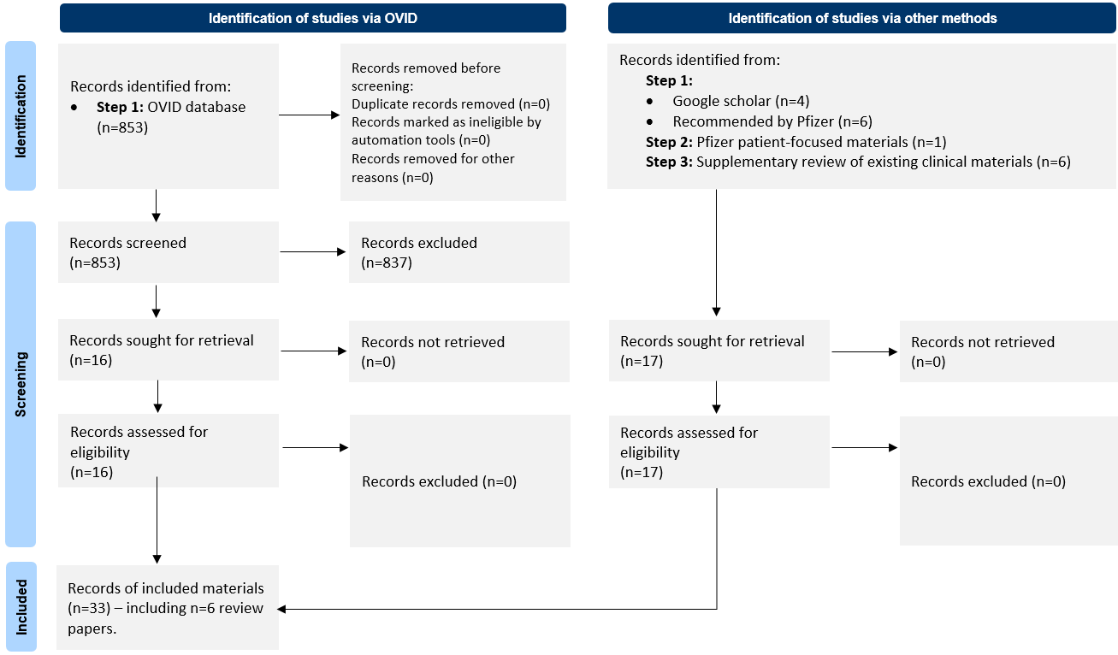
Figure 1. PRISMA diagram
Adapted from: Page MJ, McKenzie JE, Bossuyt PM, et al. The PRISMA 2020 statement: an updated guideline for reporting systematic reviews. British Medical Journal. 2021;372
Materials reviewed:
Seven journal articles were identified in the review. This included three articles identified from the OVID database search,⁹⁻¹¹, three identified from the supplementary Google Scholar search¹²⁻¹⁴ and one found manually.¹⁵ Thirteen conference abstracts were also included in the review, 10 of which were identified via the OVID database.¹⁶⁻²⁵ and three of which were found manually.²⁶⁻²⁸
Six review articles were also identified and reviewed as part of the full-text review. Three review articles were identified from the OVID database search,²⁹⁻³¹ two review articles were found manually,^{32,33} and one review article was identified in the supplementary Google Scholar search.³⁴
To supplement the literature identified in the database review, we conducted an informal search through Google Scholar. This search yielded a total of four articles that were included for full-text review. An additional six articles found manually were also included for full-text review.^{15,26-28,32,33} Three supplemental clinical resources were also reviewed.¹⁻⁶
Clinical materials were included for review. These included the BCG TICE® USPI⁶; published EAU guidance¹, ClinicalTrials.gov database providing study design information for investigational PD-(L)1 inhibitor clinical trials in BCG-naïve, high-risk NMIBC.²⁻⁵
Summary of attributes identified:
Attributes identified were categorized into three main categories: 1) administration (route, frequency, duration), 2) efficacy, 3) adverse events (symptoms, side effects, safety). A few studies identified had included information on patient perspectives.^{10,12} No patient preference study was identified related to NMIBC at the time the search was conducted.
Attribute Identified | Category | Count of publications
Mode of administration | Administration | 18
Efficacy | Efficacy | 13
Hematuria | Adverse event | 7
Urinary frequency | Adverse event | 7
Frequency of administration | Administration | 6
Duration of administration | Administration | 6
Pain on urination | Adverse event | 5
Fever/chills/pyrexia | Adverse event | 5
Patient perspectives^{10,12} | Adverse event | 2

Key takeaways
No patient preference studies in NMIBC were identified, while few published studies had included data from the patient perspective. Overall, this review highlighted the top three top categories for attributes of importance to NMIBC: treatment administration, efficacy, and adverse events. These concept categories informed development of the draft A&L grid, specifically, informing draft attribute and level selection. The literature review conducted to develop the initial A&L grid was not systematic, and given limited literatures identified in the targeted literature review, other supplement materials were identified or had to rely on product labels of PD-(L)1 inhibitors compounds approved in other settings of bladder cancer to identify AEs.
Electronic Supplementary Material B: Preliminary attribute list and supporting evidence
A list of draft attributes was developed based on findings from the targeted literature review, and external input from regulators, clinical advisors, a patient advocate.
Draft attribute developed | Supportive evidence
Route of administration (PD-[L]1 inhibitors) | - The route of administration varies across P1-(L)1 inhibitors.^{2-5,35}  - Route of administration was identified as a prominent attribute and a key factor influencing treatment satisfaction and preferences among patients with NMIBC treated with BCG.^{1-5,9,10,32,36}  - Qualitative evidence indicates that patients may favor subcutaneous injection over intravesical instillation.³⁶
Frequency of administration (PD-[L]1 inhibitors) | - The frequency of administration varies across P1-(L)1 inhibitors.^{2-5,35}  - Frequency of administration was identified in the literature review as a prominent attribute.^{9,16,17,19,35,36}
Duration of administration (PD-[L]1 inhibitors) | - Duration of administration varies across P1-(L)1 inhibitors.^{2-5,35}
Administration (BCG) | - BCG route of administration (intravesical instillation) was reported to be a key factor influencing treatment satisfaction and preferences among NMIBC patients treated with BCG.^{1-5,10,16,17,19,30,32,36}
Efficacy (event-free survival) | - Treatment efficacy was identified in the targeted literature review.^{9,23,30}  - Internal research on file at the time of review (citation available at the time of publication)³⁷ highlighted that a key goal of HR-NMIBC treatment is to achieve remission and preventing recurrences.  - While efficacy data was not available at the time of review, it was expected that event-free survival (EFS) or disease-free survival (DFS) for investigational P1-(L)1 inhibitor and BCG combination regimens may differentiate relative to BCG regimens alone.^{6,38-40}
Bladder problems | - Bladder-related symptoms (including dysuria, urinary frequency, and urinary urgency) are commonly associated with BCG.^{10,13,20,24,30,33,36,41}  - While data was not available at the time of review, bladder-related symptoms are not expected to be a common adverse event for PD-(L)1 inhibitors in similar indications.⁴²  - Qualitative evidence indicates that urinary urgency (tied with frequency) were among the most concerning aspects of BCG treatment for NMIBC, as reported by 40% of patients in the sample.¹⁰
Flu-like symptoms | - Flu-like symptoms were identified as key adverse events associated with BCG from both the patient and clinician perspective.^{20,36}  - While safety data on PD-(L)1 inhibitors was not fully available at the time of review, flu-like symptoms were not expected to be a common adverse event for PD-(L)1 inhibitors (<10% expected incidence)⁴³ relative to BCG (25% incidence).⁶
Thyroid problems | - Published clinical data PD-(L)1 inhibitor monotherapy in a BCG-unresponsive NMIBC population provides evidence for the inclusion of thyroid-related adverse events as an attribute associated with ICI therapy.⁹  - While safety data on PD-(L)1 inhibitors was not fully available at the time of review, thyroid problems were expected to be an adverse event more commonly associated with PD-(L)1 inhibitors (10-20% expected incidence)^{42,43} relative to BCG (not expected).⁶  - Evidence from a patient survey indicates patients with NMIBC had low acceptable rates of permanent treatment-related toxicity (including steroid-requiring immune-related AEs).²⁷
Adrenal gland problems | - Evidence from a patient survey indicates patients with NMIBC had low acceptable rates of permanent treatment-related toxicity (including steroid-requiring immune-related AEs).²⁷  - Published data for a PD-(L)1 inhibitors monotherapy in a BCG-unresponsive NMIBC population provides clinical evidence to support adrenal-related AEs as a potential attribute to consider.⁹  - While safety data on PD-(L)1 inhibitors was not fully available at the time of review, adrenal insufficiency was expected to be an adverse event more commonly associated with PD-(L)1 inhibitors (<5% expected incidence)⁴⁴³ relative to BCG (not expected).⁶  - Expert clinical input highlighted how HR-NMIBC patients would likely be impacted by long-term steroid use.
Diabetes | - Evidence from a patient survey indicates patients with NMIBC had low acceptable rates of permanent treatment-related toxicity (including diabetes).²⁷  - While safety data on PD-(L)1 inhibitors was not fully available at the time of review, diabetes was expected to be an adverse event more commonly associated with PD-(L)1 inhibitors (<5% expected incidence) ^{42,43} relative to BCG (not expected).⁶  - Type-1 diabetes was identified as a treatment-related adverse event associated with a PD-(L)1 inhibitors monotherapy in a BCG-unresponsive NMIBC population.⁹
Serious immune AEs | - While safety data on PD-(L)1 inhibitors was not fully available at the time of review, serious immune-related adverse events were expected to be more commonly associated with PD-(L)1 inhibitors (<10% expected incidence)⁴²⁴³ relative to BCG (not expected).⁶

Attributes shortlisted but not included for qualitative pre-testing:
Attribute | Rationale for non-inclusion
Fever/chills/pyrexia^{9,13,30,36} | - Potential overlap with the composite flu-like symptoms adverse event associated with BCG.⁶
Fatigue^{9,14,23,36} | - Fatigue may be confounded with the underlying disease symptoms and is not expected to be a severe treatment side effect for both BCG and investigational PD-(L)1 inhibitors.
Rash | - Incidence rates and severity grading was considered to be low and minimally differentiating BCG and PD-(L)1 inhibitors (expected <3% all grades).
Loss of appetite³⁷ | - Loss of appetite may be confounded with the underlying disease symptoms and is not expected to be a severe treatment side effect for both BCG and investigational PD-(L)1 inhibitors.
Myalgia | - Potential overlap with the composite flu-like symptoms adverse event associated with BCG.⁶
Arthralgia⁹ | - Potential overlap with the composite flu-like symptoms adverse event associated with BCG.⁶
Injection-site reactions | - Injection-site reactions were not included in the A&L grid due to an expected low severity (Grade 1-2) and low incidence rate for relevant PD-(L)1 inhibitors.
Infusion reactions | - Infusion reaction was not identified in the TLR/or expected to be a notable differentiator between BCG and PD-(L)1 inhibitors.
Diarrhea^{9,23} | - Diarrhea was not included based on low incidence frequency.
Cost of treatment | - Cost was not included as an attribute as this was not relevant to the specific research question. In recognition to the potential influence of cost on treatment preferences, cost will be controlled/held constant in any future preference study.

References
1. European Association of Urology. Non-muscle-invasive Bladder Cancer (Section 7), https://uroweb.org/guideline/non-muscle-invasive-bladder-cancer/#7. 2021.
2. ClinicalTrials.gov. Sasanlimab (PF-06801591) in Combination With BCG or as Single Agent in Participants With High-Risk Non-Muscle Invasive Bladder Cancer (CREST). Identifier: NCT04165317. 2021.
3. ClinicalTrials.gov. Atezolizumab Plus One-year BCG Bladder Instillation in BCG-naive High-risk Non-muscle Invasive Bladder Cancer Patients (ALBAN). Identifier: NCT03799835. 2021.
4. ClinicalTrials.gov. Efficacy and Safety of Pembrolizumab (MK-3475) in Combination With Bacillus Calmette-Guerin (BCG) in High-Risk Non-Muscle Invasive Bladder Cancer (HR NMIBC) (MK-3475-676/KEYNOTE-676). Identifier: NCT03711032. 2021.
5. ClinicalTrials.gov. Assessment of Efficacy and Safety of Durvalumab Plus BCG Compared to the Standard Therapy With BCG in Non-muscle Invasive Bladder Cancer (POTOMAC). Identifier: NCT03528694. 2021.
6. Package Insert - TICE BCG (2018).
7. Liberati A, Altman DG, Tetzlaff J, et al. The PRISMA statement for reporting systematic reviews and meta-analyses of studies that evaluate health care interventions: explanation and elaboration. PLoS medicine. 2009;6(7):e1000100.
8. Moher D, Liberati A, Tetzlaff J, Altman DG. Preferred reporting items for systematic reviews and meta-analyses: the PRISMA statement. Annals of internal medicine. 2009;151(4):264-269.
9. Balar AV, Kamat AM, Kulkarni GS, et al. Pembrolizumab monotherapy for the treatment of high-risk non-muscle-invasive bladder cancer unresponsive to BCG (KEYNOTE-057): an open-label, single-arm, multicentre, phase 2 study. The Lancet Oncology. 2021;
10. Clark M, Harris N, Martin S, et al. The impact of non-muscle invasive bladder cancer: qualitative research with patients. Value in Health. 2015;18(7):A471.
11. Loriot Y, Rouprêt M. Immunotherapies in non-muscle invasive bladder cancer: immunotherapies and NMIBC. Bulletin du Cancer. 2020;107(5S):S49-S55.
12. Garg T, Connors JN, Ladd IG, Bogaczyk TL, Larson SL. Defining priorities to improve patient experience in non-muscle invasive bladder cancer. Bladder Cancer. 2018;4(1):121-128.
13. Sharma V, Thakur AP, Ramasamy V, et al. Complications of intravesical BCG therapy in non-muscle invasive bladder cancer: our tertiary care centre experience. African Journal of Urology. 2020;26(1):1-9.
14. Siracusano S, Silvestri T, Bassi S, et al. Health-related quality of life after BCG or MMC induction for non-muscle invasive bladder cancer. The Canadian journal of urology. 2018;25(5):9480-9485.
15. Broughton EI, Gooden KM, Mycock KL, Rajkovic I, Taylor-Stokes G. Multi-country clinical practice patterns, including use of biomarkers, among physicians’ treatment of BCG-unresponsive non-muscle invasive bladder cancer (NMIBC). BMC Urology. 2022/02/26 2022;22(1):27. doi:10.1186/s12894-022-00959-z
16. De Santis M, Abdrashitov R, Hegele A, et al. A phase III, randomized, open-label, multicenter, global study of durvalumab and bacillus calmette-guérin (BCG) versus BCG alone in high-risk, BCG-naïve non-muscle-invasive bladder cancer (NMIBC) patients (POTOMAC). American Society of Clinical Oncology; 2019.
17. Kamat AM, Shore ND, Hahn NM, et al. Keynote-676: Phase 3 study of bacillus calmette-guerin (BCG) with or without pembrolizumab (pembro) for high-risk (HR) non–muscle invasive bladder cancer (NMIBC) that is persistent or recurrent following BCG induction. American Society of Clinical Oncology; 2019.
18. Kamat AM, Shore ND, Hahn NM, et al. Bacillus Calmette-Guerin (BCG) with or without pembrolizumab (pembro) for high-risk (HR) nonmuscle invasive bladder cancer (NMIBC) that is persistent or recurrent following BCG induction: Phase III KEYNOTE-676 study. American Society of Clinical Oncology; 2019.
19. Roupret M, Neuzillet Y, Bertaut A, et al. ALBAN: An open label, randomized, phase III trial, evaluating efficacy of atezolizumab in addition to one year BCG (bacillus Calmette-Guerin) bladder instillation in BCG-naive patients with high-risk nonmuscle invasive bladder cancer (AFU-GETUG 37). American Society of Clinical Oncology; 2019.
20. Rutherford C, Costa D, King MT, Smith D, Patel M. A mixed methods study to develop a conceptual framework for patient-reported outcomes in non-muscle invasive bladder cancer. SPRINGER VAN GODEWIJCKSTRAAT 30, 3311 GZ DORDRECHT, NETHERLANDS; 2017:40-40.
21. Rutherford C, Tait M-A, Costa D, et al. Development and field testing of a patient-reported symptom index for use with non-muscle invasive bladder cancer patients using mixed methods. SPRINGER VAN GODEWIJCKSTRAAT 30, 3311 GZ DORDRECHT, NETHERLANDS; 2020:S27-S27.
22. Steinberg G, Saltstein D, Shore N, et al. 795TiP Phase III study of the programmed cell death protein 1 inhibitor PF-06801591 plus bacillus Calmette-Guérin for non-muscle invasive bladder cancer. Annals of Oncology. 2020;31:S604.
23. Boormans J.L., De Wit R., Kulkarni G.S., et al. Updated follow-up from KEYNOTE-057: Phase 2 study of pembrolizumab (pembro) for patients (pts) with high-risk (HR) non-muscle invasive bladder cancer (NMIBC) unresponsive to bacillus Calmette-Guerin (BCG). European Urology Open Science. 2020;
24. Rutherford C, Patel MI, Tait M-A, et al. Patient-reported outcomes in non-muscle invasive bladder cancer: a mixed-methods systematic review. Quality of Life Research. 2021;30(2):345-366.
25. Rutherford C, Tait M-A, Costa D, et al. PD12-08 DEVELOPMENT OF A PATIENT-REPORTED SYMPTOM INDEX FOR USE WITH NON-MUSCLE INVASIVE BLADDER CANCER PATIENTS USING MIXED METHODS. The Journal of Urology. 2020;203(Supplement 4):e262-e262.
26. Chun Danielle S, Broughton Edward, Gooden Kyna M, Mycock Katie, Rajkovic Ivana, Gavin. T-S. Reasons for Non-Surgical Management of Patients with Bacillus Calmette–Guérin (BCG)-Unresponsive Non-Muscle Invasive Bladder Cancer (NMIBC). Society of Urologic Oncology 21st Annual Meeting. 2020;Dec 3-5 2020:Poster #44.
27. Hahn NM. Patient, caregiver, and provider reported risk-benefit acceptance thresholds in non-muscle invasive bladder cancer (NMIBC) trial designs. American Society of Clinical Oncology; 2021:
28. SHAHIN O, THALMANN GN, RENTSCH C, MAZZUCCHELLI L, STUDER UE. A Retrospective Analysis of 153 Patients Treated With or Without Intravesical Bacillus Calmette-Guerin for Primary Stage T1 Grade 3 Bladder Cancer: Recurrence, Progression and Survival. Journal of Urology. 2003;169(1):96-100. doi:doi:10.1016/S0022-5347(05)64044-X
29. Albisinni S, Aoun F, Diamand R, et al. Immune checkpoint inhibitors for BCG-resistant NMIBC: the dawn of a new era. Minerva Urology and Nephrology. 2021;
30. Chen S, Zhang N, Shao J, Wang X. Maintenance versus non-maintenance intravesical Bacillus Calmette-Guerin instillation for non-muscle invasive bladder cancer: a systematic review and meta-analysis of randomized clinical trials. International Journal of Surgery. 2018;52:248-257.
31. Yassaie O, Chehroudi C, Black PC. Novel and emerging approaches in the management of non-muscle invasive urothelial carcinoma. Therapeutic Advances in Medical Oncology. 2021;13:17588359211039052.
32. Anderson KC, Landgren O, Arend RC, Chou J, Jacobs IA. Humanistic and economic impact of subcutaneous versus intravenous administration of oncology biologics. Future Oncology. Oct 2019;15(28):3267-3281. doi:10.2217/fon-2019-0368
33. Lee LJ, Kwon CS, Forsythe A, Mamolo CM, Masters ET, Jacobs IA. Humanistic and Economic Burden of Non-Muscle Invasive Bladder Cancer: Results of Two Systematic Literature Reviews. ClinicoEconomics and outcomes research: CEOR. 2020;12:693.
34. Gupta M, Kates M, Bivalacqua TJ. Immunotherapy in nonmuscle invasive bladder cancer: current and emerging treatments. Current Opinion in Oncology. 2019;31(3):183-187.
35. Pfizer Internal Document. CREST protocol: Phase 3 Study of Sasanlimab (PF-06801591) in Combination With Bacillus Calmette-Guerin (BCG) or as a Single Agent in Participants With High-Risk Non-Muscle Invasive Bladder Cancer. 2022.
36. Chang J, Maculaitis M. Observational Study of Patient Experience and Unmet Needs in High-Risk Non Muscle Invasive Bladder Cancer. Protocol Number X9001300. 2022.
37. Kopenhafer L, Thompson A, Chang J, et al. Patient experience and unmet needs in high-risk nonmuscle-invasive bladder cancer: Insights from qualitative interviews and a cross-sectional survey. Elsevier; 2024:
38. Cambier S, Sylvester RJ, Collette L, et al. EORTC Nomograms and Risk Groups for Predicting Recurrence, Progression, and Disease-specific and Overall Survival in Non-Muscle-invasive Stage Ta-T1 Urothelial Bladder Cancer Patients Treated with 1-3 Years of Maintenance Bacillus Calmette-Guérin. Eur Urol. Jan 2016;69(1):60-9. doi:10.1016/j.eururo.2015.06.045
39. Fernandez-Gomez J, Madero R, Solsona E, et al. Predicting nonmuscle invasive bladder cancer recurrence and progression in patients treated with bacillus Calmette-Guerin: the CUETO scoring model. J Urol. Nov 2009;182(5):2195-203. doi:10.1016/j.juro.2009.07.016
40. Sylvester RJ, van der Meijden AP, Oosterlinck W, et al. Predicting recurrence and progression in individual patients with stage Ta T1 bladder cancer using EORTC risk tables: a combined analysis of 2596 patients from seven EORTC trials. Eur Urol. Mar 2006;49(3):466-5; discussion 475-7. doi:10.1016/j.eururo.2005.12.031
41. Brausi M, Oddens J, Sylvester R, et al. Side Effects of Bacillus Calmette-Guérin (BCG) in the Treatment of Intermediate- and High-risk Ta, T1 Papillary Carcinoma of the Bladder: Results of the EORTC Genito-Urinary Cancers Group Randomised Phase 3 Study Comparing One-third Dose with Full Dose and 1 Year with 3 Years of Maintenance BCG. European Urology. 2014/01/01/ 2014;65(1):69-76. doi:https://doi.org/10.1016/j.eururo.2013.07.021
42. Food and Drug Administration. KEYTRUDA prescribing information. https://www.accessdata.fda.gov/drugsatfda_docs/label/2020/125514s066lbl.pdf
43. ClinicalTrials.gov. A Study Of Avelumab In Patients With Locally Advanced Or Metastatic Urothelial Cancer (JAVELIN Bladder 100) Identifier: NCT02603432. 2022.

Electronic Supplementary Material C: Preliminary attributes and levels with descriptions and images
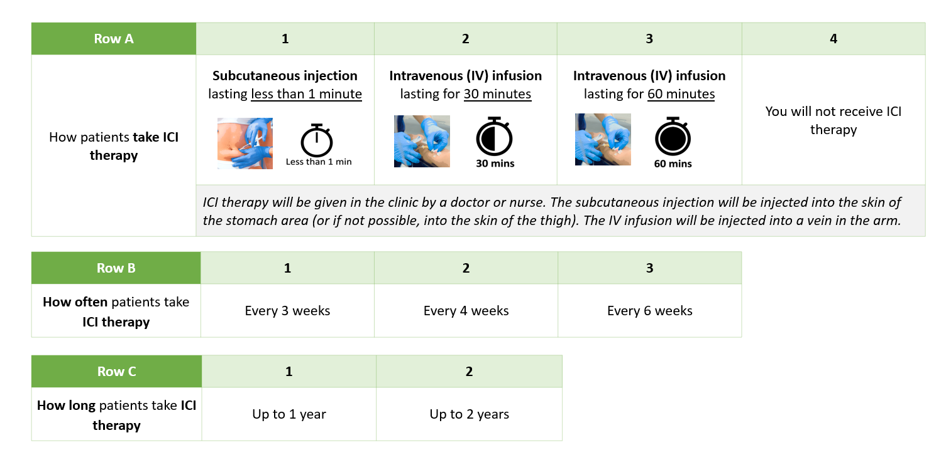

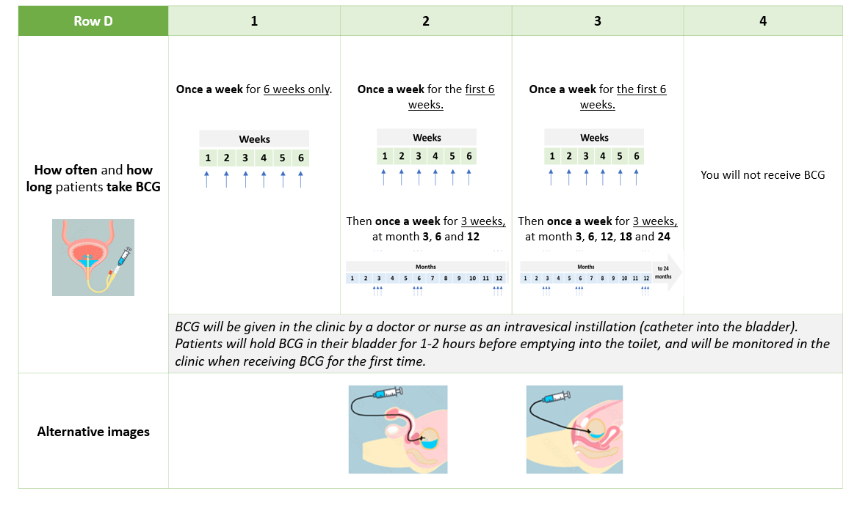
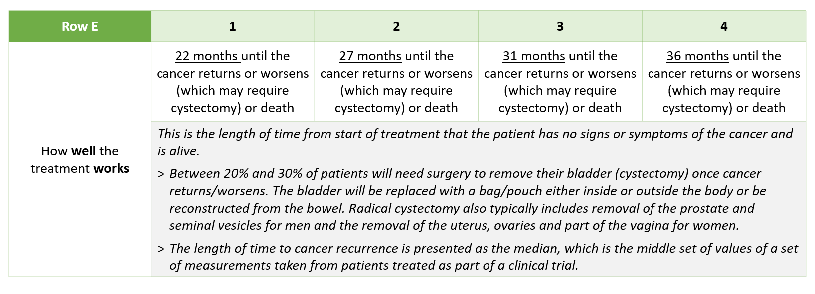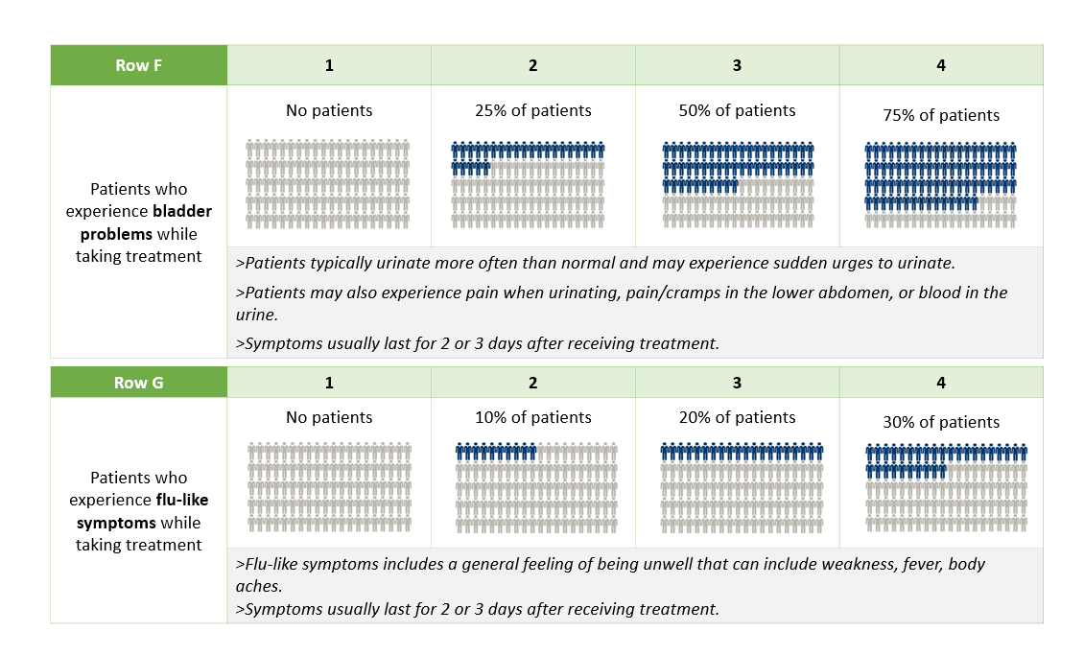

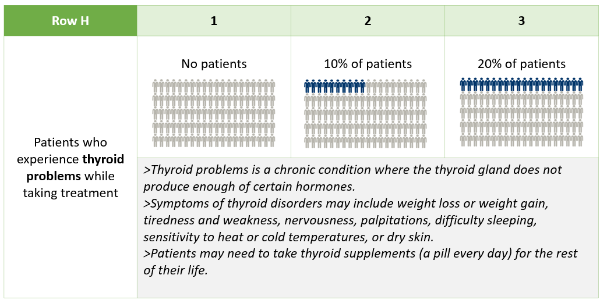
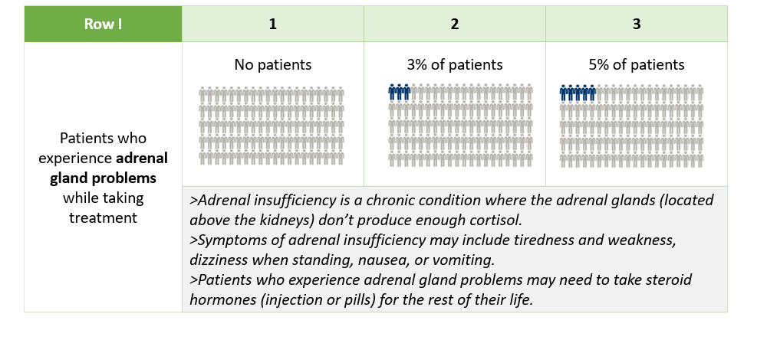

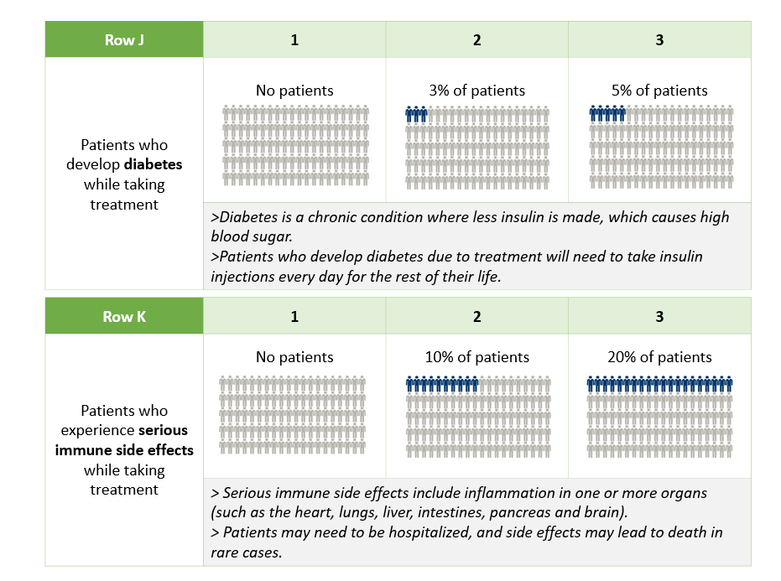
Electronic Supplementary Material D: Sample clinical and socio-demographic characteristics
A total of 12 patients with clinician-confirmed (n=6) or self-reported (n=6) HR-NMIBC were recruited. All patients had received BCG therapy. A greater proportion of patients with a clinician-confirmed diagnosis were retired (n=4/6) and lived in urban areas (n=3/6) compared to self-reporting patients (n=1/6 each, respectively), Most patients with a self-reported diagnosis reported receipt of 7 or more BCG sessions (maintenance) (n=5/6), while most clinician-confirmed patients frequently reported 6 or fewer sessions (induction) (n=4/6).

Description |  | Total sample (N=12)
Age  years | Median  Min/Max | 64  54 – 78
Gender  n (%) | Male  Female | 7 (58.3%)  5 (41.7%)
Ethnic origin  n (%) | Caucasian  Hispanic or Latino | 11 (91.7%)  1 (8.3%)
US region  n (%) | Northeast  Midwest  Southeast  Southwest  West | 3 (25.0%)  2 (16.7%)  3 (25.0%)  1 (8.3%)  3 (25.0%)
Community type  n (%) | Rural  Urban  Suburban | 4 (33.3%)  2 (16.7%)  6 (50.0%)
Highest level of education  n (%) | High school or equivalent  Associate’s Degree  Bachelor’s Degree  Master’s Degree  Doctorate | 2 (16.7%)  2 (16.7%)  4 (33.3%)  3 (25.0%)  1 (8.3%)
Employment status  n (%) | Working full time  Working part time  Retired | 4 (33.3%)  3 (25.0%)  5 (41.7%)
Current control of NMIBC  n (%) | Fair  Good  Excellent | 2 (16.7%)  6 (50.0%)  4 (33.3%)
Time since NMIBC diagnosis  n (%) | ≤1 year  >1-2 years  >2 -3 years | 5 (41.7%)  3 (25.0%)  4 (33.3%)
Number of BCG sessions  n (%) | Induction (≤6 sessions)  Maintenance (≥7 sessions) | 5 (41.7%)  7 (58.3%)
Received Intravesical chemotherapy for NMIBC  n (%) | Yes  No | 6 (50.0%)  6 (50.0%)

