TECHNICAL APPENDIX
Appendix - Table I. KCE – Belgian pharmacoeconomic guidelines: reference case methods^{[15]}
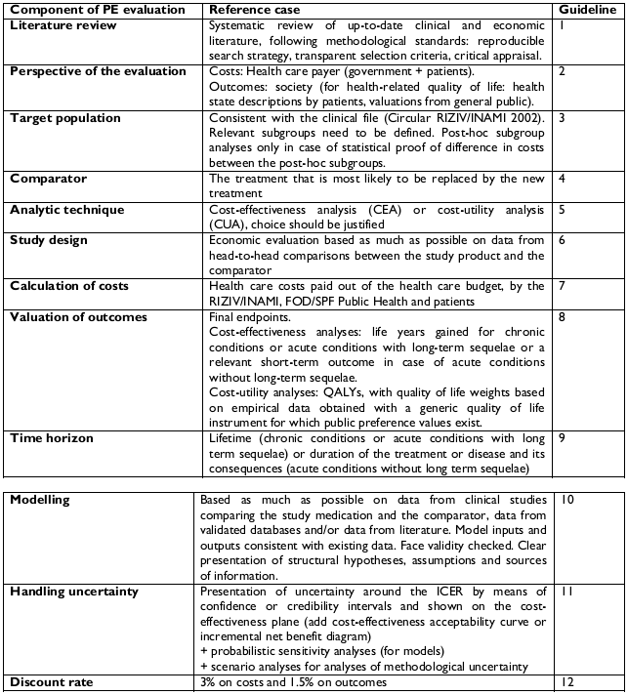
Appendix - Table II. PSA – Probabilities parameters and distributions
Inputs - Probabilities | Distribution |  |  | Parameters
Remission rate for escitalopram in step 1
 |  |  |  | Mean |  |  | VAR |  | α |  | β
Escitalopram | Beta |  |  | 0.4756 |  |  | 0.0006 |  | 186.63 |  | 205.78
Relative risk of remission for comparators vs. escitalopram in step 1
 |  |  |  | Mean |  |  | VAR |  |  | μ | σ
Duloxetine | Log-normal |  |  | 0.9460 |  |  | 0.0056 |  |  | -0.06 | 0.08
Venlafaxine | Log-normal |  |  | 0.9605 |  |  | 0.0042 |  |  | -0.04 | 0.07
Mirtazapine | Log-normal |  |  | 0.9479 |  |  | 0.0063 |  |  | -0.06 | 0.08
Citalopram | Log-normal |  |  | 0.8516 |  |  | 0.0056 |  |  | -0.16 | 0.09
Fluoxetine | Log-normal |  |  | 0.8455 |  |  | 0.0030 |  |  | -0.17 | 0.06
Paroxetine | Log-normal |  |  | 0.8978 |  |  | 0.0045 |  |  | -0.11 | 0.07
Sertraline | Log-normal |  |  | 0.9045 |  |  | 0.0049 |  |  | -0.10 | 0.08
Relapse
 |  |  |  | Events |  |  | Population |  |  | α | β
Risk of relapse | Beta |  |  | 51 |  |  | 359 |  |  | 51.00 | 308.00
Suicide attempt
 |  |  |  | LL (-% of mean) |  |  | UL (+% of mean) |  |  | a | b
Risk of suicide attempt | Uniform |  |  | -50% |  |  | 50% |  |  | 0.03 | 0.09
Suicide related death
 |  |  |  | Events |  |  | Population |  |  | α | β
Risk of suicide related-death | Beta |  |  | 9 |  |  | 95 |  |  | 9.00 | 86.00
Rate of change due to lack of efficacy
 |  |  |  | Mean |  |  | VAR |  |  | α | β
SRNI | Beta |  |  | 0.5943 |  |  | 0.0371 |  |  | 3.27 | 2.23
SSRI | Beta |  |  | 0.7332 |  |  | 0.0309 |  |  | 3.91 | 1.42
Medications changes
Lack of efficacy SNRI* in Step 1 |  |  |  |  |  | Mean |  | VAR |  | α | β
Switch to SNRI (venlafaxine 75mg/d) |  |  | Dirichlet |  |  | 0.0541 |  | 0.0351 |  | 5.41 | 1.00
Switch to SSRI (sertraline 50mg/d) |  |  | Dirichlet |  |  | 0.1287 |  | 0.0059 |  | 12.87 | 1.00
Titration |  |  | Dirichlet |  |  | 0.4558 |  | 0.0613 |  | 45.58 | 1.00
Combination with bupropion 150mg/d |  |  | Dirichlet |  |  | 0.1119 |  | 0.0121 |  | 11.19 | 1.00
Combination with psychotherapy |  |  | Dirichlet |  |  | 0.1623 |  | 0.0318 |  | 16.23 | 1.00
Augmentation with quetiapine 300mg/d |  |  | Dirichlet |  |  | 0.0584 |  | 0.0030 |  | 5.84 | 1.00
Switch to psychotherapy |  |  | Dirichlet |  |  | 0.0289 |  | 0.0023 |  | 2.89 | 1.00
Lack of efficacy SSRI in Step 1: |  |  |  |  |  | Mean |  | VAR |  | α | β
Switch to SNRI (venlafaxine 75mg/d) |  |  | Dirichlet |  |  | 0.1950 |  | 0.0092 |  | 19.50 | 1.00
Switch to SSRI (sertraline 50mg/d) |  |  | Dirichlet |  |  | 0.0454 |  | 0.0308 |  | 4.54 | 1.00
Titration |  |  | Dirichlet |  |  | 0.4140 |  | 0.0593 |  | 41.40 | 1.00
Inputs - Probabilities |  |  | Distribution |  |  | Parameters
Combination with bupropion 150mg/d |  |  | Dirichlet |  |  | 0.0933 |  | 0.0181 |  | 9.33 | 1.00
Combination with psychotherapy |  |  | Dirichlet |  |  | 0.1970 |  | 0.0242 |  | 19.70 | 1.00
Augmentation with quetiapine 300mg/d |  |  | Dirichlet |  |  | 0.0344 |  | 0.0097 |  | 3.44 | 1.00
Switch to psychotherapy |  |  | Dirichlet |  |  | 0.0209 |  | 0.0061 |  | 2.09 | 1.00
Lack of tolerability SNRI* in Step 1: |  |  |  |  |  | Mean |  | VAR |  | α | β
Switch to SNRI (venlafaxine 75mg/d) |  |  | Dirichlet |  |  | 0.2194 |  | 0.0832 |  | 21.94 | 1.00
Switch to SSRI (sertraline 50mg/d) |  |  | Dirichlet |  |  | 0.6325 |  | 0.0773 |  | 63.25 | 1.00
Switch to psychotherapy |  |  | Dirichlet |  |  | 0.1481 |  | 0.0324 |  | 14.81 | 1.00
Lack of tolerability SSRI in Step 1: |  |  |  |  |  | Mean |  | VAR |  | α | β
Switch to SNRI (venlafaxine 75mg/d) |  |  | Dirichlet |  |  | 0.5328 |  | 0.0680 |  | 53.28 | 1.00
Switch to SSRI (sertraline 50mg/d) |  |  | Dirichlet |  |  | 0.3299 |  | 0.0904 |  | 32.99 | 1.00
Switch to psychotherapy |  |  | Dirichlet |  |  | 0.1373 |  | 0.0314 |  | 13.73 | 1.00
Remission rate in Step 2
 |  |  |  |  | Events |  | Population |  | α |  |  | β
Switch to SNRI (venlafaxine 75mg/d) |  | Beta |  |  | 63 |  | 250 |  | 63.00 |  |  | 187.00
Switch to SSRI (sertraline 50mg/d) |  | Beta |  |  | 63 |  | 238 |  | 63.00 |  |  | 175.00
Combination with bupropion 150mg/d |  | Beta |  |  | 109 |  | 279 |  | 109.00 |  |  | 170.00
Combination with psychotherapy |  | Beta |  |  | 25 |  | 85 |  | 25.00 |  |  | 60.00
Augmentation with quetiapine 300mg/d |  | Beta |  |  | 163 |  | 307 |  | 163.00 |  |  | 144.00
Switch to psychotherapy |  | Beta |  |  | 26 |  | 62 |  | 26.00 |  |  | 36.00
Titration: |  |  |  |  | Mean |  | VAR |  | α |  |  | β
Duloxetine |  | Beta |  |  | 0.0000 |  | 0.0067 |  | 0.00 |  |  | -1.00
Venlafaxine |  | Beta |  |  | 0.3740 |  | 0.0067 |  | 12.60 |  |  | 21.10
Mirtazapine |  | Beta |  |  | 0.3691 |  | 0.0066 |  | 12.71 |  |  | 21.73
Citalopram |  | Beta |  |  | 0.2380 |  | 0.0034 |  | 12.30 |  |  | 39.38
Escitalopram |  | Beta |  |  | 0.3620 |  | 0.0045 |  | 18.07 |  |  | 31.85
Fluoxetine |  | Beta |  |  | 0.2380 |  | 0.0034 |  | 12.30 |  |  | 39.38
Paroxetine |  | Beta |  |  | 0.3250 |  | 0.0037 |  | 19.18 |  |  | 39.83
Sertraline |  | Beta |  |  | 0.3274 |  | 0.0037 |  | 19.10 |  |  | 39.24
a SNRI: Including mirtazapine
LL = Lower limit; UL Upper limit; VAR= variance

Appendix - Table III. PSA. Time to event parameters and distributions
Inputs - Events | Distribution |  | Parameters
Time to achieve remission
 |  |  | LL |  | UL | Cumul LL | Cumul UL
In first therapeutic step | Truncated Normal |  | 1 |  | 12 | 0.34 | 1.00
In second therapeutic step | Truncated Normal |  | 1 |  | 12 | 0.34 | 1.00
Time to relapse after remission
 |  |  | LL (-% of mean) |  | UL (+% of mean) | a | b
In first therapeutic step | Uniform |  | -25% |  | 25% | 3.00 | 5.00
Duration on treatment after achieving remission
 |  |  | LL |  | UL | Cumul LL | Cumul UL
In first therapeutic step | Truncated Normal |  | 4 |  | 12 | 0.22 | 0.98
In second therapeutic step | Truncated Normal |  | 4 |  | 12 | 0.17 | 0.81
LL = Lower limit; UL Upper limit

Appendix - Table IV. PSA. Utility parameters and distributions
Inputs - Efficacy | Distribution | Parameters
Utility - Remission
 |  | Mean | VAR | α | β
In remission | Beta | 0.81 | 0.0002 | 531.29 | 124.62
In non-remission | Beta | 0.57 | 0.0004 | 334.87 | 252.62
Utility - Suicide
 |  | Mean | VAR | α | β
In case of suicide attempt | Beta | 0.57 | 0.0004 | 334.87 | 252.62
VAR= Variance

Appendix - Table V. PSA. Costs and resource parameters and distributions
Inputs - Efficacy | Distribution |  | Parameters
Costs of specialist care
 |  |  | LL (-visits BC) | UL (+visits BC) | LL | UL
Global costs of specialist care | Triangular |  | -50% | 50% | 246.22 | 247.22
Number of visits to generalist
 |  |  | LL (-visits BC) | UL (+visits BC) | LL | UL
Treatment initiation Step1 | Triangular |  | -1 | 1 | 0.00 | 2.00
Maintenance treatment | Triangular |  | -1 | 1 | 2.00 | 4.00
Therapeutic changes:
Switch | Triangular |  | -1 | 1 | 2.00 | 4.00
Titration | Triangular |  | -1 | 1 | 2.00 | 4.00
Add-on | Triangular |  | -1 | 1 | 2.00 | 4.00
Switch to psychotherapy | Triangular |  | -1 | 1 | 0.00 | 2.00
Specialist care | Triangular |  | -1 | 1 | 0.00 | 2.00
Number of visits to specialist
 |  |  | LL (-visits BC) | UL (+visits BC) | LL | UL
Visits to the psychotherapist | Triangular |  | -1 | 1 | 0.00 | 2.00
Number of productivity days loss
 |  |  | LL (-% BC) | UL (+% BC) | LL | UL
Treatment initiation Step1 | Triangular |  | -30% | 30% | 0.88 | 1.63
Maintenance treatment | Triangular |  | -30% | 30% | 0.88 | 1.63
Therapeutic changes:
Switch | Triangular |  | -30% | 30% | 1.91 | 3.55
Titration | Triangular |  | -30% | 30% | 1.38 | 2.56
Add-on | Triangular |  | -30% | 30% | 1.38 | 2.56
Switch to psychotherapy | Triangular |  | -30% | 30% | 1.91 | 3.55
Specialist care | Triangular |  | -30% | 30% | 7.00 | 13.00
Costs of suicide
 |  |  | LL (-% BC) | UL (+% BC) | LL | UL
Suicide attempt | Triangular |  | -50% | 50% | 1,536.0 | 4,608.0
Suicide related-death | Triangular |  | -50% | 50% | 56.61 | 169.84
LL = Lower limit; UL Upper limit

Appendix – Figure 1. Cost-effectiveness plane QALYs gained (versus escitalopram) from the NIHDI (a) and societal (b) perspectives.
a-
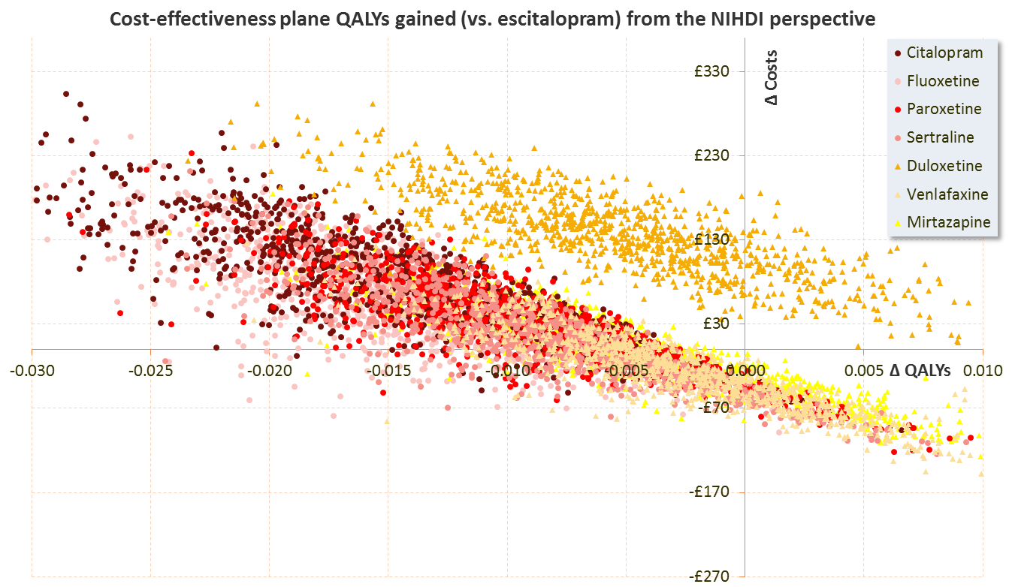
b-
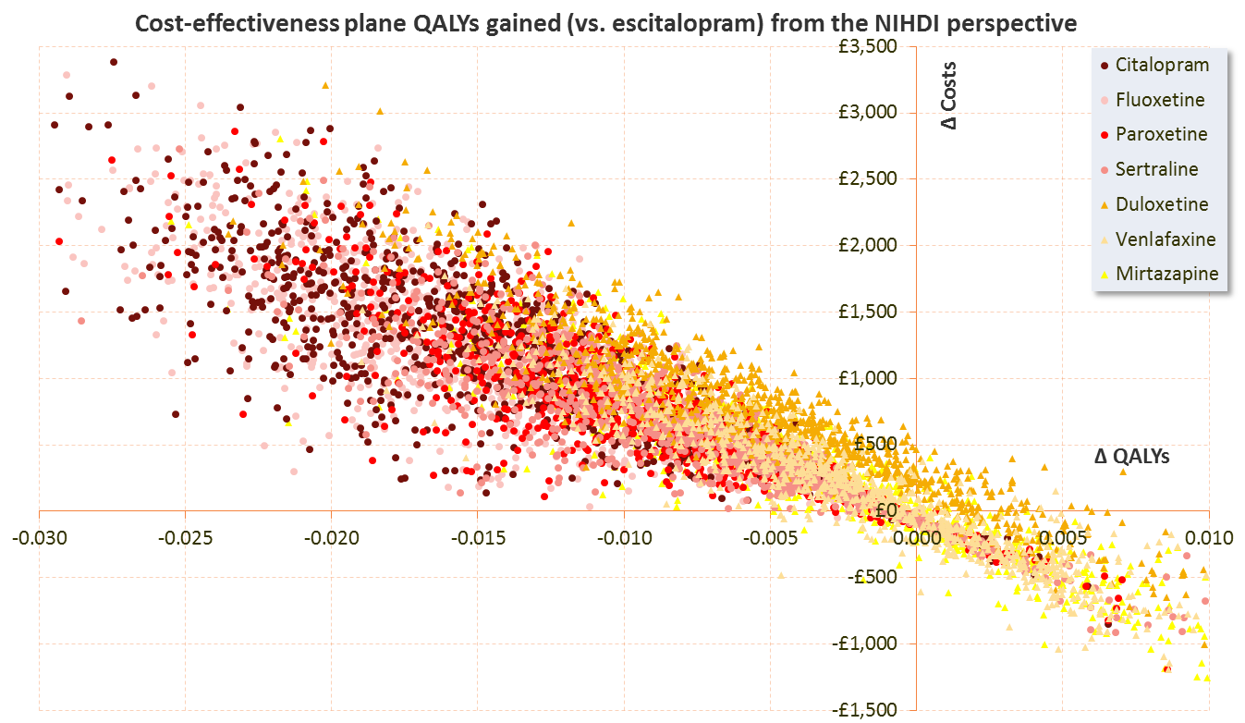
Appendix - Figure 2. Cost-effectiveness acceptability curve from the NIHDI perspective, direct comparison vs. escitalopram
