Electronic Supplementary Material

Valuing QALYs in Relation to Equity Considerations Using a Discrete Choice Experiment

Questionnaire

Introduction

Health care policy makers have to optimize the allocation of the available health care resources.

The Erasmus University Rotterdam studies public views on allocation decisions faced within the Dutch healthcare sector. The results of this study could inform policy makers in making decisions.

In this questionnaire you are asked to place yourself in the position of a health care policy maker. You have to make decisions on behalf of Dutch society.

You need to decide whether patients with a new illness should receive treatment financed from the basic benefit package. The consequences of illness and the effects of treatment will be illustrated in diagrams. We will start with an introduction of these diagrams.

Introduction of the diagrams

Step 1
In this questionnaire we use diagrams to illustrate the length and quality of life. The horizontal line of the graph shows the affected individuals’ age at onset of the illness and her life expectancy. In the example below the recipient is 30 years of age and she is expected to live for another 50 years.
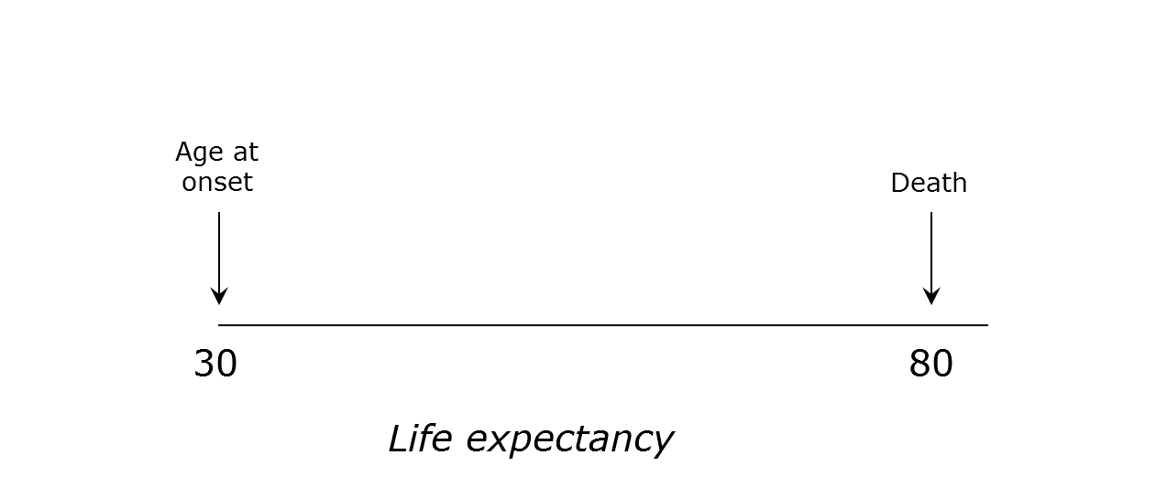

Step 2
The vertical line of the graph shows the quality of life of the recipient. You can interpret this line as a ‘health thermometer’. The lowest point, score 0, represents being dead and the highest point, score 100 represents perfect health.

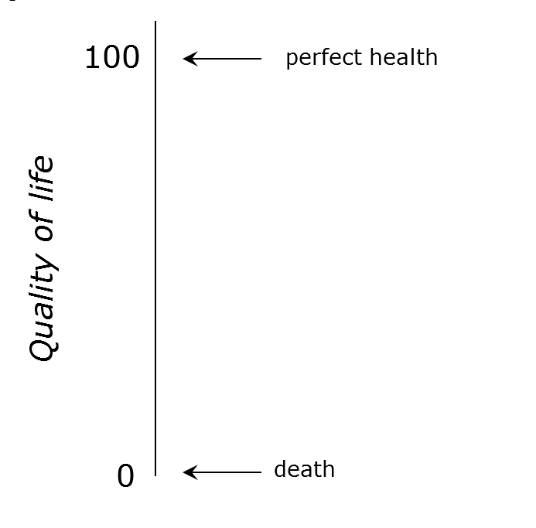

Step 3
Imagine that a person aged 30 is in perfect health until her death at age 80. The green area below shows the amount of health she will experience during her life. In this example this will be 50 years in perfect health.

Step 4
Now imagine that, as a consequence of a serious illness, this person dies sooner, for example at the age of 60. In that case she will live 30 years in perfect health and loses 20 years in perfect health compared to the situation without illness. In other words, without treatment she will lose 40% of otherwise lived health. The remaining proportion of health without treatment therefore is 60%.

Remaining health without treatment 60%

Step 5
Imagine there is a treatment available for this illness. Compared to no treatment, this treatment expands her life with 15 years in perfect health. In other words, this treatment regains 30% of otherwise lived health. The patient will then live another 45 years in perfect health (instead of 30 years without treatment).

Remaining health without treatment 60%
Health gain from treatment +30%

Step 6
There are also illnesses that reduce quality of life. In the example below, the quality of life of a person drops from 100 to 60 as a result of a serious illness. Life expectancy is not affected. Hence, the person will live another 50 years in a quality of life of 60.

Remaining health without treatment 60%

Step 7
Image a treatment is available. This treatment will improve quality of life from 60 to 85. With this treatment, the patient therefore regains 25 points (25%) of quality of life. She will therefore live another 50 years with a quality of life of 85 (instead of 60).
Remaining health without treatment 60%
Health gain from treatment +25%

Discrete choice experiment

In a moment you will be asked to choose between two groups of patients, group A and group B. First we will start with an example question.

Example

Step 1
The people in Group A and Group B are comparable with respect to gender and other demographic characteristics. Both groups include 4,000 people of aged 40. These people are currently in perfect health and their expected age of death is 80.

Group A Group B

Step 2
Tomorrow a new illness will strike both groups. The groups will experience different consequences of the illness.

In this example the life expectancy of the patients in group A drops from 80 to 50 years of age and their quality of life drops from perfect health (100) to 65. In group B the life expectancy of the patients drops from 80 to 62 years of age and their quality of life from perfect health (100) to 85.

In the graphs below, the remaining health without treatment is illustrated by the green area. The red area represents the health loss due to the illness. Below the graphs the percentages remaining health without treatment are reported for both groups.

Group A Group B

Remaining health without treatment 16% Remaining health without treatment 47%

Step 4
There is a new treatment available for this illness. The health benefits of the treatment differ between the two groups.

In this example group A gains 14 life years and 35 point in quality of life as a result of treatment. Group B gains 14 life years and 5 points in quality of life as a result of treatment. In the graphs below, the health gain as a result of treatment is marked by the green-and-red shaded area. Below the graphs the percentages health gain as a proportion of health are reported for both groups.

Group A Group B
Remaining health without treatment 16% |  | Remaining health without treatment 47%
Health gain from treatment +44% |  | Health gain from treatment +34%

Step 5
The costs of treatment can also differ between the two groups. In order to finance the treatment the mandatory monthly health insurance premium of all people in the Netherlands has to increase for one year. The increase in monthly premium is reported below the graphs.

Which of the groups below do you, as a decision maker, think should be treated?

Group A Group B
Remaining health without treatment 16%  Health gain from treatment +44%  Increase in monthly premium €24 |  | Remaining health without treatment 47%  Health gain from treatment +34%  Increase in monthly premium €18

This was an example, you do not have to answer this question.

Now we will present 10 similar questions where you are requested to choose between 2 groups of patients (Group A or Group B)

Both groups include 4000 people of 40 years old. Before they developed the illness, they were expected to live in perfect health until death at 80 years of age. In other words, without the illness they would live an additional 40 years in perfect health.

Question 1.

You can provide treatment for group A or group B.

As a consequence of illness, in Group A life expectancy drops from 80 to 50 and quality of life drops from perfect health (100) to 85 (remaining health without treatment is 21%).
In Group B the life expectancy of the patients drops from 80 to 62 and quality of life from perfect health (100) to 65 (health without treatment is 36%).

As a result of treatment Group A gains 6 life years and 5 points in quality of life (a total of 15% health gain). Group B gains 10 life years and 15 points in quality of life (in total 28% health gain).

The increase in monthly health insurance premium to finance the treatment needs to be paid by the entire Dutch population, including yourself. The amount of increase can differ between the groups as reported below the graphs.

Which of the groups below do you, as a decision maker, think should be treated?

Group A |  |  |  | Group B |  | None
Remaining health without treatment 21%  Health gain from treatment 15%  Increase in monthly premium €6 |  |  |  | Remaining health without treatment 36%  Health gain from treatment 28%  Increase in monthly premium €24
□ |  |  | □ |  | □

