Cost-effectiveness of pembrolizumab vs. standard-of-care chemotherapy as first-line treatment for metastatic NSCLC that expresses high levels of PD-L1 in the United States

Pharmacoeconomics

Min Huang, PhD*; Yanyan Lou, MD; James Pellissier, PhD; Thomas Burke, PhD; Frank Xiaoqing Liu, PhD; Ruifeng Xu, PhD; Varnsidhar Velcheti, MD

*Corresponding author: Min Huang, Min_Huang@merck.com, Centre for Observational and Real-world Evidence, Merck & Co., Inc., 351 N. Sumneytown Pike, North Wales, PA, 19454-2505, USA
Electronic Supplementary Material 1: Distribution of SoC Regimens in KEYNOTE-024
Regimen | Therapies | Dose | Frequency | Duration | Distribution
1 ª | Carboplatin | AUC 5 to 6 | Day 1 of every  3-week cycle | 4 to 6 cycles | 44%
1 ª | Pemetrexed | 500 mg/m² | Day 1 of every  3-week cycle | 4 to 6 cycles ^{b} | 44%
2 ª | Cisplatin | 75 mg/m² | Day 1 of every  3-week cycle | 4 to 6 cycles | 24%
2 ª | Pemetrexed | 500 mg/m² | Day 1 of every  3-week cycle | 4 to 6 cycles ^{b} | 24%
3 | Carboplatin | AUC 5 to 6 | Day 1 of every  3-week cycle | 4 to 6 cycles | 13%
3 | Gemcitabine | 1250 mg/m² | Days 1 and 8 of every 3-week cycle | 4 to 6 cycles | 13%
4 | Cisplatin | 75 mg/m² | Day 1 of every  3-week cycle | 4 to 6 cycles | 7%
4 | Gemcitabine | 1250 mg/m² | Days 1 and 8 of every 3-week cycle | 4 to 6 cycles | 7%
5 | Carboplatin | AUC 5 to 6 | Day 1 of every  3-week cycle | 4 to 6 cycles | 11%
5 | Paclitaxel | 200 mg/m² | Day 1 of every  3-week cycle | 4 to 6 cycles ^{c} | 11%
ª Permitted for patients with non-squamous histology only.
^{b} Followed by optional pemetrexed maintenance therapy given at a dose of 500 mg/m² every 3 weeks.
^{c} Followed by optional pemetrexed maintenance therapy given at a dose of 500 mg/m² every 3 weeks (patients with non-squamous histology only).
AUC, area under the curve

Electronic Supplementary Material 2: Modeled ToT from KEYNOTE-024 for Pembrolizumab and SoC Arms
Electronic Supplementary Material 2.1. ToT standard parametric functions fitting in the pembrolizumab arm
 | ToT Models for pembrolizumab
Model | AIC | BIC
Exponential | 815.7 | 818.8
Weibull | 778.8 | 784.9
LogNormal | 783.6 | 789.7
LogLogistic | 781.2 | 787.2
Gompertz | 800 | 806.1
GenGamma | 780.4 | 789.5
AIC: Akaike information criterion. BIC: Bayesian information criterion
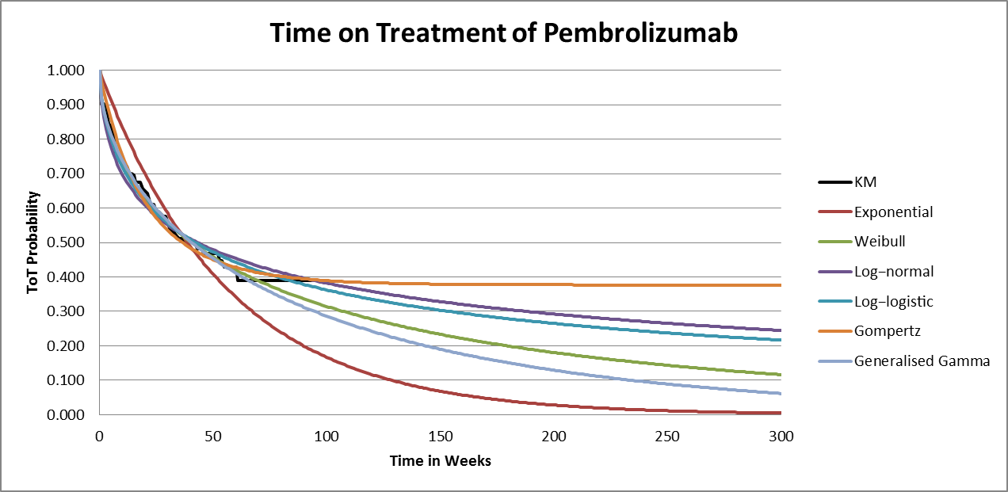
ToT, time on treatment;
Electronic Supplementary Material 2.2: ToT standard parametric functions fitting in the SoC arm
 | ToT Models for SoC
Model | AIC | BIC
Exponential | 1127.9 | 1130.9
Weibull | 1127.5 | 1133.6
LogNormal | 1186 | 1192
LogLogistic | 1169.3 | 1175.3
Gompertz | 1128.7 | 1134.7
GenGamma | 1115.3 | 1124.3
AIC: Akaike information criterion. BIC: Bayesian information criterion
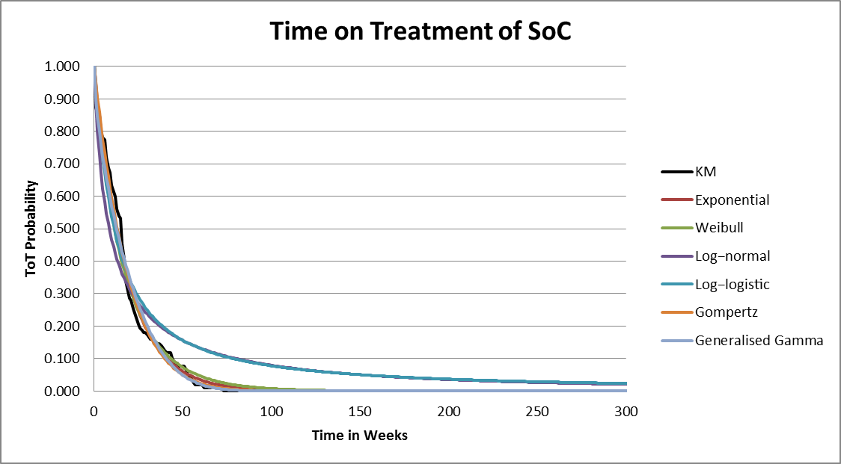
ToT, time on treatment; SoC, standard-of-care
Electronic Supplementary Material 2.3: Modeled Base Case ToT Curves in 20 year time horizon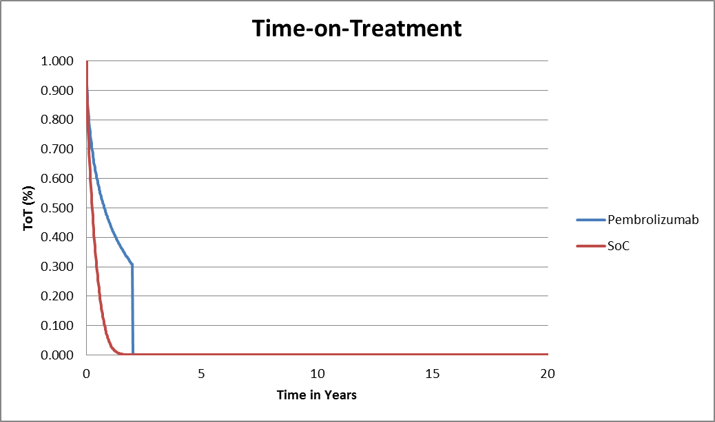

Electronic Supplementary Material 3: Modeled PFS from KEYNOTE-024 for Pembrolizumab and SoC Arms

Electronic Supplementary Material 3.1. PFS standard parametric functions fitting in the pembrolizumab arm
 | PFS Models for pembrolizumab, week 9+
Model | AIC | BIC
Exponential | 430.1 | 432.8
Weibull | 424.1 | 429.6
LogNormal | 427.3 | 432.8
LogLogistic | 425.4 | 430.9
Gompertz | 430.1 | 435.6
GenGamma | 425.3 | 433.5
AIC: Akaike information criterion. BIC: Bayesian information criterion
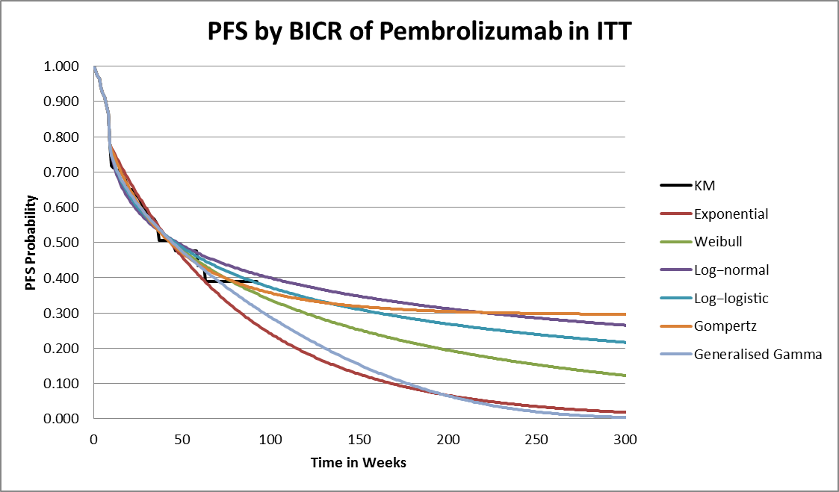
BICR, blinded independent central review; ITT, intention-to-treat; PFS, progression-free survival;

Electronic Supplementary Material 3.2. PFS standard parametric functions fitting in the SoC arm
 | PFS Models for SoC, week 9+
Model | AIC | BIC
Exponential | 718 | 720.8
Weibull | 719.4 | 724.9
LogNormal | 749.2 | 754.7
LogLogistic | 735.1 | 740.6
Gompertz | 719 | 724.4
GenGamma | 714.4 | 722.6
AIC: Akaike information criterion. BIC: Bayesian information criterion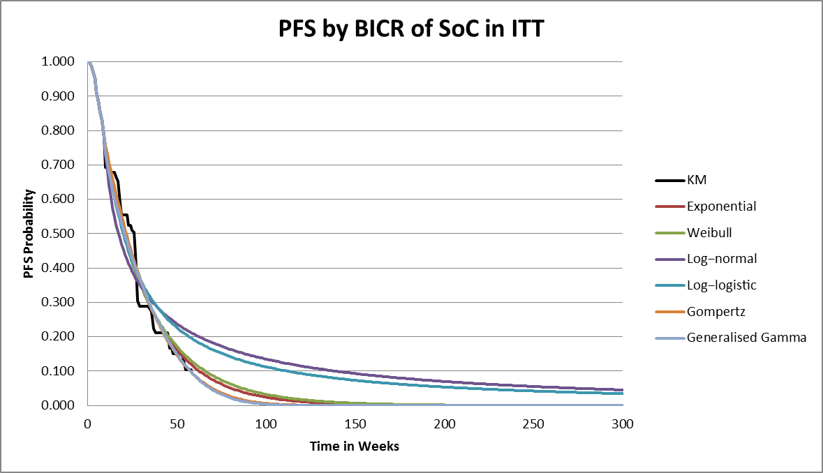
BICR, blinded independent central review; ITT, intention-to-treat; PFS, progression-free survival; SoC, standard-of-care
Electronic Supplementary Material 3.3: Modeled Base Case PFS Curves in 20 year time horizon
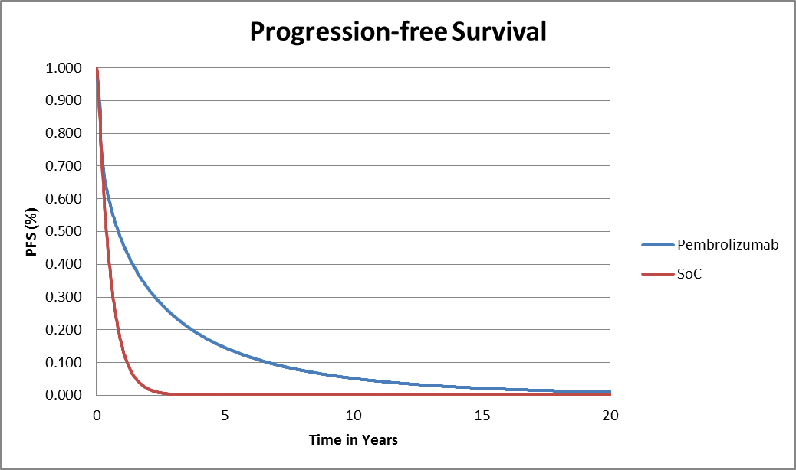

Electronic Supplementary Material 4: Modeled OS for Pembrolizumab and SoC Arms
Electronic Supplementary Material 4.1. OS standard parametric functions fitting in the pembrolizumab arm
 | OS Models for pembrolizumab
Model | AIC | BIC
Exponential | 523.9 | 527
Weibull | 525.6 | 531.7
LogNormal | 525.1 | 531.1
LogLogistic | 525 | 531
Gompertz | 524.8 | 530.9
GenGamma | 526.8 | 535.9
32 weeks KM+exponential | 115.8 | 118.5
AIC: Akaike information criterion. BIC: Bayesian information criterion
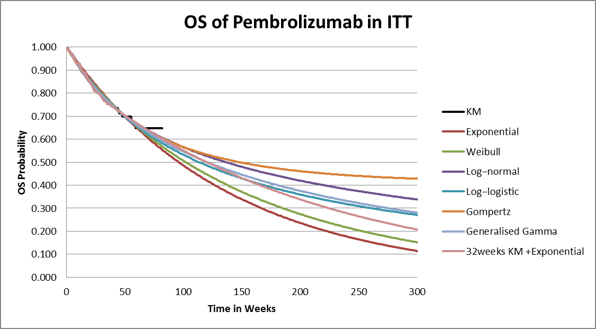
ITT, intention-to-treat; OS, overall survival;
Electronic Supplementary Material 4.2. OS standard parametric functions fitting in the SoC arm
 | OS Models for SoC
Model | AIC | BIC
Exponential | 696.2 | 699.2
Weibull | 698.2 | 704.3
LogNormal | 694 | 700.1
LogLogistic | 696.3 | 702.3
Gompertz | 697.4 | 703.5
GenGamma | 695.6 | 704.7
38 weeks KM+exponential | 94.6 | 96.8
AIC: Akaike information criterion. BIC: Bayesian information criterion
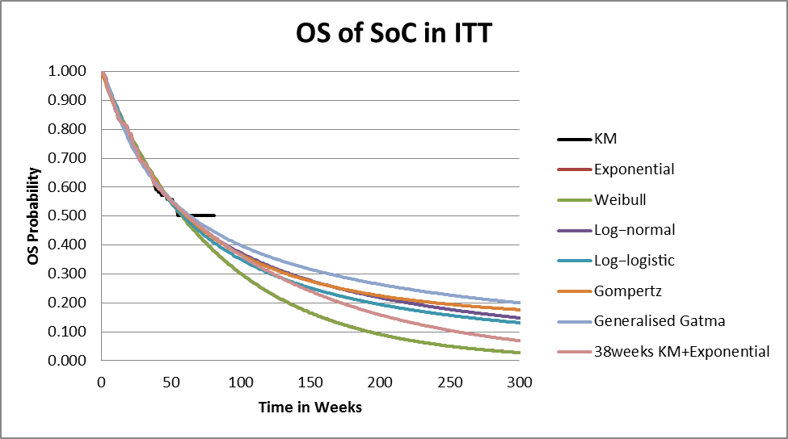
ITT, intention-to-treat; OS, overall survival; SoC, standard-of-care
Electronic Supplementary Material 3.3: Modeled Base Case OS Curves in 20 year time horizon
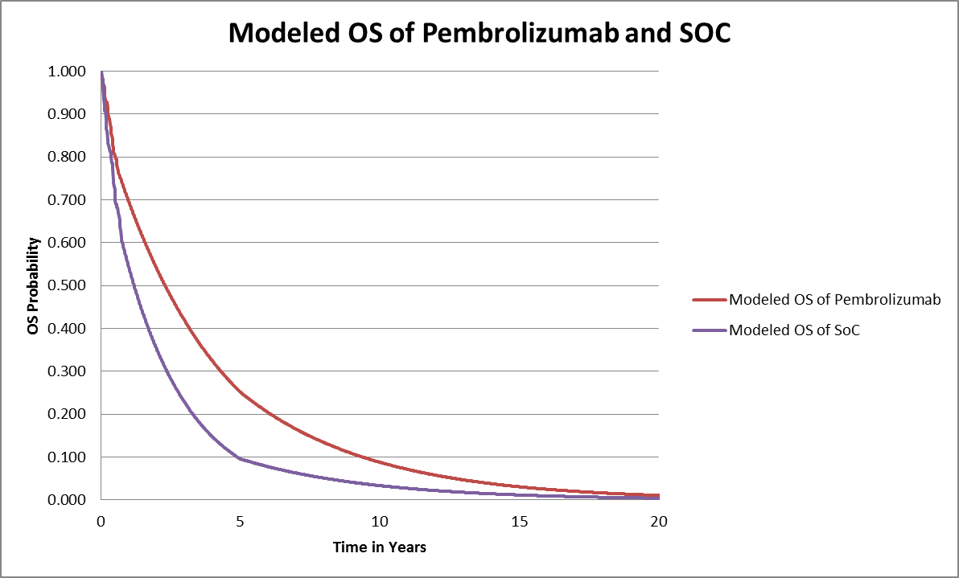
ITT, intention-to-treat; OS, overall survival; SoC, standard-of-care

Electronic Supplementary Material 5: Validation of Modeled OS in the SOC Group with Flatiron Data
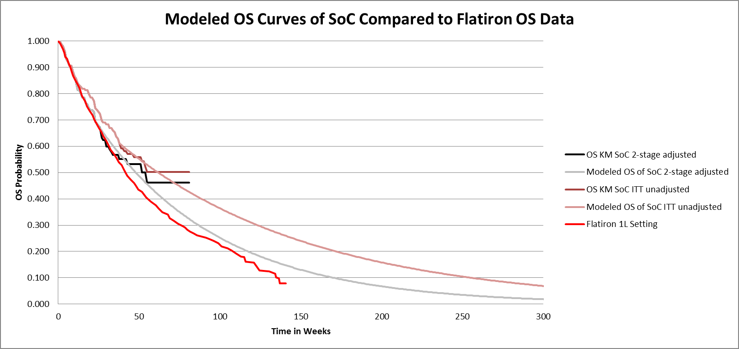
OS, overall survival; SoC, standard-of-care

Electronic Supplementary Material 6: Sensitivity Analysis Parameters
Model Parameter | Base-Case Value | PSA Distribution Model | DSA Range
PFS - pembrolizumab | KM9+ Weibull onwards | Random numbers generated from multivariate normal distribution model | 95% CI limits of the parameter estimates in the Weibull function
PFS - SoC | KM9+ exponential onwards | Random numbers generated from normal distribution model | 95% CI limits of the parameter estimates in the exponential function
ToT - pembrolizumab | Weibull model | Random numbers generated from multivariate normal distribution model | 95% CI limits of the parameter estimates in the Weibull function
ToT - SoC | Generalized gamma model | Random numbers generated from multivariate normal distribution model | 95% CI limits of the parameter estimates in the Generalized gamma function
OS - pembrolizumab | KM32+exponential model | Random numbers generated from normal distribution model | 95% CI limits of the parameter estimate in the exponential function
OS – SoC | KM38+exponential model | Random numbers generated from normal distribution model | 95% CI limits of the parameter estimate in the exponential function
Utilities | Based on KEYNOTE-024 trial data | Beta distributions using the mean and standard error (SE) estimated from the KN024 trial | +/- 20%
Disease management cost in PF - pembrolizumab | $772/week | Lognormal distribution with the SE set at 20% of the base-case value | +/- 25%
Disease management cost in PF - SoC | $1,158/week | Lognormal distribution with the SE set at 20% of the base-case value | +/- 25%
Disease management cost in PD | $1,791/week | Lognormal distribution with the SE set at 20% of the base-case value | +/- 25%
Cost of subsequent active therapies - pembrolizumab | $11,084 | Lognormal distribution with the SE set at 20% of the base-case value | +/- 25%
Cost of subsequent active therapies - SoC | $27,989 | Lognormal distribution with the SE set at 20% of the base-case value | +/- 25%
Death-related cost | $31,114 | Lognormal distribution with the SE set at 20% of the base-case value | +/- 25%
AE management cost - pembrolizumab | $521 | Lognormal distribution with the SE set at 20% of the base-case value | +/- 50%
AE management cost - SoC | $2,334 | Lognormal distribution with the SE set at 20% of the base-case value | +/- 50%
AE, adverse event; CI, confidence interval; DSA, deterministic sensitivity analysis; KM, Kaplan-Meier; OS, overall survival; PD, progressive disease; PF, progression-free; PFS, progression-free survival; PSA, probabilistic sensitivity analysis; SE, standard error; SoC, standard of care; ToT, time on treatment

Electronic Supplementary Material 7: Cost-Effectiveness of Pembrolizumab versus SoC with Switching Adjustment
 | SoC | Pembrolizumab | Incremental pembrolizumab vs. SoC
Life years | 1.42 | 3.35 | 1.94
Expected time in progression free state (years) | 0.55 | 2.16 | 1.62
Expected time in progressive state (years) | 0.87 | 1.19 | 0.32
Quality-adjusted life-years | 1.04 | 2.60 | 1.55
Costs | $185,160 | $362,662 | $177,503
Drug acquisition cost | $25,090 | $120,478 | $95,388
Pre-medication cost | $328 | $0 | -$328
Drug administration cost | $1,683 | $3,854 | $2,171
Disease management cost | $114,451 | $198,458 | $84,006
Post-discontinuation therapy cost | $11,084 | $11,084 | $0
Terminal care cost | $30,190 | $28,268 | -$1,922
Adverse event cost | $2,334 | $521 | -$1,813
Incremental cost-effectiveness ratio
Cost per life-year gained |  |  | $91,658
Cost per quality-adjusted life-year gained |  |  | $114,194
PD-L1, programmed-death ligand 1; SoC, standard-of-care

Electronic Supplementary Material 8: Effect of Different Parametric Functions to Extrapolate OS, PFS and ToT
Parameter Extrapolated | Alternative Distribution Models | ICER ($/QALY) | ICER ($/LY)
ToT Pembrolizumab | Generalized gamma | $96,033 | $77.070
ToT SoC | Exponential | $97,002 | $77,847
PFS Pembrolizumab | 9-week KM + Log logistic | $69,127 | $55,477
PFS SoC | 9-week KM + Generalized Gamma | $96,487 | $77,434
OS Pembrolizumab | Log-logistic | $99,784 | $80,151
OS SoC | Log-normal | $90,347 | $72,222
ICER, incremental cost-effectiveness ratio; KM, Kaplan-Meier; OS, overall survival; PFS, progression-free survival; QALY, quality-adjusted life-year; SoC, standard of care; ToT, time on treatment

