Cost effectiveness of secukinumab for the treatment of active psoriatic arthritis in the UK

SUPPLEMENTARY INFORMATION
Vanessa Buchanan^{1*}; Will Sullivan¹; Chris Graham²; LaStella Miles²; Steffen Jugl³; Praveen Gunda⁴; Anna Halliday⁵; Bruce Kirkham^{6,7}
¹BresMed Health Solutions, Sheffield, UK; ²RTI Health Solutions, Research Triangle Park, NC, USA; ³Novartis Pharma AG, Basel, Switzerland; ⁴Novartis Healthcare Private Limited, Hyderabad, India; ⁵Novartis Pharmaceuticals UK Limited, Camberley, UK; ⁶Guy's and St Thomas' NHS Foundation Trust, London, UK; ⁷King’s College London, London, UK
* VB is formerly of BresMed Health Solutions and was affiliated with this organisation at the time of study
Correspondence to: anna.halliday@novartis.com
+44 1276 698655

Table 4 Clinical parameter inputs used in the model
- PsARC response and PASI distribution at three months
 | Proportion of responders |  |  |  |  | Source
 | PsARC | PASI <50 | PASI 50–74 | PASI 75–89 | PASI 90–99 | Source
1 prior csDMARD
SEC | 71.40%  (60.40, 80.50) | 28.00% | 28.00% | 16.00% | 28.00% | Based on FUTURE 2 post hoc subgroup analysis
SoC | 44.80%  (34.40, 55.80) | 86.96% | 4.35% | 0.00% | 8.70% | Based on FUTURE 2 post hoc subgroup analysis
≥2 prior csDMARDs
SEC | 80.02%  (53.71, 93.26) | 18.57% | 18.89% | 24.97% | 37.56% | Based on the results of the network meta-analysis
ADA | 57.54%  (44.72, 69.42) | 29.47% | 21.91% | 23.51% | 25.11% | Based on the results of the network meta-analysis
CZP | 75.53%  (57.05. 87.77) | 55.33% | 20.73% | 15.00% | 8.94% | Based on the results of the network meta-analysis
ETN | 76.07%  (63.44, 85.35) | 55.98% | 20.59% | 14.76% | 8.67% | Based on the results of the network meta-analysis
GOL | 66.64%  (39.08, 86.15) | 37.52% | 22.59% | 21.29% | 18.61% | Based on the results of the network meta-analysis
INF | 75.34%  (62.62, 84.79) | 12.19% | 15.52% | 24.09% | 48.21% | Based on the results of the network meta-analysis
PASI values do not include the placebo adjustment. The placebo adjustment consisted of a reduction in PASI scores for secukinumab in the 1 prior csDMARD subpopulation and for each biologic in the ≥2 prior csDMARDs subpopulation based on the PASI distribution amongst placebo patients in the FUTURE 2 post hoc subgroup analysis and network-meta analysis (1 prior csDMARD = PASI <50: 86.96%; PASI 50–74: 4.35%; PASI 75–89: 0%; PASI 90–99: 8.70%; PASI 100: 0%; ≥2 prior csDMARDs = PASI <50: 88.29%; PASI 50–74: 7.82%; PASI 75–89: 3.07%; PASI 90–99: 0.82%; PASI 100: 0%). Values in brackets represent 95% confidence intervals (or credible intervals if derived from the network meta-analysis).

ADA: adalimumab; CZP: certolizumab pegol; csDMARD: conventional systemic disease-modifying anti-rheumatic drug; ETN: etanercept; GOL: golimumab; INF: infliximab; PASI: Psoriasis Area Severity Index; PsARC: Psoriatic Arthritis Response Criteria; SEC: secukinumab; SoC: Standard of Care.
- Changes in HAQ over time conditional on PsARC response
Intervention | Change in HAQ given PsARC response | Source
1 prior csDMARD
SEC | -0.600  (-0.704, -0.496) | FUTURE 2 post hoc subgroup analysis
SoC | -0.420  (-0.753, -0.087) | FUTURE 2 post hoc subgroup analysis
≥2 prior csDMARDs
SEC | -0.539  (-0.635, -0.443) | FUTURE 2
ADA | -0.490  (-0.580, -0.400) | Cawson (2014) [1]
CZP | -0.558  (-0.677, -0.438) | Average of TNFis
ETN | -0.640  (-0.770, -0.510) | Cawson (2014) [1]
GOL | -0.440  (-0.590, -0.290) | Cawson (2014) [1]
INF | -0.660  (-0.770, -0.550) | Cawson (2014) [1]
Values do not include the placebo adjustment. The placebo adjustment consisted of a reduction of 0.188 in the change in HAQ given a PsARC response for secukinumab in the 1 prior csDMARD subpopulation and 0.110 for each biologic in the ≥2 prior csDMARDs subpopulation. These values were based on the proportion of patients achieving a PsARC response at three months and the change in HAQ given a PsARC response amongst placebo patients in the FUTURE 2 trial and post hoc subgroup analyses. Values in brackets represent 95% confidence intervals. Patients that did not achieve a PsARC response were modelled to experience a steady, linear increase in their HAQ score (0.018 per cycle) from baseline HAQ until either death or a HAQ score of three.

ADA: adalimumab; CZP: certolizumab pegol; csDMARD: conventional systemic disease-modifying anti-rheumatic drug; ETN: etanercept; GOL: golimumab; HAQ: Health Assessment Questionnaire; INF: infliximab; PsARC: Psoriatic Arthritis Response Criteria; SEC: secukinumab; SoC: Standard of Care; TNFis: tumour necrosis factor inhibitors.
- Probability of serious infection with biologics (every three months)
Probability of event (every three months) | SEC | ADA | CZP | ETN | GOL | INF
Serious infection | 0.35% | 0.70% | 0.79% | 0.44% | 0.34% | 0.48%
Source | McInnes (2015) [2] | Burmester (2013) [3] | Mease (2014) [4] | Sterry (2010) [5] | Kavanaugh (2012) [6] | Torii (2010) [7]
The probability of serious infection was assumed to be 0.00% for SoC.
Five percent of all serious infections were assumed to be tuberculosis, with the remaining 95% being comprised of other serious infections [8].

ADA: adalimumab; CZP: certolizumab pegol; ETN: etanercept; GOL: golimumab; INF: infliximab; SEC: secukinumab; SoC: Standard of Care.

Table 5 Network meta-analysis
A systematic review of relevant clinical evidence used to inform the NMA was originally conducted in 2014 and was updated in November 2015. Searches were conducted using the electronic databases, MEDLINE and MEDLINE In-Process (using PubMed platform), Embase (using Elsevier Platform), Biosciences Information Services (using Dialog platform) and the Cochrane Library, including the Cochrane Central Register of Controlled Trials, the Cochrane Database of Systematic Reviews, and Database of Abstracts of Reviews of Effectiveness. In addition, internet searches were conducted to identify relevant evidence presented at selected conferences (ACR annual meeting; EULAR annual meeting; World Psoriasis and Psoriatic Arthritis Conference). ClinicalTrials.gov and the International Clinical Trials Registry Platform were also searched to identify any ongoing, discontinued or completed clinical trials of relevance. Reference lists of any relevant systematic reviews and/or meta-analyses identified in the search were also hand-searched for further studies of interest.
Articles were screened in a two-stage process. Firstly, the title/abstract of all identified articles were screened using eligibility criteria which defined relevance in terms of the population, intervention, comparators, outcomes and study design. For those articles that were considered to be of potential relevance, the full-text article was acquired and subjected to a second review, again using the same eligibility criteria. Both review stages were completed by two researchers in parallel, with any discrepancies resolved by consensus. In the combined review (2014 original and 2015 update), of the 1,782 articles that were included in the review (once duplicates had been removed), 1,447 were excluded during the title/abstract review and 207 were excluded during the full-text review. In total, 128 articles were included in the combined systematic review, representing 29 unique randomised controlled trials. Of these, 19 unique studies were identified that reported outcomes that could be used to inform the NMA (see table below). Notably, FUTURE 1 was excluded from the analysis in order to assess the relative efficacy of secukinumab according to the licensed dosing regimen. Other trials excluded from the network meta-analysis are presented below along with the reasons for exclusion.
- Included studies in the network meta-analysis
Trial | Primary reference | Intervention | PASI 50 | PASI 75 | PASI 90 | PsARC
ADEPT | Mease 2005 [9] | ADA40  Placebo | Week 12 | Week 12 | Week 12 | Week 12
CLEAR  (sub-analysis)* | Gottlieb 2015 [10] | SEC300  UST45_90 | - | - | Week 16 | -
ERASURE  (sub-analysis)* | Gottlieb 2013 [11]  Gottlieb 2015 [12] | SEC150  SEC300  Placebo | - | Week 12 | Week 12 | -
FIXTURE  (sub-analysis)* | Gottlieb 2015 [13] | ETN50BIW  SEC150  SEC300  Placebo | - | Week 12 | Week 12 | -
FUTURE 2 | McInnes 2015 [2] | SEC150  SEC300  Placebo | Week 12;  Week 16 | Week 12 | Week 12 | Week 12;  Week 16
Genovese (2007) | Genovese 2007 [14] | ADA40  Placebo | - | - | - | Week 12
GO-REVEAL | Kavanaugh 2009 [15] | GOL50  GOL100  Placebo | Week 12;  Week 16 | Week 12;  Week 16 | Week 12;  Week 16 | Week 14
IMPACT | Antoni 2005 [16] | INF5  Placebo | Week 16 | Week 16 | Week 16 | Week 16
IMPACT2 | Antoni 2005 [16] | INF5  Placebo | Week 14 | Week 14 | Week 14 | Week 14
Mease (2000) | Mease 2000 [17] | ETN25BIW  Placebo | Week 12 | Week 12 | - | Week 12
Mease (2004) | Mease 2004 [18] | ETN25BIW  Placebo | - | - | - | Week 12
PALACE1 | Kavanaugh 2014 [19] | APR20  APR30  Placebo | Week 16 | Week 16 | - | Week 16
PALACE2 | Kavanaugh 2014 [20] | APR20  APR30  Placebo | Week 16 | Week 16 | - | Week 16
PALACE3 | Birbara 2013 [21] | APR20  APR30  Placebo | Week 16 | Week 16 | - | Week 16
PRESTA | Sterry 2010 [5] | ETN50BIW  ETN50QW | - | Week 12 | - | Week 12
PSUMMIT1 | McInnes 2013 [22] | UST45  UST90  Placebo | - | - | - | -
PSUMMIT2 | Ritchlin 2014 [23] | UST45  UST90  Placebo | - | - | - | -
RAPID-PSA | Mease 2014 [4] | CZP400_200  CZP400_400  Placebo | Week 12 | Week 12 | Week 12 | -
Schett (2012) | Schett 2012 [24] | APR20  APR40  Placebo | - | - | - | Week 12
* Sub-analysis of psoriasis trials in which only the sub-population of patients with PsA were included.

ADA: adalimumab; APR: apremilast; BIW: twice weekly; CZP400_(400 or 200): certolizumab pegol 400 mg loading dose followed by 400 mg or 200 mg maintenance dose; ETN: etanercept; GOL: golimumab; INF: infliximab; PASI: Psoriasis Area Severity Index; PsARC: Psoriatic Arthritis Response Criteria; QW: once weekly; SEC: secukinumab; UST: ustekinumab.

- Excluded studies from the network meta-analysis
Study name | Active treatment(s) | Reason for exclusion
Behrens 2014 [25] | Adalimumab | Observational study
Gottlieb 2009 [26] | Ustekinumab | Mixture of dosage, including non-standard 63 mg
FUTURE 1 [27] | Secukinumab | Unlicensed loading dose of secukinumab
Mease 2014 [28] | Secukinumab | Unlicensed dose of secukinumab
PALACE4 [29] | Apremilast | Includes patients who have not previously failed csDMARDS
RESPOND [30] | Infliximab | Includes patients who have not previously failed csDMARDS
Saougou 2011 [31] | Adalimumab, etanercept and infliximab | Observational study
SPIRIT-P1 [32] | Ixekizumab, adalimumab | Ixekizumab was not approved for treatment at the time of the analysis
Torii 2010 [33] | Infliximab | Study based on only 3 patients per arm
van Kuijk 2009 [34] | Adalimumab | Does not connect for endpoint due to lack of placebo data
csDMARD: conventional systemic disease-modifying anti-rheumatic drug.
Based on data reported from the included articles, PsARC and PASI (≥50, 75, or 90) responses included in the NMA were based on outcomes assessed between Weeks 12 to 16, with those reported at 12 weeks favoured over 16-week results, and both 12- and 16-week results favoured over 14-week results. This hierarchy was principally based on frequency of reporting so as to minimise the variance in time points used; the preference for 12-week results also aligns with the use of a three-month induction period in the model.
For each outcome (PsARC and PASI), analyses were performed in a Bayesian framework and a random effects model was preferred to a fixed effects model for both outcomes. Competing models tended to be comparable with respect to goodness-of-fit. However, due to between-trial variability in potential effect modifiers (e.g. duration of PsA, the number of tender and swollen joints, gender proportions, and the way in which trial discontinuations were analysed), random effects models were considered more appropriate. For PsARC a random effects model using a baseline adjustment for placebo effects was used in order to account for the large discrepancies between trials in the placebo response rates for this outcome.
It was not possible to construct networks for populations based on the number of prior csDMARDs due to the lack of published data for these subpopulations and so the overall trial populations were used instead. A total of 13 and 14 trials informed the networks for PsARC and PASI responses, respectively, at Weeks 12 to 16, using the overall trial populations. Networks were sparser when only considering data from TNFi-naïve subgroups and did not include all relevant comparators, for example certolizumab pegol was omitted from the network for PsARC and both certolizumab pegol and etanercept were omitted from the network for PASI.
A similar NMA has been published by McInnes et al. [35].

Table 6 Derivation of utility values
Baseline utility in the model was 0.479 for all subpopulations and was based on EuroQol 5-Dimensions (3-Level; EQ-5D-3L) data from all patients included in FUTURE 2.
Patient-level data from the Week 24 analysis of FUTURE 2 was also used to fit a linear mixed model in which EQ-5D utility was considered as a response variable and PASI and HAQ as predictor variables. Linear models were also employed in previous cost-effectiveness analysis in the UK [36, 37]. Due to the inclusion of PASI in the model the analysis was conducted using observed data from the psoriasis subset (n=192; psoriasis ≥3% body surface area at baseline). Treatment was not considered as a predictor in the model. The effect of correlation within the data was explored using subject as a random effect to account for the within-subject correlation between assessments and convergence was met. EQ-5D utility baseline scores, time (post-baseline analysis visits up to Week 24), age, sex, disease duration, and stratification factor (previous TNFi therapy) were used as covariates and were included in the model as fixed effects. The inclusion of baseline characteristics in the linear model in addition to HAQ and PASI was seen to improve the model fit compared to PASI and HAQ only (Akaike information criterion [AIC]: -782.3 on inclusion of baseline characteristics versus -710.2 PASI and HAQ only).
For the cost-effectiveness model the non-significant parameters (time since first PsA diagnosis and analysis week) were not included. A linear mixed model was also conducted with an interaction term for HAQ × PASI, however, the interaction between HAQ and PASI was not found to be significant (p=0.2966) and so was not included in the model used in the cost-effectiveness analysis.

Parameter | Estimate (SE) | 95% CI
Intercept | 0.839 (0.0466) | 0.747, 0.931
PASI total score | -0.002 (0.0012) | -0.004, 0.000
HAQ score | -0.172 (0.0154) | -0.202, -0.141
Baseline EQ-5D | 0.210 (0.0360) | 0.140, 0.281
TNFi status
Inadequate responder | -0.008 (0.0208) | -0.049, 0.033
Naïve | Reference
Sex
Male | -0.019 (0.0202) | -0.059, 0.021
Female | Reference
Age (years) | -0.003 (0.0008) | -0.004, -0.001
Time since PsA diagnosis (years) | 0.000 (0.0012) | -0.002, 0.002
Analysis week
Week 4 | -0.005 (0.0145) | -0.034, 0.023
Week 8 | -0.005 (0.0137) | -0.032, 0.022
Week 12 | -0.009 (0.0135) | -0.036, 0.017
Week 16 | 0.002 (0.0135) | -0.025, 0.028
Week 24 | Reference

CI: confidence intervals; EQ-5D: EuroQoL 5-Dimensions; HAQ: Health Assessment Questionnaire; PASI: Psoriasis Area Severity Index; PsA: psoriatic arthritis; SE: standard error; TNFi: tumour necrosis factor inhibitor.

Table 7 Cost and resource use inputs used in the model
Cost category | Unit cost | Frequency |  |  | References
Cost category | Unit cost | First 3 months | Months 4–6 | Subs 3-month periods | References
Drug acquisition (list price) |  |  |  |  | Summary of Product Characteristics [38-43]  Monthly Index of Medical Specialties (searched 2017)  No vial sharing was assumed for the administration of infliximab
SEC 150 mg s.c. | £609.39 | 7.00 | 3.00 | 3.00
ADA 40 mg s.c. | £352.14 | 7.00 | 6.00 | 6.52
CZP 200 mg s.c. | £357.50 | 10.00 | 6.00 | 6.52
ETN 50 mg s.c. | £178.75 | 13.00 | 13.00 | 13.04
(biosimilar) | (£164.00)
GOL 50/100 mg s.c.ª | £958.31 | 3.00 | 3.00 | 3.00
INF 100 mg i.v. | £419.62 | 3.00 | 2.00 | 1.63
(biosimilar) | (£377.66)
Methotrexate 25 mg (SoC) | £0.95 | 7.00 | 3.00 | 3.00
Administration
s.c. | £35.00 | First administration only |  |  | Cost of ½ hour training with specialist community nurse, incl. qualifications [44]
i.v. | £328.10 | Per administration |  |  | SB15Z – Day case; deliver subsequent elements of a chemotherapy cycle [45]
Monitoring
Medical visits (s.c. only) |  |  |  |  | NHS reference costs 2015/16 [45]
Outpatient  (rheumatology clinic) | £137.04 | 1.00 | 1.00 | 0.5 | WF01A – Rheumatology consultant-led non-admitted face to face attendance, follow-up
Laboratory tests (all biologics)^{b} |  |  |  |  | NHS reference costs 2015/16 [45]; Rodgers et al. [36]
Full blood count | £3.03 | 2.00 | 0.50 |  | DAPS05 – Haematology
ESR | £3.00 | 2.00 | 0.50 |  | DAPS05 – Haematology
Liver function test | £0.76 | 2.00 | 0.50 |  | DAPS04 – Clinical biochemistry
Urea and electrolytes | £1.40 | 2.00 | 0.50 |  | DAPS04 – Clinical biochemistry
Chest radiograph | £26.58 | 1.00 | 0.00 |  | WF01B – Diagnostic imaging, first attendance
TB heaf test | £8.86 | 1.00 | 0.00 |  | DZ42Z – TB nurse support
Antinuclear antibodies | £4.72 | 1.00 | 0.00 |  | DAPS06 – immunology
DNA double-stranded test | £4.72 | 1.00 | 0.00 |  | DAPS06 – immunology
Disease-related costs
Intercept | £255.78 | Per 3 months |  |  | Based on the costs reported in Rodgers et al., with costs inflated from 2008/09 using the Hospital and Community Health Services Index in the PSSRU Unit Costs of Health and Social Care (2015) [36, 44]
Cost per HAQ change | £113.07 | Per 1-unit change per 3 months
Health states
Uncontrolled psoriasis  (PASI <75) | £217.36 | Per 3 months
Controlled psoriasis (PASI >75) | £17.56 | Per 3 months
Adverse event costs |  |  |  |  | NHS reference costs 2015/16 [45]
TB | £2,813.20 | Per event |  |  | DZ14F, DZ14G, DZ14H and DZ14J^{c}
Other serious infection | £1,259.80 | Per event |  |  | WJ06J, DZ23N, DZ22Q and DZ65J^{c}
ª Golimumab 50 mg and 100 mg are recommended for patients with body weight <100 kg and ≥100 kg, respectively. The unit cost for golimumab was calculated based on the unit cost for golimumab 50 mg (£762.97) and 100 mg (£1,525.94) weighted by the proportion of patients expected to be ≥100 kg (25.6%). This proportion was calculated from a normal distribution around the mean body weight used in the model.
^{b} Only the laboratory tests required in the subsequent three-month periods are applied for SoC, as these tests will already be standard for treatment with csDMARDs.
^{c} Based on weighted average of costs associated with the relevant Healthcare Resource Group codes.

ADA: adalimumab; CZP: certolizumab pegol; csDMARD: conventional systemic disease-modifying anti-rheumatic drug; DNA: deoxyribonucleic acid; ESR: erythrocyte sedimentation rate; ETN: etanercept; GOL: golimumab; INF: infliximab; i.v.: intravenous; NHS: National Health Service; NMA: network meta-analysis; s.c.: subcutaneous; SEC: secukinumab; SoC: Standard of Care; Subs: subsequent; TB: tuberculosis.

Table 8 Sensitivity analysis inputs
Model inputs were varied in one-way sensitivity analyses and probabilistic sensitivity analyses based on the following, with full details provided in tables below:
- PsARC and PASI responses were varied based on 95% confidence intervals (one-way sensitivity analysis; PsARC only) or using standard errors (Normal distribution; probabilistic sensitivity analysis)
- Changes in HAQ with or without a PsARC response were varied based on the 95% confidence intervals (one-way sensitivity analysis) or using standard errors (Gamma distribution; probabilistic sensitivity analysis)
- Adverse event rates were varied by ±20% (one-way sensitivity analysis) or using standard errors assumed to be 20% of the model input values (Beta distribution; probabilistic sensitivity analysis)
- Utility weights were varied based on the 95% confidence intervals (one-way sensitivity analysis) and were varied using a multivariate normal distribution for the probabilistic sensitivity analysis to account for correlation between utility weights
- Cost parameters were varied by ±20% (one-way sensitivity analysis) or using standard errors assumed to be 20% of the model input values (Gamma distribution; probabilistic sensitivity analysis)
- Mortality relative risks were varied by ±20% (one-way sensitivity analysis) or using standard errors assumed to be 20% of the model input values (Lognormal distribution; probabilistic sensitivity analysis)
Table 8 continued
 |  | One-way SA |  | Probabilistic SA
Parameter | Model input | Lower bound | Upper bound | Distribution | Log Odds | Log Odds s.e.
PsARC response
1 prior csDMARD
3-month PsARC response - SEC 150 | 71.40% | 60.40% | 80.50% | Normal | 0.9149 | 0.2540
3-month PsARC response - SoC | 44.80% | 34.30% | 55.80% | Normal | -0.2088 | 0.2253
≥2 prior csDMARDs
3-month PsARC response - SEC 150 | 80.02% | 53.71% | 93.26% | Normal | 2.3341 | 0.6321
3-month PsARC response - CER P | 75.53% | 57.05% | 87.77% | Normal | 2.0735 | 0.4303
3-month PsARC response - ETN | 76.07% | 63.44% | 85.35% | Normal | 2.1030 | 0.3090
3-month PsARC response - ADA | 57.54% | 44.72% | 69.42% | Normal | 1.2503 | 0.2633
3-month PsARC response - INF | 75.34% | 62.62% | 84.79% | Normal | 2.0634 | 0.3067
3-month PsARC response - GOL | 66.64% | 39.08% | 86.15% | Normal | 1.6382 | 0.5794
3-month PsARC response - SoC | 27.96% | 25.25% | 30.85% | Normal | -0.9464 | 0.0710

Table 8 continued
 |  | One-way SA |  | Probabilistic SA
 | Model input | Lower bound | Upper bound | Distribution | s.e. | alpha | beta
Baseline HAQ | 1.209 |  |  | Not varied
Baseline PASI | 7.304 |  |  | Not varied
HAQ change
1 prior csDMARD
HAQ change w/ PsARC response - SEC 150 | -0.600 | -0.496 | -0.704 | Gamma | 0.0530 | 128.1595 | 0.0047
HAQ change w/ PsARC response - SoC | -0.420 | -0.087 | -0.753 | Gamma | 0.1700 | 6.1038 | 0.0688
HAQ change w/out PsARC response - SEC 150 | -0.100 | 0.051 | -0.251 | Gamma | 0.0000 | 0.0000 | 0.0000
≥2 prior csDMARDs
HAQ change w/ PsARC response - SEC 150 | -0.539 | -0.443 | -0.635 | Gamma | 0.0569 | 89.7332 | 0.0060
HAQ change w/ PsARC response - CER P | -0.558 | -0.438 | -0.677 | Gamma | 0.0612 | 82.9162 | 0.0067
HAQ change w/ PsARC response - ETN | -0.640 | -0.510 | -0.770 | Gamma | 0.0663 | 93.1077 | 0.0069
HAQ change w/ PsARC response - ADA | -0.490 | -0.400 | -0.580 | Gamma | 0.0459 | 113.8726 | 0.0043
HAQ change w/ PsARC response - INF | -0.660 | -0.550 | -0.770 | Gamma | 0.0561 | 138.2976 | 0.0048
HAQ change w/ PsARC response - GOL | -0.440 | -0.290 | -0.590 | Gamma | 0.0765 | 33.0548 | 0.0133
HAQ change w/out PsARC response - SEC 150 | -0.266 | -0.131 | -0.463 | Gamma | 0.1007 | 6.9776 | 0.0381
HAQ change w/out PsARC response - CER P | -0.150 | -0.028 | -0.272 | Gamma | 0.0625 | 5.7600 | 0.0260
HAQ change w/out PsARC response - ETN | -0.200 | -0.050 | -0.350 | Gamma | 0.0765 | 6.8295 | 0.0293
HAQ change w/out PsARC response - ADA | -0.140 | -0.030 | -0.240 | Gamma | 0.0536 | 6.8295 | 0.0205
HAQ change w/out PsARC response - INF | -0.200 | -0.080 | -0.310 | Gamma | 0.0587 | 11.6192 | 0.0172
HAQ change w/out PsARC response - GOL | -0.060 | 0.060 | -0.180 | Gamma | 0.0612 | 0.9604 | 0.0625
HAQ change after long-term biologic withdrawal | 0.018 | 0.007 | 0.034 | Gamma | 0.0070 | 6.6122 | 0.0027
Yr 1 discontinuation rate | 14.0% | 9.0% | 19.9% | Beta | 0.0280 | 21.3600 | 131.2114
Yr 2 discontinuation rate | 7.2% | 4.7% | 10.3% | Beta | 0.0144 | 23.1222 | 297.0327
Drug acquisition cost - SEC 150 | £609.39 | £609.39 | £609.39 | Not varied
Drug acquisition cost - CER P | £357.50 | £357.50 | £357.50 | Not varied
Drug acquisition cost - ETN | £178.75 | £164.00 | £164.00 | Not varied
Drug acquisition cost - ADA | £352.14 | £352.14 | £352.14 | Not varied
Drug acquisition cost - INF | £419.62 | £419.62 | £419.62 | Not varied
Drug acquisition cost - GOL 50mg | £762.97 | £762.97 | £762.97 | Not varied
Drug acquisition cost - GOL 100mg | £762.97 | £762.97 | £762.97 | Not varied
Drug acquisition cost - MTX | £0.95 | £0.95 | £0.95 | Not varied
Biosimilar cost ETN | £164.00 | £164.00 | £164.00 | Not varied
Biosimilar cost INF | £377.66 | £377.66 | £377.66 | Not varied
Cost equation intercept | £259.18 | £167.73 | £370.21 | Gamma | 51.8360 | 25.0000 | 10.3672
Cost per change in HAQ | £114.57 | £18.75 | £295.32 | Gamma | 72.9000 | 2.4701 | 46.3845
Cost for uncontrolled psoriasis | £220.25 | £201.46 | £239.86 | Gamma | 9.8000 | 505.0898 | 0.4361
Cost for controlled psoriasis | £17.80 | £15.71 | £20.02 | Gamma | 1.1000 | 261.7851 | 0.0680
Tuberculosis cost | £2,813.20 | £1,820.56 | £4,018.39 | Gamma | 562.6405 | 25.0000 | 112.5281
Infection cost | £1,259.80 | £815.28 | £1,799.50 | Gamma | 251.9600 | 25.0000 | 50.3920
IV administration cost | £328.10 | £212.33 | £468.66 | Gamma | 65.6200 | 25.0000 | 13.1240
Subcut administration cost | £35.00 | £22.65 | £49.99 | Gamma | 7.0000 | 25.0000 | 1.4000
Outpatient rheumatology cost | £137.04 | £88.69 | £195.75 | Gamma | 27.4080 | 25.0000 | 5.4816
Full blood count cost | £3.03 | £1.96 | £4.33 | Gamma | 0.6059 | 25.0000 | 0.1212
ESR cost | £3.00 | £1.94 | £4.28 | Gamma | 0.5993 | 25.0000 | 0.1199
Liver function test cost | £0.76 | £0.49 | £1.09 | Gamma | 0.1526 | 25.0000 | 0.0305
Urea and electrolytes cost | £1.40 | £0.91 | £2.01 | Gamma | 0.2809 | 25.0000 | 0.0562
Chest radiograph cost | £26.58 | £17.20 | £37.97 | Gamma | 5.3164 | 25.0000 | 1.0633
TB heaf test cost | £8.86 | £5.73 | £12.65 | Gamma | 1.7714 | 25.0000 | 0.3543
Antinuclear antibodies cost | £4.72 | £3.06 | £6.74 | Gamma | 0.9443 | 25.0000 | 0.1889
DNA test cost | £4.72 | £3.06 | £6.74 | Gamma | 0.9443 | 25.0000 | 0.1889
Infection probability - SEC 150 | 0.004 | 0.002 | 0.005 | Beta | 0.0007 | 24.9086 | 7061.4669
Infection probability - CER P | 0.008 | 0.005 | 0.011 | Beta | 0.0016 | 24.7945 | 3112.5612
Infection probability - ETN | 0.004 | 0.003 | 0.006 | Beta | 0.0009 | 24.8861 | 5656.8764
Infection probability - ADA | 0.007 | 0.005 | 0.010 | Beta | 0.0014 | 24.8186 | 3532.8970
Infection probability - INF | 0.005 | 0.003 | 0.007 | Beta | 0.0010 | 24.8743 | 5118.6874
Infection probability - GOL | 0.003 | 0.002 | 0.005 | Beta | 0.0007 | 24.9105 | 7212.3086
Infection probability - SoC | 0.000 | 0.000 | 0.000 | Beta | 0.0000
% of infection that is tuberculosis | 0.054 | 0.035 | 0.077 | Beta | 0.0108 | 23.5946 | 412.9054
PsA mortality relative risk - males | 1.650 | 1.112 | 2.448 | Log-normal | 0.2014
PsA mortality relative risk - females | 1.590 | 1.062 | 2.380 | Log-normal | 0.2058
% TNF non-responder | 0.350 | 0.220 | 0.493 | Beta | 0.0700 | 15.8974 | 29.5108
Baseline utility score | 0.479 | 0.294 | 0.667 | Not varied | 0.0958 | 12.5460 | 13.6461
Utility intercept - York model | 0.897 | 0.885 | 0.909 | Normal | 0.0060
Utility HAQ coefficient - York model | -0.298 | 0.286 | 0.310 | Normal | 0.0060
Utility PASI coefficient - York model | -0.004 | 0.003 | 0.003 | Normal | 0.0003
Infection disutility | 0.000 | 0.000 | 0.000 | Beta | 0.0000

Table 8 continued
 |  | One-way SA
 | Model input | Lower bound | Upper bound
FUTURE 2 utility weights
Intercept | 0.839 | 0.747 | 0.932
HAQ disability index score | -0.172 | -0.202 | -0.141
PASI total score | -0.002 | -0.004 | 0.000
EQ-5D coefficient | 0.210 | 0.140 | 0.281
TNFi status - Inadequate responder | -0.008 | -0.049 | 0.033
Gender - Male | -0.019 | -0.059 | 0.021
Age (years) | -0.003 | -0.004 | -0.001

Table 8 continued
 | Probabilistic SA | Covariance matrix
 | Distribution | Intercept | HAQ | PASI | EQ-5D base | TNFi status | Male | Age
FUTURE 2 utility weights
Intercept | Multivariate normal | 0.0022
HAQ disability index score | Multivariate normal | -0.0002 | 0.0002
PASI total score | Multivariate normal | 0.0000 | 0.0000 | 0.0000
EQ-5D coefficient | Multivariate normal | -0.0006 | 0.0002 | 0.0000 | 0.0013
TNFi status - Inadequate responder | Multivariate normal | -0.0002 | 0.0000 | 0.0000 | 0.0001 | 0.0004
Gender - Male | Multivariate normal | -0.0003 | 0.0001 | 0.0000 | -0.0001 | -0.0001 | 0.0004
Age (years) | Multivariate normal | 0.0000 | 0.0000 | 0.0000 | 0.0000 | 0.0000 | 0.0000 | 0.0000

Table 8 continued
 |  |  | One-way SA |  |  |  |  |  | Probabilistic SA
 | Mean | s.e. | Lower bound | Upper bound |  |  |  |  | Distribution
≥2 prior csDMARDs
PASI at 3 months
Cut 1 (PASI <50) | 1.1895 | 0.0654 | 1.3177 | 1.0613 |  |  |  |  | Normal
Cut 2 (PASI 50-74) | 1.7637 | 0.0710 | 1.9029 | 1.6245 |  |  |  |  | Normal
Cut 3 (PASI ≥ 75) | 2.4002 | 0.0822 | 2.5613 | 2.2391 |  |  |  |  | Normal
 |  |  |  | PASI<50 | PASI 50-74 | PASI 75-89 | PASI 90-99 | PASI 100
SEC 150 | -2.0832 | 0.1997 | Model input | 18.57% | 18.89% | 24.97% | 37.56% | 0.00% | Normal
SEC 150 | -2.0832 | 0.1997 | Lower bound | 30.77% | 22.09% | 23.20% | 23.93% | 0.00% | Normal
SEC 150 | -2.0832 | 0.1997 | Upper bound | 9.94% | 13.92% | 23.18% | 52.97% | 0.00% | Normal
CER P | -1.0555 | 0.2276 | Model input | 55.33% | 20.73% | 15.00% | 8.94% | 0.00% | Normal
CER P | -1.0555 | 0.2276 | Lower bound | 71.91% | 15.67% | 8.75% | 3.67% | 0.00% | Normal
CER P | -1.0555 | 0.2276 | Upper bound | 37.75% | 22.59% | 21.22% | 18.44% | 0.00% | Normal
ETN | -1.0390 | 0.3280 | Model input | 55.98% | 20.59% | 14.76% | 8.67% | 0.00% | Normal
ETN | -1.0390 | 0.3280 | Lower bound | 78.62% | 12.81% | 6.32% | 2.25% | 0.00% | Normal
ETN | -1.0390 | 0.3280 | Upper bound | 31.12% | 22.14% | 23.11% | 23.63% | 0.00% | Normal
ADA | -1.7291 | 0.2659 | Model input | 29.47% | 21.91% | 23.51% | 25.11% | 0.00% | Normal
ADA | -1.7291 | 0.2659 | Lower bound | 49.26% | 21.82% | 17.26% | 11.66% | 0.00% | Normal
ADA | -1.7291 | 0.2659 | Upper bound | 14.44% | 16.89% | 24.63% | 44.04% | 0.00% | Normal
INF | -2.3552 | 0.2305 | Model input | 12.19% | 15.52% | 24.09% | 48.21% | 0.00% | Normal
INF | -2.3552 | 0.2305 | Lower bound | 23.76% | 20.68% | 24.59% | 30.97% | 0.00% | Normal
INF | -2.3552 | 0.2305 | Upper bound | 5.29% | 9.55% | 19.37% | 65.79% | 0.00% | Normal
GOL | -1.5077 | 0.2578 | Model input | 37.52% | 22.59% | 21.29% | 18.61% | 0.00% | Normal
GOL | -1.5077 | 0.2578 | Lower bound | 57.42% | 20.26% | 14.22% | 8.11% | 0.00% | Normal
GOL | -1.5077 | 0.2578 | Upper bound | 20.51% | 19.65% | 24.91% | 34.93% | 0.00% | Normal

Table 9 Disaggregated (discounted) costs by cost category
- 1 prior csDMARD
Intervention | Biologic | csDMARD | Administration | Medical support | Arthritis-related | Psoriasis-related | Infection | Total
SEC | £34,893 | £2,935 | £35 | £6,661 | £32,342 | £14,113 | £84 | £91,062
SoC | £0 | £2,917 | £0 | £7,925 | £35,011 | £15,591 | £0 | £61,443
csDMARD: conventional systemic disease-modifying anti-rheumatic drug; SEC: secukinumab; SoC: Standard of Care.
- ≥2 prior csDMARDs
Intervention | Biologic | csDMARD | Administration | Medical support | Arthritis-related | Psoriasis-related | Infection | Total
SEC | £38,591 | £2,935 | £35 | £6,252 | £31,975 | £13,232 | £93 | £93,113
ADA | £33,368 | £2,935 | £35 | £7,320 | £32,924 | £14,275 | £135 | £90,993
CZP | £44,758 | £2,935 | £35 | £6,465 | £32,112 | £14,743 | £198 | £101,246
ETN (originator) | £43,936 | £2,935 | £35 | £6,439 | £31,923 | £14,756 | £110 | £100,134
ETN (biosimilar) | £40,311 | £2,935 | £35 | £6,439 | £31,923 | £14,756 | £110 | £96,509
GOL | £47,825 | £2,935 | £35 | £6,887 | £32,672 | £14,341 | £77 | £104,772
INF (originator) | £65,406 | £2,935 | £10,447 | £5,105 | £31,913 | £13,022 | £121 | £128,949
INF (biosimilar) | £58,866 | £2,935 | £10,447 | £5,105 | £31,913 | £13,022 | £121 | £122,409
Medical support includes laboratory tests based on resource use inputs used by Rodgers et al. [26]. Disease-related costs are based on changes in HAQ (arthritis-related) and PASI (uncontrolled <75 or controlled ≥75; psoriasis-related) based on the regression analysis used by Rodgers et al. [26].

ADA: adalimumab; csDMARD: conventional systemic disease-modifying anti-rheumatic drug; CZP: certolizumab pegol; ETN: etanercept; GOL: golimumab; INF: infliximab; SEC: secukinumab.
Table 10 Scenario analyses – ICERs for the ≥2 prior csDMARDs subpopulation (secukinumab versus comparators)
# | Variable/assumption explored (base case) | Scenario | ICER (£ per QALY)
# | Variable/assumption explored (base case) | Scenario | ADA | CZP | ETN (originator) | ETN (biosimilar) | GOL | INF (originator) | INF (biosimilar)
 | Base case |  | £5,680 | Dominated by SEC | Dominated by SEC | Dominated by SEC | Dominated by SEC | £1,403,849* | £1,147,641*
1a | Time horizon  (40 years) | 10 years | £15,121 | Dominated by SEC | £294,297* | £125,744* | Dominated by SEC | £656,270* | £535,455*
1b | Time horizon  (40 years) | 20 years | £8,197 | Dominated by SEC | £999,698* | £473,067* | Dominated by SEC | £944,952* | £772,015*
1c | Time horizon  (40 years) | 52 years | £5,644 | Dominated by SEC | Dominated by SEC | Dominated by SEC | Dominated by SEC | £1,408,090* | £1,151,125*
2a | Response definition  (PsARC only) | PsARC and PASI ≥50 | £5,318 | £7,810 | £12,615 | £18,615 | Dominated by SEC | £252,567* | £209,811*
2b | Response definition  (PsARC only) | PsARC and PASI ≥75 | £8,196 | £13,984 | £18,038 | £21,324 | Dominated by SEC | £164,280* | £137,756*
2c | Response definition  (PsARC only) | PsARC and PASI ≥90 | £14,079 | £17,412 | £21,494 | £23,491 | £3,895 | £132,825* | £111,886*
3 | Adjust HAQ for placebo  (Yes) | No | £5,157 | Dominated by SEC | Dominated by SEC | Dominated by SEC | Dominated by SEC | £1,762,940* | £1,441,321*
4 | Adjust PASI for placebo  (Yes) | No | £5,677 | Dominated by SEC | Dominated by SEC | Dominated by SEC | Dominated by SEC | £1,402,861* | £1,146,833*
5 | HAQ rebound  (equal to initial gain) | HAQ rebound is equal to natural history at the time of discontinuationª | £10,340 | Dominated by SEC | £350,129* | £167,725* | Dominated by SEC | £670,537* | £547,908*
6 | Utility source (FUTURE 2) | Rodgers et al. | £3,255 | Dominated by SEC | Dominated by SEC | Dominated by SEC | Dominated by SEC | £799,852* | £653,876*
7a | Sequencing  (No; SoC on discontinuation) | Switch to biological therapy (based on weighted average of all biologics) on discontinuation | Dominated by SEC | Dominated by SEC | £1,129,278* | £802,547* | Dominated by SEC | £965,524* | £812,652*
7b | Sequencing  (No; SoC on discontinuation) | Switch to biological therapy (based on weighted average with 20% decline in efficacy) on discontinuation | Dominated by SEC | Dominated by SEC | £1,314,341* | £899,349* | Dominated by SEC | £1,001,984* | £839,020*
8 | Inclusion of PASs for certolizumab pegol and golimumab^{b}  (No; list price for all interventions) | Yes | - | Dominated by SEC | - | - | Dominated by SEC | - | -
9 | Inclusion of FUTURE 1 in NMA  (No) | Yes | £6,317 | Dominated by SEC | Dominated by SEC | Dominated by SEC | Dominated by SEC | £1,286,068* | £1,049,856*
10 | PsARC and PASI at 3 months (point estimates from NMA) | PsARC and PASI at 3 months set to be equivalent to secukinumab for non-significant NMA results^{c} | Dominated by SEC | Dominated by SEC | £149,092* | £84,594* | Dominated by SEC | £409,447* | £338,424*
* The ICER for secukinumab versus the comparator lands in the south-west quadrant of the cost-effectiveness plane (negative incremental costs and negative incremental QALYs). Therefore, the ICER is a positive value and should be interpreted as the cost savings per QALY foregone with secukinumab versus the comparator.

ª HAQ rebounds to the level and subsequent trajectory it would have been if there had been no initial response, as described by Rodgers el al. [36].
^{b} Publicly-available PASs for certolizumab pegol and golimumab were included the model for this scenario: the first 12 weeks of therapy with certolizumab pegol
were modelled to be free of charge (certolizumab pegol) and the 100 mg dose of golimumab was modelled to have the same cost as the 50 mg dose (golimumab) [46, 47].
^{c} Statistically significant differences for secukinumab 150 mg versus comparators: certolizumab pegol and etanercept (all PASI response categories) only.

ADA: adalimumab; csDMARD: conventional systemic disease-modifying anti-rheumatic drugs; CZP: certolizumab pegol; ETN: etanercept; GOL: golimumab; HAQ: Health Assessment Questionnaire; ICER: incremental cost-effectiveness ratio; INF: infliximab; NMA: network meta-analysis; PAS: Patient Access Scheme; PASI: Psoriasis Area Severity Index; PsARC: Psoriatic Arthritis Response Criteria; SEC: secukinumab; SoC: Standard of Care.
Fig. 5 One-way sensitivity analysis in the ≥2 prior csDMARDs subpopulation – tornado plots for secukinumab versus comparators
- Versus adalimumab
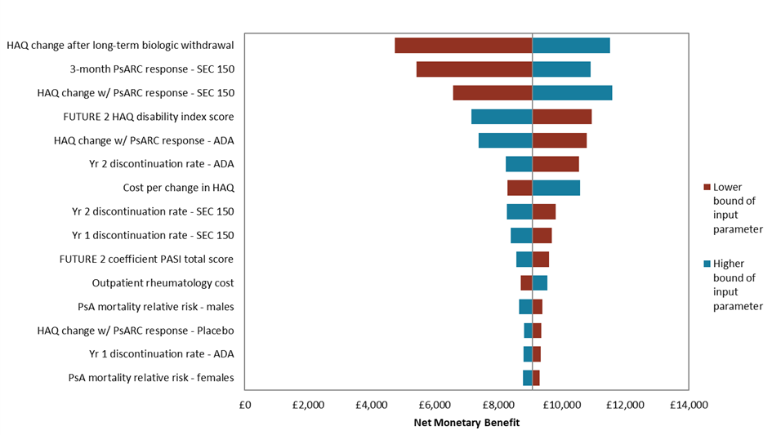
- Versus certolizumab pegol
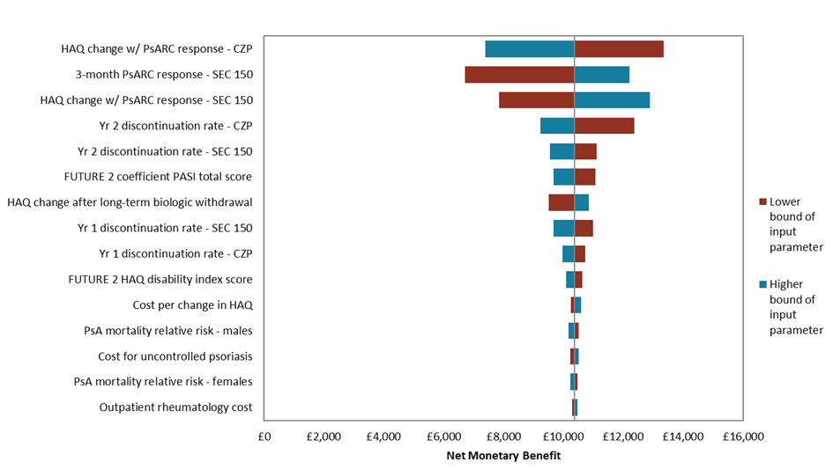
- Versus etanercept (biosimilar)
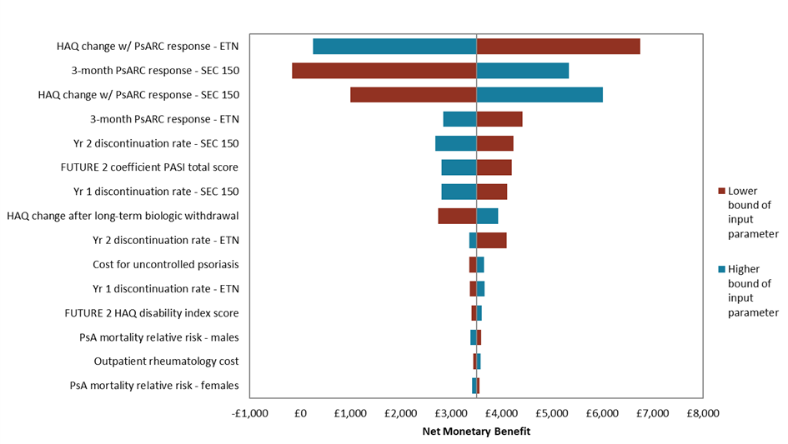
- Versus golimumab
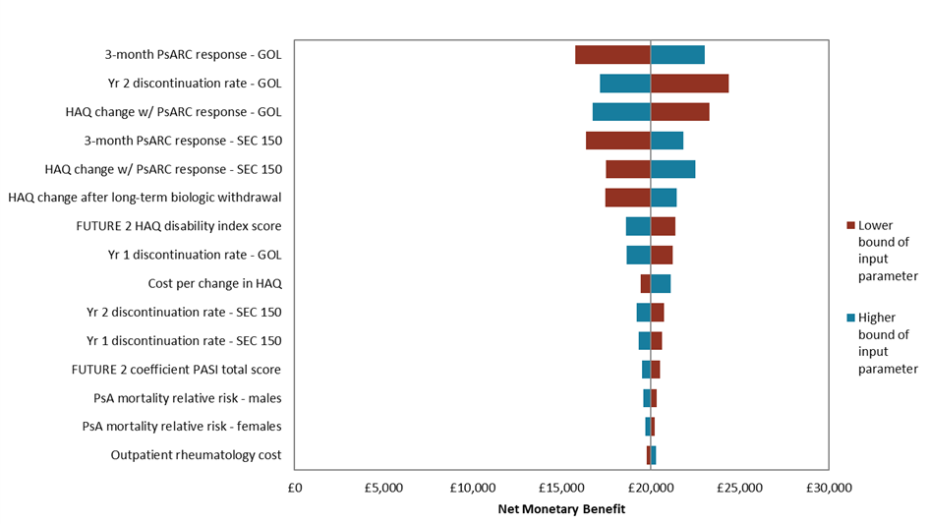
- Versus infliximab (biosimilar)
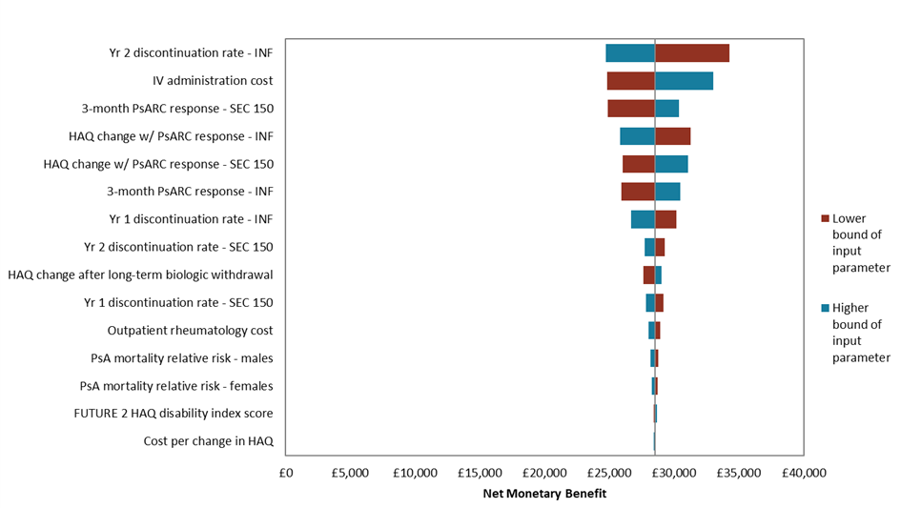
A single QALY was valued at £30,000.

ADA: adalimumab; CZP: certolizumab pegol; csDMARD: conventional systemic disease-modifying anti-rheumatic drug; ETN: etanercept; GOL: golimumab; HAQ: Health Assessment Questionnaire; INF: infliximab; IV: intravenous; PASI: Psoriasis Area Severity Index; PsA: psoriatic arthritis; PsARC: Psoriatic Arthritis Response Criteria; SEC: secukinumab; Yr: year.

Fig. 6 Probabilistic results in the ≥2 prior csDMARD subpopulation – scatter plots
- Versus adalimumab
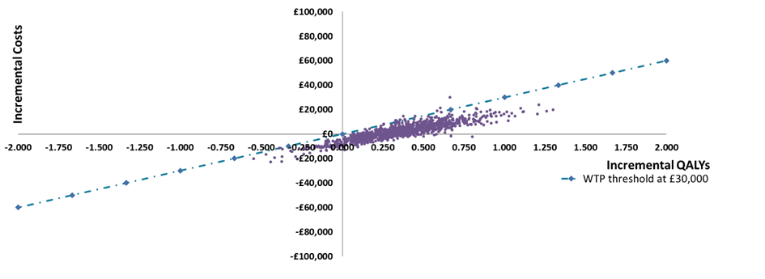
- Versus certolizumab pegol
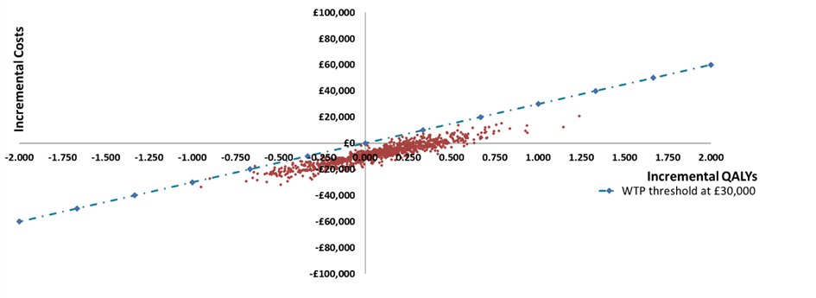
- Versus etanercept (biosimilar)
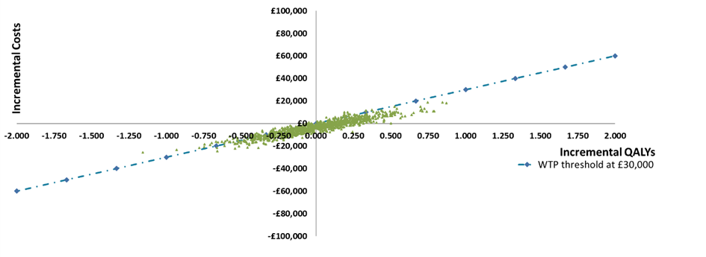
- Versus golimumab
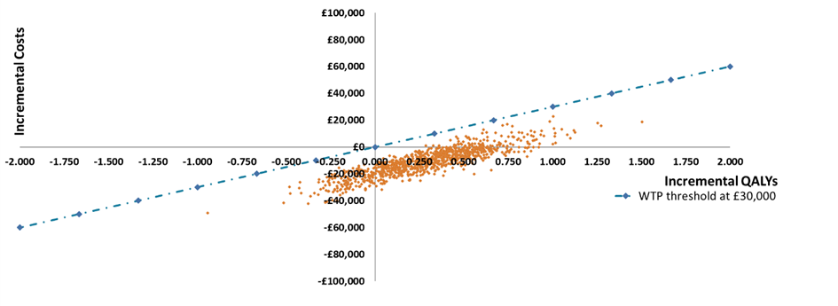
- Versus infliximab (biosimilar)
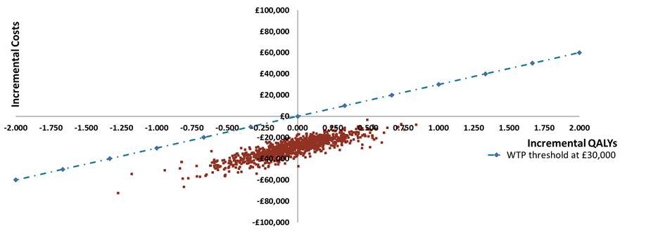
csDMARD: conventional systemic disease-modifying anti-rheumatic drug; QALY: quality-adjusted life year; WTP: willingness to pay.
Fig. 7 Probabilistic results in the ≥2 prior csDMARDs subpopulation – cost-effectiveness acceptability curve (all comparators)
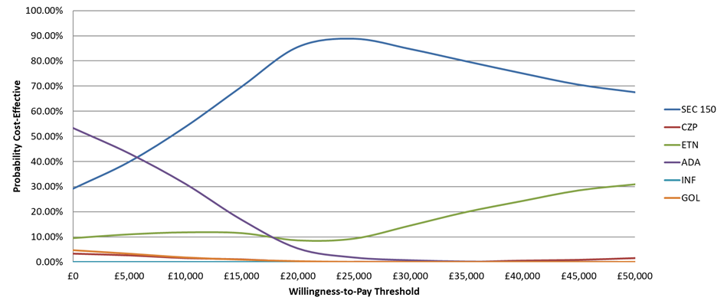
ADA: adalimumab; CZP: certolizumab pegol; csDMARD: conventional systemic disease-modifying anti-rheumatic drug; ETN: etanercept; GOL: golimumab; INF: infliximab; SEC: secukinumab.

REFERENCES
1. Cawson MR, Mitchell SA, Knight C, Wildey H, Spurden D, Bird A et al. Systematic review, network meta-analysis and economic evaluation of biological therapy for the management of active psoriatic arthritis. BMC musculoskeletal disorders. 2014;15:26. doi:10.1186/1471-2474-15-26.
2. McInnes IB, Mease PJ, Kirkham B, Kavanaugh A, Ritchlin CT, Rahman P et al. Secukinumab, a human anti-interleukin-17A monoclonal antibody, in patients with psoriatic arthritis (FUTURE 2): a randomised, double-blind, placebo-controlled, phase 3 trial. Lancet (London, England). 2015;386(9999):1137-46. doi:10.1016/s0140-6736(15)61134-5.
3. Burmester GR, Panaccione R, Gordon KB, McIlraith MJ, Lacerda AP. Adalimumab: long-term safety in 23 458 patients from global clinical trials in rheumatoid arthritis, juvenile idiopathic arthritis, ankylosing spondylitis, psoriatic arthritis, psoriasis and Crohn's disease. Annals of the rheumatic diseases. 2013;72(4):517-24.
4. Mease PJ, Fleischmann R, Deodhar AA, Wollenhaupt J, Khraishi M, Kielar D et al. Effect of certolizumab pegol on signs and symptoms in patients with psoriatic arthritis: 24-week results of a Phase 3 double-blind randomised placebo-controlled study (RAPID-PsA). Annals of the rheumatic diseases. 2014;73(1):48-55. doi:10.1136/annrheumdis-2013-203696.
5. Sterry W, Ortonne JP, Kirkham B, Brocq O, Robertson D, Pedersen RD et al. Comparison of two etanercept regimens for treatment of psoriasis and psoriatic arthritis: PRESTA randomised double blind multicentre trial. BMJ (Clinical research ed). 2010;340:c147. doi:10.1136/bmj.c147.
doi:10.1136/annrheumdis-2011-201244.
6. Kavanaugh A, van der Heijde D, McInnes IB, Mease P, Krueger GG, Gladman DD et al. Golimumab in psoriatic arthritis: one-year clinical efficacy, radiographic, and safety results from a phase III, randomized, placebo-controlled trial. Arthritis and rheumatism. 2012;64(8):2504-17. doi:10.1002/art.34436.
7. Torii H, Nakagawa H. Infliximab monotherapy in Japanese patients with moderate-to-severe plaque psoriasis and psoriatic arthritis. A randomized, double-blind, placebo-controlled multicenter trial. Journal of dermatological science. 2010;59(1):40-9. doi:10.1016/j.jdermsci.2010.04.014.
8. Singh JA, Wells GA, Christensen R, Tanjong Ghogomu E, Maxwell L, Macdonald JK et al. Adverse effects of biologics: a network meta-analysis and Cochrane overview. The Cochrane database of systematic reviews. 2011(2):Cd008794.
9. Mease, P.J., et al., Adalimumab for the treatment of patients with moderately to severely active psoriatic arthritis: results of a double-blind, randomized, placebo-controlled trial. Arthritis Rheum, 2005. 52(10): p. 3279-89.
10. Gottlieb, A.B., et al., Secukinumab improves skin symptoms and physical functioning compared with ustekinumab in patients with moderate to severe psoriasis with concomitant psoriatic arthritis: subanalysis of a randomized, double blind, parallel-group, active comparator-controlled phase 3b trial. Arthritis Rheumatol, 2015. 67((Suppl 10)).
11. Gottlieb, A.B., et al., Secukinumab Shows Substantial Improvement In Both Psoriasis Symptoms and Physical Functioning In Moderate-To-Severe Plaque Psoriasis Patients With Psoriatic Arthritis: A Subanalysis Of a Phase 3, Multicenter, Double-Blind, Placebo-Controlled Study. Arthritis Rheum., 2013. 65((Suppl 10)): p. 319.
12. Gottlieb, A.B., et al., Secukinumab Improves Physical Function in Subjects With Plaque Psoriasis and Psoriatic Arthritis: Results from Two Randomized, Phase 3 Trials. J Drugs Dermatol, 2015. 14(8): p. 821-33.
13. Genovese, M.C., et al., Safety and efficacy of adalimumab in treatment of patients with psoriatic arthritis who had failed disease modifying antirheumatic drug therapy. J Rheumatol, 2007. 34(5): p. 1040-50.
14. Kavanaugh, A., et al., Golimumab, a new human tumor necrosis factor alpha antibody, administered every four weeks as a subcutaneous injection in psoriatic arthritis: Twenty-four-week efficacy and safety results of a randomized, placebo-controlled study. Arthritis Rheum, 2009. 60(4): p. 976-86.
15. Antoni, C.E., et al., Sustained benefits of infliximab therapy for dermatologic and articular manifestations of psoriatic arthritis: results from the infliximab multinational psoriatic arthritis controlled trial (IMPACT). Arthritis Rheum, 2005. 52(4): p. 1227-36.
16. Antoni, C., et al., Infliximab improves signs and symptoms of psoriatic arthritis: results of the IMPACT 2 trial. Ann Rheum Dis, 2005. 64(8): p. 1150-7.
17. Mease, P.J., et al., Etanercept in the treatment of psoriatic arthritis and psoriasis: a randomised trial. Lancet, 2000. 356(9227): p. 385-90.
18. Mease, P.J., et al., Etanercept treatment of psoriatic arthritis: safety, efficacy, and effect on disease progression. Arthritis Rheum, 2004. 50(7): p. 2264-72.
19. Kavanaugh, A., et al., Treatment of psoriatic arthritis in a phase 3 randomised, placebo-controlled trial with apremilast, an oral phosphodiesterase 4 inhibitor. Ann Rheum Dis, 2014. 73(6): p. 1020-6.
20. Kavanaugh, A., et al., Apremilast, an Oral Phosphodiesterase 4 Inhibitor, Is Associated with Long-Term (52-Week) Improvement in Measures of Disease Activity in Patients with Psoriatic Arthritis: Results from 3 Phase 3, Randomized, Controlled Trials. Arthritis Rheumatol, 2014. 66((Suppl 10)): p. S2390-40.
21. Birbara, C., et al., OP0104 Apremilast, an Oral Phosphodiesterase 4 Inhibitor, in Patients with Psoriatic Arthritis Including Current Skin Involvement: Results of a Phase 3, Randomized, Controlled Trial. Ann Rheum Dis, 2013. 72((Suppl 2)): p. A85-6.
22. McInnes, I.B., et al., Efficacy and safety of ustekinumab in patients with active psoriatic arthritis: 1 year results of the phase 3, multicentre, double-blind, placebo-controlled PSUMMIT 1 trial. Lancet, 2013. 382(9894): p. 780-9.
23. Ritchlin, C., et al., Efficacy and safety of the anti-IL-12/23 p40 monoclonal antibody, ustekinumab, in patients with active psoriatic arthritis despite conventional non-biological and biological anti-tumour necrosis factor therapy: 6-month and 1-year results of the phase 3, multicentre, double-blind, placebo-controlled, randomised PSUMMIT 2 trial. Ann Rheum Dis, 2014. 73(6): p. 990-9.
24. Schett, G., et al., Oral apremilast in the treatment of active psoriatic arthritis: results of a multicenter, randomized, double-blind, placebo-controlled study. Arthritis Rheum, 2012. 64(10): p. 3156-67.
25. Behrens F, Köhm M, Arndt U, Wittig B, Greger G, Thaci D et al. SAT0358 Impact of Methotrexate on Anti-TNF Treatment in Psoriatic Arthritis? an In-Depth Analysis of A Large Prospective Observational Study with Adalimumab. Annals of the rheumatic diseases. 2014;73(Suppl 2):723-. doi:10.1136/annrheumdis-2014-eular.1225.
26. Gottlieb A, Menter A, Mendelsohn A, Shen YK, Li S, Guzzo C et al. Ustekinumab, a human interleukin 12/23 monoclonal antibody, for psoriatic arthritis: randomised, double-blind, placebo-controlled, crossover trial. Lancet (London, England). 2009;373(9664):633-40. doi:10.1016/s0140-6736(09)60140-9.
27. Mease PJ, McInnes IB, Kirkham B, Kavanaugh A, Rahman P, van der Heijde D et al. Secukinumab inhibition of interleukin-17A in patients with psoriatic arthritis. The New England journal of medicine. 2015;373(14):1329-39. doi:10.1056/NEJMoa1412679.
28. McInnes IB, Sieper J, Braun J, Emery P, van der Heijde D, Isaacs JD et al. Efficacy and safety of secukinumab, a fully human anti-interleukin-17A monoclonal antibody, in patients with moderate-to-severe psoriatic arthritis: a 24-week, randomised, double-blind, placebo-controlled, phase II proof-of-concept trial. Annals of the rheumatic diseases. 2014;73(2):349-56. doi:10.1136/annrheumdis-2012-202646.
29. Wells AF, Edwards CJ, Adebajo AO, Kivitz A, Bird P, Shah K. Apremilast in the Treatment of DMARD-Naïve Psoriatic Arthritis Patients: Results of a Phase 3 Randomized, Controlled Trial (PALACE 4). Arthritis and rheumatism. 2013;65(12):3320-33.
30. Baranauskaite A, Raffayova H, Kungurov NV, Kubanova A, Venalis A, Helmle L et al. Infliximab plus methotrexate is superior to methotrexate alone in the treatment of psoriatic arthritis in methotrexate-naive patients: the RESPOND study. Annals of the rheumatic diseases. 2012;71(4):541-8. doi:10.1136/ard.2011.152223.
31. Saougou I, Markatseli TE, Papagoras C, Voulgari PV, Alamanos Y, Drosos AA. Sustained clinical response in psoriatic arthritis patients treated with anti-TNF agents: a 5-year open-label observational cohort study. Seminars in arthritis and rheumatism. 2011;40(5):398-406. doi:10.1016/j.semarthrit.2010.07.004.
32. Mease P, van der Heijde D, Ritchlin C, Cuchacovich R, Shuler C, Lee C. A Randomized, Double-Blind, Active- and Placebo-Controlled Phase 3 Study of Efficacy and Safety of Ixekizumab, Adalimumab, and Placebo Therapy in Patients Naïve to Biologic Disease Modifying Anti-Rheumatic Drugs with Active Psoriatic Arthritis. Arthritis Rheumatol. 2015;67(Suppl 10).
33. Torii H, Nakagawa H. Infliximab monotherapy in Japanese patients with moderate-to-severe plaque psoriasis and psoriatic arthritis. A randomized, double-blind, placebo-controlled multicenter trial. Journal of dermatological science. 2010;59(1):40-9. doi:10.1016/j.jdermsci.2010.04.014.
34. van Kuijk AW, Gerlag DM, Vos K, Wolbink G, de Groot M, de Rie MA et al. A prospective, randomised, placebo-controlled study to identify biomarkers associated with active treatment in psoriatic arthritis: effects of adalimumab treatment on synovial tissue. Annals of the rheumatic diseases. 2009;68(8):1303-9. doi:10.1136/ard.2008.091389.
35. McInnes IB, Nash P, Ritchlin C, Thom H, Kanters S, Palaka E et al. THU0437 Secukinumab for the treatment of psoriatic arthritis: comparative effectiveness results versus licensed biologics and apremilast from a network meta-analysis. Annals of the rheumatic diseases. 2016;75(Suppl 2):348-9. doi:10.1136/annrheumdis-2016-eular.1716.
36. Rodgers M, Epstein D, Bojke L, Yang H, Craig D, Fonseca T et al. Etanercept, infliximab and adalimumab for the treatment of psoriatic arthritis: a systematic review and economic evaluation. Health technology assessment (Winchester, England). 2011;15(10):i-xxi, 1-329. doi:10.3310/hta15100.
37. Corbett, M., et al., Certolizumab pegol and secukinumab for treating active psoriatic arthritis following inadequate response to disease-modifying antirheumatic drugs: a systematic review and economic evaluation. Health Technol Assess, 2017. 21(56): p. 1-326.
38. European Medicines Agency (EMA). Cosentyx: EPAR - Product Information. Available at: http://www.ema.europa.eu/ema/index.jsp?curl=pages/medicines/human/medicines/003729/human_med_001832.jsp&mid=WC0b01ac058001d124. Accessed: 16th May 2017.
39. European Medicines Agency (EMA). Cimzia: EPAR - Product Information. Available at: http://www.ema.europa.eu/ema/index.jsp?curl=pages/medicines/human/medicines/001037/human_med_001294.jsp&mid=WC0b01ac058001d124. Accessed: 23rd May 2017.
40. European Medicines Agency (EMA). Enbrel: EPAR - Product Information. Available at: http://www.ema.europa.eu/ema/index.jsp?curl=pages/medicines/human/medicines/000262/human_med_000764.jsp&mid=WC0b01ac058001d124. Accessed: 23rd May 2017.
41. European Medicines Agency (EMA). Humira: EPAR - Product Information. Available at: http://www.ema.europa.eu/ema/index.jsp?curl=pages/medicines/human/medicines/000481/human_med_000822.jsp&mid=WC0b01ac058001d124. Accessed: 23rd May 2017.
42. European Medicines Agency (EMA). Remicade: EPAR - Product Information. Available at: http://www.ema.europa.eu/ema/index.jsp?curl=pages/medicines/human/medicines/000240/human_med_001023.jsp&mid=WC0b01ac058001d124. Accessed: 23rd May 2017.
43. European Medicines Agency (EMA). Simponi: EPAR - Product Information. Available at: http://www.ema.europa.eu/ema/index.jsp?curl=pages/medicines/human/medicines/000992/human_med_001053.jsp&mid=WC0b01ac058001d124. Accessed: 23rd May 2017.
44. Personal Social Services Research Unit (PSSRU). Unit costs of health and social care (2016). Available at: http://www.pssru.ac.uk/project-pages/unit-costs/. Accessed: 23rd May 2017.
45. Department of Health. NHS reference costs (2015 to 2016). Available at: https://www.gov.uk/government/collections/nhs-reference-costs. Accessed: 23rd May 2017.
46. National Institute for Health and Care Excellence (NICE). TA220: Golimumab for the treatment of psoriatic arthritis (2011). Available at: https://www.nice.org.uk/guidance/ta220. Accessed: 16th May 2017.
47. National Institute for Health and Care Excellence (NICE). TA445: Certolizumab pegol and secukinumab for treating active psoriatic arthritis after inadequate response to DMARDs (2017). Available at: https://www.nice.org.uk/guidance/ta445. Accessed: 24th May 2017.

