Methods Supplement.

Study design

The study followed the EuroQol’s Valuation Technology (EQ-VT) protocol Version 2, which was informed by an extensive multi-county, multi-stage methodological research program and was designed primarily for the purpose of valuing various EQ-5D-5L health states (1-5).

As Oppe, Rand-Hendriksen (6) explain EQ-VT builds upon the widely used Paris protocol and Measurement and Valuation of Health (MVH) protocol. The EQ-VT uses a composite time trade-off (c-TT0) and discrete choice experiment (DCE) to elicit preferences for health states. Both methods create preference data that are different but complementary. Both measure the quality of life in a specific health state but use different approaches to elicit preferences.
The cTTO produces a value for each health state with reference to two anchor states: 0 (dead) and 1 (full health). DCE by contrast values (Figure 1) are on an arbitrary scale that are not anchored but rather established on a relative distance between in this case two health states. (6, 9, 10)
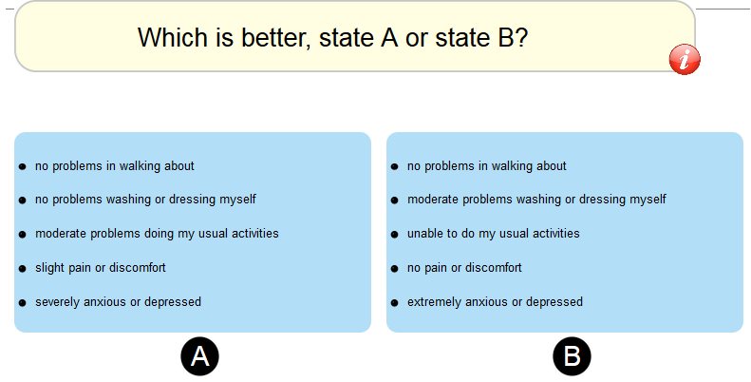
Figure 1 Discrete Choice Experiment (DCE (Source EQ-VT)

The cTTO elicitation process begins with the conventional or classical TTO (Figure 2) for health states better than dead (for values between and including 0 and 1) and then moves to ‘lead time’ TTO (Figure 3) if the participants indicate that s/he considers a particular health state to be worse than dead (for values between 0 and -1) (11-13). The cTTO was accepted following scientific research of many TTO alternative methods of addressing worse than dead states that included classic TTO, lead-time TTO and lag-time TTO (14).
The composite time trade off (cTTO) task finishes following many possible iterations (as described in detail by (1, 6) when the participant shows s/he is indifferent between life A and life B. The resulting values can range from maximum of 1 to a minimum of -1 (9). The feasibility and face validity of the c-TTO was confirmed by Janssen, Oppe (4). Further research was conducted which informed the anchor state of ‘full health’ (15).

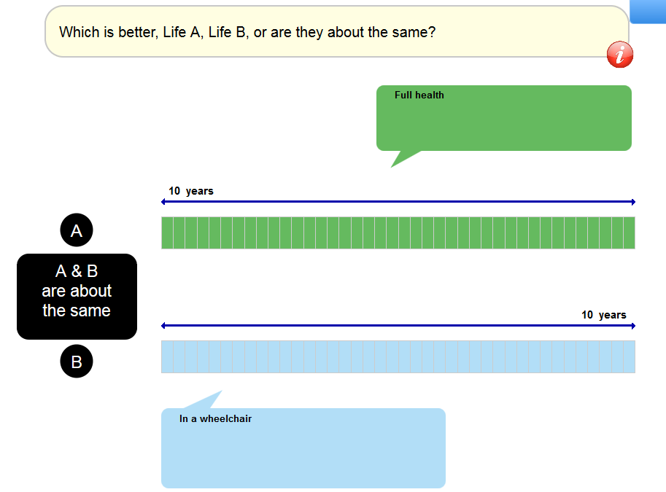
Figure 2 conventional time trade (Source EQ-VT) for values of health states better than dead or greater or equal to zero

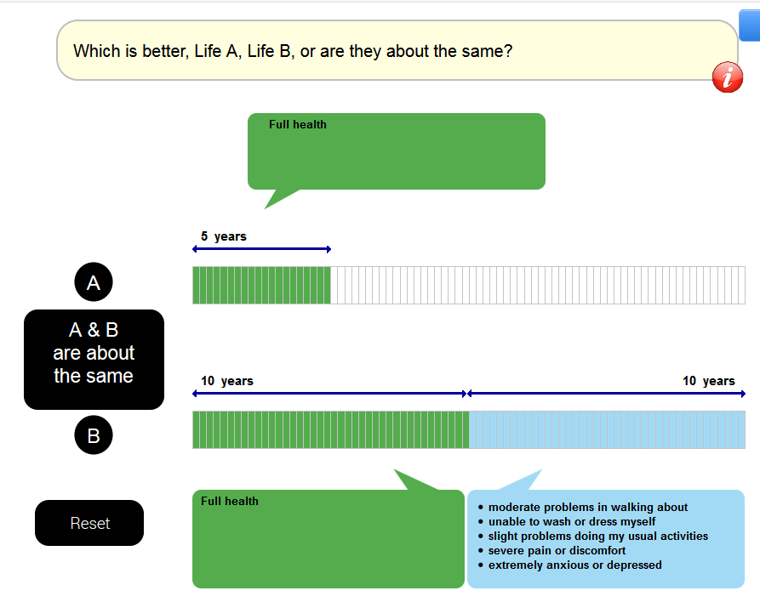

For composite Time trade off (C-TTO) there are 86 health states in total which are made up of 10 blocks with 2 fixed health states in each block (Table 1). Each cTTO block contained one very mild health state (misery index of 6 e.g. 1+1+1+1+2) and every block contained the health state 55555 (called ‘the pits’) which has a misery of 25 (5+5+5+5+5). For the Discrete choice DCE there are 196 pairs of health states which are divided into 28 blocks of 7 pairs per block. 186 of these are fixed and there are 10 very mild health states.

Source (16)

Sample Size

In accordance with the EQ-VT protocol for EQ-5D-5L valuation studies, a target sample size of at least 1,000 participants are sought in valuation exercises (16). It is reported that 100 observations for each health state lead to a small standard error (SE), values of between 0.01 and 0.06, for mild and poor health states respectively which are thought to be adequate (4).
Ramos-Goni, Pinto-Prades (17) also report that their ‘power calculations estimated that to obtain a 0.01 standard error (SE) of the observed mean c-TTO, we needed 9735 C-TTO responses’.
The pursuit of a minimum sample of 1000 was therefore pursued matching the approach adopted by other EQ-5D-5L value sets including those in England, Germany and Indonesia (9, 18, 19).

Data Collection

A representative sample of community-dwelling adults in Ireland over 18 years of age was drawn using methods set out by (20)
This involved a two-stage stratified cluster sampling process.
- In the first stage a stratified sample of Small Areas as Primary Sampling Units (PSU) was drawn. Small areas are geographical constructs developed by the Central Statistics Office that comprise a minimum of 50 households with a mean of just under 100 and for which population statistics are published. Small Areas are considerably smaller than Electoral Districts. Stratification was by quintile distribution of deprivation scores, developed using the Pobal HP Deprivation Index and the five-category urban/rural classification developed by the CSO. This yielded a maximum of 25 strata. 54 Small areas were selected with approximately 20 houses per small area invited to participate in the study. This included two pilot areas that were added to the sample.
- In the second stage households were drawn at random from within each SA. Houses were drawn at random by using a random starting point within each PSU and a fixed sampling step of every third house, thus ensuring the equal probability of each household being selected.
- Calls were made in person by interviewers to households at different times during the day and evening to a maximum of three calls per household. Information sheets were left with households where entry could not be gained. These detailed the aims of the survey and how surveyors could be contacted and that return visits would be made. The study mobile phone number was also on the flyer so that the person could ring and ask the interviewer to call back at a particular time or not to call as the case maybe.
- A log was taken of the number of; people that declined to be interviewed; how many houses that were called to as well as instances of inaccessible and unoccupied houses.
- Where entry could be gained the interviewer introduced her/himself and showed their photo identification, explained the purpose of the interview and gave a flyer and information sheet to the adult present. Any adult within the household could volunteer to participate in the survey, only one person per household though being used in the survey. The information sheet contained contact details of the research team in the area and the office phone number and email addresses of the Principal Investigator. The person was given up to 24 hours to decide whether they wished to take part. However, sometimes having read the information sheet the participants chose to do the interview immediately. The interviews were conducted in the participant’s home.
- Only one person per household was interviewed – any volunteer from among those in the household being accepted. A voucher for €10 euro was given on completion of the interview, and an acknowledgement of receipt of same was signed by the participant on the consent form.
- Following ethical approval (Reference: 15/JAN/04) being received on 4th February 2015, data was collected from March 2015 to September 2016. The interviews were carried out by a team of 7 trained interviewers which was the minimum required by EuroQol to manage the risk associated with interviewer bias.
- A pilot study was conducted in two small areas to ascertain if all the procedures put in place to ensure that the survey could be conducted safely and efficiently as planned worked. These procedures included arrangements for communication between team members as to their whereabouts; travel to from and within the study site. All team members were equipped with a mobile phone, and local police were contacted before visiting areas to ensure that they were aware of survey activity in the area.

While the survey was completed between 2015 and 2016, survey effort was confined to the months between February 2015 and October. This was a pragmatic decision intended to minimise the risk to interviewers of conducting surveys when day-light hours were limited and avoiding holidays when interviewee recruitment may have been particularly difficult. Following this a comparison between the recruited sample and the Central Statistics Office (CSO) 2011 census figures, it was clear that there was an over-representation of older people and females in the sample. Therefore, further purposeful sampling was necessary to augment the number of males and younger people. A contingency had been incorporated, in the ethics application amendment, for such a scenario. This purposeful sampling was conducted, at the end of the survey, using a snowball sampling approach starting with personal contacts and work associates.

Quality Control (QC)
To help ensure the quality of the data collected as part of the survey a strict Quality Control (QC) procedure developed by the EuroQol Foundation was followed. In this:
- EuroQol provided bi-weekly standardised quality reports to the Principal Investigator (PI) which included figures and tables. EuroQol further gave the PI access to the EQ-VT QC tool. This tool is a software program that may be used to automatically generate QC reports which can be run off daily if necessary when training new interviewers or if there are quality issues and this allows for transparent reporting of any issues that occur on a regular basis.
- These QC reports then formed the basis of a review meeting conducted on a bi-weekly basis at which they were discussed among all active survey teams at the time in other countries and members of the EuroQol “central office”. These reports provided an opportunity to assess issues related to the performance of the team and ways this could be improved and to discuss if there were any deviances from the interview protocol. For example; were enough interviews being conducted to preserve interviewer skills; were their issues with the speed that tasks were performed; the frequency with which triggers were being observed; what was the distribution of values present in any of the surveys. This information was then fed back to the team. These detailed reports were made possible because data was initially captured live in the EQ-VT.
- In addition to the QC processes imposed by EuroQol, additional measures were instigated in Ireland as further QC measures: Weekly team meetings were held. In part these were to provide an opportunity for the team to provide peer support to each other over the course of the survey. In part too however, they provided a means by which consistency of approach across the interview team could be achieved in real time. Thus, it is not possible, ex ante to predict all contingencies an interviewer might encounter during the course of an interview. By providing weekly meetings interviewers could share instances that were unusual to other members of the survey team and how it has been dealt with. Following discussion a consensus could then be agreed as to how this should be dealt with by all interviewers should it arise again. The quality reports were also discussed at these weekly meetings.

Data Analysis
First the response rates were estimated and compared across different areas with respect to their deprivation and urban/rural status. The sample was then examined using descriptive statistics in order to compare the recruited sample to that of the population.
The EQ-VT protocol does not specify a standardized modelling approach, therefore, it is up to each country to decide on their own modelling strategy. The EQ-VT design was optimised for the main effects models (16). The aim of different methodological approaches used in Ireland is not intended to arrive at a particular answer that suits a predetermined idea of what the values should be but rather to examine the data in a rational and reproducible manner. While various models were considered in the analysis, only the relevant ones are reported on here.
The analysis involved econometric analysis to arrive at a final EQ-5D-5L value set for Ireland. Models were examined with respect to: face validity (i.e. were the estimated coefficients intuitively plausible), model fit using where appropriate Akaike information criterion (AIC) and Bayesian information Criterion (BIC) statistics; if the use of all preference data (both DCE and cTTO) improved model fit and/or face validity. Analyses progressed in logical steps i.e. Ordinary Least Squares (OLS) were followed by a GLM Tobit etc. where each “level” addressed specific issues such as bias or consistency that might exist with its predecessor. The models in all analyses consisted of 20 parameters in each model. There were four parameters for each of the five domains in EQ-5D-5L. The base case is level 1 in each domain. The coefficients show the decrement from level 1 to the respective level. Value was the dependent variable in all models. Value was calculated as 1- quality of life score (disutility).

First the cTTO data was analysed first using OLS. OLS treats each observation as if it were generated independently. Data were tested for heteroscedasticity using Breusch-Pagan test.
Next a GLM Tobit was estimated. GLM tobit improves on the OLS by addressing the censored nature the data and the repeated measures on the same participant; the GLM tobit was estimated censored at -1. ,This is because the nature of the data is considered censored at -1 i.e. -1 is the lowest value possible in the EQ-VT. However, a participant may have traded off more that those 10 years in the lead-time TTO if it were available.
Third, the DCE data was analysed using the conditional logit under random utility theory both with and without a constant.
Fourth, both cTTO and DCE data was analysied in a hybrid model using the “hyreg” command (17). In combining cTTO and DCE in a hybrid as first suggested by Oppe M and van Hout (16) they can complement as both do not have the same limitations. DCE and cTTO makes use of additional preference data to model preferences. A “correction” for heteroscedasticity to address potential issues with the standard errors was applied. Shiroiwa, Ikeda (21) found the hybrid model to be slightly superior to simpler methods. This hybrid approach has been employed in the German, English, Indonesian value sets. The hybrid models used in this study first were estimated without censoring, with censoring at -1, and adjusted for heteroscedasticity using hetcon() command.. There was further analysis with the incremental hybrid model where the coefficients reported are relative to previous domain as opposed to base domain throughout

1. Oppe M, Devlin NJ, van Hout B, Krabbe PF, de Charro F. A program of methodological research to arrive at the new international EQ-5D-5L valuation protocol. Value Health. 2014;17(4):445-53.
2. Devlin NJ, Krabbe PFM. The development of new research methods for the valuation of EQ-5D-5L. The European Journal of Health Economics. 2013;14(Suppl 1):1-3.
3. Herdman M, Gudex C, Lloyd A, Janssen M, Kind P, Parkin D, et al. Development and preliminary testing of the new five-level version of EQ-5D (EQ-5D-5L). Qual Life Res. 2011;20.
4. Janssen B, Oppe M, Versteegh M, Stolk E. Introducing the composite time trade-off: a test of feasibility and face validity. Health Economics in Prevention and Care. 2013;14(Supplement 1):5-13.
5. Janssen MF, Pickard AS, Golicki D, Gudex C, Niewada M, Scalone L, et al. Measurement properties of the EQ-5D-5L compared to the EQ-5D-3L across eight patient groups: a multi-country study. Qual Life Res. 2013;22(7):1717-27.
6. Oppe M, Rand-Hendriksen K, Shah K, Ramos-Goni JM, Luo N. EuroQol Protocols for Time Trade-Off Valuation of Health Outcomes. PharmacoEcon. 2016.
7. Torrance GW. Social preferences for health states: An empirical evaluation of three measurement techniques. Socioecon Plann Sci. 1976;10(3):129-36.
8. Norman R, Cronin P, Viney R. A pilot discrete choice experiment to explore preferences for EQ-5D-5L health states. Applied health economics and health policy. 2013;11(3):287-98.
9. Devlin NJ, Shah KK, Feng Y, Mulhern B, van Hout B. Valuing health-related quality of life: An EQ-5D-5L value set for England. Health Econ. 2017:n/a-n/a.
10. Versteegh M, Vermeulen K, Evers S, de Wit GA, Prenger R, Stolk E. Dutch Tariff for the Five-Level Version of EQ-5D. Value Health. 2016;19(4):343-52.
11. Devlin NJ, Tsuchiya A, Buckingham K, Tilling C. A uniform time trade off method for states better and worse than dead: feasibility study of the 'lead time' approach. Health Econ. 2011;20(3):348-61.
12. Devlin N, Buckingham K, Shah K, Tsuchiya A, Tilling C, Wilkinson G, et al. A comparison of alternative variants of the lead and lag time TTO. Health Econ. 2013;22(5):517-32.
13. Robinson A, Spencer A. Exploring challenges to TTO utilities: valuing states worse than dead. Health Econ. 2006;15(4):393-402.
14. Versteegh MM, Attema AE, Oppe M, Devlin NJ, Stolk EA. Time to tweak the TTO: Results from a comparison of alternative specifications of the TTO. European Journal of Health Economics. 2013;14(SUPPL. 1):S43-S51.
15. Shah K, Mulhern B, Longworth L, Janssen MF. An empirical study of two alternative comparators for use in time trade-off studies. Value Health. 2016;19(1):53-9.
16. Oppe M, van Hout B. The “power” of eliciting EQ-5D-5L values: the experimental design of the EQ-VT. EuroQol working papers series 2017;17003 [Internet]. 2017 3rd March 2018. Available from: http://euroqol.org/wp-content/uploads/2016/10/EuroQol-Working-Paper-Series-Manuscript-17003-Mark-Oppe.pdf.
17. Ramos-Goni JM, Pinto-Prades JL, Oppe M, Cabases JM, Serrano-Aguilar P, Rivero-Arias O. Valuation and Modeling of EQ-5D-5L Health States Using a Hybrid Approach. Med Care. 2017;55(7):e51-e8.
18. Ludwig K, Graf von der Schulenburg JM, Greiner W. German Value Set for the EQ-5D-5L. PharmacoEcon. 2018.
19. Purba FD, Hunfeld JAM, Iskandarsyah A, Fitriana TS, Sadarjoen SS, Ramos-Goñi JM, et al. The Indonesian EQ-5D-5L Value Set. PharmacoEcon. 2017.
20. Haase T, Pratschke J. Optimising the Sampling Methodology for CSO Household Surveys. 2012.
21. Shiroiwa T, Ikeda S, Noto S, Igarashi A, Fukuda T, Saito S, et al. Comparison of Value Set Based on DCE and/or TTO Data: Scoring for EQ-5D-5L Health States in Japan. Value Health. 2016;19(5):648-54.

