ELECTRONIC SUPPLEMENTARY MATERIAL 1
Supplement to

Cost-effectiveness analysis of vedolizumab compared with other biologics in anti-TNF-naïve patients with moderate-to-severe ulcerative colitis in Japan

PharmacoEconomics
Authors: Luis Hernandez, MSc MPH¹, Hiroyo Kuwabara, MPH, PhD²; Anshul Shah, BPharm, MS¹; Kaoru Yamabe, PhD²; Heather Burnett, MSc³; Kyle Fahrbach, PhD¹; Maria Koufopoulou, MSc⁴; Ryuichi Iwakiri, MD, PhD²
Affiliates:
¹ Evidera Inc., 500 Totten Pond Road, 5th Floor, Waltham, MA 02451, USA
² Takeda Pharmaceutical Company Ltd., 1-1, Nihonbashi-Honcho 2-chome, Chuo-ku, Tokyo 103-8668, Japan
³ Evidera Inc., 7575 Trans-Canada Hwy, Suite 404, St-Laurent, Quebec, H4T 1V6, Canada
⁴ Evidera Inc., The Ark, 201 Talgarth Road, Hammersmith, London W6 8BJ, United Kingdom
Corresponding Author:
Luis Hernandez, MSc, Senior Director and Senior Research Scientist
Evidera Inc., 500 Totten Pond Road, 5th Floor, Waltham, MA 02451
Phone: +1 781 960 0249; fax: +1 781 761 0147; email: luis.hernandez@evidera.com

Appendix A. Systematic Literature Review and Network Meta-analyses

Systematic Review

Methods
A systematic literature review (SLR) was conducted to identify relevant randomized clinical trials (RCTs) that assessed the efficacy and safety of adalimumab (ADA), golimumab (GOL), infliximab (IFX), tofacitinib (TOF) or vedolizumab (VDZ), versus placebo (PBO) for the treatment of patients with moderate-to-severe ulcerative colitis (UC) who were anti-tumor necrosis factor (TNF)-naïve. The SLR was conducted in accordance with the Preferred Reporting Items for Systematic Reviews and Meta-analyses (PRISMA) guidelines [1].
Systematic searches were performed on August 22, 2017 in Embase, MEDLINE, and the Cochrane Library (for which search strategies are available from the authors upon request). Proceedings from the following key conferences (and years) were also searched for relevant abstracts that could be used to supplement the evidence base.
- United European Gastroenterology Week (2015 and 2016)
- Digestive Disease Week (2016 and 2017)
- European Crohn’s and Colitis Organization (2016 and 2017)
- Crohn’s and Colitis Foundation of America (2016 and 2017)
- Asian Organizations for Crohn's and Colitis (2016 and 2017)
- Japan Digestive Disease Week (2015 and 2016)
Screening of titles/abstracts and full-text articles was performed by two independent investigators, with any discrepancies being resolved by a third investigator. The criteria used for screening are provided in Table 1.
Data from the studies included in the SLR were extracted by one investigator; for additional quality assurance, all extracted data were validated by a second investigator. Quality assessment was undertaken for the included RCTs using the Cochrane Risk-of-Bias tool for RCTs [2, 3].
Table 1. List of Criteria for the Inclusion and Exclusion of Studies during the Screening Process
Criteria | Included | Excluded
Population | - Adults with moderate-to-severe UC who are anti-TNF treatment naïve  - Studies including anti-TNF treatment experienced patients or a mix of anti-TNF-experienced and -naïve patients, if the study reported outcomes separately for the anti-TNF treatment naïve patients | - Patients who do not have UC  - Patients who have mild UC only  - Patients who have severe UC only  - Patients who are anti-TNF treatment experienced  - Studies reporting outcomes for a mix of anti-TNF-experienced and -naïve patients, without data being reported separately for the anti-TNF naïve population  - Pediatric patients
Interventions/ Comparators | Patients treated with:  - Biologics: ADA, GOL, IFX, TOF, and VDZ  - Comparators: CT, including AZA, cyclosporine, mercaptopurine, or surgery; another intervention listed above; PBO | - Studies that do not investigate one of the biologics of interest in at least one of the arms
Outcomes | - Clinical response (with timing and definition)  - Durable clinical response (with timing and definition)  - Clinical remission (with timing and definition) | - None  - For IBD articles, exclude if results not broken down into CD and UC
Study Design | - RCTs  - Systematic reviews and meta-analyses (for citation chasing only) | - Prospective interventional studies other than RCTs (i.e., single-arm clinical trials, phase I studies, pilot studies, or non-RCTs)  - Preclinical studies  - Prognostic studies  - Retrospective studies  - Case reports  - Commentaries and letters (publication type)  - Consensus reports  - Non-systematic reviews
Abbreviations: ADA = adalimumab; AZA = azathioprine; CD = Crohn’s disease; CT = conventional therapy; GOL = golimumab; IBD = inflammatory bowel disease; IFX = infliximab; PBO = placebo; RCT = randomized controlled trial; TNF = tumor necrosis factor; TOF = tofacitinib; UC = ulcerative colitis; VDZ = vedolizumab

Results
The search yielded 2,040 results, of which 323 publications and conference materials were considered for full-text review. Ultimately, 34 full-text publications and 11 records identified from gray literature sources and SLR citation lists were eligible for inclusion. These 45 publications collectively reported on 18 trials.
Figure 1 presents the results of the search and screening process. Table 2 provides an overview of the included trials.
Figure 1. PRISMA Flow Diagram
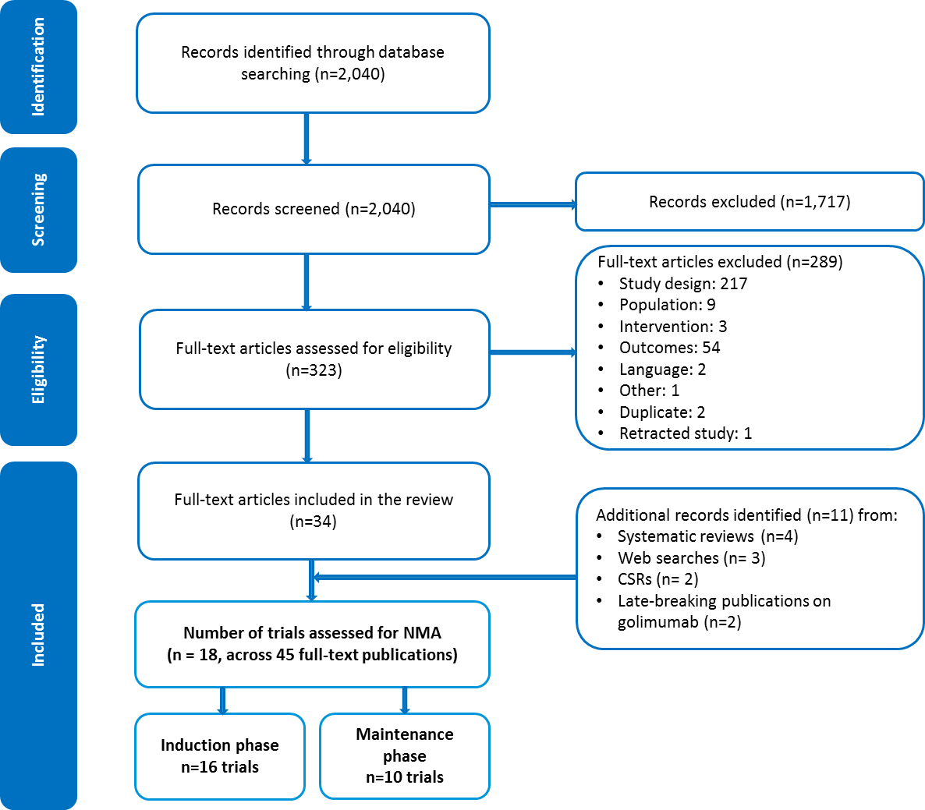
Abbreviations: CSR = clinical study report; NMA = network meta-analysis; PRISMA = Preferred Reporting Items for Systematic Reviews and Meta-analyses

Table 2. Overview of Included Trials
Trial Name | Treatment Phase | Treatment Arms | Study Duration  in Weeks | N randomized | Timepoints of Assessment in Weeks (Efficacy)
A3921063 [4] | Induction | TOF 0.5 mg  TOF 3 mg  TOF 10 mg  TOF 15 mg  PBO | 12 | 195 | 8
OCTAVE Induction 1 [5] | Induction | TOF 10 mg  PBO | 8 | 598 | 8
OCTAVE Induction 2 [5] | Induction | TOF 10 mg  PBO | 8 | 541 | 8
Probert 2003 [6] | Induction | IFX 5 mg  PBO | 6 | 43 | 6
PURSUIT IV [7] | Induction | GOL 1 mg  GOL 2 mg  GOL 4 mg  PBO | 6 | 505 | 6
PURSUIT SC [8] | Induction | GOL 200/100 mg  GOL 400/200 mg  PBO | 6 | 774 | 6
UC SUCCESS [9] | Induction | IFX 5 mg  AZA 2.5mg + IFX 5mg  AZA 2.5mg | 16 | 239 | 8, 16
ULTRA 1 [10] | Induction | ADA 80/40 mg  ADA 160/80 mg  PBO | 8 | 390 | 4, 8
ACT 1 [11] ^{b} | Induction and maintenance | IFX 5 mg  IFX 10 mg  PBO | 54 | 364 | 2, 6, 8, 30, 54
ACT 2 [11] ^{b} | Induction and maintenance | IFX 5 mg  IFX 10 mg  PBO | 30 | 364 | 2, 6, 8, 30
GEMINI-1 [12, 13] ^{a **} | Induction and maintenance | VDZ 300 mg  PBO | 66 | 895 | 6, 52
Japic CTI-060298 [14] ^{b} | Induction and maintenance | IFX 5 mg  PBO | 38 | 208 | 8, 30
Jiang 2015 [15] ^{b} | Induction and maintenance | IFX 3.5 mg  IFX 5 mg  PBO | 30 | 123 | 30
Japanese phase III study [16, 17] ^{a **} | Induction and maintenance | VDZ 300 mg  PBO | 94 | 246 | 2, 6, 10, 60
Suzuki 2014 [18] ^{b} | Induction and maintenance | ADA 80/40 mg  ADA 40 mg  ADA 160/80 mg  PBO | 52 | 450 | 6, 8, 32
ULTRA 2 [19] ^{b} | Induction and maintenance | ADA 160/80 mg  PBO | 52 | 518 | 52
PURSUIT M [20]* ^{b} | Maintenance | GOL 50 mg  GOL 100 mg  PBO | 54 | 464 | 30, 54
PURSUIT-J [21] ^{b} | Maintenance | GOL 100 mg  PBO | 54 | 63 | 30, 54
a Trials with RRAND design
b Trials with a TTHR design
*Patients included in these trials were treatment responders from the associated induction trials.
**In addition to data reported in published literature, Takeda has also provided the clinical study reports (CSRs) of vedolizumab trials as source of data for subpopulations of interest.
Abbreviations: ADA = adalimumab; AZA = azathioprine; GOL = golimumab; IFX = infliximab; PBO = placebo; TNF = tumor necrosis factor; TOF = tofacitinib; VDZ = vedolizumab

Several differences in study and patient characteristics across the RCTs were identified.
In general, two types of study design were used to generate maintenance data: one assessed maintenance outcomes in patients who had responded to randomized induction therapy and were then re-randomized to maintenance therapy (re-randomized [RRAND] design); and the other assessed response to maintenance therapy in patients who continued receiving the same intervention they had been randomized to at the beginning of induction phase (treat-through [TTHR] design).
Subgroups of studies were grouped together depending on the treatment phase and timepoint for which data were reported. Definitions of the outcomes of interest did not differ significantly across trials and were deemed sufficiently comparable to allow pooling of the related data for quantitative analyses.

Network Meta-analysis

Feasibility Assessment
A detailed feasibility assessment indicated that network meta-analyses (NMAs) could be performed (Table 3) for several outcomes of interest, including induction response and remission and maintenance of durable response and remission.
Table 3. Summary of Results of Feasibility Assessment and Recommendations for NMA
Treatment Effect Modifier | Recommendation for NMA
Treatment phase | Separate analyses were conducted based on treatment phase:  - Induction NMA  - Maintenance NMA
Treatment allocation based on responder status | Different study designs were noted in the maintenance phase trials. Two designs were represented:  - RRAND design—patients were re-randomized following the induction phase  - TTHR design—patients received the same intervention in the maintenance phase that they received in the induction phase  Imputation of TTHR trials was performed to assume similarity with RRAND trials.  Sensitivity analysis was performed to analyze RRAND trials separately.
Disease severity | Inclusive approach: this was a homogeneous characteristic across, and so no studies were recommended for exclusion on the basis of it
Concomitant therapy | Inclusive approach: variations were noted but no studies were recommended for exclusion based on differences in concomitant therapy
Treatment dose | It was agreed that data relating to the following treatments should be excluded from the NMA:  - The 3.5mg/kg and 10mg/kg doses of IFX  - The 300mg every four weeks dose of VDZ (as studied in GEMINI 1)  - IV GOL (as studied in PURSUIT-IV)
Outcome time point | Between-study variations noted in the timepoints for efficacy outcomes ranged from slight to major, with some studies being clear outliers. On this basis, the following was agreed:  - Data on efficacy outcomes assessed at 6–10 weeks (induction phase) should be pooled  - Data on efficacy outcomes assessed 52–60 weeks (maintenance phase) should be pooled  - Efficacy outcomes assessed at 12 and 16 weeks (induction phase) and 24–30 weeks (maintenance phase) should not be included in the analyses
Outcome definition | Inclusive approach: slight variations were noted but no studies were recommended for exclusion based on outcome definitions
Abbreviations: GOL = golimumab; IFX = infliximab; IV = intravenous; NMA = network meta-analysis; RRAND = re-randomized; TNF = tumor necrosis factor; TOF = tofacitinib; TTHR = treat-through; VDZ = vedolizumab

However, imputation of TTHR trials to RRAND design was required (described below).

Methods

Bayesian Approach
To obtain the relative treatment effects for biologics of interest versus PBO, Bayesian NMA models were used to simultaneously synthesize the results of the included trials for each outcome of interest. All analyses were run in OpenBUGS 3.2.3, using code as referenced in the National Institute for Health and Care Excellence (NICE) Decision Support Unit’s series of Technical Support Documents (TSD) on evidence synthesis, especially TSD2 and TSD5 [22].

Data Inputs
All outcomes of interest were binary, with treatment arm-level data having been reported for each included trial. Therefore, analyses were based on the following: 1) the number of patients with an outcome (e.g., achieving response); and 2) the number evaluated for that event (in this case, using intent-to-treat [ITT] or modified ITT populations). When only a percentage was directly reported, the number with an event was calculated using the reported percentage and denominator.

Model Fitting
All NMAs involved a 50,000 “run-in” iteration phase and a 50,000-iteration phase for parameter estimation.
Estimates of relative treatment effects between treatments were derived using fixed- and random-effects models. Given the sparsity of the data in the networks, the fixed-effects models were used in the base case. The posterior mean residual deviance was used to assess the goodness-of-fit of the model, while the deviance information criterion (DIC) was used to assess the comparative fit of fixed- and random-effects models.

Model Convergence
Convergence was confirmed by using three-chain Brooks-Gelman-Rubin plots and inspecting the ratios of Monte Carlo error to the standard deviation of the posteriors; values greater than 5% were strong signs of convergence issues. Where convergence issues were identified, the reason (usually, rare events) was investigated and addressed where possible (applying continuity corrections).

Imputation of TTHR Studies to RRAND
Unlike newer trials (e.g., GEMINI 1 [12, 13], PURSUIT-M [20], and the Japanese phase III study [16, 17]), which featured RRAND induction-treatment responders at 6–10 weeks, older trials (e.g., ACT 1 [11] and ULTRA 2 [19]) used a treat-through (TTHR) design, in which all patients received the same treatment for 52 weeks during induction and maintenance. Attempts to “convert” RRAND into TTHR data [23-25], or vice versa [26], have resulted in a mix of assumptions, calculations, and imputations, not all of which are clearly stated in the papers or examined for risk of bias.
Using an approach similar to Vickers and colleagues (2016) [26], we used TTHR data from ACT 1 [11] and ULTRA 2 [19] to estimate the following:
- Durable response: the odds ratio for maintenance response on a biologic versus maintenance response on PBO, conditional on having experienced an induction response on the biologic treatment
- Remission: the odds ratio for maintenance remission on a biologic versus maintenance remission on PBO, conditional on having experienced induction response on the biologic treatment
The impact of the assumptions required to allow for the conversion of the TTHR data to RRAND data were explored utilizing the following sets of sensitivity analyses (results not shown):
- Analyses of response and remission having pooled the imputed TTHR and RRAND data
- Base-case and sensitivity analyses to test ranges of the imputed values to provide estimates for liberal and conservative scenarios.
- Analyses of response, remission, and durable remission, pooling only the RRAND data
  - The incorporation of data from the TTHR trials was not attempted; instead, we provided estimates of the NMA without imputation.

Background and Core Assumptions
RRAND studies give numbers of patients with response or remission on a biologic (treatment [Tx]) and PBO out of the total number RRAND to those groups, where those RRAND are all induction Tx responders:
R_{Tx,Tx/}N_{Tx1} and R_{PBO,Tx/}N_{Tx2}
For N, N_{Tx1} and N_{Tx2} represent the number of induction responders RRAND to each given treatment group. For R, the first subscript delineates the treatment group, while the second delineates the group conditioned on. R_{PBO,Tx} is thus the number of patients responding or remitting to PBO during maintenance given response during induction Tx. Conventionally, an odds ratio calculated using R_{Tx,Tx/}N_{Tx1} and R_{PBO,Tx/}N_{Tx2} can be used as an estimate of efficacy for whatever outcome is of interest—here, let R = Responders at end of maintenance.
TTHR studies, which supply numbers in “durable response,” give numbers of patients with response on Tx among treatment responders and with response on PBO among PBO responders:
R_{Tx,Tx/}N_{Tx1} and R_{PBO,PBO/}N_{PBO2}
Unfortunately, while one can calculate an odds ratio for these two numbers (similar to Vickers and colleagues [2016]) [26], a strong bias exists in favor of PBO, as considerably fewer patients respond during induction than treatment, thus inflating the R_{PBO,PBO/}N_{PBO2} proportion (Figure 2).
Figure 2. Comparison of Durable Response Data from RRAND and TTHR Design (as per Vickers 2016^{[26]})
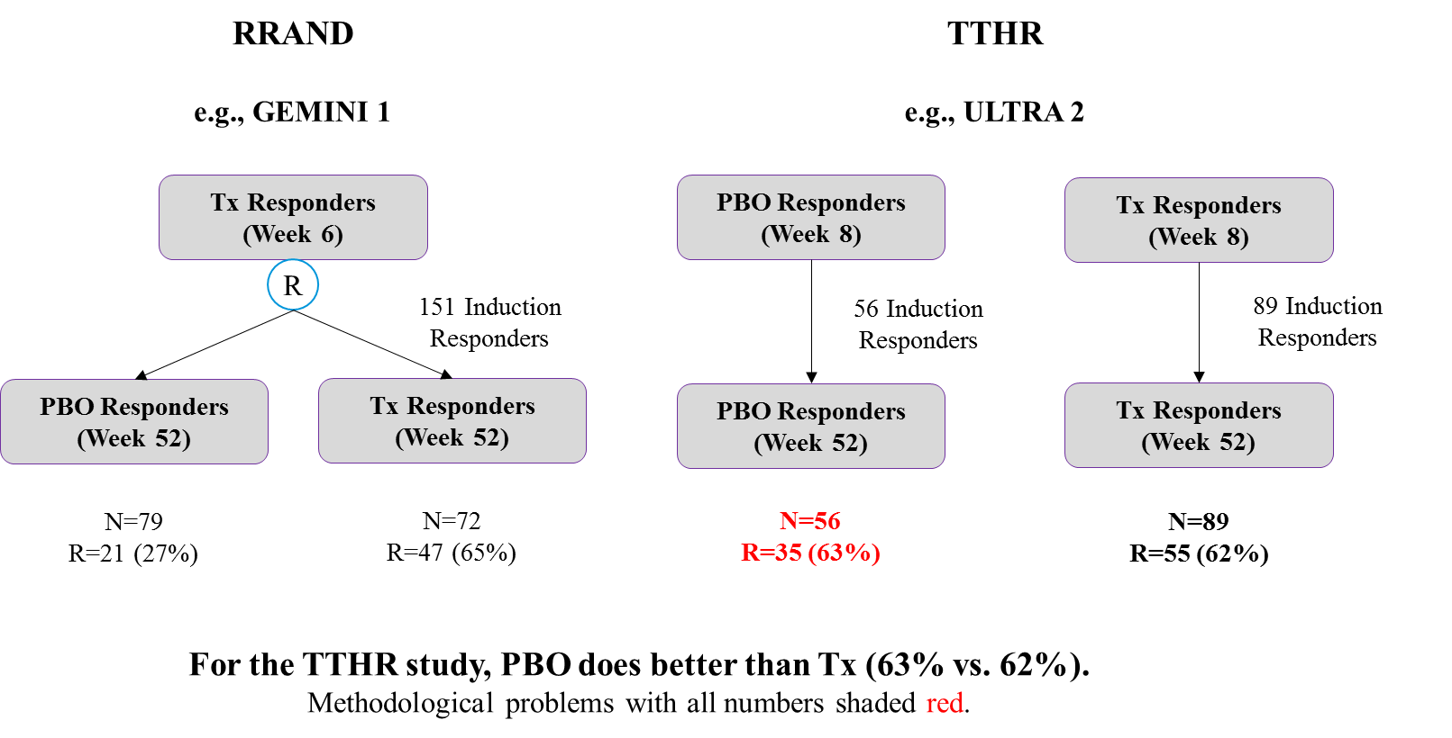
Abbreviations: PBO = placebo; RRAND = re-randomized; TTHR = treat-through; Tx = treatment

Ideally, to be comparable to data in the RRAND studies, instead of
R_{PBO,PBO}/N_{PBO2}
(the number of maintenance responders on PBO given induction response on PBO, divided by the number of induction PBO responders), we would have
R’_{PBO,Tx}/N_{Tx2}
(the number of maintenance responders on PBO given induction response on Tx, divided by the number of induction Tx responders).
Reasonable estimates (or ranges of estimates) for R’_{PBO,Tx} and N_{Tx2} are achievable if two assumptions are made:
- Assumption: No long-term effect of biologic Tx when Tx is removed at induction
- Assumption: Patients who respond to PBO would respond to Tx.
It is important to note the following:
- The violation of our assumptions by a small percentage of patients was not expected to invalidate the statistics behind the imputations.
- The violation of Assumption #1 would result in the imputed PBO rates being underestimates.
- The violation of Assumption #2 would result in the imputed PBO rates being overestimates with these errors possibly canceling each other out depending on the extent and magnitude.

Estimation/Imputation (Durable Response)
Estimating N_{Tx2}
In each TTHR study, there was a reported proportion of induction Tx responders out of the total number of patients assigned Tx during induction. For instance, in ULTRA 2 it was 89/150 = 0.593 [19]; call this proportion P_{IndTx}. Given the randomized nature of the study, P_{IndTx} represents the estimated proportion of patients who would have responded to Tx in the induction PBO group if those patients had received Tx instead of PBO.
Thus, the best estimate of the number of patients who would have responded to Tx at induction, in the group that received PBO, is P_{IndTx} * # patients assigned to PBO at induction.
N_{Tx2} = P_{IndTx} * # patients assigned to PBO at induction (1)
For instance, in ULTRA 2, N_{Tx2} = [89/150]*145 = 86 [19].
It is worth noting that no assumptions were necessary to make this estimation; given the randomized nature of the trial, 86 was the best estimate. However, Assumption #1, “No long-term effect of biologic Tx when Tx is removed at induction” was needed to make this estimate useful. We estimated that 86 patients would have responded to Tx; but they were not actually assigned Tx. With Assumption #1, because we assumed early Tx effect wore off by Week 52, the number of patients who would have responded was functionally equivalent to the number of patients who respond in RRAND trials (e.g., GEMINI 1 [12, 13]). With Assumption #1 (i.e., early Tx effect wears off), we could effectively condition our estimates on a patient’s health (“the type of patient who responds to Tx after induction”) as opposed to conditioning on actual response.
Estimating R’_{PBO,Tx}
In each TTHR study, three key results were reported in each group:
- Number of responders at the end of induction
- Number of responders at the end of maintenance (unconditional on early response): R_{PBO,ALL}
- Number of responders at the end of maintenance, conditional on early response (i.e., durable response): R_{PBO,PBO}
For instance, in ULTRA 2, 56 of 145 patients responded at the end of induction, 35 of 145 at end of maintenance (R_{PBO,ALL}=35), and 24 of 56 at maintenance given response at end of induction (R_{PBO,PBO}=24) [19]. For a comparison to RRAND studies, we need R’_{PBO,Tx} the number of patients with PBO durable response given induction Tx response.
The challenge is to estimate R’_{PBO,Tx} (or, more precisely, a realistic range for R’_{PBO,Tx}) from the data #1 through #3 above.
Assumption #2, “Patients who respond to PBO would respond to Tx” allows for a straightforward projection of the range of reasonable estimates of R’_{PBO,Tx} (see Figure 3).

Figure 3. Projection of the Range of Reasonable Estimates of R’_{PBO,Tx} for Durable Response
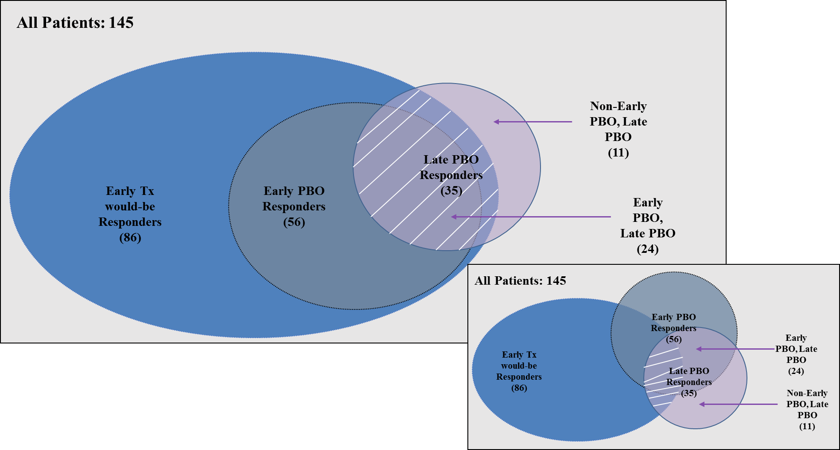
*The figure in right corner demonstrates the uncertainty in overlap that would exist without Assumption #2.
Abbreviations: PBO = placebo; Tx = treatment

Assumption #2 implies that all 24 patients who had maintenance PBO response and induction PBO response would also have had maintenance PBO response and induction Tx response. A total of 35 patients, unconditional on early response, had maintenance PBO response. This led to a range for R’_{PBO,Tx} from 24–35 for ULTRA 2 [19], or, more generally, a range for any TTHR study from R_{PBO,PBO} and R_{PBO,ALL}.
The remaining question, for the purpose of calculating an estimated R’_{PBO,Tx,} is how to pick a value between R_{PBO} and R_{PBO,ALL} that represents the patients who responded to PBO during maintenance but did not respond to PBO during induction. This group of patients (11 in ULTRA 2) comprise those within R_{PBO,ALL} but not R_{PBO,PBO}, and is represented as R_{PBO,NoPBO}. Based on clinical expert opinion, it was assumed that a proportion of R_{PBO,NoPBO} would have responded to Tx during induction, and can be referred to as R_{PBO,NoPBO,butTx}. The remaining patients can be referred to as R_{PBO,NoTx} — that is, patients who would not have responded to Tx during induction, but for some reason responded to PBO during maintenance.
The number we wish to impute is R’_{PBO,Tx} = R_{PBO,PBO} + R_{PBO,NoPBO,butTx}: that is, the number of patients responding to maintenance PBO given early Tx response was the number of patients responding to maintenance PBO given early PBO response plus the number of patients responding to maintenance PBO given early Tx-but-not-PBO response.
There are at least two relevant considerations: the underlying health of the patients and the number of patients believed to be in each group. Assumption #2 allows us to estimate the number of patients assigned to PBO who, during induction, were PBO responders, Tx-but-not PBO responders, and non-responders. Among the 145 patients in ULTRA 2 [19], these numbers were 56, 30, and 59, respectively. If there was no difference in patient health between the 30 Tx-but-not-PBO responders and the 59 non-responders, the 11 patients in R_{PBO,NoPBO} would come proportionally from these two groups:
R_{PBO,NoPBO,butTx} = 11*30/89 = 3.71
R_{PBO,NoTx} = 11*59/89 = 7.29
However, patients who eventually responded to PBO were, on average, those with less recalcitrant disease than non-responders or even patients who eventually responded to Tx. It seems more likely, all else being equal, that a patient who eventually responded to PBO would be an induction Tx-but-not-PBO responder than a Tx non-responder.
Given this, and that small violations of Assumption #1 were theorized to be likely during clinical review of Assumptions #1 and #2, our base-case estimate for R_{PBO,NoPBO,butTx} was between 3.71 and the “maximum,” if both assumptions were correct (i.e., = R_{PBO,NoPBO,butTx}).
In ULTRA 2,
R_{PBO,NoPBO,butTx} = (3.71 + 11)/2 = 7.355
R’_{PBO,Tx} = R_{PBO,PBO} + R_{PBO,NoPBO,butTx} = 24 + 7.355 = 31.355
One final adjustment was made to reflect the additional uncertainty generated by conducting these imputations. For all imputations, numerators and denominators were decreased by 10% (e.g., 0.90*31.355 = 28.2, 0.90*86 = 77.4) to inflate the variance (i.e., uncertainty in estimates that use these numbers) correspondingly. The results of the analyses using this decrease in numerators and denominators were reported as base case in this report. Given that other papers (Thorlund 2014 [23], Vickers 2016 [26]) did not use such inflation, sensitivity analyses that did not use these multipliers were conducted, as well as use of 0.80 instead of 0.90 (i.e., inflate the variances by 20% instead of 10%).

Results
For each analysis conducted, tables of the study data are presented that include data inputs used for the analyses, the timepoint of assessment, and the calculated odds ratios (ORs) and 95% confidence intervals (CIs). The plots present the results of the NMA for each treatment of interest versus PBO, as well as the probability that the treatment is better than PBO.

Induction Phase
The network of trials that reported outcomes of interest for the induction phase of treatment is shown in Figure 4.
Figure 4. Network of Induction Trials Reporting Outcomes of Interest
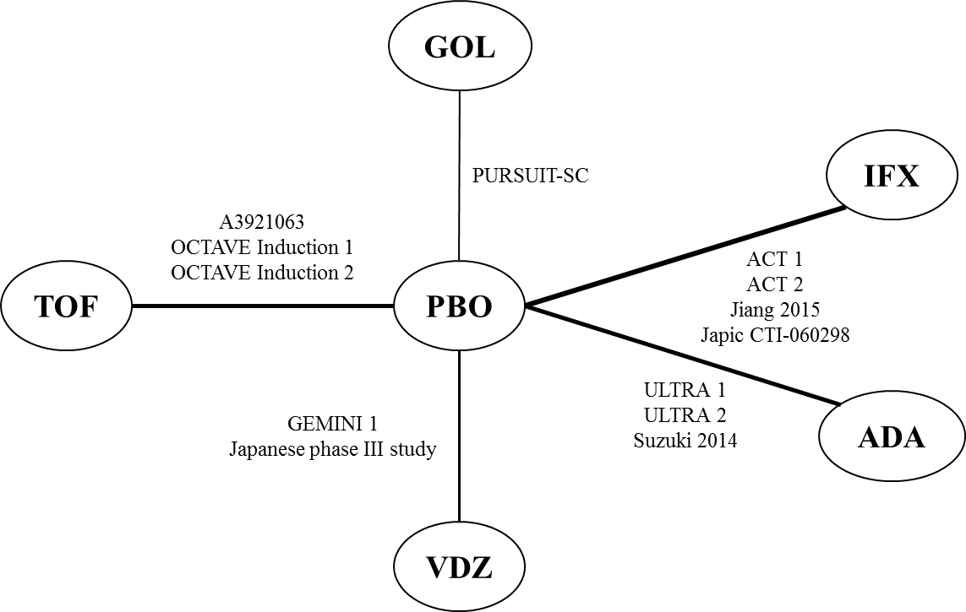

Abbreviations: ADA = adalimumab; GOL = golimumab; IFX = infliximab; PBO = placebo; TOF = tofacitinib; VDZ = vedolizumab

Clinical Response
Table 4 presents the study-level data and calculated ORs and 95% CIs (shaded columns) for each treatment versus PBO.
Results from the NMA suggest that most active treatments offer a statistically significant advantage over PBO in terms of improved induction response, except for TOF, which demonstrated a numerical but not statistically significant advantage over PBO (Figure 5). Conclusions based on the random-effects model were consistent with the fixed-effects model.
Table 4. Study Data vs. PBO for Clinical Response: Induction Phase
Trial Name or Author (Year) | Tx | N Rnd | Timepoint (weeks) | N with Event | N | % of Patients | OR (95% CI)
A3921063[4] | TOF | 23 | 8 | 14 | 23 | 60.9 | 1.87 (0.63, 5.51)
A3921063[4] | PBO | 33 | 8 | 15 | 33 | 45.5 | 1.87 (0.63, 5.51)
ACT 1[11] | IFX | 121 | 8 | 84 | 121 | 69.4 | 3.83 (2.25, 6.54)
ACT 1[11] | PBO | 121 | 8 | 45 | 121 | 37.2 | 3.83 (2.25, 6.54)
ACT 2[11] | IFX | 121 | 8 | 78 | 121 | 64.5 | 4.38 (2.56, 7.51)
ACT 2[11] | PBO | 123 | 8 | 36 | 123 | 29.3 | 4.38 (2.56, 7.51)
Jiang 2015[15] | IFX | 41 | 8 | 32 | 41 | 78.1 | 6.16 (2.32, 16.34)
Jiang 2015[15] | PBO | 41 | 8 | 15 | 41 | 36.6 | 6.16 (2.32, 16.34)
Japic CTI-060298[14] | IFX | 104 | 8 | 57 | 104 | 54.8 | 2.20 (1.26, 3.83)
Japic CTI-060298[14] | PBO | 104 | 8 | 37 | 104 | 35.6 | 2.20 (1.26, 3.83)
ULTRA 1[10] | ADA | 130 | 8 | 71 | 130 | 54.6 | 1.49 (0.92, 2.44)
ULTRA 1[10] | PBO | 130 | 8 | 58 | 130 | 44.6 | 1.49 (0.92, 2.44)
ULTRA 2[19] | ADA | 150 | 8 | 89 | 150 | 59.3 | 2.32 (1.45, 3.70)
ULTRA 2[19] | PBO | 145 | 8 | 56 | 145 | 38.6 | 2.32 (1.45, 3.70)
Suzuki 2014[18] | ADA | 90 | 8 | 45 | 90 | 50 | 1.82 (1.01, 3.28)
Suzuki 2014[18] | PBO | 96 | 8 | 34 | 96 | 35 | 1.82 (1.01, 3.28)
PURSUIT SC[8] | GOL | 258 | 6 | 129 | 253 | 51 | 2.40 (1.66, 3.45)
PURSUIT SC[8] | PBO | 258 | 6 | 76 | 251 | 30.3 | 2.40 (1.66, 3.45)
GEMINI 1[12, 13] | VDZ | 130 | 6 | 69 | 130 | 53.1 | 3.17 (1.7, 5.86)
GEMINI 1[12, 13] | PBO | 76 | 6 | 20 | 76 | 26.3 | 3.17 (1.7, 5.86)
Japanese phase III study [16, 17] | VDZ | 79 | 10 | 42 | 79 | 53.2 | 1.97 (0.91, 4.27)
Japanese phase III study [16, 17] | PBO | 41 | 10 | 15 | 41 | 36.6 | 1.97 (0.91, 4.27)
Abbreviations: ADA = adalimumab; CI = confidence interval; GOL = golimumab; IFX = infliximab; OR = odds ratio; PBO = placebo; TOF = tofacitinib; Tx = treatment; VDZ = vedolizumab
Figure 5. Results of Fixed Effect NMA for Clinical Response (6–10 weeks): Induction Phase
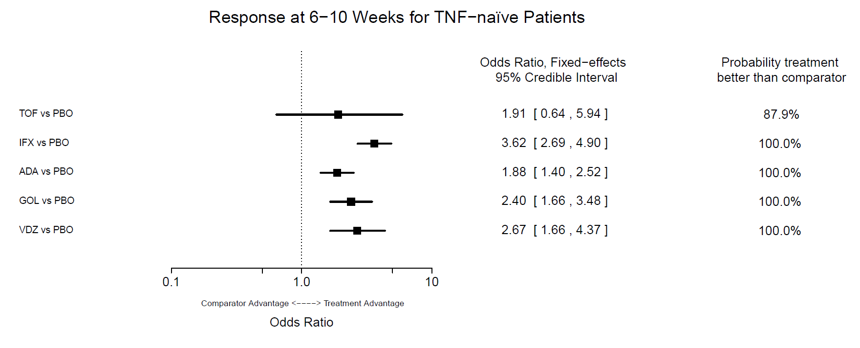
Abbreviations: ADA = adalimumab; GOL = golimumab; IFX = infliximab; NMA = network meta-analysis; PBO = placebo; TNF = tumor necrosis factor; TOF = tofacitinib; VDZ = vedolizumab

Clinical Remission
Table 5 presents the study-level data and calculated ORs and 95% CIs (shaded columns) for each treatment versus PBO.
Results from the NMA suggest that all active treatments offer a statistically significant advantage over PBO in terms of improved induction remission (Figure 6). Conclusions based on the random-effects model were consistent with the findings with the fixed-effects model.

Table 5. Study Data vs. PBO for Clinical Remission in Anti-TNF-Naïve Patients: Induction Phase
Trial Name or Author (Year) | Tx | N Rnd | Timepoint (weeks) | N with Event | N | % of Patients | OR (95% CI)
OCTAVE Induction 1 [5] | TOF | 222 | 8 | 56 | 222 | 25.2 | 1.80 (0.83, 3.90)
OCTAVE Induction 1 [5] | PBO | 57 | 8 | 9 | 57 | 15.8 | 1.80 (0.83, 3.90)
OCTAVE Induction 2 [5] | TOF | 195 | 8 | 43 | 195 | 22.1 | 3.04 (1.03, 8.95)
OCTAVE Induction 2 [5] | PBO | 47 | 8 | 4 | 47 | 8.5 | 3.04 (1.03, 8.95)
Jiang 2015 [15] | IFX | 41 | 8 | 22 | 41 | 53.7 | 4.12 (1.57, 10.76)
Jiang 2015 [15] | PBO | 41 | 8 | 9 | 41 | 21.9 | 4.12 (1.57, 10.76)
ACT 1 [11] | IFX | 121 | 8 | 47 | 121 | 38.8 | 3.63 (1.96, 6.76)
ACT 1 [11] | PBO | 121 | 8 | 18 | 121 | 14.9 | 3.63 (1.96, 6.76)
ACT 2 [11] | IFX | 121 | 8 | 41 | 121 | 33.9 | 8.49 (3.63, 19.88)
ACT 2 [11] | PBO | 123 | 8 | 7 | 123 | 5.7 | 8.49 (3.63, 19.88)
Japic CTI-060298 [14] | IFX | 104 | 8 | 21 | 104 | 20.2 | 2.14 (0.97, 4.70)
Japic CTI-060298 [14] | PBO | 104 | 8 | 11 | 104 | 10.6 | 2.14 (0.97, 4.70)
ULTRA 1 [10] | ADA | 130 | 8 | 24 | 130 | 18.5 | 2.23 (1.06, 4.67)
ULTRA 1 [10] | PBO | 130 | 8 | 12 | 130 | 9.2 | 2.23 (1.06, 4.67)
ULTRA 2 [19] | ADA | 150 | 8 | 32 | 150 | 21.3 | 2.19 (1.14, 4.19)
ULTRA 2 [19] | PBO | 145 | 8 | 16 | 145 | 11 | 2.19 (1.14, 4.19)
Suzuki 2014 [18] | ADA | 90 | 8 | 9 | 90 | 10 | 0.86 (0.34, 2.18)
Suzuki 2014 [18] | PBO | 96 | 8 | 11 | 96 | 11 | 0.86 (0.34, 2.18)
PURSUIT SC [8] | GOL | 258 | 6 | 45 | 253 | 17.8 | 3.18 (1.74, 5.79)
PURSUIT SC [8] | PBO | 258 | 6 | 16 | 251 | 6.4 | 3.18 (1.74, 5.79)
GEMINI 1 [12, 13] | VDZ | 130 | 6 | 30 | 130 | 23.1 | 4.26 (1.58, 11.52)
GEMINI 1 [12, 13] | PBO | 76 | 6 | 5 | 76 | 6.6 | 4.26 (1.58, 11.52)
Japanese phase III study [16, 17] | VDZ | 79 | 10 | 22 | 79 | 27.8 | 2.25 (0.83, 6.10)
Japanese phase III study [16, 17] | PBO | 41 | 10 | 6 | 41 | 14.6 | 2.25 (0.83, 6.10)
Abbreviations: ADA = adalimumab; CI = confidence interval; GOL = golimumab; IFX = infliximab; OR = odds ratio; PBO = placebo; TNF = tumor necrosis factor; TOF = tofacitinib; Tx = treatment; VDZ = vedolizumab
Figure 6. Results of Fixed-effect NMA for Clinical Remission (6-10 weeks): Induction Phase
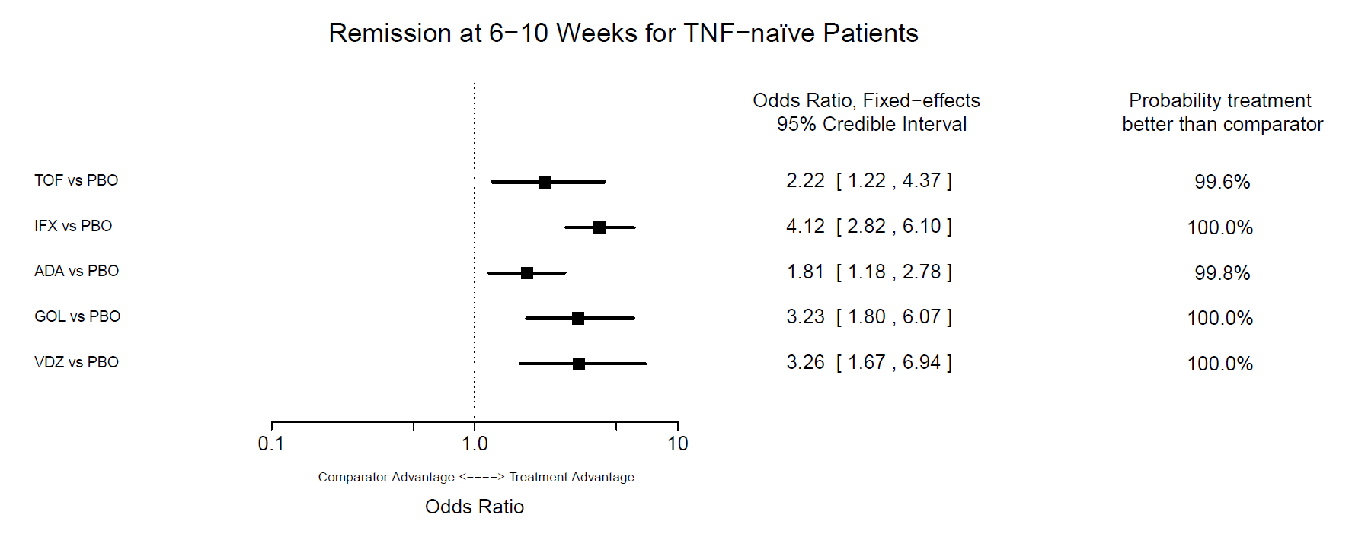
Abbreviations: ADA = adalimumab; GOL = golimumab; IFX = infliximab; NMA = network meta-analysis; PBO = placebo; TNF = tumor necrosis factor; TOF = tofacitinib; VDZ = vedolizumab

Maintenance Phase
The network of trials that reported outcomes of interest for the maintenance phase of treatment is shown in Figure 7.

Figure 7. Network of Trials Reporting Outcomes of Interest for Anti-TNF-naïve Patients
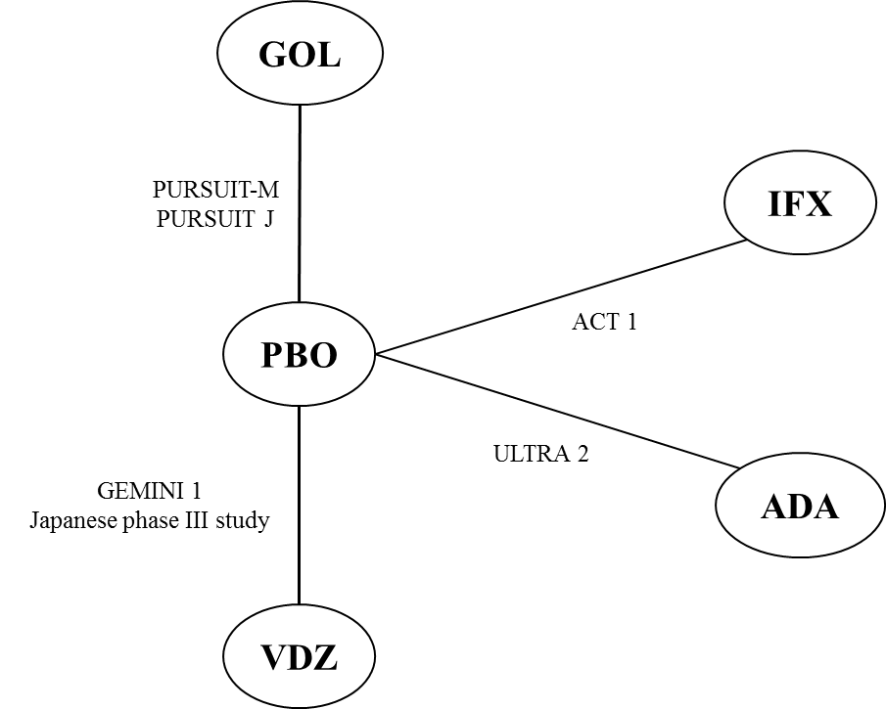

Abbreviations: ADA = adalimumab; GOL = golimumab; IFX = infliximab; PBO = placebo; VDZ = vedolizumab
Durable Clinical Response
Table 6 presents the study-level data and calculated ORs and 95% CIs (shaded columns) for each treatment versus PBO.
Results from the NMA suggest that all active treatments offer a statistically significant advantage over PBO in terms of improved durable clinical response (Figure 8). Findings from sensitivity analyses, wherein the lower and upper bound for the imputed numerators were used, resulted in similar conclusions, except for the upper bound, which showed a numerical but not statistically significant advantage for ADA over PBO.
Despite larger uncertainty observed (wider CIs), conclusions based on the random-effects model were consistent with the findings with the fixed-effects model in terms of improved durable clinical response. The only exception was for the comparison of VDZ versus ADA, where VDZ showed a numerical but not statistically significant advantage over ADA (OR [95% CI]: 2.77 [ 0.55, 13.99]). The small number of studies included in this analysis preclude any strong interpretation of the random-effects results.
Table 6. Study Data vs. PBO for Durable Clinical Response: Maintenance Phase with Imputation
Trial Name | Tx | Timepoint (weeks) | N with Event | N | % of Patients | OR (95% CI)
ACT 1 [11] | IFX | 54 | 42.30 | 75.60 | 55.95 | 3.51 (1.77, 6.96)
ACT 1 [11] | PBO | 54 | 20.10 | 75.60 | 26.59 | 3.51 (1.77, 6.96)
ULTRA 2 [19] | ADA | 52 | 39.60 | 80.10 | 49.44 | 1.70 (0.90, 3.22)
ULTRA 2 [19] | PBO | 52 | 28.20 | 77.40 | 36.43 | 1.70 (0.90, 3.22)
PURSUIT-M [20] | GOL | 54 | 75 | 151 | 49.67 | 2.18 (1.37, 3.48)
PURSUIT-M [20] | PBO | 54 | 48 | 154 | 31.17 | 2.18 (1.37, 3.48)
PURSUIT-J [21] | GOL | 54 | 18 | 32 | 56.25 | 5.36 (1.73, 16.62)
PURSUIT-J [21] | PBO | 54 | 6 | 31 | 19.35 | 5.36 (1.73, 16.62)
GEMINI 1 [12, 13] | VDZ | 52 | 47 | 72 | 65.28 | 5.19 (2.59, 10.42)
GEMINI 1 [12, 13] | PBO | 52 | 21 | 79 | 26.58 | 5.19 (2.59, 10.42)
Japanese phase III study [16, 17] | VDZ | 60 | 16 | 24 | 66.67 | 3.6 (1.14, 11.35)
Japanese phase III study [16, 17] | PBO | 60 | 10 | 28 | 35.71 | 3.6 (1.14, 11.35)
Abbreviations: ADA = adalimumab; CI = confidence interval; GOL = golimumab; IFX = infliximab; OR = odds ratio; PBO = placebo; Tx = treatment; VDZ = vedolizumab
Figure 8. Results of Fixed-effect NMA for Durable Clinical Response (52–60 weeks): Maintenance Phase with Imputation
Abbreviations: ADA = adalimumab; GOL = golimumab; IFX = infliximab; PBO = placebo; RR = re-randomized; TNF = tumor necrosis factor; TTHR = treat through; VDZ = vedolizumab

Clinical Remission
Table 7 presents the study-level data and calculated ORs and 95% CIs (shaded columns) for each treatment versus PBO.
Results from the NMA suggest that all active treatments offer a statistically significant advantage over PBO in terms of improved clinical remission (Figure 9). Despite wider CIs observed, conclusions based on the random-effects model were consistent with the fixed-effects model in terms of clinical remission.
Table 7. Study Data vs. PBO for Clinical Remission (52–60 weeks): Maintenance Phase with Imputation
Trial Name | Tx | Timepoint (weeks) | N with Event | N | % of Patients | OR (95% CI)
ACT 1 [11] | IFX | 54 | 37.80 | 75.60 | 50.00 | 3.20 (1.60, 6.41)
ACT 1 [11] | PBO | 54 | 18 | 75.60 | 23.81 | 3.20 (1.60, 6.41)
ULTRA 2 [19] | ADA | 52 | 29.70 | 80.10 | 37.08 | 2.23 (1.09, 4.53)
ULTRA 2 [19] | PBO | 52 | 16.20 | 77.40 | 20.93 | 2.23 (1.09, 4.53)
PURSUIT-M [20] | GOL | 54 | 51 | 151 | 33.77 | 1.8 (1.08, 2.99)
PURSUIT-M [20] | PBO | 54 | 34 | 154 | 22.08 | 1.8 (1.08, 2.99)
GEMINI 1 [12, 13] | VDZ | 52 | 33 | 72 | 45.83 | 3.61 (1.74, 7.48)
GEMINI 1 [12, 13] | PBO | 52 | 15 | 79 | 18.99 | 3.61 (1.74, 7.48)
Japanese phase III study [16, 17] | VDZ | 60 | 13 | 24 | 54.17 | 2.13 (0.70, 6.48)
Japanese phase III study [16, 17] | PBO | 60 | 10 | 28 | 35.71 | 2.13 (0.70, 6.48)
Abbreviations: ADA = adalimumab; CI = confidence interval; GOL = golimumab; IFX = infliximab; OR = odds ratio; PBO = placebo; Tx = treatment; VDZ = vedolizumab
Figure 9. Results of Fixed-effect NMA for Clinical Remission (52–60 weeks): Maintenance Phase with Imputation
Abbreviations: PBO = placebo; RR = re-randomized; TNF = tumor necrosis factor; TTHR = treat through; VDZ = vedolizumab

Appendix B. Calculating Relative Risks from NMA Odds Ratios
Table 8 shows the odds ratio (ORs; and their 95% confidence intervals [CIs]) calculated from the NMA for each biologic versus placebo for the clinical efficacy outcomes response and remission at the end of the induction phase, and durable response and remission for the maintenance phase.
The relative risks (RRs; and their 95% CIs) for each biologic versus placebo used in the cost-effectiveness analysis to adjust transition probabilities, were calculated using the below formula, where p is the probability of the outcome of interest observed for the placebo arm in Study CCT-101, which was used for conventional therapy (CT) in the cost-effectiveness analysis: 36.60% and 14.60% of response (including response-only and remission) and remission at the end of induction, respectively, and 35.70% for both durable response and remission in the maintenance phase [17].
$$RR=\frac{OR}{\left(1-p\right)+(p x OR)}$$
For example, the RR of response at the end of the induction phase for vedolizumab (VDZ) versus placebo was calculated as follows:
$$1.658=\frac{2.673}{\left(1-0.366\right)+(0.366 x 2.673)}$$
Table 8. Odds Ratios from NMA and Calculated RR
Induction phase | Response* |  | Remission†
 | OR (95% CI) | RR (95% CI) | OR (95% CI) | RR (95% CI)
Reference (placebo) | 1.0 | 1.0 | 1.0 | 1.0
VDZ | 2.673 (1.660-4.370) | 1.658 (1.337-1.957) | 3.260 (1.672-6.937) | 2.451 (1.523-3.716)
ADA | 1.877(1.397-2.518) | 1.421 (1.220-1.619) | 1.811 (1.184-2.784) | 1.619 (1.153-2.209)
GOL | 2.399 (1.661-3.480) | 1.587 (1.337-1.824) | 3.227 (1.802-6.077) | 2.435 (1.613-3.490)
IFX | 3.620 (2.693-4.901) | 1.848 (1.663-2.019) | 4.126 (2.824-6.100) | 2.833 (2.230-3.497)
Maintenance phase | Durable response‡ |  | Remission₸
 | OR (95% CI) | RR (95% CI) | OR (95% CI) | RR (95% CI)
Reference (placebo) | 1.0 | 1.0 | 1.0 | 1.0
VDZ | 4.815 (2.667-8.882) | 2.039 (1.672-2.329) | 3.153 (1.725-5.873) | 1.783 (1.370-2.144)
ADA | 1.698 (0.901-3.269) | 1.359 (0.934-1.806) | 2.239 (1.107-4.693) | 1.552 (1.066-2.024)
GOL | 2.529 (1.652-3.899) | 1.636 (1.340-1.916) | 1.810 (1.087-3.039) | 1.404 (1.054-1.759)
IFX | 3.557 (1.796-7.248) | 1.860 (1.399-2.244) | 3.239 (1.635-6.57) | 1.800 (1.333-2.198)
* Reduction in complete Mayo score by ≥3 points and by ≥30% from baseline with an accompanying decrease in the sub-score of rectal bleeding by ≥1 point from baseline or an absolute rectal bleeding sub-score ≤1. Response includes patients who achieve remission and response-only
† Complete Mayo score ≤2 and ≤1 in all sub-scores
‡ Response (including response-only and remission) observed at the end of induction and maintenance
₸ Response (including response-only and remission) observed at the end of induction and remission observed at the end of maintenance
Abbreviations: ADA = adalimumab; CI = confidence interval; GOL = golimumab; IFX = infliximab; OR = odds ratio; RR = relative risk; VDZ = vedolizumab

Appendix C. Resource Use
Table 9. Treatment Administration – Induction Phase
Resource | Unit cost[27] | Resource use per eight weeks
Resource | Unit cost[27] | VDZ | ADA | GOL | IFX
Outpatient visit | ¥730 | 3 | 4 | 3 | 3
UC management fee | ¥2,700 | 2 | 2 | 2 | 2
Blood test | ¥1,180 | 3 | 4 | 3 | 3
Blood test physician fee | ¥4,130 | 3 | 4 | 3 | 3
Administration fee IV | ¥4,990 | 3 | 0 | 0 | 3
Administration fee SC | ¥200 | 0 | 4 | 3 | 0
Total |  | ¥38,490 | ¥30,360 | ¥24,120 | ¥38,490
Abbreviations: ADA = adalimumab; GOL = golimumab; IFX = infliximab; IV = intravenous; SC = subcutaneous; UC = ulcerative colitis; VDZ = vedolizumab

Table 10. Treatment Administration – Maintenance Phase
Resource | Unit cost[27] | Resource use per one-year cycle
Resource | Unit cost[27] | VDZ | ADA† | GOL | IFX
Outpatient visit | ¥730 | 6.5223 | 16.3058 | 13.0446 | 6.5223
UC management fee | ¥2,700 | 6.5223 | 9.7835 | 13.0446 | 6.5223
Self-injection management fee | ¥6,500 | 0.0000 | 3.2612 | 0.0000 | 0.0000
Blood test | ¥1,180 | 6.5223 | 16.3058 | 13.0446 | 6.5223
Blood test physician fee | ¥4,130 | 6.5223 | 16.3058 | 13.0446 | 6.5223
Administration fee IV | ¥4,990 | 6.5223 | 0.0000 | 0.0000 | 6.5223
Administration fee SC | ¥200 | 0.0000 | 16.3058 | 13.0446 | 0.0000
Total* |  | ¥89,551 | ¥149,361 | ¥116,619 | ¥89,551
* Totals presented might not exactly match manual calculations due to rounding
† It was assumed that half of the patients on ADA used these resources every two weeks (when ADA is administered during the maintenance phase) and the other half every eight weeks
Abbreviations: ADA = adalimumab; GOL = golimumab; IFX = infliximab; IV = intravenous; SC = subcutaneous; UC = ulcerative colitis; VDZ = vedolizumab

Table 11. Disease Management – Costs Associated with Health States
Resource | Unit cost[27] | Resource use frequency per eight weeks |  |  | Post-surgery complication₸
Resource | Unit cost[27] | Response-only | Active UC | Post-surgery remission | Post-surgery complication₸
Outpatient visit | ¥730 | 0.30 | 1.00 | 0.25 | 2.00
Blood test | ¥1,180 | 0.30 | 1.00 | 0.25 | 2.00
Blood test physician fee | ¥4,130 | 0.30 | 1.00 | 0.25 | 2.00
Endoscopy | ¥15,500 | 0.00 | 0.80 | 0.00 | 1.00
Endoscopic biopsy | ¥16,200 | 0.00 | 0.40 | 0.00 | 0.00
X-ray | ¥1,530 | 0.00 | 0.40 | 0.00 | 0.00
Computed tomography scan | ¥14,500 | 0.00 | 0.40 | 0.00 | 0.00
Hospitalization during Active UC* | ¥359,730 | 0.00 | 0.20 | 0.00 | 0.00
Hospitalization post-surgery† | ¥284,570 | 0.00 | 0.00 | 0.10 | 0.10
Pouchitis treatment‡ | ¥6,384 | 0.00 | 0.00 | 0.00 | 1.00
Total |  | ¥1,812 | ¥103,278 | ¥29,967 | ¥62,421
* Cost of hospitalization during active UC was estimated based on an unpublished multi-center cross-sectional observational study in Japanese patients with active UC, studying the relationship between disease severity and healthcare resource utilization (data on file)
† Cost of hospitalization post-surgery was estimated based on the Japanese Inpatient Payment Scheme, Diagnosis Procedure Combination/Per-Diem Payment System [28]
‡ Includes 28-day treatment with metronidazole 500 mg daily and ciprofloxacin 500 mg daily
₸ Cost of post-surgery complications was applied as a one-time cost
Abbreviation: UC = ulcerative colitis

Appendix D. Distributions Used for Probabilistic Sensitivity Analysis
Parameter | Base Case Value | Range of variation* | Distribution | SE† | Alpha | Beta | Source of variation
Mean baseline age, years | 42.8 | 16 – 77‡ | Normal | 0.4400 |  |  | Japanese phase III VDZ study[13, 17]
Proportion of males, % | 61.6 | 38.4 – 80.8₸ | Beta | 0.1232§ | 8.98 | 5.60 | Japanese phase III VDZ study[13, 17]
Clinical efficacy – placebo
Probability of response at the end of induction phase | 0.366 | 0.221 – 0.530 | Beta | 0.1579 | 3.04 | 5.27 | Japanese phase III VDZ study[13, 17]
Probability of remission at the end of induction phase | 0.146 | 0.055 – 0.291 | Beta | 0.1205 | 1.11 | 6.48 | Japanese phase III VDZ study[13, 17]
Probability of durable response during maintenance, annual probability | 0.357 | 0.186 – 0.559 | Beta | 0.0951 | 8.70 | 15.68 | Japanese phase III VDZ study[13, 17]
Probability of remission during maintenance, annual probability | 0.357 | 0.186 – 0.559 | Beta | 0.0951 | 8.70 | 15.68 | Japanese phase III VDZ study[13, 17]
Clinical efficacy – CT after first-line biologic discontinuation
Probability of response at the end of induction phase | 0.293 | 0.178 – 0.408 | Beta | 0.0586§ | 17.38 | 41.94 | Japanese phase III VDZ study[13, 17]
Probability of remission at the end of induction phase | 0.098 | 0.255 – 0.331 | Beta | 0.0196§ | 22.45 | 206.65 | Japanese phase III VDZ study[13, 17]
Probability of durable response during maintenance, annual probability | 0.357 | 0.153 – 0.433 | Beta | 0.0714§ | 15.72 | 28.31 | Japanese phase III VDZ study[13, 17]
Probability of remission during maintenance, annual probability | 0.214 | 0.209 – 0.377 | Beta | 0.0428§ | 19.44 | 71.39 | Japanese phase III VDZ study[13, 17]
RR vs. placebo – Response at the end of induction phase
VDZ | 1.658 | 1.337 – 1.957 | Lognormal | 0.0972 |  |  | NMA
ADA | 1.421 | 1.220 – 1.619 | Lognormal | 0.0722 |  |  | NMA
GOL | 1.587 | 1.337 – 1.824 | Lognormal | 0.0792 |  |  | NMA
IFX | 1.848 | 1.663 – 2.019 | Lognormal | 0.0495 |  |  | NMA
RR vs. placebo – Remission at the end of induction phase
VDZ | 2.451 | 1.523 – 3.716 | Lognormal | 0.2275 |  |  | NMA
ADA | 1.619 | 1.153 – 2.209 | Lognormal | 0.1659 |  |  | NMA
GOL | 2.435 | 1.613 – 3.490 | Lognormal | 0.1969 |  |  | NMA
IFX | 2.833 | 2.230 – 3.497 | Lognormal | 0.1148 |  |  | NMA
RR vs. placebo – Durable response during maintenance phase
VDZ | 2.039 | 1.672 – 2.329 | Lognormal | 0.0845 |  |  | NMA
ADA | 1.359 | 0.934 – 1806 | Lognormal | 0.1682 |  |  | NMA
GOL | 1.636 | 1.340 – 1.916 | Lognormal | 0.0912 |  |  | NMA
IFX | 1.860 | 1.399 – 2.244 | Lognormal | 0.1205 |  |  | NMA
RR vs. placebo – Durable response during maintenance phase
VDZ | 1.783 | 1.370 – 2.144 | Lognormal | 0.1143 |  |  | NMA
ADA | 1.552 | 1.066 – 2.024 | Lognormal | 0.1636 |  |  | NMA
GOL | 1.404 | 1.054 – 1.759 | Lognormal | 0.1307 |  |  | NMA
IFX | 1.800 | 1.333 – 2.198 | Lognormal | 0.1276 |  |  | NMA
Discontinuation due to AEs during induction, eight-week probability
VDZ | 5.23% | ± 20% | Beta | 0.0105§ | 23.64 | 428.37 | Assumption
ADA | 5.75% | ± 20% | Beta | 0.0115§ | 23.51 | 385.28 | Assumption
GOL | 0.40% | ± 20% | Beta | 0.0008§ | 24.90 | 6199.10 | Assumption
IFX | 2.69% | ± 20% | Beta | 0.0054§ | 24.30 | 879.07 | Assumption
Discontinuation due to AEs during induction, annual probability
VDZ | 4.17% | ± 20% | Beta | 0.0083§ | 23.92 | 549.60 | Assumption
ADA | 8.95% | ± 20% | Beta | 0.0179§ | 22.67 | 230.66 | Assumption
GOL | 8.77% | ± 20% | Beta | 0.0175§ | 22.72 | 236.34 | Assumption
IFX | 6.31% | ± 20% | Beta | 0.0126§ | 23.36 | 346.84 | Assumption
Incidence of erythema during induction, weekly rate
VDZ | 0.12% | ± 20% | Lognormal | 0.0002§ |  |  | Assumption
ADA | 0.00% | ± 20% | Lognormal | 0.0000§ |  |  | Assumption
GOL | 0.00% | ± 20% | Lognormal | 0.0000§ |  |  | Assumption
IFX | 0.00% | ± 20% | Lognormal | 0.0000§ |  |  | Assumption
Incidence of infusion-associated reaction during induction, weekly rate
VDZ | 0.00% | ± 20% | Lognormal | 0.0000§ |  |  | Assumption
ADA | 0.00% | ± 20% | Lognormal | 0.0000§ |  |  | Assumption
GOL | 0.00% | ± 20% | Lognormal | 0.0000§ |  |  | Assumption
IFX | 0.80% | ± 20% | Lognormal | 0.0016§ |  |  | Assumption
Incidence of injection site reactions during induction, weekly rate
VDZ | 0.06% | ± 20% | Lognormal | 0.0001§ |  |  | Assumption
ADA | 1.16% | ± 20% | Lognormal | 0.0023§ |  |  | Assumption
GOL | 0.00% | ± 20% | Lognormal | 0.0000§ |  |  | Assumption
IFX | 0.00% | ± 20% | Lognormal | 0.0000§ |  |  | Assumption
Incidence of rash during induction, weekly rate
VDZ | 0.09% | ± 20% | Lognormal | 0.0002§ |  |  | Assumption
ADA | 0.00% | ± 20% | Lognormal | 0.0000§ |  |  | Assumption
GOL | 0.00% | ± 20% | Lognormal | 0.0000§ |  |  | Assumption
IFX | 0.00% | ± 20% | Lognormal | 0.0000§ |  |  | Assumption
Incidence of skin and subcutaneous disorders during induction, weekly rate
VDZ | 0.84% | ± 20% | Lognormal | 0.0017§ |  |  | Assumption
ADA | 0.00% | ± 20% | Lognormal | 0.0000§ |  |  | Assumption
GOL | 0.00% | ± 20% | Lognormal | 0.0000§ |  |  | Assumption
IFX | 0.00% | ± 20% | Lognormal | 0.0000§ |  |  | Assumption
Incidence of erythema during maintenance, annual rate
VDZ | 2.14% | ± 20% | Lognormal | 0.0043§ |  |  | Assumption
ADA | 0.00% | ± 20% | Lognormal | 0.0000§ |  |  | Assumption
GOL | 16.36% | ± 20% | Lognormal | 0.0327§ |  |  | Assumption
IFX | 0.00% | ± 20% | Lognormal | 0.0000§ |  |  | Assumption
Incidence of infusion-associated reaction during maintenance, annual rate
VDZ | 0.00% | ± 20% | Lognormal | 0.0000§ |  |  | Assumption
ADA | 0.00% | ± 20% | Lognormal | 0.0000§ |  |  | Assumption
GOL | 0.00% | ± 20% | Lognormal | 0.0000§ |  |  | Assumption
IFX | 17.35% | ± 20% | Lognormal | 0.0347§ |  |  | Assumption
Incidence of injection site reactions during maintenance, annual rate
VDZ | 2.14% | ± 20% | Lognormal | 0.0043§ |  |  | Assumption
ADA | 12.85% | ± 20% | Lognormal | 0.0257§ |  |  | Assumption
GOL | 9.35% | ± 20% | Lognormal | 0.0187§ |  |  | Assumption
IFX | 0.00% | ± 20% | Lognormal | 0.0000§ |  |  | Assumption
Incidence of rash during maintenance, annual rate
VDZ | 0.54% | ± 20% | Lognormal | 0.0011§ |  |  | Assumption
ADA | 0.00% | ± 20% | Lognormal | 0.0000§ |  |  | Assumption
GOL | 4.48% | ± 20% | Lognormal | 0.0090§ |  |  | Assumption
IFX | 7.36% | ± 20% | Lognormal | 0.0147§ |  |  | Assumption
Incidence of skin and subcutaneous disorders during maintenance, annual rate
VDZ | 12.93% | ± 20% | Lognormal | 0.0259§ |  |  | Assumption
ADA | 0.00% | ± 20% | Lognormal | 0.0000§ |  |  | Assumption
GOL | 0.00% | ± 20% | Lognormal | 0.0000§ |  |  | Assumption
IFX | 0.00% | ± 20% | Lognormal | 0.0000§ |  |  | Assumption
Health-state utilities
Remission | 0.87 | ± 20% | Beta | 0.1740§ | 2.38 | 0.36 | Assumption
Response-only | 0.76 | ± 20% | Beta | 0.1520§ | 5.24 | 1.65 | Assumption
Active UC | 0.41 | ± 20% | Beta | 0.0820§ | 14.34 | 20.64 | Assumption
Surgery | 0.66 | ± 20% | Beta | 0.1320§ | 7.84 | 4.04 | Assumption
Post-surgery remission | 0.71 | ± 20% | Beta | 0.1420§ | 6.54 | 2.67 | Assumption
Post-surgery complications | 0.66 | ± 20% | Beta | 0.1320§ | 7.84 | 4.04 | Assumption
AE disutility
Erythema | -0.11 | ± 20% | Beta | 0.0220§ | 22.14 | 179.13 | Assumption
Infusion-associated reaction | -0.03 | ± 20% | Beta | 0.0060§ | 24.22 | 783.11 | Assumption
Injection site reaction | -0.03 | ± 20% | Beta | 0.0060§ | 24.22 | 783.11 | Assumption
Rash | -0.11 | ± 20% | Beta | 0.0220§ | 22.14 | 179.13 | Assumption
Skin and subcutaneous disorders | -0.11 | ± 20% | Beta | 0.0220§ | 22.14 | 179.13 | Assumption
Disease management costs during induction, ¥ per eight weeks
Remission | 0 | ± 20% | Gamma | 0.0§ | 0.00 | 0.00 | Assumption
Response-only | 1,812 | ± 20% | Gamma | 362.4§ | 25.00 | 72.48 | Assumption
Active UC | 103,278 | ± 20% | Gamma | 20655.6§ | 25.00 | 4,131.12 | Assumption
Surgery₽ | 1,626,170 | ± 20% | Gamma | 325,234.0§ | 25.00 | 65,046.80 | Assumption
Post-surgery remission | 29,967 | ± 20% | Gamma | 5,993.4§ | 25.00 | 1,198.68 | Assumption
Post-surgery complications₽ | 62,421 | ± 20% | Gamma | 12,484.2§ | 25.00 | 2,496.84 | Assumption
Disease management costs during maintenance, ¥ per year
Remission | 0 | ± 20% | Gamma | 0.0§ | 0.00 | 0.00 | Assumption
Response-only | 11,818 | ± 20% | Gamma | 2,363.6§ | 25.00 | 472.72 | Assumption
Active UC | 673,612 | ± 20% | Gamma | 134,722.4§ | 25.00 | 26,944.48 | Assumption
Surgery₽ | 1,626,170 | ± 20% | Gamma | 325,234.0§ | 25.00 | 65,046.80 | Assumption
Post-surgery remission | 195,454 | ± 20% | Gamma | 39,090.8§ | 25.00 | 7,818.16 | Assumption
Post-surgery complications₽ | 62,421 | ± 20% | Gamma | 12,484.2§ | 25.00 | 2,496.84 | Assumption
AE cost per event, ¥
Erythema | 1,607 | ± 20% | Gamma | 321.40 | 25.00 | 64.28 | Assumption
Infusion-associated reaction | 149 | ± 20% | Gamma | 29.80 | 25.00 | 5.96 | Assumption
Injection site reaction | 1,607 | ± 20% | Gamma | 321.40 | 25.00 | 64.28 | Assumption
Rash | 1,607 | ± 20% | Gamma | 321.40 | 25.00 | 64.28 | Assumption
Skin and subcutaneous disorders | 1,607 | ± 20% | Gamma | 321.40 | 25.00 | 64.28 | Assumption
* 95% confidence interval, unless noted otherwise
† Calculated based on the 95% confidence interval, assuming a normal distribution (i.e., SE = [upper limit – lower limit]/[2 x 1.959964]; for parameters varied using a lognormal distribution SE = [LN{upper limit} – LN{lower limit}]/[2 x 1.959964]), unless noted otherwise
‡ Range presented as: Minimum – Maximum reported in the Japanese phase III VDZ trial
₸ Range presented as: Proportion of females – Proportion of males+Difference in Proportion of males and females
§ Calculated as 20% of the base case value
₽ Applied as a one-time cost
Abbreviations: ADA = adalimumab; AE = adverse event; CT = conventional therapy; DSA = deterministic sensitivity analysis; GOL = golimumab; IFX = infliximab; LN = natural logarithm; NMA = network meta-analysis; PSA = probabilistic sensitivity analysis; RR = relative risk; SE = standard error; UC = ulcerative colitis; VDZ = vedolizumab

Appendix E. Results of Deterministic Sensitivity Analyses
The deterministic sensitivity analyses (DSA) showed that VDZ was dominant or cost-effective versus GOL in all scenarios.
The DSA showed that VDZ was cost-effective in most scenarios versus ADA. The incremental cost-effectiveness ratio (ICER) was above ¥5,000,000 in the following scenarios:
- Drug acquisition cost of VDZ was increased by 20% (ICER = ¥8,072,928)
- Probability of durable response for the placebo arm of Japanese phase III study was reduced to the lower bound of its 95% CI (ICER = ¥8,050,283)
- Utility for the remission health state was reduced by 20% (ICER = ¥7,735,384)
- Drug acquisition cost of ADA 40 mg was reduced by 20% (ICER = ¥6,528,026)
- Efficacy of VDZ in terms of durable response during the maintenance phase was reduced to the lower bound of its 95% CI (ICER = ¥6,283,515)
- Utility for the active UC health state was increased by 20% (ICER = ¥5,713,105)
- Efficacy of VDZ in terms of response at the end of the induction phase was reduced to the lower bound of its 95% CI (ICER = ¥5,671,440)
- Probability of response at the end of the induction phase for the placebo arm of Japanese phase III study was reduced to the lower bound of its 95% CI (ICER = ¥5,579,591)
- Efficacy of ADA in terms of durable response during the maintenance phase was increased to the upper bound of its 95% CI (ICER = ¥5,547,790)
- Probability of remission during maintenance for the placebo arm of Japanese phase III study was reduced to the lower bound of its 95% CI (ICER = ¥5,430,153)
- Annual discount rate for cost outcomes was set to 0% (ICER= ¥5,360,330)
- Efficacy of VDZ in terms of remission during the maintenance phase was reduced to the lower bound of its 95% CI (ICER = ¥5,222,397)
- Mean baseline age was increased from 42.8 to 77 years (ICER= ¥5,150,429)
- Efficacy of ADA in terms of response at the end of the induction phase was increased to the upper bound of its 95% CI (ICER = ¥5,085,911)
- Utility for the response-only health state was reduced by 20% (ICER = ¥5,063,244)
- Utility for the post-surgery complications health state was increased by 20% (ICER = ¥5,048,677)
- Efficacy of VDZ in terms of remission at the end of the induction phase was reduced to the lower bound of its 95% CI (ICER = ¥5,019,957)
- Drug acquisition cost of ADA 80 mg was reduced by 20% (ICER = ¥5,016,014)
The DSA showed that VDZ was a dominant treatment (i.e., less costly and more effective) versus IFX in two scenarios
- Drug acquisition cost of VDZ was reduced by 20%
- Drug acquisition cost of IFX was increased by 20%
VDZ was cost-effective versus IFX in most of the scenarios tested, except in the following extreme scenarios:
- Drug acquisition cost of VDZ was increased by 20% (ICER = ¥32,263,396)
- Drug acquisition cost of IFX was reduced by 20% (ICER = ¥30,966,856)
- Efficacy of VDZ in terms of remission during the maintenance phase was reduced to the lower bound of its 95% CI (ICER = ¥12,667,473)
- Utility of the response-only health state was reduced by 20% (ICER = ¥7,199,494)
- Efficacy of VDZ in terms of remission during the induction phase was reduced to the lower bound of its 95% CI (ICER = ¥6,989,729)
- Efficacy of IFX in terms of remission during the induction phase was increased to the upper bound of its 95% CI (ICER = ¥6,194,335)
- Annual discount rate for cost outcomes was set to 0% (ICER= ¥6,065,519)
- Proportion of patients discontinuing IFX due to AE during the maintenance phase was reduced by 20% (ICER = ¥5,869,286)
- Administration cost per dose of VDZ during the maintenance phase was increased by 20% (ICER = ¥5,799,196)
- Administration cost per dose of IFX during the maintenance phase was reduced by 20% (ICER = ¥5,748,435)
- Utility of the active UC health state was increased by 20% (ICER = ¥5,598,174)
- Proportion of patients discontinuing VDZ due to AE during the maintenance phase was increased by 20% (ICER = ¥5,543,582)
- Annual discount rate for health outcomes was set to 4% (ICER= ¥5,511,245)
- Mean baseline age was increased from 42.8 to 16 years (ICER = ¥5,294,246)
- Probability of remission during the maintenance phase for the placebo arm of Japanese phase III study was reduced to the lower bound of its 95% CI (ICER = ¥5,276,229)
- Utility of the remission health state was reduced by 20% (ICER = ¥5,215,944)
- Efficacy of IFX in terms of remission during the maintenance phase was increased to the upper bound of its 95% CI (ICER = ¥5,121,181)
- Proportion of patients discontinuing VDZ due to AE during the induction phase was increased by 20% (ICER = ¥5,055,576)
- Utility for the post-surgery complications health state was increased by 20% (ICER = ¥5,052,238)
- Probability of response during the induction phase for the placebo arm of Japanese phase III study was increased to the upper bound of its 95% CI (ICER = ¥5,013,076)
VDZ was less costly and less effective versus IFX in the following scenarios:
- Probability of response at the end of the induction phase for the placebo arm of Japanese phase III study was reduced to the lower bound of its 95% CI
- Efficacy of VDZ in terms of response at the end of the induction phase was reduced to the lower bound of its 95% CI
- Efficacy of IFX in terms of durable response during the maintenance phase was increased to the upper bound of its 95% CI
- Probability of response at the end of the induction phase for the placebo arm of Japanese phase III study was increased to the upper bound of its 95% CI
VDZ was dominated by IFX when the efficacy of IFX in terms of response at the end of the induction phase was increased to the upper bound of its 95% CI

REFERENCES
1. Moher D, Liberati A, Tetzlaff J, Altman DG, PRISMA Group. Preferred reporting items for systematic reviews and meta-analyses: the PRISMA statement. BMJ. 2009;339:b2535. doi:10.1136/bmj.b2535.
2. Cochrane Methods. Assessing Risk of Bias in Included Studies: The Cochrane Risk of Bias Tool 2018. http://methods.cochrane.org/bias/assessing-risk-bias-included-studies. Accessed May 22 2018.
3. Higgins J, Sterne J, Savovic J, et al. A revised tool for assessing risk of bias in randomized trials. Cochrane Methods. Cochrane Database of Systematic Reviews. 2016;10(Suppl 1):29-31.
4. Sandborn, W J, Ghosh, S, Panes, J et al. Tofacitinib, an oral Janus kinase inhibitor, in active ulcerative colitis. New England Journal of Medicine. 2012;367(7):616-24.
5. Sandborn, Wj, Su, Sands, Be, D'Haens et al. Tofacitinib as Induction and Maintenance Therapy for Ulcerative Colitis. New England journal of medicine. 2017;376(18):1723-36.
6. Probert CS, Hearing SD, Schreiber S, Kuhbacher T, Ghosh S, Arnott ID et al. Infliximab in moderately severe glucocorticoid resistant ulcerative colitis: a randomised controlled trial. Gut. 2003;52(7):998-1002.
7. Rutgeerts, P, Feagan, B G, Marano, C W et al. Randomised clinical trial: A placebo-controlled study of intravenous golimumab induction therapy for ulcerative colitis. Alimentary Pharmacology and Therapeutics. 2015;42(5):504-14.
8. Sandborn WJ, Feagan BG, Marano C, Zhang H, Strauss R, Johanns J et al. Subcutaneous golimumab induces clinical response and remission in patients with moderate-to-severe ulcerative colitis. Gastroenterology. 2014;146(1):85-95; quiz e14-5. doi:10.1053/j.gastro.2013.05.048.
9. Panaccione R, Ghosh S, Middleton S, Marquez JR, Scott BB, Flint L et al. Combination therapy with infliximab and azathioprine is superior to monotherapy with either agent in ulcerative colitis. Gastroenterology. 2014;146(2):392-400.e3. doi:10.1053/j.gastro.2013.10.052.
10. Reinisch W, Sandborn WJ, Hommes DW, D'Haens G, Hanauer S, Schreiber S et al. Adalimumab for induction of clinical remission in moderately to severely active ulcerative colitis: results of a randomised controlled trial. Gut. 2011;60(6):780-7. doi:10.1136/gut.2010.221127.
11. Rutgeerts P, Sandborn WJ, Feagan BG, Reinisch W, Olson A, Johanns J et al. Infliximab for induction and maintenance therapy for ulcerative colitis. The New England journal of medicine. 2005;353(23):2462-76. doi:10.1056/NEJMoa050516.
12. Feagan BG, Rutgeerts P, Sands BE, Hanauer S, Colombel JF, Sandborn WJ et al. Vedolizumab as induction and maintenance therapy for ulcerative colitis. The New England journal of medicine. 2013;369(8):699-710. doi:10.1056/NEJMoa1215734.
13. Takeda. FINAL CLINICAL STUDY REPORT C13006. A Phase 3, Randomized, Placebo-Controlled, Blinded, Multicenter Study of the Induction and Maintenance of Clinical Response and Remission by Vedolizumab (MLN0002) in Patients with Moderate to Severe Ulcerative Colitis. 2012.
14. Kobayashi, T, Suzuki, Y, Motoya, S et al. First trough level of infliximab at week 2 predicts future outcomes of induction therapy in ulcerative colitis—results from a multicenter prospective randomized controlled trial and its post hoc analysis. Journal of Gastroenterology. 2016;51(3):241-51.
15. Jiang, X L, Cui, H F, Gao, J et al. Low-dose Infliximab for Induction and Maintenance Treatment in Chinese Patients with Moderate to Severe Active Ulcerative Colitis. Journal of Clinical Gastroenterology. 2015;49(7):582-8.
16. Takeda Pharmaceutical Company Limited. Clinical study report -Phase 3, multicenter, randomized, double-blinded, placebo-controlled, parallel-group study to evaluate the efficacy, safety, and pharmacokinetics of intravenous MLN0002 (300 mg) infusion in induction and maintenance therapy in Japanese subjects with moderate or severe ulcerative colitis (Takeda Pharmaceutical Company Limited; 1-1, Doshomachi 4-chome, Chuo-ku, Osaka-shi, Osaka). Data on file. 2016.
17. Motoya S, Watanabe K, Ogata H, Kanai T, Matsui T, Suzuki Y et al. Vedolizumab in Japanese patients with ulcerative colitis: A Phase 3, randomized, double-blind, placebo-controlled study. PloS one. 2019;14(2):e0212989. doi:10.1371/journal.pone.0212989.
18. Suzuki Y, Motoya S, Hanai H, Matsumoto T, Hibi T, Robinson AM et al. Efficacy and safety of adalimumab in Japanese patients with moderately to severely active ulcerative colitis. J Gastroenterol. 2014;49(2):283-94. doi:10.1007/s00535-013-0922-y.
19. Sandborn WJ, van Assche G, Reinisch W, Colombel JF, D'Haens G, Wolf DC et al. Adalimumab induces and maintains clinical remission in patients with moderate-to-severe ulcerative colitis. Gastroenterology. 2012;142(2):257-65.e1-3. doi:10.1053/j.gastro.2011.10.032.
20. Sandborn WJ, Feagan BG, Marano C, Zhang H, Strauss R, Johanns J et al. Subcutaneous golimumab maintains clinical response in patients with moderate-to-severe ulcerative colitis. Gastroenterology. 2014;146(1):96-109.e1. doi:10.1053/j.gastro.2013.06.010.
21. Hibi T, Imai Y, Senoo A, Ohta K, Ukyo Y. Efficacy and safety of golimumab 52-week maintenance therapy in Japanese patients with moderate to severely active ulcerative colitis: a phase 3, double-blind, randomized, placebo-controlled study-(PURSUIT-J study). Journal of Gastroenterology. 2017:1-11.
22. National Institute for Health and Care Excellence (NICE). Appendix M: WinBUGS code. 2015.
23. Thorlund K, Druyts E, Mills EJ, Fedorak RN, Marshall JK. Adalimumab versus infliximab for the treatment of moderate to severe ulcerative colitis in adult patients naive to anti-TNF therapy: an indirect treatment comparison meta-analysis. Journal of Crohn's & colitis. 2014;8(7):571-81. doi:10.1016/j.crohns.2014.01.010.
24. Thorlund K, Druyts E, Toor K, Mills EJ. Comparative efficacy of golimumab, infliximab, and adalimumab for moderately to severely active ulcerative colitis: a network meta-analysis accounting for differences in trial designs. Expert review of gastroenterology & hepatology. 2015;9(5):693-700. doi:10.1586/17474124.2015.1024657.
25. Cameron C, Ewara E, Wilson FR, Varu A, Dyrda P, Hutton B et al. The Importance of Considering Differences in Study Design in Network Meta-analysis: An Application Using Anti-Tumor Necrosis Factor Drugs for Ulcerative Colitis. Medical decision making : an international journal of the Society for Medical Decision Making. 2017;37(8):894-904. doi:10.1177/0272989X17711933.
26. Vickers AD, Ainsworth C, Mody R, Bergman A, Ling CS, Medjedovic J et al. Systematic Review with Network Meta-Analysis: Comparative Efficacy of Biologics in the Treatment of Moderately to Severely Active Ulcerative Colitis. PloS one. 2016;11(10):e0165435. doi:10.1371/journal.pone.0165435.
27. Ministry of Health Labour and Welfare. Japan National Health Insurance Medical Fees List 2018. https://www.mhlw.go.jp/stf/seisakunitsuite/bunya/0000188411.html. Accessed August 28 2019.
28. Ministry of Health Labour and Welfare. Japanese Inpatient Payment Scheme, DiagnosisDiagnostic Procedure Combination/Per-Diem Payment System. https://www.mhlw.go.jp/stf/seisakunitsuite/bunya/0000198757.html. Accessed August 28 2018.

