PharmacoEconomics
Online Resource 2: Electronic Supplementary Material

Cost-effectiveness of screening for hepatitis c virus in Iraq in the era of simplified testing and treatment
Running title: Cost-effectiveness of screening for hepatitis C virus in Iraq

Bassem Asker¹, Raghad Jawad¹, Rabah Asreah², Haydar Jamal³, Ahmed Jassem⁴, Muslim Abdelkareem Inaya⁴, Hiwa Abou Baker³, Sam Kozma⁵, Eid Mansour⁵, Bryony McNamara⁶, Ryan Miller⁶, Oliver Darlington⁶, Phil McEwan⁶, Daniel M Sugrue⁶, and Haidar Jarallah⁶

¹GIT Center, Baghdad, Iraq
²Baghdad Teaching Hospital, Baghdad, Iraq
³Sulaimania Hospital, Sulaimania, Iraq
⁴Najaf Hospital, Najaf, Iraq
⁵Gilead Sciences, Dubai, United Arab Emirates
⁶Health Economics and Outcomes Research Ltd, Cardiff, UK
⁷Basra Hospital, Basra, Iraq

Corresponding author
Daniel Sugrue, Health Economics and Outcomes Research Ltd, Cardiff, UK
Email: daniel.sugure@heor.co.uk
Tel: +44 (0)2920 399146
v
Table S1. Proportion of the Iraqi population screened based on Iraqi risk-based screening strategies
Screening prior to | Value | Source
Marriage* | 1.87% | United Nations Statistics[1]  United Nations[2]
Blood donations† | 0.37% | WHO[3]  United Nations[2]
Surgery₽ | 14.19% | U.S. Department of Commerce[4]  United Nations[2]
Total | 16.43%
* Based on the number of marriages from the 2007 Iraqi population
† Based on the number of blood donations from the 2010 Iraqi population
₽ Based on the number of surgery procedures based on the 2018 Iraqi population
Table S2. Screening profile for four scenarios: risk-based screening with a either a standard or simplified approach, or total population level screening with a either a standard or simplified approach
 | Standard approach  N (%) | Simplified approach  N (%) | Distribution for PSA | Source
Risk-based screening
Invited to screening | 3,494,120 (16.43%) | 3,494,120 (16.43%) | Beta | See Table S2
Of those who are invited, those who attend testing | 3,255,356 (93.17%) | 3,255,356 (93.17%) | Beta | Expert opinion*
Of those who are tested, those who test positive for HCV antibodies | 69,990 (2.15%) | 69,990 (2.15%) | Beta | Expert opinion*
Of those who are HCV positive, those who attend to RNA-HCV testing | 48,993 (70.0%) | 69,990 (100.0%) | Beta | Munang et al.[5]  Garcia et al.[6]
Of those tested using an HCV-RNA PCR, those who test positive | 38,739 (79.07%) | 55,341 (79.07%) | Beta | Expert opinion*
Of those that test HCV-RNA positive, what proportion initiate antiviral treatment | 34,219 (88.33%) | 48,885 (88.33%) | Beta | Expert opinion*
Total population screening
Invited to screening | 21,266,710 (100.0%) | 21,266,710 (100.0%) | Beta | Assumption
Of those who are invited, those who attend testing | 21,266,710 (100.0%) | 21,266,710 (100.0%) | Beta | Assumption
Of those who are tested, those who test positive for HCV antibodies | 99,431 (0.47%) | 99,431 (0.47%) | Beta | Expert opinion*, Polaris[7] ^
Of those who are HCV positive, those who attend to RNA-HCV testing | 69,602 (70.0%) | 99,431 (100.0%) | Beta | Munang et al.[5]  Garcia et al.[6]
Of those tested using an HCV-RNA PCR, those who test positive | 55,034 (79.07%) | 78,620 (79.07%) | Beta | Expert opinion*
Of those that test HCV-RNA positive, what proportion initiate antiviral treatment | 55,034 (100%) | 78,620 (100%) | Beta | Assumption
HCV: hepatitis C virus; PCR: polymerase chain reaction; PSA: probabilistic sensitivity analysis; RNA: ribonucleic acid
* Averaged estimate across the opinion of stakeholders
^Calculated based on the expert opinion of those who test positive from an HCV-RNA PCR and the HCV prevalence of the Iraqi population by the following formula: HCV prevalence of the Iraqi population / those who test positive from an HCV-RNA PCR
Standard errors assumed at 20% for PSA

Table S3. Screening and treatment related costs
 | IQD (SE) | USD (SE) | Distribution for PSA | Source
Screening costs – standard approach
HCV PCP – Visit 1 | 100,000 (20,000) | 83.88 (16.78) | Gamma | MOH laboratory costs
ELISA | 10,000 (2,000) | 8.38 (1.68) | Gamma | MOH laboratory costs
HCV PCP – Visit 2 | 100,000 (20,000) | 83.88 (16.78) | Gamma | MOH laboratory costs
HCV RNA PCR test | 65,558 (13,312) | 55.83 (11.17) | Gamma | MOH
Screening costs –simplified approach
HCV PCP – Visit 1 | 100,000 (20,000) | 83.88 (16.78) | Gamma | MOH laboratory costs
Rapid Ab test | 1,192 (238.40) | 1.00 (0.20) | Gamma | Assumption
Rapid HCV RNA test | 17,882 (3,576) | 15.00 (3.00) | Gamma | FIND[11]
8 x PCR machines†† | 143,059,200 | 120,000 | Gamma | FIND[11]
Treatment costs
HCV treatment**, Year 1 | 6,556,880 | 5,500 | Gamma | Expert opinion
HCV treatment**, Year 2 | 5,901,192 | 4,950 | Gamma | Expert opinion
HCV treatment**, Year 3 | 5,311,073 | 4,455 | Gamma | Expert opinion
HCV treatment**, Year 4-7 | 2,384,320 | 2,000 | Gamma | Expert opinion
HCV treatment**, Year 8-11 | 1,192,160 | 1,000 | Gamma | Expert opinion
FIND: Foundation for Innovative New Diagnostics; Ab: antibody; HCV: hepatitis C virus; PCR: polymerase chain reaction; PCP: primary care physician; PSA: probabilistic sensitivity analysis; RNA: ribonucleic acid
* A study which performed a systematic review of studies published from 2000 to 2011 to inform key parameters in a cost-effectiveness model of HCV. 2008 USD inflated to 2018 USD using an inflation factor of 1.331 [12], converted to IQD with a conversion of 1,195.22 [13].
ͱ 2019 USD converted to 2019 IQD with a conversion of 1,192.16 (XE Corporation. XE Currency Converter - Live Rates: 1 USD to IQD. [accessed 18/10/2019])
₽ 2019 IQD converted to 2019 USD with a conversion of 0.000838812 (XE Corporation. XE Currency Converter - Live Rates: 1 USD to IQD. [accessed 18/10/2019])
^GIT centre noted Decompensated cirrhosis (DC) will go to Transplant Year 1 India or Turkey
ǂ Oncology Costs / Liver Transplant
† Committee team at the GIT centre Baghdad
**Treatment assumes a 12-week course
††Assumed the cost of GeneXpert machine
Standard errors assumed at 20% for PSA
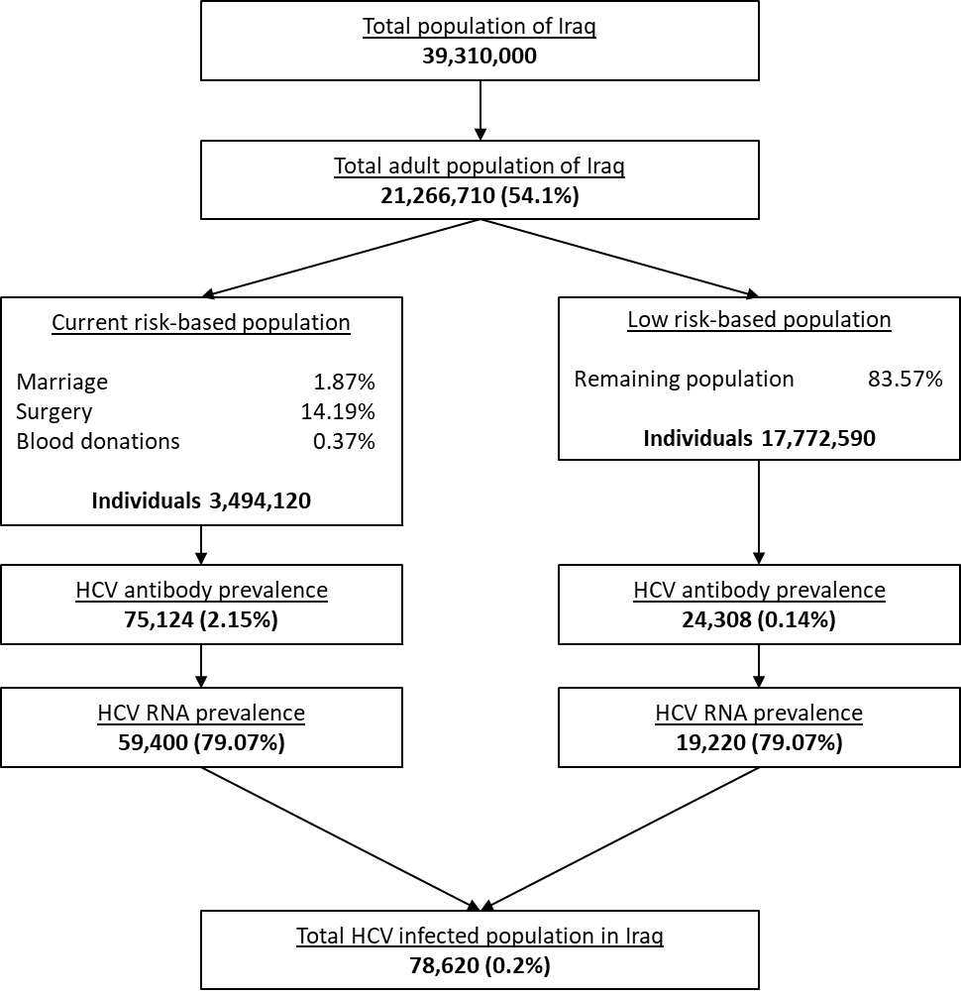
Fig. S1. HCV prevalence in Iraq

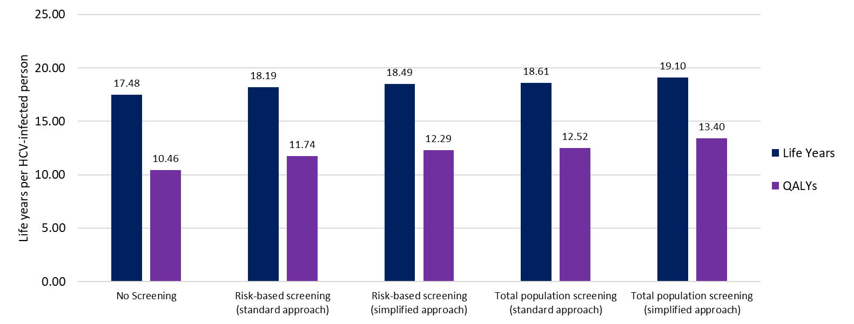
Fig. S2. Total per-patient life years and quality adjusted life years over a lifetime (60 year) horizon for five scenarios: no screening, risk-based screening with a either a standard or simplified approach, or total population level screening with a either a standard or simplified approach

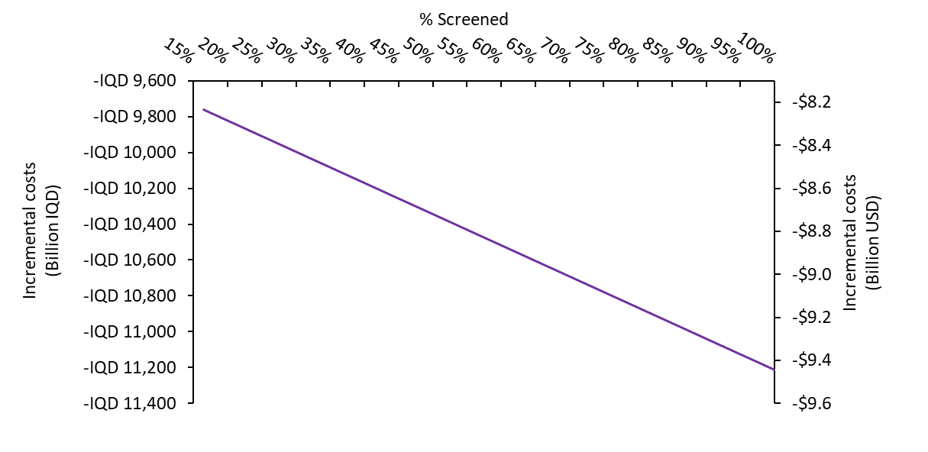

Fig. S3. Incremental costs of risk-based screening (standard approach) compared to no screening when the proportion of the Iraqi population screened is increased

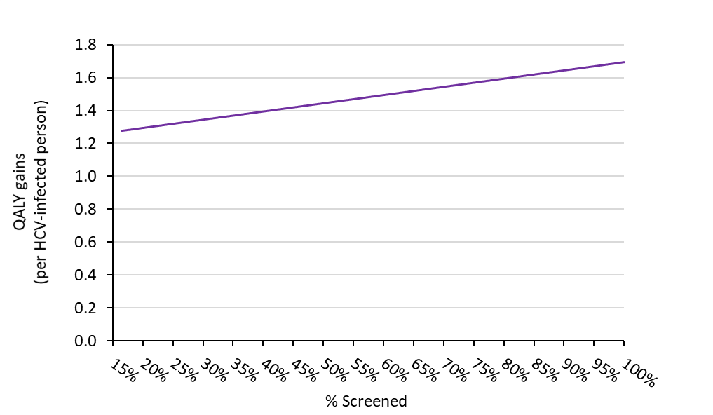
Fig. S4. QALY gains of risk-based screening (standard approach) compared to no screening when the proportion of the Iraqi population screened is increased.

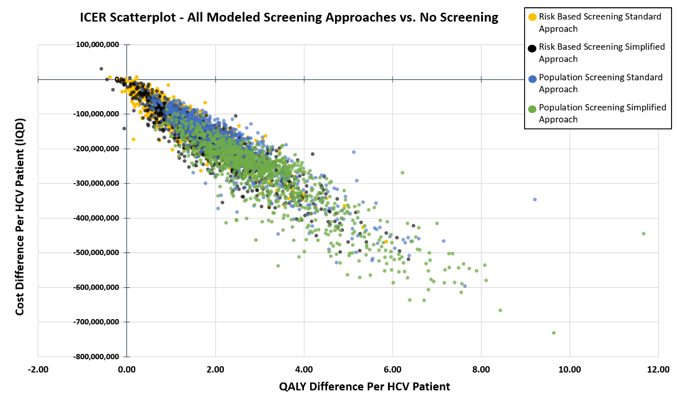

Fig. S5. ICER scatterplot, showing per patient results of the 1,000 PSA runs for all modelled screening approaches vs. No Screening. Costs given in IQD.

Table. S4. Mean outputs from the 1,000 PSA runs completed for each screening approach. ICERs vs. No screening. Using IQD costs and given for the full HCV population.
PSA OUTPUTS (Discounted) |  | Risk Based Screening with a Standard Approach | Risk Based Screening with a Simplified Approach | Total Population Screening a Standard Approach | Total Population Screening with a Simplified Approach
Full HCV Population: | QALYs | 931264.90 | 973056.97 | 997154.82 | 1066858.76
Full HCV Population: | no screening QALYs | 835269.66 | 835269.66 | 834297.48 | 834297.48
Full HCV Population: | Direct Cost (IQD) | 14,743,426,419,853 | 10,657,290,372,493 | 10,139,899,518,455 | 3,135,976,160,670
Full HCV Population: | no screening Direct Cost | 23,798,419,206,148 | 23,798,419,206,148 | 23,765,016,070,994 | 23,765,016,070,994
Full HCV Population: | % Cost Effective (WTP threshold of 9,000,000) | 99.20% | 98.80% | 100% | 100%
Full HCV Population: | ICER (QALY) vs No Screening | -IQD 94,161,049 | -IQD 82,622,398 | -IQD 77,351,768 | -IQD 79,697,782

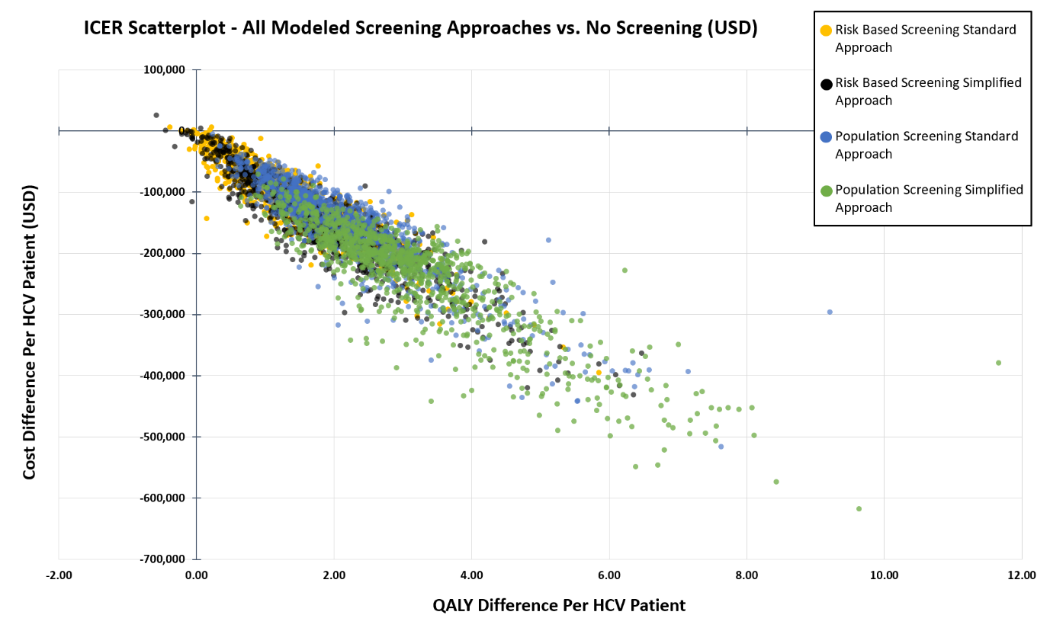
Fig. S7. ICER scatterplot, showing per patient results of the 1,000 PSA runs for all modelled screening approaches vs. No Screening. Costs given in USD.
Table. S5. Mean outputs across the 1,000 PSA runs completed for each screening approach. ICERs vs. No screening. Using USD costs and given for the full HCV population.
PSA OUTPUTS (Discounted) |  | Risk Based Screening with a Standard Approach | Risk Based Screening with a Simplified Approach | Total Population Screening a Standard Approach | Total Population Screening with a Simplified Approach
Full HCV Population: | QALYs | 931264.90 | 973056.97 | 997154.82 | 1066858.76
Full HCV Population: | no screening QALYs | 835269.66 | 835269.66 | 834297.48 | 834297.48
Full HCV Population: | Direct Cost (USD) | $12,371,153,854 | $8,944,982,726 | $8,505,117,457 | $2,627,929,490
Full HCV Population: | no screening Direct Cost | $19,971,426,475 | $19,971,426,475 | $19,938,375,365 | $19,938,375,365
Full HCV Population: | % Cost Effective (WTP threshold of $7,550) | 99.20% | 98.80% | 100% | 100%
Full HCV Population: | ICER (QALY) vs No Screening | -$79,033 | -$69,326 | -$64,892 | -$66,864

References
1. United Nations Statistics. Marriages and crude marriage rates (2007-2011)2011. Available from: https://unstats.un.org/unsd/demographic/products/dyb/dyb2011/Table23.pdf.
2. United Nations. Department of Economic and Social Affairs, Population Division (2007, 2010, 2018)2018. Available from: https://population.un.org
3. World Health Organisation (WHO). Iraq, World Blood Donor Day2012. Available from: http://www.emro.who.int/irq/iraq-events/world-blood-donor-day.html.
4. U.S. Department of Commerce. Healthcare Resource Guide: Iraq 2018. Available from: https://2016.export.gov/industry/health/healthcareresourceguide/eg_main_116238.asp
5. Munang M, Smit E, Barnett T, Atherton C, Tahir M, Atabani SF. Outcomes and costs of single-step hepatitis C testing in primary care, Birmingham, United Kingdom. Public health. 2019;166:40-4. Epub 2018/11/19. doi: 10.1016/j.puhe.2018.09.024. PubMed PMID: 30448691.
6. Garcia FG, Dominguez R, Arboledas JCA, Casado M, Sanchez JM, Pérez FT, et al. FRI-229-Reflex testing in patients with chronic hepatitis C in Spain improves healthcare outcomes and is cost effective. Journal of hepatology. 2019;70(1):e495-e6.
7. Polaris Observatory HCV Collaborators. Global prevalence and genotype distribution of hepatitis C virus infection in 2015: a modelling study. The lancet Gastroenterology & hepatology. 2017;2(3):161-76. Epub 2017/04/14. doi: 10.1016/s2468-1253(16)30181-9. PubMed PMID: 28404132.
8. Thein HH, Yi Q, Dore GJ, Krahn MD. Estimation of stage-specific fibrosis progression rates in chronic hepatitis C virus infection: a meta-analysis and meta-regression. Hepatology. 2008;48(2):418-31. Epub 2008/06/20. doi: 10.1002/hep.22375. PubMed PMID: 18563841.
9. McEwan P, Ward T, Yuan Y, Kim R, L'Italien G. The impact of timing and prioritization on the cost-effectiveness of birth cohort testing and treatment for hepatitis C virus in the United States. Hepatology. 2013;58(1):54-64. Epub 2013/02/08. doi: 10.1002/hep.26304. PubMed PMID: 23389841.
10. McEwan P, Ward T, Bennett H, Kalsekar A, Webster S, Brenner M, et al. Estimating the clinical and economic benefit associated with incremental improvements in sustained virologic response in chronic hepatitis C. PLoS One. 2015;10(1):e0117334. Epub 2015/01/31. doi: 10.1371/journal.pone.0117334. PubMed PMID: 25635922; PubMed Central PMCID: PMCPMC4311930.
11. Foundation for Innovative New Diagnostics (FIND). GeneXpert® negotiated prices 2019 [18/10/2019]. Available from: https://www.finddx.org/pricing/genexpert/.
12. United States Department of Labor: Bureau of Labor Statistics. Databases, Tables & Calculators by Subject 2019 [09/08/2019]. Available from: https://data.bls.gov/timeseries/CUUR0000SAM?output_view=pct_12mths.
13. XE Corporation. XE Currency Converter - Live Rates: 1 USD to IQD 2019 [30/05/2019]. Available from: https://www.xe.com/currencyconverter/convert/?Amount=1&From=USD&To=IQD.
14. Martin NK, Vickerman P, Miners A, Foster GR, Hutchinson SJ, Goldberg DJ, et al. Cost-effectiveness of hepatitis C virus antiviral treatment for injection drug user populations. Hepatology. 2012;55(1):49-57. Epub 2011/09/08. doi: 10.1002/hep.24656. PubMed PMID: 21898506.

