How much does it cost to research & develop a new drug? Systematic review and assessment

Supplementary Information

PharmacoEconomics Journal

Michael Schlander^{1,2,3,a}, Karla Hernandez-Villafuerte^{1,a}, Chih-Yuan Cheng^{1,2}, Jorge Mestre-Ferrandiz⁴, Michael Baumann¹
¹German Cancer Research Center (DKFZ), Heidelberg, Germany
²Mannheim Medical Faculty, University of Heidelberg, Heidelberg, Germany
³Alfred Weber Institute (AWI), University of Heidelberg, Heidelberg, Germany
⁴Universidad Carlos III, Madrid, Spain
ª Equal contributing first authors.

Corresponding author:
Prof. Michael Schlander, m.schlander@dkfz.de

Content
Supplementary Information 1. Systematic literature review 3
Articles selection process 3
Search strategy 5
Data extraction 6
Supplementary Information 2. Detailed analysis of the identified articles 7
Quantitative analysis 7
Qualitative analysis 17
Supplementary Information 3. Systematic literature review categories to evaluate the suitability of estimated R&D costs) 28
Product-sample characteristics 28
Possible sources of variation in R&D costs 31
Monetary values (cash expenses) characteristics 34
Supplementary Information 4. Categories to evaluate the variables with impact on future R&D cost development 38
Supplementary Information 5. Suitability scores – Sensitivity analysis 41
Supplementary Information 6. Regressions 46
Supplementary Information 7. R&D costs - Preclinical and clinical figures 48
Supplementary Information 8. References 53

Supplementary Information 1. Systematic literature review
A full systematic literature review on the topic of research and development costs (pre-launch costs) to bring a new medicine to the market was conducted. The search period was restricted to the publications between 1 January 2010 and 5 March 2020, as a previous systematic review by Morgan et al. [1] had explored the literature up to the end of 2009.
Three databases were searched: Pubmed, Embase (OvidSP) and EconLit (EBSCO). To include grey literature, Google Scholar was also considered. The search terms used were the combination of the concepts of “drug research and development” and “costs” or “expenditure”. Reference snowballing based on the selected articles was also used to identify additional relevant studies.

Articles selection process
Similar inclusion criteria as outlined in the review by Morgan et al. [1] were applied, which entailed the following:
- Original research providing estimation of the total costs of drug research and development,
- Studies describing the source of data and research methods in details, and
- Articles written in English.
Two persons, Chih-Yuan Cheng (CYC) and Erica Niebauer (EN), independently performed the title and abstract screening. In the abstract screening stage, if the abstract was not electronically available, it was not eliminated, but included for the full-text screening stage. For the full-text inclusion, articles chosen from the abstract screening were divided between the two persons above, who determined inclusion eligibility and extracted the data. Any disagreement regarding article inclusion was decided by another author (Karla Hernandez-Villafuerte [KHV]).
The selection process is summarized in the PRISMA diagram (Figure 5). The initial search revealed 5,278 potentially related citations, reduced to 5,034 after eliminating duplicates.
After title and abstract screening, 15 articles were selected for full-text screening. The main reasons for exclusion of articles at this stage included being unrelated to the topic (4,880 articles) or not providing original estimates of drug R&D costs (30 articles).
During the full-text assessment stage, we identified two more articles [2, 3] through reference snowballing. After full-text assessment, six articles were excluded: two did not provide original estimates of drug development costs; two focused only on the elements for estimating drug R&D costs (e.g., only estimating the cost of capital or success rate) instead of the overall costs of developing a drug; one estimated the revenue needed to bring a new drug to the market; and one assessed the social costs of drug R&D.
Eleven articles were identified in our systematic literature review that fulfilled all criteria. Combining these articles with the 11 previously identified by Morgan et al. [1], the analysis includes a total of 22 articles.
Potential unique citations for title and abstract screening: N=5,034

Search in relevant databases, 1 Jan 2010 – 5 Mar 2020: 5.278 citations
5,019 articles excluded after title and abstract screening:
- Not on topic (4,880)
- Duplicate (92)
- Not original research with new cost estimates (30)
- Conference proceedings (10)
- Not in English (5)
- Unpublished theses (2)
Identified studies for full-text screening: N=15
Total number of included studies from this search: N=11
244 duplicates removed in EndNote
6 studies excluded after full-text screening:
- Secondary research papers with no original cost estimates (2)
- No R&D costs estimates presented, only evaluation of elements used in the R&D costs estimation (e.g., development times, success rates) (2)
- Estimation of the revenue needed to bring a drug to the market (1)
- Estimation of social costs instead of costs of drug development (1)
2 studies identified by reference snowballing

Fig 1 PRISMA flow diagram

Search strategy

Google scholar
Three sets of searches:
- (intitle:“pharmaceutical”) AND (intitle:“cost” OR intitle:“economics” OR intitle:“expenditure” OR intitle:“spend”) AND (intitle:“research” OR intitle:“development” OR “innovation” OR “investigation” OR “R&D”)
- (intitle:“ drug”) AND (intitle:“cost” OR intitle:“economics” OR intitle:“expenditure” OR intitle:“spend”) AND (intitle:“research” OR “development” OR “innovation” OR “investigation” OR “R&D”)
- (intitle:“ medicine”) AND (intitle:“cost” OR intitle:“economics” OR intitle:“expenditure” OR intitle:“spend”) AND (intitle:“research” OR intitle:“development” OR “innovation” OR “investigation” OR “R&D”)

Pubmed
(pharma*[Title/Abstract] OR drug[Title/Abstract] OR medicine[Title/Abstract])
AND
(cost[Title/Abstract] OR economic*[Title/Abstract] OR expenditure[Title/Abstract] OR spend*[Title/Abstract])
AND
(research[Title/Abstract] OR development[Title/Abstract] OR innovation[Title/Abstract] OR investigation[Title/Abstract] OR R&D[Title/Abstract])

EconLit
(AB Pharma* OR drug OR medicine)
AND
(AB cost OR econom* OR expenditure OR spend*)
AND
(AB research OR development OR innovation OR investigation OR R&D)

Embase
(Pharma* OR drug OR medicine).kw,ti.
AND
(research OR development OR innovation OR investigation OR R&D).kw,ti
AND
(cost OR econom* OR expenditure OR spend*).ab,ti.
Exclude ((clinical trial or randomized controlled trial or controlled clinical trial or multicenter study or phase 1 clinical trial or phase 2 clinical trial or phase 3 clinical trial or phase 4 clinical trial) and (abstract report or "book review" or conference abstract or "conference review" or editorial or erratum or letter or note or patent or "review" or short survey or tombstone))

Data extraction
Information were extracted from the following topics:
- Information related to the article (e.g. authors, year of publication)
- General information regarding the methodology applied (e.g. drug inclusion period, therapeutic class, NCEs or NBE, method used)
- Information on the sources of drug sample selection and cost related data
- R&D costs reported by phase (from discovery to approval), including capitalized and non-capitalized values
- Success rates
- Development time
- Sensitivity analysis
- Limitations
- Description of the sources of potential biases
The extraction was done in three stages:
- Two people (CYC and EN) extracted the information from the 22 articles (11 articles each)
- The information of the 22 articles was extracted again independently by KHV.
- The extracted information was compared and agreement on any difference was reached.
All costs were converted and inflated to 2019 US dollars using the exchange rates in the Exchange Rate Archives of the International Monetary Fund and US Gross Domestic Product (GDP) price deflator (Bureau of Economic Analysis).

Supplementary Information 2. Detailed analysis of the identified articles

Quantitative analysis
Table 1. Average cash estimated per investigational compound (cash expenses, not considering failures)
Articleª | Selected sample |  |  |  | Average cash estimated per investigational compound  (millions of USA dollars - 2019 prices)
Articleª | Drug inclusion period^{b} | # of drugs | # of drugs considered to extract the sample | Sample: # companies | Discovery | Preclinical | Phase I | Phase II | Phase III | Sub. market approval | Total Clinical Phase ^{c}
Wouters et al. [4] - All | FDA approval between 2009 - 2018 | 63 NCEs and NBEs | 355 NCEs and NBEs | 47 |  | Partially include in Phase I ^{d} | 53.82e | 102.56 e | 296.68 e |  | 380.62 e
Wouters et al. [4] - High quality | FDA approval between 2009 - 2018 | 23 NCEs and NBEs | 355 NCEs and NBEs | 47 |  | Partially include in Phase I ^{d} | 27.58 e | 90.84 e | 258.74 e |  | 317.30 e
Wouters et al. [4] - Oncology | FDA approval between 2009 - 2018 | 20 NCEs and NBEs | 116 NCEs and NBEs | 47 |  | Partially include in Phase I ^{d} | 71.43 e | 133.40 e | 286.62 e |  | 363.04 e
Wouters et al. [4] - At&Me | FDA approval between 2009 - 2018 | 15 NCEs and NBEs | 44 NCEs and NBEs | 47 |  | Partially include in Phase I ^{d} | 37.04 e | 86.07 e | 285.62 e |  | 357.51 e
Wouters et al. [4] - CNS | FDA approval between 2009 - 2018 | 8 NCEs and NBEs | 33 NCEs and NBEs | 47 |  | Partially include in Phase I ^{d} | 20.35 e | 60.54 e | 189.53 e |  | 242.55 e
Wouters et al. [4] - Abx | FDA approval between 2009 - 2018 | 5 NCEs and NBEs | 40 NCEs and NBEs | 47 |  | Partially include in Phase I ^{d} | 88.55 e | 156.75 e | 303.46 e |  | 450.64 e
Jayasundara et al. [5] -  Orphan | FDA approval between 2000 - 2015 | 100 orphan approved for a new indication | 1,163 trails with 602 orphan drugs | Not relevant |  |  | 4.23 | 26.29 | 55.04 |  | 85.55
Jayasundara et al. [5] -  Non-orphan | FDA approval between 2000 - 2015 | 100 non-orphan approved for a new indication | 1,163 trails with 561 non-orphan drugs | Not relevant |  |  | 2.93 | 10.90 | 113.28 |  | 127.11
Jayasundara et al. [5] -  Orphan (NME) | FDA approval between 2000 - 2015 | 74 NME | As scenario analysis they identified from the original selected sample those that were NME | Not relevant
Jayasundara et al. [5]-  Non-orphan (NME) | FDA approval between 2000 - 2015 | 54 NME |  | Not relevant
Årdal et al. [6] - Min | Not relevant | One hypothetical antibacterial project | Costs of finishing all of the expected clinical trials per phase for the main antibacterial project. | 19 SMEs | 1.31 | 1.19 | 1.19 | 1.19
Årdal et al. [6] - Max |  |  |  |  | 8.93 | 5.95 | 11.91 | 23.82
Prasad, Mailankody [7] | Approved by FDA between 2006 & 2015 | 10 NCEs and NBEs | 13 NCEs and NBEs | 10
DiMasi et al. [8] | 1995-2007 | 106  (87 NCEs, 19 NBEs) | 1,442 NCEs and NBEs | 10 |  |  | 27.93 | 64.70 | 281.98 |  | 374.61
Chit et al. [9] | 2000-2011 | 39 vaccines | Influenza vaccines meet the inclusion criteria | 24
Falconi et al. [10] | Phase I-III trial taken place between 1998 and 2012 | 199 NCEs and NBEs | 199 NCEs and NBEs | Not relevant |  |  | 276.02 | 772.84 | 883.25 |  | 1,932.11
Sertkaya et al. [3] - Abx (Min - ABSSSI) | Not relevant | A hypothetical new antibacterial drug for oral or intravenous (IV) administration for six indications. | A hypothetical new antibacterial drug | Not relevant
Sertkaya et al. [3] –Abx (Max - HABP/VABP)
Sertkaya et al. [3] - Vaccines | Not relevant | A model based on a theoretical new vaccine in preventing acute bacterial atitis media (ABOM). | A hypothetical vaccine | Not relevant
Mestre-Ferrandiz et al. [11] | If one of the interval was completed between 1998-2002:  Intervals: (1) Pre-first toxicity dose, (2) First toxicity dose to first human dose, (3) First human dose to first patient dose, (4) First patient dose to first pivotal dose, (5) First pivotal dose to first core submission, (6) First core submission to first core launch | 97 NMEs | 209 NMEs | 16 |  | 7.44 | 18.32 | 61.71 | 148.05 | 33.20 | 228.08
Adams, Brantner [12] | 1989-2001 (Costs and drugs databases overlaps) | All NCEs that fulfils the selection criteria (See Table 5) | 2,245 observations (firm/year) | 183 |  |  | 34.11 | 126.21 | 89.13 |  | 249.44
Paul et al. [2] | The available data was from 2000-2007 | A no clear number of NCEs and NBEs | No Info | 13 | 16.09 | 5.96 | 17.87 | 47.66 | 178.73 | 47.66 | 244.26
DiMasi, Grabowski [13] | 1990-2003 | 17 NBEs  (4 from DiMasi et al. [14] sample, 13 from a Biotech firm) | 522 NBEs | 4 (3 from DiMasi et al. [14] sample and 1 biotech) | InPC | 76.95 | 41.48 | 48.44 | 123.45 |  | 213.36
Adams, Brantner [15] | 1989-2002 | Same selected sample as DiMasi et al. [14]:  68 NCEs | 3,181 NCEs | Cash expenses costs from DiMasi et al. [14]. Dev. times and success rates based on Pharmaprojects |  |  | 21.87 | 33.81 | 124.17 |  | 187.05
DiMasi et al. [16] - All | 1983-1994 | 68 out of 68 (NCEs and NBEs) | Not clear (all compounds in the Tufts CSDD database that meet the criteria) | 10 |  |  | 21.58 | 34.53 | 123.74 |  | 187.05
DiMasi et al. [16] -Anes | 1983-1994 | 10 out of 68 (NCEs and NBEs) |  | 10 |  |  | 25.90 | 44.60 | 93.53 |  | 166.91
DiMasi et al. [16] - Abx | 1983-1994 | 9 out of 68 (NCEs and NBEs) |  | 10 |  |  | 33.09 | 28.78 | 197.13 |  | 271.95
DiMasi et al. [16] - CV | 1983-1994 | 12 out of 68 (NCEs and NBEs) |  | 10 |  |  | 12.95 | 31.66 | 115.11 |  | 172.66
DiMasi et al. [16] - CNS | 1983-1994 | 13 out of 68 (NCEs and NBEs) |  | 10 |  |  | 15.83 | 33.09 | 94.97 |  | 151.08
DiMasi et al. [14] | 1983-1994 | 68  (61 NCEs + 7 NBEs) | 583 | 10 |  |  | 21.87 | 33.81 | 124.17 |  | 187.34
Global Alliance for TB Drug Development [17] - Min | Not relevant | One hypothetical project to develop a new TB drug | One hypothetical project to develop a new TB drug | Not relevant |  | 6.99 | 0.93 | 4.87 | 32.52 |  | 38.32
Global Alliance for TB Drug Development [17] - Max |  |  |  |  |  | 7.38 | 0.93 | 4.87 | 32.52 |  | 38.32
Young, Surrusco [18]-Min | FDA approval years between 1990-1996 | Results from the 207 NCEs are reported in this study. Additionally, they also estimated R&D costs based on all approved drugs. | 563 new drugs | No Info
Young, Surrusco [18]-Max | FDA approval years between 1994-2000 | 234 NCEs | 667 new drugs  They also reported estimations for R&D cost all approved drugs. | No Info
DiMasi et al. [19] - Small firms | 1970-1982 | 23 out of 93 NCEs | The selected data corresponds to 19% of all NCEs in the Tufts CSDD database | 5 out of 12 |  |  | 3.42 | 6.19 | 9.13 |  | 31.13
DiMasi et al. [19] - Medium firms | 1970-1982 | 33 out of 93 NCEs |  | 4 out of 12 |  |  | 4.73 | 9.78 | 28.85 |  | 48.58
DiMasi et al. [19] - Large firms | 1970-1982 | 37 out of 93 NCEs |  | 3 out of 12 |  |  | 4.89 | 9.78 | 42.06 |  | 60.31
DiMasi et al. [20] - All | 1970-1982 | 93 NCEs | All drugs in the Tufts CSDD database that full fill the criteria | 12 |  |  | 4.24 | 8.15 | 25.92 |  | 44.01
DiMasi et al. [20] - NSAID | 1970-1982 | 8 out of 93 NCEs |  | 12 |  |  | 6.52 | 11.74 | 58.52 |  | 81.50
DiMasi et al. [20] - CV | 1970-1982 | 21 out of 93 NCEs |  | 12 |  |  | 5.05 | 9.78 | 29.34 |  | 53.63
DiMasi et al. [20] - Abx | 1970-1982 | 15 out of 93 NCEs  (1 outlier excluded) |  | 12 |  |  | 5.05 | 8.64 | 29.18 |  | 46.62
DiMasi et al. [20] - Neuro | 1970-1982 | 18 out of 93 NCEs |  | 12 |  |  | 2.45 | 5.05 | 26.08 |  | 37.00
DiMasi et al. [21] | 1970-1982 | 93 NCEs | The selected data corresponds to 19% of all NCEs in the database | 12 |  |  | 4.20 | 7.79 | 25.21 |  | 1,317.59
Wiggins [22] | FDA approval data from the period 1970-1985 | 223 NCEs | 324 NCEs | No Info
Hansen [23] | 1963-1975 | Around 100 NCEs | Sample corresponds to around 15% of the NCEs taken into human testing by the 25 firms surveyed during the study conducted by Hansen [24]. | 14 | 6.56 | 0.58 | 0.99 | 5.26 | 9.23 |  | 15.72
All= The estimation includes all the observations in the sample. ABOM = Acute bacterial otitis media. ABSSSI = Acute bacterial skin and skin structure infections. Abx = Anti-infectives. Anes = Analgesics/Anesthetic. CNS = Central nervous system. CV = Cardiovascular. FDA=Food and Drug Administration. InPC = Included in preclinical. Max= Maximum reported value. MIN= Minimum reported value. NBE = New Biological Entity. NCE = New chemical entity. Neuro = Neuropharmacological. NME = New Molecular Entity. No Info = It is used in the estimation but the value is no reported. NSAID = Nonsteroidal anti-inflammatory drugs. TB = Tuberculosis. Tufts CSDD = Tufts Center for the Study of Drug Development.
ª Each row corresponds to the information related to one main R&D estimate. When more than one R&D cost estimate is reported, we refer to each by including the reference of the corresponding article and a keyword that describes the main characteristic of the R&D cost estimate. Wouters et al. [10] categorized each selected data point as high, medium, or low quality, depending on the availability and consistency of reported data. ‘High quality’ corresponds only to the estimations considered high quality observations.
^{b} Time period when the NCE/NBE where first tested in humans, otherwise an explanation is included.
^{c} Total Clinical Phases, including long term animal testing.
^{d} Authors collected information by drug candidate, starting from the year in which the company began reporting costs for that particular drug in their financial statements until approval. This period could include one or more years of preclinical costs. The development time reported by the authors is based on the average time of all drugs included in the analysis. This means that, for some of these drugs, time also includes a few years in the preclinical phase.
^{e} Based on the average of the reported values by product, listed in the Supplement by Wouters et al. [4]. Therefore, the column “Total Clinical Phase” is not equal to the sum of the values in Phase 1, 2 and 3.
Source: Authors´ elaboration
Table 2. Average cash spent estimated per successful drug (considering failures)
Articleª | Transition probabilities and overall clinical approval rates |  |  |  |  |  |  | Phases I-III expected expenditures  reported | Average cash estimated per successful drug (million USA dollars - 2019 prices)
Articleª | Discovery to Preclinical | Preclinical to Phase I | Phase I to II | Phase II to III | Phase III to Sub/ approval | Submission to approval | Clinical approval success rate | Phases I-III expected expenditures  reported | Discovery | Preclinical |  | Phase I | Phase II | Phase III | Total Clinical Phase ^{b} | Sub. market approval | Total^{c}
Wouters et al. [4] - All |  |  | 0.39 | 0.59 | 0.71 | 0.83 | 0.138 |  | A.Not.Estimated | Partially include in Phase I |  | A.Included |  |  |  | A.Not.Estimated | Not reported
Wouters et al. [4] - High quality |  |  | 0.39 | 0.59 | 0.71 | 0.83 | 0.138
Wouters et al. [4] - Oncology |  |  | 0.51 | 0.19 | 0.43 | 0.82 | 0.034
Wouters et al. [4] - At&Me |  |  | 0.81 | 0.47 | 0.64 | 0.80 | 0.196
Wouters et al. [4] - CNS |  |  | 0.77 | 0.38 | 0.62 | 0.82 | 0.150
Wouters et al. [4] - Abx |  |  | 0.72 | 0.47 | 0.89 | 0.85 | 0.252
Jayasundara et al. [5] -  Orphan |  |  | 0.87 | 0.70 | 0.67 | 0.81 | 0.329 | Yes | A.Not.Estimated |  |  | 4.23 | 22.82 | 33.44 | 183.70 | A.Not.Estimated | 183.70
Jayasundara et al. [5] -  Non-orphan |  |  | 0.65 | 0.32 | 0.60 | 0.83 | 0.104 | Yes |  |  |  | 2.93 | 7.03 | 23.67 | 321.84 | A.Not.Estimated | 321.84
Jayasundara et al. [5] -  Orphan (NME) |  |  | 0.87 | 0.70 | 0.67 | 0.81 | 0.329 |  |  |  |  | A.Included |  |  |  | A.Not.Estimated | Not reported
Jayasundara et al. [5]-  Non-orphan (NME) |  |  | 0.65 | 0.32 | 0.60 | 0.83 | 0.104
Årdal et al. [6] |  |  |  |  |  |  |  |  | A.Not.Estimated
Prasad, Mailankody [7] |  |  |  |  |  |  |  |  | A.Included |  |  |  |  |  |  | A.Not.Estimated | 750.18
DiMasi et al. [8] |  |  | 0.60 | 0.36 | 0.62 | 0.90 | 0.118 | Yes | InPC | 474.75 |  | 27.93 | 38.53 | 59.62 | 1,065.50 | A.Not.Estimated | 1,540.25
Chit et al. [9] |  |  | 0.40 | 0.74 | 0.69 | InPIII | 0.204 |  | A.Not.Estimated |  |  | 2.11 | 11.54 | 56.51 | 70.16 | A.Not.Estimated | 70.16
Falconi et al. [10] |  |  | 0.95 | 0.42 | 0.28 |  | 0.112 |  | A.Not.Estimated |  |  | A.Included^{d} |  |  |  | A.Not.Estimated
Sertkaya et al. [3] - Abx (Min - ABSSSI) |  | 0.35e | 0.33 | 0.50 | 0.67 | 0.85 | 0.094 |  | InPC |  | 23.69 | 10.84 | 9.95 | 37.79 | 58.58 | 2.20 | 84.47
Sertkaya et al. [3] – Abx (Max - HABP/VABP) |  | 0.35e | 0.33 | 0.50 | 0.67 | 0.85 | 0.094 |  | InPC |  | 23.69 | 10.84 | 17.57 | 113.89 | 142.30 | 2.20 | 168.19
Sertkaya et al. [3] - Vaccines |  | 0.57e | 0.72 | 0.79 | 0.71 | 0.96 | 0.388 |  | InPC |  | 83.02 | 44.76 | 52.26 | 133.23 | 230.24 | 2.20 | 315.47
Mestre-Ferrandiz et al. [11] |  | 0.70 | 0.63 | 0.31 | 0.63 | 0.87 | 0.107 |  | 87.59 | 99.39 |  | 171.18 | 362.85 | 270.10 | 804.13 | 38.13 | 1,029.34
Adams, Brantner [12] |  |  | 0.75 | 0.48 | 0.71 |  | 0.240 | Yes | A.Not.Estimated |  |  | 34.11 | 93.39 | 41.00 | 702.08 | A.Not.Estimated | 702.08
Paul et al. [2] | 0.51 | 0.69 | 0.54 | 0.34 | 0.70 | 0.91 | 0.117 |  | 260.95 | 73.88 |  | 152.52 | 220.43 | 280.01 | 652.96 | 52.43 | 1,040.21
DiMasi, Grabowski [13] |  |  | 0.84 | 0.56 | 0.64 | InPIII | 0.303 | Yes | InPC | 254.36 |  | 41.48 | 40.54 | 58.16 | 463.39 | A.Not.Estimated | 717.75
Adams, Brantner [15] |  |  | 0.74 | 0.62 | 0.52 | InPIII | 0.240 | Yes | InPC | 191.37 |  | 21.87 | 25.02 | 57.12 | 446.05 | A.Not.Estimated | 637.42
DiMasi et al. [16] - Total |  |  | 0.71 | 0.44 | 0.69 | InPIII | 0.215 | Yes | A.Not.Estimated |  |  | 21.58 | 24.52 | 38.86 | 405.48 | A.Not.Estimated | 405.48
DiMasi et al. [16] - Anes |  |  | 0.71 | 0.44 | 0.78 | InPIII | 0.246 | Yes |  |  |  | 25.90 | 31.49 | 29.37 | 359.36 | A.Not.Estimated | 359.36
DiMasi et al. [16] - Abx |  |  | 0.66 | 0.58 | 0.65 | InPIII | 0.249 | Yes |  |  |  | 33.09 | 19.02 | 75.30 | 517.77 | A.Not.Estimated | 517.77
DiMasi et al. [16] - CV |  |  | 0.71 | 0.38 | 0.68 | InPIII | 0.184 | Yes |  |  |  | 12.95 | 22.41 | 31.19 | 401.75 | A.Not.Estimated | 401.75
DiMasi et al. [16] - CNS |  |  | 0.73 | 0.40 | 0.61 | InPIII | 0.180 | Yes |  |  |  | 15.83 | 24.19 | 28.01 | 394.10 | A.Not.Estimated | 394.10
DiMasi et al. [14] |  |  | 0.71 | 0.44 | 0.69 | InPIII | 0.215 | Yes | InPC | 174.10 |  | 21.87 | 24.01 | 38.99 | 405.50 | A.Not.Estimated | 579.60
Global Alliance for TB Drug Development [17] - Min |  | 0.10 | 0.30 | 0.50 | 0.65 | InPIII | 0.098 |  | A.Included^{d} |  |  |  |  |  |  | A.Not.Estimated | Not reported
Global Alliance for TB Drug Development [17] - Max |  | 0.10 | 0.30 | 0.50 | 0.65 | InPIII | 0.098 |  |  |  |  |  |  |  |  | A.Not.Estimated | Not reported
Young, Surrusco [18]-Min |  |  |  |  |  |  |  |  | A.Not.Estimated |  |  | A.Included |  |  |  |  | 247.97
Young, Surrusco [18]-Max |  |  |  |  |  |  |  |  | A.Not.Estimated |  |  | A.Included |  |  |  |  | 326.65
DiMasi et al. [19] - Small firms |  |  |  |  |  |  | 0.24 | Yes | InPC | 213.38 |  | 3.48 | 5.63 | 5.10 | 78.52 | A.Not.Estimated | 291.89
DiMasi et al. [19] - Medium firms |  |  |  |  |  |  | 0.17 | Yes | InPC | 137.90 |  | 4.66 | 7.03 | 9.85 | 139.26 | A.Not.Estimated | 277.16
DiMasi et al. [19] - Large firms |  |  |  |  |  |  | 0.28 | Yes | InPC | 138.07 |  | 4.85 | 6.76 | 13.31 | 97.16 | A.Not.Estimated | 235.23
DiMasi et al. [20] - All |  |  | 0.75 | 0.48 | 0.64 | InPIII | 0.23 | Yes | InPC | 133.01^{f} |  | 4.24 | 6.03 | 9.45 | 97.10 | A.Not.Estimated | 230.11
DiMasi et al. [20] - NSAID |  |  | 0.75 | 0.42 | 0.71 | InPIII | 0.22 | Yes | A.Not.Estimated |  |  | 6.52 | 8.64 | 18.26 | 162.27 | A.Not.Estimated | 162.27
DiMasi et al. [20] - CV |  |  | 0.64 | 0.57 | 0.72 | InPIII | 0.262 | Yes | A.Not.Estimated |  |  | 5.05 | 6.19 | 10.60 | 101.41 | A.Not.Estimated | 101.41
DiMasi et al. [20] - Abx |  |  | 0.78 | 0.50 | 0.77 | InPIII | 0.302 | Yes | InPC | 166.27 |  | 5.05 | 6.68 | 11.41 | 79.88 | A.Not.Estimated | 246.15
DiMasi et al. [20] - Neuro |  |  | 0.90 | 0.44 | 0.51 | InPIII | 0.203 | Yes | A.Not.Estimated |  |  | 2.45 | 4.40 | 10.27 | 97.16 | A.Not.Estimated | 97.16
DiMasi et al. [21] |  |  | 0.75 | 0.48 | 0.64 | InPIII | 0.23 | Yes | InPC | 128.99 |  | 4.20 | 5.84 | 9.13 | 94.57 | A.Not.Estimated | 223.56
Wiggins [22] |  |  |  |  |  |  |  |  | A.Not.Estimated |  |  | A.Included^{g} |  |  |  | A.Not.Estimated | 131.17
Hansen [23] |  |  | 0.50 | 0.38 | 0.68 | 1.00^{h} | 0.13 | Yes | 52.51 | 4.63 |  | 0.99 | 2.63 | 1.75 | 48.79 | A.Not.Estimated | 105.93
All= The estimation includes all the observations in the sample. ABOM = Acute bacterial otitis media. ABSSSI = Acute bacterial skin and skin structure infections. Abx = Anti-infectives. Anes = Analgesics/Anesthetic. CNS = Central nervous system. CV = Cardiovascular. InPC = Included in preclinical. InPIII = Included in Phase 3. Max= Maximum reported value. MIN= Minimum reported value. NBE = New Biological Entity. NCE = New chemical entity. Neuro = Neuropharmacological. NME = New Molecular Entity. NSAID = Nonsteroidal anti-inflammatory drugs. TB = Tuberculosis.
A.Included = Assumed to be included. Although the value is not reported, the analysis of the article suggests that the R&D costs for that particular phase is reflected in the TOTAL R&D reported.
A.Not.Estimated= Assumed to be NOT estimated. The analysis of the article suggests that R&D costs for that phase were NOT estimated; therefore, it is not included in the estimation of the R&D reported in the column TOTAL.
ª Each row corresponds to the information related to one main R&D estimate. When more than one R&D cost estimate is reported, we refer to each by including the reference of the corresponding article and a keyword that describes the main characteristic of the R&D cost estimate. Wouters et al. [10] categorized each selected data point as high, medium, or low quality, depending on the availability and consistency of reported data. ‘High quality’ corresponds only to the estimations considered high quality observations.
^{b} Total Clinical Phases, including long term animal testing.
^{c} Total includes all the phases estimated by the authors (e.g. long animal testing, preclinical and clinical if they have been estimated).
^{d} Author reported first the estimated the R&D costs without considering risk of failure and opportunity costs; they reported at the end the capitalized figures. Therefore, it is assumed that the cash estimated per successful drug was estimated, but it is not reported.
^{e} Included preclinical and later state of discovery (i.e. target-to-hit, hit-to-lead, lead optimization).
^{f} Based on the information provided by the authors. They state that the preclinical R&D costs per approved an anti-infective NCE is 25% above the full sample average.
^{g} Author mentioned that they considered third, fourth and fifth preceding years of expenditures to capture the expensive human testing. Therefore, it is assumed that clinical phases are reflected here; however, it is not certain.
^{h} Authors also considered other studies which suggested 88%, but decided on 100%.
Source: Authors´ elaboration
Table 3. Average capitalized costs estimated per successful drug (considering failures and cost of capital)
Articleª | Development time (years) |  |  |  |  |  |  |  | Real annual COC (rate) | Authors reported Phases I-III estimated cash expenses^{b} | Average capitalized costs estimated per successful drug  (millions of USA dollars - 2019 prices ) |  |  |  |  |  |  |  | Cost of capital % of:
Articleª | Discovery | Preclinical | P I | P II | PIII | Sub. to approval | Clin. Phase  (PI+PI+PIII) | Total | Real annual COC (rate) | Authors reported Phases I-III estimated cash expenses^{b} | Discovery | Preclinical | P I | P II | PIII | Sub. to approval | Total Clin. Phase ^{c} | Total ^{d} | Total Clin. Phase^{e} | Total^{f}
Wouters et al. [4] - All |  |  |  |  |  |  | 8.3 | 8.3 | 0.105 |  | A.Not.Estimated | 241.9 | A.Included |  |  | For COC |  | 1,359.2
Wouters et al. [4] - High quality |  |  |  |  |  |  | 9.4 | 9.4 | 0.105 |  | A.Not.Estimated | 312.9 |  |  |  | For COC |  | 1,163.2
Wouters et al. [4] - Oncology |  |  |  |  |  |  | 7.0 | 7.0 | 0.105 |  | A.Not.Estimated | 270.4 |  |  |  | For COC |  | 4,538.9
Wouters et al. [4] - At&Me |  |  |  |  |  |  | 9.2 | 9.2 | 0.105 |  | A.Not.Estimated | 269.7 |  |  |  | For COC |  | 1,455.2
Wouters et al. [4] - CNS |  |  |  |  |  |  | 8.6 | 8.6 | 0.105 |  | A.Not.Estimated | 276.2 |  |  |  | For COC |  | 1,095.7
Wouters et al. [4] - Abx |  |  |  |  |  |  | 8.0 | 8.0 | 0.105 |  | A.Not.Estimated | 50.3 |  |  |  | For COC |  | 1,319.8
Jayasundara et al. [5] -  Orphan |  |  | 3.3 | 4.0 | 4.1 | 0.8 | 11.4 | 12.3 | 0.105 | Yes |  |  | 9.7 | 44.3 | 50.9 | For COC | 321.6 | 321.6 | 42.9% | 42.9%
Jayasundara et al. [5] -  Non-orphan |  |  | 1.7 | 2.3 | 2.1 | 1.0 | 6.1 | 7.1 | 0.105 | Yes |  |  | 5.1 | 11.0 | 31.4 | For COC | 455.3 | 455.3 | 29.3% | 29.3%
Jayasundara et al. [5] -  Orphan (NME) |  |  |  |  |  |  |  |  | 0.105 |  |  |  |  |  |  | For COC | 267.2 | 267.2
Jayasundara et al. [5]-  Non-orphan (NME) |  |  |  |  |  |  |  |  | 0.105 |  |  |  |  |  |  | For COC | 539.9 | 539.9
Årdal et al. [6] - Min | identification: 6 months + optimization: 6 months | 1.0 | 0.5 | 1.0 |  |  |  | 3.5 | COC not applied |  | A.Not.Estimated
Årdal et al. [6] - Max | identification: 4yrs + optimization: 4yrs | 2.0 | 2.0 | 4.0 |  |  |  | 16.0 | COC not applied
Prasad, Mailankody [7] | A.Included |  |  |  |  |  |  | 7.3 | 0.070 |  | A.Included |  |  |  |  | For COC |  | 943.8 |  | 20.5
DiMasi et al. [8] | InPC | 2.6 | 1.7 | 2.5 | 2.6 | 1.3 | 6.7 | 10.7 | 0.105 | Yes | InPC | 1,212.3 | 54.8 | 62.6 | 73.3 | For COC | 1,611.3 | 2,823.6 | 33.9 | 45.5
Chit et al. [9] | A.Included |  | 1.8 | 1.8 | 3.8 | A.Included | 7.3 | 7.3 | 0.090 |  | InPC | 278.6 | A.Included |  |  | For COC | 243.8 | 522.4 | 71.2
Falconi et al. [10] |  |  | 2.5 | 4.0 | 5.0 |  | 11.5 | 11.5 | 0.090 |  | A.Not.Estimated |  | 233.0 | 865.6 | 988.1 | A.Not.Estimated | 2,086.7 | 2,086.7
Sertkaya et al. [3] - Abx (Min - ABSSSI) | InPC^{g} | 5.5 | 0.9 | 0.8 | 1.0 | 0.8 | 2.8 | 9.0 | 0.110 |  | A.Not.Estimated
Sertkaya et al. [3] –Abx (Max - HABP/VABP) | InPC^{g} | 5.5 | 0.9 | 1.5 | 3.3 | 0.8 | 5.6 | 11.9 | 0.110
Sertkaya et al. [3] -Vaccines | InPC^{g} | 4.3 | 1.6 | 2.4 | 2.7 | 1.3 | 6.7 | 12.3 | 0.110
Mestre-Ferrandiz et al. [11] | 3.9 | 0.8 | 1.3 | 2.2 | 2.4 | 0.9 | 5.9 | 11.5 | 0.110 |  | 237.5 | 210.8 | 325.2 | 574.3 | 336.4 | 40.0 | 1,235.9 | 1,724.1 | 34.9 | 40.3
Adams, Brantner [12] |  |  | 1.4 | 2.6 | 2.3 | A.Included | 6.2 | 12.2 | 0.110 |  | A.Not.Estimated |  | A.Included |  |  | For COC | 1,785.9 | 1,785.9 | 60.7 | 60.7
Paul et al. [2] | 4.5 | 1.0 | 1.5 | 2.5 | 2.5 | 1.5 | 6.5 | 13.5 | 0.110 |  | 803.1 | 178.7 | 325.3 | 380.1 | 374.1 | 57.2 | 1,079.5 | 2,118.6 | 39.5 | 50.9
DiMasi, Grabowski [13] | InPC | 4.3 | 1.6 | 2.4 | 2.7 | 1.3 | 6.8 | 12.5 | 0.115 | Yes | InPC | 788.5 | 92.2 | 72.4 | 78.4 | For COC | 803.2 | 1,591.7 | 42.3 | 54.9
Adams, Brantner [15] | InPC | 4.3 | 1.6 | 2.5 | 2.5 | 1.3 | 6.6 | 12.2 | 0.110 | Yes | InPC | 548.2 | 44.6 | 42.6 | 74.8 | For COC | 700.7 | 1,248.9 | 36.3 | 49.0
DiMasi et al. [16] - Total |  | A.Included |  |  |  | 1.8 | 6.0 | 7.9 | 0.110 |  | A.Not.Estimated |  | A.Included |  |  | For COC | 670.5 | 670.5 | 39.5 | 39.5
DiMasi et al. [16] - Anes |  |  |  |  |  | 1.3 | 3.9 | 5.2 | 0.110 |  |  |  |  |  |  | For COC | 539.6 | 539.6 | 33.4 | 33.4
DiMasi et al. [16] - Abx |  |  |  |  |  | 1.0 | 4.2 | 5.3 | 0.110 |  |  |  |  |  |  | For COC | 707.9 | 707.9 | 26.9 | 26.9
DiMasi et al. [16] - CV |  |  |  |  |  | 1.8 | 5.1 | 6.8 | 0.110 |  |  |  |  |  |  | For COC | 661.9 | 661.9 | 39.3 | 39.3
DiMasi et al. [16] - CNS |  |  |  |  |  | 1.8 | 7.7 | 9.6 | 0.110 |  |  |  |  |  |  | For COC | 758.3 | 758.3 | 48.0 | 48.0
DiMasi et al. [14] | InPC | 4.3 | 1.0 | 2.2 | 2.8 | 1.5 | 6.0 | 11.9 | 0.110 | Yes | InPC | 482.0 | 43.9 | 42.4 | 53.8 | For COC | 671.6 | 1,153.7 | 39.6 | 49.8
Global Alliance for TB Drug Development [17] - Min |  | 1.6 | 1.6 | 2.0 | 3.0 | 0.5 | 6.6 | 8.7 | 0.100 |  | 57.6 | A.Included |  |  |  | For COC | 109.4 | 166.9
Global Alliance for TB Drug Development [17] - Max |  | 1.6 | 1.8 | 2.5 | 5.0 | 0.5 | 9.3 | 11.4 | 0.120 |  | 194.2 |  |  |  |  | For COC | 165.5 | 345.3
Young, Surrusco [18] | Estimations are based on the average (per year) R&D spending over 7-year period divided by the average (per year) number of drugs approved during the 7 years before. No clear which Phases are included |  |  |  |  |  |  |  | COC not applied |  | A.Not.Estimated
DiMasi et al. [19] - Small firms | InPC | 4.8 | 1.2 | 1.1 | 2.3 | 3.7 | 4.7 | 13.1 | 0.090 | Yes | InPC | 542.0 | 6.8 | 9.8 | 7.8 | For COC | 132.7 | 674.7 | 40.8 | 56.7
DiMasi et al. [19] - Medium firms | InPC | 2.7 | 1.6 | 2.0 | 2.6 | 2.4 | 6.1 | 11.3 | 0.090 | Yes | InPC | 324.2 | 9.1 | 11.8 | 13.1 | For COC | 221.4 | 545.6 | 37.1 | 49.2
DiMasi et al. [19] - Large firms | InPC | 2.8 | 1.2 | 2.3 | 2.3 | 2.2 | 5.7 | 10.7 | 0.090 | Yes | InPC | 307.6 | 9.1 | 10.8 | 17.2 | For COC | 143.6 | 451.2 | 32.3 | 47.9
DiMasi et al. [20] - all | A.Included |  |  |  |  |  |  | 8.2 | 0.090 | Yes | InPC | 320.4^{h} | 8.3 | 9.9 | 12.7 | For COC | 152.4 | 472.8 | 36.3 | 51.3
DiMasi et al. [20] - NSAID |  |  | 1.8 | 1.9 | 4.6 | 3.2 | 8.3 | 9.6 | 0.090 | Yes | A.Not.Estimated |  | 13.5 | 16.0 | 25.1 | For COC | 265.1 | 265.1 | 38.8 | 38.8
DiMasi et al. [20] - CV |  |  | 1.5 | 2.9 | 3.3 | 2.5 | 7.6 | 8.8 | 0.090 | Yes | A.Not.Estimated |  | 9.9 | 10.1 | 14.2 | For COC | 160.5 | 160.5 | 36.8 | 36.8
DiMasi et al. [20] - Abx | InPC | 2.4 | 0.9 | 1.1 | 3.0 | 2.0 | 5.0 | 6.4 | 0.090 | Yes | InPC | 278.7 | 8.3 | 10.3 | 14.5 | For COC | 114.4 | 393.2 | 30.2 | 37.4
DiMasi et al. [20] - Neuro |  |  | 1.2 | 2.0 | 3.4 | 3.5 | 6.5 | 9.7 | 0.090 | Yes | A.Not.Estimated |  | 5.1 | 8.5 | 15.8 | For COC | 167.8 | 167.8 | 42.1 | 42.1
DiMasi et al. [21] | InPC | 3.6 | 1.4 | 1.9 | 2.5 | 2.5 | 5.7 | 11.8 | 0.090 | Yes | InPC | 306.4 | 35.1 | 42.1 | 53.4 | For COC | 148.1 | 454.5 | 36.1 | 50.8
Wiggins [22] |  |  | A.Included |  |  |  |  |  | 0.080 |  | A.Not.Estimated |  | A.Included^{i} |  |  | For COC | 252.3 | 252.3 |  | 48.0
Hansen [23] | 3.0 | 1.1 | 0.8 | 1.9 | 1.9 | 2.0 | 4.6 | 10.7 | 0.080 | Yes | 99.3 | 8.1 | 1.6 | 3.9 | 2.1 | For COC | 68.7 | 176.2 | 29.0 | 39.9
All= The estimation includes all the observations in the sample. ABOM = Acute bacterial otitis media. ABSSSI = Acute bacterial skin and skin structure infections. Abx = Anti-infectives. Anes = Analgesics/Anesthetic. CNS = Central nervous system. COC = Cost of Capital. CV = Cardiovascular. `For COC´ = R&D cash expenses was not estimated for the submission stage, but the time in this stage was considered for the capitalization value. InPC = Included in preclinical. InPIII = Included in Phase 3. Max= Maximum reported value. MIN= Minimum reported value. NBE = New Biological Entity. NCE = New chemical entity. Neuro = Neuropharmacological. NME = New Molecular Entity. NSAID = Nonsteroidal anti-inflammatory drugs. TB = Tuberculosis.
A.Included = Assumed to be included. Although the value us not reported, the analysis of the article suggests that the R&D costs for that particular phase is reflected in the TOTAL R&D reported.
A.Not.Estimated= Assumed to be NOT estimated. The analysis of the article suggests that R&D costs for that phase was NOT estimated; therefore, it is not included in the estimation of the R&D reported in the column TOTAL.
ª Each row corresponds to the information related to one main R&D estimate. When more than one R&D cost estimate is reported, we refer to each by including the reference of the corresponding article and a keyword that describes the main characteristic of the R&D cost estimate. Wouters et al. [10] categorized each selected data point as high, medium, or low quality, depending on the availability and consistency of reported data. ‘High quality’ corresponds only to the estimations considered high quality observations.
^{b} According with the methodology explained by DiMasi et al. [21].
^{c} Total Clinical Phases, including long term animal testing.
^{d} Total includes all the phases estimated by the authors (e.g. long animal testing, preclinical and clinical if they have been estimated).
^{e} 1- (Average capital estimated per successful drug - Total Clinical Phase (Table 3))/(Total Average cash estimated per successful drug - Total Clinical Phase (Table 2))
^{f} 1- (Average capital estimated per successful drug - Total (Table 3))/(Total Average cash estimated per successful drug - Total (Table 2))
^{g} Only later state of discovery considered (i.e. target-to-hit, hit-to-lead, lead optimization).
^{h} Based on the information provided by the authors. They states that the capitalized preclinical R&D costs per approved an anti-infective NCE is 13% below the full sample average.
^{i} Authors mentioned that they considered third, fourth and fifth preceding years of expenditures to capture the expensive human testing. Therefore, it is assumed that clinical phases are reflected here; however, it is not certain.
Source: Authors´ elaboration

Qualitative analysis
Table 4. Data Sources
Article | Cash expenses related data |  |  | Drugs/project sample related data |  |  |  | Real annual cost of capital (rate)
Article | Database for Clinical Phases | Source for Clinical Phases | For Discovery and Preclinical | Database | Source | Success rate: source | Development time: source | Source | Estimated method
Wouters et al. [4] | SEC filings (annual 10-K and quarterly 10-Q forms). Estimates were categorized as high, medium, or low-quality, depending on the availability and consistency of reported data. | Publicly available database | Costs tracked from the year a company started reporting costs. Certain companies started tracking costs at late stages of preclinical or at start of phase. Licensing: Authors assumed that any preclinical and clinical costs incurred during initial development was included in licensing fees and mile stone payments. | Sample selected from the Drugs@FDA database. | Publicly available database | Phase 1-3: Wong et al. [25].  Submission period: Proportion of biologics license applications and new drug applications that are approved by the FDA (83.2%) [26]. | Start and end dates of clinical studies estimated based on the data from ClinicalTrials.gov. Dates verified with reports in SEC, if there were discrepancies dates from SEC filings used.  Dates for submission of investigational new drug applications were used to approximate the end of preclinical testing. | DiMasi et al. [8] | Real after-tax weighted average cost of capital (WACC) (estimated using CAPM).
Jayasundara et al. [5] | 1) For non-orphan drugs: Practice BTP. Biopharmaceutical Industry-Sponsored Clinical Trials: Impact on State Economies; 2015.  2) Data from EvaluatePharma to calculate the per patient cost for phase 3 trial for orphan drug trials and non-orphan drug trials: EvaluatePharma, Orphan Drug Report 2015. 2015. | Publicly available database | No estimated | 1) Orphan: FDA Orphan Drug Database.  2) Non-orphan: Drugs@FDA database.  3) For both the orphan and non-orphan drugs: clinicaltrials.gov searched for all related clinical trials for the approved indication | Publicly available database | Transition probabilities: Hay et al. [26] | Own estimation. Based on data extracted from the clinicaltrials.gov | DiMasi et al. [8] | Real after-tax weighted average cost of capital (WACC) (estimated using CAPM).
Årdal et al. [6] | Survey to European SMEs from the DRIVE-AB initiative. Answers were formatted as multiple choice ranges based on existing studies [8, 27] | Confidential survey | Respondents to the survey were asked to report discovery (lead compound identification and lead compound optimization) and preclinical testing and costs | Survey to European SMEs (DRIVE-AB initiative). Cost of finishing all clinical trials that the company expects to perform for their main antibacterial project by phase | Confidential survey | Not considered | Survey to European SMEs from the DRIVE-AB initiative | Not considered
Prasad, Mailankody [7] | US Securities and Exchange Commission (SEC) filings: SEC10-K | Publicly available database | SEC filings used to approximate time of discovery or initial acquisition. For those with initial acquisition the start of R&D expenses is 2 years before first mention in the literature (It is assumed that this covers preclinical) | US Securities and Exchange Commission (SEC) filings: SEC10-K | Publicly available database | Not considered | SEC filings used to approximate time from discovery/acquisition to drug approval. | Buffett EC. (thestreet.com)  and  Experts | Based on:  1) Normally rate payed by pharma companies bonds  2) Experts information on annual returns for equity investments
DiMasi et al. [8] | Ten multinational pharmaceutical firms of varying sizes provided data through a confidential survey of their new drug and biologics R&D costs | Confidential survey | Annual expenditures report split into pre-human and clinical periods. Estimated ratio 30.8%.  Lag structure (5 years) that associates pre-human with clinical expenditures. | Tufts CSDD database | Confidential survey | Own estimations based on Tufts CSDD database | Own estimations based on Tufts CSDD database | Own estimation which resulted in a value similar to DiMasi et al. [14] | Real after-tax weighted average cost of capital (WACC) (estimated using CAPM).
Chit et al. [9] | (1) Trialtrove database: Quantity of inputs required to produce a new drug.  (2) Canadian Center for Vaccinology (CCfV): Cost by input | Publicly available  database | Used DiMasi ratio of preclinical expenditures to total R&D: 30%. | Tiraltrove database by (clinicaltrials.gov) | Publicly available database  (by clinical trial) | Own estimations based on Trialtrove database  Klaplan-Meier estimator used to account for censored obsv. | Own estimations based on Trialtrove database | Mainly Harrington [28] (Chit et al. [9] and DiMasi, Grabowski [13] also considered) | CAPM & Fama-French (F-F)
Falconi et al. [10] | Experts with extensive experience in the oncology drug development sector | Expert consultation | Not estimated | ClinicalTrials.gov Repository database and other public available databases | Publicly available database  (by clinical trial) | Own estimation based on clinicaltrials.gov and FDA data | From authors own analysis of trial data. No clearly explanation of how is calculated | Harrington, 2009 | CAPM and Fama-French (F-F) models
Sertkaya et al. [3] for the estimations including ABX | Considered DiMasi et al. [16], but used the values suggested by the experts (individuals who worked for drug companies and now advise companies on drug development, FDA and pharma representatives, clinicians, and hospital pharmacists). Submission costs: new drug application fee for drug or biologic products requiring clinical data. | Expert consultation | Paul et al. [2] | The study examines the private and social returns (i.e., expected present value, EPV) to developing a new hypothetical antibacterial drug for oral or intravenous (IV) administration for six indications. | A hypothetical new antibacterial drug | Previous studies and expert consultation | Based on the published information and discussion with experts and drug sponsors. From submission to approval estimated assuming most new antibacterial will get priority review by the FDA | Previous articles and expert consultation
Sertkaya et al. [3] for the estimations including Vaccines | Cash expenses per investigational biopharmaceutical compound from DiMasi, Grabowski [13]. Submission costs: the reported new drug application fee for drug or biologic product applications requiring clinical data. | Confidential Survey/ Expert consultation | DiMasi, Grabowski [13]. | Theoretical new vaccine to prevent acute bacterial atitis media (ABOM) | One hypothetical vaccine | Struck [29] | DiMasi, Grabowski [13]. The regulatory review period is estimated by the authors to last 16 months (for a total time-to-market of 12.5 years). | Even though the experts reported that biopharmaceutical companies use rates ranging from 18% to 24%, 11% deemed appropriate for pharmaceutical developers as for ABX
Mestre-Ferrandiz et al. [11] | Center for Medicine Research (CMRI) 2002 Resource Metrics Pilot Program | Confidential survey | Not be linked to a specific compound. Estimated from the survey participants. | CMRI | Confidential survey | Own estimations (based on CMRI) | Own estimations (based on CMRI) | DiMasi et al. [14] | CAPM
Adams, Brantner [12] | Standard Poor’s CompuStat Industrial file and Global Vantage Industrial Commercial | No publicly available database | Not estimated | Pharmaprojects  data set | Publicly available database | Based on the collected data and compared with Adams, Brantner [15] | Based on the collected data and compared with Adams, Brantner [15] | DiMasi et al. [14] | CAPM
Paul et al. [2] | Pharmaceutical Benchmarking Forum (PBF) and internal 15-year R&D portfolio from Eli Lilly | Blinded data submitted by firms | Based on internal and benchmarking data. They were set to approximate DiMasi’s assumption that 30% of cash expenses come from these early phases. | PBF firms blinded pipeline and productivity information provided to KMR Group. | Confidential survey | 1) Industry benchmarking study (PBF/KMR) 2) Approximations based on Eli Lilly idata and other public sources. | 1) Industry benchmarking study (PBF/KMR)  2) Approximations based on Eli Lilly data and other public sources. | DiMasi et al. [14] | CAPM
DiMasi, Grabowski [13] | 1) DiMasi et al. [14]: Confidential survey of 10 multinational pharma companies.  2) A consulting project from a bio-tech firm | Confidential Survey | As in DiMasi et al. [14]: ratio between preclinical and clinical expenditures at the firm level. These and clinical costs used (5 year lag). | Tufts CSDD database and a biotech firm | Confidential survey | Own estimations (based on Tufts CSDD database) | Own estimations (based on Tufts CSDD database) | Same methodology as Myers, Shyam-Sunder [30] | CAPM
Adams, Brantner [15] | Cost extracted from DiMasi et al. [14] | Confidential Survey/ previous publication | Calculated using DiMasi et al. [14] preclinical to total expenditure ratio 30%.  Estimate of fifty-two months for preclinical development. | Pharmaprojects database | Publicly available database | Own estimation based on Pharmaprojects. | Own estimation based on Pharmaprojects.  From submission to approval time the estimation were based on Orange Book | DiMasi et al. [14] | CAPM
DiMasi et al. [16] | Confidential survey to 10 multinational pharma companies | Confidential Survey | Not estimated | Tufts CSDD database | Confidential survey | Own estimations (based on Tufts CSDD database) | Own estimations (based on Tufts CSDD database) | DiMasi et al. [14] | CAPM
DiMasi et al. [14] | Confidential survey to 10 multinational pharma firms (foreign and US-owned) | Confidential Survey | Annual expenditure submitted by firms were split into pre-human and clinical. Preclinical to total R&D expenditure ratio: 30%. | Tufts CSDD database | Confidential survey | Own estimations based on the Tufts CSDD database | Own estimations based on the Tufts CSDD database. The bulk of the approvals occurred in the mid to late 1990s. Estimation of phase lengths, gaps, and overlaps for drugs approved during 1992–1999. | Estimation followed Myers, Shyam-Sunder [30]: Weighted COC for each firm in a representative group | CAPM
Global Alliance for TB Drug Development [17] | 1) Experts from the CDC, Duke University Medical Center, SAMRC, the Sequella Foundation and WHO  2) PAREXEL's Pharmaceutical R&D Statistical Sourcebook [31]  3) Current procedural terminology (CPT) code (American Medical Association)  3) Service unit cost from Medicare’s Resource Based Relative Value Scale | Expert consultation and documents available from public and private institutions | 1) Discovery: PhRMA  2) Preclinical and Microbiology test costs: Research organisations specialising in microbiology, toxicology, and drug metabolism.  3) Preclinical: Safety tests list from the M3 Guidance for Industry developed in the International Conference on Harmonisation (ICH). | Not relevant | One hypothetical TB Project | Boston Consulting Group, 2000 | Based on CDC refapentine clinical trial process and the Scientific Blueprint for TB Drug Development | From personal contact with Henry Grabowski. They mentioned that estimate is close to Myers, Shyam-Sunder [30] and Myers, Howe [32] who used CAPM | Not clear
Young, Surrusco [18] | PhRMA annual survey | Publicly available database | It is not clear whether the authors considered that the 7 years lag used also captures discovery and/or preclinical | FDA’s annual new drugs approved | Publicly available database | Not considered | Not considered | Not considered
DiMasi et al. [19] | Confidential survey of 12 US pharma companies | Confidential Survey | Ratio between expenditures in preclinical and clinical (Ratios: Small=70.9%, Medium=50.3, Large=58.7%). This together with estimates of the average cash expenses for clinical phases. | Tufts CSDD database | Confidential survey | Own estimations (based on Tufts CSDD database) | Own estimations (based on Tufts CSDD database) | DiMasi et al. [21] | CAPM
DiMasi et al. [20] | Confidential survey of 12 US pharma companies | Confidential Survey | Confidential survey of 12 US pharma companies | Tufts CSDD database | Confidential survey | 2-stage statistical process [21] (based on Tufts CSDD database) | Own estimations (based on Tufts CSDD database) | Grabowski, Vernon [33] | CAPM. Discount rate applicable to the US pharma industry for the period studied.
DiMasi et al. [21] | Confidential survey of 12 US pharma companies | Confidential Survey | Confidential survey: Ratio between expenditures in preclinical and clinical: 66.1%. This together with estimates of the average cash expenses for clinical phases. | Tufts CSDD database | Confidential survey | Own estimations (based on Tufts CSDD database) | Own estimations (based on Tufts CSDD database) | Grabowski, Vernon [33] | CAPM
Wiggins [22] | PMA annual survey and FDA approval data by therapeutic class (not product specific) | Survey and public data | Giving that the research expenditures considered included only the preceding 3-5 years, we can say that Discovery/preclinical are not considered | PMA annual survey and FDA approval data by therapeutic class | Publicly available database | Not considered | Not used. Hansen (1979) estimated the % of expenditures occurring by year. Wiggins multiply this percentage, times the total spent to develop a new drug to estimate the capitalized values. | Shyam, Sunder [34] | CAPM
Hansen [23] | Confidential survey of 14 US pharma companies | Confidential Survey | Basic research (discovery costs) expenditure in the USA by year from 1962 to 1975 reported in the survey. Preclinical costs are reported as pre-IND cost in NCE R&D expenditure. | The 1975 NCE survey conducted by William Wardell generated a list of all NCEs that were first tested in humans on [24]. This was the base for the more detail follow-up survey conducted here | Confidential Survey | Overall success rate 12.5% Christopher Cox analysis. Hansen's own survey data used for estimating the probability of leaving each phase. | Hansen´s confidential survey asked for the date of first clinical trial and the date as which testing was completed or suspended. | Different COC value are tested. Author considered that 8% is the appropriate rate. | No method of selection reported.
ABOM = Acute bacterial otitis media. ABSSSI = Acute bacterial skin and skin structure infections. Abx = Anti-infectives. Anes = Analgesics/Anesthetic. CAPM = Capital Asset Pricing Model. CNS = Central nervous system. COC = Cost of Capital. CV = Cardiovascular. FDA = U.S. Food and Drug Administration. NBE = New Biological Entity. NCE = New chemical entity. Neuro = Neuropharmacological. NME = New Molecular Entity. NSAID = Nonsteroidal anti-inflammatory drugs. PhRMA = The Pharmaceutical Research and Manufacturers of America. TB = Tuberculosis. Tufts CSDD = Tufts Center for the Study of Drug Development.
Source: Authors´ elaboration
Table 5. Methodology and therapeutic classes considered
Article | Study design | Methodology | Sample selection method | Therapeutic class considered
Wouters et al. [4] | Retrospective cost accounting | Direct and indirect costs included. Direct costs: all resources directly allocated to a particular agent. Indirect costs: personnel and overhead costs reported as a lump sum across all drug development programs and assigned to the particular agents.  Method: (1) Summed direct and indirect R&D spending on a therapeutic agent in each year. (2) Accounted for failed projects by dividing total R&D expenditures on a drug in a particular year by the corresponding aggregate phase-specific probability of success (similar to Tufts group method). | Products approved by the FDA between 2009 and 2018.  Excluded: (1) Private US drug firms and foreign companies listed on non-US stock exchanges (reports not available). (2) Products developed by companies that only reported total R&D expenditures across all drug candidates or across therapeutic areas. (3) If more than 3 years of SEC filings were missing.  Products excluded could be included again if other firms via licensing deals reported R&D for those products. | Mixed: Separated estimations for Oncology, Metabolism and endocrinology, Cardiovascular, Central nervous system, Autoimmune and inflammation, Ophthalmology, Infectious disease, and Other
Jayasundara et al. [5] | Retrospective cost accounting | (1) Average cost per trial and trial phase equal to the product of the average number patients enrolled and the average cost per patient. For Phase III estimates extracted from the databases resulted in a ratio of per patient costs for orphan: non-orphan equal to 2.5:1. Given the similarities in study designs between Phase II and III, the same ratio for phase II trials is assumed. Patient costs for Phase I trials assumed to be equal for orphan and non-orphan groups.  (2) DiMasi et al. [21] methodology is applied to estimate the R&D costs | Random selection | Mixed
Årdal et al. [6] | Retrospective cost accounting | Estimations only of the average cash per investigational compound: These are based on a survey to pharma companies formatted as multiple choice ranges. The results are organized in a way that the variability in the responds (range of distribution) is highlighted. | The list of companies in the survey was based on expert advice and personal contacts. European SMEs with at least one antibacterial project in their pipelines (44 invited - 25 answered). Reported results relate only to those who perform R&D on small molecules (n = 19). | Antibiotics
Prasad, Mailankody [7] | Retrospective cost accounting | Authors screened new molecular entities approved for oncologic indications for drug products from a manufacturer that, at the time of FDA approval, had no other drugs on the market. They suggest that this approach allows for an analysis of the cost of developing a single, new molecular entity from a portfolio of chemical agents. | All new molecular entities approved for oncologic indications during a decade (January 1, 2006, through December 31, 2015) from the FDA website and whose companies had no previous FDA-approved. Three companies were excluded because they did not have 10-K filings available | Oncology
DiMasi et al. [8] | Retrospective cost accounting | Tufts Group method ª | Stratified random sample: Stratification was based on the status of testing as at the end of 2013. Cost survey sample was purposely weighted toward compounds that lasted longer in development. Reported costs were weighted to reflect the development status of compounds in the population relative to those in the cost survey sample. | Mixed.  They also present a regression of clinical phase costs on therapeutic class (antineoplastic, systemic anti-infective, and cardiovascular)
Chit et al. [9] | Retrospective cost accounting (considering censoring) | Tufts Group method ª | All the clinical trial records on seasonal influenza vaccines that entered clinical development after the year 2000 until 2011 | Seasonal influenza vaccine
Falconi et al. [10] | Retrospective cost accounting | Cash expenses and time length from "expert" consultation. They state that clinical trial success rates were used to estimate a total risk-adjusted clinical trial testing cost per single approved drug, however, the method used is not clear. | 676 out of 2,407 clinical trials that included 199 unique compounds that meet the inclusion criteria | Oncology  Specifically stage IIIb-V NSCLC
Sertkaya et al. [3] for the estimations including ABX | Bottom-up approach | Estimations only from the average cash per investigational compound. In this study, they modeled the drug developer’s evaluation in the form of a decision tree that looks at the decision process from the point of view of an expected-revenue-maximizing sponsor in the face of uncertainty (or risk). Part of the analysis is to evaluate R&D costs of the different stages of development. | It examines the private and social return to developing a new theoretical antibacterial drug for oral or intravenous (IV) administration for six indications that represent major areas of antibacterial use. | Antibacterial drugs: (1)Acute bacterial otitis media (ABOM); (2) Acute bacterial skin and skin structure infections (ABSSSI); (3)Community acquired bacterial pneumonia (CABP); (4) Complicated intra-abdominal infections (CIAI); (5) Complicated urinary tract infections (CUTI); (6) Hospital acquired/ ventilator associated bacterial pneumonia (HABP/VABP).
Sertkaya et al. [3] for the estimations including vaccines | Bottom-up approach |  | ABOM was chosen because otitis media is an infectious disease for which efforts to develop a preventive vaccine are already underway. Easier to find published studies to be used in the model. | Vaccines. A model based on a theoretical new vaccine in preventing acute bacterial atitis media (ABOM)
Mestre-Ferrandiz et al. [11] | Retrospective cost accounting | Based on (1) the mean spending cost by phase and (2) the probability of success. The authors estimate the number of compounds needed in each stage to produce one successful medicine, and then, the (capitalized) R&D cost per stage. | To be included in the analysis, each project must fulfil the following criteria: (1) Has start and end date in the interval, (2) Has person hours and external expenditure for the complete interval. (3) Has an interval duration that is not negative and not zero. | Mixed
Adams, Brantner [12] | Retrospective econometric analysis | Econometrics: Regress R&D expense (Y) on number of drugs (X)  Only clinical costs (PI, PII and PII) | Selection criteria: All available data from the firms that have R&D expenditure information in the CompuStat database, are in the pharmaceutical industry, and have drugs in the Pharmaprojects data set. The data sets are matched using the name of the pharmaceutical firm. | Mixed.  Additional estimations of the total cost for: CV, dermatological, formulations, genitourinary, anti-infective, oncology, neurological, biotechnology, and miscellaneous
Paul et al. [2] | Retrospective cost accounting | Based on (1) the mean spending cost by phase and (2) the probability of success. The authors estimate the number of compounds needed in each stage to produce one successful medicine, and then, the R&D cost per stage. | Blinded pipeline | Mixed
DiMasi, Grabowski [13] | Retrospective cost accounting | Tufts Group method ª | Selected sample (oncology) | Therapeutic recombinant proteins and monoclonal antibodies (mAbs): More concentrated on oncology and immunology
Adams, Brantner [15] | Retrospective cost accounting | Tufts Group method ª | The sample selected to estimate cash was base on DiMasi et al. [14].  Development times and success rates based on data available in Pharmaprojects | Databases contains information for the following disorders: Blood, CV, dermatological, genitourinary, HIV/AIDS, oncology, musculoskeletal, neurological, anti-parasitic, respiratory, and sensory  .
DiMasi et al. [16] | Retrospective cost accounting | Tufts Group method ª | Stratified random sampling, four strata: (1) Compounds that failed in four years or less from the initiation of human testing. (2) Compounds that failed after more than four years. (3) Compounds that had a NDA or BLA at least submitted for regulatory approval.  (4) Compounds that were still in active testing. | Mixed  (analgesic/anesthetic, anti-infective, cardiovascular, central nervous system)
DiMasi et al. [14] | Retrospective cost accounting | Tufts Group method ª | Stratified random sample: Stratification based on the time elapsed since the origination of clinical trials and the current status of that testing. Reported costs were weighted to reflect the characteristics of the population. The population is composed of all investigational compounds in the Tufts CSDD investigational drug database that met study criteria. | Mixed  (analgesic/anesthetic, anti-infective, antineoplastic, cardiovascular, central nervous system, endocrine, gastrointestinal, immunologic, miscellaneous, and respiratory)
Global Alliance for TB Drug Development [17] | Bottom-up approach | Bottom-up approach considering a hypothetical TB drug. Based on the estimation of clinical trial cost and number of patients required in each phase. | The model was populated using cost estimates for U.S.-conducted trials. Methods to approach costs of clinical trials: (1) Multiple searches of medical literature databases (e.g. Medline, HealthSTAR, International Pharmaceutical Abstracts, HEED). (2) Meetings with experts on the design and implementation of clinical trials. (3) Internet searches on drug development, tuberculosis agents, and clinical trials | TB (tuberculosis)
Young, Surrusco [18] | Retrospective cost accounting | Division: (1) Average (per year) R&D spending over 7-year period (e.g. R&D 1994-2000 ),  divided by,  (2) Average (per year) of the number of drugs approved during the 7 years before (e.g. 1988-1994).  An annual average was calculated for each period, which has the effect of smoothing out peaks and valleys. | All NME approved by the FDA during the period of interest. | Mixed
DiMasi et al. [19] | Retrospective cost accounting | Tufts Group method ª  The time and cost data was adjusted to account for differences in therapeutic class´s distributions in each of the three size groups | Stratified random selection of NCEs from the survey firms that meet the inclusion criteria.  Each group (small, medium, large) of firms received different sample stratification weights defined according to the fate of an NCE. | Mixed.
DiMasi et al. [20] | Retrospective cost accounting | Tufts Group method ª | NCEs in the sample were grouped into strata according to their fate, specifically: (1) The time spent in active testing for those NCEs that failed. (2) Whether or not research was still in progress. (3) Whether or not an NDA had been submitted or approved.  Within each stratum sample NCEs were selected at random. NCEs that reached NDA submission or approval and NCEs that spent a relatively long time in testing before being abandoned were oversampled. | Mixed  (anti-infective, CV, neuropharmacology and non-steroidal anti-inflammatory)
DiMasi et al. [21] | Retrospective cost accounting | Tufts Group method ª | Random selected sample | Mixed
Wiggins [22] | Retrospective econometric analysis | Econometrics: Tobit regression and Fixed effect model.  Regress Number of NCE approvals by year and therapeutic class (Y) on Research Spending (Res), Government Regulation (Reg) and a set of research opportunity dummy variables by therapeutic class (α_{i}). | Given the lag structure the estimations were carried with all drugs approved between 1970 and 1986 | Mixed  66 Abx, 38 CV, 54 CNS, 13 dermatological, 43 (oncology and endocrine), 9 respiratory
Hansen [23] | Retrospective cost accounting | Tufts Group method ª | A randomly selected follow-up sample (based on the drugs whose information was collected previous survey [24].  This contained a greater than proportional share of NCEs that had progress to advance testing stages and a reduced share of NCEs with INDs open less than two years. The sample was reweighted to remove the bias imparted by oversampling NCE with long development times. | Mixed
ABOM = Acute bacterial otitis media. ABSSSI = Acute bacterial skin and skin structure infections. Abx = Anti-infectives. Anes = Analgesics/Anesthetic. CNS = Central nervous system. CV = Cardiovascular. FDA = U.S. Food and Drug Administration. NBE = New Biological Entity. NDA=New Drug Application. NCE = New chemical entity. Neuro = Neuropharmacological. NME = New Molecular Entity. NSAID = Nonsteroidal anti-inflammatory drugs. NSCLC=Non-small cell lung cancer. SEC= U.S. Securities and Exchange Commission. TB = Tuberculosis.
ª Tufts Group method explained in detail in DiMasi et al. [21].
Source: Authors´ elaboration
Table 6. Risk and sensitivity analysis
Article | Is the risk of failures considered? | Is the opportunity cost considered? |  |  | Sensitivity analysis |  |  |  |  | Limitations mentioned
Article | Is the risk of failures considered? | Capitalized cost estimated | Devel. times | Capitalized until: | Methodology | COC | Devel. times | Succ. rates | Other variables | Limitations mentioned
Årdal et al. [6] | No | No | Phases and total |  | No |  |  |  |  | 1) Not able to measure the quality and scope of the research. 2) Small Sample particularly when is sub-divided by R&D phase. 3) Results are based on costs within fairly broad ranges.
Prasad, Mailankody [7] | Assumed that the risk of failures is considered by including all R&D expenditures done by each company with only one approved drug. | Yes | Only total | Discovery or acquisition to marketing authorization point | DSA | 5%, 9% |  |  |  | 1) Small sample 2) Companies in the sample could over/under emphasized R&D costs. 3) Only cancer drugs  4) Taxes not considered.
DiMasi et al. [8] | By considering the transition probability | Yes | Phases and total | Marketing authorization point | 1) Different lag structures to determinate the ration preclinical to clinical. 2) Regression to estimate cost per investigational compound considering Therapeutic class and molecule size. 3) Monte Carlo (PSA). 4) DSA. 5) Validation techniques | From 1% to 15% | yes | yes | DSA: Cash outlays  PSA: allowing all parameters to vary according to their sampling distributions | No
Chit et al. [9] | By considering the overall success rate and the probability of entering a particular phase | Yes | Phases and total | Marketing authorization point | DSA | 5%, 11% |  |  |  | 1) Preclinical costs not available from public data. 2) Small number of trials. 3) Unit price databased on the Canadian context.
Falconi et al. [10] | Not clear. Transition probabilities are compared. However, the R&D estimations appear to be based on the number of expected trials by phase and the estimated cost | Yes | Phases and total | Submission point | Comparison differences by treatment indication (e.g. therapy line, biomarker targeted therapy), and by mechanism of action (e.g. angiogenesis/enzyme inhibitors, receptor targeted therapies, immunotherapy) |  |  |  |  | Small sample size; trials combined only take the later phase (possible overestimation)
Sertkaya et al. [3] | They considered transition probabilities for estimating the ENPV, but R&D costs adjusted by the risk of failure are not reported. | No capitalization, but they estimated Expected Net Present Values (ENPV) for evaluating private returns | Phases and total | ENPV from approval point to late discovery | DSA | Triangular probability distribution. Lower limit 9% and upper limit 24%, and a likely point estimate of 11% | yes | yes | Every input | 1) High model parameter uncertainty. 2) The simplified nature of the decision tree. 3) Model lacks some antibacterial drug specific parameters. 4) Only the U.S.  5) Inability to account for other decision criteria that drug developers use in deciding which new compounds to pursue
Mestre-Ferrandiz et al. [11] | By considering the probability of leaving stage | Yes | Phases and total | To first core launch | DSA | From 0% to 15% | yes | yes |  | Small number of projects for the later 3 intervals
Adams, Brantner [12] | By considering the total R&D cost per year/firm of a number of years | Not mentioned. We assumed that COC are used since reported values are used to compared with Adams, Brantner [15]´s capitalized estimations | Time considered in the regression as the number of years passed from 1988 | Not clear. Appears to be until marketing authorization | 1)DSA 2)Comparison of two methodologies: OLS and quartile regression 3)Estimation considering expenditure by therapeutic area |  |  |  | Variations in the regression variables included: 1) By phase or Total R&D expenditures; 2) Considering Time, Time^2; and 3) Considering sales (proxy for size of the firm) | 1) Aggregate R&D includes also drugs that have not reach trials. 2) The estimation of the cost of the marginal drug. 3) No consideration of joint ventures for specific medicines
Paul et al. [2] | By considering the probability of technical success | Yes | Phases and total | Marketing authorization point | DSA |  | yes | yes | Cost per stage | Analysis does not incorporate: value, post-launch commitments and strategies, and overheads
DiMasi, Grabowski [13] | By considering the probability of entering a phase | Yes | Phases and total | Marketing authorization point | DSA | From 10% to 12% |  |  |  | Sample sizes for mean phase costs is small
Adams, Brantner [15] | By considering the probability of entering a phase | Yes | Phases and total | Marketing authorization point | 1) Comparison between companies using different definitions of size. 2) Costs only for the 10 largest firms 3) Comparison by primary disorders and by primary indication. |  |  |  |  | 1) The data has very few drugs completing all three phases, therefore, they do not used a duration model. Biased could exist if drugs with longer durations are more likely to succeed/fail. 2) No consideration of overlapping between phases. 3) Database used less accurate as Tufts
DiMasi et al. [16] | By considering the probability of entering a phase | Yes | Only total | Marketing authorization point | None |  |  |  |  | Regarding sales and cost comparison: the R&D cost and sales periods may not match well for some therapeutic subclasses.
DiMasi et al. [14] | By considering the probability of entering a phase | Yes | Phases and total | Marketing authorization point | 1) DSA. 2) PSA (Monte Carlo simulation).  3) Different lag structures for the preclinical costs estimation. 4) Applying Myers, Howe [32]´s two-discount rate method. 5) Validation analysis | From 0% to 15% |  | yes |  | No
Global Alliance for TB Drug Development [17] | They mentioned that the probability of entering a phase is considered, but, how is unclear | Yes | Phases | Marketing authorization point | 1) Estimated the clinical trial costs using data from a developing country.  2) Comparison with the cost of developing rifapentine. |  |  |  |  | The clinical phase costs were conservatively (-high) estimated, so the actual costs might be lower
Young, Surrusco [18] | No | No |  |  | 1) Compared US R&D spending to US + foreign R&D spending. 2) Not including lags in the estimation. 3) Pre-Tax compared with After-Tax R&D.  4) Variation the time period considered |  |  |  |  | No
DiMasi et al. [19] | By considering the probability of entering a phase | Yes | Phases and total | Marketing authorization point | DSA |  |  |  | 1) Splitting the firms using different size measures: A) Number of self-originated NCEs and B) Sales.  2) Adjusted vs non-adjusted by differences in therapeutic class distribution | No
DiMasi et al. [20] | By considering the overall success rate and the probability of entering a particular phase | Yes | Phases and total | Marketing authorization point | DSA | 1) Fix: 5%, 10%, 15%, 2)Variable discount rates (decline by phase) |  |  |  | No. Only a mention to the lack of previous data to compare the results
DiMasi et al. [21] | By considering the probability of entering a phase | Yes | Phases and total | Marketing authorization point | DSA | 0%, 5%, 8%, 9%, 10%, 15% | yes | yes | Reductions in average phase length | No, however, the authors listed areas of future research, which could be interpreted as limitations
Wiggins [22] | By considering the average of the total R&D cost of the last three years | Yes | No (see Table 4) | Marketing authorization point | DSA | 5%, 8%, 10% |  |  | 1) Time series variation in research opportunities by clinical areas.  2) Variation in the share of research expenditure devoted to NCE (78%-84%) | Industrial level data, not able to link R&D expenditure to individual project
Hansen [23] | By considering the overall success rate and the probability of entering a particular phase | Yes | Phases and total | Marketing authorization point | DSA | 5%,8%, 10%, 15% | yes |  | 1) Phase 3: Including or excluding period after submission point.  2) Testing a new law that imposes finishing long term animal testing prior to human testing. | 1) Small sample size.  2) Optimistic success rate
COC= Costs of Capital. DSA = Deterministic Sensitivity analysis. NCE = New chemical entity. OLS= Ordinary Least Square method. PSA = Probabilistic sensitivity analysis. TB = Tuberculosis.
Source: Authors´ elaboration

Supplementary Information 3. Systematic literature review categories to evaluate the suitability of estimated R&D costs

Product-sample characteristics
- Breadth of coverage
  - 6 = The information provided by the authors clearly shows the database used for the R&D costs calculation covers the breadth of overall pharmaceutical industry pipeline during the research period.
  - 5 = The selected sample (or database used) does not cover the overall pharmaceutical industry pipeline. However, the information provided by the authors clearly shows that a specific sub-sector of the pharmaceutical industry is represented by the selected sample (e.g. NBE/NCE, by firm size or for specific therapeutic area[s]).
  - 4 = The authors state that the sample covers the overall pharmaceutical industry pipeline, but based on the information provided it cannot be determined that all sub-sectors of the pharmaceutical industry are considered.
  - 3 = The authors use a hypothetical project/drug.
  - 2 = A) Authors state that although the sample does not cover the overall pharmaceutical industry pipeline, it fulfils the objectives of the study. B) It is not clear from the information provided whether the sample covers the entire pharmaceutical industry pipeline.
  - 1 = Article does not provide enough information to determine the breath of the pharmaceutical industry (or subsector) represented.
- Replicability
  - 6 = The database used to select the drug sample is publicly available and replicability of the methodology is possible (e.g. estimation of success rates, development times and/or “the R&D cost per successful new medicine”).
  - 5 = The database used to select the drug sample is available upon (reasonable) request (as stated in the paper). Moreover, the replicability of the methodology used is possible (e.g. estimation of success rates, development times and/or “the R&D cost per successful new medicine”).
  - 4 = The database used to select the drug sample is not publicly available but could be accessed by a third party (possibly for a fee). Moreover, the replicability of the methodology used is possible (e.g. estimation of success rates, development times and/or “the R&D cost per successful new medicine”).
  - 3 = The database used to select the drug sample is not publicly available, but are collected by a third party with strict confidentiality arrangements where only individual companies can access their own data submitted. Moreover, the replicability of the methodology used is possible (e.g. estimation of success rates, development times and/or “the R&D cost per successful new medicine”).
  - 2 = The database used to select the drug sample is based on interviews with experts or other non-attributable sources of data. Moreover, the replicability of the methodology used is possible (e.g. estimation of success rates, development times and/or “the R&D cost per successful new medicine”).
  - 1 = The database used to select the drug sample is not available, there is no means to access the collective database by third party, so it is impossible to replicate the analysis (e.g. estimation of success rates, development times and/or “the R&D cost per successful new medicine”).
- Transition or success probabilities – Estimation
  - 6 = Probabilities are estimated based on the database used to select the drug sample, and it is possible to replicate the methodology to test the estimations.
  - 5 = Probabilities are estimated based on the database used to select the drug sample, but it is NOT possible to replicate the methodology to test the estimations.
  - 4 = Probabilities are based on previous quoted studies where the methodology applied and the database used are clearly reported.
  - 3 = Probabilities are based on expert consultation or similar sources, but no data analysis was conducted.
  - 2 = A) Probabilities are used, but their source is not clear. B) Probabilities are based on previous studies, but these are not properly quoted or the methodology applied is not clear.
  - 1 = Transition or success probabilities are not mentioned anywhere in the document.
- Risk of failure
  - 6 = Costs are adjusted by considering transition or success probabilities, and sensitivity analysis has been conducted to examine the effect of using alternatives values of transition or success probabilities.
  - 5 = Costs are adjusted by considering transition or success probabilities, and no sensitivity analysis has been reported.
  - 4 = Costs are adjusted by assuming that all R&D costs (failures and success) of the company for a particular period of time are reflected in the selected data.
  - 3 = Adjustments are based on expert consultation or other methodologies, but no data analysis was conducted.
  - 2 = The authors state that the risk of failures is considered, but the methodology used is unclear.
  - 1 = Risk of failure was not considered in the R&D cost estimation.
- Development times to estimate the capitalized R&D costs – Estimation
  - 6 = Development times are used, estimation is based on the database used to select the drug sample, and it is possible to replicate the methodology used.
  - 5 = Development times are used, their estimation is based on the database used to select the drug sample, but it is NOT possible to replicate the methodology.
  - 4 = Development times are used, their estimation is based on previous quoted studies where the methodology applied and the database used is clearly reported.
  - 3 = Development times are used and their estimation is based on expert consultation or similar sources, but no data analysis was conducted.
  - 2 = A) Development times are used, but their source is not clear.
B) Development times are used, but these are based on previous studies that are not properly quoted or the methodology applied is unclear.
  - 1 = Development times are not used anywhere in the document.

Possible sources of variation in R&D costs
- R&D cost variation by therapeutic areas
  - 6 = Main estimation of the R&D cost (per successful medicine) reported by the authors considered differences by therapeutic class, due for example, to differences in out of pocket costs, development times or success rates (by therapeutic area).
  - 5 = Additional estimations are reported where differences by therapeutic class are considered. It can be, for instance, that the authors considered different costs, development times, or success rates according to the therapeutic class.
  - 4 = The analysis is based on one therapeutic class.
  - 3 = Authors mention differences by therapeutic class, but these are not linked to an effect on R&D costs (e.g. authors state that therapeutic class differences affect R&D costs; or authors mention that differences by therapeutic class cannot be determined).
  - 2 = Authors state that differences by therapeutic class do not affect R&D costs or argue it is not relevant for the R&D cost calculation.
  - 1 = There is no mention of differences by therapeutic classes in any part of the document, either explicitly, or because it is beyond the scope of their analysis.
- R&D cost variation by NCEs or NBEs
  - 6 = A) Main estimation of the R&D costs reported by the authors considered differences between NCEs and NBEs. It can be, for instance, that the authors considered different costs, development times, or success rates.
B) Estimation is based on only one type, NCEs or NBEs, but the difference between NCEs and NBEs are evaluated based on previous R&D cost estimations.
  - 5 = Additional estimations are reported where differences between NCEs and NBEs are considered. It can be, for instance, that the authors considered different costs, development times, or success rates.
  - 4 = The analysis is based on only one type entity, NCEs or NBEs, and no comparisons are available.
  - 3 = A) Authors mention that the differences between NCEs and NBEs affects R&D costs (e.g. authors mention that differences between NCEs and NBEs cannot be determined; or authors mention differences between NCEs and NBEs, but these are not linked to an effect on R&D costs). B) Authors distinguish between NCEs or/and NBE, but any differences between them are not linked to an effect on R&D costs.
  - 2 = Authors state that differences between NCEs and NBEs do not affect R&D costs.
  - 1 = There is no mention of differences between NCEs and NBEs anywhere in the document.

- R&D costs for orphan and non-orphan drugs
  - 6 = A) Main estimation of the R&D costs reported by the authors considered differences between orphan and non-orphan drugs. It can be, for instance, that the authors considered different costs, development times or success rates. B) Estimation is based on only one type of drug, orphan or non-orphan, but the difference on R&D costs between orphan and non-orphan drugs are evaluated based on previous R&D cost estimations.
  - 5 = Additional estimations are reported where differences between orphan and non-orphan drugs are considered. It can be, for instance, that the author considered different costs, development times or success rates.
  - 4 = The analysis is based on only one type of drug, orphan or non-orphan, and no comparisons are available.
  - 3 = A) Authors mention that the differences between orphan and non-orphan drugs affects R&D costs (e.g. authors mention that the differences between orphan and non-orphan drugs cannot be observed; or authors mention differences between orphan and non-orphan drugs, but these are not linked to an effect on R&D costs). B) Authors mention the number of molecules that are orphan and/or non-orphan, but these are not linked to an effect on R&D costs.
  - 2 = Authors state that differences between orphan and non-orphan drugs do not affect R&D costs.
  - 1 = There is no mention of differences between orphan and non-orphan drugs anywhere in the document.
- Compound origin: self-originated or licensed-in
  - 6 = A) Main estimation of the R&D costs reported by the authors considered differences between self-originated or licensed-in compounds. It can be, for instance, that the authors considered different costs, development times or success rates. B) Estimation is based on only one type, self-originated or licensed-in drugs, but the difference between self-originated or licensed-in drugs R&D costs are evaluated based on previous R&D cost estimations.
  - 5 = Additional estimations are reported where differences between self-originated or licensed-in drugs are considered. It can be, for instance, that the authors considered different costs, development times or success rates.
  - 4 = The analysis is based on only one compound type, self-originated or licensed-in, and no comparisons are available.
  - 3 = A) Authors state that the differences between self-originated or licensed-in affects R&D costs (e.g. authors mention that differences between self-originated or licensed-in cannot be examined; or authors mention differences between self-originated or licensed-in drugs, but these are not linked to an effect on R&D costs). B) Authors mention the number of molecules that are self-originated or licensed-in, but these are not linked to an effect on R&D costs.
  - 2 = Authors state that differences between self-originated or licensed-in drugs do not affect R&D costs.
  - 1 = There is no mention of differences between self-originated or licensed-in drugs anywhere in the document.
- Firm Size
  - 6 = The main estimation of the R&D costs reported by the authors considered differences by firm size. It could be, for instance, differences in costs, development times or success rates.
  - 5 = Additional estimations are reported where differences by firm size are considered.
  - 4 = The analysis is based on only one type of firm size.
  - 3 = A) Authors state that firm size affects R&D costs (e.g. authors mention that the size of the firm cannot be determined; or authors mention differences in firm size, but these are not linked to an effect on R&D costs). B) Authors mention the number of small firms and large firms in their sample, but these are not linked to an effect on R&D costs.
  - 2 = Authors state that firm size does not affect R&D costs.
  - 1 = There is no mention of that firm size anywhere in the document.

Monetary values (cash expenses) characteristics
- Cash expenses for discovery and/or preclinical considered?
  - 6 = Main estimation of the R&D costs reported by the authors includes the discovery and/or preclinical phases.
  - 5 = Additional estimations are reported where the discovery and/or preclinical phases are considered.
  - 4 = A) Authors state that it is important to consider the discovery and/or preclinical phases in the estimation of the R&D costs. B) Authors state that R&D costs during discovery and/or preclinical phases were not considered because the data was not available.
  - 3 = Authors mention the discovery and/or preclinical phases, but without establishing any link with R&D costs.
  - 2 = Authors state that R&D expenditures during the discovery and/or preclinical phases should not be included in the estimation of R&D costs.
  - 1 = There is no mention of the discovery and/or preclinical phases anywhere in the document.

- Cash expenses for discovery and/or preclinical – source reliability
  - 6 = Data collection method is based on company reported total R&D costs in the discovery and/or preclinical phases during a period of time just before the clinical phases, and the ratio between this and the total R&D expenditure in clinical phases. This category applies even if the value used for the discovery and/or preclinical phases is extracted from a previous study that fulfils the criteria (e.g. use of a previous estimated ratio).
  - 5 = Data collection method is based on company reported total R&D costs by year and firm in the discovery and/or preclinical phases. This category applies even if the article does not mention the discovery and/or preclinical phases, but used the total R&D costs per year and firm.
  - 4 = Data estimation is based on the average expenditures of the relevant tests/studies conducted during discovery and/or preclinical development of a hypothetical treatment.
  - 3 = Data collection is based on experts’ interviews or other non-attributable sources of data.
  - 2 = No mention of the source of data.
  - 1 = A) There is no mention of the discovery or preclinical phases in any part of the document. B) The authors mentioned the discovery and/or preclinical phases, but they do not include them in the estimations.

- Cash expenses for clinical phases considered?: Specificity
  - 6 = Cash spent in R&D by project in Phase 1, Phase 2, Phase 3 and the phase from submission to approval are considered.
  - 5 = Cash spent in R&D by project in Phase 1, Phase 2 and Phase 3 are considered, but not the phase from submission to approval.
  - 4 = Cash spent in R&D by firm and year done in Phase 1, Phase 2 and Phase 3 are considered.
  - 3 = Cash spent in R&D on a hypothetical treatment during Phase 1, Phase 2 and Phase 3 was estimated (e.g. based on the average cost of a clinical trial).
  - 2 = At least one of the three phases (Phase 1, Phase 2 or Phase 3) is missing from the analysis.
  - 1 = An overall estimation of the R&D costs is reported, but it is not clear which phases are considered or at which level (e.g. project or firm) the data was analyzed.
- Replicability – clinical phases
  - 6 = The information used to estimate the cash expended in R&D during the clinical phases (e.g. input prices, cost per project per phase, annual/monthly R&D cost per firm) is publicly available.
  - 5 = The information used to estimate the cash expended in R&D during the clinical phases (e.g. input prices, cost per project per phase, annual/monthly R&D cost per firm) is available upon (reasonable) request (as stated in the paper).
  - 4 = The information used to estimate the cash expended in R&D during the clinical phases (e.g. input prices, cost per project per phase, annual/monthly R&D cost per firm) is not publically available, but could be accessed by a third party (possibly for a fee).
  - 3 = The information used to estimate the cash expended in R&D during the clinical phases (e.g. input prices, cost per project per phase, annual/monthly R&D cost per firm) is not publically available, but are collected by a third party with strict confidentiality arrangements where only individual companies could access their own data submitted.
  - 2 = The information used to estimate the cash expended in R&D during the clinical phases (e.g. input prices, cost per project per phase, annual/monthly R&D cost per firm) is based on interviews with experts or other non-attributable sources of data.
  - 1 = The information used to estimate the cash expended in R&D during the clinical phases (e.g. input prices, cost per project per phase, annual/monthly R&D cost per firm) is not available, there is no means to access the collective database by any third party, so it is impossible to replicate the analysis.
- Opportunity costs
  - 6 = Cost are capitalized until marketing authorization by adjusting R&D costs using the cost of capital (COC). Additionally, sensitivity analysis is conducted to examine the effect of using alternatives values of COC.
  - 5 = Cost are capitalized until marketing authorization by adjusting R&D costs using the COC. No sensitivity analysis is reported.
  - 4 = Cost are capitalized, but not until marketing authorization.
  - 3 = Opportunity costs was considered, but based on expert consultation or other methodologies rather than using a COC.
  - 2 = Authors state that opportunity cost should not be, or are not, considered in the R&D cost estimation.
  - 1 = There is no mention of opportunity cost (or any related concept) anywhere in the document.
- Tax-deductible costs
- 6 = Main estimation reported of the R&D costs are adjusted by considering tax-deductible costs.
- 5 = Additional estimations are reported where R&D costs are adjusted by considering tax-deductible costs.
- 4 = Authors state that tax-deductible costs should be considered in the estimation of R&D costs, but it is not considered (e.g. due to lack of information).
  - 3 = Authors mention tax-deductible costs, but without any link to the estimation of the R&D costs.
- 2 = Authors state that tax-deductible costs should not be considered in the R&D cost estimation.
- 1 = There is no mention of tax-deductible costs in any part of the document.

Supplementary Information 4. Framework’s Terminology
The terminology used to define the different elements in the suitability framework is as followed:
  - 3 domains: 1) how success rates and development time used for cost estimation were obtained; 2) if the study considered potential sources attributing to the variation in R&D costs; and 3) what the components of the cost estimation were.
  - 16 factors: (1) breadth of coverage of the drug sample; (2) replicability of the information collected; (3) transition or success probabilities; (4) risk of failure; (5) development time; (6) therapeutic class; (7) NCE or NBE; (8) orphan drug; (9) self-originated or licensed-in; (10) firm size; (11) consideration of discovery/preclinical stages; (12) source of data to estimate discovery/preclinical stages; (13) specificity of the data used to estimate clinical phases; (14) replicability of the monetary values estimated for the clinical phases; (15) opportunity costs; and (16) tax-deductible costs
  - 6 categories for each factor are organized on a scale of 1 to 6 where higher numbers indicate that the estimations reflect the factor to a higher degree.
  - 4 variables impacting future trends in R&D costs and processes: (1) role of public investment; (2) post-authorization R&D costs; (3) variations in regulation or approval times; and (4) variations in the complexity of clinical trials or drug discovery.

Supplementary Information 5. Categories to evaluate the variables with impact on future R&D cost development
- Role of public investment
- 6 = Main estimation reported of the R&D costs are adjusted by considering public investment expenditures in R&D.
- 5 = Additional estimations are reported where R&D costs are adjusted by considering public investment expenditures in R&D.
- 4 = A) Authors state that public investment has a role in the R&D costs related to the discovery of new successful drugs. B) Authors mention that public investment cannot be determined.
  - 3 = Authors mention public investment, but without any link to the estimation of the R&D costs.
- 2 = Authors state that public investment should not be considered in the estimation of the R&D costs.
- 1 = There is no mention of public investment in any part of the document.

- Post-authorization R&D costs
  - 6 = Main estimation of the R&D costs reported by the authors includes post-authorization costs.
  - 5 = Additional values are reported where the post-authorization phase is considered or related R&D costs estimated separately.
  - 4 = Authors state that it is important to consider the post-authorization phase in the estimation of the R&D costs. However, the authors were not able to consider it in the estimation, due to various reasons (e.g. lack of available data).
  - 3 = Authors mention the post-authorization phase, but without mentioning any link to the estimation of the R&D costs.
  - 2 = Authors state that the expenditures done in the post-authorization phase should not be included in the estimation of R&D costs.
  - 1 = There is no mention of the post-authorization phase in any part of the document.
- Variations in regulation or approval times
- 6 = Main estimation reported the R&D costs are adjusted by considering variations in regulation or approval times.
- 5 = Additional estimations are reported where R&D costs are adjusted by considering variations in regulation or approval times.
- 4 = A) Authors state that variations in regulation or approval times along time affect R&D costs. B) Authors mention that variations in regulation or approval times cannot be analysed.
  - 3 = Authors mention variations in regulation or approval times, but without any link to the estimation of the R&D costs.
- 2 = Authors state that variations in regulation or approval times do not affect R&D costs.
- 1 = There is no mention of variations in regulation or approval times anywhere in the document.

- Variations in the complexity of clinical trials or drug discovery
- 6 = Main estimation reported the R&D costs are adjusted by considering variations in the complexity of clinical trials or drug discovery.
- 5 = Additional estimations are reported where R&D costs are adjusted by considering variations in the complexity of clinical trials or drug discovery.
- 4 = A) Authors state that variations in the complexity of clinical trials or drug discovery affect R&D costs. B) Authors mention that variations in the complexity of clinical trials or drug discovery cannot be analyzed.
  - 3 = Authors mention variations in the complexity of clinical trials or drug discovery, but without any link to the estimation of the R&D costs.
- 2 = Authors state that variations in the complexity of clinical trials or drug discovery do not affect R&D costs.
- 1 = There is no mention of variations in in the complexity of clinical trials or drug discovery anywhere in the document.

Supplementary Information 6. Suitability scores – Sensitivity analysis
We conducted a sensitivity analysis in the calculation of the scores by excluding between one and four of the 16 factors considered in the original score. All possible combinations of factors were tested for exclusion, for a total of 2,516 new scores estimated by article. These were distributed as follows:
- 16 scores, each one with a different factor excluded
- 120 scores, excluding all possible combinations of two different factors
- 560 scores, excluding all possible combinations of three different factors
- 1,820 scores, excluding all possible combinations of four different factors
Two analyses were conducted:
- A maximum possible score was calculated according to the number of factors excluded. The percentage from the maximum score achieved by each of the 22 articles was estimated. Results are presented in Fig 2.
- Based on each of the new estimated scores, the articles were ranked from 1 to 22. With some values equal, the corresponded rankings were determined by the average of the number of positions covered. For instance, if two articles shared the same score, and if this score was also the maximum in the sample, the ranking assigned to both articles would be equal to 1.5 ((1 + 2) / 2). Results are presented in Fig 3.
In addition to the 2,516 new scores, Fig 2 and Fig 3 also include the original score based on the 16 factors, represented by the red line.
Fig 2 Sensitivity analysis – Percentage from maximum possible score
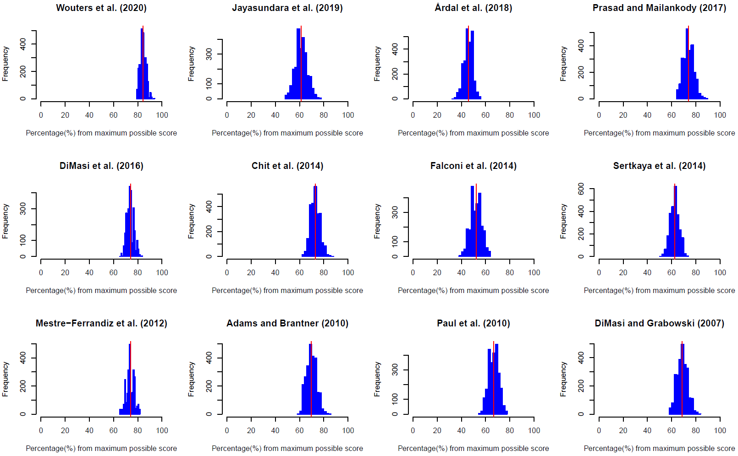
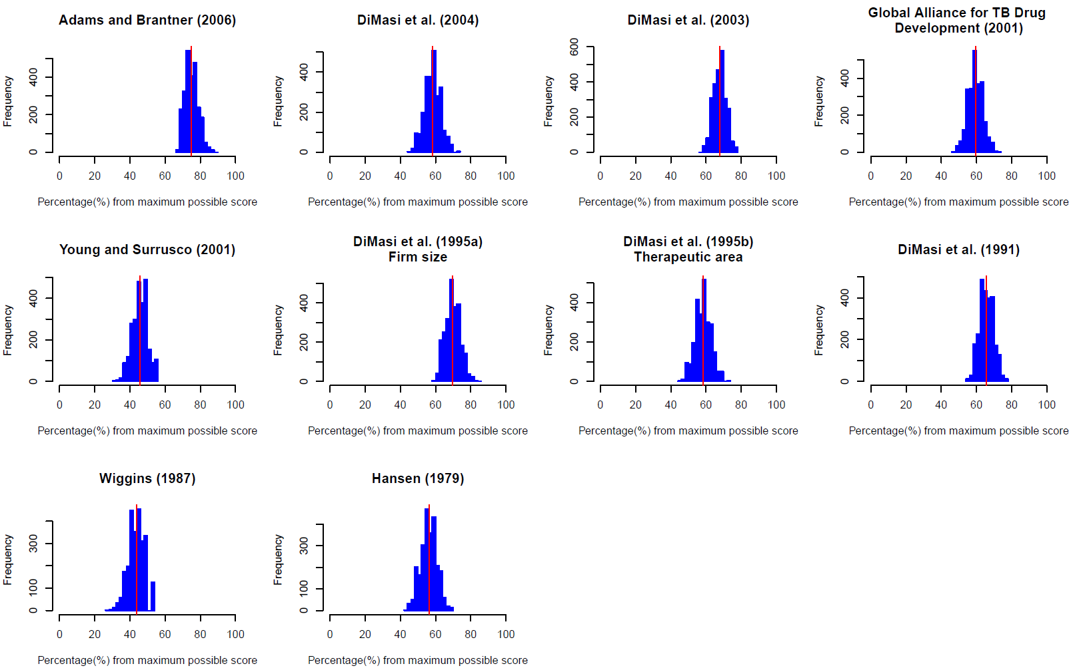
Red line represents the original suitability score that includes all the 16 factors.
Source: Authors’ elaboration.
Fig 3 Sensitivity analysis – Variation on the ranking
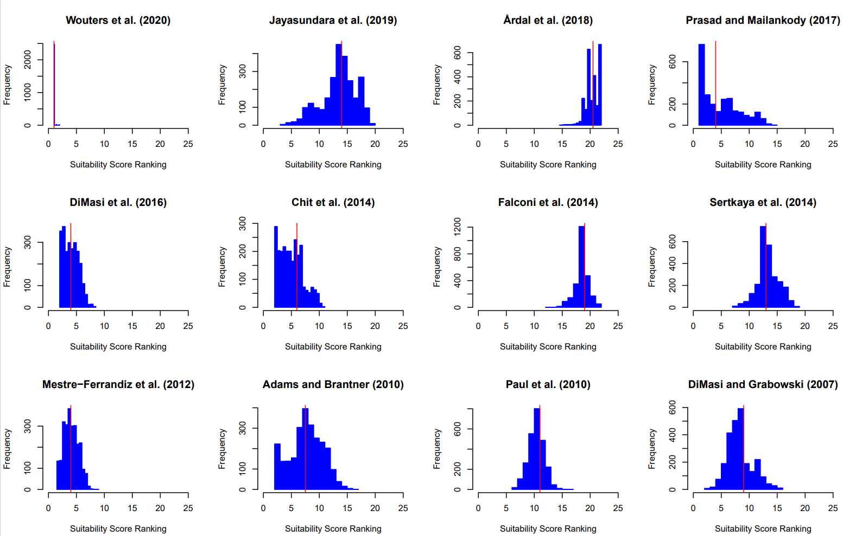
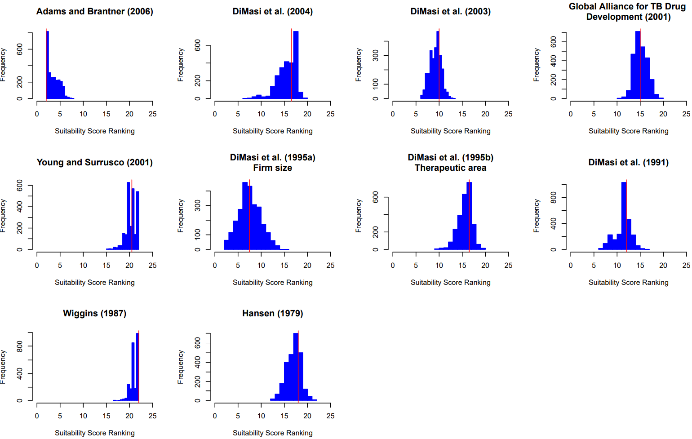
Red line represents the original suitability score that includes all the 16 factors.
Source: Authors’ elaboration.

Supplementary Information 7. Regressions
Table 7. Coefficients from the OLS regressions, drug inclusion period effect on R&D costs – All observations included
Dependent Variable | Intercept |  | YEAR  (Middle Periodª) |  | YEAR  (Middle Period^2) |  | Method (1=Tuft^{b} Method, 0=Other) |  | Phases Included  (Base category: Only clinical phases) |  |  |  | Therapeutic Area (Mixed=1,  One therapeutic area=0) |  | Degrees of Freedom | Adjusted R²
 |  |  |  |  |  |  |  |  | Preclinical and clinical |  | Preclinical, clinical and submission phase |  |  |  | Degrees of Freedom | Adjusted R²
Average capitalized costs estimated per successful drug - Clinical | -44,570.78 | *** | 22.70 | *** |  |  |  |  |  |  |  |  |  |  | 27 | 0.27
 | -6,961,346.15 | ** | 6,974.29 | ** | -1.75 | ** |  |  |  |  |  |  |  |  | 26 | 0.41
 | -37,551.66 | *** | 19.54 | *** |  |  | -899.83 | *** | 102.11 |  | -397.93 |  |  |  | 24 | 0.51
 | -6,431,624.01 | *** | 6,445.06 | *** | -1.61 | *** | -872.31 | *** | 139.52 |  | -397.04 |  |  |  | 23 | 0.64
 | -39,669.81 | *** | 20.66 | *** |  |  | -947.28 | *** | 174.88 |  | -343.91 |  | -193.36 |  | 23 | 0.52
 | -6,076,612.36 | *** | 6,087.85 | *** | -1.52 | *** | -895.07 | *** | 169.99 |  | -372.93 |  | -86.49 |  | 22 | 0.63
Average capitalized costs estimated per successful drug - Total | -60,556.13 | *** | 30.87 | *** |  |  |  |  |  |  |  |  |  |  | 34 | 0.25
 | -2,127,024.32 |  | 2,104.39 |  | -0.52 |  |  |  |  |  |  |  |  |  | 33 | 0.23
 | -52,445.05 | *** | 26.83 | *** |  |  | -446.15 |  | 519.22 | * | 656.54 |  |  |  | 31 | 0.31
 | -4,417,254.75 |  | 4,406.59 |  | -1.10 |  | -433.86 |  | 666.90 | ** | 587.67 |  |  |  | 30 | 0.32
 | -50,368.74 | *** | 25.84 | *** |  |  | -452.64 |  | 546.58 | ** | 772.21 |  | -208.25 |  | 30 | 0.30
 | -4,512,815.05 |  | 4,503.63 |  | -1.12 |  | -440.39 |  | 698.92 | * | 707.53 |  | -218.56 |  | 29 | 0.32
Average cash spent estimated per successful drug (considering failures) – Clinical | -26,805.47 | *** | 13.65 | *** |  |  |  |  |  |  |  |  |  |  | 23 | 0.35
 | -3,913,073.33 | *** | 3,921.42 | *** | -0.98 | *** |  |  |  |  |  |  |  |  | 22 | 0.51
 | -20,608.91 | ** | 10.68 | ** |  |  | -338.69 |  | 7.71 |  | -45.64 |  |  |  | 20 | 0.40
 | -3,943,802.19 | *** | 3,955.09 | *** | -0.99 | *** | -252.78 |  | 51.02 |  | 79.37 |  |  |  | 19 | 0.58
 | -20,519.38 | ** | 10.63 | ** |  |  | -331.14 |  | 2.43 |  | -45.30 |  | 11.26 |  | 19 | 0.37
 | -4,294,796.85 | *** | 4,308.29 | *** | -1.08 | *** | -186.02 |  | 13.64 |  | 93.24 |  | 88.01 |  | 18 | 0.58
Average cash spent estimated per successful drug (considering failures) – Total | -29,511.40 | *** | 15.05 | *** |  |  |  |  |  |  |  |  |  |  | 27 | 0.27
 | -2,456,670.85 |  | 2,454.78 |  | -0.61 |  |  |  |  |  |  |  |  |  | 26 | 0.29
 | -25,011.67 | ** | 12.74 | *** |  |  | -20.36 |  | 183.23 | * | 548.74 | ** |  |  | 24 | 0.40
 | -3,851,892.24 | ** | 3,859.13 | ** | -0.97 | ** | -35.69 |  | 269.66 | ** | 576.15 | *** |  |  | 23 | 0.51
 | -25,217.49 | ** | 12.83 | ** |  |  | -9.87 |  | 175.87 |  | 540.97 | ** | 28.19 |  | 23 | 0.37
 | -3,844,939.00 | ** | 3,852.05 | ** | -0.96 | ** | -27.05 |  | 263.46 | ** | 569.72 | ** | 23.15 |  | 22 | 0.49
Significance: *** 0.01, ** 0.05, * 0.1
ª Middle Period: (Year in which the drug inclusion period starts + Year in which the drug inclusion period ends) / 2
^{b} Method applied by the Tufts Center for the Study of Drug Development [21, 8, 14]
Source: Authors’ elaboration.
Table 8. Coefficients from the OLS regressions, drug inclusion period effect on R&D costs – Excluding all R&D estimations calculated by Jayasundara et al. [5] and Chit et al. [9] as well as the R&D estimation for oncology calculated by Wouters et al. [4]
Dependent Variable | Intercept |  | YEAR  (Middle Periodª) |  | YEAR  (Middle Period^2) |  | Method (1=Tufts Method^{b}, 0=Other) |  | Phases Included  (Base category: Only clinical phases) |  |  |  | Therapeutic Area (Mixed=1,  One therapeutic area=0) |  | Degrees of Freedom | Adjusted R²
 |  |  |  |  |  |  |  |  | Preclinical and clinical |  | Preclinical, clinical and submission phase |  |  |  | Degrees of Freedom | Adjusted R²
Average capitalized costs estimated per successful drug - Clinical | -93,639.35 | *** | 47.47 | *** |  |  |  |  |  |  |  |  |  |  | 22 | 0.80
 | 3,192,007.67 |  | -3,259.15 |  | 0.83 |  |  |  |  |  |  |  |  |  | 21 | 0.81
 | -89,699.42 | *** | 45.71 | *** |  |  | -486.39 | *** | 6.17 |  | -640.02 | *** |  |  | 19 | 0.88
 | 3,963,823.24 | * | -4,036.09 | * | 1.03 | * | -356.92 | ** | -75.33 |  | -717.53 | *** |  |  | 18 | 0.89
 | -90,404.38 | *** | 46.05 | *** |  |  | -461.25 | ** | -21.74 |  | -656.81 | *** | 40.95 |  | 18 | 0.87
 | 4,602,298.77 | ** | -4,680.05 | ** | 1.19 | ** | -266.38 |  | -166.02 |  | -776.61 | *** | 114.19 |  | 17 | 0.89
Average capitalized costs estimated per successful drug - Total | -64,480.30 | *** | 32.87 | *** |  |  |  |  |  |  |  |  |  |  | 28 | 0.50
 | -5,464,428.11 | *** | 5,451.78 | *** | -1.36 | *** |  |  |  |  |  |  |  |  | 27 | 0.60
 | -55,338.62 | *** | 28.33 | *** |  |  | -264.36 |  | 144.17 |  | 555.67 |  |  |  | 25 | 0.53
 | -6,774,182.88 | *** | 6,772.18 | *** | -1.69 | *** | -300.36 |  | 431.33 | ** | 474.04 |  |  |  | 24 | 0.67
 | -62,736.83 | *** | 31.98 | *** |  |  | -173.68 |  | -6.44 |  | 359.69 |  | 281.96 |  | 24 | 0.55
 | -6,396,997.29 | *** | 6,391.19 | *** | -1.60 | *** | -240.61 |  | 319.19 |  | 353.98 |  | 179.40 |  | 23 | 0.67
Average cash spent estimated per successful drug (considering failures) –  Clinical | -49,405.62 | *** | 25.06 | *** |  |  |  |  |  |  |  |  |  |  | 20 | 0.85
 | 1,079,044.63 |  | -1,111.11 |  | 0.29 |  |  |  |  |  |  |  |  |  | 19 | 0.85
 | -49,096.48 | *** | 24.96 | *** |  |  | -117.91 |  | 4.27 |  | -142.03 |  |  |  | 17 | 0.83
 | 2,808,167.48 | * | -2,853.87 | * | 0.73 | * | -74.00 |  | -50.86 |  | -274.56 | * |  |  | 16 | 0.85
 | -49,459.41 | *** | 25.11 | *** |  |  | -53.29 |  | -45.42 |  | -143.01 |  | 71.99 |  | 16 | 0.83
 | 2,851,775.96 | * | -2,898.04 | * | 0.74 | * | -5.83 |  | -103.61 |  | -277.63 | * | 75.18 |  | 15 | 0.86
Average cash spent estimated per successful drug (considering failures) –  Total | -49,122.78 | *** | 24.95 | *** |  |  |  |  |  |  |  |  |  |  | 24 | 0.62
 | 686,054.10 |  | -714.57 |  | 0.19 |  |  |  |  |  |  |  |  |  | 23 | 0.61
 | -52,821.16 | *** | 26.68 | *** |  |  | 218.36 | ** | 146.66 | * | 441.71 | *** |  |  | 21 | 0.75
 | -474,844.99 |  | 451.49 |  | -0.11 |  | 204.64 | * | 161.65 |  | 450.33 | *** |  |  | 20 | 0.74
 | -56,354.70 | *** | 28.41 | *** |  |  | 295.55 | ** | 87.40 |  | 392.15 | ** | 126.79 |  | 20 | 0.77
 | 875,349.09 |  | -909.82 |  | 0.24 |  | 342.07 | ** | 41.85 |  | 362.71 | ** | 153.39 |  | 19 | 0.76
Significance: *** 0.01, ** 0.05, * 0.1
ª Middle Period: (Year in which the drug inclusion period starts + Year in which the drug inclusion period ends) / 2
^{b} Method applied by the Tufts Center for the Study of Drug Development [21, 8, 14]
Source: Authors’ elaboration.

Supplementary Information 8. R&D costs - Preclinical and clinical figures
Fig 4 Average cash spent estimated per successful drug – Discovery and preclinical
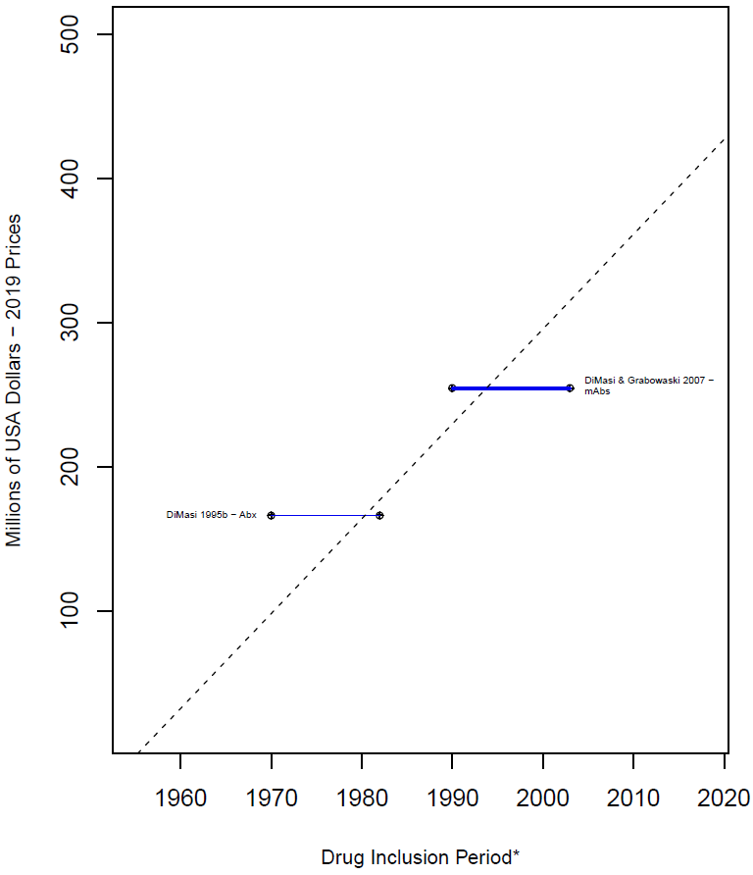
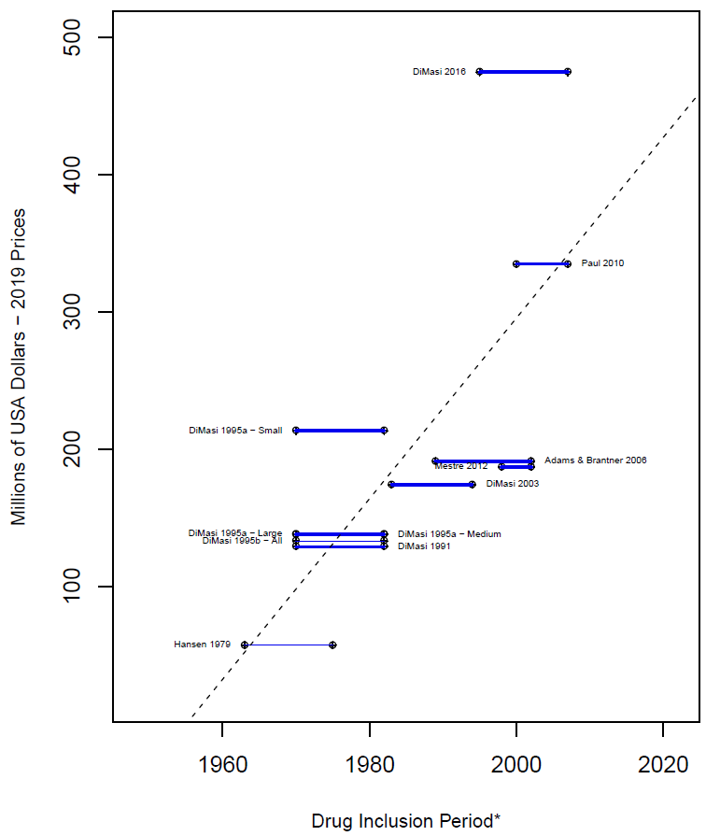
b. R&D estimations based on one particular disease category (2 out of 13)
a. R&D estimations based on multiple disease categories (11 out of 13)
* A thicker line represents a higher value of the suitability score, thus higher suitability of the R&D cost estimated. The length of the lines corresponds to the drug inclusion period. This is the time period considered by the authors for the selection of the drug sample. In most articles, it is the period in which the drug was first tested in humans. Nevertheless, some authors applied different definitions, for more details see Supplementary Information 4 .
Dashed line: OLS regression (excluding Jayasundara et al. [5], Chit et al. [9], and Wouters et al. [4] for Oncology): $R\&Dcosts=-1,287.41\left(p^{-}value=0.0\right)+6.58(p₋value=0.0)*Year$
All= The estimation includes all the observations in the sample. Abx = Anti-infectives. Large= Large enterprises. mAbs= Monoclonal antibodies. Medium= Medium enterprises. Small= Small enterprises.
Note: Each line corresponds to one main R&D estimate. When more than one R&D cost estimate is reported, we refer to each by including the reference of the corresponding article and a keyword that describes the main characteristic of the R&D cost estimate.
Source: Authors’ elaboration.
Fig 5 Average cash spent estimated per successful drug (considering failures) – Clinical phases†
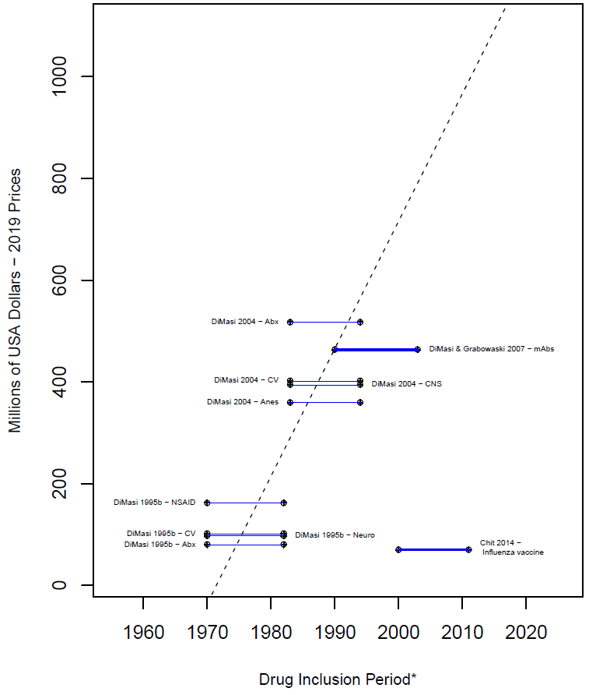
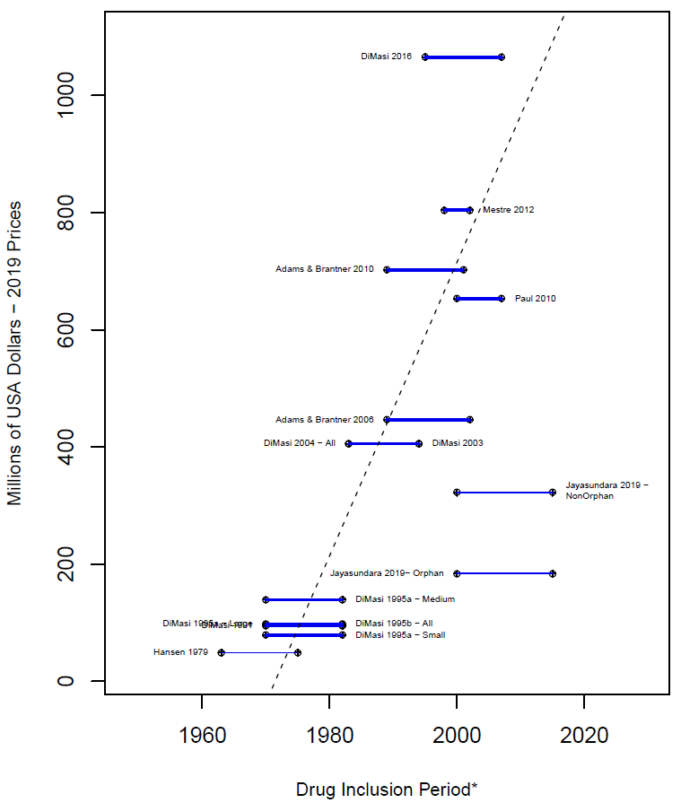
b. R&D estimations based on one particular disease category (10 out of 25)
a. R&D estimations based on multiple disease categories (15 out of 25)
†Total Clinical Phases, including long term animal testing
* A thicker line represents a higher value of the suitability score, thus higher suitability of the R&D cost estimated. The length of the lines corresponds to the drug inclusion period. This is the time period considered by the authors for the selection of the drug sample. In most articles, it is the period in which the drug was first tested in humans. Nevertheless, some authors applied different definitions, for more details see Supplementary Information 4.
Dashed line: OLS regression (excluding Jayasundara et al. [5], Chit et al. [9], and Wouters et al. [4] for Oncology): $R\&Dcosts=-42,095.5+21.4(p₋value=0.0)*Year$
All= The estimation includes all the observations in the sample. Abx = Anti-infectives. Anes = Analgesics/Anesthetic. CNS = Central nervous system. CV = Cardiovascular. Large= Large enterprises. mAbs= Monoclonal antibodies. Medium= Medium enterprises. Neuro = Neuropharmacological. NSAID = Nonsteroidal anti-inflammatory drugs. Small= Small enterprises.
Note: Each line corresponds to one main R&D estimate. When more than one R&D cost estimate is reported, we refer to each by including the reference of the corresponding article and a keyword that describes the main characteristic of the R&D cost estimate.
Source: Authors’ elaboration.
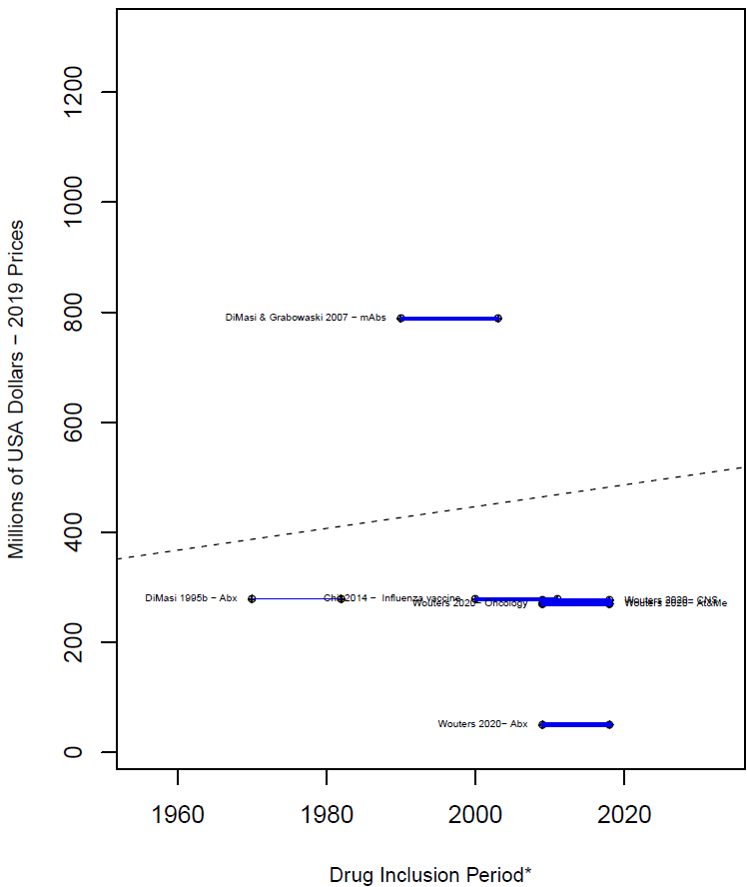
Fig 6 Average capitalized costs estimated per successful drug – Discovery and preclinical
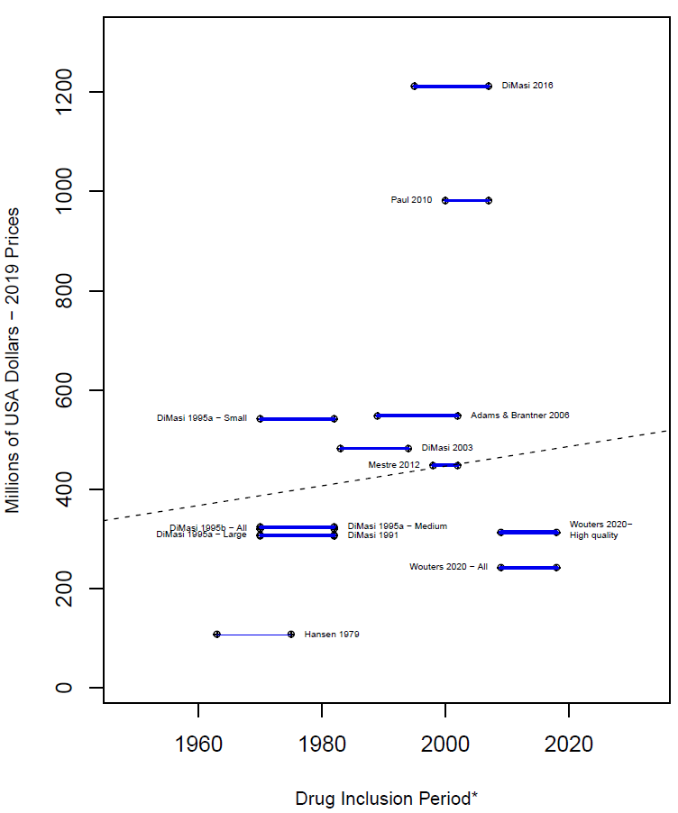
a. R&D estimations based on multiple disease categories (13 out of 20)
b. R&D estimations based on one particular disease category (7 out of 20)
* A thicker line represents a higher value of the suitability score, thus higher suitability of the R&D cost estimated. The length of the lines corresponds to the drug inclusion period. This is the time period considered by the authors for the selection of the drug sample. In most articles, it is the period in which the drug was first tested in humans. Nevertheless, some authors applied different definitions, for more details see Supplementary Information 4.
Dashed line: OLS regression (excluding Jayasundara et al. [5], Chit et al. [9], and Wouters et al. [4] for Oncology): $R\&Dcosts=-1,339.84\left(p^{-}value=0.9\right)+0.88(p₋value=0.8)*Year$
All= The estimation includes all the observations in the sample. Abx = Anti-infectives. Anes = Analgesics/Anesthetic. CNS = Central nervous system. CV = Cardiovascular. Large= Large enterprises. mAbs= Monoclonal antibodies. At&Me= Metabolism and endocrinology. Medium= Medium enterprises. Neuro = Neuropharmacological. NSAID = Nonsteroidal anti-inflammatory drugs. TB = Tuberculosis. Small= Small enterprises.
Note: Each line corresponds to one main R&D estimate. When more than one R&D cost estimate is reported, we refer to each by including the reference of the corresponding article and a keyword that describes the main characteristic of the R&D cost estimate.
Source: Authors’ elaboration.
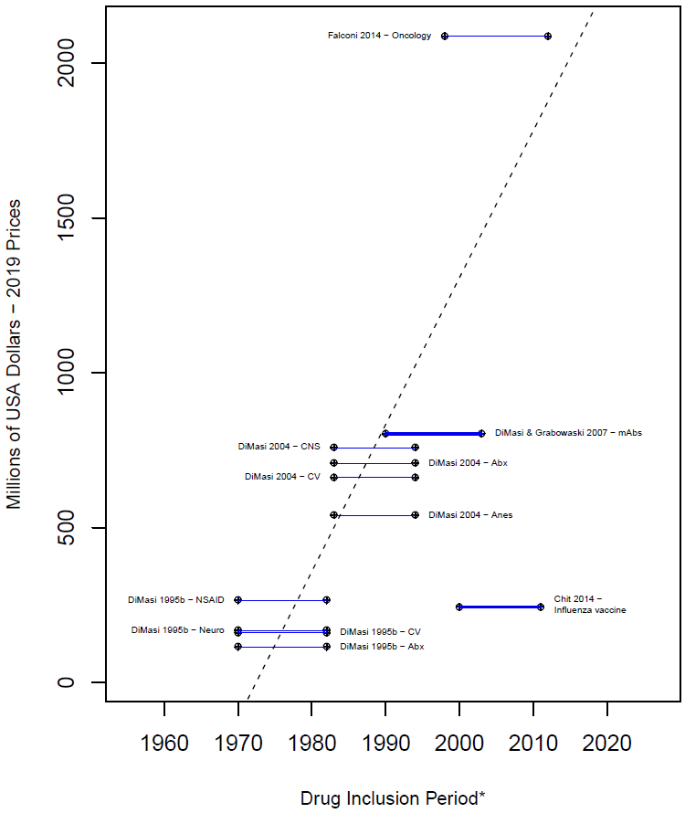
Fig 7 Average capitalized costs estimated per successful drug (considering failures) – Clinical phases†
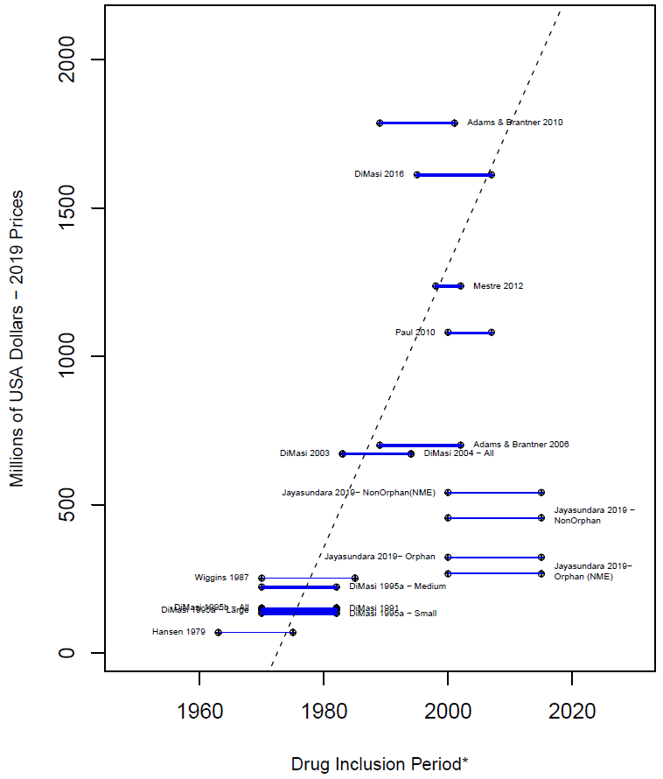
b. R&D estimations based on one particular disease category
(11 out of 29)
a. R&D estimations based on multiple disease categories (18 out of 29)
†Total Clinical Phases, including long term animal testing
* A thicker line represents a higher value of the suitability score, thus higher suitability of the R&D cost estimated. The length of the lines corresponds to the drug inclusion period. This is the time period considered by the authors for the selection of the drug sample. In most articles, it is the period in which the drug was first tested in humans. Nevertheless, some authors applied different definitions, for more details see Supplementary Information 4.
Dashed line: OLS regression (excluding Jayasundara et al. [5], Chit et al. [9], and Wouters et al. [4] - Oncology): $R\&Dcosts=-49,315.23(p₋value=0.0)+25.09(p₋value=0.0)*Year$All= The estimation includes all the observations in the sample. Abx = Anti-infectives. Anes = Analgesics/Anesthetic. CNS = Central nervous system. CV = Cardiovascular. mAbs= Monoclonal antibodies. Large= Large enterprises. Medium= Medium enterprises. Neuro = Neuropharmacological. NSAID = Nonsteroidal anti-inflammatory drugs. Small= Small enterprises.
Note: Each line corresponds to one main R&D estimate. When more than one R&D cost estimate is reported, we refer to each by including the reference of the corresponding article and a keyword that describes the main characteristic of the R&D cost estimate.
Source: Authors’ elaboration.
Fig 8 Costs of time as proportion of the total average capitalized costs - Clinical phases†
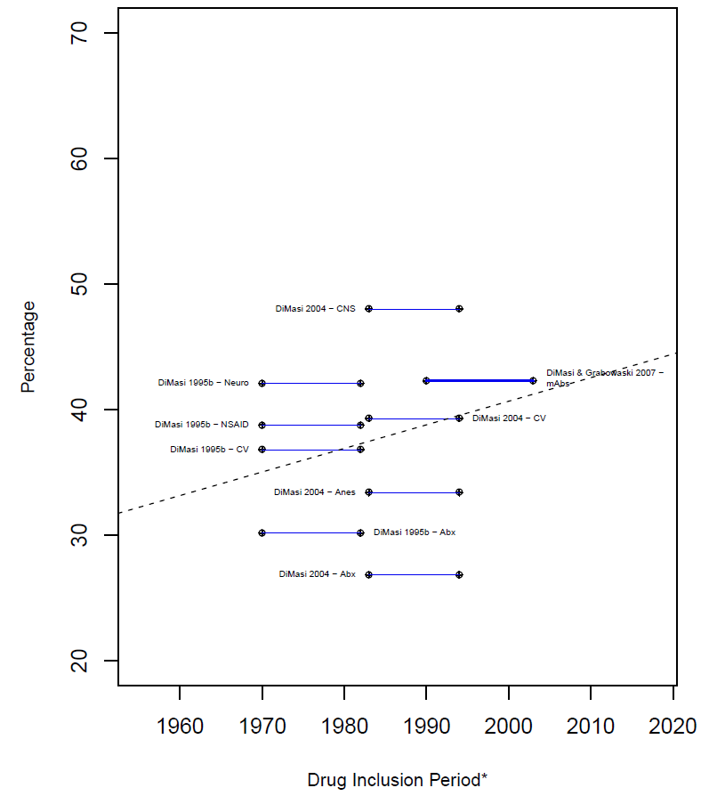
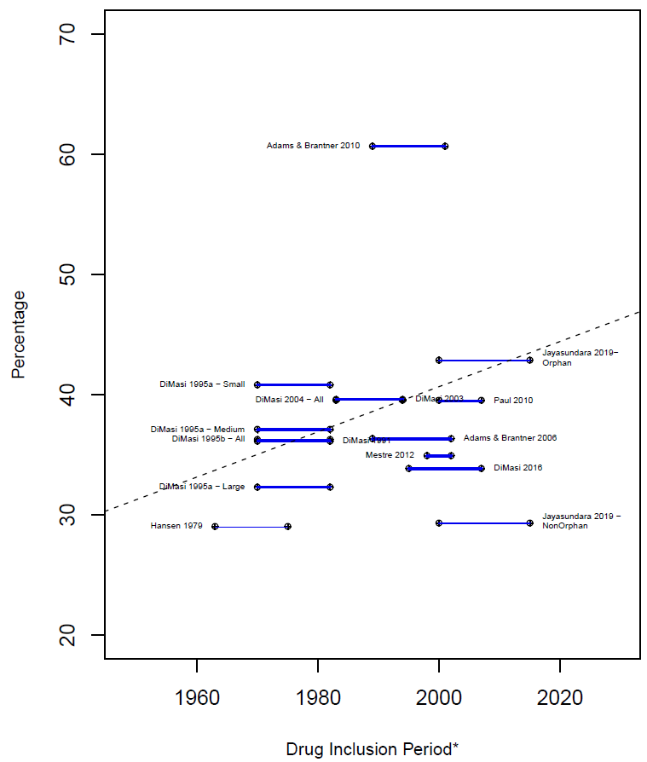
b. R&D estimations based on one particular disease category (9 out of 24)
a. R&D estimations based on multiple disease categories (15 out of 24)
Percentage that the costs related to time (COC) represents equal to: $\frac{\left(Clinical phases average capital per successful drug\right)- Clinical phases average cash per successful drug }{\left(Clinical phases average capital per successful drug\right)}$
†Total Clinical Phases, including long term animal testing
* A thicker line represents a higher value of the suitability score, thus higher suitability of the R&D cost estimated. The drug inclusion period corresponds to the time period considered by the authors for the selection of the drug sample. In most articles, it is the period in which the drug was first tested in humans. Nevertheless, some authors applied different definitions, for more details see Supplementary Information 4.
** Chit et al. [9] was excluded from this figure as their capitalized cost estimation is in 2022 Canadian dollars, which we do not have a proper method to deflate to 2019 USD to compare with other studies.
Dashed line: OLS regression (excluding Jayasundara et al. [5], Chit et al. [9], and Wouters et al. [4] - Oncology) (see Appendix F): $R\&Dcosts=2,808.57\left(p^{-}value=0.0\right)-1.39(p₋value=0.0)*Year$All= The estimation includes all the observations in the sample. Abx = Anti-infectives. Anes = Analgesics/Anesthetic. CNS = Central nervous system. CV = Cardiovascular. Large= Large enterprises. mAbs= Monoclonal antibodies. Medium= Medium enterprises. Neuro = Neuropharmacological. NSAID = Nonsteroidal anti-inflammatory drugs. Small= Small enterprises.
Note: Each line corresponds to one main R&D estimate. When more than one R&D cost estimate is reported, we refer to each by including the reference of the corresponding article and a keyword that describes the main characteristic of the R&D cost estimate.
Source: Authors’ elaboration.

Supplementary Information 9. References
1. Morgan S, Grootendorst P, Lexchin J, Cunningham C, Greyson D. The cost of drug development: A systematic review. Health Policy. 2011;100:4–17.
2. Paul SM, Mytelka DS, Dunwiddie CT, Persinger CC, Munos BH, Lindborg SR et al. How to improve R&D productivity: The pharmaceutical industry's grand challenge. Nature Reviews Drug Discovery. 2010;9(3):203.
3. Sertkaya A, Eyraud JT, Birkenbach A, Franz C, Ackerley N, Overton V et al. Analytical framework for examining the value of antibacterial products: Submitted to the US Department of Health and Human Services2014.
4. Wouters OJ, McKee M, Luyten J. Estimated research and development investment needed to bring a new medicine to market, 2009-2018. Jama. 2020;323(9):844-53.
5. Jayasundara K, Hollis A, Krahn M, Mamdani M, Hoch JS, Grootendorst P. Estimating the clinical cost of drug development for orphan versus non-orphan drugs. Orphanet journal of rare diseases. 2019;14(1):12.
6. Årdal C, Baraldi E, Theuretzbacher U, Outterson K, Plahte J, Ciabuschi F et al. Insights into early stage of antibiotic development in small-and medium-sized enterprises: A survey of targets, costs, and durations. Journal of Pharmaceutical Policy and Practice. 2018;11(1):8.
7. Prasad V, Mailankody S. Research and development spending to bring a single cancer drug to market and revenues after approval. JAMA Internal Medicine. 2017;177(11):1569-75.
8. DiMasi JA, Grabowski HG, Hansen RW. Innovation in the pharmaceutical industry: New estimates of R&D costs. Journal of Health Economics. 2016;47(1):20-33.
9. Chit A, Parker J, Halperin SA, Papadimitropoulos M, Krahn M, Grootendorst P. Toward more specific and transparent research and development costs: The case of seasonal influenza vaccines. Vaccine. 2014;32(26):3336-40.
10. Falconi A, Lopes G, Parker JL. Biomarkers and receptor targeted therapies reduce clinical trial risk in non–small-cell lung cancer. Journal of Thoracic Oncology. 2014;9(2):163-9.
11. Mestre-Ferrandiz J, Sussex J, Towse A. The R&D cost of a new medicine. London: Office of Health Economics2012.
12. Adams CP, Brantner VV. Spending on new drug development. Health Economics. 2010;19(2):130-41.
13. DiMasi JA, Grabowski HG. The cost of biopharmaceutical R&D: Is biotech different? Managerial and Decision Economics. 2007;28(4‐5):469-79.
14. DiMasi JA, Hansen RW, Grabowski HG. The price of innovation: New estimates of drug development costs. Journal of Health Economics. 2003;22(2):151-85.
15. Adams CP, Brantner VV. Estimating the cost of new drug development: Is it really $802 million? Health Affairs. 2006;25(2):420-8.
16. DiMasi JA, Grabowski HG, Vernon J. R&D costs and returns by therapeutic category. Drug Information Journal. 2004;38(3):211-23.
17. Global Alliance for TB Drug Development. The economics of TB drug development: New data for new research. New York, NY: Global Alliance for TB Drug Development2001.
18. Young B, Surrusco M. RX R&D myths: The case against the drug industry’s ‘R&D scare card’ Washington, DC: Public Citizen2001.
19. DiMasi JA, Grabowski HG, Vernon J. R&D costs, innovative output and firm size in the pharmaceutical industry. International Journal of the Economics of Business. 1995;2(2):201-19.
20. DiMasi JA, Hansen RW, Grabowski HC, Lasagna L. Research and development costs for new drugs by therapeutic category. PharmacoEconomics. 1995;7(2):152-69.
21. DiMasi JA, Hansen RW, Grabowski HG, Lasagna L. Cost of innovation in the pharmaceutical industry. Journal of Health Economics. 1991;10(2):107-42.
22. Wiggins SN. The cost of developing a new drug. Pharmaceutical Manufacturers Association; 1987.
23. Hansen RW. The pharmaceutical development process: Estimates of development costs and times and the effects of proposed regulatory changes. In: Chien RI, editor. Issues in Pharmaceutical Economics. Lexiton, Massachusetts: D.C. Heath and Company; 1979.
24. Hansen RW. Regulation and pharmaceutical innovation: A review of the literature on monetary measures of costs and benefits. Washigton, D.C.: Center for Research in Goverment Policy and Business, University of Rochester1976.
25. Wong CH, Siah KW, Lo AW. Estimation of clinical trial success rates and related parameters. Biostatistics. 2019;20(2):273-86.
26. Hay M, Thomas DW, Craighead JL, Economides C, Rosenthal J. Clinical development success rates for investigational drugs. Nature biotechnology. 2014;32(1):40-51.
27. Maurer SM. The right tool(s): Designing cost-effective strategies for neglected disease research: Goldman School of Public Policy, University of California at Berkeley2005.
28. Harrington SE. Cost of capital for pharmaceutical, biotechnology, and medical device firms. In: Danzon PM, Nicholson S, editors. The Oxford Handbook of the Economics of the Biopharmaceuticals Industry Oxford University Press; 2012. p. 75-99.
29. Struck M-M. Vaccine R&D success rates and development times. Nature Biotechnology. 1996;14(5):591.
30. Myers SC, Shyam-Sunder L. Measuring pharmaceutical industry risk and the cost of capital. In: Helms R, editor. Competitive Strategies in the Pharmaceutical Industry. Washington, DC.: American Enterprise Institute for Public Policy; 1995. p. 208-37.
31. Mathieu MP. Parexel’s pharmaceutical R&D statistical sourcebook, 1998. MA Waltham1999.
32. Myers SC, Howe CD. A Life-cycle financial model of pharmaceutical R&D. Working paper (Sloan School of Management). Cambridge, MA.: Massachusetts Institute of Technology; 1997.
33. Grabowski H, Vernon J. A new look at the returns and risks to pharmaceutical R&D. Management Science. 1990;36(7):804-21.
34. Shyam M, Sunder S. Pharmaceutical industry profits. Washington: Pharmaceutical Manufacturers Association1987.

“Database used” refers to the data used in the R&D estimation at the highest level of disaggregation used by the authors (i.e., product, firm, and/or year).
Idem
Idem
Idem
Idem
Idem
Although there is not a difference in the suitability of the R&D costs estimated between those articles classified in categories 5 and 6, we considered it relevant to capture the attitude of the authors regarding these factors; i.e., is the factor ignored? Should these factors not be part of the R&D costs estimation?
It is assumed that expenditures related to long term animal testing are included in Phase 1, Phase 2 and Phase 3 R&D expenditures.
The factor “Replicability” in the domain “Monetary Values” refers to the source of the monetary values, and not to the sample selected for the study. Replicability exists when: (1) it is possible to calculate the final R&D costs estimation based on the original monetary data (i.e., data by company and/or selected drugs); or (2) when it could be possible to replicate the data collection fully (e.g., by interviewing the same set of companies using the same form and considering the same drugs).

